Internship Report
On
Activities and Financial Statement Analysis of

“Consumer Knitex Limited”



Submitted to:
Dr. Seyama Sultana
Assistant Professor
School of Business & Economics
United International University

Submitted by:
Marufa Sultana
ID 111-151-286
School of Business& Economics
United International University

Date of Submission: November 15, 2019

Letter of Transmittal

To,

Dr. Seyama Sultana
Assistant Professor
School of Business & Economics
United International University

Subject: Submission of internship report.

Dear Ma’am,

Every student of UIU Business School needs to do their internship in an organization and submit a report about their experience in the company in order to complete their graduation. As per the BBA program’s requirement, my internship report has been completed. In this report, I have tried to follow all the guidelines and instructions that you have communicated to me through our conversations.

UIU internship program is a yearlong program of which I have completed three months till date. Throughout my ongoing internship period I have not only acquired different skills and knowledge, but also a good network. Working in this organization has exposed me to the inner workings in an organization. While preparing the report, I ensured that I abide by the rules and regulations of UIU and use authentic materials to support my report. I hereby, submit my report.

Sincerely,

Marufa Sultana
ID- 111151286
School of Business & Economics
United International University

Acknowledgement

Firstly, I would like to thank Almighty Allah for his blessings upon me to make it this far and for giving me an opportunity to work in one of the finest developing company in Bangladesh. Secondly, I would like to convey my special thanks to Dr. Seyama Sultana Ma’am, my faculty advisor for her valuable guidance, which helped me to complete this report successfully. I am highly grateful to her.
I would also like to acknowledge the help of my organizational supervisor, Nasib oashim Chowdhury for his upmost support for my learning outcomes and giving me guidelines to do different works and maintain the daily routine work in the organization. I would also like to give thanks to Sazzad Hassan Chowdhury, Head of Accounts and Finance Department for supporting my work and for giving me the guideline to complete my three months internship work and learning. I am also grateful for the support of my colleagues during the time of my internship period.

Executive Summary

Garments and textile sector plays an important role in the economy of Bangladesh. There are 4621 garments factories in Bangladesh which contributes a lot to the economic development of our country. One of the major sources of foreign exchanging earnings is coming from export of RMG and textiles industry. RMG and Textile industry contributes a lot to the economy of the country and it’s a major contributor of GDP in our country. The study focuses on the overall activities of Compagnie Mauricienne de Textile Ltée (CMT) Bangladesh and financial statement analysis of CMT (Bangladesh).. As a business graduate this report helps me to better understand of how a business can perform its overall activities outstandingly and improve its financial strength.

In this report I provide an overview of RMG and Textile industry in beginning part of report, and then I provide company overview of the CMT (Bangladesh). In later part of the report I provide brief description of overall production activities of the CMT (Bangladesh).provides brief departmental description of the company. In this report I also include the job responsibility what I performed during my internship period. Lastly I include a financial statement analysis to evaluate the financial performance of the CMT (Bangladesh).i also provide some suggestions to improve the overall operational efficiency.

The main purpose of this report is to better understanding of the activities of the CMT (Bangladesh) and the impact on the operational efficiency of its overall activities. This report also focuses on the financial performance of the CMT (Bangladesh) and its impact on its profitability.

Contents
Executive Summary 4
1. Introduction 6
1.1 Objectives of the Report 6
1.2 Rationale of the Study 7
1.3 Scope of the Report 7
1.4 Limitations of the Report 7
1.5 Methodology of the Report 8
1.6 Data Design 8
1.7 Analytical Tools 8
2. Industry and Company Overview 9
2.1 Industry Overview 9
2.2 Introduction to CMT 10
2.3 CMT Bangladesh 10
2.4 Objective of the Company 12
2.5 Mission Statement 12
2.6 Vision Statement 13
2.7 Goal 13
2.8 SWOT Analysis of the Company 14
3. Job responsibilities 16
3.1 Description of the Job 16
3.2 Specific Responsibilities of the Job 16
3.3 My Experience as an intern 16
4. Operational activities and Department of the organization 21
4.1 Departments of CMT (Bangladesh) 22
5. Financial Statement Analysis and Findings 24
5.1 Major Findings of this study 33
6. Conclusion and Recommendations 35
6.1 Conclusion 35
6.2 Recommendations 35
7. References 36

Introduction

RMG sector in Bangladesh has a great impact on economic growth of the country. From last four years RMG and Textile industry has been the major contributor of foreign export in Bangladesh. This sector stands in the 3rd position in the apparel manufacturing throughout the world and secures the commanding place in South Asia. This sector covers more than 80% of total export in Bangladesh and generates US$27.16 billion within 2016-17. This sector also contributes 12.36% in the GDP of Bangladesh within 2016-17, the trade was conjoint Some dangerous or uncommon prevalence happen however this trade going well and its remission hits our gross domestic product massively. This sector currently accounts for eighty three of total export earnings of the country. There square measure many folks late Akhter Mohammed Musa, late Mohammed Reazuddin, Md Humayun, M Shamsur Rahman, the primary President of BGMEA helps to create RMG sector.

Compagnie Mauricienne de Textile Ltée (CMT) is an international company which starts its journey in Bangladesh at 2011 by acquiring two textile companies. CMT is a 100% export oriented company which contributes a lot to our economy through its diversified activities in Bangladesh. In this report I focus on overall activities of CMT Bangladesh and perform a financial statement analysis through ratio analysis.

I will direct my examination under the nearby supervision of my Scholastic Manager who will reliably screen my advancement and suggest any means taken with the end goal of comprehending the blunders happened amid my investigation.

1.1 Objectives of the Report

Broad Objective

The main goal of this report is to describe the overall activities of CMT Bangladesh and conduct a financial analysis through ratio analysis to evaluate its financial performance.

Specific Objectives
- To provide a better understanding of entire activities of CMT.
- To provide an understanding of how activities of CMT contributes to the economy.
- To analyze the financial performance of CMT
- To interpret the financial ratios outcome.
- To provide some recommendation for improving their overall activities
- To provide some recommendation for improving their financial performance

1.2 Rationale of the Study
The study focuses on the overall activities of Compagnie Mauricienne de Textile Ltée (CMT) Bangladesh and financial statement analysis of CMT (Bangladesh).RMG and Textile industry contributes a lot to the economy of the country and it’s a major contributor of GDP in our country. The main purpose of this report is to better understanding of the activities of the CMT (Bangladesh) and the impact on the operational efficiency of its overall activities. This report also focuses on the financial performance of the CMT (Bangladesh) and its impact on its profitability. As a business graduate this report helps me to better understand of how a business can perform its overall activities outstandingly and improve its financial strength.

1.3 Scope of the Report
- Better understanding of how overall activities of CMT (Bangladesh) are performed.
- Providing a brief idea about all the departments of the CMT (Bangladesh).
- Interpreting ratio analysis result.
- Recommendations for the company to improve their overall activities towards organizational goals.
- Recommendations for the company to improve their financial strength.

1.4 Limitations of the Report
There is not really any action which has no impediment. This examination likewise has a few confinements. In setting up this report I face a few issues. Time is the main impediment of this examination. As the proposition time frame is for 3 months, it is extremely a brief period to investigation a colossal association like CMT (Bangladesh). Along these lines, information accumulation process is likewise hampered for this and I can only include five years historical data to analysis and most of the data are collected from secondary source.

1.5 Methodology of the Report
Approach is considered as the deliberate, hypothetical investigation of the techniques connected to a field of study which includes the hypothetical examination of the group of strategies and standards related with a part of learning. Typically, it includes ideas, for example, worldview, hypothetical model, stages and quantitative or subjective procedures. So as to set up the report, I choose to gather different kinds of essential and optional information. At that point the information was organized as required.

1.6 Data Design
- Collection of Data- data of all about activities and all departments are collected from the website of the company and financial data are collected from annual report of the company.
- Data Types- in this report I use secondary data about company’s overall activities and financial data of the company

1.7 Analytical Tools
Microsoft excel is used for analysis the financial statement of the company and graphs and charts are made through the use of Microsoft word.

Industry and Company Overview

2.1 Industry Overview
Garments and textile sector plays an important role in the economy of Bangladesh. There are 4621 garments factories in Bangladesh which contributes a lot to the economic development of our country. One of the major sources of foreign exchanging earnings is coming from export of RMG and textiles industry. Major buyers of RMG of Bangladesh are European Union, USA, UK, and Australia etc. Total 78% of merchandise exports of Bangladesh are comes from the export of RMG, clothing and textiles in 2016.According to the world bank GDP of Bangladesh was US$6.28 billion in1972, which is grew to US$172.78 Billion in 2014, where US$32.18 billion was generated through exports, in which more than 83% was supplied from RMG sector. This sector stands in the 3rd position in the apparel manufacturing throughout the world and secures the commanding place in South Asia. Bangladesh stands in the 2nd position in producing RMG following China. Bangladesh also belong the 2nd position in exporting western fashion around the world. In Bangladesh most of the garments company is owned by the local investor only 5% of the garments company is owned by foreign investor. This sector covers more than 80% of total export in Bangladesh and generates US$27.16 billion within 2016-17. This sector also contributes 12.36% in the GDP of Bangladesh within 2016-17.a brief scenario of textile and clothing sector is given below:

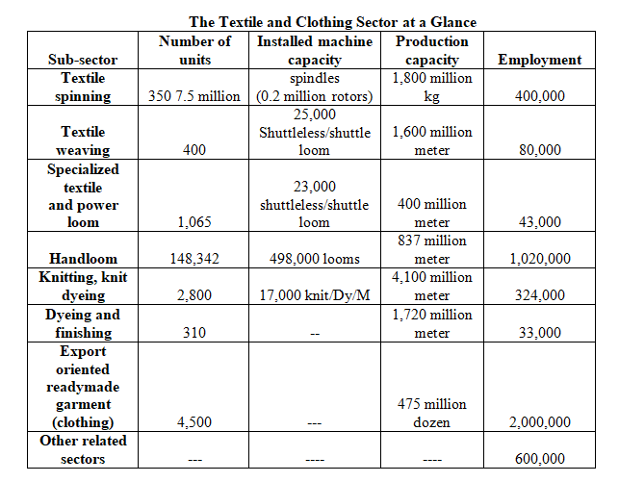

2.2 Introduction to CMT
Compagnie Mauricienne De Textile Ltée (CMT), a pioneer in fashion industry all over the world for its jersey-wear, CMT has it’s headquarter in Mauritius with several distribution office in deferments region like United Kingdom, France, USA. It has the biggest manufacturing plants and also renowned for its marketed investment and innovative operations.It is specialized for the best vesture brands and fastfashion retailers in the style and development of fastfashion jerseywear apparel. With $200 million in turnover and around 10,000 people, CMT is one of the most important companies in Mauritius.

2.3 CMT Bangladesh
In 2010 CMT (Bangladesh) enter in Bangladeshi market as a multinational company with CMI LTD., which is operate as an investment firm. In January 2011, they purchased Dignity Textile Mills Limited (DTML) following the acquisition by CMI of Consumer Knitex Limited (CKL) in October 2011. A dramatic fire struck DTML in May 2015; a 2nd unit of DTML (APEX) was established, after a few months in July 2015. CMT has grown its business as a sign of growth and a new factory is set up in July 2016, CKL Unit 2 (TRISHAL).



CMT Head Office
The head office of CMT is made up with five different departments which are Sales Department, Accounting & Audit Department, General Order Department, Purchase of Accessories Department and Human Resource Department. All the departments work together to acquire the organizational goals and all the senior management work as a team to take decision about important issues on the company.

CMT Dhaka Office Organizational Structure

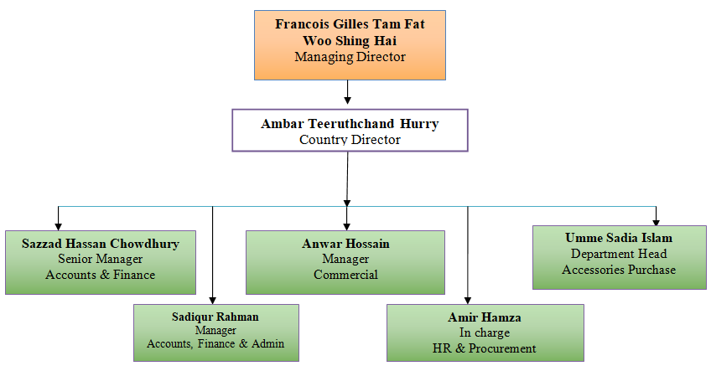

Factory Know About:

CMT (Bangladesh) operates with 3 factories in Bangladesh and all the 3 factories are in production. There are More than 6000 workers are work in CMT (Bangladesh).T-Shirt, Polo-Shirt, Jersey-Wear, Women and Kids Wear are the key products of CMT (Bangladesh) and all the products are mainly exported to Europe, Asia, Africa and North America.


There is the brief info about 3 factories of CMT (Bangladesh):
- CMT (Bangladesh) first acquire Dignity Textile Mills Limited in February, 2011, which is located in Gazipur. There are more than 800 people currently works in this company and the company is in full production.
- CMT (Bangladesh) second acquire Consumer Knitex Limited in October, 2011, which is located in Mymensingh. There are more than 1500 people currently works in this company and the company is in full production.
- CMT (Bangladesh) newly setup Consumer Knitex Limited unit 2 in Trishal, Meymensingh. There are around 4000 workers currently employed in this company with accommodation facility of 6000 workers.

2.4 Objective of the Company
CMT (Bangladesh) is a multinational textile company. The main objectives of the CMT are given below:
- Provide a better pathway for effective business development. to consumer and company
- To avoid short-term insolvency should maintain a balanced cash flow.
- CMT insures highest level of customer satisfaction to become a successful firm and secure the leading position in the market.
- CMT want to enhance their profit not only doing profitable business in Europe but also reach the other part of the world.
- CMT want to increase their sales volume by providing better customer satisfaction.
- CMT design an effective delivery schedule to satisfy the customer in handover process.
- CMT provide product information to the customer to gain the customer trust.
- Ensure a better networking system to facilitate the business transactions.
- Analyzing the buying decision of the customer to provide better solution to them.
- Analyzing the supplier’s actions to improve product quality.

2.5 Mission Statement
We will ensure the number one position in the manufacturing of top quality fabrics & jersey wear by using top class technology, providing world class training & development to our
Employee

We will contributes to the social and economic development to the country by improving ourselves a learning hub

We are the dream team in the manufacturing world!

2.6 Vision Statement

- CMT Bangladesh Ltd operates as a cost effective, environment friendly and responsible partner..
- Company’s vision is to stand them-self into leading position.

2.7 Goal
Major goal of the company is providing quality product by optimizing method, skilling expertise and improving quality, across the entire firm.

- In order to scale back the risks of employee safety and health issues of employee into minimum level.

- To shield the surroundings and guarantee property for upcoming generations.

- In order to develop skilled skills & leadership skills, depending on competence, personal goals and therefore the organizational needs.

Overall shopper satisfaction is that the slogan of this kingdom based mostly company.

2.8 SWOT Analysis of the Company
SWOT evaluation helps an organization to improve its situation, quality of the product, overcome shortcomings, risk and open prompting identifying the competitive advantageous capability of the organization. It’s also empowers a company to comprehend its market position. Here’s the SWOT analysis of CMT (Bangladesh) is prepare to perceive the embedding of the company better.

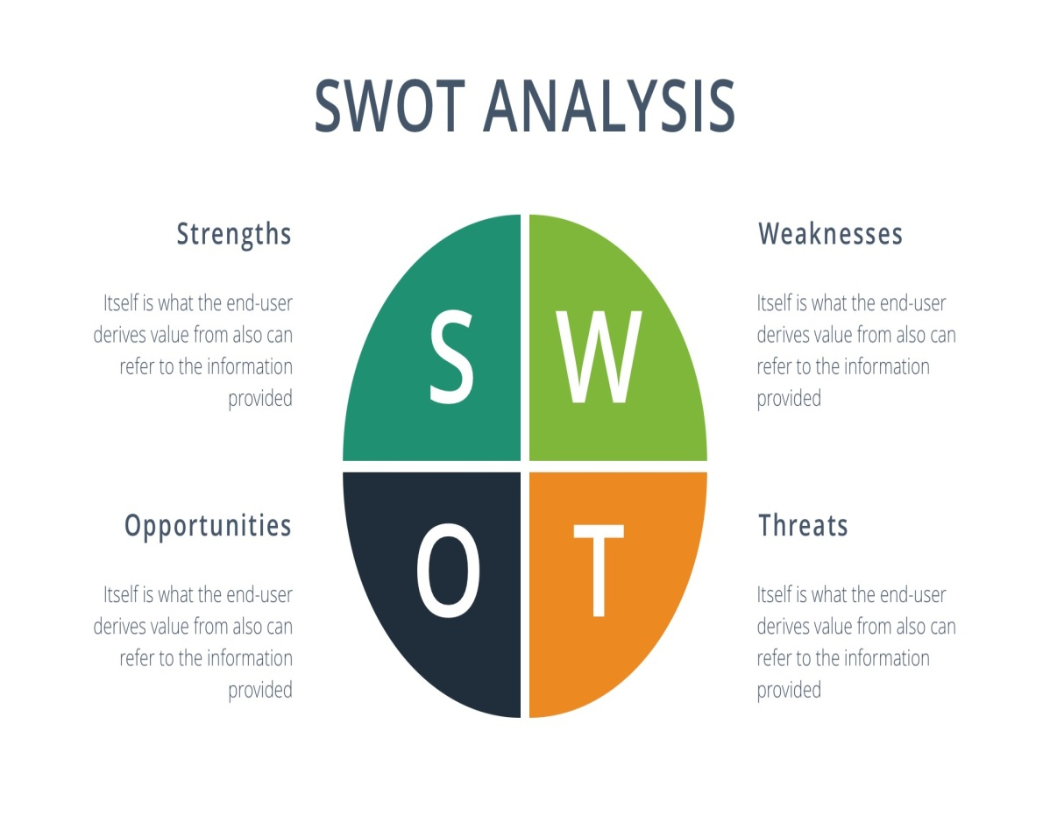

Strength
- Compagnie Mauricienne DE Textile Ltée (CMT) management systems are perpetually committed to superior service.
- CMT has a team of sincere and responsible employee.
- CMT maintains sensible relationship between high management & staff.
- Could not maintain the foundations & regulation in keeping with acceptable law attributable to government interference.
- CMT use advanced information system.
- CMT maintains a good connection between higher management & employee.
- CMT has a strong security system.
- CMT has a well-decorated office.

Weakness

- Could not maintain the rules & regulation according to appropriate law because of government interference.
- Raw materials are not available here.
- Decision can take only the higher management.
- Lack of proper govt. policy.
- Poor market coverage in Bangladesh

Opportunity
- New foreign buyers coming to the market
- Improving service quality than competitor
- Improve higher customer satisfaction by providing quality product
- Take the opportunity to get a huge amount of money.
Threat
- Increased the number of foreign buyers.
- Government policy interrupts the development process.
- Growing up the cost of production.
- BGMEA rules & regulation are so much complex in nature.
- Project areas are hassled by the local village political.

Job responsibilities

3.1 Description of the Job
I joined Consumer Knitex Limited as an intern in finance, accounts and audit department and work with the Reward & Talent Acquisition Team. Financing in the appropriate project and recovery is the biggest function of the Accounts and Finance Department in Compagnie Mauricienne de Textile Ltée (CMT). Right investment basically looks after all kinds of profit provided to the employees of CMT BD Ltd, financial as well as non-financial. As an intern I do some routine work like processing cheque, handling account of the company along with new project account on a monthly basis. As a team member of talent acquisition team I learned a lot of things that is undertaken to handling account which candidate perfectly match with the job specification.

3.2 Specific Responsibilities of the Job
Now a day every company tries to keep record their information computer based system. That’s why many of the organization adopt some basic accounting software which provides them flexibility in information recoding, summarizing that information and reporting the transaction to the organization top management. Like other firms CMT (Bangladesh) adopt the well-known accounting software SAP. Parents Company of CMT in Mauricious is mainly adopted this software. This software is basically use by the purchase and accounts department of CMT. Purchase department of CMT record all the purchases information and input purchase entry on the software. By using this software CMT Purchase Department create PURCHASE ORDER (PO).

3.3 My Experience as an intern
I start my internship as a member of Reward & Talent Acquisition Team of CMT (Bangladesh).In the CMT; they ensure a beautiful working environment, all the employees are so much friendly. As the time of working as an intern they teach me a lot of practical implementation what I learn throughout my academic period. The head office is beautifully decorated and all the departments are very much well organized. All over environment of the office is nature friendly and it’s been a great achievement for me to work with this highly skilled team.

Depiction of the job
In my three months work encounter I experience distinctive obligations, preparing, coordinated discussion, group meeting and so forth. Every one of the general population here treat me as a changeless representative that causes me a long way to go things rapidly and encounter the genuine condition of the corporate world. People who are working here are cordial and the workplace is great.
As an intern I was busy with various kinds of exercises. Among them my key obligations are given below:

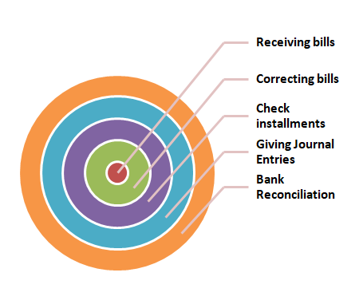

Receiving Bills
Each day numbers of bills of various textures frill and different purposes originate from various providers. Alongside these bills some critical papers must be joined and checked by material checking focus and Baxter Security Service. The papers that require to be joined are the Invoice, P.O. (Buy Order) of the materials, the MRIR (Material Receiving and Inspection Report). On these bills there ought to be indication of specific individuals too. By checking every one of these connections and prerequisites one bill must be gotten. Later the bills are adjusted and sent for installment.
Correcting Bills
In the wake of obtaining the bills the next stage is to deal with them. Coordinative they got quantity with the organized quantity, recognizing the MRIR (Material Received and scrutiny Report) got quantity and receipt quantity, removing the rejected materials from the real bill, recheck the problem solving so on square measure the system of adjusting a bill. Once the rectification these bills square measure sent for the any procedure of installment.

Give Journal Entries
Every day I provide a lots of journals regarding delivery of product and entry of raw materials after understanding the issues related to bank installments, export-import dealing, payment system which affecting the delivery of product and purchase of raw materials. Journal entries mainly related to stock of the product and distribution of the product.

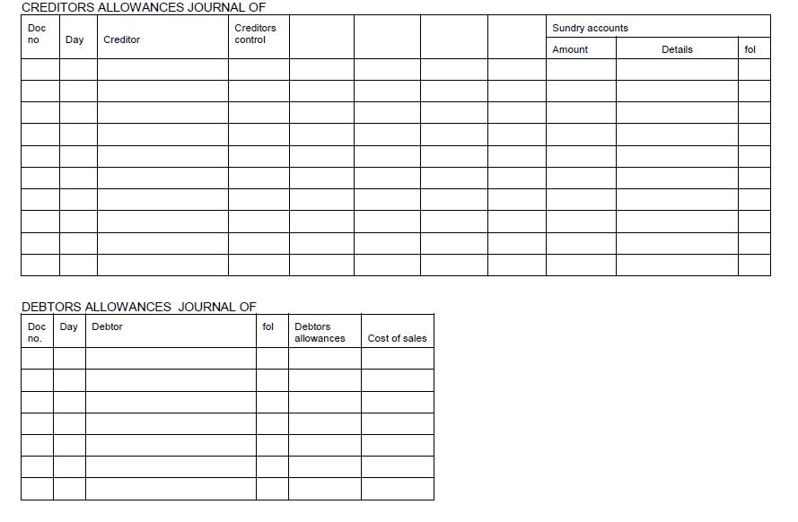
Checking Payments
In CMT raw materials and machineries are purchase from different suppliers and we have to be compelled to pay our suppliers. That’s why we have to keep a close eye on each installment of suppliers. We keep all the records of payment with great care. We use SAP to record the payment to suppliers. We use a special form of payment to our suppliers which helps them to ease with U.S business policy


Bank Reconciliation
We record all our bank transaction related issues in bank reconciliation such as deposit both in cash and card, withdrawal of fund. It provides us the information of bank balance in a quick time which helps us to maintain a sufficient bank balance to secure our banking transactions.

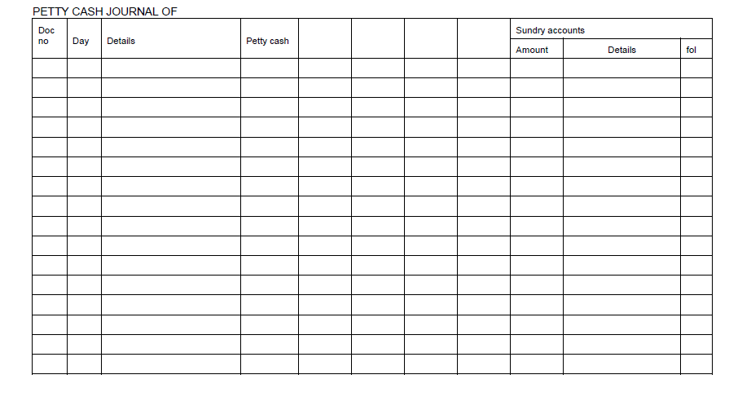
Scanning
I additionally perform scan because it was a task of accounts and money department. I scanned the documents that are reaching to be hold on within the last year.
Benefits of scanning:
- Document scanning will save our time and cash. While not scanning if any files/bills are required you have got to look through all the boxes that are unquestionably a waste of your time.
- Through scanning we will simply resolve the wished info, like if you required any invoice range you'll simply see the scanned image and you'll get your info.
- Document scanning is required to scale back space for storing. If like if you regenerate files into scanned files into laptop you won’t get to store the files or boxes with regards to your hands.

Uploading on Accounting Portal
I also upload the scanned document into the accounting portal of the CMT with a short description of each document, which directly connect with headquarter of Mauritius. All the business documents and bookkeeping are recorded with SAP which is automatically added in the accounting portal of the CMT (Bangladesh).

Operational activities and Department of the organization

CMT (Bangladesh) operates through several department which starts with product design and development department and ended with the delivery department which helps to distribute its product in Europe and USA. In overall production process CMT (Bangladesh) ensure highest quality of product with combination of advance technology, expertise and superior management team. More than 6000 workers relentlessly work under five departments to provide a better quality product. The operational structure is given below.

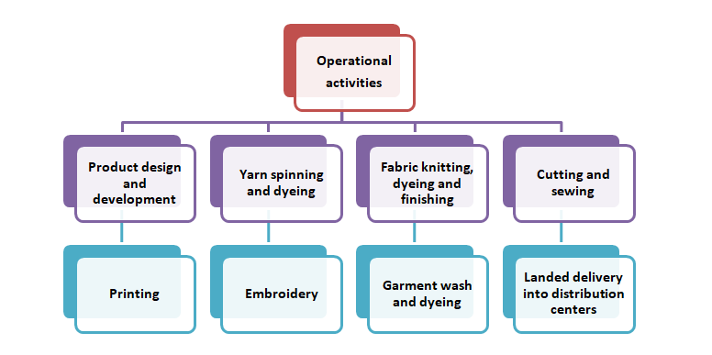

Operation starts with the finest raw material mainly cotton entering into spinning, then knitting, dyeing, finishing, after that cutting and sewing, lastly the garments wash and ready for the delivery. Throughout the overall procedures they ensure highest quality in production. Overall production process is vertically integrated process which is carefully design to produce quality product and ensure timely delivery of order.

Overall production unit activities are given trough production unit picture, which provide a better understanding of overall production activities of the organization.

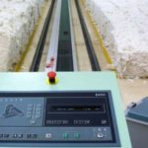



4.1 Departments of CMT (Bangladesh)
- Finance, Accounts & Audit Department: This department of CMT mainly deals with the overall payment associated with organization. This department also maintains the integrity for other departments of the CMT (Bangladesh).

- Commercial Department: Commercial department is headed by Mr. Anwar Hossain. This department handles all the procedure and activities related to the export-import dealing. Five enthusiastic people handle this important department in Dhaka Office of CMT (Bangladesh).

- General Purchase Department: General Purchase department mainly buys the whole factory items-equipment, which is needed for running the day to day production and operation of CMT (Bangladesh).

- Accessories Purchase Department: Accessories purchase department mainly deals with the purchasing of accessories of items which is needed in factory for manufacturing procedure.

- Human Resource Department: Human resource department are responsible for administrative activities by using Management information system, also deals with payroll system, recruitment procedure and communication.

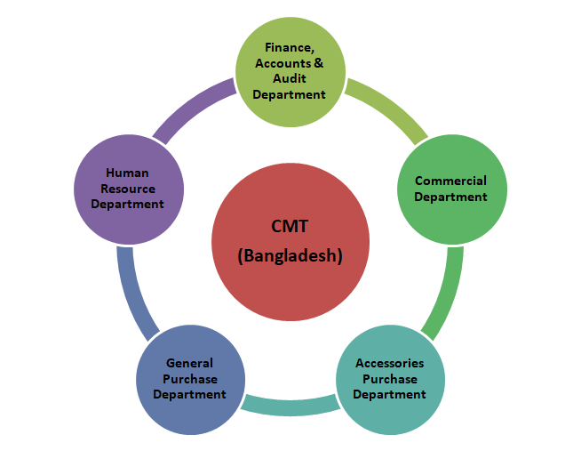

5. Financial Statement Analysis and Findings

By analyzing financial data we can understand the operational efficiency of the firm, overall performance and managerial control of the firm. Financial statement analysis is the common approach to understand the financial strength of a firm. In this report I use several ratios to analyze the operational efficiency, profitability and solvency of the CMT (Bangladesh) by using financial statement of the both Consumer Knitex Limited (CKL) and Dignity Textile Mills Limited (DTML).

Year to year comparative ratio analysis:

Comments: The Ratio shows fluctuating trend. It reached peak in 2014 and lowest in 2012. But this trend do not show actual scenario regarding Absolute Current Asset and Current Liability. In 2016 Current Asset was about 20321539779 whereas in 2014 it was about 3194154551. However throughout these 5 years CMT (Bangladesh) have been holding adequate to meet its current obligations.

Comments: Acid Test Ratio remains almost stable throughout the years. This ratio basically involves most liquid assets e g: Marketable Securities and account receivables in addition to cash along with cash which reflects the ability of CMT (Bangladesh) to meet its short term obligations more appropriately. The ratio over the year reflects that CMT (Bangladesh) holds liquid assets marginally to meet its current obligation.

Comment: Collection period indicates the time taken to collect accounts receivables. The lower this period more liquidity the company will hold. However, this depends on the policies taken by market competitors. In 2016 collection period are about 28.39 which is far lower than the previous years. Possible reason could be because of holding more current liabilities compared to previous years

Comment: Days to sale inventory measures the time taken to get the inventories sold. This ratio is important for CMT (Bangladesh) to determine its Working Capital need. This ratio depicts the fluctuating trend over the years. However, the variations are not significant. CMT (Bangladesh) requires not much time to get its inventory sold. In the year 2016 it is about 5.54 days.

Comment: The Key measure in evaluating long term structure and capacity is the Debt to Equity Ratio. If this ratio is too high, it may indicate that the company has used up its borrowing capacity has no caution for future events. If it is too low, it may mean that, available leverage is not being used to the owners. If the ratio is trending up it may mean that earnings are too low to support the needs of the enterprise and if its trending down it may mean that the company is doing well and setting the stage for expansion. The Debt to Equity Ratio for CMT (Bangladesh) is almost similar in 2015 and 2016 and it is too low in 2012, 2013, 2014. The reason for such deviation is the presence of long term debt in the Capital Structure in 2015 to 2016.

Comment: CMT (Bangladesh) did not obtain any long term Debt up to 2014. Although the ratio is higher in 2015 compared to 2016, the absolute amount of long term debt is higher in 2016. The reason for such deviation is the absolute amount of Equity which is significantly higher in 2016.

Comment: The ability to make interest payment is more a function of company’s liability to generate positive cash flows from operations in the short run as well as overtime. Thus time interest earned shows how comfortably the company should be able to make interest payment assuming that earning trends are stable. Time interest earned is comparatively higher in 2013 and 2014 as company did not incur any long term debt in that year. Hence the interest cost was low and the ratio was higher.

Comment: ROA measures company’s ability to generate return from asset utilization. The ROA in 2016 is about 16% which is the highest. The reason is higher sales in 2016 compared to previous years.

Comment: Return on Common Equity shows fluctuating trend and it is higher in 2016 compared to others as sales was highest in 2016.

Comment: The ratio represents the percentage of sales revenue that exceeds the variable cost. When this ratio is low, it is a sign that product cost is high in comparison with selling price. The ratio shows almost a stable trend over the year, although the sales are higher in 2016, the ratio remains stable as the cost of goods sold was also high. In 2012 the ratio is higher as cost of goods sold was the lowest in 2012.

Comment: This ratio shows the portion of sales that exceeds the cost (both variable and fixed). When there is a weakness in this ratio, it is generally an indication that either gross margins are too low or volume is too low with respect to fixed cost. Here operating profit margin is highest in 2016 as sales volume is too high compared to previous years.

Comment: The Net Operating ratio shows fluctuating trend over the years and it is lowest in 2015 as cost of goods sold was too high and covers a large portion of sales in 2015 and it is highest in 2016.

Comment: Account Receivable turnover reflects likelihood of generating cash from Account Receivables. The ratio is lowest in 2016 as receivables were the highest in 2016.

Comment: Inventory Turnover measures likelihood of generating cash from Inventories. The ratio shows fluctuating trend over the years. This ratio is highest in 2015 although cost of goods sold was the highest in 2016. This is because larger amount of inventories in 2016.

Comment: This ratio measures the likelihood of generating sales using its working capital. Working Capital is highest in 2012 which means in that year the company was able to utilize its working capital more efficiently compared to other years. The ratio above measures the under utilizations of Working Capital

Comment: This ratio measures the amount that the investor has to spend to earn each Taka. The lower the ratio is the better the position. In 2016 this ratio is 8.43 and in 2015 it was about 57.48. This is because the EPS was comparatively low in 2015.

Comment: The ratio measure the company’s ability to generate sales through asset utilization. Throughout the year, the ratio is below 1 which means CMT (Bangladesh) is not so much efficient to utilize its assets to generate sales.

Comment: It measures the amount the investor can earn from each taka invested. The higher the ratio is the higher the performance of the company. The ratio is highest in 2016 as sales were too much higher and cost of goods sold was not so high which leads to higher yield.

5.1 Major Findings of this study
Here I provide some major finding which I found through the financial analysis of CMT (Bangladesh) and working as a team member of finance accounts and audit team throughout my internship period.
- Excellent work environment provide by CMT (Bangladesh), which helps to increase the efficiency in work process.
- All the five departments are very much well organized to provide a better service.
- CMT insures highest level of customer satisfaction to become a successful firm and secure the leading position in the market
- CMT Analyze the buying decision of the customer to provide better solution to them and also analyze the supplier’s actions to improve product quality.
- CMT follows a standard reward and payroll system, which highly motivated the employee
- Ratios explain the operational efficiency, profitability and solvency are quite well throughout the selected five years.
- Overall production process is vertically integrated process which is carefully design to produce quality product and ensure timely delivery of order.
- CMT (Bangladesh) has to work on some specific ratios to overcome its cash shortfalls.
- CMT (Bangladesh) use latest technology to improve their product quality.
- CMT (Bangladesh) use effective distribution channel to distribute its product throughout the world.

Conclusion and Recommendations

6.1 Conclusion
RMG sector in Bangladesh has a great impact on economic growth of the country. From last four years RMG and Textile industry has been the major contributor of foreign export in Bangladesh. Compagnie Mauricienne De Textile Ltée (CMT), a pioneer in fashion industry all over the world for its jersey-wear, which starts its journey in Bangladesh in 201o. In January 2011, they purchased Dignity Textile Mills Limited following the acquisition by CMI of Consumer Knitex Limited in October 2011. I work there as an intern which helps me to acquire practical knowledge about operational activities of a textile firms. I describe all the activities I routinely done in my internship period in Consumer Knitex Limited. In this report I try to provide a brief idea about the entire operational activity of the CMT (Bangladesh) and also analyze its financial statements through ratio analysis. This report provides a better understanding about the operational performance of the CMT (Bangladesh) as well as financial performance Of CMT (Bangladesh).

6.2 Recommendations
Here are some suggestions to CMT (Bangladesh) to improve their overall operational and financial performance. These suggestions help CMT (Bangladesh) to acquire their organizational goals ensuring better service
- Cost of raw materials should be reduced to increase the profit and also have to increase the sales volumes adapting effective marketing strategy.
- Provide adequate training to the employee to adapt with the changing trend of this particular sector.
- Advancement of production technology, ordering procedure and delivering system.
- Reduce the time in converting inventory in cash, ensure rapid collection of receivables
- Reduce the time of transforming inventories into sale.

References

- Chowdhury, R. and Ahmed, A. (2017), a study on RMG industry of Bangladesh
- http// www. Annual report of CMT Bangladesh, 2016
- http // www.web site CMT Bangladesh.
- Ramesh, V. (2015), financial statement analysis of a garments company.
- Newaz, A. (2016), operational activities of a textile company

