REPORT ON
TRAINING, DEVELOPMENT
AND THE RECRUITMENT PROCESS OF MUTUAL TRUST BANK LIMITED


INTERNSHIP REPORT

ON
TRAINING, DEVELOPMENT AND RECRUITMENT PROCESS OF MUTUAL TRUST BANK LIMITED

Submitted To:
DR. ABU ZAFAR MD. RASHED OSMAN
Associate Professor
School of Business and Economics
United International University

Submitted By:
Tasdeed Hossain Tasin,
ID: 111123262,
Program: BBA Major in Human Resource Management
United International University

LETTER OF TRANSMISSAL

16/2/2018
DR. ABU ZAFAR MD. RASHED OSMAN
Associate Professor
School of Business and Economics
United International University

Subject: Submission of Internship Report

Dear Sir,
I am exceptionally happy to yield my internship report on “Training and Development strategy that taken after and connected by Mutual Trust Bank Limited (MTB)” which could be a portion of the BBA Program course of think about. It may be a great accomplishment to piece of work beneath your dynamic supervision. I would like to require this opportunity to thank you for the directing and backup you've got given me amid the course of this report. With profound appreciation, I too recognize the assistance given by Rashed Rezwana , AVP & head of “Accounts & IT” department in Panthopath branch of Mutual Trust Bank Limited for giving me most extreme bolster amid my internship within the framework. To get ready the report I have collected what I accept to be most relevant information to form my report as expository and solid as conceivable. I would truly be thankful on the off chance that you edify me along with your considerations and sees with respect to the report. Moreover, on the off chance that you want to investigate around a viewpoint of my report, I would gladly answer your quarries. Thank you again for your support and patience.

Yours Sincerely,
Tasdeed Hossain Tasin,
ID: 111123262,
Program: BBA Major in Human Resource Management

Acknowledgment

I would like to convey my significant appreciation to all those who have been instrumental within the preparation of this internship report. Much obliged to All-powerful Almighty for favoring to complete the report within the plan time. I am obligated to an entirety part of individuals for their kind suggestion, accommodation, course, co-operation and their collaboration would like to thank Rashid Rezwana (AVP), Aklima Akter (Officer) & Sadman Prodhan (JAVP) sir for their warm welcome within the bank and kind exhortation. It is my delight to them and my thankful appreciation goes to Mutual Trust Bank (MTB) specialist for rendering me their ability, information and giving me the opportunity of having a down to earth encounter through this internship program. I need to expand my profound sense of appreciation to my supervisor Rashid Rezwana Internship supervisor, for his persuading motivation, kind rules, important recommendations & exhortation amid my internship period to prepare this report.
I would like to thank all the honorable teachers of the United International University Business School, for their valuable supports, inspirations and proper advice during this study. Finally, I would like to thank Rashed Osman, Associate Professor, School of Business and Economics United International University for enormous help and feedbacks on the report procedure.

Executive Summary

This report provides a study and collected information on “Training and recruitment practices & procedure that is followed and applied by Mutual Trust Bank Limited (MTB))”. Method of findings and analysis include both primary and secondary data. The method of analysis includes frequency distribution of the collected data. The primary data was collected by face to face conversation with officers and the secondary data was collected from company’s annual reports, website and other yearly reports. This report also includes overview of Mutual Trust Bank Limited (MTBL), services and products, working experience during the internship period and operation of general banking of MTBL. The report also includes the fact that the analysis conducted has limitations. Based on the data, this report finds that most of the customers are satisfied with quality of service provided by the foreign trade department of MTBL. MTBL should focus on these issues in order to improve their quality of service in Foreign Exchange department and card divisions. A bank’s performance and profit largely depends on its divisions.
I have completed my internship at MTB because I have preferred to learn about banking and I think MTB is the best training institution for all sectors because of its good accommodation, providing best speakers to the trainees, and it also has a sophisticated management system.

CHAPTER 1: INTRODUCTION

  - Introduction:

As a part of study in BBA a student needs to have some practical knowledge about business world, corporate culture and corporate rules. So to gain practical in this vast corporate world a student have to do 3 months of internship in any organization. As a BBA student I had done my internship in Panthapath branch of Mutual Trust Bank (MTB).

Mutual Trust Bank is a top rated commercial bank functioning with 133 branches in 33 districts. The scope of the report covers almost all the functions of training and development and the recruitment of Mutual Trust Bank Limited. The report try to cover all the all the training and development in Mutual Trust Bank.

  - Objectives of the study:

My objective of this report is learning, understanding and get practical knowledge. As a intern of human resource management I focus on the field of “Training and Development” of MTB a field which is valued by MTB. MTB has its own training institution with their own training facilities.
My study mainly focus on:

- Firsthand knowledge on Bangladeshi banking system.
- Overall understanding of Mutual Trust bank (MTB).
- Know about the procedural training and development and the recruitment process of MTB.
- To have some practical experience of working in corporate and banking sector.
- To hove glimpse in HR function of MTB.

  - Methodology:

Methodology is the tools and techniques for collecting data. This report is based on two types of data:1) Primary Data and 2) Secondary Data

- Primary Data: a) Face to face interview MTB officials.
b) Practical observation

- Secondary Data: a) Previous records
b) Data from internet and other sources of the organization.

1.4. Limitations of Study:
It was a pleasant experience to work in MTB as employees from top to bottom are very friendly and helpful. But I have to face some limitations as follows:

- Three months are very short to understand an organization. Especially for an vast organization like MTB.
- I have not much experience in on field study like this.
- Officers in the organization are always busy in banking function from 10pm to 6pm and some till 8pm. So I get few time to communicate with them.
- Due to secrecy policy I don’t get much internal information about the organization.

CHAPTER 2: BANKING SECTOR IN BANGLADESH

2.1. Banking Sector in Bangladesh:
Now Bangladesh has two forms of bank: scheduled bank and non-schedule bank. Banks that runs under Bank Company Act, 1991 are scheduled banks. All government owner banks, private banks, Islamic commercial banks, foreign owned which functioned fully for commercial purpose are scheduled banks. Non-scheduled banks are the banks that have specific objective. They don’t have much power like scheduled bank. Grameen Bank, Probashi Kollyan Bank, Karmasangsthan Bank, Progoti Co-operative Land Development Bank Limited (Progoti Bank) and Ansar VDP Unnayan Bank etc. are non-scheduled banks.
The commercial banks play a pivotal role in shaping Bangladesh’s economy through its contributions. Promotion of capital formation, investment opportunities in new ventures, promotion of trade and industry, agricultural development, promotion of economic activity, implementation of monetary policy, are some of the significant portrayals of commercial banks. In regards to establishment of banks in rural areas, much progress has not been made. As of 2012, there was a decrease from 57.94 percent to 57.20 percent of bank branches in rural areas. However, the percentage of banks in urban areas witnessed increases. The problem associated with banking sector is widespread and is not constricted to banking system only.
The independence and accountability of the regulatory body is still questionable and therefore calls for drastic improvement. As of June 2017, reports suggest, Tk20 Billion (US$250M) were allocated by the government to recapitalize Bangladesh state-owned banks as there have been problems resurfacing regarding regulators’ inefficiency to fix various related issues. Limited actions have been undertaken to penalize defaulters, improve risk management and strengthen bank management. In its latest Article IV report, the IMF has highlighted some underlying risks to the banking sector due to surplus liquidity. However, an improvement in conditions within the state-owned banking sector is dependent on government’s political will to focus on problems, which has been limited till date.
However, if the aforementioned problems are addressed and tackled well, new opportunities from the banking sector can arise. Acceleration of expansion due to a high number of population, ability to meet global standards in terms of product quality, prospects for new global banks to start operation in Bangladesh, opportunity for the banking sector to become a major contributor in the national economy are some of the benefits that can be reaped, if opportunities are reaped strategically and problems handled tactfully.

CHAPTER 3: COMPANY PROFILE

3.1. Company Profile:
MTB comes into existence on 29th October, 1999 under the Companies Act 1994 and granted license on October 05, 1999 by Bangladesh Bank under the Banking Companies Act 1991. MTB started function from 24th October, 1999.
At the beginning the bank had an Authorized Share Capital of BDT 1,000,000,000 divided into 10,000,000 ordinary shares of BDT 100 each and now the bank has BDT 10,000,000,000 divided into 1,000,000,000 ordinary shares of BDT 10 each.
3.2. Vision:
Mutual Trust Bank’s vision is based on a philosophy known as MTB3V. MTB3V are:
1. One of the best performing banks in Bangladesh
2. The bank of choice
3. A truly world-class bank

3.4. Mission:
We aspire to be the most admired financial institution in the country, recognized as a dynamic, innovative and client focused company that offers an array of products and services in the search for excellence and to create an impressive economic value.

3.5 MTB Core Values:
Commitment:
- Shareholders – Create sustainable economic value for our shareholders by utilizing an honest and efficient business methodology.

- Community – Committed to serve the society through employment creation, support community projects and events and be a responsible corporate citizen.

- Customers – Render state-of-the-art service to our customers by offering diversified products and by aspiring to fulfill their banking needs to the best of our abilities.

- Employees – We rely on the inherent merits of the employee and honor our relation as a part of this renowned financial institution. We work together to celebrate and reward unique backgrounds, viewpoints, skills and talents of everyone at the work place, no matter what their job is.

Accountability:
As a bank, we are judged solely by the successful execution of our commitments; we expect and embrace this form of judgment. We are accountable for providing the highest level of service along with meeting the strict requirements of regulatory standards and ethical business practices.
Agility:
We can see things from different perspectives; we are open to change and not bound by how we have done things in the past. We can respond rapidly and adjust our mode of operation to meet stakeholder needs and achieve our goals.
Trust:
We value mutual trust, which encompasses transparent and candid communications among all parties.
3.6 Slogan: “You can bank on us”
Corporate Structure:
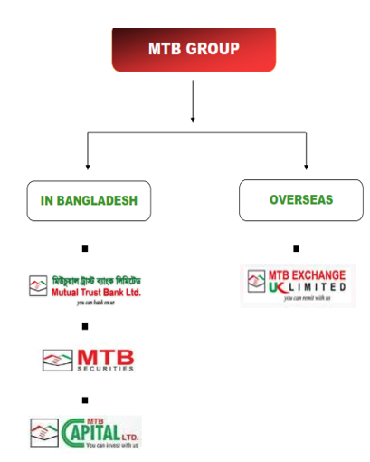

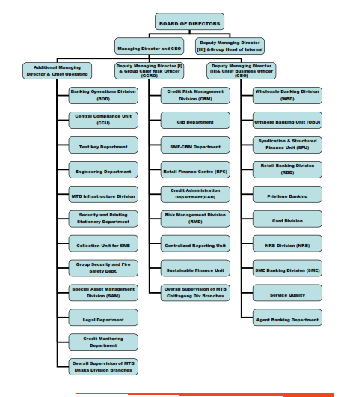
Organogram:

CHAPTER 4: TRAINING & DEVELOPMENT IN MTB

4.3 Training & Development:
Training and development is part and parcel of modern HR department. Almost all organizations in modern corporate world. Training is an educational process which involves the sharpening of skills, concepts, changing of attitude and gaining more knowledge to enhance the performance of the employees. And development is the result training which includes improvements of skills, knowledge, behavior, efficiency. Good & efficient training of employees helps in their skills & knowledge development, which eventually helps a company improve. Training can be provided individually or in group. In corporate level employees need training just to know how functioning their assigned duties.
4.4 Training and Development of MTB:
MTB gives far more importance in training and development than any other organizations in Bangladesh. MTB’s training and development function have two very different attributes:
  - Greater Budget: MTB contribute higher percentage of their monetary resources in training and development function than any other organizations in Bangladesh.

  - Especial Emphasis: MTB beliefs in Human capital. Efficient human capital is one of the competitiveness of MTB in banking sector. To keep the employees competitive HR Department of MTB runs continues staff development to cope up with changing market demand and technology.
4.5 Steps of Training and Development in MTB: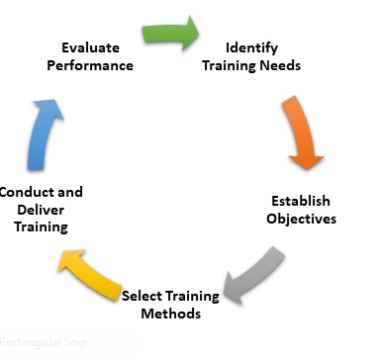

- Identify Training Needs: At first HR department conduct TNA (Training Need Analysis) to know any skill gap in employees. It is usually conducted in December of every year for the upcoming year.

- Establish Objectives: After TNA analysis HR department sort out: which employees require training? and what type of training?

- Select Training Method: Based on their objective HR department select proper training method for each of the employees who have some lacking in skills based on findings of previous step. Then HR departments design training calendar for the year and sent E-mail to each employees who are selected for training. Employees can also check in M-net (MTB’s internal internet system about any training programs they selected for).

- Conduct and Deliver Training: In this step the training programs are implemented according to the routine of the training calendar.

- Evaluate Performance: Now HR department will evaluate employee’s knowledge, skill and attitude and compare to their situation before training to find out the success of training programs.

4.6 Different Methods of Trainings in MTB:
MTB trainings are usually designed based on the needs of different types of employees. These employees and the training they get can be categorized into following types:

- Training for new employees with no previous banking experience: These are the newly recruited employees with no previous experience in banking industry. They participated in various foundation programs in MTB training Institute based on their assigned duty after orientation induction. They then participate in on-the-job-training under their supervisor for brief trainee period.

- Training for new employees with previous banking experience: New employees with banking experience in any other banking institution before recruited by MTB only requires orientation induction. But if they are assigned to new function that they don’t have any previous experience about it then they have to go through training about that particular functions like the employees of previous category.

- Regular TNA Based Training: These training is based on previously TNA analysis that occurs every year. These training programs usually held in training institution inside and outside of MTB. For senior employees or senior managerial level this training could occur in foreign countries.

- Refresher training: New employees who have some previous banking knowledge or employees who rejoined MTB after leaving the institute for a certain period of time and before their joining they don’t participate in banking functions for a long period of time get refresher training. As they don’t participate in banking sector in long time they usually forget many functions of bank. This training brings back some of their former memory about banking activities. This training usually held in MTB training center.

- Bangladesh bank’s Mandatory Training: These trainings are held in the training center of Bangladesh bank. These training are mandatory for all employees who are directly associated with banking functions of MTB. They are held in Bangladesh Bank Training Center. They are Mandatory for all the employees of the banking sectors of Bangladesh. These trainings are like Fire Training, Money Laundering Prevention training, ICC (Internal Control and Compliance), ISS (Integrated Supervision System).

4.7 Training Institutes of MTB:
MTB usually held training in three types of institutes:
- MTB Training Institute: MTB has their own training institute in MTB Square building in Tajgaon.

- The Training Institute run by a principle and a faculty. Sometimes experienced employee is called upon as a faculty temporarily. Outside experts are also hired as temporary faculty.

- Training Outsourcing: MTB also outsource training activities to outside institutes. That institute
can be both inside and outside the country. Local outsourcing is done in local training institutes like BIBM, BBTA, BAB, FINEXL etc. Foreign outsourcing usually done in training institutes of India, China, Malaysia, Singapore etc.

CHAPTER 5: RECRUITMENT PROCESS OF MTB

5.1 Recruitment:
Recruitment refers to the overall process of attracting, selecting and appointing suitable candidates for jobs within an organization. Recruitment is the starting point of HR activities of an organization. Success of organization depends on manpower. Recruitment provides that manpower. Recruitment process starts from HR planning.

5.2 Recruitment Process of MTB: Steps of recruitment process:
- Manpower planning: During HR planning the need for additional human resource is measured. Then HR department tries to find out in which positions human resources are needed and the number of required human resources.
- Advertising: Then advertisement for job applications for those positions are published in daily newspapers, MTB’s own website, job searching websites like chakri, bdjobs etc.

- Initial Screening: In this stage the CV of potential candidates are taken. These CVs are screened and the best candidates based on CVs are chosen for next step.

- Written Test: The candidates who passed initial test will face written test. Only people who passed will move to next stage.

- Interview Sessions: In this session the candidates who passed previous session will face two consecutive interviews. The candidates who passed the first interview will attend the second one.

- Reference Check: The candidates who passed the second interview will have their reference checked.

- Medical Test: Two different medical test is done after reference check: (a) Dope test
(b) Physical fitness test
- Offer Letter: After passing medical test the candidates get offer letter.

- Placement: Now candidates will join MTB as new employees in the date which written in offer letter.

5.4 Sources of Recruitment:
- Educational Institute: Educational institute like universities, colleges sometimes provide talented employees. Sometime HR department contact with the administration of these institutions.
- Recruitment Agency: MTB sometimes contracted Recruitment agency for providing essential human resources.

- Employee Referral: Sometimes employees are referred by old employees.

- Internal source: Suddenly emptied posts are usually filled up by internal recruitment. It is usually done for emergency recruitment when there is no time elaborate recruitment process.

- Job fair: MTB sometime open stalls in job fair for recruitment in empty position.

5.5 Recruitment of Experience Employee or Top Management person:
Experience employee who are recruited in MTB requires 5-6 years of experience in related field. They will face viva, background test but don’t face written test.
For top level management usually internal source is preferred. But in many case external source also used. External source is from head hunting agency. For these people their experience and work in business world is considered.

CHAPTER 6:DATA ANALYSIS

6.1 Frequency Distribution:
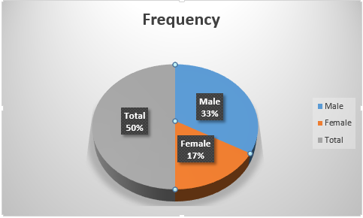

Gender | Frequency | Percent
Male | 20 | 66.67
Female | 10 | 33.33
Total | 30 | 100
Among the employees of sample of MTB, 66.67% are male and 33.33% are female.
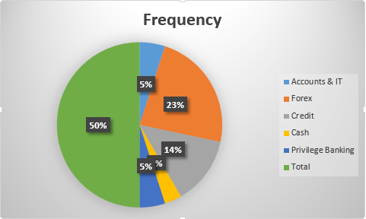
Division | Frequency | Percent
Accounts & IT | 3 | 10
Forex | 14 | 46.67
Credit | 8 | 26.67
Cash | 2 | 6.67
Privilege Banking | 3 | 10
Total | 30 | 100.00

- Your organization places the right person in right job.
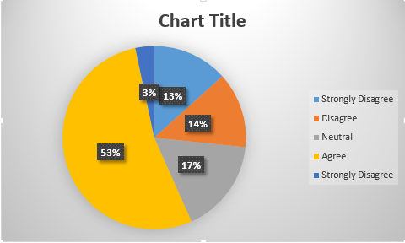

According to the table, 13.33% respondents say their “Strongly Disagree” about this statement. Another 13.34% “Disagree” with this statement. And another 16.67% respondents have “neutral” with this statement. 53.33% respondents said that “Agree” and 3.33% respondents are said “Strongly Agree”.

- Selection of a candidate in our organization is strictly based on his/her merit.
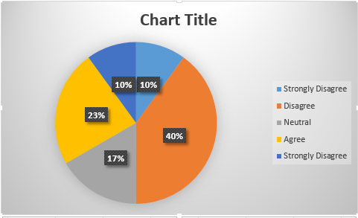

According to the table, 10% respondents say their “Strongly Disagree” about this statement. Another 40% “Disagree” with this statement. And another 16.67% respondents have “neutral” with this statement. 23.33% respondents said that “Agree” and 10% respondents are said “Strongly Agree”.

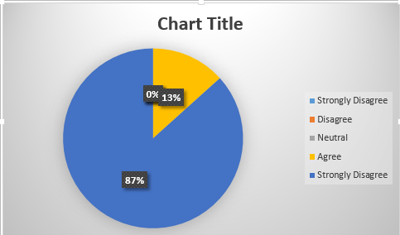
- Your organization makes all payments due to us in time.

According to the table, 0% respondents say their “Strongly Disagree” about this statement. Another 0% “Disagree” with this statement. And another 0% respondents have “neutral” with this statement. 13.33% respondents said that “Agree” and 86.67% respondents are said “Strongly Agree”.

- Performance appraisal in our organization aims at improving employee performance and strengthening our job skills.

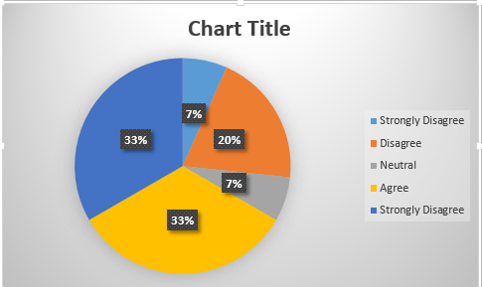
According to the table, 7% respondents say their “Strongly Disagree” about this statement. Another 20% “Disagree” with this statement. And another 7% respondents have “neutral” with this statement. 33.33% respondents said that “Agree” and 33.33% respondents are said “Strongly Agree”.

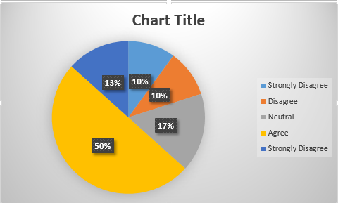
- We do not work under the threat of losing our jobs.

According to the table, 10% respondents say their “Strongly Disagree” about this statement. Another 10% “Disagree” with this statement. And another 16.67% respondents have “neutral” with this statement. 50% respondents said that “Agree” and 13.33% respondents are said “Strongly Agree”.

- Is the organization doing timeliness planning & audit for HR requirements?
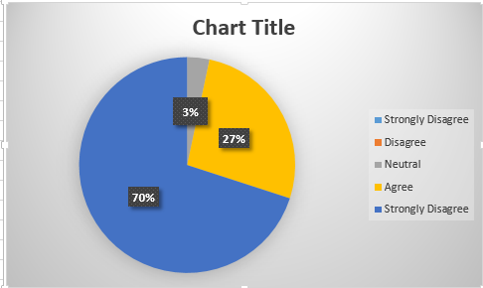
According to the table, 0% respondents say their “Strongly Disagree” about this statement. Another 0% “Disagree” with this statement. And another 3.33% respondents have “neutral” with this statement. 26.67% respondents said that “Agree” and 70% respondents are said “Strongly Agree”.

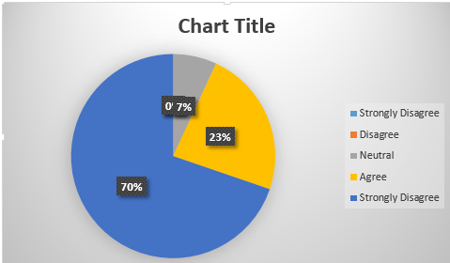
- Does HR provides an adequate pool of employees after HR Planning Process?

According to the table, 0% respondents say their “Strongly Disagree” about this statement. Another 0% “Disagree” with this statement. And another 6.92% respondents have “neutral” with this statement. 23.34% respondents said that “Agree” and 69.74% respondents are said “Strongly Agree”.

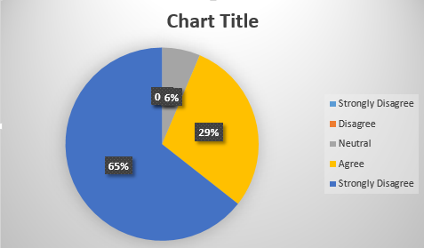
- Do you think company is doing HR Planning according to the skills, knowledge and education of existing employees?

According to the table, 0% respondents say their “Strongly Disagree” about this statement. Another 0%“Disagree” with this statement. And another 6.38% respondents have “neutral” with this statement. 29.22% respondents said that “Agree” and 64.4% respondents are said “Strongly Agree”.

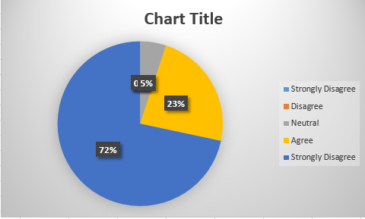
- Do you think HR Audit & Planning in the organization helps to analyze effective utilization of human resources?

According to the table, 0% respondents say their “Strongly Disagree” about this statement. Another 0% “Disagree” with this statement. And another 6.38% respondents have “neutral” with this statement. 29.22% respondents said that “Agree” and 64.4% respondents are said “Strongly Agree”.

- Does the company consider Leaves and Overtime of the employees in HR audit process?
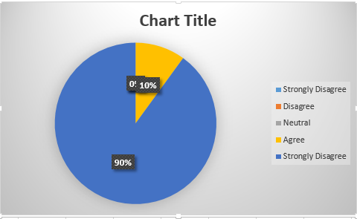

According to the table, 0% respondents say their “Strongly Disagree” about this statement. Another 0% “Disagree” with this statement. And another 0% respondents have “neutral” with this statement. 10% respondents said that “Agree” and 90% respondents are said “Strongly Agree”.

- How would you rate the HR department’s performance in HR Audit and Planning Process?

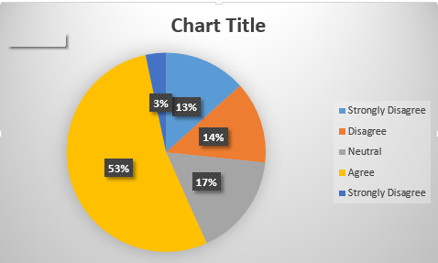

According to the table, 13.33 respondents say their “Strongly Disagree” about this statement. Another 13.34% “Disagree” with this statement. And another 16.67% respondents have “neutral” with this statement. 53.33% respondents said that “Agree” and 3.33% respondents are said “Strongly Agree”.

6.2 Findings:
  - In MTB training is essential part of Human Resource Management. Employees of all level participate in training process.

  - Human Resource Department constantly checked the deficiency of required skills in its human resources.

  - Employees are well informed about their required skills and training they should get. MTB develops a culture where employees are motivated to take part in training and development activities.

  - Before officially joining their assigned activity it is made sure by Human Resource that trainees are well fitted by training process for their duty.

  - Training in MTB is very well structured activity. It is done by very well designed Training routine which is done in the previous for the running year.

  - Employees are well informed about the training they are getting in the year.

  - MTB keep their employees up to date in technology and banking sector by extensive training.

  - Not only skills but etiquettes and manners of corporate world are also included in training programs.

  - Recruitment in MTB put importance on referral for reliability which important in banking sector and get talented people in the organization.

  - Even referred employees requires some minimum qualification and have to pass interview.

  - Recruitment MTB is most gender neutral in Bangladeshi Banking sector. MTB get award for women empowerment.

CHAPTER 7: CONCLUSION AND RECOMMENDATIONS

7.1 Conclusion
Banks play vital part within the present day economy. Human Resource Management (HRM) issues play a critical part in every organization and within the banks as well. No organization can accomplish its objective or can be great until or unless it fulfills workers. Organizational individuals can play the part of team who convert the corporate objectives into reality and victory. Within the keeping money segment exceedingly taught and vital work force are required to make a competitive position and to hold it for a long time. Recruiting, Enlisting and Training. Guideline of uniformity, job fulfillment and career improvement are important within the bank. Mutual Trust Bank Limited is performing its best within the banking industry. They are developing their network and are attempting to get its banking administrations more modernized day by day. They esteem their clients in each conceivable way and serve to each lesson of individuals within the society for their reason. The number of clients for the bank is expanding than compared to other within the industry for its quality administrations. And for giving its great services MTB has well-arranged preparing sessions each separately and carefully outlined to prepare the most excellent enlisted officer.
It was an incredible delight for me to total my internship program at Mutual Trust Bank Limited, one of the driving banks of the nation. My general encounter was great. And I trust, in spite of the a few confinements the report is well arranged and serves the reason of the reader. I accept the encounter will offer assistance me a parcel within the proficient world. At last, I wish extraordinary victories of Mutual Trust Bank Limited within the coming a long time.

7.2 Recommendations
  - Number of faculties in MTB training institute need to be increase. Only one faculty is not enough to hold training session on increasing number employees in MTB.

  - Training and developmental need of the employees of the branch of distant region of Bangladesh is often ignored or out of site.

  - Over emphasis on training put pressure HR to give training to all employees in one time another in a year. So employees are sometimes sent to training programmers that they are not needed by those employees.

  - HR managers are very much distant with ground level employee and their situation. HR is very much linked with upper level management.

  - In many cases employees are not sure why they are sent to certain training programs.

  - Much training is needed for the employees in front desk to improve communication skills.

  - MTB should rely less on reference for requiting.

  - HR department should extend in important branches.

  - MTB should upgrade their bank server.

  - In case of recruitment MTB should search employees in Job fair in educational institute than they do.

Reference:
- http://www.mutualtrustbank.com/
- https://www.thedailystar.net/supplements/building-modern-economy/banking-sector-and-its-impact-on-bangladesh-economy-1536568

