Project Report On
“Going Global: Overcoming the Challenges of SME Internationalization through Blockchain Technology”

Project Report on “Going Global: Overcoming the Challenges of SME Internationalization through Blockchain Technology”

Prepared For:
Dr. James Bakul Sarkar
Associate Professor
School of Business and Economics
United International University

Prepared By:
Fatema Khanom
ID: 114183004
Program: BBA in AIS

Date of Submission: 15 September, 2023


School of Business and Economics
United International University
Letter of Transmittal
September 15, 2023
Dr. James Bakul Sarkar
Associate Professor
School of Business and Economics
United International University
MadaniAenue, Dhaka, Bangladesh

Subject: Submission of the project report entitled “Going Global: Overcoming the Challenges of SME Internationalization through Blockchain Technology”
Dear Sir,
With due respect, I would like to transmit the report entitled “Going Global: Overcoming the Challenges of SME Internationalization through Blockchain Technology” as a partial fulfillment of the requirement for the Bachelor’s degree.
I have adhered to the project guidelines to the utmost of my ability. I have collected data through a survey and literature review and summarized the findings in this report. I tried my level best to furnish this report with the necessary information. I greatly appreciate your assistance in preparing this report.
I, therefore, hope that you find the report satisfactory Please feel free to communicate any query at fatemakhanomtunna01@gmail.com.

Yours sincerely,
FatemaKhanom
ID: 114 183 004
Student Declaration

I, Fatema Khanom, hereby declare that the contents of the report entitled “Going Global: Overcoming the Challenges of SME Internationalization through Blockchain Technology" is entirely my own work and has been completed independently by me without any unauthorized assistance. I have conducted the survey, research, analysis, and written the report with my own effort. Furthermore, I declare that all sources and information used in the study are appropriately cited according to established guidelines.

------------------------------------------------------
FatemaKhanom
Acknowledgement
First and foremost, I would like to praise Allah the Almighty, my parents and my faculties at United International University, for guiding and assisting me through every step leading to my graduation. I am grateful to my project supervisor, Dr. James BakulSarkar, for his wonderful guidance and mentorship. I would also like to extent my gratitude to all those have given their valuable time taking part in my survey.

Abstract
The purpose of this study is to explore how Blockchain Technology mediates the barriers encountered by SMEs in the internationalisation of their business operation. The paper attempts to illustrate a Blockchain-based supply chain to enhance the international operations of SMEs.This report is based on primary and secondary data. Primary data was collected through the survey of 21 Dhaka-based SMEs in Bangladesh. Descriptive statistics and correlation analysis methods have been used to analyze all the collected primary data. Secondary data mainly included reviewing prior literature. The findings of the study showed that SMEs experience barriers like slow payment, complex procedures, inability to meet product quality standards, lack of trust, and finance during internationalization. The report illustrates how specific Blockchain attributes mediate the aforementioned barriers. Finally, the report proposes a Blockchain-based framework to facilitate SME internationalization. The study has been conducted within a narrow time frame; thus, the number and variability of respondents are low to generalize the findings of the report.
Table of Contents
Abstract vi
Chapter 1: Introduction 1
1.1 Small and Medium Sized Enterprises around the world 1
1.2 Industry Overview: Bangladeshi SMEs in International Markets 3
1.3 Research Objectives 4
1.4 Research Methodology 5
1.5 Limitation 6
Chapter 2: Literature Review 7
2.1 Challenges to Internationalization of SMEs 7
2.2 Blockchain Technology 12
2.3 Application of Blockchain Technology in Real World 15
2.4 Blockchain in SMEs 17
Chapter 3: Findings & Analysis 21
3.1 Results and Discussion 21
3.1.1 Demographic profile of respondents 21
3.1.2 Descriptive Statistics 21
3.2 Blockchain Mediates Barriers to Internationalization 22
3.3 Proposed Blockchain-based Framework for SMEs 26
Chapter 4: Conclusion 29
Appendix 30
Reference 34

Chapter 1: Introduction

Small and Medium Sized Enterprises around the world
In many developing and developed countries, small and medium-sized enterprises (SMEs) are at the forefront of the surge in industrial output (Glonti et al., 2021), and they view SMEs as an essential instrument for innovation, trade, employment, and sustainable economic growth. According to The World Bank (2022), SMEs comprise ninety per cent of businesses, creating half of the employment worldwide. Generally, SMEs engage in major and minor activities in forward and backward linkages, driving industrialization in the long run. SMEs in many parts of Asia produce over 90% of the industrial output. The contribution of SMEs has become paramount in developing countries like Bangladesh as these relatively low-investment enterprises can shift the workforce away from its less-skilled and low-yielding agricultural economy to an industrial and service-oriented economy.
In recent years, Bangladesh has shown strong economic growth and surpassed South Asian peers like India, Pakistan, and Nepal in annual GDP growth (The World Bank, 2022). In Bangladesh, more than 868,000 SMEs (BBS, 2013) employ nearly a third of the labour force, yet they hold only one-fifth of the overall share of the industrial sector (Bangladesh Bank, 2022), which is 80% in neighbouring India. The SME sector contributes to only 3.74% of the share of GDP (Bangladesh Bureau of Statistics, 2022), increasing only by 1.19% since 1994. As such, SMEs in Bangladesh need to increase their contribution to growth and job creation.
The economy largely depends on RMG exports for its foreign earnings, accounting for 9.25% of GDP. Like many countries, large firms generate a substantial portion of the exports by value. Unlike SMEs, these firms enjoy cost advantages due to large-scale production economies and can better absorb export or foreign business operations costs. Nonetheless, in recent years, various public policies have been formulated, keeping SMEs at the core of the strategy to increase the manufacturing of industrial goods, reduce import dependency, and expand export markets. The National Industrial Policy 2022 and the 8th Five Year Plan have expressed their goal of developing SMEs for export. Although these policy statements had no specific strategies for easing the entry of SMEs in foreign markets, they have action plans to increase SME capacities like online loan platforms, credit rating systems, and conversion of SME foundation to an agency that will become a one-stop solution for financing and operating support. Dhaka Stock Exchange (DSE) has introduced a compelling avenue for Bangladeshi SMEs to access the pool of domestic capital. Meanwhile, a stark growth in the Bangladeshi Diaspora, with more than 13 million Non-resident Bangladeshis residing overseas for occupation, study, or business purposes, has created significant scope for domestic enterprises to access foreign markets.
Since early 2000, the Bangladesh government’s industrial policy pursued export-oriented industrialization that heavily relied on the ready-made garments sector. However, the entry of China into the World Trade Organization with cheap labour and raw materials and Vietnam signing FTA with the EU and joining the plurilateral trade agreement left Bangladesh trailing behind as the second leading RMG exporter and vehemently competing to retain its global market share. This necessitated the diversification of export-oriented products to capture new markets. Meanwhile, many SMEs aiming to expand their business began looking into international markets. Overcoming national borders and trading in international markets have proved to bring long-term success for any business (Kuivalainen et al., 2012). According to Faruk et al. (2019), by creating greater value, exporting serves as an incentive to increase the efficiency of SMEs. To match global market demand and boost export performance, SMEs improve their product and service offerings, leading to better performance (Maurel, 2009).
According to Child et al. (2017), business operations in foreign markets broadly differ from those in local markets and might necessitate a change in business model. Furthermore, traditional approaches formulated for local ecosystems might need to be revised to survive in the global marketplace. Thus, the internationalization of SMEs changes how the business creates, delivers, captures, and retains value. However, recent developments in digital technology and IoT have mediated many of the business model challenges of internationalization. These technologies assist in creating innovative business models, finding more efficient supply chains, and exploring new value-generating sources in international markets. Furthermore, digitalization has evened out some benefits urban SMEs enjoy over their rural counterparts, such as access to foreign business contacts, marketing channels, and shipping logistics (Glonti et al., 2021).
Adopting Industry 4.0 technology can become a source of competitive advantage, and Nijssen et al. (2003) argued that businesses will lose competitive profit if they do not keep in step with technological advances. This report explores blockchain technology as a digital tool for promoting the internationalization of SMEs. According to Kshetri (2018), Blockchain can achieve many supply chain management goals of SMES, such as reducing cost, improving quality, increasing speed, fostering credibility, and minimizing risk. It is argued that Blockchain deters fraudulent transactions across the supply chain by implementing transparency, traceability, and legitimacy in its features. Blockchain integration in business models can address some of the problems inherent to international logistics.
Although much prior literature explored how Blockchain facilitates internationalization, the findings are mainly relevant to large businesses that were predominantly studied. Despite having the exact technological needs, SMEs often fail to employ such digital resources to become more efficient and effective. As a result, there is a lack of definitive insights into what kind of digital technologies and how their use can support the operation of SMEs in foreign markets. The lack of research in this area has led to the stagnant growth of SMEs in foreign markets due to barriers, such as a lack of market knowledge, information asymmetry, difficulties in real-time cross-border transactions, and the credibility of market participants.

Industry Overview: Bangladeshi SMEs in International Markets
The definition of Small and Medium-Sized Enterprises (SMEs) varies geographically. According to the Bangladesh Bank (2010), small enterprises comprise 50 to 100 employees having total assets ranging from BDT 10 million (approx. USD 92,000) to 150 million (approx. USD 1.37 million). Medium-sized enterprises have 100 to 250 employees and a total assets base ranging from BDT 150 million to 300 million (approx. USD 2.74 million). Based on these criteria, more than 99% of the enterprises in Bangladesh are SMEs. These SMEs were critical in reshaping a predominantly agrarian society into a robust hub of industrial activity. They evolved as the beacon of innovation, diversity, and economic prosperity.
Integration with the world economy is arguably the driving force of economic growth and development in Bangladesh. It has strived to develop its exports, achieving great success in becoming a world-leading manufacturer of RMG. From a slender annual export earning of $348 million in FY1973, Bangladeshi exports soared to $55.55 billion in FY23. The country stands in 56th position in total exports. This gearing comes from converting imported intermediaries into labour-intensive final products. In 2021, Bangladesh was the largest importer of various types of woven cotton, synthetic yarn, and pile fabric.
Within fifty years of independence, Bangladesh became a flagship for RMG export, making its way into the wardrobes of people worldwide. However, the landscape has drastically changed in recent years with an explosive growth in the number of SMEs entering the global marketplace with myriad products like IT, agriculture, leather, pharmaceuticals, fisheries, handicrafts, and more. This contributed to diversifying the country's export portfolio while reducing its dependency on a single industry. According to the Bangladesh Bureau of Statistics (2013), there were 109,000 SMEs exporting products and services. Another study shows that only 26% of the thirty-one thousand small enterprises and 48% of three thousand medium enterprises were exporting. Modifying the export orientation of the country can boost the potential output of SMEs and expedite the internationalization of the economy.
Bangladeshi SMEs have also displayed remarkable versatility by responding quickly to global trends and demands. These enterprises understood the growing need for sustainable, eco-friendly, ethical products and services to conform with SGD and other environmental goals. They responded by using cleaner energy sources, organic input, and a sustainable supply chain, which attracted global appreciation. Many of these SMEs have also demonstrated noteworthy adaptability and resilience. For instance, by switching to the production of medical supplies and personal protective equipment during the COVID-19 pandemic, many SMEs avoided falling into the global economic crisis.
There are various ways for SMEs to enter foreign markets, like partnerships, licensing, and joint ventures. Since they rely on relatively small investments, their success depends on availability and ease of market access. Due to this reason, exporting has been a popular option for SME internationalization. However, a publication by the World Trade Organization revealed a need to understand what factors or determinants underlie SME export or the probable benefits of internationalization. Although Bangladeshi SMEs earn considerable foreign exchange through exports, they need to more efficiently capitalize on the rise of global value chains and free trade agreements.

Research Objectives
This paper attempts to bridge the research gap on the potential of blockchain technology to help SMEs in Bangladesh to operate in the global marketplace. The main objective of this paper is to examine how Blockchain mediates barriers to the internationalization of SMEs. SME contribution is unparalleled for the economic and social development of the country. For this reason, researchers are always keen to explore more ways to enhance their growth. International operation is a critical growth path for SMEs. Digital technologies are becoming cornerstones for business competitive advantage and performance in international markets. Blockchain technology can streamline the business's foreign operations. Despite the many advantages of internationalization and digital enablers, many SMEs in Bangladesh experience difficulties during global expansion.
This report approaches these research questions in the following ways:
- It lays down a theoretical background to factors impeding the internationalization of SMEs from least developed and developing countries.
- It explores the functional attributes of Blockchain technology that can assist SMEs in mediating the barriers to take advantage of the emerging opportunities in the global marketplace.
- It attempts to illustrate a business framework that connects SMEs with other stakeholders with various priorities but can find common ground in the Blockchain-based platform for international operation.

Research Methodology
The reports draw upon qualitative and quantitative data from primary and secondary sources.
- Primary Data: A structured questionnaire comprising seven close-ended and five open-ended questions was emailed to 32 SMEs between 15th August 2023 and 4th September 2023. A convenient sampling technique was used to select SMEs residing in Dhaka. Twenty-one responses were collected and summarized in chapter 3.
- Secondary Data: The secondary sources account for a significant share of the qualitative information present in this report. Numerous management, computer science and engineering literature dated between 2002 and 2023 from reputed sources like Springer, IEEE, Emerald Online and ScienceDirect were used to establish the theoretical foundation of the report. The study also drew upon industry publications, relevant government agency reports, and policy statements to get insight into SMEs' present economic and market conditions.

Limitation
The study was conducted to examine how Blockchain mediates the barriers to the internationalisation of SMEs in Bangladesh. Nonetheless, several limitations affect the scope, validity and generalizability of the findings. The major limitation of this study was time, which shortened the duration of the collection of data from respondents. Furthermore, the survey was conducted among SMEs operating from the capital, Dhaka. Due to geographical limitations, there were no SME representations from rural and indigenous communities of Bangladesh with varying prevalence, magnitude and nature of challenges. On the other hand, a large portion of SMEs in the initial sample did not respond to the questionnaire. The final sample size accounts for a significantly small portion of the SME population.

Chapter 2: Literature Review

Challenges to Internationalization of SMEs
SMEs are the backbone of many economies, substantially contributing to industrial output, job creation, and innovation. Their agility and versatility fit the rapidly evolving global business climate. Encouraging SME internationalization catalyzes economic growth, technology transfer, and product and market diversification. Internationalization is adapting a business's strategy, structure, and resources to operate internationally. This definition captures internationalization's dynamic and revolutionary nature and its behavioral and economic impact. The global market offers many opportunities to SMEs, such as access to larger markets, technological advantages, technical level upgrades, risk minimization, and access to finance (Saunila, 2020). Managers and entrepreneurs utilize access to these international markets as a strategic tool to enhance their business competitiveness and growth. Despite their eagerness to recognize and exploit the opportunities embedded in internationalization, various obstacles prevent SMEs from expanding and thriving internationally. Exploring these barriers is imperative to formulating strategies and mechanisms counteracting them and unlocking the potential of SMEs on the global stage.
Samy et al. (2023) carried out focus group discussions with 41 participants from across Cambodia and Vietnam to identify the opportunities and barriers experienced by Women entrepreneurs in export-oriented SMEs. The participants said business fraud, particularly payment risks, discourages them from international trade. Researchers found that exporters and importers fear counterparty risk in new markets.
Lee et al. (2022) examined 260 Chinese SMEs newly engaged in international ventures and found that risks associated with using digital platforms for cross-border transactions reduce willingness to participate in international e-commerce. The risks identified included inadequate protection in internet transactions, privacy protection, and constant changes in tax, business, and e-commerce regulations.
Akter (2018) probed into the most influencing barriers to the internationalization of Bangladeshi SMEs in the RMG sector. Analysis of the data collected from 107 respondents revealed barriers, mainly the lack of control over foreign markets and currency fluctuation, payment and documentation hurdles, poor human resources and logistics, and high cost of meeting desired product quality. Furthermore, study findings showed a strong negative relation between SMEs' information system strategic orientation and payment and procedural barriers. The report concluded that higher information system integration could reduce the export barriers experienced by SMEs in RMG.
In an empirical study, Wijayarathne et al. (2018) identified the export barriers faced by 129 Sri Lankan manufacturing SMEs and arranged them in a hierarchy of the most perceived barriers. The high cost of financing exports ranked at the top of thirty-one barriers, while government bureaucracy stood as the least perceived barrier. Besides, the barriers listed above median comprised the lack of new technology, complex export formalities, foreign exchange uncertainty, inability to fulfill export product quality, and slow collection period of payment made by foreign customers. An extensive study conducted by Cardoza and Fornes (2011) on 465 SMEs in Brazil, Colombia, and Peru came to a similar conclusion that complex export bureaucracy and lengthy payment collection processes discourage exporting.
The research of Rahman et al. (2017) surveyed 212 Bangladeshi businesses to examine the difficulties SMEs from emerging economies face in entering foreign markets. Findings suggested that legal and procedural formalities, high dependency on foreign agents, low research and development, and the absence of efficient logistics impede the foreign operation of SMEs.
Roy et al. (2016) commissioned a study to outline the internal and external barriers to internationalization of Indian SMEs. After analyzing the responses from 327 firms, researchers concluded that procedural and currency barriers are the biggest obstacles to internationalization. SMEs are anxious to incur exchange loss from inadequate understanding and vigilance to foreign currency movement and perceive delays in collecting payment from foreign agents as cumbersome and risky. On the other hand, the low creditworthiness of SMEs creates internal barriers to obtaining funds and committing to costly product quality standards. They also need more trust and control over foreign agents.
Pietrasieński and Ślusarczyk (2015) studied the barriers to foreign market expansion from three dimensions: financial instruments, business environment, capabilities, and access to the market. Study findings showed that 54% of the respondents pointed out barriers to market access, and 47% experienced difficulties connected with the exploitation of financial instruments. The analysis further disclosed that obtaining trustworthy foreign business representatives hindered market access by large. Lack of awareness about business opportunities and limited data on foreign markets discouraged many SMEs from internationalizing. The report also indicated a lack of control over foreign agents, complex export procedures and documentation, and low access to export distribution channels constricting foreign market access. Simultaneously, capability constraints, mainly low product development, and substandard quality, led to poor customer demand in foreign markets.
Hashim (2015) conducted a meta-analysis to identify the internal and external barriers to the internationalization of Malaysian SMEs and explored the plausible government and industry measures to lift these barriers. His analysis suggested that low labour skills, poor SME infrastructure and government assistance, and currency volatility were the most notable external barriers. In contrast, lack of product and market knowledge, low ICT implementation, and inability to fulfil customers' product expectations were the intrinsic barriers to SMEs. The Organization for Economic Co-operation and Development (OECD) (2009) showed similar concern regarding the difficulties that SMEs in developing countries encounter in product innovation, adapting to foreign tastes, and quality satisfaction.
Toulova et al. (2015) examined 135 Czech SMEs from IT, agriculture, food, and wood processing industries to identify the factors impeding their international business. Researchers found that insufficient knowledge and experience with the foreign market and high promotion costs prevent SMEs from exploring the global marketplace. They also noticed that SMEs doing extensive foreign market analysis have significantly higher chances of success.
After investigating 25 Pakistani SMEs, Shah et al. (2013) concluded that the inability to meet customer product quality expectations constricts export and complex procedural obligations demoralize exporters and restrain their internationalization.
Al-Hyari et al. (2012) explored the nexus between exporting barriers and the export performance of 135 Jordanian SMEs. The authors found solid statistical evidence suggesting external exporting barriers relating to legal/political environment, socio-culture, and currency and procedural complexities impeded the export performance of SMEs. Findings revealed that foreign exchange fluctuations, unconvertible foreign currencies, lengthy collection periods for abroad operations, procedural complexities, and inadequate real-time communication with foreign customers affected the performance of exporting SMEs. On the other hand, factors such as vague knowledge of overseas markets, shortage of export finance, and inability to meet importers' product standards deterred the non-exporting SMEs from internationalization. These findings corroborate with that of Crick (2007).
Similar factors were documented in prior research by Abdullah et al. (2011), in which the researchers outlined profit uncertainty from foreign operations, lack of experience, and difficulties in making new customer networks as the top reasons for the non-internationalization of 250 Malaysian SMEs. They concluded that by reducing trade barriers and developing their ICT infrastructure, they can induce SMEs to expand their business into foreign markets.
Anderson (2011) investigated sixty SMEs from the South African manufacturing industry to outline the opportunities and challenges of internationalization. The author observed that extrinsic factors such as poor technology, absence of solid legal and regulatory framework, and lack of government initiatives supporting SMEs restricted internationalization. Besides, intrinsic incapacities, such as low awareness of existing export promotion programs and low foreign business operation skills, deepened the problems.
In research conducted by Todd and Javalgi (2007), the researchers looked into challenges to internationalizing Indian SMEs at three levels- country, industry, and firm. The researchers pointed out that lack of privacy, security, and liability discourages customers and suppliers from engaging in cross-border trade. They are also concerned about regulatory commerce infrastructures needing to be more decentralized in dealing with currencies, clearing systems, and financial networking, which needs modifications to accommodate international business transactions. Meanwhile, firm-specific challenges mainly involved obtaining credit to finance operations beyond borders.

Table 1: Summary of barriers identified in literature review
Barriers | Sources | Total
Transaction risk | Samy et al. (2023) , Lee et al. (2022), Akter (2018), Roy et al. (2016), Wijayarathne et al. (2018), Hashim (2015), Al-Hyari et al. (2012), Todd and Javalgi (2007) | 8
Complex procedure and documentation | Lee et al. (2022), Akter (2018), Pietrasieński and Ślusarczyk (2015), Rahman et al. (2017), Roy et al. (2016), Wijayarathne et al. (2018), Shah et al. (2013), Al-Hyari et al. (2012), Cardoza and Fornes (2011) | 9
Failure to meet product quality standards | Akter (2018), Wijayarathne et al. (2018), Pietrasieński and Ślusarczyk (2015), OECD (2009), Shah et al. (2013), Al-Hyari et al. (2012), Crick (2007). | 7
Lack of Technology | Wijayarathne et al. (2018), Hashim (2015), Abdullah et al. (2011), Anderson (2011) | 4
Trustworthiness | Rahman et al. (2017), Pietrasieński and Ślusarczyk (2015), Todd and Javalgi (2007) | 3
Lack of Finance | Roy et al. (2016), Pietrasieński and Ślusarczyk (2015), Al-Hyari et al. (2012), Crick (2007), Todd and Javalgi (2007) | 5

Blockchain Technology
Digital technologies have changed how firms operate beyond national boundaries. Digital cross-border trading platforms removed significant entry barriers to new markets by granting customer networks and market data access (Jin &Hurd, 2018), thereby facilitating value creation (Reim et al., 2022). These technologies enabled remote control and monitoring, saving resources and accelerating value delivery. Digitalization allows enterprises to engage internationally at an early inception stage (Rosyidah et al., 2023) and gain cost efficiency by integrating into an interconnected ecosystem of customers, partners, suppliers, and distributors (Hervé, 2020).
Blockchain is a fourth-generation industry technology that can revolutionize how transactions and data are stored digitally. In 2008, Satoshi Nakamoto coined Blockchain- the Peer-to-Peer communication technology underlying his electronic currency, Bitcoin. It was an extraordinary leap from the 1970s shared database technology to distributed ledger technology (Belotti, 2019). However, Blockchain is not only an incorruptible digital ledger of financial transactions but a programmable application to record anything of value. It has become a one-stop solution for industrial systems needing decentralized, robust, trusted, and automated decision-making capabilities.
Blockchain observed a three-phase development. In the first phase, Bitcoin emerged as the first digital currency within a costly distributed ledger system using Merkle Tree for data verification. VitalikButerin identified the cost and efficiency constraints of the prevailing technology and initiated a second development phase to include smart contracts and a decentralized distributed ledger denoted by Ethereum instead of Bitcoin. This was used in financial or economic markets to deal with inventories, bonds, futures, loans, mortgages, ownership rights, and other agreements. The third phase of innovation led to a scalable, user-friendly, and interoperable Blockchain technology with no transaction processing cost, leading to its popularity in public service and supply chain systems.
Based on accessibility, Blockchain has two types- Permissioned blockchains and Permissionless or public blockchains. Permissioned blockchains are proprietary networks that only authorized entities can access. Typically, large companies use this form for private or commercial use, like creating a vendor-client network or industry collaboration to expedite transaction and resource sharing Rennock et al., 2018). In contrast, public blockchains like Bitcoin Blockchain are open to everyone.
Blockchain garnered interest due to its temper evident and irreversible attributes, offering security, anonymity, and data integrity without third-party intervention. There are six main components of blockchain architecture: node, transaction, block, hash, miners, and consensus protocol. Nodes verify any data entered into a Blockchain before being added to a block. All information in a block is automatically marked with a cryptographic hash of the parent block, preventing tampering with the information in the hash. As more information blocks get added, the subsequent blocks amplify the verification of the previous blocks, augmenting the reliability of the Blockchain. Blockchain stores this information in a block secured by complex encryption. Each block is linearly chained to other blocks at regular intervals. Much like a ledger, each block contains several transactions maintained by a network of participants decentrally. Unlike a centralized transaction management system prone to trust issues (Luther, 2016), events are stored and processed across multiple interconnected nodes.
The information also contains a timestamp indicating the time of inception of the block. Once Blockchain registers transaction information, it becomes readily visible to all the participating nodes and users of the chain; this makes the system more transparent than centralized and third-party-dependent systems. Furthermore, all the verifying nodes in the Blockchain are anonymous, which maintains the system's impartiality. The system's high security, privacy, and integrity act as a deterrent to attack, damage, and destruction of transaction records in the Blockchain.
Cryptocurrencies in Blockchain use the Public Key Infrastructure (PKI) mechanism to secure transactions. Each user, i.e., Externally Owned Accounts (EOAs) or contract accounts, holds public and private keys. The public key contains the address of the user's account and the private key acts like a password for authorizing transactions. PKI is crucial to preserving the anonymity and privacy of Blockchain, particularly the private key safeguards of the users' digital assets. Alongside, Blockchain uses smart contracts to govern how transactions are executed. Smart contracts are self-enforceable contractual clauses in the form of codes. Each transaction protocol has a unique address that automatically activates when a transaction is sent to it and executes it in the prescribed manner on every node. Treleaven et al. (2017) published a list of uses of smart contracts in managing personal records like medical history, education background, employment record, wills, and public records like property titles, passports, and social security.
Blockchain has two key enablers: Proof of Work and Proof of Stake. Proof of Work (PoW) is arguably the suitable consensus mechanism for permissionlessblockchain networks to ensure trust and secure service. When a user sends data to the Blockchain storage, particular users, called miners, fetch and consolidate these data to the blocks through mining. Mining requires the participants to solve a cryptographic puzzle that becomes increasingly tricky over time to ensure the new block of transactions is recorded on the Blockchain. The algorithm depends on the number of participants and the problem's difficulty level. The miners get rewards in cryptocurrencies. Proof-of-work gives more rewards to participants with more and better equipment. This motivates miners to centralize and defeat the purpose of a decentralized technology. The process also consumes massive amounts of energy. On the other side, Proof of Stake gives the user the highest stakes in each network to validate the data. Since the miner has the highest stake, he is expected to maintain the ledger's credibility and avoid fraudulent transactions. Proof of Stake is suitable for permissioned networks because of the lack of scalability (Sangeetha et al. 2020). Both these methods are complicated and costly to manipulate; in the case of proof-of-work, a hacker must have at least 51% of all the computational power on the Blockchain to tamper with the information. In contrast, at least 51% of all the digital currency is needed in proof-of-stake (Nair &Dorai, 2021). For this reason, Blockchain is a highly secured platform for business transactions overseas.
Blockchain has several utilities beyond channelling cryptocurrencies. Although much of the attention goes to Blockchain’s ability in the financial service industry, the technology can benefit any business that acts or relies on an intermediary between two parties (Morkunas et al., 2019). Blockchain can make the supply chain more traceable and verifiable, drastically eradicating fraudulent activities like bribery, money laundering, forgery, sanction violations, and misrepresenting goods and services. In international business, Blockchain can eliminate the time-consuming and costly process of obtaining a Letter of Credit, expedite insurance claim fulfillment in case of damage or destruction of goods in transit, release bureaucratic customs procedures and brokerages, and detect fraud in real-time. Many supply chain processes heavily use Blockchain, like Blockverify and Bext360, allowing stakeholders to track products, warranties, coupons, and vouchers.

Application of Blockchain Technology in Real World
i. Governance: According to the World Economic Forum, public procurement is one of the largest sources of corruption globally, which commonly sprouts from lack of transparency, misrepresentation and insufficient record-keeping. Blockchain technologies can target these government processes to reduce the risk and prevalence of corruption and improve accountability in the public sector. It will monitor and record the entire process comprising planning, bidding, bid evaluation, implementation and monitoring. Meanwhile, Blockchain also offers services like digital paperless proof of identity like ID2020 and Estonian E-Residency application. Blockchain-enabled electronic voting systems like My Vote can prevent the manipulation of vote counts (Golosova et al.,2018). Digital certificates and authentication for creative or innovative work can reinforce the intellectual property protection regime of the country.
ii. Healthcare Industry: Distributed ledger technology can enhance the transparency and traceability of healthcare services. The pharmaceutical industry is susceptible to drug counterfeiting. A report from Health Research Funding claims that as high as 30% of the medicines sold in developing countries are counterfeits, having either the wrong ingredients or inadequate therapeutic ingredients. These drugs are not only incapable of curing disease, they can further deteriorate health by triggering secondary effects of the disease, thereby risking the patients' lives. Drug counterfeiting also causes economic loss. Blockchain can address this issue by digitally stamping drugs from the production stage to consumption so that every stakeholder can verify the authenticity of the drugs.
On the other hand, prescription medication abuse has been at an all-time high, particularly among teens. Most of them exploit the prescriptions of other patients. For this reason, protecting patient data integrity is a significant concern. At the same time, keeping detailed patient records is important to customize treatment according to their physiological variability and medical history. These data are sensitive, so they are mostly centralized with the hospital or doctors. However, the existing medical record-keeping system lacks privacy and interoperability. Blockchain enables the sharing of medical records among different healthcare facilities securely while maintaining its integrity with immutable ledger technology.
MedRec and MedChain are examples of permissioned Blockchains currently used in the healthcare industry. Based on Hyperledger technology, these provide patients full control over the sharing and providing access to their medical records to other parties. Deloitte (2016) reported that smart contracts can facilitate interoperability in the healthcare industry without intermediaries or high-cost burdens.
iii. Energy Industry: Power grid systems worldwide face the same vulnerability of centralization. When a centralized system breaks down, millions of people and institutions fall into an energy crisis. A decentralized Blockchain-enabled microgrid system can relieve this problem. In this system, residents, offices and factories with private energy generation sources like solar panels can sell surplus energy to other people or access their desired energy using the technology. Blockchain works as an automated accounting system which keeps real-time records of how much energy is traded, how much energy is available and how much it costs. Time-stamped smart contracts enable swift execution of transactions when predefined conditions are fulfilled. Customers can have full transparency of the energy source with an auto-traceable certificate of origin.
Blockchain-based power system can bring cost efficiency, sustainability and credibility to energy transactions and promote sustainable business models with renewable energy. Furthermore, in recent years, the national power grid systems of many countries were subject to malicious attacks. These attacks pose a huge threat to national security. A decentralized power system can diversify the risk of failure from having a single power system. It can also redirect energy to sectors where it's critically needed like hospitals and aviation in times of local disruptions. Thus, utilizing blockchain in the energy sector has potential to reduce energy costs as well as increase resiliency.
iv. Stock market: In the stock market, it takes three days on average to complete a transaction due to the presence of intermediaries and regulatory procedures. This is a cumbersome process, especially in hyperactive markets with millions of transactions taking place in a day and highly volatile stock prices. Blockchain implementation will eliminate intermediaries and speed up transaction settlement at a comparatively lower cost. Smart contracts in Blockchain can act as a regulator for all transactions. It can also replace lengthy paperwork to transfer the stock title to the buyer. The distributed ledger technology can improve stakeholder trust as insider trading activities will be visible to all network users. This way, Blockchain can solve the problems in fragmented market systems, such as interoperability, trust, and transparency.
v. Insurance: Blockchain has extensive use in the insurance industry. Consumers can use the technology to negotiate, buy and register policies, submit and process claims and initiate reinsurance upon maturity. Blockchain can expedite transactions between policyholders and insurance companies. Using digital protocols in smart contracts, the terms in insurance policies can be automatically executed at significantly reduced administration costs. Furthermore, smart contracts can evade the complexities and disputes arising from misinterpreting insurance terms. Cost reduction will enable insurance companies to be more competitive, and with less ambiguity, they can attract more customers even on a global scale.
vi. Food Industry: According to a McKinsey report (2022), 40% of food loss occurs post-harvest due to a faulty supply chain. Amid a world hunger affecting 690 million people, many criticize the contemporary global food supply chain failure for being excessively prone to disruption, waste and political manipulation. Blockchain technology can solve the global food chain turmoil by improving traceability and the flow of goods. This "farm to fork" technique can trace a finished or marketable product back to its origin.
Combined with IoT, Blockchain technology can instantly track an item in the supply chain. With better transparency, Blockchain can gain more trust from global customers. It enables faster and more cost-effective delivery, real-time coordination between stakeholders, and automatic record-keeping by the concerned parties, which can sustainably improve the food chain. Blockchain enhances supply chain management in four areas: disintermediation, smart contracts between trading partners, data security, and product traceability. Walmart has reconfigured its supply chain using Blockchain and significantly shortened the time it takes to track food products and the origin of food contamination. It uses the platform to gather data inputs from leafy green vegetable suppliers to track the product's origin. This way, Walmart can track contaminated produce in seconds.

Blockchain in SMEs
Blockchain has reimagined the way from the formation of enterprises to their flight on the international stage. In underdeveloped countries, small businesses often suffer from corruption, delays, non-availability of authorities and administrative hurdles during regulatory and compliance processes like obtaining trade license registration, import/export permit, and product standardization. Blockchain can offer transparent and decentralized solutions that can reduce bureaucratic costs and promote the proliferation of enterprises, which is vital to increasing economic output and employment. Again, Blockchain can find untapped markets and expand the trade horizon of SMEs (Wong et al., 2020). Small enterprises with less human and capital resources can get the same safety, traceability, and transparency as large companies with Blockchain. It can also improve collaboration in clusters formed by the SMEs to share limited resources. Conflict often arises in these communities due to repudiations and lack of trust, transparency, accountability and common consensus. Blockchain technology enables the smooth functioning of these SME clusters towards greater productivity and holistic good.
Although these are the well-researched benefits of Blockchain, more is needed to know about the extent to which SMEs were able to utilize them. Much literature suggests that SMEs need to be faster to embrace emerging technologies. (Maroufkhani et al., 2023; Valeri&Baggio, 2021; Wong et al., 2020). Many factors influence Blockchain adoption in SMEs. Iranmanesh (2023) drew upon the resource-based view and concluded that Blockchain-enabled supply chain transparency and agility increase the willingness of SMEs to adopt this technology. The effects are amplified in SME industries with turbulent and unpredictable markets. Bhardwaj et al. (2021) found that Indian SMEs are keen to adopt Blockchain if it provides a relative advantage in tracking transactions, verifying records, and attaining transparency (Swan, 2015). Technologically compatible SMEs with positive top management are more likely to embrace this technology in supply chains. Nuryyev et al. (2020) made similar observations where strategic orientation and personal characteristics of owners or managers, like self-efficacy and innovativeness, have a substantial effect on the intention to adopt new technology. Vendor support like technical support, training, and incentives to adopt the new technology significantly impact SMEs’ intention. The culture, values, hardware and software infrastructure, and existing practices of a country also influence Blockchain adoption (Pilkington, 2016). Some SMEs are interested in using Blockchain to improve customer experience and to keep an eye on competitors' behaviour. Ilbiz and Durst (2019) assessed the feasibility of Blockchain integration in traditional business processes. They concluded that cost reduction, internalization, digital representation of assets, immutability, network size, transparent and synchronized ledger, scalability, fair trade and financing motivate SMEs to adopt this technology.
Many shortcomings of Blockchain discourage SMEs. The complexity and cost are the biggest inhibitors of adopting this technology in SMEs. The technology is at an infant stage and receives skepticism about its security, scalability, usage and interoperability. Although a decentralized network structure with a solid information trail makes it significantly less prone to security attacks, it is not impossible to destroy users' digital assets by stealing their private keys. At the same time, many people perceive Blockchain as malicious because of its association with cryptocurrencies, which lacks legitimacy in many countries. Management also fears the technology's immutability as erroneous data cannot be changed once stored in a block. Many SMEs lack the appropriate methods, tools, metrics, and techniques to implement Blockchain in their supply chain. It can financially overwhelm SMEs since collecting and assimilating vendor-client data in new systems can be costly. For this reason, spending on new technology infrastructure becomes a burden instead of investment (Maroufkhani et al. (2020), Wong et al. (2020). They also stress that redirecting resources to integrating the Blockchain may cause competitiveness to suffer, especially in markets where its sustainability is less sought. The availability of human resources with the required skill set and scope for continuous development of their knowledge is also essential for Blockchain integration (Morabito, 2017). Meanwhile, in many countries, more government support must be needed for faster diffusion of Blockchain in trade and economy. Similarly, external stakeholders like NGOs and industry leaders hesitate to promote a complex technology. Thus, the factors preventing Blockchain adoption in SMEs are high cost, lack of infrastructure and human resources, complexity, denial of legitimacy, private key theft, error irreversibility, and absence of government intervention.
Blockchain platforms must run a consensus mechanism before adding new data to a block. For thousands of nodes to reach this consensus, substantial CPU time and energy resources that are costly or unavailable to most SMEs are needed. The rapid proliferation of smartphones created a digital trading tool utilized by more than half of SMEs worldwide. Existing mobile devices have limited capacity, which is unsuitable for accessing Blockchain platforms. However, once combined with IoT, like cloud computing, Blockchain platforms can be easily accessible by mobile devices at low cost (Xiong et al., 2018). This way, much of the complexities surrounding the usage of such platforms will be alleviated, and simple training will enable employees to operate the system with fewer errors. Since errors made in Blockchain are irreversible, employees will also need training on countering entries that will balance off the effects of prior erroneous input. Meanwhile, several anti-theft mechanisms have emerged to protect users' digital assets, isolating the private key from the cryptocurrency wallet and making it resilient to hacking and phishing (Dai et al., 2018). Finally, large multinational companies like Microsoft, Nestle, and Alibaba can encourage governments and national leaders to adopt Blockchain to streamline their supply chain management, thereby transferring new technologies to developing nations.

Chapter 3: Findings & Analysis

Results and Discussion

Demographic profile of respondents
The final data is based on the 21 responses collected during the survey. The largest number respondents, 24%, comes from the agriculture and food processing industry (see , Figure 1). The majority of the respondents were female, comprising 57.1%. About 66.67% of the respondents are aged between 25 and 35 years. 76% of the respondents claimed annual revenue between BDT 1 million and BDT 5 million (see , Figure 2).

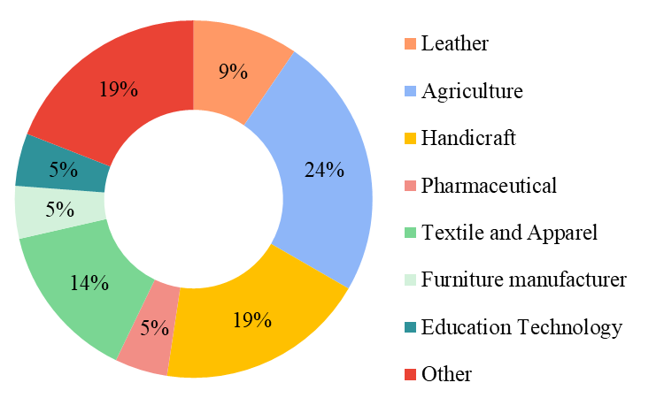Figure 1: Sector-wise allocation of Respondents
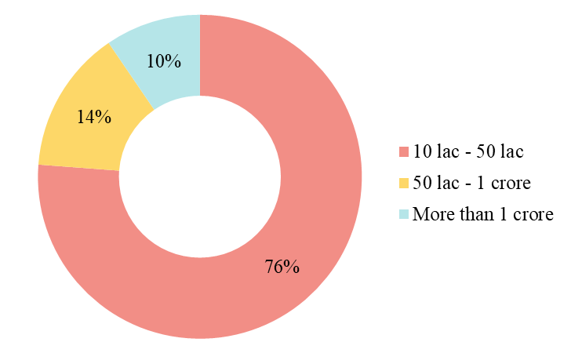Figure 2: Annual Revenue of Respondents

Descriptive Statistics
Correlation analysis of the data has revealed that SMEs' perception of the complexity of export procedures and documentation strongly correlates with their involvement in international operations. Besides, the availability of export credit schemes has a significant negative correlation with trust in interaction with foreign customers and agents. This suggests that SMEs are more willing to trust in global operations if they have export crest schemes protecting their earnings from the risk of buyer's insolvency. The inverse association between access to export credit schemes and lack of financing suggests that financial factors highly motivate international operations. The survey also analysed SMEs' awareness and knowledge of Blockchain and factors affecting their intention to adopt the technology. The cost and availability of skilled resources negatively influence SMEs' willingness to adopt Blockchain. In contrast, SMEs are keener to adopt Blockchain if digital currency has high security and legitimacy. These correlations also support prior literature findings. Furthermore, SMEs who perceive a lack of financing and foreign market knowledge as barriers to selling abroad are likelier to adopt Blockchain technology to access foreign markets. The descriptive statistics of the responses are illustrated in Table 2.
Table 2: Descriptive statistics and correlation analysis
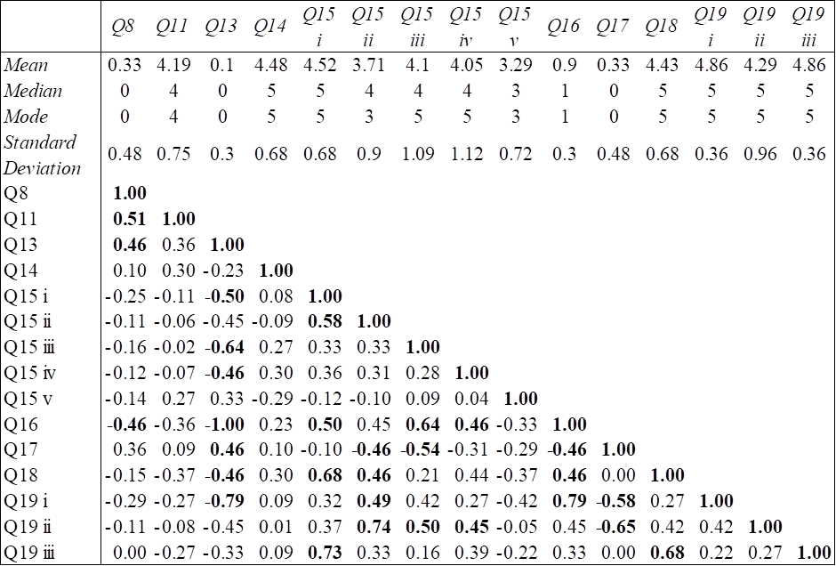

Blockchain Mediates Barriers to Internationalization
The study findings and survey of prior literature provided a deeper insight into the obstacles SMEs face to enter and survive in the global marketplace and how Blockchain enables SMEs to overcome many of these obstacles. The following section illustrates the mediating linkage between Blockchain attributes and barriers to SME internationalization (see, Figure 3).
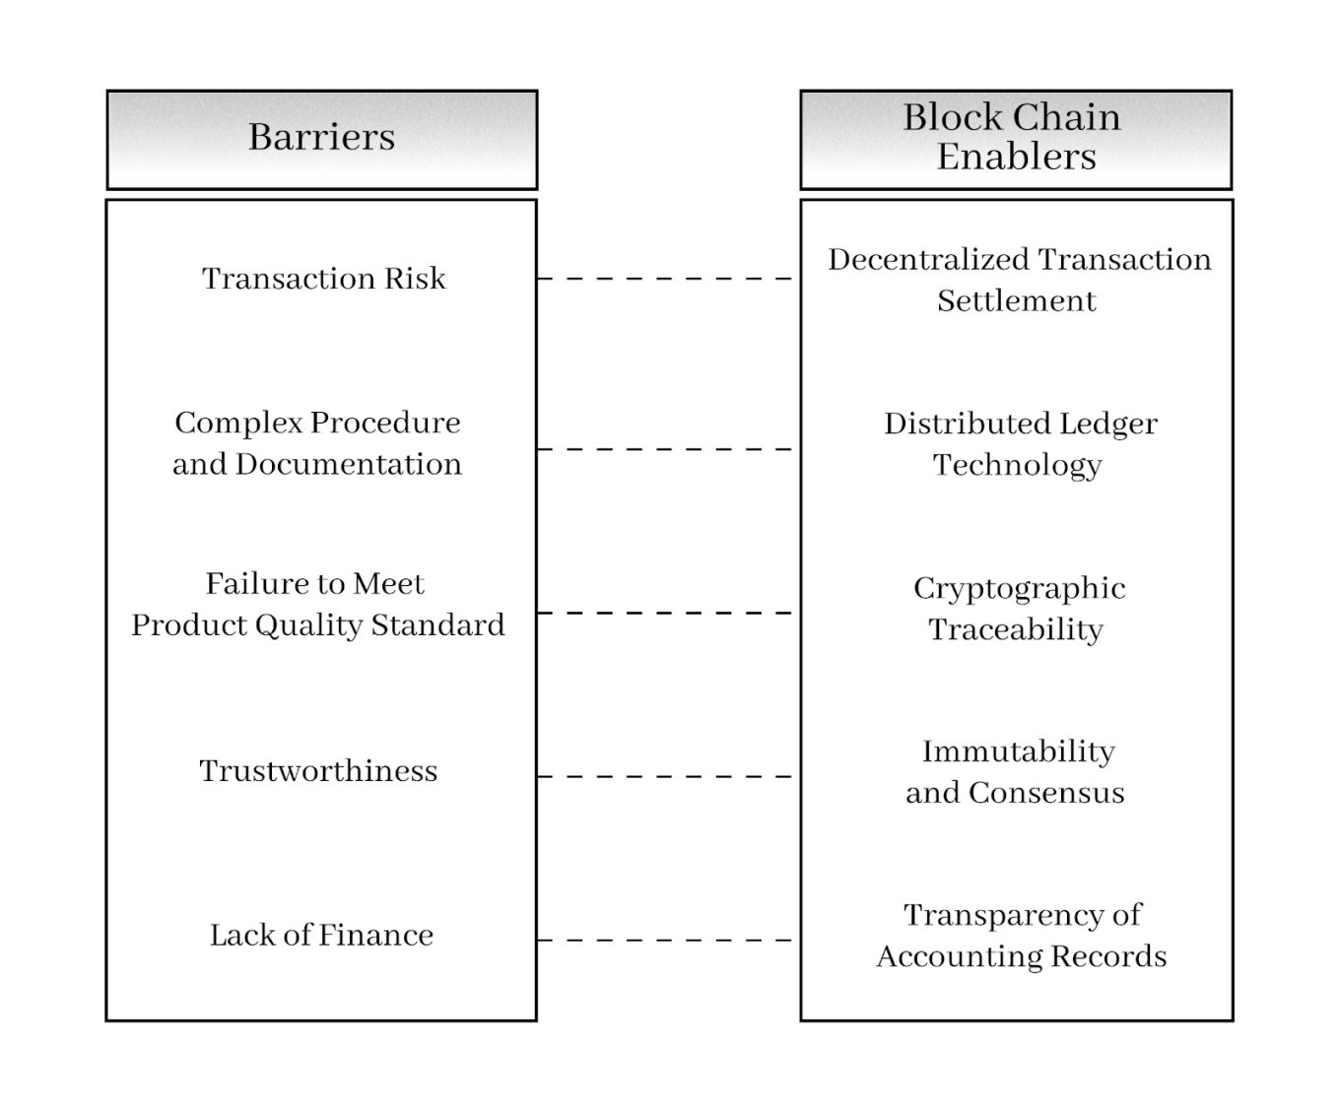Figure 3: Blockchain mediates SME internationalization barriers

i.Decentralized point to point transaction mediates slow payment and transaction risk.
Cross-border payment by customers takes four forms-remitting the sum via interbank SWIFT payment, remitting the sum to the seller's authorized agencies overseas, payment through multinational credit or debit cards like MasterCard or Visa, and payment through third-party payment institutions like Bkash, Paypal or AliPay. Payment via SWIFT or agents takes several days before settlement, multinational payment cards are costly, and most third-party payment methods lack legitimacy as money in other countries. Slow fund transfer hampers the liquidity of SMEs and increases transaction risk. By using Blockchain, SMEs can overcome the disadvantages of traditional methods of cross-border payments.
Since its inception, blockchain has enabled decentralization and disintermediation in many business and governance structures. Blockchain can create a more compatible, globalized, and transposable alternative financial structure. This scalability technology can accommodate the global foreign exchange settlement system. Compared to the mainstream cross-border payment system, it enables point-to-point value transfer between parties who do not trust each other, thereby discarding any intermediary and providing all-weather service. The transactions involve the payer and payee only, with no time expended on clearing between different intermediaries, substantially shortening the transaction cycle. The shared ledger technology records all relevant transactions in blocks, with accurate timestamps, so that transactions can be tracked and queried efficiently.
ii. Distributed ledger technology mediates complex procedure and documentation
Export operations heavily rely on documents. Several commercial documents are issued to capture the sale and physical movement of goods from the seller to the buyer, such as the invoice, packing list and bill of lading. Similarly, the financial payment process that customers initiate involves another set of documents like the letter of credit and bill of exchange. According to a study conducted by Boston Consulting Group, a single international trade operation might involve more than twenty entities carrying out a cumbersome process that ultimately creates a volume of documents. Each entity has a different priority and uses a different information logistic, which accrues administrative costs. Blockchain is ideal for facilitating trade documentation exchange between these entities, thereby minimizing the time and financial costs of administration work. The distributed ledger will store all documents about a particular international trade transaction, which can be accessed and verified by the importer, exporter, shipping agencies and customs regulatory bodies. Global trade can gain a faster momentum with Blockchain. Blockchain can expedite customs clearance procedures by simplifying identity verification of export-import participants, tracking product provenance, relaxing quality conformance checks and quickly detecting tax evasion attempts. It can reduce the time and cost associated with verifying import and export licenses, shipping documents, and customs declarations and minimize the risk of penalties for non-compliance with customs requirements.
iii. Cryptographic traceability mediates failure to meet quality standards through traceability and product provenance.
Many SMEs do not have any accreditations signifying the quality and standard of their products. Product quality, input sustainability, and a business's ecological footprint have become pressing concerns for modern customers. These factors influence customers' perceived value of a product. Many SMEs do not gain customers' trust due to their failure to meet product standards and specifications of foreign markets. At the same time, virtual customers face the threat of substandard, counterfeit, expired products. Faulty transportation, preservation, or storage conditions sometimes cause products to perish in transit. Recalling faulty products takes considerable time and money for the seller. The absence of insurance or formal dispute-resolution mechanisms leaves sellers dealing with damaged products, return-inward shipping charges and loss of customers' goodwill. These issues can discourage international trade.
Integrating the product quality and sustainability certification mechanism into the blockchain system can assist in overcoming compliance barriers at a relatively low cost. Blockchain can record data and information relevant to certifying, monitoring and improving the quality and sustainability of the products. The system can also define compliance protocols using smart contracts and continuously monitor information to detect and prevent faulty or non-compliant products. Besides, real-time product tracking means every participant has access to a single version of the truth. So, the party responsible for the damage can be immediately identified without lengthy investigation or paperwork. Thus, the digital accreditation system and the tracking of goods improve information symmetry and transparency of SMEs' products and processes.
iv. Immutability and consensus mechanism promotes trustworthiness
Blockchain has changed how market participants cooperate, coordinate trade activities and enforce trade agreements. The interaction between buyers and sellers may differ in a Blockchain-based exchange platform, so it fundamentally changes the nature and extent of trust in the buyer-seller relationship. Its design enables transparency, traceability, and immutability of transactions, thereby enhancing the trustworthiness of information. Blockchain is a series of blocks containing time-stamped, unalterable and irreversible data connected by hash chains. The cryptographic linkage of new blocks with old ones exponentially replicates the same data over all the nodes, guaranteeing data permanence. In other words, any enterprise or trade information stored in Blockchain will retain its provenance. Data immutability will make such information immune to manipulation, destruction, and misrepresentation for exploitative purposes. Therefore, overstatement, understatement, concealment or misrepresentation of transactions cannot be perpetrated. Furthermore, the consensus mechanism protects against false data entry into the system.
A highly appealing aspect of Blockchain’s smart contract is that it not only outlines the terms and conditions and penalties of exchange agreement. but it also enforces the contract automatically. So long as the transaction parties comply with the terms and conditions of the smart contract, it will automatically be executed without the risk of forceful deliberation of performance. Many labor-intensive and costly business procedures can be quickly and inexpensively replaced by smart contracts. In summary, Blockchain being tamper-proof against fraudulent activities, it increases stakeholders' trustworthiness and reliance on the system's information.
v. Trust, transparency, immutability mediates access to financing
SMEs experience stagnant growth due to a lack of comprehensive credit channels and financial instruments. Blockchain provides an efficient way to accumulate credit information to improve the credit system for SMEs. The system can use its algorithm to automatically and faithfully record, organize, store and report every transaction required in credit reporting. Through its distributed ledger technologies, Blockchain can create a foundation of trust and security in business networks, thereby reducing the risk of fraud. It augments the capacity to communicate information and proof of many things safely and reliably. In the long run, financial institutions can quickly and economically track detailed and unaltered versions of the client’s sales, cash flow, and credit history. So, even though financial institutions do not trust businesses, they may rely on the unalterable data in an immutable shared ledger. The system can be adapted to use future trading smart contracts as collateral in lending arrangements. This way, smart contracts may minimize cost, credit risk, paperwork challenges, and other trade financing obstacles, improving the cash flow and solvency of SMEs.

Proposed Blockchain-based Framework for SMEs
The traditional global supply chain involves several disconnected stakeholders such as suppliers, producers, certifiers, logistics, insurance, banks, and final customers. All information flows sequentially, and often, the downstream stakeholder loses track of a product's provenance. Lack of transparency of the seller impacts consumer trust. In addition, the payment process is risky and cumbersome. SMEs engaging in business-to-customer (B2C) trading often do not qualify for export credit schemes, which guarantee payment to the exporters in events of buyers' insolvency. As such, SMEs either depend on costly intermediaries like Amazon to collect payment on their behalf or require customer payments on product order confirmation. Customers are reluctant to pay in advance due to trust and online transaction security issues.
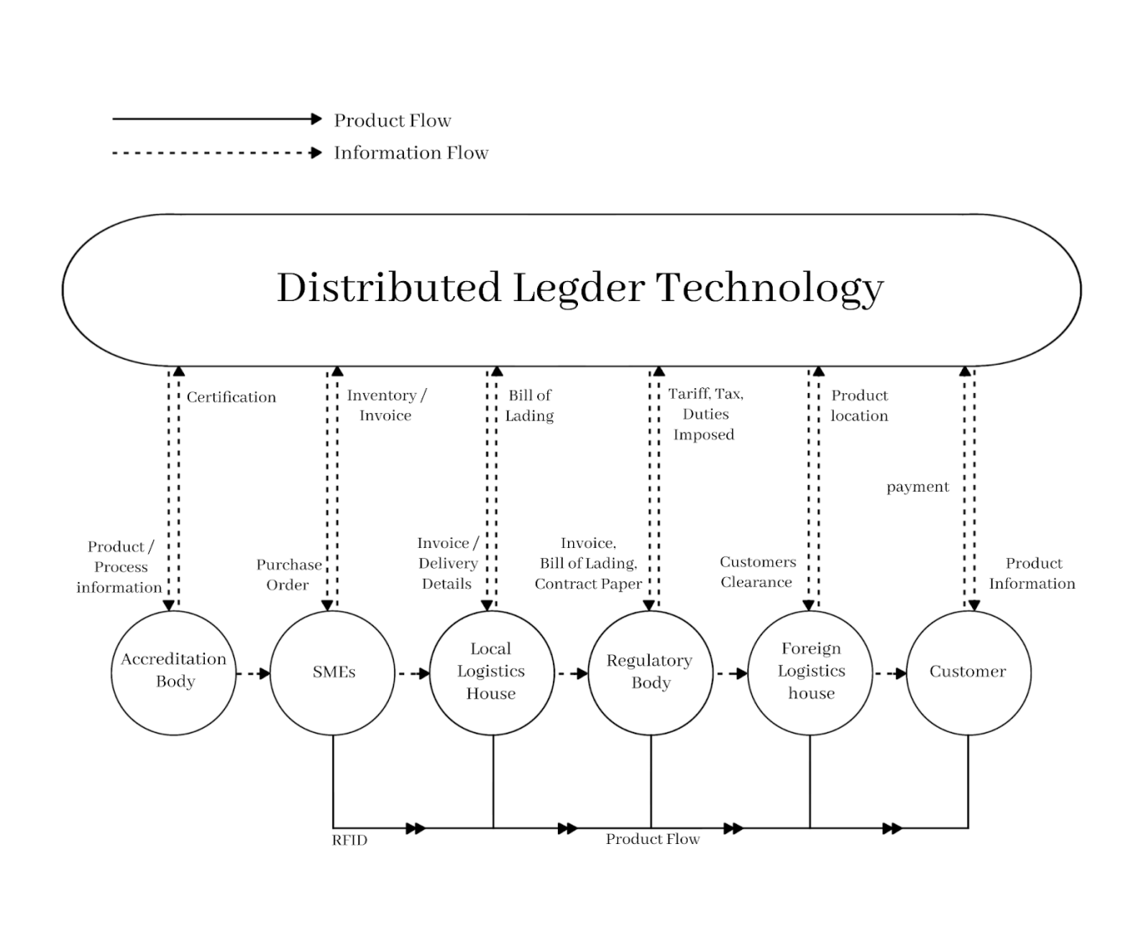Figure 4: Proposed Blockchain-based framework for SME internationalization
Blockchain can transform SMEs' international strategy and structure of business model. Blockchain can enhance all facets of the trading process beyond national boundaries (Kimani et al., 2020). In a trust-less world, it ensures the security, tracking, and validity of assets and the performance of contractual obligations. This paper presents a Blockchain-driven global operations model for SMEs (see, Figure 4). This model's primary motivation is facilitating SMEs' internationalization through low logistics and compliance costs, decentralized cross-border transactions and instantaneous traceability. The proposed framework connects five stakeholders in a distributed ledger technology with IoT enablers. The users are SMEs, Accreditation Bodies, Customers, Drop-shipping logistics, and Regulatory Bodies.
The SMEs will input information such as the sources of raw materials, human resources, workplace conditions and safety, production and warehousing process, waste disposal, and other business practices in the system and request inspection from the relevant accreditation body. Based on observation, testing and the information, the accreditation body will generate a digital certificate available for viewing by all the stakeholders in the Blockchain network. A customer who desires to buy the product and is satisfied with the quality and accreditations of the product will create a digital product order (PO) confirmation in the platform. If the system accommodates stock-keeping mechanisms, SMEs can automate the confirmation of the PO; otherwise, the SME will manually confirm the PO after checking product availability. This will create a smart contract between the customer and the SME. Depending on the platform's scale, the system may automatically bid for shipping services, stating the product class, weight, delivery destination and time, and choose the shipping agency offering the lowest ask price. Without a computerized bidding system, the SME will manually select a shipping agency with a distribution center in the delivery destination and agree on the time slot, charges and other service terms. In either case, the agreement between the SME and the shipping agency will be recorded in a smart contract, which will be the digital equivalent of a bill of lading. All information, including product class and quantity, bill payable, shipping agency and vessel, delivery destination and delivery date, will be stored in the distributed ledger technology for immediate visibility. The framework incorporates an RFID product tagging method with IoT enablers, which Miraz et al. (2023) also support to improve the physical traceability of the products. An RFID tag will be attached to the product before it is dispatched to the shipping agency. All permissioned stakeholders will receive automatic notification of the product's location upon arrival at the local logistics warehouse, port, foreign logistics warehouse and finally, at the customer's doorstep. The framework incorporates regulatory bodies that will supply the system with the customs and tax structure for auto calculation of duties and tariffs based on product and invoice information. A smart contract will exist between the bearer of the regulatory charges and the regulatory body. The agreement between customers and SMEs will determine the bearer regulatory body. This smart contract will be executed once the product gets clearance from foreign customs and the bearer remits the charges in digital currency. Once the foreign distribution center delivers the product to the customer, the smart contracts between the SME and the customer and the SME and shipping agency will be executed, and digital currencies will immediately move to the payee's digital wallet.

Chapter 4: Conclusion
Small and medium-sized enterprises (SMEs) are hotbeds of economic output, employment and innovation. In Bangladesh, SMEs have a substantial stake in self-employment and job creation. Nonetheless, the sector’s contributions to GDP and export earnings have stagnated over the decades. A large number of SMEs and large companies in the RMG sector engage in earning foreign revenues from exporting. However, fierce competition from China and Vietnam is shredding off the global RMG market share from Bangladesh. Thus, to retain its export volume in future, the country needs to diversify its export portfolio.
SMEs in Bangladesh are highly adaptive to market trends and possess tremendous diversity, versatility and creativity, giving them an edge in the global marketplace. Nonetheless, they shrug away from global markets due to several barriers. SMEs desire immediate cash flow from sales. Since they operate with tight working capital, slow payment from sales might curb their operation and financial performance. Traditionally, exporting lengthens payment collection due to the centralised nature of cross-border money transfers. At the same time, complex documentation and customs procedure makes international trade highly bureaucratic, discouraging many SMEs from selling abroad. Often, foreign customers are reluctant to buy from developing country SMEs because of inadequate care for maintaining product quality and standards. The lack of funds to finance exports deepens the problems, leaving little scope for international expansion.
Blockchain is a decentralised distributed ledger technology that offers transparency, traceability and immutability of stored data and information. Smart contracts govern transactions in this network, and a preferred consensus mechanism, such as proof of work or proof of stake, validates every event. Participants use public keys for transferring data or assets and protect their digital assets using private keys.
The study findings suggest that Blockchain can ease some of the barriers experienced by SMEs during internationalization. SMEs can improve their product and process transparency by sharing information with the distributed ledger, enabling accreditation bodies to assess and certify their standards. The technology can eliminate repetition and repudiation of information used by regulatory bodies. A decentralized payment system drastically shortens transaction time and risk. Nonetheless, Blockchain is an infant technology, and the lack of legitimacy of cryptocurrency garners skepticism from users who lack the knowledge, scope and capital to implement the technology.

Appendix
Questionnaire
The purpose of this survey is to explore the impediments faced by SME during internationalisation and how SMEs perceive Blockchain technology as an enabler of internationalisation.
- Name of the Respondent:
- Name of Organization:
- Position:
- Gender
- Male | - Female
- Age group
- Less than 25 years | - 25 years - 35 years | - 36 years - 45 years | - More than 45 years
- In which sector does your organisation belong?
- Agriculture | - Leather | - Handicrafts
- Textile and Apparel | - Furniture Manufacturer | - Others
- Annual Turnover
- Less than 10 lac | - 10 lac - 50 lac | - 50 lac - 1 crore | - More than 1 crore
- Does your organisation directly or indirectly export to foreign countries?
- Yes | - No
- What percentage of the annual turnover represents export?
- Nil | - 10% - 30% | - 50% - 80%
- Less than 10% | - 30℅ - 50% | - More than 80%

- Does your organisation have agents for foreign operations?
- Yes | - No
- Exporting follows rigorous documentation and regulatory processes like opening LC, obtaining a Bill of Lading and Customs declaration. To what extent do you agree these processes hamper export operations?

- Strongly Disagree | - Disagree | - Neither Agree nor Disagree | - Agree | - Strongly Agree
- How many days does it take to receive payments from foreign buyers?
- Less than 2 days | - 2 days - 14 days | - 14 days - 30 days
- 1 month - 2 month | - More than 2 month | - Not Applicable
- Does your organisation protect its exports through an export credit scheme?
- Yes | - No
- Payment from foreign buyers takes several days before it is deposited in the bank. To what extent do you agree slow payment increases the risk of transactions with foreign buyers?
- Strongly Disagree | - Disagree | - Neither Agree nor Disagree | - Agree | - Strongly Agree
- To what extent do you agree the following factors affect your entry or operation in foreign markets:
i. Lack of Capital
- Strongly Disagree | - Disagree | - Neither Agree nor Disagree | - Agree | - Strongly Agree
ii. Lack of Foreign Market Knowledge
- Strongly Disagree | - Disagree | - Neither Agree nor Disagree | - Agree | - Strongly Agree
iii. Lack of Trust among Customers, Agents and Sellers
- Strongly Disagree | - Disagree | - Neither Agree nor Disagree | - Agree | - Strongly Agree
iv. High Logistics Cost
- Strongly Disagree | - Disagree | - Neither Agree nor Disagree | - Agree | - Strongly Agree
v. Failure to meet product standard demand of foreign customers
- Strongly Disagree | - Disagree | - Neither Agree nor Disagree | - Agree | - Strongly Agree
- Do you use any digital platform to conduct online business?
- Yes | - No
- Do you know about Blockchain and cryptocurrency?
- Yes | - No

- If Blockchain can help businesses enter foreign markets, to what extent would you be willing to adopt the technology? Note that strongly disagree means highly unwilling, and strongly agree means highly willing.
- Strongly Disagree | - Disagree | - Neither Agree nor Disagree | - Agree | - Strongly Agree
- To what extent do you agree the following factors would affect your Blockchain Technology adoption?
i. Cost of implementing Blockchain Technology
- Strongly Disagree | - Disagree | - Neither Agree nor Disagree | - Agree | - Strongly Agree
ii. Availability of skilled human resource
- Strongly Disagree | - Disagree | - Neither Agree nor Disagree | - Agree | - Strongly Agree
iii. Security and legitimacy of digital currency
- Strongly Disagree | - Disagree | - Neither Agree nor Disagree | - Agree | - Strongly Agree

Reference
Abdullah, N., Halim, N. A., &MohdZain, S. N. (2011).The internationalization theory and Malaysian small medium enterprises (SMEs). International Journal of Trade, Economics and Finance, 2(4), 318-322.
Al‐Hyari, K., Al‐Weshah, G., &Alnsour, M. (2012). Barriers to internationalisation in SMEs: evidence from Jordan. Marketing Intelligence & Planning, 30(2), 188-211.
Akter, S. (2018). Influencing Export Barriers for Internationalization and Relationship Between Export Barriers and Information Systems Strategic Orientation on SMEs’ in Bangladesh: A Study on Ready-Made Garment (RMG). European Journal of Business and Management www.iiste. org ISSN 2222-1905 (Paper) ISSN 2222, 2839.
Anderson, W. (2011). Internationalization opportunities and challenges for small and medium-sized enterprises from developing countries. Journal of African Business, 12(2), 198-217.
Bangladesh Bank (2010). Small and Medium Enterprise (SME) Credit Policies & Programmes.
Bangladesh Bureau of Statistics (2013), Preliminary Report of Economic Census.
Begum, L. A., Talukder, S., Rahman, M., Das, R. C., Bhattacharjee, P., &Miah, N. (2022). Bangladesh Bank. Estimating the contribution of SMEs output on GDP growth in Bangladesh A VECM Approach. https://www.bb.org.bd/pub/research/sp_research_work/srwsp2022-02.pdf
Belotti, M., Božić, N., Pujolle, G., &Secci, S. (2019). A vademecum on blockchain technologies: When, which, and how. IEEE Communications Surveys & Tutorials, 21(4), 3796-3838.
Cardoza, G., Fornes, G., Farber, V., Duarte, R. G., & Gutierrez, J. R. (2016). Barriers and public policies affecting the international expansion of Latin American SMEs: Evidence from Brazil, Colombia, and Peru. Journal of Business Research, 69(6), 2030-2039.
Child, J., Hsieh, L., Elbanna, S., Karmowska, J., Marinova, S., Puthusserry, P., ...& Zhang, Y. (2017). SME international business models: The role of context and experience. Journal of World Business, 52(5), 664-679.
Crick, D. (2007). SMEs’ barriers towards internationalisation and assistance requirements in the UK: Differences between exporters and firms employing multiple modes of market entry. Journal of Small Business & Entrepreneurship, 20(3), 233-244.
Dai, W., Deng, J., Wang, Q., Cui, C., Zou, D., & Jin, H. (2018). SBLWT: A secure blockchain lightweight wallet based on trustzone. IEEE access, 6, 40638-40648.
Deloitte US | Audit, Consulting, advisory, and Tax Services(2016). Blockchain: Opportunities for Health Care.
Faruk, O., &Subudhi, R. N. (2019). Export Performance of SMEs: A Review of Firm-Level Controllable Determinants. Parikalpana: KIIT Journal of Management, 15(1and2), 112-126.
Glonti, V., Manvelidze, R., &Surmanidze, I. (2021). The contribution of SME to regional economic development: On example of adjara autonomous republic. European Journal of Sustainable Development, 10(1), 513-513.
Golosova, J., & Romanovs, A. (2018, October).Overview of the blockchain technology cases.In 2018 59th International Scientific Conference on Information Technology and Management Science of Riga Technical University (ITMS) (pp. 1-6).IEEE.
Hashim, F. (2015). SMEs’ impediments and developments in the internationalization process: Malaysian experiences. World Journal of Entrepreneurship, Management and Sustainable Development, 11(2), 100-119.
Hervé, A., Schmitt, C., &Baldegger, R. (2021). Internationalization and Digitalization: Applying digital technologies to the internationalization process of small and medium-sized enterprises. Technology Innovation Management Review.
Iranmanesh, M., Maroufkhani, P., Asadi, S., Ghobakhloo, M., Dwivedi, Y. K., & Tseng, M. L. (2023). Effects of supply chain transparency, alignment, adaptability, and agility on blockchain adoption in supply chain among SMEs. Computers & industrial engineering, 176, 108931.
Jin, H., &Hurd, F. (2018).Exploring the impact of digital platforms on SME internationalization: New Zealand SMEs use of the Alibaba platform for Chinese market entry. Journal of Asia-Pacific Business, 19(2), 72-95.
Kimani, D., Adams, K., Attah-Boakye, R., Ullah, S., Frecknall-Hughes, J., & Kim, J. (2020). Blockchain, business and the fourth industrial revolution: Whence, whither, wherefore and how?.Technological Forecasting and Social Change, 161, 120254.
Kshetri, N. (2018). 1 Blockchain’s roles in meeting key supply chain management objectives. International Journal of information management, 39, 80-89.
Kuivalainen, O., Sundqvist, S., Saarenketo, S., & McNaughton, R. (2012). Internationalization patterns of small and medium‐sized enterprises. International Marketing Review, 29(5), 448-465.
Kumar Bhardwaj, A., Garg, A., &Gajpal, Y. (2021). Determinants of blockchain technology adoption in supply chains by small and medium enterprises (SMEs) in India. Mathematical Problems in Engineering, 2021, 1-14.
Luther, W. J. (2016). Bitcoin and the future of digital payments. The Independent Review, 20(3), 397-404.
Maurel, C. (2009). Determinants of export performance in French wine SMEs. International Journal of Wine Business Research, 21(2), 118-142.
Miraz, M. H., Gazi, M. A. I., &Hasan, M. T. (2023). Fruits supply chain management using Blockchain: A theoretic operation. Journal of Survey in Fisheries Sciences, 10(1S), 5438-5450.
Morkunas, V. J., Paschen, J., & Boon, E. (2019). How blockchain technologies impact your business model. Business Horizons, 62(3), 295-306.
Nair, P. R., &Dorai, D. R. (2021).Evaluation of Performance and Security of Proof of Work and Proof of Stake using Blockchain. 2021 Third International Conference on Intelligent Communication Technologies and Virtual Mobile Networks (ICICV). doi:10.1109/icicv50876.2021.93884
Nijssen, E., Singh, J., Sirdeshmukh, D. andHolzmüeller, H. (2003), “Investigating industry contexteffects in consumer-firm relationships: preliminary results from a dispositional approach”,Journal of the Academy of Marketing Science, Vol. 31 No. 1, pp. 46-60.
Nuryyev, G., Wang, Y. P., Achyldurdyyeva, J., Jaw, B. S., Yeh, Y. S., Lin, H. T., & Wu, L. F. (2020). Blockchain technology adoption behavior and sustainability of the business in tourism and hospitality SMEs: An empirical study. Sustainability, 12(3), 1256.
Organization for Economic Cooperation and Development (OECD) (2009b), “The impact of the global crisis on SME and entrepreneurship financing and policy responses,” available at: http://www. oecd.org/industry/smes/4318090.pdf (accessed 5 February, 2017)
Pietrasieński, P., &Ślusarczyk, B. (2015). Internationalization of small and medium enterprises: empirical research review on barriers to entry into foreign markets. Polish Journal of Management Studies, 11(1), 113-123.
Pilkington, M. (2016). Blockchain technology: principles and applications. Research Handbook on Digital Transformations.
Rahman, M., Lincoln, U. K., Uddin, M., &Lodorfos, G. Barriers to Enter into Foreign Markets: Evidence from SMEs in an Emerging Economy1.
Reim, W., Yli-Viitala, P., Arrasvuori, J., &Parida, V. (2022).Tackling business model challenges in SME internationalization through digitalization.Journal of Innovation & Knowledge, 7(3), 100199.
Rennock, M. J., Cohn, A., & Butcher, J. R. (2018).Blockchain technology and regulatory investigations. Practical Law Litigation, 1, 35-44.
Rosyidah, U., Sudarmiatin, S., &Sumarsono, H. (2023). Digitalization and internationalization of SMEs: A Systematic Literature Review. Journal of Enterprise and Development (JED), 5(3), 479-499.
Roy, A., Sekhar, C., &Vyas, V. (2016). Barriers to internationalization: A study of small and medium enterprises in India. Journal of International Entrepreneurship, 14(4), 513-538.
Samy, Y., Adedeji, A., Iraoya, A., Dutta, M. K., Fakmawii, J. L., &Hao, W. (2023). Trade and Women’s Economic Empowerment: Qualitative Analysis of SMEs from Cambodia and Vietnam. In Trade and Women’s Economic Empowerment: Evidence from Small and Medium-Sized Enterprises (pp. 59-103). Cham: Springer Nature Switzerland.
Sangeetha, A. S., Shunmugan, S., &Murugan, G. (2020). Blockchain for IoT Enabled Supply Chain Management - A Systematic Review. 2020 Fourth International Conference on I-SMAC (IoT in Social, Mobile, Analytics and Cloud) (I-SMAC). doi:10.1109/i-smac49090.2020.9243371
Saunila, M. (2020). Innovation capability in SMEs: A systematic review of the literature. Journal of Innovation & knowledge, 5(4), 260-265.
Shah, T. H., Javed, S., & Syed, S. (2013). Internationalization of SMES in Pakistan: A Brief Theoretical Overview of Controlling Factors. Journal of Managerial Sciences, 7(2).
Swan, M. (2015). Blockchain: Blueprint for a New Economy, O’Reilly Media, Sebastopol, CA, USA.
Todd, P. R., &Javalgi, R. R. G. (2007). Internationalization of SMEs in India: Fostering entrepreneurship by leveraging information technology. International journal of emerging markets, 2(2), 166-180.
Toulova, M., Votoupalova, M., &Kubickova, L. (2015).Barriers of SMEs internationalization and strategy for success in foreign markets. International Journal of Management Cases, 17(1), 4-19.
Treleaven, P., Brown, R. G., & Yang, D. (2017).Blockchain technology in finance. Computer, 50(9), 14-17.
Wijayarathne, J. M. D. S., &Perera, M. P. S. R. (2018).Sri Lankan SMEs and Perceived Export Barriers Evidence from Manufacturing Sector.
World Bank SME finance: Development news, research, Data. World Bank.(n.d.). https://www.worldbank.org/en/topic/smefinance#:~:text=SMEs%20account%20for%20the%20majority,(GDP)%20in%20emerging%20economies.
Xiong, Z., Zhang, Y., Niyato, D., Wang, P., & Han, Z. (2018).When mobile blockchain meets edge computing. IEEE Communications Magazine, 56(8), 33-39.

