Internship Report
On
General Banking Activities of Dutch Bangla Bank Ltd

General Banking Activities
Of
Dutch Bangla Bank Ltd.

Prepared By
Shaneeta Rahman Shifa
ID- 111 133 039
School of Business & Economics
United International University (UIU)

Prepared For
Dr. Abu Zafar Md. Rashed Osman
Associate Professor
School of Business & Economics
United International University (UIU)

Date of Submission: December 04, 2018

EXECUTIVE SUMMARY
The main objective of the report is to present the general banking activities of Butch Bangla Bank Limited, Panthapath Branch. In this internship report, the details of general banking activities of Dutch Bangla Bank Limited are closely described. From this report, one can understand how the general banking activities of Dutch Bangla Bank Limited is accomplished and how it performs over the year. The study also revealed through proper data analysis that job satisfaction is positively influencing quality of work.

Chapter 1: Introduction

1.1 Background of the Report
The knowledge we gain from our lecture rooms does not create any value if we are not capable of using them in our actual life. Our classrooms give us a theoretical framework or idea that we are going to face in our near upcoming days at the same time as we are able to be working in a real workplace with actual responsibilities and duties. This internship has proposed by United International University that gives us a glimpse of the corporate scenario. This is a document on my internship program which I attended at Dutch Bangla Bank Limited, Panthapath Branch from 10th July 2018 to 11th October 2018. This report contains the details of my experience and learning at the selected organization. As I even have chosen my internship program in Dutch Bangla Bank Limited, Panthapath Branch I am working to develop an internship report in this branch’s general activities that I’ve been assigned.

1.2 Significance of the Study
The theoretical & hypothetical information is less beneficial when it isn't always applied in practical life. However, we've done so many theoretical subjects in BBA program and we have not such practical & realistic knowledge to be successful in the actual workplace so as a student of business studies we have to learn more practical knowledge to become a good performer in our original workplace. For this reason, the internship program is very important for every student.

1.3 Scope of the Study
In this internship report, the details of general banking activities of Dutch Bangla Bank Limited Panthapath Branch are closely described. From this report, one can understand how the general banking activities of Dutch Bangla Bank Limited Panthapath Branch is accomplished and how it performs over the year.
1.4 Objective of the Study
Primary Objective
The main objective of the report is to present the general banking activities of Dutch Bangla Bank Limited Panthapath Branch.
Secondary Objectives
The other relevant objectives of this study are as follows
- To know the procedure of account opening with different types of conditions.
- To understand the features of different types of deposit.
- To identify problems related to account opening dept.
- To recommend or suggested actions of the identified problem.

1.5 Methodology
This is an illustrative kind of research that rapidly investigate the overall banking activities of Dutch Bangla Bank Limited Panthapath Branch. It has been presented with the aid of accumulating two varieties of records. One is primary data and another is secondary data.

Primary data
Primary data is all about gathering knowledge by experiencing face to face situation and collecting data in personally. For example, I have collected many data by asking questions of our Executive Officer, Deputy Managers. Even I have experienced some situation that has helped me to collect primary data.
Secondary data
Secondary data is all about investigation of information via various sources. Here data is collected by various websites, Reports, Journals rather than personal investigations. For Example, I can say that I have studied many annual reports of DBBL and I also have browsed many websites to know more info about DBBL.
Sources of data/records
Sources of data/records of this can be divided into two classes:
Primary Sources:
A. Through remark and face-to-face communication.
Secondary Sources:
- Annual report of Dutch Bangla Bank Ltd.
- Different textbooks.
- Web-based help from the internet.

1.6 Limitations
General banking is a critical sector for a bank. As Dutch Bangla Bank Ltd. is a newly fashioned bank so there are many problems in this bank though they are trying very hard to overcome. As I have been given only 3 (three) months for my internship program at this organization so it’s not sufficient to understand or recognize the entire operation or how it is interconnected with all different divisions. However, my experiences which have given me clue for making ready this report or document, some of the barriers have been faced by me during report making is given below:
- The main limitation of this report is bank has the policy of not disclosing or notified to anyone regarding their internal data and information for an obvious reason.
- Time Limitations of collecting much information.
- Inadequate information’s is also one of the limitations among various limitations.
- Lack of Record has been seen while I was collecting the info.
- As I am still a student so I don’t have enough experience to collect data and understand the given info so lack of experience is one of the reasons of limitations.
- It is very difficult to arrange an appointment or fix up a date with the High Officials of the Bank as they are always busy with their official work.

Chapter 2: Company Overview
2.1 Overview of Dutch Bangla Bank Ltd
Dutch Bangla Bank is one of the fourth generation private region banks. They have started their operation journey in 2000. Dutch Bangla Bank is very ambitious to be one of the most dedicated financial institutions in Bangladesh. They want to achieve the rights to be entered in International Banking Market. Dutch Bangla Bank supplying Corporate, SME, Retail banking, DBBL and Premium banking, Internet Banking,2FA, various types of Nexus cards to satisfy the desire of millions of clients located all over Bangladesh. With an undertaking of constructing longtime dedication to our clients, Dutch Bangla Bank could be offering the right answers that integrate professionalism, expertise and economic power, and ambitions to be the favored provider of monetary offerings. DBBL is going ahead very fast with the motto "Your Trusted Partner" They are becoming successful by keeping their motto in their mind through their dynamic values, Innovativeness, connecting globally, Integration and Techno-Centric to create successful monetary Bank regionally all over the world.

2.2 Visions for the future
Being the leading dedicated monetary economic institution for DBBL wants to make corporate access in international markets. All they want is “Healthy democratic and poverty free Bangladesh.” Dutch-Bangla Bank’s goal is to become extra successful all over Bangladesh, where there are arts and letters, sports activities and athletics, song and amusement, science and education or training, fitness and hygiene, smooth and easy pollution free environment and mainly a society that based on morality and ethics make all our dwelling surely really worth. Dutch-Bangla Bank’s principle rests on a unique creativity and elite lifestyles of clients that abounds with the spirit of their existence and adventures that contribute towards human improvement.
2.3 Mission
Dutch-Bangla Bank is such a financial business enterprise that renowned for their creativity in service with a dedication of social obligation. "Profits by myself alone" do not accept the principal awareness of the bank’s operation; because "man does not live by bread and butter alone".
2.4 Values
We are trusted financial consultant or advisor; valuing our own roots and we remain devoted to our global presence by being specific and unique from other banks.
• Dynamic: We try to alternate and carry out to progress.
• Integrity: We govern through the principles of ethics and transparency.
• Global: We empower to create competitive facet to set the global standard.
• Innovating: We foster ideas through findings better ways to enhance.
• Techno-centric: We step ahead with technological development.

2.5 Core Objectives
Dutch-Bangla Bank believes in its uncompromising dedication to satisfy its customer wishes and pleasure and to get chosen as their first preference in banking. Dutch-Bangla Bank proposes every client for a new technology in banking that sustain and symbolizes its wonderful creativity that never ever done by other banks so they happily say to the customer "Your Trusted Partner".

2.6 History of Dutch Bangla Bank Ltd
Dutch-Bangla Bank started out operation is Bangladesh's first joint venture financial institution. The financial institution changed into an attempt via neighborhood shareholders named M Sahabuddin Ahmed (founder chairman) and the Dutch organization FMO.
From the onset, the original point of the bank has been financing excessive-boom production industries in Bangladesh. Their main purpose is producing sector that exports Bangladeshi products globally. Thereby financing and concentrating allows Bangladesh to obtain favored growth. Dutch Bangla Bank also focuses on Corporate Social Responsibility (CSR). Even though CSR is now a common thing in other banks Dutch Bangla Bank is the pioneer in this CSR and they also have the contribution in 'social responsibility'. Due to its investment on this region, Dutch Bangla Bank has to turn out to be one in all the most important donors and the largest financial institution donor in Bangladesh. The financial institution has gained numerous international awards due to its particular method as a socially conscious financial institution.

Dutch Bangla Bank was the first bank in Bangladesh to be completely automatic. The Electronic-Banking Division was set up in 2002 to undertake fast automation and bring modern-day banking offerings into this field. Full automation becomes finished in 2003 and hereby delivered plastic cash to the Bangladeshi masses. Dutch Bangla Bank additionally operates the country's biggest ATM system and within the system significantly cut additional fees near 80%. Moreover, Dutch Bangla Bank choosing the low profitability direction for this region it has amazed by many critics. Dutch Bangla Bank had pursued the mass automation in Banking. As a result, it is now offering unrivaled banking to all its customers. Because of this mindset, maximum local banks have joined Dutch Bangla Bank banking infrastructure in preference to pursuing their personal.

By the records of vast technological investments and excellent large donations, client and investor very much appreciated them. Dutch-Bangla Bank inventory set the document for the best proportion charge within the Dhaka Stock Exchange in 2008.

Dutch Bangla Bank at a glance

Name | Dutch Bangla Bank Ltd
Founder | M Sahabuddin Ahmed
Types of Financial Institution | Foreign Commercial Bank,  Second generation private sector com. bank.
Form of Company | European private joint venture.
Date of Incorporation | July 23, 1995
Date of Starting Operation | July 04, 1996 with one branch
Registered Office | SenakalyanBhaban, 195 Motijheel C/A, Dhaka-1000, Bangladesh
Name of the Chairman | Mr. AbulHasnat Md. Rashidul Islam
Slogan | Your Trusted Partner
Number of Branches | 260 (up to 2017)
Services Provided | Deposit scheme, Loan & other Banking
Diversification of Products & Services | Corporate banking, Retail banking & Consumer banking
Paid up Capital | 202,135,000
Publicity Traded Company | Share quoted daily in DSE & CSE
Available Cards | DBBL MASTER, VISA & NEXUS
Banking Operation System | Both conventional and Islamic banking system
Telephone | (88020)7176390-93
Fax | (8802)9561889
E-mail | bddl@bdmail.net
Web-Site | www.bddl.com.bd
SWIFT | BDDL BD DH

Hierarchy of Dutch Bangla Bank Limited

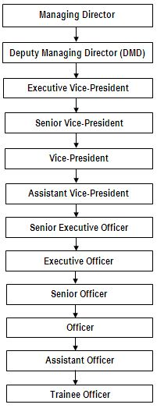

2.7Corporate Division
Dutch Bangla Bank Limited basically deals with three separate departments to provide banking services. There are-

- General banking division
- Foreign exchange division
- Investment Division

Figure: Corporate Division of DBBL

Dutch Bangla Bank Ltd.

General Banking Foreign Remittance Investment

A/C Opening Clearing

Cash Remittance of Funds Export Import

2.8 Operational activities of DBBL
It is considered as a crucial issue for commercial and business corporations because it has the capacity to bind the business enterprise together. The tradition and values of Dutch Bangla Bank Ltd were proved as a competitive advantage for the bank and are performing as a key thing to establishing the connection between the financial institution and employees and, in the term, among employees and clients. Culture and values also encourage customers and personnel to enroll in with the bank and stay with them. This bank is one of the most disciplined banks with a distinctive corporate culture. Dutch Bangla Bank Ltd believes in shared that means shared expertise and shared feel making. They always trying to make their service up to the mark so that the desires of the clients become fulfilled who is the paramount significance to the financial institution. Dutch Bangla Bank Ltd has been capable of enhancing organizational overall performance via improving the overall performance of person members, acknowledges present abilities to refill the higher vacancies within the organization or area them in the right position.

2.9 A Brief Outline of Dutch Bangla Bank Ltd. Panthapath Branch
Dutch Bangla Bank Ltd. Panthapath Branch is located on Panthapath near Square hospital Dhaka. Every day thousands of people gather here for transaction purpose. To serve customers the branch was launched by January 2015. Now the branch has 65 employees.
From the beginning, it has been providing satisfactory services to their clients with a better level of performance. There are various sections that providing customers with required services. In the general banking department of DBBL, Panthapath has some sections which include, Account opening section, Cash section, Remittance section, Account Opening Section, Clearing section, Foreign Exchange, and Credit section, Card and Pin section. This branch is located mainly in a fully commercial area.

The overall activities of this branch are well organized. Strong chains of command among the employees are maintained. It’s a great opportunity for me to be a part of this branch for a certain period this branch of DBBL. This is one of the busiest branches among other branches of DBBL. They have a good reputation in the financing market. They are growing rapidly to fulfill their main targets.

Figure: Company Overview
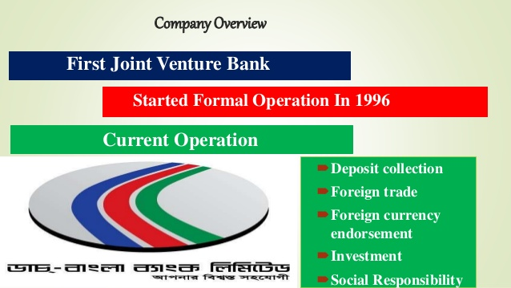

2.10 Product Range of Dutch-Bangla Bank Limited
The product list of Dutch-Bangla Bank Limited is stated below:

Deposit Product
- Savings Deposit Account
- Current Deposit Account
- Short Term Deposit Account
- Resident Foreign Currency Deposit
- Foreign Currency Deposit

Loans & Advances
- Consumer Credit Scheme
- Real Estate Loan (Res. & Comm.)
- Industrial Term Loan
- Agricultural Term Loan
- Lease Finance
- FMO Local currency Loan for SME
- FMO Foreign currency Loan
- Cash Credit (Hypothecation)
- Small Shop Financing Scheme
- Secured Overdraft (SOD)

Term Deposits (DPS)
- Monthly Term deposits
- Term Deposit 3 Months
- Term Deposit 6 Months
- Term Deposit 12 Months
- Term Deposit 36 Months
- Term Deposit above 36 Months

Retail & SME Products
- DBBL Life Line (Health / Education / Professional / Marriage / Travel / Festival / Dreams Come True / Car / General )
- DBBL Secured Credit Lines (Auto / Home / Full Secured )
- DBBL Future Line (Deposit Pension Scheme/ Periodic Benefit Scheme/ Pension Plus/ Children Education Savings Scheme
- DBBL-Nexus Pro Gold/ Classic Credit Card, Multicurrency/ Local
- DBBL Visa Credit Card, Multicurrency/ Local
- Locker Facility

Other Products/ Services
- Online Banking
- ATM Availability & PCOS machine
- SMS Alert Banking
- Internet Banking& 2FA
- Remittance Services (Western Union, X Press Money, Ria, Small World, Pay Pal Etc)
- Locker Facility
- DBBL Rocket

2.10 Social Responsibilities & Economic performance:
We should focus on the social responsibilities of our surrounding. The ethics of DBBL is to serve every customer in such a manner that they become loyal to us so as per their ethics they give superior value. DBBL also plays an important role to maintain social responsibilities. Dutch-Bangla Bank Foundation (DBBF) is consistently pursuing its objective of involving in those social areas where it is needed most. The Foundation reflects various social activities in the field of education, health, conservation of nature, the creation of social awareness. It also promotes different socio-cultural and sports activities
Figure: Socio-Cultural activities of DBBL
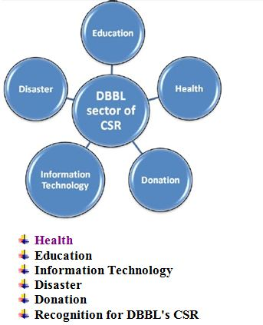

2.11 Health:
DBBL helped 50 HIV positive patients. They have arranged various services to this people.
- For HIV/AIDS patients they arranged a program called “Smile Brighter Program/Support to ACID & Dowry Victims”.
- They have provided V.V.F operation for female for the improvement of their maternity issues.
- DBBL arranged a donation of DNA detection machine to Bangabandhu Sheikh Mujib Medical University for medical service improvement purpose.
- DBBL has arranged a donation on the amount of Taka 9.36 core to Diabetic Association of Bangladesh for diabetic patients.
- DBBL has always stood near disabled and underprivileged children.
- DBBL has donated an Endoscope machine to National Medical College & Hospital for the medical service improvement purpose.
- DBBL Smile-Brighter program is still running in every branch and they are providing free treatment to these patients.
- DBBL has organized a program in Faridpur that named as plastic surgery operation for the betterment of needed patient.
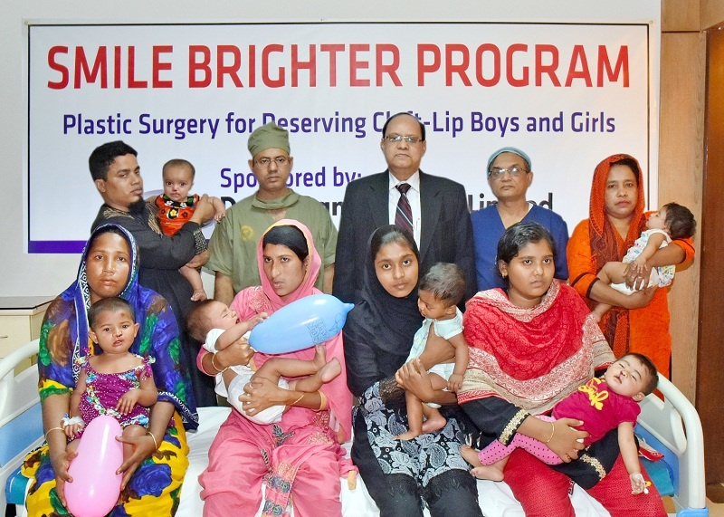

2.12 Education:
- DBBL has awarded a scholarship to 200 Brilliant and needy students every year.
- DBBL arranged a program for blind patients that named “Blind Education and Rehabilitation Organization (BERDO)”.
- DBBL has arranged free books donation for Bangabandhu Sheikh Mujib Medical University.
- DBBL has donated a Pick-up Van to Bangladesh Agricultural University for transport purpose.
- DBBL has arranged free books donation for Dhaka University Central Library.
- DBBL has arranged a program as a sponsor named “International Mathematical Olympiad-2006”.

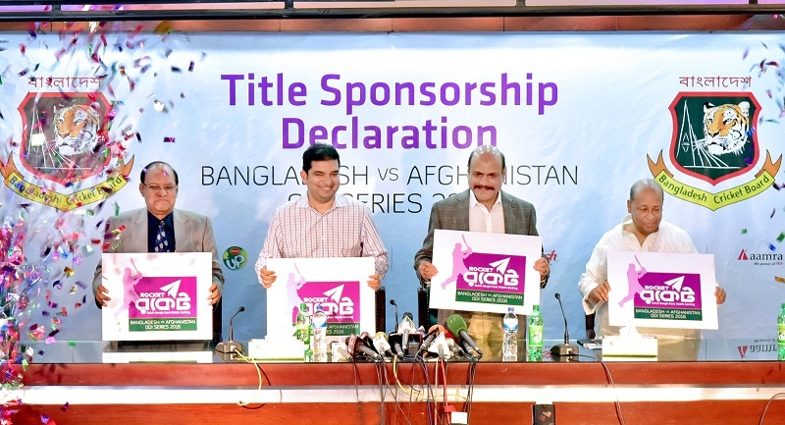

2.13 Information Technology:
Dutch-Bangla Bank Limited (DBBL) arranged a project named BASIS (Bangladesh Association of Software and Information Services) to award the best IT uses by Bangladeshi companies.
DBBL and BASIS organized IT award-giving ceremony in this regard that many companies will participate in this program and will be honored by achieving price. The Award Ceremony was held on 30th November 2005, which was the day before last day of BASIS SOFEXP02005 (November 27-December 01, 2005). This was a wonderful evening (with dinner and cultural program) attended by around 700 dignitaries including government high officials & policy makers, corporate heads, representatives from development agencies, IT policy makers, academicians, and the IT industry members.
In this regards, DBBL has contributed 50% for arranging this beautiful event with the estimated cost Taka. 6.25 Lac.

2.14 Disaster
DBBL has donated Taka. 25 lac for the devastating landslides in Chittagong. Mr. Md. Yeasin Ali, Managing Director of the Bank handed over a Payment Order of Tk. 25.00 lack (Taka Twenty Five Lac) to the Honorable Adviser Major General M. A. Matin at Chittagong Circuit House on June 13, 2007. He has given this money so that those victims get shelter on their bad day.

2.15 Donation
Donation to a different organization:
- DBBL has provided Taka.4 core for setting up a modem cancer hospital to Ahsania Mission Cancer Society.
- DBBL has donated Taka.1.20 core to build up a pediatric hospital to provide service to low-income people whose 30% will be free and rest will be at a low cost.
- DBBL has donated Taka.90 lack to kidney foundation for setting up Operation Theater for kidney diseases people.

Chapter 3: General Banking Activities

General Banking
Making a Profit is the primary target of every bank. But a bank does not produce any tangible product to sell nevertheless does offer a variety of financial services to customers.
General Banking Department is considered as the direct customer service center. It is the starting and main point of all the banking procedure to serve the customer. This department plays one of the most important roles in commercial banks. This department provides daily services, solve customer’s problem along with customer’s requirement of their service. Every day it receives deposits from the clients and meets their demand for cash by honoring cheques. It opens new accounts, remits funds, issues bank drafts and pays orders chequebooks, various ATM cards etc.
To establish a better understanding relationship between a banker and customer account opening is the first step. The opening of an account binds the Banker and customer into a contractual relationship. But the selection of customer for opening an account is very crucial for a Bank. Bank has to verify their customers by taking the personal interview as like talking to the customers in a personal way along with the document customer bring during account opening time.

3.1 Components of General Banking
General banking consists of the following sections in the branch. These are as follows:
- Account opening
- Account closing
- Deposits account
- Issuance of chequebook
- Payment order in cash or in account
- Issuance of Debit Card, master/visa card, credit card and solve the problems related with the customer.
- SMS alert Banking
- Internet Banking, 2FA
- Clearing cheques
- Provide foreign remittance services.
- Fund Transfer
- Credit Card Payment

3.2 The Procedures of Opening Account
It is said that bank deals and talks with the document. “NO DOCUMENT NO ACCOUNT”. By opening an account banker and customer create a contractual relationship. However, the selection of the customer for opening an account is very crucial for a bank. Dutch Bangla bank opens three types of account; savings account, student account & current or business account. Code number for a savings account is 151, the Code number for student account is 105 and Code number for current account is 110. There is another account called minor account and the code is 107. In DBBL many employees open salary account so that they can get their monthly salary by this account and the code number of this account is 103. There are also systems for an interest-free account and its code number is 112.
Before the opening of a Savings & current account, the following formalities must be completed by the client
- The applicant fills up the relevant application form along with necessary documents and photos in the prescribed manner.
- The applicant is required to fill up the specimen signature in the account opening form along with nominee signature.
- For individual information is needed by an account holder.
- The authorized officers examine the documents submitted.
- Issuance of slip and the deposit must be made in cash. Cash deposit should be minimum 500 taka.
- After depositing the cash account holder can take nexus debit card and can go for requisition of Chequebooks.
- After fulfilling all this steps account can be created.
Opening a Student account, formalities are same as a savings account but chequebook is not issued in this account. And in case of Current Account Company sill is must along with signatures. So whenever current account holder will come to DBBL for any general banking purpose he must have to bring with company sill with himself in some important term.

3.2a General requirement for opening Savings/Business Account:
There are few general rules for opening current or business account which is as follows:
- Account opening form to be filled in and signed by the account holders along with company seal in specific areas.
- Introduced by an existing account holder with signature, account number, branches, relationship with the account holder, mobile number or any other person acceptable to the bank.
- Two copies of recent passport size photographs of each account holders attested by the introducer. And NID card photocopy.
- One copy passport size photograph of nominee attested by the account holder. And NID card photocopy.
- Utility bill copy where the account holder is living.
- Trade License photocopy.
- If the account holder is operating his business by giving the rent of his business place then rent copy of those specific places is needed.
- TIN Certificate copy

3.2b Additional documents that required for opening accounts
The rules and regulations to open a new account may differ from person to person, depending on the type of account customer wishes to obtain. First of all, different of customers such as individual, joint, proprietorship, partnership, private limited company, public limited company, associations, club, societies, trusts etc. can open their various types of accounts according to their requirements which are as follows:

Individual and Joint Account:
- A copy of passport/ national ID card/ driving license/ office ID/ Word commissioner certificate, any ID acceptable to the bank.
- Attested photocopy of passport with visa for Foreign Currency Account.
- Joint account declaration form for the joint account.
- TIN Certificate.

Proprietorship Account:
- Declaration form of sole proprietorship from the bank must be filled up.
- TIN Certificate.
- Submission a copy of trade license.

Partnership Account:
- A copy of the registered partnership deed.
- Submission of a copy of the partnership deed.
- Association letter signed by all partners.
- Copy of trade license.
- Photocopy of company TIN
- List of partners with full address and phone number.

3.3 To close an Account:
- Account holder requires applying in a particular form with full signature along with account number.
- He/ she/ they must surrender the remaining chequebook and card issued by the bank.
- Verifying the signature and approved by the operational head.
- After fulfilling all this step account can be closed.

3.4 Deposits Account:
Dutch Bangla bank Deposits Accounts has two types. One is DPS (Deposit plus Scheme) where is periodically such as 3 years, 5 years and 10 years. And this interest rate is 5.96%. This is a very low-interest-rate other than Banks in Bangladesh. An additional requirement is one copy passport size photo and NID or driving license or passport copy to the account holder and nominee one copy photo with attested to the account holder and NID copy along with the signature of both account holder and nominee and obviously account holder must have to open a savings account. Then he/she open or create Deposit account.

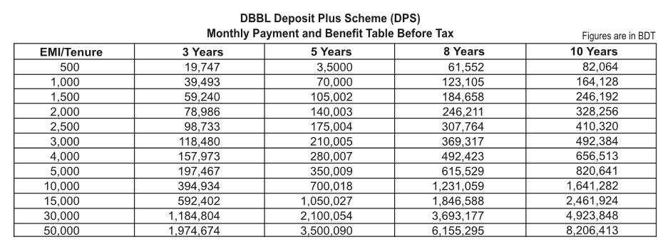
Another is Fixed Deposit Account (FDR) where is periodically such as 1 month, 3 months, 6 months, 1 year, 3 years, 5 years and 10 years. And this interest rate is fluctuating in periodically. Its Additional requirement is one copy passport size photo and NID or Driving license or passport copy to the account holder and nominee one copy photo with attested to the account holder and NID copy along with signatures of both account holder and nominee in some specific areas. Then he/she open or create Deposit account. She/he can use DBBL authorized Exchange House to receive remittance with 1% extra bonus. Biometric Fixed deposit is also available to the Dutch Bangla bank.

- Biometric Fixed Deposit (FDR) is a special type of Term Deposit product designed for the savers who are willing to deposit money for a specific time period.
- The customer can open Biometric FDR for Taka.10, 000/- and above amount for3, 6 & 12 months tenure.
- An attractive interest rate is offered for this product. The Biometric FDR will be opened by debiting the Biometric savings Account of the customer and at maturity principal amount along with maturity, the benefit will be credited to his/her Biometric Account.
- Cash transactions will not be allowed.
- For more details, please contact with nearest Agent points / DBBL Agent Banking Field offices/ dial DBBL Call Center (16216).

3.5 Issuance of Cheque Book:
1st Cheque book order must have to give at the mother branch where the account has been created, later the account holder’s signature verification or his duly authorized representative against proper acknowledgment. After ordering of chequebook can be collected by the account holder after four working days.
The In-Charge of the departmental stocks of Chequebooks will receive the request and allow entering the DCBIR (Departmental Chequebooks Issued Register), and separate register which are allotted for accounts Chequebooks of 20, 50, 100 pages; 20 pages for savings account and 50 pages for current account. While the opening of an account, the customer must have to sign a chequebook order slip. He/she will receive a chequebook only if the account opening form is found complete and authorized in all respects. The person IN-Charge enters the name and account number of the customer in the CBIR against the particular chequebook series and keeps a record on the computer. The order slip should be preserved as vouchers. And cheque requisition rate is 115 taka with VAT. This amount will be deducted from their own account.

Bank Issuance the new chequebook if everything is the right form

Requisition Slip occupied up accurately along with the account number

Banker Verifies the Slip

Enter the chequebook number in the register book of the specific customer name

The subsequent processes are upheld for issuing of a chequebook:
- In the beginning, the clients must have to fill up the chequebook order form.
- The officer In-Charge enters the name, and customers account number in the chequebook register.
- Then the officer In-Charge from the deposit department signs the register chequebook and the order slip.
After that, the customer receives the chequebook from the officer of the deposit department after the acknowledgment on the register book.

3.6 SMS Banking:
Dutch Bangla Bank launched SMS Banking services to provide immediate contact to client account information at any time. Any mobile phone operator having an account of Dutch Bangla Bank can get the service through the mobile phone upon registration. This service name called “SMS Alert Service”.
Advantages of SMS Banking:
- Quick control over the status of the account – the message regarding the transaction is received immediately.
- Dutch Bangla Bank SMS info service is available for both individuals and corporate clients and all cards issued by the bank.
- Avoid fraud – Fast information in the case of theft or the card is being used without proper authorization
- Unlimited messaging service received regardless of the number of transactions.
- Control over transactions made using a secondary card.
- Dutch Bangla Bank SMS Information service is available in place, in all areas covered by mobile operators having roaming agreements.

3.7 Internet Banking:
DBBL has happily introduced the service named as "Two Factor Authentication (2FA) Security Solutions” This protects customers account from unrecognized sources. This service has arranged for the advantage of internet banking and 3rd party fund switching within the DBBL account holder.
Only the 2FA registered customers can transfer the 3rd party fund transfer transaction by the use of Internet Banking System.
DBBL 2FA is an additional safety that offers an extra verification of your online transactions. This verification can be completed with the aid of the use of Secured ID Tokens. Using of Secured ID Tokens are very Tokens are very easy as entering a password, however, it's far very secured. You get a token which generates new password within every 60 seconds. You should combine that number with existing name and password to make a secured transaction the use of our web services. This new feature offers extra protection for your accounts. To make this easy transaction available we offer two kinds of tokens. These are Hardware and Software Token. If the customer wants to take software program token she/he must have to use android Smartphone and install additional software named “RSA Software”. This software enables to run the software token.

3.8 Clearing Section:
Clearing is a coordination through which a bank can gather customers fund from one financial institution to any other through a clearing residence. It is an area wherein the representatives of various banks get collectively to obtain and deliver cheque with another bank.
Usually, Bangladesh Bank plays the Clearinghouse in Dhaka, Chittagong, Rajshahi, Khulna, & Bogra where there is no department of Bangladesh Bank, Sonali Bank arranges this feature.
As far security is concerned client get crossed check for the transaction. The main motive of clearing section is to function with safety and protection of financial transaction of the economic instrument like DD, PO, Cheque on behalf of the clients via Bangladesh Bank Clearinghouse (BCH), Outside Bank Clearing (OBC), Inter-Branch Clearing (IBC). This section examines in the following manner:

- Whether the remunerating bank out of doors the Dhaka city.
- Then these cheques may be cleared by OBC, OBC stands for an Outward Bill For Collection. Whether the remunerating is their branch. These cheques can be cleared by OBC, OBC stands for an Outward Bill for Collection.
- Branch Bill for Collection).
Inward Clearing
When the Banks obtain cheque drawn on them from different banks within the clearinghouse, it is called Inward Clearing. When the cheques of its customers are received for collection from other banks, the following should be monitored very carefully,
- The cheque has to be crossed.
- The amount should be the same in both words and figure into the deposit slip and it needs to be adapted to the quantity mentioned in words and figures in the cheques as well.
- The cheque should not deliver a date older than the receiving date for extra than months.
- The collecting bank needs to test whether the endorsement is executed well or now not.
- Instrument (DD/Cheque /PO) comes from principle office.
- Entry in “Inward Register”.
- Checking inside the pc.
- Pay respective order register.
- Sign in the register by the authorized officer.
- Cancellation of the instrument.
- Send IBCA to Local Office for the honored instrument.
- Send return memo, displaying reason to the workplace for the dishonored instrument.

Outward Clearing
When the branches of a bank receive a cheque from its customers drawn on the other Banks within the local clearing zone for collection through Clearinghouse, it is called Outward Clearing. When particular branch collects the financial instruments like PO, DD, Cheque inside the Dhaka City and now not of their branch, then the Outward Clearing will be functional.
The strategies of outward clearing are as follows:

The strategies of outward clearing are as follows:
- The instruments with schedules to the principal in the event of any of Dutch Bangla Bank Ltd after issuing an Inter-Branch Debit Advice (IBDA).
- Clearing stamps must be attached to the instruments.
- The authorized signature endorses instruments.
- The consumer receives the obligation signed instruments and also branch code number affixed on the instruments.
- Entry in the Outward Clearing Register.
- Receipt of an instrument with paying in slip.
- Affixing of a seal.
- Special crossing seal.
- Clearing seal (Instrument & Paying in slip).
- Endorsement seal with signature.
- Separation of the instrument from paying in slip.
- Sorting of instrument bank wise and branch wise.
- Preparing for a schedule as per branch.
- Preparation banking program.
- Preparation of clearinghouse sheet.
- Details of the instruments and vouchers are recorded inside the “Outward Clearing” register.
- Sending instruments to the main branch with the schedule.

3.9 Remittance Section:

The word ‘Remittance’ means the distribution of cash from one place to another place through a post and transmits. Money- making banks represents this facility to its customers the usage of unloading money from one branch of the bank and making an easier arrangement for payment to another branch within the country.
The essential function of the remittance department is to transit the cash from one place to another place to reduce the risk associated with handling cash. I have learned the various mechanism of remitting fund. There are three ways of paying fund.
1. Payment Order (PO)
2. Demand Draft (DD)
3. Telegraphic Transfer (TT)

3.9a Payment Order

It is a non-negotiable acclaim file. It is normally used as a substitute for coins. It also can be recycled because of the safety of the loan. A bank concerns he pay-order in the time period of a quantified charge or correctly altercation of cash. For transmitting money, pay-order may be used as cheques where the customer of different banks can easily credit via clearing the pay-order.
This is the appliance allotted by the branch of a bank for permitting the customer to remuneration positive sum of money to the order of a character/ association/ branch/ place of work within the same clearinghouse area of the pay order-issuing branch.

Pay Order has various kinds of features:
- The issuing branch and the paying branch must have to be same.
- Application for payment within the clearinghouse area of the issuing branch.
- This may be open or can be crossed.

Procedures for Pay Order payments
- Examine genuinely of the pay order.
- Enter in to pay order register and provide access.
- Debit if the fund is ok for payment.

3.9b Demand Draft

Demand Draft is similar to the telegraphic transfer besides the usage of an application note for transferring money from branch to branch of Dutch Bangla Bank Ltd.
Demand Draft is a sort of invoice of exchange. It is the most commonly used way of inland remittance. It is a complete instruction of the bank to pay a positive sum of money from one branch to another branch as per application. While transferring the money safely from one city to another city, people use DD due to the fact that it is able to transfer the money between different branches of the same bank easily and fast
Issuing technique of Demand Draft:
- Acquiring a demand draft application form which is filled in appropriately and signed by the applicant.
- Receiving the amount of transfer as according to advice from the commission and postage charge.
- Enter in the D.D register.
- Issuing recommendation to the payee department.

Payment techniques of Demand Draft:
- Examine the demand draft normally, the amount, verify the signature, request, series, and many others.
- Enter in the demand draft payable register.
- Verifying with the IBCA (Inter Bank Credit Advice).

3.9c Telegraphic Transfer

Telegraphic Transfer is an instrument for transferring cash via a telephonic message or telex from one bank to alternative of unlike locality or from one branch to another branch of the altered place of the same bank. Mostly, it's an instruction from importer’s bank to the exporter’s bank or some different bank in the exporter’s country to a named person. And it’s no longer available now.
Telegraphic Transfer is the fastest and convenient but high priced method. There are exclusive sorts of telegraphic transfer which include Fax, Mobile, Telephone, Telex, and Telegram.

CHAPTER 4: DATA ANALYSIS

4.0 Introduction
Data were gathered through well-designed questionnaire from Dutch Bangla Bank Limited Panthapath Branch. In the total of 25 samples were accumulated for statistical analysis and respondents were employees of the bank. After collecting data, the result found that job satisfaction influencing the quality of work. In this study, descriptive statistics, ANOVA, T-test, and regression analysis have been conducted. Details data analysis outcome has provided below: This study constructed the conceptual model based on job satisfaction of employees and quality of work. Job satisfaction (JS) denoted as independent variable and quality of work (QW) denoted as a dependent variable. The objective of this study is to investigate the influence of job satisfaction on the quality of work. The conceptual model is as follows and one hypothesis is shown below:
H1: There is a positive relationship between job satisfaction and quality of work.
Quality of Work
Job satisfaction

Figure 1: Conceptual Model of Quality of Work

4.1 Demographic Information
According to Table 4, 64 percent male and 36 percent female respondents have participated in this study. Table 1 depicts that 52 percent of employees have 0 to 5 years experiences and 48 percent of employees have 6 to 9 years experiences. Table 2 demonstrates that 52 percent of employees are in the salary range of 20,000 to 50,000. Table 3 provides that 68 percent of employees are holding a MBA degree and only 4 percent are holding a BBA degree.
Frequency Table 1: Experience
Number of Years | Frequency | Percent | Cumulative Percent
0 to 5 years | 13 | 52.0 | 52.0
6 to 9 years | 12 | 48.0 | 100.0
Total | 25 | 100.0

Salary Range | Frequency | Percent | Valid Percent
20000-50000 | 13 | 52 | 52
51000-80000 | 12 | 48 | 48
Total | 25 | 100 | 100
Frequency Table 2: Salary

Frequency Table 3: Education
Degree | Frequency | Percent | Cumulative Percent
BSC | 1 | 4.0 | 4.0
MSC | 6 | 24.0 | 28.0
BBA | 1 | 4.0 | 32.0
MBA | 17 | 68.0 | 100.0
Total | 25 | 100.0

Frequency Table 4: Gender
Gender | Frequency | Percent | Cumulative Percent
Male | 16 | 64.0 | 64.0
Female | 9 | 36.0 | 100.0
Total | 25 | 100.0

4.2 Descriptive Analysis
According to Table 5, the study found that quality of work variable’s mean value is 3.40 which is indicating not very strong perception of respondents due to the poor level of job satisfaction. The mean value of job satisfaction is 3.22 which is a poor indication of employees’ perception.
Table 5: Descriptive Statistics
Variables | N | Minimum | Maximum | Mean
 | Statistics | Statistics | Statistics | Statistics
JS | 25 | 2.75 | 4.50 | 3.2250
QW | 25 | 2.80 | 4.80 | 3.4080
Valid N | 25

4.3 Analysis of Variance
Table 6 demonstrates that there is no mean difference among different levels of experience on quality of work because it is not significant at p < 0.05 level. Table 7 also demonstrates that there is no mean difference among different levels of education on quality of work because it is not significant at p < 0.05 level. Finally, Table 8 shows that there is no mean difference among various levels of salary ranges on quality of work.

Table 6: Experience
QW | Sum  of Squares | Df | Mean Squares | F | Sig
Between Groups | .461 | 1 | .461 | 2.837 | .106
Within Groups | 3.737 | 23 | .162
Total | 4.198 | 24

Table 7: Education
QW | Sum Of Squares | Df | Mean Squares | F | Sig
Between Groups | 1.026 | 3 | .342 | 2.265 | .111
Within Groups | 3.172 | 21 | .152
Total | 4.198 | 24

Table 8: Salary
QW | Sum  Of Squares | df | Mean Squares | F | Sig
Between Groups | .461 | 1 | .461 | 2.837 | .106
Within Groups | 3.737 | 23 | .162
Total | 4.198 | 24

Regression Analysis
Table 9 shows that job satisfaction explains 35.6 percent variation in quality of work because of adjusted R² is 0.356. The correlation of coefficient (R) is 0.619 that means there is a moderate relationship exists between job satisfaction and quality of work. The ANOVA Table 10 shows that F = 14.266 and it is significant at 0.001 level that means predictor job satisfaction has the power to predict the quality of work.
Table 9: Model Summary
Model | R | R Square | Adjusted R Square | Std. Error
1 | 0.619 | 0.383 | 0.356 | 0.3356
- Predictor: (constant), JS
- Dependent Variable: QW
Table 10: ANOVA
Model | Sum of Squares | Df | Mean Square | F | Sig.
Regression | 1.607 | 1 | 1.607 | 14.266 | .001
Residual | 2.591 | 23 | .113
Total | 4.198 | 24
A. Predictors: (Constant), JS
B. Dependent Variable: QW

Table 11: Coefficient
Model | Unstandardized Coefficient |  | Standardized  Coefficient | t | Sig. | Colinearity Statistics
Model | B | Std. Error | Beta | t | Sig. | Tolerance | VIF
(Constant)  JS | 1.297  .656 | .563  .173 | .619 | 2.303  3.777 | .031  .001 | 1.000 | 1.000
A. Dependent Variable: QW

According to Table 11, the study revealed that job satisfaction strongly influencing the quality of work because the β value is 0.619 and significant at 0.001level. Thus, H1 (hypothesis 1) is supported by the study.

CHAPTER FIVE: CONCLUSION & RECOMMENDATIONS

5.1 Conclusion

Dutch Bangla Bank Limited is one of the well-developed banks. It is committed to providing high- quality financial service to contribute to the growth of G.D.P. of the country. Dutch Bangla Bank Ltd is creating employment opportunity for educated youth, alleviating poverty and raising the standard of living of limited income group. The Bank has made tremendous progress, almost in every sphere of its activities. So there is a high possibility that in near future they will be one of the top-rated banks all over Bangladesh. Moreover, the study found that job satisfaction is positively influencing quality of work. F test also confirmed that job satisfaction is the right predictor of quality of work.

5.2 Recommendations
Few recommendations are listed below based on data analysis, which are critical success factors for this bank. These are as follows;
- Need to assess employees’ job satisfaction every year because it has a great impact on quality of work which is directly linked to productivity of the organization.
- Need to develop homely work environment and fair promotion policy.
- Need to develop quality culture through organizational justice.
- Need to ensure top level management commitment to improve service processes continuously.
- Top level management must expose their leadership towards qualitative improvement of the organization and they should focus on employees and systems.

