Internship report

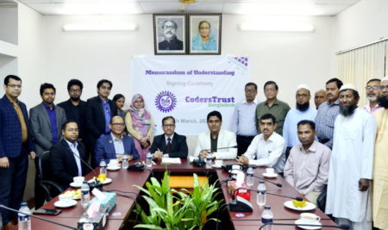

Md. Didarul Hossain Didar
CodersTrustBangladesh

Internship Report
Submitted to:
Dr. Seyama Sultana
Associate Professor
School of Business & Economics
United International University

Submitted by:
Md.Didarul Hossain Didar
ID: 111 151 298
Major in Marketing
Bachelor of Business Administration (BBA)


United International University
Date of submission
16thDecember, 2020

Letter of Transmittal

16th December, 2020
Dr. Seyama Sultana
Associate Professor
School of Business & Economics
United International University
Subject: Submission of internship report.

Dear Ma'am,
With due respect, I am presenting my internship report within the time you have given to me. I followed your all instruction to make this report where I tried to explain the activities of renowned freelancing training organization “coders trust Bangladesh”. All of those things are monitored by my own experience, attempt, and my supportive colleagues. This report is a principal part of my internship and I have attempted my best to take a shot at it with greatest consideration and genuinely to make it all the more edifying, satisfactory, functional and explicit just as much as could be expected under the circumstances.
I would like to express my thankfulness to you for your warm support and effort which encouraged me to do this report successfully. Thank you so much for your endless support. Some unintentionally mistakes may arise so I am expecting you earnest image will remain same for those mistakes.
Sincerely Yours,
___________________
Md. Didarul Hossain Didar
ID: 111 151 298
United International University

Acknowledgement

First of all, I would like to express my gratitude to Allah that he has given me enough patience and energy to make this report which in fundamental requirements for my internship program. During making this report I got complete honest direction, management and coordinated effort from the people of my organization.
I would like to share my warm appreciation from the bottom of my heart to the instructor of my internship program and the honorable faculty member of United International University and Dr. seyama sultana who was always available for supporting, co-operating, providing valuable advice which encouraged me a lot to do this report successfully. Her unreservedly behavior and motivation made me extra energetic to face all difficulties to make it happen.
I am so thankful to my team leader S.M Towsif Ahmed Nishan who provided me all the proper guidance that I have to do and maintain accordingly and also kept me in his observation. Also thankful to others colleagues farhana zaman, happy akter and specially Md Harun (business development executive) who trained me up and prepared me for the organization. Lastly I want to mention Md imtiaz ahmed (Head of business development) who inspired and motivated us to complete everything smoothly.
Finally, I would like to confess my gratitude to every member I worked with and praying for their longevity and prosperity.

Executive Summary

Internship is the final stage of completing graduation and I got that opportunity from renowned freelancing training organization coders trust Bangladesh under the supervision of my honorable faculty Dr. Seyama Sultana.
For being established in this competitive era people are looking for different ways and freelancing can be the strong hand for them. Coders trust Bangladesh is that organization who providing that platform to learn freelancing skills and how to use that properly. Learning freelancing ensures many extra privilege, earning extra money and being established in own way is the most major part of them. For ensuring that, Coder trust arranges several freelancing training course where people can learn what they need with a minimum amount of money. Though there are many freelancing organizations are working on that but coders trust one of them with huge good will. They also work on free women’s skills update program just to prove that women are also asset for the country and family support.
Between my 4 months’ internship period I learned lot of things which actually needs for any corporate organization and practical knowledge. I learned how to interact with corporate peoples, learned new software (ZOHO CRM) and office activities.

Table of Contents

Letter of Transmittal i
Acknowledgement ii
Executive Summary iii
1. CHAPTER I: 1
INTRODUCTION 1
1.1. Background of the Report 2
1.2. Objective of the Report 2
1.3. Motivation of the Report 3
1.4. Scope and limitation of the Report 4
1.5. Definition of key terms 5
2. CHAPTER II: 7
COMPANY AND INDUSTRY PREVIEW 7
2.1. Company Analysis 8
2.1.1 Overview and history 8
2.1.2 Mission and Vision: 11
2.1.3 Trend and growth 13
2.1.4 Customer mix 13
2.1.5 Services mix 13
2.1.6 Operations 14
2.1.7 SWOT analysis 17
2.2 Industry analysis: 22
2.2.1 Specification of the industry 22
2.2.2 Size, trend, maturity, of the industry 22
2.2.3 External economic factors 22
2.2.4 Technological factors 22
2.2.5 Barriers to entry 23
2.2.6 Supplier and Buyer power 23
2.2.7 Threat of Substitutes 23
2.2.8 Industry rivalry 23
3. CHAPTER III: 24
INTERNSHIP EXPERIENCE 24
3.1. Position, duties and responsibilities 25
3.2. Training 25
3.3. Contribution to department function 25
3.4. Evaluation 27
3.5. Skills applied 28
3.6. New skills developed 28
3.7. Application of academic knowledge 31
4. CHAPTER IV: 32
CONCLUSION AND KEY FACTS 32
4.1. Recommendations for improving operations 33
4.2. Conclusion 33
References vii

List of Figure:

Figure 1: Campuses of Coders Trust 10
Figure 2: Mission & Vision of Coders Trust 11
Figure 3: Offering Courses that Coders Trust offers 14
Figure 4: Organization Structure of Coders Trust 15
Figure 5: SWOT Analysis of Coders Trust 20

List of abbreviations

- CTBD : Coders Trust Bangladesh
- CRM : Customer Relationship Management
- UNDP : United Nations Development Program
- BTEB : Bangladesh Technical Education Board

CHAPTER I:

INTRODUCTION

Background of the Report

There is no doubt that internship is a great way to learn practical knowledge about corporate culture and physical experience in organization. The universe of work is rapidly moving for which every individual needs different skills to grow up their career and being established in future. Skills are requirement for continuous enrichment to serve continuous workflow of any organization. To improve the personal skills coders trust Bangladesh sets several own skill development program like digital marketing, graphic design, web design, web development, diploma in freelancing, python and others. These programs makes a person develop for their own career and also if some want to earn money by doing freelancing they can. But they need to find out the proper guideline to help them. All the processes are conducted through business development team, finance department, student’s affairs and HR department. As an intern I got the opportunity to know about all process through my team leader and supportive colleagues. Coders trust Bangladesh presented me the extension to have my internship program for three months.

Objective of the Report

The objectives of the report are to analysis a freelancing organization, how they operate their program towards students and build their freelancing career. Which is coders trust Bangladesh a part of coders trust Denmark based organization.

Specific Objective
The substance purposes of the report is showing and analyzing the overall company operation in Bangladesh.
- Report is about to break down the actual culture of Coders trust Bangladesh
- The others departments overview towards organization and students
- Learning about customer relationship management of coders trust Bangladesh
- Analyzing the uses of ZOHO CRM software in coders trust Bangladesh
- Analyzing the process of handling the all duties and achieving organizations goal

Broad Objective
- To consider the organization and their valuable commitment to their employees and students.
- Gaining the experience by fulfilling job duties as per company’s expectations.

Motivation of the Report

Bangladesh is a fast growing country but most of the people are not that much educated to set them in an organization. For that, there are some freelancing program which can easily learn by well or little educated people. It is also a way of earning without depending others. In Bangladesh job opportunity is decreasing day by day according to public demand. So if they can make their own ways by doing freelancing for their present or future career it would be also helpful for the government. Everyone is facing difficulties to manage or support their families for several issues where self skills program help them to come out from the situation. This is a stage for individuals willing to increase their skills to earn money through online and can do from home or any convenient place. The goal of Coders Trust BD is to change the social burden of education and youth joblessness into an "Investible Opportunity".

Scope and limitation of the Report

Scope of the report
The scope of the report is basically a skill update area which is covered by the organization including the strategy, process, technology and activities that the organization uses for oversee connections with existing and expected clients and employees. Company’s goal is to maintain long term relationship between organization and potential clients for creating value in significant markets. For that, they are providing after course service to ensure that the individual may learn properly from the organization and may suggest another to admit here and build their career. Customer loyalty is a great issue for the organization to extend their marketplace and performance. As many people are looking for their better career so definitely they grab the opportunity where proper services are given. In My report I focused on how the organization collect their potential customer and manage internal activities between employees.

Limitation of the study
Limitations are basically problems or difficulties during preparing the report which I had to face also. After getting all kind of support from my team leader and members I faced various limitations for preparing this report which are given below:
- Time was undoubtedly short for preparing this report on whole organization
- Some complicated issues were arise to find out the actual information of organization
- Mainly I worked on ZOHO CRM software which is used by many organizations and it’s quite difficult to explain the uses of CRM.
- It’s hard to explain how we were convince people to join our organization

Definition of key terms

Marketing:
Marketing is a process of creating value for the customers and build strong customer relationship by company for capturing the value from customers in returns.

Service marketing
Service marketing is basically consisting of seven factors which are used for before or after sales. Those are product, price, place, promotion, people, process and physical evidence.

Consumer Behavior
Consumer behavior is how they think about product, service or organization and how they make decision about their needs and what they want to buy.

Customer mix
Customer mix is the sales driven by a specific sort of client section communicated as a level of business' total sale.

Technological factors
Technological factors are being utilized for assessing accessible options concerning technological capacities.

Branding
Branding is a process creating and shaping a brand in consumers’ minds by giving a specific value of a product, service or organization.

CHAPTER II:

COMPANY AND INDUSTRY PREVIEW

Company Analysis

Coders trust is a global organization which create platform to work on generating income through online. They work on the people who want to update their abilities for participating in different activities and can earn money through online by working independently at home. The image of the worldwide labor force is changing quickly into an actually tirelessly advancing "gig economy". Occupations are turning out to be area autonomous and time-free as freelance job. If persons have the valuable skills, they do not need to be stacked in any kind of geographical boundaries, they can manage work by themselves over internet. Coders trust believe that life may change by the blessings of internet because internet is a borderless world where everyone has equal opportunities if they can grab. For that coders trust brought the opportunities to everyone which are learning area that everybody can learn. Here people can learn through online and people can earn through online.

Overview and history

CODERS TRUST BANGLADESH is financially supported by the Danish Global Development Agency or "Danida". Danida basically distribute microfinance and guideline to those students whose are from developing countries and want to make them expert in particular section of skills. The headquarter of coders trust is located in Copenhagen, Denmark and founded by four people Ferdinand Kearwolff, Jan-CayoFiebig, Asser Smidt, and Morten Lund.
Coders trust has established in Bangladesh November 2013, but it’s started operations from March 2015. Mr. Aziz ahmad established coders trust In Bangladesh who is a global business leader. He dreams about carrying education to the general population at a moderate expense so that everyone can overcome professional difficulties to face workforces and make themselves to organizational demands by learning digital skills. Coders trust sets standards where they ensure local workforce

can reach global needs by learning skills. They also believe that everyone can achieve the IT skills by their own ideas and innovative intentions (Bangladesh, 2020).



Currently coders trust has offices in 4 countries (Denmark, Bangladesh, USA, and Kosovo) but the operations of this organization over 11 different countries across Europe and Asia (India, Malaysia, Bhutan, Kosovo, Bangladesh, Iraq, Poland, Palestine, Honduras, Kenya, and Jordan). This is the only international skill development organization in Bangladesh that works on developing world wide recognized skills and currently they are offering 11 international courses. Mr. Ataul Goni Osmani is honorable Country Director of Coders trust Bangladesh (Bangladesh, 2020).

In Bangladesh coders trust operates four branches in Dhaka, They are:

Figure 1: Campuses of Coders Trust

It does not describe itself only as a technological company but also they have their own commitment to improve skills the people of developing and developed countries. They like to introduce themselves as a collector of global innovative creators.

Purposes of coders trust Bangladesh:
It also works like others it institutions but it has some different initiatives.
- Providing guidelines, solutions and information just to help the people who are actually want them as a successful person in their own career by developing online skills.
- Providing scholarship and financial support to the interested capable individuals.
- Providing after course service for long time just to ensure that people can learn properly to make them stable and serve the nation.

Mission and Vision:

Figure 2: Mission & Vision of Coders Trust

Mission (Bangladesh, Coders Trust Bangladesh, 2020):

- Be the best by providing solution to develop and digitalized nation
- Be the great career consultancy institution
- Be the world class skill development organization
- Be unique than other freelancing solution providers
- To make effective educational organization with the minimal price and great quality
- Conquer the challenge of unemployment

Vision:
Paid education and equal opportunities are not available in many countries, especially in developing countries where millions of people are denied to access education. Coders Trust believes in a society and country development having the motto as “Learn a skill, make a living”. Investing in the education of our youth is something beneficial for everyone, they believe as a skill development training center in Bangladesh. The local and freelance market will get more skilled People, students of coders trust will find their earning ways, coders trust also can earn by increasing their service to more people (Bangladesh, Coders Trust Bangladesh, 2020).
- Overcome the obstacles to make skill development freelancing education & training available for any kind of people to financial improvements
- Overcome the challenge of unemployment and make them capable for local job markets and others international freelancing website like Up-work, Fiber, people per hour etc.

Coders trust is open platform for all kind of people but it works among the young generation to expand their career opportunities in online market place with more incomes and allocate their financial stability.

Trend and growth

Coders trust Bangladesh is gradually rising in market place. But they are few steps forward rather than other competitors just because of their quality education with reasonable price, training policy and after course support. Coders trust Bangladesh also planning to launch new courses and them starting a free skill up course for women.

Customer mix
Coders trust is basically a platform where people can increase their abilities and can earn through online. When it’s started operations in Bangladesh their ultimate Customers are Bangladeshi people. Here every people can do whose are from different sectors and different educational background. They just need to have the basic idea of using computer. Though our main customer is Bangladeshi people but also a lot of Bangladeshi people are doing course from all over the world through online.

Services mix
Coders trust Bangladesh arrange those service which are demanding for freelancing market place and they form the course content according to number of classes.

Figure 3: Offering Courses that Coders Trust offers

For short course they take 15 days and for broad course they take around 3 months.

Operations

Coders trust Bangladesh started their operation with little amount of people but day by day employees are increasing with the number of courses.

Team contributions:
They form several teams based on work categories. Every team is helping hand for another team. They have focused to improve the organization’s level.
- Organization culture
- Business develop team
- Consultancy team
- Department team
- Branch team
- Service delivery team
- Marketing team

Figure 4: Organization Structure of Coders Trust

Business development department

Business development department is the most challenging department is coders trust Bangladesh. Every employee of this department has to do multiple tasks from their job duties along with other departments. They provide all information and counseling to the potential customers and has to prove why an individual should do a particular training with proper examples, contents and facilities. They have to do documentation all the information, financial statement and other according to customer’s words.

Accounts department
This department handles all kind of financial issues for the organization. This team support coders trust Bangladesh by providing Billing, salary, every kind of financial statements, compensations of employees and so on.

Student’s affairs
Student’s affairs are mainly work for maintaining the admission of students, class schedule, Batch, providing solution of all troubles according to student’s demand. They also provide admission document to students and keep record for organization and future query.

IT (Information technology)
IT section always provides digital service to the employees and students for smoothing the process and operations like website solutions, update, organizational support and others.

Digital marketing department
Marketing is undoubtedly important for any organization and digital marketing contributes tremendously for the organization especially in this era. Our digital marketing team also doing the same thing for coders trusts Bangladesh. They are promoting the organization, providing Ads through social media and other online platforms where people can know about coders trust Bangladesh.

Human resource
Human resource is heart of the organization. The maintain employees all activities, recruiting, leaving according to the rules and regulations of organization.

SWOT analysis

SWOT analysis is the way of findings company’s strength, weakness, opportunities and threads. It helps the organization to know current position and panning for future. Before exploring new initiatives or actions, SWOT analysis should be completed. SWOT analysis objectives are to get a proper guideline for current issues and future actions about internal and external factors.
Coders Trust Bangladesh can also do SWOT analysis before applying new strategy for assessing internal and external position.

Strengths of Coders trust Bangladesh:

- Organization’s culture:
Coders trust Bangladesh ensures pure organizational culture. Here every employee is motivated by the culture of organization to be helpful and co-operative to others. Here employees are warmly accepted to do task out of the job responsibilities for developing the organization and helping other team. That boosts employees to provide 100% effort.

- International organization:
Coders trust is an international organization which carries additional benefits in this country. People may easily rely on this organization for better output.

- Strong management system:
As an international organization coders trust has to maintain their best quality. And for maintaining the quality they have strong management system whose are able to manage employees and customers.

- Expertise:
Coders trust has lot of expertise employees who can handle different types of trouble situation. As here everyone work together tough situation become easier with proper guideline and actions. Coders trust also has many expert mentors to provide proper knowledge and training to the students.

- Higher student success rate:
The vital strengths of coders trust is their success ratio comparatively other than similar technical training organization. As mentioned earlier they strictly maintain the quality service and for that they reach the success. They have strong mentor support, strong management system and proper student support helps to accomplish this. People who got training from coder trust, they can earn so early from online and get path to make their career.

- Approved by BTEB
Coders trust Bangladesh is more than a freelancing training organization. It’s approved by the Bangladesh Technical Education Board (BTEB), the wing of Bangladesh government under the ministry of education.

Weakness of Coders trusts Bangladesh:
Weakness is a lack of some potential resource or process which should be include in business strategy or operations.

- Dropout rate of students:
Sometimes coders trust has to face high dropout ratio of students for their barriers, financial and family problems. Due to lack of interest some people admit here but they dong last long.

- Limitations of courses:
Some courses are not allowed for all at the beginning because for doing those course people need to have some mandatory knowledge of that subject. So some prerequisite course must has to be done.

- Locations:
As an international organization lot of people wants to join here to get better training but all branches of coders trust is located in Dhaka. It’s become trouble to get the service for outsiders of Dhaka.

Figure 5: SWOT Analysis of Coders Trust

Opportunities of Coders trust Bangladesh:
Opportunity defines finding new potential steps to extend the business for short or long run benefits.

Offering new course:
Coders trust may take a new opportunity by offering new general skill development course for people from every sector. At the current level coders trust launch some advance course for higher or progressed knowledge.

Online facilities:
Current world is running through online based work. Coders trust also may take this chance to get more benefits. A lot of people cannot join here due to regional problems so when they get the chance to do course in online they can increase their Skills from anywhere in the world. Off campus training is not available in Bangladesh yet that much, so if they start they may get fast mover advantages.

Increasing branches:
Coders trust has only four branches in Dhaka city. So they can expand their organization through increasing branches all over the country so that other regional people can also get service from here.

Threats of Coders trust Bangladesh:
Threats are outer component that can influence an organization's performance and also can be burden for long run prosperity.

Competitors:
There are so many skills development organizations are opening in Bangladesh which are not enough standard. For those coders trust may face financial trouble as the people are admitting there.

Economical condition:
Economic stability is important for new learning. Most of the people in our country are lives in below poverty line or middle class. So sometimes it’s difficult to spend money for new something.

Industry analysis:

Specification of the industry
Coders trust is a freelancing training organization where people can learn extra skills out of the box can share with others and also can generate money through providing service. Coders trust also work in BB service where they provide training employees of organization. It also help people to develop their skills in a specific sectors.

Size, trend, maturity, of the industry
Size of coders trust is massive globally but coders trust Bangladesh is medium size organization which expanding day by day. Trend is rising gradually in Bangladesh day by day. Coders trust is very well known in Bangladesh as a freelancing training organization just because of their education method and high success ratio.

External economic factors
Massive training center can settle their business through providing service to other organization. In Bangladesh freelancer were unrecognized but present government started providing their own identification as they are contributing in GDP.

Technological factors
Technological factors are more important to do something new. For doing freelancing people need just a computer with internet connection to connect clients. Specially freelancing training organization knows how to use technology properly to get the best output in short period of time.

Barriers to entry
For the entrance of this sector people needs to be more skillful knowledge about the organization and big capital to settle down.

Supplier and Buyer power
In freelancing work relationship between supplier and customer are not visible. They contact through online, provide through online and also transaction happen in online. As coders trust is training organization they provide service through offline and online. Students can communicate any time over online or offline.

Threat of Substitutes
Freelancing is getting popular all over the world. And its demand is growing day by day. So many organizations are trying to rise up. Government also helping freelancing institutions to reduce unemployment of Bangladesh. So it is going to be very competitive near future.

Industry rivalry
As freelancing demand is growing up now a day so many organizations are trying to expand their business by adding several programs without ensuring quality. For that good organizations are take positions of protest against them. For long term relationship organization should be devoted to clients.

CHAPTER III:

INTERNSHIP EXPERIENCE

Position, duties and responsibilities

I have done four months as a business development intern in coders trust Bangladesh. Where I managed sales, documentation, admission process and others data related activities. My responsible was selling freelancing course through providing proper benefits of that. After admitting I was also responsible for their every support and needs that fulfilled by organization.

Training

My team leader SM Tawsif ahmed nishan (Head of Dhanmondi branch) supported me to learn every stage of learning. I also learned how to use ZOHO CRM software from Md. Harun (business development executive). Also got support from other team members. They trained me almost 1 month just to ensure the quality which I would provide clients.

Contribution to department function

Service of sales and admission:
Here organization communicates directly with clients to provide proper information. People can clear their all queries by coming to office or call over phone. If someone interested to admit here they also can do that online or offline.

Business development:
This is the most important department of coder trust Bangladesh. This is heart of the organization. They have to manage everything from the beginning of admission to end. Where we used to precede all documents and get them easy. They do:

- Promote every freelancing course and make sell strategy
- Maintain relationship and communication with old and new potential clients
- Also maintain communication within the organization to resolve any issue
- Admitting clients and documentation their information
- Financial transaction

Data collection method:
For example, in ZOHO CRM we found all generated data which provided by team leader and We contact everyone to provide information and do documentation of their data with proper analysis.

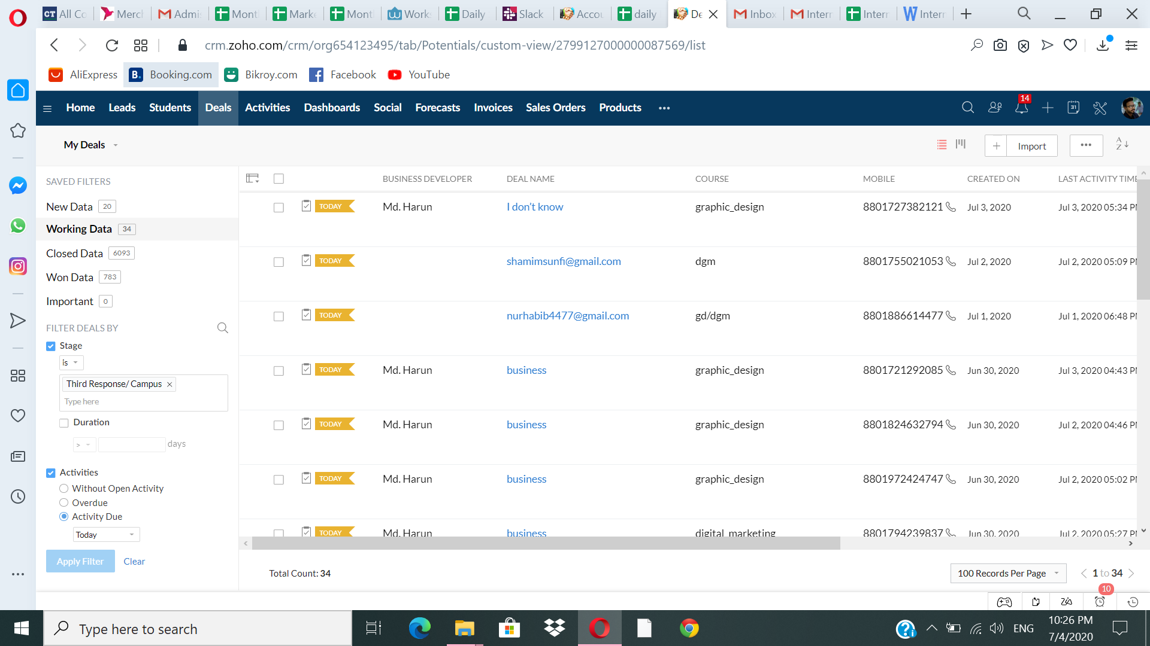

Follow-up:
After interacting clients, they provide a possible date to admit and we select that date on our follow-up list which reminds to contact those clients.

Admission:
After getting payment from clients we input their updates in leads like adding section, time, clearance and others.

Collaboration with student affairs team:
After admission if they face any problems beyond our access, we contact student affairs to resolve that issues.

Other activities:

- Daily report had to show to my team leader
- Attending meeting for two times in a day through zoom
- Also got much advice from seniors and after applying had to provide feedback.

Evaluation
Coders trust always concern about quality. Am I doing well or not for that they used to take a small viva after a certain period of time how I use my software and how I interact with people. If something wrong they helped me to correct.

Skills applied
As this is training organization so I had to convince people for doing any course. For that I had to absorb all content of courses so that people can get to know properly. My communication skills help me a lot. As we had to documentation all record so computer skills also helped in a proper way.

New skills developed

ZOHO CRM software

Customer relationship management (CRM) is software which is used for getting technical support. This software helps to maintain communication with customers in an effective way where possibilities of error are zero. Specially for keeping the record of customer’s data and information in sales and service industry CRM is great way to use.
Customer relationship management is very important to maintain for any organization. CRM helps to any employer to get easier way to maintain effective contact to current and future potential buyer. In coders trust Bangladesh, primarily they collect all students’ documents or proper information from website, face book and registration list and create data base in ZOHO CRM. Such as:
- Collect basic information from different sectors (name, phone number, email, interested course)
- Create CRM file
- Update information regularly after interaction

In coders trust Bangladesh I had to do documentations of all record provided by present and potential customers and CRM helped. Those are:

- Artificial intelligence
- Documentations
- Follow-up
- Data restore
- Fixing schedule
- Transaction record
- Agreement deed
- Customers information and demand

Here is some picture of ZOHO CRM

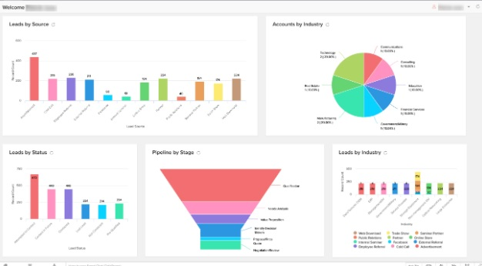

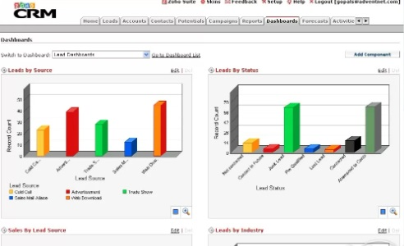

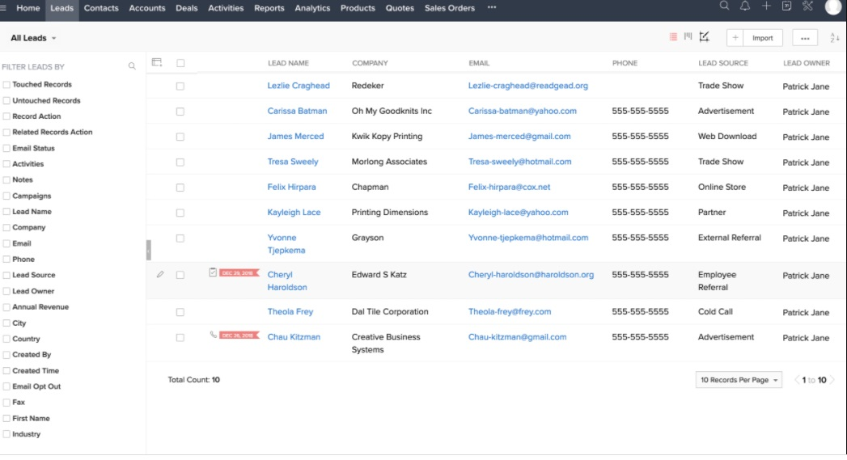

Application of academic knowledge

My academic knowledge helped me a lot to cope-up with the job duties. My computer skills, business communication, consumer behavior knowledge, office word everything supported me.

CHAPTER IV:

CONCLUSION AND KEY FACTS

Recommendations for improving operations

- Coders trust can increase number of course which are demanding for coming future.
- They can increase their branches all over the Bangladesh so that people can get it easily.
- They should grab all opportunities according to SWOT analysis.
- Sometimes they can do campaign in different universities and organizations to let people know about this.

Conclusion

Coders trust Bangladesh is a fast growing freelancing training organization which established in Bangladesh in 2013 and started work from 2015. Now a day’s freelancing has huge demand to the people for extra earnings and build career in a different ways. As the ratio of unemployment of Bangladesh is high so it’s very difficult to get a job for major amount of people. When they can learn some specific knowledge or skills, they can work for any organization or people from national or international as a freelancer. That is also helps to the people and government as well.
Coders trust is trying to provide that platform where people can use their knowledge and learn demanding skills to apply in career. As an international organization coders trust always concern their quality. For that they are improving their methods and course content. People’s success rate is comparatively pretty high among the competitors. Finally, throughout this report I want to say coders trust has multifunctional department which work for the same goals. I also learned many things in my internship period which were enjoying, interesting and challenging.

References
Bangladesh, C. T. (2020, November 22). Coders Trust Bangladesh. Retrieved from coderstrustbd web site: https://coderstrustbd.com/about-coderstrustbangladesh/
Bangladesh, C. T. (2020, November 20). Coders Trust Bangladesh. Retrieved from Coders Trust Bangladesh web site: https://coderstrustbd.com/about-coderstrustbangladesh/

- https://academy.coderstrust.com/
- https://www.facebook.com/coderstrustbangladesh
- https://www.youtube.com/channel/UC-87-uUgQ2G779xaBSeuMLA

