

United International University
Internship report
On
Customer Service and the Resulting Customer Satisfaction of Let’s Go Mart
Course code: INT 4399 (A)

Submitted to:
Muhammad Hasan Al-Mamun
Assistant Professor
School of Business and Economics
United international University(UIU)

Submitted by:
Mehedi Hasan
ID: 111 162 132
BBA Program, School of Business and Economics
United International University(UIU)

Internship report

on

Customer Service and the Resulting Customer Satisfaction of Let’s Go Mart


Letter Of Transmittal
June 01, 2022
Muhammad Hasan Al-Mamun
Assistant Professor, School of Business and Economics,
United international University(UIU)

Subject: Submission of internship Report.

Dear Sir,
This is my incredible joy to present the entry level position report of my 3-months temporary job program in Let’s Go Tech Ltd. in the customer service &the customer satisfaction under Marketing Department. in Banani. This report has been arranged to satisfy the necessities of my entry level position program in Let's Go Mart. I’ve invested my best energy to make this report a productive one. However, this has been obviously a great opportunity of learning.
I'm grateful to you for your rules, ideas for setting up this report. I genuinely trust that you would appreciate finding out with regards to the association and its buyers.
Regards,
Mehedi Hasan
ID: 111 162 132, BBA Program,
School of Business and Economics
United International University (UIU)

Acknowledgement
This report is a summation of many individuals' undertaking and opinions. However, toward the starting I might want to pass my earnest appreciation on to all-powerful Allah for empowering me the strength to complete the responsibility inside the stipulated time. Then, at that point, I like to offer my genuine thanks to every individual who contributed towards getting ready and making this report effectively. The experience and information acquired at Let's Go Mart assisted me to understand various aspects of real-world business. Any sort of remarks or ideas with respect to this will be exceptionally valued.
Executive Summary

My internship report is about the customer service and the resulting customer satisfaction of Let’s Go Mart (e-commerce) where I’ve worked for a period of 3 months. The report is the basically concerned with clarification of the tasks undertaken by the client support department of the aforesaid organization and the evaluation of the resulting level of customer satisfaction.
The objectives pursued in this report include explaining the promotional efforts of the organization to convince the target market to purchase their market offerings and examining the resulting customer satisfaction regarding marketing efforts and offerings. Great efforts have been made to clarify the consumer behavior of the target market, service quality perception, and customer satisfaction.
A survey was conducted to uncover customer perception regarding service quality and other related issues, and their level of satisfaction. The study was conducted on the basis of the responses collected from 100 respondents who are frequently purchasing products and/or services from online platforms. Care has been taken to ensure that the collected sample resembles the target market in terms of gender, age, and demographic and behavioral patterns.
The most frequently purchasers were found to come from the age range 21 to 30. But no significant differences were found across the gender. Most of the purchasers in this e-commerce site were found to come from the income level of more than 1,00,000 BDT per month. In an average, a regular customer of Let’s Go Mart purchases for the value 20,000 to75,000 BDT per month. The most sought-after products were found to be Bikes and Autos, Home appliances, Tickets, Food, Books, Electronics, Shoes etc. It was also found that customer purchasing from this e-commerce site value fast transection, home delivery, and delivery of the promised products on time. It was also found that 34 percent of the current customers prefer online and/or mobile payment system but the majority of the customers still prefer cash-on-delivery. Let’s Go Mart always tries to make sure that the ordered products are delivered within 2 to 3 days inside Dhaka, and 4 to 5 days outside Dhaka. A significant majority of the customers (almost 68 percent) are reported to be satisfied with the overall service quality of Let’s Go Mart.
Keywords: Customer Satisfaction, e-commerce
Contents
Introduction 1
Ecommerce 1
Company Overview 5
Types of Business model they are following: 6
Industry Perspective 8
Market insight 9
Objectives of the Report 11
Broad Objective: 11
Specific Objectives: 12
Background of the study 12
Methodology: 12
Marketing mix of Let’s Go Mart 13
Product 13
Price 14
Place 14
Promotion 15
The Findings of the study 17
Respondents (Age) 17
Respondents (Sex) 18
Respondents (Occupation) 18
Respondents (Income level) 19
Respondent frequency of online shopping 19
Money spent behind online shopping per month 20
Products usually bought online 21
The respondents opt for E-commerce (When?) 22
For what reason respondents are attracted to e-commerce websites 22
Consumer’s medium of payment 23
Product/Services Delivery time 24
Consumers most trusted e-commerce website 25
E-commerce in Bangladesh 27
Consumer Perception 27
Consumer Perception Theory 27
Next Big Thing in Retailing in Bangladesh 28
Perception towards Organization 29
User feedback 29
Advantages of E-commerce 32
Disadvantages of E-commerce 32
Recommendations 33
Conclusion 34
References vi

Introduction

In our country, like 10 years back from now, we didn't think about purchasing or requesting or buying anything from online sites or on the web. In any case, at present the situation has completely changed. This occurred because of the improvement of innovation as well concerning a novel idea, E-business. Online business was started 40 years earlier with expectation of client interest and more looking for after consumer loyalty.

Some facets of e-commerce operations are:
- Payment system
- On-request-printing
- Online shopping
- Online banking
- Video chatting (like phones or work stations)
- Electronic tickets
- Instant messaging
- Pre-book/Pre-order
- Digital Wallet etc.

Ecommerce

‘Ecommerce or Web-based business’ is the assistance of trading things or organizations through having PC associations, similar to the Internet. E-commerce involves trading over online platforms with the communication between the customers the site-owners. Majority of the businesses online are being conducted in the World Wide Web.

Web-based-business run by the Let's Go Mart involves various aspects:
• Business-to-business purchasing/selling
• Web-based shopping websites
• Conveying on the web-commercial centers
• Gathering data through web contacts and electronic media too
• Business-to-Business (B2B) electronic information exchange
• Promoting by email
Let’s GO Mart is an online business platform arranging itself to transform into the market leader position in the e-commerce business in Bangladesh focusing on customer care, quality service, hassle-free transaction, and the delivery of the ordered products on time with the facility of payment-on-delivery option.
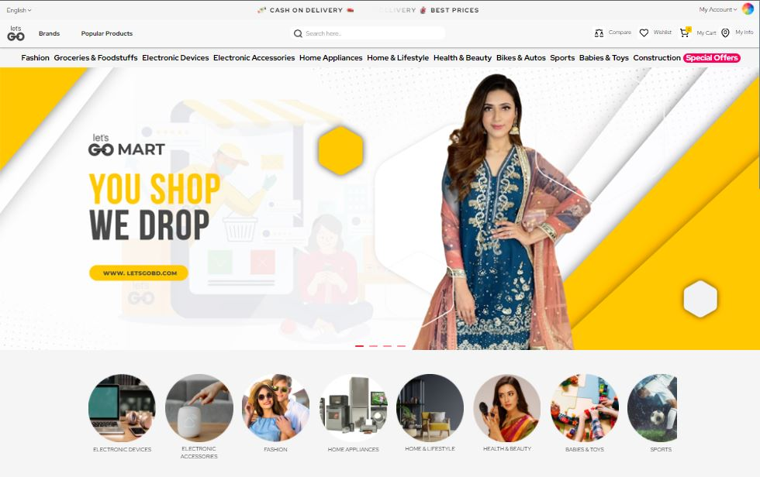

The company offers a B2B and a B2C answer for online shoppers and buyers of physical, durable items initially and later add different types of services to increase revenue. The company utilizes the platform to bring common and uncommon things for buyers. It guarantees consumer loyalty and invigorate rehash deals, while offering buyers a helpful, unified web-based area to purchase and guarantee returns. According to the available statistics, Bangladesh has got in excess of 900 internet-based dealers. The web-based stages till date couldn't assemble full confidence on their dealers. Let’s GO Mart will work for that belief and set up a good foundation for itself as a dependable web-based stage to its clients.
They have come up with lots of categories (almost 17000+ products) like:
- Fashion
- Beauty& Health
- Electronic Devices
- Electronic Accessories
- Lifestyle & Home appliances
- Groceries & Foodstuffs
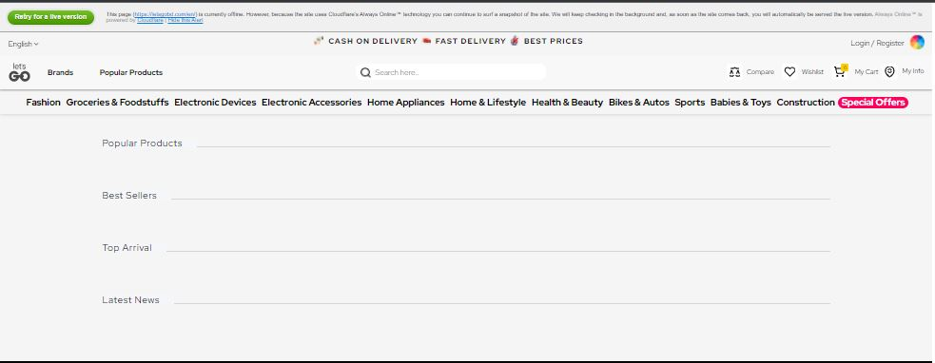
- Baby products & Baby toys

- Home & Appliances
- Sports
- Bikes & Autos
- Others
- Special offers’
- Construction
- Mega TV offers etc.

Company Overview

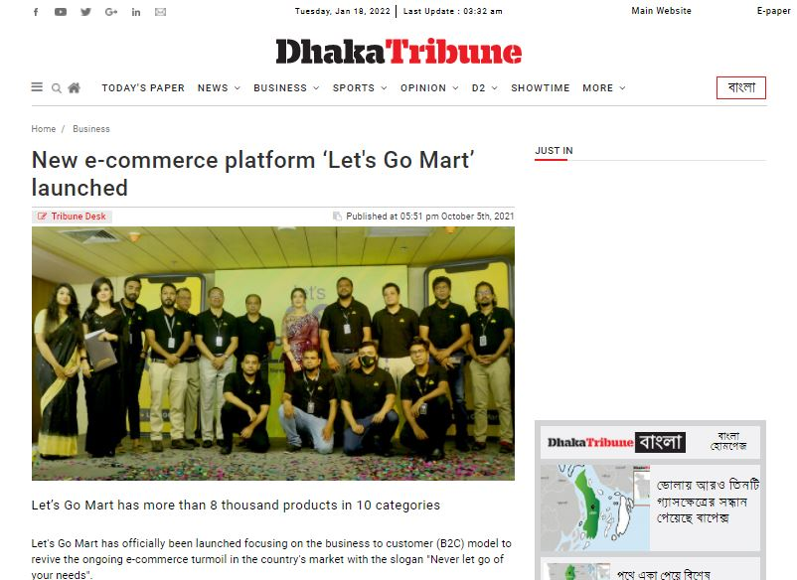
Let’s Go Tech Ltd is a privately owned business enlisted under the Companies Act in 1994. It began its journey on February 11 of every 2018. Let’s GO Mart is a sister concern of of Let's GO Tech Ltd. Let’s Go Mart is an internet business platform with dreams to transform into the market leader in presenting on web sellers and shoppers a commercial center and a simple way to deal and buy.(Dhaka Tribune, 2021)

The organization began its online business with a business launching program at AHM Mahmudul Haque Auditorium at the Daily Star Center in the capital on October 5, as indicated by an official statement.(The Daily Star, 2021)
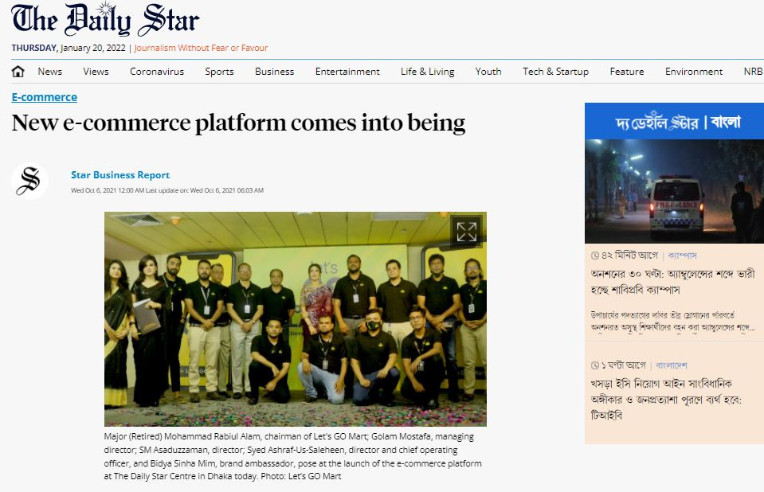

Types of Business model they are following:

- Business-to-Business (B2B): Business-to-Business (B2B) online business facilitates the transaction between or among the interested businesses through platform owned by a third party.
- Business-to-Consumer (B2C): The B2C business, on the other hand is concerned with facilitating making the platform for the interested businesses to sell to the ultimate customers through a third-party owned platform.(Big Commerce, 2021)

Administrator of Let's GO Mart Major (Retd.) Mohammad Rabiul Alam; Managing Director Golam Mostafa; Director SM Asaduzzaman; Director and Chief Operating Officer Syed Ashraf-Us-Saleheen; senior authorities of the association and Brand Ambassador Bidya Sinha Mim were available at the business launching function.
Golam Mostafa said: "Let’s Go Mart will presently give quality items with the objective of making it more straightforward, bother-free system that allowed to get items in the quickest time workable for the clients in the current internet business industry of the country."
He added: " The workforce working for this organization is striving hard to ensure the quickest possible service delivery of the ordered products and services. This company will help customers all over the country to place their order with their own mobile devices with their preferred mode of businesses. The general exercises of Let's GO Mart will be administered by the 'You Shop We Drop' strategy."
Then, at that point, the organization's Chief Operating Officer (COO) Syed Ashraf-Us-Saleheen, said: "Each Business has its own eco-framework, the better the business eco-framework is the more maintainable the business climate will be. As of now, shakiness exists in the environment of the online business industry in Bangladesh and we will work with our partners to beat this internet business emergency."
He added: "In our web-based business platform, we will be straight-forwarded all of the time to support buyers and buyer vendors to carry on with work in the correct manner. This will assume a solid part in restoring the internet business industry in the country. At the end of the day, we will 'Restore' and feature the center idea of this internet business industry. Simultaneously, through this web-based business, we will keep on attempting to help the country's new business people to get by in the cutthroat market and make more business people. (The Daily Star, 2021)
“Customers do not have to pay any advance to purchase from Let’s Go Mart”

Industry Perspective

Bangladesh, as well as for all of the countries on the planet earth, is confronting lockdown/closure because of the flare-up of Coronavirus. Economies are dialing back; individuals are losing their employment and countless lower-pay individuals are going into outrageous dire circumstances. Web-based-business organizations are additionally confronting difficulties because of limitation on transportation and dread among certain shoppers of getting tainted by the delivery men.


Internet business locales moreover failed to source things at first as all of the shops were closed down. Particularly, IT accessories, health care products, dairy products, home appliances, cleaning materials, and sanitizers were in great demand. More and more customers were opting for buying products and services online rather than buying them in person. As a result, the number of customer was increasing dramatically during the pandemic. In Bangladesh as we as a whole are going through an undesirable predicament and are battling ordinarily with this pandemic circumstance, individuals are showing additional interests on buying from online as opposed to visiting the market. Before they needed to go to advertised shop and pick and buy and afterward carry that to their homes. In any case, during lockdown individuals for the most parts are pondering their security and by web-based buying the orders are put to their doorsteps, and they can check it quickly prior to paying for their arranged item. Let’s Go Mart major competitors are chaldal, Direct Fresh, Khaas Food, meenaclick and other similar online-based business platforms. However other major players include pathao, shohoz, Uber Eats, and Foodpanda.
Because of the pandemic, a few new products were in demand. They include face masks, plastic head protective head-gears, PPE, security goggles, and sanitizers and so on.
In the staple retail internet business market, Direct Fresh, Chaldal.com, Meena-click, Khass food and so forth were flourishing before the pandemic. In the underlying phase of the lockdown, they got an enormous number of requests however they were missing the opportunity to make delivery of all the products ordered. Much of the time, they needed to limit their day by day arrangement and at times, they required over one day to deliver the items ordered.
At that stage in the staple retail online business market, new players entered. Pathao, Shohoz, Uber, Foodpanda four significant food delivery specialist organizations began to deliver staple items.

They followed alongside super shops like Meena Bazar, Shwapno and other nearby staple shops. Their delivery time is additionally quicker than most other online platforms. As a rule, they delivered inside 35 to 45 minutes as they focused client to client living near their premises. Indeed, even Othoba.com, Priyoshop.com, Ajkerdeal.com, Daraz who were typically other types of online business platforms began including staple products in their online sites. (Wikipedia, 2022)

Market insight
According to a market insider, the web based essential food thing business focus is experiencing twofold digits improvement in the number of delivery. For example, Chaldalʼs consistently number of solicitations is growing at an astounding rate every day. As Let's Go Mart is a startup business and they are following the current many E-commerce same framework, they are focusing on those factors those are fundamentally preferred by the clients.
Along these lines, the box size per demand has extended as a result of the lockdown. They said per demand size has become for all intents and purposes twofold than the past situation. In view of the pandemic, the online business market could experience significant traffic and simultaneously, the market is little small. The Bangladeshi retail staple market size is around BDT1,01,000 crore every year, and the as a rule web-based business is around BDT 8,500 crore where retail is just a part.(Statista, 2021)

Objectives of the Report
The primary objective of this report is to discover the workings of web-based business organizations in Bangladesh. Determining from Facebook pages of a few organizations obviously shoppers are not that much content with the assistance they receive from the internet-based shops or web-based business organizations.
There are several issues of consumers thinking about an Ecommerce, for example:
- Lower/poor customer services
- Lower/poor after sales services
- Lower/Poor quality products
- Little bit higher price than the offline shops
- Delivery time issues etc.
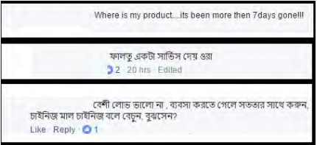
The basic objective can be classified into 2 types:
i. Broad Objective
ii. Specific Objective

Broad Objective:
The overriding objective of this report is to evaluate the customers perception of various aspects of online businesses in the context of Bangladesh. But at a more specific level, such evaluation will be made for the Let’s Go Mart.

Specific Objectives:

The following specific objectives were pursued in the preparation of this report:
[1] To evaluate the relative importance of various factors affecting the customers’ purchase decisions online. Such evaluation will be generalized to the company level for Let’s Go Mart.
[2] To examine the demographic and behavioral patterns the existing or current customers base of Let’s Go Mart.
[3] To determine the level of customer satisfaction of the current or existing and/or regular customers of the company: Let’s Go Mart.

Background of the study
With all the progress of web workplaces in our country, online trades have become more commonplace for the Bangladeshis. The straightforwardness of trade, less time usage, fast-delivery etc. are a set of purposes behind the fact that electronic business is getting notable among the mass people no doubt. As needs be, in this assessment, I attempted to figure out the buyer's overall knowledge towards electronic business in Bangladesh.

Methodology:
The general working procedures of the online company became visible to me through my 3 months internship period. In this period of time, I was in a position to observe workflows needed to run an online shop like Let’s Go Mart. Apart from such first hand observations, various data were collected from the following sources:
Secondary Sources of Data: Secondary sources of the collected data include websites of the company, previous company records (both financial and non-financial), various company-sponsored promotional materials, and various interval record systems
Primary Sources: A survey was conducted to uncover customers’ perception about various aspects of the online business, in general, and for Let’s Go Mart in particular. The sample size was 100 respondents with the experience of purchasing products and/or services online.

Marketing mix of Let’s Go Mart

The marketing mix is the set of controllable tools that a marketer blends effectively to produce a desired response in the target market. Now efforts will be made to clarify the various components of the marketing mix elements of Let’s Go Mart.
- Product
- Price
- Place
- Promotion

Product
Let’s Go Mart doesn’t produce any product. Let’s Go Mart is an online marketplace where various sellers can place their items on Let's Go Mart site. Sellers need to register to put their products. These sellers are called vendors. Let’s Go Mart and Sellers come to mutual understanding for the commission. In Let’s Go Mart, there are about 90+ vendors who sell different products like fashion products, mobiles and mobile accessories, kitchen and home appliances. Customers can visit Let’s Go Mart website and choose the products.
There are a few item classifications accessible in Let’s Go Mart website like Men & Women’s Fashion products, Mobiles and mobile accessories, Tablets, kitchen and home Appliances, Health care& Beauty products etc. There are almost 17000 products are available now in Let’s Go Mart Website.

Price
Discussing the value Let's Go Mart sets serious cost in view of shopper's assumption. In any case, because of the unsteady and less observed market a large portion of the organizations set cost to support and build their sales. As a matter of fact, this comes up as terrible practice. Organizations with low venture cannot make due in this market. So, value variety is recognizable in current market.
Cost essentially set by the merchants. Let’s Go Mart obtains commission selling items. During any mission item's costing are getting changed. Clients have gripe that Let's Go Mart offers more cost than the disconnected store. It's a result of Let's Go Mart needs to add commission with the cost.

Place
Let’s Go Mart is an online marketplace so it doesn’t have any physical store. Let’s Go Mart sells via its website https://letsgobd.com/en/. Vendors upload their products on the website and buyers buy from the website. Let’s Go Mart has introduced Bengali website few weeks back. Hence, Let’s Go Mart has portable application additionally which clients can introduce in their cell phone and can shop whenever.
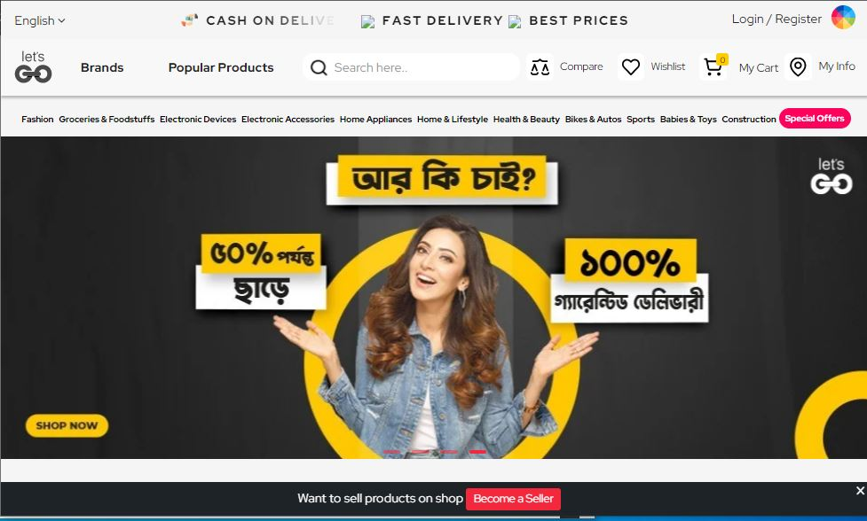

Promotion
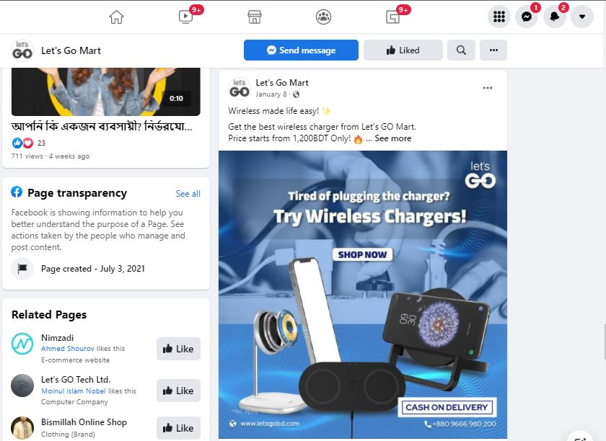
Let’s Go Mart primarily centered around web-based advertising rather than disconnected promoting. Facebook, Google-adwords etc. these are the vitally special spot of Let’s Go Mart. It has a bunch of targets gathering to push limited time exercises. Moreover, Let’s Go Mart has done projects in several universities.(Armstrong & Kotler, 2020)

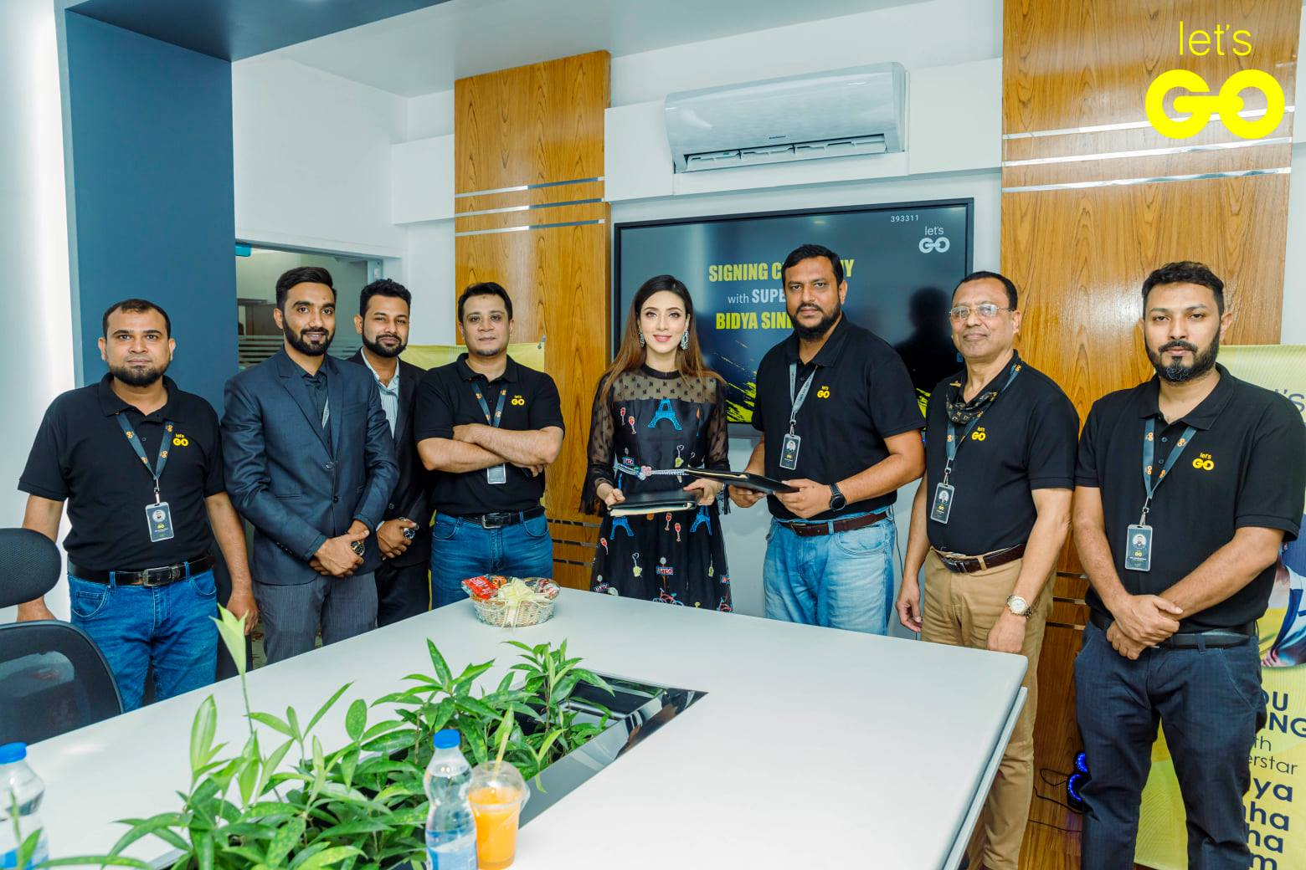
- Let’s Go Mart is also affiliated with Bidya Sinha Shaha Mim (Bangladeshi Actress & Model).

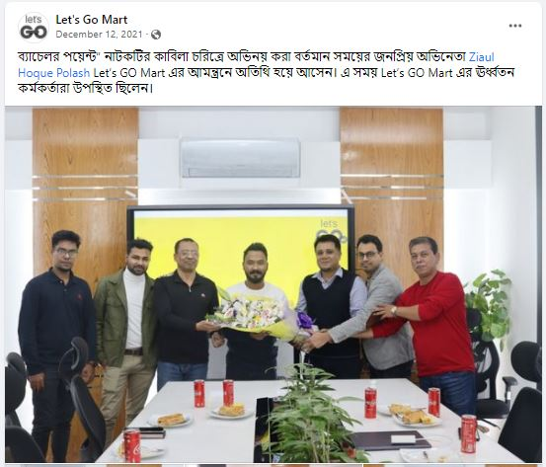

- Let’s Go Mart also affiliated with Ziaul Haque Polash (Actor, Producer, TV presenter).(The Daily Star, 2021)

The Findings of the study

One of the major objectives of the report is to understand customers’ underlying perceptions about the various facets of online businesses in the context of Bangladesh. An elaborate survey was conducted by Let’s Go Mart for the purpose of uncovering such perceptions and discovering demographic and behavioral patterns of their existing or current customers. The survey was based on the data collected from 100 respondents who have purchased at least one time from Let’s Go Mart. The major findings from this survey are presented, with due interpretation, below:

Respondents (Age)
Considering 100 respondents considered in the study, age group 21-30years (75%) and 11-20years (18%) and some are in lower percentage of purchasing intention or they want Ecommerce to provide services to them and showing their interests towards Ecommerce.

Respondents (Sex)

Out of 100 people 62% were male and 32% were female.

Respondents (Occupation)

Out of 100 respondents 81% were students, 11% were service holders, business people were 6% and others were 2%.

Respondents (Income level)

Here, Out of the 100 respondents 62% had a compensation level of under 10,000(BDT) and 22% had a compensation level of 11,000-20,000 BDT.

Respondent frequency of online shopping

Out of the 100 respondents, 49 selected web-based shopping regularly and 31 picked it incidentally.

Money spent behind online shopping per month

Out of 100 respondents, 53 selected web-based shopping each month BDT 0 to 500, 27 picked BDT 501-1000 and others.

Products usually bought online

The reactions recommend greater part of items purchased online are clothes and hardware.

The respondents opt for E-commerce (When?)

Larger part of the reactions recommends that individuals for web-based business when they need home conveyance. Uniqueness in thing and speedy-trades are other prominent component in which people settle on web business too.

For what reason respondents are attracted to e-commerce websites

Study shows that Discounts offered and assortment of items are the significant reason for fascination with the online business site. An incentive for cash is one more significant element that causes the fascination also.

Consumer’s medium of payment

Survey shows that cash on delivery is generally the preferred mode of payment, Bkash comes next in such manner.

Product/Services Delivery time
Organizations need to ensure they convey items as they guarantee. Extravagant commercials probably won't guarantee on time delivery so they need to guarantee their responsibility toward client-satisfaction. The greater part of the clients-need their items inside 2-3 days yet matter of truth that the majority of the organizations neglect to do as such. Rather than 2-3 days submitted delivery time requires over 7 days. This additionally causes disappointment for the vendor and the clients’ trust.

Consumers most trusted e-commerce website

Here could be picked more than one choice. Foodpanda, Chaldal, Bikroy.com, Daraz are the most confided in web-based business sites as indicated by the study.

Regardless of whether purchasers imagine that web-based shopping will ultimately override conventional shopping
Study shows that 28% respondents are unbiased in such a way however 23% respondents unequivocally agree that they figure web shopping will eventually replace standard shopping. 20% agree to this direct and one more 21% varies toward this point. 8% respondents unequivocally differs to this point.

E-commerce in Bangladesh
For the remarkable development in mobiles & computer as well as web infiltration; new skylines of chances in Bangladesh has now opened up effectively; both for the business people and buyers the same. Organizations have really outperformed the limits of actual areas. Nowadays, organizations are increasingly becoming virtual present without a doubt. Nearby business visionaries are utilizing the expanded web availability through being on the web and buyers are likewise reacting profoundly. All things considered, who wouldn't adore having the option to shop from the consolation of their home essentially through tapping on their PCs and having items conveyed right to their doorstep! In this manner, it is nothing unexpected that the E-Commerce sector has grown greatly in Bangladesh and there are numerous sites taking special care of the shopping needs of the customers.(Wikipedia, 2022)

Consumer Perception
The shopper is the person who gives payment to consume services and products delivered. Customer, as they are, develop certain perception about the various facets of online sites based on the experiences derived from their purchasing experiences online. A significant number of customers are found to be worried that the actually shown or advertised products might not be delivered.(Khatun, Rahmatullah, Afrin, & Islam, 2020)

Consumer Perception Theory
Dealers mean to build their deals by figuring out what drives their clients' buying choices. Consumer perception theory supposed that customers’ reaction to the online sites will be influenced by the perception they have about those online sites. This theory is commonly known as the Stimulus-Response theory in the field of consumer behavior and marketing. So, to do well, marketers must work on the perceptions customers have about the online sites in general.(Ahamed & Islam, 2016)

Next Big Thing in Retailing in Bangladesh
Analyzing the Bangladeshi web-based business industry and checking out its quick development (anticipated development rate is 100 percent toward the finish of 2025, presumption) and furthermore due to the fast change in the overall retail methodology, it is very clear that online business will be the next big thing in retailing. A burgeoning internet retailing business should have to be reciprocated by the responsible behavior of the online retailers in Bangladesh.
Online business has been popular in the business scene all around the world for a long while now, and Bangladesh has been of no exemption. Yet, the pattern has been acquiring energy in the country as of late, primarily because of the pandemic stopping actual business sectors for quite a while. From its vibes, any reasonable person would agree that the pattern is digging in for the long haul.(Bangladesh Emerging Channel's Future: Modern Retail (Super Market), 2021)

Perception towards Organization
The first day I came to Let's Go Mart, The Head of HR, Shojib Ahmed Khan, took me to one-on-one meeting, which was, I believe, an interview in disguise. In the meeting he posed inquiries about scholastics and life and I was truly apprehensive at the hour of interview. I was called 2 days after the meeting and was inquired as to whether they could prepare me up for a week and afterward they will inform me as to whether or not I will be a fit candidate for them. After the arrangement of seven days then I had a get-together with the COO where I was selected as an intern for a period of three months.
In any case, after the 2nd week things began to change as I to associate with nearly everybody at my office. Everybody was truly amicable and supportive; some of the time they would go out of their way for aiding me out as I was new in the company and had restricted information about specific things.
The most preferred thing of the organization was the chain of order and I was made clear about my roles and responsibilities. Such clarity of roles actually helped me to perform the tasks assigned to me with confidence.
Whenever anybody committed an error, they were given "Feedback" in regards to it and I saw that how pleasantly the individual and work-life relationship was kept separated with practically no undue sentiments.

User feedback
Data coming straightforwardly from clients about the fulfillment or disappointment they feel with an item or a help. Client remarks and grumblings given to an association are a critical resource for improving and keeping an eye on the necessities and requirements of the clients.
Clients input data/information is given by clients in regards to whether they are satisfied or disheartened with a product or organization and about expansive experience they had with the company. Their perspective is an asset for further developing client experience and changing the activities to their necessities. Such information can be accumulated with different sorts of outlines (provoked input). However, we can likewise observe assessments and surveys our clients post on the web (unprompted criticism) and gather them utilizing Internet checking instruments. The two sources are critical to get a full image of how one client sees your image.
The reason of Users feedback is important for an organization:
- User feedback helps to improve products and services
- User feedback helps to measure your customer satisfaction
- Collecting user feedback shows the value of their opinion
- User feedback helps one to create the best customer experience
- User feedback helps to improve customer retention
- User feedback is a reliable source for information to other consumers as well
- User feedback gives the data that helps taking business decisions
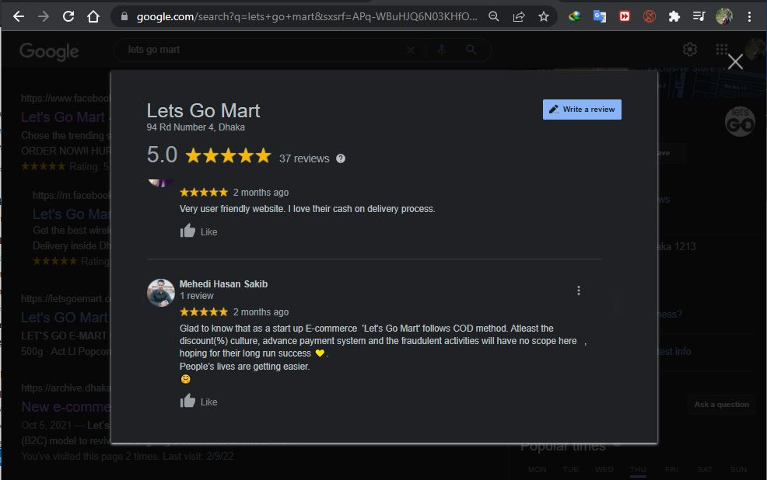
User feedbacks can be gathered with a wide range of instruments. At Let's Go Mart, we gathered the entire information of client feedback through Connection pages, Instagram, Facebook pages, and a Facebook client's gathering which is known as "Let’s Go Mart Fan Club".
Feedback is something enlightening which can be both a negative and positive. We had such countless inputs that we invited and addressed with most open mind and readiness. We get practically 55+ inputs in less than seven days.
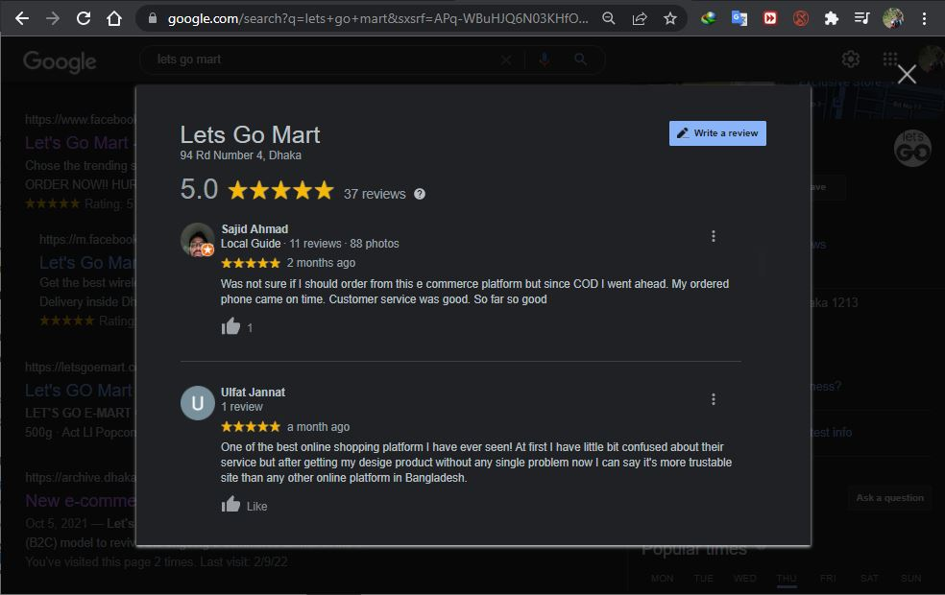
Clients get an opportunity to rate us through stars, five stars (1* to 5*) being awesome and one star being terrible. Clients additionally get an opportunity to depict alongside the stars. Here they can explain their extraordinary and awful experience and their important ideas of how the help can be gotten to the next level. A portion of the extremely continuous negative reasons of client criticisms are: Poor packaging, long delivery time, slow correspondence in customer service, damaged products, and defective items.

Advantages of E-commerce
- Overcoming Geographical Limitations
- Gaining New Customers with Search Engine Visibility
- Low Costs
- Quickly Locate the Product
- Eliminate Travel costs and Time
- Providing Comparison Shopping
- Enable Bargains, Deals, Coupons, and Group Buying
- Give Abundant Information
- Create Targeted Communication
- Create Markets for Niche Products

Disadvantages of E-commerce
- Online business Lacks individual touch
- Online business postpones merchandise
- Can't buy an excessive number of merchandize on the web
- Online business doesn't permit testing or encountering the item before buy
- Anybody can set up an internet business site quickly
- Security

Recommendations

- To guarantee responsiveness and practicality of product delivery, I might prescribe Let's Go Mart to lay out solid and committed dispersion channels.
- Let’s Go Mart brand need to post their advertisements on the webpages where their customers visit regularly and they may also develop some “click per visit” business on Facebook product campaign.
- As it is an start up E-commerce, they could have come up with an idea of monthly give-away services in free delivery, if any customer purchases minimum purchase amount of 2500 BDT to 3000 BDT.
- They can arrange servicing system according to the customers needs (electronic device servicing, bike servicing, AC servicing, Refrigerator etc.).
- As they are following Daraz mainly, so they can add more shop and merchants to their online platform.
- They can add more information about products and their services on their website, it means they can provide products proper model number, serial number of a product etc. so that customer can easily find and be about the authentication of a product Let’s Go Mart is delivering.
- They can create promotional activities with roadside playground so that on that playground interested ones can join or paly games there and earn prizes from that roadside playground.
- They should at-least make a plan of doing business in the Bangladesh market for 5years business plan.
- They should arrange financial supports (Investor or loan) for sustaining in the online business in BD market.
- They should have a plan of satisfying their every employee working with Let’s Go Mart. Such employee satisfaction will be ultimately translated into customer satisfaction according the concept of service-profit-chain model.
- They should arrange a weekly departmental meeting so that the team or group coordination reaches highest peak of desired outcome.

Conclusion
The Bangladeshi online business market is expanding by leaps and bounds. But such growth is not unblemished. There were several scandals over the years. Customers were worried about the money they have already invested in many of those scandalized online businesses. But Government has taken steps to regularize the sector and to ensure the customers’ rights in online business transactions. Considering the much-needed government intervention and the innovativeness of several successful online retailers, one can optimistically claim that the best days int the e-commerce in Bangladesh are yet to come.

References
Ahamed, B., & Islam, S. M. (2016, March 01). Customers’ Attitude towards E-commerce in Bangladesh: An Empirical Study on Some Selected B2C E-commerce Sites. Retrieved January 20, 2022, from researchgate.net: https://www.researchgate.net/publication/296632041_Customers'_Attitude_towards_E-commerce_in_Bangladesh_An_Empirical_Study_on_Some_Selected_B2C_E-commerce_Sites
Armstrong, G., & Kotler, P. (2020). Marketing: An Introduction. Chicago: Pearson.
Big Commerce. (2021, Feburuary 15). Types of Ecommerce Business Models: Traditional and Innovate New Ones to Consider. Retrieved January 20, 2022, from bigcommerce.com: https://www.bigcommerce.com/articles/ecommerce/types-of-business-models/
Khatun, M., Rahmatullah, N. M., Afrin, T., & Islam, S. (2020, June 01). Consumer Perception of Online Marketplace in Bangladesh: An Empirical Study on Dhaka City. Retrieved January 20, 2022, from researchgate.net: https://www.researchgate.net/publication/342170458_Consumer_Perception_of_Online_Marketplace_in_Bangladesh_An_Empirical_Study_on_Dhaka_City
Statista. (2021, October 16). Digital Markets ecommerce. Retrieved January 20, 2022, from statista.com: https://www.statista.com/outlook/dmo/ecommerce/bangladesh
The Daily Star. (2021, February 13). E-Commerce of Bangladesh in the next five years: What to expect? Retrieved January 20, 2022, from thedailystar.net: https://www.thedailystar.net/supplements/30th-anniversary-supplements/going-digital/news/e-commerce-bangladesh-the-next-five-years-what-expect-2043981
The Daily Star. (2021, October 5). Let's GO Mart starts operation as new e-commerce platform. Retrieved January 20, 2022, from Thedailystar.net: https://www.thedailystar.net/business/news/lets-go-mart-starts-operation-new-e-commerce-platform-2191256
Wikipedia. (2022, January 25). E-commerce in Bangladesh. Retrieved Feburay 1, 2022, from wikipedia.org: https://en.wikipedia.org/wiki/E-commerce_in_Bangladesh

