Internship Report
On

Measuring the Financial Performance of Rahimafrooz Energy Service Limited

Prepared For:
Muhammad Enamul Haque
Assistant Professor
School of Business and Economics (SOBE)

Prepared By:
Ayesha Momtaj
ID: 111 152 080
Fall 2019

Date: 21st January, 2020

United International University
Letter of Transmittal

December 31, 2019
Muhammad Enamul Haque (MEH)
Assistant Professor,
School of Business and Economics (SOBE),
United International University,
Badda, Dhaka 1212.
Subject: Submission of Internship Report on Rahimafrooz Energy Service Limited.

Dear Sir,
I am pleased to inform you that I have prepared my internship report on “Measuring the financial performance of Rahimafrooz energy service ltd” as per your instructions. I have gathered all the knowledge that I have learned throughout these 4 months’ practical experience and expressed them through this report.
I tried to highlight all the information that would fulfill the purpose of this report. I’m ensuring that I will be there when any clarification or explanation is needed regarding this report.
Thank you for providing me your time and proper guidelines.

Sincerely yours
Ayesha Momtaj
ID: 111 152 080
United International University

Acknowledgment

Firstly I would like to convey my profound gratitude to Almighty Allah for blessing me with intelligence and patience required for completing the report.
I would be delighted to convey my heartiest gratefulness to Muhammad Enamul Haque (MEH), Assistant Professor, United International University, for his significant direction and astute advices. Without his assistance, it would not have been conceivable to finish this report. I express gratitude toward him for letting me to pick this topic and giving his direction and support which draw out a result of this report. I value his patient guidance and immense support.
I have an abundance of thanks to make. While setting up this report, my regarded supervisor from Rahimafrooz Energy Service Limited Md. Golam Yunus (Senior Executive, F&A, Rahimafrooz Energy Service LTD) gave significant data and precious remarks on every one of the segments of the report. He extraordinarily improved the reliability of the content. . Much gratitude goes to Md. Aminur Rahman, (Officer, Project Accounts), whose advice and support smoothened the path for this report.
While setting up this report, if any mistake of reality, exclusion or accentuation happened, those are exclusively my obligations.
Table of Contents
Executive summary 1
CHAPTER ONE (INTRODUCTION) 2
1.1 Origin of the Report 3
1.2 Objectives of the study 3
1.3 Scope 4
1.4 Limitation 4
1.5 Methodology 5
1.6 Company Description 6
CHAPTER TWO (QUANTITATIVE ANALYSIS) 10
TECHNIQUE 1 12
2.1 Horizontal Analysis 13
2.1.1 Balance Sheet 13
2.1.2 Income Statement 14
TECHNIQUE 2 15
2.2 Vertical Analysis 16
2.2.1 Balance Sheet 16
2.2.2 Income Statement 17
TECHNIQUE 3 18
2.3 RATIO ANALYSIS 18
2.3.1 Liquidity Ratios 19
2.3.2 Profitability Ratios 27
2.3.3 Solvency Ratios 35
2.3.4 Efficiency Ratios 44
2.3.5 Market ratios 60
TECHNIQUE 4 62
2.4 DuPont Analysis 63
Chapter 3 65
3.1Findings 66
3.2 Conclusion 67
APPENDIX 68

Executive summary

In this report, the financial statement of Rahimafrooz Energy Service Limited performance has been analyzed. Rahimafrooz Energy Service Limited was examined on how it manages its performance and what is the current condition of the company in terms of its financial position. All the data used in the report are primary data mostly collected from the Finance & Accounts Department through interview and financial ratios and graphical representation of the ratios in the report was done using Microsoft Excel 2016. The report’s first chapter contains introduction and second chapter contains 4 techniques which includes horizontal analysis, vertical analysis, ratio analysis and DuPont analysis. Ratio analysis was done under five dimensions; these are liquidity dimension, profitability dimension, solvency dimension, efficiency dimension and market value dimension. Total 40 ratios were analyzed. These techniques have been used to measure the performance of the company. Liquidity ratio shows Rahimafrooz Energy Service Ltd has a better ability to satisfy its debt obligations. Profitability ratio shows Company growth health is not good. Solvency ratio shows Rahimafrooz Energy Service Ltd had been forceful in financing its development with debt. Efficiency ratio summarizes the organization isn't utilizing its assets effectively and probably have production problems. Market ratio shows that stock's price of Rahimafrooz Energy Service Ltd was low relative to earnings and possibly undervalued. DuPont Analysis shows that Rahimafrooz Energy Service is ready to extend its ROE just because of increase in financial leverage, it’s risky since the organization is ready to extend its assets by taking debt.

CHAPTER ONE

INTRODUCTION

CHAPTER ONE

INTRODUCTION

1.1 Origin of the Report

This report has been started to complete an incomplete necessity of the internship program joined by the author. The author is a graduating understudy of the United International University and has been allotted as an intern in the Finance & Accounts Department of Rahimafrooz Energy Service Limited (RESL). As per the particular prerequisites of the program, the author has finished the 12 weeks’ time of the entry level position connection with the association. This report is thus submitted as the internship report of author. The report has been set up under the supervision of the Academic Advisor, Muhammad Enamul Haque, Assistant Professor, School of Business and Economics (SOBE), United International University and as per the directions and direction of the Official supervisor, Md. Golam Yunus (Senior Executive, F&A, Rahimafrooz Energy Service LTD).

1.2 Objectives of the study

The prime objective of current report is to assess the overall financial performances of Rahimafrooz Energy Service Limited (RESL).
There are some other objectives of the report which are given below:
- To become familiar with the Energy industry in Bangladesh, its operation and activities, management style and endeavor to realize the gap between the theoretical knowledge with the real business world.
- To analyze the current performance of the industry and do analysis as per learning
- To know how to analyze a business from given data
- To know how to conduct the different types of analysis in order get the total idea about the company
- To continue the business in the right way which leads to excellent results
- To identify inherent problems associated with the industry analysis and bring about changes to this sector for a better future.
- The most important of all is to determine the performance of the firm which will give the idea about the reflection of the business condition of the company for both internal and external users.

1.3 Scope

- An overview of Rahimafrooz Energy Service Ltd.
- Rahimafrooz Energy Service Ltd has been analysed from different view point by financial techniques.
- Financial statement analysis of Rahimafrooz Energy Service Ltd
- Performance evaluation of Rahimafrooz Energy Service Ltd
- All the data has been collected during internship period from 22nd October to 22nd January.

1.4 Limitation

In Rahimafrooz Energy Service I worked as Intern. At this company Intern is considered as outsider. So they generally don't give sensitive and significant data to the interns. So I was unable to get some significant data from them as they were hesitating to give those. For example, they were hesitating to give the detail data. Like these I was unable to get a lot more data from Rahimafrooz Energy Service Limited due to their reluctance.
Besides, There are a not many research work has been accomplished for the Rahimafrooz Energy Service Ltd. Because of this reason, I was unable to get adequate assistance from the secondary data resource.

1.5 Methodology
Methodology depicts the way where information is gathered, investigated and deciphered. The information that will introduce in this report would gather from primary and secondary source.
1.5.1 Sources of Data
Usually we can collect data from two sources which are primary and secondary.
Primary source
Data collected by perception or questionnaire is a characteristic of data obtained in an uncontrolled situation. The essential information source that will be utilized in this report is information acquired through involvement with the firm. The data has been collected through interview. There annual report is not available in website, that’s why the balance sheet and income statement related all data has been collected by interviewing the employee of Finance & Accounts department of RESL.
Secondary source
Data analysis has been done through internet. The data about financial statement analysis has been collected from different text books, different online books and other online sites which are basically written about how to analyses the financial performance of the firm through financial analysis
1.5.2 Data Processing and Analysis Method
Information Processing: A progression of steps performed on information to confirm, sort out, change, coordinate, and concentrate information in a proper yield structure for subsequent use. Processing method must be thoroughly archived to guarantee the utility and honesty of the information.
Information Analysis: includes activities and techniques performed on information that help to depict actualities, recognize designs, create clarifications and test theories. This incorporates information quality confirmation, measurable information examination, displaying, and interpreting results.
After assortment of the considerable number of information it has been guaranteed that it is right and utilized appropriately in the report in determined headings.

CHAPTER TWO

COMPANY DESCRIPTION

1.6 Company Description

Rahimafrooz group was established in the year 1954 as a small trading company by Late Mr. A C Abdur Rahim. It is one of the leading conglomerates of Bangladesh having market leadership in domestic & presence in global market. The company has four broad operations; 7 strategic business units (SBUs), 4 ventures, and 1 Non-profit Social Enterprise. They are as follows:
  - Storage power
  - Distribution
  - Energy
  - Retail
- The seven SBUs are:

Other business ventures:
- Metronet

- RZ Power
- Core Knowledge
- Deligram
Non-profit social enterprise:
- RSF: Rural Services Foundation


Values of Rahimafrooz:

Vision:
“To be the leading power generation, transmission & distribution equipment supplier, EPC and MEP solution provider in the country”




Rahimafrooz Energy Services Limited (RESL) established in the year 2000, as one of the strategic business units (SBU) of Rahimafrooz group. The group works on five broad sectors, these are Storage power, Automotive and Electronics, Energy, Retail and Agro. RESL falls under the Energy sector. At present the product lines of RESL comprises of Power generation (PG), Mechanical Electrical Plumbing (MEP) and Gas field. It has a leading name in the diesel generator industry. Diesel generators are imported from FERBO and Gas & Diesel generators from MITSUBISHI. MEP currently provides Electrical Substation, Bus Bar Trunking system (BBT), MV and LV Switchgear Panel, MV and LV AVR, Distribution board & Sub-distribution boards. On the other hand, Gas field business is working on current and upcoming tenders and offering accessories such as line pipes, primers, fittings, valves and tapes.
Power Generation | Mechanical Electrical Plumbing (MEP) | Gas field
- Diesel generator
- Gas generator
- Rental power solution
- Spare parts business
- Steam boiler
- Online UPS
- MV and LV AVR
- Electrical Substation 33/11kV
- MV and LV Switchgear Panel
- DB and SDBs
- Bus Bar Trunking System (BBT)
- Process plant
- RMS
- Accessories (Line pipes, Valves, Tapes, Primers, Fittings)
Product Portfolio
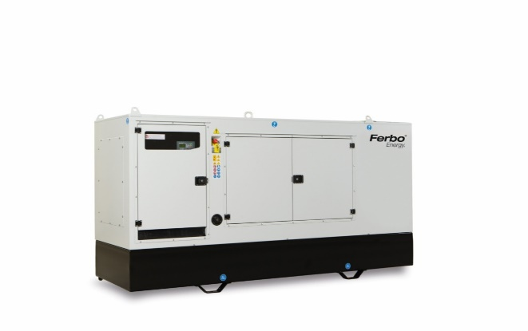

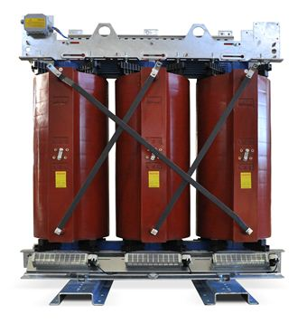
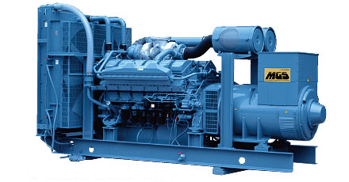
HV/LV Distribution Transformer

MITSUBISHI Diesel Generators, Japan

FERBO Generators, Italy

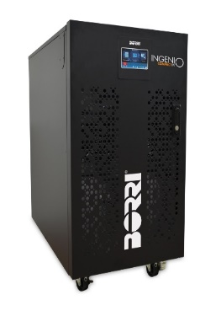
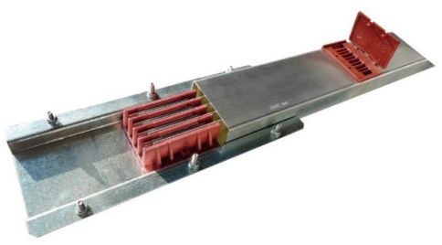
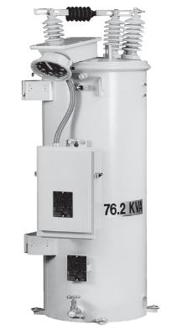
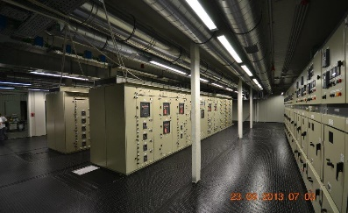

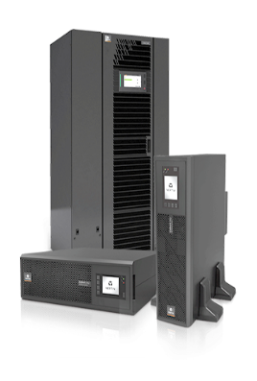

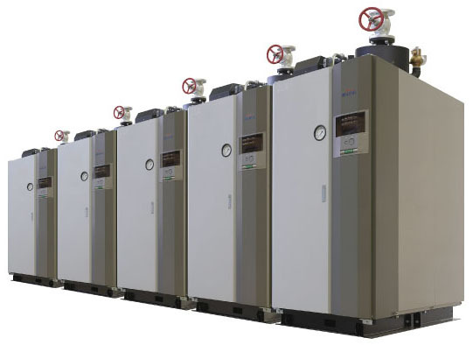

Online UPS: Borri

Online UPS: Vertiv (Emerson)

Automatic Voltage Regulator (AVR)

Busbar Trunking (BBT)
MV/LV Switchgear

MIURA Steam boiler, Japan

CHAPTER THREE

QUANTITATIVE ANALYSIS



TECHNIQUE: 1
Horizontal analysis investigates a particular part of the business all through various timespans for comparison. This gives a comprehension of how certain components of the financial worksheet have changed after some time.

QUALITATIVE TECHNIQUES

These are the strategies which are commonly favored by the enormous scale organizations in this cutting edge time as these are basic control techniques.

HORIZONTAL ANALYSIS


VERTICAL ANALYSIS

TECHNIQUE: 2
A vertical analysis takes a gander at the far reaching perspective on the budgetary worksheet for a particular time period. This gives an extensive perspective of the organization's funds in general for that time


TECHNIQUE: 3
TECHNIQUE: 2
The reason and significance of Ratio Analysis are to assess or break down the money related execution of the firm as far as Risk, Profitability, Solvency, and Efficiency. It encourages to look at the patterns of at least two organization over some undefined time frame.

RATIO ANALYSIS


TECHNIQUE: 4
DuPont examination is a valuable strategy used to disintegrate the various drivers of profit for value (ROE).
DUPONT ANALYSIS

TECHNIQUE 1

HORIZONTAL ANALYSIS

2.1 Horizontal Analysis

This technique is also known as comparative analysis. It is to calculate amount changes & percentage changes from the previous years to current year. Horizontal analysis of Rahimafrooz Energy Service Ltd shows the comparison of historical financial information over a series of reporting periods (2015-2019) to know the overall performance of the firm. For doing the horizontal analysis current year can’t be the base year so we have selected 2015-2016 as the base year and then we compared year 2016-2019 with the base year.

2.1.1 Balance Sheet
Balance Sheet | 2016-2017 | 2017-2018 | 2018-2019
Current Assets | 9.2% | 44.7% | 7.2%
Non-Current Assets | -4.3% | -3.1% | -4.0%
Non-Current Liabilities | 17.3% | 155.4% | -80.6%

In year 2017-2018 we can see significant change in current asset of 44.7% which shows positive change but there was less positive change in 2016-2017. After 2017-2018 this positive change decreased massively in 2018-2019. This means that the company made huge investment in non-current assets in 2017-2018. On the other hand, from year 2017 to 2019 non-current assets didn’t fluctuate much. Non-current liabilities also changed significantly. In the non-current liabilities part we can see there is a huge positive change in 2017-2018 of 155.4 % which is not good for the company. . As positive change in liabilities means that the company had liabilities which is not desirable. Again there is a huge negative change in 2018-2019 of -80.6 % which is not good for the company.

2.1.2 Income Statement

Income Statement | 2016-2017 | 2017-2018 | 2018-2019
Gross profit | -2.02% | -8.33% | 51.37%
Profit before interest and tax | -26.30% | -28.73% | 16.35%
Net profit for the year | -34.24% | -41.38% | 45.36%

Over the 3 years period we can see some significant changes in the statement of profit or loss statement of Rahimafrooz Energy Service Ltd. Here total comprehensive income increases from -34.24% to 45.36% over the 3 years period. Now if we analyze it even deeper then we can figure out why it increases. Gross profit increases to 51.37% in 2018-2019 even though in 2017-2018 it was -8.33% .But the 51.37% increase amount is quite a lot higher than the -8.33% increase amount. Which helps to increase the gross profit compare to the past years. Again, the Profit before interest and tax in 2016-2017 was -26.30% and in 2018-2019 it increases to 16.35% just because other income increased over the year. As a result, the net profit increased to 45.36%in the 2018-2019 just because the deferred tax reduced by 35% over the 3 years.

TECHNIQUE 2

VERTICAL

ANALYSIS

2.2 Vertical Analysis

Vertical analysis also known as common-size analysis, is a popular and traditional method of financial statement analysis, in which each item of financial statement are listed as percentage of base figure. Vertical analysis of Rahimafrooz Energy Service Ltd shows the comparison of historical financial information over a series of reporting periods (2015-2019) to know the overall performance of the firm. For doing the vertical analysis we use total asset as the base figure to do vertical analysis.

2.2.1 Balance Sheet

Balance Sheet | 2015-2016 | 2016-2017 | 2017-2018 | 2018-2019
Property, plant and equipment | 5.6% | 4.9% | 3.3% | 3.0%
Current Liabilities | 46.8% | 44.9% | 42.7% | 65.4%
Total equity | 29.4% | 29.2% | 39.5% | 38.8%

From vertical analysis we can see that from 2016 to 2019, property, plant & equipment gradually decreasing. In 2015-2016, it was 5.6%and in 2018-2019, it increased to 3.0%. We can say from these value that, Rahimafrooz Energy Service Ltd are investing less in property, plant & equipment to increase their productivity. On the other hand, Current Liability is increasing as current asset of Rahimafrooz Energy Service Ltd is increasing. Current liabilities are debt that is payable within one year. As current liabilities are increasing, it is not a good sign .Shareholders equity is fluctuating every year. From Property, Plant, Equipment section, we saw that, Rahimafrooz Energy Service Ltd are increasing it. This types of fixed asset normally increase through equity. That’s why we can see a bigger change in shareholder’s equity.

2.2.2 Income Statement

Income Statement | 2015-2016 | 2016-2017 | 2017-2018 | 2018-2019
Gross profit | 24% | 18% | 22% | 25%
Profit before tax and contribution fund | 4% | 3% | 6% | 10%
Total comprehensive income | 2% | 2% | 4% | 6%

In vertical analysis, over the 4 years period we cannot see too much significant percentage changes in the statement of profit or loss statement of Rahimafrooz Energy Service Ltd. We decided to explain why the there is less significant changes over the 4 years.
Here our base is turnover. If we observe the vertical analysis then we can figure out the actual reason behind the stable situation. In year 2015-2016 the gross profit was 24% of the turnover and in year 2018-19 it is 25%. The changes were not too much. Although the net amount was different than the percentage rate. Again, in year 2015-2016 operating profit was 4% of turnover but in 2017-18 it increased to 10% of turnover. On the other hand, the percentage of comprehensive income over turnover was almost same over the 5 years. In 2013 it was 2% and on 2017-18 it became 6% of turnover. The rate changed very little but the amount was a little bit higher than 2015-2016 comprehensive income.

TECHNIQUE 3

RATIO ANALYSIS

2.3.1 Liquidity Ratios

Liquidity is the accessibility of liquid assets to a market or organization. Without having spare liquidity, a company may come to be unable to pay its debt.
Liquidity ratios are a vital category of financial metrics which used to verify a debtor's capability to take care of existing debt obligations without rising external capital. Liquidity proportions measure an organization's capacity to pay obligation commitments and its edge of security through the estimation of measurements.

The Liquid Ratios calculated in this report are:

Cash total to operating expenses
Current Ratio
Cash to TA
Sales to Current Asset Ratio
Cash Ratio

Quick Ratio
Cash to CA

Current asset by total liability

Current Ratio
The current proportion is a liquidity proportion that estimates an organization's capacity to pay short obligations or those due inside one year. It tells financial specialists and investigators how an organization can augment the present resources on its asset report to fulfill its present obligation and different payables. A higher current proportion is commonly superior to a lower current proportion as to keeping liquidity.
Equation: Current Ratio= (Current Asset/Current Liability)
Year | 2015-2016 | 2016-2017 | 2017-2018 | 2018-2019
Current Ratio | 2.02 | 2.12 | 2.26 | 1.48
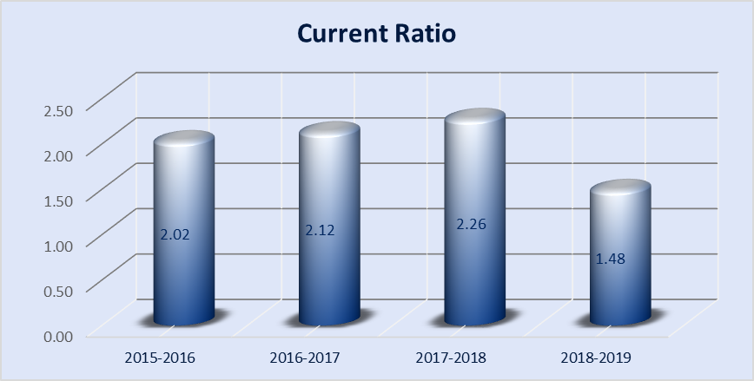
In 2015-2016, current ratio was 2.02, which indicates that current assets were 2.02 times the value of the company’s current liabilities. That ratio was more 2.12 in 2016-2017, suggesting a slight improvement in the current ratio. But in 2017-2018, we can see that current ratio increased to 2.26, which is even better than the previous year and it suggests that now the business has more cash or assets available to pay its debts. In 2018-2019, the ratio became lower which was 1.48, that means current assets are 1.48 times the value of current liabilities. There has been a slight decrease in 2018-2019 but still it is a good ratio. This was a good financial position for Rahimafrooz Energy Service Ltd meaning that it can meet its short-term debt obligations with no stress.
Quick Ratio
Quick Ratio is a marker of organization's short-term liquidity. It quantifies the capacity to utilize its quick assets, for example, inventories, to pay its current liabilities. Along these lines, Quick proportion decides if the present resources that can be immediately changed over into cash are adequate to cover current liabilities. A quick proportion higher than 1:1 demonstrates that the organization can meet its present commitments with the accessible quick fund.
Equation: Quick Ratio = (CA - Inventory) /CL
Year | 2015-2016 | 2016-2017 | 2017-2018 | 2018-2019
Quick Ratio | 1.56 | 1.56 | 1.82 | 1.24

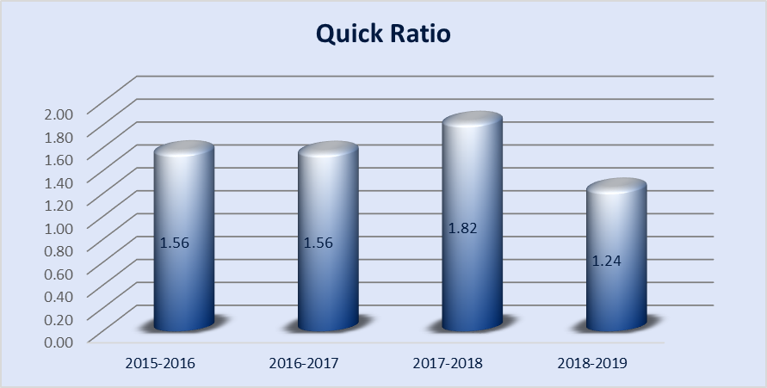

From the calculations, we have seen that in 2015-2016 the company’s quick ratio is 1.56, which means its current assets are 1.56 times current liabilities, indicating that the company is in a good position and can meet its obligations with the quick cash and assets. In 2016-2017, the ratio didn’t fluctuate, which is better. In 2017-2018, the ratio increases to 1.82 which shows that the company had more quick assets to fulfill its liabilities. In next year, the ratio decreased to 1.24 which is lower than previous years but still it is a good one.

Cash Ratio

The cash ratio indicates the ratio of a company’s total cash and cash equivalents to its current liabilities. The metric calculates a company's ability to repay its short term debt, so, this is really useful to creditors when deciding how much obligation they would stretch out to the asking party.
Equation: Cash Ratio = Cash + Cash equivalent / CL
Year | 2015-2016 | 2016-2017 | 2017-2018 | 2018-2019
Cash Ratio | 0.028 | 0.034 | 0.026 | 0.025

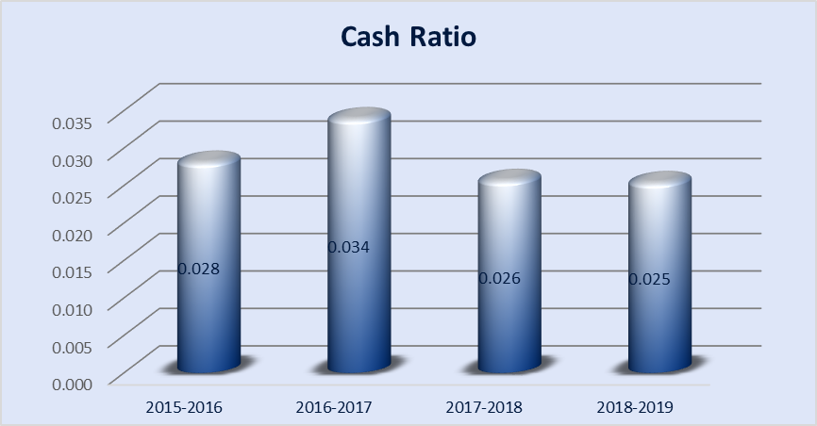

From the calculation, we have seen that the company’s cash ratio of 4 subsequent years are 0.028, .034, 0.26, 0.025 which shows that the company has less cash and cash equivalents than its current liabilities, so it can’t meet its short term liabilities or repay its accounts payables immediately.
Sales to Current Asset Ratio
The Sales to Current Assets proportion quantifies how well an organization is utilizing its assets in creating sales. The higher the asset turnover proportion, the more productive and organization. Then again, if an organization has a low asset turnover proportion, it demonstrates it isn't proficiently utilizing its assets for making sales.
Equation: Sales to Current Asset Ratio= Total Sales / Current Asset
Year | 2015-2016 | 2016-2017 | 2017-2018 | 2018-2019
Sales to Current Asset Ratio | 1.02 | 1.04 | 0.82 | 0.87

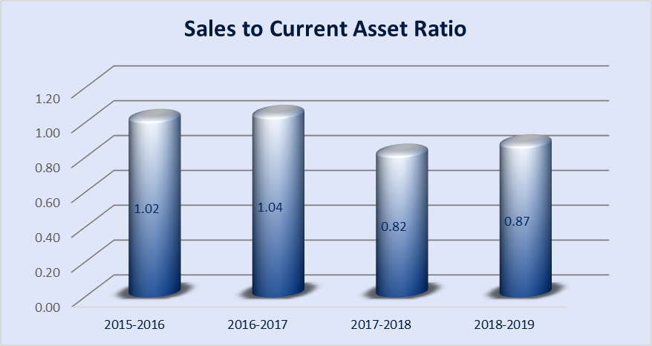

At the beginning it’s an upward slopping ratio from 2015-2016 to 2016-2017 then again it’s a downward slopping ratio after 2016-2017. So Rahimafrooz Energy Service Ltd has given its best performance at 2016-2017 with the highest turnover ratio of 1.04 throughout these years which means it had done well because the highest the ratio the more the company is doing well.
Current asset by total liability
The Current Assets to Total Debt proportion quantifies the organization's capacity to cover its total debt with its Total Current Assets. This proportion is additionally used to gauge the liquidity of the organization by indicating the organization can pay its creditors with its current assets if the organization's assets at any point must be liquidated.
Equation: Current asset by total liability = Current Asset / Total Liability
Year | 2015-2016 | 2016-2017 | 2017-2018 | 2018-2019
Current Asset by Total Liability | 1.54 | 1.57 | 1.37 | 1.37

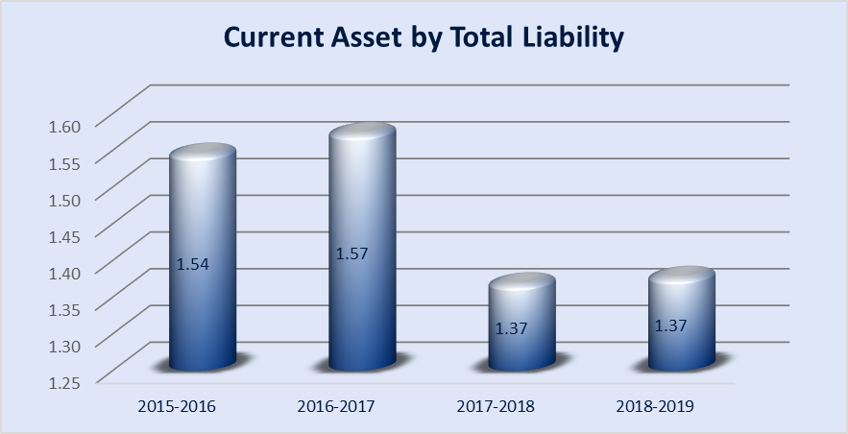

This ratio rises from 2015-2016 to 2016-2017 upwards and again it rapidly falls down from 2017-2018 to 2018-2019 at the lowest point. An increasing Current Assets to Total Debt ratio is generally a positive sign, showing that Rahimafrooz Energy Service Ltd has a better ability to satisfy its debt obligations using its Total Current Assets which is done in 2016-2017 with the highest ratio of 1.57.
Cash to Current Asset
The term cash to current assets ratio refers to a metric that allows the investor-analyst to understand the proportion of cash residing in current assets. This measure causes the financial specialist expert to decide whether an organization has enough money available to take care of their obligations or they would need to depend on different types of current resources, for example, accounts receivable, which must be gathered from clients.
Equation: Cash to CA = Cash / CA
Year | 2015-2016 | 2016-2017 | 2017-2018 | 2018-2019
Cash to Current asset | 1.39% | 1.60% | 1.13% | 1.71%

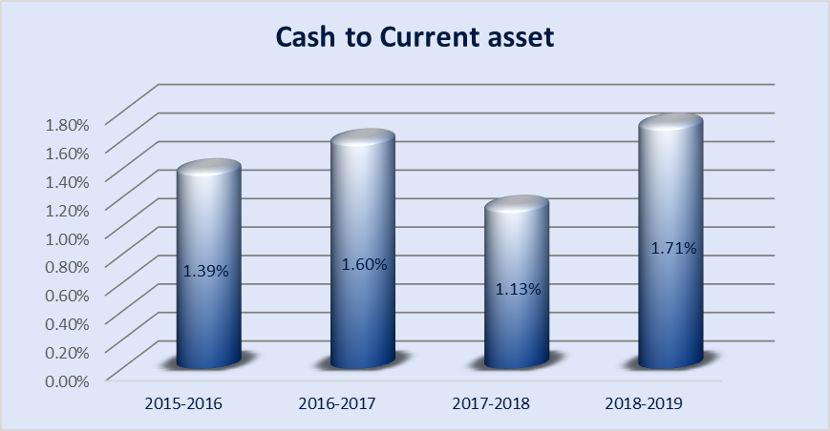

It’s a fluctuating ratio again with the highest value of 1.71% at 2018-2019 and lowest of 1.13% at 2017-2018. In 2015-2016 ACI has an average growth then it was increased at 2016-2017, again it fell down a bit within 2017-2018 and rose again at 2018-2019.

Cash to Total Asset
Cash/Total Assets—quantifies the segment of an organization's assets held in in cash or marketable securities.. Though a high proportion may show some level of wellbeing from a creditor’s perspective, overabundance measures of money might be seen as wasteful.
Equation: Cash to Total Asset = Cash / Total Asset
Year | 2015-2016 | 2016-2017 | 2017-2018 | 2018-2019
Cash to Total asset | 0.96 | 0.99 | 0.79 | 0.85

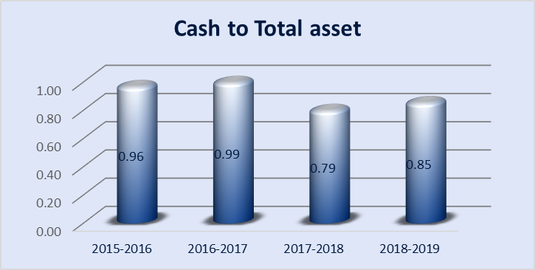

It’s a fluctuating ratio again with the highest value of .96 & .99 at 2015-2016 & 2016-2017 and lowest of .79 at 2017-2018. In 2015-2016 Rahimafrooz Energy Service Ltd has an average growth then it was increased at 2016-2017 again it fell down a bit within 2017 -2018 and rose again at 2018-2019.

2.3.2 Profitability Ratios
Profitability proportions contrast income statement records and classes with demonstrate an organization's capacity to create profits from its operations. Profitability proportions center around an organization's return on interest in stock and different resources. These proportions mainly show how well organizations can accomplish benefits from their tasks.

The following Profitability Ratios have been calculated in the report:

Earnings before Tax margin
Net Profit Margin
Return on Assets

Earnings per share shares Ratio
Operating Profit Margin

Gross Profit Margin
Return on Equity

Net Profit Margin
This proportion tells the measure of benefit that an organization can create from its total sales. A high net profit margin shows that a business is valuing its items effectively and is practicing great cost control.
Equation: Net Profit Margin = Income / Sales
Year | 2015-2016 | 2016-2017 | 2017-2018 | 2018-2019
Net Profit Margin | 6.32% | 3.72% | 1.91% | 2.44%

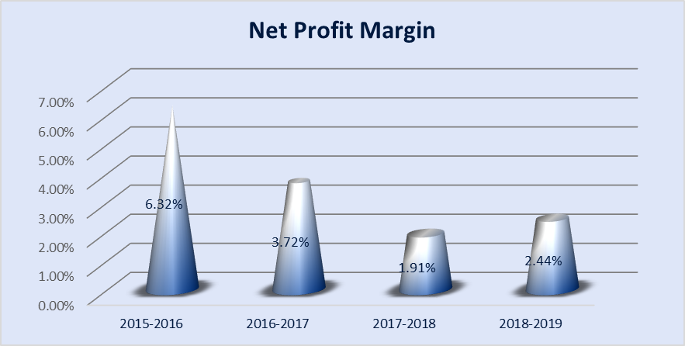
Net profit margin of 4years as computed are-6.32, 3.72, 1.91, 2.44. This means that a company has 6.23 taka of net income for every BDT of sales. But after 2016-2017 the profit margin starts to decrease, meaning that the net income generated from every BDT of sales got lower in the next years, which is not a positive factor for the company. For a high volume, high competition business, a profit margin of 4% may be good but here the Rahimafrooz Energy Service Ltd Company has average net profit margin of 3.59% so, this net profit margin is quite sound for their company.

Gross Profit Margin
The gross profit margin ratio is also known as gross margin, is the proportion of gross margin expressed as a percentage of sales. Gross margin demonstrates how much benefit an organization makes after taking care of its Cost of Goods sold.
Equation: Gross Profit Margin= Gross profit/ net sales
Year | 2015-2016 | 2016-2017 | 2017-2018 | 2018-2019
Gross Profit Margin | 25% | 22% | 18% | 24%

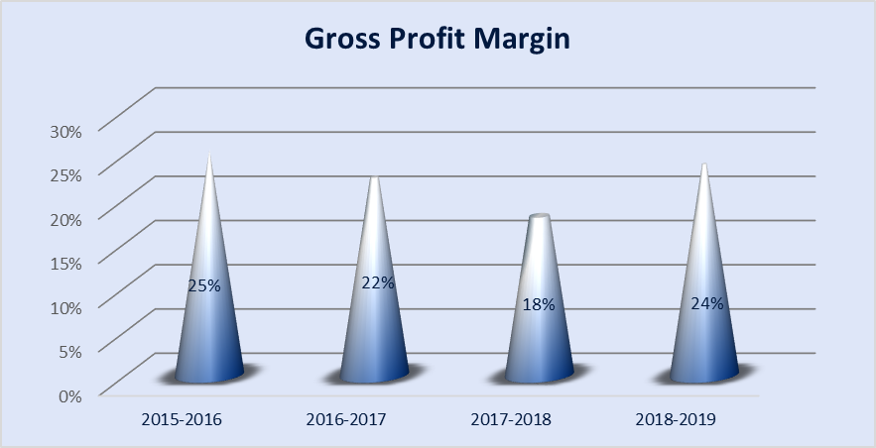
For Rahimafrooz Energy Service Ltd, this ratio was 25% in 2015-2016. Then in 2016-2017 it decreased to 22% and again in 2017-2018 it decreased to 18%. In 2018-2019 it increased to 24%, meaning that for every BDT generated in sales, the company has 24 tk left over to cover basic operating costs and profit. A good target gross profit margin is around 50% but comparing with that Rahimafrooz Energy Service Ltd Company has average 22.25% GMP which is below the requirement.

Operating Profit Margin
Operating margin is a proportion of profitability. It shows the amount of every dollar of income is left over after the both costs of goods sold and operating expenses are considered.
Equation: Operating Profit Margin = Operating income/ net sales
Year | 2015-2016 | 2016-2017 | 2017-2018 | 2018-2019
Operating Profit Margin | 11.59% | 7.65% | 4.79% | 4.88%

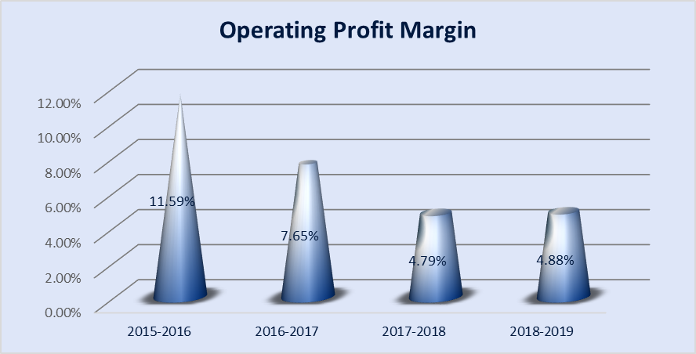

Here we can see that the graph is downward sloping. In 2015-2016 the ratio was 11.59%. But the ratio starts to decline, which is not a positive sign. As the operating profit margin declined it is anything but a decent clue for the organization in light of the fact that to remain in a good position the organization ought to keep up least 20% OPM for them.

Return on Assets
The return on assets ratio or ROA basically measures essentially quantifies how effectively an organization can deal its assets to produce profits during a period.
Equation: Return on Assets = Net Income/ Total Asset
Year | 2015-2016 | 2016-2017 | 2017-2018 | 2018-2019
Return on Assets | 6.1% | 3.7% | 1.5% | 2.1%

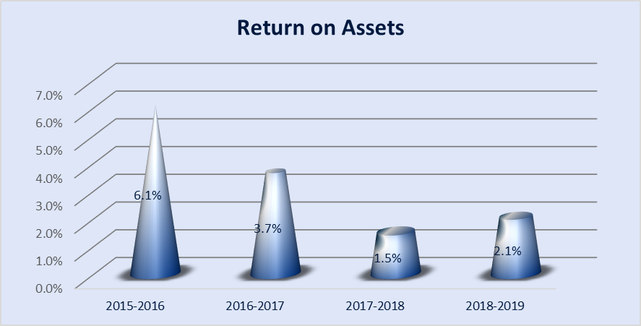

In 2015-2016 the ratio was 6.1% but drastically the ratio decreased over the next year, which shows a decrease in efficiency of the company to produce sales using its assets over the years, which is a negative sign for the company but the company may face loss in future.

Earnings before Tax margin
The pre-tax profit margin is the ratio of a company's pre-tax earnings to its total sales. The higher the pre-tax profit margin, the more productive the organization.
Equation: Earning before Tax margin = EBT/ Net sales
Year | 2015-2016 | 2016-2017 | 2017-2018 | 2018-2019
Earning before tax Margin | 9.7% | 5.7% | 2.9% | 3.8%

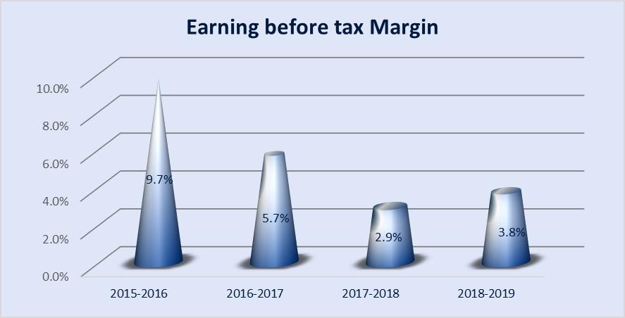

This graph slowly fluctuated over the years. From 2015-2016 to 2017-2018 the ratio decreased from 9.7%, 5.7% to 2.9% but again it slightly increased in 2018 to 2019 and became 3.8%. The high pretax profit margin shows it more profitable as the ratio declined so, this is not good for company growth health.

Return on Equity
The return on equity (ROE) is a proportion of the profitability of a business in connection to the equity, also known as net assets or assets minus liabilities ROE is a proportion of how well an organization utilizes speculations to produce profit development.
Equation: Return on Equity = Net Income/ Equity
Year | 2015-2016 | 2016-2017 | 2017-2018 | 2018-2019
Return on Equity | 15.7% | 9.4% | 5.2% | 7.0%

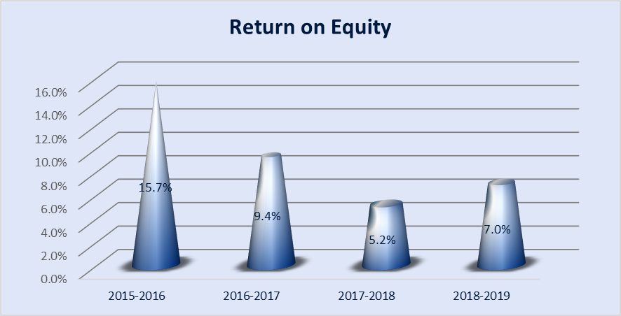

This graph slowly fluctuated over the years. From 2015-2016 to 2017-2018 the ratio decreased from 15.7%, 9.4% to 5.2%. In following years the ratio decreases which is not a positive sign because it means that company’s ability to generate profit from stockholder’s equity is low. But again it slightly increased in 2018 to 2019 and became 7.0%. Generally, it is considered that good ROE for a company should be 15 to 20 percent but here the company ROE only 7.0% that is very poor compare to good performance.
Earnings per Share
Earnings per share (EPS) ratio measures how many BDT of net income have been earned by each share of common stock, which is a popular measure of overall profitability of the company.
Earnings per share: Total income / number of share
Year | 2015-2016 | 2016-2017 | 2017-2018 | 2018-2019
Earning Per Share | 106.09 | 69.76 | 40.89 | 59.44

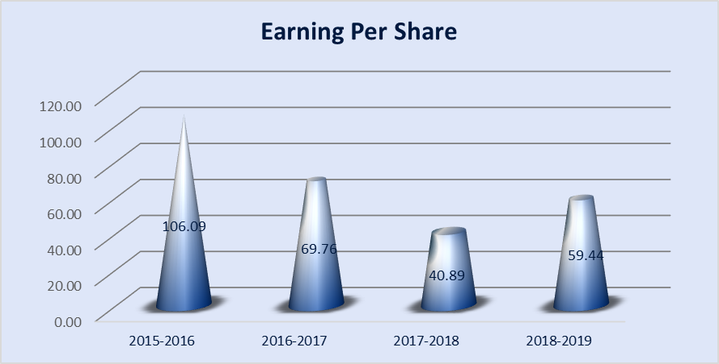

From above we see that in 2015-2016, every share of the common stock earned 106.09tk of net income but in following years it starts to decline. This variance isn't useful for organization as the investors lose their trust on them.
A reliably rising EPS throughout the years is a positive sign, and it implies the organization is making great predictable development. Though there is a drop in EPS, it is a reason for alert for the financial specialist.

2.3.3 Solvency Ratios

The solvency ratio is a key measurement used to quantify an undertaking's capacity to meet its debt obligation commitments and is utilized regularly by prospective business lenders. The solvency ratio demonstrates whether an organization's cash flow is adequate to meet its short-and long term liabilities. The lower an organization's solvency proportion, the more prominent the likelihood that it will default on its debt obligation.
Solvency Ratios Calculated in the report are as following,

Times interest earned ratio

Debt to Income Ratio

Equity Multiplier Ratio

Equity ratio
Debt Ratio
Debt to Equity Ratio
Debt to capital ratio

Fixed Asset to Total Liability Ratio

Debt Ratio
This proportion gauges the financial leverage of an organization. Organizations with more levels of liabilities compared with assets are considered highly leveraged and riskier for lenders. This helps investors and creditors analysis the overall debt burden on as the organization's capacity to take care of the debt in future,, uncertain economic times.
Equation: Debt Ratio = Total Liability / Total Asset
Year | 2015-2016 | 2016-2017 | 2017-2018 | 2018-2019
Debt Ratio | 61.22% | 60.54% | 70.76% | 70.56%

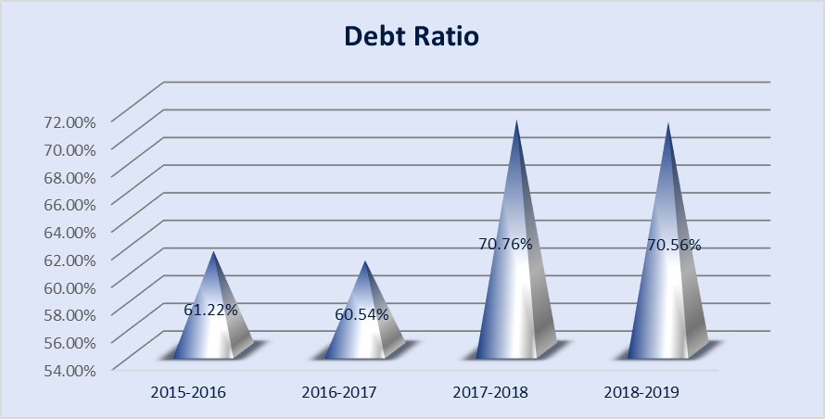

A company that has a debt ratio of more than .5 is known as a levered company. Here, the ratios keep increasing after 2016-2017. It was less before then.
A higher debt proportion as a rule suggests a progressively unsteady business since when Rahimafrooz Energy Service Ltd will have higher proportion likewise has higher generally overall debt, which isn't useful for Rahimafrooz Energy Service Ltd with higher obligation proportions are in an ideal situation looking to equity financing to develop their activities.
Debt to Equity Ratio
The proportion is utilized to assess an organization's financial leverage. The D/E proportion is a significant measurement utilized in corporate finance. It is a proportion of how much an organization is financing its operation through obligation versus entirely owned funds. All the more explicitly, it mirrors the capacity of investor value to cover every single exceptional obligation in case of a business downturn.
Equation: TL/ Shareholders Equity
Year | 2015-2016 | 2016-2017 | 2017-2018 | 2018-2019
Debt to Equity Ratio | 158% | 153% | 242% | 240%

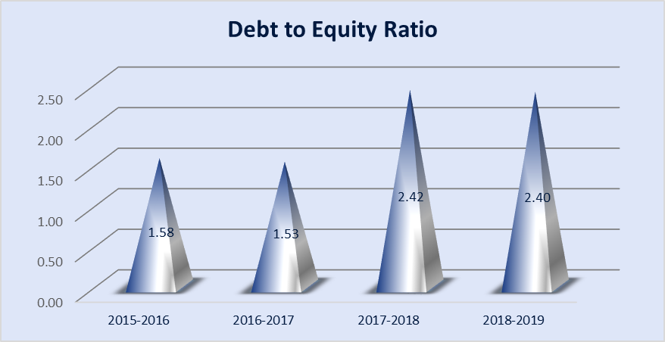
We can see that the graph indicates that from 2015-2017 the ratio was low, after then the debt financing was 2.42 relative to equity financing, which is not good for overall financial position, but the debt to equity ratio increased over the years, so it’s a negative sign.
A high debt/equity proportion is frequently connected with high risk; it implies that Rahimafrooz Energy Service Ltd had been forceful in financing its development with debt.
Debt to capital Ratio
Debt to capital is a significant measure to distinguish how a lot of an organization is reliant on debt to finance its everyday exercises and to evaluate the risk level to an organization's investors. It likewise gauges the creditworthiness of an organization to meet its liabilities in the form of interest expenses and other payments.
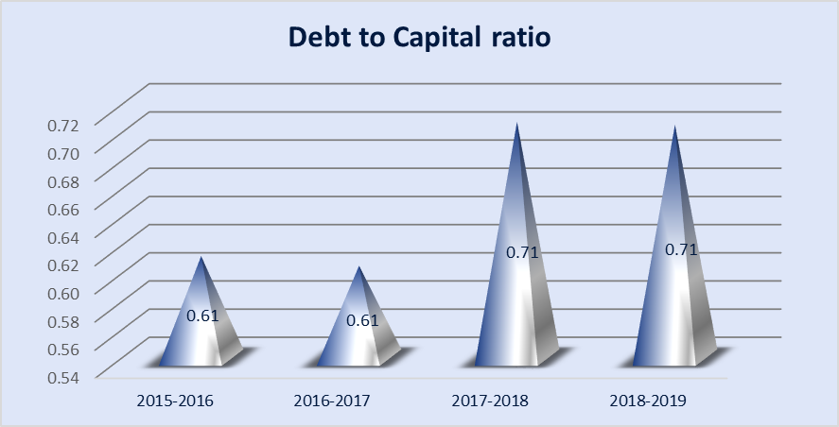
Equation: Debt to capital = Total Liability / Total debt + Shareholders equity
Year | 2015-2016 | 2016-2017 | 2017-2018 | 2018-2019
Debt to Capital ratio | 61.2% | 60.5% | 70.8% | 70.6%

From the chart we can see, until further notice the proportion is under 1, which implies the debt levels are sensible and the organization is viewed as less risky to contribute or loan to given different variables are contemplated. But, Rahimafrooz Energy Service Ltd is expanding its debt to capital proportion year by year.
On the off chance that the obligation to-capital proportion gets more prominent than 1in the following coming years, at that point this organization will be considered as very dangerous. On the off chance that additional liabilities are gained without a growth in earning, the organization may fail.
Times interest Earned Ratio
An organization's TIE demonstrates its capacity to pay its obligations. A superior TIE number means an organization has enough money in the wake of paying its obligations to keep on putting resources into the business. A proportion of short of what one demonstrates that a business may not be in a situation to pay its interest debt, as is bound to default on its obligation; a low proportion is likewise a solid marker of approaching insolvency.
Equation: Times interest Earned ratio= EBIT/ interest Expense
Year | 2015-2016 | 2016-2017 | 2017-2018 | 2018-2019
Times Interest Earned Ratio | 8.38 | 4.67 | 2.83 | 5.19

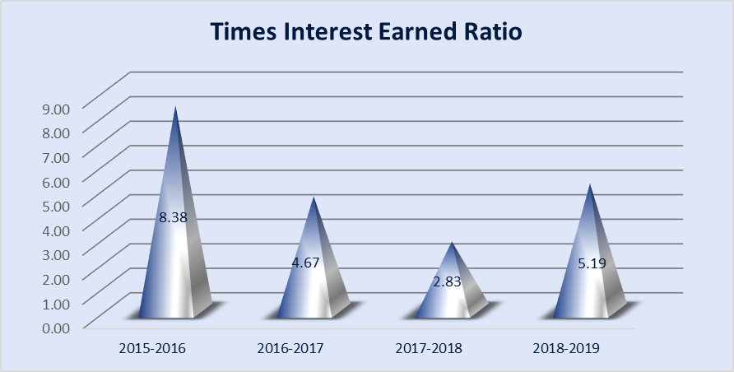

We can see that the graph is fluctuating. The ratio started to fall from the year 2015 to 2017, again the ratio increased in 2018-2019.
A high proportion implies that Rahimafrooz Energy Service Ltd can meet its interest debt obligations since earnings are altogether more prominent than yearly interest debt obligations.
Equity Multiplier Ratio
The equity multiplier shows the percentage of assets that are financed or owed by the investors. On the other hand, this proportion likewise shows the degree of debt financing is utilized to get resources and look after activities.
Equation: Equity Multiplier Ratio = TA/ Total Equity
Year | 2015-2016 | 2016-2017 | 2017-2018 | 2018-2019
Equity Multiplier Ratio | 2.58 | 2.53 | 3.42 | 3.40

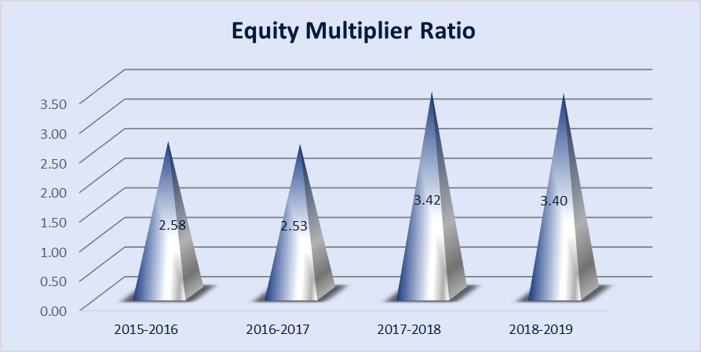
In 2015-2016 the proportion was low, however it began to increase from the following year. A high value multiplier shows that Rahimafrooz Energy Service Ltd has been utilizing more obligation than equity to finance its asset purchases. The equity multiplier is best utilized when contrasted with the equity multiplier of other comparable organizations or, if accessible, an industry standard. Regardless of whether the proportion is high contrasted with comparative organizations, if Rahimafrooz Energy Service Ltd is working beneficially, and hence proficiently utilizing its advantages, at that point the utilization of a more significant level of obligation is suitable.
Equity ratio
Equity proportion is a financial proportion demonstrating the general extent of equity used to finance an organization's assets. The two segments are regularly taken from the organization's balance sheet or statement of financial position (so-called book value), yet the proportion may likewise be determined computing market values for both, if the organization's equities are traded publicly.
Equation: Equity ratio = Total equity / Total Asset
Year | 2015-2016 | 2016-2017 | 2017-2018 | 2018-2019
Equity Ratio | 0.39 | 0.39 | 0.29 | 0.29
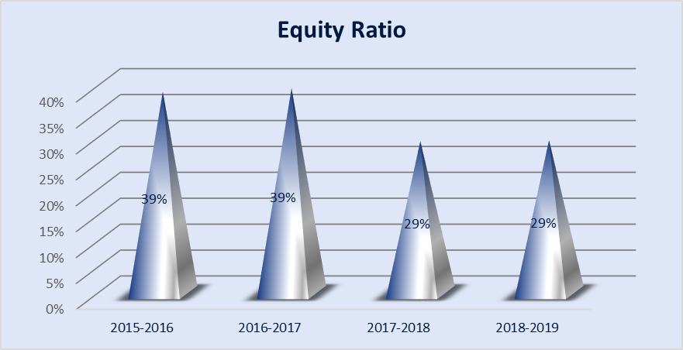
From the diagram we can see the proportion is diminishing. At the point when an organization's equity proportion is under 50% it is known as a leveraged firm. A low equity proportion will create great outcomes for investors as long as Rahimafrooz Energy Service Ltd acquires a rate of return for assets that is more prominent than the loan fee paid to lenders. The Equity Ratio is a decent pointer of the degree of leveraged utilized by Rahimafrooz Energy Service Ltd. The Equity Ratio quantifies the extent of the total assets that are financed by investors, instead of lenders.
Debt to Income Ratio
Debt to income ratio shows that the firm’s ability to pay their current liability from their net income. In practical net income & positive cash flows are in trade off in nature because net income is an accounting calculation it does not depends on cash flows.
Equation: Debt to Income Ratio = Current Debt / Income
Year | 2015-2016 | 2016-2017 | 2017-2018 | 2018-2019
Debt to Income Ratio | 7.68 | 12.16 | 28.09 | 31.64

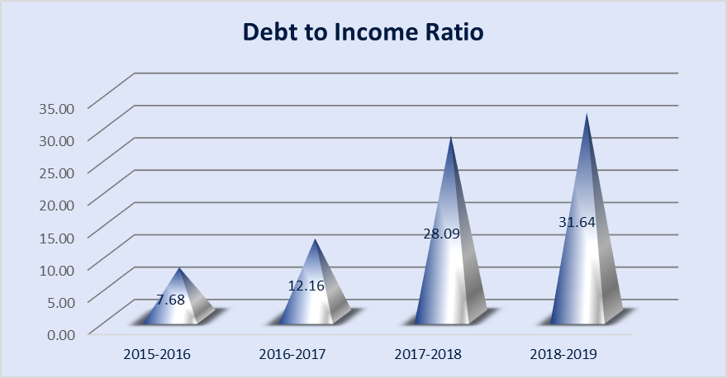
\
Above graph shows debt to income ratio 7.68, 12.16, 28.09, 31.64 from year 2015 to 2019 respectively which has been increased year to year but in the year 2019 shows almost 32 times higher from net income. It seems that company’s has current liabilities which are incurred due to company’s inventory policy.
Fixed Asset to Total Liability Ratio
Fixed Assets proportion is a kind of solvency proportion, it shows the measure of fixed resources being financed by every unit of long term funds. It decides the limit of an organization to release its liability towards long term creditors demonstrating its financial strength and guaranteeing its long term endurance.
Equation: Fixed Asset to Total Liability Ratio = Fixed Asset/Total Liability
Year | 2015-2016 | 2016-2017 | 2017-2018 | 2018-2019
Fixed Asset to Total Liability Ratio | 0.09 | 0.08 | 0.05 | 0.04

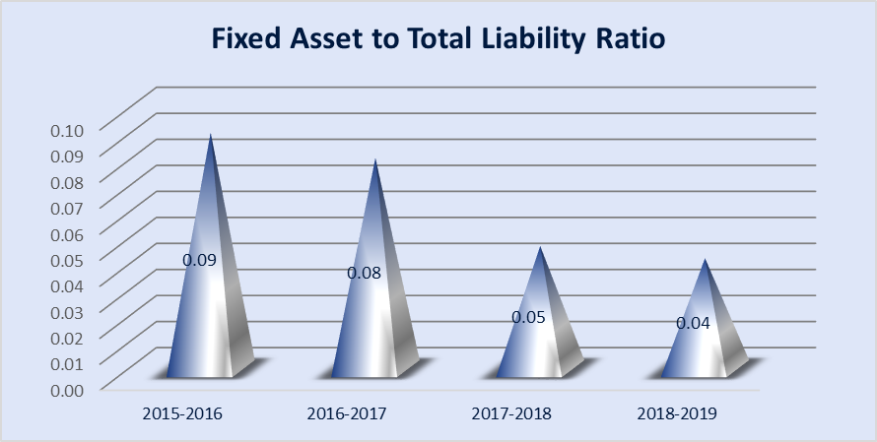

From the chart it is seen that the proportion is diminishing every year. In 2015-2016 the proportion was 0.09, however in 2018-2019 it got 0.04. Proportion of under 1 demonstrates long term funds of the organization are more than its net fixed assets It is alluring somewhat as it implies that an organization has adequate long term assets to cover its fixed assets.

2.3.4 Efficiency Ratios

Efficiency is the capacity to abstain from squandering materials, vitality, endeavors, cash, and time in accomplishing something or in delivering an ideal outcome. In a progressively broad sense, it is the capacity to do things well, effectively, and without waste. The efficiency proportion is normally used to break down how well an organization utilizes its assets and liabilities inside. An effectiveness proportion is computing the turnover of receivables, the reimbursement of liabilities, and the general usage of inventory and apparatus.
Days Payables Outstanding
Tax Management Efficiency ratio

Employee Productivity Ratio
Inventory Turnover ratio
Asset Turnover Ratio
Days Sales in Inventory
Days Sales Outstanding
Payables Turnover Ratio
Current Asset turnover Ratio
Receivables Turnover Ratio
Operating Efficiency Ratio
Current Asset turnover Ratio

Fixed asset Turnover Ratio

Expense Control Efficiency Ratio
Inventory Turnover ratio
The inventory turnover proportion is a proficiency proportion that shows how adequately stock is overseen by contrasting expense of merchandise sold and normal stock for a period.
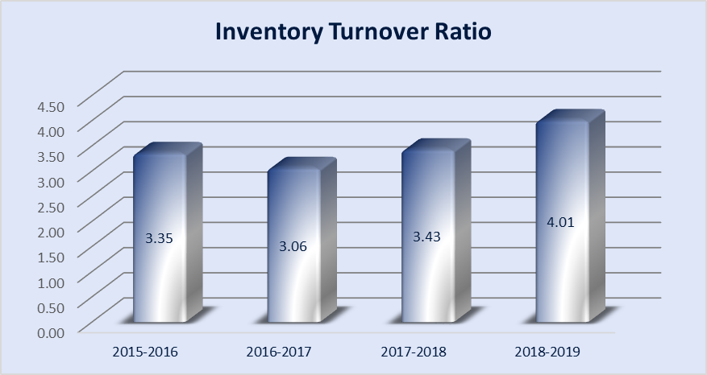
Equation: Inventory Turnover ratio = COGS/ Inventories
Year | 2015-2016 | 2016-2017 | 2017-2018 | 2018-2019
Inventory Turnover Ratio | 3.35 | 3.06 | 3.43 | 4.01
We can see the chart is fluctuating. In 2015-2016, the stock turnover was 3.35 % where in 2016-2017 it diminished to 3.06%. A low stock turnover proportion shows that an organization might be overloading or insufficiencies in the product offering or showcasing exertion. It is an indication of incapable inventory administration since stock as a rule has a zero rate of return and high stockpiling expense.
After then it expanded to 4.01%. Higher stock turnover proportions are viewed as a positive marker of viable inventory administration. In any case, a higher inventory turnover proportion doesn't constantly mean better execution. It here and there may show insufficient inventory level, which may bring about diminishing in sales.
Days Sales in Inventory
Days in inventory is an effectiveness proportion that estimates the normal number of days the organization holds its stock before selling it. The proportion quantifies the quantity of days' funds are tied up in stock.
Equation: Days Sales in Inventory = (Inventory/ COGS)*365
Year | 2015-2016 | 2016-2017 | 2017-2018 | 2018-2019
Days Sales in Inventory | 109 | 119 | 107 | 91

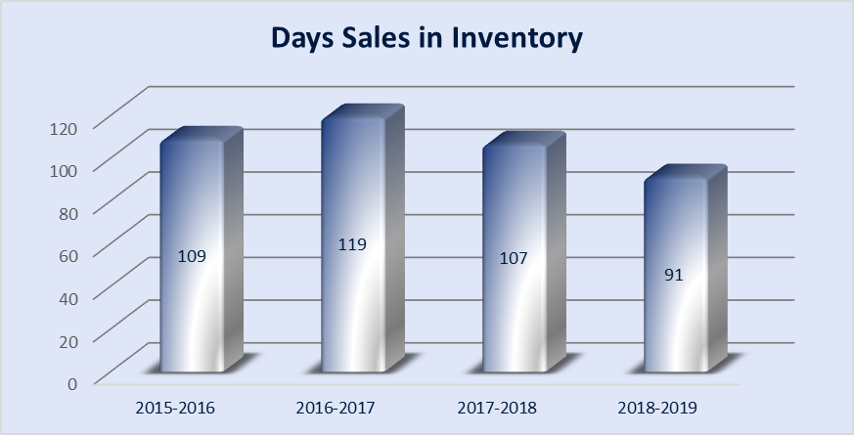
It is appeared that the proportions are fluctuating throughout the year. In 2015-2016 the DSI esteems was 109. A huge DSI value shows that the organization might be battling with obsolete, high-volume inventory and may have put a lot into the equivalent. Be that as it may, in 2018-2019 the worth got 91, which is lower than earlier year. A more modest number demonstrates that an organization is all the more proficiently and much of the time auctioning off its inventory, which implies fast turnover prompting the potential for higher benefits

Receivables Turnover Ratio
Receivable Turnover Ratio or Debtor's Turnover Ratio is a bookkeeping measure used to gauge how viable an organization is in expanding credit just as gathering obligations. The receivables turnover proportion is an action proportion, estimating how productively an organization utilizes its assets.
Equation: Receivables Turnover Ratio = Net credit sales/ Avg accounts rec
Year | 2015-2016 | 2016-2017 | 2017-2018 | 2018-2019
Receivables Turnover Ratio | 7.34 | 6.67 | 5.20 | 7.21
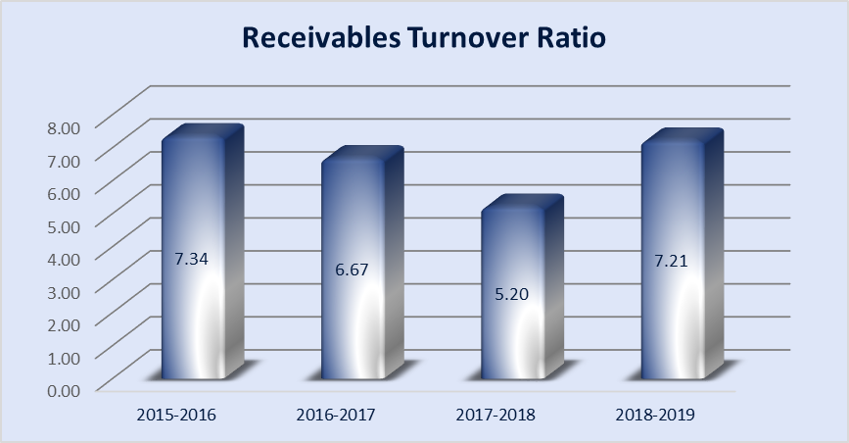
In 2015 - 2016 the proportion was 7.34 .After that it diminished to 6.67 at that point ceaselessly continued diminishing till 2017-2018. A lower proportion may imply that either the Rahimafrooz Energy Service Ltd is less effective in gathering the lender has a merciful credit strategy or has a low quality of account holders. Then again it expanded to 7.21 in the following year. A higher proportion implies that the Rahimafrooz Energy Service Limited is gathering cash all the more as often as possible or potentially has a decent nature of indebted individuals. This thus implies the organization has a superior cash position, showing that it can take care of off its bills and different liabilities sooner.
Days Sales Outstanding
The Days Sales Outstanding equation shows speculators and loan lenders how well organizations' can gather money from their clients. Clearly, sales don't make a difference if money is rarely gathered. This proportion quantifies the quantity of days it takes an organization to change over its sales into money.
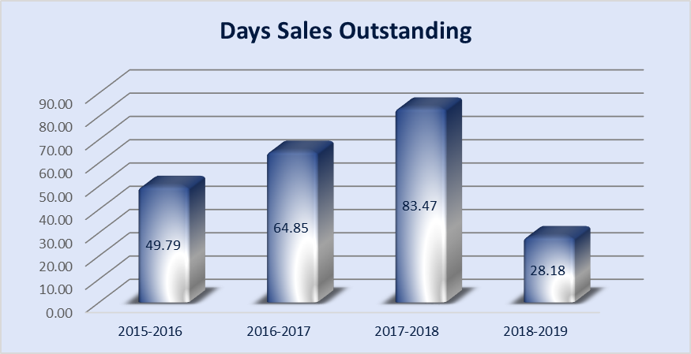
Equation: Days Sales Outstanding = (Accounts receivable / credit sales) * number of days Year
Year | 2015-2016 | 2016-2017 | 2017-2018 | 2018-2019
Days Sales Outstanding | 49.79 | 64.85 | 83.47 | 28.18
In 2015-2016 the proportion was 49.79, it constantly expanded for the following 2 years. The higher proportion was 83.47. A higher proportion demonstrates Rahimafrooz Energy Service Ltd with poor assortment methods and clients who can't or reluctant to pay for their buys. So Rahimafrooz Energy Service Ltd can't change over sales into money as fast as firms with lower proportions. Afterwards, the proportion diminished to 28.18 in 2018-2019. A lower proportion is progressively good since it implies organizations gather money earlier from clients and can utilize this money for different activities. It additionally shows that the account receivables are great and won't be discounted as bad debt.
Payables Turnover Ratio
The accounts payable turnover proportion is a short-term liquidity measure used to evaluate the rate at which an organization takes care of its providers. Accounts payable turnover shows how often an organization takes care of its accounts payable during a period.
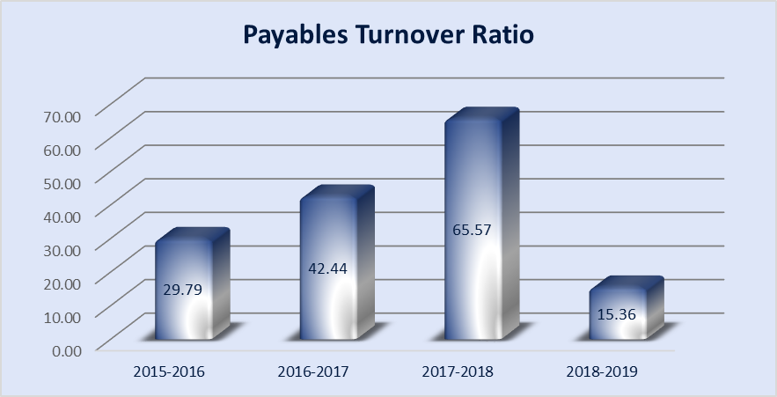
Equation: Payables Turnover Ratio = Total credit purchase/ Avg Accounts payable
Year | 2015-2016 | 2016-2017 | 2017-2018 | 2018-2019
Payables Turnover Ratio | 29.79 | 42.44 | 65.57 | 15.36
In 2015-2016 the proportion was 29.79, it ceaselessly expanded for the following 2 years. The higher proportion was 65.57. At the point when the turnover proportion is expanding, the organization is taking care of suppliers at a quicker rate than in past periods. An expanding proportion implies Rahimafrooz Energy Service Ltd has a lot of cash accessible to take care of its short term obligation in a convenient way. In 2018-2019 it all of a sudden diminished to 15.36. A diminishing proportion could flag that an organization is in money related misery. On the other hand, a diminishing proportion could likewise mean the organization has arranged distinctive installment courses of action with its suppliers.
Days Payables Outstanding
Days payable extraordinary (DPO) is a productivity proportion that estimates the average number of days an organization takes to pay its providers.
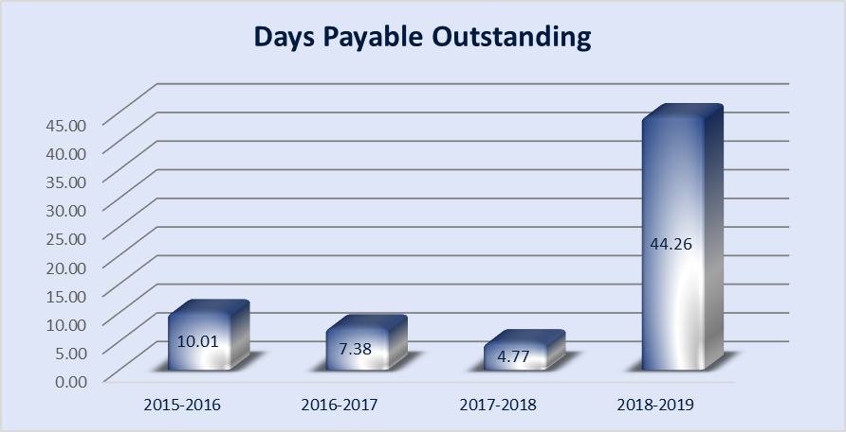
Equation: Days Payables Outstanding = (Accounts payables * number of days)/ COGS
Year | 2015-2016 | 2016-2017 | 2017-2018 | 2018-2019
Days Payable Outstanding | 10.01 | 7.38 | 4.77 | 44.26
In 2015-2018 the proportion was low. A low DPO of Rahimafrooz Energy Service Ltd may demonstrate that the organization isn't completely using its credit period offered by banks. On the other hand, it is conceivable that the organization just has momentary acknowledge courses of action for its loan creditors. In 2018-2019, the proportion expanded drastically to 44.26. A high DPO is commonly valuable for an organization. On the off chance that an organization takes more time to pay its banks, the overabundance money available in hand might be utilized for short-term investing activities. Notwithstanding, taking too long to even consider paying leasers may bring about troubled lenders and their refusal to broaden further credit or offer great credit terms. Likewise, if the DPO is excessively high, it might demonstrate that the organization is battling to discover cash to pay its lenders.
Fixed asset Turnover Ratio
The fixed resource turnover proportion is a proportion that estimates how productively an organization is creating net sales from its fixed- asset investments.
Equation: Fixed asset Turnover Ratio = Net sales / Fixed Asset
Year | 2015-2016 | 2016-2017 | 2017-2018 | 2018-2019
Fixed Asset Turnover Ratio | 17.31 | 20.20 | 23.75 | 28.26

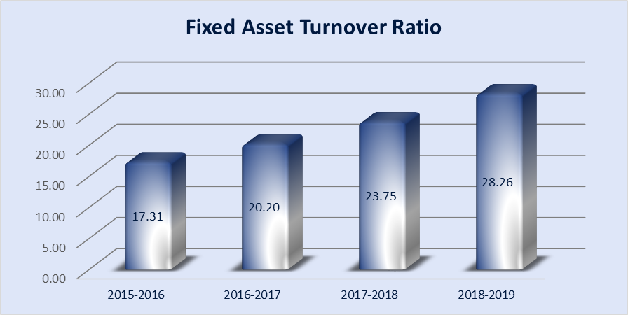
In 2015-2016 the proportions was 17.31, it persistently expanded throughout the years to 28.26. The higher the proportion better is the proficiency of the organization in using the assets and the other way around. A high proportion demonstrates that a business is-Doing a compelling activity of creating sales with a moderately limited quantity of fixed assets , Outsourcing work to abstain from putting resources into fixed assets, Selling off overabundance fixed asset limit.

Current asset Turnover Ratio
Current resources turnover proportion that demonstrates how proficiently an organization is utilizing its current assets to generate income.
Equation: Current Asset Turnover Ratio= Net Sales/ Current Asset
Year | 2015-2016 | 2016-2017 | 2017-2018 | 2018-2019
Current Asset Turnover Ratio | 1.020 | 1.043 | 0.821 | 0.875

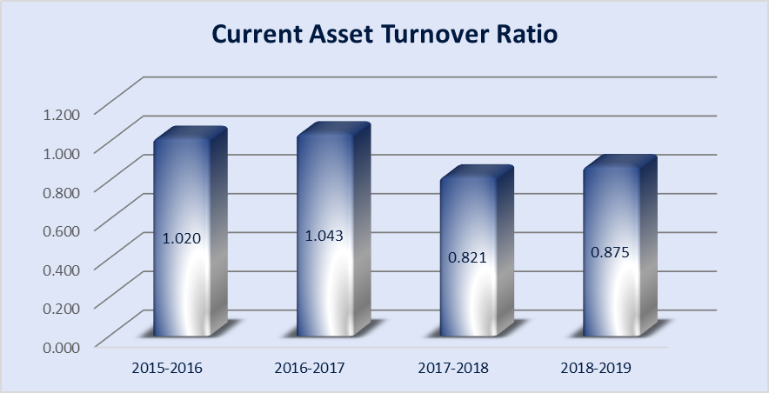

In 2015-2016 the ratio was 1.020, in 2016-2017 it increased to 1.043 and then it declined to 0.821 in the next year. In 2018-2019 the ratio slightly improved to 0.875 than the previous year.
Higher turnover proportions mean the organization is utilizing its all the assets more effectively. Lower proportions imply that the organization isn't utilizing its assets productively and probably have the supervision problems.

Operating Efficiency Ratio
Operating proportion is an organization's expense as a percentage of income. The working proportion can be utilized to decide the productivity of an organization's administration by contrasting expenses with net sales.
Equation: Operating Efficiency Ratio = Operating Expense /Sales
Year | 2015-2016 | 2016-2017 | 2017-2018 | 2018-2019
Operating Efficiency Ratio | 0.14 | 0.15 | 0.13 | 0.19

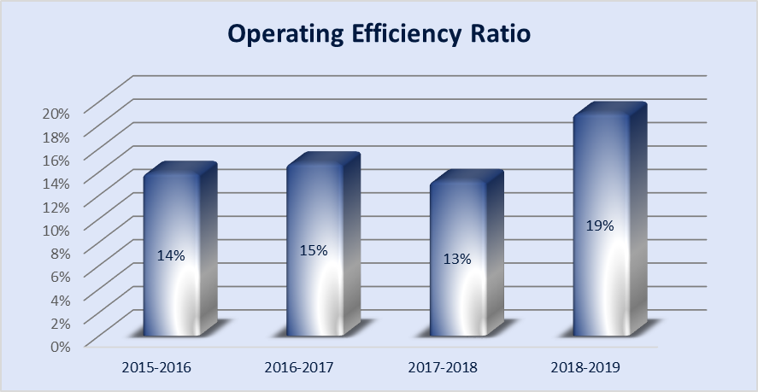

In 2015-2016 the ratio was 14%, in 2016-2017 it increased to 15% and then it declined to 13% in the next year. In 2018-2019 the ratio slightly improved to 19% than the previous year.
An operating proportion that is going up is seen as a negative sign, as this shows working costs are expanding comparative with sales or income. Rahimafrooz Energy Service Ltd may need to actualize cost controls for margin improvement if its operating proportion rises after some time.

Expense Control Efficiency Ratio
Expense control efficiency proportion implies how you effectively control your costs.
Equation: Expense Control Efficiency Ratio = EBIT / Sales
year | 2015-2016 | 2016-2017 | 2017-2018 | 2018-2019
Expense Control Efficiency Ratio | 12% | 8% | 5% | 5%

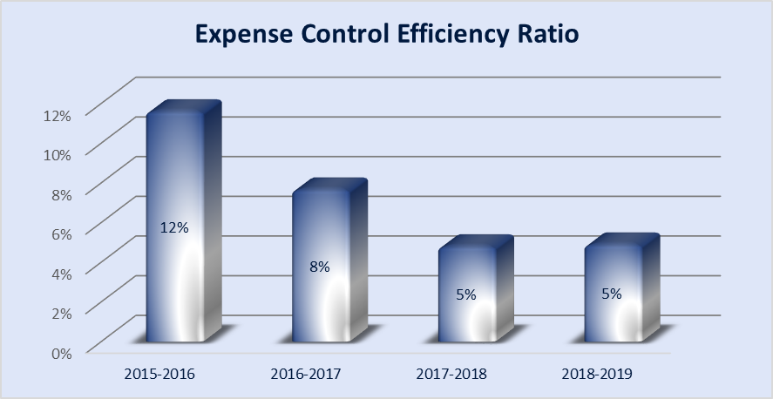

In 2015-2016 the ratio was 12%, but it declined continuously for the next 3 years to 5%.
A higher proportion demonstrates that more costs are acquired to deal with a set amount of assets. A lower proportion demonstrates that less are costs are expected to gauge a similar measure of assets. As such, the board is doing a progressively effective activity at fund operating. A lower productivity proportion is best since lower proportions demonstrate that it takes less cost to create each dollar of revenue.
Tax Management Efficiency ratio
The tax management efficiency proportion of a reserve estimates what level of a store's profit are lost to taxation. Assets that lose a ton of cash to taxes have low productivity and are less alluring, while those that lose little to taxes have a high tax management efficiency proportion and more desirability.
Equation: Tax Management Efficiency ratio = Net Income/ Net income before Tax
Year | 2015-2016 | 2016-2017 | 2017-2018 | 2018-2019
Tax Management Efficiency Ratio | 0.65 | 0.65 | 0.65 | 0.65

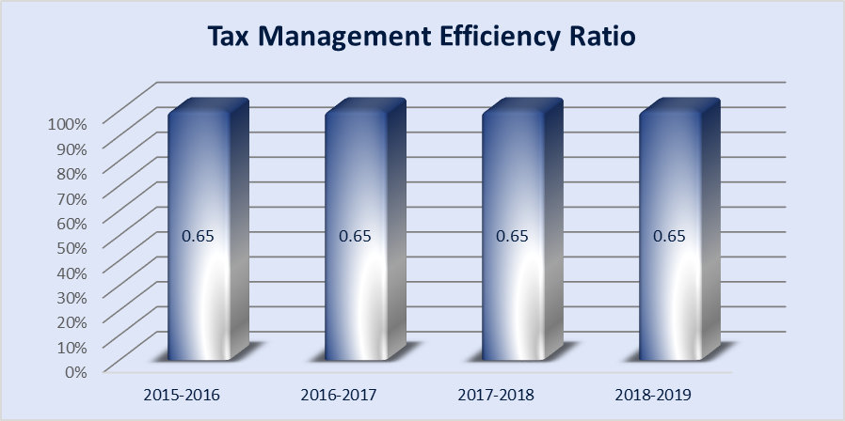

Here the proportions are same for the 4 years . Funds with a very high level of turnover will in general be less proficient, while funds with a low degree of turnover will in general have a high tax efficiency rating
Employee Productivity Ratio
Employee productivity is an appraisal of the proficiency of a laborer or gathering of laborers.
Equation Employee Productivity Ratio = Net operating income/ number of employees Year
Year | 2015-2016 | 2016-2017 | 2017-2018 | 2018-2019
Employee Productivity Ratio | 656756.22 | 484024.06 | 324675.19 | 389216.95

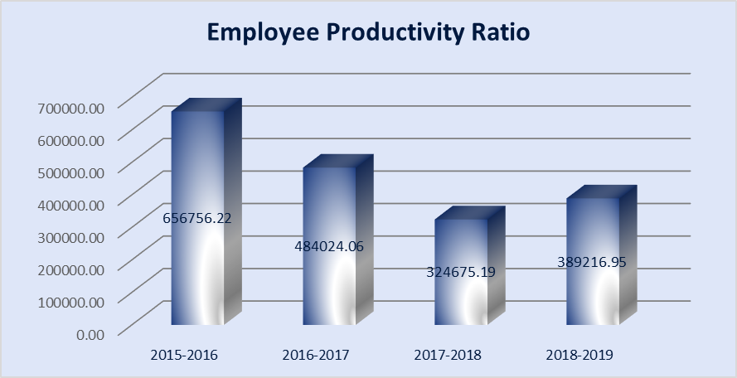

In 2015-2016 the ratio was more but drastically it declined for the next 3 years.
We can say that the company overall employee productivity has been decreased over the period.

Asset Turnover Ratio
The benefit turnover proportion is an effectiveness proportion that estimates an organization's capacity to produce sales from its assets by contrasting net sales with average total assets. As such, this proportion shows how effectively an organization can utilize its assets for making sales.
Equation: Asset Turnover Ratio= Net Sales/ Average total Asset
Year | 2015-2016 | 2016-2017 | 2017-2018 | 2018-2019
Asset Turnover Ratio | 0.98 | 1.03 | 0.93 | 0.88

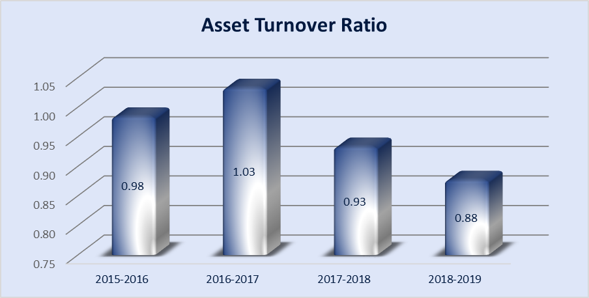

The ratio was higher in 2016-2017, that means the company is using its assets more efficiently.
It became lower for the following 2 time frame. Lower proportions imply that the organization isn't utilizing its assets effectively and probably have production problems

Inventory Conversion Period
The inventory conversion period is the time required to get materials for an item, fabricate it, and sell it. The inventory conversion period is basically the timeframe during which an organization must put money while it changes materials into a sale.
Equation: Inventory Conversion Period=365/inventory turnover
Year | 2015-2016 | 2016-2017 | 2017-2018 | 2018-2019
Inventory Conversion Period | 108.81 | 119.34 | 106.54 | 91.08

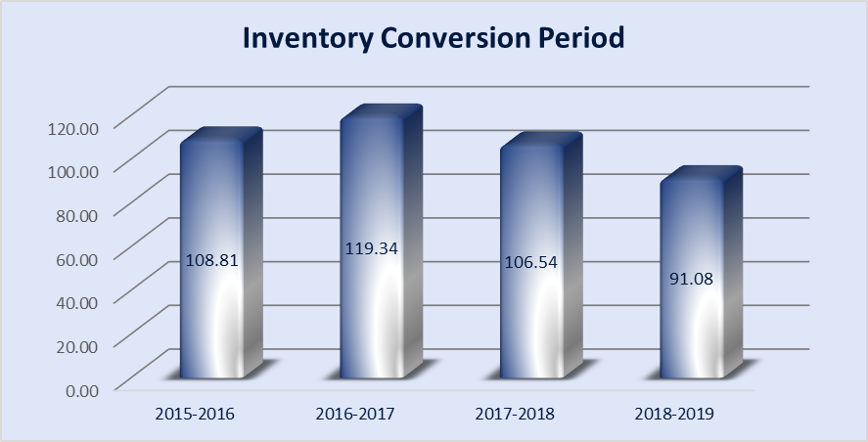

From the calculation it is founded that in 2015-2016 the period is 108.81 days, meaning that, inventories are sold after 108.81 days in average over the year.. But we can see that in next 3 years, the period starts to decrease. In this case, the lesser the ratio, the better. In next 4 years, the ratios are- 119.34, 106.54, and 91.08 which is lower than 2015-2016 but worse. It means in these years the inventories were sold after short period of time and turned into cash sooner than 2015-2016 .
Payable deferral period
The payable deferral time frame quantifies the executives' capacity to postpone installment to sellers. In other words, the accounts payable deferral time frame gauges the normal postponement between when a bill is gotten and when it is paid.
Equation: Payable deferral period=365/payable turnover
Year | 2015-2016 | 2016-2017 | 2017-2018 | 2018-2019
Payable deferral period | 12.25 | 8.60 | 5.57 | 23.77

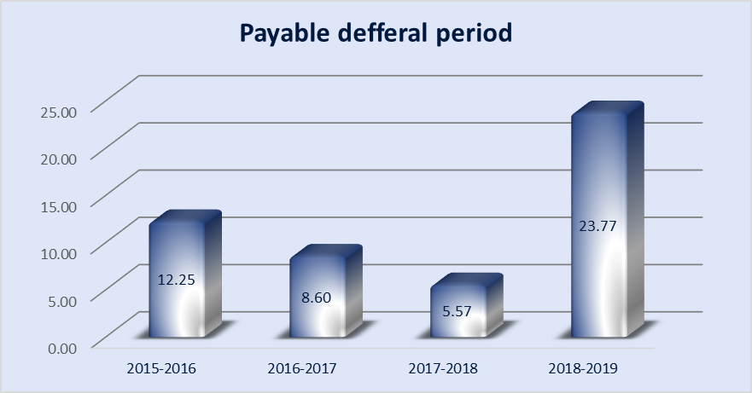
From the graph it can be seen that in 2015-2016 the ratio was low up to 2017-2018, then it increased in 2018-2019.
So now Rahimafrooz Energy Service Ltd Company with a higher estimation of payable deferral period takes more time to take care of its bills, which implies that it holds the accessible funds for a more drawn out span. It might permit the organization a chance to use the accessible money in a superior manner to expand the advantages.

2.3.5 Market ratios

Market value proportions are utilized to assess the current share price of a publicly held organization's stock. These proportions are utilized by present and potential speculators to decide if an organization's offers are over-estimated or undervalued.
The following Market Ratios have been calculated in the report:
1. Price to Earnings Ratio
Price to Earnings Ratio

The price-to-earnings ratio (P/E ratio) is the proportion for esteeming an organization that estimates its present offer value comparative with its per-share income (EPS). The price-to-earnings ratio is likewise some of the time known as the price multiple or the earnings multiple. P/E proportions are utilized by financial specialists and analysts to decide the overall estimation of an organization's offers in logical examination.
Equation: Price to Earnings Ratio = Share price/ Earnings per share
year | 2015-2016 | 2016-2017 | 2017-2018 | 2018-2019
Price to Earning Ratio | 0.94 | 1.43 | 2.45 | 1.68

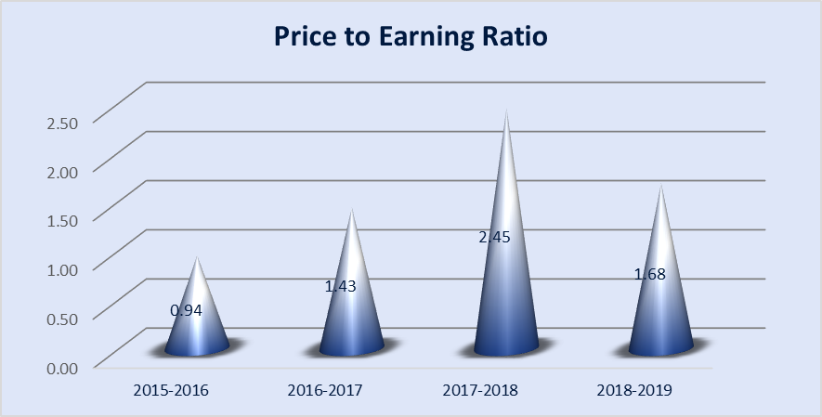

Here this ratio is very low at the year of 2015-2016 with 0 .94 which indicates that stock's price of Rahimafrooz Energy Service Ltd was low relative to earnings and possibly undervalued. Then it increased rapidly at 2016-2017 and 2017-2018. It means in 2015 the current stock price of Rahimafrooz Energy Service Ltd was high relative to earnings. Then it again started to decrease in 2018-2019.

TECHNIQUE 4

DU PONT ANALYSIS

2.4 DuPont Analysis

Extended analysis of return on equity is known as Dupont analysis. It refers that a company can receive a high return on equity if it:

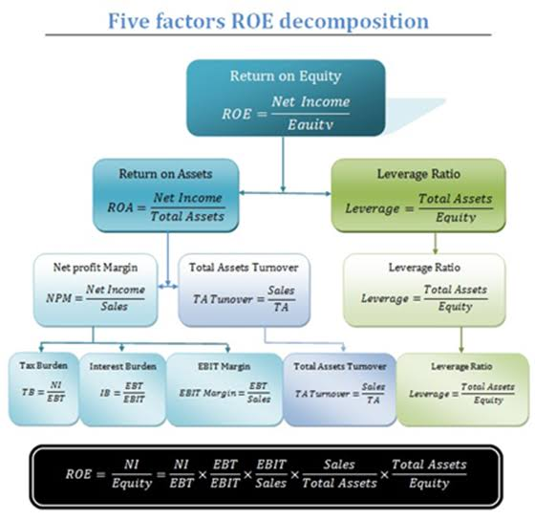
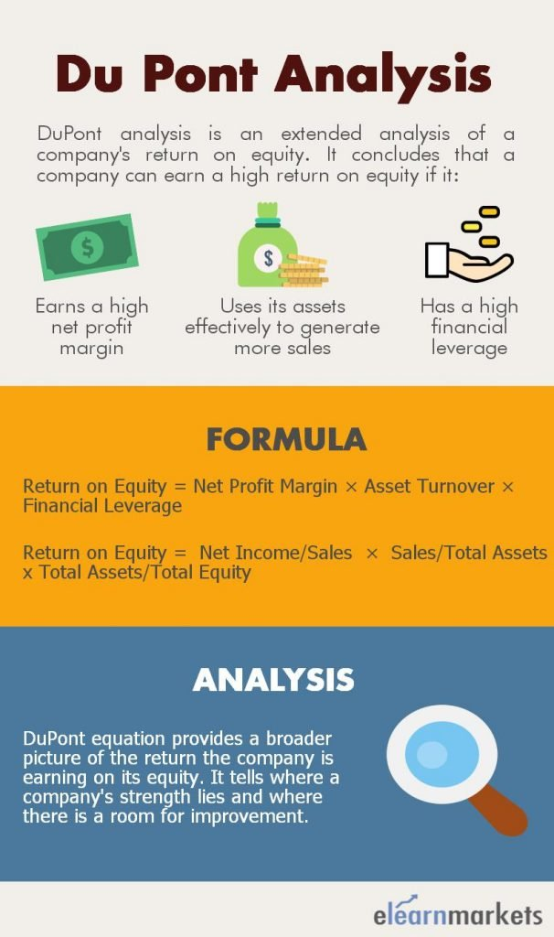
Has a high financial leverage
Uses its assets effectively to generate more sales
Earns a high net profit margin
3 Step and 5 steps Dupont Analysis:

Three step Dupont model: | 2018-2019 | 2017-2018 | 2016-2017 | 2015-2016
Net profit margin (Net income/sales) | 2.4% | 1.9% | 3.7% | 6.3%
Asset Turnover (Sales/Total asset) | 0.85 | 0.79 | 0.99 | 0.96
Equity Multiplier (Total Asset/ Equity) | 3.40 | 3.42 | 2.53 | 2.58
Return on Equity | 7.0% | 5.2% | 9.4% | 15.7%

Five step Dupont model: | 2018-2019 | 2017-2018 | 2016-2017 | 2015-2016
Tax Burden (Net Income/ EBT) | 0.65 | 0.65 | 0.65 | 0.65
Interest Burden (EBT/EBIT) | 0.77 | 0.62 | 0.75 | 0.84
Operating Income Margin ( EBIT/Sales) | 4.9% | 4.8% | 7.6% | 11.6%
Asset Turnover (Sales/ Total Asset) | 0.85 | 0.79 | 0.99 | 0.96
Equity Multiplier (Total Asset/ Equity) | 3.40 | 3.42 | 2.53 | 2.58
Return on Equity | 7.0% | 5.2% | 9.4% | 15.7%

In 2015-2016 Rahimafrooz Energy Service Ltd was able to generate large number of sales while maintaining a lower cost of goods which can be seen from its high-profit margin of 6.3%.
On the other hand, in 2018-2019 Rahimafrooz Energy Service Ltd is selling its products at a lower margin also having very low Asset Turnover Ratio representing that the company is not making a large number of sales. Moreover, Rahimafrooz Energy Service Ltd seems risky since its Equity multiplier is higher than 2015-2016.
If there is a rise in the Net Profit Margin without an adjustment in the Financial Leverage, it shows that the organization can increase its profitability.
But here Rahimafrooz Energy Service is ready to extend its ROE just because of increase in Financial Leverage, it’s risky since the organization is ready to extend its assets by taking debt.

CHAPTER FOUR

FINDINGS, CONCLUSION

3.1Findings

- Before 2018-2019 Rahimafrooz Energy Service Ltd could meet its short-term debt obligations better with no stress.
- Company had more quick assets to fulfill its liabilities.
- The company has less cash and cash equivalents than its current liabilities, so it can’t meet its short term liabilities or repay its accounts payables immediately.
- The company may face loss in future because of a decrease in efficiency of the company to produce sales using its assets over the years
- Company’s ability to generate profit from stockholder’s equity is low
- Rahimafrooz Energy Service Ltd is expanding its debt to capital proportion year by year.
- Rahimafrooz Energy Service Ltd has been utilizing more obligation than equity to finance its asset purchases.
- Organization has adequate long term assets to cover its fixed assets.
- Organization has a superior cash position, showing that it can take care of off its bills and different liabilities sooner.
- Organizations gather money earlier from clients and can utilize this money for different activities.
- Business is-Doing a compelling activity of creating sales with a moderately limited quantity of fixed assets
- Rahimafrooz Energy Service Ltd may need to actualize cost controls for margin improvement if its operating proportion rises

3.2 Conclusion

Rahimafrooz Energy Services Limited (RESL) established in the year 2000. The study focused on the financial performance evaluation. RESL has huge issue in keeping up liquidity yet they attempt to maintain it by delaying installment to their banks. Simultaneously it isn't all that great in debt management. However, RESL is exceptionally proficient to control its inventory, lenders and sales. Then again, RESL is in low position in benefit by improving net benefit, gross profit and operating profit. Despite the fact that they have issues in ROE and ROA they ought to recover it by giving profound fixation. Generally speaking it can take great situation in the market by improving.

APPENDIX
Bibliography

- Rahimafrooz Energy Services Ltd. (RESL) - Home. (n.d.). http://www.rahimafroozenergy.com/
- Horizontal and Vertical Analysis. (n.d.). https://www.dummies.com/business/accounting/horizontal-and-vertical-analysis/
- DuPont Analysis, Interpretation, Formula, Ratios, Chart, Model, Calculator. (n.d.). from https://www.elearnmarkets.com/blog/dupont-analysis/
- Home Corporate Office- Rahimafrooz Bangladesh Ltd. (n.d.). from https://www.rahimafrooz.com/
- Henry, E., Robinson, T. R., & Van Greuning, J. H. (2011). Financial Analysis Techniques LEARNING OUTCOMES.

Income statement
Horizontal Analysis
Income Statement | 2015-2016 | 2016-2017 | 2017-2018 | 2018-2019
Sales | 1.77% | 11.67% | 13.91% | 14.16%
Less: Cost of goods sold | 1.11% | 16.36% | 20.32% | 6.00%
Gross profit |  | -2.02% | -8.33% | 51.37%
Less: Operating expenses |  | 18.23% | 2.28% | 64.06%
Administrative expenses |  | 18.27% | 2.02% | 58.57%
Sales & distribution expenses |  | 17.35% | 7.96% | 175.93%
Profit before interest and tax |  | -26.30% | -28.73% | 16.35%
Less: Finance cost |  | 32.31% | 17.70% | -36.64%
Profit before tax and contribution fund |  | -34.24% | -41.38% | 45.36%
Contribution to WPPF and WF |  | -34.24% | -41.38% | 45.36%
Net profit before tax |  | -34.24% | -41.38% | 45.36%
Provision for corporate tax @ 35% |  | -34.24% | -41.38% | 45.36%
Net profit for the year |  | -34.24% | -41.38% | 45.36%
Other comprehensive income
Total comprehensive income |  | -34.24% | -41.38% | 45.36%
Earning Per Share |  | -34.24% | -41.38% | 45.36%

Vertical Analysis
Income Statement | 2015-2016 | 2016-2017 | 2017-2018 | 2018-2019
Sales | 100% | 100% | 100% | 100%
Less: Cost of goods sold | 76% | 82% | 78% | 75%
Gross profit | 24% | 18% | 22% | 25%
Less: Operating expenses | 19% | 13% | 15% | 14%
Administrative expenses | 17% | 13% | 14% | 13%
Sales & distribution expenses | 1% | 1% | 1% | 1%
Profit before interest and tax | 5% | 5% | 8% | 12%
Less: Finance cost | 1% | 2% | 2% | 1%
Profit before tax and contribution fund | 4% | 3% | 6% | 10%
Contribution to WPPF and WF | 0% | 0% | 0% | 0%
Net profit before tax | 4% | 3% | 6% | 10%
Provision for corporate tax @ 35% | 1% | 1% | 2% | 3%
Net profit for the year | 2% | 2% | 4% | 6%
Other comprehensive income
Total comprehensive income | 2% | 2% | 4% | 6%

Balance Sheet
Horizontal Analysis
Balance Sheet | 2015-2016 | 2016-2017 | 2017-2018 | 2018-2019
ASSETS
Non-Current Assets
Property, plant and equipment |  | -4.3% | -3.1% | -4.0%
(At cost less accumulated depreciation)
Current Assets |  | 9.2% | 44.7% | 7.2%
Inventories | 973.1% | 27.6% | 7.4% | -9.4%
Accounts receivable | 0.2% | 45.4% | 46.6% | -61.5%
Advance income tax |  | 4.9% | 10.8% | 54.0%
Advances, deposits and prepayments |  | 10.5% | 52.3% | 32.0%
Inter company receivables |  | -13.2% | 88.5% | 28.0%
Cash and cash equivalent |  | 25.7% | 2.4% | 61.9%
Total Assets | 4.4% | 8.4% | 42.3% | 6.8%
EQUITY AND LIABILITIES
Shareholders' equity |  | 10.3% | 5.5% | 7.6%
Share capital |  | 0.0% | 0.0% | 0.0%
Retained earnings |  | 12.1% | 6.3% | 8.7%
Non Current Liabilities |  | 17.3% | 155.4% | -80.6%
Lease obligation |  | 18.0% | 161.4% | -83.1%
Liability for gratuity |  | 10.0% | 90.8% | -43.9%
Current Liabilities |  | 4.1% | 35.4% | 63.7%
Bank overdraft |  | -47.7% | 313.5% | 26.4%
Lease obligation (Current portion) |  | 26.2% | 248.1% | -54.4%
Short term loan |  | 1.4% | -6.5% | 50.3%
Liabilities for expenses |  | -89.8% | 1314.4% | 1456.0%
Accounts payables | 27.2% | -14.2% | -22.2% | 883.0%
Inter company payables |  | -29.9% | 1443.3% | 126.5%
Provision for taxation |  | 12.8% | 6.6% | 9.0%
Total Equity and Liabilities |  | 8.4% | 42.3% | 6.8%
Total Liability |  | 7.2% | 66.4% | 6.5%

Balance Sheet
Vertical Analysis
Balance Sheet | 2015-2016 | 2016-2017 | 2017-2018 | 2018-2019
ASSETS
Non-Current Assets
Property, plant and equipment | 5.6% | 4.9% | 3.3% | 3.0%
(At cost less accumulated depreciation)
Current Assets | 94.4% | 95.1% | 96.7% | 97.0%
Inventories | 21.4% | 25.2% | 19.0% | 16.1%
Accounts receivable | 13.1% | 17.6% | 18.2% | 6.6%
Advance income tax | 12.8% | 12.4% | 9.6% | 13.9%
Advances, deposits and prepayments | 7.9% | 8.1% | 8.6% | 10.7%
Inter company receivables | 37.9% | 30.3% | 40.1% | 48.1%
Cash and cash equivalent | 1.3% | 1.5% | 1.1% | 1.7%
Total Assets |  |  |  | This is the base for Asset so it is 1
EQUITY AND LIABILITIES
Shareholders' equity | 38.8% | 39.5% | 29.2% | 29.4%
Share capital | 5.7% | 5.3% | 3.7% | 3.5%
Retained earnings | 33.0% | 34.2% | 25.5% | 26.0%
Non Current Liabilities | 14.5% | 15.6% | 28.1% | 5.1%
Lease obligation | 13.1% | 14.3% | 26.3% | 4.2%
Liability for gratuity | 1.3% | 1.3% | 1.8% | 0.9%
Current Liabilities | 46.8% | 44.9% | 42.7% | 65.4%
Bank overdraft | 0.5% | 0.2% | 0.7% | 0.8%
Lease obligation (Current portion) | 3.5% | 4.0% | 9.9% | 4.2%
Short term loan | 22.6% | 21.1% | 13.9% | 19.5%
Liabilities for expenses | 0.9% | 0.1% | 0.9% | 12.4%
Accounts payables | 2.0% | 1.6% | 0.9% | 7.8%
Inter company payables | 0.5% | 0.3% | 3.4% | 7.2%
Provision for taxation | 16.9% | 17.6% | 13.2% | 13.4%
Total Equity and Liabilities |  |  |  | This is the base for Liability so it is 1
Total Liability | 61.2% | 60.5% | 70.8% | 70.6%
Total equity | 29.4% | 29.2% | 39.5% | 38.8%

Liquidity Ratio
1. Current Ratio= (Current Asset/Current Liability)
Year | 2015-2016 | 2016-2017 | 2017-2018 | 2018-2019
Current Asset | 888,882,490.81 | 970,346,839.24 | 1,404,083,807.32 | 1,504,941,750.50
Current Liability | 440,234,219.00 | 458,228,212.00 | 620,334,043.89 | 1,015,471,388.07
Current Ratio | 2.02 | 2.12 | 2.26 | 1.48
2. Quick Ratio = (CA- Inventory/ CL)
Year | 2015-2016 | 2016-2017 | 2017-2018 | 2018-2019
Current Asset | 888,882,490.81 | 970,346,839.24 | 1,404,083,807.32 | 1,504,941,750.50
Inventory | 201,369,874.00 | 256,987,415.00 | 276,027,889.83 | 250,123,687.00
Current Liability | 440,234,219.00 | 458,228,212.00 | 620,334,043.89 | 1,015,471,388.07
Quick Ratio | 1.56 | 1.56 | 1.82 | 1.24
3.Cash Ratio = (Cash+Cash Equivalent/CL)
Year | 2015-2016 | 2016-2017 | 2017-2018 | 2018-2019
Cash & Cash Equivalent | 12,325,698.00 | 15,487,897.00 | 15,855,985.42 | 25,665,797.00
Current Liability | 440,234,219.00 | 458,228,212.00 | 620,334,043.89 | 1,015,471,388.07
Cash Ratio | 0.028 | 0.034 | 0.026 | 0.025
4. Cash total to operating expense = Cash/ total operating expenses
Year | 2015-2016 | 2016-2017 | 2017-2018 | 2018-2019
Cash | 12,325,698.00 | 15,487,897.00 | 15,855,985.42 | 25,665,797.00
Total operating expenses | 125,988,625.00 | 148,960,902.00 | 152,359,911.00 | 249,959,677.00
Cash total to operating expense | 9.8% | 10.4% | 10.4% | 10.3%
5.Sales to Currrent Asset Ratio= Total sales / Current Asset
Year | 2015-2016 | 2016-2017 | 2017-2018 | 2018-2019
Total sales | 906,548,617.00 | 1,012,369,874.00 | 1,153,214,567.00 | 1,316,546,460.00
Current asset | 888,882,490.81 | 970,346,839.24 | 1,404,083,807.32 | 1,504,941,750.50
Sales to Current Asset Ratio | 1.02 | 1.04 | 0.82 | 0.87
6. Current Assset by Total Liability = Current Assset /Total Liability
Year | 2015-2016 | 2016-2017 | 2017-2018 | 2018-2019
Current Assset | 888,882,490.81 | 970,346,839.24 | 1,404,083,807.32 | 1,504,941,750.50
Total Liability | 576,260,080.00 | 617,809,615.00 | 1,027,888,542.94 | 1,094,687,811.07
Current Asset by Total Liability | 1.54 | 1.57 | 1.37 | 1.37
7. Cash to Current asset = Cash/ Current asset
Year | 2015-2016 | 2016-2017 | 2017-2018 | 2018-2019
Cash | 12,325,698.00 | 15,487,897.00 | 15,855,985.42 | 25,665,797.00
Current asset | 888,882,490.81 | 970,346,839.24 | 1,404,083,807.32 | 1,504,941,750.50
Cash to Current asset | 1.39% | 1.60% | 1.13% | 1.71%
8. Cash to t asset = Cash/ Total asset
Year | 2015-2016 | 2016-2017 | 2017-2018 | 2018-2019
Cash | 906,548,617.00 | 1,012,369,874.00 | 1,153,214,567.00 | 1,316,546,460.00
Total asset | 941,247,968.81 | 1,020,470,536.24 | 1,452,631,704.32 | 1,551,529,163.50
Cash to Total asset | 96.31% | 99.21% | 79.39% | 84.85%
Profitability Ratio
1. Net Profit Margin= income/ sales
Year | 2015-2016 | 2016-2017 | 2017-2018 | 2018-2019
income | 57,289,147.81 | 37,673,032.43 | 22,082,240.14 | 32,098,191.05
sales | 906,548,617.00 | 1,012,369,874.00 | 1,153,214,567.00 | 1,316,546,460.00
Net Profit Margin | 6.32% | 3.72% | 1.91% | 2.44%
2. Gross Profit Margin = Gross profit /Net sales
year | 2015-2016 | 2016-2017 | 2017-2018 | 2018-2019
Gross profit | 231,069,620.00 | 226,404,751.00 | 207,554,693.00 | 314,180,473.00
Net sales | 906,548,617.00 | 1,012,369,874.00 | 1,153,214,567.00 | 1,316,546,460.00
Gross Profit Margin | 25.5% | 22.4% | 18.0% | 23.9%
3. Operating Profit Margin = Operating income/ net sales
year | 2015-2016 | 2016-2017 | 2017-2018 | 2018-2019
Operating income | 105,080,995.00 | 77,443,849.00 | 55,194,782.00 | 64,220,796.00
Net sales | 906,548,617.00 | 1,012,369,874.00 | 1,153,214,567.00 | 1,316,546,460.00
Operating Profit Margin | 11.59% | 7.65% | 4.79% | 4.88%
4. Return on Assets = net income / total asset
Year | 2015-2016 | 2016-2017 | 2017-2018 | 2018-2019
Net income | 57,289,147.81 | 37,673,032.43 | 22,082,240.14 | 32,098,191.05
Total asset | 941,247,968.81 | 1,020,470,536.24 | 1,452,631,704.32 | 1,551,529,163.50
Return on Assets | 6.09% | 3.69% | 1.52% | 2.07%
5.Earning before tax Margin = EBT/Net sales
Year | 2015-2016 | 2016-2017 | 2017-2018 | 2018-2019
EBT | 88,137,150.48 | 57,958,511.43 | 33,972,677.14 | 49,381,832.38
Net sales | 906,548,617.00 | 1,012,369,874.00 | 1,153,214,567.00 | 1,316,546,460.00
Earning before tax Margin | 9.7% | 5.7% | 2.9% | 3.8%
6.Return on Equity = Net income/ Equity
Year | 2015-2016 | 2016-2017 | 2017-2018 | 2018-2019
Net income | 57,289,147.81 | 37,673,032.43 | 22,082,240.14 | 32,098,191.05
Equity | 364,987,888.81 | 402,660,921.24 | 424,743,161.38 | 456,841,352.43
Return on Equity | 15.70% | 9.36% | 5.20% | 7.03%
7. Earning Per Share = total income/ number of shares
Year | 2015-2016 | 2016-2017 | 2017-2018 | 2018-2019
total income | 57,289,147.81 | 37,673,032.43 | 22,082,240.14 | 32,098,191.05
number of shares | 540,000 | 540,000 | 540,000 | 540,000
Earning Per Share | 106.09 | 69.76 | 40.89 | 59.44
Solvency ratio
1. Debt Ratio = Total liability/ Total asset
year | 2015-2016 | 2016-2017 | 2017-2018 | 2018-2019
Total liability | 576,260,080.00 | 617,809,615.00 | 1,027,888,542.94 | 1,094,687,811.07
Total asset | 941,247,968.81 | 1,020,470,536.24 | 1,452,631,704.32 | 1,551,529,163.50
Debt Ratio | 61.22% | 60.54% | 70.76% | 70.56%
2. Debt to Equity Ratio = Total liability / shareholders equity
year | 2015-2016 | 2016-2017 | 2017-2018 | 2018-2019
Total liability | 576,260,080.00 | 617,809,615.00 | 1,027,888,542.94 | 1,094,687,811.07
shareholders equity | 364,987,888.81 | 402,660,921.24 | 424,743,161.38 | 456,841,352.43
Debt to Equity Ratio | 1.58 | 1.53 | 2.42 | 2.40
3. Debt to Capital ratio = Total Liability/ total debt+shareholders equity
year | 2015-2016 | 2016-2017 | 2017-2018 | 2018-2019
Total Liability | 576,260,080.00 | 617,809,615.00 | 1,027,888,542.94 | 1,094,687,811.07
total debt | 576,260,080.00 | 617,809,615.00 | 1,027,888,542.94 | 1,094,687,811.07
shareholders equity | 364,987,888.81 | 402,660,921.24 | 424,743,161.38 | 456,841,352.43
Debt to Capital ratio | 61.2% | 60.5% | 70.8% | 70.6%
4. Times Interest Earned Ratio =EBIT/ Interest Expense
Year | 2015-2016 | 2016-2017 | 2017-2018 | 2018-2019
EBIT | 105,080,995.00 | 77,443,849.00 | 55,194,782.00 | 64,220,796.00
Interest Expense | 12,536,987.00 | 16,587,412.00 | 19,523,471.00 | 12,369,872.00
Times Interest Earned Ratio | 8.38 | 4.67 | 2.83 | 5.19
5. Equity Multiplier Ratio = Total Asset / Total Equity
Year | 2015-2016 | 2016-2017 | 2017-2018 | 2018-2019
Total Asset | 941,247,968.81 | 1,020,470,536.24 | 1,452,631,704.32 | 1,551,529,163.50
Total Equity | 364,987,888.81 | 402,660,921.24 | 424,743,161.38 | 456,841,352.43
Equity Multiplier Ratio | 2.58 | 2.53 | 3.42 | 3.40
6. Equity Ratio = Total Equity/ Total Asset
Year | 2015-2016 | 2016-2017 | 2017-2018 | 2018-2019
Total Equity | 364,987,888.81 | 402,660,921.24 | 424,743,161.38 | 456,841,352.43
Total Asset | 941,247,968.81 | 1,020,470,536.24 | 1,452,631,704.32 | 1,551,529,163.50
Equity Ratio | 0.39 | 0.39 | 0.29 | 0.29
7.Debt to Income Ratio = Current Debt / Income
Year | 2015-2016 | 2016-2017 | 2017-2018 | 2018-2019
Current Debt | 440,234,219.00 | 458,228,212.00 | 620,334,043.89 | 1,015,471,388.07
Income | 57,289,147.81 | 37,673,032.43 | 22,082,240.14 | 32,098,191.05
Debt to Income Ratio | 7.68 | 12.16 | 28.09 | 31.64
8. Fixed Asset to Total Liability Ratio = Fixed Asset / Total Liability
Year | 2015-2016 | 2016-2017 | 2017-2018 | 2018-2019
Fixed Asset | 52,365,478.00 | 50,123,697.00 | 48,547,897.00 | 46,587,413.00
Total Liability | 576,260,080.00 | 617,809,615.00 | 1,027,888,542.94 | 1,094,687,811.07
Fixed Asset to Total Liability Ratio | 0.09 | 0.08 | 0.05 | 0.04
Efficiency Ratio
1. Inventory Turnover Ratio = COGS/Inventories
Year | 2015-2016 | 2016-2017 | 2017-2018 | 2018-2019
COGS | 675,478,997.00 | 785,965,123.00 | 945,659,874.00 | 1,002,365,987.00
Inventories | 201,369,874.00 | 256,987,415.00 | 276,027,889.83 | 250,123,687.00
Inventory Turnover Ratio | 3.35 | 3.06 | 3.43 | 4.01
2. Days Sales in Inventory = (Inventory/COGS)*365
Year | 2015-2016 | 2016-2017 | 2017-2018 | 2018-2019
Inventory | 201,369,874.00 | 256,987,415.00 | 276,027,889.83 | 250,123,687.00
COGS | 675,478,997.00 | 785,965,123.00 | 945,659,874.00 | 1,002,365,987.00
365 | 365 | 365 | 365 | 365
Days Sales in Inventory | 108.81 | 119.34 | 106.54 | 91.08
3. Receivables Turnover Ratio = Net Credit Sales/ Avg Accounts Receiveable
year | 2015-2016 | 2016-2017 | 2017-2018 | 2018-2019
Net Credit Sales | 906,548,617.00 | 1,012,369,874.00 | 1,153,214,567.00 | 1,316,546,460.00
Avg Accounts Receiveable | 123559397.5 | 151,758,099.00 | 221,792,887.64 | 182,693,008.14
Receivables Turnover Ratio | 7.34 | 6.67 | 5.20 | 7.21
4. Days Sales Outstanding = (Accounts Receivables/ Credit Sales)* Nm Of Days
Year | 2015-2016 | 2016-2017 | 2017-2018 | 2018-2019
Accounts Receivables | 123,659,874.00 | 179,856,324.00 | 263,729,451.28 | 101,656,565.00
Credit Sales | 906,548,617.00 | 1,012,369,874.00 | 1,153,214,567.00 | 1,316,546,460.00
Nm Of Days | 365 | 365 | 365 | 365
Days Sales Outstanding | 49.79 | 64.85 | 83.47 | 28.18
5. Payables Turnover Ratio = Total Credit Purchase/Avg Accounts Payable
Year | 2015-2016 | 2016-2017 | 2017-2018 | 2018-2019
Total Credit Purchase | 492,874,441.00 | 730,347,582.00 | 926,619,399.17 | 1,028,270,189.83
Avg Accounts Payable | 16,545,732.50 | 17,210,542.50 | 14,131,469.50 | 66,956,667.50
Payables Turnover Ratio | 29.79 | 42.44 | 65.57 | 15.36
6. Days Payable Outstanding = (Accounts Payble * Nm Of Days)/COGS
Year | 2015-2016 | 2016-2017 | 2017-2018 | 2018-2019
Accounts Payble | 18,523,624.00 | 15,897,461.00 | 12,365,478.00 | 121,547,857.00
Nm Of Days | 365 | 365 | 365 | 365
COGS | 675,478,997.00 | 785,965,123.00 | 945,659,874.00 | 1,002,365,987.00
Days Payable Outstanding | 10.01 | 7.38 | 4.77 | 44.26
7. Fixed Asset Turnover Ratio = Net Sales / Fixed Asset
Year | 2015-2016 | 2016-2017 | 2017-2018 | 2018-2019
Net Sales | 906,548,617.00 | 1,012,369,874.00 | 1,153,214,567.00 | 1,316,546,460.00
Fixed Asset | 52,365,478.00 | 50,123,697.00 | 48,547,897.00 | 46,587,413.00
Fixed Asset Turnover Ratio | 17.31 | 20.20 | 23.75 | 28.26
8. Current Asset Turnover Ratio =Net Sales /Current Asset
year | 2015-2016 | 2016-2017 | 2017-2018 | 2018-2019
Net Sales | 906,548,617.00 | 1,012,369,874.00 | 1,153,214,567.00 | 1,316,546,460.00
Current Asset | 888,882,490.81 | 970,346,839.24 | 1,404,083,807.32 | 1,504,941,750.50
Current Asset Turnover Ratio | 1.02 | 1.04 | 0.82 | 0.87
9. Operating Efficiency Ratio = Operating Expense/ Sales
year | 2015-2016 | 2016-2017 | 2017-2018 | 2018-2019
Operating Expense | 125,988,625.00 | 148,960,902.00 | 152,359,911.00 | 249,959,677.00
Sales | 906,548,617.00 | 1,012,369,874.00 | 1,153,214,567.00 | 1,316,546,460.00
Operating Efficiency Ratio | 0.14 | 0.15 | 0.13 | 0.19
10. Expense Control Efficiency Ratio = EBIT/ Sales
year | 2015-2016 | 2016-2017 | 2017-2018 | 2018-2019
EBIT | 105,080,995.00 | 77,443,849.00 | 55,194,782.00 | 64,220,796.00
Sales | 906,548,617.00 | 1,012,369,874.00 | 1,153,214,567.00 | 1,316,546,460.00
Expense Control Efficiency Ratio | 0.12 | 0.08 | 0.05 | 0.05
11. Tax Management Efficiency Ratio = Net Income/ Net Income Before Tax
Year | 2015-2016 | 2016-2017 | 2017-2018 | 2018-2019
Net Income | 57,289,147.81 | 37,673,032.43 | 22,082,240.14 | 32,098,191.05
Net Income Before Tax | 88137150.48 | 57958511.43 | 33972677.14 | 49381832.38
Tax Management Efficiency Ratio | 0.65 | 0.65 | 0.65 | 0.65
12. Employee Productivity Ratio = Net Operating Income/ Nm of Employees
Year | 2015-2016 | 2016-2017 | 2017-2018 | 2018-2019
Net Operating Income | 105,080,995.00 | 77,443,849.00 | 55,194,782.00 | 64,220,796.00
Nm of Employees | 160 | 160 | 170 | 165
Employee Productivity Ratio | 656,756.22 | 484,024.06 | 324,675.19 | 389,216.95
13. Asset Turnover Ratio= Net Sales/ Average total Asset
Year | 2015-2016 | 2016-2017 | 2017-2018 | 2018-2019
Net Sales | 906,548,617.00 | 1,012,369,874.00 | 1,153,214,567 | 1,316,546,460
Average total Asset | 921,558,972.40 | 980,859,252.52 | 1,236,551,120.28 | 1,502,080,433.91
Asset Turnover Ratio | 0.98 | 1.03 | 0.93 | 0.88
14. Inventory Conversion Period=365/inventory turnover
Year | 2015-2016 | 2016-2017 | 2017-2018 | 2018-2019
365 | 365 | 365 | 365 | 365
inventory turnover | 3.35 | 3.06 | 3.43 | 4.01
Inventory Conversion Period | 109 | 119 | 107 | 91
15. Payable defferal period=365/payable turnover
Year | 2015-2016 | 2016-2017 | 2017-2018 | 2018-2019
365 | 365 | 365 | 365 | 365
payable turnover | 29.79 | 42.44 | 65.57 | 15.36
Payable defferal period | 12 | 9 | 6 | 24
Market Ratio
1. Price to Earning Ratio = Share Price / Earning Per Share
year | 2015-2016 | 2016-2017 | 2017-2018 | 2018-2019
Share Price | 100 | 100 | 100 | 100
Earning Per Share | 106.09 | 69.76 | 40.89 | 59.44
Price to Earning Ratio | 0.94 | 1.43 | 2.45 | 1.68
2. Price to Book Ratio = Market Price / Book Value Per Share
year | 2015-2016 | 2016-2017 | 2017-2018 | 2018-2019
Market Price | 100 | 100 | 100 | 100
Book Value Per Share | 100 | 100 | 100 | 100
Price to Book Ratio | 1 | 1 | 1 | 1
3 Step and 5 steps Dupont Analysis:

Three step Dupont model: | 2018-2019 | 2017-2018 | 2016-2017 | 2015-2016
Net profit margin (Net income/sales) | 2.4% | 1.9% | 3.7% | 6.3%
Asset Turnover (Sales/Total asset) | 0.85 | 0.79 | 0.99 | 0.96
Equity Multiplier (Total Asset/ Equity) | 3.40 | 3.42 | 2.53 | 2.58
Return on Equity | 7.0% | 5.2% | 9.4% | 15.7%

Five step Dupont model: | 2018-2019 | 2017-2018 | 2016-2017 | 2015-2016
Tax Burden (Net Income/ EBT) | 0.65 | 0.65 | 0.65 | 0.65
Interest Burden (EBT/EBIT) | 0.77 | 0.62 | 0.75 | 0.84
Operating Income Margin ( EBIT/Sales) | 4.9% | 4.8% | 7.6% | 11.6%
Asset Turnover (Sales/ Total Asset) | 0.85 | 0.79 | 0.99 | 0.96
Equity Multiplier (Total Asset/ Equity) | 3.40 | 3.42 | 2.53 | 2.58
Return on Equity | 7.0% | 5.2% | 9.4% | 15.7%

