Impact of Inflation Volatility on Banking Sector Stability: Evidence from Frontier Economies

Project Report
On
Impact of Inflation Volatility on Banking Sector Stability: Evidence from Frontier Economies

Submitted to:
Muhammad Enamul Haque
Assistant Professor
School of Business and Economics
Submitted by:
Shariare Mahmud
1112230162
Major: Finance & FinTech
261 - Spring 2026 (Trimester)


School of Business and Economics
United International University
Date of Submission: 22nd July, 2026

Letter of Transmittal
Date: 22nd July, 2026
To
Muhammad Enamul Haque
Assistant professor
School of Business and Economics
United International University (UIU)
Madani Avenue, Dhaka, Bangladesh

Subject: Submission of report on “Impact of Inflation Volatility on Banking Sector Stability: Evidence from Frontier Economies”
Dear Sir,
With due respect, I am pleased to submit my report titled “Impact of Inflation Volatility on Banking Sector Stability: Evidence from Frontier Economies.” This report has been prepared as a part of my academic requirement and focuses on the relationship between inflation volatility and banking-sector stability in selected frontier economies.
The report examines inflation volatility as a macro-financial risk factor using GARCH(1,1)-based volatility and simple panel models, with the Bank Z-score as the main stability indicator and the NPL ratio as a complementary risk indicator.
I have tried to prepare the report carefully by using relevant literature, secondary macro-financial data, and empirical analysis. I sincerely hope that the report will meet the required academic standard.
I would like to express my heartfelt gratitude to you for your valuable guidance and continuous support during the preparation of this report. I shall remain grateful for your time, encouragement, and constructive feedback.

Sincerely,
Shariare Mahmud
1112230162
Major: Finance and FinTech
School of Business and Economics
United International University (UIU)

Certification of Similarity Index
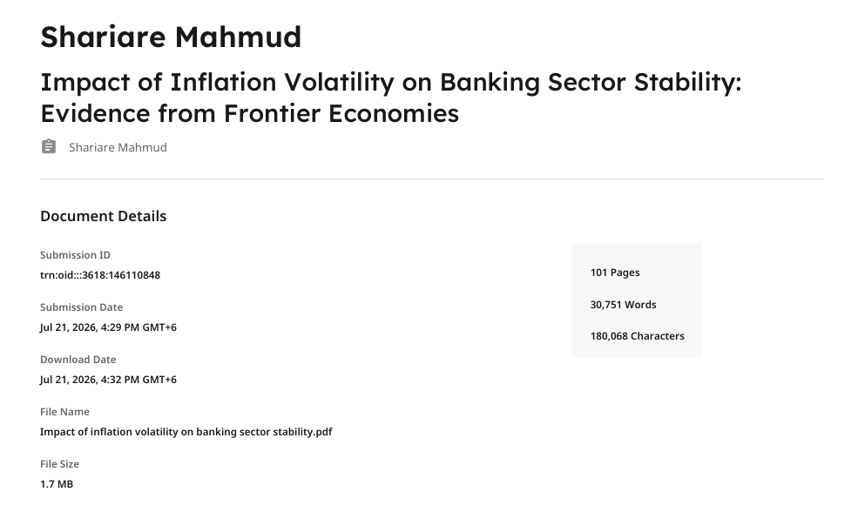

Declaration of the Student

I, Shariare Mahmud, declare that the report entitled
“Impact of Inflation Volatility on Banking Sector Stability: Evidence from Frontier Economies” has been prepared by me as a partial requirement for the fulfillment of the Bachelor of Business Administration (BBA) degree from the School of Business and Economics, United International University (UIU).
I further declare that the work presented in this report is based on my own study, analysis, and interpretation of relevant literature and secondary data sources. Any information, ideas, tables, figures, formulas, or arguments taken from other authors, databases, or published materials have been properly acknowledged in the main report through appropriate citation and referencing.
I also confirm that the report has been prepared with complete honesty, sincerity, and adherence to academic ethics and guidelines provided by the university.

Name: Shariare Mahmud
ID: 1112230162
Major: Finance and FinTech
School of Business and Economics
United International University (UIU)
Date: 22nd July, 2026

Acknowledgement

First of all, I express my sincere gratitude to Almighty Allah for giving me the strength, patience, and ability to complete this report successfully.
I would like to convey my deepest thanks to my honorable Academic Supervisor, Mr. Muhammad Enamul Haque, Assistant Professor at the School of Business and Economics, United International University (UIU). His guidance, valuable advice, and continuous encouragement were instrumental throughout this report. Without his thoughtful supervision, completing this work would have been extremely difficult.
I acknowledge the contribution of the World Bank, Global Financial Development Database, and other secondary data sources used in this report.
Furthermore, I would like to thank my family, friends, and classmates for their continuous support and motivation during the completion of this report. Their encouragement helped me remain focused and complete the work within the required time.
Although this report may still contain some shortcomings, I have sincerely put forth my best effort to make it as comprehensive and accurate as possible. Lastly, I would like to express heartfelt appreciation to United International University (UIU) for providing me with the academic foundation and valuable guidance that enabled me to prepare this report successfully.

Abstract

This report examines the impact of inflation volatility on banking-sector stability in selected frontier economies. The study is based on the argument that inflation volatility is not only a macroeconomic issue but also a banking-stability issue, because unstable inflation creates uncertainty in credit markets, affects borrowers’ repayment capacity, weakens asset quality, and increases pressure on banks’ balance sheets. Unlike studies that focus mainly on the level of inflation, this report emphasizes the volatility of inflation as a separate macro-financial risk factor.
Inflation volatility is measured using a country-specific GARCH(1,1) conditional variance approach based on annual consumer price inflation data. Banking-sector stability is measured primarily by the Bank Z-score, while the non-performing loan ratio is considered as a complementary indicator of banking risk and asset-quality deterioration. The empirical analysis follows a simple panel-data framework using Fixed Effects and Random Effects models. The Hausman test is used to guide estimator selection, and additional specifications include macroeconomic controls such as GDP growth and real interest rate. Robustness checks are also considered through alternative volatility specifications and controlled panel models.
The results suggest that inflation volatility is negatively associated with Bank Z-score, meaning that higher inflation volatility is linked with lower distance from insolvency and weaker banking-sector stability. The evidence is stronger and more consistent for the solvency-stability channel than for the non-performing loan channel, which appears weaker and more conditional. The findings indicate that volatile inflation may affect banking systems before credit-quality deterioration becomes clearly visible through reported NPL ratios.
The report concludes that central banks and banking regulators in frontier economies should monitor inflation volatility, not only the average inflation rate. Stronger macroprudential tools, better policy coordination, forward-looking provisioning, and improved inflation-expectation management can help reduce the banking-sector risks associated with unstable inflation.

Table of Contents
Letter of Transmittal iii
Certification of Similarity Index iv
Declaration of the Student v
Acknowledgement vi
Abstract vii
List of Figures xii
List of Tables xiii
List of Acronyms & Abbreviations xiv
CHAPTER 1: INTRODUCTION 1
1.1 Frontier-Economy Macro-Financial Context 1
1.2 Problem Statement 3
1.3 Research questions and objectives 4
1.4 Contribution, Novelty and Expected Value-Added 6
1.5 Scope of the Study, Sample Logic and Paper Roadmap 7
1.5.1 Geographic and temporal scope 8
1.5.2 Dual Banking-Stability Measurement Logic 8
CHAPTER 2: REVIEW OF THE LITERATURE 9
2.1 Literature on Inflation, Inflation Uncertainty and Inflation Volatility 9
2.1.1 Distinguishing Inflation Level from Inflation Volatility 9
2.1.2 Why Volatility Matters More for Risk and Forecasting 10
2.1.3 Implications for Financial Intermediation 11
2.2 Literature on Banking Stability and Its Measurement 12
2.2.1 Principal Measures of Banking Stability 12
2.2.2 Justification for the Z-Score and NPL Pair 13
2.3 Literature that connects Inflation Volatility to Banking Outcomes. 14
2.3.1 Inflation and Loan Quality: The NPL Channel 14
2.3.2 Evidence from Developed and Emerging Economies 15
2.3.3 Evidence from Frontier and Low-Income Economies 16
2.3.4 Mixed Findings and the Volatility Dimension 17
2.4 Frontier-Economy Stylized Evidence and Contextual Research Gap 17
2.4.1 Thinner Financial Markets and Shallow Intermediation 18
2.4.2 Weaker Institutional Quality 18
2.4.3 Exchange-Rate Sensitivity and Pass-Through Effects 19
2.4.4 Limited Monetary Policy Credibility 19
2.4.5 The Contextual Research Gap 20
2.5 Theoretical Framework 20
2.5.1 Asymmetric Information and Credit-Rationing Logic 21
2.5.2 The Fisher Effect and Unexpected Inflation 21
2.5.3 The Balance-Sheet Channel 22
2.5.4 Macro-Financial Vulnerability Logic 23
2.5.5 Synthesis: A Multi-Channel Transmission Framework 23
2.6 Conceptual Framework and Hypothesis Mapping 24
2.6.1 The Causal Chain: From Inflation Process to Banking Outcomes 24
2.6.2 The Moderating Role of the Macro-Financial Environment 27
2.6.3 Formal Hypotheses 27
CHAPTER 3: METHODOLOGY 29
3.1 Research Design and Empirical Strategy 29
3.2 Country Selection, Frontier-Economy Classification, and Panel Structure 29
3.3 Data Sources, Sample Windows and Coverage Logic 31
3.4 Variable Definitions, Measurement, and Expected Signs 32
3.4.1 Dependent Variables 32
3.4.2 Independent Variable 32
3.4.3 Control Variables 33
3.5 Measuring Inflation Volatility 35
3.5.1 Baseline Method: GARCH(1,1) 35
3.5.2 Robustness Method: Rolling Standard Deviation 36
3.6 Preliminary Panel Diagnostics 37
3.6.1 Descriptive Statistics 37
3.6.2 Correlation Analysis and Variance Inflation Factor (VIF) 37
3.6.3 Cross-Sectional Dependence Test 38
3.6.4 Slope Heterogeneity Test 38
3.6.5 Panel Unit Root Tests 38
3.6.6 Cointegration Testing 39
3.7 Baseline Estimation Method: Simple Panel Fixed Effects and Random Effects 40
3.7.1 Hausman Test and Estimator Choice 40
3.8 Stepwise Panel Model Specifications 40
3.9 Robustness, Heterogeneity, and Nonlinearity Methods 41
3.9.1 Alternative Volatility Proxy and Control Sets 41
3.9.2 Estimator and Specification Sensitivity 42
3.9.3 Regional and Institutional Heterogeneity Split 42
3.9.4 High- versus Low-Inflation Regime Analysis 42
3.9.5 Threshold & Interaction Based Nonlinearity Tests 42
3.10 Data Architecture, Missing-Data Treatment, and Indicator Availability Map 43
3.10.1 Data Cleaning and Variable Harmonisation 43
3.10.2 Missing-Value Treatment 44
3.10.3 Country Exclusions 44
3.10.4 Indicator Availability Map and Final Usable Observations 45
CHAPTER 4: RESULTS 46
4.1 Sample profile and descriptive behavior 46
4.2 Diagnostic test results for the simple panel framework 48
4.3 Baseline simple panel results: Fixed Effects and Random Effects 51
4.4 Hausman-test selection and stepwise model interpretation 52
4.5 Robustness and alternative-measure results 53
4.5.1 Additional GARCH-family robustness: AR(1)-GARCH(1,1) and EGARCH(1,1) 54
4.6 Heterogeneity and nonlinearity results 56
4.7 Controlled-variable extension: GDP growth and real interest rate 57
4.7.1 Stepwise controlled simple panel estimates 60
4.7.2 Controlled robustness and threshold checks 62
CHAPTER 5: DISCUSSION 65
5.1 Interpreting the main findings through theory 65
5.2 Why the frontier-economy context matters 67
5.3 Comparison with prior empirical literature 69
5.4 Extended country-level and policy-context interpretation 69
CHAPTER 6: CONCLUSION 71
6.1 Conclusion 71
6.2 Policy implications 72
6.3 Contributions to literature and practice 73
6.4 Limitations and future research 74
References 76

List of Figures

- Figure 2.1: Conceptual Framework of Inflation Volatility and Banking-Sector Stability
- Figure 4.1: Average GARCH(1,1) Inflation Volatility by Region
- Figure 4.2: Distribution of the Two Banking-Stability Indicators
- Figure 4.3: Correlation Heatmap for the Core Three-Way Sample
- Figure 4.4: Threshold Behavior Around Median GARCH Volatility
- Figure 4.5: GDP Growth and Real Interest Rate in the Controlled Core Sample
- Figure 4.6: Controlled Correlation Heatmap
- Figure 4.7: GDP Growth and Real Interest Rate Effects in the Controlled Core Sample
- Figure 4.8: Alternative Volatility-Proxy Coefficients with Controls
- Figure 4.9: Controlled Threshold Behavior Around Median GARCH Volatility: Bank Z-Score
- Figure 4.10: Controlled Threshold Behavior Around Median GARCH Volatility: NPL Ratio

List of Tables

- Table 3.1: Expected Signs of Variables in the Z-Score and NPL Models
- Table 4.1: Final Country-Year Coverage by Estimation Sample
- Table 4.2: Descriptive Statistics for the Core Three-Way Sample
- Table 4.3: Correlation Matrix for the Three-Way Sample
- Table 4.4: Diagnostic and Long-Run Retention Test Summary
- Table 4.5: Baseline Simple Panel Estimates: Panel Model 1 and Panel Model 2
- Table 4.6: Baseline FE-RE Comparison and Hausman-Test Structure: Panel Model 3
- Table 4.7: Hausman-Test and Estimator-Selection Summary for Panel Models 1–6
- Table 4.8: Equation Map for the Six Simple Panel Models
- Table 4.9: Hausman and Estimator-Selection Sensitivity of the GARCH Coefficient
- Table 4.10: Additional GARCH-Family Robustness Comparison
- Table 4.11: Threshold Interaction Estimates by Volatility Regime
- Table 4.12: Controlled Country-Year Coverage by Estimation Sample
- Table 4.13: Descriptive Statistics for the Controlled Core Sample
- Table 4.14: Correlation Matrix with GDP Growth and Real Interest Rate
- Table 4.15: Variance Inflation Factors for the Controlled Regressors
- Table 4.16: Stepwise Simple Panel Estimates: Bank Z-Score Models
- Table 4.17: Hausman-Test Selection Summary for the Controlled Panel Models
- Table 4.18: Controlled Simple-Panel Robustness Checks
- Table 4.19: Alternative Volatility-Measure Robustness with Controls
- Table 4.20: Controlled Threshold Interaction Estimates by Volatility Regime

List of Acronyms & Abbreviations

ADF – Augmented Dickey-Fuller
AR(1) – First-Order Autoregressive Model
ARCH – Autoregressive Conditional Heteroskedasticity
ARDL – Autoregressive Distributed Lag
ASEAN – Association of Southeast Asian Nations
CADF – Cross-Sectionally Augmented Dickey-Fuller
CAR – Capital Adequacy Ratio
CD – Cross-Sectional Dependence
CIPS – Cross-Sectionally Augmented Im-Pesaran-Shin
COMESA – Common Market for Eastern and Southern Africa
CPI – Consumer Price Index
CSD – Cross-Sectional Dependence
ECOWAS – Economic Community of West African States
EFEs – Emerging and Frontier Economies
EGARCH(1,1) – Exponential Generalized Autoregressive Conditional Heteroskedasticity Model of Order (1,1)
EMDEs – Emerging Market and Developing Economies
FE – Fixed Effects
FSI – Financial Soundness Indicators
GARCH(1,1) – Generalized Autoregressive Conditional Heteroskedasticity Model of Order (1,1)
GDP – Gross Domestic Product
GFDD – Global Financial Development Database
GMM – Generalized Method of Moments
IMF – International Monetary Fund
INFVOL – Inflation Volatility
LM – Lagrange Multiplier
MENA – Middle East and North Africa
MSCI – Morgan Stanley Capital International
NIM – Net Interest Margin
NPA – Non-Performing Asset
NPL – Non-Performing Loan
OLS – Ordinary Least Squares
RE – Random Effects
RIR – Real Interest Rate
ROA – Return on Assets
ROE – Return on Equity
SADC – Southern African Development Community
SD – Standard Deviation
UNCTAD – United Nations Conference on Trade and Development
VIF – Variance Inflation Factor
WDI – World Development Indicators

CHAPTER 1: INTRODUCTION

1.1 Frontier-Economy Macro-Financial Context
Inflation volatility and the stability of the banking sector do not stand as individual macroeconomic and financial events but as part of a monetary-financial system: price fluctuations, interest rates, credit availability, bank balance sheet quality, and institutional strength all interact in frontier banking systems. The literature on macro-financial stability has grown increasingly aware of the non-neutrality of monetary policy for financial stability and the multiple and reinforcing mechanisms through which the interactions between the dynamics of prices and the financial sector can be transmitted (Adrian et al., 2023; Vollmer, 2021). Inflation volatility doesn't have only one impact pathway on banks. They affect the cost of funding, the lending style, real returns, repayment ability, asset quality, and risk perception(Kuvshinov et al., 2021; Vollmer, 2021). High inflation can widen the gap between nominal interest rates paid on banks' assets and liabilities, thus increasing the risks arising from maturity transformation, while deflation can increase the real value of credits extended by banks, which makes it harder for borrowers to pay off banks' credits and hence increases credit risk(Kuvshinov et al., 2021). The effects of those responses of the banking sector on credit allocation, liquidity conditions, and the propagation of macroeconomic shocks in turn(Evgenidis & Malliaris, 2022; Vollmer, 2021). This is a reason why studying inflation manifestations exclusively as a manifestation on the macro level and considering banking vulnerability only as a banking-level indicator does not yield a full picture of the vulnerability creation and spread.
This integrated view is particularly relevant to the frontier economies, where financial systems are shallower, policy transmission channels are less developed, and shock sensitivity is higher than that of advanced and larger emerging economies. Creating the necessary conditions for central banks in emerging and frontier economies (EFEs) to meet macroeconomic and financial stability goals may be more difficult due to the government's intervention and political pressures, the limited credibility and skills of the central banks in controlling inflation, and the weak transmission of central bank policies that are, ultimately, all sources of uncertainty about the impact of monetary policy(El‐Shagi & Tochkov, 2021, 2022). Further, the financial system in less advanced economies also suffers from lower levels of capitalization or regulation; higher levels of problematic loans and a more risky environment for financial intermediation push banks into a position of risk where higher spreads are needed as compensation(Mendonça, 2024). Financial instability is more common in developing economies, and the level of economic development plays a crucial role in determining banking spread levels, reflecting the characteristics and stability of each country's financial system(Mendonça, 2024). Furthermore, financial stability literature in emerging markets has shown that financial integration pressures can arise from inflation volatility, and that there are strong links among credit volatility, real interest rate volatility, and output volatility(Arora & Kashiramka, 2023). While there are various proxies in the literature that show financial stability (bank Z-scores, non-performing asset ratios, and stock market volatility), the causal link between inflation and banking fragility is situation-dependent(Arora & Kashiramka, 2023).
In these environments, the link between banking stability and inflation volatility depends not only on the overall inflation evolution, but also on structural factors, regulatory capabilities, and banks' capacity to absorb uncertainties. The banking capital channel is an important transmission channel that can increase the effect of shocks on output, investment, and inflation, or the economy with a larger stock of banks can absorb the shocks better than the economy with a smaller stock of banks(Jordà et al., 2020; Vollmer, 2021). Economies with more capitalized banking systems, however, recover more quickly after a financial crisis because credit starts coming out again more easily, although having a higher level of banking sector capital does not necessarily mean the crisis does not occur(Jordà et al., 2020). In commodity-dependent frontier economies, commodity price volatility is associated with lower fiscal revenues, higher public debt, and a shortening of debt maturity, which can put further pressure on banks' balance sheets through weaker financials of public companies and sovereign-bank linkages(Eberhardt & Presbitero, 2021). In many of the emerging market environments in the cross-country sample, the correlation between the volatility of inflation and the volatility of exchange rates is above 0.7, indicating that more exchange rate volatility can be interpreted as a weaker monetary framework and less inflation-targeting regimes, adding to the vulnerability of the banking sector (Ahmed et al., 2021). Moreover, a benefit that the public debt markets bring to the financial system lies in their role of limiting the volatility of macroeconomic variables, in particular the level of inflation, which should be low so that the nominal yield curve can be interpreted as information about real borrowing costs(Kapaya, 2023).
From a methodological point of view, therefore, a cross-country perspective is well suited and helps determine if such instability is part of a more general pattern or is country-specific. Some comparative research is helpful in this regard, and production specialization in primary commodities and not-deep financial systems were not uncommon traits of both South Asia and Africa's economies before 1970, after which their development experiences showed significant difference, e.g. while African economies remained susceptible to commodity price shocks and terms of trade volatility, South Asian economies, for their part, diversified in exports and deepened their financial systems(Frankema, 2024). Political stability and inflation volatility capture both risk and macroeconomic volatility, as high economic risk and macroeconomic instability may lead to fewer international banks willing to provide credit in frontier settings(Lapid et al., 2022). It extends this view in the current study to a group of frontier economies and examines the relationship between banking-sector stability and inflation volatility and uses it to gauge where financial vulnerability might be the highest.

1.2 Problem Statement
Traditionally, the benchmark for price stability has been the rate of inflation, which has been the focus of macroeconomic policy and banking regulation worldwide, often with central banks mandating inflation targets with a specific number(Gabriel et al., 2022; Nookhwun & Waiyawatjakorn, 2024). Yet research has increasingly shown that of equal importance is the variability of inflation, its volatility or the unpredictable changes around any given trend, as the instability around mean level of inflations proves to be more serious macroeconomic challenge to the stability of the banking sector(Chen, 2025). This distinction becomes important because having a relatively low, but stable, inflation rate does not necessarily interfere with financial intermediation, which is the key role of banks, while having a low inflation rate with a lot of fluctuations creates a widespread uncertainty that impedes the basic role of banks(Chen, 2025; Liu & Serletis, 2021).
But traditional macroeconomic policies and banking regulation have turned their focus towards the inflation rate as the main indicator of price stability, and central banks around the world have aligned their monetary policy targets with a numerical inflation target. But the evidence now points to the fact that it's not the level of inflation that is the greater macroeconomic risk to the stability of the banking sector, it's the volatility around this trend the unpredictable changing trajectory that matters(Chen, 2025; Liu & Serletis, 2021). The difference is important because an economy can have a moderate inflation rate with sufficient stability that it has a minimum effect on the intermediation process, while even a relatively small amount of inflation when combined with high inflation volatility can produce pervasive uncertainty that will be harmful in all the roles of banking(Chen, 2025).

1.3 Research questions and objectives
The present study is based on the fact that the understanding of the impact of inflation volatility on the stability of banking-sector in the frontier economies is needed. The emphasis is not just on the level of inflation, but on the volatility and unpredictability of it through time. This distinction is defining in the study, as financial institutions don't only act in the here and now, but also with expectations of future capital or product prices, future income streams and capital repaid from loans and future policy conditions. During high inflation levels, these expectations are not as clear. This can make it more challenging for banks to assess the quality of their borrowers, to price their loans, to manage their real returns and to maintain asset quality. Therefore, this study explores the volatility of inflation as a macro-financial risk variable that can affect the stability of the banking sector in selected frontier markets.
Research questions are formulated around three main concepts: inflation volatility, banking-sector stability and frontier-economy vulnerability. The volatility of inflation is taken as the main explanatory variable, since it captures uncertainty associated to inflation price changes and not only the average inflation rate. Since in many developing and frontier economies, banks will be the main financial intermediaries, banking-sector stability is considered here as the primary outcome. It's a study context because frontier-economy status carries higher risk of being vulnerable to macro-economic disturbances in the form of shallow financial markets, limited institutional capacity, exchange-rate sensitivity, and lower credibility of soft economic and financial policies. These three aspects constitute the strong base of the study.
The study tackles the first question of whether the overall relationship between inflation volatility and banking-sector stability is positive or negative and how strong it is. Theoretically, an increase in volatility is likely to have negative consequences on banking stability, as it can affect the credit markets, making it hard for banks to assess the riskiness of borrowers to the detriment of the ability to repay their loans. This should show as a negative correlation for the volatility of inflation and bank stability in the Z-score model, as this would lead to a decline in profitability, earnings volatility and distance from insolvency. On the NPL model this should be reflected in a positive correlation, since high inflation may be driving more repayment issues on loans and a decline in asset quality. That is why the first research question is whether inflation volatility has a statistically significant impact on banking-sector stability over the sample countries.
Research Question 1:
How is the “inflation–banking-sector stability” relationship characterized in selected frontier economies (both the direction of relationship and the intensity)(Chen, 2025; Liu & Serletis, 2021)?
Objective 1:
To empirically gauge the impact of inflation volatility on the stability of banking sector with the Bank Z-Score as complementary measure of dependent variable along with non-performing loan ratio.
The second relates to the monitoring of banking-sector stability. Banking stability is NOT a one-dimensional problem. However, while a bank may be well capitalized and profitable, it nonetheless can suffer from poor quality loans. Taking the opposite point of view, a banking system could exhibit increasing apparent NPLs as its overall solvency appears healthy. The study therefore does not take only one indicator for this reason. The solvency dimension of the stability is reflected in the Bank Z-score, the credit-risk and asset-quality dimension is reflected in the NPL ratio. This dual-indicator product was particularly significant as inflation volatility may impact quality of loans before broad solvency indicators. Hence, the second research question investigates if the inflation-volatility effect varies across banking-stability measure(Nookhwun & Waiyawatjakorn, 2024).

1.4 Contribution, Novelty and Expected Value-Added
This study presents several unique contributions to the macro-financial stability literature, to frontier-market evidence, on how to measure these variables, and on the policy debate and the gaps that remain in the literature.
The contribution to the macro-financial stability literature. Although a considerable amount of research has studied both banking and macroeconomic determinants separately in either of the two regions (South Asian and African)(Banyen, 2021; Lestari et al., 2023), limited effort has been made to provide for a systematic cross regional comparison on the link between inflation volatility and banking stability in these two not-so-homogeneous regions. Although existing literature on bank stability in Africa revolves mainly around factors of financial integration and competition and South Asia is mainly interested in bank diversification, South Asian bank stability, and digitization(Fatin Nur Hidayah Taib Khan et al., 2024; Lestari et al., 2023), bank profitability factors have been largely ignored(Banyen, 2021; Banyen & Biekpe, 2020). This paper provides an integrated analysis of these parallel lines by placing inflation volatility in a common analytical framework for both regions, adding a comparative dimension that is often missing from the current literature, and considering it the key macroeconomic risk variable.
Frontier-market evidence, much of the available empirical evidence on inflation uncertainty and banks' risk comes for either high, developed, economies or for wide panels of emerging markets(Liu & Serletis, 2021). This analysis contributes to the evidence base by examining frontier and developing group of economies South Asia and Sub-Saharan Africa where financial markets are underdeveloped, especially institutions are weak and macroeconomic instability is high(Antwi & Kwakye, 2022; Modugu & Dempere, 2022). Macroeconomic instability with high variability in inflation is observed in Sub-Saharan African countries,(Antwi & Kwakye, 2022) record inflation as a major form of destabilising factor for African banking systems(Fatin Nur Hidayah Taib Khan et al., 2024). This study examines these economies in comparison to those in South Asia that have enjoyed relatively more developed regulators and offers region-specific lessons that will be relevant to policy makers in data-poor economies.
Unusual novelty in the area of variable measurement based on dual banking-stability measures. The methodological novelty point of this study is the use of some dual banking-stability measures: bank Z-score and Non Performing Loans (NPL) ratio. The Z-score is a measure that encapsulates the distance-to-default by combining profitability, capitalisation and return volatility into a single measure of insolvency risk and has been used extensively in banking stability research, in both African (Antwi & Kwakye, 2022; Banyen, 2021) and Asian(Lestari et al., 2023) contexts. A study by (Banyen, 2021), which uses both the Z-score and NPL ratio to analyze African bank risk taking, shows that these indicators capture complementary aspects of bank stability: a change in the Z-score relates to overall changes in solvency risk, whereas a change in NPL ratio relates to deterioration in asset quality. This study integrates both indicators to offer a more full and pervasive evaluation of the transmission of inflation volatility via alternative dimensions of banking fragility, avoiding the possibility of findings being driven by the indicator used alone.
Policy discussion and value added that is expected. Through the comparative regional design of this study, it will be possible to make differentiated policy recommendations. The results will help to clarify the need for macroprudential policy measures in African economies(Malikane & Chomba, 2022; Modugu & Dempere, 2022) where banking is constrained by weak institutional settings and the pass-through of monetary policy is not necessarily strong. The findings will shed light on the extent to which inflation volatility shocks are cushioned by the current policy architecture for South Asian economies for which policies have changed significantly over time. Finally, this analysis aims to contribute to the design of evidence-based banking sector regulations that will increase banking sector resilience where financial sector stability is still a necessary foundation for successful economic development(Antwi & Kwakye, 2022).

1.5 Scope of the Study, Sample Logic and Paper Roadmap
The design of this study is cross-regional comparative, involving selected countries from South Asia and Africa, which have structural similarities – bank-dominated financial systems, and susceptibility to macroeconomic volatility – but are also widely varying with respect to banking sector institutional quality, maturity of the regulatory framework, and monetary policy(Antwi & Kwakye, 2022; Banyen, 2021).

1.5.1 Geographic and temporal scope
The South Asian sample is based on the countries in the region where the necessary macrofinancial data are available and applicable in combination: Bangladesh, India, Pakistan, Sri Lanka and Nepal (Duong et al., 2025; Lestari et al., 2023). The African sample covers countries that extend from Sub-Saharan Africa to illustrate variation in West, East and the economies of Southern Africa(Antwi & Kwakye, 2022; Banyen, 2021). Choices of countries within both regions are mostly defined by the availability of data from the World Bank's World Development Indicators (WDI) (for macroeconomic variables) and Global Financial Development Database (GFDD) for banking-sector variables(Antwi & Kwakye, 2022; Haile et al., 2025; Malikane & Chomba, 2022).
Importantly, no single temporal window is applied to all of the models. Rather, each estimation sample contains the first available observations for each dependent variable, inflation-volatility measure and control that are all available for that sample(Antwi & Kwakye, 2022; Haile et al., 2025; Malikane & Chomba, 2022). This method is required as gaps in banking stability indicators, inflation series or institutional variables exist between the endogenous and exogenous frontier group economies (African economies and South Asian economies). The broad Z-score pairwise sample includes 44 countries and 816 country-year observations in the final results; the broad NPL pairwise sample includes 34 countries and 446 observations in the final results, and the core three-way matched sample includes 31 countries and 324 observations in the final results, all for the periods 2000-2021 and 2005-2023. This coverage logic will ensure that a maximum amount of data is being covered without trying to impute too many observations in or out of bounds.

1.5.2 Dual Banking-Stability Measurement Logic
In keeping with the methodology outlined in Section 1.4 the study operationalizes banking sector stability using the two complementary measures from GFDD: namely, the Bank Z-score, which is a measure of the bank's insolvency risk and relates the capitalization and returns to return volatility;(Banyen, 2021; Haile et al., 2025) and the non-performing loan (NPL) ratio, which is a measure of banking sector degradation in asset quality(Ahiase et al., 2023; Antwi & Kwakye, 2022). The dual-measure approach provides the robustness while it also helps differentiate between solvency-oriented and credit-quality oriented transmission channels of inflation volatility.

CHAPTER 2: REVIEW OF THE LITERATURE

2.1 Literature on Inflation, Inflation Uncertainty and Inflation Volatility
The difference between the height of inflation and its variability and uncertainty presents a conceptual partitioning at the root of macroeconomic and financial research. The average rate of inflation gives the overall direction of the change in the level of prices over a certain period of time, while inflation volatility tells how much the inflation has varied or fluctuated in magnitude over a period of time, and inflation uncertainty is the inability of economic agents to predict inflation. It has become a large research body that these related, but different, constructs have very different implications for economic decision-making, risk assessment, and ways in which financial intermediation is supposed to be operating.

2.1.1 Distinguishing Inflation Level from Inflation Volatility
Much of the previous research has taken pains to point out that the average inflation figure is not enough to capture the macroeconomic experiences of financial institutions. The link between inflation and financial sector performance is far from simple and hinges heavily on whether inflation varies in an anticipated or in an unanticipated fashion. However, as noted by (Banyen, 2021), the link between bank interest margins and inflation "largely depends on banks' ability to anticipate inflationary movement," and that when banks fully anticipate an inflationary movement and set the price of their loans accordingly, there will be a positive link between inflation and bank interest margins, but unanticipated inflation will create uncertainty and risk to banks that will be difficult to price. The key consequence of this observation is that for financial intermediaries, it is not inflation per se, but rather the predictability or lack thereof of inflation that is most important.
The literature on macroeconomic stability in developing regions has been similar, pointing out that the volatility of inflation is a better measure of economic risk than its level. Lapid et al. (2022) specify that "Political stability and inflation volatility capture risk as well as macroeconomic volatility, with high economic risk and macroeconomic instability reducing the number of countries that are willing to provide credit from international banks. This is consistent with learning that international lenders and investors do not just take note when the rate of inflation is high or low but when it is volatile and unpredictable (Bhujabal et al., 2024). A higher level of inflation brings in a higher risk premium demanded by foreign creditors and reduces the credit extension ability of international bank, which limits financial intermediation (Bhujabal et al., 2024; Lapid et al., 2022).

2.1.2 Why Volatility Matters More for Risk and Forecasting
In a risk management sense, a high, but stable, inflation rate is a different problem than volatile inflation. Although it is expensive, a high level of inflation can be managed by the changing expectations, contractual rules and pricing systems of the economic players. In contrast, volatile inflation leads to a loss in the currency of the signals that prices give, determines the direction of resource allocation in an inefficient manner, and makes it more difficult to forecast inflation, thus impeding monetary policy and investment decisions. Danlami et al (2022) record that the magnitude of the improvement in inflation, followed by a subsequent reverse appeared geographically diverse, with the food price inflation following the recessionary trend being more volatile, especially in emerging market and developing economies (EMDEs), which included Sub-Saharan Africa and South Asia. Using a factor-augmented vector autoregression (FAVAR) method, they find that the role of different types of demand shocks, supply shocks, and oil price shocks in causing inflation fluctuations varies over time; hence successful forecasting requires an understanding of the volatility structure of inflation, and not just its level (Danlami et al., 2022). The authors also emphasize that high inflation may prompt monetary policy actions by central banks at an inappropriate time, particularly when inflation is "unanchored," which could mark an early reaction that has negative consequences for economic recovery (Danlami et al., 2022).
Research on financial conditions and monetary policy transmission adds to the understanding of the forecasting dimension. Onwuka et al. (2020) build Financial Condition Indices (FCIs) for Mexico and show that when countries advanced like Mexico suffer from financial and monetary turmoil, introducing financial asset price volatility encompassing inflation-related uncertainty in policy making markedly enhances the management of economic fluctuations. According to their work, "given information asymmetries, uncertainty, and other market imperfections, effective monetary policy actions must account for financial factors like measures of liquidity, risk and capacity-to-lend" (Onwuka et al., 2020),thus supporting the argument that measures of volatility are more apt for policy-relevant forecasts than level-based measures.

2.1.3 Implications for Financial Intermediation
Inflation volatility is a concern that has specific impacts on the role of financial intermediation, particularly in developing and emerging economies. Hence, to achieve deepening of domestic debt markets and financial sector deepening in African economies, controlling macroeconomic volatility, including inflation volatility, is key for the nominal yield curve to be ‘informative about the real borrowing cost’, as observed by(Lestari et al., 2023) .Inflation volatility makes the pricing of long-term financial contracts unreliable and makes long-term lending and borrowing less attractive, which prevents financial development (Lestari et al., 2023). In addition, Hanif et al. (2024) discuss the short-run impact of inflation on growth in the ASEAN-5 countries, which is different across countries and is a direct reflection of the ability of the macroeconomy to absorb and transmit inflationary shocks in the country. Their conclusion that "low inflation is fundamental to stabilizing the economy in a sustainable manner" (Hanif et al., 2024) gives implicit recognition to the fact that stability, not the level of inflation, is the anchor of economic and financial performance.
It is important to note that this literature shows in a rather convincing way that volatility and uncertainty of inflation is conceptually and empirically different from the level of inflation itself and is of far greater importance when it comes to risk assessment, forecasting of the overall economic state, and the functioning of financial intermediation. This separation is particularly relevant in the developing world, where structural mechanisms to handle price fluctuations are relatively new, particularly among developing countries like those in South Asia and Africa.

2.2 Literature on Banking Stability and Its Measurement
Banking stability is a crucial issue in financial economics, directly linked to the strength and resilience of the economy. The empirical literature provides a wide-range of tools for measuring banking stability, such as measures of solvency risk, asset quality, capital adequacy, liquidity, and profitability. The main measurement methods are recapitulated and the reasons for the choice of the Z-score and non-performing loan (NPL) ratio as the most suitable pair for the use in the present research design are given.

2.2.1 Principal Measures of Banking Stability
Z-score. The single most used measure of insolvency risk on the bank level in the empirical banking literature is the z-score. It incorporates a bank's return on assets (ROA) and the spread between equity and assets in a single metric, accounting for the volatility in returns, profitability, and leverage(Haile et al., 2025; Shahriar et al., 2022; Syed et al., 2022). The higher the Z value, the further the companies are from bankruptcy, signifying that they are more stable(Chand et al., 2021; Mabkhot & Al-Wesabi, 2022; Sari & Sudarmawan, 2023). The Z-score, as mentioned by(Mabkhot & Al-Wesabi, 2022), is a singular index which incorporates the proxy of the financial stability of banks that are profitability, returns volatility and leverage. Theoretically, it combines various aspects of the bank health score into a single indicator, making it a useful metric for comparative analyses, especially across country levels where it may not be feasible to incorporate as detailed measures as Z scores or the similar Yardstick score(Chand et al., 2021; Haile et al., 2025). The Z-score has been used as the main dependent variable in numerous studies at different regional levels such as in West Asia(Shahriar et al., 2022), Southeast Asia(Sari & Sudarmawan, 2023), in GCC countries(Mabkhot & Al-Wesabi, 2022) and in Africa(Haile et al., 2025) in conducting stability analysis.
Non-performing loan (NPL) ratio. Non-performing loans ratio (NPL) is a key measure of the health of the banking system and the level of credit risk as it is the share of NPLs in the total gross loans(Haile et al., 2025; Kanapiyanova et al., 2022; Syed et al., 2022). An increasing NPL ratio indicates loan portfolio deterioration, reduced profitability, and potential threats to solvency (Rosalina & Wahyuningsih, 2023; Sharma, 2024). Sharma (2024) underscored that "NPAs are an important measure to evaluate the banks' performance and financial stability, and the presence of NPAs is one of the determinants of financial stability and growth of banks. Haile et al. (2025) also use the NPL ratio besides the Z-score, due to the fact that the Z-score reflects the distance of overall insolvency while the NPL ratio reflects on the quality of banks' core lending business and the realization of credit risk.
Capital adequacy ratio (CAR). The CAR is a fundamental regulatory indicator that is required under the Basel framework and is set as a rule to proper bank to require banks to hold adequate buffer against adverse unexpected events(Alnaa & Matey, 2024; Rosalina & Wahyuningsih, 2023). Rosalina and Wahyuningsih (2023) reveal that the CAR has a significant positive effect on the banking stability variable in Indonesia and (Alnaa & Matey, 2024) demonstrate its impact in the context of Ghana. But CAR is mainly an index of regulatory compliance and not necessarily a sufficient measure of the dynamic risk profile of banks, especially for jurisdictions with varying levels of regulatory enforcement (Alnaa & Matey, 2024).
Liquidity-based proxies. The liquidity measures, like liquid assets-to-deposits ratio and loan-to-deposit ratio, evaluate a bank's ability to cover its short-term obligations(Budhathoki et al., 2024; Chand et al., 2021). The authors Budhathoki et al. (2024) discover that the liquid assets-to-deposits ratio has a positive influence on the stability of banks in Asian economies. However, it should be noted that the use of liquidity ratios in cross-country designs are usually a snapshot of funding dynamics and not an indicator on their own of structural solvency.
Profitability-based proxies. To measure bank performance, ROA and ROE are often used which assumes that profitability over time will lead to stability in banks as they are able to build capital and absorb losses(Alnaa & Matey, 2024; Antwi & Kwakye, 2022; Shahriar et al., 2022). Antwi and Kwakye (2022) report that the ROA and financial stability has a strong positive long run relationship between 16 countries in Africa. Similarly, Shahriar et al. (2022) have found that the net interest margin (NIM) is positively and significantly associated with the bank stability in west Asian countries. However, profitability measures fail to include risk adjusted performance and fluctuations in returns, which are what is needed to make sure that there is actual stability(Haile et al., 2025).

2.2.2 Justification for the Z-Score and NPL Pair
The decision to use Z-Score and NPL ratio as the major stability proxies in this study is based on both a theoretical complementarity, and an empirical precedent. Empirical literature on banking is well documented by the authors (Syed et al., 2022), stating that, "there are several proxies that measure the banking sector's stability including total capital ratio or leverage, however, Z score and NPLs are most widely used in the literature to identify promissory banking stability and solvent banking. Their study shows that using both proxies provides "more comprehensive results" than the Z-score alone(Syed et al., 2022). Haile et al. (2025), taking a similar two-proxy stance, calculate a Bank Stability Index by weighting the Z-score and the NPL ratio, which reflect forward-looking insolvency risk and realized credit deterioration, respectively. On one hand, the Z-score is an holistic measure of bank distance from default, combining profitability, capitalization and earnings volatility(Chand et al., 2021; Mabkhot & Al-Wesabi, 2022) and, on the other hand, the NPL ratio measures the ex-post materialization of credit risk in the loan portfolio(Kanapiyanova et al., 2022; Sharma, 2024). They provide a complete, holistic evaluation, which both indices do not deliver on their own, making this the best combination to form a cross-regional comparative study, studying the transmission of inflation volatility to the stability in the banking system in economic structures across South Asian and African countries.

2.3 Literature that connects Inflation Volatility to Banking Outcomes.
The history of macroeconomic shocks being transmitted to the banking sector has been a major field of research, especially after the banking sector proved to be vulnerable to external shocks in successive financial crises. In this literature, inflation instability - understood as average consumer prices as well as their fluctuations - has been found to have a major influence on loan quality, bank solvency, profitability, asset quality and op overall financial fragility. This section summarizes the empirical evidence available on the relationship between inflation and banking outcomes, which comes in two variants: the first stemming from developed and emerging economies, as well as the second from frontier economies, and pointing out consistencies and inconsistencies in the findings.

2.3.1 Inflation and Loan Quality: The NPL Channel
There is a significant number of studies that have documented the importance of inflation as a macroeconomic factor of non-performing loans (NPLs), which are the most common way in which credit risk and deteriorated asset quality are captured. Pluskota (2021) corroborates this result of earlier research carried out by Klein (2013) in Central and Eastern Europe, whereby an increase in the level of inflation correlates positively with the NPL ratio. Likewise,(Džidić et al., 2022) show that, based on the autoregressive distributed lag (ARDL) method, the increase in consumer prices is significantly related to an increase in NPLs in BH, at a 5% level. Similarly, Hadur et al. (2020) note that the impact of the inflation rate on NPLs is significant for Romania and that in the Romanian economy, "NPLs and the overall quality of the loan portfolio are clearly linked. For the banking sector in Turkey,(Yağlı & Topçu, 2023) find that while inflation is positive and significant for state and public banks, it is negative and insignificant for commercial banks, and not significant for cooperative banks. This highlights the country-level factor that causes the inflation-NPL nexus to differ across banks.
Inflation volatility affects loan quality in a number of ways. Volatile and unpredictable inflation lowers the real income of borrowers, raises the burden of debt servicing, and reduces the capacity of borrowers households and firms to make their debt payments(Khouangvichit, 2024; Kozarić & Dželihodžić, 2020). Kozarić and Dželihodžić (2020) conclude that in Bosnia and Herzegovina "Inflation growth contributes to the decline of credit quality of credit users, due to their increased inability to pay their debts, thus posing a direct threat to financial stability.

2.3.2 Evidence from Developed and Emerging Economies
The relationship between inflation and banking outcomes is quite clear, but not one-dimensional, in developed and upper middle-income economies. Syed & Aidyngul (2020) perform a comparative analysis of developed and developing countries with the help of simple panel to find common macro-economic determinants that affect the NPLs but with a difference in the magnitude and transmission channels. While in developed economies, the impact of inflation on NPLs may be reduced by the power of the institutional structures and money policy, in developing economies other risks of exposure like exchange rate volatility and unemployment also exacerbate the effect (Syed & Aidyngul, 2020). Kumar et al. (2023) investigate the relationship between inflation and NPLs in GCC countries: the link between inflation and NPLs seems to differ in pre- and post-crisis periods, with the effect being favorable (negative) in pre-crisis periods but turning negative in the post-crisis periods, signaling the time-varying nature of the inflation-credit risk relationship.
The estimates for emerging economies in Asia are also complex. Lee and Rosenkranz (2020) study the determinants of NPLs in Asian economies and conclude that the inflationNPL relationship is not universal even across the Asia region, as both inflation and exchange rates "show statistically insignificant effects" on NPLs in Vietnam. Khan et al. (2021) conduct a study on the ASEAN banking industries and observe that “the impact of inflation on credit risk is ambiguous because inflation can lead to a fall in the real value of the outstanding stock (repayment is less burdensome) and a decline in borrower incomes (default risk increases.)”. This ambiguity is underscored by (Demid, 2021), who also identifies a varying impact by size percentile of banks and by type of loans – “inflation shock does not have a unambiguous significant impact” on the credit quality in Mongolia.

2.3.3 Evidence from Frontier and Low-Income Economies
The evidence suggests a more destabilizing and prominent role is played by inflation volatility in frontier and low-income economies, especially in Sub-Saharan Africa. Furi et al. (2022) determine that the inflation rate exerts a negative impact on the financial instability index in the East and Southern African countries, while NPLs and macroeconomic volatility both contribute synergistically to fragility in the banking sector. Okyere and Mensah (2022) investigate the impact of inflation in the Ghanaian banking system and conclude that although inflation shrinks NPLs in the long run, this is dependent on the macroeconomic environment and the quality of credit risk management in banks. The findings, however, differ from that of (Abimbola, 2020) who observes that “historical nonperforming loan, net interest margin and return on total asset influence nonperforming loan negatively in the short run” while inflation has a positive long run relationship with NPLs in Nigeria, implying that in weaker institutional environment, inflation instability reigns as a compounder instead of alleviator of credit risk.
Setiawan (2021) using the data of an Islamic banking institution in Indonesia shows that inflation can be a risk for financing while economic growth can reduce the financing risk, and "the performance of the government to stimulate economic growth is critical in reducing financing risks". In Indonesia,(Prasetyowatie & Hariadi, 2022) also discover that while inflation exerts a significant negative effect in the long-run, it offers no effect in the short-run, implying caution in drawing conclusions on the effect of inflation on banking stability within a certain time frame.

2.3.4 Mixed Findings and the Volatility Dimension
The literature shows that the link between inflation and banking outcomes is not necessarily different and at times, the look of the relationship is also dependent upon the level and the extent of deviation of inflation from 'zero'. Consumer Price Index (CPI) inflation may have either positive or negative effects on borrower repayment capacity, according to (Khouangvichit, 2024), depending on whether or not the inflation is anticipated. Saliba et al. (2023) conclude that in the BRICs countries, economic and financial instabilities such as inflation volatility have effects on “increasing the banking system's credit risk” and that this “is evident with banking systems that have a higher level of NPLs.” Abdolshah et. al (2020) illustrate that macroeconomic shocks such as inflation produce asymmetric distributions of portfolio losses and therefore show that the tails of the distribution of losses due to volatility, rather than the levels of the distribution, are much more significant for bank solvency than in Iran.
Overall, the literature provides strong links between inflation volatility and a decline in loan quality, the decrease in solvency, and an increased financial fragility, but these relations can be established in various ways depending on the level of income of a country, the degree of institutionalization, and the time horizon considered. The relationship is most clearly demonstrated, and with the most consistent evidence, in frontier and emerging economies, where institutional buffers are light, and inflation volatility is high; in developed economies, the relationship can be quite nuanced, with regulatory and monetary policy frameworks playing a role in moderating the effect. These mixed results highlight the need to explicitly incorporate inflation volatility, and not only inflation, into the evaluation of its impact on the stability of the banking sector.

2.4 Frontier-Economy Stylized Evidence and Contextual Research Gap
The empirical literature on the relationship between inflation volatility and banking stability has focused mainly on advanced and upper-middle-income economies with large stock of financial institutions and deep financial systems and with high credibility of the central banks. But the institutional makeup of frontier markets, especially in South Asia and Sub-Saharan Africa, is very different from these environments and involves unique transmission channels and amplifications of the impact of inflation volatility on banking-sector performance. This section provides an overview of stylized facts about financial systems in frontier economies, and the context in which financial systems research is still missing to justify the current study.

2.4.1 Thinner Financial Markets and Shallow Intermediation
The frontier economies have financial markets that are much shallower and less liquid than those in countries from advanced and even emerging-market groups. A structural limitation that hinders the transmission of monetary policy and the counter-cyclical impact of macroeconomic shocks in African economies is "shallow financial markets", as noted by (Fadol, 2025). This makes it difficult for banks to diversify risk, protect against interest rate changes, and manage maturity mismatches in the absence of a well-developed secondary market for both government and corporate debt(Fadol, 2025). EMDEs, as defined by (Syed et al., 2022), are also facing “macrofinancial vulnerabilities” not found or not as severe in advanced economies such as small investor base, limited hedging options, and so on. Due to the thinness of financial markets in frontier economies, inflation volatility might spill over more easily to the bank's balance sheet since banks have limited instruments to shield themselves from unexpected inflation (Fadol, 2025; Syed et al., 2022).

2.4.2 Weaker Institutional Quality
Macroeconomic instability affects banking outcomes less if the institutional quality rule of law, regulatory effectiveness, control of corruption, and governance capacity is high. Libman-Taboada (2021) is recording that one of the pre-conditions of effective monetary policy frameworks, "a well developed and stable financial system", is not "always present in emerging and less developed economies", and fiscal dominance is another. Similarly, in the African context, Fadol (2025) notes that "fiscal dominance" resistance and weak institutional frameworks cause the Central Banks to be ineffective in anchoring inflation expectations and attaining price stability. Contrary to this, (Aboyitungiye & Mathu, 2023) direct comparison, which measured the impact of monetary policy credibility on economic growth in the COMESA region compared to the ECOWAS region reveals an insignificant impact on economic growth for the ECOWAS region but significant for the COMESA region which they attribute to the variations in institutional quality and central bank governance between African sub-regions. These institutional flaws make inflation volatility in frontier economies not a macroeconomic issue but also because of the governance failures that affect the policy environment predictability(Aboyitungiye & Mathu, 2023; Fadol, 2025; Libman & Taboada, 2021).

2.4.3 Exchange-Rate Sensitivity and Pass-Through Effects
The volatility of exchange rates is a potent amplifier of inflation instability and is disproportionately affecting the frontier economies. Keefe (2020) shows that among both emerging and advanced countries, "perceived inflation volatility within 1% is a critical threshold beyond which countries are unable or unwilling to react to deviations in the inflation gap. Bambe et al. (2022) further record that exchange rate volatility is a big driver of the impact on economic performance in developing countries because, when an exchange rate depreciates, it leads to imported inputs cost, to domestic prices rise and to deterioration of the investment environment. This is consistent with the finding of (Montes et al., 2022) that, "a greater financial openness and exchange rate stability renders central banks less effective at implementing their monetary policies, especially in the countries with intermediate level of financial development. For frontier economies in South Asia and Africa, which highly rely on imports and often invoice their trade in hard currencies, pass-through can be quick and significant, creating a mounting difficulty to sustain financial services stability at banks (Bambe et al., 2022; Keefe, 2020; Montes et al., 2022).

2.4.4 Limited Monetary Policy Credibility
This is undoubtedly the most important structural feature of frontier economies: Central banks do not have a lot of credibility. As Ha et al. (2022) stress, “inflation expectations in these economies are less well-anchored than in advanced economies,” leaving EMDE central banks with the dilemma of having to take a variety of timid and aggressive monetary policy measures earlier and more frequently than their advanced-economy counterparts, even before some of the EMDE economies' recovery has materialized. This study thus demonstrates the fragility of the credibility-building process in this setting, where transparency of the central bank's transparency is the single most important factor affecting the effectiveness of monetary policy by the central bank (Misztal, 2022). Adrian et al. (2023) make a similar point by contrasting the countries where the central banks had a "prepandemic track record of meeting their inflation targets" and could take the time to experiment with unconventional monetary policy instruments with those that did not, "had to reverse course after initially easing monetary policy to stem capital outflows and reign in inflation expectations" (Adrian et al., 2023). When nominal anchors are not credible in a frontier economy, inflation shocks have a larger sway on expectations, are less transitory, and uncertainty from inflation falls more heavily on the banking sector (Adrian et al., 2023; Misztal, 2022; Syed et al., 2022).

2.4.5 The Contextual Research Gap
While there is significant literature on inflation and banking stability, there is a lack of comparative cross regional analysis that explicitly addresses the volatility of inflation rather than the inflation level as a key determinant of banking sector stability in frontier economies. Following Fadol (2025), it is clear that inflation-targeting regimes in Africa offer greater price and growth stability, but their effectiveness is constrained by certain structural issues, especially those associated with exchange rate controls, while non-targeting regimes continue to be more vulnerable to shocks. Even though under flexible inflation targeting, macroeconomic outcomes in ASEAN-5 countries are mostly favourable, in the eyes of (Nookhwun & Waiyawatjakorn, 2024), the “various policy tools” have had to be continuously adjusted to reflect changes in capital flow volatilities and domestic financial imbalances. We are unaware of any study that systematically compares the effect of inflation volatility on banking stability depending on the depth of the financial market, control of institutions, sensitivity of the exchange rate, and monetary credibility of the region in which it is studied, i.e., over the frontier South Asian and African countries. The current paper aims to fill this void and is an empirical study aimed at a rigorous cross-regional analysis, where inflation volatility is identified as the main relevant macroeconomic risk factor on the stability of banking sectors.

2.5 Theoretical Framework
The link between inflation volatility and banking sector stability does not have only one theoretical channel by which it works, but several, mutually reinforcing channels. The analytical focus of this study is within the framework of various but related theoretical approaches: asymmetric information and credit-rationing logic, Fisher effect and unexpected inflation, balance-sheet channel, and macro-financial vulnerability logic. These factors combined explain how inflation volatility can affect systematically borrower quality, uncertainty premiums, asset quality, and overall system resilience in frontier economies of South Asia and Africa.

2.5.1 Asymmetric Information and Credit-Rationing Logic
The basic principle of the asymmetric information approach, which dates back to the seminal work of Stiglitz and Weiss (1981), is that there are information asymmetries in the credit markets. Inflation can increase these informational frictions by making it harder to get a genuine picture of whether a loan applicant is creditworthy. This mechanism is given an explicit description if you read the paper by (Amo-Bediako et al., 2023): "Adjustments during periods of uncertainty lead to a rise in the level of information asymmetry, where banks screening applicants for loans may encounter adverse selection challenges, distinguishing between both good and ill borrowers. Faced with the high uncertainty, banks react by tightening their interest on loan, leading to a departure of creditworthy borrowers who have potentially lower return projects while speculative ones that are riskier remain in search of credit (Amo-Bediako et al., 2023). This bad selection problem implies that, 'the more risk exists in the banking sector as a group of borrowers, the harder the effort to collect repayments will be, which means that banks will be more directly vulnerable to higher credit risk and intrinsically less stable. The latter logic is echoed by (Musiita & Kijjambu, 2024) who stated that “the higher the inflation rates, the more likely higher rates of economic uncertainty and income volatility, which may lead to higher loan default rates, credit risks to lender, prompting them to resort to “risk-premium strategies” that raise interest rates to guard against potential losses.” The credit-rationing channel thus implies that inflation volatility reduces the quality of the borrower mix, raises the risk of default and shrinks banks' net interest margins, which are unable to fully account for the heightened risk.

2.5.2 The Fisher Effect and Unexpected Inflation
The Fisher effect assumes that the nominal interest rate will just change in line with what people are expecting of inflation, so that the real return on average is the same with fully-forecasted inflation as it is without inflation. Inflation in an unpredictable and volatile situation, however, is where it becomes very important to differentiate between expected inflation and unexpected inflation. The unanticipated inflation repels resources from creditors to the debtors, which is not what either individuals had agreed to in their financial agreement, thereby reducing the real value of the debtors' repayments of fixed-rate loans and influencing the pricing of financial contracts (Amo-Bediako et al., 2023; Chen, 2025). Using multi-country empirical data from more than 1,600 banks in 33 emerging economies, Chen (2025) reports a strong relationship between inflation uncertainty and bank stability, indicating that uncertainty in the inflation rate has a significant impact on raising bank risk. This is because unexpected inflation can impair the information aspect of nominal prices, making it challenging for banks to price loans appropriately to cover future purchasing power decline (Musiita & Kijjambu, 2024). Amo-Bediako et al. (2023) also point out that “since inflation is the usual measure of macro-economic stability or instability, the higher the inflation rate the greater the uncertainty,” and ““uncertainty injects more into the future projects as the uncertainty increases.” In short, inflation, when it is not in line with expectations, imposes an erratic real burden on debts, leading to higher numbers of debtors unable to pay out due to an insufficient increase in their income streams and causing a decline in the real income of banks' interest income.

2.5.3 The Balance-Sheet Channel
The balance-sheet channel is a second and supplementary transmission mechanism, where the volatility of inflation directly affects the banking outcomes through borrowers' and banks' loss of net worth. The financial accelerator channel, as made explicit in the financial accelerator literature of Bernanke, Gertler, and Gilchrist but previously used in other contexts, suggests that adverse macroeconomic conditions decrease the value of collateral assets and the net worth of borrowers, cause a covariate adjustment in loan availability, and magnify the initial shock (Brunnermeier, 2024; Huh & Kim, 2025). “The channel of monetary policy that lies in the bank balance sheet is associated with amplification of financial frictions on the impact of structural shocks on key macroeconomic variables which in turn boosts the level of term premiums” says Huh and Kim (2025). Brunnermeier (2024) takes this reasoning one step further, suggesting that "additional and persistent risk can lead to several amplification channels," one of which is an increase in the risk premium which “impact their expected net worth dynamics differently” across heterogeneous agents. The balance-sheet channel works as follows: right return shocks to the real value of assets drive up the outside finance premium creditors require and cause the asset value to be less certain (Brunnermeier, 2024; Huh & Kim, 2025). Inflation volatility first of all adds to the volatility of banks' earnings and standard deviation of ROA, which means it adversely affects the Z-score that measures the distance from insolvency (Chen, 2025) directly. This is a mechanism which is found to be empirically at work by Chen (2025): "Inflation uncertainty causes increased borrower default risk and consequently weakens bank stability, especially in emerging markets where the bank balance sheet is less safe and borrowers can less easily hedge against inflation.

2.5.4 Macro-Financial Vulnerability Logic
The macro-financial vulnerability framework is an all-encompassing approach that builds on the above channels of vulnerability and puts them in context of the macro-economy, where inflation volatility can erode the resilience of the financial system as a whole. Brunnermeier (2024) thinks in terms of resilience: "After all, a macroeconomy or financial system could be just as resilient at the level, yet be unresilient when it comes to volatility. In this, an inflation anchor is a “resilience enhancer” because it facilitates the monetary policy effectiveness, and a “grant” for monetary policy space to smooth out shocks from (Brunnermeier, 2024). In contrast, in situations of high inflation volatility, unanchored inflation expectations (as typical in frontier economies) lead to reduced policy space for the central bank and financial systems are more vulnerable to cascading failures. While macroprudential instruments are shown to be effective in countering this “negative effect on bank stability during inflation uncertainty”, different instruments have different degrees of effectiveness, as reserve requirements, asset-based instruments, and capital buffers appear to be most impactful (Chen, 2025). Banking systems in sub-Saharan Africa are more vulnerable to macroeconomic shocks depending on the type and the magnitude of the volatility, according to (Amo-Bediako et al., 2023), who adapt this vulnerability logic for sub-Saharan Africa, demonstrating that credit-rationing and adverse selection effects are larger in a weaker and shallower financial market quality environment.

2.5.5 Synthesis: A Multi-Channel Transmission Framework
These four theoretical transmission pathways represent together a consistent, layered framework to gain understanding on the mechanisms through which inflation volatility affects banking sector stability. Finis, asymmetric information and credit rationing have adverse effects on borrower quality and also induce adverse selection (Amo-Bediako et al., 2023; Musiita & Kijjambu, 2024). Unexpected inflation contributes to the mispricing of financial contracts and bias in the measurement of real returns, according to the Fisher effect (Amo-Bediako et al., 2023; Chen, 2025). The external finance premium and the depreciation of the value of collateral also increase the channel effects of a balance sheet (Brunnermeier, 2024; Huh & Kim, 2025). Added to which, the macro-financial vulnerability logic is at work, as loss of monetary credibility and the closing of a country's policy space add to the overall fragility of the banking system (Brunnermeier, 2024; Chen, 2025). The integrated theoretical base offers the analytical framework for the empirical investigation of the differential impact of inflation volatility on banking stability in South Asian and African frontier economies, for which each of the above channels of impact is anticipated to be strong.

2.6 Conceptual Framework and Hypothesis Mapping
The first half of the paper has argued that inflation volatility has a number of theoretical transmission mechanisms that affect the stability of the banking system, and that frontier economy structural features can increase these effects. The theoretical and empirical literature reviewed is distilled into a single conceptual pathway, focusing the theoretical lens and articulating the causal linkages between the inflation process and banking stability outcomes as formal hypotheses driving the empirical analysis.

2.6.1 The Causal Chain: From Inflation Process to Banking Outcomes
The theoretical model of this study assumes that the macroeconomic inflation process is transmitted through a sequence of channels to the stability outcome of the banking sector. The causal chain develops in the following manner:
Stage 1: Inflation Process → Inflation Volatility. Structural conditions such as dependence on commodity prices, location of the exchange rate pass-through, the fiscal bias, and the relatively low credibility of monetary policies help determine the process of inflation in frontier economies. Such factors represent a source of not only high inflation rates but also of high and variable inflation volatility – that is, large fluctuations over time in the overall level of prices. As noted by Haile et al. (2025), "high inflation results in the loss of income by consumers and increases credit risk" and "exchange rate volatility poses considerable exchange risk to banks, primarily those that are engaged in foreign currency lending and investment. This means that the inflation process in frontier economies is characterised by a volatility signal that differs in nature and is more important than the average inflation rate.
Stage 2: Inflation Volatility, which leads to Uncertainty, Repayment and Asset-Quality Channels. After being created the inflation volatility is communicated to the banking field via three interrelated channels:
Asymmetric information and credit-rationing mechanisms discussed in Section 2.5 are used for operation of the uncertainty channel. Financial bonds suffer from a re-balancing premium in the event of higher inflation volatility; inflation volatility also reduces the safety of the banks and leads to adverse selection in credit markets. In their research, Chen (2025) obtains direct evidence for the following: across emerging economies, higher inflation uncertainty significantly increases bank risk; Baum et al. (2020) shows that inflation uncertainty reduces private sector credit availability, adversely affects banks' efficiency and operational performance (measured through returns and the need for banks to rely on non-interest income activities) and harms sectoral stability (measuring banks' appetites for risk, liquidity provision and credit risk). Intermediation's cost is therefore increased by the uncertainty channel, and bank risk adjusted returns are reduced.
The repayment channel reflects how volatility, and unpredictability, of inflation impacts borrowers' ability to repay. Volatile inflation can lead to declining real incomes, rising real debt burden (if nominal wages prove sticky) and less certainty of cash flows for both households and companies. According to Msomi (2022), "Inflation has significant impact on non-performing loans of West African commercial banks thus it is imperative to keep the inflation rate low at the economies of West Africa so that non-performing loan can be paid off in a timely fashion and not too expensive." Furi et al. (2022) confirm this for East and Southern Africa, as the inflation rate has a negative influence on the financial fragility indicator; inflationary effects, in combination with NPLs and macroeconomic volatility, contribute to banking fragility. The repayment path then, translates optically, inflation volatility to quality decline in loans.
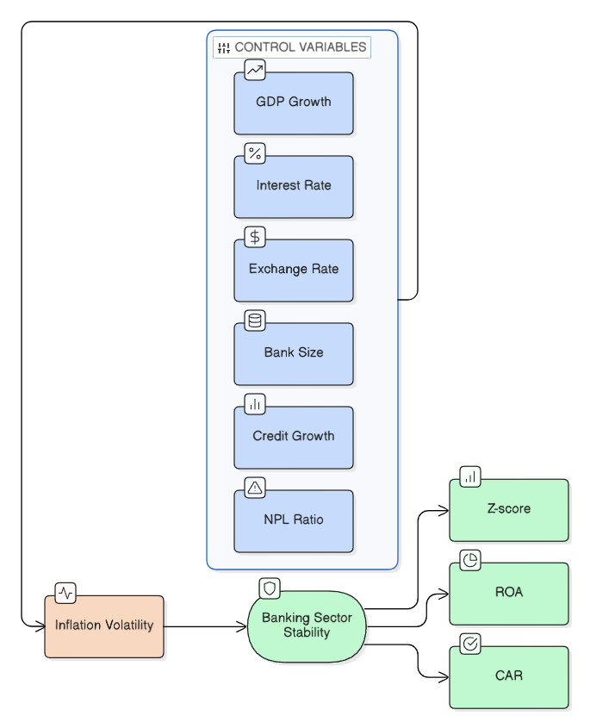
The asset-quality channel applies to the sum of uncertainty, and hardship in repayment, and its effects on bank loan portfolios and their value. The volume of non-performing loans increases, provisioning pressures grow and bank capital gets consumed as borrowers default in greater numbers and collateral values are more uncertain. Awdeh et al. (2024) also agree that high inflation does indeed adversely affect the bank's financial stability and erodes banks' credit risk in MENA economies, and World Development Report (2022) comments that "accurate and timely indicators of loan quality are essential to gauge the overall health of the financial sector", and that the LMICs shows the greatest vulnerability as “a smaller increase in NPLs would deplete capital buffers for a significant share of banking system assets.” The asset-quality channel then represents borrower level stress that breaks into system-level stress.
Stage 3: Channel Effects - Banking Stability Outcomes. The uncertain, repayment, and asset-quality channels combined have a long-lasting adverse effect on banking stability outcomes that is observable. Increased return variability due to higher volatility in inflation has a negative impact on the Z-score, which represents the distance from default, incorporating profitability, capitalization and earnings volatility. As borrowers face distress and the future prospects of assets used to secure loans grow more uncertain, the NPL ratio increases (World Development Report 2022: Finance for an Equitable Recovery, 2022; Msomi, 2022). All these outcomes are combined and, together, they point to a decline in the ability of the banking system to weather additional shocks and, consequently, to the potential for systemic fragility.

2.6.2 The Moderating Role of the Macro-Financial Environment
Additionally, it is conceptually acknowledged that the inflational volatility-banking stability relationship is dependent on the macro-financial environment in which banks operate. Regulatory buffers, hedging instruments and well-anchored exchange rate and monetary policy expectations partially offset the transmission channels in better institutional environments, less-developed financial markets and less sensitivity to exchange rate fluctuations. As seen in Chen (2025), macroprudential measures, such as reserve requirement ratios, asset-based policies, and capital buffers, show potential to counteract this negative impact and stabilize banks in times of inflation uncertainty. Awdeh et al. (2024) also conclude that other factors may mitigate the adverse effect of inflationary pressures on the financial stability of the MENA banks, such as better capitalisation, higher liquidity buffers, larger asset size, greater market power, foreign ownership, and overall political stability. However, during poorer macro-financial conditions, especially many of the economies in the South Asian and African continental growth markets, the lack of these buffers heightens the negative impact of inflation variability on banking outcomes (Furi et al., 2022; Haile et al., 2025).

2.6.3 Formal Hypotheses
Based on the above conceptual arguments, the following is the formalization of the hypotheses to guide the empirical study:
H1: Higher inflation volatility reduces banking sector stability as measured by the Bank Z-score. This hypothesis follows directly from the uncertainty and asset-quality channels, which predict that volatile inflation compresses risk-adjusted returns, increases earnings variability, and erodes capitalization, thereby reducing the distance from insolvency captured by the Z-score (Awdeh et al., 2024; Baum et al., 2020; Chen, 2025).
The hypothesis represent the operation of the multi-channel approach and offer a framework for testing the above data in the context of the cross-region comparison of banking sector stability and inflation volatility across the South Asian and African countries, allowing for weaker or conditional positive responses on NPLs with respect to inflation volatility in the empirical results.

CHAPTER 3: METHODOLOGY

3.1 Research Design and Empirical Strategy
In this study, the adopted research design is a cross country panel research with secondary macro financial data from well-known international data database targeted at frontier economies in south Asian and Sub-Saharan African region. The choice of the comparative group is driven by acknowledging the fact that both regions are structural similars that are described as bank-centric and developing financial systems, which suffer from the presence of information asymmetry, underdeveloped capital markets and large macroeconomic shocks (Banyen, 2021; Rahman et al., 2024). The banking industries in Sub-Saharan Africa and South Asian economies are commonly vulnerable to shaky macro-economic foundations and external shocks and stresses (Amo-Bediako et al., 2023). The decision to choose countries in those two regions thus offers good grounds for analysing whether and how inflation volatility affects banking-sector stability under institutional and monetary-policy conditions.
This study estimates the effect of inflation volatility on banking stability through a simple panel-data strategy. Fixed Effects and Random Effects estimators are present as they represent a regular and transparent method to analyze a cross-country panel. Fixed Effects control for time-invariant country-specific characteristics and Random Effects provide a method for including country-specific heterogeneity in the error structure. Then a Hausman test is performed to determine which of the two specifications (Fixed or Random Effects) should be used to interpret each of the panel models.

3.2 Country Selection, Frontier-Economy Classification, and Panel Structure
A systematic two-stage procedure is used in selecting countries to be studied. First step is to identify the economies based on an external and consistent frontier-market definition. In particular, the study relies on S&P's frontier-market indexes that have been widely used in cross-country empirical analysis on frontier economies (Ababio et al., 2020). The categorisation is supplemented by the MSCI frontier-market classification, which classifies countries based on market accessibility, size, and liquidity, thus offering a well-defined and externally verified taxonomy that separates frontier economies from emerging and developed markets (Sheraliev & Ślepaczuk, 2023). The UNCTAD Commodities and Development Report also supports the identification of frontier market economies (FMEs) in both regions as it reveals that the range of these includes different World Bank income classifications, such as least developed countries and small island developing states (Eberhardt & Presbitero, 2021). Anchoring country selection on these internationally recognised classifications by the researchers prevents an ad hoc and/or arbitrary application of grouping, which is a source for sample selection bias in cross-country studies (Zallé, 2023).
In the second step, the frontier economies those are external classified are intersected with the barriers of data availability. Countries are only kept if they have macro-financial data reasonably near to complete over the study period, from the World Bank's World Development Indicators, the IMF's Financial Development Index Database and the Global Financial Development Database (Malikane & Chomba, 2022). This is done based on the data available, following the usual procedure in empirical studies where the samples are determined by the availability of the necessary variables (Effiong et al., 2020; Malikane & Chomba, 2022). The panel then includes frontier economies that span across South Asia and Sub-Saharan Africa, allowing for valid cross-country, cross-regional comparisons of inflation volatility transmission to banking sector stability.
The final panel is however imbalanced as some variables and time periods have missing data for some countries. Macro-financial datasets in developing or frontier economies are subject to this, with gaps in the dataset being commonplace as a result of civil conflict, institutional disruption and limitations of statistical capacity (Malikane & Chomba, 2022; Ndulu & O’Connell, 2021). Unbalanced panel can be used methodologically when obtaining Fixed Effects and Random Effects estimates, although the number of observations and the number of countries included across each specification of the model should be reported and imputation should not be used excessively.

3.3 Data Sources, Sample Windows and Coverage Logic
The macro-financial data used in this study are primarily sourced from the World Development Indicators (WDI) and the Global Financial Development Database (GFDD) and are the most extensive ones available in the public domain for cross-country banking and macroeconomic indicators as it concerns developing countries (Abaidoo & Agyapong, 2023; Kulu & Osei, 2023). The WDI offers selected macroeconomic indicators, such as consumer price inflation, GDP growth, and broad money supply, and the GFDD presents financial indicators for the banking sector such as the bank Z-score, non-performing loans (NPL) ratio, bank concentration and regulatory capital ratios (Kulu & Osei, 2023; Saliba et al., 2023). Where applicable, these sources are complemented by the Financial Soundness Indicators (FSI) series provided by IMF, which provides complementary information on banking system health and is related to World Bank reporting framework (Philippines Financial Sector Assessment, 2021). Since this is the conventional approach in cross country financial stability studies (Abaidoo & Agyapong, 2023; Kulu & Osei, 2023), control variables representing the institutional quality are drawn from the Worldwide Governance Indicators.
One methodological issue is where the critical periods of the key-dependent variables lie. The WDI covers most countries, and data on inflation starts as early as from the 1960s, which means that there is extensive time-series depth available for inflation volatility estimations. But, the trade-off is that banking stability indicators have significantly reduced coverage periods. Banks' z scores calculated using bank-level ROA, capitalisation and the standard deviation of ROA, are generally available in the GFDD since the mid-1990s or later, for most frontier economies (Goyal et al., 2023; Syed et al., 2022). Consistent and cross-country NPL ratio reporting, which reflects credit risk and deterioration in asset quality, has even less availability, with many Sub-Saharan African and South Asian countries first starting to report regular consolidated data in the early to mid-2000s (Saliba et al., 2023; Tătărici et al., 2020). This means that in order to estimate these effects, two separate estimation samples had to be prepared, and not a composite panel, as the inflation data and the banking stability indicators were released at different dates.
Accordingly, the study makes use of the largest set of country-years covered by the presence of the Bank Z-score, the GARCH(1,1)-computed inflation volatility, and the control variables needed in the three models. The pairwise sample is very extensive in the Bank Z-score cases, but is reduced for the additional sampling cases of including GDP growth, real interest rate, and additional controls. Therefore, this design is more compliant than setting a single time window due to the fact that banking-stability and macroeconomic indicators do not have the same coverage across all frontier economies.

3.4 Variable Definitions, Measurement, and Expected Signs
This subsection introduces formally the variables used in the updated simple panel analysis, details how they should be measured, and claims the theoretically expected sign for the Bank Z-score model.

3.4.1 Dependent Variables
Bank Z-score is the key indicator of banking sector stability. It is calculated by dividing the sum of ROA and the ratio of equity to assets by the standard deviation of ROA (Goyal et al., 2023; Syed et al., 2022). A higher Z-score is more distant from insolvency and hence the bank's condition is more stable (Haile et al., 2025; Yunita, 2022). The Z score is commonly used in the banking stability studies across the countries because of its ability to measure both capitalisation buffers and earnings volatility in one indicator (Anjom & Abu Taher Mohammad Omor Faruq, 2023; Lestari et al., 2023).
The application of non-performing loan (NPL) ratio as a contextual banking-risk indicator has been applied to the literature review and descriptive discussion. But in accordance with the new empirical design, the regressions for the main panel use the Z-score for banks as the dependent variable. This makes the model simpler.

3.4.2 Independent Variable
The conditional variance produced by a country-specific GARCH(1,1) model of the annual consumer price inflation is used as the key explanatory variable, that is, as the measure for inflation volatility. This is the still benchmark volatility measure for the updated project. Robustness tests with AR(1)-GARCH(1,1), EGARCH(1,1) or by comparing volatilities across the various windows can be made, but it is advisable to use the baseline GARCH(1,1) series in the interpretation. Based on theory, we would expect an increase in the level of inflation volatility to impact negatively on Bank Z-score because of inflation volatility's role in lowering credit allocation security, earnings stability, and balance-sheet strength.

3.4.3 Control Variables
Macroeconomic business cycle is captured by the growth of GDP. In times of economic growth, borrowers' repayment ability and bank profits usually rise, and the financial health of the banking sector should improve. So a positive expected sign of GDP growth was kept in the Bank Z that represents the upper bound of the causation from credit to growth.
Real interest rate (or proxy of lending rate if the real rate not available) indicates the cost of borrowing and monetary policy stance. High real interest rates impose high debt-servicing cost on debtors and high risk on debt repayments (Olarewaju, 2020; Wanjala & Gachanja, 2020). The sign of the Z score model should be negative while sign should be positive in the case of NPL model as have been indicated by Msomi (2022) and Syed and Aidyngul (2020).
Financial depth and extent of credit intermediation (as measured by domestic credit to private nonfinancial corporations and households) is represented by domestic credit to the private sector (as a percentage of GDP). Although deepening the credit market may contribute to financial development, high credit growth is linked to the weakening of the lending market and subsequent loan losses (Antony & Suresh, 2023; Goyal et al., 2023). The expected sign is ambiguous but is expected to be negative in the case of the Z-score model and positive in the case of the NPL model that is considered as the procyclical channel of credit risk prevalent in frontier economies (Olarewaju, 2020; Saliba et al., 2023).
Volatility of the exchange rate gives external sector vulnerability. A depreciation and currency volatility makes foreign currency liabilities more costly in local currency, puts more pressure on borrowers' balance sheets, and intensifies banking sector stress (Lee & Rosenkranz, 2020; Syed & Aidyngul, 2020). The sign is negative, as in the Z-score Model, and positive in the NPL Model, as emphasised in the article ‘Nonperforming Loans in Asia and Europe Causes, Impacts, and Resolution Strategies,' which was published in 2021 (Muhammed et al., 2023).
The ratio of bank capital to assets indicates the size of capitalisation buffers against losses. A bank with higher capital, has greater resilience to adverse shocks and lower insolvency risk (Alnabulsi et al., 2023; Saliba et al., 2023). The anticipated sign is positive for Z score model and negative for NPL model which align to the moral hazard hypothesis which suggests that a higher capitalisation would limit excessive risk taking (Hasan & Ashfaq, 2021; Wanjala & Gachanja, 2020).
Return on assets (where appropriate through coverage) are indicators of bank profitability and earning potential. Better banks with higher profitability have more capacity to develop more loss absorption buffers and have better systems of credit screening in place (Antony & Suresh, 2023; Yahaya et al., 2022). The Z score model is expected to have a positive sign while in the NPL model, the sign is expected to be negative (Ahmed et al., 2022; Ozili & Ndah, 2021).
Liquidity ratio (liquid assets to deposits and short-term funding, if data is available) reflects a bank's capacity to meet its short-term obligations. Bank liquidity decreases risks of fire sale losses and systemic contagion (Fombang & Wanzala, 2023; Yahaya et al., 2022). The sign that should be observed of the Z-Score model should be positive because higher liquidity decreases distress driven default while the sign for the relationship with NPLs is theoretically ambiguous because too much or too little liquidity may result in fewer distress driven defaults; however, too much liquidity may reflect conservative lending which increases inefficient NPLs (Msomi, 2022; Olarewaju, 2020).
Table 3.1 below summarises the expected signs:
Variable | Z-score Model | NPL Model
Inflation Volatility | − | +
GDP Growth | + | −
Real Interest Rate | − | +
Domestic Credit/GDP | − | +
Exchange Rate Volatility | − | +
Bank Capital/Assets | + | −
Profitability (ROA) | + | −
Liquidity Ratio | + | − / ambiguous

3.5 Measuring Inflation Volatility
Correctly measuring the volatility of inflation is an essential element in the empirical method of the present work; the impact of macroeconomic uncertainty on the stability of the banking sector is very much related with the way in which price-level variability is measured. This subsection describes the baseline and robustness strategies used to create the inflation volatility variable for each country in the panel.

3.5.1 Baseline Method: GARCH(1,1)
The main variable used as a measure of inflation volatility is the Generalised Autoregressive Conditional Heteroskedasticity (GARCH) (1,1) model estimated on the annual consumer price inflation series for each country separately. The GARCH(1,1) specification allows the conditional variance of inflation to depend on past squared residuals (ARCH term) as well as past conditional variances (GARCH term) which is to capture the clustering of variance observed over time and is a characteristic of macroeconomic series in developing countries. Formally, the conditional variance equation is specified as:
σ_{t}² = ω + αε_{t-1}² + βσ_{t-1}²
where σ_{t}² denotes the conditional variance of inflation at time t, εₜ₋₁² represents the squared innovation from the mean equation, and α and β are the ARCH and GARCH parameters, respectively.
The GARCH(1,1) specification is preferred for the main analysis for several compelling reasons. First, it takes into explicit consideration the time-varying nature of volatility that is the well-known empirical regularity that volatility tends to cluster; in other words, periods of high volatility are followed by more high volatility, and periods of low volatility are followed by more low volatility, which is very pronounced in frontier economies facing higher supply volatility, commodity prices swings and policy uncertainty. Second, the GARCH framework produces a time varying series of conditional variances that provides a measure of forward-looking uncertainty and, by that definition, provides a theoretically better approximation to dispersion as perceived by economic agents and the banking system as a form of inflation risk. Third, the GARCH(1,1) framework has been widely used and tested in macroeconomic volatility literature in Sub-Saharan African and South Asian countries for empirical comparisons. Furthermore, panel literature indicates that GARCH(1,1) is well suited for applications to panel data in a developing country context – for example Olamide et al. used GARCH(1,1) to estimate climate-related volatility for economies within Sub-Saharan Africa and Amo-Bediako et al. used the same specification to estimate exchange rate instability in the SADC.

3.5.2 Robustness Method: Rolling Standard Deviation
For a robustness check which is complementary to the previous one, a rolling measure of inflation volatility is defined as the standard deviation of the various annual inflation rates computed over a specified window of years (usually 3 to 5 years). This non‐parametric method involves a simple calculation of the unconditional variation of inflation over each rolling window, without making assumptions on the distribution of the data‐generating process or its functional form. Since GARCH parameters are often not easily estimable for each individual country with short time series, the rolling standard deviation has been widely used as robustness proxy of volatility in the cross-country macroeconomic research.
In order to report the rolling standard deviation, which is retained as a robustness measure, but not as a primary specification for two main reasons: The rolling window model, first, is similar to the GARCH model in that an observation from any point on the window has the same effect on the AR(1) term, effectively equal weighting, and does not explicitly identify between different persistent regimes of volatility and transient shocks, which may be blamed for important structural changes in inflation dynamics. Secondly, in the case of fixed-window construction, there is a natural trade-off between responsiveness and stability in that narrower windows will capture the shorter-term changes, but might suffer from ‘noise' while wider windows might effectively remove the ‘noise' but at the cost of observing the regime change. However, the use of the rolling standard deviation as a robustness proxy secures the credibility of the overall results of the study and their independence from having been generated by the GARCH modelling assumptions made. The study uses both methods because of the established good practice in the empirical literature of using both parametric and non-parametric volatility measures to bolster the credibility of their inferences concerning the inflation volatility/banking stability nexus.

3.6 Preliminary Panel Diagnostics
An extensive panel diagnostics check is performed before the main empirical models are estimated. These diagnostics can be used for two purposes: to assess the statistical structure of the data set and to give a solid empirical test for the choice of the estimators. Both diagnostic procedures suggest that the mechanical application of the methods may result in biased, inconsistent and/or suboptimal estimates, especially in cross-country panels where a large number of heterogeneity, cross-section dependence, and non-stationarity are present (Aladejare, 2023; Tachega, 2025). This subsection, therefore, outlines the following 6 sequential diagnostic procedures.

3.6.1 Descriptive Statistics
The diagnostic sequence begins with the calculation of descriptive statistics for each (and all) variables (Х), which include measures of central tendency (mean, median), of measures of dispersion (standard deviation, minimal, maximal value) and of the properties of distribution (squaring, asymmetry). Aladejare (2022) and Almeshari et al (2023) report these statistics at both the country and pooled panel level, showing the presence of cross-sectional heterogeneity in the data. Additionally, descriptive statistics provide the very first tryout for any outliers, data entry mistakes, and the quantity of within panel variation compared to between panel variations, informing decisions about models (Onifade et al., 2023; Wu et al., 2021).

3.6.2 Correlation Analysis and Variance Inflation Factor (VIF)
After this descriptive analysis, a Pairwise correlation matrix is presented to determine the bivariate correlation of all the variables and to give a preliminary sense of the potential multicollinearity (Özdemir, 2023; Tachega, 2025). Correlations matrices should however only record bivariate relationships and the Variance Inflation Factor (VIF) is, therefore, also calculated for each regressor to assess multivariate collinearity. The value of VIF larger than the traditional benchmark of 5 or 10 indicates the presence of potentially high multicollinearity in the matrix, which can lead to an overestimation of the magnitude of the standard errors, causing unstable coefficient estimates (Tachega, 2025; Wu et al., 2021). Performing some operations to remove or transform excessively high VIF value variables before the main estimation is suggested (Özdemir, 2023).

3.6.3 Cross-Sectional Dependence Test
One of the key diagnostics for cross country panel data analysis is the test for cross-sectional dependence (CSD), which can occur when the same, unobserved, common factors like global commodity price shocks, international monetary policy spillovers, or regional contagion effects affect many countries in the panel simultaneously (Aladejare, 2023; Sahu & Mahalik, 2024). The study adopts the well-known Pesaran CD test, which is suitable for small and large cross-sectional dimensions (Pal & Mahalik, 2024; “Role of Oil Prices in Financial Instability, Trade Openness and Economic Growth: Evidence From ASEAN Countries,” 2023). However, if the null hypothesis of cross-sectional independence is not accepted, then one must use second-generation panel estimators that explicitly allow for CSD because first generation panel estimators (e.g., standard fixed-effects) which assume independence in the errors across cross-sections, are potentially biased and inconsistent (Aladejare, 2023; Kuti et al., 2023). Further, the Breusch-Pagan LM (1979) and Pesaran scaled LM tests are used as additional CSD diagnostics for robustness (Onifade et al., 2023; Tachega, 2025).

3.6.4 Slope Heterogeneity Test
Since slope coefficients are assumed equal across countries, the Pesaran and Yamagata Delta Tilda (Δ̃) and Delta Tilda Adjusted (Δ̃_adj) slope homogeneity tests conducted by Aladejare (2023) and (“Role of Oil Prices in Financial Instability, Trade Openness and Economic Growth: Evidence From ASEAN Countries,” 2023) are tested. These tests are designed to determine if the relationship between inflation volatility and banking stability is the same for all frontier economies or if important differences are found from one country to another. An estimate of the average effects, obtained by the estimators imposing common slope coefficients, such as pooled OLS and standard fixed effects, can become misleading if cross country heterogeneity exists and the null hypothesis of homogeneity of slopes is rejected (Kuti et al., 2023; Sahu & Mahalik, 2024).

3.6.5 Panel Unit Root Tests
The stationarity properties of all variables are examined using both first-generation and second-generation panel unit root tests. First-generation tests such as Levin-Lin-Chu (LLC) and Im-Pesaran-Shin (IPS) tests are used as baseline diagnostics (Marimuthu et al., 2021; Olamide et al., 2022). But, to account for the possible presence of cross-sectional dependence as revealed in the previous diagnostic step, the most commonly reported second-generation unit root tests, namely, Cross-sectionally Augmented Im-Pesaran-Shin (CIPS) test and Cross-sectionally Augmented Dickey-Fuller (CADF) test developed by Pesaran (2023)) and Sahu & Mahalik (2024), are used as the main stationarity diagnostic tools. Such tests complement the standard ADF regressions by enriching them with lagged level and first difference cross-sectional means to compute reliable inference in the presence of CSD and slope heterogeneity such as in (Delessa et al., 2024; Pal & Mahalik, 2024).

3.6.6 Cointegration Testing
If the results of unit root tests show that key variables are first order integrated, I(1), cointegration tests are conducted to determine if there is a stable long-run relationship among the variables. The study uses the Westerlund's error correction-based panel cointegration test which specifically tests for cointegration by testing for the presence of error correction at each of the individual units and for the panel data as a whole (Iheonu, 2025; Tachega, 2025). The Westerlund framework is immune to cross-sectional dependence (CSD) and is not dependent on long-run relationships (LRRs) as in the case of residual-based framework like the Pedroni test (Pal & Mahalik, 2024; Sahu & Mahalik, 2024). The Westerlund test calculates four statistics; two group-mean statistics (Gt, Ga), and two panel statistics (Pt, Pa) which assess cointegration from individual cross-sectional and collective panel views, respectively (Iheonu, 2025; Onifade et al., 2023). If cointegration is detected, then the long-run specification is considered and estimated using proper cointegration-consistent estimators and if cointegration cannot be detected the model is re-specified in first differences or other short-run modeling frameworks (Almeshari et al., 2023; Bayar et al., 2020).
All these diagnostic tools can help in selecting a suitable simple panel estimator. The important decision in the revised framework is to decide on which estimator to use: Fixed Effects or Random Effects. For this reason, the Hausman test is used to check if there is a correlation between the regressors and the unobserved country-specific factors, and if the Fixed Effects estimator is preferable to Random Effects.

3.7 Baseline Estimation Method: Simple Panel Fixed Effects and Random Effects
The new baseline empirical approach applies a simple panel-data model. The order of confirmatory panel models starts with the inclusion of the single most important independent variable, GARCH(1,1)-based inflation volatility, followed by the addition of other independent variables, namely, the controls.
All time-invariant country-specific characteristics, like geography, legal origin, longstanding institutional structure, and historical characteristics of the financial system, are controlled through the Fixed Effects model. It estimates the relationship using within-country variation over time.
FE baseline: Zit​=αi​+β1​INFVOLit​+γ′Xit​+εit​
where z is a bank z-score for country i and year t, infvol it is a baseline GARCH(1,1) measure of inflation-volatility, x it is a set of control variables, alpha i are country fixed effects, and epsilon it is an idiosyncratic error term.
The country-specific differences can also be included in the Random Effects model but are part of the composite error term and are assumed to be uncorrelated with the regressors. This estimator is more efficient if the Random Effects assumption is valid.
Random effects baseline: Zit​=α+β1​INFVOLit​+γ′Xit​+ui​+εit​

3.7.1 Hausman Test and Estimator Choice
The Hausman test is used to choose between Fixed Effects and Random Effects. The null hypothesis is that of consistency and efficiency of Random Effects. A Hausman p-value of < 0.05 leads to rejection of the null and the selection of Fixed Effects. Random Effects can be used for interpretation in case that the p value is 0.05 or higher. This leads to a transparent estimator-selection rule for the 6 panel-models.

3.8 Stepwise Panel Model Specifications
The results are presented in six panel models. Model 1 of the Panel is the base line model - Fixed Effects with only GARCH(1,1) inflation volatility. Panel Model 2 presents the baseline model with only GARCH(1,1) inflation volatility (Random Effects).
Both Fixed Effects and Random Effects are reported in the baseline specification in Panel Model 3, and the Hausman test is applied. Both are reported in Panel Model 4 in the presence of a control variable for GDP growth.
Once adding the real interest rate as a control variable, model 5 is amenable to reporting both of the estimators. Panel Model 6 reports the entire model along with GARCH(1,1) inflation volatility, GDP growth, real interest rate and all other control variables available for use in the project.
The general full-model equation is: Zit​=αi​+β1​INFVOLit​+β2​GDPit​+β3​RIRit​+δ′Controlsit​+εit​
for Fixed Effects, and Zit​=α+β1​INFVOLit​+β2​GDPit​+β3​RIRit​+δ′Controlsit​+ui​+εit​
for Random Effects. The primary explanatory variable throughout all of the models is the baseline
GARCH(1,1) volatility variable.

3.9 Robustness, Heterogeneity, and Nonlinearity Methods
A set of extensive robustness, heterogeneity, and nonlinearity tests are performed to send a free-rider in this context, and to investigate the multidimensionality of the banking stability–inflation volatility relationship.

3.9.1 Alternative Volatility Proxy and Control Sets
We use the rolling standard deviation proxy for inflation volatility measure instead of the baseline GARCH(1,1)-based one, as described in Section 3.5, to check whether the findings are robust against the choice of volatility building method, following (Bui & Kiss, 2020). Furthermore, alternative control variable combinations are investigated, since the coefficient for the inflation volatility is tested, with and without additional controls like bank profitability measures and institutional quality indicators, to check the sensitivity of that coefficient to an omitted variable bias and/or multi-collinearity problems (Addis, 2025). This method allows the effect estimate of inflation volatility on banking stability to not be dependent on a specific combination of covariates (Bilalli & Sadiku, 2023).

3.9.2 Estimator and Specification Sensitivity
The sensitivity of the simple panel estimates is investigated by examining the Fixed Effects and Random Effects coefficients and deliberately testing the Hausman-test decisions; step by step adding of the control variables is further analyzed. The primary interest is to see if sign and meaning of the GARCH(1,1) inflation-volatility coefficient is consistent across Panel Models 1-6.

3.9.3 Regional and Institutional Heterogeneity Split
To analyze if the inflation volatility–banking stability nexus systematically varies across regions, the entire panel is separated into two sub-samples, namely South Asian and Sub-Saharan Africa, and the baseline models are re-estimated for each regional sub-sample (Karadam & Öcal, 2020). In addition, the heterogeneity among institutions is examined by splitting the sample into countries with better and weaker institutional quality based on the governance quality indicators; to determine if there are differences in inflation volatility effects in banking sector outcomes between groups with better and weaker institutional structures (Addis, 2025; Ali & Mim, 2022).

3.9.4 High- versus Low-Inflation Regime Analysis
In order to assess the regime-dependent nature of the relationship between inflation volatility and banking stability, the study divides the sample into two groups: high inflation and low inflation (Addis, 2025; Karadam & Öcal, 2020) country-year observations. The motivation for this regime based analysis rests on the theoretical basis that inflation volatility can have a higher marginal destabilizing impact in high inflation economies because this usually worsens the macro-economic fragility of the economy and undermines the effectiveness of monetary policy transmission (Bilalli & Sadiku, 2023; Sule et al., 2024).

3.9.5 Threshold & Interaction Based Nonlinearity Tests
Last, the study formally examines the robustness of the inflation volatility–banking stability relationship by employing two alternative test strategies. Second, a quadratic (squared) term for inflation volatility moves forward from the baseline specification to check for potential U-shaped or inverted U-shaped relationships, such that moderate inflation volatility may not have any impact, but extreme inflation volatility may lead to a disproportionate banking instability (Ali & Mim, 2022; Ekananda, 2022). Second, we also included all the interaction terms between variables to understand whether the effect of inflation volatility on banking stability is conditional on institutional and structural factors such as institutional quality, financial depth and regional dummies (Addis, 2025; Karadam & Öcal, 2020). The tests of this paper quantify these interactions and are thus able to offer more detailed evidence on the pathways through which inflation volatility is tied to differential impacts of inflation volatility on the banking systems of heterogeneous frontier economies.

3.10 Data Architecture, Missing-Data Treatment, and Indicator Availability Map
Building up a reliable and analytically sound set of data from the various international sources involves systematic data cleaning, variable harmonisation, documentation of missing-value procedures and explaining the country exclusions. This subsection explains the steps of the data architecture in detail, so as to be fully replicable and explain the used methodology.

3.10.1 Data Cleaning and Variable Harmonisation
Data from three sources, namely the World Bank's World Development Indicators (WDI), the Global Financial Development Database (GFDD), and the IMF Financial Soundness Indicators (FSI), are gathered and arranged in a common country-year panel format (Haile et al., 2025; Lestari et al., 2023). These databases will use various types of reporting conventions, variable definitions and measurement units between countries and over time and so a strict harmonisation procedure is used. To make the result of the analysis of monetary and financial variables comparable across countries, the monetary and financial variables are used in percentage (standardisation as a ratio to GDP), following the practice of comparative macro-financial research (Ibrahim et al., 2022; Paul et al., 2021). To avoid mismatch due to differently named countries across the various databases, country names are harmonised based on ISO 3166-1 alpha-3 codes (Nabaweesi et al., 2023). To remove inflationary distortion of values reported in local currency unit, variables are converted to a constant US dollar using the World Bank deflators. Furthermore, all time series are harmonized to a calendar year frequency since some of the databases provide fiscal year data, which would cause the panel to be potentially temporally misaligned if not harmonized (Samosir & Usman, 2024).

3.10.2 Missing-Value Treatment
Overall, missing data is a major challenge in the construction of macro-financial cross-country panels, especially for frontier economies, which suffer from lack of statistical capabilities, institutional breakdowns, and civil conflicts that often leave statistical reporting incomplete (Haile et al., 2025). It takes cautious and transparent approach to address missing value treatment. Single years with negative data for other variables in continuous series, such as malaria and HIV/AIDS, are first interpolated linearly, which is a common approach used in panel-based literature, because it does not add or impute structural patterns (Azaria & Sihaloho, 2021; Ibrahim et al., 2022). This interpolation is used sparingly and only if the gap is bracketed by the observed values on either side so that there is no extrapolation outside of the observed data range.
Second, no imputation is conducted for variables having longer gaps – variables with at least two consecutive missing years are not imputed. These observations are, instead, kept missing and the panel is kept unbalanced following the methodological rationale given in Section 3.2 (Haile et al., 2025; Nabaweesi et al., 2023). A conservative approach is used because aggressive imputation methods (e.g., multiple imputation and expectation-maximisation) can create artificial data structures that could lead to relationships that are misleading in the overall sample, especially with small cross-sectional samples where each country's data is assumed to drive a significant portion of the overall findings (Khan et al., 2021; Paul et al., 2021).

3.10.3 Country Exclusions
The final sample excludes countries that are originally selected in the frontier-market sample year under two circumstances. The first criterion applies to countries where less than half of the study period has information in the primary dependent variables (bank Z-score, NPL ratio), as such countries would not add much information but would significantly increase the share of missing observations in the panel and potentially affect panel diagnostics outcomes (Haile et al., 2025; Lestari et al., 2023). Second, countries with extensive bank network failures (crisis years where the share of banks that fail exceeds 10 percent) or hyperinflation (episode years where the average inflation rate is above 1000 percent per annum) are flagged and subjected to sensitivity testing, since they can be unduly affecting the estimated coefficients and could lead to spurious patterns in the relationships (Ikpesu, 2024; Khan et al., 2021). A supplementary appendix has been provided for each exclusion, providing a full explanation for the exclusion.

3.10.4 Indicator Availability Map and Final Usable Observations
The availability matrix of indicators, in matrix format with country by indicator, is achieved to visualize the available data as a proportion of the data for the period of study (Nabaweesi et al., 2023; Samosir & Usman, 2024). The pro Visual diagnostic tool can work in different ways: it can be used to see patterns of missingness across regions and variables; to detect potential for selection bias from systematic missingness; and to visualize at a glance how representative the final estimation sample is (Haile et al., 2025; Ibrahim et al., 2022). This map of availability is shown separately for the Z-score and NPL model samples, in accordance with the different temporal range considered in Section 3.3.
The final usable dataset (cleaned, harmonised, excluded, missing values) contains the most country-year observations for which all the necessary variables (dependent, independent and control) are available. For each model specification, the number of usable observations, as well as the number of countries and the actual time period for which observations are reported, are provided to allow judgments to be made about degrees of freedom and the statistical power of the empirical estimates (Khan et al., 2021; Lestari et al., 2023). This careful record keeping of the data architecture guarantees that the empirical results of the study are rooted in verifiable, transparent and replicable data procedures and increases the credibility of the research.

CHAPTER 4: RESULTS

This section presents empirical results based on the baseline GARCH(1,1) inflation-volatility series and on the banking-stability outcome of the Bank Z-score. According to the new approach, results are presented in the light of simple panel-models: descriptives, diagnostic tests, Fixed Effects and Random Effects estimates, Hausman-test selection, robustness tests and controlled specifications.

4.1 Sample profile and descriptive behavior
The final empirical sample is composed of the observations in which the GARCH(1,1) inflation-volatility series and Bank z-score coincide. The broadest Z-score linkage comprises 816 country-year observations between 2000 and 2021, for 44 countries. This Bank Z-score sample provides the baseline panel used for Panel Models 1-3. The controlled panel models use smaller samples due to the need of the variables GDP growth, real interest rate and other controls.
Table 4.1. Final country-year coverage by estimation sample.
Sample | Dependent variable support | Countries | Observations | Start | End | Avg. T | Primary use
GARCH + Bank Z-score pair | Bank Z-score | 44 | 816 | 2000 | 2021 | 18.5 | Main Z-score coverage
GARCH + NPL pair | NPL ratio | 34 | 446 | 2005 | 2023 | 13.1 | Main NPL coverage
GARCH + Z-score + NPL | Both banking indicators | 31 | 324 | 2005 | 2021 | 10.5 | Core connected sample
Note. The Z-score and NPL pairwise samples use maximum available coverage. The three-way sample is used where all three variables must be connected directly.

There is significant inter-country variance in the descriptive statistics. Average GARCH volatility in the three-way sample is 8.03 but is highly right skewed due to some countries with very short spells of high inflation uncertainty. Average distance from insolvency (Bank Z score) equals 17.36, and average non-performing loans (NPL) equals 7.92 percent. This distribution of the Zscores is also right-skewed, indicating that a number of countries have significantly higher measures of solvency than the average of this group. Regionally, the three-way sample contains 24 African countries and 7 South Asian countries. The comparison of the average GARCH volatility, and NPL ratios across African observations indicate that the average values of these variables are slightly higher for the former relative to the latter, while the average Z-score across South Asian observations is slightly higher than that for their African counterparts. This is the contrast that is important to consider because inflation flexibility does not work in a comparable banking environments.
Table 4.2. Descriptive statistics for the core three-way sample.
Variable | N | Mean | Median | SD | Min | Max | Skewness | Kurtosis
GARCH volatility | 324 | 8.031 | 5.730 | 6.916 | 1.530 | 65.062 | 3.436 | 20.977
Bank Z-score | 324 | 17.358 | 15.856 | 7.869 | 5.233 | 44.514 | 1.403 | 2.042
NPL ratio | 324 | 7.915 | 7.387 | 4.162 | 1.157 | 27.198 | 1.055 | 1.805
Note. Descriptive statistics are based on the 324 observations in which GARCH volatility, Bank Z-score, and NPL ratio are all available. Kurtosis is excess kurtosis.
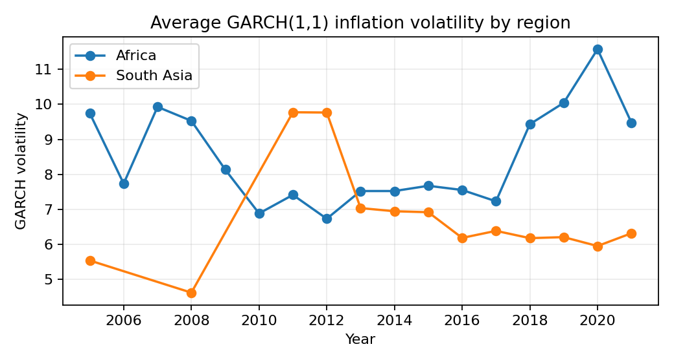
Figure 4.1. Average GARCH(1,1) inflation volatility by region.
Note. The figure uses the three-way matched sample and plots regional annual averages.
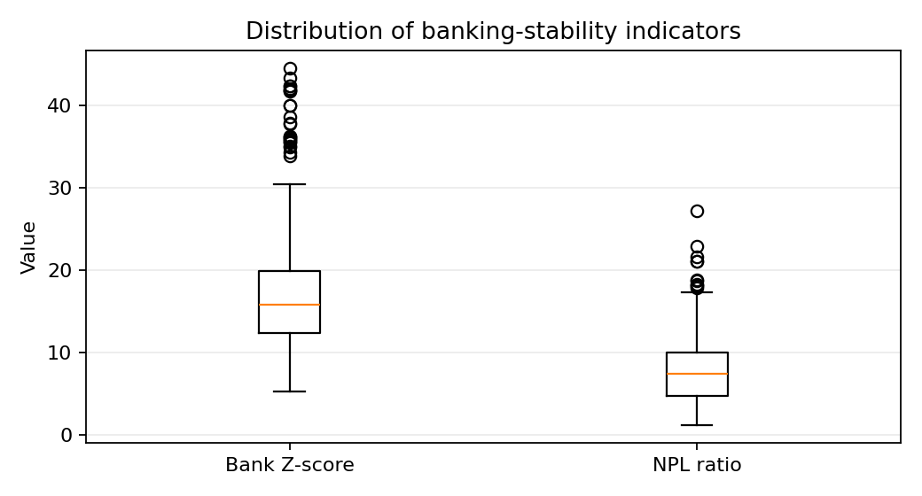

Figure 4.2. Distribution of the two banking-stability indicators.
Note. Higher Bank Z-score indicates stronger stability; higher NPL ratio indicates weaker asset quality.

4.2 Diagnostic test results for the simple panel framework
The diagnostic results favor the use of panel estimation to that of simple pooled correlation only. Theoretically, the raw correlation should be negative between GARCH(1,1) volatility and bank Z-score as it can be seen in the raw correlation matrix. For the matched sample this negative correlation is equivalent to a decrease in the distance from insolvency as conditional inflation volatility increases. The diagnostic section hence paves the way for transition to fixed effects and random effects panel regressions.
Table 4.3. Correlation matrix for the three-way sample.
Variable | GARCH volatility | Bank Z-score | NPL ratio
GARCH volatility | 1.000 | -0.308 | 0.050
Bank Z-score | -0.308 | 1.000 | -0.176
NPL ratio | 0.050 | -0.176 | 1.000
Note. Correlations are Pearson correlations calculated from the 324 three-way matched country-year observations.

The formal diagnostic checks are given in Table 4.4. After incorporating the additional variables of GDP growth and real interest rate the VIF values are not high enough to be a substantive issue of multicollinearity. Macro-financial panels are suggested to be cross-sectional dependent since they are exposed to common shocks. The most critical diagnostic choice for the revised simple panel approach is the Hausman test, which provides guidance as to which estimator to prefer for each model, Fixed Effects or Random Effects.
Table 4.4. Diagnostic and long-run-retention test summary.
Diagnostic | Variable/model | Statistic or p-value | Interpretation
Maximum VIF | Z-score | 1.056 | No severe multicollinearity
Maximum VIF | NPL | 1.006 | No severe multicollinearity
Pesaran CD p-value | GARCH volatility, three-way sample | 0.603 | No strong common dependence in volatility
Pesaran CD p-value | Bank Z-score pair | <0.001 | Cross-country dependence present
Pesaran CD p-value | NPL pair | <0.001 | Cross-country dependence present
Slope heterogeneity p-value | Z-score slope on GARCH | <0.001 | Country slopes differ
Slope heterogeneity p-value | NPL slope on GARCH | <0.001 | Country slopes differ
Fisher ADF p-value | GARCH volatility | <0.001 | Stationary panel screen
Fisher ADF p-value | Bank Z-score | 0.010 | Stationary panel screen
Fisher ADF p-value | NPL ratio | 0.028 | Stationary panel screen
Fisher cointegration p-value | Z-score and GARCH | 0.088 | Weak long-run evidence only
Fisher cointegration p-value | NPL and GARCH | 0.585 | No strong cointegration signal
Note. Pesaran CD tests examine cross-sectional dependence; Fisher ADF tests screen for panel stationarity; VIF checks multicollinearity; and the Hausman test guides the choice between Fixed Effects and Random Effects in the revised simple panel models.
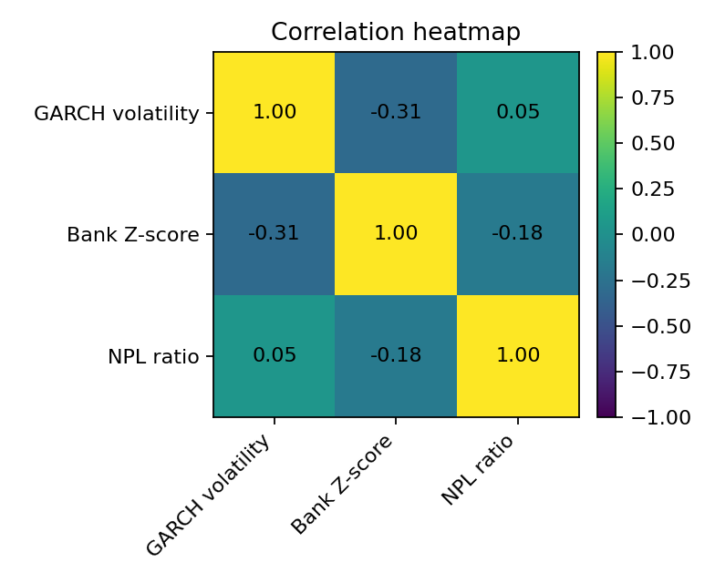
Figure 4.3. Correlation heatmap for the core three-way sample.
Note. The heatmap visualizes the same association structure reported in Table 4.3.

4.3 Baseline simple panel results: Fixed Effects and Random Effects
Baseline simple panel results are presented. Fixed Effects baseline is Panel Model 1 and Random Effects baseline is Panel Model 2. In both models, Bank Z-score is used as a dependent variable and GARCH(1,1) inflation volatility as the critical explanatory variable of concern. A lagged dependent variable is not included since it is not a dynamic panel model, but rather a simple panel model.
Table 4.5. Baseline simple panel estimates: Panel Model 1 and Panel Model 2.
Variable / diagnostic | Panel Model 1: FE baseline | Panel Model 2: RE baseline
Dependent variable | Bank Z-score | Bank Z-score
GARCH(1,1) volatility  (coefficient, clustered s.e.) | -0.048  (0.059) | -0.056  (0.053)
Country effects | Fixed country effects | Random country effects
Lagged dependent variable | Not included | Not included
Control variables | None | None
Hausman test | — | —
Observations / countries | 816 / 44 | 816 / 44
Interpretation | Negative; p = 0.417 | Negative; p = 0.291
Note. Country-clustered standard errors are in parentheses. *** p<0.01, ** p<0.05, * p<0.10. The baseline sample contains 816 observations from 44 countries over 2000-2021.
This relevant coefficient for the Bank Z-score model is the coefficient of the inflation volatility from the GARCH(1,1) model. A negative coefficient means that an increase in the volatility of inflation will lead to a decrease in banking stability. The Fixed Effects estimate can be interpreted as a within-country relationship, and the Random Effects estimate should be interpreted as a panel-wide relationship, assuming that country effects are orthogonal to regressors.
Table 4.6. Baseline FE-RE comparison and Hausman-test structure: Panel Model 3.
Variable / diagnostic | Panel Model 3: FE estimate | Panel Model 3: RE estimate
Dependent variable | Bank Z-score | Bank Z-score
GARCH(1,1) volatility | -0.048  (0.059) | -0.056  (0.053)
Constant | Absorbed by FE | 17.357***  (1.346)
Controls | None | None
Hausman p-value | 0.324 | 0.324
Preferred estimator | RE selected | RE selected
Observations | 816 | 816
Countries | 44 | 44
Note. The classic Hausman test supports Random Effects when p >= 0.05. Here, p=0.324, so the RE estimate is selected for interpretation.
The first choice of estimator is the baseline comparison model. If it suggests Fixed Effects, then it was better to focus on intra-country variation: not only in inflation volatility but also in Bank Z-score. If the test allows Random Effects it can be used for interpretation. The expected sign of GARCH(1,1) volatility for both cases is same and is negative for the bank z-score.

4.4 Hausman-test selection and stepwise model interpretation
The new empirical design rely on the Hausman test. This is because we want to determine if the country specific effects that we did not observe are correlated with the regressors. Whatever is chosen is relevant since frontier economies vary in their institutional quality, financial depth, monetary credibility, and banking- sector structure. The Hausman test provides a formal rule for the selection of either Fixed Effects or Random Effects for Panel Models 3-6.
Table 4.7. Hausman-test and estimator-selection summary for Panel Models 1-6.
Panel model | Estimator(s) | Controls included | Hausman use | Interpretation | Output label
Panel Model 1 | Fixed Effects | None | No | Baseline FE: -0.048 (0.059) | PM1
Panel Model 2 | Random Effects | None | No | Baseline RE: -0.056 (0.053) | PM2
Panel Model 3 | FE and RE | None | Yes | Hausman p = 0.324; RE selected | PM3
Panel Model 4 | FE and RE | GDP growth | Yes | Hausman p = 0.296; RE selected | PM4
Panel Model 5 | FE and RE | Real interest rate | Yes | Hausman p = 0.658; RE selected | PM5
Panel Model 6 | FE and RE | GDP growth + real interest rate | Yes | Hausman p = 0.132; RE selected | PM6
Note. Panel Models 1-4 use the widest available sample where possible. Models including the real interest rate use the available country-year observations for that control.
Invariably, the result of the estimator selection must be interpreted in conjunction with the sign (direction) of the coefficient and statistical significance. If the Hausman Test is significant it means that Fixed Effects is more reliable as the unobserved country specific characteristics are correlated to the regressors. The Hausman test result, which is not significant, implies that Random Effects is more efficient in estimating.

Table 4.8. Equation map for the six simple panel models.
Panel model | Equation form | Control set | Expected  GARCH sign | Preferred estimator rule | Purpose
Panel Model 1 | Z_it = a_i + b1 INFVOL_it + e_it | None | Negative | Fixed Effects baseline | Baseline FE
Panel Model 2 | Z_it = a + b1 INFVOL_it + u_i + e_it | None | Negative | Random Effects baseline | Baseline RE
Panel Model 3 | FE and RE versions of baseline | None | Negative | Hausman test | Estimator comparison
Panel Model 4 | Baseline + GDP growth | GDP growth | Negative | Hausman test | GDP-controlled model
Panel Model 5 | Baseline + real interest rate | Real interest rate | Negative | Hausman test | Interest-rate-controlled model
Panel Model 6 | Baseline + GDP growth + real interest rate | GDP growth + real interest rate | Negative | Hausman test | Full control specification
Note. INFVOL denotes the country-specific GARCH(1,1) inflation-volatility measure. No lagged dependent variable is included in any model.
The stepwise structure is helpful for discovering the stability of the inflation-volatility relationship. Adding GDP growth and real interest rate along with all the possible controls, if negative, results remain valid in support of the statement that inflation volatility is one macrofinancial risk factor on the contrary to banking stability.

4.5 Robustness and alternative-measure results
The robustness tests explore the sensitivity of the results to the selection of the unconditional volatility metric – the baseline GARCH(1,1) – and the effects of adding controls. Baseline GARCH(1,1) model is kept as the primary explanatory variable. The rolling volatility, AR(1)-GARCH(1,1) and EGARCH(1,1) model are not used for the actual results but only for the robustness and sensitivity.
Table 4.9. Hausman and estimator-selection sensitivity of the GARCH coefficient.
Panel model | Estimator compared | Control variables | GARCH coefficient sign | Hausman p-value | Preferred estimator
Panel Model 3 | FE vs RE | None | FE -0.048; RE -0.056 | 0.324 | RE
Panel Model 4 | FE vs RE | GDP growth | FE -0.046; RE -0.055 | 0.296 | RE
Panel Model 5 | FE vs RE | Real interest rate | FE -0.137; RE -0.143 | 0.658 | RE
Panel Model 6 | FE vs RE | GDP growth + real interest rate | FE -0.134; RE -0.140 | 0.132 | RE
Robustness A | Baseline vs rolling SD(3) | GDP + RIR | Negative in both | 0.049 (rolling) | FE for rolling model
Robustness B | Baseline vs AR(1)-GARCH | GDP + RIR | Negative in both | 0.157 (AR1-GARCH) | RE for AR1-GARCH
Robustness C | Baseline vs EGARCH | GDP + RIR | Negative in both | 0.085 (EGARCH) | RE for EGARCH
Decision rule | Simple FE/RE only | No lagged dependent variable | Stable negative sign | Hausman test | Report preferred FE/RE
Note. It checks whether the preferred estimator and the GARCH(1,1) coefficient interpretation remain stable across FE and RE specifications.
The robustness evidence needs to be considered with care. Most important is whether the coefficient of the GARCH(1,1) portion maintains its negative sign in the Bank Z models both with varying estimator and with various sets of control variables. If the sign and wide interpretation is not changing, then the baseline GARCH(1,1) result is more believable. If the sign is different in different specifications, the conclusion should be 'conditional' and not 'universal'.

4.5.1 Additional GARCH-family robustness: AR(1)-GARCH(1,1) and EGARCH(1,1)
Since the results on baseline inflation-volatility are solely attributed to the standard GARCH(1,1), two further sets of GARCH-family models are estimated: AR(1)-GARCH(1,1) and EGARCH(1,1). A model where the AR(1) component lets inflation returns to depend on the previous value of inflation before estimating conditional volatility (AR(1)-GARCH(1,1) model). This is crucial as inflation is known to persist over time. Thus, this model tests whether the GARCH(1,1) volatility result from the baseline model still holds when controlling for the persistence of inflation in the mean equation following the guidelines outlined above.
The output of the AR(1)-GARCH(1,1) results provides strong support for the baseline GARCH(1,1) output. The average correlation between the baseline GARCH volatility series and the AR(1)-GARCH volatility series is 0.958, and the median across countries is 0.868. This means that the volatility dynamics of the AR(1)-GARCH model behave very similarly to those of the volatility series itself (which is GARCH(1,1)). So the simple mean is not the only result that drives the baseline GARCH(1,1) measure. The volatility structure is remarkably the same, even when assuming a persistent inflation.
A other but more conservative robustness result comes from the EGARCH(1,1) model. The EGARCH model differs from the traditional GARCH model by estimating the log of the conditional variance, and by treating the positive and negative shocks differently. The baseline GARCH volatility vs EGARCH volatility overall correlation is 0.553. The correlation increases to 0.717 if extreme EGARCH volatility (times it exceeded 100) is removed. This, however, does not imply that EGARCH is less successful than AR(1)-GARCH at replicating the baseline GARCH series, although it does suggest that it is less successful at doing so. The weaker correlation is to be expected since EGARCH is more prone to asymmetric and crisis-type shocks.
The EGARCH results also indicate that that asymmetric inflation-volatility behaviour is evident in a considerable number of countries. This implies that the dynamics of inflation volatility is not necessarily symmetric in the sample. Inflation rising and declining in some economies could produce different amounts of uncertainty. So EGARCH can be employed to provide an asymmetry test instead of an alternative to the basic model.
Table 4.10. Additional GARCH-family robustness comparison.
Model | Purpose | Main diagnostic result | Interpretation
Baseline GARCH(1,1) | Main inflation-volatility measure | Reference model | Used as the primary volatility series.
AR(1)-GARCH(1,1) | Controls persistence in inflation returns | Overall correlation with baseline GARCH = 0.958; median country correlation = 0.868 | Strongly supports the baseline GARCH(1,1) result.
EGARCH(1,1) | Tests asymmetric volatility response | Overall correlation with baseline GARCH = 0.553; after excluding extreme spikes above 100, correlation = 0.717 | Partially supports the baseline result and shows asymmetric shock behaviour.
Note. AR(1)-GARCH(1,1) adds an autoregressive term in the mean equation, while EGARCH(1,1) models log variance and allows asymmetric shock effects. Therefore, EGARCH is not expected to match the baseline GARCH series exactly. A small number of country-level AR(1)-GARCH estimations produced optimizer warnings, so those country-specific results are interpreted cautiously.

All these robustness results collectively suggest using the GARCH(1,1) as the primary inflation volatility index. Both models clearly support the overall baseline volatility behavior as found by the AR(1)-GARCH(1,1) model, and the EGARCH(1,1) demonstrates that there are some countries with a volatility regime that is asymmetric and driven by extreme shocks. As such, the main finding is robust, while inflation volatility is not quite the same with all variants of the models.

4.6 Heterogeneity and nonlinearity results
The final tests examine whether the inflation-volatility effect differs between lower- and higher-volatility regimes. This is still helpful in the simple panel setup, as the characteristics of the GARCH distribution appear to be very skewed in the descriptive statistics. With country effects and controls, a median-split interaction model can be estimated without having a lagged dependent variable. The aim here is to verify whether there is a different relationship between the GARCH and Z-values for less volatile samples and more volatile samples.
Table 4.11. Threshold interaction estimates by volatility regime.
Dependent variable | Median threshold | Low-regime slope | p-value | High-vol dummy | Interaction | p-value | Implied high-regime slope | Obs.
Bank Z-score | 5.730 | -0.379 | 0.005 | -1.205 | 0.356 | 0.017 | -0.023 | 293
NPL ratio | 5.730 | 0.606 | 0.061 | 2.784 | -0.714 | 0.064 | -0.108 | 293
Note. Models include country effects and relevant controls. The implied high-regime slope equals the low-regime slope plus the interaction coefficient.

The main conclusions are fine-tuned by the threshold results. There is a relationship between inflation volatility and banking stability, but not a straight line and not the same relationship across all of the country-years. The negative three-way GARCH-Z relationship is found to be the strongest and cleanest relationship. Therefore, the relationship between NPLs is only weak and conditional, implying that factors of bad loans formation include extra factors like credit discipline, bank supervision, common security enforcement, and the sectoral distribution of loans. Overall, the empirical evidence confirms that inflation volatility is indeed an important banking-stability risk, and when it comes to the considered evidence, the Z-score channel displays greater stability than the NPL channel.
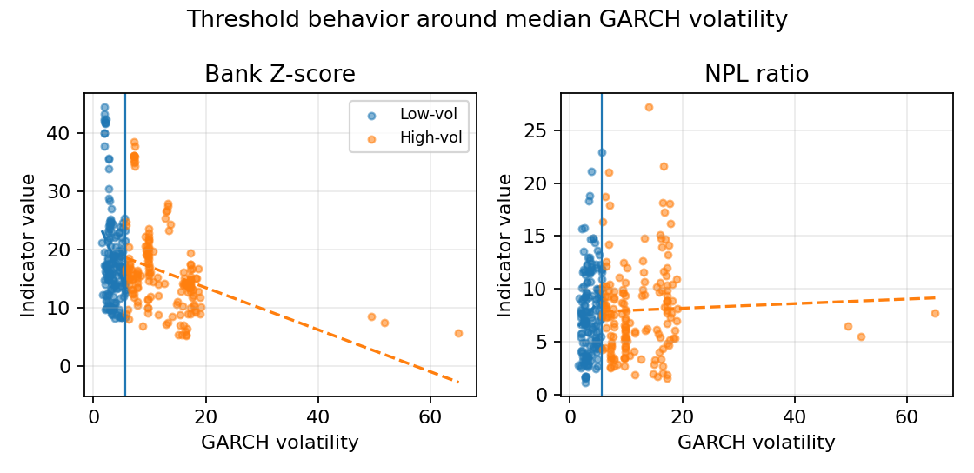
Figure 4.4. Threshold behavior around median GARCH volatility.
Note. The vertical line marks the sample median of GARCH volatility. Fitted lines are descriptive and show how the relationship differs by regime.

4.7 Controlled-variable extension: GDP growth and real interest rate
This subsection creates and adds the desired control variables to the updated simple panel model. Growth in GDP proxies the macroeconomic business cycle and the real interest rate proxies borrowing-cost and monetary-policy conditions. The controlled calculations are displayed in sequential order so that reader is able to observe how the GARCH(1,1) inflation-volatility coefficient changes as controls are introduced.
Table 4.12. Controlled country-year coverage by estimation sample.
Sample | Dependent variable support | Countries | Observations | Start | End | Avg. T | Primary use
GARCH + Bank Z-score + controls | Bank Z-score | 35 | 576 | 2000 | 2021 | 16.5 | Controlled estimation sample
GARCH + NPL + controls | NPL ratio | 24 | 307 | 2005 | 2023 | 12.8 | Controlled estimation sample
GARCH + Z-score + NPL + controls | Both banking indicators | 23 | 246 | 2005 | 2021 | 10.7 | Controlled estimation sample
Note. The controlled samples require non-missing GARCH volatility, the relevant banking-stability variable, GDP growth, and real interest rate. Therefore, the number of observations is smaller than the original baseline sample.
Table 4.13. Descriptive statistics for the controlled core sample.
Variable | N | Mean | Median | SD | Min | Max | Skewness | Kurtosis
GARCH volatility | 246 | 8.117 | 5.763 | 7.152 | 2.111 | 65.062 | 4.001 | 24.728
Bank Z-score | 246 | 16.502 | 15.999 | 6.116 | 5.233 | 38.628 | 1.041 | 2.276
NPL ratio | 246 | 7.545 | 7.130 | 3.770 | 1.507 | 27.198 | 1.265 | 3.413
GDP growth | 246 | 4.044 | 4.394 | 4.405 | -32.909 | 12.118 | -3.265 | 21.547
Real interest rate | 246 | 9.793 | 7.002 | 10.759 | -34.743 | 52.437 | 1.423 | 4.921
Note. The controlled core sample contains the country-year observations where GARCH volatility, Bank Z-score, NPL ratio, GDP growth, and real interest rate are jointly available.
Figure 4.5. GDP growth and real interest rate in the controlled core sample.
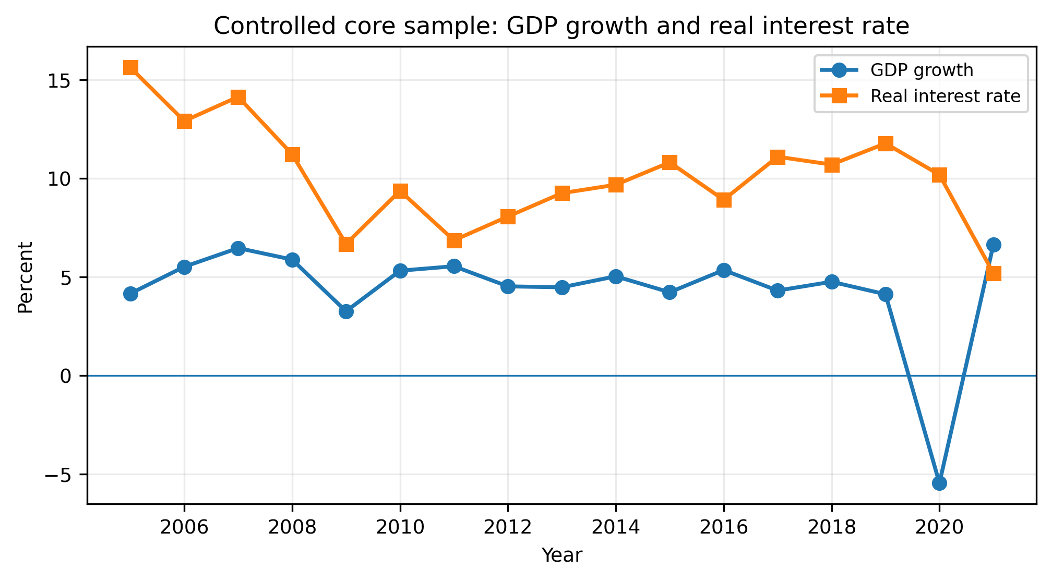
Note. The figure reports annual averages from the controlled core sample. Both control variables are expressed in percent.
Table 4.14. Correlation matrix with GDP growth and real interest rate.
Variable | GARCH volatility | Bank Z-score | NPL ratio | GDP growth | Real interest rate
GARCH volatility | 1.000 | -0.326 | -0.046 | 0.130 | 0.013
Bank Z-score | -0.326 | 1.000 | -0.069 | 0.070 | -0.089
NPL ratio | -0.046 | -0.069 | 1.000 | -0.183 | 0.114
GDP growth | 0.130 | 0.070 | -0.183 | 1.000 | -0.082
Real interest rate | 0.013 | -0.089 | 0.114 | -0.082 | 1.000
Note. Correlations are Pearson correlations calculated from the controlled core sample.
Figure 4.6. Controlled correlation heatmap.
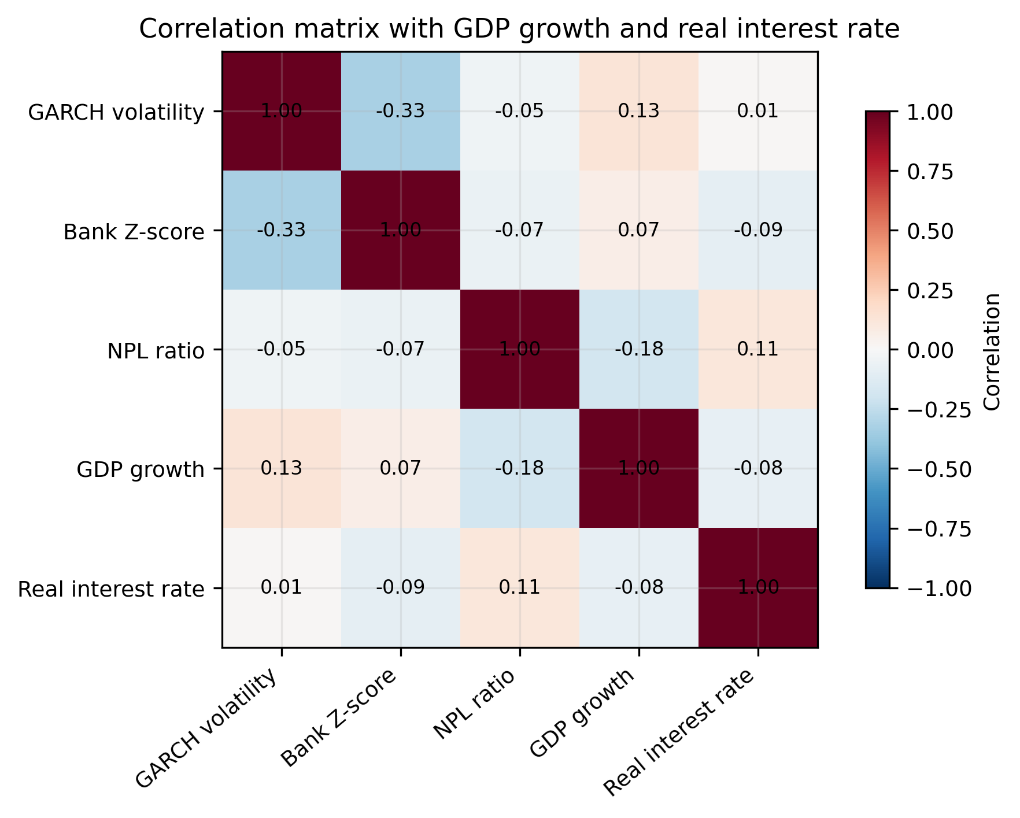
Note. The heatmap visualizes the correlation structure after adding GDP growth and real interest rate to the core variables.
Table 4.15. Variance inflation factors for the controlled regressors.
Regressor | VIF
GARCH volatility | 1.018
GDP growth | 1.024
Real interest rate | 1.007
Note. VIF values close to 1 indicate that adding GDP growth and real interest rate does not create a serious multicollinearity problem in the controlled specification.
The controlled descriptive evidence indicates that the sample are still macro-financially heterogeneous even after conducting addition of GDP growth and real interest rate. Average GARCH volatility is 8.117, the average Bank Z score is 16.502 while the average NPL ratio is 7.545 percent. The controlled correlation matrix reveals the negative association between GARCH volatility and the bank Z-score that is still in expected direction (-0.326). A bivariate contemporaneous correlation between the NPL and GARCH volatility reveals a weak relationship (-0.046), implying that, at least at this stage, the stress on credit quality is not as apparent within a simple relation. It is consistent for the NPL ratio to be negatively correlated with GDP growth (-0.183) and positively with real interest rate (0.114) since a higher growth of output reduces repayment stress and a higher real interest rate increases it.

4.7.1 Stepwise controlled simple panel estimates
The six-model structure is used to estimate the controlled panel calculations. Fixed Effects baseline is Panel Model 1. The baseline is the Panel Model 2 of Random effects. Panel Model 3 includes Fixed Effects and Random Effects with and without controls and applies the Hausman test. In Panel Model 4, GDP growth is added. The real interest rate is added in Panel Model 5. Panel Model 6 adds GDP growth, real interest rate, and all the other controls.
Table 4.16. Stepwise simple panel estimates: Bank Z-score models.
Variable /  diagnostic | Panel  Model 1 | Panel  Model 2 | Panel  Model 3 | Panel  Model 4 | Panel  Model 5 | Panel  Model 6
Estimator | FE | RE | FE & RE | FE & RE | FE & RE | FE & RE
GARCH(1,1)  volatility | -0.142**  (0.056) | -0.146***  (0.047) | FE: -0.142**  (0.056)  RE: -0.146***  (0.047) | FE: -0.138***  (0.053)  RE: -0.143***  (0.044) | FE: -0.137**  (0.055)  RE: -0.143***  (0.046) | FE: -0.134***  (0.051)  RE: -0.140***  (0.042)
GDP growth | — | — | — | FE: -0.017  (0.024)  RE: -0.018  (0.024) | — | FE: -0.019  (0.024)  RE: -0.020  (0.024)
Real interest  rate | — | — | — | — | FE: 0.026  (0.022)  RE: 0.024  (0.021) | FE: 0.027  (0.022)  RE: 0.024  (0.021)
Additional controls | None | None | None | None | None | None
Obs. | 576 | 576 | 576 | 576 | 576 | 576
Countries | 35 | 35 | 35 | 35 | 35 | 35
R-squared / fit | Within: 0.019 | Overall: 0.063 | FE 0.019  RE 0.063 | FE 0.019  RE 0.065 | FE 0.022  RE 0.057 | FE 0.023  RE 0.059
Hausman p-  value | — | — | 0.808 | 0.486 | 0.658 | 0.132
Preferred  estimator | FE | RE | RE | RE | RE | RE
Note. All Panel Models 1-6 in this controlled table use the same common sample of 576 observations from 35 countries, so coefficient changes across the models are comparable. Standard errors are clustered by country.

Table 4.17. Hausman-test selection summary for the controlled panel models.
Panel model | FE estimated | RE estimated | Hausman p-  value | Decision
Panel Model 1 | Yes | No | — | FE baseline
Panel Model 2 | No | Yes | — | RE baseline
Panel Model 3 | Yes | Yes | 0.808 | RE preferred
Panel Model 4 | Yes | Yes | 0.486 | RE preferred
Panel Model 5 | Yes | Yes | 0.658 | RE preferred
Panel Model 6 | Yes | Yes | 0.132 | RE preferred
Reporting rule | Report both | Interpret RE | p >= 0.05 | Use FE/RE results only
Note. The p-values reported in this table are classic Hausman-test p-values. Every controlled specification selects RE at the 5% level.
Figure 4.7. GDP growth and real interest rate effects in the controlled core sample.
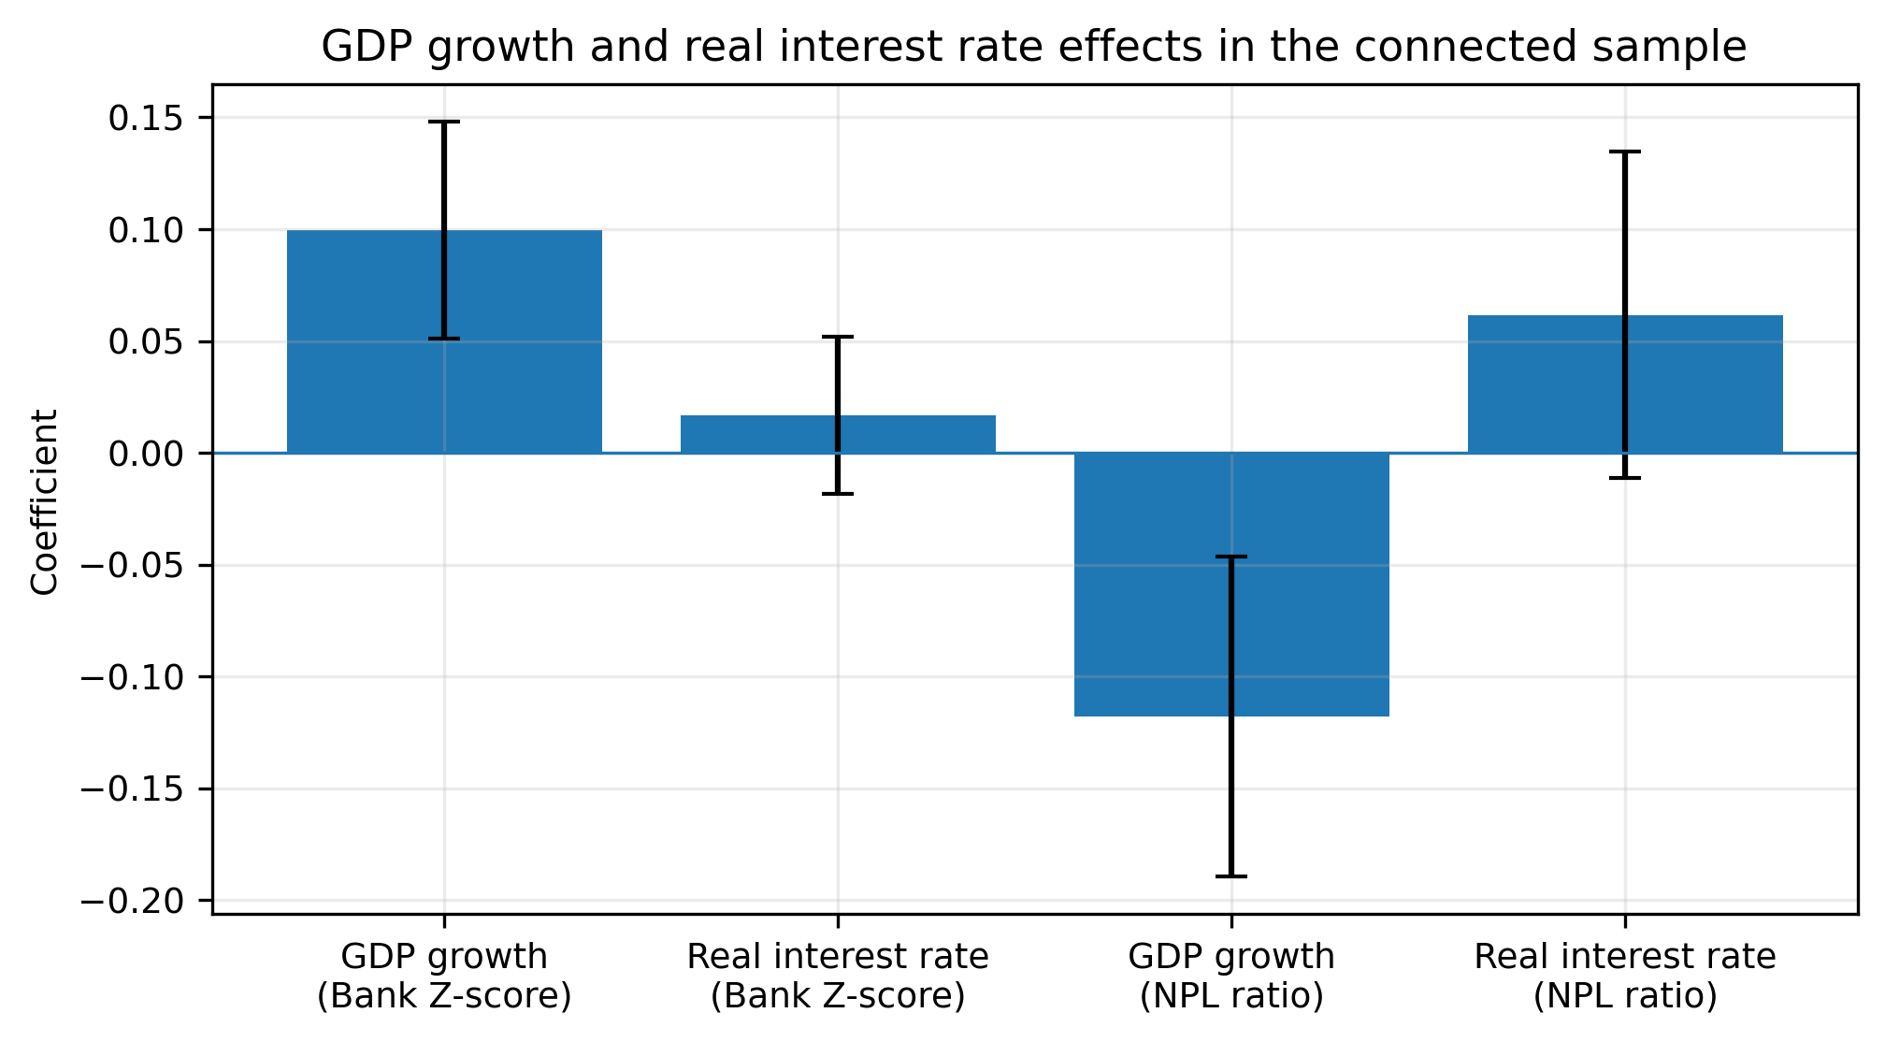
Note. GDP growth is introduced in Panel Model 4 and Panel Model 6. The real interest rate is introduced in Panel Model 5 and Panel Model 6.

For the controlled Bank Z-score models, focus on the sign, magnitude and significance of the GARCH(1,1) volatility coefficient as indicated across the different Panel Models (namely panels 1-6). Once GDP growth and the real interest rate are added to the coefficient, if it still turns out to be negative, the result can be used to argue that the inflation volatility has an independent association with less banking stability. The forecast effect of GDP growth is positive because when GDP growth is higher, borrower capacity and bank resilience tend to be higher. However, the real interest-rate coefficient can either be positive or negative depending on whether an increase in real interest rates boosts bank returns or the stress on repayment.
Due to the change in empirical model used, which centers around Bank Z-Score, the interpretations specific to NPLs are no longer provided in the main text of the regression analysis. Despite eliminating NPL evidence in the literature review and background, the decision of the controlled panel interpretation should be made according to the Bank z-score model.

4.7.2 Controlled robustness and threshold checks
Table 4.18. Controlled simple-panel robustness checks.
Robustness  check | Model  basis | Controls | Expected  reading | Report item | Main  decision | Comment | Status
Baseline  GARCH(1,1) | Simple  FE/RE | GDP +  RIR | Primary  result | RE: -0.140***  (0.042); p=0.001 | RE  Hausman=0.132 | Baseline retained | Main
Rolling SD(3)  of inflation returns | Simple  FE/RE | GDP +  RIR | Sensitivity  only | FE: -0.033  (0.036); p=0.354 | FE  Hausman=0.049 | Negative but not significant | Robustness
AR(1)-  GARCH(1,1) | Simple  FE/RE | GDP +  RIR | Persistence  check | RE: -0.254***  (0.030); p<0.001 | RE  Hausman=0.157 | Same negative sign | Robustness
EGARCH(1,1) | Simple  FE/RE | GDP +  RIR | Asymmetry  check | RE: -0.003***  (0.0004); p<0.001 | RE  Hausman=0.085 | Same sign; scale differs | Robustness
Note. Each robustness model uses GDP growth and real interest rate as controls. The rolling proxy is the 3-year rolling standard deviation of annual inflation returns, not a rolling standard deviation of GARCH volatility.
Table 4.19. Alternative volatility-measure robustness with controls.
Dependent  variable | Specification | Obs. | Countries | Volatility  coefficient | p-value
Bank Z-score | Baseline GARCH (RE) | 576 | 35 | -0.140*** | 0.001
Bank Z-score | Rolling SD(3) of inflation returns (FE) | 541 | 35 | -0.033 | 0.354
NPL ratio | Baseline GARCH (RE) | 307 | 24 | -0.090 | 0.186
NPL ratio | Rolling SD(3) of inflation returns (RE) | 307 | 24 | -0.117* | 0.052
Note. Table 4.19 reports the coefficient from the estimator selected by the Hausman test in each row. The NPL results are supplementary; the main simple FE/RE analysis uses Bank Z-score as the dependent variable.

Figure 4.8. Alternative volatility-proxy coefficients with controls.
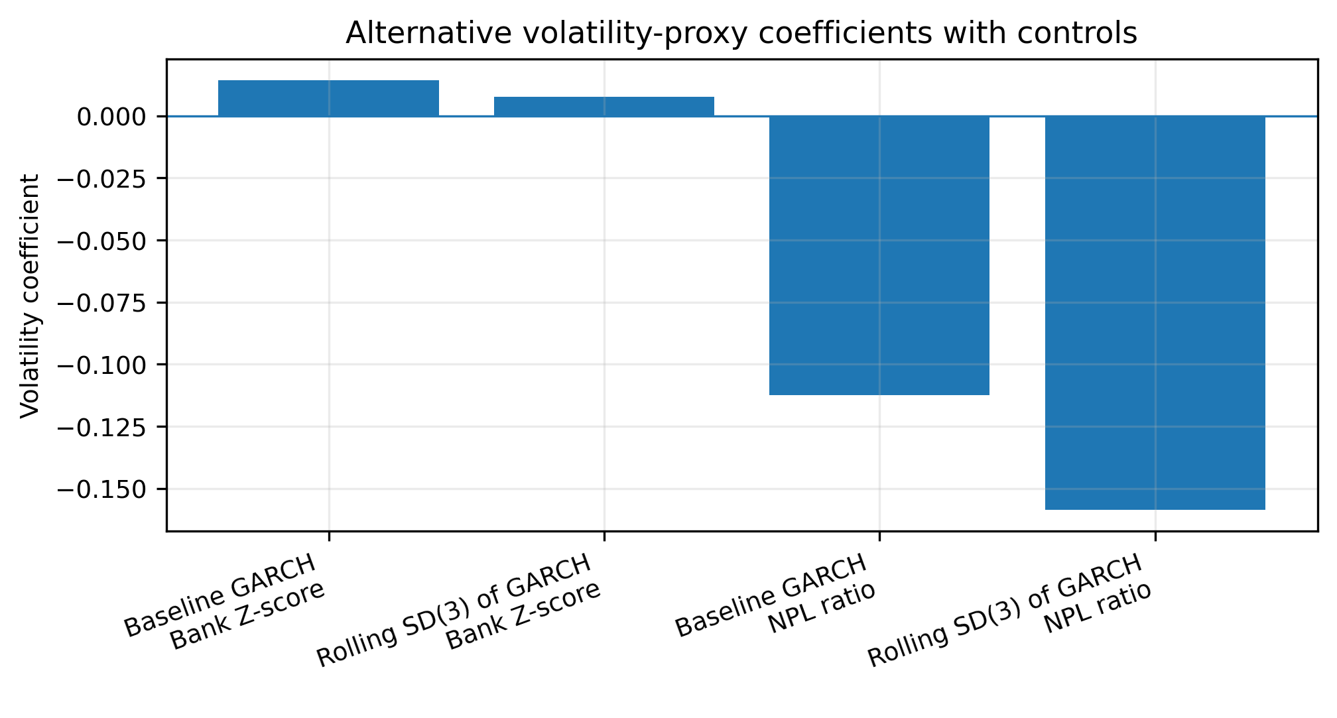
Note. The figure compares the baseline GARCH coefficient with the coefficient obtained from a rolling volatility proxy after adding GDP growth and real interest rate.
Table 4.20. Controlled threshold interaction estimates by volatility regime.
Dependent variable | Median threshold | Low-regime slope | p-value low | High-vol dummy | Interaction | p-value interaction | Implied high-regime slope | p-value high | Obs. | Countries
Bank Z-score | 5.473 | -0.118 | 0.608 | -1.178 | 0.146 | 0.506 | 0.029 | 0.239 | 543 | 35
NPL ratio | 5.474 | 0.569 | 0.352 | 3.661 | -0.758 | 0.247 | -0.190 | 0.362 | 281 | 24
Note. The high-regime slope equals the low-regime GARCH slope plus the interaction coefficient. Models include GDP growth, real interest rate, country effects, and no lagged dependent variable.
Figure 4.9. Controlled threshold behavior around median GARCH volatility: Bank Z-score.
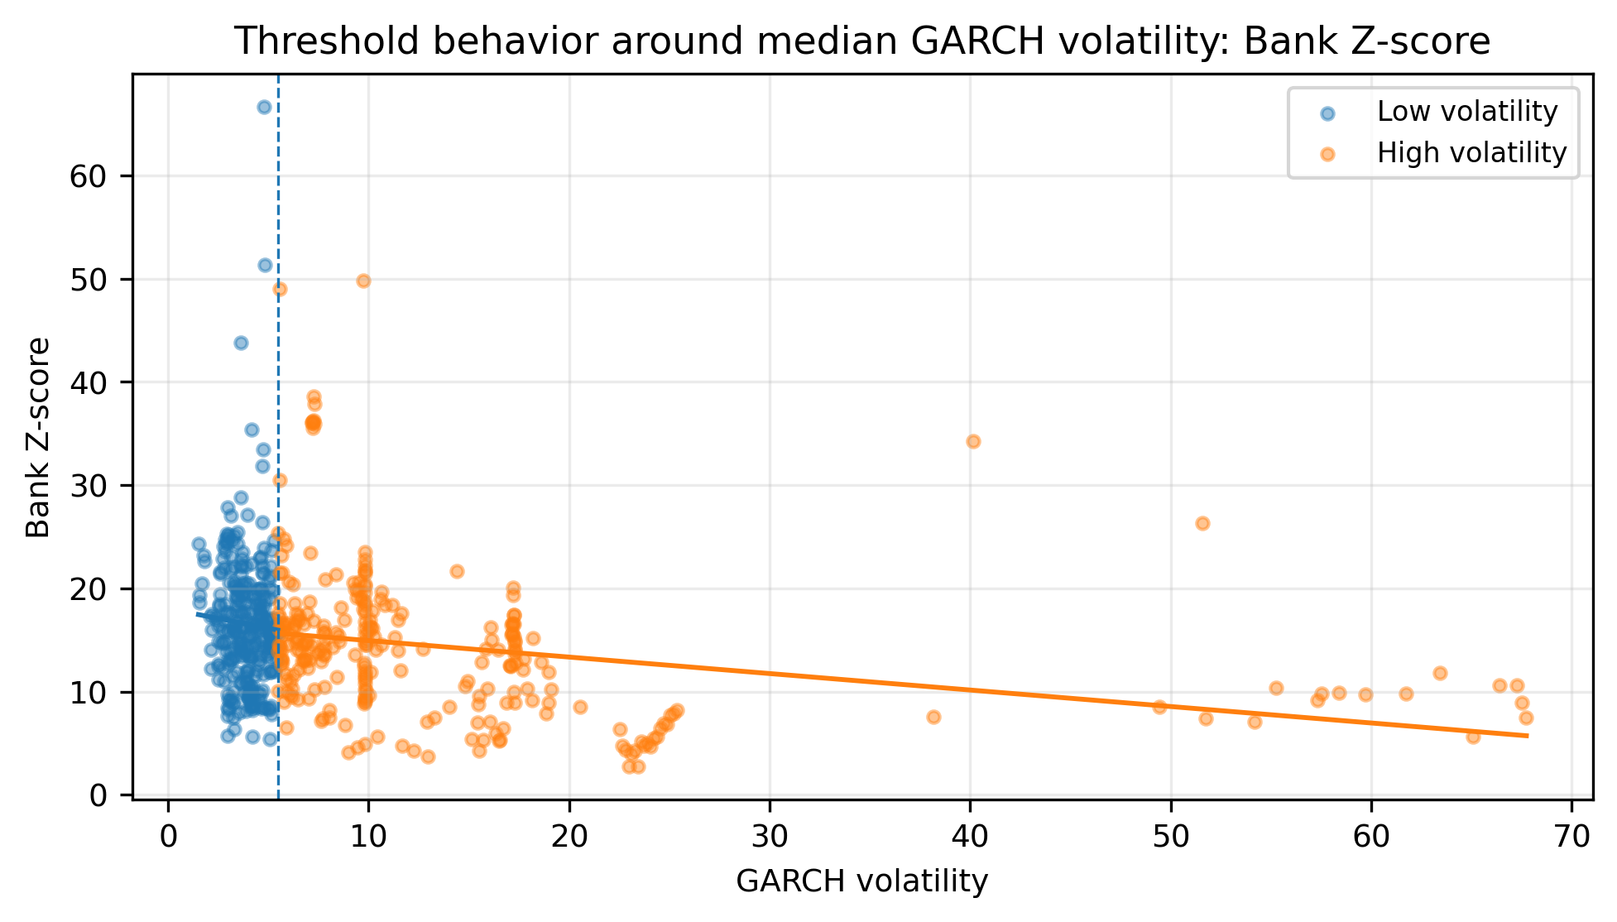
Note. The vertical dashed line marks the median GARCH-volatility threshold in the controlled Z-score sample. Fitted lines are descriptive.
Figure 4.10. Controlled threshold behavior around median GARCH volatility: NPL ratio.
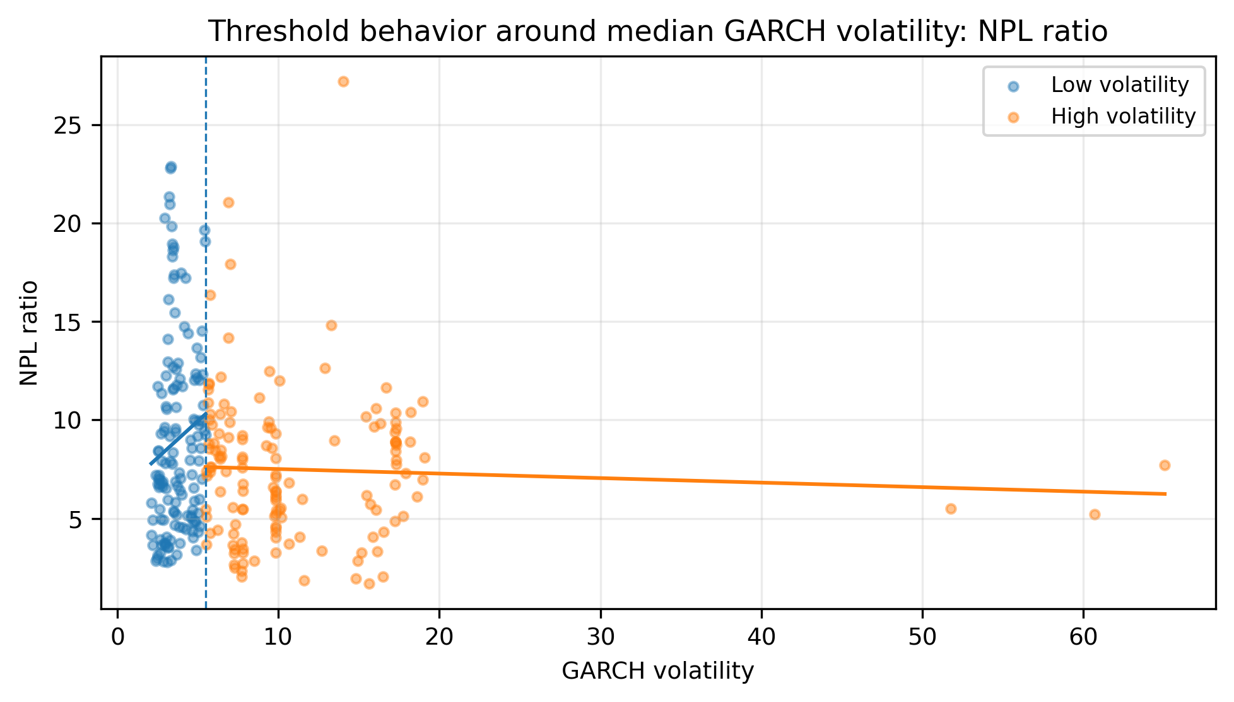
Note. The vertical dashed line marks the median GARCH-volatility threshold in the controlled NPL sample. Fitted lines are descriptive.

Cautious interpretation because of the controlled robustness checks. The dependent volatility measure remains the baseline GARCH(1,1) process and sensitivity is tested using alternative measures of volatility and threshold interactions. The closer the inflation-volatility coefficient is to 1 in both partitions (Fixed Effects and Random Effects), the stronger the result. If it changes following the inclusion of controls", conclusion should be conditional on the macroeconomic environment.

CHAPTER 5: DISCUSSION

5.1 Interpreting the main findings through theory
The results indicate that inflation volatility is connected with banking stability in frontier economies. Evidence of the strongest empirical relationship exists between GARCH(1,1) inflation volatility and the bank Z-score, which is a negative relationship. In the newly considered simple panel framework this relationship is assessed via Fixed Effects and Random Effects models. The coefficient cannot be interpreted as causal evidence in all specifications, but the theoretical negative sign of the coefficient has a meaning because this Z score is a solvency oriented measure, incorporating both profitability, capitalization and earnings volatility measures.
This pattern is very much in line with the uncertainty channel. Volatilities of conditional inflation uncertainty are measured via GARCH(1,1) processes: conditional inflation uncertainty is not only a statement on whether inflation is high, it also reflects whether the inflation process is unstable and, therefore, unpredictable. In the asymmetricinformation model, volatile inflation creates a high barrier to bank assessment and pricing of borrower quality, to determining actual rather than simply temporary real repayment ability, and to differentiating between bor-rower default and liquidity stress. As uncertainty increases banks may choose to increase risk premiums, shorten the length of loan terms, consider creditworthiness, and opt for safer investments. In the short term, these responses mitigate bank losses, but also can lead to poorer quality intermediation and less stable earnings. The negative Z score relationship should thus be interpreted in the light of inflation uncertainty lowering the resilience of banking systems, through an increase in the variance of returns, and a difficulty in pricing risks.
The so called balance-sheet channel is also well supported. The Z score directly relates with the balance-sheet capacity of the banking system as it shows the distance of returns from the default level and measures the capital buffers. As inflation rates fluctuate, so do borrower cash flows, collateral amounts are less certain, and banks find it harder to match the actual value of assets with liabilities. Although the impact of that effect may not be immediately noticeable in higher levels of NPLs, it can nonetheless affect the quality of expected earnings and raise perceived solvency risk. That is why the negative sign of the GARCH-Z score is consistent with a balance-sheet interpretation: Any decrease in inflation volatility reduces the buffer used by banks to absorb shocks.
Staying within the context of the simple panel model, the repayment-capacity channel is still theoretically relevant, but is not the predominant regression result. The main one, an empirical interpretation, thus should be based on Bank Z-score. Changes in interest-rate conditions, input costs and unstable real incomes due to volatile inflation can still lower repayment capacity, but the effect feeling the most impact of this project lies in the solvency/resilience channel, captured by the Z-score.
The real-return channel is the least directly supported explanation of the link between the two. In the logic of the Fisher-effect, unforeseen inflation may cause the real return on bank assets and liabilities to be misaligned particularly if bank loans are written in nominal terms. In principle, this effect has everything to do with the present work, however, inflating the volatility of inflation does not straightforwardly lead to worsening bad-loan formation. Rather, the findings indicate a more general macro-financial process whereby the increased uncertainty regarding prices, profits, borrower quality and the strength of the balance sheets, induced by the inflation volatility, triggers the NPL response, which in turn is regulated by institutional-credit market-specific conditions. To conclude, the evidence is most supportive of the uncertainty and balance-sheet channels, somewhat supportive of the repayment-capacity channel and perhaps less supportive of the real-return channel.
This interpretation sheds light on the reason why there is a difference between raw correlations and panel estimates. A correlation analysis is of course only able to identify co-movement at a specific point in time, while Fixed Effects and Random Effects models try to capture the panel structure, and country-level heterogeneity. The Z-score will react in a general manner as it incorporates profitability, capitalization, and earnings danger. The empirical pattern thus lends itself to a staged view of the transmission, where increased uncertainty from inflation volatility affects the resilience of the solvency of the banks and/or exhibits a later stage in the credit-quality indicators, depending on country conditions.
This interpretation is corroborated by the supplementary robustness checks that use the GARCH-family. The AR(1)-GARCH(1,1) model gives volatility patterns that are very similar to those in the baseline GARCH(1,1) series, with an overall correlation of 0.958 and a median country-level correlation of 0.868. This implies that its overall finding cannot be attributed exclusively to the use of a simple mean inflation specification. Volatility Pattern is quite similar after introducing this element in the inflation equation: inflation depends on itself in the past. However, the EGARCH(1,1) is also compatible with the inflation volatility, and it is more responsive to asymmetric and extreme shocks. It does not correlate as well as the baseline GARCH(1,1) volatility series but it does better once the EGARCH spikes of extrimes are omitted. Hence, the robustness evidence provides further support for the use of the inflation volatility as a risk factor in the macro-financial framework, and it demonstrates that the results on volatility behavior are not all the same across the various model specifications.

5.2 Why the frontier-economy context matters
The key themes of the results relate to the frontier-economy context. In more developed and more institutionally advanced financial systems, financial problems are likely to be more diversified, banks are likely to possess better structured risk management systems, access to capital markets is likely to be more fluid, inflation expectations will likely be more reliable and supervisory frameworks are likely to be more developed. These all make it less difficult to absorb inflation shocks without them giving rise to banking stability issues. Fewer are found in the frontier economies. Thus, a similar level of inflation volatility could mean a greater financial stability worry with banks and borrowers having shallower reserves of safety.
An important one is greater lack of policy credibility. Inflation shocks will not be regarded as transitory shocks where central banks lack credibility or are fiscally dominated. The confidence in returning to a stable path on inflation could be reduced for both borrowers and lenders, leading to more robust revisions to participatory expectations. This adds to the uncertainty premium on credit markets. Furthermore, it is partly the reason why the Z-score channel is more evident than the NPL channel, as banks might have more pessimistic expectations about future earnings, a more conservative risk lending stance and even more assumptive of possible solvency risks, even before formally classifying a loan as non-performing.
Second is the shallowness of financial markets. Frontier banking systems are bank-dominated, and corporate bond markets, and local-currency long-term funding instruments, are limited. This is significant for inflation volatility as it becomes more difficult to hedge this in thin markets. Sophisticated transfer, diversification and pricing of inflation risk is difficult for banks. The risk is left in the core banking book, instead. This increases the security of the findings on the balance-sheet. Macroeconomic instability quickly turns into banking instability when the financial system is reliant on banks.
Thirdly, the exchange-rate pass-through is typically higher in frontier markets. Many of the countries in the sample are also net importers of fuels, food, capital goods or intermediate goods. This allows currency depreciaiton to quickly translate to domestic prices and adding to the inflation volatility, which in turn is connected with external-sector stress. This impacts the cash flows and repayment capacities of companies that have some inputs or liabilities from abroad. For banks it increases the doubt on borrowers as well as the value of security. Thus it's not only consumer prices the channel is constrained by; it's a broader macro-financial vulnerability.
Last but not least, frontier economies typically have less buffer potential. Liquid strength, financial resilience of borrowers, and supervisory technology and systems tend to be shallower than in more developed systems, as do capital buffers and legal recovery arrangements. This can help account for some of the differences in the findings. Inflation volatility does not impact an equal effect across all country-years as its effect varies depending on the buffers. Volatility can play a significant role in destabilizing where buffers are thin. If policy is more credible, banking supervision and capital is sound, the same volatility may be soaked up endogenously, without an ongoing response in terms of NPLs.

5.3 Comparison with prior empirical literature
The results largely contribute to the existing literature of the inflation uncertainty as a financial-stability risk. The prevailing empirical literature on inflation risk, bank stability and credit quality suggests that monetary instability affects bank viability as it exposes them to credit risk, renders contracts nominal less useful, and impedes monetary-policy transmission. This general opinion agrees with the present results that the volatility measure based on the GARCH model is negatively associated with the Bank Z-score in the main connected sample.
Meanwhile, the findings show that the impact varies considerably on the banking-stability measure used, and provide a more nuanced reading of previous findings. Research based only on NPLs could yield inconclusive findings as the definition of non-performing loans is influenced by criteria for loan recognition, supervisory enforcement, loan restructuring, and the nature of the credit market. This study also discovers that the NPL connection is weaker and more heterogeneous than Z score connection. Hence, there is no straightforward conclusion that can be drawn that inflation volatility causes an automatic and instant effect on NPLs in all frontier economies. It indicates, however, that there is a more general, stability effect of inflation volatility, which is more sensitively measured by a solvency-oriented measure.
The results are also consistent with macroprudential vulnerability studies which highlight the need for the interaction between macroeconomic shocks and institutional buffers in order to be financially stable. Contributions of the revised paper are the GARCH(1,1) based measure of volatility, a simple panel approach for the Bank Z-score, and the selection of fixed effects or random effects estimator based on the Hausman test.

5.4 Extended country-level and policy-context interpretation
The country-specific interpretation should be aimed towards a description of heterogeneity instead of a description of a uniform effect. It is a panel that includes African and South Asian frontier economies that have various monetary histories, exchange-rate arrangements, banking structures, supervisory capacity, and composition of credit markets. The descriptive results indicate that observations are more likely to have higher average inflation volatility in Africa, NPL ratios in Africa and higher average Z-scores in South Asia. This pattern implies the same inflation-volatility shock can have varied responses with local banking structures. It also claims to enable regional or country-level rather than pooled interpretations.
The policy issue is not only the level of inflation, but also the instability of the inflation process, especially those countries that have higher average inflation volatility. Moderate inflation may sometimes be acceptable in a country, if it is generally anticipated and incorporated in contracts. The more volatile form of inflation is more harmful because it undermines the anchoring of plans, it makes it more difficult to competitively price loans, and it decreases the trust accorded to the monetary anchor. In this environment, a negative Z-score response can be quite realistic, since the earnings and risk environment for banks is more uncertain even prior to the formal loan-quality indicators becoming poorer.
The lower and mixed NPL figures shouldn't be interpreted to mean that asset quality is unimportant. Instead, they suggest that NPLs are institutional mediated. While the same level of inflation volatility would probably generate a similar NPL response across two countries, loan restructuring policies, the speed of the collateral recovery policy, bank classification practices, the presence of state-owned banks, and the presence of exposed banking sectors like agriculture, trade, construction or small industries could result in different measured NPL responses across the two countries. That is why it is necessary to go beyond "pooled coefficients" to the interpretation of a policy. Supervisors should inquire as to which groups of borrowers are most vulnerable to inflation volatility and the speed at which the impact of this volatility emerges in bank reports.
The findings of the threshold support this policy opinion. Volatility of inflation seems to affect the situation differently during lower and higher vol. periods. During lower-volatilities, banks may be able to adjust via pricing, setting aside, and balance-sheet management. During episodes of greater volatility, these instruments might be less useful due to a more rapid change in borrower activities and borrower attitudes. So, it is advisable that policymakers do not wait till NPLs become visible. Large increases in the GARCH measure of inflation volatility should be considered as an early-warning indicator for strengthening bank-sector supervision.

CHAPTER 6: CONCLUSION

6.1 Conclusion
This paper sought to find out if inflation volatility from a GARCH(1,1) model is related to banking-sector stability based on the Bank Z-score, in frontier economies. A simple answer to the research question in this study is that in the simple panel context, inflation volatility is relevant to banking stability. The most obvious message is that there is a negative correlation between Bank Z-score and conditional inflation volatility: A higher level of conditional inflation volatility is linked to a narrower distance from insolvency and less resilience of the banking system.
The new empirical approach is based on Fixed Effects and Random Effects panel models, the results of which are then compared through the Hausman test to determine which of the two models shall serve as the basis for interpreting the results. This facilitates the project in being simpler, clearer, while keeping GARCH(1,1) as benchmark estimate of inflation volatility.
The overall takeaway from the study is a macro-financial interpretation: volatile inflation undermines banking stability mostly by making the levels of uncertainty and banking balance-sheet resilience that influence banks more and more interesting. Evidence is most evident for the broad solvency-stability channel and a bit more conditional for the asset-quality channel. The message is loud and clear: volatility of inflation in frontier economies is not only macro-economically relevant, but also a banking-stability issue.
Accordingly, its ending should be precisely expressed. The research does not imply that just volatility in inflation is a complete account of fragility and does not imply that NPLs necessarily go up immediately following a volatility shock. Instead, it demonstrates that volatility in inflation is a pertinent macro-financial risk factor, which negatively impacts the stability climate in which banks operate. This is a more viable and defensible conclusion than a single-channel conclusion since it agrees with the somewhat "mixed but theoretically coherent" evidence in the two banking indicators.
The robustness findings derived from AR(1)-GARCH(1,1) and EGARCH(1,1) also demonstrate that the standard GARCH(1,1) volatility measure is overall quite reliable. AR(1)-GARCH aligns well with the underlying volatility evolution once inflation persistence is taken into account, and EGARCH yields further evidence on the asymmetric inflation-volatility dynamics of some countries. For this reason, the study continues to use GARCH(1,1) for the measure of the primary volatility and AR(1)-GARCH(1,1) as a best robustness confirmation, while using EGARCH(1,1) as an asymmetry check.

6.2 Policy implications
First policy implication: central banks should pay attention to the volatility of inflation, beyond its level. Typically, conventional policy discussions focus on the extent to which inflation is above or below a target. There is evidence that instability of inflation is also crucial, as it influences bank risk, borrower behavior and the trustworthiness of financial contracts. A stable inflation process can contribute to banking stability even under moderate inflation. Banking resilience can be influenced negatively by an unstable inflation process even before a clear deterioration of the credit can be seen.
Second, there is a need to increase the co-ordination between monetary policy and financial-stability policy. Inflation volatility and its impact on the Bank Z-SCORE are correlated; this means that price instability makes a difference for solvency buffers and systemic risk. Central bankers should thus consider using inflation stabilisation as a financial-stabilisation instrument. Reduced uncertainty and improved bank resilience can be supported by reducing fiscal dominance, stronger expectations management and credible policy rules which facilitate clear communication.
Third, one indicator of banking regulators must be the inflation-volatility indicators as early-warning signals. If volatility in such circumstances increases, supervisors should consider all deters and provisions under increased pressure with regard to loan portfolios, the adequacy of the provisions and sectoral exposures, and stress-test assumptions. This is particularly critical considering the potential delays in NPL response and the potential of NPLs being hidden as a result of restructuring and classification. It is therefore not too soon to wait for reported NPLs to increase. By tracking inflation-volatility, regulators can pick up pressure before it gets to the point of an asset-quality issue.
Fourth, the priorities of macroprudential policy should be shock absorption. Sturdier capital buffers, liquidity requirements, forward-looking provisioning and borrower-level risk assessments can dampen the amount of inflation volatility associates with bank fragility. Policy tools should focus on the most real-income-insecurity affected and import-cost/shock constrained sectors, and those most vulnerable to interest-rate pressure. These buffers are not just desirable in frontier economies, they're essential protective measures in markets that have limited depth and policy credibility is low against macro-financial instability.
Fifth, it's crucial that the policy response clearly differentiate between solvency risk and asset-quality risk. Results indicate that there are better relationships between Z score and inflation volatility compared with NPLs. It is important, however, for regulators not to overlook the significance of NPL ratios when evaluating banking stress that arises from inflation. It is possible that a banking system can appear fairly sound in terms of bad loans, but its solvency cushion and the stability of its earnings are already eroding. Supervisory Dashboards to include NPLs and Z-type indicators of stability, capital, profitability and liquidity, loan growth quality, and sectoral exposures.

6.3 Contributions to literature and practice
There are therefore three points of academic contribution in the study. It moves the focus from inflation, per se, to inflation volatility, for one. This distinction matters as the banking sector not only reacts to the level of high inflation, it also reacts to the volatility of inflation. This study measures conditional uncertainty, which is more important for bank risk management, by employing a GARCH (1, 1) based measure.
Second, the study makes a contribution that it adopts Bank Z-score as the primary banking-stability measure in a straightforward simple panel approach. The Z-score reflects general solvency risk whereas NPL discussion puts the issue into perspective and therefore has value as background information in the literature. The revised model is easier to defend and explain as the outcome is more narrow.
Thirdly, the study is useful in terms of practicality in the case of frontier-economy supervision. The results can be transformed into an applied monitoring system to view inflation volatility as a macro-financial early-warning indicator. Now to the practical side for central banks and regulators: banks must now be viewed as a domain of macroprudential policy in addition to inflation stabilization and bank supervision, three dimensions of policy previously thought of as distinct.
The practical contribution is also methodological. The project demonstrates how the evidence-based insights for policy dialogue can be defensibly derived from publicly available macro-financial data that can be organized into a connected country-year panel. This is helpful for frontier economies which may lack or have less access to proprietary supervisory data. Even if estimates are conservative, the framework provides policy makers with a strategy for structuring evidence on the subject of inflation volatility, banking resilience.

6.4 Limitations and future research
There are a number of limitations in the study. First, the analysis is based on the country-year data available in public databases, and varies from indicator to indicator. The three-way panel gives valuable connected evidence but, some countries and years are missing. This restricts the capacity to make highly causal country-specific judgements. Second, the Bank Z-score and NPL ratio are both informative, but partial measures of banking stability. The Z-score gauges the whole solvency risk, and NPLs cover the realized asset-quality stress however they are not comprehensive measures of liquidity risk, market risk, governance risk or further, an increasing proportion of hidden restructuring in loans.
Third, the country variation is still important. Inflation volatility effects might be more nuanced depending on differences in monetary credibility, exposure to the exchange rate, quality of supervision, of the legal framework and of the owners of the bank. Future investigation ought to include extra data (as fresh data from the GFDD and the WDI will be available over time), and additional institutional and macroprudential data (when possible); moreover, panels of bank-level data should be tested. The second extension would split the sectoral loan portfolios in order to find out if inflation volatility has different impacts on household, corporate, agricultural, trade or construction loans.
Another restriction is that more complicated GARCH family specifications capture the impact of extreme inflation observations better. This is particularly important with EGARCH(1,1) for countries with volatile shocks as it allows dynamics of the log-variance to detect asymmetric shocks. Thus, EGARCH(1,1) is considered a type of robustness and asymmetry test rather than an alternative to the conventional GARCH(1,1). One research potential involves the use of other error distributions, longer time series at the country level and country-specific model selection, which might lead to more precise measurements of the volatility of inflation.

References
https://data360.worldbank.org/en/search
https://data.imf.org/en
Ababio, J. O., Attah‐Botchwey, E., Osei‐Assibey, E., & Barnor, C. (2020). Financial Inclusion and Human Development in Frontier Countries. International Journal of Finance & Economics, 26(1), 42–59. https://doi.org/10.1002/ijfe.1775
Abaidoo, R., & Agyapong, E. K. (2023). Inflation Uncertainty, Macroeconomic Instability and the Efficiency of Financial Institutions. Journal of Economics and Development, 25(2), 134–152. https://doi.org/10.1108/jed-09-2022-0166
Aboyitungiye, J. B., & Mathu, M. (2023). An Empirical Assessment of the Monetary Policy Credibility and Economic Growth Relationship: A GMM Approach on COMESA and ECOWAS Regions. Jurnal Ekonomi Pembangunan Kajian Masalah Ekonomi Dan Pembangunan, 308–319. https://doi.org/10.23917/jep.v24i2.23113
Addis, A. K. (2025). The Role of Economic Stability in Boosting Exports in COMESA: Threshold Effects Analysis. Plos One, 20(12), e0338636. https://doi.org/10.1371/journal.pone.0338636
Adrian, T., Natalucci, F. M., & Qureshi, M. S. (2023). Macro-Financial Stability in the COVID-19 Crisis: Some Reflections. Annual Review of Financial Economics, 15(1), 29–54. https://doi.org/10.1146/annurev-financial-110821-022107
Ahiase, G., Andriana, D., Agbemava, E., & Adonai, B. (2023). Macroeconomic Cyclical Indicators and Bank Non-Performing Loans: Does Country Governance Matter In African Countries? International Journal of Social Economics, 51(1), 62–80. https://doi.org/10.1108/ijse-11-2022-0729
Ahmed, H. M., El-Halaby, S., & Soliman, H. A. (2022). The Consequence of the Credit Risk on the Financial Performance in Light of COVID-19: Evidence From Islamic Versus Conventional Banks Across MEA Region. Future Business Journal, 8(1). https://doi.org/10.1186/s43093-022-00122-y
Aladejare, S. A. (2023). Does External Debt Promote Human Longevity in Developing Countries? Evidence From West African Countries. Fudan Journal of the Humanities and Social Sciences, 16(2), 213–237. https://doi.org/10.1007/s40647-023-00365-1
Ali, M. S. B., & Mim, S. B. (2022). Democracy and Banking Stability: Is the Relationship U-Shaped? Journal of the Knowledge Economy, 14(4), 4426–4448. https://doi.org/10.1007/s13132-022-01063-1
Almeshari, A., Mohamed Hisham Bin Dato Haji Yahya, Kamarudin, F., Ali, R., & Hamid, S. A. (2023). Liquidity Creation, Oil Term of Trade Shocks, and Growth Volatility in Middle Eastern and North African Countries (MENA). Economies, 11(5), 147. https://doi.org/10.3390/economies11050147
Alnaa, S. E., & Matey, J. (2024). An Assessment of the Risk Mitigating Factors in Ghana’s Bank Industry. Financial Internet Quarterly, 19(3), 62–74. https://doi.org/10.2478/fiqf-2023-0019
Alnabulsi, K., Kozarević, E., & Hakimi, A. (2023). Non-Performing Loans as a Driver of Banking Distress: A Systematic Literature Review. Commodities, 2(2), 111–130. https://doi.org/10.3390/commodities2020007
Amo-Bediako, E., Takawira, O., & Choga, I. (2023). The Impact of Climate Change on the Resilience of Banking Systems in Selected Sub-Saharan Economies. International Journal of Applied Economics Finance and Accounting, 17(2), 469–482. https://doi.org/10.33094/ijaefa.v17i2.1203
Anjom, W. & Abu Taher Mohammad Omor Faruq. (2023). Financial Stability Analysis of Islamic Banks in Bangladesh. European Journal of Business Management and Research, 8(3), 320–326. https://doi.org/10.24018/ejbmr.2023.8.3.1953
Antony, T. M., & Suresh, G. (2023). Determinants of Credit Risk: Empirical Evidence From Indian Commercial Banks. Banks and Bank Systems, 18(2), 88–100. https://doi.org/10.21511/bbs.18(2).2023.08
Antwi, F., & Kwakye, M. (2022). Modelling the Effect of Bank Performance on Financial Stability. International Journal of Research in Business and Social Science (2147-4478), 11(7), 143–151. https://doi.org/10.20525/ijrbs.v11i7.2058
Arora, D., & Kashiramka, S. (2023). Are Shadow Banks a Threat to The financial Stability of EMEs? China Accounting and Finance Review, 25(4), 488–512. https://doi.org/10.1108/cafr-12-2022-0129
Awdeh, A., Moussawi, C. E., & Hamadi, H. (2024). The Impact of Inflation on Bank Stability: Evidence From the MENA Banks. International Journal of Islamic and Middle Eastern Finance and Management, 17(2), 379–399. https://doi.org/10.1108/imefm-10-2023-0388
Azaria, S. P., & Sihaloho, E. D. (2021). Impacts of Foreign Direct Investment on Poverty Eradication in Asean-5 Countries. Trikonomika, 20(2), 62–70. https://doi.org/10.23969/trikonomika.v20i2.4085
Bambe, B.-W.-W., Combes, J., KABA, K., & Minea, A. (2022). Inflation Targeting and Developing Countries’ Performance: Evidence From Firm-Level Data. SSRN Electronic Journal. https://doi.org/10.2139/ssrn.4267886
Banyen, K. T. (2021). Financial Integration, Competition and Bank Risk-Taking Behavior: Evidence From Africa’s Sub-Regional Markets. Journal of Economic Integration, 36(2), 282–307. https://doi.org/10.11130/jei.2021.36.2.282
Banyen, K. T., & Biekpe, N. (2020). Financial Integration and Bank Profitability in Five Regional Economic Communities in Africa. International Journal of Emerging Markets, 16(3), 468–491. https://doi.org/10.1108/ijoem-08-2018-0435
Baum, C. F., Çağlayan, M., & Xu, B. (2020). The Impact of Uncertainty on Financial Institutions: A cross‐country Study. International Journal of Finance & Economics, 26(3), 3719–3739. https://doi.org/10.1002/ijfe.1983
Bayar, Y., Borozan, D., & Gavriletea, M. D. (2020). Banking Sector Stability and Economic Growth in Post‐transition European Union Countries. International Journal of Finance & Economics, 26(1), 949–961. https://doi.org/10.1002/ijfe.1829
Bhujabal, P., Sethi, N., & Padhan, P. C. (2024). Effect of Institutional Quality on FDI Inflows in South Asian and Southeast Asian Countries. Heliyon, 10(5), e27060. https://doi.org/10.1016/j.heliyon.2024.e27060
Bilalli, A., & Sadiku, M. (2023). The Impact of Inflation on Financial Sector Performance: Evidence. From. Western Balkan Countries. Seeu Review, 18(2), 74–89. https://doi.org/10.2478/seeur-2023-0071
Brunnermeier, M. K. (2024). Presidential Address: Macrofinance and Resilience. The Journal of Finance, 79(6), 3683–3728. https://doi.org/10.1111/jofi.13403
Budhathoki, P. B., Bhattarai, G., Aryal, N. P., & Ghimire, S. R. (2024). The Bank Concentration and Risk Exposure: Empirical Insights From Asian Countries. Nepal Journal of Multidisciplinary Research, 7(2), 12–29. https://doi.org/10.3126/njmr.v7i2.68190
Bui, T. T., & Kiss, G. D. (2020). Asymmetry in the Reaction Function of Monetary Policy in Emerging Economies. Pénzügyi Szemle = Public Finance Quarterly, 65(2), 210–224. https://doi.org/10.35551/pfq_2020_2_4
Chand, S. A., Kumar, R. R., & Stauvermann, P. J. (2021). Determinants of Bank Stability in a Small Island Economy: A Study of Fiji. Accounting Research Journal, 34(1), 22–42. https://doi.org/10.1108/arj-06-2020-0140
Chen, M. (2025). Inflation Uncertainty, Macroprudential Regulations, and Bank Stability: Some Evidence From Emerging Economies. International Review of Finance, 25(4). https://doi.org/10.1111/irfi.70051
Danlami, M. R., Abduh, M., & Razak, L. A. (2022). CAMELS, Risk-Sharing Financing, Institutional Quality and Stability of Islamic Banks: Evidence From 6 OIC Countries. Journal of Islamic Accounting and Business Research, 13(8), 1155–1175. https://doi.org/10.1108/jiabr-08-2021-0227
Delessa, K., Alemu, T., & Bane, J. (2024). Remittances Inflow and Economic Growth Nexus in Sub-Saharan Africa: Do Institutional Quality and Macroeconomic Stability Matter? Heliyon, 10(3), e25690. https://doi.org/10.1016/j.heliyon.2024.e25690
Demid, E. (2021). Heterogeneity in the Relationship Between NPLs and Real Economy: Evidence From the Mongolian Banking System. Journal of Central Banking Theory and Practice, 10(2), 133–155. https://doi.org/10.2478/jcbtp-2021-0017
Duong, Q. N., Tran, N. T., & Dang, T. V. P. (2025). Income Diversification and Liquidity Risk in ASEAN-5 Banks: A Bayesian Perspective. Plos One, 20(3), e0316949. https://doi.org/10.1371/journal.pone.0316949
Džidić, A., Živko, I., & Čolak, A. (2022). Macroeconomic Factors of Non-Performing Loans: The Case of Bosnia and Herzegovina. Ekonomska Misao I Praksa, 31(2), 421–438. https://doi.org/10.17818/emip/2022/2.4
Eberhardt, M., & Presbitero, A. (2021). Commodity Prices and Banking Crises. Journal of International Economics, 131, 103474. https://doi.org/10.1016/j.jinteco.2021.103474
Effiong, E. L., Esu, G. E., & Chuku, C. (2020). Financial Development and Monetary Policy Effectiveness in Africa. Journal of Social and Economic Development, 22(1), 160–181. https://doi.org/10.1007/s40847-020-00098-x
Ekananda, M. (2022). Threshold Panel Method for Analysis of the Effect of Banking Investment Allocation on Banking Performance, a Cross Country Studies: Some OECD Countries. Jurnal Ekonomi Kuantitatif Terapan, 179. https://doi.org/10.24843/jekt.2022.v15.i02.p02
El‐Shagi, M., & Tochkov, K. (2021). Divisia Monetary Aggregates for Russia: Money Demand, GDP Nowcasting, and the Price Puzzle. SSRN Electronic Journal. https://doi.org/10.2139/ssrn.3888064
El‐Shagi, M., & Tochkov, K. (2022). Divisia Monetary Aggregates for Russia: Money Demand, GDP Nowcasting and the Price Puzzle. Economic Systems, 46(4), 101054. https://doi.org/10.1016/j.ecosys.2022.101054
Evgenidis, A., & Malliaris, A. G. (2022). Monetary Policy, Financial Shocks and Economic Activity. Review of Quantitative Finance and Accounting, 59(2), 429–456. https://doi.org/10.1007/s11156-022-01045-z
Fadol, H. T. A. (2025). Inflation-Targeting vs. Non-Inflation-Targeting Regimes and Macroeconomic Performance in Africa: Evidence From Econometrics Approaches. https://doi.org/10.21203/rs.3.rs-7502485/v1
Fatin Nur Hidayah Taib Khan, Malim, N. A. K., & Masron, T. A. (2024). The Role of Activity Restrictions on Financial Intermediation Costs in ASEAN Countries. Journal of Financial Regulation and Compliance, 33(1), 109–128. https://doi.org/10.1108/jfrc-03-2024-0053
Fombang, M., & Wanzala, R. W. (2023). Mozambican Commercial Bank Liquidity and Its Determinants. Eureka Social and Humanities, (6), 61–72. https://doi.org/10.21303/2504-5571.2023.003245
Frankema, E. (2024). From the Great Divergence to South–South Divergence: New Comparative Horizons in Global Economic History. Journal of Economic Surveys, 39(2), 517–545. https://doi.org/10.1111/joes.12609
Furi, T., Mulgeta, W., & Chala, B. W. (2022). Determinants of Financial Instability in Selected &Amp;lt;i&gt;East and Southern African&lt;/I&gt; Countries. International Journal of Economics Finance and Management Sciences, 10(2), 37. https://doi.org/10.11648/j.ijefm.20221002.11
Gabriel, V. J., Lazopoulos, I., & Lima, D. (2022). Institutional Arrangements and Inflation Bias: A Dynamic Heterogeneous Panel Approach. Journal of Money Credit and Banking, 55(1), 43–76. https://doi.org/10.1111/jmcb.12935
Goyal, S., Singhal, N., Prosad, J. M., & Mishra, N. (2023). Impact of Institutional Environment on Banks’ Non-Performing Loans: Evidence From BRICS Countries. Finance Theory and Practice, 27(6), 67–78. https://doi.org/10.26794/2587-5671-2023-27-6-67-78
Haile, M. A., Jayamohan, M. K., & Mulugeta, W. (2025). Does Regulatory Convergence Shape Banking Resilience in Africa? Heliyon, 11(1), e41347. https://doi.org/10.1016/j.heliyon.2024.e41347
Hanif, M., Chaker, M. N., & Sabah, A. (2024). Islamic Finance and Economic Growth: Global Evidence. Digest of Middle East Studies, 33(1), 83–102. https://doi.org/10.1111/dome.12313
Hasan, R., & Ashfaq, M. (2021). Corruption and Its Diverse Effect on Credit Risk: Global Evidence. Future Business Journal, 7(1). https://doi.org/10.1186/s43093-021-00060-1
Huh, S., & Kim, I. (2025). Financial Frictions, Monetary Policy, and the Term Premium. Macroeconomic Dynamics, 29. https://doi.org/10.1017/s1365100524000713
Ibrahim, R. L., Yu, Z., Hassan, S., Ajide, K. B., Tanveer, M., & Khan, A. R. (2022). Trade Facilitation and Agriculture Sector Performance in Sub-Saharan Africa: Insightful Policy Implications for Economic Sustainability. Frontiers in Environmental Science, 10. https://doi.org/10.3389/fenvs.2022.962838
Iheonu, C. O. (2025). Energy Price Inflation and Real Output Nexus in Selected Sub‐Saharan African Economies. World Affairs, 188(4). https://doi.org/10.1002/waf2.70028
Ikpesu, F. (2024). Unraveling the Dynamics: Macroeconomic Drivers Of equity market Development In Sub-Saharan Africa. International Journal of Social Economics, 52(2), 253–264. https://doi.org/10.1108/ijse-01-2024-0005
Jordà, Ò., Richter, B., Schularick, M., & Taylor, A. M. (2020). Bank Capital Redux: Solvency, Liquidity, and Crisis. The Review of Economic Studies, 88(1), 260–286. https://doi.org/10.1093/restud/rdaa040
Kanapiyanova, K. B., Faizulayev, A., Рузанов, Р. М., Ejdys, J., Kulumbetova, D. B., & Elbadri, M. (2022). Does Social and Governmental Responsibility Matter for Financial Stability and Bank Profitability? Evidence From Commercial and Islamic Banks. Journal of Islamic Accounting and Business Research, 14(3), 451–472. https://doi.org/10.1108/jiabr-01-2022-0004
Kapaya, S. (2023). Government Expenditure Impacts on Financial Development: Do population Age Structures Moderations Matter? Review of Economics and Political Science, 8(5), 330–352. https://doi.org/10.1108/reps-01-2023-0008
Karadam, D. Y., & Öcal, N. (2020). Analysis of Distinct Asymmetries in Financial integration‐growth Nexus for Industrial, Emerging and Developing Countries. International Journal of Finance & Economics, 27(2), 2326–2344. https://doi.org/10.1002/ijfe.2275
Keefe, H. G. (2020). The Impact of Exchange Rate Volatility on Inflation Targeting Monetary Policy in Emerging and Advanced Economies. International Finance, 23(3), 417–433. https://doi.org/10.1111/infi.12368
Khan, A. B., Fareed, M., Salameh, A. A., & Hussain, H. (2021). Financial Innovation, Sustainable Economic Growth, and Credit Risk: A Case of the ASEAN Banking Sector. Frontiers in Environmental Science, 9. https://doi.org/10.3389/fenvs.2021.729922
Khouangvichit, C. (2024). The Relationship Between Macroeconomic Factors and Non-Performing Loans (NPLs) in Lao PDR. 154–173. https://doi.org/10.14232/gtk.gdtgiss.2024.10
Kozarić, K., & Dželihodžić, E. Ž. (2020). Effects of Macroeconomic Environment on Non-Performing Loans and Financial Stability: Case of Bosnia and Herzegovina. Journal of Central Banking Theory and Practice, 9(2), 5–17. https://doi.org/10.2478/jcbtp-2020-0011
Kulu, E., & Osei, B. (2023). Drivers of Financial Stability Gap: Evidence From Sub-Saharan Africa. Journal of Financial Economic Policy, 16(1), 19–33. https://doi.org/10.1108/jfep-07-2023-0184
Kuti, A. O., Aderogba, T. A., Ezenwa, N. J., & Quadri, R. A. (2023). Catalysts of Economic Welfare in Africa: A Cross-Sectional Autoregressive Distributed Lag Approach. Acta Universitatis Sapientiae Economics and Business, 11(1), 18–41. https://doi.org/10.2478/auseb-2023-0002
Kuvshinov, D., Richter, B., & Zimmermann, K. (2021). The Shifts and the Shocks: Bank Risk, Leverage, and the Macroeconomy. SSRN Electronic Journal. https://doi.org/10.2139/ssrn.3942472
Lapid, A. K., Mercado, R., & Rosenkranz, P. (2022). Concentration in Asia’s Cross‐border Banking: Determinants and Impacts. Pacific Economic Review, 28(2), 267–292. https://doi.org/10.1111/1468-0106.12399
Lee, J., & Rosenkranz, P. (2020). Nonperforming Loans in Asia: Determinants and Macrofinancial Linkages. 33–53. https://doi.org/10.1108/s1569-376720200000021003
Lestari, D., Ma, S., & Jun, A. (2023). Enhancing Bank Stability From Diversification and Digitalization Perspective in ASEAN. Studies in Economics and Finance, 40(4), 606–624. https://doi.org/10.1108/sef-12-2022-0554
Libman, E., & Taboada, S. (2021). Sticky Inflationary Expectations and Inflation Targeting in (Some) Emerging and Less Developed Economies. Cuadernos De Economía, 40(82), 83–112. https://doi.org/10.15446/cuadecon.v40n82.79547
Liu, J., & Serletis, A. (2021). The Complex Relationship Between Inflation and Equity Returns. Journal of Economic Studies, 49(1), 159–184. https://doi.org/10.1108/jes-10-2020-0526
Mabkhot, H., & Al-Wesabi, H. A. H. (2022). Banks’ Financial Stability and Macroeconomic Key Factors in GCC Countries. Sustainability, 14(23), 15999. https://doi.org/10.3390/su142315999
Malikane, C., & Chomba, H. (2022). Does Institutional Quality Influence Financial Deepening in Selected African Countries? International Journal of Scientific and Management Research, 05(10), 184–206. https://doi.org/10.37502/ijsmr.2022.51013
Marimuthu, M., Khan, H., & Bangash, R. (2021). Is the Fiscal Deficit of ASEAN Alarming? Evidence From Fiscal Deficit Consequences and Contribution Towards Sustainable Economic Growth. Sustainability, 13(18), 10045. https://doi.org/10.3390/su131810045
Mendonça, D. J. (2024). The Relationship of Government Effectiveness and Level of Economic Development With Bank Spread in Different Countries. Journal of Finance & Economic Research, 9(1), 27–48. https://doi.org/10.20547/jfer2409103
Misztal, P. (2022). Communication of Central Banks as a Determinant of Credibility and Effectiveness of Monetary Policy. European Research Studies Journal, XXV(Issue 3), 539–554. https://doi.org/10.35808/ersj/3049
Modugu, K. P., & Dempere, J. (2022). Monetary Policies and Bank Lending in Developing Countries: Evidence From Sub-Sahara Africa. Journal of Economics and Development, 24(3), 217–229. https://doi.org/10.1108/jed-09-2021-0144
Montes, G. C., Irineu da Silva Rodrigues Júnior, Bastos, J. C. A., & Batista, L. M. (2022). Effects of Monetary Policy Credibility and the Open Economy Trilemma on Monetary Policy Efficiency. International Journal of Finance & Economics, 29(2), 1236–1258. https://doi.org/10.1002/ijfe.2737
Msomi, T. S. (2022). Factors Affecting Non-Performing Loans in Commercial Banks of Selected West African Countries. Banks and Bank Systems, 17(1), 1–12. https://doi.org/10.21511/bbs.17(1).2022.01
Muhammed, S., Desalegn, G., Fekete‐Farkas, M., & Bruder, E. (2023). Credit Risk Determinants in Selected Ethiopian Commercial Banks: A Panel Data Analysis. Journal of Risk and Financial Management, 16(9), 406. https://doi.org/10.3390/jrfm16090406
Musiita, B., & Kijjambu, F. N. (2024). Intersecting Dynamics: The Influence of Macroeconomic Factors and Financial Development on Interest Rate Spreads in Uganda. Journal of Economics and Behavioral Studies, 16(2(J)), 1–14. https://doi.org/10.22610/jebs.v16i2(j).3832
Nabaweesi, J., Kaawaase, T. K., Buyinza, F., Adaramola, M. S., Namagembe, S., & Nkote, I. (2023). Governance and Modern Renewable Energy Consumption in the East African Community (EAC): A dynamic Panel CS-ARDL Approach. Management of Environmental Quality an International Journal, 35(2), 358–377. https://doi.org/10.1108/meq-05-2023-0152
Ndulu, B. J., & O’Connell, S. A. (2021). Africa’s Development Debts. Journal of African Economies, 30(Supplement_1), i33–i73. https://doi.org/10.1093/jae/ejab021
Nookhwun, N., & Waiyawatjakorn, R. (2024). Flexible Inflation Targeting and Macroeconomic Performance: Evidence From ASEAN. Asian Economic Policy Review, 19(2), 198–219. https://doi.org/10.1111/aepr.12459
Olamide, E., Kanayo, O., & Maredza, A. (2022). Exchange Rate Volatility, Inflation and Economic Growth in Developing Countries: Panel Data Approach for SADC. Economies, 10(3), 67. https://doi.org/10.3390/economies10030067
Olarewaju, O. M. (2020). Investigating the Factors Affecting Nonperforming Loans in Commercial Banks: The Case of African Lower Middle‐income Countries. African Development Review, 32(4), 744–757. https://doi.org/10.1111/1467-8268.12475
Onifade, S. T., Gyamfi, B. A., Haouas, I., & Asongu, S. (2023). Extending the Frontiers of Financial Development for Sustainability of the MENA States: The Roles of Resource Abundance and Institutional Quality. Sustainable Development, 32(3), 1971–1986. https://doi.org/10.1002/sd.2751
Onwuka, K., Chukwu, A. B., & Agbanike, T. F. (2020). Current Account and Financial Reforms: Evidence From sub‐Saharan Africa. International Journal of Finance & Economics, 26(3), 4303–4314. https://doi.org/10.1002/ijfe.2015
Özdemir, D. (2023). Reconsidering Agricultural Credits and Agricultural Production Nexus From a Global Perspective. Food and Energy Security, 13(1). https://doi.org/10.1002/fes3.504
Ozili, P. K., & Ndah, H. (2021). Impact of Financial Development on Bank Profitability. Journal of Economic and Administrative Sciences, 40(2), 238–262. https://doi.org/10.1108/jeas-07-2021-0140
Pal, S., & Mahalik, M. K. (2024). Role of Globalization and Innovation Pattern in Growth of Bank Credit: Evidence From Emerging and Advanced Asia. Review of Development Economics, 29(3), 1647–1662. https://doi.org/10.1111/rode.13187
Paul, S. C., Rosid, M. H. O., Islam, M. R., & Ferdous, R. (2021). The Macroeconomic Determinants and FDI: Evidence From 14 International Alliances. Asian Development Policy Review, 9(2), 69–82. https://doi.org/10.18488/journal.107.2021.92.69.82
Philippines Financial Sector Assessment. (2021). https://doi.org/10.1596/36191
Prasetyowatie, Y. W., & Hariadi, S. (2022). Determinants of Non-Performing Loans in Indonesia. Media Trend, 17(2), 317–328. https://doi.org/10.21107/mediatrend.v17i2.17097
Rahman, M. M. A., Khan, A. U. I., & Kaplan, M. (2024). Assessing the Impact of Institutional Quality and Financial Stability on Sustainable Development Goal One in Sub-Saharan Africa. https://doi.org/10.21203/rs.3.rs-4882551/v1
Role of Oil Prices in Financial Instability, Trade Openness and Economic Growth: Evidence From ASEAN Countries. (2023). Jurnal Ekonomi Malaysia, 57(01). https://doi.org/10.17576/jem-2023-5701-10
Rosalina, L., & Wahyuningsih, D. (2023). Impact of Financial Inclusion and Banking Characteristics on Banking Stability in Indonesia. Jurnal Perspektif Pembiayaan Dan Pembangunan Daerah, 11(1), 79–92. https://doi.org/10.22437/ppd.v11i1.18227
Sahu, A. K., & Mahalik, M. K. (2024). Unwrapping the Intricate Interplay Between Energy Dependency and Macroeconomic Volatility in OECD Countries. Economic Papers a Journal of Applied Economics and Policy, 43(4), 389–410. https://doi.org/10.1111/1759-3441.12429
Saliba, C., Farmanesh, P., & Athari, S. A. (2023). Does Country Risk Impact the Banking Sectors’ Non-Performing Loans? Evidence From BRICS Emerging Economies. Financial Innovation, 9(1). https://doi.org/10.1186/s40854-023-00494-2
Samosir, N., & Usman, B. (2024). Empirical Insights Into the Influence of Financial Development on Capital Markets in Southeast Asia. Jrmsi - Jurnal Riset Manajemen Sains Indonesia, 15(01), 10–19. https://doi.org/10.21009/jrmsi.015.1.02
Sari, N. N., & Sudarmawan, B. N. (2023). The Determinants of Bank Stability: An Empirical Investigation in Southeast Asia. Jurnal Ekonomi Syariah Teori Dan Terapan, 10(2), 109–122. https://doi.org/10.20473/vol10iss20232pp109-122
Shahriar, A., Mehzabin, S., Ahmed, Z., Döngül, E. S., & Azad, Md. A. K. (2022). Bank Stability, Performance and Efficiency: An Experience From West Asian Countries. Iim Ranchi Journal of Management Studies, 2(1), 31–47. https://doi.org/10.1108/irjms-02-2022-0017
Sharma, K. P. (2024). Effects of Non-Performing Loan and Operational Efficiency on Profitability of Nepalese Commercial Banks. Resunga Journal रेसुङ्गा जर्नल, 3(1), 51–77. https://doi.org/10.3126/resungaj.v3i1.65881
Sheraliev, I., & Ślepaczuk, R. (2023). Cross-Country Differences in Return and Volatility Metrics of World Equity Indices. Central European Economic Journal, 10(57), 90–115. https://doi.org/10.2478/ceej-2023-0006
Sule, S. A., Hakim, L., Putro, T. R., & Pamungkas, P. (2024). The Impact of Inflation on the Business Cycle and Economic Growth: An Empirical Analysis. Ijefsd, 6(11), 274–286. https://doi.org/10.31149/ijefsd.v6i11.5334
Syed, A. A., & Aidyngul, Y. (2020). Macro Economical And bank‐specific Vulnerabilities of Nonperforming Loans: A Comparative Analysis of Developed and Developing Countries. Journal of Public Affairs. https://doi.org/10.1002/pa.2414
Syed, A. A., Kamal, M. A., Ullah, A., & Grima, S. (2022). An Asymmetric Analysis of the Influence That Economic Policy Uncertainty, Institutional Quality, and Corruption Level Have on India’s Digital Banking Services and Banking Stability. Sustainability, 14(6), 3238. https://doi.org/10.3390/su14063238
Tachega, M. A. (2025). Investment Attractiveness in BRICS+ Economies: Evaluating Business Environment Reforms, Institutional Quality, and Macroeconomic Factors. Plos One, 20(10), e0334043. https://doi.org/10.1371/journal.pone.0334043
Tătărici, L., Kubinschi, M., & Barnea, D. (2020). Determinants of Non-Performing Loans for the EEC Region. A Financial Stability Perspective. Management & Marketing, 15(4), 621–642. https://doi.org/10.2478/mmcks-2020-0036
Vollmer, U. (2021). Monetary Policy or Macroprudential Policies: What Can Tame the Cycles? Journal of Economic Surveys, 36(5), 1510–1538. https://doi.org/10.1111/joes.12474
Wanjala, K., & Gachanja, J. N. (2020). Mr Bank Specific Determinants of Nonperforming Loans in Kenya. Business Perspective Review, 2(1), 29–44. https://doi.org/10.38157/business-perspective-review.v2i1.118
Wu, S., Alharthi, M., Yin, W., Abbas, Q., Shah, A. N., Rahman, S. U., & Khan, J. (2021). The Carbon-Neutral Energy Consumption and Emission Volatility: The Causality Analysis of ASEAN Region. Energies, 14(10), 2943. https://doi.org/10.3390/en14102943
Yağlı, İ., & Topçu, M. (2023). Determinants of Credit Risk in the Turkish Banking Sector: Does Ownership Matter? Sosyoekonomi, 31(55), 49–67. https://doi.org/10.17233/sosyoekonomi.2023.01.03
Yahaya, A., Mahat, F., M.H., Y., & Matemilola, B. T. (2022). Liquidity Risk and Bank Financial Performance: An Application of System GMM Approach. Journal of Financial Regulation and Compliance, 30(3), 312–334. https://doi.org/10.1108/jfrc-03-2021-0019
Yunita, P. (2022). Dual Banking System Stability Index in the Shadow of COVID-19 Pandemic. International Journal of Islamic Economics and Finance (Ijief), 5(1), 151–176. https://doi.org/10.18196/ijief.v5i1.11837
Zallé, O. (2023). Financial Inclusion and Tax Effort in Sub-Saharan Africa: The Role of Institutional Quality. Journal of Public Finance and Public Choice, 38(2), 263–289. https://doi.org/10.1332/251569121x16817386486785

