

Internship Report
On
Marketing & Promotional Activities of Kazi Food Industries Limited (Kazi Farms Kitchen)

Submitted To:
DR. MD. SHARIFUL ALAM
Associate Professor
School of Business and Economics
United International University

Submitted By:
Sakib Hossain Chowdhury
Id: 111151324
BBA (Marketing)

Date of Submission:
May 12, 2020

Declaration

I am Sakib Hossain Chowdhury, a Student of United International University, BBA Program. ID Number: 111 151 324, major in Marketing, hereby declare that the internship report on Marketing & Promotional Activities of Kazi Food Industries Limited, was embodied after the completion of my internship at Kazi Food Industries Limited, (Shimanto Shambar, level- 05, Dhanmondi- 02, Dhaka). I announce that the report of internship is made for an academic intention and has not been submitted by me before of any purpose.

Letter of Transmittal

23 December, 2019
Dr. MD. Shariful Alam
Associate Professor
School of Business & Economics
United International University

Subject: Submission of Internship on Marketing & Promotional Activities of Kazi Food Industries Limited
Dear Sir,
With humble respect to inform you that I have completed my internship Program at Kazi Food Industries Limited. I am submitting the internship report on Marketing & Promotional Activities of Kazi Food Industries Limited. The report will preview how marketing mix involved with the brands. I have tried heart and soul for earning extensive experience and collecting information about the topic. I am submitting the report for your gracious perusal and acceptance. At the time of preparing report I acquired lots of practical lesson which will help me to lead my life.
I will be Thankful, if you mercifully accept this report. Thanks to you for your Cooperation and Guideline.

Sincerely yours,

___________________
Sakib Hossain Chowdhury
ID: 111 151 324
School of Business & Economics
United International University

Acknowledgement
At the very Starting of the report I would like to impart my sincere gratitude to Almighty Allah for guiding me to the right pathway, which supports me to complete my task effectually.
I would like to express my gratitude and appreciation to all those who gave me the possibility to complete this report. A special thanks to my Coordinator MD Shariful Alam, Associate Professor SOBE, United International University whose help me by giving his benefiting guidance and encouragement, astute advice and endless endurance throughout the semester without which this paper have not been flourishing.
I am thankful to Kazi Food Industry limited for the internship opportunity. I am grateful to all the officials and employees of Kazi Farms Group for their gracefulness and kindness.
Special thanks to Mr. Rajib Saha, Senior Manager of Marketing & Branding of Kazi Food industries Limited for selecting this interesting research topic and giving valuable guidelines. His has greatly motivated me to give my best effort in preparing this report.
I would like to give thank, Mr. ASM Zakaria- General Manager of Marketing & Branding, Mr. Santonur Rahman- Deputy Manager of Marketing & Branding, Moshiur Rahman- Asst. Manager of Marketing & Branding of Kazi Food Industries Limited for aiding me to prepare this report by providing adequate and informative information.
The report might never have been preferred without the necessary academic knowledge, assistance of reference books, web pages and some practical knowledge, assistance of The Kazi Food Industries Limited Officials. I am grateful to all the employee who have helped to complete this report.

Executive Summary
Internship is one of the best ways where we can see the practical scenario of the corporate world. We can get fundamental idea about job, corporate culture, which is not possible to learn through reading book or performing classroom activities. The topic of the report is “Marketing & Promotional Activities of Kazi Food Industries Limited”.
Nowadays Food & Beverage industry in Bangladesh is developing gradually. Competition is increasing based on increasing demand. Along with the newer diversity of food & beverage products, many participants are entering into this sector. This industry is the largest sector and is the most adequate one to be used to diversify the economy.
By based on the topic of the report we can easily expect that which will be the purpose of the information. From this report, we will get different marketing mix, agreement, condition, systems, and observation of the marketing & branding area of Kazi Food Industries Limited. The report is completed on three month internship in one of the Commanding & reputed Food and Beverage manufacturing organization and their marketing process, which leads the organization in the most excellent position in Bangladesh. To nurse the nation, Kazi Food Industries Limited does some operations as collecting the raw material from their own source, material processing with the assistance of external production managers, stock the ultimate items, serve the products by distributors, etc. The food & Beverage sector is one the prime concern of this organiza,tion and as well as it hasa few other SBUs. The report is founded on actual information & working process as well as their marketing and branding activities in Kazi Food Industries Limited. The initial aim of the report is to present the marketing activities and strategies of Kazi Food Industries Limited to increase the value of brand and product in a very complicated competitive condition. We also learn about Consumer appreciation of a number of brand alternative, character of distribution channel and their practice, advertising and promotional task, market share and growth by this report.

Table of Content
Chapter | Content | Page No
Chapter – 01 (Introduction) | Introduction | 1
Chapter – 01 (Introduction) | Background of the Study | 1
Chapter – 01 (Introduction) | Food & Beverage Industries In Bangladesh | 2
Chapter – 01 (Introduction) | Purpose of the Report | 2
Chapter – 01 (Introduction) | Objective of the Report | 3
Chapter – 01 (Introduction) | Scope of the Report | 3
Chapter – 01 (Introduction) | Limitation of the Study | 4
Chapter – 02 (Methodology of the Report) | Methodology | 4
Chapter – 03 (Organizational Overview) | Company Profile of Kazi Farms Group | 5
Chapter – 03 (Organizational Overview) | Overview of Kazi Farms Industries Limited | 6
Chapter – 03 (Organizational Overview) | Mission, Vision | 6
Chapter – 03 (Organizational Overview) | Philosophy of Kazi Farms Industries Limited | 7
Chapter – 03 (Organizational Overview) | Goal of Kazi Farms Industries Limited | 7
Chapter – 03 (Organizational Overview) | CSR of Kazi Farms Industries Limited | 7
Chapter – 03 (Organizational Overview) | Corporate Information of Kazi Farms Industries Limited | 7
Chapter – 03 (Organizational Overview) | Contact Information of Kazi Farms Industries Limited | 8
Chapter – 03 (Organizational Overview) | Factory Brief of Kazi Farms Industries Limited | 10
Chapter – 03 (Organizational Overview) | Management profile of Kazi Farms Industries Limited | 10
Chapter – 03 (Organizational Overview) | Organizational Hierarchy of Kazi Farms Industries Limited | 12
Chapter – 03 (Organizational Overview) | Departmental Role of Kazi Farms Industries Limited | 13
Chapter – 03 (Organizational Overview) | Competitors of Kazi Farms Industries Limited | 15
Chapter – 03 (Organizational Overview) | SWOT Analysis of Kazi Farms Industries Limited | 16
Chapter – 04 (Marketing Activities Of Kazi Food Industries Limited- Kazi farms Kitchen) | Market Overview | 20
 | Market Trends | 20
 | Kazi Farms Kitchen Food Brand | 23
 | Kazi Farms Kitchen’s Health Promise | 24
 | Segmentation, Targeting of Kazi Farms Kitchen | 25
 | Positioning of Kazi Farms Kitchen | 26
 | Marketing Mix (7ps) of Kazi Farms Kitchen | 26
Chapter – 05 (Findings, Conclusion & Recommendations) | Findings | 35
Chapter – 05 (Findings, Conclusion & Recommendations) | Conclusion | 36
Chapter – 05 (Findings, Conclusion & Recommendations) | Recommendations | 37

List of Acronyms

- RDC – Radio Commercial
- BP – Brand Promoter
- POS – Point of Sales
- KFK – Kazi Farms Kitchen
- IT – Information Technology
- ERP - Enterprise resource planning
- KFIL – Kazi Food Industries Limited
- CSR – Corporate Social Responsibility
Chapter - 01 (Introduction)

1 Introduction:
In the territory of BBA Theory and Hands on experience complement each other. The
BBA program is designed to orient the student with the interaction of theoretical
knowledge along with the knowledge of the applied area of business. Here, I can
experience and asses the usual phenomena and probability of the theoretical
concepts which I have come across in the sessions with our learned teachers. As per
example this report is the requirement of the fulfillment of the internship program.
The report is on Marketing & Promotional Activities of Kazi Food Industries Limited, which is a requirement & important for the completion & fulfillment of the
Bachelor of Business Administration program under the Faculty of Business Studies. The objective of this study is to trace and explore Kazi Food Industries Limited; capitally its food & beverage business and its procedure also. The recent activities of Kazi Food Industries Limited are include here.
Across the world Food and Beverage Industry are rapidly growing day by day. Along with raising population and quick pace in cities specifically the urban and resident becoming incrementally demanding for ready food & beverage. The city dwellers are prosperously adapting to foods & beverage as readymade. Competition is increasing day by day by the basis of increasing demand. It is high time to explore marketing mix of the brands of Kazi Food Industries Limited that recognized and performed for holding down in the competition and also for earning leading position of the food & beverage sector of the country. Our country has achieved colossal augmentation in the food & beverage sector over the last couple of decades. This growth can be attributed to the accomplishment of the food & beverage sector over the course of this decade as one of the sources. The 'marketing mix' is a grounding thought in marketing. The marketing mix has been defined as the "set of marketing tools that the firm uses to explore its marketing purpose in the target market". Thus the marketing mix indicate the four broad levels of marketing decision, as like: product, price, promotion, and place. So it is important to analyze the marketing mix of the brands of Kazi Food Industries Limited. I got that scope as an intern to find out and pursue marketing mix of the brands of Kazi Food Industries Limited.

1.1 Background of the Study:
Kazi Food Industries Limited is one of the growing private food & beverage companies of Bangladesh. I was join as Intern in Marketing & Branding Department. They assists me to make this report under the supervision of experience executives and staffs. I have prepared the report focusing all the aspect of this company by counseling with my honorable course supervisor and the team members of Kazi Food Industries Limited Marketing & Branding department.

Every Company needs to adopt exact Marketing and Branding Activities for winning in the competition. Every company should increase their skill about Marketing and Branding for achieving customer satisfaction as well as competitive advantages which are the eventual objective of every Organization. Leading position holder need maximum market share in a specific arena, 1st for launching creative items in the market, 1st for observing switches in buying attitude model, 1st for reacting of customer switching demand etc. Most landmark be present in the specific company that wants to achieve leading position along with implementing effective marketing activities. Now a days Kazi Food Industries Limited is one of the Leading food and Beverage Providers in Bangladesh. They started their business in this market and after a short period they able to achieve their position in Food and Beverage sector.

1.2 Food and Beverage Industry in Bangladesh:
In Bangladesh Food and Beverage Industry is a swiftly raising sector, applying a momentous volume of the labour force in the country. Within 2006 and 2013, the food & beverage procedure industry in Bangladesh rose at a mean 9.8 % annually. Bangladesh Bureau of Statistics (BBS), in its 27006 financial Census, indicated that there were nearly 346 medium-sized food and beverage processing industries applying 19 % of the artificial manufacturing workforce in Bangladesh or 8 % of the full manufacturing labour capacity. The food & beverage industry make employment 2.45 % of the nation's full labour force and its share in the GDP was 2.01 % in 2010. There are also numerous short scale factories and domestic parts involved in food & beverage processing over the country.
With the opinion of some industry analysts, in our country the food and beverage processing arena is a 4.5 billion US Dollar industry. Among 2010, Bangladesh consigned above $700 million value of processed food and beverages, above 60 % of them were shrimp & fish items. Food processing in Bangladesh has traditionally been short range, together with local or household business using general procedure sense and efficiency to the restrain and handle of fresh agricultural merchandise for making them valuable as food and feed. Even though mercantile range food and beverage process are using modern technology at the time of 1960s, the growth of this area did not avail momentum in terms of operational range and quality till the 1980s. Now a days the identifying characteristics of the industry have been the processing of increasingly various products to meet the changing demands of the Bangladesh population. Induced by the powerful growth of the various middle class population of Bangladesh and the arising demands for additional consumption, the food and beverage processing sector is set to witness therewithal hefty propagation in the oncoming years.

1.3 Purpose of the study:
The first purpose of writing the report is completing the partial requirement of the BBA program. Another purpose is for making a bridge between theory and practical knowledge. I have tried to give an overview of Kazi food Industries Limited in general in this report. Main objectives are given below:
- For Introducing the history and operational activities of Kazi Food Industries Limited
- To display the marketing and promotional activities of Kazi Food Industries Limited
- For showing the advertising activities, RDC activities of Kazi Food Industries Limited
- For placing SWOT analysis of Kazi Food Industries Limited
- For identifying the problems which are faced by Kazi Food Industries Limited
- For recommending actions plan that may be important to redesign of Kazi Food Industries Limited
1.4 Objective of the Study:

Primary Objective:
- To pursue the marketing mix of the brands
- To discover the way to prosper Marketing and Branding operations
Secondary Objective:
- To show an overview about Kazi Food Industries Limited
- To introduce the business structure, processing system and the status of Kazi Food Industries Limited
- To show the Marketing and Branding activities of Kazi Food Industries Limited
- To relate theoretical knowledge with practical experience with different functions of Kazi Food Industries Limited
- For Completing the BBA Program and Internship Program requirements

1.5 Scope of the Report:

The prime benefit of this report is that the corporate office at Shimanto Shambar, Level-5, Road: 2, Dhanmondi, Dhaka-1205 and they operate their operations across all over the Bangladesh. The report also concern the Food and Beverage sector and its tendency and rivals in Bangladesh. Another scope of the report is Marketing and Branding team Of Kazi Food Industries Limited helps me to collect necessary information about report.

1.6 Limitations of the study:
I have tried heart and soul to achieve the objectives of this report and make this report feasible and informative. Although there are some limitations that made obstacle in acquiring my goals. These are;
- 3 month is not enough time to complete the final report
- Time was too short to work where normally I arrive back from office at 7 pm and many times 8.00pm
- Busy office Environment was another obstacle for collecting data
- secrecy of the company for expressing many sort of fact
- Couldn’t take idea from expert people of as much as necessary
- Few obstacle available for collecting sufficient data
- Lack of availability of Secondary sources of data as much to serve my purpose

Chapter – 02 (Methodology of the Report)

2 Methodology:
Types of Data:
Generally two types of data have been used to make this report. Those are;
- Primary Data: Primary data means all the data organized by the organization for the specific purpose of addressing the problem at hand.
- Secondary Data: Secondary data cover information made available by business and government sources, commercial marketing research firm, and computerized databases.
Sources of Data:
Data are collected from;
Primary Sources
- Interview with people who are associated with Industry
- Data Collection from consumers of food & beverage
- Personal observations
- Annual report
- Office files & working papers
Secondary Sources
- Articles
- Journal
- websites
- Related books

Chapter - 03 (Organizational Overview)

3. Company Profile of Kazi Farms Group:
Kazi Farms Group is one of the largest organization in poultry sector in Bangladesh. The managing director Kazi Zahedul Hasan, was rewarded as a business icon of the year of 2004 in the country. Kazi Farms conduct maximum of their office computers by using Linux software as open source.
List of sister companies:
- Kazi Farms Group and poultry related farms organizations sell poultry feed, chicks, eggs and live broiler chickens across all over the country.
- Kazi Food Industries Limited sells their ice cream under the brand name Bellissimo & Za ‘n Zee and they also sells Kazi Farms brand of chicken items and other food products across all over the country. Kazi Farms export their frozen food item to different countries of the world.
- Kazi Media Limited the youngest venture of the Kazi Farms Group which operates of a private TV channel under the name of Deepto TV.
- Sysnova Information Systems Limited which is Kazi Farms Group’s an IT company specializing in open source solutions. It supports all Kazi Farms Group companies ERP.

Brand Logos of the Kazi Farms Group’s Sister Companies:

Kazi Farms Limited | 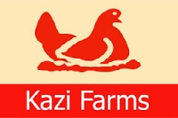
Kazi Food Industries Limited | 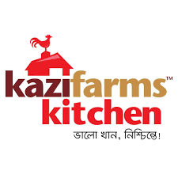
Kazi Media Limited | 
Sysnova Information Systems Limited | 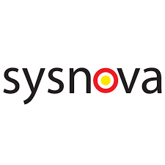

3.1 Overview of Kazi Food Industries Limited:
Kazi Food Industries Limited (KFIL) is a venture of the Kazi Farms Group that started its journey in the year 2013. Its corporate office located in Dhanmondi and factory is located in Beron, Ashulia. Dhaka. Kazi Food Industries Limited started with Bellissimo Premium Ice Cream to introduce a taste of international quality ice creams with 10% milk fat to the domestic market. Bellissimo also produces parlor ice creams under the sub-brand Bellissimo Creations. Kazi Food Industries Limited has another item of ice creams with the brand name Za 'n Zee. Shakib Al Hasan is the official brand ambassador of this brand. Under the brand name Kazi Farms Kitchen they sell biggest number of frozen food items. All Kazi Farms Kitchen items are made with chickens which are vegetable-fed and completely free of harmful preservatives, antibiotic residue and tasting salt. The brand also manage franchise outlets that are rapidly arising all over the country. Kazi Food Industries Limited is always committed to provide consumers with food products of the greatest quality. They are covenanted for not comprising any antibiotic residues, as chickens are not brought up any antibiotics among seven days of slaughter, by the terms of international manner. The meat is also covenanted to be made from chickens raised on feed without containing MBM as per European manner. The meat products are also promised to be MSG and nitrate-free, as we do not use any of these chemicals during food concoction.

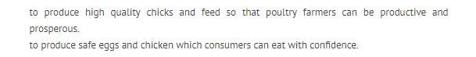
3.2 Mission:

3.3 Vision:

3.4 Philosophy of Kazi Food Industries Limited:
- Kazi food believes in creativity
- They wants to provide quality product
- They trust in quick development

3.5 Goal of Kazi Food Industries Limited:
Kazi Food’s products, people and policies are classified for visiting the requirement of our deciding consumers. Their aim is for achieving a dissimilation as like the luminaries in the sky. Their main motive is for providing a quality that exhibits a correct repercussions of their vision.

3.6 CSR of Kazi Food Industries Limited:
- From 2010 to 2019, Kazi Farms Group gave fifty three core Taka of economic corroboration to Central Women’s University, the 1st women private university in Bangladesh.
- Besides Kazi Farms Group contributes to the function of Kazi Zahural Huq College in Mary Gopinathpur, Gopalganj, that is the hometown of the Managing Director of Kazi Farms Group. These is a free privately-driven HSC college along with one of the greatest pass rates of the district.
- They are giving fifteen core Taka for the construction of a modern conference center at Bangladesh University of Engineering and Technology (BUET). The managing Director of Kazi Farrms was student and as well as teacher of BUET.
- They gave One point Nine acres of land in Gazipur to Utsho in 2003 as the reason of construction of a permanent residential school for underprivileged children.

3.7 Corporate Information of Food Industries Limited:

Name of the Company: | Kazi Food Industries Limited
Company Type: | Private Limited Company
Industry Type: | Food & Beverage
Head Office: | Shimanto Shambar, level-5, Road-02, Dhanmondi, Dhaka-1205
Factory: | Beron, Ashulia, Saver, Dhaka
Establish Year: | 2013
Company Founder: | Mr. Kazi Zahedul Hasan
Telephone: | 880-2-9123432, 9134276, 9128062
E-mail: | info @ kazifoodindustrieslimited.com
Brand Logos: | 

3.8 Contact Information of Kazi Food Industries Limited, Regional Offices:

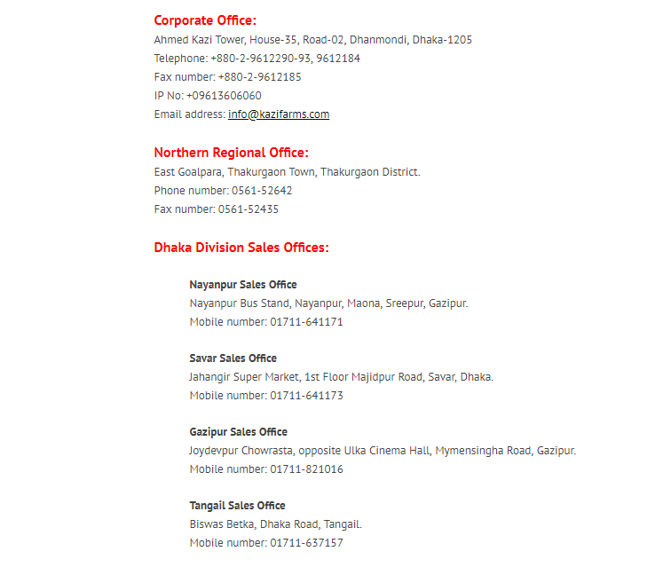

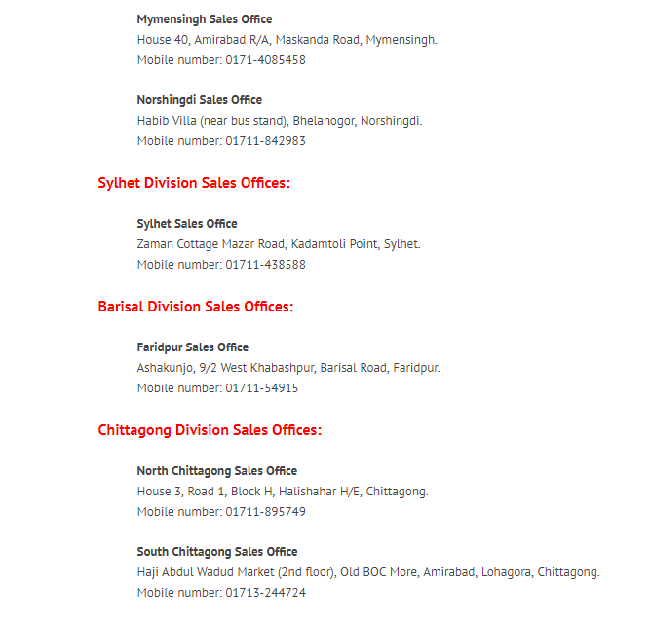
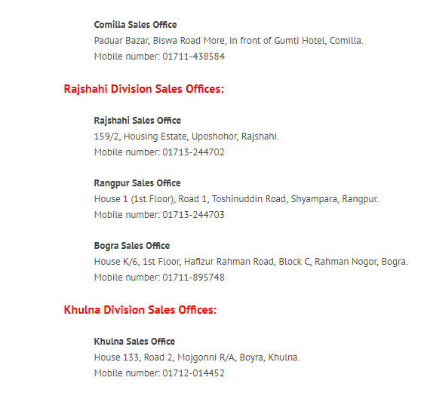

3.9 Factory Brief of Kazi Food Industries Limited:

The factory of Kazi Food Industries Limited is founded on huge area of land at Beron, Ashulia, Savar. There are several buildings for several brands production and manufacturing. For the brand of Bellissimo ice cream it has its own building for production, and for the brand under Za ‘n Zee ice cream has a building for production and manufacturing and also for the brand under Kazi Farms Kitchen has a building for production and manufacturing. For the officers there are four storied administrative building. The building includes a board meeting room, hall room, prayer room, store room, and kitchen. There is separate large room for their own power generator system.

  - Management Profile of Kazi Food Industries Limited:
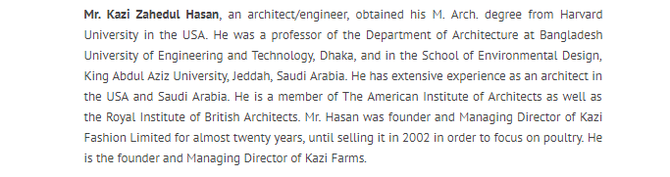
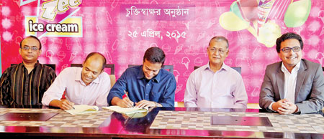

- Dr. Perween Hasan, wife of Mr. Kazi Zahedul Hasan, gained an M.A. in English from Dhaka University, and another M.A. and a Ph.D. (History of Fine Arts) from Harvard University. USA. Presently, she is a professor at Dhaka University. She is a Director of all companies in Kazi Farms Group.
- Mr. Kazi Zeeshan Hasan earned his B.A. in Economics from Oberlin College, USA, his M. Theological Studies from Harvard University, USA, and an his M.Sc. (Management of Information Systems) from the London School of Economics, UK. He is a Director of Kazi Farms Limited and its sister companies, where he is directly involved in overseeing management of sales and raw materials purchases. He has gained training in feed milling and raw materials evaluation from Cargill Indonesia.
- Mr. Kazi Zahin Hasan gained his B.A. (Economics) from Oberlin College, USA, and his Master of Public Administration degree from Columbia University, USA. He is a Director of Kazi Farms Limited and its sister companies. He has been responsible for the production operations of Kazi Farms Group for the past ten years. He has earned training in poultry in the U.S.A. and Thailand.

3.11 Organizational Hierarchy of Kazi Food Industries Limited:

Accounting
Executive
DGM
Purchase

Area Sales Manager

Key Accounts
GM
Sales
AGM Franchise

Asst. Manager
Sales Admin
CEO

Executive Digital
Senior Manager
GM
Marketing
Intern
R & D
AGM Export

AGM
Purchase
AGM
Purchase
AGM
Purchase
AGM
Purchase
AGM
Purchase

Intern
Human Resource

3.12 Departmental role of Kazi Food Industries Limited:

Human Resource Department:
Kazi Food Industries Limited always believe that people is the most worthy asset. Kazi Food Industries Limited commits considerable investments in developing efficient professional human resources. They inspire their human resource to transform their innovation and creativity into new products to gratify their valued customer. Kazi Food constantly give effort for providing their human resource with best working environment. Their Human Resource involve people from various discipline such as Chemistry, Engineering, Accounting, Administration, Finance and Food experts. The talent, skilled, efficient and hard work of their employees drive Kazi Food Industries Limited towards acquiring their purpose and objectives.

Research & Development:
Highly skilled human resources of Kazi Food Industries Limited is its one of the driving forces. They are continuously striving to explore the core competencies of the employees to face the challenges of the competitive environment. Kazi Food Industries Limited necessary to research a product before launching it to the market. They should study the ingredients of a product necessary to made it. Kazi Food Industries require to study the chemicals used in products very carefully. According to that they have chemistry and food expertise to do so. They have the plan for expanding their research department for more innovative and quality products to introduce in the market.

Marketing & Branding Department:
Kazi Food Industries Limited Marketing and Branding department is accountable for advertising and promotional activities of products of the organization. In many times, it may be mobilized with the sales functions. Kazi Food Industries Limited Marketing and Branding department engaged in the several tasks, like promotional materials designing and developing, organizing marketing events, likely commencement and campaigns, websites developing as a digital marketing system.

Finance, Accounting, Treasury & Audit Department:
Kazi Food Industries Limited has got efficient finance, accounting and treasury & audit department. They veil day to day performance of financial transactions. The Department assist the purchase department and for short or long term investment. They have to do cross function with VAT officer of the factory. The basic function of these departments is to assure that there is monetary stability among a business and a constant cash flow for supporting day to day transactions. These departments are also accountable for payment and transaction, investments, accounting procedures, budgets and forecasting.

Distribution Channel & Network:
Kazi Food Industries Limited marketing strategies are very primitive, they have different agents from the company, and have dealers or whole sellers across the country and also sub dealers. There distributor divided by district wise in some places each dealer have sub-dealers. In this case dealer received the goods they sell the goods and received commission from company, and whole sellers received the goods they sell it and received the commission from the company. No dealer or whole sellers have not any rights to enhance or blow goods except company’s permission. Dealer and Whole sellers are working for getting commission. Company increases the price by depends on occasion and they inform their dealers and whole sellers. There are lots of Sales Representative works across the country under the dealers and whole sellers. They accept order from retail shop venders and apprise the dealers and whole sellers. Every dealer or whole seller has specific target of sell within given time. If many times fail to earn the target company may cancel dealership or abate supply of goods and that amount transmitted to dealer.
Sales Department:
Kazi Food Industries Limited team of sales trade along with purchaser and propagate orders. They takes a techniques to propagate sales alters among organizations, but few of the most ordinary are telephone, door-to-door sales, advertising and direct sales by representatives. Sales Depertment of Kazi Food Industries Limited may also supply corroboration task to other sectors, specifically in case the firms does not have a devoted marketing or consumer service section.
Information Technology Department:
Kazi Food Industries Limited has a potential IT Department which is accountable for providing the infrastructure for automation. It implements the governance for the usage of network and operating systems, and it helps the operational units by providing the functionality as require it also provides support for data processing and storage, networks and support for the necessary program, as well as services for the accelerator complex and for the whole company and its users.

Manufacturing Department:

Kazi Food Industries Limited deals with all of the processing of product service. As A large national organization it offers a several extent of products would certainly necessity a manufacturing department to spearhead product developments.

Purchase Department:

Kazi Food Industries Limited purchasing department is accountable for monitoring how many products or stock is necessary at any one time and buying accordingly. The purchasing department may also be accountable for buying in consumable products, such as stationery, to provide help the other functional departments among the organization.

Administrative Department:
Kazi Food Industries Limited also has a potential administrative department. This department is responsible for; forming meetings, receiving minutes, audio and touch typing and letter composing are many of the day to day activities an office administrator take on.

3.13 Competitors of Kazi Food Industries Limited:

Competitors Brands List for Ice Cream:

- Igloo
- Polar
- Kwality
- Savoy
- Lovello
- Mark
- Cream & Fudge
- Magnum
- Movenpick
- Buskin & Robin
- Haagen Dazs

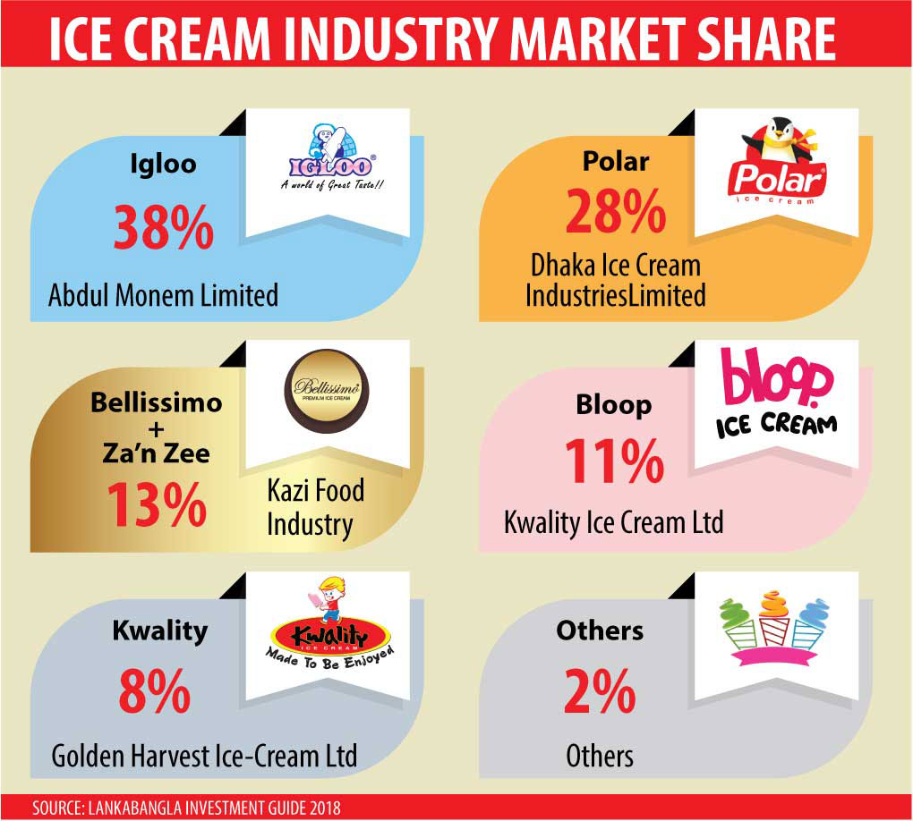

Competitors Brands List for Food:

- CP
- Bengal Meat
- Deshi Meat
- Jhotpot
- BRAC Chicken
- Country Natural
- Golden Harvest
- Mughal snacks Limited
- Paragon

3.14 SWOT Analysis of Kazi Food Industries Limited:

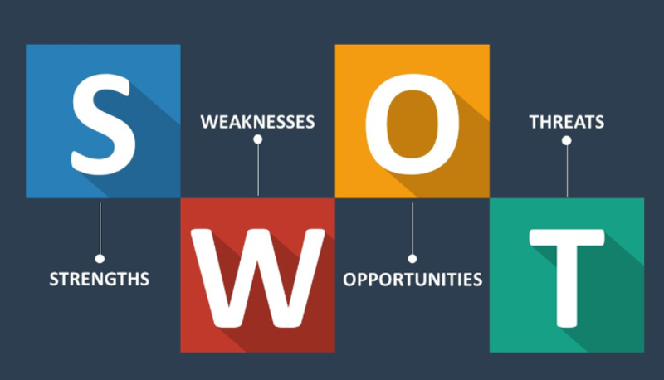

Strengths of Kazi Food Industries Limited:

The strengths of a business or company are secure elements, something they do well and are under their control. The strengths of Kazi Food Industries Limited are given below:

- Competitive pricing is a main element of Kazi Food Industries Limited’s aggregated success, as this keeps them in line with their competitors, if not above them
- Maintaining costs lower than their rivals and maintaining the cost advantages helps Kazi Food Industries Limited pass on some of the benefits to consumers
- They have potential reputation and good popularity which people view it with respect and believe in it
- Being financially potential supports Kazi Food Industries Limited deal with a problem, ride any dip in profits and out perform their rivals
- The important strength of Kazi Food Industries Limited as it is recognized and respected
- They have a high percentage of the market share which indicates it is ahead of many competitors
- Kazi Food Industries Limited’s marketing strategy has measured to be effective, helping to increase profiles and profits and standing out as a major strength
- Employees are experienced which helps to reach key to the success of Kazi Food Industries Limited helping to drive them forward with expertise and knowledge
- Kazi Food Industries Limited has an comprehensive customer base, which is a major strength about sales and profit
- Kazi Food Industries Limited’s distribution channel may be listed as one of their strengths and way to success
- Supplier relationships are potential at Kazi Food Industries Limited, which can only be seen as strength in their in total performance

Weaknesses of Kazi Food Industries Limited:

The weaknesses of Kazi Food Industries Limited are given below:

- Kazi Food Industries Limited’s one of the prime Weakness is low availability of adequate infrastructural facilities
- gradual investment on advanced technologies catch Kazi Food Industries Limited back and limits success, as other firms are making use of better and more reliable technologies
- Unavailability of adequate quality control and testing methods as per international standards hamper Kazi Food Industries Limited’s market research
- Kazi Food Industries Limited does not act internationally, which has an effect on success, as they do not reach consumers in overseas markets
- High requirement huge amount of working capital of Kazi Food Industries Limited is important to expand more into the market

Opportunities of Kazi Food Industries Limited:

Opportunities help to firms or organization to continue the business. The opportunities of Kazi Food Industries Limited are given below:

- Kazi Food Industries Limited could benefit by expanding their online presence and making more money from online shoppers / internet users
- They could benefited by Governmental helps, in the form of grants, allowances, training etc.
- New market opportunities can be a way to push Kazi Food Industries Limited move forward
- Technology changes might give Kazi Food Industries Limited an opportunity to bolster future success
- They are belonging in good financial position, which is a chances for them to pursue in terms of investment in new projects
- They have the opportunity to come in a niche market, earn leading position and therefore boost financial performance
- Expanding the product/service lines by Kazi Food Industries Limited might serve them increase sales and raise their product portfolio

Threats of Kazi Food Industries Limited:

Threats can be make damage to business and it can prevent to continue the business. The threats of Kazi Food Industries Limited are given below:

- without adopting with technology switches might be injurious to the future of Kazi Food Industries Limited as they might slip behind their opponent
- Switches in the way consumers shop and expend and other changing consumer patterns might be a threat to Kazi Food Industries Limited
- Price wars among competitors, price cuts and so on might harm profits for Kazi Food Industries Limited
- The actions of an opponent could be a prime threat against Kazi Food Industries Limited, for instance, if they get in new technology or expand their workforce to meet demand
- The arise or fall of the foreign exchange rate might threaten Kazi Food Industries Limited about importing and exporting
- increasing costs might be a main downfall for Kazi Food Industries Limited as it would eat into profit
- Kazi Food Industries Limited might be threatened by the thriving power customers have to set the price of their products/ services
- Alternative products available on the market present a prime threat to Kazi Food Industries Limited

Chapter - 04 (Marketig Activities of Kazi Food Industries Limited - Kazi Farms Kitchen)

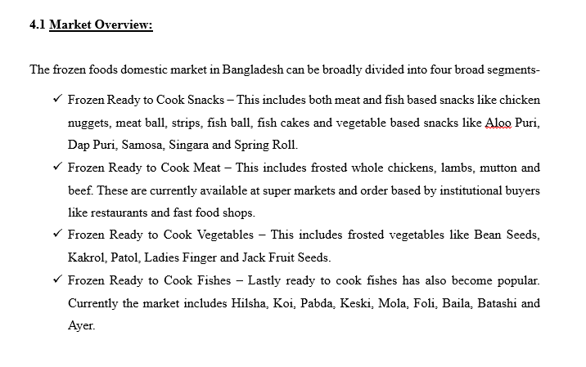
Along with raising population at a quick pace in cities especially the capital and citizens becoming increasingly demanding for ready food & beverage. The city dwellers are prosperously adapting to foods & beverage as readymade. Competition is increasing day by day by the basis of increasing demand. Additionally, the marketing campaigns of the frozen food companies in Bangladesh have inspired a rise in demand.

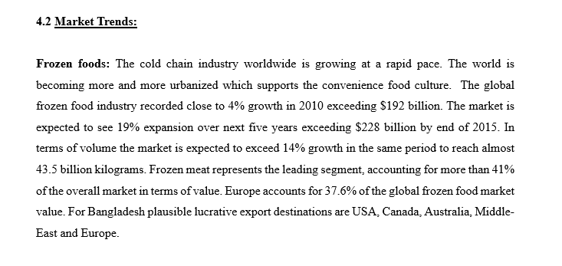



Source: Mordor Intelligence

Frozen Chickens: The flying need for light and hygienically-prepared foods within the urban middle class is drawing in massive investors to the processed chicken and ready-to-cook frozen foods sector, industry operators said.
Domestic poultry monster Kazi Farms now a days entered the segment to take a pie of the Tk 150-crore market that is thriving by more than 20 percent a year.
Pran, a processed food conglomerate, and Abdul Monem Ltd, an infrastructure contractor and ice cream monster, are also queuing up to build a foray.
"People's lifestyles are changing based on their arising incomes and upper economic growth of the country.

Competitive Landscape:
Afterwards the few imported brands like McCain, Lamb Weston, Doux and range of imported frozen goods from Al Kabeer Group, the native brands have infiltrated the market in a huge scale. Below is the snapshot of the market share.
Competitive Scenario: Bangladesh Frozen Foods Market

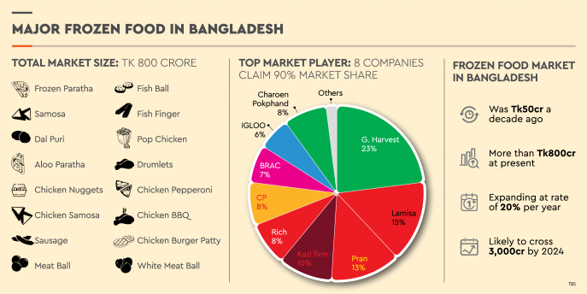

Although Golden Harvest and Lamisa have a lofty assortment of products and are the largest players, however Pran, BRAC and CP are big players in the processed chicken Bazaar. Nowadays Kazi has forayed into the market and time will tell whether they can successfully earn market share.
Frozen food sector display promise considering steadily increasing per capita income, changing family size (nuclear) and change in taste and fashion. Though different large players have successfully infiltrated the market, opportunities lie in beside Dhaka and Chittagong where the frozen chain is developing.

4.3 Kazi Farms Kitchen Food Brand:
Kazi Food Industries Limited introduce Kazi Farms Kitchen branded frozen food (ready-to-cook) and ready-to-eat items that are palatable and delicious!
Kazi Farms Kitchen Highlight:

- Frozen food products under the parent brand name of “Kazi Farms Kitchen”
- Superstore launch: November, 2013
- Franchise outlet launch: October,2014
- Best standard of production,
  - Vegetable feed chickens
  - No antibiotic relic in chicken meat
  - No affixed MSG or Nitrate
  - No using of Tasting Sault
- One of the prime frozen food generator in the country
- Go through 100% Halal pathway
- Stand out brand in an already saturated market
- Cohere health & goodness
- More than 100 Franchise outlets in Dhaka & outside Dhaka

Products Highlight:



Franchise Outlet Design:

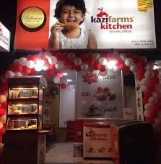

4.4 Kazi Farms Kitchen’s Health Promises:

Chickens Raised With "MBM Free" Feed
Maximum Chicken and fish item made in Bangladesh comprise Meat and Bone Meal (MBM). MBM is the lowest protein, made by cooking, drying & grinding slaughter house wastage (intestines, bones, feet etc). MBM may comprise harmful bacteria. For that reason chickens we beget for our branded meet products are increased on feed that does not contain any MBM.
"No Antibiotic Residue" in the Chicken Meat
Chickens on farms are at times given antibiotics for treating bacterial infections. Numerous people are worried about that when they eat farmed chickens, they will unconsciously consume "residual" antibiotics, which may still have been in the chicken's body at the time of slaughter. We guarantee that the chickens used to make Kazi Farms chicken items were not given antibiotics for at least 10 days earlier on slaughter. So there will be no antibiotic residuum in the chicken meat.
"MSG and Nitrate Free"
Numerous People are worried about that particular ingredients like MSG & nitrates food additives are injurious for human health. Kazi Farms do not use MSG or nitrate in the recipes for their chicken items.

4.5 Segmentation of Kazi Farms Kitchen:
By User
- Frozen Food
- Franchise Outlets

By Gender/Age/Income
- All aged, Income and gender people are included here
By Product Type
- Fish-based Frozen Products
- Dried Fish Products
- Meat-based Frozen Products
- Flour-based Frozen Products
- Egg
- Jam-Jelly

By Geographically
- Urban & Urban

By Psychographiclly
- Social Class: Middle and Upper Middle
- Personality: Extrovert, Creative and Confident

4.6 Targeting of Kazi Farms Kitchen:
- Students
- Housewives
- People who do not have cooking skills
- Working women’s
- Food and Meat lovers
- Working Males
- Children's
4.7 Positioning of Kazi Farms Kitchen:
- Kazi Farms Kitchen usage their own farms chicken and eggs for their frozen foods and outlets stores.
- Kazi Famrs Kitchen started its journey with the slogan “Valo Khan Nishchinte “It mean Eat well with security.
- Kazi Farms Kitchen Chickens Raised With "MBM Free" Feed.
- They do not use MSG or nitrate in the recipes for Kazi Farms chicken items.
- "There are No Antibiotic Residue" in the Chicken Meat of Kazi Farms Kitchen.

4.8 Marketing Mix (4 P’s) of Kazi Farms Kitchen

Product:
Kazi Farms Kitchen products are produced in its own area situate in Baron, Ashulia, Savar. Now a days Kazi Farms Kitchen has six types of products -Meat-based frozen items, Dried Fish Products, Fresh Eggs, Fish-based frozen items, Flour-based Frozen Products, and also Jam-Jelly

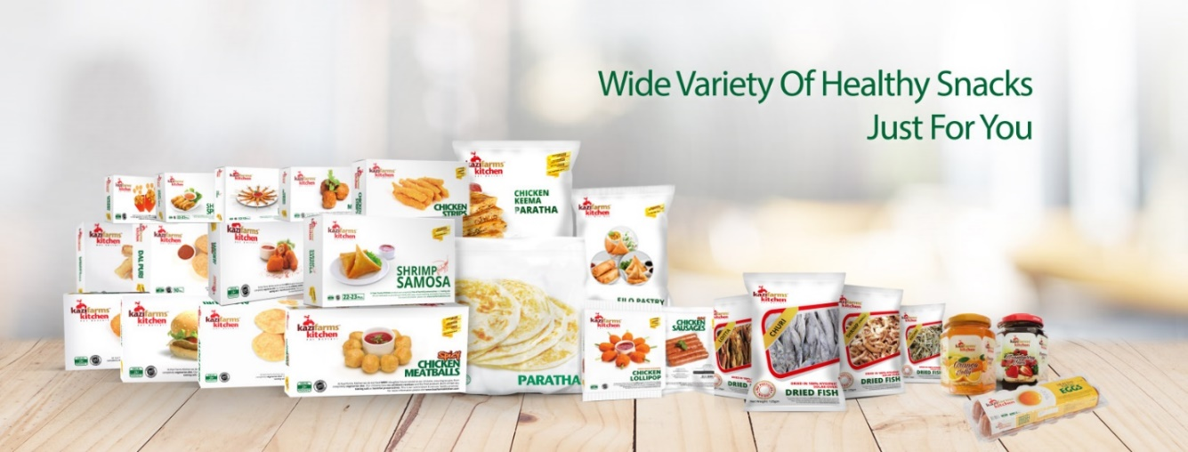

Category Wise Kazi Farms Kitchen Product Name:

Categories | Product Name
Meat-based Frozen Products | Chicken Burger
Meat-based Frozen Products | Chicken Nuggets Original
Meat-based Frozen Products | Chicken Nuggets Kids
Meat-based Frozen Products | Chicken Cutlet
Meat-based Frozen Products | Chicken Nuggets Spicy
Meat-based Frozen Products | Chicken Strips
Meat-based Frozen Products | Chicken Teasers
Meat-based Frozen Products | Chicken Drum Sticks
Meat-based Frozen Products | Chicken Spicy Meat Ball
Meat-based Frozen Products | Chicken Meat Ball
Meat-based Frozen Products | Chicken Sausage-Plain
Meat-based Frozen Products | Chicken Sausage-Plain
Meat-based Frozen Products | Chicken Sausage-Spicy
Meat-based Frozen Products | Chicken Sausage-Spicy
Meat-based Frozen Products | Chicken Keema Paratha
Meat-based Frozen Products | Chicken Lollipop
Flour-based Frozen Products | Dal Puri
Flour-based Frozen Products | Aloo Puri
Flour-based Frozen Products | Chicken Spring Roll
Flour-based Frozen Products | Plain Paratha Regular
Flour-based Frozen Products | Plain Paratha family
Flour-based Frozen Products | Vegetable Singara
Flour-based Frozen Products | Vegetable Samosa
Flour-based Frozen Products | Vegetable Spring Roll
Flour-based Frozen Products | Chicken Samosa
Flour-based Frozen Products | Filo Pastry
Dried Fish Products | Shrimp Small
Dried Fish Products | Churry
Dried Fish Products | Keski
Dried Fish Products | Lottia
Fish-based Frozen Products | Shrimp Spring roll
Fish-based Frozen Products | Shrimp Samosa
Jam-Jelly | Orange Jelly
Jam-Jelly | Strawberry Jam
Egg | Fresh Chicken Egg

Place:
Now a days Kazi Farms Kitchen have 15 distribution centers across the country and almost 220 plus dealers nationwide help them to distribute their items in several Super shops, retail and its own franchise store. Products are distributed by using a cold chain. Now a days there are around more than 100 franchise store of Kazi Farms Kitchen. Kazi Farms Kitchen uses the summation of Push strategy and Pull strategy as distribution strategy. Products are distributed through following a cold chain in the following ways-

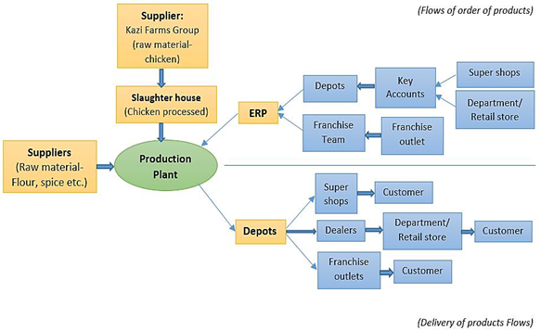

Price:
Kazi Farms kitchen’s products pricing are made by joining cost based pricing and value based pricing. Every product is priced in a way that is right to the value of that product and beneficial for the customers at the same time. Products price may be changed by based on changing in environmental factors, raw materials price, changing in demand, value of brand, and cost of importing raw materials.

Price Lists of Kazi Farms Kitchen All Category Products;

Category | Product Name | Weight in KG/pcs | MRP
Meat-based Frozen Products | Chicken Meat Ball | 250 | 175
Meat-based Frozen Products | Chicken Lollipop | 300 | 225
Meat-based Frozen Products | Chicken Shami Kabab | 250 | 185
Meat-based Frozen Products | Chicken Nuggets Original | 250 | 160
Meat-based Frozen Products | Chicken Nuggets Spicy | 250 | 165
Meat-based Frozen Products | Chicken Strips | 250 | 210
Meat-based Frozen Products | Chicken Teasers | 250 | 160
Meat-based Frozen Products | Chicken Burger | 200 | 160
Meat-based Frozen Products | Chicken Popcorn | 250 | 250
Meat-based Frozen Products | Chicken Cutlet | 200 | 165
Meat-based Frozen Products | Chicken Nuggets Kids | 250 | 165
Meat-based Frozen Products | Chicken Sausage-Plain | 170 | 115
Meat-based Frozen Products | Chicken Sausage-Plain | 340 | 224
Meat-based Frozen Products | Chicken Sausage-Spicy | 170 | 115
Meat-based Frozen Products | Chicken Sausage-Spicy | 340 | 230
Meat-based Frozen Products | Chicken Spicy Meat Ball | 250 | 175
Meat-based Frozen Products | Garlic Butter chicken Kiev | 360 | 295

Category | Product Name | Weight in KG/Pcs | MRP
Flour-based Frozen Products | Dal Puri | 450 | 100
Flour-based Frozen Products | Aloo Puri | 450 | 100
Flour-based Frozen Products | Chicken Spring Roll | 250 | 160
Flour-based Frozen Products | Plain Paratha 5pcs | 325 | 80
Flour-based Frozen Products | Plain Paratha 10pcs | 650 | 150
Flour-based Frozen Products | Plain Paratha 20pcs | 1300 | 265
Flour-based Frozen Products | Chicken Liver Singara | 300 | 100
Flour-based Frozen Products | Vegetable Samosa | 400 | 120
Flour-based Frozen Products | Vegetable Spring Roll | 400 | 120
Flour-based Frozen Products | Vegetable Singara | 300 | 80
Flour-based Frozen Products | Chicken Samosa | 250 | 155
Flour-based Frozen Products | Filo Pastry | 400 | 170
Dried Fish Products | Shrimp Small | 125 | 235
Dried Fish Products | Churi | 125 | 260
Dried Fish Products | Keski | 125 | 230
Dried Fish Products | Lottia | 125 | 165
Fish-based Frozen Products | Shrimp Spring roll | 250 | 185
Fish-based Frozen Products | Shrimp Nobashi | 250 | 250
Fish-based Frozen Products | Shrimp Samosa | 250 | 180
Jam-Jelly | Orange Jelly | 340 | 130
Jam-Jelly | Strawberry Jam | 340 | 230
Egg | Fresh Chicken Egg | 12p | 140

Promotion:

Kazi Farms Kitchen pay more emphasis in promotion for making the target customer conscious about its products and services. They use several media for promotion like promotion in a physical environment, traditional and digital media. They perform their promotional activities with the help of third party who assist them in designing POSM and other promotional tools.

Discount offers in 2019-20:

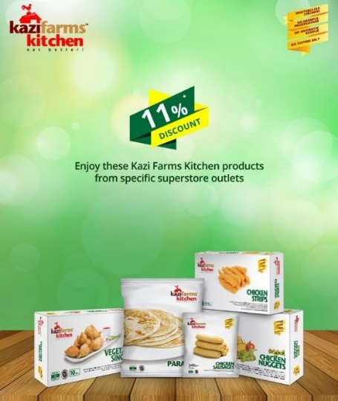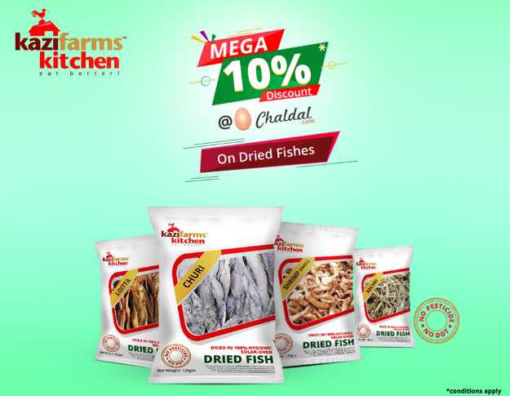

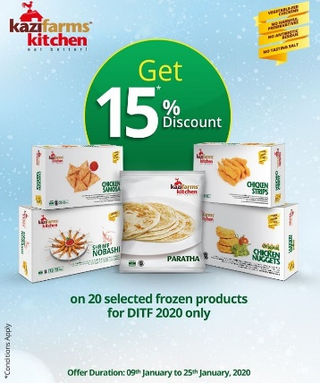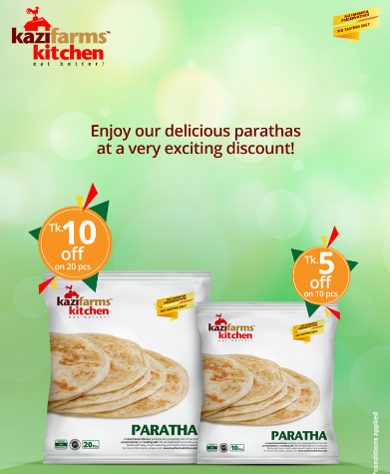

Event Promotion:

Generally promotions can be held in natural environments at particular events like concerts, festivals, trade shows, fair and in the field, such as in grocery or department stores. Interactions in the field allow direct purchases.

- Brand Promoters (BP): Kazi Farms Kitchen flourish their brand, products and services with the supervision of BP. BP share information regarding a brand, provides answer to customer’s inquiry and develop the differentiation.
- Sponsor: Kazi Farms Kitchen sponsor different Fair, Magazine, Concert, Science Fair, Academic Function (study tour, rag day, seminar etc.) monetarily or by the provision of their products or services.
- Activation at Superstore: When companies launch new product than activation is superstore is performed. It is kind of providing customer, a company’s product as free sample for encouraging them to purchase their product.

Traditional Media:

Sample of usual media include, electronic media such as radio and television, outdoor media such as banner or billboard advertisements and print media such as newspapers and magazines as platforms ways for brands to reach consumers with promotions.

- Advertisement: Generally Kazi Farms Kitchen concentrated on advertisement as like as a promotional media to maintain balance in demand and supply of their items as it can make greatest demand for a company’s product. However their demand and supply of products has raised a lot than the past, they are concentrating more on advertising. At present they are broadcasting advertisements of their items in few TV channels which they want to increase in future.

- Radio commercial (RDC): Kazi Farms Kitchen flourishes their product by Radio Commercial. They introduces their product through Radio Commercial Endorsement. In radio commercial endorsement, RJ of several radio program mention about any particular brand the company of which endorses that radio program.

- Point of sales material advertising (POS): For seeking attention and introducing brands (goods, services) exactly at points of sale, POS material advertisement are designed. For motivating the customer to make a purchase POS strategy is taken. They usage several point of sales materials like attractive Bill board, light box, poster, festoon, cut out, dangler, X banner, press ad, leaflet etc. for attracting customer.

- Digital Media & Marketing: In Digital media Internet, social networking and social media sites are included, which is a recent trick for brands to interact with consumers as it deliveries news, information and advertising from the technological limits of print and broadcast infrastructures. Kazi Farms Kitchen pays more importance in digital marketing also for the convenience of this media to attract target customers. Their website ‘www.kazifarmskitchen.com’ contains all the information regarding their product and services. They have Facebook page named ‘Kazi Farms Kitchen’ by which they inform their customer regarding their new offerings, discounts, opening of new franchise outlet etc. they also available in tweeter and other social and digital media.

Media Marketing & Contests of 2019-20:
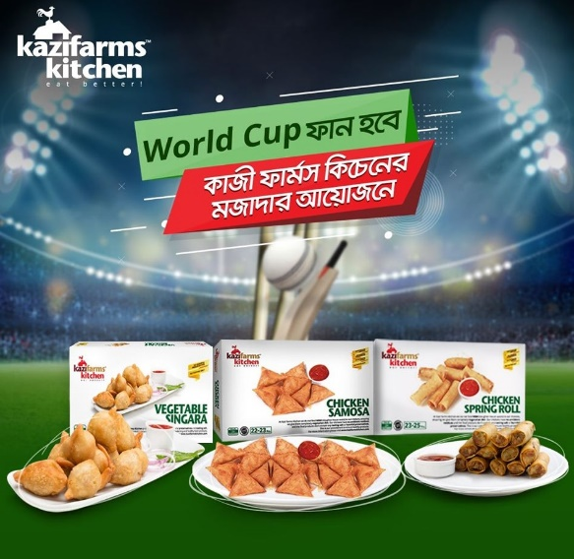
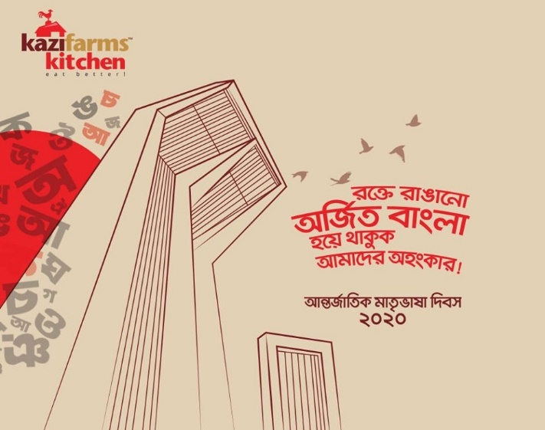



People:
Kazi farms Kitchen has Key Account team, Franchise team, research and development, sales, Marketing and Branding etc. they help Kazi Farms Kitchen like Accounts Team maintain several accounts, Production team helps by ensuring production, Purchase team help through gathering raw materials, Key accounts Team are helping by maintaining corporate sales, Franchise Team are helping by analyzing opportunities to establish franchise store in different area, R&D Team are helping by developing new product, upgrading/improving existing products, observing market condition, competitors, and consumers changing behavior and needs and demands, Sales Team are helping by ensuring sales of products to the dealer and retailer who eventually sell the products to the final consumers, Marketing and Branding Team are helping by performing marketing activities like advertising, promotion, communication and positioning their products in the mind of consumer through their performance.

Processes:

Kazi Farms Kitchen make offers by based on two forms - frozen and fried. Delivery process is slightly different for Kazi Farms Kitchen’s frozen and fried products.

Frozen food goods are sold in several super shops, retail stores, department stores and Kazi Farms Kitchen’s franchise outlets. Customers purchase the frozen food goods on their own or with the help of salespersons and pay for the purchased item. Fried Items are sold in Kazi Farms Kitchen’s franchise outlets. Customer need to give order and after sometimes they can get their products as their order.

Physical Evidence:

Physical Evidence is very important because it influences people in shaping their attitude toward an organization and attracting customer in making their purchase decision. Kazi Farms Kitchen renders services in case of its fried products that are sold in their Franchise outlets. The physical Evidence of Kazi Farms Kitchen represents their promises to customer wellbeing by maintaining a neat and clean environment.

Chapter - 05 (Findings, Conclusion & Recommendations)

5.1 Findings:

Working as an Intern at Kazi Food Industries Limited was a massive experience for me. All the employee are very friendly and helpful. I have learnt many things from them. I am observe many things during my internship which are given below:

- Every employee perform their task very effectively and cordially.
- I once and again saw other staff members helping each other out.
- Office condition is very much friendly and employees are co-operative.



- A good job performance is occasionally praised, consequently lacking motivation of the employees. This is the duty of the HR department. Maybe they could train the senior officers to be more motivating to their fellow people.
- There is always a crowd of vendors so there is no standard on what the employees do throughout the day. The work activity of an employee is set, but it gets hard to finish the pre scheduled works if there is a huge rush of vendors.
- All the tasks are always set and parted for each of the employees. This is the way it should be, but when I saw it firsthand it was exceptional. Every employee has a particular set of responsibilities.
- Every employees are effective and sincere to their ascribed job responsibilities.
- The work process is little bit slow which can be faster with better computers and operating systems. They are currently using Linux Operating System open source; whereas the market have better upgrades for Microsoft office. They follow ethical issues so that they evade the uses of piracy.
- Normally, office hour is 9.00 am to 5.00 pm however employees are so accountable that they don’t leave office until work is done.
- They have a spontaneous sitting arrangement.
- They have improved strong and well equipped IT department for driving all the activities smooth & systematic way except any delay.

5.2 Conclusion:
From the beginning of Kazi Food Industries Limited has earn the faith of people and their admiration whoever consumed its product. They are optimistic regarding their food sector and they can rely on their promises for the wellbeing of their customers. But they have lack of outlet for reaching their product all over the country and their brand awareness is few, as a result they are unable to reach their growth. Kazi Food’s Management should take necessity steps for filling the gap between the service and the satisfaction level of the customers. To fill this gap, each corner of the system need to be in gradual observation for identifying the faults and so that those can be corrected properly. This study highlight some of the Marketing and Branding related marketing mix as target group and also highlight some faults and lacking of the Kazi Food Industries Limited products and services, and also some demand of the customers to the firm and their perceptions, by which some fruitful measurement and ratification steps can be made to keep the existing customers as well as to invite the potential customers to involve with Kazi Food Industries Limited. Instead of being few limitations Kazi Food Industries Limited is making better and catching good percentages of market share in food and beverage sector. Kazi Food Industries Limited has obtained recognition at the national and international level. They gain different Awards in past few years those are different awards, CSR Award. At the end I am giving thanks to all the employee of Kazi Food Industries who helped me during my internship season and to complete the report successfully.

5.3 Recommendations:

- We know that Kazi Food is the leader of food and beverage industry of the country. For that they should reach their products at every corner of the country. Even in the small cities their products should be available.
- Kazi Farms Kitchen should sketch their package, advertisement through paying priority to personal and family consumption.
- In a competitive financial market, their products and services requires to be more focused on customers’ needs than simply offering what the competitors are offering.
- Kazi Farms Kitchen doesn’t close office all the Saturday of month. They should close office two days in a week for recreation of employees.
- Kazi Farms need to do more marketing activities for developing their presence in the minds of the target market and also the potential target market. They should go for mass media coverage for increasing new customer.
- Sales department should increase their potentiality so that they can reach their product across the country.
- They need to be enlisted their products in all the subsisting and new popular super shops and assure availability of their products in those super shops when stock become down.
- Kazi Farms need to invest more in research & development for creating new product, flavor and increasing taste & quality also.
- Kazi Farms should increase customer consciousness regarding their brand. They can share with the potential customers the negative aspect of consuming low quality products perniciousness.
- They need to encourage customer for making complain and take necessary steps for resolving those complain. In other way they can miss out their customer.
- They need to focus more to create loyal customer by customer satisfaction and can do survey on regular basis to find out whether their products can satisfy the customers or not. They can upgrade their product based on the feedback of the customer.
References

- https://www.kazifarmskitchen.com/
- http://www.projectsprofile.com/info/potential_five.html
- https://en.wikipedia.org/wiki/Food_industry_in_Bangladesh
- https://en.wikipedia.org/wiki/SWOT_analysis
- http://www.bangladeshyellowpages.com/details/206775
- http://www.marketing91.com/reference-groups-in-consumer-buying/
- https://www.nfraweb.org/resources/articles/details.aspx?ArticleId=18
- http://www.adrianswinscoe.com/continuous-innovation-the-only-way-to-stay-ahead-of-your-competitors/
- http://reflectionnews.com/kazi-food-launches-ready-to-cook-frozen-foods/
- http://www.lightcastlebd.com/blog/2015/07/market-insight-bangladesh-frozen-food-sector
- https://www.alliedmarketresearch.com/frozen-food-market

