

Research Project
Course code: MDS 699
Spring 2018

Life & Livelihoods of Former Chitmôhol People

Submitted by:
Maisha Farzana Rafa
ID: 125161004
Master in Development Studies (MDS)
United International University (UIU)

Submitted Date: April 22, 2018

Submitted to:
Dr. Hamidul Huq
Professor
Department of Economics
United International University (UIU)

08 March, 2018
Dr. Hamidul Huq
Professor
Department of Economics
School of Business and Economics
United International University (UIU) Dhaka, Bangladesh

Subject: Submission of Research Project Report

Dear Sir,
As a part of Master in Development Studies (MDS) program of Department of Economics, School of Business and Economics, United International University (UIU), it is my great happiness to submit herewith three copies report of my research project (MDS 699) titled ‘Life and Livelihoods of Former Chitmôhol People’ for your kind acceptance. This Research Project (MDS 699) is a requirement of my MDS program. In the course of preparation of this project, I have collected primary data through surveying and interviewing people. I have also collected secondary data from website, e-newspapers and e-journals. I have prepared this research project by doing an analysis of both primary and secondary data that I collected during Fall 2017 trimester.
It has been a great opportunity for me to conduct this research project under your supervision. This research work contributed enriching my research knowledge and skills. I have tried my best to make this study relevant, informative and error-free. Despite my best effort, there may remain some error in the report.
I would be grateful to you for your kind acceptance of this research project.

Sincerely yours

Maisha Farzana Rafa
125161004
Master in Development Studies (MDS)
Department of Economics
School of Business and Economics
United International University (UIU)

Declaration

I sincerely declare that my Research Project (MDS 699) work titled Life and Livelihoods of Former Chitmôhol People submitted to Master in Development Studies (MDS) program under Department of Economics at United International University (UIU) in Bangladesh, is an original work done by me under the guidance of Dr. Hamidul Huq, Professor, Department of Economics, School of Business and Economics, United International University (UIU). This Research Project Report is submitted as a part of the partial fulfillment of the requirements for the degree of Master in Development Studies (MDS). The findings narrated in this research project report/part of this report have not been submitted to any other University or Institute for the award of any degree.

Maisha Farzana Rafa
ID: 125161004
Master in Development Studies (MDS)
Department of Economics
School of Business and Economics
United International University (UIU)

Certification of Approval

This is to certify that the Research Project (MDS 699) report titled titled Life and Livelihoods of Former Chitmôhol People submitted to Department of Economics at United International University (UIU) in partial fulfillment of the requirement for the award of the degree of Master in Development Studies (MDS) is an authentic and original work carried out by Maisha Farzana Rafa, ID: 125161004 under my supervision and guidance.
To best of my knowledge, this is original research work of Maisha Farzana Rafa. I have accepted this research report satisfactory in partial fulfillment of the requirement for the degree of ‘Master in Development Studies (MDS)’. My student Maisha Farzana Rafa has not submitted this report/part of this report to any other University/Institute for the fulfillment of the requirements of any other course of study.

Supervisor

Hamidul Huq, PhD, WUR
Professor
Department of Economics
School of Business and Economics
United International University (UIU)
Dhaka, Bangladesh

Executive Summary

This study is a part of my Master in Development Studies (MDS) at United International University (UIU). I have conducted this research project during the period of Summer 2017 to Fall 2017. My study areas are Noyahat, Bongerbari & Gucchogram of Dahagram Union which were the areas of former enclaves Dahagram- Angarpota. I collected data of this study from both the primary and secondary sources. Primary data was collected through survey and KII (Key Informant Info) in the study area. Secondary data was collected from the websites (Bangladesh National Portal, BANGLAPEDIA), e-journals and e-newspapers (Prothom Alo, Daily Star, Dhaka Tribune, Daily Star) for my research background analysis.
Dahagram was isolated from 22 years after Bangladesh got birth. Chitmôhols or Enclaves are unresolved issues until 2015 when the two countries Bangladesh and India exchanged 162 enclaves, addressed border demarcation and adverse propositions. The people of chitmôhols fight back for the opportunities and sources of livelihood before when there was no corridor. Although Dahagram was provided a corridor to move on to the mainland, but it was not permitted to open for the whole day. In 2011 the corridor is opened for 24 hours and certain government facilities were given to them. People struggled for decades for living a normal life. As it is allowed to open 24 hours for only last seven years, until 2011, government and other non-government services could not enter there for upholding their living standard. As a result their life and livelihood is lagging behind for a long. Now Dahagram Union is developing day by day. Although education, livelihood sources, medical and hospital facilities still needs to be developed, but people are relived as the enclaves and border issues are resolved and finally they became citizen of the Bangladesh.

Table of Contents
Declaration 3
Certification of Approval 4
Executive Summary 5
Background of my Research Project: 7
Objectives of my Research Project: 9
Methodologies I have followed: 9
Table 1: Techniques of Primary Data Collection 10
Timeline of Research Project: 11
My Research Findings: 12
Education: 12
Occupation: 14
Income & Living Cost: 15
Communications and Mobility: 17
Legal Aid Services: 17
Access to NGO and other services: 18
Drinking water, Sanitation & Healthcare services: 18
Social Capital: 19
Discussions of my study: 20
My Recommendations: 21
Conclusion of my Research Project: 21
References I used: 22
Annex 23

Background of my Research Project:

The India–Bangladesh enclaves, also known as chitmôhols, were the territories alongside the Bangladesh and India border, in Bangladesh and the Indian states of West Bengal, Tripura, Assam and Meghalaya (Wikipedia). According to Land Boundary Agreement, in 1947 after the partition of India, the Radcliffe Line became the border between India and East Pakistan and following the liberation of Bangladesh in 1947 after the partition of India, the Radcliffe Line became the border among India and East Pakistan and following the liberation of Bangladesh in 1971, the identical line became the border among India and Bangladesh. Although the separation of the border between India and the then Pakistan had commenced quickly after the partition, development became slower than expectation, due to the problems in figuring out precisely wherein the border ran. Despite the fact that some of those boundary disputes had been sought to be settled through the Nehru-noon settlement of 1958, next hostilities among the 2 countries left the challenge incompleted. Even after the introduction of Bangladesh, the boundary dispute among the two nations inherited the legacy of history and fractured politics.
After 68 years, India and Bangladesh formally exchanged 162 enclaves on August 1, 2015, ending a centuries-old territorial difference and completing a process of land and population exchange that began in the 1950s. In 1974, the prime ministers of India and Bangladesh signed the Land Boundary agreement to change enclaves and simplify their border. A revised version of the settlement became adopted by using the two nations on 7 may also 2015, whilst the Parliament of India passed the one centesimal modification to the Indian constitution. Underneath this agreement, which become ratified on 6 June 2015, India obtained fifty one Bangladeshi enclaves (overlaying 7, one hundred ten acres (2,880 ha)) inside the Indian mainland, whilst Bangladesh obtained 111 Indian enclaves (covering 17,one hundred sixty acres (6,940 ha) within the Bangladeshi mainland. The enclave residents are to be allowed to either reside at their gift area or pass to the United States of America in their preference. The physical trade of enclaves becomes to be finished in phases between 31 July 2015 and 30 June 2016. The enclaves stand exchanged at the nighttime of 31 July 2015 and the switch of enclave citizens became completed on 30 November 2015. After the Land Boundary agreement, India misplaced around forty rectangular kilometres (15 squaremi) to Bangladesh. There are 111 enclaves within Bangladesh, among those 12 are in Kurigram, 59 are in Lalmonirhat, 36 are in Panchagram, and rest 4 are in Nilphamari. The enclaves of Lalmonirhat are in Lalmonirhat Sadar, Kaliganj, Aditmari & Patgram (Source- Banglapedia).
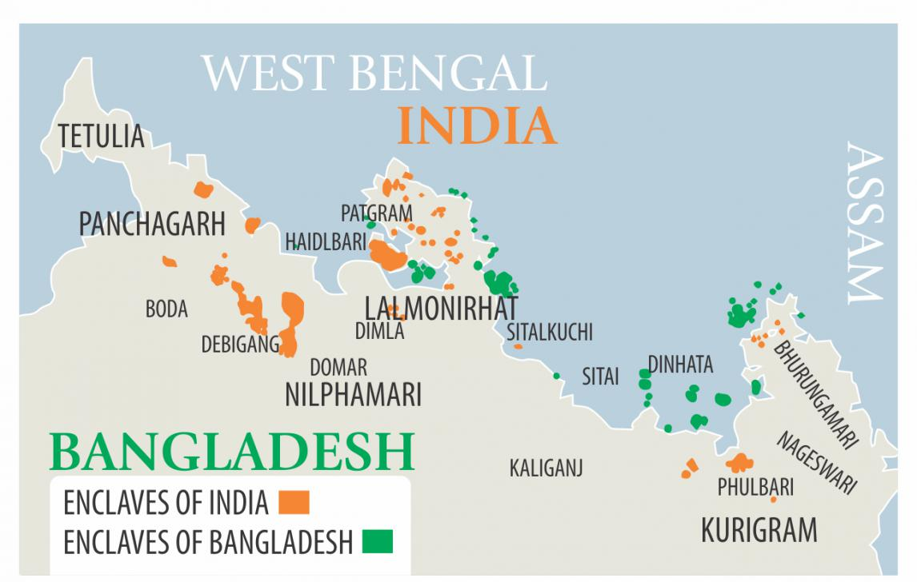
Figure 1: Map of the Chitmôhols/Enclaves(source: http://www.newsbangladesh.com/english/details/5397)
Dahagram-Angorpota was one of the largest enclaves of Bangladesh. After the independence, Dahagram Union was a neglected piece of land which was isolated from the main land for 22 years. It was very much under developed. People lived miserable lives for years. There was no hospitals, markets and schools. In these circumstances people of Dahagram began to struggle for their independence. In 1992, they were granted a corridor for their movement but there was still lack of their independence. For the first time they were granted 6 hours to move between the mainland. But in the government of Sheikh Hasina, it declared for 12 hours to open the corridor. In 2011, the then government free them by allowing 24hours to open the gate (Bangladesh Government Web Portal).
Although corridor was granted but it was not ultimate solution when inhabitants have been deprived of public services and living in squalid conditions. This vagueness has led the life of the residents of these enclaves to desolation. They are incapable to receive the basic government services because they were insulated from their own country by shreds of foreign land. This issue was undecided ever since Bangladesh got birth to 2015. So I have identified this issue to study as part of my research project for completing my post-graduation in Master in Development Studies (MDS).

Objectives of my Research Project:

- To assess the livelihood conditions of the people after the exchange of the Chitmôhols
- To compare the availability and standard of government &non-government services from Chitmôhol times to present study
- To find out the current struggling factors of the Chitmôhol dwellers.

Methodologies I have followed:

I collected data from both primary and secondary sources in this research project. I used both Qualitative & Quantitative Method for primary data collection. The quantitative information was collected through Questionnaire Survey. The qualitative information was collected through interview. A total of 50 respondents were surveyed for data collection. A questionnaire containing both open and close ended questions was used for survey following simple random sampling technique. I interviewed two persons as Key Informant to collect qualitative information in details. I have consulted newspapers, reports, journals as sources of information. Usually the heads of the household were taken as respondents of questionnaire survey. Most of them were farmer. Among the respondents 67% were farmer, 15% were businessmen, 10% were life stock earners and small farmers and other 8% were service holders. I conducted this research in three selected villages of Noyahat, Bongerbari & Gucchogram under Dahagram-Angorpota chitmôhols currently under Dahagram Union. I have selected these villages because earlier the people of these villages were chitmôhol Bashi. Two key informants of my study are the resident of Gucchogram and Noyahat of Dahagram. One of them is a farmer and another is grocery shopkeeper. I have collected primary data from these two villages during November 20, 2017 to November 23, 2017.
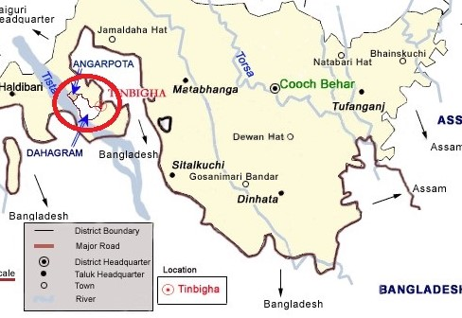
Figure 2: Map of my Study Area (Source: http://coochbehar.nic.in/HTMfiles/tinbigha.html)
First of all, I introduced myself and discussed my research project in the study area. If they were agreed to talk with me, then I discussed about their living and livelihoods when the area was known as chitmôhols. I also used secondary sources for background analysis and development of proposal for research project. The secondary data were collected from the websites (Bangladesh National Portal, BANGLAPEDIA, wikipedia).

Table 1: Techniques of Primary Data Collection
Techniques of Data Collection | Number | No. of People | No. of Village | Name of Village
Survey | 50 | 41 Male & 9 Female | 3 | Noyahat, Bongerbari & Gucchogram
Key Informant Info (KII) | 2 | 2 Male | 2 | Noyahat & Gucchogram

Timeline of Research Project:

Since I am a student of 125 batch, I am under the previous curriculum of MDS program, which requires I have to do a research project (3 credit) to complete my post-graduation. My research project started soon after my summer semester registration that is from June 2017 (Summer Semester). The activities are planned monthly on the Gantt Chart. The Gantt Chart is given below:
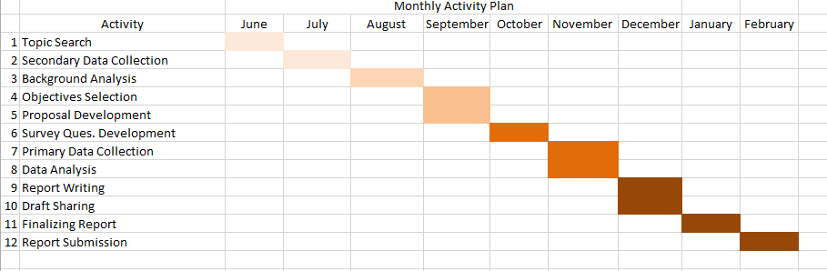
Figure 3: Gantt chart of Research Project
First of all I went through the secondary sources to investigate the research project topic. I have collected data from news portals. Then I developed the objectives based on my findings. After then I developed the research project proposal and questionnaire for survey. I presented my research proposal before my Supervisor and Head of my department in the University. After the approval of my research project proposal from the professors, I submitted the proposal and the survey questionnaire. Then I visited the study area for data collection. After collecting data, I analyzed the findings and developed my research project report based on it.

My Research Findings:

Education:

There are 5 primary schools, one high school and one madrasah found in Dahagram. In this regard, the area is not far behind comparing to the other area of Bangladesh. As the area was isolated for many years the literacy rate is not satisfactory. 87% of our respondents are below secondary grade. But people are getting themselves educated day by day. As communication is developing day by day, people are educating themselves by moving into the nearby Patgram Upazilla and other districts.
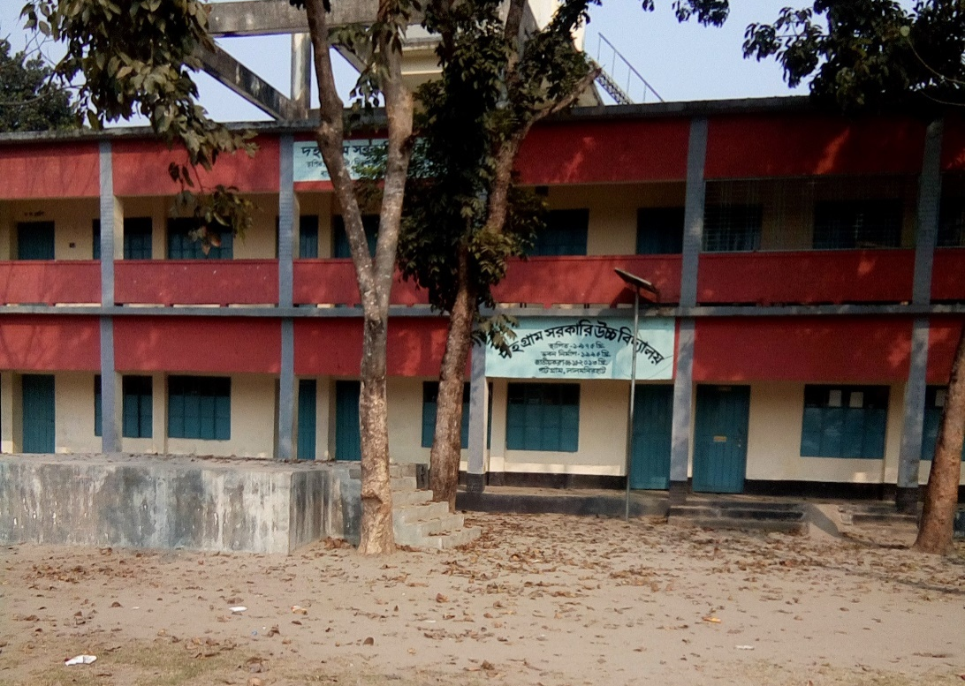
Figure 4: A photo in front of Dahagram Government High School

Figure 5: Education Status of my study area

According to the chart of figure 5, among the survey respondents 87% people did not complete secondary grade of the school and 13% completed the secondary grade of the school. 95% of them highlighted that girl children are getting into the schools more than before. People are becoming conscious for educating themselves. As there are no colleges been established yet, after completing secondary level, they tend to have their college in the nearest Patgram Upazilla or Lalmonirhat District.

Occupation:

The people living in the former enclaves, most of their living depends on agriculture. About 67% of them live on agriculture. Most of them are small and marginal farmers. The farmers mentioned that the land fertility is good and production is not bad. They also mentioned they face security problem while working in the fields as Indian boundary is close to them. People grow rice, corn, tobacco, and vegetables. About 15% of them received training on cropping using pesticides, fertilizers etc. Among the respondents 70% work on their own lands. Rest 30% works on others land. Some of them who are engaged in agriculture, also do like raising cows, hens, goats etc. There were school teachers among service holders. People who do business some of them runs hotels, tea stalls, grocery shops and autos. The capital of the business came from agriculture, mortgaged lands or their own investment. They are not empowered with any training facilities of entrepreneurship.

Figure 6: Occupational Status of my study area
According to Figure 6; 67% people of the study area are engaged in agricultural activities, 15% are engaged in business, 10% are engaged in livestock rearing and 8% are them in service. Women are seasonally engaged with agricultural activities, rest of them are engaged in household activities. 80% of women are involved in household activities, 10% works regular on land and rest 10% are service holders. The reason they are less involved in formal sector is there were limited scope of education as the area was departed from mainland from decades. But the scenario will be changed in the upcoming years. As the people are becoming aware and now they access to the mainland with their own rights.

Income & Living Cost:

According to figure 7; the monthly income of the 40% respondents is between 1500 taka to 4500 taka. They are the extremely poor, as per the definition of World Bank on Poverty (1.25$ per day income earner belongs to extreme poorest group). The monthly income of 16% people is 4500 taka to 7500 taka. This group is moderately poor, as per the definition of World Bank (3.10 $ per day income earner belongs to moderately poorer group). The monthly income of 19% people is 7500 taka to 10000 taka. The income of 23% people is 10000 to 20000 taka per month (according to figure 6 below). The income of 2% people is 20000 to 30000 taka. 25% families have 2 person working among five family members. 33% families are extended and more than two person works.

Figure 7: Income Status of my study area

The cost of land increased to two to threefold than before. 60% of the respondents agreed with this. The daily necessaries costs more than before. In the past, they used to buy daily necessaries from the border. Some people of India used to sell daily necessaries to them secretly. Then the prices were much lesser. Now they buy the things from their own area. But the cost is very high. The people buy their daily necessaries from their own market of Dahagram.

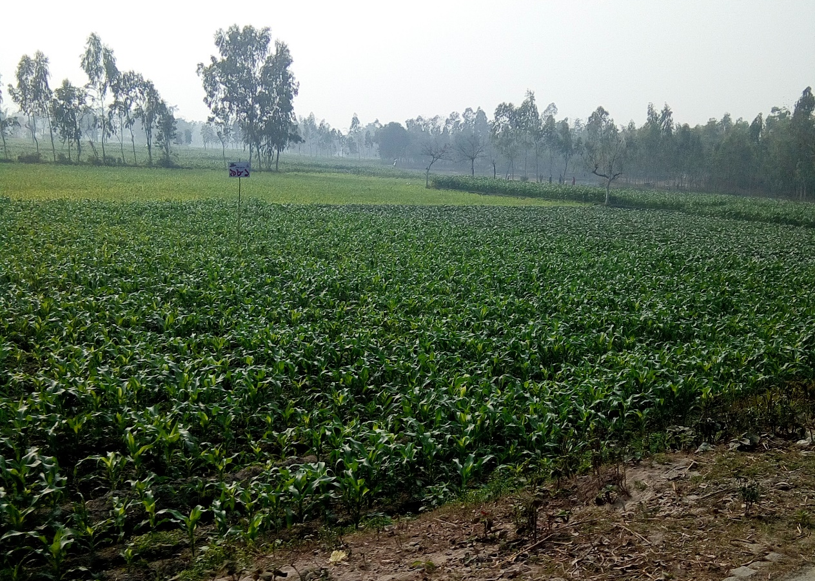
Figure 8: A photo of Agricultural Land of Dahagram

Communications and Mobility:

Among the respondents, 70% people goes to nearest upazillas, districts and divisions for education, treatment, buying necessaries, selling agricultural products and others. Among them 90% people goes to the nearest upazilla for buying necessaries and selling their agricultural products. 32% students goes to Lalmonirhat, Rangpur & Dhaka for studies. 96% of the people goes to Patgram and Rangpur for medical treatment. Now they move easily through the corridor. When the corridor was closed for 12 hours every day, it was difficult for them to move. They were not able to move easily whenever they wanted. Especially for an emergency hospitalization, they always needed permission from the border guards and higher authorities. But those days have been passed. They can now easily move through the corridor whenever they need to. In 2011 electricity has been provided in Dahagram from mainland. After the establishment of electricity, the crime was reduced than before.
Increasing mobility brought positive impacts to their livelihoods. Access to information, developmental services and others. 3G network was inaugurated at Dahagram in 2015. There are networks of two telecommunication companies such as Grameenphone and Teletalk. The network coverage is good and 3G also works well in the areas of Dahagram. People can use internet and easily communicate.
Transportation facilities are better than before. There are rickshaws, vans, auto rickshaws, nosimon as local transport. People from different corner of our country use to visit Dahagram-Angorpota Corridor. It is also a tourist spot. People from different part of the country use to come to visit the Tin Bigha Corridor. The spot also generates income for the transport providers. But at the same it is a restricted area and border guards are always on duty.

Legal Aid Services:

They don’t have any direct legal services there. If they need to have any legal aid, they go to the member or union chairman. 20% people goes to the chairman and member. 40% people goes to the nearest (Patgram) Upazilla. Other 40% people goes to Union Parishad for legal aid. Which was not possible when there was no corridor.

Access to NGO and other services:

A NGO named Podokkhep actively works on the areas of Dahagram. They do provide different services like micro credits and others. There are associations for financial services. 50% people are the members of the associations. But those are formed newly. The associations are not there for before. There is no bank. The people who need to have the services of bank goes to the banks of the Patgram upazilla. There are social safety net programs of Government. 90% people are aware of the programs. 10% people receive allowances under social safety net programs.

Drinking water, Sanitation & Healthcare services:

The people of Dahagram maintains hygiene and sanitation. They are very much aware about it. 90% people do have the source of safely drinking water and sanitation from before. 80% people built sanitary latrines by themselves. Other 20% latrines are provided by government. They all have drinking water tube-well in their own house. Before they use to share one tube-well among four to five families. Impact of primary diseases, sufferings of women & children became less after the availability of pure drinking water and sanitation for each family.
Health service is very crucial in the area of Dahagram. There is a government hospital which is consist of 10 beds. There are five registered doctors in the hospital. But they hardly present in the hospital. There is an assistant who used to stay there. So the people of Dahagram are bound to visit the doctors of the nearest upazilla. They had to suffer for emergency treatment and hospitalization. They are very much depended upon other upazillas and districts. Prior they had also been suffered for emergency treatment and hospitalization for the corridor. As it was open for a specific time on those days. Although now they are allowed to move through corridor. But they are even now suffering for the absent of doctors.

Social Capital:

The relationship between the people of Bangladesh and India is always supportive. Even though the societies of both the Chitmôhols of India and Bangladesh suffered for their basic rights for years. But both the mainland people are always been there for assistance. In the days of not having corridor they used to sell the products on the market of India, which was illegal. But they still had to do as there was no way for survival. That time some of them had a good connection with the traders or general people of India. The people of Bangladeshi Chitmôhols also used to buy their daily necessaries from Indian market. Now those days are gone by. People used to buy daily necessaries from their own market. Also the relationship between the Dahagram people with the mainland is also very co-operative.

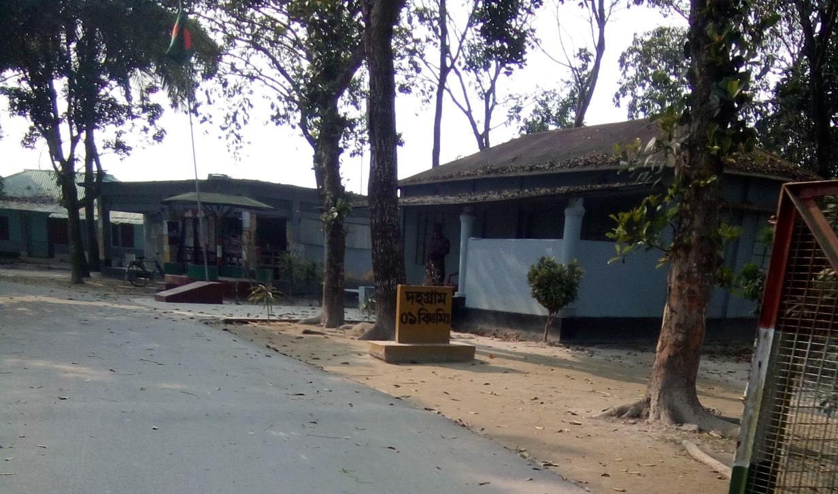

Figure 9: A photo outside of Tin Bigha Corridor

Discussions of my Study:

Some of the local people are involved in illegal cattle trading business. They bring cows from neighboring country at lower price and sell in Bangladesh at higher price. Some Indian people around the Chitmôhol help them for collaborating the illegal business. Sometimes the illegal cattle traders are arrested or shot by BSF’s. As a result it creates social unrest among the two countries. There are also some people who are involved in drug smuggling. Drug business is also present in there. As a result the young generations of the areas are more open to drug addiction. That is so alarming at the same time is also a threat for the entire economy of our country.
Border killing is another issue in the locality. Sometimes some people get caught while illegal cattle trading and shot on the border. Two interviewed respondent said, “Border killing was very much 10 to 12 years before when the corridor was not fully open for Bangladeshi people. At that time people need to sell their product on the Indian Market for buying their daily necessaries. But now the present scenario, they can buy and sell their own product in their own market of locality. But the people who do illegal business through border, sometimes they get shot”. They also mentioned that they receive help from the BGB people and Police of Patgram Police Station for preventing crime and tackling criminals.
Medical and Hospitalization Facilities is still an issue for the people of Dahagram Union. There is no doctor available in the hospitals. So the people of the locality suffers for emergency treatment and hospitalization. They are dependent upon the doctors and hospitalization facilities of nearest Upazilla Patgram. It can be identified as current struggling factor for them.
Banking facility is another struggling factor for them. They need to prevail the bank services from Patgram Upazilla, which is a difficulty for them in their living.

My Recommendations:

There are some recommendations based on my research findings. I found there are very few researches conducted on the people of Dahagram on their achievement towards nationality. As per my findings, 40% people belongs to extreme poorer group. Researches can be done for upgrading their sustainable livelihoods approach so that they can improve their income status. They also have some struggling factors like medical & hospitalization facilities, banking facilities, drug smuggling, illegal cattle trading and border killing. These issues should be investigate further in order to find ‘why’ these are happening and ‘how’ should we address them properly. I want to suggest that more researches should be done for addressing the struggling factors with the proper human centric design by the local government organizations, NGO’s and private organizations.

Conclusion of my Research Project:

The people of the enclaves struggled a lot before for their rights towards nationality and better living opportunities. Now they are very much happy because they are citizen of Bangladesh. Although the area is not much developed yet. But they feel relieve for their achievement after the decades of struggles on achieving nationality as Bangladeshi and every aspects of livelihood opportunities and development. I think more researches should be done on the living of the people of Dahagram so that local government organizations, NGOs and private organizations can create opportunities for them availing the services by the former Chitmôhol people. NGO’s can work on their sustainable livelihood approach & development so that the former Chitmôhol people can contribute in every sector of growth in Bangladesh.

References I Used:

- India Bangladesh Land Boundary Agreement by Ministry of External Affairs Govt. of India; https://www.mea.gov.in/Uploads/PublicationDocs/24529_LBA_MEA_Booklet_final.pdf
- Bangladesh Government Web portal; http://dahagramup.lalmonirhat.gov.bd/site/page/9e00052e-18fd-11e7-9461-286ed488c766
- India Bangladesh Enclaves Wikipedia; August 2016, Available at: https://en.wikipedia.org/wiki/India%E2%80%93Bangladesh_enclaves
- Webpages of Tin Bigha Corridor available at: http://coochbehar.nic.in/HTMfiles/tinbigha.html
- News Bangladesh;July 31, 2015, Available at: http://www.newsbangladesh.com/english/details/5397
- Migration Policy; March 9, 2016, available at:http://www.migrationpolicy.org/article/india-and-bangladesh-swap-territory-citizens-landmark-enclave-exchange

Annex

Survey Questionnaire on Life & Livelihoods of Former Chitmahal People
উত্তরদাতারনামঃ |  | বয়সঃ |  |  | তারিখঃ
গ্রামঃ |  | ইউনিয়নঃ
উপজেলাঃ | জেলাঃ |  |  |  |  |  | কোডঃ
পেশাঃ | শিক্ষাগত যোগ্যতাঃ |  |  |  |  | সদস্যসংখ্যাঃ
পিতা/স্ত্রী/স্বামীর নামঃ |  |  |  | পেশাঃ
পিতা/স্ত্রী/স্বামীর শিক্ষাগত যোগ্যতাঃ |  |  | মোবাইল নম্বরঃ

১। (ক) আপনার পরিবারে আয়ের উৎস কি?
-চাকুরী/ ব্যবসা/ জমি চাষ/ পশু পালন/ মাছ চাষ/ দিন মজুর/ অন্যান্য
...............................মাসিক আয়.....................দৈনিক আয়............
কতো দিন ধরে এই পেশায় আছেন? ..............দিন।আগে কি করতেন?...........................
চাকুরী হলে, আপনি কোন প্রশিক্ষণ পেয়েছেন কি? - হ্যাঁ/ না
হ্যাঁ হলে, কি প্রশিক্ষণ? কারা দিয়েছেন? ..............................
চাকুরীর জন্য আপনাদের প্রাক্তন ছিটমহলবাসিদের জন্য কোন কোঠা/বিশেষ সুবিধা আছে কি?
..............................
আগে যখন ছিটমহল ছিল, তখনকার তুলনায় এখন চাকুরীর সুযোগ কি বেড়েছে? ..................................
(খ) ব্যবসা হলে, কি ব্যবসা?
…………………..
মূলধন কোথা থেকে পেয়েছেন?
…………………..
আগে কি করতেন?
…………………..
ব্যবসা হলে, আপনি কোন প্রশিক্ষণ পেয়েছেন কি?
.............................. হ্যাঁ হলে, কি প্রশিক্ষণ? …………………
আগে যখন ছিটমহল ছিল, তখনকার তুলনায় ব্যবসার সুযোগ কেমন?
……………............
(গ) দিন মজুর হলে,
…………………
আগে কেমন মজুরী পেতেন? এখন কেমন?
…............ আগে…………এখন
আগে যখন ছিটমহল ছিল, তখনকার তুলনায় এখন কাজের সুযোগ কেমন?
........................
(ঘ) জমি জায়গা আবাদ করলে,
আপনার নিজের জমি?............ নিজের/অন্যের.................................
আপনি কোন প্রশিক্ষণ পেয়েছেন কি?
.............................. হ্যাঁ হলে, কি প্রশিক্ষণ? …………………
নিজের হলে, জমির পরিমাণ কতোখানি?
..............................
আগে কতো ছিল?
........................
এখন কতোখানি?
........................
জায়গা জমির দাম কি বেড়েছে?
........................
কতোখানি বেড়েছে?
.................................
আপনার জমিতে, কোন ধরণের ফসল ফলানো হয়?
.................................
(ঙ) পুকুরে/নদীতে মাছ চাষ ধরলে... কি মাছ চাষ করেন?
.................................
আপনার খরচ কতো হয়?
.................................
লাভ কতো খানি?
.................................
আগে যখন ছিটমহল ছিল, তখনকার তুলনায় কি খরচ বেড়েছে?
.................................
কতোখানি বেড়েছে?
.................................
(চ) পশু পালন করলে, কি ধরণের পশু পালন করেন?
.................................
খরচ কেমন হয়?
.................................
লাভ কতোটুকু?
.................................
আগে যখন ছিটমহল ছিল, তখনকার তুলনায় কি লাভ বেড়েছে?
.................................
২।পরিবারের কর্মক্ষম সদস্য কয়জন এবং মোট মাসিক আয় কত?
................ জনএবংপ্রায়.................... টাকা
৩।কয়জন সদস্য লেখাপড়া করে এবং কি পড়ছে?
................জনএবং..................................
৪। আপনার এলাকায় স্কুল আছে কি?
- হ্যাঁ
- না
যদি থাকে তাহলে কতটি আছে …………………….
আগের চেয়ে, ছেলেমেয়েদের স্কুলে যাওয়া কি বেড়েছে?- হ্যাঁ/ না
যদিহ্যাঁহয়, কেন বেড়েছে বলে আপনার মনে হয়?
……………
যদি না হয়, কেন কমেছে বলে আপনার মনে হয়?
……………

৫। আপনার এলাকায় কলেজ আছে কি?
- হ্যাঁ
- না
যদি থাকে তাহলে কতটি আছে …………………….
আগে থেকেই কলেজ ছিল?
- হ্যাঁ
- না
যদি না হয়, কবে প্রতিষ্ঠিত হয়েছে?
……………
৬। আপনার এলাকায় ডিগ্রী কলেজ আছে কি?
যদি থাকে তাহলে কতটি আছে ……………………..
আগে থেকেই কলেজ ছিল?
- হ্যাঁ
- না
যদিনাহয়, কবে প্রতিষ্ঠিত হয়েছে?

৭। আপনার এলাকায়, চিকিৎসা ব্যবস্থা আছে কি?
- হ্যাঁ
- না
যদি থাকে তাহলে ব্যবস্থাটি কতো দূরে?
-
৮। ডাক্তার কত জন আছে বলে আপনার ধারণা?
-
৯। হঠাৎ অসুস্থ হলে হাতের কাছে চিকিৎসা গ্রহণের ব্যবস্থা আছে কি?
- হ্যাঁ
- না
যদি না থাকে, তাহলে জরুরী ব্যবস্থা কিভাবে গ্রহণ করেন?
-
১০।শিশু ও মায়েদের স্বাস্থ্য সেবা গ্রহণের ব্যবস্থা আছে কি?
-হ্যাঁ/ না
কয়টি স্বাস্থ্যকেন্দ্র আছে এবং কতোদুরে?
…………টি…………কিমি দূরে।
খাওয়ার পানি কোথা থেকে ব্যবহার করেন?
…………………
১১।প্রসাব-পায়খানা করার ব্যবস্থা আছে?
- হ্যাঁ
- না
থাকলে সেটা কোথায়?
…………………
কতোগুলো পরিবার ব্যবহার করে?
..................... টি পরিবার।
আগে থেকেই ছিল কি?
- হ্যাঁ
- না
প্রসাব-পায়খানা করার ব্যবস্থা কে করে দিয়েছে?
……………………………
১২।আপনার এলাকায়, সরকার থেকে বিধবাভাতা/ বয়স্কভাতা/ প্রতিবন্ধীভাতা/ মাতৃত্বকালীন ভাতা দেওয়া হয় কি?
……………………………আপনি এইভাতাগুলোর আওতায় আছেন কি? ............................
১২। আপনার এলাকায় ব্যাংক আছে কি?
- হ্যাঁ/ না
কয়টি ব্যংক আছে?
……………………
আগে যখন ছিটমহল ছিল তখন ছিল কি? - হ্যাঁ/ না
না থাকলে কোথাকার ব্যাংক এ যান?
…………………….....
১৩। ক্ষুদ্র ঋণ নেওয়ার সুবিধা আছে কি?
- হ্যাঁ/ না
না থাকলে কোথা থেকে এই সুবিধা নেন?
…………………….....
১৪। আপনার এলাকায় এন জি ও আছে কি?
-হ্যাঁ/ না
১৫। আপনার এলাকায় কোনো সমিতি আছে কি?
-হ্যাঁ/ না
থাকলে আপনি কি সেই সমিতির সদস্য?
- হ্যাঁ/ না
আগে যখন ছিটমহল ছিল, তখন সমিতি ছিল কি?
........................
১৬। আপনার এলাকায়, আইনের সহায়তা পাওয়ার ব্যবস্থা আছে কি?
- হ্যাঁ/ না
হ্যাঁ হলে, আগে এই ব্যবস্থা ছিল কিনা?
........................
নাহলে, আইনের সহায়তা কোথা থেকে নেয়?
........................
১৭। নারী নির্যাতন দমন আইনের প্রয়োগ আছে কি?
- হ্যাঁ/ না
আইনের সহায়তা নিতে হলে, কোথা থেকে নেওয়া হয়?
........................
১৮। পাশের গ্রামে আপনাদের গ্রাম (দহগ্রাম) থেকে আত্মীয়তা করা হয় কি?
- হ্যাঁ/ না
আগে যখন ছিটমহল ছিল, তখন কি আত্মীয়তা করা হত?

১৯। দৈনন্দিন কেনাকাটা কোথা থেকে করেন?
- এলাকারদোকানপাট
- এলাকার বাজার
- এলাকার শহরে
- পাশের এলাকায়
দৈনন্দিন ব্যবহারের সামগ্রীর দাম কেমন?
যখন ছিটমহল ছিল, তখন দাম কেমন ছিল?
…………………………………
দহগ্রাম সদর উপজেলা/পাটগ্রাম উপজেলা/ লালমনিরহাট জেলা/ রংপুর বিভাগ/ঢাকা বিভাগের দিকে যাওয়া হয় কি?
....................................
কি উদ্দেশ্যে যাওয়া হয়?
বাজার করতে/হাট করতে/পড়াশুনার কাজে/...............
আগে যখন ছিটমহল ছিল, তখনকার চেয়ে এখন যাওয়া আসার কোনো পার্থক্য আছে কি?
.................................

২০। এখন করিডোর দিয়ে যাতায়াতে কোন অসুবিধা হয় কি?
- হ্যাঁ /না
যদি হ্যা হয়, কি ধরণের অসুবিধা হয়?
..................................................................................................................................................................................................
আগে যখন ছিটমহল ছিল, তখন কি অসুবিধা হত?
-হ্যাঁ/না, যদি হ্যাঁ হয়, আগে কি ধরণের অসুবিধা হত?
....................................................................................................................................
২১। এই এলাকায় আপনি কতোদিন থেকে বসবাস করছেন?
..........................................
আগে কোথায় ছিলেন?
..........................................
আপনার পূর্বের বসবাসরত স্থানের চেয়ে এখনকার এই এলাকার কি কোন অমিল আছে?
হ্যা/না, যদি হ্যাঁ হয়, আপনার মন্তব্য বলুন?

আপনার কি মনে হয়, করিডোর হওয়ার পর, আপনার এলাকায় উন্নয়নমূলক ব্যবস্থা যথেষ্ট পরিমাণে নেওয়া হয়েছে? – হ্যাঁ/ না
কি ধরনের ব্যবস্থা নেওয়া হইয়েছে?
..................................................................................................................................... যদি না হয়ে থাকে, কেন হয়নি বলে আপনি মনে করেন?
..........................................................................................................................................................................................................................................

