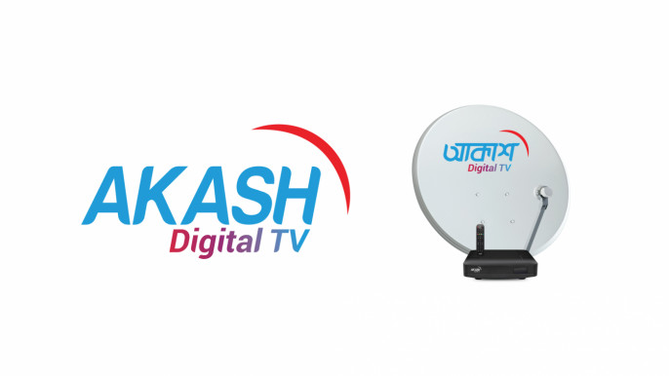




United International University (UIU)
An Internship Report
On
“Improvement of Accounts Payable and Payment system from Akash Digital TV”

Prepared By
Mominul Islam Rahat
111-201-234
BBA Major In Accounting

Internship Supervisor
Professor Dr. James Bakul Sarkar
School of Business and Economics
United International University

Date of Submission: 31-May-2025

Declaration

I’m Mominul Islam Rahat, carrying the ID number 111-201-234, I have completed my internship successfully in Finance and Accounts division at Akash Digital Tv (Beximco Communication Ltd). I said that my internship report is about, “Improvement of Accounts Payable and Payment system from Akash Digital TV “.
I work on it with the help of Dr. James Bakul Sarkar, Professor at United International University.
This report is only made to meet the requirements for the completion of Bachelor of Business Administration Degree.

Best Regards,
Mominul Islam Rahat
111-201-234
United International University.

Letter of Transmittal
Date: July, 2025

Professor Dr. James Bakul Sarkar
Internship Supervisor
School of Business and Economics
United International University
Subject: Submission of Internship report on Improvement of Accounts Payable and Payment system from Akash Digital TV

Dear Sir,
I am pleased to present the internship report entitled “Improvement of Accounts Payable and Payment system from Akash Digital TV “, which has prepared as a requirement from the completion of my internship at Akash Digital Ltd (Beximco Group).
This report provides a comprehensive analysis of the Account Payable strategies by Akash Digital Ltd (Beximco Group) and their impact on vendor payment levels within the organization. The findings and recommendations outlined in this report are based on data collected during my tenure as an intern, along with relevant literature reviews and surveys with personnel.
I would like to express my sincere gratitude for the guidance and support you have provided throughout my internship period. Your expertise and insights have been invaluable in the completion of this report. I have dedicated my earnest time and effort. I kindly ask your attention were giving it rating. Working for you has been the biggest stroke of luck I could have ever hoped for.
Yours Sincerely,
Mominul Islam Rahat
Student ID: 111 201 234

Acknowledgement
I would like to express my deepest appreciation to all those who provided me the possibility to complete this report. A special gratitude I give to my internship supervisor, Professor Dr. James Bakul Sarkar, whose contribution is stimulating suggestions and encouragement, helped me to coordinate my internship.
Furthermore, I would also like to acknowledge with much appreciation to crucial role of the staff of Beximco Communication Ltd. Who gave the permission to use all required equipment and the necessary materials to complete the task of researching and compiling the insights presented in this report.
I am also immensely grateful to United International university for providing the guidelines and facilities that contributed to successful completion of this report.

Table of Contents

Executive Summery…………………………………………………….viii
Chapter One: Introduction of the report ………………….viii-X
- 1.1- Origin………………………………………………………………………….ix
- 1.2- Scope……………………………………………………………. …………..ix
- 1.3- Objective………………………………………………………………….. ix
- 1.4-Methodology………………………………………………………………x
- Limitations……………………………………………………………………….x
Chapter Two: Introduction of the Organization…………….xi
- 2.1-History………………………………………………………………………..xii
- 2.2-Mission, Vision & Value system………………………………….xii
- 2.2.1-Mission………………………………………………………xii
- 2.2.2-Vision……………………………………………………….xiii
- 2.2.3-Value system……………………………………………xiii
- 2.3-Product & Service………………………………………………….xiii
- 2.3.1-Product…………………………………………………..xiii
- 2.3.2-Service…………………………………………………...xiv
- 2.4-Organization Structure ……………………………………xv-xvi
- 2.4.1-Core Department…………………………………..xvi
- 2.4.2-My Role & Position……………………….xvii-xviii
Chapter Three: Responsible brand and Growth…………….xix
- 3.1-CSR policies…………………………………………………………………….xx-xxiv
- 3.2-SOWT Analysis…………………………………………….…,,,,,,,,,,,,,,,,,,,,,,,xxi
Chapter Four: Findings & Analysis……………………………….xxvi
- Manual system………………………………………………………...xxvii-xxxi
- Automation System…………………………………………………xxxi-xxxvi
Chapter Five: Lessons……………………………………………...xxxvii
- Lessons……………………………………………………………………….xxxviii
Chapter Six: Conclusions & Recommendation…………xli-xliii
- Conclusions……………………………………………………………………..xlii
- Recommendation…………………………………………………………..xliii
Chapter Seven: Reference ……………………………………………xlix

Executive Summery

This report evaluates the current accounts payable and payment system at Akash Digital TV, a subsidiary of Beximco Communications Ltd., and proposes strategic improvements to enhance efficiency, accuracy, and compliance. The analysis is grounded in hands-on experience gained during an internship in the Finance Department, with a focus on vendor payments, credit period monitoring, internal controls, and ERP integration. Currently, the AP system follows a manual, multi-step process that begins with vendors submitting physical invoices and ends with payment disbursement via various methods (cash, cheque, or BFTN). Each invoice passes through departmental verification, supply chain validation, accounts payable compliance, and payment authorization. While this structure demonstrates strong internal controls and segregation of duties, it also exposes the organization to delays, manual entry errors, and inefficiencies in document handling and audit tracking.
This report identifies key bottlenecks in the existing manual process and introduces a revised framework leveraging digital tools and automation. Recommendations focus on ERP optimization, document digitization, electronic approvals, and vendor communication improvements, aiming to streamline operations, ensure regulatory compliance, and strengthen financial performance.

Chapter One:
Introduction Of the Report

  - Origin/ Background

The inception of this report stems from a keen interest in understanding the operational efficiency and financial integrity of the Accounts Payable (AP) & Payment settlement process within large-scale organizations. In the context of corporate finance, effective management of accounts payable is essential for maintaining strong liquidity position, building strong suppliers’ debt position, and aligning compliance with internal controls.
This report was initiated during my internship at Beximco Communications Ltd., a company known for its structured financial systems and robust internal control processes. The motivation behind selecting the Accounts Payable sector lies in its critical role in managing payments outflows and ensuring smooth operations of Supply Chain. The aim was to explore how Beximco Communications manages its payable cycle, handles vendor relationships, and maintains accuracy and being complained with Government Authorities.
The study intends to contribute to the understanding of AP practices in the corporate sector, highlighting how automation, policy enforcement, and departmental coordination can enhance overall financial performance and control.

  - Scope:
This report covers the Accounts Payable functions of Beximco Communications Ltd., focusing on invoice processing, payment procedures, reconciliation activities, and internal control mechanisms. It also examines the impact of AP practices on cash flow management and vendor satisfaction.

  - Objectives
- Primary Objective:
To analyze and evaluate the effectiveness and efficiency of the Accounts Payable system at Beximco Communications Ltd.

B) Secondary Objectives:
- To identify challenges in the AP process and their impact on financial operations.
- To propose recommendations for improving AP efficiency and accuracy.
- To integrate AP process with Accounting Software for smoothing the operations.

  - Methodology
The methodology of this report is structured around a combination of qualitative observation and document analysis. During the internship period, relevant documents such as invoices, payment schedules, reconciliation statements, and ERP system reports were reviewed. Informal interviews and discussions were also conducted with finance team members to gain insights into workflow processes and internal policies.
The collected information was analyzed to assess the timeliness and accuracy of payments, compliance with internal controls, and overall process efficiency. This data-driven approach forms the basis for the findings and recommendations presented in this report.

  - Limitations
The research encountered certain limitations. Due to confidentiality constraints, access to some financial data was restricted. Additionally, time constraints and the remote nature of some interactions limited deeper engagement with all stakeholders. These factors may have influenced the breadth of the analysis and depth of insight into certain processes.



Chapter Two:
Introduction of the Organization

2.1 History
Akash Digital TV is the brand name under which Beximco Communications Ltd. launched the first-ever Direct-to-Home (DTH) television service in Bangladesh. The journey began in 2014, when Beximco Group, a leading conglomerate in the country, acquired a license from the Bangladesh Telecommunication Regulatory Commission (BTRC) to operate a DTH platform. After years of preparation, infrastructure development, and technology integration, Akash Digital TV officially launched its commercial services in May 2019. Akash introduced a revolutionary shift in the Bangladeshi television industry by offering a satellite-based TV service that ensured consistent picture and sound quality, regardless of weather conditions or geographic location. Unlike traditional cable TV, which often faced signal disruptions and limited coverage, Akash Digital TV provided a modern and reliable alternative for viewers across the country.
The platform quickly gained attention for its wide channel lineup, HD quality broadcasts, and user-friendly set-top boxes. Akash also became known for its focus on customer service, digital payment options, and advanced features like parental control, EPG (Electronic Program Guide), and multi-language support. Today, Akash Digital TV continues to grow its subscriber base, aiming to offer high-quality digital entertainment and become a household name in Bangladesh. Its success marks a major milestone in the country’s move toward digitizing home entertainment and establishing global-standard broadcasting service.

2.2 Mission, Vision, and Value Statements
2.2.1 Mission
To revolutionize the digital entertainment experience in Bangladesh by delivering high-quality, accessible, and on-the-go television services through Akash Digital TV and its mobile platform, Akash Go. We aim to bridge local and global entertainment by integrating international content providers like Netflix, ensuring our customers enjoy world-class entertainment anytime, anywhere.
2.2.2 Vision
Beximco Communications Ltd. envisions becoming the most advanced and customer-centric digital entertainment provider in Bangladesh. The company seeks to redefine how people consume media by combining satellite television, mobile streaming, and international partnerships into a unified, seamless platform. Through continued innovation and strategic expansion, Akash aims to set new standards for convenience, content quality, and viewer satisfaction across the nation.
2.2.3 Value Statements
Akash believes in constant innovation, driven by technology that simplifies and enhances how entertainment is delivered. The company values global connectivity and is committed to bringing the world’s best content to Bangladeshi households through partnerships with international platforms. Customer satisfaction is a central priority, with every product and service designed to meet evolving viewer preferences. At the heart of its operations, Akash upholds accessibility, ensuring that premium entertainment is available to all, regardless of location. Trust, integrity, and a forward-thinking mindset guide every step in its journey to lead the country’s digital entertainment sector.
2.3 Product and Service
Here Akash Digital TV have product and also the service it wiil be more specifically talk in the bellow so it will be given by,
2.3.1 Product:
- Akash Digital TV Set-Top Box (Standard & HD Version): Akash offers two types of set-top boxes Standard Definition (SD) and High Definition (HD) designed for different user preferences and budgets. These boxes receive satellite signals and decode them into high-quality digital audio and video content for televisions. The HD version offers superior resolution and clarity, enhancing the viewing experience for modern LED and smart TVs.
- Akash Remote Control: Each set-top box comes with an ergonomic and easy-to-use remote control that allows users to switch channels, adjust settings, access the Electronic Program Guide (EPG), set parental controls, and navigate the interface conveniently.
- Akash Viewing Cards: These smart cards are inserted into the set-top box to activate the subscription. They are linked to the customer’s chosen package and help in secure content delivery by verifying authorized access.
- Akash Go Mobile App: This is Akash’s official mobile streaming platform. Available on both Android and iOS, the Akash Go app enables users to watch live TV, catch up on selected programs, and manage subscriptions from anywhere, using mobile internet or Wi-Fi.
2.3.2 Services:
- Satellite TV Broadcast Service: Akash Digital TV uses satellite technology to transmit television signals directly to users’ homes. A satellite dish, installed at the customer’s premises, captures signals from the Bangabandhu Satellite-1 or other partner satellites. These signals are then decoded by the Akash set-top box, providing uninterrupted access to a wide variety of channels. This service ensures coverage even in remote or rural areas where cable networks are limited or unavailable.
- Subscription Packages: Akash offers flexible and affordable monthly subscription packages such as Basic, Regular, and HD Packs. These allow users to select channels based on their budget and preferences. Customers can recharge their packages via mobile financial services like bKash, Rocket, Nagad, or through the Akash Go app.
- Akash Go Streaming Service: Akash Go is an extension of the satellite TV experience to mobile devices. It works via internet connectivity and allows subscribers to enjoy live TV anytime, anywhere. The app features an intuitive interface, program schedules, and notifications. It supports a seamless user experience for those who prefer digital mobility over traditional TV viewing.
- Customer Service & Technical Support: Akash provides 24/7 customer service through its helpline, website chat, and social media platforms. It also has a network of authorized service partners for installation, maintenance, and troubleshooting. After purchasing the DTH system, a trained technician installs the satellite dish, configures the set-top box, and ensures signal quality before handing it over to the user.
- Parental Control & Program Guide: Customers can control content accessibility through parental lock features and stay updated with a real-time Electronic Program Guide (EPG), which shows schedules and brief descriptions of current and upcoming programs.
- Future Integration with Global Platforms (e.g., Netflix): Akash is currently working toward integrating streaming services like Netflix, which would allow customers to access global entertainment content through the same platform. This service, once launched, will position Akash as a unified media gateway, combining local TV with international streaming in one ecosystem.
So, Akash Digital TV also offer customer solutions and expert consultation to meet specific customer needs. Their commitment to quality and innovation has made them a trusted name in the industry.

2.4 Organization Structure
The organizational structure of Akash Digital TV, a concern of Beximco Communications Ltd., follows a hierarchical model, where responsibilities and authority are distributed from top management down to operational-level employees. The structure promotes specialization and efficiency in handling key business functions such as operations, finance, marketing, technology, and customer service.
At the top is the Chief Executive Officer (CEO), who provides strategic direction and oversees the entire company. Reporting directly to the CEO are various department heads or directors, each managing specific divisions such as;
- Operations,
- Sales & Marketing,
- Finance & Accounts,
- Technology,
- Customer Care, and
- Human Resources.
These departments are further subdivided into teams and units, depending on their specific responsibilities. This clear chain of command ensures that decisions are implemented efficiently, accountability is maintained, and performance across various sectors is aligned with the organization’s goals & total employee categorized into three categories as per below,
- Management Staff
- Non-Management Staff
- Worker
Below are the details grading of Management staff, non-management staff and worker category. Worker grading my change and follow accordingly where legal guideline exists.
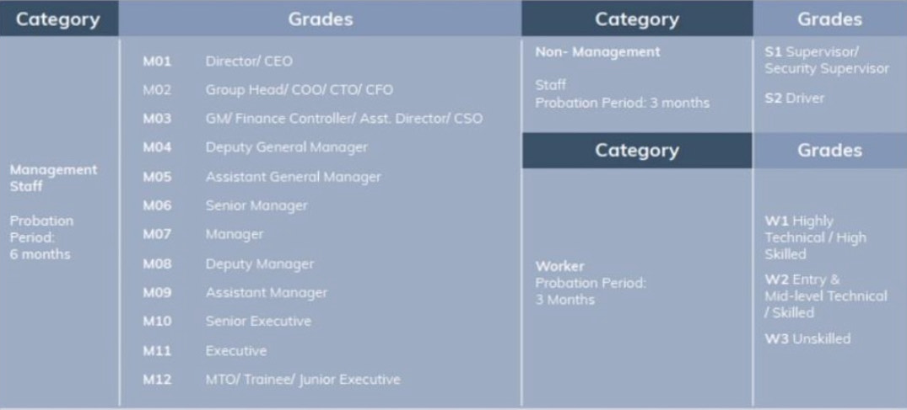

2.4.1 Core Departments:
- Research and Development (R&D): Focuses on developing new products and improving existing ones.
- Sales and Marketing: Drives revenue through sales strategies and marketing campaigns, on the other hand the fixed customer or the existing customer are monthly recharge that are also main key factor to generate the monthly revenue.
- Customer Support: Provides after sales supports and helps maintain customer regulations.
- Human Resources: manages employee’s relations, recruitment, training and organizational culture.
- It and Infrastructure: Maintain the company’s technological framework and operational facilities.
- Accounts and Finance: To maintain and try to develop organizational fund and maintain government and company good relation through tax.
- Legal: They are mainly focused on the company all legal binding’s and they are handling in this problem.
2.4.2 My Role and Position:
In February 2025, I embark on a journey as an Intern Finance at Akash Digital TV (Beximco Communication Ltd) a leading provider of DTH services. These outlines my contributions, learning experiences and the growth opportunities provided by the company during my internship.
Key Responsibilities and Achievements:
- Worked in the Accounts Payable section under the Finance Department.
- Responsible for making vendor payments while monitoring credit periods:
  - Ensured payments were made when the credit period was nearing its end.
  - Fixed Costs (e.g., Office and warehouse rent, utility bills, satellite bill) were paid on time.
- Maintain and update the AP management system with all payment details to support financial planning.
- Manage, update DUE list to track pending payments.
- Enter and record all payment journal entries in the company’s accounting system (ERP).
- Help streamline the vendor payment process, ensuring compliance with internal credit policy.
- Maintain clear documentation that supported smooth internal audits.
- Gaining hands-on experience with real-time payment processing and professional accounting software.
- Improved my proficiency in Excel-based financial tracking and vendor communication.
Recognition: My efforts and dedication were acknowledged when I was honored as “Intern of the week”, a testament to my commitment and hard work.
Akash Digital TV boasts an exceptional working environment where all employees are supportive and helpful. The culture promotes learning and professional development, making it an ideal setting for Interns to thrive and grow. My internship period at this organization has been a transformative experience with invaluable insights about the Finance and Accounts field. The competencies, skills and knowledge I have gained from Akash Digital TV will undoubtedly serve as a solid foundation for my future career growth.

Chapter Three:
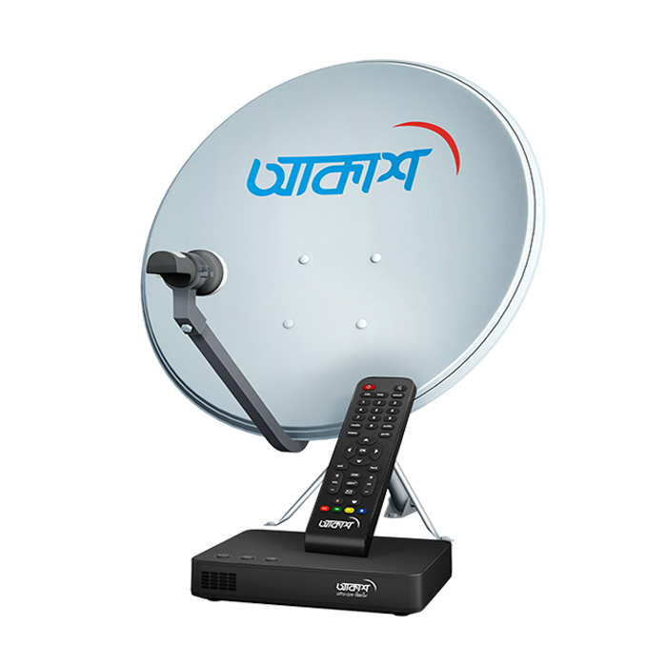
Building a Responsible Brand and Unlocking Growth: Akash Digital TV’s CSR and SWOT Insights

3.1 Akash Digital TV's Corporate Social Responsibility (CSR) Policies,
Akash Digital TV's operational philosophy is firmly rooted in Corporate Social Responsibility (CSR), which reflects the larger Beximco Group values. Being a leader in Bangladesh's DTH (Direct-To-Home) industry, Akash Digital TV is aware of its impact in the social, ethical, and environmental spheres in addition to business. The following areas are the focus of its CSR efforts:
3.1.1 Making High-Quality Information and Entertainment More Accessible
Akash Digital TV built an echo system which connected audiences with best quality contents for entertainment. Akash Digital TV promotes social inclusion by guaranteeing top-notch television services in isolated and under privileged areas where traditional cable TV services are available. Broader demographics can now access through educational channels, contents for children, health and farming awareness, and many more, which helps rural and semi-urban families being updated about all information.
3.1.2 Making Certain Ethical and Open Business Practices. The business is dedicated to upholding the highest moral standards in all of its interactions. Akash Digital TV highlights:
- Clear pricing with no additional fees.
- Clear communication about service renewals and plans.
- robust privacy and customer data protection that complies with international best practices for digital security.
This emphasis on trust-building enhances long-term customer loyalty and aligns the company with international corporate governance standards.
3.1.3 Initiatives for Environmental Sustainability
Akash Digital TV has made efforts to adopt more environmentally friendly procedures after realizing the effects that satellite broadcasting equipment has on the environment. These consist of:
- Encouraging clients to recycle used set-top boxes and accessories in an environmentally responsible manner.
- Introducing gadgets that use less electricity and are energy efficient.
- Reducing the amount of plastic used in promotional materials and packaging.
- Investigating possibilities for solar-powered signal transmission devices in order to lower future carbon emissions.
These efforts show the company's intention to be an environmentally conscious player, even though they are still in their infancy.
3.1.4 Philanthropy and Social Contributions
Akash Digital TV takes part in a variety of charitable endeavors through its parent company, Beximco Group. Among the noteworthy instances are:
- Donation of supplies and medical equipment to hospitals during the COVID-19 outbreak.
- Involvement in disaster relief initiatives during cyclones and floods, providing both financial and logistical support.
- Supporting national competitions, sporting events, and cultural initiatives that foster patriotism and community involvement.
Through these initiatives, Akash Digital TV is positioned as a significant contributor to social welfare as well as a service provider.
3.1.5 Workplace Development and Employee Welfare
Employee development, safety, and well-being are highly valued at Akash Digital TV. Important projects consist of:
- Employees at all levels should receive regular training in both soft and technical skills.
- Putting in place safety protocols and providing field technicians and operational personnel with health insurance.
- Encouragement of an inclusive, diverse workplace culture that guarantees opportunities for women and people with disabilities.
- Supplying chances for professional advancement and performance-based rewards to sustain high staff morale and output.
Akash Digital TV can sustain a motivated workforce by investing in human capital, which improves service quality and innovation.
3.2 SWOT Analysis of Akash Digital TV
An in-depth SWOT analysis offers a thorough understanding of Akash Digital TV's present market position and future strategic opportunities.
3.2.1 Strengths:
- First-Mover Advantage and Market Leader Position: Being Bangladesh's first licensed DTH service, Akash Digital TV has a devoted following and a high level of customer trust that are difficult for new competitors to match.
- Superior Transmission Quality: Akash Digital TV has a major edge in the entertainment-focused Bangladeshi consumer market by providing HD (High Definition) and even Full HD channels with continuous digital clarity, in contrast to traditional cable operators.
- Variety of Packages: Akash Digital TV provides specialized packages to meet the needs of various clientele, ranging from premium subscribers seeking access to international sports and entertainment channels to households on a tight budget.
- Strong Beximco Group Support: Supported by one of the biggest conglomerates in Bangladesh in terms of finances, strategy, and infrastructure, Akash Digital TV can leverage cross-industry synergies for growth and stability.
3.2.2 Weaknesses:
- High Cost of Entry into the Mass Market: Compared to traditional cable services, Akash Digital TV is more costly for lower-income families due to the requirement for a set-top box purchase, dish antenna installation, and monthly subscription fees.
- Vulnerability to Service Disruptions: One technical limitation of satellite-based broadcasting that may irritate consumers is the possibility of temporary signal loss due to weather conditions like intense rain.
- Limited Attention to Localized Content: Akash Digital TV finds it more difficult to compete with local cable companies that customize content to suit local tastes because local entertainment, regional news, and community-specific programming are less prevalent in its offerings.
- Dependency on Third-Party Satellite Infrastructure: Because Akash Digital TV depends on foreign satellite service providers, any technical malfunction or interruption in satellite contracts could have a significant effect on business operations.
3.2.3 Opportunities:
- Integration with OTT Platforms: Akash Digital TV can develop into a hybrid entertainment platform that offers both traditional TV and internet-based services by partnering with top Over-the-Top (OTT) service providers like Netflix, Disney+, or regional streaming services in Bangladesh.
- Extending Internet TV and Smart TV Integration: As Smart TVs become more widely used, Akash Digital TV is able to provide value-added services, built-in apps, and even the beginning of bundled internet and TV packages.
- Growing Digital Literacy and Urbanization: Akash Digital TV will benefit from the rising demand for high-quality digital entertainment services as the Bangladeshi populace grows more tech-savvy and urbanization picks up speed.
- New Niche Markets: Niche markets may be created by specialized content offerings, such as business news for professionals, educational TV for students, and agriculturally orientated shows for farmers.
3.2.4 Threats:
- Competition from Online Streaming Services: As internet connectivity increases, consumers, particularly younger generations, are turning to on-demand streaming services to lessen their reliance on traditional satellite TV.
- Aggressive Pricing by Local Cable Operators: Local cable operators' aggressive pricing is putting a lot of pressure on prices as they keep cutting costs, bundling TV and internet services, and providing flexible monthly or even daily payment options.
- Regulatory Risks: Regulatory risks include the possibility of unforeseen operational difficulties for Akash Digital TV due to future modifications to licensing fees, content regulations, tax laws, or national broadcasting guidelines.
- Technological Disruptions: If not developed in tandem with satellite TV, rapidly advancing technologies like IPTV (Internet Protocol TV) and 5G-based content delivery may eventually surpass them.

Chapter Four:
Findings & Analysis

Here We can give the ordinary or manually clearance or release the payment. I will show the process as a flowchart and then we can discuss the whole frame easily. It will be given by,
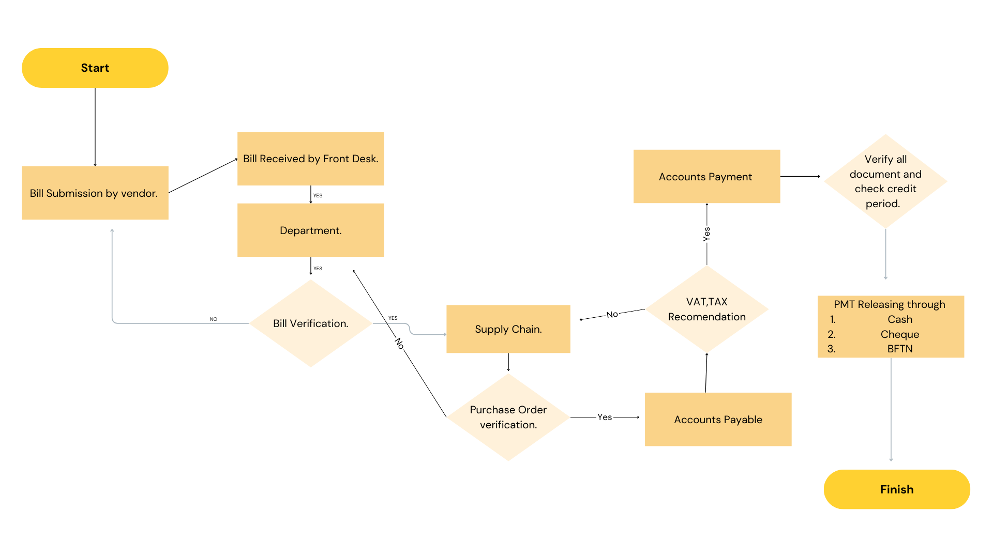
Figure 1: Current manual system to Akash Digital TV.

4.1 Bill Submission by Vendor (Starting Point)
The process begins when a vendor manually submits a bill at the front desk of the organization. The term “manual submission” means the vendor physically visits the office and hands over the bill and related documents in person. At this stage, the vendor is responsible for ensuring that all necessary supporting documents (such as the invoice, delivery note, work order completion, etc.) are included in the submission.
Once the bill is submitted, the Front Desk Officer accepts the documents and issues a receiving seal or token, which serves as an acknowledgment and proof that the bill has been received by the organization. This is a critical control point, as it creates a reference for any follow-up or tracking by the vendor later in the process.

4.2 Internal Forwarding to the Concerned Department
After receiving the bill, the Front Desk Officer’s next responsibility is to forward the bill to the concerned department. This is the department that either:
- Ordered the service, or
- Incurred the expense for which the bill has been submitted.
This step is crucial because only the respective department can verify the legitimacy of the bill. The internal office staff usually handle the physical movement of the bill file to the department.

4.3 Department-Level Verification
When the bill reaches the concerned department, the department staff carry out a thorough verification of the bill. Their job is to cross-check and confirm that:
- The invoice details match the service/goods actually received.
- The quantities and rates are accurate and as per agreement.
- The vendor has provided all necessary documentation.
- There is no duplication or overbilling.
If the department is satisfied that the bill is legitimate and complete, a departmental signatory will sign the invoice as a confirmation. This signature indicates that the department takes responsibility for the correctness of the expense and approves it for further processing.
However, if the bill is found to be incomplete or incorrect (e.g., missing documents, wrong amount, or unauthorized service), the department may reject the bill and send it back to the vendor through the front desk. This protects the organization from fraudulent or erroneous payments.

4.4 Supply Chain Review and Purchase Order Verification
Once approved by the department, the bill is then forwarded to the Supply Chain department. The Supply Chain team focuses on purchase order (PO) verification and physical validation of goods or services received. Their responsibilities include:
- Matching the bill with the existing PO (if applicable).
- Checking whether the goods have actually been received (for inventory items).
- Reviewing the delivery challan, GRN (Goods Receipt Note), and service delivery confirmations.
If the bill pertains to inventory, Supply Chain ensures that the units and types of inventories claimed match with the physical stock. They also check for service completion in case of non-inventory purchases (like repair or maintenance work).
If everything is in order, the Supply Chain forwards the bill to the Accounts Payable team. However, if there are any inconsistencies or missing documents, the bill is sent back to the concerned department with a note explaining what is missing or incorrect.

4.5 Accounts Payable (AP) Processing
Upon receiving a verified bill from the Supply Chain, the Accounts Payable team begins financial recording and compliance checks. Their tasks include:
- Recording the bill manually into the accounting system.
- Tagging the correct cost head and updating the relevant budget sector to reflect the expense.
- Evaluating the VAT and TAX implications for the bill. They apply the proper rates, deductions, and document recommendations for tax compliance.
This step is highly sensitive because it involves ensuring the organization complies with tax laws and internal budgeting policies. If AP discovers any issues—like missing tax documentation, budget overrun, or incorrect cost tagging—they do not proceed. Instead, they return the bill to the Supply Chain team with a clear note written on the invoice, stating the problems or missing elements.

4.6 Accounts Payment Verification
Once Accounts Payable has completed all tax and budget updates, the bill moves to the Accounts Payment team. Their role is to:
- Check the credit period mentioned in the bill (e.g., Net 30, Net 60).
- Verify that the bill is now completely processed and cleared by all previous departments.
- Create a payment voucher, update the Cash Flow (CF) link, and register the bill in the DUE list to track upcoming payments.
This is the final checkpoint before payment is made. It ensures that payments are not made prematurely and that liquidity is managed properly.

4.7 Payment Authorization and Method Selection
Once payment is due, the Accounts Payment team selects the most suitable payment method, such as:
- Cash (for small payments),
- Cheque (for formal or larger payments),
- BFTN (Bank Fund Transfer Network) for direct bank-to-bank transfers.
After selecting the method, they obtain necessary authorization from the approving authority, which may include a finance manager or director. This step is vital for preventing unauthorized disbursements. Once approved, payment is disbursed to the vendor.

4.8 Vendor Collects Payment
To complete the process, the vendor returns to the office to collect the payment (if cash or cheque), or they receive a notification if the amount has been credited through bank transfer (BFTN). The finance or accounts team provides the vendor with payment acknowledgment and necessary paperwork.

4.9 Key Observations and Strengths of the Process
- Strong Internal Control System:
  - The multi-departmental review (Department → Supply Chain → Accounts Payable → Accounts Payment) ensures that no single person can authorize payment independently. This minimizes fraud risk.
- Segregation of Duties:
  - Responsibilities are distributed across different teams, such as verification, accounting, and payment, which ensures integrity and transparency.
- Document Tracking & Escalation:
  - Each handover includes a tracking or noting mechanism (e.g., notes on invoices, seal at the front desk), making it easy to identify bottlenecks and responsible persons.
- Tax and Budget Compliance:
  - The Accounts Payable team’s role in VAT/TAX recommendation and budget tagging ensures legal and financial discipline.
- Clear Feedback Loops:
  - Bills with errors are not discarded but returned with specific notes to be corrected and reprocessed.

  - Risks for this following flowchart follow, it will be given by

- Delays due to manual processes
- Missing documents in circulation
- Manual data entry errors
- Duplicate payments
- Difficulty in auditing

Analysis:
Proposed Process for Bill Submission and Payment Workflow
This workflow outlines the streamlined and automated process from a vendor's bill submission to the bank's final payment confirmation. The objective is to enhance transparency, accuracy, and efficiency by integrating an Automated ERP System.
So here my proposed will be given by to better under stand the system will be more accurate and specified and easy to documentary process. I can conduct it as a flowchart diagram.
1. Bill Submission by Vendor
The process begins when the vendor submits a bill for services rendered or goods delivered. There is an option to enhance this step through software development that enables vendors to upload their bills electronically by submitting a scanned copy. This digitized approach reduces paper handling, improves efficiency, and enables quicker access to submitted bills by relevant departments. Implementing such a system ensures that documents are systematically logged into the organization's internal system from the outset.

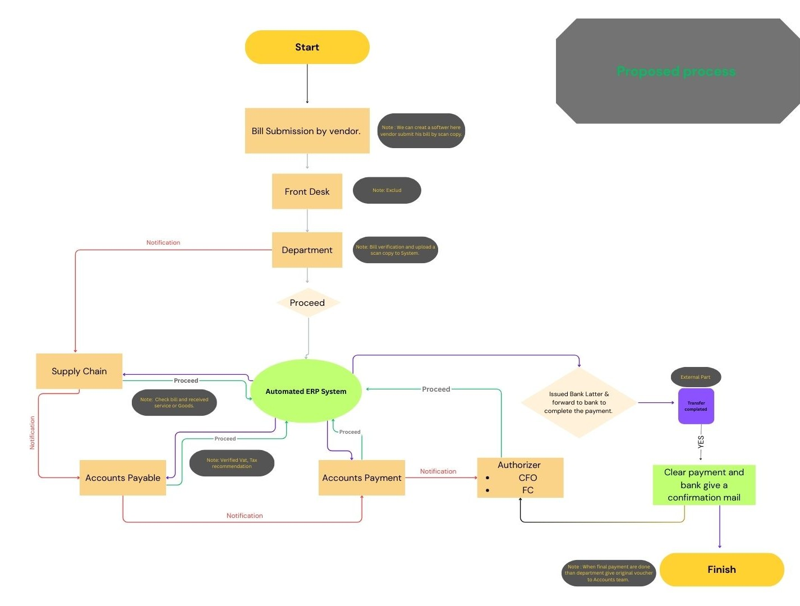
Figure 2: My Proposed process for the Akash Digital TV.

2. Front Desk Handling
Once the bill is submitted, it is received by the front desk. The front desk serves as the first point of physical or digital receipt. Its role may include assigning a reference number, recording the date of receipt, and routing the bill to the concerned department. However, the process design also allows this step to be excluded if a fully automated bill submission portal is in place. This offers flexibility based on the organization’s operational model and technological maturity.
3. Departmental Verification
The bill is then forwarded to the appropriate internal department. The department’s responsibility is to review and verify the bill's details to ensure accuracy and validity. This includes checking the items billed, dates, amounts, and any associated documentation or approvals. After successful verification, the department uploads a scanned copy of the verified bill into the organization’s Automated ERP (Enterprise Resource Planning) System. This action transitions the process from a manual or semi-manual phase into a fully digital environment, enabling centralized tracking and further processing.
4. Entry into Automated ERP System
Once uploaded, the bill enters the Automated ERP System, which acts as the hub for all subsequent activities. The ERP system facilitates seamless coordination across departments and records every step, action, and update in real time. This ensures transparency, accountability, and audit readiness. The ERP platform initiates multiple parallel processes involving the Supply Chain, Accounts Payable, and Accounts Payment departments.
5. Supply Chain Department Review
The Supply Chain department is notified via the ERP system and is tasked with confirming whether the goods or services billed have indeed been received. This step is crucial in validating the vendor’s claim. The department checks delivery records, service logs, or any relevant documents to ensure the transaction aligns with the bill. Once verified, the Supply Chain department provides approval, and this information is logged back into the ERP system for onward processing.
6. Accounts Payable Processing
Following Supply Chain validation, the Accounts Payable department is engaged. Their primary role is to examine the financial aspects of the bill, including verifying VAT applicability, ensuring tax deductions are accurate, and confirming that the bill aligns with company policies. This department plays a vital role in maintaining regulatory compliance and financial integrity. Once this verification is complete, the bill is cleared for payment processing and sent to the Accounts Payable team.
7. Accounts Payment Initiation
The Accounts Payment department then prepares the necessary documentation and initiates the process of releasing payment. They ensure that all previous verifications have been completed and that the bill has gone through every required checkpoint. At this stage, the ERP system triggers a notification to senior authorizers, typically the Chief Financial Officer (CFO) or the Financial Controller (FC), requesting their final approval.
8. Authorization for Payment
Upon receiving the notification, the designated authorizer—either the CFO or FC—reviews the payment request. This high-level approval ensures that only legitimate and fully verified payments are released. Once authorized, the payment team issues a formal bank letter and forwards it to the relevant banking institution to process the payment. This step represents the formal initiation of fund disbursement to the vendor.
9. Bank Transfer and Confirmation
After receiving the payment instruction, the bank processes the transfer and completes the transaction. Once the payment is successfully transferred to the vendor, the bank sends a confirmation email or notification back to the organization. This confirmation is registered in the ERP system, triggering an internal notification to the Accounts team.
10. Completion of Process
With the confirmation from the bank, the Accounts team marks the transaction as complete. The system is updated with all relevant data, including payment status, transaction reference, and completion date. At this point, the process concludes, ensuring that the vendor has been paid and all internal stakeholders have full visibility over the entire workflow. Additionally, a note is made to issue a final payment voucher and store it in the system for future audits or reconciliation.

Percentage of Payment method to use manual system:
Method Name | Percentage
CHEQUE | 60%
CASH | 30%
BEFTN | 20%

My proposed system method will be given by:
Method Name | Percentage
CHEQUE | 10%
CASH | 5%
Automated BEFTN | 85%

Benefits of Introducing an Automated ERP System
Implementing an Automated ERP (Enterprise Resource Planning) system in the organization introduces significant advantages that enhance both operational efficiency and financial control. One of the foremost benefits is centralized data management, where all departments can work from a single platform, reducing communication gaps and the risk of data duplication. The ERP system provides real-time tracking of bill submissions, approvals, and payments, which increases transparency and accountability across all functional units. It also ensures that each step in the workflow is systematically documented and time-stamped, thereby creating a fully auditable trail of activities.
Automation reduces manual errors, accelerates the processing time, and minimizes paperwork, ultimately saving valuable administrative hours where previously all this work, manually required at least 45 to 60 days to complete the cycle, whereas now it would take only a few days after the credit period. Additionally, ERP integration enhances interdepartmental collaboration, as it allows seamless data sharing between departments like Supply Chain, Accounts Payable, and Finance. From a compliance standpoint, the system enables more accurate tax calculations, validation checks, and adherence to internal policies, reducing the risk of regulatory penalties. Moreover, it reduces the need for a high number of officials to carry out the whole cycle. The company usually settled the payments through cheques and incurred multiple errors in it. However, introducing the automated ERP system ensures that payment is settled through BFTN or Bank Transfers, which increases vendor satisfaction as they are not required to come to the business to collect their payment through cash or cheque, as they are automatically receiving it without any hassle which indicates a significant improvement as 60% of the vendors account are settled through cheque. Finally, by streamlining the approval and payment cycles, the ERP system improves vendor relationships, as payments become timelier and more predictable, fostering trust and long-term cooperation.
Tabular Comparison between the Manual ERP system and the Automated ERP system:
Aspect | Manual System | Automated ERP System
1. Data Entry & Handling | Manual input is time-consuming and error-prone. | Fast, accurate data entry with reduced human error.
2. Document Tracking | Difficult to track bill status across departments; prone to misplacement. | Real-time tracking and status updates; fully traceable workflow.
3. Approval Process | Dependent on physical signatures and internal follow-ups, delays are common. | Digital approval routing ensures quicker decision-making and accountability.
4. Interdepartmental Workflow | Requires physical or email communication; often disjointed. | Seamless integration among departments via a unified platform.
5. Compliance & Audit | Harder to maintain consistent tax and policy compliance; audit trails are limited. | Built-in validation rules ensure compliance; complete digital audit trail available.
6. Payment Processing | Slower due to manual preparation of vouchers and letters. | Fast processing through system-generated vouchers and automated bank instructions.
7. Vendor Relations | Delays and miscommunication can strain relationships. | Timely payments and a transparent process improve vendor trust and satisfaction.

Chapter FIVE:
Lessons

5.1 - Lessons Learned from Internship
The main goal of my internship was to gain real-world experience in a corporate setting and develop practical skills relevant to the finance and accounting field. As an intern in the Accounts Payable section of the Finance department at Akash Digital TV, I had the opportunity to observe and participate in professional work processes, helping me understand how organizations function internally.
During my internship, I didn’t have many expectations beyond gaining valuable exposure and learning from my assigned responsibilities. However, the experience turned out to be highly enriching, providing insights into both specific tasks and the broader organizational culture. Some of the key lessons I learned during my time at Akash Digital TV include:
- Understanding Company Culture: I observed how professionalism, communication, and accountability play a vital role in maintaining a smooth workflow in a corporate finance setting.
- Teamwork and Collaboration: I learned the importance of clearly understanding instructions from supervisors and coordinating effectively with colleagues to ensure that tasks were completed accurately and efficiently.
- Time Management: Working with deadlines taught me how to manage my workload under pressure and prioritize tasks, especially during month-end closing and payment cycles.
- Technical Skills: I gained hands-on experience in preparing vouchers, checking supporting documents for vendor payments, updating Excel spreadsheets, and working with financial software. I also improved my proficiency in functions like VLOOKUP, pivot tables, and data validation.
- Attention to Detail and Confidentiality: As I was dealing with sensitive financial documents, I had to be extremely cautious and detail-oriented to avoid errors. This helped me improve my accuracy and taught me the importance of maintaining confidentiality in finance-related tasks.

Overall, my internship at Akash Digital TV gave me a strong foundation in finance operations and helped me develop essential workplace skills that will support my future career in accounting and finance.

Chapter SIX:
Conclusion & Recommendation

Conclusion

My internship at the Finance Department of Akash Digital TV has been an enriching and insightful experience that allowed me to bridge the gap between academic knowledge and real-world financial practices. Over the course of the internship, I was actively involved in the vendor payment cycle, from invoice verification and documentation review to the preparation of payment vouchers and recording of journal entries. This hands-on exposure significantly deepened my understanding of financial controls, payment authorization workflows, and the importance of accurate and timely financial reporting. One of the key observations during my time at Akash Digital TV was the strength of its internal control structure. The Accounts Payable (AP) process is supported by a clear segregation of duties, consistent policy enforcement, and strict compliance with regulatory and tax obligations. Each department plays a well-defined role, contributing to a system that prioritizes accountability and financial integrity.
However, despite these strong procedural safeguards, the AP function is still heavily dependent on manual data entry and paper-based documentation. This reliance introduces operational inefficiencies such as processing delays, heightened risk of human error, difficulties in document retrieval, and challenges in maintaining a clear audit trail. In some cases, these issues can lead to late payments, strained vendor relationships, or reconciliation backlogs that could have otherwise been avoided with more streamlined processes.
Based on my observations and learning, it is evident that there is a strong foundation in place for implementing digital transformation within the AP function. By adopting an automated and integrated system featuring digital invoice submission, workflow-based approval routing, and seamless synchronization with the accounting ledger Akash Digital TV can significantly improve process efficiency, reduce the risk of errors, and enhance the overall scalability of its finance operations. In conclusion, this internship has not only expanded my technical skills in financial operations but also enhanced my analytical ability to evaluate internal processes and suggest practical improvements. I leave with a deep appreciation for the importance of robust financial systems, and I am confident that the insights gained during this period will serve as a valuable asset in my professional development.
Recommendation
In the context of a growing organization like Akash Digital TV, where accuracy, compliance, and efficiency in financial operations are paramount, modernizing the Accounts Payable (AP) process is no longer optional it is essential. While the current manual system demonstrates strong internal control and departmental accountability, its dependency on physical documentation and human input creates bottlenecks that can hinder timely payments, affect vendor trust, and increase operational risk.
To remain competitive and financially agile, the AP process must evolve toward a more streamlined and technology-driven model. This transition requires the integration of automation, digital workflows, and intelligent tracking mechanisms that not only improve day-to-day operations but also ensure scalability and audit readiness.
Based on my internship experience and firsthand exposure to the AP system, I propose the following actionable recommendations:
- Introduce AP automation tools to handle invoice processing, tax deductions, and journal entries with greater speed and accuracy.
- Develop a digital invoice submission system that allows vendors to upload documents remotely and reduce front-desk congestion.
- Enable workflow-based electronic approvals to eliminate internal delays and strengthen internal controls.
- Integrate AP and ERP systems for real-time synchronization of financial data and automatic ledger updates.
- Establish a centralized document repository for all invoices and payment records to enhance audit traceability.
- Create vendor dashboards or portals where suppliers can track invoice status, payment dates, and resolve disputes independently.
- Schedule monthly reconciliation reviews to proactively catch errors, prevent duplicate payments, and ensure data integrity.
- Implement due-date alert systems to ensure timely vendor payments and protect organizational credibility.
- Provide staff training on automation tools and updated tax regulations to ensure consistent and informed performance.
- Formulate a standard AP policy manual that clearly defines timelines, responsibilities, and escalation paths.

References

- Bourreau, M., & Doğan, P. (2001). Regulation and innovation in the telecommunications industry. Telecommunications Policy, 25(3), 167-184.
- Zamil, F., & Hossen, M. M. (2012). Problems and prospects of telecommunication sector of Bangladesh: A critical review. New Media and Mass Communication, 4, 16-25.
- Banu, S., & Tasnim, J. Entrepreneurial Marketing in Direct to Home (DTH) Service: The Case of AKASH in Bangladesh.
- Quadir, S., Islam, S., & Khan, I. M. (2021). Factors Influencing Customer Gratification to use DTH Service in Bangladesh. i-Manager's Journal on Management, 16(3), 22.
- Demirguc-Kunt, A., & Levine, R. (2008). Finance, financial sector policies, and long-run growth.
- Nitto, M. (2020). Financial Management Strategies for Sustaining Small Entertainment Businesses (Doctoral dissertation, Walden University).

