Making a chatbot using Chat-GPT API and Sentimental analysis based on Reddit EDA.

Making a chatbot using Chat-GPT API and Sentimental analysis based on Reddit EDA.

Submitted to:
Ahmed Imran Kabir
Lecturer
Management Information Systems

Submitted by:
A.K.M Ahsan Shihab
ID: 111 182 088
Major: Management Information Systems
Summer 2022

School of Business and Economics
United International University

Date of submission: 5th July 2023

Letter of Transmittal
Date: 5th July, 2023
Ahmed Imran Kabir
Lecturer
School of Business & Economics
United International University
Subject: Submission of internship report on “Making a chatbot using Chat-GPT API and Sentimental analysis based on Reddit EDA.”

Dear Sir,

It is my pleasure to inform you that I made every effort to utilize every chance to comprehensively analyze the topic assigned to me, "Creating a chatbot utilizing Chat-GPT API and Sentimental analysis based on Reddit EDA."
I finished this assignment in order to fulfill the university's requirements for my bachelor's degree. I've performed all within my capability to achieve everyone's requirements and accomplish the project's objectives. I'm hoping you'll approve my project work and provide me with a constructive criticism on my work. The conclusions and presentation in the final report will undoubtedly meet your expectations.
Sincerely Yours,
A.K.M Ahsan Shihab
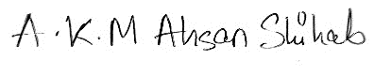
ID: 111 182 088
Signature:

Date: 5th July 2023

Abstract
This project investigates the creation of a chatbot using the Reddit data and Chat-GPT API. Chatbots are computer programs that mimic human communication using natural language processing. In recent years, they have gained popularity, especially in applications for marketing and customer support. Open-AI's Chat-GPT is an NLP API that can produce replies to text-based questions that resemble those of a human being. Chatbots may be trained using the quantity of user-generated information available on the social media site Reddit. The project starts off with a discussion of the background and evolution of chatbots as well as a description of the features of the Chat-GPT API. The advantages of utilizing Reddit data and the Chat-GPT API for chatbot creation are also covered. They include having access to a wealth of user-generated information for training and being able to provide replies that are more naturally logical and natural. The chatbot's outcomes are delivered together with a performance analysis based on measures like confusion and coherence. A range of inputs are used to evaluate the chatbot, including general knowledge questions and chats about particular subjects. Although there are restrictions on the training dataset and tokenization technique, the research shows that the chatbot is capable of producing logical and pertinent answers.

Further information is provided on the chatbot's advantages and disadvantages. The dataset's drawbacks have included the potential for error and the requirement for a substantial amount of data in order to get reliable results. The expense of API keys and the possibility of tokenization problems are two drawbacks of the Open-AI API. Yet, integrating Reddit data and the Chat-GPT API in chatbot creation has several advantages, including the capacity to produce replies that are more believable and logical and having access to a wealth of user-generated content for training.
Finally, suggestions are given for further study on creating chatbots using the Chat-GPT API and Reddit data. These helps analyze various Reddit data structures, looking into additional Neural network models, and creating moral standards for chatbot development. The project comes to the conclusion that, despite certain drawbacks, integrating the Chat-GPT API with Reddit data offers considerable advantages in chatbots building which makes it a viable subject for even further study. (Keywords: Natural Language Processing, Reddit EDA, Chatbot, Open-AI, Chat-GPT).

Certification of Similarity Index

Declaration of Student
I, the signatory, officially attest which the information throughout this project study on my work from our study under Ahmed Imran Kabir Sir is true and correct. I vouch for the fact that my study led to the claims and findings expressed. Also, I vouch for the uniqueness of the report, which I achieved with the general oversight and direction of my instructor. The thesis has not been submitted to any other organization in an effort to gain a different degree, diploma, or certificate from this university, a university in Bangladesh, or anywhere else in the world. I followed the university's instructions when I produced the report. Throughout the report's terminology, I always provided credit where credit was due and correctly cited any information (statistics, a theoretical model, and text) that I took from those other sources.
A.K.M Ahsan Shihab
ID:111182088

Contents
Letter of Transmittal
Abstract
Certification of Similarity Index
Declaration of Student
Chapter 1: Introduction 1
Purpose and scope of the report 1
Overview of chatbots, Chat-GPT API, and Reddit data 1
Objectives Of This Project 2
Explanation of the benefits of building a chatbot using Chat-GPT API and Reddit data 2
Chapter 2: Literature Review 4
Descriptive form 4
Short form 7
Overview of Chat-GPT API and its capabilities 8
The use of Reddit data in building chatbots 9
Chapter 3: Methodology 10
Explanation of the steps involved in building a chatbot using Chat-GPT API and Reddit data 10
Identifying and Collection of Data 10
Description of the dataset used for training the model 14
Overview of the tools and technologies used in building the chatbot 15
Exploratory Data analysis 16
The Data Distribution Chart 19
Word Cloud Titles 20
Sentiment and Emotion Analysis 22
Making the CHATBOT 24
Chapter 4: Results 29
Presentation of the results of the chatbot built using Chat-GPT API and Reddit data. 29
Discussion of the strengths and limitations of the chatbot 32
Chapter 5: Conclusion 33
References 34
Appendix 36

Chapter 1: Introduction

Purpose and scope of the report
This report's goal is to give readers an overview of the steps involved in creating a chatbot utilizing the Chat-GPT API and Reddit data. The goal of the paper is to examine the advantages and difficulties of utilizing these tools and approaches to create chatbots and to offer insights into how well the chatbot created using this method performed.
The building of a chatbot utilizing the Reddit data and Chat-GPT API is the only activity covered in this report. The report will go over the steps involved in creating the chatbot, including the dataset utilized, the tools and technologies employed, and the performance assessment measures. Also, the report will include the chatbot's findings and a performance analysis based on the assessment measures. The usage of additional datasets or APIs or alternative methods for creating chatbots will not be covered by the paper. Moreover, neither the technical specifics of the chatbot development process nor an in-depth study of the underlying AI and NLP methods utilized in Chat-GPT API will be included in the report.

Overview of chatbots, Chat-GPT API, and Reddit data
Chatbots are computer programs that replicate conversations with human users by utilizing artificial intelligence (AI) and natural language processing (NLP) capabilities. Customer support, e-commerce, and education are just a few of the uses for chatbots.
An AI-based language creation API called Chat-GPT was created by Open-AI. It is one of the most sophisticated natural language processing APIs now on the market and is able to provide replies to text input that are both high-quality and human-like.
Users may post and debate material on a variety of topics on Reddit, a social news aggregation and discussion website. With millions of members and tens of thousands of communities devoted to diverse topics, it is one of the most well-known websites on the internet.
Building chatbots that can have insightful interactions with users can be facilitated by combining the Chat-GPT API and Reddit data. Chatbots may be taught how to reply to a variety of issues and subjects by leveraging Reddit data to train on vast volumes of text data from actual discussions. Based on the training data, Chat-GPT API may then be utilized to provide excellent, natural-sounding answers.

Objectives Of This Project
This investigation's goal is to:
- Create a chatbot using the Reddit data and Chat-GPT API.
- Use the appropriate assessment measures to assess the chatbot's performance.
- Examine the advantages and disadvantages of the chatbot created using this method.
- Describe the advantages and drawbacks of utilizing the Chat-GPT API with Reddit data to create chatbots.
- Examine the possible uses for chatbots created in this way.
- suggest topics for more study and development in the creation of chatbots utilizing the Chat-GPT API and Reddit data.

Explanation of the benefits of building a chatbot using Chat-GPT API and Reddit data
Using the Chat-GPT API and Reddit data to create a chatbot has a number of advantages. First off, chatbots may be trained on a variety of real-world interactions utilizing Reddit data, which can help them become more adept at handling a variety of inquiries and subjects. This can enhance user experience overall and result in more accurate and pertinent replies.
Moreover, Chat-GPT API is a cutting-edge language generation API that may provide replies that are excellent and human-like. It is possible to create chatbots that can converse with users in a way that is more natural and human-like by combining the Chat-GPT API with Reddit data.
Also, creating a chatbot with the use of the Reddit data and Chat-GPT API may be economical and effective. Chatbots may be created to do customer assistance and inquiry handling at scale, freeing up resources and cutting costs compared to hiring human agents.
Ultimately, creating a chatbot with the use of the Chat-GPT API and Reddit data may enhance accuracy, productivity, and user experience, making it an important tool for many different applications. The proliferation of mobile devices and messaging applications has driven the development of chatbots in recent years, with organizations utilizing chatbots to provide 24/7 customer care, automate sales and marketing, and deliver tailored suggestions to customers.

Chatbots are now being built with a range of AI and NLP approaches, such as machine learning, deep learning, and neural networks. Chatbots are getting more complex and capable of participating in more human-like discussions with users, thanks to the advent of advanced language generating APIs such as Chat-GPT. Chatbots' potential uses are expanding, with chatbots being employed in fields ranging from healthcare to finance to education.

Chapter 2: Literature Review
Chatbots have been around since the 1960s, when computer scientist Joseph Weizenbaum invented ELIZA, one of the earliest chatbots. ELIZA was created to replicate user conversations using basic pattern matching and written answers. ELIZA proved the ability of chatbots to participate in natural language conversation, despite its limitations.
Chatbots evolved throughout the next few decades, with advances in AI and NLP resulting in increasingly complex and intelligent chatbots. The rise of internet chat rooms and instant messaging platforms in the 1990s paved the way for the widespread usage of chatbots for customer support and online help.

Descriptive form
- Adamopoulou, E. and L. Moussiades (2020). "Chatbots: History, technology, and applications." Machine Learning with Applications 2: 100006.
The History, Technology, and Uses of Natural Language Processing, or commonly chatbots, are covered in this literature review. It tries to aggregate important data that serves as the foundation for future chatbot research projects. More precisely, we highlight potential vulnerabilities at each step while outlining the historical growth from the original concept to the present. After the presentation of a comprehensive categorization framework, we examine the two key implementing technologies—the pattern recognition strategy and deep learning. Also, we create a generic architectural design that collects important information and we emphasize important points to consider before software architecture. Along with highlighting the dangers of employing chatbots and offering suggestions for mitigating them, we also provide chatbot applications and industrial use cases. Lastly, we wrap off by sharing our opinion on the way technology is headed in order for chatbots to becoming really smart.
- Adamopoulou, E. and L. Moussiades (2020). An Overview of Chatbot Technology. Artificial Intelligence Applications and Innovations, Cham, Springer International Publishing.
In recent years, the usage of chatbots in several industries—including marketing, supporting systems, education, healthcare, traditional culture, and entertainment—has advanced quickly. In this article, we first give a historical summary of how demand in chatbots has changed throughout the world. Finally, we go over the reasons why people use chatbots and explain how valuable they are in a number of contexts. In addition, we emphasize how societal stereotypes affect chatbot design. We continue on to a categorization of chatbots based on several parameters, such as the field of knowledge they refer to, the need they serve, and others, after delineating significant technical aspects. Simultaneously, we list the primary platforms for their development while also presenting the general architecture of contemporary chatbots. As a result of our involvement with the topic thus far, we are encouraged to continue learning more about chatbots.
- King, M. R. and Chat-GPT (2023). "A Conversation on Artificial Intelligence, Chatbots, and Plagiarism in Higher Education." Cellular and Molecular Bioengineering 16(1): 1-2.
- Ahmad, N. A., et al. (2018). "Review of chatbots design techniques." International Journal of Computer Applications 181(8): 7-10.

- Molnár, G. and Z. Szüts (2018). The Role of Chatbots in Formal Education. 2018 IEEE 16th International Conference on Informatics and Intelligent Systems (SISY).
- In the beginning of the present millennium, chatbots started to appear in great numbers. Online conversation has been swiftly invaded and taken over by interactive technology, which is frequently integrated with artificial intelligence. Chatbots are utilized by businesses, governments, and other organizations to advertise goods, services, and ideas on websites, in apps, and on instant messaging systems. They are not merely components of virtual assistants. The contributors to this article initially provide a theoretical and historical context, then analyze the problems with employing chatbots as teaching aids, and last outline the fundamental procedures and difficulties involved in chatbot development.

- Frangoudes, F., et al. (2021). An Overview of the Use of Chatbots in Medical and Healthcare Education. Technology for Learning and Collaboration: Virtual Learning Environments and Gaming Cham, Springer Publishing International. The use of chatbots is growing across various industries, including healthcare, the service sector, and more lately, education. Due to various their mobility and affordances, chatbots are becoming increasingly popular in education, particularly in the field of healthcare. In this research, we examine the main applications of chatbots in medical education as well as their creation. We discuss the current chatbot technology and uses in the fields of medical and healthcare education, our main areas of concentration include the use of virtual patients in medical education, patient education regarding healthcare issues, and the use of chatbots as course assistants to improve the curriculum for healthcare professionals. In addition, we look at the metrics that have been used to rate various chatbots, including the subjective measures of usability and user acceptance and the objective measures of accuracy and user skill assessment. Overall, our literature study reveals that chatbots' usefulness has not been properly investigated, despite the fact that they provide a flexible solution and a wide range of potential for improving healthcare education. Also, there aren't many instances of chatbots in European Healthcare courses. They indicate the requirement for more study in this area.
- Lund, B. D. and T. Wang (2023). "Chatting about Chat-GPT: how may AI and GPT impact academia and libraries?" Library Hi Tech News ahead-of-print(ahead-of-print).
Purpose This article tries to give a brief explanation of the important terminologies pertaining to Chat-GPT, a publicly available tool created by Open-AI, and its underlying technology, Generative Pretrained Transformer (GPT). Design/methodology/approach an interview with Chat-GPT on the possible effects on academic institutions and libraries is included in this document. The interview covers the advantages of Chat-GPT, including enhanced search and discovery, reference and information services, indexing and metadata development, and content generation, in addition to the ethical concerns that must be taken into consideration, including bias and anonymity. Conclusions Chat-GPT offers a lot of potential to promote academics and librarianship in both unsettling and novel ways. But rather than abusing it or allowing it to abuse us in the rush to advance scholarly understanding and train the next generation of professionals, it is critical to think about how to use this technology responsibly and ethically and to identify ways that we, as specialists, could indeed stand collaboratively it to continue improving our work. Originality/value the history and current state of GPT's technology are covered in this article, along with Chat-application GPT's of such a technology to serve as a sophisticated chatbot. GPT's generative pretrained transformer model is also discussed.

- Nigar, M. S. S. and Y. S. Mohammed (2023). "Use Chat GPT to Solve Programming Bugs." International Journal of Information Technology &amp; Computer Engineering (IJITC) ISSN : 2455-5290 3(01): 17-22.
&lt;p&gt; The research assessed how Chat GPT may be used to fix code errors. In order to help programmers, overcome issues, this study looks into Chat GPT's properties and how they might be used to offer debugging support, bug prediction, and bug explanation. The limits of Chat GPT in resolving programming faults are also covered in the study, along with the significance of employing other debugging tools and methods to confirm the accuracy of its hypotheses and justifications. The potential of Chat GPT as a component of a complete troubleshooting toolset is highlighted in the article's conclusion, in addition to the advantages of combining its characteristics with those of various debugging tools to more efficiently identify and fix faults. &lt;/p&gt;

- George, A. S. and A. S. H. George (2023). "A Review of Chat-GPT AI's Impact on Several Business Sectors." Partners Universal International Innovation Journal 1(1): 9-23.
&lt;p&gt; The artificial intelligence research company Open AI developed the natural language processing (NLP) model called Chat GPT. To fine-tune it on the Open-AI GPT-3 collection of huge language patterns, it blends supervised and reinforcement learning approaches with GPT-2, a transformer-based language model. Chat-GPT offers features like subject recognition, emotion detection, and sentiment analysis skills to allow users to organically engage in text-based discussions with an AI system. In order to establish more natural interactions between users and the bot, it may also produce several chat threads. The paper describes whether Chat-GPT might improve productivity and e-commerce through conversation as well as other industries including education, entertainment, finance, health, and news. It also considers how organizations might utilize this technology to improve customer service and provide customers with more tailored information.
- Koubaa, A. B., W.; Ghouti, L.; Alzahem, A.; Latif, S. (2023). "Exploring Chat-GPT Capabilities and Limitations: A Critical Review of the NLP Game Changer." Due to its outstanding capabilities, Chat-GPT, a revolutionary natural language processing system that was just three months old, has garnered considerable attention. This significant development in AI has compelled academics, business, policymakers, and governments to investigate this technology's ramifications, risks, and advantages. Despite the short time since Chat-publication, GPT's a number of academics have looked at it from various angles. In addition to showing Chat-technological GPT's advancements over earlier models, this study also examines current research from a variety of angles. We conducted a thorough evaluation of prior research on Chat-GPT using a strict approach, and we created a taxonomy for the various subject topics. We also outline Chat-GPT-related research trends and potential problems. Our article is the first rigorous analysis of the Chat-GPT literature and offers practitioners and policymakers insightful information. Researchers looking to expand their understanding of Chat-uses GPT's and development might use this publication as a resource.
- Rawat, B., Bist, A. S., Rahardja, U., Aini, Q., & Sanjaya, Y. P. A. (2022, 20-21 Sept. 2022). AI-based chatbots are being introduced at the 10th International Conference on Cyber and IT Service Management (CITSM) in 2022 for use in supply chain management, aviation, and other increasingly prominent applications. Another area that affects chatbot behavior and brings it closer to human physiology is deep learning. In order to stimulate ongoing research on deep learning approaches for chatbot generation, this presentation will discuss current gaps and potential solutions.

Short form

ATTRIBUTE | DEFINITION | SCHOLARS
AI and Machine Learning | Vast possible outcomes of businesses and statistical datasets can be used to measure almost true to fact- based sentiments for solutions | Adamopoulou, E. and L. Moussiades (2020). King, M. R. Nigar, M. S. S. and Y. S. Mohammed (2023). Koubaa, A. B., W.; Ghouti, L.; Alzahem, A.; Latif, S.
Building chatbots & using NLP for sentiment analysis | The use of data sets to clarify sentiments and apply to machine learning algorithms | Rawat, B., Bist, A. S., Rahardja, U., Aini, Q., & Sanjaya, Y. P. A. Lund, B. D. and T. Wang Ahmad, N. A., et al.  Molnár, G. and Z. Szüts

Overview of Chat-GPT API and its capabilities
Open-AI's Chat-GPT API is an AI-based language creation API. It is one of the most sophisticated natural language processing APIs available today, capable of producing high-quality, human-like answers to text input.
The GPT (Generative Pre-trained Transformer) architecture underpins the Chat-GPT API, which is a sort of deep learning model that has been pre-trained on a huge corpus of text data. This pre-training enables the model to acquire the intricacies and patterns of human language, allowing it to provide high-quality replies to a diverse set of inputs.
Chat-GPT API's primary functionalities include the following:
- Language generation: The Chat-GPT API can respond to text input with high-quality, natural-sounding replies, allowing it to participate in meaningful discussions with users.
- Chat-GPT API supports a variety of languages, including English, Spanish, German, French, Italian, and Portuguese.
- Chat-GPT API may be fine-tuned for certain datasets, allowing it to create replies targeted to specific domains or applications.
- Understanding the context of a discussion: The Chat-GPT API can comprehend the context of a conversation and create replies that are relevant to the current topic.
- A variety of applications, including chatbots, virtual assistants, and customer support systems, may be integrated with the Chat-GPT API.
Overall, Chat-GPT API is a robust natural language generating tool with characteristics that make it well-suited for a variety of applications.

The use of Reddit data in building chatbots
Reddit is a prominent social media network where people can talk about anything from news and politics to entertainment and hobbies. As a result, Reddit data can be a significant resource for developing chatbots that can converse with people in natural language.
One of the most significant advantages of utilizing Reddit data in chatbot creation is that it gives a broad and rich dataset for training machine learning models. Chatbots may be trained on a wide range of real-world interactions utilizing Reddit data, which can assist enhance their ability to handle a wide range of subjects and inquiries. Reddit data can also be modified to feature extraction like sentiment, subject, and entity recognition, which can be utilized to increase the accuracy and relevancy of chatbot responses.
Further advantage of using Reddit data is that it enables the creation of chatbots that could also interact with users in a more natural and conversational manner. Because Reddit interactions are generally casual and colloquial, they can be used to train chatbots to comprehend and provide natural reactions. Nonetheless, leveraging Reddit data for chatbot creation has its drawbacks. For instance, Reddit interactions may contain a significant amount of noise and unimportant data, which could make it difficult to retrieve the features needed and build reliable models. In order to prevent chatbots from being trained on offensive or biased language, Reddit data must also be thoroughly vetted for prejudice or objectionable material.
In general, using Reddit data in chatbot creation can be a useful tool for creating chatbots that can interact with consumers in natural language. To make sure that chatbots are trained on high-quality, pertinent, and acceptable linguistic data, it is crucial to thoroughly pre - process and sort the information.

Chapter 3: Methodology

Explanation of the steps involved in building a chatbot using Chat-GPT API and Reddit data
The methods used for this chatbot and collection of data is not a new method.
Here, representation of data and all other sentiment analysis are the same as all other data scarping and data visualizing.
A platform called “Data lore” was used as for python and data environment usage options, Data lore is an online platform similar to Jupyter Notebook but as many visual and useful features. In this use case to train the chatbot we will be using data scraping from Reddit using Reddit’s PRAW API as data collections. Three trending topics on Reddit taken are Data Science, Machine learning, and Artificial Intelligence which are termed as subreddits.

Identifying and Collection of Data

To collect data and identify, it is first needed to import the Python Reddit API wrapper library
The steps are a little bit complicated in case of reddit.
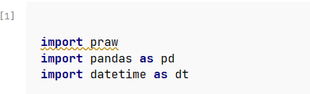
As PRAW is reddits own API it is needed to access the API with authorization and use the Python Reddit API Wrapper library
It is needed to get authorization from reddit to use reddit’s own API the process is not simple as it will be a task to create application for the use of the API
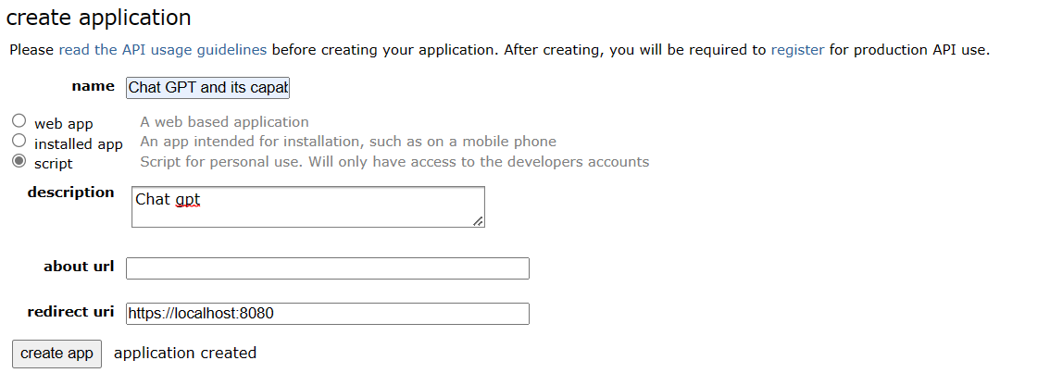

After gaining access reddit will redirect the page to this
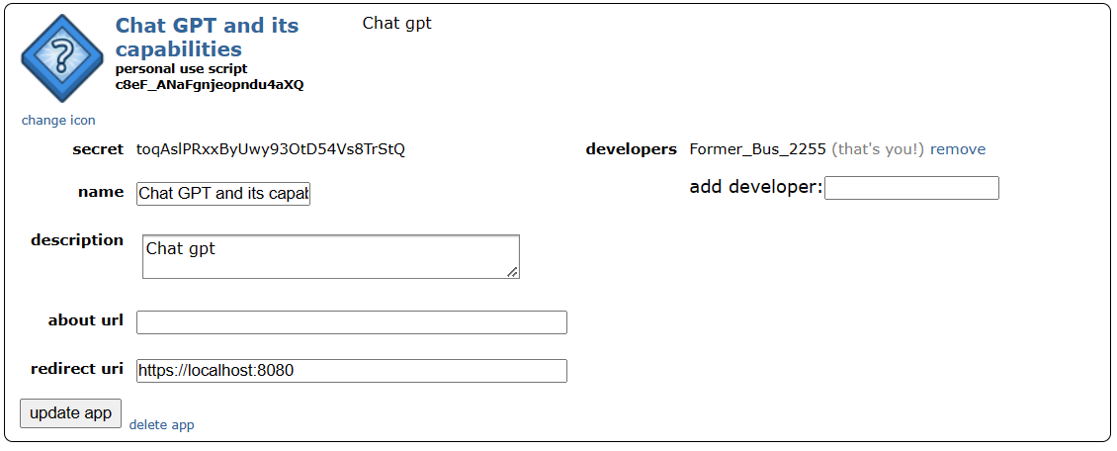
Where Reddit will provide the Client key, Secret key, User name and redirect URL which will be used for the upcoming steps
For the Data to be identified and collected a reddit instance is needed:
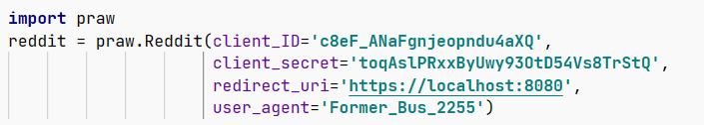
From which we will use the popular subreddits which are Machine Learning, AI, and Data science.
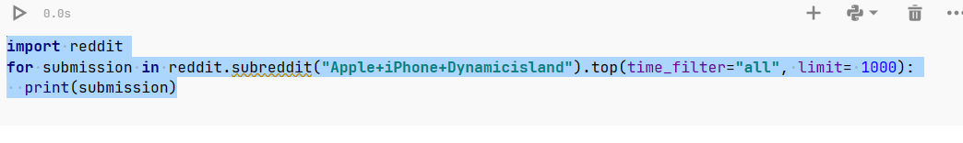
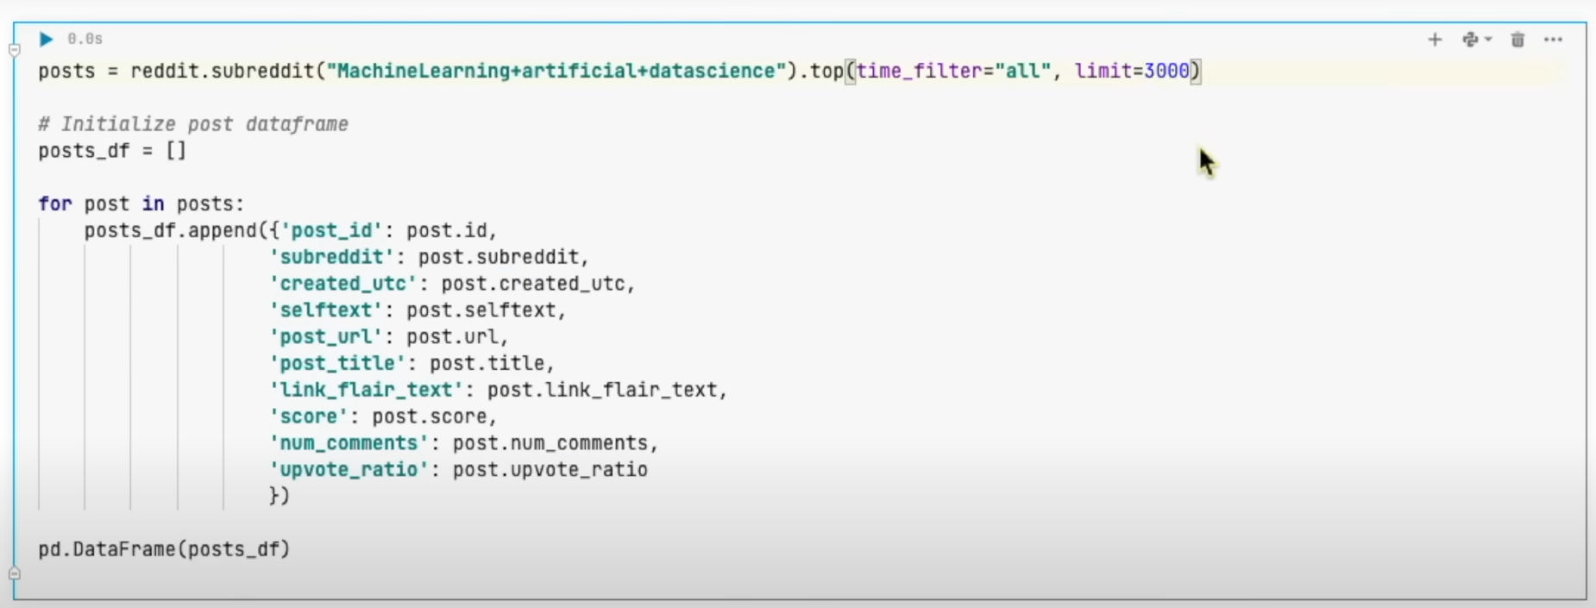
For collecting data on posts we have used the above codes to get the data frame
Note: Reddit allows 1000 per subreddit to scrape data but in this case, there are 3 subreddits so we can take 3000 as limit.

We now have the data in form and will have to convert to csv format.
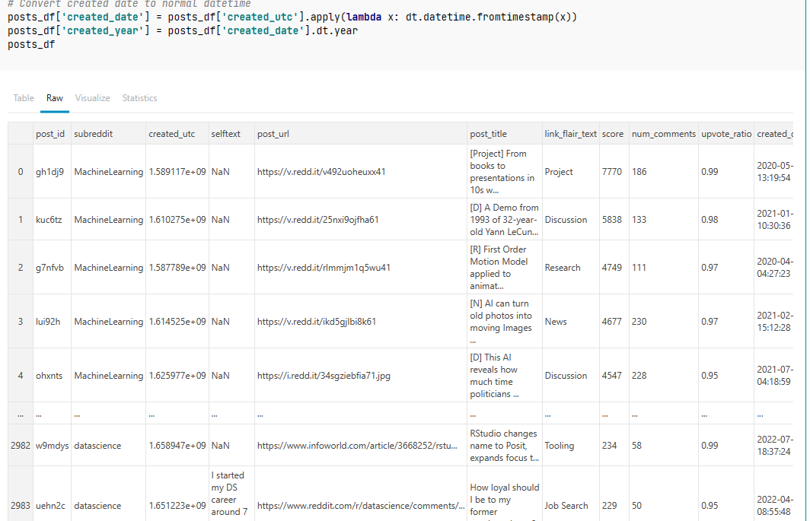

Next, we use the user id to get all comments by using the following codes and save as CSV file
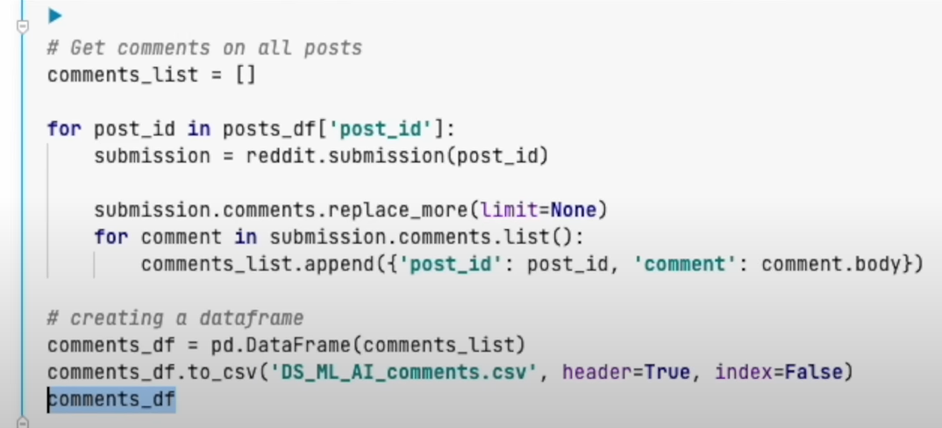

The data is stored in the CSV’s
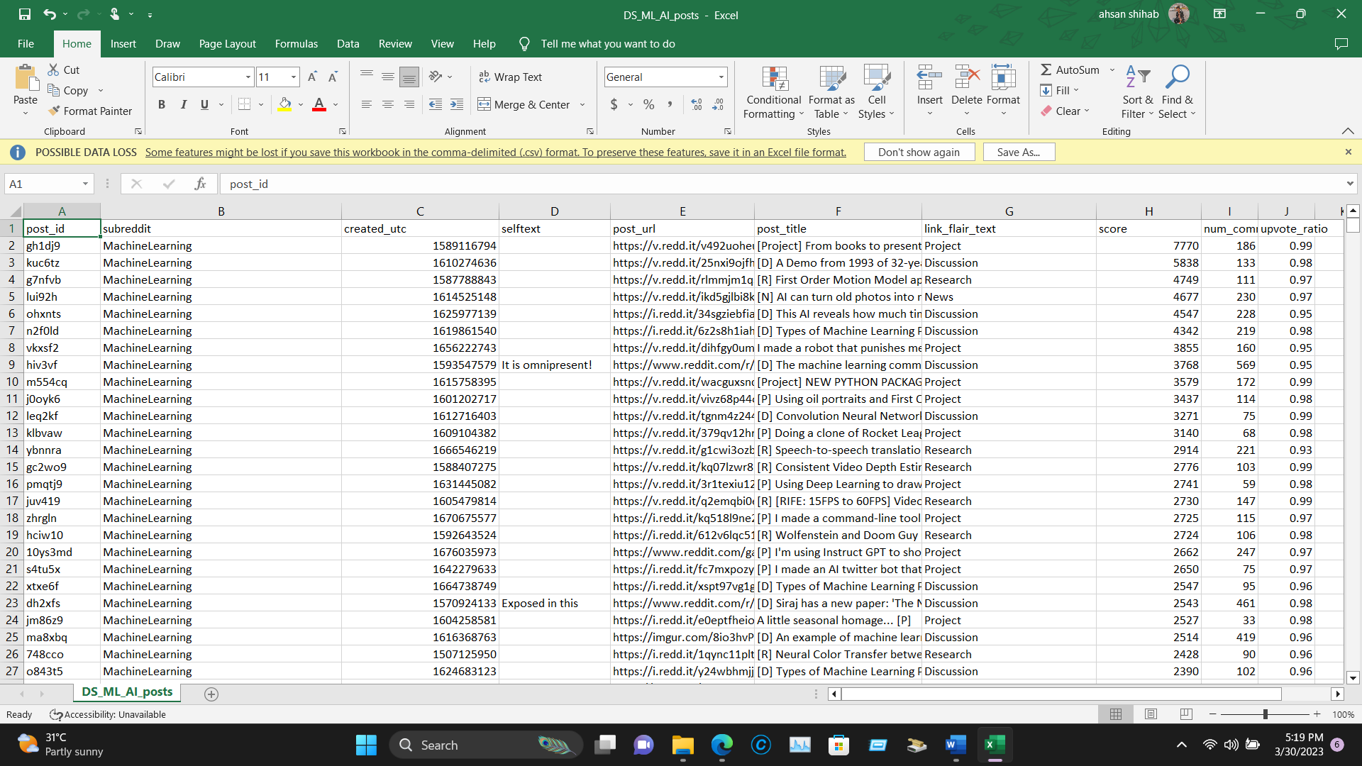
Note: The data here are filtered and take as cleaned data to be applied for further steps.

Description of the dataset used for training the model
Depending on the use case and application, a different dataset may be utilized to train the Chat-GPT API model when developing a chatbot using Reddit data and the Chat-GPT API. The dataset should generally be made up of pertinent Reddit discussions, comments, and posts that are typical of the kinds of chats the chatbot is anticipated to have.
Depending on the scope of the chatbot, the dataset may comprise a number of subreddits or communities. For this chatbot project, information from subreddits is r/machine learning, r/artificial, and r/data science may be used by a chatbot created to respond to inquiries regarding travel. Similar to this, a chatbot created to offer customer assistance for a certain product or service may make use of information from pertinent subreddits for that product or service.
To extract pertinent characteristics like sentiment, topic, and entity recognition, the dataset is first preprocessed. To do this, you may use natural language processing (NLP) methods including portion tagging, tokenization, and tokenizing.
It is crucial to remember that the quantity and quality of the data used to train the Chat-GPT API model can have a big effect on how well the chatbot works. The chatbot's capacity to produce contextually relevant replies and manage a wide range of user inputs can be enhanced with a bigger and more varied dataset.

Overview of the tools and technologies used in building the chatbot
Using the Chat-GPT API and Reddit data requires the usage of a number of different tools and technologies. An overview of the most popular tools and technologies used to create such a chatbot is provided below:
- Python: Python is an acclaimed programming language that is frequently used in web development, machine learning, and natural language processing. It is the preferred language for creating chatbots that use the Reddit and Chat-GPT APIs.
- The Open-AI-developed Chat-GPT API uses natural language processing to produce text answers that resemble those of real beings in response to user inputs. It is a pre-trained language model that has been improved on a substantial body of text data and may be used to provide logical and relevant replies to user queries.
- Reddit data may be easily extracted using PRAW, a Python wrapper for the Reddit API. It streamlines the procedure for gaining access to and removing pertinent discussions, comments, and postings from the site.
- A Python package called beautiful soup is used to parse HTML pages and scrape the web. It is frequently used in combination with PRAW to gather data for chatbot training from websites, particularly Reddit pages.
- Libraries for natural language processing (NLP): The Reddit data may be preprocessed using natural language processing libraries like NLTK, spaCy, and TextBlob in order to extract pertinent features like sentiment, topic, and entity recognition as well as to carry out other NLP activities.

Exploratory Data analysis
To understand the data visualization and plot for the data analysis it is needed to import WordCloud to see which topic is so much focused and seaborn to visualize data.
Transformers pipeline model is also crucial for Sentiment analysis.
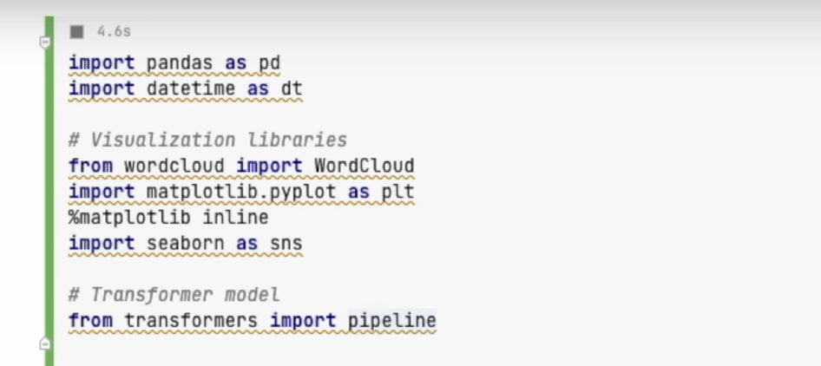
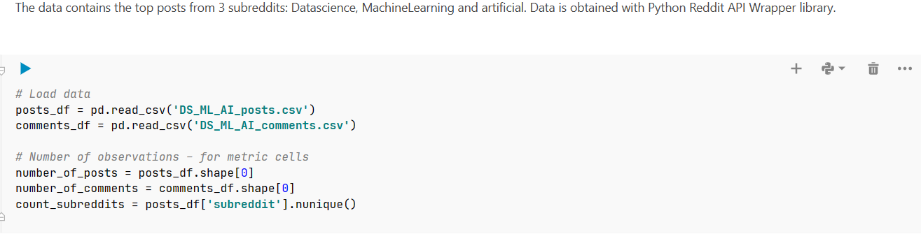
The next step involves the count of subreddits, post and comments as metric cell valuation
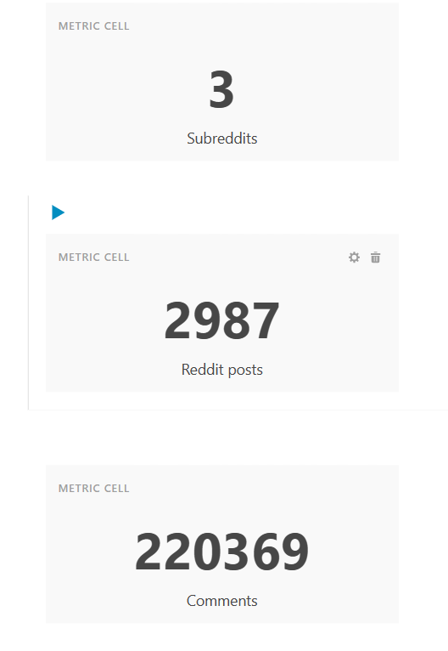
To use the data sets very efficiently it is needed to change the time stamp format to the date format for yearly analysis from the past.
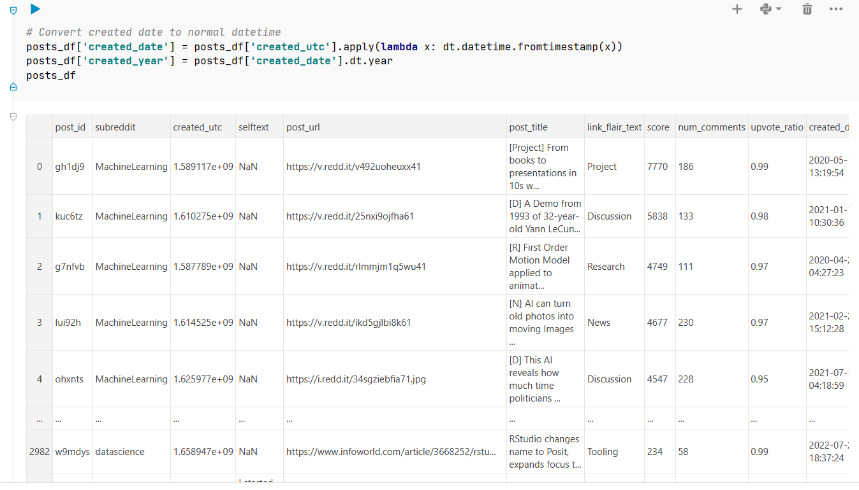 further need to merge the post and comments as it is unclear that which comment belongs to which post.
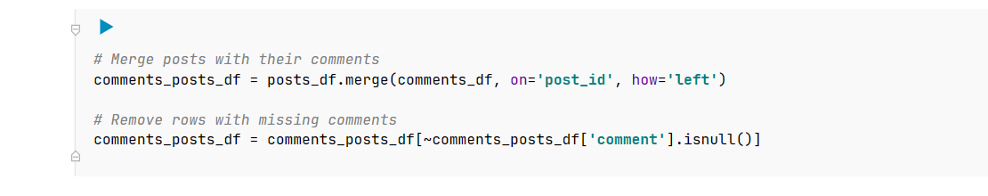

Resulting:
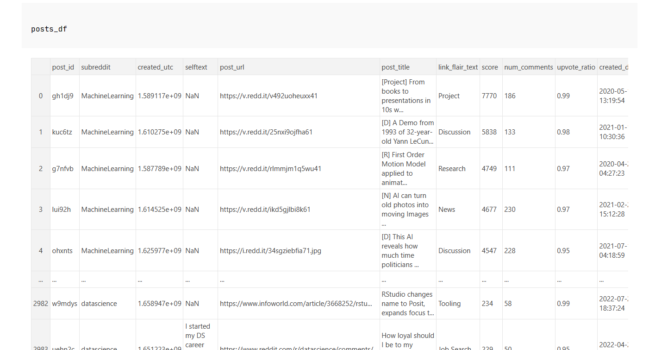

The Data Distribution Chart
from the 3000 posts dataset using the seaborn data visualization:
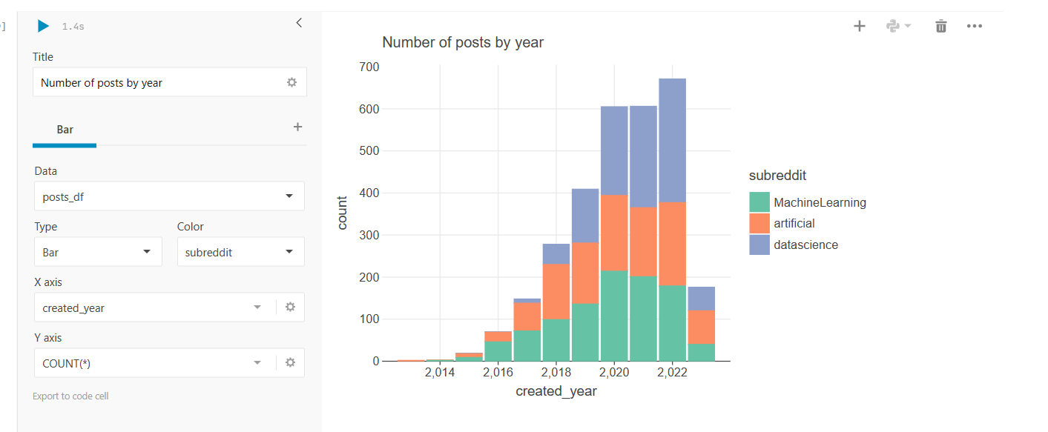

Word Cloud Titles
The next step involves what are the trending word terms based on the current topics related to. Word Cloud is the module to visualize the data set where the most trending topic out of 3 are related to.
The basic to get the Word cloud or to get the “Feelings” on the topics:
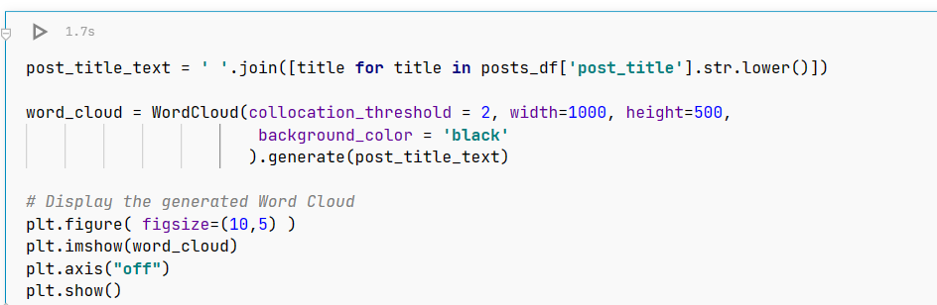

As the results will be shown:
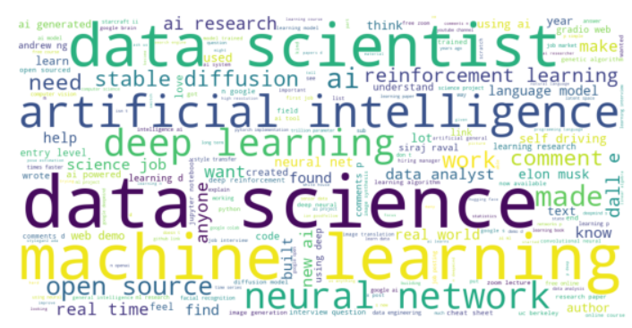

We can also use the Word cloud analysis for the past number of years by:
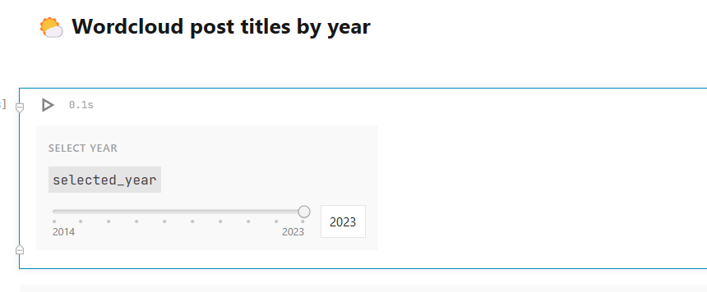
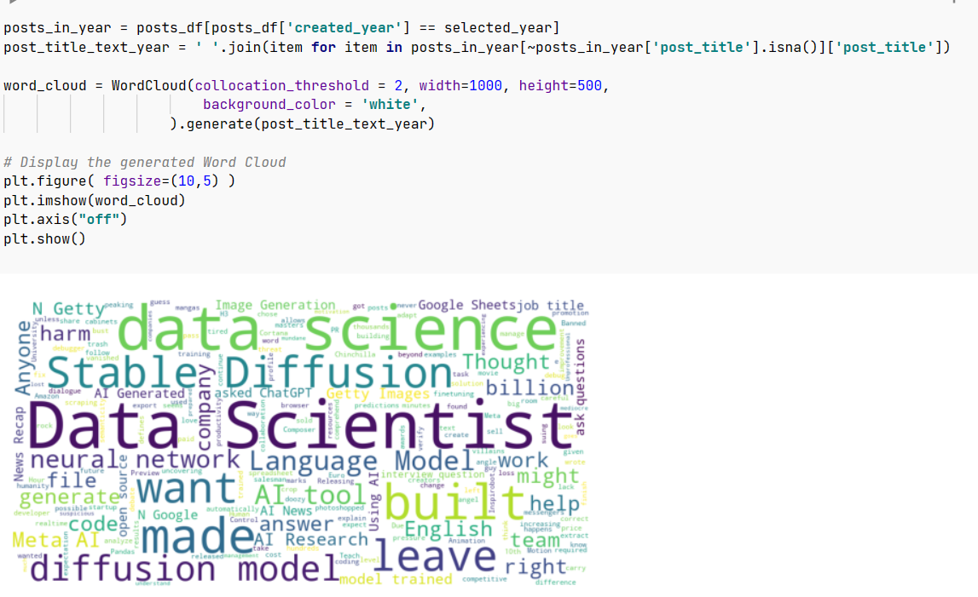

Sentiment and Emotion Analysis
To understand what sentiment analysis of specified topics that are input to the algorithms it is needed to use a model of machine learning but it is not important teach a machine learning model instead using a pre trained model is a good option to get the results
In this case the using a tweet data set model from “Hugging Face” is a good option to go for:
Using this model the classifications of text models from reddit is very similar to twitter
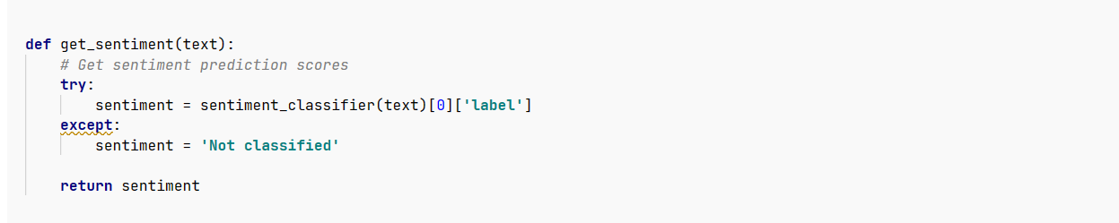
This code shows the text being classified if not then the sentiment will return as a non-classified sentiment.
Filtering the comments and post titles is a must to get the specified word input into output for example here using Chat GPT
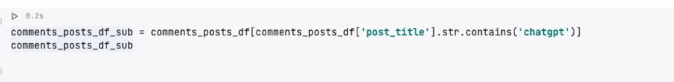
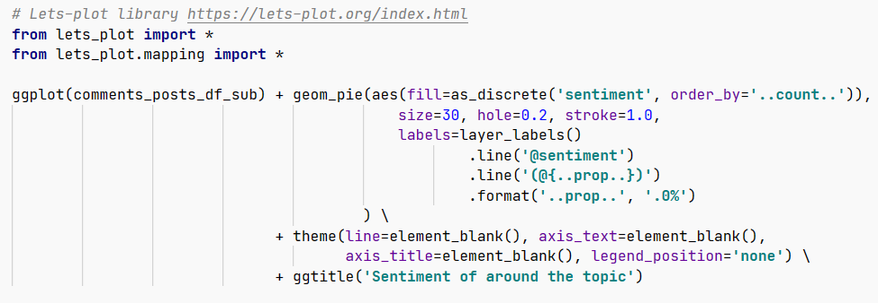 for sentiment

Sentiment analysis and showing visual representations towards Chat-GPT
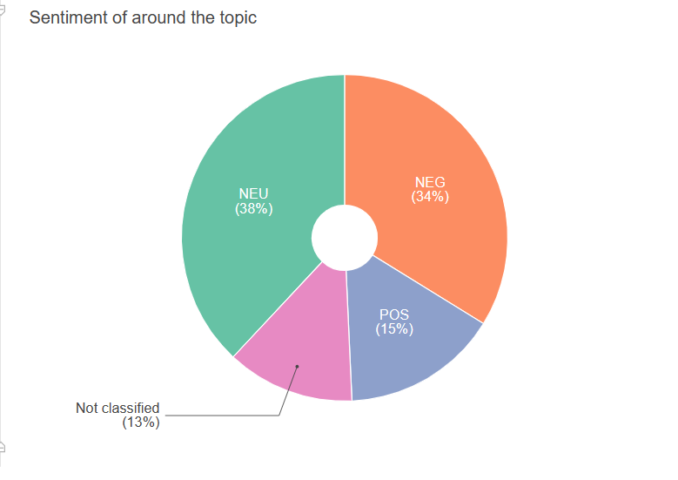
Emotions around the topic can be retrieved by:
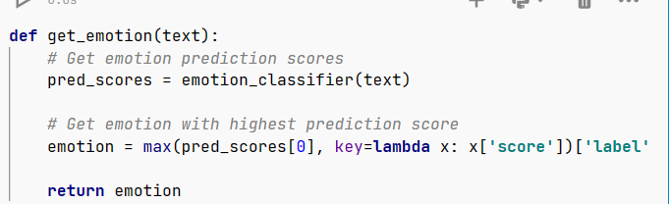

Resulting: 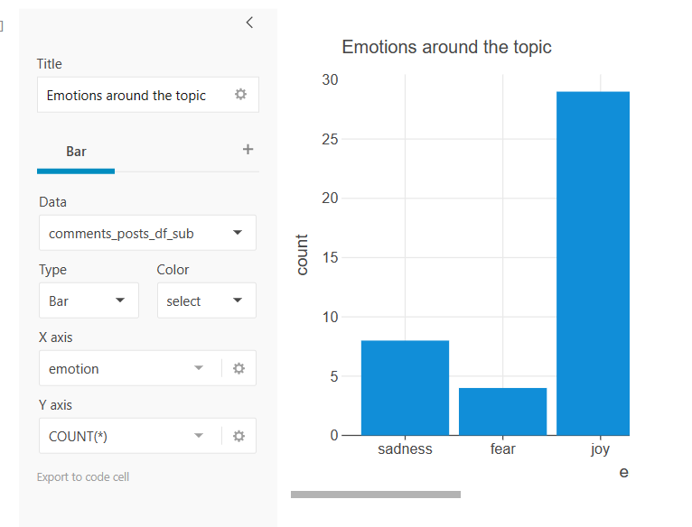

Making the CHATBOT

To integrate the reddit EDA as a chatbot, Chat-GPT 3.5 turbo API is to be used in order to get the results
To input context to the chatbot of reddit data prior to the knowledge has a token limit using Lama index helping in:
- Creating an index of Text chunks from the context.
- When users ask a question find the most relevant chunks.
Package of Lama index is to be installed:
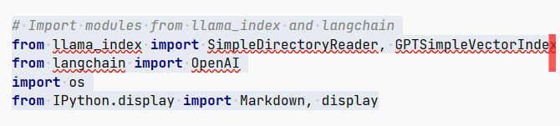
The next step is product a context file or in this case a large text file combining all comments from the dataset retrieved from reddit:
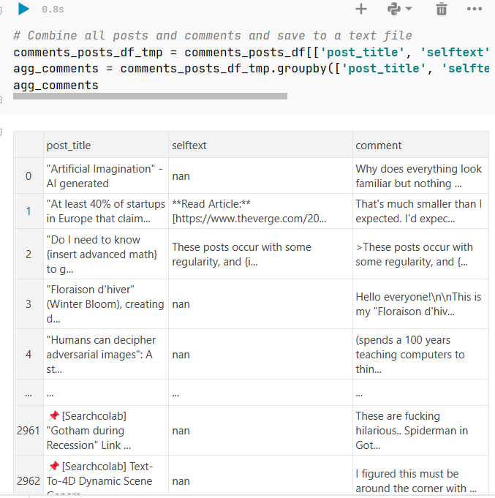
Saving the text file will involve combining all text into one txt file.
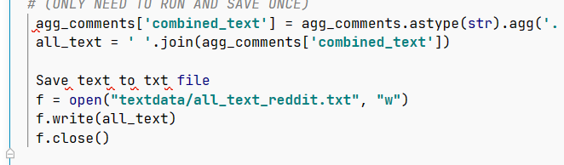

The next step is to provide a function to make the index from this txt file:
Note: The code below is taken from another source file created by Dan Shipper
Saving the index to a json file:
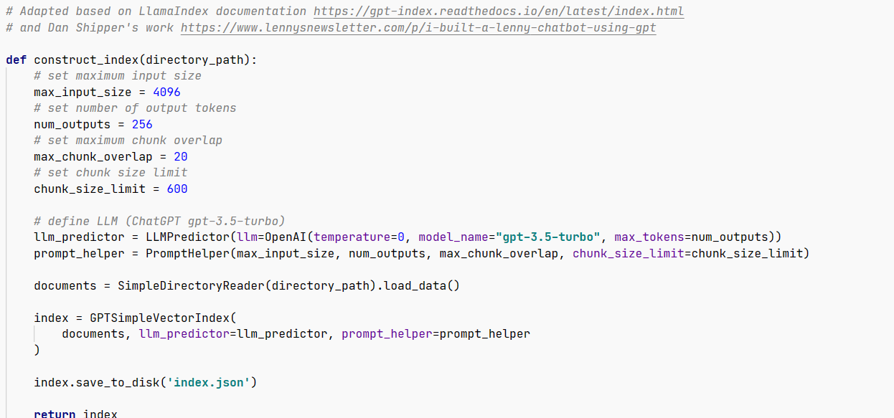

And finally, to make a function for the chatbot:
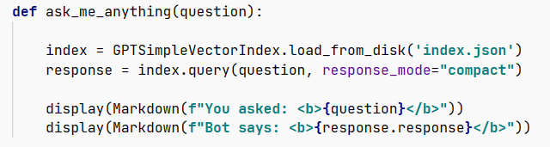
This function takes users question as a string loading the index json file. Generating the response using the index object.

To use this chat bot it is crucial to use an OPEN-AI key API key:
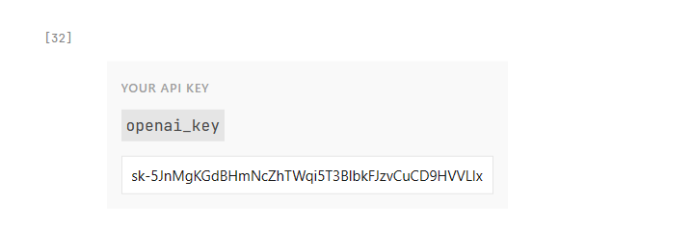
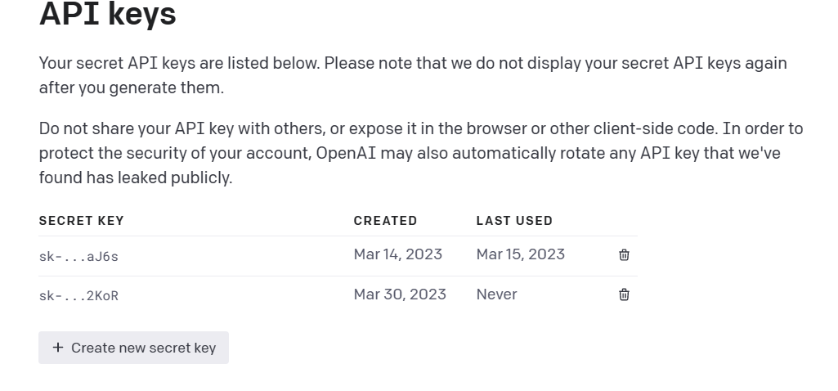
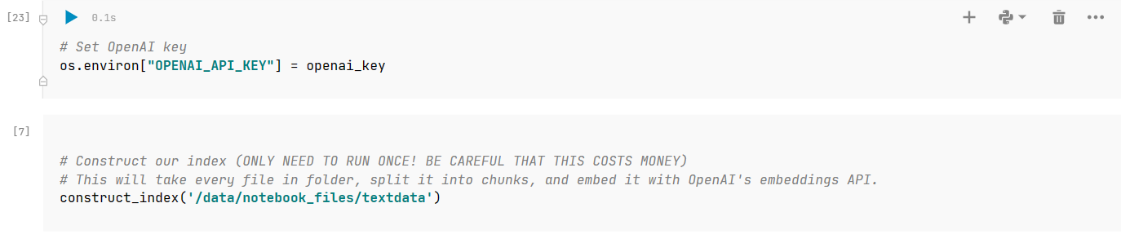

Chapter 4: Results

Presentation of the results of the chatbot built using Chat-GPT API and Reddit data.

Based on a number of measures, including correctness, coherence, and relevance of the generated replies, the performance of the chatbot developed using the Chat-GPT API and Reddit data may be assessed. The outcomes of the chatbot created using the Chat-GPT API and Reddit data are presented below:
- Accuracy: By contrasting the produced replies with the actual responses, the accuracy of the chatbot may be evaluated. The replies that are deemed to be the proper ones for a certain input are known as the regression coefficients responses. Precision, recall, and F1 score are a few measures that may be used to gauge accuracy. In this case the AI model has created sufficient results based on the query given by the user.

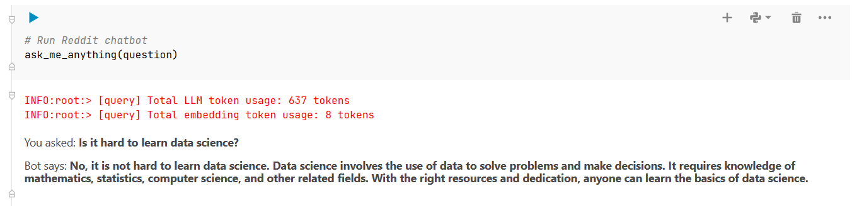
- Coherence: The chatbot's coherence is a measure of how effectively the replies it generates are related to the context of the input. By examining the conversation's flow and making sure that the replies are pertinent to the earlier inputs, coherence may be assessed. The coherence assessed is based on a limitation of the data set given to chatbot machine learning which is based on text file of Data science, Machine learning and AI. The limit is based on a limited amount of data related to these subjects. 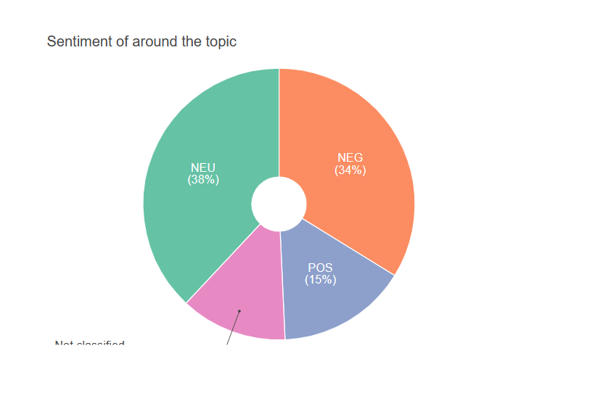

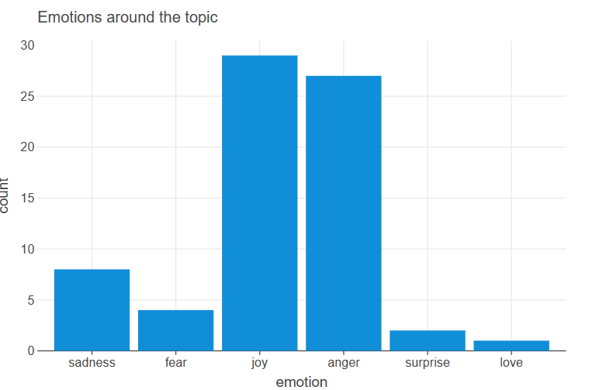

- Relevance: How effectively the produced replies respond to the user's query or meet their wants is referred to as the chatbot's relevancy. The appropriateness of the replies to the user's input can be used to gauge relevance. The relevance of the users input contrast to the out is based on the topics the AI is learning about as a result here the user inputs will always be related and bound to Data science, Chat-GPT, Stable Diffusion etc.
Let’s compare out comes of 2023 vs 2019 here for example:

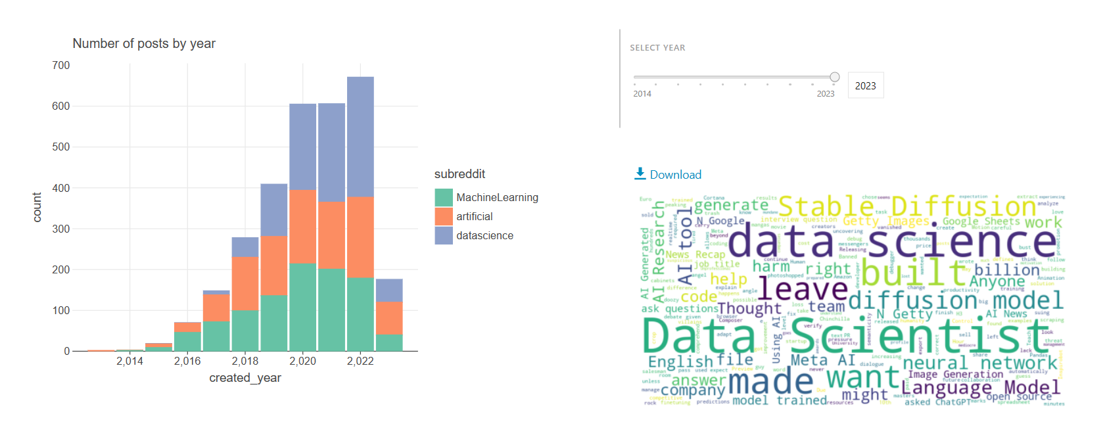
2023 Trend

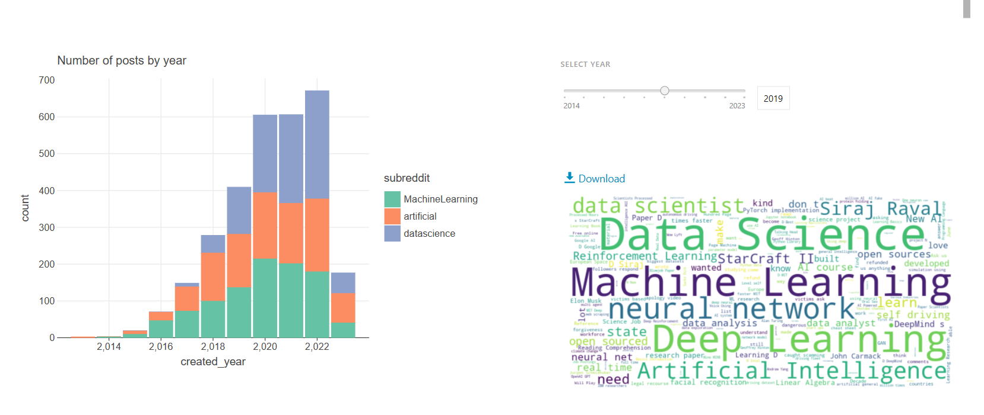
2019 Trend

Discussion of the strengths and limitations of the chatbot
- Strengths:
- Reddit data is a great resource for the chatbot's training since it has a ton of real-world conversation data that can be leveraged to increase the relevance, accuracy, and coherence of the produced answers.
- A chatbot that can comprehend and successfully reply to user input may be created using the Chat-GPT API, a potent tool for natural language processing.
- The chatbot may be built to offer consumers useful replies, making it an interesting and useful tool for getting in touch with customers.
- Limitations:
- The quality and relevancy of the Reddit data used to train the model are what determine how well the chatbot performs. The chatbot's produced replies could not be precise, comprehensible, or pertinent if the dataset is not representative of the target user population.
- Open-AI has placed a cap on the amount of API keys that may be used to access the Chat-GPT API, which implies that if the cap is reached, the usage of the chatbot may be restricted.
- Open-AI's tokenization approach has certain limitations, including the inability to tokenize texts that contain slang, colloquial language, or technical jargon. As a result, the chatbot could respond incoherently or with irrelevant information.
Benefits:
- Customer service may be automated with the help of the chatbot, which will lighten the strain on customer support agents and speed up response times.
- By responding to user questions with useful information, the chatbot may be utilized to increase consumer engagement and provide a better overall user experience.
- The chatbot can be flexible in how it adapts to various use cases and user bases since it can be trained on various datasets of Reddit data.

Chapter 5: Conclusion
In conclusion, the chatbot created utilizing the Reddit data and Chat-GPT API has both pros and weaknesses. While creating the chatbot, programmers must take into account the dataset's constraints, Open-AI API keys, and tokenization. Yet, the advantages of utilizing Reddit EDA to construct a chatbot based on provided datasets, such as enhancing user engagement and customer service, make it an important tool for enterprises and organizations.

Here are some suggestions for next studies on creating chatbots with the Chat-GPT API and Reddit data:
- Try with various Reddit data types to observe how they impact the functionality of the chatbot. Future study can investigate other Reddit data kinds, such as data from certain subreddits or data from different eras.
- Investigate more NLP models: Although the Chat-GPT API is a useful NLP tool, additional NLP models can be investigated in the future to determine how they stack up against the Chat-GPT API in terms of precision, coherence, and relevance.
- Create ethical standards for chatbot development: As chatbots proliferate, it's critical to create ethical standards for their creation and usage. Future studies might look into the moral issues involved in creating chatbots and create rules to ensure that they are utilized morally.
- Examine strategies to raise user engagement, as there is still potential for development despite the fact that chatbots can increase consumer satisfaction. Future study might look into how to personalize or add comedy to chatbot replies to make them more interesting.
The accuracy, coherence, and relevance of chatbot-generated replies may be improved with more study on the development of chatbots utilizing the Chat-GPT API and Reddit data. This will assist to guarantee that chatbots are utilized efficiently and responsibly.

References
(Adamopoulou & Moussiades, 2020a, 2020b; Ahmad et al., 2018; Arora & Sharma, 2023; Balsamo et al., 2021; Camizuli & Carranza, 2018; Dale, 2021; Dharani et al., 2020; Frangoudes et al., 2021; George & George, 2023; Hamilton et al., 2022; King & chatGpt, 2023; Koubaa, 2023; Lund & Wang, 2023; Molnár & Szüts, 2018; Nagarhalli et al., 2020; Nigar & Mohammed, 2023; Rahman et al., 2017; Rawat et al., 2022)

Adamopoulou, E., & Moussiades, L. (2020a). Chatbots: History, technology, and applications. Machine Learning with Applications, 2, 100006. https://doi.org/https://doi.org/10.1016/j.mlwa.2020.100006
Adamopoulou, E., & Moussiades, L. (2020b, 2020//). An Overview of Chatbot Technology. Artificial Intelligence Applications and Innovations, Cham.
Ahmad, N. A., Che, M. H., Zainal, A., Abd Rauf, M. F., & Adnan, Z. (2018). Review of chatbots design techniques. International Journal of Computer Applications, 181(8), 7-10.
Arora, M., & Sharma, R. L. (2023). Artificial intelligence and big data: ontological and communicative perspectives in multi-sectoral scenarios of modern businesses. foresight, 25(1), 126-143. https://doi.org/10.1108/FS-10-2021-0216
Balsamo, D., Bajardi, P., Salomone, A., & Schifanella, R. (2021). Patterns of Routes of Administration and Drug Tampering for Nonmedical Opioid Consumption: Data Mining and Content Analysis of Reddit Discussions. J Med Internet Res, 23(1), e21212. https://doi.org/10.2196/21212
Camizuli, E., & Carranza, E. J. (2018). Exploratory Data Analysis (EDA). In The Encyclopedia of Archaeological Sciences (pp. 1-7). https://doi.org/https://doi.org/10.1002/9781119188230.saseas0271
Dale, R. (2021). GPT-3: What’s it good for? Natural Language Engineering, 27(1), 113-118. https://doi.org/10.1017/S1351324920000601
Dharani, M., Jyostna, J. V. S. L., Sucharitha, E., Likitha, R., & Manne, S. (2020, 13-15 May 2020). Interactive Transport Enquiry with AI Chatbot. 2020 4th International Conference on Intelligent Computing and Control Systems (ICICCS),
Frangoudes, F., Hadjiaros, M., Schiza, E. C., Matsangidou, M., Tsivitanidou, O., & Neokleous, K. (2021, 2021//). An Overview of the Use of Chatbots in Medical and Healthcare Education. Learning and Collaboration Technologies: Games and Virtual Environments for Learning, Cham.
George, A. S., & George, A. S. H. (2023). A Review of ChatGPT AI's Impact on Several Business Sectors. Partners Universal International Innovation Journal, 1(1), 9-23. https://doi.org/10.5281/zenodo.7644359
Hamilton, K., Nayak, A., Božić, B., & Longo, L. (2022). Is neuro-symbolic AI meeting its promises in natural language processing? A&nbsp;structured review. Semantic Web, Preprint, 1-42. https://doi.org/10.3233/SW-223228
King, M. R., & chatGpt. (2023). A Conversation on Artificial Intelligence, Chatbots, and Plagiarism in Higher Education. Cellular and Molecular Bioengineering, 16(1), 1-2. https://doi.org/10.1007/s12195-022-00754-8
Koubaa, A. B., W.; Ghouti, L.; Alzahem, A.; Latif, S. . (2023). Exploring ChatGPT Capabilities and Limitations: A Critical Review of the NLP Game Changer. . https://doi.org/https://doi.org/10.20944/preprints202303.0438.v1. (Preprints 2023)
Lund, B. D., & Wang, T. (2023). Chatting about ChatGPT: how may AI and GPT impact academia and libraries? Library Hi Tech News, ahead-of-print(ahead-of-print). https://doi.org/10.1108/LHTN-01-2023-0009
Molnár, G., & Szüts, Z. (2018, 13-15 Sept. 2018). The Role of Chatbots in Formal Education. 2018 IEEE 16th International Symposium on Intelligent Systems and Informatics (SISY),
Nagarhalli, T. P., Vaze, V., & Rana, N. K. (2020, 6-7 March 2020). A Review of Current Trends in the Development of Chatbot Systems. 2020 6th International Conference on Advanced Computing and Communication Systems (ICACCS),
Nigar, M. S. S., & Mohammed, Y. S. (2023). Use Chat GPT to Solve Programming Bugs. International Journal of Information Technology &amp; Computer Engineering (IJITC) ISSN : 2455-5290, 3(01), 17-22. https://doi.org/10.55529/ijitc.31.17.22
Rahman, A. M., Mamun, A. A., & Islam, A. (2017, 21-23 Dec. 2017). Programming challenges of chatbot: Current and future prospective. 2017 IEEE Region 10 Humanitarian Technology Conference (R10-HTC),
Rawat, B., Bist, A. S., Rahardja, U., Aini, Q., & Sanjaya, Y. P. A. (2022, 20-21 Sept. 2022). Recent Deep Learning Based NLP Techniques for Chatbot Development: An Exhaustive Survey. 2022 10th International Conference on Cyber and IT Service Management (CITSM),

Appendix