Internship Report
On
“Recruitment and Selection Process of Abdul Monem Limited”

Sumaia Tasnim

This report is submitted to the school of Business and Economics, United International University as a partial requirement for the degree fulfillment of Bachelor of Business Administration

Internship Report
On
“Recruitment and Selection Process of Abdul Monem Limited”

Submitted to:
Name: Shayla Khanam
Designation: Assistant Professor
Major: Human Resource Management

Submitted by:
Name: Sumaia Tasnim
Id:111 201 186
Major: Human Resource Management
Registration Trimester: Spring 2024


School of Business and Economics
United International University
Date of submission: July 01, 2025

Letter of Transmittal

1st July, 2025
Shayla Khanam
Assistant Professor
School of Business & Economics
United International University
Subject: Internship report on “Recruitment and Selection Process of Abdul Monem Ltd.”
Dear Ma’am,
It is my privilege to submit to you my internship report on the “Recruitment and Selection Process of Abdul Monem Ltd,” The report was prepared based on my three-month internship period in Abdul Monem Limited’s beverage unit. The report was prepared based on the requirements needed in order to attain a bachelor’s degree in Business Administration (BBA).
It has been an honor to work at AML under experienced veterans of the industry and I was able to learn a lot in my short amount of time there. I tried my best to acquire the necessary information in order to write this report while working in the confines of a private limited company. I am grateful for the time you provide in order to advise and guide me while making the report and I hope the final result proves satisfactory to you based on your expectations. I am always available to clear up any queries regarding the report.
I hope you will oblige me by accepting my report.
Respectfully,
Sumaia Tasnim,
ID: 111 201 186

Certification of Similarity Index

Declaration of the Student

I am gratified to announce that this report on “Recruitment & Selection Process of Abdul Monem Ltd.” has been prepared by me under the guidance of Shayla Khanom for the partial fulfillment of BBA program, United International University (UIU) under the course Internship/Project (INT 4399). I also affirm that this report is innovative in nature and has not been acquiesced in another place aimed at all other purpose.
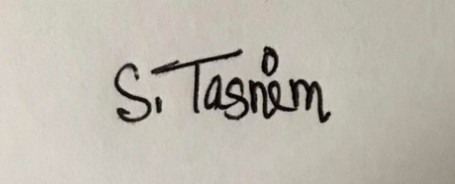

Yours Sincerely,
Sumaia Tasnim
ID: 111 201 186
School of Business & Economics

Corporate Evidence

Please find below my corporate experience as evidence of my industry engagement. This reflects my involvement in real-world professional settings and the skills I have developed through hands-on work
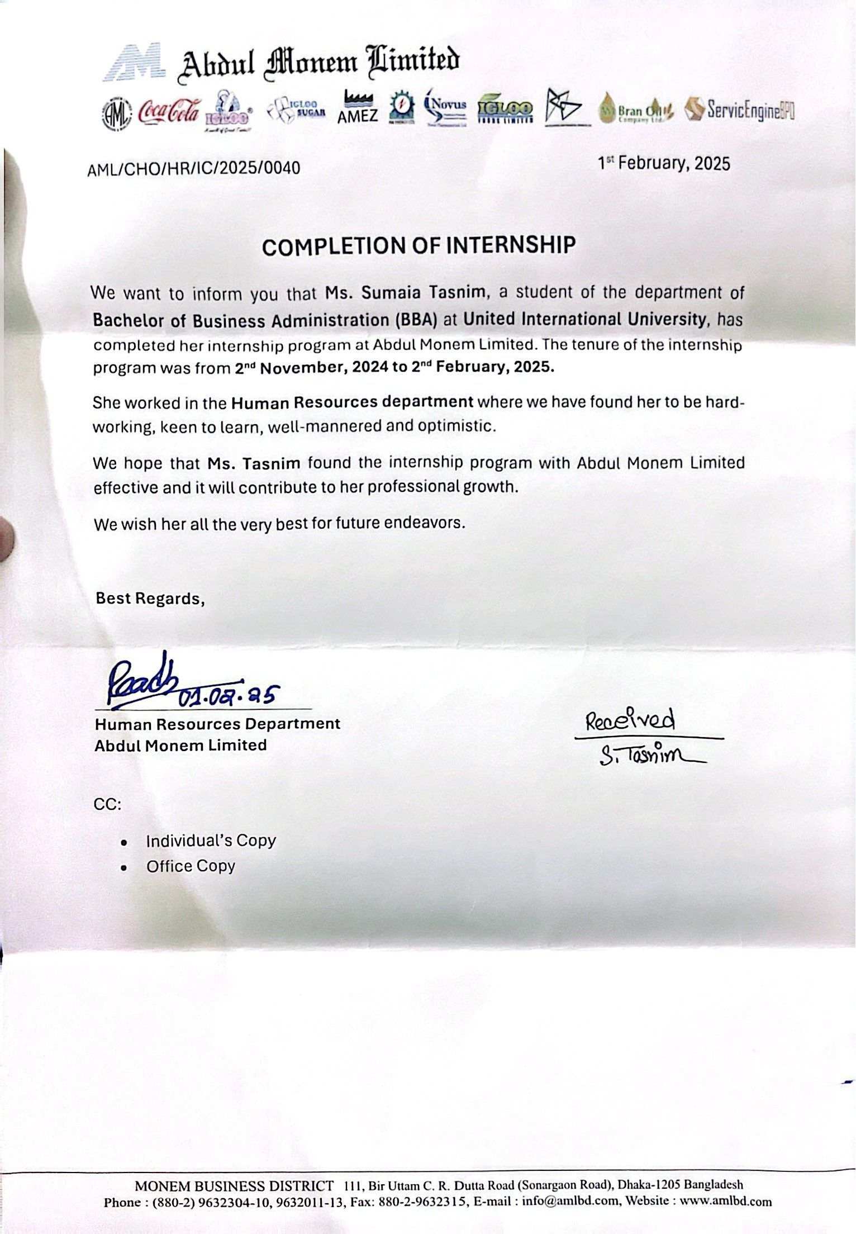

Acknowledgement

Every meaningful endeavor requires guidance and support for the successful realization of its objectives. This report, too, is the result of the invaluable assistance and blessings I received along the way & above all, the grace of Almighty Allah.
I would like to extend my heartfelt gratitude to the administration of United International University for organizing and overseeing this internship program. My deepest appreciation goes to Ms. Shayla Khanom (Assistant Professor, School of Business & Economics), for her unwavering support, insightful guidance, and encouragement throughout the preparation of this report. Her contributions have been truly indispensable and will always be remembered with gratitude.
I am also sincerely thankful to Mr. Ainul Haque Sardar, Head of HR (Group HR); Mr. Readh Hossain Chowdhury, Manager; and Mr. Md. Ryhan Mahmud, Senior Executive, Department of Human Resources at Abdul Monem Limited (Beverage Unit), for their generous cooperation and support during my internship. Their assistance significantly enriched my learning experience and made the preparation of this report possible.
Although this report is authored by me, it is a collective outcome shaped by the guidance, support, and encouragement of the aforementioned individuals. I remain deeply grateful to each of them.
Thank you.

Executive Summary
This report entitled (Recruitment & Selection Process of Abdul Monem Limited) is indicative of the many vigorous and sustained activities which are involved to reach the successful stage of recruitment of an employee. It is also indicated here that, the HR managers must receive a discernible number of activities that impact and influence the individuals, who are working in the organization and the horizontal intakes which in turn how these people have an influence over the recruitment process. I have written the standard process of the recruitment process and the process I have been intended to carry out in the organization. I have devised some important findings and substantial and useful proposals that could be useful to the organization. To this effect, all my data is obtained in both primary and secondary sources of data and the report is written in proper APA citation and adoption of standardization form of referencing. Besides, on annexure section, I have illustrated some of the important questionnaires that can substantiate appropriate recruitment and selection process. As a part of the report, it is depicted and visualized that AML (Abdul Monem Limited), has a very strong HR department and HR policy. It is also observed that AML will always ensure that it takes care of employee proper safety and health. They have embarked on many initiatives so as to guarantee the employees the right of security & health. In AML, their communication with the workers is given greater focus. In conclusion, each of the procedures makes the whole HR department of Abdul Monem Limited consummate.

Table of Contents
Letter of Transmittal iii
Certification of Similarity Index iv
Declaration of the Student v
Corporate Evidence vi
Acknowledgement vii
Executive Summary viii
List of Figures xi
List of Acronyms & Abbreviations xii
CHAPTER 1: INTRODUCTION 1
Introduction 2
1.1. Background of the Report 2
1.2. Objective Of the Report 2
1.3. Rationale of the Report 3
1.4. Scope and Limitations of the Report 3
1.5. Definition of Key Terms 4
CHAPTER 2: COMPANY AND INDUSTRY PROFILE 6
2.1. Company Analysis 7
2.1.1 Overview and History: 7
2.1.2 Trend and Growth: 7
2.1.3 Product / Service / Customer Mix: 8
2.1.4 Company Operations / Activity: 9
2.1.5 SWOT Analysis: 10
2.2 Industry Analysis 11
2.2.1 Specification of the Industry: 11
2.2.2 Size, Trend, and Maturity of the Industry: 12
2.2.3 Industry SWOT Analysis: 12
CHAPTER 3: INTERNSHIP EXPERIENCE 14
3.1. Position, Duties, and Responsibilities 15
3.2 Training & Development 18
3.3 Contribution to Organization / Operations 19
3.4 Evaluation 21
3.5 Skills Applied 21
CHAPTER 4: CONCLUSIONS AND KEY FACTS 24
4.1. Recommendations 25
4.2. Key understanding 26
4.3. Conclusion 30
Reference 31
Appendix 33

List of Figures
Figure No. | Figure Title | Page No.
Figure 1 | Recruitment Process Flowchart at AML | 14
Figure 2 | Employee Onboarding Checklist at AML | 17
Figure 3 | Organizational Hierarchy of Abdul Monem Limited | 20

List of Acronyms & Abbreviations
AML | AML Abdul Monem Limited
HR | Human Resources
HRM | Human Resource Management
AMSRL | AM Sugar Refinery Ltd.
AMBOL | AM Rice Bran Oil
BPO | Business Process Outsourcing
AMEZ | Abdul Monem Economic Zone
MBO | Management By Objective
UI | User Interface
CEO | Chief Executive Officer
ERP | Enterprise Resource Planning
TNA | Training needs assessment
OJT | On- the- Job Training

CHAPTER 1: INTRODUCTION

Introduction
Human Resource Management (HRM) being a component of an organization should be ready to handle the outcome of the evolving world of work. To them, these translate to being cognizant of the implications of globalization and the changes in technology, and the diversification of workforce, the changing necessities in skills, trying on a continuous improvement program, the depending workforce, decentralized workplaces and the input of employees (Huselid, 1995). An examination of how these transformations is influencing HRM goals and practices should be performed. The modern dilemmas of the HRM are to articulate programs related with human resources and strategy objectives within an organization. Besides, competition in organizations is immense across the globe (Wright & McMahan, 2011).

Background of the Report
Education appears to be complete with theoretical and practically acquired knowledge. The theoretical ideas can only teach us how to apply it in the real world but practical knowledge puts us in an actual situation in the real world so that we may apply the knowledge ourselves. The internship program has been garnished in the manner that will enable all students to obtain a preview of the actual corporate world operations with application of learned theories. The primary goal of this research is to achieve corporate culture and activities and to obtain a summarized picture of recruitment and selection process, which is the most significant HR activity; this will provide a generalized idea of how its functionality is done correctly (Bauer & Erdogan, 1998).

Objective Of the Report
The main objectives of this internship report are to gain practical insights into the recruitment and selection process of AML and to bridge the gap between theoretical knowledge and real- life practice.
- Primary Objective: To complete the academic requirement of the BBA program through an internship with a report based on the recruitment-selection activities of Abdul Monem Ltd.
- Secondary Objective: to study and review the recruitment-selection procedure observed at AML, and appraise the effectivity on the alignment of the practices with theoretical HR courses,

Rationale of the Report
The Rationale behind preparing this internship report is to bridge the gap between theoretical knowledge and practical experience by examining the recruitment and selection process of AML, one of the leading conglomerates in Bangladesh. As part of the BBA program, this report fulfills the academic requirements of conducting an in- depth organization study during the internship period.
The HR function, particularly recruitment and selection, plays a crucial role in shaping an organization’s workforce. By analyzing AML’S HR practices, this report seeks to uncover how theoretical concepts taught in university are implemented in real-life corporate environments. Through this study, the intern had an opportunity to gain first-hand insights into job analysis, application screening, interviewing, and selection methods , as well as the organizational challenges in attracting and retaining talent (Breaugh et al., 2008).

Scope and Limitations of the Report
The research will give the following scopes:
- The study focuses on the HRM department of AML having the focal emphasis on the recruitment-selection section.
- During the on-site internship within a certain time period in the HR division, all the data and inspections were collected.
- The report aims to distinguish the practical practices of the HR department with the theoretical knowledge obtained during the BBA program.
- The scope also includes understanding the framework of AML’s HR policies, recruitment criteria and the difficulties in hiring.
However, in spite of trying to make it thorough, there were a few limitations :
- Through the reasons of organizational confidentiality, some policy and information were not revealed.
- Already existing internal insights were not at the disposal of better comprehension.
- It is a challenge to know all the levels and the systems of an organization in such a short period of time.

Definition of Key Terms
- Recruitment: A procedure of recognizing and reaching potential applicants to fill in employment openings.
- Selection: The act of selecting an applicant, among others.
- Human Resource Management (HRM): The organization of some functionally related activities to employees like recruitment, development, and retention.
- Internal Recruitment: Using employees in the organization to fill vacancies through promoting or transferring them.
- External Recruitment: Recruitment of external candidates into the organization with the use of job postings or employment agencies.
- Onboarding: Incorporating new employees in the organization and training them as well as orientation.
- Aptitude Test: An exam that helps to analyze the problem-solving and reasoning skills of a candidate.
- Psychometric Test: An assessment of the personality, cognitive, and emotional intelligence of a candidate.
- Employee Relations: Employer-employee relationship addressing the problems of communication and managing conflicts.
- Job Analysis: Determining the responsibilities and the requirements of a job position.
- Job Description: The document is an explanation of the tasks, responsibilities and qualifications of a job.
- Recruitment Policy: During the employment of employees, an organization sets rules.
- Key Performance Indicators (KPIs): Action to figure out employee performance and goal alignments.
- Organizational Culture: The norms, convictions, and procedures are prevalent in an organization.

CHAPTER 2: COMPANY AND INDUSTRY PROFILE

Company Analysis

2.1.1 Overview and History:
Abdul Monem Ltd (AML) is a well-established conglomerated company that is richly diversified in Bangladesh. The company was embarked on by Mr. Abdul Monem in 1956 and began to provide its services in the construction industry. It also undertook mega national infrastructural projects all over the country. Its principal thinking has been inclined toward the monetary growth of the country Bangladesh since its establishment and the long-run concerns associated with the notions of quality and sustainability. Over the years, AML has diversified its portfolio, and it has made interests in various other industries, including the food and beverage industry, construction industry, real estate industry, consumer goods industry, as well as the financial service industry.
The association of AML brand with other brands of the world began in the late 1990s when it was made the single bottler of Coca-Cola in Bangladesh. Such an alliance put AML in the spotlight, and the corporation managed to create a massive niche in the beverage industry. This growth was accompanied by the introduction of other company products, which include ice cream, whose special brand, Igloo, was made famous in households. Another milestone to make AML one of the pioneers in industrial development in the country is the introduction of the Abdul Monem Economic Zone (AMEZ) in 2015.

2.1.2 Trend and Growth:
AML has continuously been on an upward growth path characterized by organic growth as well as strategic diversification. The company has been making more gains both locally and in international markets over the years. Two collaborative products (with Coca-Cola) have been a major component of boosting the company's market share in the beverages market. Projecting its growth and sustainability, AML has embraced cutting-edge technologies in its manufacturing activities as part of its efforts to maintain competitiveness in the fast-growing market.
Over the past years, the firm has been turning to growth beyond traditional product lines. It has diversified its services to offer foodstuffs, medicine, building materials, and even financial services that ensure a wide revenue base. AML has diversified its portfolio, and this has enabled it to shield its business against the risks of being too exposed in a given sector. Therefore, the company better responds to economic fluctuations.
Moreover, another objective of AML in the future is to take the opportunities given by the Abdul Monem Economic Zone (AMEZ) to draw foreign investments and support a variety of industries, including manufacturing and service-oriented businesses. To date, AML is still committed to infrastructural development and widening its presence in different industries with a solid strategic guide towards sustainability and long-term prosperity.

2.1.3 Product / Service / Customer Mix:
The companies of Abdul Monem Limited work in a wide variety of industries, but the most distinguished product lines are in the field of food and beverage. Given that it is the authorized bottler of Coca-Cola in Bangladesh, AML distributes and manufactures a variety of products in terms of beverages, such as soft drinks, bottled water, and fruit juices. The company markets these products in elaborate systems of retail stores both in urban and rural areas.
AML's other major product line is its brand of ice cream, Igloo, which has long played a great role in the market of dairy products and frozen food in Bangladesh. The company also manufactures other consumer products, such as cooking oil, and special food products, such as rice bran oil. AML manufactures and supplies many building materials in the infrastructure sector, has a presence in the construction industry, and deals mainly with large infrastructure tasks.
AML's customer base is vertical, with goods and services relating to both individual customers and corporate customers (Schein, 2010). Its products are used by wholesalers, retailers, food service outlets, and big industrial customers. Moreover, AML enjoys considerable market share in both rural and urban regions, which means that it will be eligible to access a broad customer base.

2.1.4 Company Operations / Activity:
AML trades across a number of industries, and its undertakings span a spectrum of sectors, which include manufacturing, distribution, and construction. At its food and beverage department, AML has established an ultra-modern food manufacturing facility where it carries out through ingress of beverage drinks and ice cream, among other foods. This is sustained through its strong distribution system that ensures that its products are sold in overseas markets as well as in the local market.
AML also exists in the construction and infrastructure building industry, including major-scale public projects and commercial undertakings. The company has been at the forefront of building major roads/bridges and airports in Bangladesh, and thus, its contribution to the country's economy and infrastructure has been enormous.
AML specializes in financial services other than construction and manufacturing, and its branches are involved in investment and wealth management. The firm has also decided to embrace digital technologies with the aim of ensuring that its activities are simple and effective in all its business divisions. Another notable element of the operations of AML involves the establishment of the Abdul Monem Economic Zone (AMEZ) since it is intended to draw investments, industrial development, and job creation within the region.

2.1.5 SWOT Analysis:
Strengths:
- Strong Brand Equity: The collaboration with Coca-Cola has gone a long way in mapping up the brand equity of AML in the beverage industry, as the company is a well-recognized name in the industry.
- Diversified Portfolio: Its product diversification in different sectors has helped the firm to be strong despite economic shocks.
- Operational Efficiency: The company has maintained a strong competitive position in the market through effective manufacturing systems and distribution links.
Weaknesses:
- Dependence on International Brands: Although the Coca-Cola tie-up is a significant advantage, AML has no control over some of its product lines since the company outsources some of its product lines.
- Focus on Certain Product Lines: Although its beverage and ice cream products are doing well, there are occasions when AML, in its concentration on these product lines, has forgotten to give its other product lines, such as the Igloo ice cream line, attention to the extent that they have the potential to grow.
Opportunities:
- Product Diversification: AML can expand its product range, particularly in healthy products such as fruit juices and organic products.
- International Expansion: The company has the opportunity to venture into other new markets other than Bangladesh taking advantage of the growing popularity of its products in other developing nations.
Threats:
- Intense Competition: The food and beverage industry, particularly in Bangladesh, is very competitive. Both local and international companies compete for market share.
- Market Saturation: Certain sectors, such as soft drinks, are nearing saturation, and AML may face challenges in sustaining growth without innovation.
- Economic Factors: Fluctuations in the economy and government regulations could affect AML’s operations, particularly in the construction and manufacturing sectors (De Dreu & Gelfand, 2008).

2.2 Industry Analysis
2.2.1 Specification of the Industry:
AML has its operations in various industries, among others in the food and beverage industries, construction and real estate, and consumer goods. All these industries have quite specific sets of challenges and possibilities. In another instance, the food and beverage industry are very competitive as new players keep entering the industry. The construction industry, on the other hand, has a steadier growth trend, which is based on national infrastructure projects.
The food and beverage market in Bangladesh has been one of the fastest-developing industries, thanks to rapid urbanization, a shift in consumer behavior patterns, and growth in the middle-income population. The construction industry, in turn, is affected by state projects and investments by the business community, which guarantee stable demand for building materials and infrastructure construction.
2.2.2 Size, Trend, and Maturity of the Industry:
The food and beverage industry in Bangladesh is considered one of the biggest industries in the economy, and its future growth is expected to remain stable in the coming ten years. The demand for packaged food and beverages is increasing, especially in urban areas, because of the high population and lifestyle change. The industry is currently mature, and in fact, it is experiencing expansion in other facets, such as health-conscious products, which are increasingly developing a popularity.
The same case applies to the construction industry, which is likely to improve since the government has been spending heavily on funding major infrastructure works. The movement is also towards more sustainable building practices and materials, which allows companies such as AML to be creative in this aspect.
2.2.3 Industry SWOT Analysis:
Strengths:
- Growing Consumer Demand: Growth of disposable income and urbanization have stimulated demand for packaged food and beverages.
- Government Support for Infrastructure: There is a demand for infrastructure development by the government, which gives opportunity to construction and allied industries.
Weaknesses:
- Saturation in Some Markets: Some parts of the food and beverage industry are maturing, so they cannot grow with differentiation.
- Rising Raw Material Costs: The rising prices of raw materials, including sugar and plastic, might impact profiteering.
Opportunities:
- Health-Conscious Products: Consumer demand for healthier food and beverage products is increasing, which can be viewed as an innovation opportunity.
- New Market Expansion: Enterprising firms have the opportunity to pursue foreign markets, especially in South Asia and the Middle East.
Threats:
- Intense Competition: Both local and international companies are vying for market share in the food and beverage sector, which could lead to price wars.
- Economic Volatility: Economic downturns and political instability could impact consumer spending and business operations (Huselid, 1995).

CHAPTER 3: INTERNSHIP EXPERIENCE

Position, Duties, and Responsibilities
My internship experience at Abdul Monem Limited (AML) was in the Human Resource (HR) department, where I got experience in taking part in different Human Resource activities of the company in terms of recruitment, selection, staff members induction, and generally employee handling. My position was to help me gain practical experience in HR functions in a large, well-established organization. I communicated and worked closely with the HR managers and fellow workers in helping them in their day-to-day activities and helping them in the recruitment and selection process.
Position Overview:
My job role was HR Intern, and my tasks mainly included recruitment and employee handling. I was supposed to carry out administrative tasks and help the HR department run smoothly. My duties included assisting in the recruitment process, helping with employee documentation, and orienting new employees.
Key Duties and Responsibilities:
- Recruitment Support:
One of my major obligations was helping in the recruitment process. I screened the resumes, shortlisted the candidates, and maintained the candidate records. I also assisted in organizing and coordinating the interviews by ensuring that the logistical concerns were clear, including the timing and booking of the interview sessions.
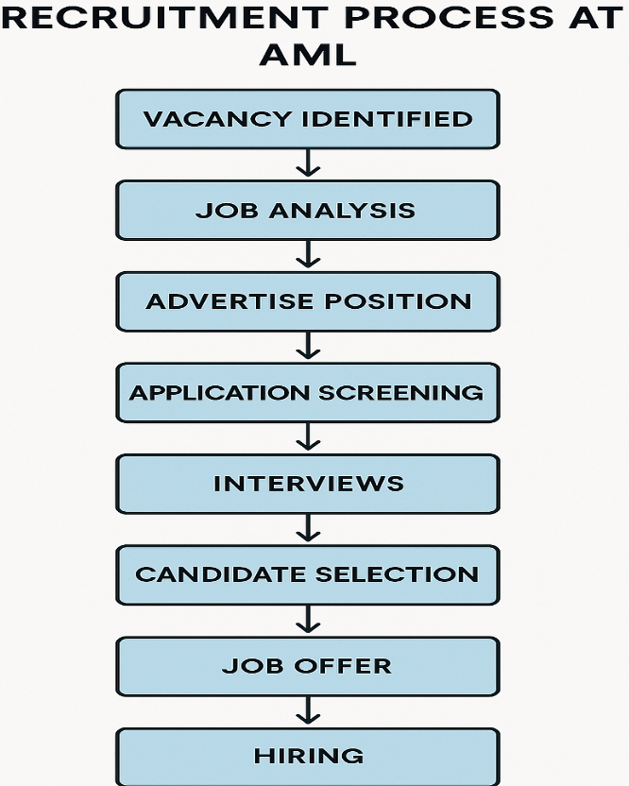
- Job Postings and Advertising:
I was also helpful in the development and publishing of job ads both internally and externally, e.g., job boards, websites, and recruitment sites or agencies. My responsibility entailed the clearance of job descriptions to be simple, clear, and in line with the AML standards of recruitment.
- Pre-screening and Interview Scheduling:
I was also involved in the pre-screening visit, where I looked at resumes to assess the candidates' qualifications. I also arranged interviews with shortlisted candidates and communicated with the department heads and top HR managers to ensure the interview process was successful.

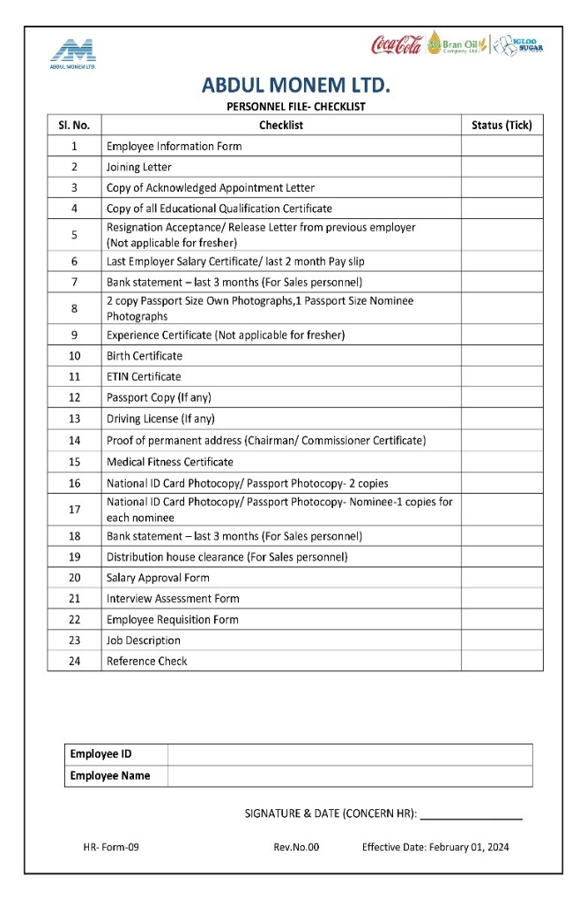
- Employee Onboarding:
I also helped welcome the recruits by verifying and processing all the necessary documents. I did likewise in orienting the sessions and familiarizing new workers with the culture, policies, and working environment of AML.

- Maintaining HR Records:
I assisted in maintaining and updating HR records so that employees' information is updated and readily available. This involved processing both hard and soft copies of employee records, such as recruitment papers, performance analysis, and employee benefits.
The position allowed me to get exposure to various matters of human resource management and also allowed me to test my academic understanding of the sphere in a real-life business environment. The duties enabled me to acquire feasible experience and more insight into HR practices, especially in recruitment duties and employee management (Marler & Fisher, 2013).

3.2 Training & Development
Employee development and the creation of continuous learning opportunities are highly considered, including interns, in AML. As an intern, I engaged in a number of training sessions, which guided me in acquiring both soft and technical abilities.
Induction and Orientation:
When I started my internship, I was taken to an induction program that enabled me to learn more about the values, mission, and structure of AML. The program gave me an understanding of how the company utilizes the system of business operation and the role of the HR department in attaining organizational objectives. There was also an office tour with me being introduced to major staff members and this actually made me gain comfort within the place of work very easily.
On-the-Job Training:
A part of my training was through experience on the job. Those superiors in HR are my mentors, so they helped me through guidance and constant feedback. Since I have been helping in the recruitment processes, I have gained experience in how to apply various HR concepts in recruitment, including good communication, the process of evaluating candidates, and recruitment decision-making processes. The mentorship was priceless as it guided me through the intricacies of HR activities in a corporate environment.
Workshops on Interviewing Techniques:
AML also carried out a workshop on the topic of interview skills which I was lucky to attend. The workshop touched on different methods of conducting interviews, such as behavioral and situational interviews, and gave an idea of how to assess candidates desirably. The workshop helped me realize the importance of asking the right questions and interpreting candidates' responses based on the nature of the positions in which they were being interviewed.

HR Software Training:
AML has the most up-to-date HR management software to track an applicant's credentials, employee records, and employee performance appraisals. The training I received on using this software proved to be very useful in ensuring that I performed my responsibilities well. The training involved inserting candidate information, scheduling interviews, and generating recruitment reports. This has given me practical experience in HR technology, which is a current big deal in HR work (Rasmussen & Ulrich, 2015).
Communication Skills Development:
AML also provided programs that aimed to contribute to the development of effective communication, especially in the working sphere. These sessions assisted me in perfecting my verbal and written communications because HR positions involve direct and precise communication with candidates as well as employees. I realized the value of active listening, professionalism, and clear communication.
Such training and development opportunities played a prominent role in developing my competencies and making sure that I was fit enough to assume a role in the HR department. I gained on-the-job experience of HR practices and a clearer idea of them, which I will take with me in life.

3.3 Contribution to Organization / Operations
During my internship, I contributed a lot to the HR operations of AML. In spite of the supportive position I was working in, my effort contributed to the efficient facilitation of various HR procedures, especially the recruitment and assimilation of staff members.
Improving Recruitment Efficiency:
My contribution was mainly in helping with the process of recruiting. The reduction of the amount of time wasted in the administrative activities of vetting candidates and arranging interviews led to more time wherein the senior HR team could focus on the more strategic aspects of recruitment. I also assisted in keeping a comprehensive database of applicants that was organized to help the group monitor the progress of different candidates and contact them effectively.
Support in Employee Onboarding:
I was instrumental in helping us onboard with new employees. I did not allow new employees to do everything about the firm without doing the necessary paperwork and documentation, so I also allowed new employees to be placed in the company without difficulty in their induction. After handing out the necessary information concerning the policies, culture, and work environment of AML, I assisted the newcomers to accommodate themselves efficiently and feel relaxed within their profession.
HR Data Management:
I helped maintain a proper HR database by updating employees' files and arranging databases. This made it easy to access highly critical employee information in the HR department, and it has facilitated the streamlining of other HR functions like performance appraisal and the definition of benefits.
Report Generation and Documentation:
I helped produce HR reports concerning recruitment progress, employee performance, and departmental needs. The top management used these reports to evaluate the HRs' activity and make their decisions well. This is because my contribution to the compilation and formatting of such reports made them easy to read and comprehend.
With these HR functions, I assisted in the general performance of the HR department of AML, which increased the operational efficiency and satisfaction among its employees. I also gained more insight into the HR practices being applied in a large organization, which allowed me to gain practical themes that will be helpful in my future profession (Backhaus & Tikoo, 2004).

3.4 Evaluation
At the end of the internship, my supervisor and team members also gave me formal and informal appraisals. This appraisal procedure helped me review my work and determine ways to improve.
Formal Performance Review:
The performance review was done during the end of my internship by my supervisor. Specifically, I was told that I was on time, thorough, and capable of juggling tasks in this review. Nevertheless, my supervisor recommended that I could still do more to enhance my interpersonal communication skills, especially with the candidates when conducting interviews. This was informative feedback that made me realize the gaps that I could work on professionally.
Self-Evaluation:
In the evaluation process, I did a self-evaluation. Within the scope of this evaluation, I thought about the events that happened and the abilities that I had gained during the internship. I was aware of my strengths in time management and organizational skills, but I understood that I had to improve my confidence in dealing with decisions, especially when it comes to selecting candidates.
Peer Feedback:
Besides getting feedback from the supervisor, I could ask my colleagues in the HR department through informal feedback. I was enthusiastic to learn and proactive in their work, and they liked it. They mentioned I could work independently after some time, and I could add value to the discussions and meetings of the team.

3.5 Skills Applied
As an intern at AML, I was in a position to practice some of the skills that I had gained both at the university and through past employment. These skills and the acquisition of some new ones necessary in the HR career were facilitated by the fact that the internship was practical.
Communication Skills:
Communication skills were one of the elements that I used well in my placement. I was in constant contact with job applicants, staff members, and other managers, who must have found all information delivered efficiently and with a high level of professionalism. I also practiced both oral and written communication since I drafted job postings, wrote emails, and interviewed.
Organizational Skills:
My task was to perform several things at a time, i.e., schedule interviews, organize recruitment activities, and keep the records of the candidates. These necessitated high levels of organization, and I learned how to manage time so that I prioritized my tasks and completed them within set deadlines.
Time Management:
It was a time-consuming HR department, yet it was fast. I also learned how to manage time well so that I could finish the work on time and balance urgent issues and routine duties.
Problem-Solving:
During my internship, I encountered cases where decisions needed to be made and problems solved quickly. Indicatively, when there were clashing interview schedules, I was able to learn how to recognize the problem and find a proper solution that would please all parties concerned.
HR Technology Skills:
My HR management software knowledge was applied in my internship, and I had the opportunity to have first-hand experiences with the software systems in tracking recruitments, employee data, and performance. This experience increased my technical knowledge and equipped me with good expertise in human resources tools of the modern era.
Teamwork and Collaboration:
I grew with the HR team and also learned how to work as a team and attain the team's goals. I attended team meetings, simply helped where I could, and gained a greater appreciation of how to work in a professional team situation.

CHAPTER 4: CONCLUSIONS AND KEY FACTS

Recommendations
AML could look into the following ways to enhance its HR practices with a view to sustaining growth:
- Improve job design to enhance the matching of the roles with the expectations of the employees.
- Java descriptions and specifications must be balanced in order to boost job satisfaction.
- Rewards have to be on performance so that it motivates employees more.
- Encourage the development of employee relations by meeting often, giving feedback as well as engaging the staff.
- Sharpen more skills through the organization of training and development activities at all levels.
- Ensure more recruitment to address the needs of talent in its various lines of business that are growing.
- Create a monitoring unit where the performances of employees are monitored.
- Evaluate the assessors' schedules every three months and use internal software to manage their availability.
- Ensure that you use varied channels of recruitment in order not to miss precious talent.
- Make an active move in hiring young talents across Bangladesh to inject fresh blood and thinking (Wright & McMahan, 2011).

Key understanding
During my internship period at Abdul Monem Limited (AML), I learned many issues regarding the operation of Human Resources (HR) and strategy in a big corporate organization. It was my experience that helped me to close the distance between the theoretical knowledge I had acquired at school and its practical usage in the job market. The following are the main learnings I got throughout my experience at AML:
  - The Importance of Structured Recruitment Processes:
Among the greatest lessons I learned during my internship experience is the importance of an effective recruitment and selection process. The recruitment strategies used by AML in the screening of resumes and the final interview stages stressed the need to ensure that the hiring process was competent in terms of clarity, efficiency, and fairness. I discovered how a recruiting process that has structure will ensure that the company gets access to the right personnel and does not make biased assessments. I also understood the importance of the recruitment activity to correlate with the goals and values of the company.
  - Candidate Experience and Employer Branding:
As an intern in the firm, the realization I had was that the experience that the candidate goes through in the recruitment process has a significant contribution to the brand of the employer. Unlike most hiring firms, AML does not only concentrate on getting the right applicants but also making them feel loved and adored in the recruitment and selection procedures. The treatment of the candidates, whether during the initial contact with the company up to the last recruitment process, has a significant effect on perceptions of the company. This involvement in an interview underlined the need to uphold a favorable and work-related image, even when a person might not be employed at the end of the day.

  - The Role of Technology in HR Functions:
I also gained appreciation for the position of technology in contemporary HR processes. At AML, the candidate application tracking system, employee data management system, and the reportage system on the activities of the different arms of the HR machinery were all facilitated by what was called the HR management software system, which drastically brought all the HR operations up by such a level. I understood how digital tools can automate the workflow, decrease the administrative burden of the HR team, and reinforce the impact of data-driven decisions made by HR professionals. The lesson that I learned is that I need to keep up with HR technologies and constantly seek out opportunities to enhance efficiency and automate many of the processes through the use of program examples.
  - Onboarding as a Key to Employee Retention:
One lesson that I learned during onboarding at AML is the importance of receiving new personnel in a way to helps them fit with the company. Onboarding may leave a lasting effect on staff retention and satisfaction with employment. Through my working experience, I witnessed the involvement of AML in ensuring proper employee onboarding namely training and cultural orientation, which helped increase the level of employee engagement and allowed seamless absorption of the newly hired employees. This once again confirmed the notion that onboarding does not only require paperwork but ensures the future extension of a healthy relationship that works around employees.
  - Communication and Interpersonal Skills in HR:
During my internship, I have realized that communication is central to the activities of HR. It would be either communicating with candidates, interacting with department heads, or communicating with team members, but in all these cases, communication played a significant role in the goings-on. I was taught the thing about the necessity of clear, clean communication in any form. Moreover, the professionals working in HR ought to be good at interpersonal relations to establish cooperation and trust amongst employees and the candidates as well, therefore, the HR department is considered pivotal to preserving the organizational culture.
  - The Significance of Data-Driven Decision Making:
I also realized the essence of using data in HR decision-making. The data-driven recruitment strategy aimed at monitoring the process of recruitment, evaluating the performance of employees, and making HR decisions is one of the AML practices. My participation in the creation of recruitment reports allowed me to understand how data can help gain important information on the success of HR strategies (De Dreu & Gelfand, 2008). Now, I understand that HR functions cannot be entirely built on intuition. However, they have to be organized on the basis of evidence-based practices in order to lead to improved results for the organization.
  - Understanding of Organizational Culture and HR’s Role:
In my experience at AML, I also got a clearer picture of how the roles of the HR can shape and retain organizational culture. AML emphasizes much on having a good working culture through it; Human resources is important in ensuring people change their ways and fit the culture and the values of the organization. All these developments with recruitment, onboarding, and employee engagement efforts help develop a working environment that values employees, motivates them, and makes them connected to the mission of the company. I also understood that HR is not an auxiliary activity but a significant collaboration in implementing cultural change and organizational success (Schein, 2010).

  - The Challenges of Balancing Strategic and Administrative HR Tasks:
Among the most significant insights I obtained was the balance that HR professionals have to maintain between HR strategic decision-making on the one hand and administrative work on the other hand. Though the alignment of HR practices to the goals and strategy of the company is crucial, HR departments are usually overwhelmed with administrative work, i.e., managing the documents related to hiring, organizing interviews, and making sure they comply with labor laws. I observed that the AML HR department was able to control both points, and this helped me to value the responsibility of HR in making both operations smooth and growth strategic.
  - Employee Relations and Conflict Resolution:
The second key learning point was that employee relations should always be good. As an intern, I was also allowed to observe how the HR department tries to avoid poor relationships between employees and management, hence a peaceful working relationship. An important part of my learning was conflict management, listening to the issues of the employees, and making all of them feel heard. I learned that it is not merely an administrative role that HR can play. However, it can also serve as a mediator in addressing the issue of conflicts and in keeping employees satisfied and encouraged.
  - Continuous Improvement in HR Practices:
Finally, I have learned about the necessity of perpetual betterment in HR practice. The HR department of AML is always monitoring its procedures and possibilities to make its recruitment strategy, employee involvement practices, and general activities of the HR department better. This concern about improvement enables the organization to keep abreast of changing tendencies in the business environment as well as offer it the guarantee that it will continue to be competitive. As I have experienced, I came to know that HR should be dynamic and be willing to change as per the organizational requirements (Huselid, 1995).

4.3. Conclusion
Human Resources will act as the backbone of any organization since it will ensure that the best people are recruited and nurtured to bring success. Abdul Monem Limited's HR unit has become well-structured and efficient, handling picky records and corporate needs. The department is important in handling employee’s inquiries, upholding the company standards, and assisting the employees. The recruitment process of AML is both systematic and formal, and transparency and efficiency are guaranteed whereby there is documentation in place such as requisition of manpower, assessment tools, salary surveys, and training plans. The internship turned out to give an invaluable experience concerning AML recruitment and HR. It did not only increase my professional insight into job hiring practices, but also made me introduce to a corporate workplace culture. The culture-driven at the employee level has also demonstrated to me that it is people within an organization being enthused and supported that leads to the success of organizations (Bauer & Erdogan, 1998).

Reference
Bauer, T. N., & Erdogan, B. (1998). Organizational socialization. Personnel and Human Resource Management, 16, 149-214. https://www.researchgate.net/profile/Berrin-Erdogan/publication/285984504_Organizational_Socialization_Outcomes_Now_and_Into_the_Future/links/56742c8808aebcdda0de1f17/Organizational-Socialization-Outcomes-Now-and-Into-the-Future.pdf
Backhaus, K., & Tikoo, S. (2004). Conceptualizing and researching employer branding. Career Development International, 9(5), 501–517. https://doi.org/10.1108/13620430410550754
Breaugh, J. A., Macan, T. H., & Grambow, D. M. (2008). Employee recruitment: Current knowledge and directions for future research. International Review of Industrial and Organizational Psychology 2008, 23, 45-82. https://doi.org/10.1002/9780470773277
De Dreu, C. K. W., & Gelfand, M. J. (2008). The psychology of conflict and conflict management in organizations. Lawrence Erlbaum Associates. https://api.pageplace.de/preview/DT0400.9781136679926_A23855965/preview-9781136679926_A23855965.pdf
Huselid, M. A. (1995). The impact of human resource management practices on turnover, productivity, and corporate financial performance. Academy of Management Journal, 38(3), 635–672. https://doi.org/10.5465/256741
Marler, J. H., & Fisher, S. L. (2013). An evidence-based review of e-HRM and strategic human resource management. Human Resource Management Review, 23(1), 18–36. https://doi.org/10.1016/j.hrmr.2012.06.002
Rasmussen, T., & Ulrich, D. (2015). Learning from practice: How HR analytics avoids being a management fad. Organizational Dynamics, 44(3), 236–242. https://doi.org/10.1016/j.orgdyn.2015.05.008
Schein, E. H. (2010). Organizational culture and leadership (4th ed.). Jossey-Bass. https://books.google.com.bd/books?id=Mnres2PlFLMC
Wright, P. M., & McMahan, G. C. (2011). Exploring human capital: Putting ‘human’ back into strategic human resource management. Human Resource Management Journal, 21(2), 93–104. https://doi.org/10.1111/j.1748-8583.2010.00165.x

Appendix
Survey Questionnaire
How did you learn about job vacancies at AML?
☐ Online job portals (e.g., Bdjobs.com)
☐ Company website
☐ Employee referral
☐ Advertisement in newspapers
☐ Other (Please specify):
How would you rate the clarity of the job description provided during the recruitment process?
☐ Very clear
☐ Somewhat clear
☐ Neutral
☐ Somewhat unclear
☐ Very unclear
How satisfied are you with the initial communication from the HR team during the recruitment process?
☐ Very satisfied
☐ Satisfied
☐ Neutral
☐ Dissatisfied
☐ Very dissatisfied
How easy was it to apply for a position at AML?
☐ Very easy
☐ Easy
☐ Neutral
☐ Difficult
☐ Very difficult
Was the recruitment process timely and efficient?
☐ Yes, very efficient
☐ Yes, somewhat efficient
☐ Neutral
☐ No, somewhat inefficient
☐ No, very inefficient
Did you receive timely feedback after the interview?
☐ Yes, very timely
☐ Yes, somewhat timely
☐ Neutral
☐ No, somewhat delayed
☐ No, very delayed
How would you rate the overall interview process at AML?
☐ Very effective
☐ Effective
☐ Neutral
☐ Ineffective
☐ Very ineffective
Were the interviewers professional and respectful during the interview?
☐ Yes, very professional
☐ Yes, somewhat professional
☐ Neutral
☐ No, somewhat unprofessional
☐ No, very unprofessional
Did the recruitment process provide you with adequate information about AML’s company culture?
☐ Yes, very informative
☐ Yes, somewhat informative
☐ Neutral
☐ No, somewhat uninformative
☐ No, very uninformative
How transparent were the HR team’s communication regarding the selection criteria?
☐ Very transparent
☐ Somewhat transparent
☐ Neutral
☐ Somewhat opaque
☐ Very opaque
How would you rate the thoroughness of the job-related assessments (e.g., aptitude tests, personality tests) during the selection process?
☐ Very thorough
☐ Thorough
☐ Neutral
☐ Somewhat superficial
☐ Very superficial
Was the job offer process clear and straightforward?
☐ Yes, very clear
☐ Yes, somewhat clear
☐ Neutral
☐ No, somewhat unclear
☐ No, very unclear
How satisfied are you with the overall recruitment and selection process at AML?
☐ Very satisfied
☐ Satisfied
☐ Neutral
☐ Dissatisfied
☐ Very dissatisfied
Were you informed about the onboarding process before you joined?
☐ Yes, completely informed
☐ Yes, somewhat informed
☐ Neutral
☐ No, somewhat uninformed
☐ No, very uninformed
Did the onboarding process at AML provide adequate support to help you settle into your role?
☐ Yes, very supportive
☐ Yes, somewhat supportive
☐ Neutral
☐ No, somewhat unsupportive
☐ No, very unsupportive
How likely are you to recommend AML as an employer to others?
☐ Very likely
☐ Likely
☐ Neutral
☐ Unlikely
☐ Very unlikely
Do you think AML’s recruitment and selection process ensures fairness and equal opportunity for all candidates?
☐ Yes, completely fair
☐ Yes, somewhat fair
☐ Neutral
☐ No, somewhat unfair
☐ No, very unfair
What improvements, if any, would you suggest for the recruitment and selection process at AML?
☐ More transparent communication
☐ Faster feedback process
☐ More detailed interview preparation
☐ Better onboarding procedures
☐ Other (Please specify):

