Internship Report
Analyzing the Voice of the Brand Clemon: Integrated Marketing Communication

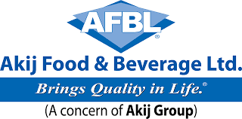

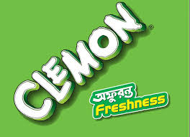



Internship Report
Analyzing the Voice of the Brand Clemon: Integrated Marketing Communication

Intern Supervisor:
Dr. Md. Shariful Alam
Associate Professor
School of Business and Economics
United International University

Submitted By:
Ashiqur Rob Ashique
ID: 111-131-283
School of Business and Economics
United International University

Date of Submission: 14th October 2018

Acknowledgement

All praises to the Almighty Allah forgiving me physical & mental strength, and blessings to successfully carrying out the Internship Report.
I would like to convey my heartiest gratitude to my Internal Supervisor Dr. Md. Shariful Alam, Associate Professor, United International University, School of Business and Economics, United International University for giving me the opportunity to conduct my internship report on “Analyzing the Voice of the Brand Clemon of AFBL: Integrated Marketing Communication” and for his continuous supporting preparing this report. It would have been difficult for me to prepare my internship report without his support. I would like to thank my external supervisor Abdul Aziz, Assistant Manager, Brand Department, Akij Food and Beverage Limited. I am also thankful to all the faculty members and teachers of UIU Business School for equipping me with the knowledge and tools for the preparation of such a report.

I am deeply indebted to Maidul Islam, AGM and Abdul Aziz Assistant Manager of Akij Food and Beverage Limited.
I am also owed and thankful to each person who provides their co-operation inside of Akij Food & Beverage Ltd in carrying out this report with reliable information. And last but not the least, I wish all my unwilling and unintentional mistakes for example miss presentation of kind of information will be forgiven.

Table of Contents
Executive Summary 6
Chapter- 1 7
Organization Overview 7
Akij Group: An Overview 8
Board of Directors 10
Chapter - 2 15
Introduction 15
Chapter 2: Introduction 16
Rational of Study 16
Statement of Problem: 16
Objectives of the Report: 16
Scope of the Study 16
Methodology: 17
Limitation of the report: 17
Chapter- 3 19
All Brands & Promotional Analysis 19
Mojo 20
Clemon 22
Goal: 28
Chapter-4 34
Integrated Marketing Communication 34
Introduction 34
Objective of integration 35
Market Analysis of Clemon: 44
Poster Observation of Clemon 56
Chapter – 5 66
SWOT Analysis 66
SWOT Analysis of AFBL 67
Chapter – 6 70
Finding and Conclusion 70
Findings 71
Recommendations: 71

Executive Summary

The report contains the Akij Food & Beverage Ltd profile and data about the brand, products, Analysis of market and company history. The report also outlines integration policy and Process of the Company’s long-term solvency. Effective communication is understood to be where messages are passed without any disruption and have the best clarity. This new mode of communication guarantees this sort of communication as well as promoting relationships between our companies and other target audience. The overall effect is a boost in the company’s profit margins. The future plans of the company are discussed which fills a strong positive attitude. This report also contains objectives, values, brand strategies, strategic group map & SWOT analysis and Market analysis of Akij Food & Beverage Ltd.
Integrated marketing communications is a marketing strategy that has emerged in the recent past. The new strategy seeks to fuse modern and traditional marketing strategies with the intention of creating an efficient, reliable tool to convey our company’s brands to the relevant stakeholders. Since its inception, integrated marketing strategies have proved to be a reliable mode of communication because the fusion guarantees that the communication harnesses the best of traditional and modern communication methods.

Chapter- 1

Organization Overview

Akij Group: An Overview
Background
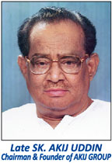
Akij Group is a historic organization of our country. It is sustaining and extending its operation since British era to still now. After getting liberated from Pakistan, Akij initially got famous for its tobacco operation, which primarily started as Akij Biri. It is a significant reason behind people’s misunderstanding about leaf on the logo of Akij Group. Most of the people mistake it for tobacco leaf, whereas it is actually a jute leaf, symbolic to the heritage of the entire group of industries, as a monument to the historic introduction of the entire empire of business from a single small jute business. Food and Beverage segment became a strong hand of Akij Group with the march of time. It is not long since it started its journey, 2006. But within this short period, its reach to the consumers and domination over the market is quite appreciable and worth of looking into some details.
The ultimate goal of Akij Food & Beverage Ltd. is to provide quality products to people of all economic groups along with maintaining commitments to other stakeholders of the community. With the economy of Bangladesh went a little slothful due to some recent political events, country’s all domestic organizations faced some difficulty maintaining the same balance between quality and price, however, AFBL maintained its negotiation with obstacles and prevailed zero tolerance about quality compromising. We expect such character from our entire domestic manufacturer.

Akij group

Akij group is one of the largest domestic group of industries in our country. It was founded by Sheikh Akij Uddin around during British rule. In 1940, he started a jute business. The logo of the group still holds that jute leaf. Criticism goes, the business had used child labour. Later in 1950, Akij Biri was introduced and gradually that little business, within all these years consistently, to form such humongous shape adapting more than 18 subsidiaries. The corporate house of Akij is known as Akij House located at Tajgoan Commercial Area near Gulshan. Now it is country’s one of the highest tax payer. During 2014-45 fiscal year, it paid around 3500 core BDT tax, which was the one third of the country’s entire national budget that year. And in 2015, its revenue was around 5 billion USD. This persistence is taking them to set up other 4 or 5 new subsidiaries in near future into different industries.

Board of Directors
As mentioned, Sheikh Akij Uddin was the founder chairman of the Akij Group. Private limited company currently runs by five Brothers:
- Chairman: Sheikh Nasir Uddin
- Managing Director: Sheikh Bashir Uddin
- Director: Sheikh Jamil Uddin
- Director: Sheikh Shamim Uddin
- Director: Sheikh Jashim Uddin

The present Concern of AKIJ GROUP are as follows:

- Akij Jute Mills Ltd.
- Akij Securities Ltd.
- Akij CNG Station Ltd.
- Akij Wildlife Farm Ltd.
- Akij Tours & Travels
- Akij Hotel & Resort Ltd.
- Akij Food & Beverage Ltd
- Akij motors & Automobiles Ltd.
- Akij Biri Factory Ltd
- Akij Corporation Ltd.
- Akij Cement Company Ltd.
- SAF Industries Ltd.
- Akij Shipping Line

- Dhaka Tobacco Industries
- Akij Match Factory Ltd.
- Akij Printing & Pkg. Ltd.
- Akij Particle Board Mills Ltd.
- Akij Textile Mills Ltd.

.

Company Profile

(Akij Food & Beverage Ltd)
Akij Food and Beverage Limited started its journey on 2006. Though the plan was dairy would be the introductory segment to join the food industry, however, due to some legitimacy in the capital installment and long, complicated and much sophisticated milk collection procedure; it got delayed, and the CSD (Carbonated Soft Drink) industry became the first one to start with. Later it introduced juice, carbonated drink, fruit jelly, pickles, chips, mineral water, dairy products etc. The head office of AFBL is located at AKIJ HOUSE near Hatirjill. .

Business Structure:

Like other manufacturing organizations, it is a tall structured company, but unlike corporations, the decision-making procedure is more centralized here. The directors directly involve themselves in each planning and approves every move by their own.
The graphical representation of the Akij Group business structure:

The brands of AFBL are:

Chapter - 2

Introduction

Chapter 2: Introduction

Rational of Study
Internship is the mandatory course for all BBA students to fulfill the graduation because it gives firsthand experience of the complexities of practical life as well as giving the experience of an office’s wok environment. As a result it benefits the students to relate acquired knowledge with practical job life and make them comfortable with the office environment. The prime objective of the internship program is to work under organizational environment so that, we can turn up ourselves as professionals with practical experience and can get an opportunity to reconcile the theoretical knowledge with real life situation which will add more values to our job life. For this reason internship is an indispensable and most important part of BBA program. I try to prepare this report on the basis of practical knowledge and experiences, which I gather from this organization. As a mandatory part our BBA program I have to accomplish my internship from an organization. And in this process I have completed 3 months internship in Akij Food & Beverage Ltd. Akij Food & Beverage Ltd. is one of the largest organizations in our country and I have to involve all most all activities related with marketing which is my major in BBA program. This company has many sections and units and I’m involved in the brand department.

Statement of Problem:

As it is a mandatory policy to give a report upon the problems and situations on the company that I intern. I’ve selected a problem titled “Integrated marketing communication of Clemon Akij Food & Beverage Ltd.”

Objectives of the Report:

The study attempted to explore and examine the present brand integration communication situation with related notes of Akij food and the integration process in Akij Food & Beverage specially the objective of the study as follows:

- To understand the present scenario of the market of Akij Food & Beverage Ltd.
- To identify the branding objectives of Akij Food & Beverage Ltd.
- To analysis the brand position of Akij Food & Beverage Ltd.

Scope of the Study

The scope of the whole study may be stated as under:

- The study would help top management in planning, organizing and decision making strategy.
- The study would help management in identifying the key areas of weakness and strength for making SWOT analysis.
- The study would aware the top management to take corrective and appropriate measure timely to improve the company’s branding position and other performance on the basis of reliable information.

Methodology:
I have used both primary and secondary data for preparing this report which is from the reliable sources, of course but most of the data are collected from primary source. I observed and learned various activities of Akij Food & Beverage Ltd. My practical experience in AKIJ Food & Beverage Ltd. (brand department) was a vast source of information.

- Primary source of Data:
Primary data is collected through unstructured personal interview with officials and top management of Akij Food & Beverage Ltd.
Day to day desk job (Informal conversation with the employees)
A primary source is a document, speech, or other sort of evidence written, created or otherwise produced during the time under study and internship. Primary sources offer an inside view of a particular event with lots of information.
The sources are as follows Face-to-face conversation with the Executives, Senior Executives, and officers of Akij food.

- Secondary source of Data
Annual report of Akij Food &Beverage Ltd.
Recent held was event & activation of Akij Food &Beverage Ltd.
Prospectus of Akij Food &Beverage Ltd.
Internet, Web-sites.

Limitation of the report:
The limitations of the report including the following:
- Lack of time: One of the major limitations of the study was limited time with lots of responsibilities. The allocation of the study was inadequate because in this short time one intern student had to both attend the office and also does the survey which is the part of his/her internship. For the scarcity of time I could not communicate largely with concern persons and authority, which would be very helpful for preparing, the report could be made much more comprehensive and informative.
- Administrative secrecy: Another major problem every private company maintains some secrecy of its brand Ltd which is very essential. It was not expected in this regard. The authority kept much information as secrete as possible.
- Lack of adequate information: There was lack of necessary information what I needed for my internship report. That is primary and secondary data and the information is not updated.
- Lack of knowledge about (AFBL)
Lack of self-knowledge and self-esteem concerning report preparation, was also a limiting factor in preparing a better report.

Chapter- 3

All Brands & Promotional Analysis
Mojo
Clemon
Speed
Spa
Aafi
Frutika
Farm Fresh

Mojo
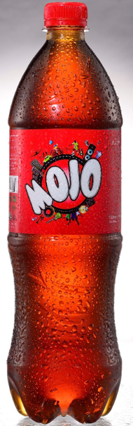
Mojo was the first brand introduced by Akij Food and Beverage. It was a carbonated soft drink brand in cola flavor. It was imaged in the market as a fusion brand, a fusion of classic and modern trend. Its packaging and communications perfectly reflects that. It initially started campaigns with the tagline “antore antore”, however, now it has been changed into “antore is on”. Mojo was a successful brand from the very early of its journey. Market penetration in this industry was always very hard because of the two existing multinational giants Coca Cola and Pepsi. However, it not only survived, but also managed to acquire a significant amount of market share. Currently Mojo has 35% market share in cola, 20% in overall CSD market and more than 80% in 250ml SKU segment. Besides, it achieved 2nd position in consumer top of the mind.
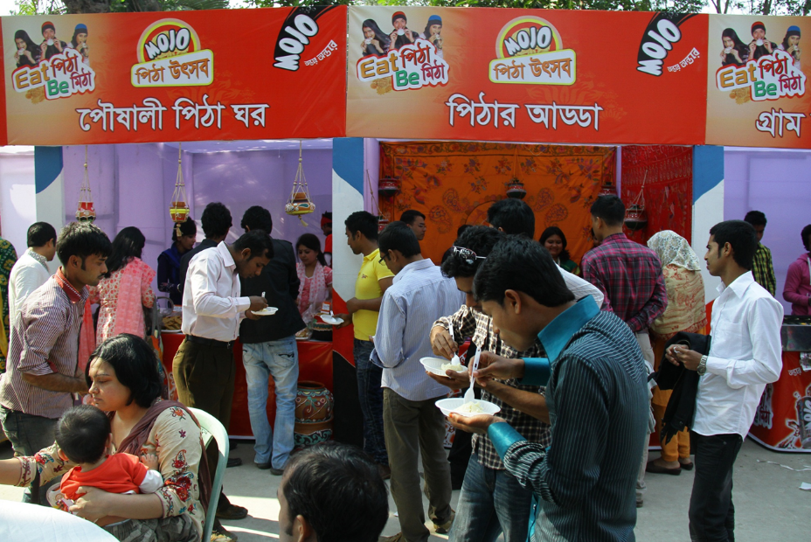
Promotional Campaigns: One of the leading reason for Mojo being so successful is its communication effectiveness and promotional campaigns. One of the mentionable events is “Mojo Pitha Utshob” which is held every winter.

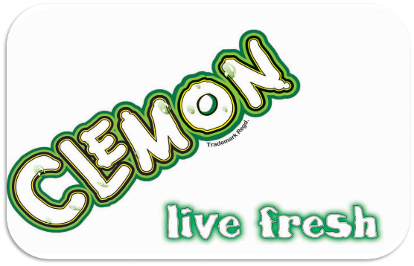
Clemon
Clemon and Lemu are clear CSD brands. They also have started their journey on 2006 alongside with Mojo. Their market position currently is not that promising as Mojo though, they are putting quite a competition. Except sprite and seven up, they are giving a hard time to the local clear drinks.
Promotional Campaigns: Clemon is doing wide campaign program all over the country throughout the year with the tagline “Live Fresh”, which is strengthening the ground beneath. These campaign program includes Clemon Indoor Cricket Tournament, Clemon Grooming Clemon Beach Carnival, Clemon Victory Day Green Ride and Rally etc. which create enormous exposure increasing brand value at a significant rate.
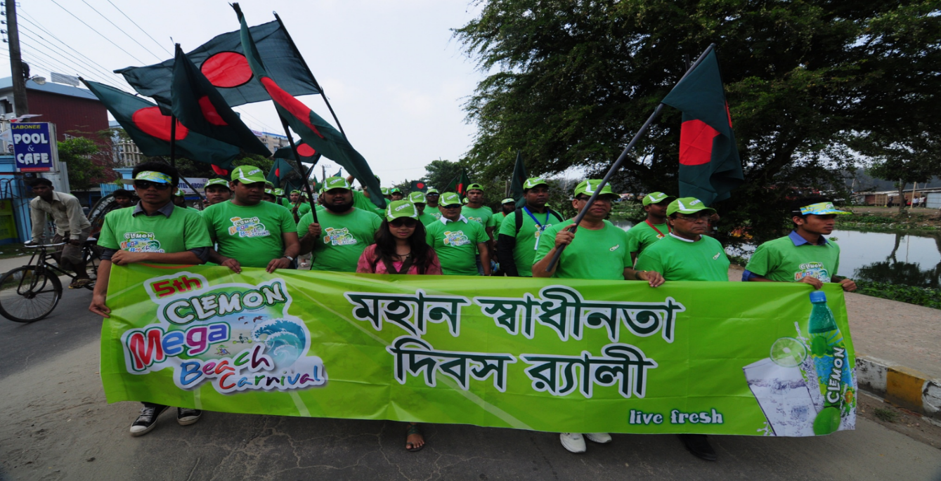

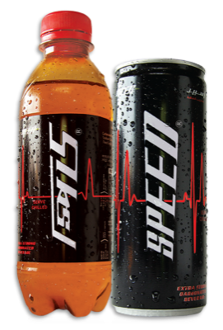
Speed
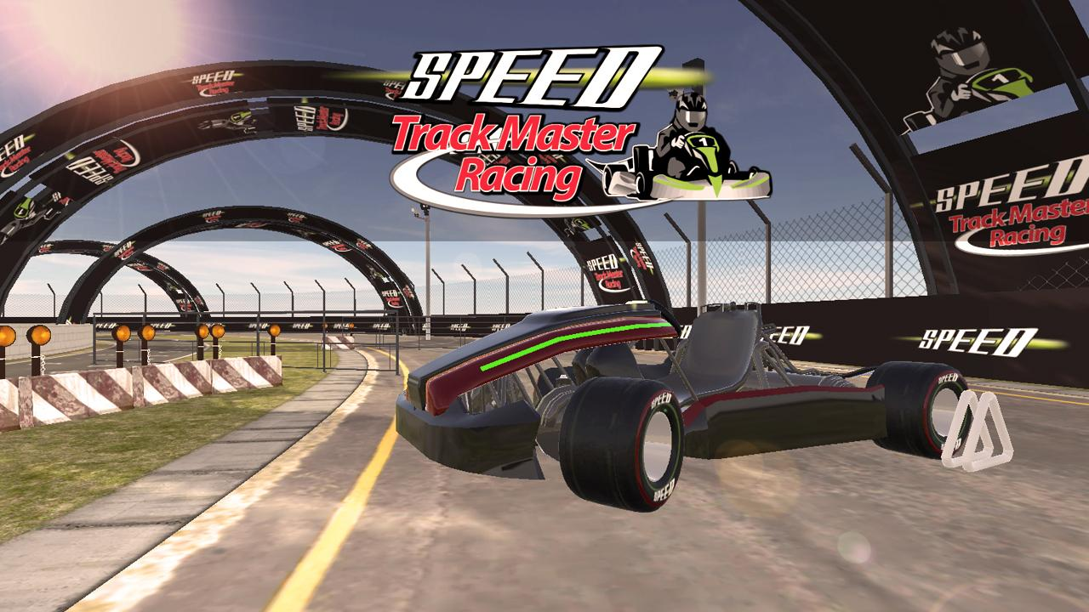
Speed is an energy drink brand, the most successful brand of Akij Food and Beverage Ltd for so long. Like Mojo, it was one of the initial brands with the journey of AFBL. It was launched on 14th April, 2006. Speed promotes itself into the market with tagline “Hebby Energy”. It has got itself into the top in both market share and top of the mind. Currently it has 52% market share in hard drink category.
Promotional Campaigns: It was not that successful at the very early stage. Its first TVC faced criticisms. Then on 2009, it was launched with completely different logo and packaging; and also with new positioning and tagline. The through consistent 360 marketing and proper distribution, Speed fought back and eventually reached to the top. Gradually Tiger and Shark are pushed away outside the capital. One of the most important mega events of Speed is “Speed Track Master” which takes place every year with the participation of university students.

Spa
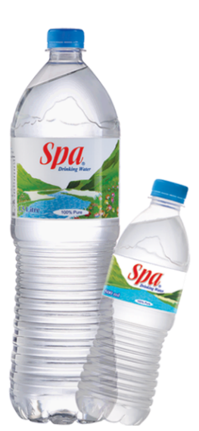
Spa is a fresh drinking water brand of AFBL. It was launched on April, 2007. It tried to attach emotion through its positioning; the tagline is “Love for water”. It also changed its packaging once throughout its timeline. Currently, it is holding a competitive positioning with Mum and Aquafina. Currently AFBL is planning to launch another fighter drinking water brand to compete in the countryside and sub-urban markets. The process is now very close to launch.
Promotional Campaigns: Spa always tries to bring emotional attachment through its promotions. Focusing on the emotional relation between the existences of all our lives with water is the ultimate message of all the communications of Spa. Besides, Spa arranges lots of publicity events and campaigns. 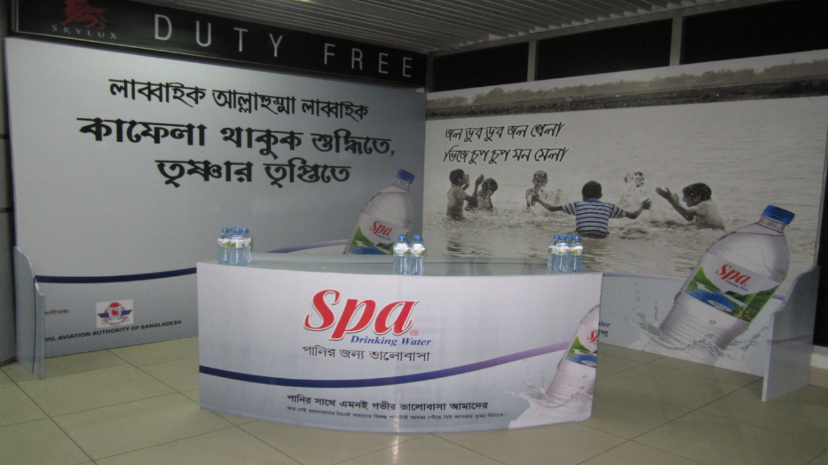

Aafi
Aafi is a comparatively new brand of AFBL started its journey in 2014. It was launched as a fruit drink (mainly mango) brand to assist Frutika. Along with Frutika, it also has a good demand in Middle East. Besides, fruit drink, there are juices of guava and litchi flavor, mango bar, pickles of mango and olive flavor, tomato sauce, and chanachur etc. Products are also under this brand’s roof. Besides, they introduced the latest offering from AFBL, which is Aafi Zira Pani.

Frutika
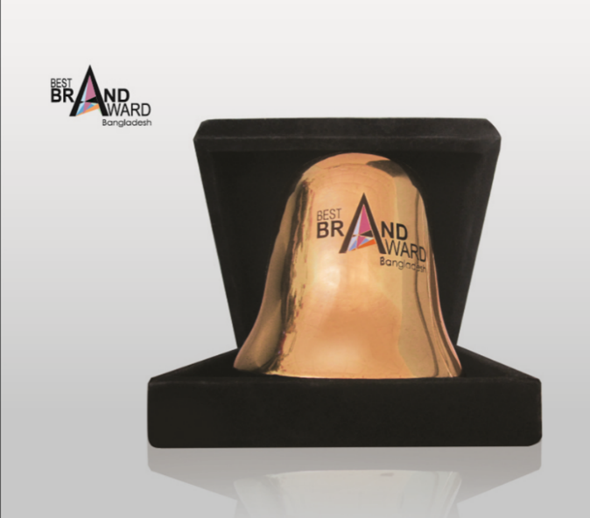
Frutika is the flagship fruit drink brand of AFBL. It was launched in 2007. Its positioning is “purity” as it does not contain any harmful preservative. It was quite successful in the market before 2010 when it faced a significant insufficiency in production and delivery in comparison to demand. Later it became difficult for it regain that amount of market share, however, it made a mentionable recover over years. Later it received the “The Best Brand” award from Bangladesh Brand Forum in 2011, 2012, 2014 & 2015.

Frutika fruits drink has four different flavors:
- Mango
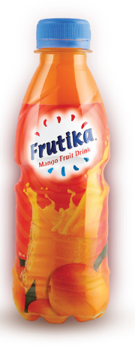
- Red Grape
- Green Mango
- Orange

Promotional Campaign: Among promotional campaigns of Frutika, the “Frutika Islamic Genius” is mentionable. It is a quiz program on the Islamic history and knowledge.

Farm Fresh
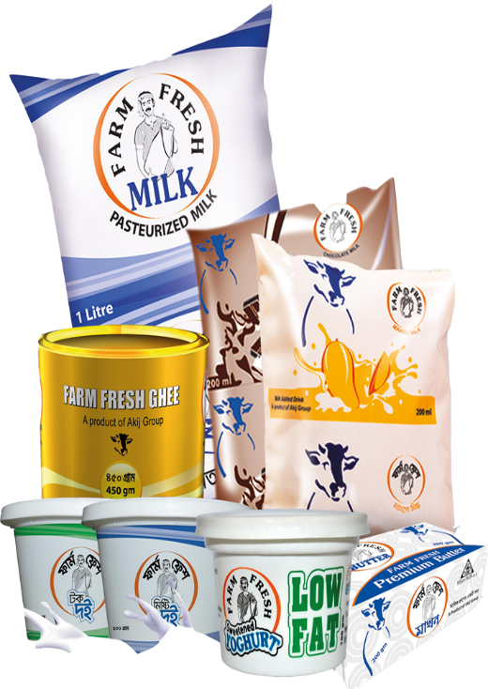
Farm Fresh is the dairy brand of AFBL, launched in 2011, one of the dream project of the director brothers. Even being late, the company managed to set up an efficient milk processing plant along with planned and well monitored supply chain channel. Besides pasteurized and UHT milk, they also produce almost all kind of dairy products.
The dairy product categories Farm Fresh is competing are:
- Farm Fresh Pasteurized Milk
- Farm Fresh UHT Milk
- Mango Shake
- Chocolate Milk
- Ghee
- Yogurt
- Sour Curd
- Butter
- Low Fat Curd
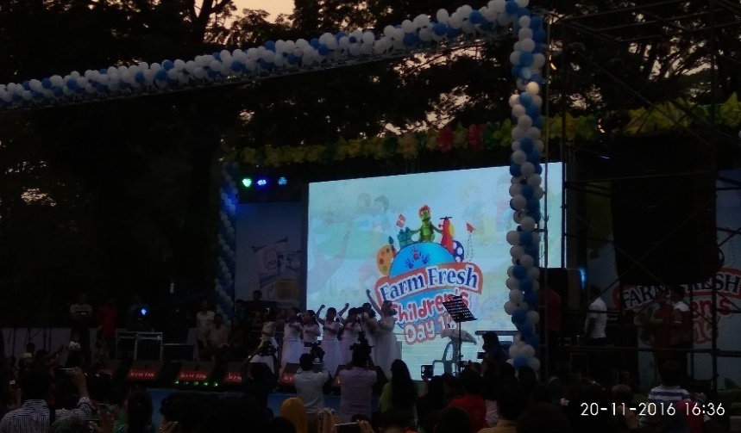
Promotional Campaign: Despite being the latest brand, Farm Fresh is very active in campaigns and events. The mentionable programs initiated by Farm Fresh are “Farm Fresh Jannani”, “Children’s Day”, “Colony Drive” etc.
Besides these, there are also some other brands i.e. Happy-Times, Home-Makers, Cheese-Puffs, and O’Potato. Cheese Puffs and O’Potato are chips brands. Happy-Times and Home-Makers are a little under developed in terms of product line. Happy-Times offers a fruit jelly for now and Home-Makers offers spice or seasoning items.

AFBL Mission, Vision& Objective

The tag line of AFBL is ‘‘BRINGS QUALITY IN LIFE”
Mission: To the market leader in quality food and beverage sector discovering and satisfying the desire and need of the community working in harmony with our customers, employees and business partners.
Vision: To be the leading food and beverage brands excelling in product quality, social, technical & marketing creativity and service to our customers through the skills and cordial commitment of our employees
According to late Sheikh Akij Uddin regarding AKIJ Food & Beverage Limited(AFBL) ‘‘ we will manufacture and introduce those high quality products in the market that we ourselves and our family will always use, we will NOT just produce products for the consumers in the market and let our family consume other foreign products.

Goal:
To achieve market leadership, profitability, good corporate citizenship and a sustainable growth.

Objective
To strive hard to optimize profit through conduction of transparent business operations within the legal & social framework with malice to none and justice for all in respective of gender disparity, caste, creed of religion or region:

- To create more jobs with minimum investments
- To be competitive in the internal as well as external markets
- To maximize export earning with minimum imported in-puts
- To reduce the income gap between top & bottom categories of employees

AFBL: Morale, Ethics &Values:
- Believing in quality and excellence in service
- Believing open communication, personal responsibilities, integrity, and active
- Participation.
- Supporting the creative diversity and share of ideas
- Building culture of learning based on leadership, teamwork, accountability, and cooperation.

Marketing mix 4ps
4Ps ANALYSIS OF AFBL: The 4ps analysis of a company involves in the company’s Product, Price, Place and Promotion. Each of these segments of AFBL is given below they have categorized its products in eight products line and each line incorporates various brands to captivate the market. Product Description: Clemon is a carbonated soft drink (CSD) in cola flavor. The packaging of the product is very attractive because of its color combination on the bottle and can.

PRODUCT
The recent launching of the Akij Groups beverage line has been gaining popularity among all carbonated water lovers. It gained popularity particularly among teenage people and children. The favorite brand name gained popularity with in a short period. Presently the company able to introduce new types of product which increase the depth of the category of AFBL
Akij food &Beverage limited started their journey officially on July 2006 with three products but within this two year company able to add lot of products on its rosters. The products which are offering now by the company are given:

Product Category | Brand Name | Size
Cola | MOJO | 150ml can, 250ml pet and can, 500ml pet, 1 liter pet, 2 liter pet.
Cloudy Lemon | Lemu | 150ml can, 250ml pet and can, 500ml pet, 1 liter pet, 2 liter pet.
Clear Lemon | Clemon | 250ml pet and can 500ml pet, 1 liter pet, and 2 liter pet.
Energy Drink | Speed | 250ml pet and can
Juice | Frutika , Aafi | 250ml pet, 1 liter.
Milk | Farm Fresh UHT milk | ½ liter tetra pack.
Malt Beverage | Wild Brew | 250ml can.
Chips | Cheese Puffs | 15 and 30 gm. Foil pack.

PRICE

Pricing is one of the crucial aspects of a products destiny to success and failure. There are many different methods of pricing a company can employ. But the main scrutiny is to strategically set the pricing that facilitates the company and the product as well. Various sorts of pricing methods are stated below:
▪ Competition-based pricing

▪ Cost-plus pricing

▪ Creaming or skimming

▪ Limit pricing

▪ Loss leader

▪ Market-oriented pricing

▪ Penetration pricing

▪ Price discrimination

▪ Premium pricing

▪ Predatory pricing

▪ Contribution margin-based pricing

▪ Psychological pricing

▪ Dynamic pricing

▪ Price leadership

▪ Target pricing

▪ Absorption pricing

PLACE
PLACE: Place means that outline of distribution channel a company employs to make its products available to the final consumer. AFBL inborn the advantage and was been able to use the wide network distribution channel to promote and provide its products in each and every place across the country. AFBL has segmented the entire Bangladeshi market into 25 regions for its distribution purpose.
DHAKA-1 | GAZIPUR | MYMENSING | SYLET
DHAKA-2 | NORSINDI | CTG-1 | MOULOBIVABAZAR
DHAKA-3 | ZINZIRA | CTG-2 | COMILLA
DHAKA-3 | NARAYANGONJ | CTG-3 | CHOWMOHANI
KUSTIA | BARISAL | FARIDPUR | BOGRA
RAJSHAHI | RANGPUR | ZESSORE

PROMOTION
It is one of the most important facets of a company which it has to promote in a very proper way to achieve best possible outcome. AFBL values the importance of promotion, because it believes no matter how high-quality, good taste, attractive packaging of the product, it has to be properly communicated to the customer to pursue the final purchase. AFBL has broadly categorized its promotional activities in two types: • Trade promotion (TP): Trade promotions are targeted for the retainers and the distributors. It usually involves free products, cash incentives and gifts for the retainers and distributors for high volume purchase. • Consumer Promotion (CP): All the promotional activities that are targeted for the customer.

Chapter-4

Integrated Marketing Communication

Introduction
Integrated marketing is an approach to creating a unified and seamless experience to interact with the brand. It attempts to meld all aspect of marketing communication such as advertising, sales promotion, public relation, direct marketing and social media, through their respective mix of tactics, methods channels, media and activates. So that all work together as unified force originally marketing was focused around the 4P's (product, price, place and promotion) which narrowed company’s perspectives to concentrate on their internal concepts. The idea of integrated marketing communications was first instigated in 1993 by Don E. Schultz a professor most notable for his study and contributions toward IMC (Gambetta & Schultz, 2015). Schultz revolutionized the 4P's concept by changing it with the 4C's model. The four parts include; consumer, communication, convenience and cost. This switched the attention toward a consumer orientated outlook which took into consideration their needs and wants. Weak and plain messages were evolving toward a larger scale platform that allowed for creativity between the fusion of marketing and communications.

Objective of integration
Integrated marketing communications accomplished synergy when each element was executed in accordance with the overall vision of the organization’s campaign, which allows the message to be executed efficiently. Businesses are now able to implement IMC strategically within their business practice as it has progressed towards a holistic analysis from audiences internally and externally. This happens simply because the different aspects of strategy often aren't well integrated because of the way the report is split up into separate sections. However, the distinction described so far was mostly due to the fact that marketers and advertisers were much more limited as to what they could really do with platforms they had available to them. However, we have many more platforms and much more technology available to us. Integration marketing are following the target objective:
.
- Quantified objectives grouped around customer acquisition, conversion or retention or our framework.
- Evidence proving your goals are realistic based on situation analysis or creating conversion models.
- Outline the main ways you will reach your objectives
- Lack of integration between goals, strategies and tactics is a problem I often find when reviewing online marketing strategies.
- Businesses are now able to implement IMC strategically within their business practice.
- The new strategy seeks to fuse modern and traditional marketing strategies with the intention of creating an efficient.

Tools of Clemon integration
Understanding Clemon the type of information sharing being pursued and the challenges associated with achieving the Clemon stated objectives are important to understanding the benefits that organizations can expect to realize. The benefits realized from information integration different from organization to organization and according to characteristics of specific projects. Let's say we want to use an image of our social media campaign and Clemon wonder if it should be considered ATL, BTL or TTL. We realize that social media offers a huge reach and hefty exposure - meaning it could be considered ATL - but that it can also be very highly targeted, so it could be BTL too. So, does that mean it should just be considered TTL then?

Tools of integration

BTL
Below The Line

ATL
Above The Line

Door to door
Event
Bill board
Newspaper
Radio
Television

TTL
Through The Line

ATL Marketing
'ATL Marketing' stands for 'Above The Line Marketing'. This kind of marketing is the kind of marketing that has a very broad reach and is largely untargeted. Clemon think about a national TV campaign, where viewers across the nation see the same advertise aired across the various networks. Here the print media is also ATL section of the integration sector .It is very important for the Clemon modern marketing communication. This kind of marketing is mostly used for building brand awareness and goodwill.
BTL MARKETING
'BTL Marketing' stands for 'Below The Line Marketing'. This kind of marketing is the kind of marketing that targets specific groups of people with focus in the Clemon. For example, a leaflet drop in a specific area, a You Tube campaign, bill board, arrange many kinds of event & activation like as Clemon sales fair ,Clemon fridge offer, digital BPL camping , drive, indoor cricket, Islamic concert etc., for targeting a certain group or a direct telemarketing campaign targeting specific businesses loyal customer of Clemon. This kind of marketing is best for conversions and direct response.
TTL MARKETING
'TTL Marketing' stands for 'Through the Line Marketing'. This kind of marketing is really an integrated approach, where brand Clemon would use both BTL and ATL marketing methods to reach their customer base and generate conversions. But It might seem obvious, although not all marketing campaigns are like this - some are ATL only and some are BTL only (it would be much more common to see a BTL-only marketing campaign in practical).This kind of marketing delivers both a wide reach and a focus on conversions.

ATL, BTL and TTL Marketing activity
An example of above the line marketing activity
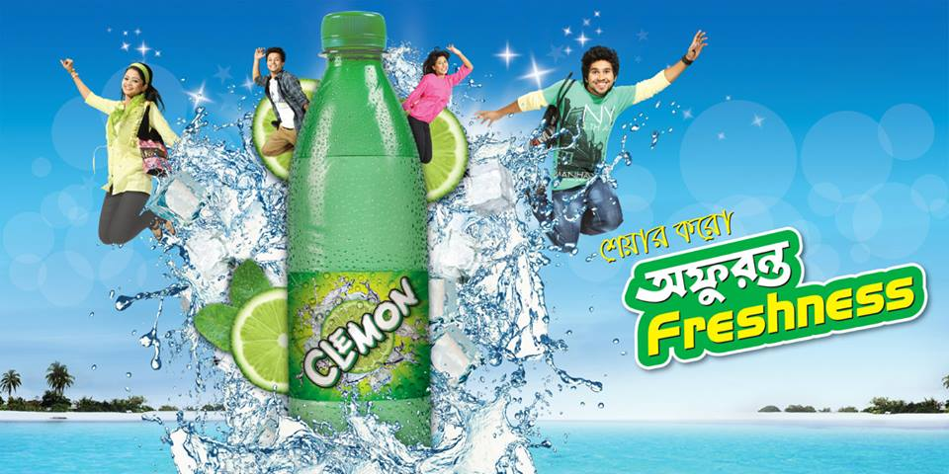
An example of Above the Line marketing would be a television campaign run by a cereal company. The ad would be aired across the nation, with every viewer seeing the exact same message. Here the Clemon campaign the running TVC is the affouranto freshness, it title name is charideka utashas. As mentioned above, this kind of marketing would be used to build general brand and awareness of the business and its products over the long term as well as goodwill. It used to be that the following kinds of media would be considered ATL marketing activity:
- Television
- Radio
- Newspaper

An example of below the line marketing activity
The same cereal company could also run a direct marketing campaign in a large city, targeting commuters on the way to work. They might offer free cereal samples along with vouchers that could be used in a local store. Here the Clemon arrange the event is the indoor university cricket, beach carnival etc. sponsor in different proposal and out of home activation.
And the following kinds of marketing would be considered BTL marketing activity
- Door to door
- One to one communication
- Event
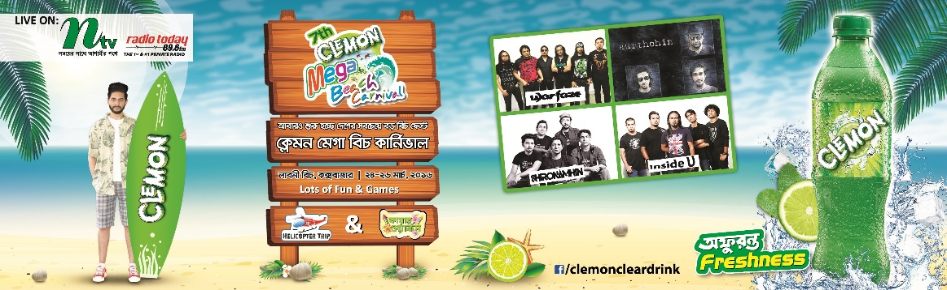
An example of through the line
As we can see, this is a combination of both of the other forms - ATL in terms of its wide reach, BTL in terms of its targeted nature and conversion focus. Here when we arrange the radio and TVC program at a time we advertise the press ads at the handbill this ads and campaign are booth captcher the target customer very easily. It seems simple enough and it definitely works like that in practice, most of the time anyway.
TTL campaigns would be an integrated mix of the two.
Integration Strategy of Clemon (AFBL)
Pull Strategy
Integration strategy have to maintain the two types of strategy like as pull strategy and push strategy, we discuss the pull strategy. Pull strategy are using the target customer here the customer are convince to offer the many kinds of offer system, by one get one free and other attractive free gift Boucher and other alternative things to satisfy the customers and CP fridge offer to increase and develop the sales and production and the end of the moment the customer are happy and use our product.
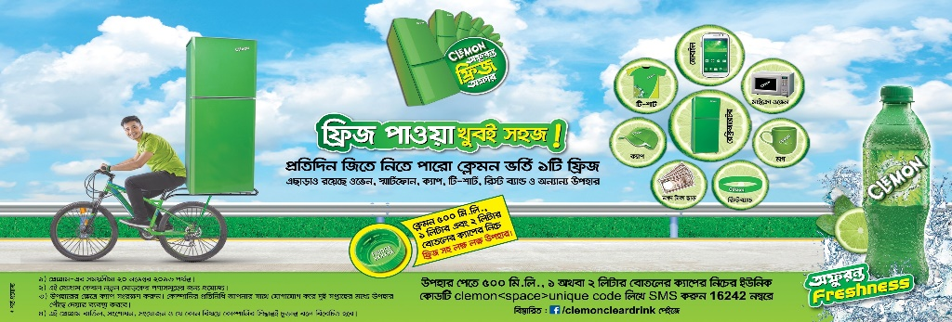
Push Strategy
Push strategy are totally different from the pull strategy, here we using the retailer or seller. We use the via way to reach the target customer. Here first time we motivate the seller and they give a good feedback for reach the target customer. Clemon arrange the display offer for the seller and retailer. The seller are communicate to the one to one communication in many ways. Businesses are now able to implement IMC strategically within Clemon business practice as it has progressed towards a holistic analysis from audiences internally and externally.
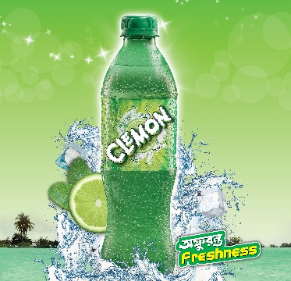

Integration Benefits Clemon (AFBL)
A greater capacity to share information across AFBL boundaries, to discover patterns and interactions, and to make better informed decisions based on more complete data. Clemon adds that information integration in the justice enterprise can lead to improved safety and more coordinated justice services. Decentralization, improved decision making, high quality services, empowerment, and greater productivity have been mentioned as potential gains from information integration projects. The following instruction are maintain the integration of AFBL organization. Classifies these benefits into three categories: technical, organizational, and political.

Technical benefits
Here the technical benefits are those related to data processing and information management of AFBL. The information integration reduces duplicate data collection, processing, and storage and therefore reduces data processing costs that attend every public program this brand. System reliability and accessibility are two well-known examples of Clemon.

Organizational benefits
Organizational benefits known also as business or firm benefits, are benefits related to the solution of Agency-wide problems or the enhancement of AFBL capabilities. We improving the decision making process, broadening professional networks, improving coordination, increasing the quality of services, and reducing costs are some examples of organizational benefits.

Political benefits
Political benefits might include better appreciation for government-wide policy goals, more public accountability, and more comprehensive public information, integrated planning, and improved service delivery of AFBL. Political benefits can also be considered as individual benefits for public officials as a result of the use of specific technology characteristics or applications.

Clemon Integration System of (AFBL)
Clemon brand is one of the best brands of AFBL. Its brand position is very good, from 2006 to 2016 the positioning of market place is very highly reachable. Its market competitors are the 7up, Fizz up, Uro cola, Pran up etc. The Clemon brand are using the integration marketing system like as (ATL,BTL,TTL) for promotion the brand in the competitor market place. Under the ATL system Clemon making many kinds of TVC to reach the target customer and captcher the customers mind set up. The under of BTL Clemon is arrange many kinds of event like as indoor university cricket. The cricket is T20 cricket format. When we arrange the event then we follow some rule and revelation. The event will held at least 2 month. First time we make some TVC at indoor university cricket event then we registration the university name, after few days later the game is start and 1st round, quarter final, semifinal and final are arrange step by step. Finally the event is over very gorgeously.

Market Analysis of Clemon:

Report on COP, CTP and CQP

Area: Dhaka South-3 Lalbagh (Amligola) Date: 18.02.2018

SL. | Shop Name | Current Status
1 | Shifa Store | CQP is available but COP and CTP is unavailable.  Offer: Don’t know about COP and CTP offers.  Competitors: 7up, Sprite.
2 | Family Shop | CHP and CQP is available but COP and CTP is unavailable.  Offer: Don’t know about COP and CTP offers.  Competitors: 7up, Sprite.
3 | Ananto Store | Though there is no stock of CQP but CQP is available most of the time and COP, CTP is unavailable.  Offer: Don’t know about COP and CTP offers.  Competitors: 7up, Sprite.
4 | Beauty Confectionary | CQP is available but COP and CTP is unavailable.  Offer: Don’t know about COP and CTP offers.  Competitors: only Sprite.
5 | Hridoy Confectionary | CQP is available but COP and CTP is unavailable.  Offer: Don’t know about COP and CTP offers.  Competitors: 7up, Sprite.
6 | Maa General Store | CQP is available but COP and CTP is unavailable.  Offer: Don’t know about COP and CTP offers.  Competitors: 7up, Sprite.
7 | Bhai-Bhai Store | CQP is available but COP and CTP is unavailable.  Offer: Don’t know about COP and CTP offers.  Competitors: 7up, Sprite.
8 | Newaz Store | CQP is available but COP and CTP is unavailable.  Offer: Don’t know about COP and CTP offers.  Competitors: 7up, Sprite.
9 | Aftab Store | CQP is available but COP and CTP is unavailable.  Offer: Don’t know about COP and CTP offers.  Competitors: 7up, Sprite.
10 | Sheikh Vanu Store | CQP is available but COP and CTP is unavailable.  Offer: Don’t know about COP and CTP offers.  Competitors: 7up, Sprite.
11 | Masum Store | CQP is available but COP and CTP is unavailable.  Offer: Don’t know about COP and CTP offers.  Competitors: Only Sprite.
12 | Bismillah | CQP is available but COP and CTP is unavailable.  Offer: Don’t know about COP and CTP offers.  Competitors: 7up, Sprite.
13 | Pushpo | CQP is available but COP and CTP is unavailable.  Offer: Don’t know about COP and CTP offers.  Competitors: 7up, Sprite.
14 | No Name | CQP is available but COP and CTP is unavailable.  Offer: Don’t know about COP and CTP offers.  Competitors: 7up, Sprite.
15 | No Name | CQP is available but COP and CTP is unavailable.  Offer: Don’t know about COP and CTP offers.  Competitors: 7up, Sprite.
16 | No Name | CQP is available but COP and CTP is unavailable.  Offer: Don’t know about COP and CTP offers.  Competitors: 7up, Sprite.
17 | No Name | CQP is available but COP and CTP is unavailable.  Offer: Don’t know about COP and CTP offers.  Competitors: 7up, Sprite.
18 | No Name | CQP is available but COP and CTP is unavailable.  Offer: Don’t know about COP and CTP offers.  Competitors: 7up, Sprite.
19 | No Name | CQP is available but COP and CTP is unavailable.  Offer: Don’t know about COP and CTP offers.  Competitors: 7up, Sprite.

Note:
- I have visited Dhaka South-3 Distribution Store and came to know that they know about the CQP and CTP offer. In CTP the Bat-Ball offer is available and 10tk off in per case of CQP.
- Most of the store has 7up and Sprite which is the competitor of Clemon.
- No Pran up, Fizz Up is in those store.
- Most of the shopkeeper don’t know about the offer of CQP but most of them know about the offer of CTP.
- Demand of “Clemon” is poor rather than the demand of 7up and Sprite.

Additional:
- More Slab Program can be introduced to increase the sales.
- If we focus on the taste of what consumer wants, it will be more helpful.

This Pie Chart will help to understand the percentage of sales in “Clemon” and its competitors.

Market Visit on COP, CTP and CQP

Area: Mohakhali Amtoli, Dokkhin Para Date: 10.02.2018

SL. | Shop Name | Current Status
1. | Maa er Doa Store | CQP is available and COP and CTP is unavailable. Don’t know about the offers.  Competitor: 7up, Sprite.
2. | Raj Store | CQP is available and COP and CTP is unavailable. Don’t know about the offers.  Competitor: Pran Up.
3. | Sunny Store | CQP is available and COP and CTP is unavailable. They know about the offers.  Competitor: None.
4. | Selim Store | CQP is available and COP and CTP is unavailable. Don’t know about the offers.  Competitor: Pran Up, 7up, Sprite.
5. | Babul Store | Availability of CQP, COP and CTP.  Don’t know about the offers.  Competitors: 7up, Sprite, Pran Up.
6. | Emon Store | CQP, COP and CTP is unavailable. Don’t know about the offers.  Competitor: 7up, Sprite.
7. | Babu Store | CQP, COP and CTP is unavailable. Don’t know about the offers.  Competitor: Pran Up.
8. | S.M. Dept. Store | CQP is available and COP and CTP is unavailable. Don’t know about the offers.  Competitor: Pran Up, 7up, Sprite.
9. | Takwa Enterprise | CQP is available and COP and CTP is unavailable. Don’t know about the offers.  Competitor: 7up, Sprite.
10. | Abdul Rouf Store | CQP is available and COP and CTP is unavailable. Don’t know about the offers.  Competitor: 7up, Sprite.
11. | Sohna Tea Store | CQP, COP and CTP is unavailable. Don’t know about the offers.  Competitor: 7up.
12. | Maa Store | CQP, COP and CTP is unavailable. Don’t know about the offers.  Competitor: 7up, Sprite.
13. | Anowar Store | CQP is available and COP and CTP is unavailable. Don’t know about the offers.  Competitor: 7up.
14. | No Name | CQP is available and COP and CTP is unavailable. Don’t know about the offers.  Competitor: Pran Up.
15. | No Name | CQP is available and COP and CTP is unavailable. Don’t know about the offers.  Competitor: 7up only.

Note:
- The demand of CQP in Mohakhali area is quite good rather than Pran Up and Fizz Up.
- Main competitors are 7up, Sprite, Pran up.
- Most of the shopkeepers don’t know about the offering of CTP.
- There are some whole-sale store, they have a large amount of CQP, COP and CTP. On the other hand they also don’t know about the Bat-Ball offer.
- If we calculate in percentage then we can say that, 70% (approximately) shop keeps CQP and rest of 30% (approximately) keeps Pran Up. But 100% shop has 7up and Sprite.
- I have took some pictures for better understanding about the market condition.

Additional:
- By discussing with the shopkeepers I’ve come to know that they want more offers with CQP. One of them told me that if we provide some extra CQP with per case it will be more benefited.
- Sharing my personal thinking, if we change the package of CQP, COP and CTP modified with something new the targeted customer may attract.
- We can provide CQP in a glass bottle. It will compete the Sprite and 7up market.
- Some campaign can be introduced for increase the sell.

Below in the pie chart we can see the percentage of CQP, COP, CTP and their competitors:

Market Visit on COP, CTP and CQP

Area: Modhubag, Mogbazar Date: 05.02.2018

SL. | Shop Name | Current Status
1. | Alam Store | CQP is available and COP, CTP is unavailable.  No Competitors.
2. | Jannat Store | Unavailable of COP, CTP and CQP.  Competitor: Fizz Up.
3. | Mawlar Daan Store | Unavailable of COP, CTP and CQP.  Competitor: Fizz Up, Pran Up.
4. | Allah’r Daan Store | Unavailable of COP, CTP and CQP.  Competitor: Fizz Up 250ml.
5. | Makkah General Store | Unavailable of COP, CTP and CQP.  Competitor: Pran Up.
6. | Alam Store | One single piece date over CQP is available and COP, CTP is unavailable.
7. | Bhai Bhai General Store | CQP is available. COP and CTP is unavailable.  Competitors: Pran Up, Fizz Up.
8. | Rakib Store | CQP available and no competitors.
9. | Safa Dept. Store | CQP is available. COP and CTP is unavailable.
10. | Hridoy Dept. Store | Unavailable of CQP, COP and CTP.  Competitors: Fizz Up.
11. | Mouchaak Sweets | CQP is available. COP and CTP is unavailable.
12. | Rahmania Store | CQP is available. COP and CTP is unavailable.
13. | Fatema Super Shop | CQP is available. COP and CTP is unavailable.
14. | Bismillah Store | CQP is available. COP and CTP is unavailable.
15. | No Name | CQP, COP and CTP is unavailable.  Competitors: 7up, Fizz Up.
16. | No Name | CQP, COP and CTP is unavailable.  Competitors: Pran Up.
17. | No Name | CQP, COP and CTP is unavailable.  Competitors: Pran Up, 7up, Fizz Up.
18. | No Name | CQP, COP and CTP is unavailable.  Competitors: Cheer Up, Pran Up.
19. | No Name | CQP, COP and CTP is unavailable.  Competitors: Pran Up, Fizz Up.
20. | No Name | CQP, COP and CTP is unavailable.  Competitors: Fizz Up.

Note:

- Competitors offer:
Fizz Up: Per Case 3 Piece.
Pran Up: Per Case 3 Piece.
- No Shopkeeper knows about the Bat-Ball offer.
- Less demand of COP, CTP and CQP.
- There is no COP and CTP in a single store.
- Competitors:
7up, Sprite, Fizz Up, Pran Up, Cheers.

Supervisor: Abdul Aziz (Sr. Executive. Dept. Brand Marketing)
Market Visited by: Ashiqur Rob Ashique (Intern)

Market Visit on COP, CTP and CQP

Area: Nabisco Date: 04.02.2018

SL. | Shop Name | Current Status
1. | F.C Fast Food | CQP is available but COP and CTP is unavailable and it has less demand in market. Competitors are: Sprite, 7up.
2. | Bhai Bhai General Store | CQP is available but COP and CTP is unavailable and it has less demand in market. Competitors are: Sprite, 7up.
3. | Bismillah Store | CQP is available but COP and CTP is unavailable and it has less demand in market. Competitors are: Sprite, 7up.
4. | Faiza Stationary | One Date Over COP is available but CQP and CTP is unavailable. Competitors are: Sprite, 7up.
5. | No Name | CQP is available but COP and CTP is unavailable and it has less demand in market. Competitors are: Sprite, 7up.
6. | No Name | CQP is available but COP and CTP is unavailable and it has less demand in market. Competitors are: Sprite, 7up.
7. | No Name | CQP is available but COP and CTP is unavailable and it has less demand in market. Competitors are: Sprite, 7up.
8. | No Name | CQP is available but COP and CTP is unavailable and it has less demand in market. Competitors are: Sprite, 7up.

Note:
- Shopkeepers don’t know about the Bat-Ball offer.
- The demand of COP and CTP is less than Sprite and 7up.
- CQP is available but in a small quantity.

Supervisor: Abdul Aziz (Sr. Executive. Dept. Brand Marketing)

Poster Observation of Clemon

AREA NAME – 1. AGARGAON
Explanation - There was not a single piece of Clemon Poster except two piece of broken poster in Agargaon area.

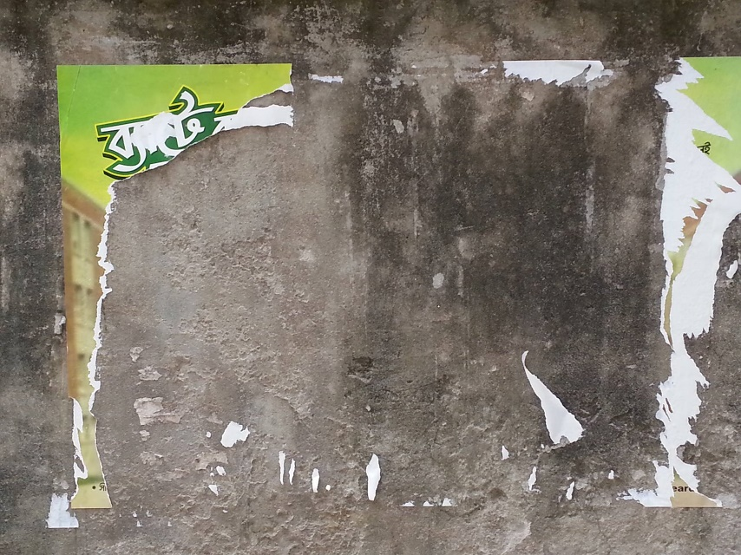

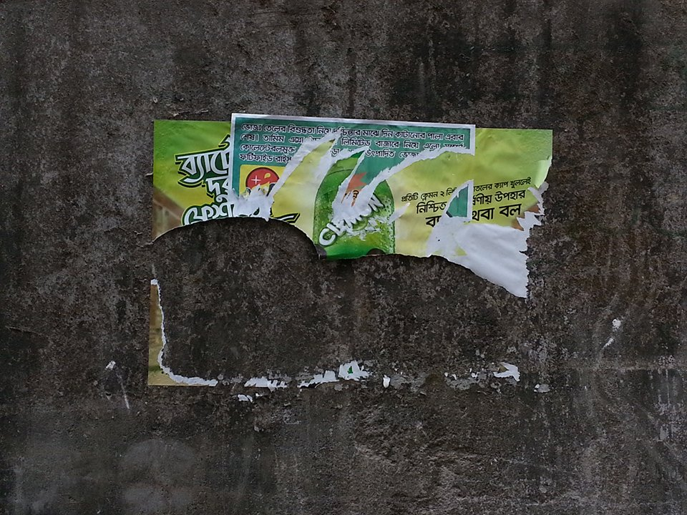

AREA NAME – 2. SHAMOLI
Explanation- There was not a single piece of Clemon Poster in Shamoli area.
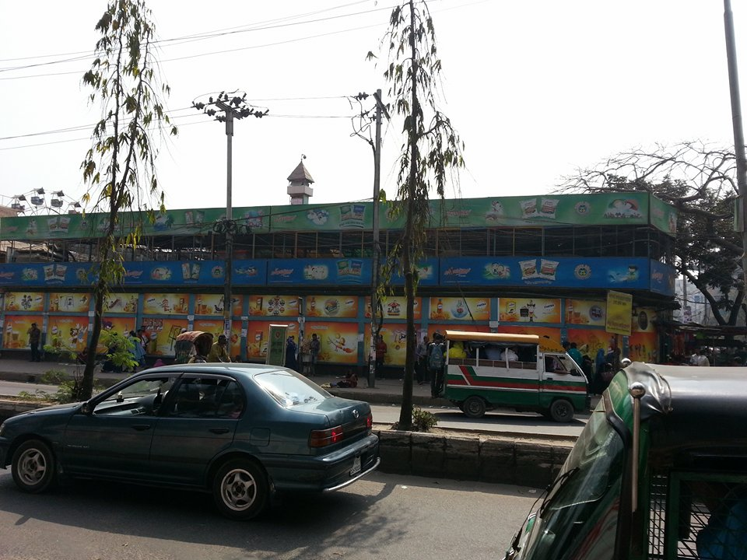

AREA NAME – 3. ADABOR
Explanation- There was not a single piece of Clemon Poster in Adabor area.

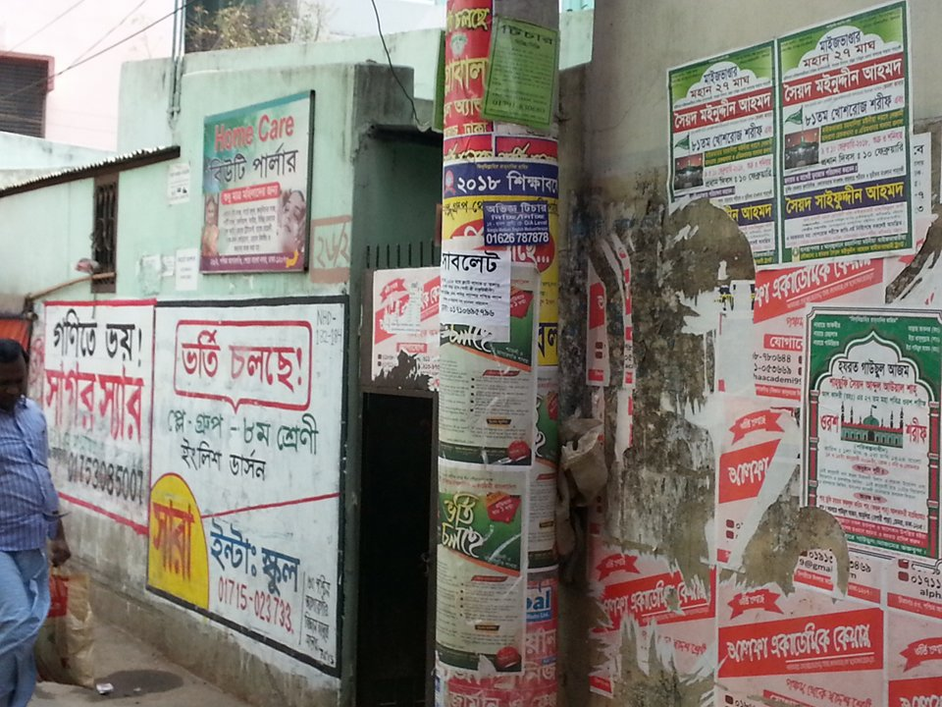

AREA NAME – 4. DHAKA UDDAN BLOCK-A, B, ROAD NO. 1,2,3,4
Explanation- There was not a single piece of Clemon Poster in those area which area was suggested by Mr. Rabiul Islam (TSM)
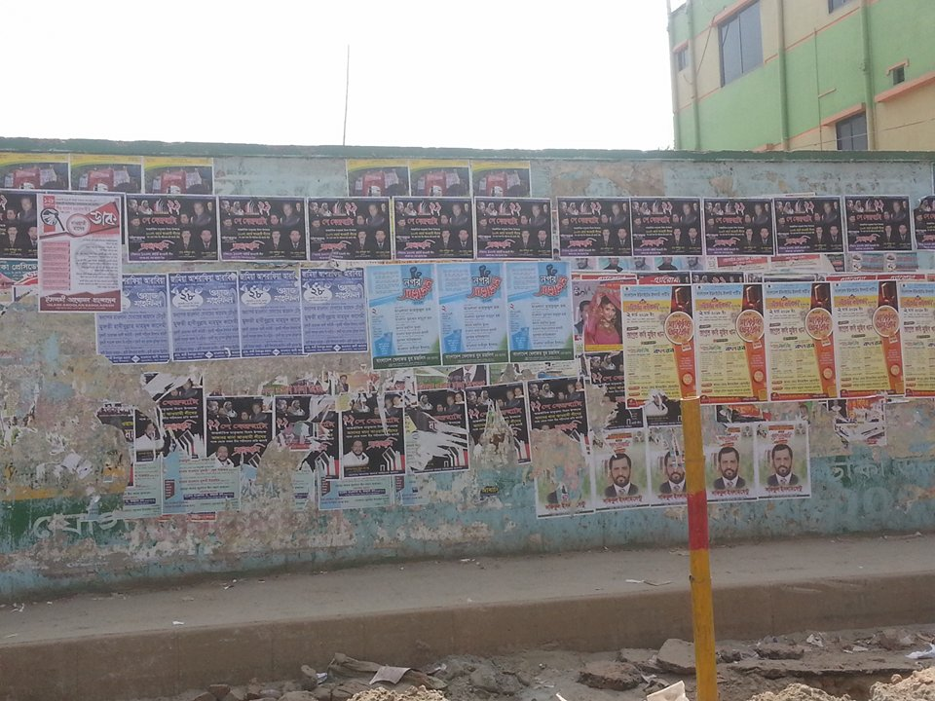

AREA NAME – 5. TURAG HOUSING GARMENTS
Explanation- There was not a single piece of Clemon Poster in those area which area was suggested by Mr. Rabiul Islam (TSM)
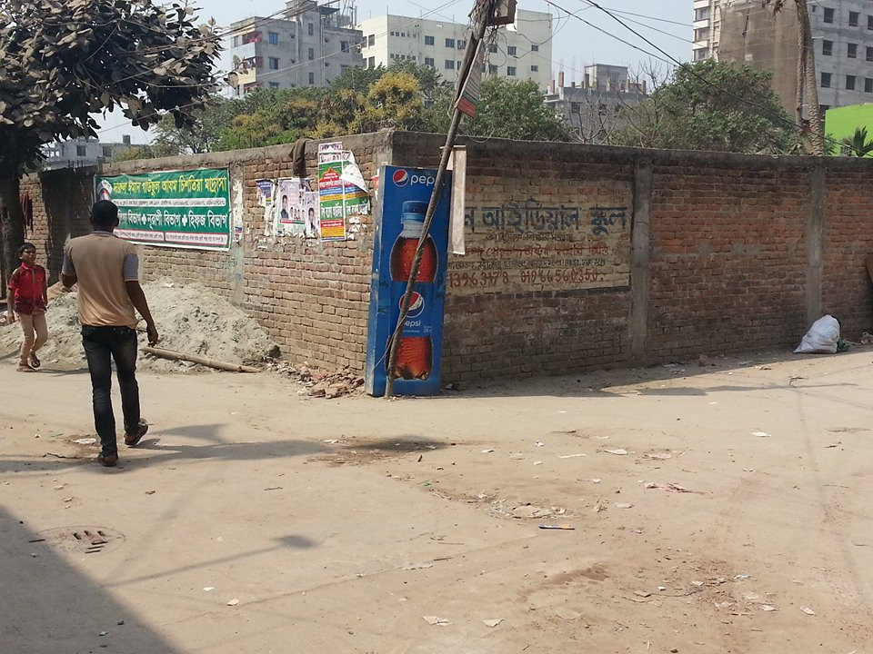
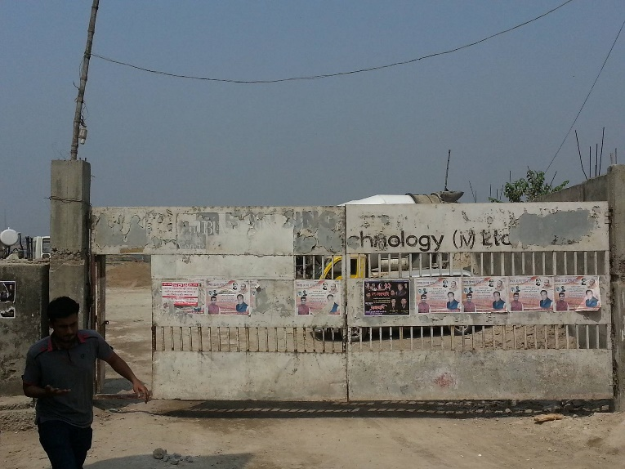

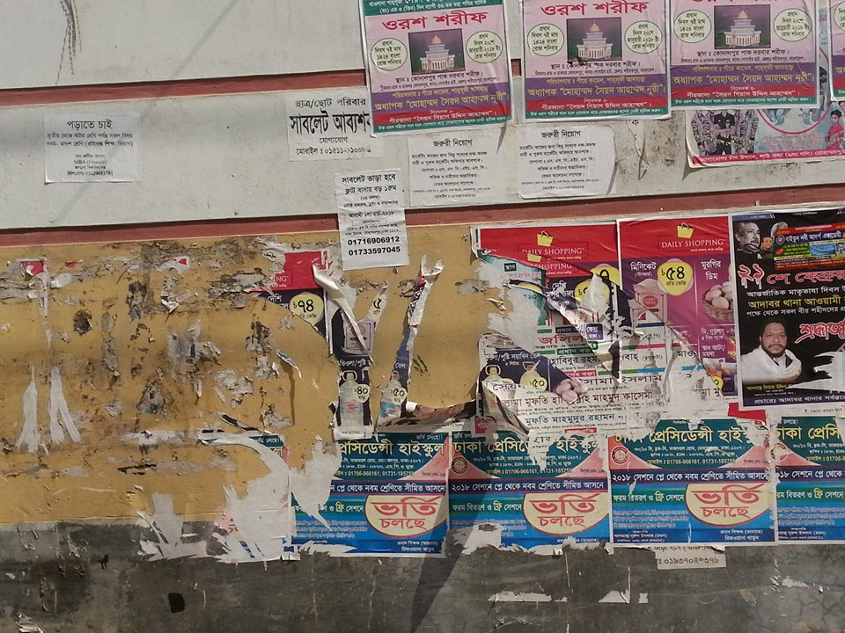

AREA NAME – 6. LAUTOLA
Explanation- There was not a single piece of Clemon Poster in those area which area was suggested by Mr. Rabiul Islam (TSM)

AREA NAME – 7. CHAAD UDDIN
Explanation- There was not a single piece of Clemon Poster in those area which area was suggested by Mr. Rabiul Islam (TSM)
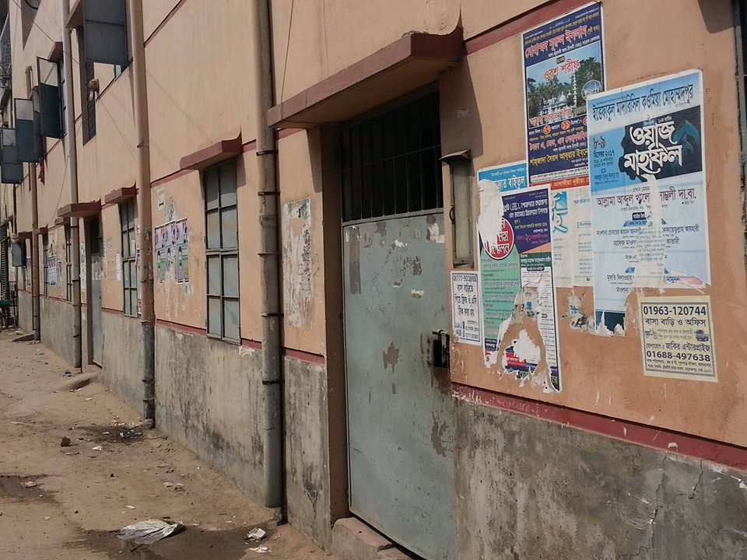

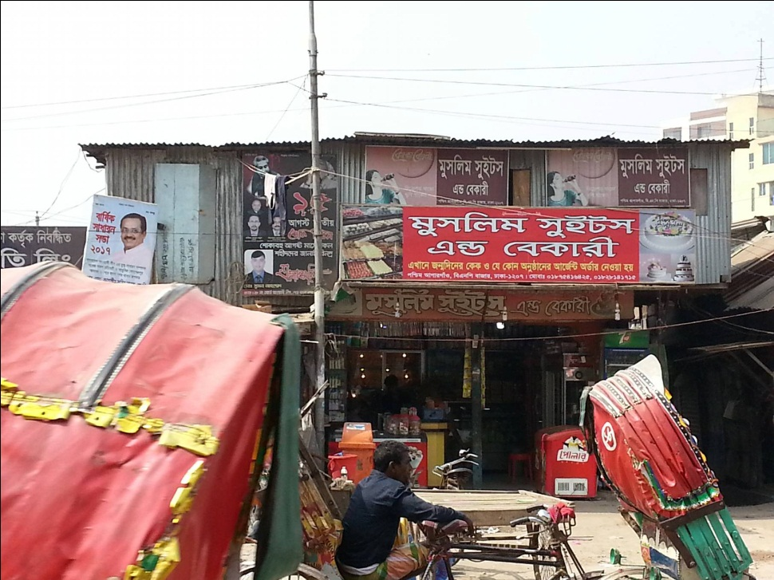

AREA NAME – 8. JOYNAL ABEDIN MARKET
Explanation- There was not a single piece of Clemon Poster in those area which area was suggested by Mr. Rabiul Islam (TSM)

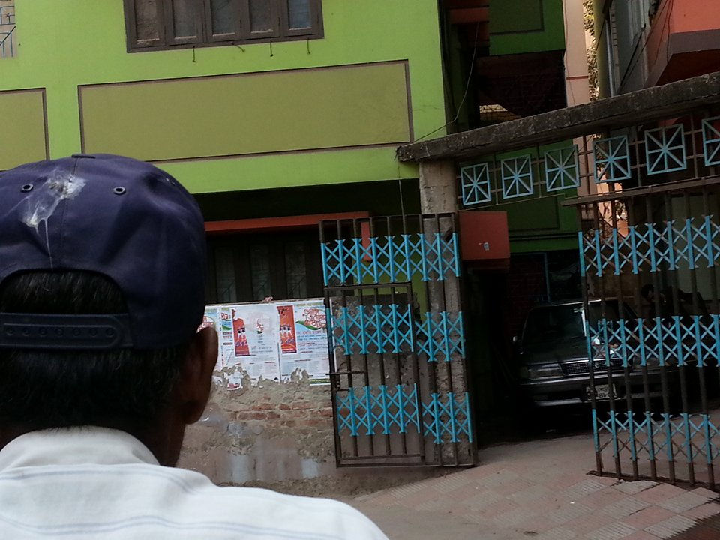

AREA NAME – 9. RAYER BAZAR
Explanation- There was not a single piece of Clemon Poster in Rayer Bazar area.

AREA NAME – 10. ZHIGATOLA
Explanation- There was not a single piece of Clemon Poster in Zhigatola area
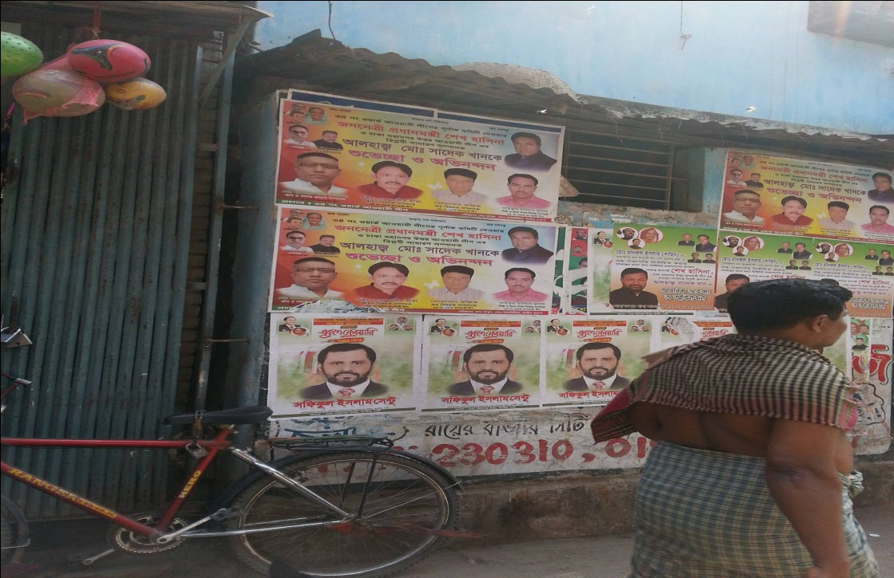

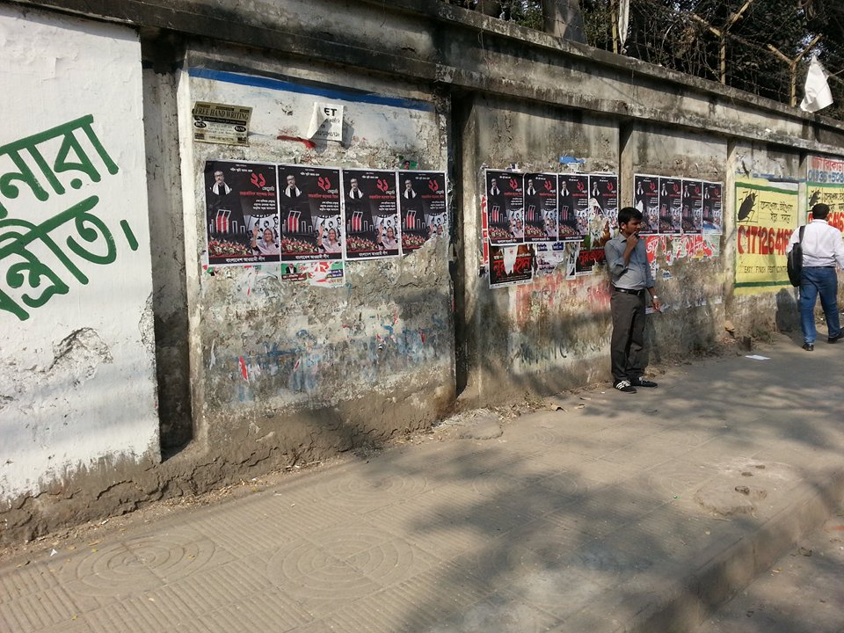

AREA NAME – 11. ELEPHANT ROAD
Explanation- There was not a single piece of Clemon Poster in Elephant area.

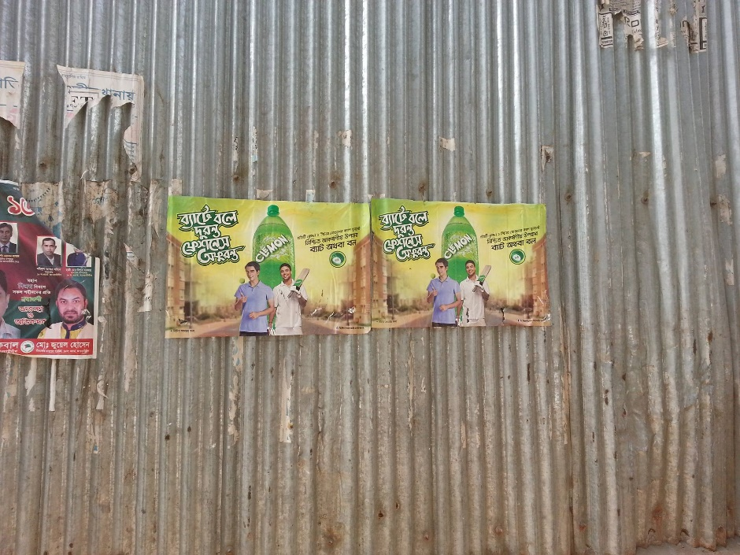

AREA NAME – 12. HATIRPUL
Explanation- There were only two piece of Clemon Poster in Hatirpul area.

AREA NAME – 13. TSC MORRE
Explanation- There was not a single piece of Clemon Poster in TSC Morre
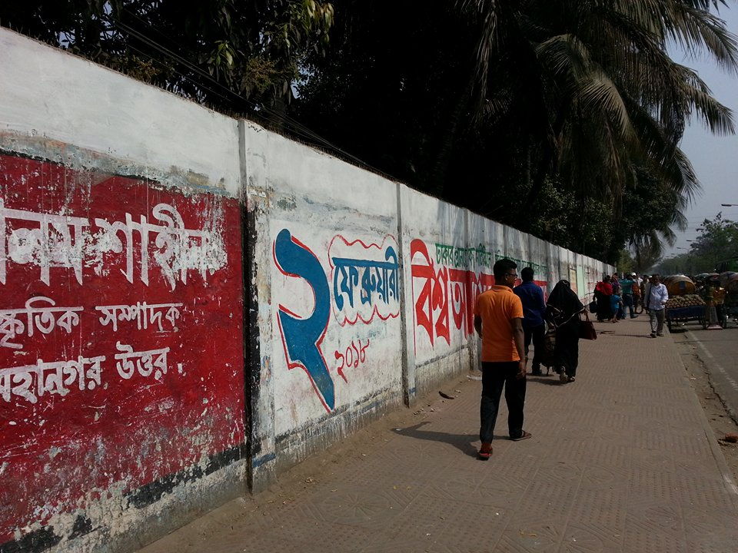

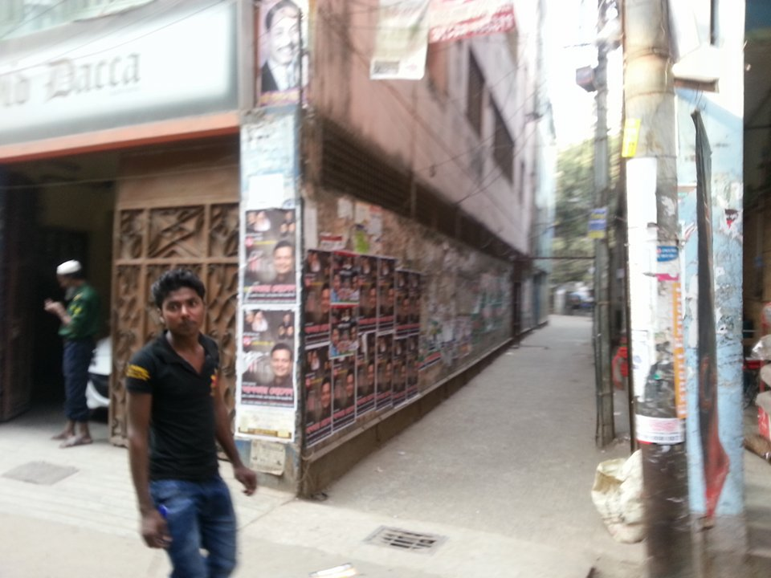
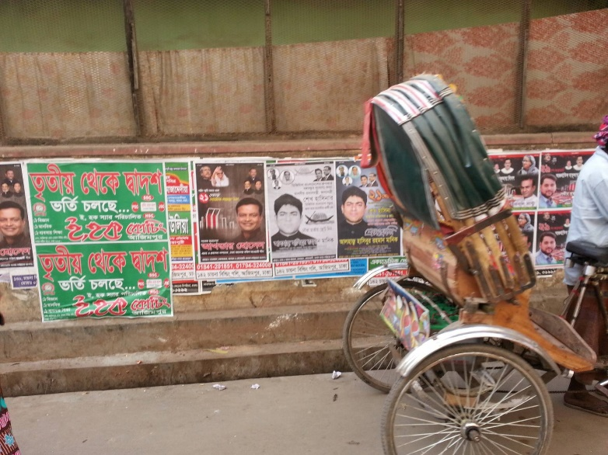
AREA NAME – 14. LALBAGH (RAHMATULLAH HIGH SCHOOL)
Explanation- There was not a single piece of Clemon Poster in Lalbagh area.

AREA NAME – 15. KAMRANGI CHAR
Explanation - There was not a single piece of Clemon Poster in Kamrangi Char area.
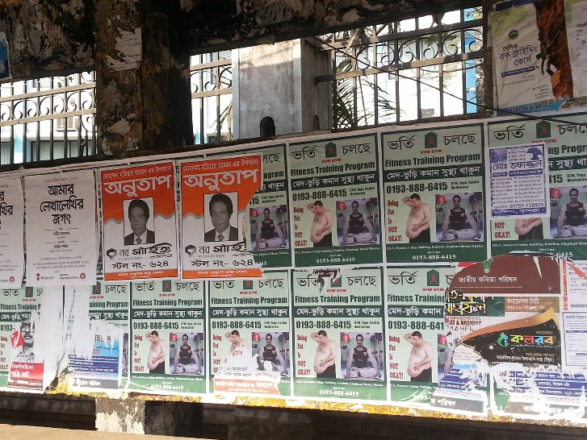

Note:
- I’ve covered almost 15 areas regarding Clemon “Bat-e Ball-e Duronto, Freshness Ofuronto” poster observation but the result was too much unsatisfied.
- There were only two posters among these 15 areas.
- I didn’t find any competitors (Pran up, 7up, Sprite, Fizz up) posters among those areas.
- If we could paste the expected amount of posters in those areas, the outcome would be more fruitful.
- We can monitor the TSM’s to do the task properly and to reach our expected goal.

The Pie Chart will help to understand the whole observation of these 15 ares.

Chapter – 5

SWOT Analysis

SWOT Analysis of AFBL
Strength
- Quick establishment of brands like MOJO, SPEED, CLEMON, FRUTIKA.
- Quality of the products.
- Availability of products through mass distribution around the country.
- High quality machineries and manufacturing system of AFBL.
- Unique promotional activities.
- Full sliver-Packaging in terms of color combination and design.
- Potable in terms of 150ml and 250ml bottle and can.
- Wider product range
- Strong local presence
- Favorable brand image
- Comprehensive knowledge of the total market and client
- All raw materials are imported from foreign countries (Thailand &Malaysia, Germany)

Weakness
- Less experience in the beverage market in terms of understanding in timely proper customer need.
- Some improper promotional activities.
- Lack of brand awareness
- Lack of consistency in promotional activities
- competitive price; competitor sourcing product at cheaper price
- Being new in the market AFBL considers a weakness in the entire supply-chain-management.

Opportunity
- There is a scope for the local companies to attaining maximum market share for the refreshing flavored CSD drink.
- Opportunity for AFBL products to be exported in the overseas Asian market.
- As a local company it will get preference from the Bangladeshi people.
- Huge profitability scope in beverage market of Bangladesh because a sustainable growth of 6% prevails in the market.

Threat
- Companies like Coca-Cola and Pepsi to be operated as MNCs like Unleveled rather than the licensing owned by the local Bangladeshi company.
- Any new company introducing unique flavored refreshing drinks and having huge financial capabilities.
- Unethical practice of the competitors, for example tax violation, to reduce the price of the product.
- More competitors in FMCG sector.
- Very difficult to maintain the product’s quality.

Chapter – 6

Finding and Conclusion

Findings
a) Lack of some system: Some kinds of system at AFBL are lacking here, when the system are update and solve out then the program is running and developing the brand.
b) Shortage of backup:
Because of the software not online basis so the backup of the files is very important otherwisethe file will be missing.

c) Improving the product delivery local area:
As we know that AFBL is a 100% oriented company some kinds of local area AFBL products are not available so improve the product delivery system.
d) Lake of communication:
The communication system must be develop in the brand and marketing department. Here customer is our main things so it is very important to know the customer opinion.

e) Less number of employees:
Again, some kinds of position there is low number of employees the task as well as dispatch related works. So, it takes a bit longer time to finish off his or her job with efficiently.

f) Lake of corporate system:
Some kinds of corporate system are lacking in the AKIJ HOUSE, because all kinds of Akij concern are shift in the Akij House .Some kinds of problem are find out and solve it very fast.

Recommendations:

a) Creating online basis software:
At present AFBL Ltd is using their own software for operating and managing the organizational task but it is not online basis software. If any occurrence happens then the whole department has to suffer for this problem by stuck at the unfinished work. So if they upgrade the system then that could be more effective and efficient for operating the task in the organization.

b) Developing event activation
Must be developing the event & activation. Day by day update new program and modifies all kinds of program. When new event and activation are arrange then the target customer are satisfy to take the product.

c) Developing communication
Internal communication must be developing and some time to arrange the survey research to know the market position.

d) Ensuring the backup:
Because of the software not online basis so the backup of the files is very important otherwise valuable files will be missing. Using of software reduces environmental pollution like less using of paper but company’s important documents can be under risk by depending on computer. So the company should more aware of the backup and ensure that they have the documents backup in both sectors.

e) Ensure the product quality:
The product quality of specific product must be develop in the competitors market otherwise
It is not possible to stay the market.

Conclusion:
Lots of new food & beverage industries have been established in last few years and these industries have made this sector very competitive with their new scheme. So, now food & beverage Clemon have to organize their operation and do their operations according to the need of the market and compare to their competitors. Food &beverage no more depend on a traditional method but in this competitive world this sector has trenched its wings wide enough to cover any kind of financial services anywhere in this entire world. The major task for food industries, to survive in this competitive environment is by managing its assets and liabilities in an efficient way which will make them more secure.

If the AFBL wants to compete with world class textile industries, they must have analyzed about marketing distribution channel, price margin maintains, competitors by them and the promotional activities given to traders etc. In order to know the current marketing management system of this company they must have to do market research.

Reference
- Internal information source (AFBL)
- Philip Kotler, Marketing Management 11th Edition, Inc, USA, 2003.
- Philip Kotler, Principles of Marketing 13th Edition, Inc, USA, 2005
- David W. Cravens & Nigel F. Piercy, Strategic Marketing 8th Edition, Inc, Singapur, 2006.
- Akij website (www.akij.com)

- Wikipedia

