A Study on SME Business of Grameenphone Ltd

Atiqul Islam

This report is submitted to School of Businesses & Economics, United International University as a partial requirement for the fulfillment of Bachelor of Business Administration Degree requirement

A Study on SME Business of Grameenphone Ltd

Submitted By
Atiqul Islam
111-142-038
School of Business & Economics
United International University

Supervised by
Professor Dr. Kawsar Ahmmed
Deputy Director - BBA Program
School of Business & Economics
United International University

Submission Date- 21-02-2021

Letter of Transmittal
05th January 2020
Dr. Kawsar Ahmmed
Professor
School of Business & Economics
United International University

Subject: Submission of report on “A Study on SME Business of Grameenphone Ltd,,
Dear Sir,
With a great pleasure, I here submit my internship report on the topic of “A Study on SME Business of Grameenphone Ltd” that, I have prepared the report as a requirements of my BBA program. I put my best effort to prepare this report and to make it a worthy one.
I hope this report will attract your kind appreciation.

--------------------------------
Atiqul Islam
ID: 111 142 038
BBA - Marketing

Declaration
“I Atiqul Islam, a student of BBA major in marketing of school of Business and Economics, hereby declare that the project report on “A Study on SME Business of Grameenphone Ltd,, is my original work and has not submitted by me before for any degree, diploma title and recognition. It is completed under the supervision of Dr. kawsar Ahmmed of United International University”

………………………………………………..
Atiqul Islam
ID-111 142 038
Business and Economics School
United International University

Certification of Supervisor
“This is to certify that Atiqul Islam Student of BBA bearing ID 111 142 038 of United International University, major in marketing under the faculty of Business and economics, has successfully completed project report on A Study on SME Business of Grameenphone Ltd.
I wish him success in life”

…………………………………………………..
Dr. Kawsar Ahmmed
Professor
School of Business and Economics
United International University.

Acknowledgement
It is necessary to understand the consequences of theoretical and practical knowledge, as a part of my practical knowledge I prepare such kind of report.
Firstly I want to thank to the Almighty Allah for giving me the opportunities and ability to work on this report. I am grateful for the love of my parents, caring for me and supporting my efforts.
I call my supervisor for timeless accurate and accurate guidance, inspiration, affection, encouragement and valuable advice for this investigation. I would like to thanks to my academic supervisor Kawsar Ahmed Professor, School of Business and Economics, UIU.
I am extremely grateful to everyone who helped me in conducting my research, taking time out of their busy schedule to discuss my various issues with me.
Finally I would like to thank the user of Grameenphone who patiently completed the questionnaire and helped me to prepare this report. Without them I would never have been able to successfully complete my project report.”

Executive Summary
Mobile telecommunication companies are playing a key role in communication in the current world. Grameenphone has become one of the leading companies in the mobile telecommunications industry of Bangladesh. Creating a higher image than competitors is a daunting task. Grameenphone has produced a higher image than other operators. Customer manager behaves well. GP users say Grameenphone billing rates are higher.
This report is prepared to meet the partial requirements for a Bachelor of Business Administration degree at United International University. The main objective of this report is to do a thorough analysis of SME business of Grameenphone Limited and suggest some areas for improvement. At the outset, this report highlights the purpose of the report, the motivation for the study, the scope of the study, the limitations of the study, and the significance of the study. Profile of the organization including Mission, Vision, SWOT Analysis, Porters Five Force Model, Products and Services, are given then. Then Literature Review is placed that include the relevant studies relating to SME business. Methods, data collection and analysis, interpretation and discussion are included in the third chapter.
Based on the analysis, a number of important factors have been identified which are the major factors affecting SME business of Grameenphone Limited including network coverage, customer service, pricing, internet service and employee behavior. Based on the findings of the study, several recommendations and conclusions have been made at the end of the report.
Keywords: SME Business, Customer satisfaction, expectations, network coverage, and Grameenphone
Contents
Letter of Transmittal i
Declaration ii
Certification of Supervisor iii
Acknowledgement iv
Executive Summary v
Chapter -1 3
Introduction 3
Introduction 4
Constraints facing SMEs 5
Objectives of the Term Paper 7
Methodology 7
Limitations 8
Chapter-2 9
Company overview & Literature Review 9
Introduction 10
Historical background 11
Mission, vision, and values Of Grameenphone 11
Mission: 11
Vision: 11
Legal Form: 11
Registered Office: 12
Board of Directors 12
Organogram of Grameenphone Ltd: 12
The shareholders 14
Corporate Responsibility in Grameenphone: 14
Products and services of Grameenphone Ltd: 15
Customer service: 17
New Connection Purchase: 18
Customer satisfaction 19
The importance of customer satisfaction 20
The factors that have impacts on customer satisfaction 20
Chapter-3 22
SME Business Sector of Grameenphone 22
Business Solutions Offer 23
Package Features: 24
Price Quotation 25
Strength 46
Weakness 46
Opportunity: 46
Threat 47
Chapter 4 48
Finding & Conclusion 48
Positive aspects 49
Negative Findings 50
Recommendations 51
Conclusion 52
Reference 53

Chapter -1

Introduction

Introduction
(SMEs) means Small and Medium Enterprises, it is an engine of growth and an engine of global development. It plays an important role in developing economic growth and employment.
In Bangladesh, SMEs business has a great role shaping the economy. SMEs business plays an important role in accelerating industrialization and economic growth of the country, creating jobs and reducing poverty. This business sectors creating employments, expending export revenues and helps in creating new venture. It has a great contribution around 45 percent in small and medium production and about 80 percent of the industrial employment. The larger part of our national GDP comes from the industrial part and among them small and medium enterprise are the most. According to a study conducted by japan and found that Bangladesh has 17,384 micro enterprises, 15,666 small ones, 6,103 medium and 3,639 large scale enterprises, the study also told that around 5.02 million people are engaged with this industry. Our small and medium enterprise (SME’s) business are mostly based on the rural areas, a study found that about 65% of all SMEs are developed and managed from the village area. The country's SME businesses already made hugs jobs in our country. From now on, private and foreign banks distribute.
In Bangladesh in each year approximately millions young people comes to the country's workforce and doing jobs or starting business at lower capital. Therefore, creating more jobs becomes a challenge for us.
Country’s development, growth and economics structure depends on the total business structure of a country. In our country fastest growth depends largely on the garments, agricultural sectors and also small and medium-sized businesses. SMEs can play an important role in developing and creating jobs outside the agricultural and informal sectors as it doesn’t required highly skilled labor. SMEs are labor intensive but relatively low capital intensive. Bangladeshi company manufacturing lower scale company and also manufactures large-scale industries owned by government and private agencies, SMEs can provide a proper solution by building a small and medium enterprise business. Seasonal and pseudo unemployment can also be solved by small and medium enterprises. Small and medium enterprises can reduce urban migration (by creating lower capital small business) to the capital and other large cities, increase cash flow in rural areas and increase the level of standard life at rural residents. Small and medium enterprises are widely distributed across the country which means that the development of SMEs growing up and reducing the income gap between urban and rural areas and contributing to inclusive growth.

Constraints facing SMEs
Each and every business has some limitations which creates unfavorable situation for a business and business sectors. In our country SMEs sectors faces few constrains, some are following

- Lack of capital.
- Lack if modern technology.
- Uncertain market.
- Lack of skilled technicians and workers and manager.
- Higher bank interest.
- Lack of government policies and facilities.
- Lack of infrastructural facilities.
Bangladeshi government has selected the SMEs sector as a priority sectors for shifting our nation from low income to middle class country. For this purpose our central bank Bangladesh Bank (BB) plays a supportive role in planning, developing, and implementing this sector. Bangladesh Government has taken some initiative to expend this sector at large scale and for this purpose it publish gadgets to finance the small companies and also monitors them. All local banks are now financing the small companies against the legal documents. Each banks opened a special department to support the small and medium companies named as a SME department.
Our central bank is promoting cluster-based SME credit programs for supporting at mess level. Some of the clusters are following
- Sewing and handicrafts in Jamalpur
- Flower farming and processing
- Weaving in Moulvibazar
- bamboo and bamboo crafts in Sylhet
- Tangail weaving light engineering of Bogra
- Clothing in Saidpur
- Khadi in Comilla and Chandpur
- Jamdani in Narayanganj.
Government support the SMEs business industry to distribute the products nationally. So that the economic cycle move nationally. Government and owner of small and medium companies are now carries the modern equipment to produce the product at large scale. The labor of this sector need to be learned the process the modern equipment. Now a days there are several tanning facilities are offered by government and related authorities for the betterment of this sector.

Objectives of the Term Paper
The main objective of this report is to identify the SME business of Grameen Phone Limited in the telecommunications industry in Bangladesh and to point out the areas for continuous improvement of Grameen phone service in this area.

Methodology
To prepare this report, we conducted a literature search in connection to the topic. This search was conducted primarily in Grameen phone’s employees, Gp website, university databases, journal databases, library journals, and others,
As I do my internship at GP house I collected most of the information from them by discussing, articles, previous data and etc. I also visit GP website for collecting specific information their background.
Then we searched information at university library, such as Emerald, Business Insight, ABI / Inform, Global Information Inc. (Professional Research Report) and Google Scholar search engines, and all databases and databases provided by university specialized search engines linked to authorized books. The key terms that are used are Bangladesh Telecommunications Industry, Telecommunications future, Telecommunications trends, Bangladesh Telecom market”
The theoretical framework of this report has been developed with the help of some articles, case, textbooks on SMEs sectors and telecommunication in Asia. This project uses "international marketing" by Katora and Ghuri (23 2006), "international marketing" by Bennett and Blythe (212) and marketing text books such as Porter's On Competition (1998)”

Limitations
Noting is perfect in the world, this report is not out some limitations. During the report we faces few problems. Some of these-
• Limitations regarding accurate information’s
• Lack of recent data and statistics
• Time constraints
• Primary data are not available enough

Chapter-2

Company overview & Literature Review

Introduction
"Grameenphone Limited is own the most users and become the best telecom operator in Bangladesh in terms of network facility, revenue, coverage and customer group. It was enlisted as a private limited company on October 7, 1996. After then it listed as a Public limited company on June 27, 2007. The company enlisted on the stock exchange on the November in Dhaka Stock and Chittagong Stock Exchange ember started trading from November to November 27. Basically, it is a jointed venture company where Telenor Mobile Communications own (7.7%) and Grameen Telecom (1.25%), the remaining percentage of shareholder is comprised of 1.5% for the general public and other organizations"
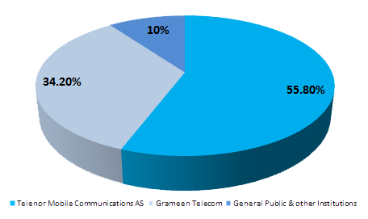

Historical background
“Grameenphone was introduced in 1997 by Telenor in the Asian telecom market. Telenor and its partners are connecting millions of previously connected people by expanding network capabilities and expanding coverage to new and almost remote areas. Grameenphone offers key voice, internet, corporate services that have great value to customer and users

Mission, vision, and values Of Grameenphone
Grameenphone is here to inspire you. It provides the power of digital communication, enabling everyone to improve their lives by proper communication, creating partnerships and ensuring a better future for all.
Mission: Grameenphone mission is “We are here to help our customers”
We exist to help our customers to take full advantage of communication. Our success is measured by how passionately they encourage us.
Vision: Grameenphone visions is to “Empower societies.”
We offer the power of digital communication that enables everyone to improve their lives, build societies, and secure a better future for all.
Values: Grameenphone has its own values by which it operates it businesses
- Make It Easy
- Keep Promises
- Be Inspiring
- Be Respectful.
Corporate Information’s:
Company Name: Grameenphone Ltd.
Company Registration No.: C-31531 (652) / 96

Legal Form:
Grameenphone was incorporated as a limited liability company on October 10, 1996, then converted to a limited company on June 25. Grameenphone listed on both Dhaka and Chittagong Stock Exchanges on November 7, 2009.

Registered Office:
GPHouse
Bashundhar,Baridhara
Dhaka-1229, Bangladesh

Board of Directors
Directors

Organogram of Grameenphone Ltd:
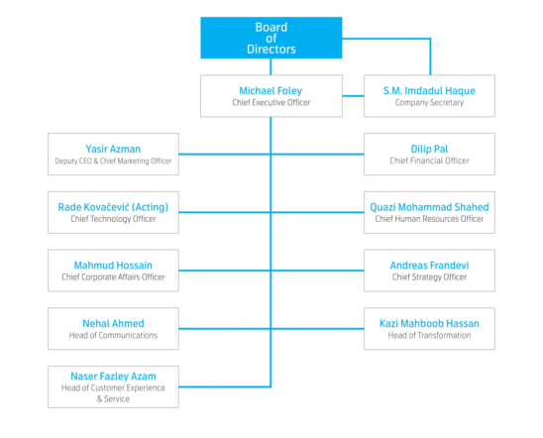

The shareholders
The shareholding structure of Grameenphone is consist of two sponsored shareholders called Telenor Mobile Communications as (55.80%) and Grameen Telecom (34.20%). The remaining percentage of shareholders consists of 1.5% for the general public and (2.5%) for foreign (3.66%) and others (1.313%) as of December 1st 2019.

Telenor Mobile Communications AS (TMC)
"Telenor Mobile Communication (TMC) is the subsidiary organization of Telenor ASA. TMC if the Norway's leading telecommunications company is the ASA of Telenor listed on the Oslo Stock Exchange. TMC owns 1.5% stake in Grameenphone Ltd.
Grameen Telecom:
Grameen Telecom is established by Professor Muhammad Yunus which is a not-for-profit organization. It operates from Bangladesh and it owns 34.20% shares of GP.

Corporate Responsibility in Grameenphone:
Corporate accountability is manifested in all aspects of the organization by applying Grameenphone's vision and values ​​and its value chain. Grameenphone believe that "development is not a destination, but a journey." It is not their job to make connections, it helps to connect with people that creates relationship based on trust of the customers, business partners, employees, shareholders, stakeholders, broad community and government’s regulations. They believe that development is a good business which can be maintained focusing on our business, advance technologies and better services that results the nation top priority company. These relationship with Bangladesh government developed on a partnership that seeks to achieve common economic and social goals. CR initiatives will be focused more on creating social welfare through the use of core skills of the company.

Products and services of Grameenphone Ltd:
Grameenphone Limited provides various services through Nishchinto, Dostho, Djuice, and Smile. Through this national bundle, users can get various benefits like talk time, data packs, SMS packs etc.
Nishchinto:
Nishchinto is one of the best prepaid tariff plan for GP users, it offers the customer's default prepaid tariff plan in Nishchinthoich. Every new prepaid customer will get the same call rate for making a local voice call with a call rate of 21.5 paise per second.
For each new connection the fees is TK.100
GP to GP: Call rate is 45 poisha for 10 seconds.
GP to Others: .88 poisha for 10 seconds in others operators.
FnF: No fnf package available
Pulse: 10 second
SMS: Each SMS is 0.10 tk

Features:
This package contains 10 second pulses.
Bonds, smiles and juice packages can be transferred to this package. For migration, customers can get confirmation by just type "N" or by send SMS to 4444 or dial * 121 * 1 * 6 * 2 #
Customers has the power to switch to other prepaid plans such as Friends and Deutsche.
5% Supplementary Charge (SD) + 15% VAT with SD + 1% surcharge will be applicable
Bondhu:
Bondhu is another package which provides the maximum F&F numbers. Users of this package can talk to their closest and loved some at the lowest rate. Grameenphone allows to make 18 F&F numbers in every connection with 10 second pulse. Grameenphone gives every friend the opportunity to call GP-GP super F&F in just 5.5 Poisha for each 10 seconds and others operator F&F of 17 (max) is available at 11.5 Poisha / 10 sec
Features:
- Customer can make 18 F&F numbers in total
- Customers can make on super F&F(GP to GP)
- 17 (maximum) GP-GP F&F or GP-Other operator F&F in any combination
- GP-GP Super F&F numbers call rate is At 5.5 poisha/10 second.
- At users can make calls to GP-GP F&F numbers
- Other operator F&F number call rate 11.5 poisha/10 second
- Customers can make All GP-GP calls (excluding F&F calls) at 27.5 poisha/10 second.
Djuice:
“Grameenphone Limited's new design price plan has been created with the youth in mind. It addresses the most relevant elements of Atlantic youth living: community, F&F! Each customer is given the freedom to talk to your community (design-by-design) all day and night on a flat tariff of only 0.1 pa / sec. You can also enjoy 5 F&F numbers at any local mobile number in just 0.5 paisa / sec. According to the article, users will be able to talk to any GP or other operator in just 2.5 ps / sec"
Features:
- price: BDT 100
- Pulse: 10 Seconds
- A subscriber can also migrate to the other prepaid price plans - Bondhu and Nishchinto
- 10 FnF numbers
- Calls to F&F numbers at 11.5 poisha/ 10 second
Note: 5% Supplementary Duty (SD) + 15 % VAT inclusive of SD will be applicable for all charges + 1% surcharge on base tariff.
Smile:
Grameenphone offers customers a Smile Prepaid connection which gives customers more freedom, more opportunity and more reason to laugh. Users with 5 seconds pulse will be able to talk to all their friends at 20 Poisha / 1 second and can talk to three GP-GP F&F numbers in just 0.1 Poisha / 1 second.
Features:
- Number of FnF: 3
- 5% Supplementary Duty (SD) + 15 % VAT inclusive of SD will be applicable for all charges + 1% surcharge on base tariff.

Customer service:
Customer service provision before, during and after the purchase of customer service The success of this national interaction depends on the staff "who can reconcile with the personality of the guest"
Online customer service:
- Customers can click on “How May We Help You” options at the bottom right corner of this page to get live chat with customer service team.
- Email can be sent to insta.service@grameenphone.com for any assistance
- The Grameenphone fan page on Facebook: https://www.facebook.com/grameenphone can be used to obtain the service. Customers can post their questions on the Grameenphone fan page bulletin board or send messages to try out the instant online service.
Neel –The GP Genius:
This is the 'blue', proper talk-planning, internet package, activation process and customer answers to all the queries in an eternally friendly avatar

New Connection Purchase:
To buy a new connection, customers have to go to Grameenphone Center, or Retailer outlet.
Documents required:
Grameenphone accepts the National Identity Card (NID) and its photocopy (passport for foreign / diplomats ). Customers who have a passport or driving license (GPC only) do not have an NID to purchase a new SIM copy of the passport size image.
Name, telephone number and NID number of the identifier (this is a test for diplomats and foreigners).

For corporate subscription – Grameenphone has a big corporate clients. If corporate customers faces problems regarding their connections the must follow few procedures.
- The contact person need to send an application to the letterhead pad / fill out the SIM replacement form with the appropriate company seal and valid sign
- Corporates clients should come to any GP GPC, GPCF, and express.
- Pay BDT 100tk for prepaid and BDT 100tk for postpaid connection.
- Customers are also provide the following documents to service points
Documents required: The request number of GPC, GPCF and Grameenphone Express verified by Bio-Metrics will be blocked. After checking the mobile number information (e.g. FNF number, last top up, etc.), the request will be executed 121 times. Prices and fees do not apply.
Store Locator:
Customers can use 'Store Locator' to find the nearest GP sales and customer service center and get the service quickly and easily.
SIM Replacement: Customers must visit the service points for any error related to connections.
Contact Point: Customers must have to visit GP service point or its authorized service point for sim replacements and any others problems. Its authorized points are GPC, GPCF Express
For individual subscription – When customers go for replacements they need to follow few instructions, these are following
- Connections information
- Biometric verification
- Fill up replacement form.

There is high level of competition between Grameenphone and other providers.

Customer satisfaction
Customer satisfaction is a measure of how the requirements and responses help to deliver customer expectations and are delivered. Customer satisfaction is only available if the customer has a good overall relationship with the supplier. An important performer of the business strategy spender and basic differentiator is customer satisfaction in today's competitive business market. Therefore, customer satisfaction is even greater; What’s more is the bonding with the business and the customer. Customers will be satisfied if the company provides a great customer service. So customers get a decent service, you earn the right revenue and everyone is happy.

The importance of customer satisfaction
Grameenphone managed to create a superior image compared to other carriers. In other words, GP has a clear advantage over its competitors and has some additional features than its competitors.
1. Customers who are satisfied will recommend the company to their network. There is a proverb that a satisfied customer can make a 10 positive customers which is called the word of mouth (WOM). A survey found that 85% of their new business comes from word of mouth of satisfied customers. The positive word of mouth increases sales. So revenue also increases.
2. Satisfied customers will continue to buy from the company. A company’s most of the revenue comes from the top 1 or 2 percent of loyal customers. Developing new customers is 6 times more expensive than to retain an existing customer.

The factors that have impacts on customer satisfaction
Grameenphone has managed to create a superior image compared to other operators. In other words, GP has a clear advantage over its competition and has additional features compared to its competition.
1. Access: The internet discovered products and services in an instant. At this digital time customers can easily find and take reviews about competitors by searching on web, making mail and word of mouth. So it become so competitive for company to keep its clients onward.
2. At Face Value: If a company charge higher price compared to others company customers will avail the information through internet. The power of customers is higher at the present market so company need to be more careful in pricing.
3. A Nice Atmosphere: Ask any smart person and they will tell you that, given the same product or service, they would rather buy where it offers a clean, safe and harmonious environment.
4. The one R: Responsibility: The organization values has to publish the truth information. Hiding Information cannot satisfy customers. When a problem arise related product or service, company should take necessary action immediately to make it solve for it satisfying it customers.
5. Technology: Technology means more than simple and user friendly websites. To satisfy customers, companies must continue the latest technological technology and provides faster information on website. Change is never easy, but business as usual is not a viable option.

- Network coverage
- Package price
- Bonus talk time /SMS
- Facing any types of overcharging issues
- Clear sound quality.
- Internet service
- The service rate of caller tunes, missed calls, call blocks service
- value added services
- accessibility of service hotline
- Behavior of Customer service managers.
- The activity of Grameenphone to increase social awareness in Bangladesh.
- Contribution to sports and education
- Availability of customer care centers
- Promotional offers Of Grameenphone

Chapter-3

SME Business Sector of Grameenphone

Business Solutions Offer
In addition to group experience operating in 5 countries in Asia and Europe, we have learned from the experience of serving the corporate market over the past 6 years, how mobile voice communication helps a company manage and manage operational speed and efficiency. An organization requires a continuous spread network with clear voice quality, be it urban, semi-urban, rural or deep-rural. An un-established call can cause huge disadvantages, from customer dissatisfaction to financial loss; even this can be a complete loss of forgiving clients and businesses. We have also learned that in the dynamics of the modern business environment, access to communication is needed, whether national or global. We learned how communication gets cascading errors, and how single communication from management to employees can change the overall mindset of an organization and motivate them toward goals.
The largest and best network in the country: “Grameenphone operates the largest and best network coverage in the country with over 13,500+ base stations across the country. We cover 1.5% of the population and 1.57% of the land area, enabling you to communicate with your colleagues, supply chain members or even friends, family and relatives, including all your branches, stakeholders, etc. To give you a seamless communication experience, a team of nearly a thousand qualified engineers and technicians are working to keep the network up and running on a continuous basis on a 24X7 basis. To ensure coverage for your office premises, we take steps to improve the quality of the network as needed. We propose you to enable Edge / GPRS / 3G / 4G network coverage and work tirelessly to improve the network to provide better quality and upgraded technical services. From our commitment to nature, we are transforming our network into a green network through energy efficiency. "

International Coverage:
With a changing landscape of the business environment, we provide you with global coverage through our international roaming service, which allows you to carry the same number worldwide. We offer "One Country One Rate" for the International Roaming Service to avoid Bill Shock and establish precision on billing. We offer detailed billing for this service by default. Currently we are offering international roaming facilities in 120 countries.
Clear and Convenient Billing:
"We clearly believe in billing because we believe in long-term business relationships with our clients. For our post-paid offers, to avoid bill shock, we offer precision on billing through the details bill both for the company and both individually and when needed. In addition to giving you timely bills, we provide e-bills. To ensure your ease of bill payment, we accept payments through Flexi-Load, scratch cards, checks or even at banks and online payment gateways. We also supply printed invoices in Bengali as per client's requirement. "
Uninterrupted After Sales Service: To streamline the sales service, we will appoint an account manager for your company, including regular sales centers, call centers, online customer care and sales centers across the country, including service touch points.

Package Features:

Flat Tariff: We provide you with a simple flat fee throughout the day to fulfill your desire to make tensionless and easy to calculate telecom expenses. Your team can communicate fearlessly and avoid the shock of the bill through these additional general tariff plans.
Free Stuffs: Each pack of business solutions brings you some interesting free stuff with the free stuff designed for you on the tariff chart.
Free Access Fee: As a business client, we offer a free access fee for your postpaid subscription. The access fee applies only to VAS.
Promotional Offers: Besides the regular offers the subscribers will be able to enjoy the time to time promotional offers targeting this product.

Price Quotation
To avail all the facilities provided by Grameenphone, we offer you the following price for your esteemed organization
Feature | Operator/Activity | Tariff (BDT)
Start Up Price |  | 200
Free Stuffs | Data: 200 MB [1 Month Validity]  SMS: 300 [1 Month Validity]  Free Miss Called Alert  Free Call Back | Free of Cost
24 Hour | To any operator | BDT 88.0 Per Min [10 Sec Pulse]
Office Talk (CUG) | To all Business Solutions Postpaid Subscribers using same package | BDT 0.45 Per Min [10 Sec Pulse]
SMS (160 Characters) | To any operator | 0.5
International SMS (160 Characters) | To any country | 2.5
Push-pull SMS | To any port | 2
MMS | To other operator (Selected) | 3
MMS | To Port | 5
International MMS (Selected Country) |  | 15
Itemized Bill |  | 100

International Roaming: international Roaming charge will be done as per the charging of foreign operator.
Notes:
- All the charges are excluding applicable Supplementary Duty & VAT: 10% Supplementary Duty (SD) +15 % VAT on price (inclusive of SD) +1% Surcharge
- This offer is valid for 15 Days from the date of the offer is given
- No security deposit is required for the above mentioned subscription
- Mode of Payment: Cash/PO/DD in favor of Grameenphone Ltd. before delivery
- Mode of Delivery: After payment, within 72 hours, products would be delivered, unless Grameenphone Ltd. specifies a timeline for delivering
Internet Price Plan
Pack Details | Validity (Days) | Regular Price  (includes all charges)
1.5GB | 31 | 240
2.5GB | 31 | 353
3.5 GB | 31 | 448
6GB | 31 | 609
12GB | 31 | 1211
18GB | 31 | 1594
30GB | 31 | 2550

Bulk SMS
“A Customer friendly Bulk SMS solution that understand you need”

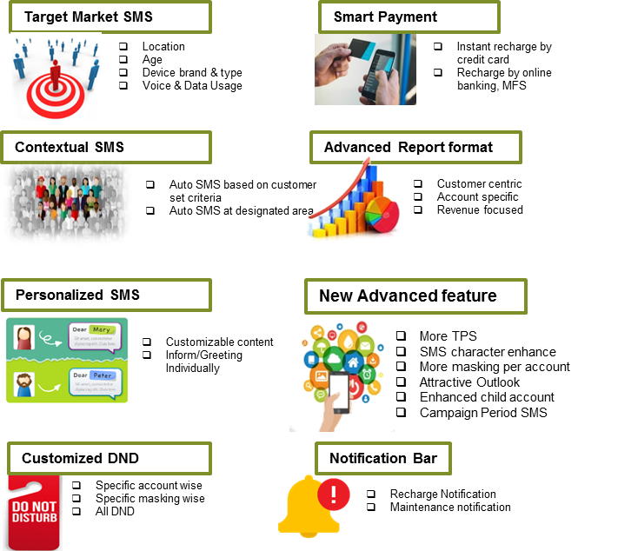
Quotation for Bulk SM
Please select suitable tariff plan for your customers from tariff plan documents
Count of SMS in Single Bill Cycle | Charge (BDT)/SMS
1 to 24,999 | 0.50/SMS
25,000 to 50,000 | 0.45/SMS
50,001 to 100,000 | 0.38/SMS
100,000+ | 0.30/SMS

Note:
- All the charges are excluding applicable Supplementary Duty & VAT: 10% Supplementary Duty (SD) +15 % VAT on price +1% Sur Charge
Terms and conditions:
- Price quoted is net and not deductible.
- The offer is valid till 15 days from the submission date unless Grameenphone Ltd. decides to change.
- VAT, Taxes & Levies will be applicable as per government rule.
- Mode of Payment: Cash/PO/DD in favor of Grameenphone Ltd. before delivery
- Mode of Delivery: Corporate Bulk SMS customized solution that requires some back end configuration (i.e API based). Thus, it will take no less than 3 working days for implementing such a customized network solution for a Business Client.
- Client cannot send any SMS that are abusive, anti-government or anti-religious believes through this platform. Clients will be solely liable for such non-compliant SMS and if not, customers will be held liable for this through BS agreement.
- Masking/CLI Sender ID will be only applicable in GP-GP numbers and for the other operator numbers; the Virtual MSISDN will be displayed.
- Client cannot re-sell this SMS to other third party companies.

M. Centrex
Grameenphone Centrex Service is a centralized phone number solution that guarantees mobility and business efficiency. This is a highly customized solution to meet your organizational needs to provide a seamless communication experience.

Major Features:
- HD Voice Quality
- Welcome Message
- Interactive Voice Response (IVR)
- Call Attendant
- Call Hunting
- Short Number Dialing
- Web Portal for Administrative Management
Some of the key benefits of this service are:
- No additional hardware or connectivity needed
- Efficient customer support & responsiveness
- Extremely easy to operate
- Enhanced efficiency and profitability of business entity
- Cost effective Solution at ZERO investment
- Employee mobility and availability at the same time
- One unified umbrella of voice communication- consolidated offer of both mobile and PBX solutions from single service provider
- Easy Product Installation with no need for maintenance all the year round
Slab Based Charging:
Slab (#Users) | Monthly Fee(BDT)/User | Dial In Charge (BDT)
10-100 | 200 | 0.45
101-250 | 175 | 0.45
251-500 | 150 | 0.45
500+ | 150 | 0.45

Notes:
1. 10 Second Pulse
2. All the above prices are quoted excluding applicable government charges (VAT, SD, SC & etc.)
3. Child numbers fee will be charged on monthly basis for the full month. Any cancellation will be effective from next month onwards
4. Monthly fee will be charged for the full month for any new inclusion of the child number in the middle of the month. No partial charging policy is available
Grameenphone Smart Security
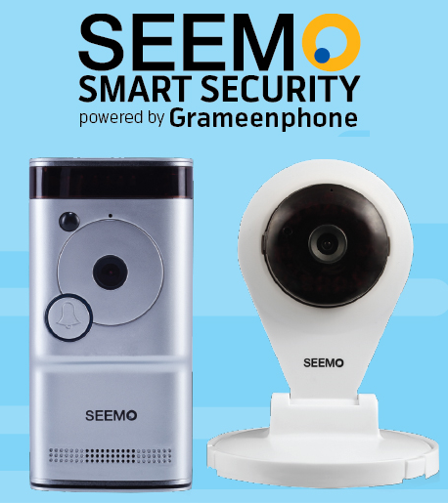
SEEMO Smart Security” Powered by Grameenphone

Grameenphone introduces "SEEMO" - the country's first intelligent security brand dedicated to simplifying your security. With the Simo Smart doorbell and indoor camera, you can speak to anyone at your front door using any built-in speaker and microphone.

Product Features


High Definition Video:
See your visitor in High Definition (720p)


Motion Sensor
Can trace any motion in front of your address.


2-Way Communication
Two way audio and one way video that means you can enjoy the full conversation with the visitor

Cloud Storage

Record and archive every photo and video in the cloud
Instant Alerts

Receive instant notifications when someone rings the bell or motion is detected
Live Monitoring
Watch your front door at all times by starting the video from the app

Pricing Details
Item | Regular Price  (BDT) | Promotional Price* (BDT)
4G Router | 7,999/= | 5,999/=
Indoor Camera | 7,999/= | 5,999/=
Free 7 Days or 5GB Cloud backup | 7,999/= | 5,999/=
6 Months EMI Facility | 7,999/= | 5,999/=
Insurance Coverage of BDT 1Lac | 7,999/= | 5,999/=
M2M Data Pack  (10GB/20GB/30GB/50GB/100GB) | BDT 800/1200/1500/2000/3500 | 25% Discount

Audio Conference
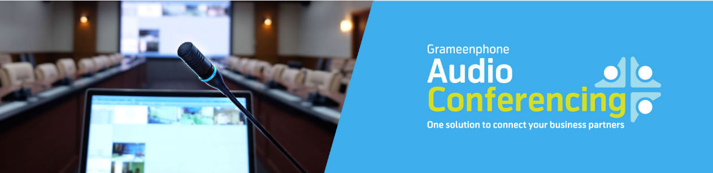
“Grameenphone Audio Conferencing is a highly scalable carrier-grade solution designed to meet the most demanding large-scale needs such as investor calls, partner briefings and employee town halls in a toll-free manner. Customized features like roll-call, dial-outs, speech mode, mute / mute and more can be added seamlessly to make the overall conference experience extremely professional and attractive to attendees. "Grameenphone Audio Conferencing is a highly scalable, carrier-grade solution designed to meet the most demanding large-scale requirements such as investor calls, partner meetings and employee town halls toll-free. Custom features such as roll call, dial-in, voice mode, mute / unmute and more can be added seamlessly to make the entire conference experience extremely professional and attractive for attendees.

Business Benefits
"Our solution enables you to conduct on-demand conference calls anytime, anywhere in the business. Be it meetings, training, brainstorming sessions, team call Grameenphone audio conferencing service is designed to scale and support all kinds of needs”
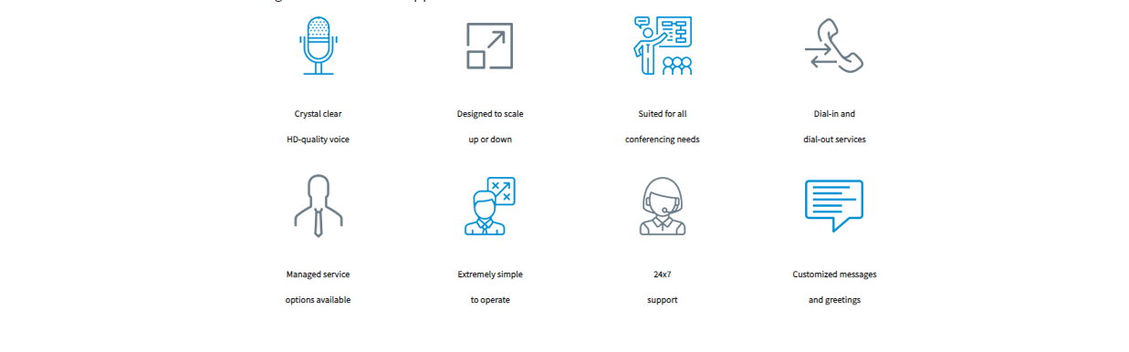

Grameenphone audio conferencing services are available in standard and managed service options. While a perfect presentation is sufficient for most conference needs, operator assisted audio services are designed for organized events such as media briefings, investor relations and more.

UNPARALLELED GLOBAL COVERAGE
• Unmatched global coverage
• Availability of outgoing calls
• Connect to any local / international number

HIGHLY CUSTOMIZED FEATURES
• 24/7 support
• Appeal calls for structured conference requests
• Mute / unmute participants during a busy call

SUPERIOR MANAGED SERVICES
- Controlled Q and A sessions so that one attendee speaks at a time
- Calls can be extended smoothly, without any interruption

USER GUIDED OPEX MANAGEMENT
- Email and SMS notifications
- Host has the ability to limit the number of participants

Outgoing calls may be disabled to avoid calls to high cost routes

Conduct conference calls over demand

Conduct instant, high-service, professional quality audio conferencing instant conference calls anywhere, anytime with 24x7 media.

Team Tracker

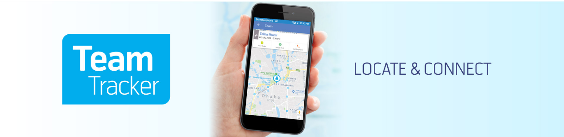
Business is like playing chess and every move is important. Time is valuable. You must know the location and movements of each piece to win the game. Today's competitive and changing business world demands the same
With Grameenphone's "Team Tracker", you can define your workforce and lead them to your business goals.
Team Tracker is a new value added solution for the corporate market. This solution will bring expertise to the value chain of employees in the field. Conducting field operations and directing field personnel to business success is always a concern for field executives such as national and regional sales managers, regional managers and distributors.
By Grameenphone Team Tracker services, companies can now identify their employees, assign tasks digitally, and receive job updates electronically. Even the system is robust enough to handle the data of a thousand employees.
The Features of Service:
The end result is that a business will benefit from higher productivity in field operations in terms of improved sales volume and prompt customer service. All of these advantages will help the company maintain a competitive advantage in the market.

- Real-time overview of employee movements outdoors on the map
- Location-based task delegation and proactive workload assignment
- Immediate update of task status
- Generation of business reports at the employee's location
By using this solution, a business is expected to get:
- Faster Actions
- Faster actions
- Excellent planning and precise workforce management
- Effective allocation of workload for greater employee satisfaction
- Cost efficiency
To activate this service, companies have to pay TK. 300 per month per employee. 'Task Assign' SMS charge is Tk 1.5 for SMS and 'Task Update' SMS charge from mobile phone is Tk 2.5 / USD per SMS. Business houses will be able to enjoy up to 50% of monthly service fees based on volume purchases.
Interested Business Solutions customers are asked to contact the Grameenphone Account Manager directly with their concerns. Other interested companies can call our business hotline at 222 or contact us at Business.solutions@greenphone.com and provide their company profile
Vehicle Tracking
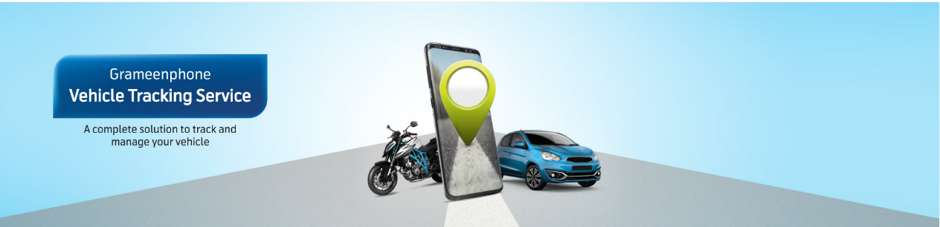
Vehicle Tracking Services (VTS) will provide you with protection and tracking of your vehicle every hour using satellite and GPS communications. With GP VTS, you can see your vehicle's position, speed and engine status on a map. The information will be visible on your own mobile application and website.
Grameenphone has three (3) VTS packages: Economy, Lightweight, and Standard. Grameenphone VTS requires a tracking device to connect to your vehicle. GP VTS ​​will allow you to easily configure your gear, such as go-no-go zones, speed limit notifications, and many more features. Grameenphone VTS turns your car into a smart car.

Insurance Benefits
Grameenphone introduced “Accidental and General Life Insurance” as a free service for customers of new and existing vehicle tracking services. This means that both existing and new VTS subscribers will be able to get coverage without paying any additional fees (other than the regular monthly fee). For more details and forms, please see the “Insurance Benefits” tab below.

Maximize your workforce.
Don't just manage your fleet. GP VTS ​​- Innovative, Affordable and Easy to Use Operation Together, GP VTS ​​combines Global Positioning Systems (GPS) and GSM technology with powerful features and cost effectiveness:
- Manage your fleet more efficiently.
- Reducing fuel and labor costs.
- Lower maintenance costs. Increased productivity.
- Enhance customer satisfaction.
- Improve safety, reduce risk and reduce insurance costs.
- Monitor and protect unpowered assets.
Drive your fleet performance.
GP VTS ​​also provides valuable information to help your company penetrate and identify and correct driver behavior that affects your bottom line:

- Speed
- Excessive idle
- Fulfillment of routes and schedules
- Travel outside authorized areas
- Unauthorized use of company vehicles
- Increase accuracy and efficiency

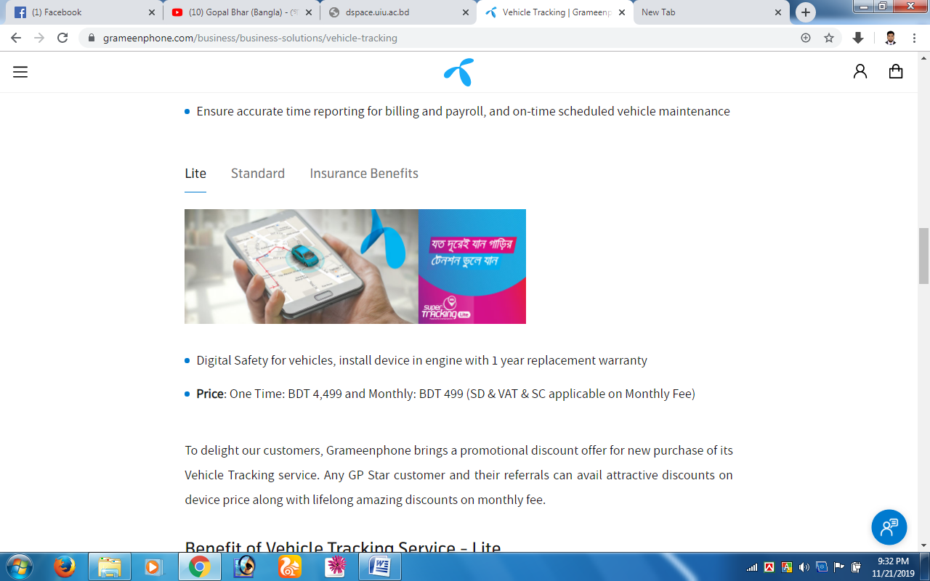
Lite Vehicle Tracking Service

- Digital security for vehicles, install the device in the engine with a one year replacement warranty
- Price: One Time: BDT 4,499 and Monthly: BDT 499 (SD & VAT & SC applicable on Monthly Fee) n order to delight our customers, Grameenphone is offering a special offer for the purchase of its vehicle tracking service. Every GP Star customer and their referrals can enjoy attractive discounts on the price of the device as well as amazing lifetime discounts on the monthly fee.
Benefit of Vehicle Tracking Service Lite
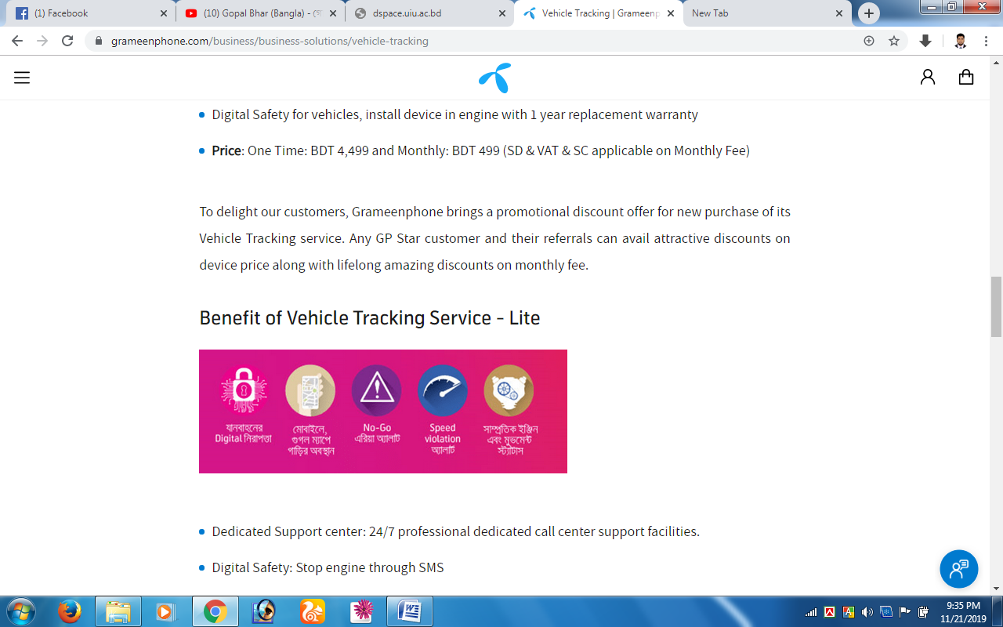
- Dedicated Support Center: 24/7 professional dedicated call center support facilities.
- Digital security: stop the engine by SMS
- On-the-go tracking: vehicle location, using the mobile application (Android, IOS)
- Engine movement status: Engine moving status, last and last update
- Speed ​​override alert: Set a maximum travel speed limit for the vehicle, and any violation will be reported through the alerts
- Geo fence violation alarm: set go or no go area for the vehicle and any violation will be reported via
- SOS alerts: for any emergency support - SOS button sends exact location for immediate help. After the user press the SOS button in the VTS, the VTS device will send the position and SOS alarm to the current number via SMS
- Battery removal alarm
- Improved customization
Features of Vehicle Tracking Service Lite
Vehicle Tracking Services (VTS) will provide you with hourly protection and tracking of your vehicle using satellite GPS and GSM communications. Using GP VTS, you can see your vehicle's position, speed and engine status on a map. The information will be visible on your own mobile app and website.
- Historical monitoring report (up to 3 months)
- Speed ​​analysis report
- Multiple alert option: SMS or email
- Option to monitor expense
- Alternative Vehicles tracking solution
- Several types of reports can be provided. For example: travel distance report, trip report and trip count report, arrest report, expense report, all alert report, etc.
- Unlimited geo-fence with rescheduling options.
- The necessary reports can be created in Excel and PDF.
- Option to display the driver profile.
- Live alarm display option
- Alarm resolution report
- Trip count report
- Trip list report
- Trip wise trip distance report
- Trip wise trip history report
- Expense report
- Fuel consumption report (based on distance traveled)
- Regular software updates
- Over 1,500,000 POIs on the map with reverse geographic coding
Standard Vehicle Tracking Service
Grameenphone offers three (3) VTS packages - Economy, Light and Standard. The Grameenphone VTS requires a tracking device to connect to your vehicle. With GP VTS ​​you can define functions for your vehicle, e.g. B. Go-to-go zones, speed limit notifications and more.
- Vehicle safety, device installation in the engine with a 3-year replacement warranty
- Price: once: 8,250 BDT and monthly: 696 BDT (SD In order to delight our customers, Grameenphone is offering a special offer for the purchase of its vehicle tracking service. Every GP Star customer and their referrals can enjoy attractive discounts on the price of the device as well as amazing lifetime discounts on the monthly fee.
Benefit of Vehicle Tracking Service – Standard
- Grameenphone offers three VTS packages - Economy, Lite and Standard. Grameenphone VTS requires a tracking device to connect to your vehicle. GP VTS ​​will allow you to set features for your vehicle such as take-out zones, speed limit notifications, etc.
- Dedicated Support Center: 24/7 dedicated call center support facilities. • Digital safety: stop the engine via SMS
- Tracking on the go: Vehicle location, using a mobile application (Android and IOs)
- Engine movement status: engine running, stopped and last update status
- Over speed warning: set the speed limit for vehicle travel and any violation must be notified via warnings
- Geo fence violation warning: setting the 'go or no go area per vehicle and any violation will be reported via alerts
- SOS Alerts: For any emergency assistance - The SOS button sends an exact location for immediate rescue. After the user has pressed the SOS button in the VTS, the VTS device sends the location and the SOS alarm via SMS to the current number
- Battery remove alert
- Improved custom

Features of Vehicle Tracking Service Standard
Features include historical tracking reports, speed analysis, multiple alert and expense monitoring options, multiple vehicles, tracking solutions report, driver profile display and live alarm display.
- Historical tracking report (up to 3 months)
- Speed ​​analysis report
- Multiple alert option: SMS •
- Expense tracking option
- Various vehicle tracking solution
- Various type of reports can be submitted. For example - travel distance report, trip report, trip count report, stopover report, expense report, all alerts report, etc.
- Unlimited geo-fence with reprogramming functions
- Necessary reports can be generated in excel and pdf
- Driver profile viewer option
- Real time alarm viewer option
- Alarm resolution report
- Number of trips report
- Trip list report
- Trip route report
- Trip history report
- Expense report
- Fuel consumption report (based on trip distance)
- Regular software updates
- Over 1500,000 POIs on map with reverse geography coding

SWOT Analysis of Grameenphone

A SWOT analysis (or SWOT matrix) is a strategic planning strategy that helps an individual or organization to identify strengths, weaknesses, opportunities, and threats associated with business competition or project planning. It defines the objectives of the commercial enterprise or project and can determine the internal and external factors that are favorable and unfavorable for their achievement.

Strength
- Grameenphone has the best network coverage as all 64 districts of Bangladesh are covered first by all other carriers in Bangladesh with 4G network coverage.
- Grameenphone has a large market share.
- By increasing network capacity and expanding network coverage to new and often remote areas in Bangladesh, Grameenphone has achieved a strong brand image.
- Since Grameenphone ensures the best network coverage and provides superior value to customers / users, Grameenphone can build a loyal customer base.
- It’s financially strong.

Weakness
- The call rate offered by Grameenphone is higher than the call rates offered by other providers in Bangladesh
- Since GP has a huge network cost, GP cannot reduce its call rate. It has become your weakness.

Opportunity:
- Grameenphone has just introduced 5G SIM. It has not introduced all over the country. It should spread all the districts of Bangladesh. It is an opportunity for Grameenphone.
- Grameenphone can also do diversification

Threat
- Bangladesh is now in political instability .National election is going to be held. There are lots of conflicts between present govt. and other political parties of Bangladesh

Chapter 4

Finding & Conclusion

Positive aspects

GP aims to bring quality to the lives of customers. It is an everlasting promise. It simply doesn't happen. They make this happen by innovating by expanding the product category using advanced technology and eco-friendly machinery.
- 40% users of Grameenphone are satisfied and 42% are somewhat satisfied with the network coverage of Grameenphone.
- 45% of the users/subscribers are somewhat satisfied with the package price for various packages.
- 49% of the users are somewhat satisfied with the prepaid packages offered by Grameenphone.
- 20% users are satisfied and 39% are somewhat satisfied with the bonus talk time/SMS
- 37% of the users/subscribers are somewhat satisfied that they do not face any types of overcharging issues.
- 42% users of Grameenphone are satisfied and 32% users are somewhat satisfied with the sound quality of Grameenphone when they talk over phone.
- 63% of the users/subscribers are somewhat satisfied that Calls never disconnects during the conversation.
- 18% users are satisfied and 32% are somewhat satisfied with the internet service of Grameenphone.
- 43% of the users/subscribers are somewhat satisfied that the service rate of caller tunes, missed calls, call blocks service and others are reasonable. But it is not a good thing that 39% users are neither agree nor disagree with this.
- 0nly 33% the users are somewhat satisfied and 41% users are neither agree nor disagree that Grameenphone provides value added services which enrich their lifestyles.
- 70% of the users are satisfied that the service hotline of GP is easily accessible.
- 20% users of Grameenphone are satisfied and 50% are somewhat satisfied that they get the service quickly from the helpline.
- 58% of the users are satisfied that the Customer service managers carefully give attention to their problems. But 30% users are neither agree nor disagree that the Customer service managers carefully give attention to their problems.
- 62% of the users are satisfied that Grameenphone tries to increase social awareness in Bangladesh. In this matter 23% users are neither agree nor disagree.
- 30% users of GP are very satisfied and 39% are satisfied that Grameenphone customers Care Centers are widely available.
- 66% of the users are satisfied that Grameenphone has prompt online customer service assistance.
- 30% users of Grameenphone are very satisfied and 40% are satisfied that Grameenphone informs to me about Grameenphone’s promotional offers through SMS which is helpful.
- 56% of the users are satisfied with the service of Grameenphone.18% users are neither agree nor disagree.
- 60% of the users are satisfied and they would still be connected with Gp if other operators come to me with the same offer. But 20% users are neither agree nor disagree.

Negative Findings
GP aims to bring quality to the lives of customers. It is an everlasting promise. It simply doesn't happen. They make this happen by innovating by expanding the product category using advanced technology and eco-friendly machinery.
- 24% users are dissatisfied with the additional features of Grameenphone in comparison to other operators. And 36% users are neither agree nor disagree.
- 20% users said that they would not be connected with Grameenphone if other operators come to them with the same offer.17% users are neither agree nor disagree.
- 26% users are dissatisfied with the service of Grameenphone. But 18% users are neither agree nor disagree.
- 40% users are not satisfied with the overcharging issues of Grameenphone.23% users are neither agree nor disagree.

Recommendations
Very few suggestions or suggestions on the best course of action, especially those initiated by an authorized authority.
- Network towers should be allocated according to the size of the users.
- They need to increase capacity as the number of subscriber’s increases.
- Grameenphone needs to invest more for increasing the capacity.
- Arranging some kinds of awareness programs for the subscriber about unnecessary network traffic.
- Grameenphone should increase the capacity of server according to the subscribers’ increasing rate.
- More awareness programs should be arranged regarding those basic features.
- All the subscribers should be given all the basic features of Grameenphone.
- The family doctor should try to organize an awareness program regarding lower price sensitivity
- Product providing system should be more flexible and soft.
- GP should be more efficient and market oriented. To do this, Forecasters of GP should be more efficient.
- Price of different packages should be decreased according to the level of subscribers’ expectation.
- Grameenphone should arrange some programs to create positive perception regarding the price of different packages.
- It is necessary to organize some awareness program to reduce unnecessary practice trend of similar calls in the network.
- The customer managers should behave more friendly with the subscribers.
- Smooth access of 121 hot lines should be provided to get service.
- Grameenphone should train their employees well to make them more efficient.
- Grameenphone should deal with complaints accurately and effectively.
- Treat customer that they are your boss.
- The employees of customer care can apologize personally when customers are not fully satisfied.

Conclusion
Grameenphone Limited serves all customers in Bangladesh and the countryside, with mobile phones being the main driver of social and economic development. The company always strives to deliver the power of digital communication that enables everyone to improve their lives, build society, and protect everyone's better future. If Grameenphone does not raise customer satisfaction levels, it will be difficult for general practitioners to maintain their current market share. So I believe if Grameenphone follows these recommendations, it will enable it to conveniently achieve sustainable single competitive advantage with loyal clients / users. Grameenphone operators and employees need to think about customer needs, aspirations and expectations and act accordingly. By providing their best service, they should build a relationship with the customer so they can meet customer expectations. Customers / users will be happy or satisfied if Grameenphone service exceeds customer expectations. They need to set goals in order to satisfy the customer by improving what they lack.

Reference

Keller Lane Kevin. Strategic Brand Management.4th ed. United States: Pearson education, 2013
https://www.grameenphone.com/
https://www.grameenphone.com/business
business.solutions@grameenphone.com
Documents: GP SME Sector
PPT: Research and Development Dept

