Problems and Prospects of Startups in Bangladesh

Sharif Jikrul Abadeen

This Report is Submitted to the School of Business & Economics United International University in Fulfillment of Requirement for the Degree of Bachelor of Business Administration

Problems and Prospects of Startups in Bangladesh

Submitted By
Sharif Jikrul Abadeen
ID no.: 111131460
BBA Program
Major In Marketing
School of Business & Economics
United International University

Supervised By
Kawsar Ahmmed, PhD
Professor
School of Business and Economics
United International University

Date of Submission: 22/09/2021

Letter of Transmittal
September 22, 2021

Kawsar Ahmmed, PhD
Professor, School of Business and Economics
United International University

Subject: Submission of the Project report on ‘Problems and prospects of startups in Bangladesh’

Dear Sir,
With due respect, I would like to inform you that, it is a great pleasure for me to submit the project report on “Problems and prospects of startups in Bangladesh” as it is a fulfillment of partial requirement to achieve BBA degree under the curriculum of United International University, Bangladesh.

To prepare this report, I have gathered what I believe to be the most complete information available, I have worked hard preparing this report, and I hope that it will fulfill my degree requirement. I will be always available for answering any query on this report.

So, I fervent requesting and hope that you would be kind enough to accept my report and oblige thereby. Though I have put my best effort, yet it is very likely that the report may have some mistakes and omissions that are unintentional. Therefore, I hope that the report will worthy of your consideration.

Sincerely yours

-----------------------------------------------
Sharif Jikrul Abadeen
ID no. 111 131 460
BBA Program
School of Business & Economics
United International University

Certification

This is to certify that Sharif Jukrul Abadeen, a student of BBA, ID – 111 131 460, under School of Business and Economics, United International University (UIU) has completed the project report titled on “Prospects & Progress of Startups of Bangladesh” as a part of requirement for obtaining BBA degree. He has tried his best to complete the report.
I wish all the best in his future endeavors.

Supervisor

Kawsar Ahmmed, PhD
Professor, School of Business and Economics
United International University

Acknowledgement

At the very beginning, I would like to express my deepest gratitude to Almighty Allah for giving me the strength and the composure to finish the task. While the writing of this report has been difficult during this covid situation, the preparation for writing has been even harder. It certainly would not have been possible without the help of many people. I would like to thank those people who supported me during my project period and actively helped me in making this report a reality.

This study is the outcome of the project program undertaken by the course and instructed by Kawsar Ahmmed, PhD, SOBE, UIU for Summer, 2021. I am indebted to them who have directly and indirectly assisted me in conducting the study. Specially, I am thankful to my honorable teacher Kawsar Ahmmed, PhD because of his assistance gives me the opportunity to start my project report promptly.

I was also indebted to the websites that indirectly helped me in completing our term paper specially collecting information. Finally, I owe a profound intellectual debt to my seniors for their part time help, assistance and valuable advice in thinking and developing of this report.

Executive Summary

The overall objectives of this research project are to determine the problem the startups of Bangladesh are facing in the current scenario and the possible problem they will face in near future. On the other side, the opportunities of the startups they are getting to run the business in Bangladesh. It has been found that most young entrepreneurs are likely to open their startups. The startup ecosystem started its journey in Bangladesh in 2010. In the past few years, 1000 thousand startups founded in Bangladesh. People are more focused on developing tech startups because of the potential of the tech market. Above 62% of people of Bangladesh are now dependent on tech directly or indirectly. 98% of people have a cellphone for digital communication. 45 million social media users. The number of audiences is huge for this market. On the other side, the government is encouraging young entrepreneurs to be more focused on tech business. Startup Bangladesh Limited, run by the ICT division has been invested 500 cr in 7 startups of Bangladesh, and this is encouraging the youths. On the other side, some potential startups already achieved seed funds from foreign investment. The majority of young entrepreneurs are now in search of problems as they know the solution will be a business anyway. In the populated city Dhaka, regularly facing new challenges from the starting of the day to the end of the night. New businesses are trying to figure out the solution. As people are more tech-oriented, that’s why companies are figuring out the solution through technology. Every traditional section is an opportunity for startups. Who thought to have classes on an online platform! Now there is tech startup like 10 minutes school, Edu hive, shikho. Healthcare statups like doctor koi, private health, digital healh, maya. The transportation problem is omitting the traditional problem. 60% of users in Dhaka are using a ride-sharing app like pathao, shohoz, uber. This is happening all because of the startups, and they are providing the solution through technology. Still, doing business in Bangladesh is not easy at all. People are more likely to go with trends, not in their own way. Startups are here to figure out the solution but whenever someone is coming with the solution, other people starting doing the same model of business, which is creating problems as the customer number is fixed. Too many same service providers cannot gain benefits from the market at all. This me-too-type idea is creating a bad impact in the ecosystem of startups. Foreign companies are likely to invest in Bangladeshi startups but few startups could establish them in a good way. People are entering the market with our proper research, knowledge and best technology. On the other side, not all founders have connections with global investors. This is quite challenging for startups. Due to having small fund in startup business, founders usually get nervous and starts focusing on getting profit over revenue. However, the startup's business model doesn’t allow getting revenue in the early-stage as the company needs to educate the audience first. From all the startups only 8% of the companies are maintaining startup things.

Keywords: problems and prospects, startups, young entrepreneur, Bangladesh

Table of contents
Contents
Letter of Transmittal 3
Certification 4
Acknowledgement 5
Executive Summary 6
Chapter One 10
Introduction 10
Introduction 11
Motivation of the study 12
Objective of the study 12
Methodology of the study 13
Scope and limitation of the study 13
Scope: 13
Limitations: 13
Significant of the study 14
Chapter Two 15
A Sketch of Startups in Bangladesh 15
About Startup 16
Scale using technology 16
Attempt to win the market 16
When a startup is not considered a startup 16
The ecosystem of startup in Bangladesh 17
Development of startups 18
Investment Scenario 19
Who are the investors? 20
Eco system builder 21
Startup from the aspects of founders 22
Bangladesh Govt. initiatives and supports for startup 23
Chapter Three 25
Problems and challenges faced by startups in Bangladesh 25
Important factors to build a startup 26
Challenges that startup faces 27
Prospects of startups in Bangladesh 30
Some top startups of Bangladesh 34
Findings from the study 35
Recommendation 35
Reference 38

Chapter One

Introduction

Introduction

Tech startups have taken the world by storm in the past couple of decades. And like most Asian countries, Bangladesh is experiencing a tech startup uprising. Bangladesh is a developing country. At present, this country is on the way of rapid civilization. Majority of people of this country is young aged 35 and below and the number term of percentage is 65%. Most of the people in this country are early stage tech adapter. Even an 8 years old child know how to operate a smart phone. Around 62% people are internet users. Internet is the main thing for booming startups over the world and now day’s internet is quite cheaper in Bangladesh and it’s helping companies to reach those people in shortest possible time. Startup the term use for the tech companies which bring solution through their tech medium. Startup eco system started its journey in Bangladesh in 2010 and now it’s passing quite good time. Startup is quite different from traditional business. The ideas, technology, marketing strategy, employment all are quite different from traditional business. It usually start by own funding or by taking loans from relatives and time to time it grows and company management pitch for more funding to continue the business to local or foreign investors. In past few years much unique startup business established and smoothly running their operations in Bangladesh. The companies are omitting the problem of the people of Bangladesh. Now in every possible sector startup is entering like in education sector, in health sector, transportation, logistics, food, fashion, finance, marketing and many more. Demand for technology based things are increasing and people are taking it as an opportunity. People are trying to convert themselves as a multitasker and for this, they need more time from their regular working life. Time will save if proper technology is there. Moreover, founders of new tech startups are taking this as an opportunity.

Motivation of the study

Startup is the trending term in global business, which is growing rapidly. Country like ours is also going in the same direction. I got the opportunity to work in an early stage startup from the beginning where I saw the way of their generating ideas, implementing strategy, plan and how investors and investment companies funded them. In most of the cases it is encouraging the youth of Bangladesh. Startup is quite different from traditional business. They give more priority to the talents who actually can contribute in the business. But there is lack in studying on tech startup in Bangladesh and less data on internet. Even many people are not aware about startup. The overall scenario of startups encourage me a lot to research on it.

Objective of the study

In this project, I tried to identify the reason behind growing startup in Bangladesh and the challenges they are facing while running their operations. Startup is not a traditional business or not even SME. How startup ideas are implemented, how it starts, the employment process, knowledge on tech industry, research method, way of getting investment are the major part of this study where I researched on few startups that how they start and operating the business. Objectives of the study are highlighted below:

- To demonstrate the idea on startup ecosystem in Bangladesh
- To analyze the overall operations of startup.
- To identify the impacts of startup in Bangladesh.
- To understand the concepts of investment, series funding, seed funding.
- To identify the key factors for growing startups in this region.
- To identify the problem and challenges startup companies and founders are facing.

Methodology of the study

For preparing the report I used both primary and secondary data source. For preparing the report I had one on one discussion with different startup management. I have talked with the management of ShopUp, Kalke, Praava Health, Digital Health Care, Tutors Inc. On the other side I used some poll post in linkedin for getting some important data. For the secondary data I took support of different Reliable websites from where some major information is taken to prepare this report. For analyzing the data, I used cohort technique as the people are from similar group and their thinking process is quite similar on startup tools.

Scope and limitation of the study

Scope:
The report covers the overall startup ecosystem specially the progress of startup and the challenges of startups in Bangladesh. It also covers some insights about startups and some top startups that grows in past few years. I tried to cover the investment scenario as well, and compared the scenario with our native county to give better recommendation on the report.

Limitations:
There were certain limitations regarding the study that is summarized below:
- Difficulty in accessing sensitive data and information.
- Non-availability of some preceding year’s important data.
- Project is based on a new business model, which made it tough to find the information.
- The overall scenario is changing on regular basis.
- The secondary source of information was not enough to complete the report.
- Limitation of proper help from colleagues.
- Limitation of time to prepare this report.
- Limited data in internet.

Significant of the study

Startup is a new term in Bangladesh and small number of people are aware on it. I tried to cover the topic, which has less information in any kind of medium. This helped me to know detail insights about this industry and will help other people as well to know more detail about startup and the growing opportunity of this industry. While asking many people about startup they were mixing it with SME business. I tried to cover this part here for better understanding about startup.

Chapter Two

A Sketch of Startups in Bangladesh

About Startup

Usually people mixed SME and Startup together. Both are different in terms of business model. In Bangladesh there is a common misconception that a startup is a "young company," often aged 3 years or younger with some sort of technology. This perception is completely wrong. Startup is a company, which aim to win the market with the help of technology scaling up the business then previous days. Here mentioned 2 things are must for startup are

Scale using technology
Every additional dollar put into the business should grow the business more than the previous dollar did. For instance, if the first $1 got you 5 users, the second $1 should get you 7 and the third ought to get you 9. If your unit economics see an improvement in the process, it usually indicates the company has a technology or tech-enabled system in place to grow at an accelerated pace with incremental capital. It effectively validates that you are solving a real problem with a relatively large market.

Attempt to win the market
If company’s vision is not to be the market leader in what you are trying to do (even if it is in a niche), then you are not a startup.
Startup needs to be aimed to provide outsize, huge return to the investors to match the risk that has been taken.
Investors generally invest their money in different areas of asset classes, like stock market, bonds, real estate and venture capital. Even within venture capital, there are different stages: angel, early stage, growth stage, etc.
Venture capital, that invests in startups, investors want a very high return may be 25X in 5 years. This is the normal scenario for startups.

When a startup is not considered a startup
In recent time, people are telling that startups like pathao, shopup, chaldal is no longer a startup just because they served for long years and quite old & big now. However, this perception is so wrong.
A company is no longer a startup for below 3 reasons,
- When the company is acquired or lists in stock exchange
- When the company no longer want to grow rapidly to become financially self-sustainable.
- When the company reached its certain size of population and there is no scope to serve in a new population.

The ecosystem of startup in Bangladesh

Startup started its journey in Bangladesh in the early 2010, experienced amazing conversion, and is finally coming of age. At present, the number of startups stands around 1000+ and still growing in different sectors where it is digitalizing the ecosystem. In our country, 63% of people are below aged 35 and are familiar with internet, smartphone and social media. On the other side, IOS users are increasing by 10% year on year. This aged people are quite tech centric and companies can convert them as a user quite easily. The high growth of digital users and increasing in purchasing power of consumers is booming the startup ecosystem.

Development of startups

Bangladesh’s startup is mainly based in Dhaka and Chittagong and has been growing the areas as in IT, e-Commerce, Digital marketing, Jobs, Financing, Education, Transportation, Ridesharing, Logistics etc. Currently, due to high demand of consumer’s startup focus is more on now Ridesharing and Logistics sector. In past few years, many local startups formed in Bangladesh with ridesharing ideas like Pathao, Shohoz, Obhai, Sam riders, Car bangla etc. Event global market was aware about the demand and Uber entered in the market. These all were based on ride sharing. Now in recent time transportation rental service is also growing. Company like Jatri, Shuttle are running amazingly in Bangladesh.

On the other side logistics companies like REDX, e-Courier, Paperfly, Pathao is running fluent service in Bangladesh and competing with traditional companies like Shundarban, SA paribahan. By seeing the growth of startup, traditional logistics companies are forming them into a digital platform.

Fintech companies changed liquid using scenario of Bangladeh. Now people are using digital wallet where people are not using paper money. One phone is enough to hold unlimited amount of money. bKash played a major role here. They made transaction of money so easy. Now people can transfer money from one city to other city by sitting in room just by tapping on phone. Amazingly, bKash has 31 million of users in Bangladesh and most of the users are active. Rocket – a digital mobile banking of Dutch Bangla Bank, Nagad, Upay is running the same module of business in the country. All these platforms made users life quite easy.

Another important sector is ed-tech startup like Ten Minuit School, Sikho, Edu-hive is doing amazing work by transforming education into digitally. These are helping people to learn in anytime from anywhere. In the covid time, these platforms are playing quite important role in country.

7/8 Years back no one thought to order food from online. Now people can order food from home just using a simple mobile app. Pathao, Shohoz, Efood, Foodpanda, Hungrynaki is now everywhere. Foodpanda is generating around 20 lacks taka food order daily basis. Other competitors are doing it too. Demand of this service is now on hike.

Digital heath industry booming during this covid situation. Where people are staying at home and quite scared to visit hospital in any physical difficulties, now can consult with a doctor just using phone. Praava health, Digital Healthcare, Maya are providing doctor consultancy, checkup and treatment to its users.

e-Commerce industry is the most common in Bangladesh. There are thousands of e-commerce industry here. Daraz, Evaly are the most renowned in the market. These companies have shown 300-cr transaction in a month. Millions of users are ordering from the e-commerce on daily basis. Daily needs, Grocery, Clothing, Medicines, Bikes, Cars everything is now available in e-Commerce platforms.

Investment Scenario

Investment is the biggest challenge for startups in Bangladesh. Only 7.1% of startups are funding through local investors. Which means startups need investment like series A, series B from international platform to grow the business in larger scale and make it successful.

In order to grow internationally Bangladeshi startups must offer the investors potential good return that will match the risk level of the business. For instance, when an investor from Singapore, London or New York are likely to invest they don’t think about themselves but they identify the best place and scopes to invest. They compare the business of India, Indonesia, Vietnam with Bangladeshi one. The just want to invest in the best platform, best place, best ideas, that’s it.

In terms of getting good fund, Bangladeshi startups must be good or better then international startups. In our continent we just want to be a best only in our country. We don't make good plan to expand the business from one country to another. Just setting a big office in Gulshan or Bananis will not bring the success. It sounds harsh but it is simply true. Whoever you are or whatever the business is, investors will see only the thing that are you capable enough to dominate the whole country through the business.

In the history of early stage funding in Bangladesh so far, there has been about $325 million raised of that, only $22 million is local. Of the $22 million, only $4 million has been allocated to Series A and later rounds.
However, for a startup to be successful, it will require multiple rounds of funding: seed, Series A, Series B, etc. As local investors are not investing large amounts and in those stages, it becomes necessary for founders to raise abroad. Until local investors start investing more actively, this will likely remain the case. From a survey of investors, they mentioned the top sectors they preferred based on current performance and future growth prospects.

Who are the investors?

The angel market is growing rapidly in Bangladesh with presence of players such as Bangladesh angels, Pegasus, Tech ventire, SBK tech ventures, Bangladesh ventire capital among others. The angel’s network is consisting of angel investors in Bangladesh has been working together towards bringing the early stage startups in front and introduce them in the market, entrepreneurs. Majority of angel investors are focused on tech startups, which might have a great impact in near years in economy.
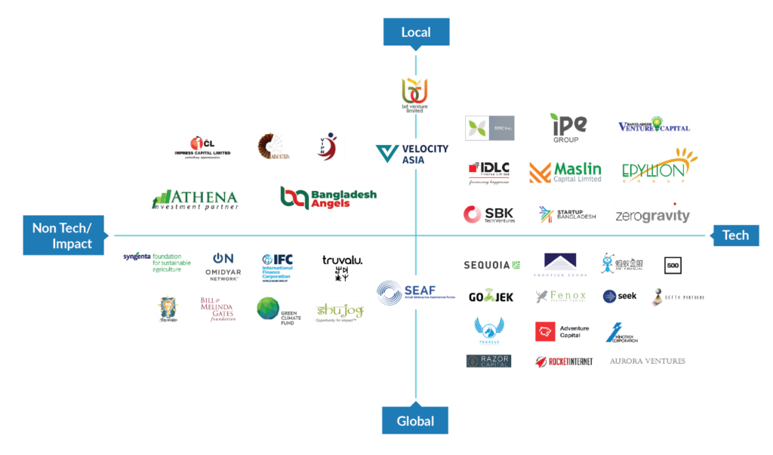

Eco system builder

Emerging of Bangladeshi startup was quite late comparing with the regional peers. We are still in million-dollar investment whereas India already got above 4.5 Billion investments for their startups. But we are still not late. The growth is still possible by having some successful implementation of countrywide incubators and accelerators programs. The global and local incubators and accelerators have been assisting entrepreneurs in aspects ranging from scaling up their ideas to raising funds and becoming sustainable in the long run. Grameenphone accelerator was one of the successful program where startups such as sheba xyz, CMED health, Repto came on. Banglaling incubator was associated with government, ministry of ICD division dacilitating innovative ventures to grow further. Ikhkul, Axus technology are the promising outcome from the program. Robi announced R-Venture investment for reality platform aiming to transform digital business ideas into reality. In recent years a significant number of local incubators and accelerators programs are coming up to guide both tech and non-tech startups. Startup Dhaka grabbed the attention from the global market with its flagship documentary in 2013 highlighting the promise of startups in Bangladesh. 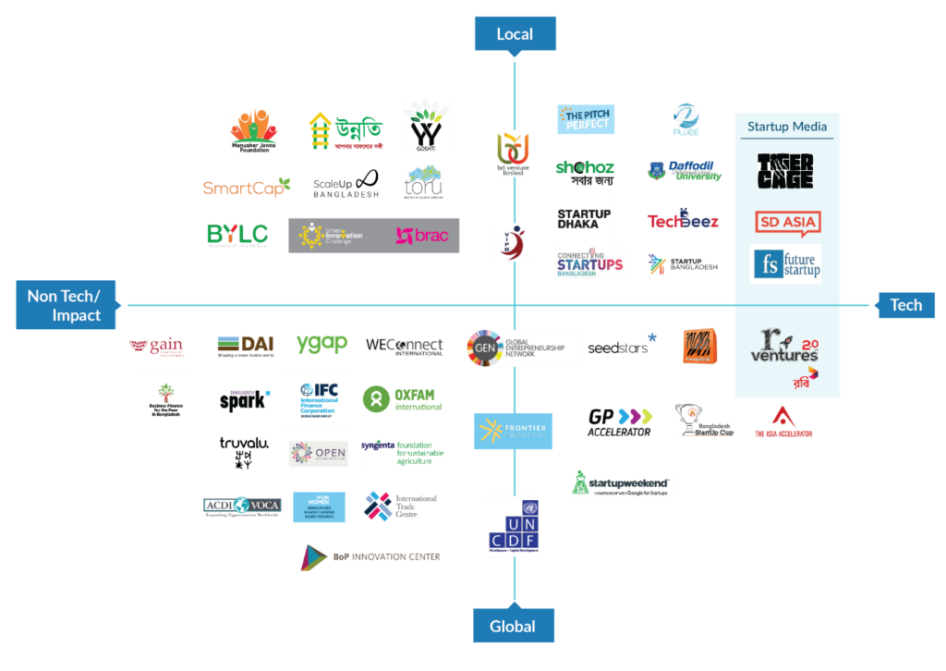
Eco system builders of startups

Startup from the aspects of founders

Founders of different startups are highly focused on Fintech industry. From there perspective Bangladesh is the potential market to obtain the tech ideas and explore those through a business. They want to acquire as much as possible number of clients for pulling investments from global firm. Preferable areas for the startup founders are:

- FinTech
- Online Marketplace
- Media
- EduTech
- Ridesharing
- Logistics
- Agritech
- E-Commerce
- Tourism
- Healthcare

Founders are confident with those sectors, which are gaining 40% of support from market. Fintech, Ridesharing, Logistics are over 40% and both investors and founders are matching here where the demand is meeting.

Bangladesh Govt. initiatives and supports for startup

Government plays important role in business eco system. Currently Bangladeshi government is focus on developing Bangladesh digitally for this tech companies are getting higher attention to the government. Government encouraging business students to develop more tech business. Different startup programs like Agragami, Bangladesh Innovation grant are taking place to encourage the new talents. Government is declaring millions of dollar as prize money with what new entrepreneur can start their startup. IDEA Project and Startup Bangladesh Limited with 500 crore BDT (U$ 65 Million) funds, are taken to improve the local startup ecosystem. Additionally, Government is setting up 28+ Hi-Tech Parks, including infrastructure support like data centers, to support technology companies.

Government is giving attention to the startups but the number of startup is getting higher day by day which is creating problem for the government to give attention to all the sectors. Top startups are getting quite good support and response from the government but the early-stage companies are facing problems here. While discussion with the early-stage startups management were seeking attention of government to arrange specialized and experienced technical support through which they can measure the calculative risks to overcome and prepare the flow to build a plan that is sustainable. Integrating failure studies and the reason behind failures could also support early-stage ideas to understand the market better and gain proper insights and feedback on their products and services.

Chapter Three

Problems and challenges faced by startups in Bangladesh

Startups in Bangladesh, despite of being the most potent engine for growth, face challenges in three levels. Firstly, the absence of proper mentorships and access to funds make it difficult for early stage startups to escalate. Through proper implementation of accelerator and incubator programs and circumvention of capital needs through investors’ network, this challenge can be addressed. Secondly, due to market malpractices (e.g. lobbying, using speed money, bad payment terms), the financial cost rises manifold resulting in closing down of ventures at an early stage. Lastly, the older generation have a negative outlook towards entrepreneurship and assume that one only does business if one fails to get a respectable job. Therefore, younger generation often prefer waiting to get a job rather than creating it.

Important factors to build a startup

Good Idea: Ideas are the key source to establish a startup, which will help to capture a market in a region. Founder can established any unique idea but if it does not stand up to the market then it will not work out. In past few years, many founders came up with unique ideas where some of some got success and some failed. Ideas can be unique but need to be compatible with the market demand. Some innovative ideas like, online grocery market place, digital health, ridesharing, market place, logistics support etc are doing good in recent time.

Polished market research: Without a proper research, no good idea will work out. Founder need to identify the demand of users first, how much will it be costing and what will be the potential revenue against the model. ShopUp enter the market with proper research where they were confirmed about their target market, number of audience, how they gona take the service. They established a completely new product which help the consumers by making their life easy. Just by using a app their consumers start doing their own business in facebook platform.
On the other side a SaaS platform name Kalke, enter in the market without research. They were not aware about the demand, not aware about the competitors. They came with an idea where companies can post unlimited jobs in Kalke’s platform and candidates can apply through the platform. But the problem is people are already used to search job in BD jobs portal. Again they launched assessment where Bangladesh job culture don’t required this support at all. For this a proper research is needed before launching a product.

Set revenue and profitability goal: Don’t enter in the market without setting profitability goal. Pathao did a great mistake here. They were assuming an invisible profitability and for what they started giving discounts, offers to the consumers and hired huge amount of employees for their company. After few years, investors noticed it and found that the founders were spending unnecessary amount of money. The result was, terminating 300 employees in one night by the investors. Startups are mainly based on the investments, and a healthy investment helps to grow their business. In current scenario what Bangladesh’s startups are doing is, selling a product in less amount then production cost. For example, o product costs 1 taka, company selling that by 8 taka. The reason behind doing this was to acquire huge number of customers what will help them to get investments for angel investors.

A good team: A good team can take a startup into the peak. A fantastic example is bKash. They had an extraordinary team. Their innovation, ideas, marketing, presenting everything one up to the mark. They are close to become a unicorn in Bangladesh. Same thing is for ShopUp, Founder Afeef along with his friend Ataur and Siffat started to build an extraordinary idea into reality. Their team effort helped them to get $28 million investment from seed fund.

Challenges that startup faces:

1. Social Stigma: This is perhaps the most difficult challenge in our country. From family, friends to acquaintances, most people are negatively sees entrepreneurs. One of the reasons is the society is brand centric and if you don’t have a brand they will reject any how. I tried to build a business model and started working on it in 2018, but no one encouraged me to do it. Even I earned a lot from there but still everyone forced to join a company and work as an employee. Our family is more concert about our security and future. They thing jobs can give us security what business cant.

2. Capital: For startup capital is more important to start its journey. Founder usually starts with own savings or by taking loan from financial institution. Usually own savings never support enough to grow a business. Need financial support from institutions. But in our country the interest rate is higher than any other developed nation. We charge inters 12-15% which is quite high for a startup business.

3. Legal: The legal aspect of starting a business is perhaps the most traumatizing experience of all. This happens due to asymmetric information and widespread corruption. In our country, no one is willing to provide proper information’s without speed money. This is a big problem. From opening trade license to create a BIN, open an office to selling a product everywhere we seen to spend money illegally. No copyright is there, no trdemark is applicable here. Easily any one can use my idea, name, product to start a new business, and system will remain silent.
4. Human resource: It might come as a surprise but in a country of 160 million people we are not enough capable to support our business. For this many people remain jobless for years and years. Basically our education system is main problem here. We are not getting any practical lessons which will genuinely help us to grow our career. Due to lack of skilled worker startup struggle especially in early stage.

5. Finance: The early stage founders usually don’t know that how to utilize the finace. Were to spend, how to spend. They struggle with time and monetary management. To make things worse, most people are not respectful towards their fellow entrepreneurs in regards to their payments. Evally is a good example of it. They just acquired the money but were not aware how to finance. For this reason their current debt is close to 400 cr where their asset value is 69 cr. The problem of bad debts is prevalent in many countries and Bangladesh is no exception. The large portion of unrecoverable money that comes in the form of bad debts adversely affects the financial position of companies and hence creates big problems for the entrepreneurs.

The problem in startups:
1. Same idea, same product: Country like bangladesh has many problems in terms of doing business and those need to be addressed. One of the problem people create by themselves while founding a startup is working on same idea. Pathao came with ride sharing idea and on the same time, shohoz, obahi, sam rider came with the same service. This same idea is creating problem in new business. For this no one is getting advantage in terms of doing business. On the other side customers are getting too many options for what companies are not able to manage active users.




2. Trying to make money too quickly: Startups main target should be acquire customers as much as possible through delivering a promising service. This service and number of customers will help them to acquire investment. But in most of the cases startups in Bangladesh expect of huge return in short time. Without developing a proper service company cannot get revenue at all. For this reason many company have shut down their operations in recent years.

3. Lack of focus in quality product and tech: Just have an IDEA & Develop a website, thast it. People started thinking that they are now ready to enter in startup market. Thousands of business specially in e-commerce sector people do this. Founders don’t even study on tech that how developers need to work, what reach, JS, back end , frond end needs to do for developing a product. They just tell I need a product to enter into the market. After entering to meet zero expectaion of users. Product is full of bugs. This is one of the major problem created by our selves. For better understanding below apps can be checked: Priyozone, Shohoz, ShopUp store. Here shohoz was one of the promising app in bangladesh but they were not focused on proper development of their app. Tracking, Locations, Views, Registration in most of the steps there is bug.

4. Lack focus on KPI driven marketing: Market for tech startup is quite tricky in our country. Most of the big companies invest their money in branding purpose but hardly know what to do next. Here companies don’t try to understand the user psychology, set poor KPI, unrealistic targets. For these reasons company struggle in finding such a good way to establish their brand. In many cases they follow traditional marketing tactics but marketing for tech startups shouldn’t be done with traditional strategies that are mostly based on the success of distribution-driven businesses.

5. Substandard customer service: Go beyond the limit is a good terminology. But always it doesn’t went well. When some one try to do something out of capacity it may consider as a harmful effort. Startups of our country usually forget to ensure customer satisfaction. For example I have capacity to sell 100 products from online plafrom, but I am taking amount from 1000 of customers, this cannot be a good practice at all. For the sake of getting investment we try to acquire customers without fulfilling their demand. Evaly, Alisha mart are the real example of worst customer service. For their worst service people are loosing confidence on e-commerce platforms now days. In only three years, customers reported case file arount 4,932 against evaly. In same direction Alesha mart, e-orange shop, aladin er prodip is going on. These are are reflection of worst customer support.

6. Too many experts: Everyone knows everything. People with a very little knowledge shows themselves as an expert. Without are proper study, proper research they go with the campaigns and they face failure on regular basis. In many companies, they are hiring too many candidates in place of one position and things are being messed. Companies are rotating job position of people and placing them in different areas without any proper confirmation that if they are willing to perform the job or not.

Prospects of startups in Bangladesh

Startups are growing continuously and many SMEs and Startups are contributing in the economy of Bangladesh. In employment area, startups are contributing higher than other company in Bangladesh according to MSME 2021 report. Though there have many problems in starting a startup but a good plan and idea came as a fruitful success. Some successful companies are,
ShopUp, Pathao, Shuttle, Shikho, Pravaa health, Maya, Daraz, Sheba XYZ, Bkash, Chaldal, Foodpanda. All these are doing quite good as an early stage startup in Bangladesh and contribution in the welfare of Bangladesh economy.
Things are helping to grow Bangladeshi startup are,

1. Advanced technology: People of Bangladesh are quite adapt with the technology right now. So, companies are focusing on developing the tech side. Better technology create the acceptance of the product or services of the companies.

2. Tech adapter: Majority of people of our country are young aged. 62% of the people are below 35. above 62% of people are now using internet and 98% are using mobile phone. As people are comfortable with new technologies, new business opportunities are growing as well. In past few years many business has been converted their business digitally. Healthcare, education sector, FMCG sector, Fashion industry, financial companies came across the digital platform.

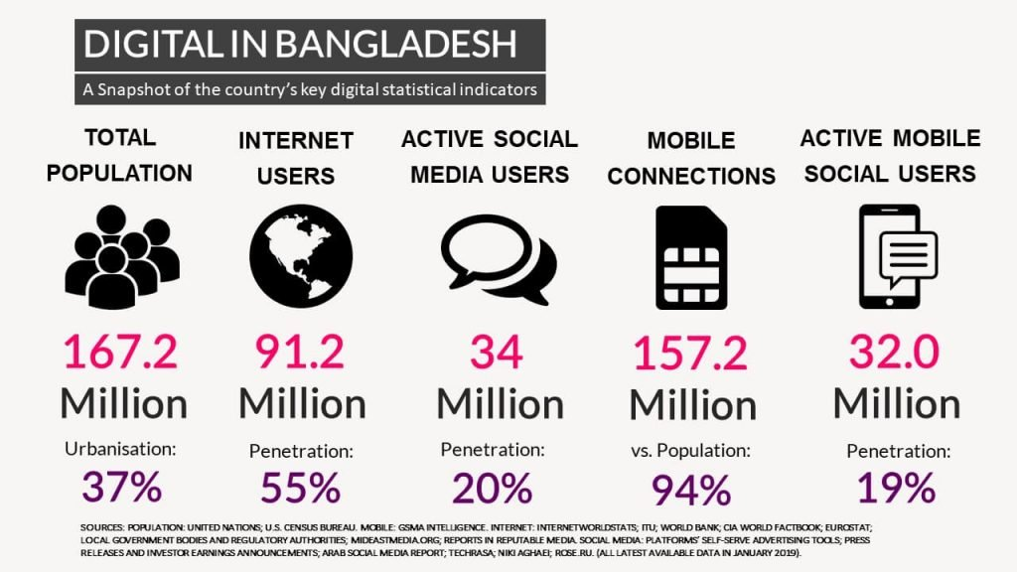

3. Local and global initiatives: Government encouraging youth to establish tech sector. Startup Bangladesh already funded over 100 million in different local startups. On the other side telco companies like robi funding 10 Minuit School for growing the business.

4. Startups are attracting FDI: The Bangladesh Entrepreneurship Ecosystem is at an inflection point with an excess of U$ 300 million in international investments from big-name corporate investors and venture capitals, investing in industries like FinTech, Logistics, and Mobility over the last six years.

5. New marketing method: Through digital marketing tech, companies are enabling their business globally. Its technical but good way than traditional marketing method. Easy to reach huge number of audience, can play with the interest of audience. It has larger scope to implement new ideas. Over 50 million people are connected in digital platform like facebook, google, linkedin, twitter and through digital marketing its quite flexible to reach out those audience in shortest time.

6. Data oriented business: Companies are now more data oriented. They are using many platform for gathering users data which is actually attracting foreign investors for investing in our startups. Startups are storing million of data in their platform by what they are getting deep understanding users demand, behavior, need. 2 years back in india, JIO launch their free service where they have invested billion of dollars. JIO offered their audience complete free internet, call outgoing charge. Millions of shifted to JIO from other telco companies. This attract facebook a lot as JIO has data of Indian people. Facebook bought 10% of share of JIO by investing $5.7 billion. This reflects that global giants are looking for data and following the trend bangladeshi startups are also focus on this.

7. Investment: Government investing in startups for encouraging youth. In past few years Startup bangladesh invested in many tech companies 15cr taka for each. Not only this local giants are also investing in startups.

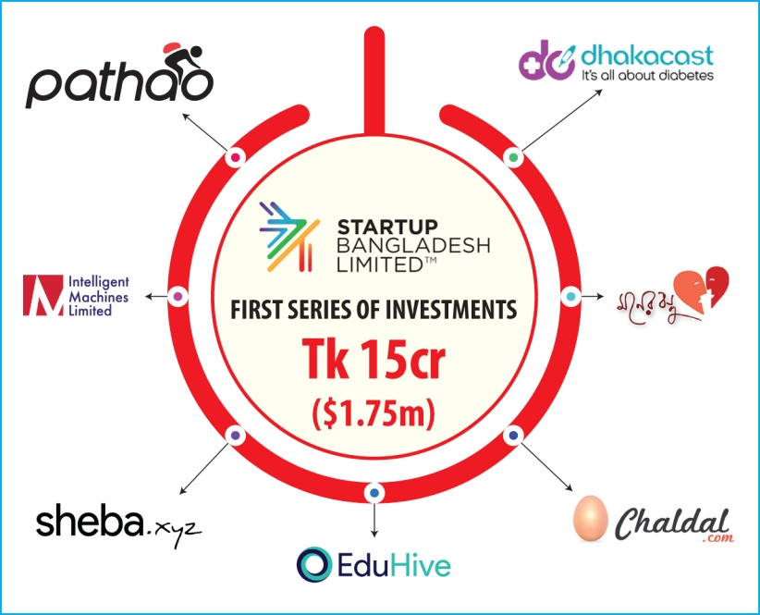

Startup Bangladesh invested 1st series of investment in tech companies.

With this foreign investment companies are also investing in our tech companies. In coming years foreign investment companies are likely to invest more than any other time in Bangladeshi startups. This year shuttle raiser $750000 in a seed round, led by Accelerating Asia. Robi Axiata Limited (r-ventures), Impact Collective (The Ventures, South Korea) and Bangladesh Angels Network (BAN)
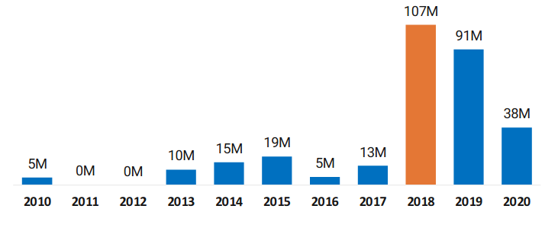
are some of the investors that participated in the round in addition to angel investors from home and abroad including industry (logistics) experts. Shikho raised $1.3 million in seed round. More companies will get fund this year as well.
Foreign Investment in Bangladeshi Startups

8. Population: 170 million people live in Bangladesh and above 62% are tech users. In this dense poputaled city of dhaka, many people are facing different problem and the problems are relatable with our everyone’s regular life. Many people thought for the solution but in traditional way the problem cannot be reduced. Tech support are quite easy to omit the problems. This huge number of digital users are creating opportunities for startups.

Some top startups of Bangladesh

Many startups from bangladesh grab attention of global investors, and businesses. The mission to serve the community by the service of new startups are quite promising and may get 25X growth in near future. Here is some promising startups,

1. ShopUp: A software company established in 2016 with a mission of enabling the SME businesses of Bangladesh. The company raised over $28 Million till now. The company found problems of SME businesses and bring with a solution to make SME business more easy. From their Product sourcing to Marketing, Delivering the product to end customers, Small investment to the SME business all are operating by ShopUp.

2. Pathao: One of the prominent startup of Bangladesh changed the ride sharing and delivery service scenario of Bangladesh. Initially the company started with parcel delivery service and then they add ride sharing service as well. Now they have collaborated with many different tech companies like bongo, bKash. They have established online food ordering service as well. They found that people who have vehicles can use is in their free time to earn extra money and their thought really changed the overall scenario of this sector. Later on many more companies added in this category. Like shohoz, sam rider, pick me etc.

3. Bkash: It is a mobile financial service and payment method for users. It is kind of like e-Wallet that changed the mean of holding money. Now people do not need to keep money in wallet. Mobile phone is enough for this. This company is close to be a unicorn of Bangladesh. The daily average transaction of bKash is above 2000 Cr. The company saw people are transforming them digitally and are purchasing products from online platform. On the other side people used to send money for one city to another through different courier, which was actually, time consuming. With bkash people can transfer money instantly. After them nagad, upay, sure cash, rocket entered into the market.

4. Chaldal: Another promising sector chaldal raised above $10 million from different investors. E-Commerce industry for fashionable products was fine but for grocery item was not quite adaptable in bangaldesh. But the company took the risk, and established a online grocery market from where people can order regular essentials just by few clicks.

There have more startsup in diiferent sector like BD jobs is working as a recruitment tool for companies, Sindabad as a e-Commerce platform, Zantrik as a vehicles repairing service, Jatri for long distance transportation service, Shuttle for official transportation service are doing really well. All the companies are working for the big number of audience of Bangladesh and they audience are quite tech oriented young. Companies are identifying their problems and bringing a solution through a tech medium.

Findings from the study

- Technology is still not well enough to serve the huge number of people.
- There have more opportunity founders can work on to develop better services.
- Comparing with our neighbor country like India got over 4.7billion investment till now where we are counting in million.
- Global research is needed for implementing better strategy
- We are still not focused on advance marketing through digital platform, where global business are implementing proper marketing strategy.
- Many founders follow global business idea, but our people are not fit yet to adapt those technology.
- Lack in proper study on startup and the eco system. Need to educate employee with new updated technology to use those for better return.
- Lack concentration in goal setting strategy.
- Companies are still not focused in KPI driven model.
- Need to come with new ideas for existing business as many are running same business. To get better advantage the service or product should be restructured.

Recommendation

- Utilize Human Resource: In recent time, startup companies are investing on their human resource but need to identify that is it worthy to invest more on the people. Companies are endorsing celebrities, influencers by spending millions. Face value is important but for a early stage company talent is more required than face value. Startup is more young people friendly and the operations are different comparing with traditional business. So hiring experienced but old people may not bring any result for the startup. On the other side rotating jobs of employees is important for startups. If you are in marketing department that doesn’t mean that your inpur will be only for the marketing. That resource can give inpur in business development department, branding department as well. Another common scenario is startup is hiring huge number of people to show the investors that the company is getting big and creating work for people, but in true scenario many people don’t have any task to do for the company. For this reason, KPI setting is more important for the startup. And the HR department must need to monitor the workforce, train them and go for the appraisal.
- Customer Satisfaction: Startup is tech oriented company. Direct appearance of human may not happen all the time. For example, Going to store to buy oil, customer and sellers are connected directly. But thing of food panda, ordered a food form a restaurant which is not even a concern of food panda, and a delivery guy delivering the product who is not connected with the restaurant. So here, trust plays a major role for the startup companies. Thousands of startups are now in Bangladesh but how many gain trust of customers? For gaining the trust and make customer satisfied startup need to ensure proper service, not to make any fake promise, show what the company can provide, time line, usability of the product. And companies must need to have a strong customer service department, FAQ channel to answer customers query on time. Companies need to update the customers with any major changes.
- Use of proper tech: Just opening a website will not consider the company a startup. Think of the user experience, think of the ability of the tech that can store data properly. Good companies are using highest level of tech like ISO Delopers, Android Developers, Front end, back end, PHP, Dev ops for better product development. Companies are using Jira, Metabase, Chunch, SAP for better visibility of data. For early stage startup all together may seems tough but for doing business they need to consider minimum level of product quality.
- Utilizing Data: Data science will play a major role for startups. Company need to follow data driven model. In modern era to digitization tech companies knows everything about their user behavior. Companies know who are the right customer, who are the upcoming potential customer, who are churned, Service time line of users, first service data, last service date all plays important part for startup specially for the marketing team. So company need to know proper use of data for better return.
- Marketing channel: Company need to utilize proper marketing mediums and can research on those. They need to know proper analytics, pixel, SDK for better reach to the audience. Company need to use above data shared in number 4 for marketing purpose.
- Ensure return: Till now in our country no unicorn is built. But look on our neighbor country, many of the startup are now unicorn. Major problem in our country is, we are not focusing on the return. Our investment ration is higher than return. Yes, for startup revenue in tough to get in beginning but at-least company should use cost cutting method for better return. Think of evaly, they spent around 6 taka for earning 1 taka revenue. Think of pathao, they were having unnecessary 300 employee and investors layoff them just in 1 day notice period. For getting return few things need to be considered are:
  - Market fit product
  - Unique ideas
  - Population
  - Demand of users
  - Management
  - Number of users
  - Proper human resource
  - Ongoing market research
- Come out from me too ideas: There have lot of similar business in Bangladesh for what; no one is getting advantage properly. Stop doing same business what your friend and family is doing. Try to identify the demand, research on market. If you can see the potential of similar business in same market then go for it. Otherwise stop coping others. Need to come out from this situation.

Reference

- https://www.lightcastlebd.com/insights/2020/01/bangladeshs-startup-ecosystem-coming-of-age
- https://www.entrepreneur.com/article/233451
- https://www.shopup.com.bd
- https://www.techinasia.com/talk/opinion-reason-bangladesh-tech-startup-struggle
- https://en.wikipedia.org/wiki/Startup_company
- https://unb.com.bd/category/Lifestyle/the-7-most-promising-tech-startups-in-bangladesh/71010
- Shopup, mohakhali DOHS
- Pathao, Banani

