

Internship Report
On
HR Practice & Procedures:
A foremost guideline followed and applied in Aarong
&
Ayesha Abed Foundation.



INTERNSHIP REPORT
ON
HR Practice & Procedures:
A foremost guideline followed and applied in Aarong

Submitted To:
Md.Abul Mohaimen
Assistant Professor
School of Business & Economics
United International University

Submitted By:
Afsana Anwar Shoma
ID No: 111 132 243
School of Business & Economics
United International University

Date of Submission: 22 March 2019

Letter of Transmittal

22 March,2019
Md.Abul Mohaimen
Assistant Professor
School of Business & Economics
United International University

Subject: Submission of internship report on HR practice & Procedures: A foremost guideline followed and applied in Aarong& AAF.

Dear Sir,
I am very pleased to submit my internship report on “HR practice & procedures: A foremost guideline followed and applied in BRAC-Aarong& AAF”, this report is written based on my internship program.It is likewise an essential prerequisite for the finish of my graduation program. It is really a great pleasure to have the opportunity to submit my internship report on the experience gained during my 3 months of internship periods at Brac-Aarong. I have prepared this report in accordance with the instructions given by you.
It was extremely a rousing and learning background for me to working in Aarong. I trust this learning and experience will help me a great deal later on vocation.

I am extremely thankful to you for your incredible help during my internship report writing.

Sincerely yours
Afsana Anwar Shoma
ID: 111 132 243
School of Business & Economics
United International University

Acknowledgment

At first, I might want to pay in all seriousness Almighty ALLAH who made each progression effective and bailed me out in any sort of emergency. Most importantly I might want to say thanks to Aarong Human Resource division for choosing me as an intern. I view myself as fortunate on the grounds that I had the capacity to work with such stunning individuals who gave me gigantic learning and made the start of my corporate life very fought. It is certain that finishing of this report would not be conceivable without their caring help.

I am extremely appreciative to my director S.M. Zahidul Islam (Manager, HRD) for helping me to comprehend the corporate standards and behaviors in Aarong. I also want to thank my colleagues Monjori Monica Drong (Senior Officer, HRD), Rutaba Fairuz (Officer, HRD) Tahmina Hossain (Executive, HRD), ShefaBinteZakirShefa (Officer, HRD) for helping me in every single step during my internship program. They helped me to comprehend the whole capacity of Human Resource Department of Aarong, so I could apply those learning in my future calling.

Then I might want to pass my appreciation to Mr. MdAbulMohaimen who has been helped me during the internship period of "The Recruitment and Selection in Aarong". He was constantly useful and kind. I also want to say thanks to Carrier Counseling Centre (CCC) of United International University for their help.

Table of content
Contents
Chapter-01 1
1.0: Introduction: 2
1.1: Origin of the report: 2
1.2: Objectives of the report: 2
1.3: Scope of the study: 3
1.4: Limitations of the study: 3
1.5: Methodology: 4
1.6: Data collection technique: 5
Chapter-2 6
2.0: Company Overview: 7
2.1. History: 8
2.2. Logo: 10
2.3: Mission Statement: 11
2.4: Vision Statement: 11
2.5: Key Values: 11
2.6: Operational Network: 14
2.7: Organogram: 15
2.8: Products and services of Aarong: 17
2.9: Awards: 19
Chapter-3 22
3.1: Literature Review: 23
Recruitment & Selection Process of Aarong and AAF: 26
Compensation Management Team: 30
Job Separation and Grievance Management team 31
Support and HRIS Team: 33
4.5 Performance Appraisal of Aarong: 35
Chapter-4 37
4.0: Analysis and Interpretation: 38
Chapter-5 47
Recommendations: 48
Conclusion: 50
Appendix: 51
Bibliography: 55

Executive summary

This report is an analysis of the practices followed by Aarong, Human Resource Department. Aarong is a gigantic association working with a great many representatives where Aarong HR office works as a solid power to deal with those a huge number of HR with their intense pound. Initial segment of this report incorporates little presentation about the report, objective, system, degree and constraint of the report.
The second part describes about the association, their history, and mission and vision articulation. It additionally gives brief portrayal of Ayesha Abed Foundation, Aarong's product offering, grants possessed by Aarong, Aarong's logo and so on. This piece of the report gives the peruse foundation learning about Aarong's character, their voyage and huge undertaking to set up themselves as Bangladesh's main way of life retail chain.
The third part of the report includes ta literature review and the detail list of works done by Aarong Human Resource Department. There are several teams in Human Resource Department which are recruitment and selection team, compensation. The executives team grievance and partition team, performance evaluation group, and Human Resource Information System group. Each group has their own appointed work. Those work are portrayed legitimately in this part. This part additionally examines about execution examination and some different exercises that are directed in HR division.
The fourth part includes analysis and interpretation of the survey questionnaire of Aarong employees.
The fifth part is the last part where the finish of the report is given. At that point the references of all the data and index are additionally given.

Chapter-01
Introduction of the report

1.0: Introduction:
This report is an Internship report ready as a requirement for the fulfillment of my BBA program from United International University. The primary goal of the internship is to provide a corporate experience to the students and a chance for translation of theoretical learning in real life situation. An entry level position is a time of work experience offered by a business to give understudies introduction to the workplace, frequently inside a particular industry, which identifies with their field of study. As they lean toward somebody from HR foundation along these lines, I have been chosen in the Human Resource Department of Aarong as an understudy. My internship journey was started from October 01,2018.

1.1: Origin of the report:
This report has been set up as a piece of session of getting learning about Human Resource Department of Aarong under direction of my faculty Md.Abul Mohaimen. The report titled, "HR Practice &Procedures: A chief rule pursued and connected in Aarong". I have gathered required data from the essential and optional source. I have attempted my best to gather data with the idea of the report, yet because of association protection strategies and confined access to data there still stays a few impediments.

1.2: Objectives of the report:
Two main objectives in this internship report are:
Broad objectives:
The principle reason for this report is to delineate my understanding of the work done and experience gathered in the midst of the entire time of the internship program. It intends to find how practical this learning foundation had been in setting up a person for the exceptional difficulties those are going to develop in the genuine corporate world. In this way, this report has been set up to mirror the general information and understanding accumulated amid the temporary job time frame.

Specific Objective:
•To accumulate careful learning on enrollment and choice procedure of Aarong.
•To make an analysis of human resource exercises of Aarong.
- To satisfy the necessity of submitting internship report.

1.3: Scope of the study:
The report basically centers around the Human Resource exercises of Aarong,so there are some mystery information of Human Resource division that they would lean toward not to reveal. In the midst of the joining time span an arrangement letter is given to the new assistants, where a couple of standards and rule is given. One of them is that the understudies needs to keep up the characterization of inside information which they may keep running over while working in Aarong and they have to give their imprint and fulfill the joining tradition. So mystery of internal issues are painstakingly kept up in this report.

1.4: Limitations of the study:
The major limitations of this report are:

•Recruitment and selection practice of Aarong has fewer problems.
•Recruitment secret data with respect to the enrollment and choice procedure or some other HR action is exceedingly disallowed by the tenets of Aarong. Thus, the inner data are not talked about in this report.

•. The entry level position time of three months is an actually quite brief time to appropriately see every single exercises of the Human Resource department.

1.5: Methodology:
The two sources of data are:

Primary Sources:
Primary sources were utilized to do the examination of enlistment and determination process and a few other human asset exercises. To accumulate essential data dialog with associates were finished. Some data were additionally taken through survey which were replied by the HR partners. Other than that, the majority of the essential sources were gathered from my reasonable perceptions and encounters of employment obligations and duties amid the temporary position time frame.
Secondary Sources:
Auxiliary data was used for information, for instance, establishment, history, mission, vision, objective, logo, Ayesha Abed Foundation and other information with respect to the item contributions of Aarong. Some other information were accumulated from the reports of past colleagues who have worked in Aarong. The discretionary data sources were generally accumulated from power site of Aarong which has been referenced in the reference zone of this report.

1.6: Data collection technique:
Primary Data:

- Conversations with the employees
- Survey Questionnaire

Secondary Data:
- Aarong Website
- Articles regarding human resource
- Previous internship report of Aarong

- Abbreviations:
- HRIS – Human Resource Management Information System
- ERP- Enterprise resource planning
- HR- Human Resource
- HRD- Human Resource Department
- JD- Job Description
- COO- Chief Operation Officer

Chapter-2
Company Overview

2.0: Company Overview:
Aarong is a chain of retail outlet located in major cities in Bangladesh an enterprise of BRAC (Building Resources across Communities). Aarong means Bengali for ‘village fair’. It has started its journey in 1978. This moral brand started as a modest way to engage provincial artisans to rise above poverty. Today, with 20 retail locations crosswise over Bangladesh and more than 100 style and way of life product offerings, Aarong bolsters 65,000 craftsmans with reasonable terms of exchange. Reforming the retail business with exclusive expectations for quality and creativity, this notable brand mixes the customary with the contemporary in manners that never stop to win buyer request both at home and abroad. 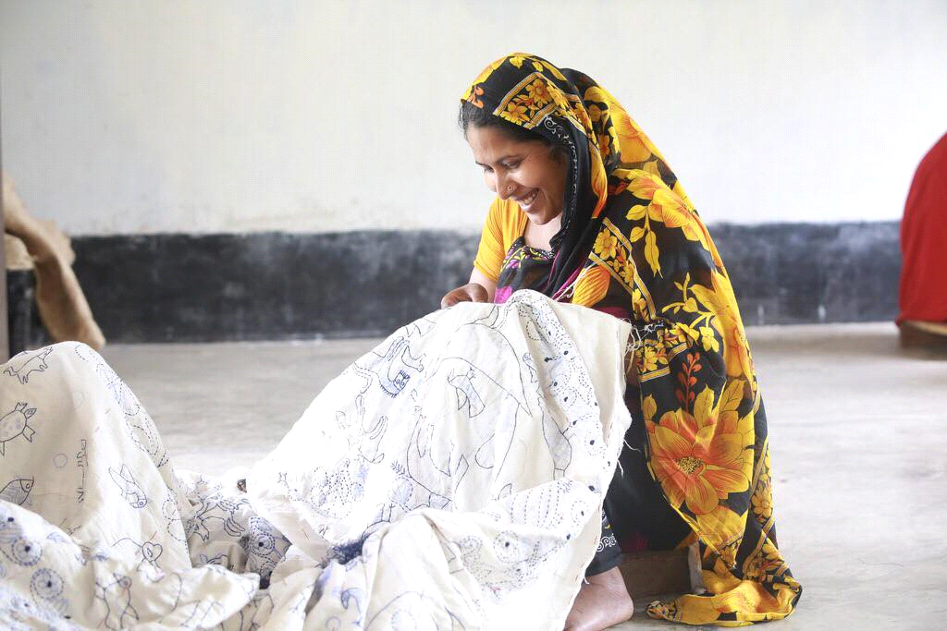
Figure: Nakshi Katha
Aarong implies a town reasonable – it symbolizes reasonableness in the worldwide town. Aarong works as the advancing arm of BRAC. Its will likely give a relentless and gainful wellspring of work for the poor commonplace people. Aarong set up in a fantasy to help the craftsmans with helping themselves by restoring their pride and certainty, reestablishing Bangladesh's customary Art and Craft. Another point was to attest the women right and to set up them as an imperative asset in the overall population. In the process Aarong contributes remarkably to BRAC's target of desperation relief and fortifying of needy individuals.

2.1. History:
“Hope is an element in which people take action, and energize them out of poverty”
– Sir Fazle Hasan Abed
During the 1970s, BRAC was inspecting all conceivable outcomes for elective types of profitable job, particularly for ladies, and the best possible commercialization of expressions and artworks ended up being a promising choice. In 1976, Ayesha Abed, the spouse of Sir Fazle Hasan Abed, originator of BRAC (NGO) BRAC, started huge numbers of the significant exercises of Aarong by distinguishing and trying different things with different artworks that ladies could deliver at home, for example, nakshikantha, weaved merchandise, crates, mats and things made of stick, bamboo and jute. Be that as it may, the two principle snags to transforming make generation into an advantageous undertaking were keeping up great quality and appropriate advertising.In 1978, BRAC went into a joint undertaking with the Mennonite Central Committee, the overall progression arm of the Mennonite Church, to open a shop in Dhaka called Aarong – signifying 'town reasonable.' ' The Mennonites had a long experience of conveying workmanship to make pay and had set up a program called Ten Thousand Villages, which worked with skilled worker groups the world over and sold their things through inventories and retail shops in the US and Canada. In the primary year the Mennonites assisted with the business side of the errand while BRAC endeavored to develop the capacities of town women and their things. The late 1970s and mid-1980s, BRAC focused on structure up Aarong's item contributions and creation limits. They began to study and record the plans and topics of traditional masterpieces by visiting verifiable focuses, old workmanship managers and private experts. They investigated diverse roads in regards to indigenous structures and materials, modifying them to possible new lines. They contracted pro craftsperson to help train town women and made a material structure and organization workshop in Manikganj to attempt diverse things with materials and advances in sewing, weaving and shading.
Ayesha Abed Foundation (AAF):

In 1982, the Ayesha Abed Foundation (AAF) was set up by family and allies to respect the memory and work of the late Ayesha Abed who kicked the container leaving her newborn child kid, Shameran, and young lady, Tamara. The foundation was made to develop women's capacities in various claims to fame through a fitting working environment, cash related and concentrated help and getting ready. At first it was enrolled with the organization to get outside unselfish blessings and raise saves, anyway now works just as a bit of Aarong. The AAF board incorporates the eight family and buddies of the late Ayesha Abed. Its money related arrangement is a bit of the Aarong movement under BRAC. The AAF masters are generally people from BRAC's town affiliation social occasions or the gathering of the people.

AAF's first endeavor, the Manikganj center, was opened on 3 September 1983. The foundation buys careful work made by the town women, distinctive NGOs and workmanship creators. Despite starting the AAF, Aarong opened four retail outlets and began conveying somewhat dimension of stock to sensible trade relationship in the midst of the 1980s. By the mid to late 1980s Aarong began to ascend as a plan brand despite how Bangladesh was still new to the style business. Aarong was the foremost brand to start dealing with photo shoots close by style appears, shows and changed sorts of media-focused events. Through these significant advancing exercises, Aarong had the ability to develop its notoriety and brand character inside the country. By the mid-1990s, Aarong transformed into the primary structure house in Bangladesh and had made a one-stop objective for focus to high society urban clients. Meanwhile, Aarong's thing plans returned client thought to the things and styles that are indigenous to Bangladesh. Its fashioners blended the standard with the contemporary in a way that considered buyers and started a change in examples, grasped by perpetual diverse boutiques and stores.

Amid the 1990s, Aarong kept on structure brand an incentive through plan shows and media consideration events. The rising detectable nature of style in Bangladeshi society accepted a catalyzing work in doing this. Aarong in like manner continued broadening its age limit with the extension of three new AAF centers. In any case, by the late 1990s and mid 2000s, Aarong went up against a fiscal incident due to reasonable organization and a nonattendance of improvement. Some place in the scope of 2001 and 2004, the association was modified to improve everything from costing, esteeming, structure and promoting to new thing introductions and brand progressions. In 2004, its arrangements totaled almost US$14 million. Aarong earned an advantage of US$1.96 million for BRAC which was scattered among its cultivation, guidance, and prosperity programs, with the bigger part taking off to a remarkable program for the ultra-poor. In 2013, Aarong had crossed US$50 million in arrangements.

2.2. Logo:
The logo of Aarong symbolizes an image of a peacock. It is marvelously beautiful because of the shining, luminous, diversified colorful patterns in its tail. This logo of Aarong indicates that its products are as eye-catching and as unique as a peacock. There are two colors in the logo. One is black and another is orange. Black represents professionalism and the orange represents energy.

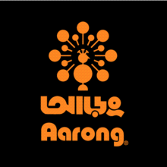
Figure: Aarong Logo
.
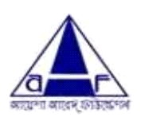
Figure: Ayesha Abed Foundation Logo

2.3: Mission Statement:
“To make Aarong the best in the world in providing a unique Bangladeshi lifestyle experience which promotes Bangladeshi pride while empowering people and protecting the environment.”

2.4: Vision:
Aarong‟s vision is to remain market leader throughout its business. Aarong expand its business in international arena. Aarong has a dream to develop more artisans of Bangladesh and make them dependent and attract more and more international customers toward Bangladeshi Culture.

2.5: Key Values:
Aarong’s values are same as Brac. The key values are:

- Innovation: Aarong values the innovation that creates opportunities for the poor to lift themselves out of poverty. They strive to display global leadership in ground-breaking development initiatives.

- Integrity: Aarong values the integrity, because transparency and accountability are the most essential elements of our work ethic. With clear policies and procedures, they continue to display the utmost level of honesty in our financial dealings.
- Inclusiveness:They are committed to inclusiveness to ensure that they engage, support and recognize the value of all members of society, regardless of race, religion, gender, nationality, ethnicity, age, physical or mental ability, socioeconomic status and geography.
- Effectiveness:Aarong value effectiveness in all of their work, which constantly challenge themselves to perform better and to improve and deepen the impact of their interventions.

Figure: Key Values of Aarong

2.6: Operational Network:

Aarong task organize begins from the creation of the distinctive items which are sold in the retail outlets. The items are delivered under establishment for creation and gathering named Ayesha Abed Foundation. Ayesha Abed Foundation is arranged in Baniachong, Gorpara, Jamalpur, Jessore, Kushtia, Manikganj, Rajbari, Sherpur, Pabna, Pallobi, Kurigram, Nilphamari, Jhenaidah having 653 sub focuses crosswise over Bangladesh. In excess of forty thousand of the aggregate women of Aarong makers work straightforwardly for Aarong in these 13 generation focuses in and Twenty-five thousand free helpful gatherings and conventional family-based craftsmen additionally, showcase their artworks through Aarong.

Potters, Brass Workers, Jewelers, Jute laborers, Basket Weavers, Handloom Weavers, Silk Weavers, Wood Carvers, Leather specialists and different craftsmen with particular aptitudes from everywhere throughout the nation come to Aarong for promoting and bolster administrations (aarong.com).
After the accumulation of the items and entry in the outlet shoppers can purchase the items from the retailer outlets. This is the means by which the gathering and moving of the item go on. The tasks in the outlets are for the most part conveyed by the directors of the outlets. They primarily are mindful to deal with the outlet inventories, item moves, client administrations, installment accumulations, and workforce the executives. They oversee the outlet's execution and are specifically mindful to report the Cooperative Officer of Retail and Infrastructure for any sort of activity happens

2.7: Organogram:
In this part, I will describe the organizational chart of HR department. According to the organizational detail, the senior director directly reports in BRAC Enterprises. The detail Organogram of Ayesha Abed Foundation will be attached in appendix part
Managing Director BRAC

Director Aarong, AAf& BDFP

HR Department

Design Studio
Finance Department

Retailed Department

CRM

Creative

Branding & Buzz

Public Relations

Marketing Research & Product development

E-commerce

Sustainability

Marketing Manager

Logistic & Maintenance Department
Social Compliance
Marketing Department

Export Department

Figure: Organogram of Aarong


Deputy General Manager(DGM)
Sr. Executive
Manager
Manager
Manager
Executive
Manager



Officer
Officer
Sr. Officer
Assist. Officer
Officer
Assist. Officer
HRM department Assistant

Figure: Organogram of Aarong HRD

2.8: Products and services of Aarong:
Aarong started with the subject of making unadulterated silk and high quality nakshikantha. Over the long haul, it turned into the highest retail chain of Bangladesh together with design, way of life and family unit items. The merchandise can be isolated into littler classifications. They are given underneath:

1. Women (Clothing and Accessories)
2. Men (Clothing and Accessories)
3. Kids (Clothing and Accessories)
4. Jewelry
5. Dairy Item
6. Home Décor
7. NakshiKantha (Home Décor and Clothing)
8. Wedding (Clothing, Accessories, Décor and Gift Card)
9. Taaga (Youth Brand)
10. Herstory (Exclusive Designer Line for women)
11. Leather Item
12.Taaga Man

Services of Aarong:
Aarong provides the following services to the production workers of Ayesha Abed Foundation:

1. Legal support to employees
2. Free skills training
3. Raw materials
4. Transportation of goods
5. Quality Control
6. Storage
7. Management
8. Finance
9. Marketing and Public recognition
10. Medical
11. Free medical checkup
12. Medicine supply
13. Free eye checkup and glass supply
14. Treatment cost for severe illnesses
15. Day care center
16. Advance wage payment
17. Workers‟ gratuity benefit
18. Workers‟ welfare support

thatnever stop to win customer offer both at home and abroad.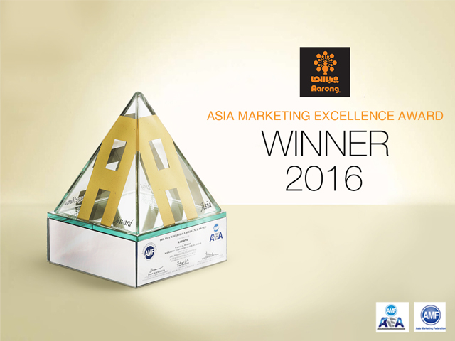

Aarong has received the Bangladesh Supply Chain Excellence Award 2018 in the category of “Excellence in supply chain finance” as a local organization at an event held at ICCB on 21st July, 2018. The event was jointly organized by IPDC Finance Ltd and Bangladesh Supply Chain Management Society.
Aarong has long prioritized the financial sustainability as it provided instant payments upon delivery of goods, low interest collateral free loans and regular orders throughout the years to support the producers and artisans. The awarding committee has recognized the efficiency of Aarong’s processes to ensure such principles through our ERP system which is integrated at all producer service points.
Aarong has recently signed an agreement with IPDC. The agreement will allow work order financing for producers. This initiative of supply chain finance has brought a meaningful social service for micro, small and medium enterprises and has imposed the sustainability of their respective businesses.

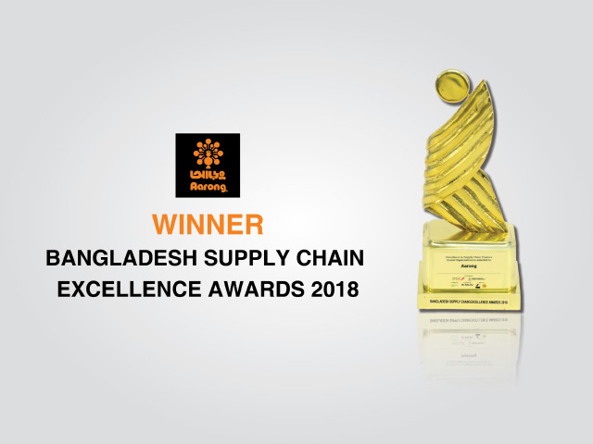

Chapter-3
HR Practice & Procedures:
A foremost guideline followed and applied in Aarong
&
Ayesha Abed Foundation.

3.1: Literature Review:
HR is basically significant in the present contemporary associations since it actuate superior administration using workers; by upgrading their dimensions of client's administration, profitability, development, benefits and quality control (Armstrong, 2000).

As indicated by Story (1995) contends that HR arranging today is a critical assignment of each contemporary association's HR division. As indicated by him, HR arranging basically includes the recognizable proof of abilities and skill inside the association, the filling of distinguished capability holes, and the assistance of developments of representatives inside the association.

A fundamental piece of the HR arranging is the progression arranging which expects to guarantee the supply of people and filling of holes on senior key positions when they become empty and renew capabilities to regions where they are most esteemed (Wolfe, 1996).

In association the framework that in charge of setting enhances abilities all through is alludes to as enrollment and determination forms. The procedure of enlistment and determination is a moral methodology by a firm to look for and draw in the most skilled and appropriate candidate for an empty position (Analoui, 2007).

The way toward choosing and holding potential workers is the best authoritative focused fight in present day days (Pfeffer, 1994).

The idea of estimating execution or overseeing execution inside associations is to strategize how firms can get the most extreme advantages from their representatives (Dransfield, 2000).

The way to deal with estimating execution can be named a three-advance methodology that created by goals, evaluation and criticism. The initial step is the setting of execution destinations that are quantifiable, simple to gauge and easy to impart all through the association (Dransfield, 2000). From that point onward, the procedure of execution examination should occur (Bredin, 2008).

The administration of execution incorporates plan of work frameworks, help of information usage, sharing and creation, and examination and reward frameworks (Cardon and Stevens, 2004).

Worker fulfillment is the individual fulfillment as an expert individual, that is, the individual affects his frame of mind. Association part to its working trademark is the intellectual assessment, representatives get past the more sensible qualities and desires for the hole between the esteem acquired after the gathering whether all parts of work mentalities and enthusiastic reactions. It includes crafted by the level of authoritative duty and work inspiration is firmly related (Saari, L. M., and Judge, T. A., 2004).

Unrivaled subordinate correspondence is an imperative effect on employment fulfillment in the working environment, in which the manner in which a subordinate sees a director's conduct can decidedly or contrarily impact work fulfillment. Nonverbal messages assume a focal job in relational connections regarding impression development, trickiness, fascination, social impact, and enthusiastic articulation (Burgoon, Buller, and Woodall, 1996).

3.2: A foremost guideline followed and applied in Aarong& AAF:
Aarong Center is the head office of Aarong and AAF. In this way, all the HR related exercises occur for the most part here.Apart from the enrollment and choice group Aarong HR office is in charge of numerous other imperative work. Aarong has a lot of outlets around Bangladesh and keeping up all the HR of the impressive number of outlets close by the head office staff and Ayesha Abed foundation agents is a huge test. Aarong has a standout amongst the most grounded HR office in Bangladeshi corporate world.

Amid my entry level position period I was entrustedin the enlistment and choice group. Along these lines, I had the capacity to get ability with every single movement of the enrollment and choice precess. It was hard for me to find fundamentally all the human asset exercises performed by Aarong inside the compact time of three months. Regardless, I was sufficiently honored and my senior associates were important to show to me the general exercises of the HR division. Other than that, I have likewise gotten learning by watching exchange works out. So here I will mean an examination of the general HR rehearses subject to my sensible experience, learning and astuteness.

The Aarong Human Resource division includes four groups and all of the groups are accountable for each locale of work. The groups' are-

Figure: Aarong HRD Teams

Recruitment & Selection Team:
Enrollment and determination group is in charge of picking the best fitted representative forAarong and AAF. The group begins working in the wake of landing the position order from any office for an unfilled position (to be), the HR office at first get the underwriting from Chief Operating Officer (COO).

The enrollment and determination group is isolated into two areas:

• Project Staff Recruitment Team • Management Staff Recruitment Team

Recruitment & Selection Process of Aarong and AAF:

The recruitment and selection process of Aarong is very much well arranged. They follow every steps very strictly. The recruitment and selection of Aarong and AAF is totally unbiased. They take CVs from both internal and external applicants.
The recruitment and selection process mainly starts from requisition from different departments. The process is given below:
- Requisition:
The first step of recruitment and selection process of Aarong is getting the requisition from other department for an empty position. After collecting the requisition they need to get approval from the COO and other authority. Than they prepare the job description and job specification for that specific position.

- Advertisement in Different Media:
Aarong give their advertisement renowned newspapers, online media aarong prefers most is (BD jobs.com.) and posturing the job circular in different area. They use the posturing method basically for the lower level positions like driver, helper etc. In all the job circular they give a particular due date and candidates must apply within that due date. After the due date of occupation round they began gathering Cvs from different sources. CV is gathered through email, Bd employments CV bank, printed version duplicate CVs from Aarong CV box, inward CVs and alluded CVs. CVs are orchestrated dependent on certain criteria, for instance, training qualification, experience, resultant age limit, pay desire range, experience.

- Date Fixing:
After CV screening they fixed a date for the written test and interview for the candidates.
- Question Paper Preparing:
It is a very important and confidential part of recruitment and selection process. They assigned a particular officer for preparing the question for the written test. They must need the approval from the DGM after preparing the question. The question includes some specific criteria:

- Subject related knowledge
- Analytical ability
- English

- Calling Session :

One of the officer from recruitment and selection team call the selected candidate to inform them about the date of written test and interview, place of the exam, time, or if they have to bring something in the time of interview for example (calculator, CV, Portfolio in case of designer etc.). When the officer called the candidate they have to make sure if they are coming or not. On the basis of the candidate coming they prepare questions for the exam.

- Messaging Session: In this step they give a message on the candidate’s mobile number with detail information like the designation he or she applied for, date and time of the exam, address of the place where the exam will take place.

- Single & Detail list Preparing:

The single list includes serial number, the candidate and their father’s name, contact number, space for their signature and remarks. The detail list includes their name, name of current or past organization, experiences, educational qualification and name of institution. This list contains considerable competencies on the basis of which a candidate is given viva status. So this rundown is imperative, through this rundown the meeting board individuals becomes acquainted with all the data initially about the competitor. So

- Offering Job:
In this step one of the member from recruitment and selection team give a call to the selected candidate to inform about their selection. The candidate are informed about the company policies, benefits etc. If the candidate is interested for the job and accept the offer then they are given a date on which the candidate must join.

- Joining Formalities:
On the joining date the new representatives needs to satisfy a few conventions, for instance, displaying their instructive declarations, Photo, CV, NID, Nominee NID, photo and other critical reports. By then the representative needs to fulfill some structure, for instance:

History Form
Joining Form
Nominee Form
Guardian Form
Signing Code of Conduct
Reference Check
- Appointment Letter
On the day of joining the employee gets the appointment letter from the HR department. Appointment letter should be signed by the employee.
- Software Entry:
At that point all data in regards to the employee is contribution to the ERP and HRMS programming. Data, for example, name, father's-mother's name, birth date, changeless, present location, reference data, training data, chosen one data, kids information(if any) are contribution to ERP.
.

Compensation Management Team:
Aarong has a strong compensation management team who deals with compensation and pay system.
- Salary:
The compensation management team makes salary for all the permanent employee, the management employee,part time employee, project employee and so forth. They fixes the compensation of the employee as per their grade and slab.

- Fund:
This group additionally takes care of the essential issues, for example, fund. So the compensation management team is in charge of legitimate administration of the tip support, provident fund, and health care insurance and so on.

- Allowances:
Another important work of compensation team is provide allowances to the employees. Aarong provides allowance like house, mobile, hospital, overtime, special, transfer, distance, entertainment, transport, conveyance, accommodation and food allowance etc.

Job Separation and Grievance Management team

Some procedures of termination are-
- A claim is made to the HR department regarding why a representative ought to be rejected.

- Aarong HRD frames an examination group who delves profound into the issue and goes for undeniable examination. What's more, presents an answer to the HRD dependent on the discoveries of the examination.

- After the appraisal of the HRD the report is sent to the Director of Aarong.

- The Director of Aarong concludes the choice whether the representative ought to be ended or not.

In the event that a representative is ended, at that point he is informed about his end by the HR office. If there should be an occurrence of end a worker isn't furnished with offices which were guaranteed by Aarong. For example, insurance money, provident fund and so on are not gave to him/her.
- Grievance Management Team:
Grievance management is a very important issue that is carefully managed by the HR team of Aarong. It is very important to find a solution to any grievance related issue in an organization or it may create other conflict in the organization. First the victim sends a written complaint or reports the incident to the Human Resource department of Aarong. Then an investigation team is created who sends a show case letter to the accused party. After accepting the reply within one week the investigation team prepares a report. Then the investigation committee reaches a final decision regarding the case. The accused party is informed about the decision. All the files regarding the investigation are carefully recorded, maintained and secured.

Chapter-4
Analysis and Interpretation

4.0: Analysis and Interpretation:
Question-1. Gender
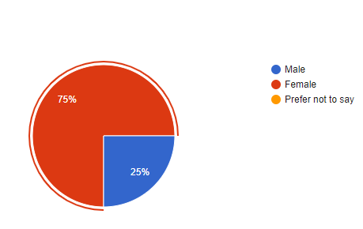
Interpretation: Above graph shows that maximum of the respondent are female, Aarong HRD has 75% female employee and 25% male employee.

Question-2.Aarong offers comfort in your physical workplace

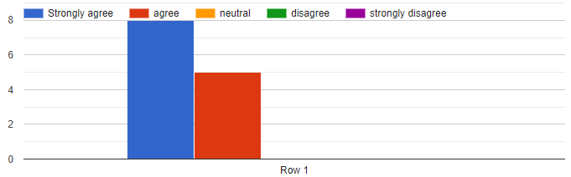

Interpretation: From theabove graph shows that most of the respondents was strongly agree (8 respondents) with Aarong offers comfort in physical workplace. On the other hand 5 respondents were agree to this.

Question-3.My group works well together to accomplish the organization's goals.

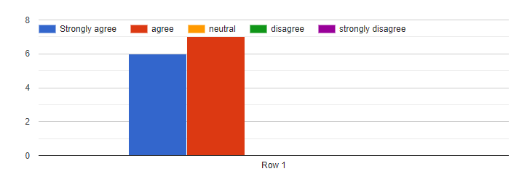
Interpretation: From the above graph shows that most of the respondents was agree (7 respondents) with my group works well together to accomplish the organization’s goal. On the other hand 6 respondents were strongly agree to this.

Question-4.Aarong offer adequate opportunities for promotions and career development

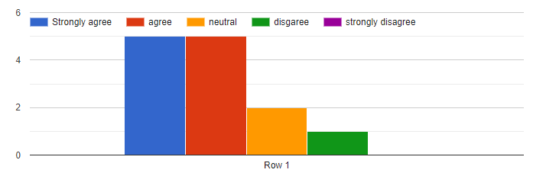

Interpretation: From the above graph shows that most of the respondents was strongly agree (5 respondents) and agree (5 respondents) with Aarong offer adequate opportunities for promotions and career development. On the other hand 2 respondents were neutral and 1 respondent was disagree with this.

Question-5.I see myself contributing to Aarong in the long run

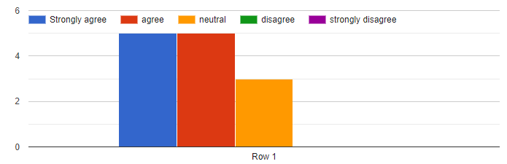

Interpretation: From the above graph shows that equal amount of respondents were strongly agree (5 respondents) and agree (5 respondents) with I see myself contributing to Aarong in the long run. On the other hand 3 respondents were neutral to this.

Question-6.I am compensated fairly for the work I do.

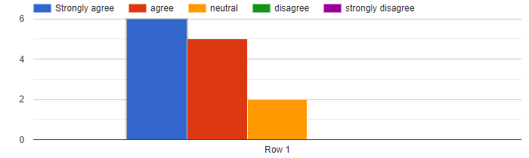
Interpretation: From the above graph shows that most of the respondents were strongly agree (6 respondents) and agree (5 respondents) with I am compensated fairly for the work I do. On the other hand 2 respondents were neutral to this.

Question-7.I am provided with opportunities to improve my skills.

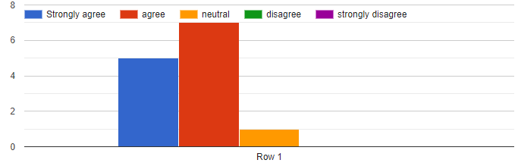

Interpretation: From theabove graph shows that most of the respondents were agree (7 respondents) with I am provided with opportunities to improve my skills. 5 respondents were strongly agree. On the other hand 1 respondent was neutral to this.

Question-8.I am treated fairly by my supervisor.

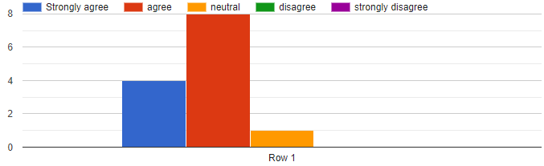
Interpretation: From the above graph shows that most of the respondents were agree (8 respondents) with I am treated fairly by my supervisor.4 respondents were strongly agree to this. On the other hand 1 respondent was neutral to this.

Question-9. My supervisor provides me with adequate feedback.

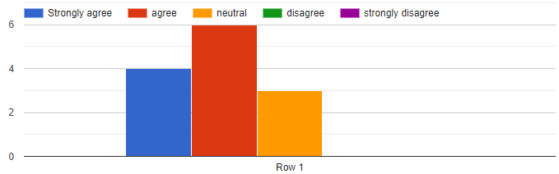
Interpretation: From the above graph shows that most of the respondents were agree (6 respondents) with my supervisor provides me with adequate feedback. 4 respondents were strongly agree to this. On the other hand 3 respondents were neutral to this.

Question-10.I am recognized by my manager for my contributions.

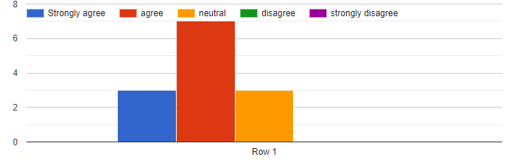
Interpretation: From the above graph shows that most of the respondents were agree (7 respondents) with I am recognized by my manager for my contributions. On the other hand 3 respondents were strongly agree and 3 respondents were neutral to this.

Question-11.My manager has set performance goals for my job.

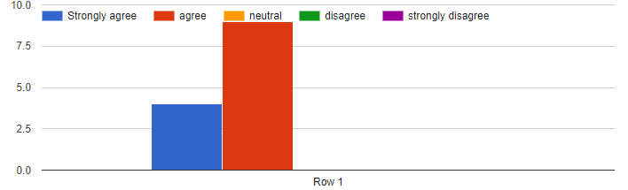

Interpretation: From the above graph shows that most of the respondents were agree (9 respondents) with my manager has set performance goals for my job. 4 respondents were strongly agree to this.

Question-12.The performance appraisal system at Aarong is unbiased.
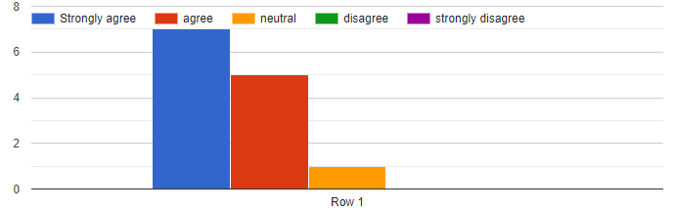
Interpretation: From the above graph shows that most of the respondents were strongly agree (7 respondents) and agree (5 respondents) with the performance appraisal system at Aarong is unbiased. On the other hand 1 respondent is neutral to this.

Question-13.The employee recruitment and the selection process at Aarong is unbiased.
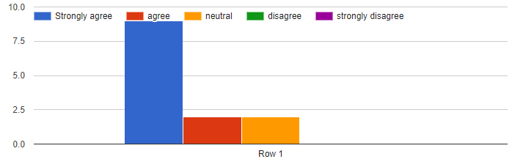

Interpretation: From the above graph shows that most of the respondents were strongly agree (9 respondents) with the employee recruitment and the selection process at aarong is unbiased. On the other hand 2 respondents were agree and 2 respondents were neutral to this.

Question-14. I have a clear understanding of the company pay policy.

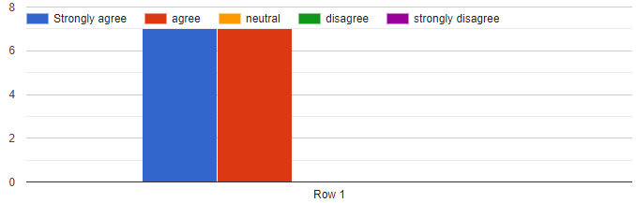
Interpretation: From the above graph shows that most of the respondents were strongly agree (7 respondents) and agree (6 respondents) with I have a clear understanding of the company pay policy.

Question-15.Aarong follows the employee law properly.

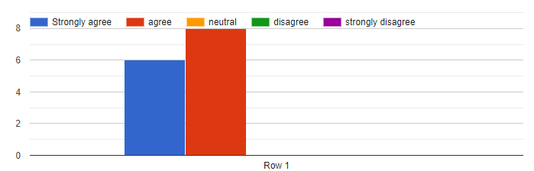

Interpretation: From the above graph shows that most of the respondents were agree (8 respondents) and strongly agree (5 respondents) with Aarong follows the employee law properly.

Question-16.The training provided by Aarong is effective for the employee.

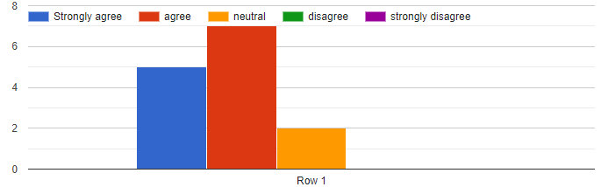
Interpretation: From the above graph shows that most of the respondents were agree (6 respondents) and strongly agree (5 respondents) with the training provided by aarong is effective for the employee. On the other hand 2 respondents were neutral to this.

Chapter-5
Recommendations and Conclusion

Recommendations:
This report additionally has some recommendations forAarong HR department, which are depicted underneath:

- Aarong could take their written test online for the candidates whose job location is outside of Dhaka and who are applying from a distant place from Dhaka. It would reduce both the time and hustle.

- The HR department ought to assign a room just for the examination purposes. With the goal that when there will be a ton of possibility for composed test it would not make any hustle for the sitting arrangement.

- Use the brand estimation of Aarong in term of the board recruitment. A large portion of the general population don't know about Aarong corporate office and Ayesha Abed Foundation. Though using the brand estimation of BRAC and Aarong it tends to be useful for powerful recruitment.

- The accommodation of records during joining ought to be all the more carefully practiced for new employees.

- Aarong HRD should endeavor to convey some innovativeness to their work. They ought to propel their representatives to think of new thoughts that can make their work progressively fun and improve profitability. They have to give some self-governance to their employees as well.

- HRIS.ERP and EDMS software should be more updated so that the employees can work smoothly.

- As the Aarong HRD have to maintain a lot of employee at a time they should recruit more employee for Human resource department. It is really a tough challenge for them to handle all the things with minimal employee.

Conclusion:
Arong has a reputation globally. They earn it through many process. They have maintained their human resource department like their product quality from the beginning . Arong might not have many different assignment and selection techniques from other organizations but what they follow is very appropriate in terms of Bangladesh’s perspective and they are very strict to their system.

Appendix:
HR survey questionnaire regarding employee satisfaction and HR policies of Brac-Aarong

Name
Designation
Gender
- Male
- Female
- Prefer not to say

How long have you been working at Aarong?
Answer:

- Aarong offers comfort in your physical workplace.
- Strongly Agree
- Agree
- Neutral
- Disagree
- Strongly Disagree

- My group works well together to accomplish the organization's goals.
- Strongly Agree
- Agree
- Neutral
- Disagree
- Strongly Disagree
- Aarong offer adequate opportunities for promotions and career development

- Strongly Agree
- Agree
- Neutral
- Disagree
- Strongly Disagree
- I see myself contributing to Aarong in the long run
- Strongly Agree
- Agree
- Neutral
- Disagree
- Strongly Disagree

- I am compensated fairly for the work I do.
- Strongly Agree
- Agree
- Neutral
- Disagree
- Strongly Disagree

- I am provided with opportunities to improve my skills
- Strongly Agree
- Agree
- Neutral
- Disagree
- Strongly Disagree

- I am treated fairly by my supervisor
- Strongly Agree
- Agree
- Neutral
- Disagree
- Strongly Disagree
- My supervisor provides me with adequate feedback
- Strongly Agree
- Agree
- Neutral
- Disagree
- Strongly Disagree

- I am recognized by my manager for my contributions.
- Strongly Agree
- Agree
- Neutral
- Disagree
- Strongly Disagree
- My manager has set performance goals for my job
- Strongly Agree
- Agree
- Neutral
- Disagree
- Strongly Disagree
- The performance appraisal system at Aarong is unbiased
- Strongly Agree
- Agree
- Neutral
- Disagree
- Strongly Disagree

- The employee recruitment and the selection process at Aarong is unbiased
- Strongly Agree
- Agree
- Neutral
- Disagree
- Strongly Disagree

- I have a clear understanding of the company pay policy

- Strongly Agree
- Agree
- Neutral
- Disagree
- Strongly Disagree

- Aarong follows the employee law properly
- Strongly Agree
- Agree
- Neutral
- Disagree
- Strongly Disagree

- The training provided by Aarong is effective for the employee
- Strongly Agree
- Agree
- Neutral
- Disagree
- Strongly Disagree

Bibliography:
Websites
- About Aarong, (2017) ,
https://www.aarong.com/about-aarong/
- Aarong. (10 march.2019) .retrieved from Wikipedia, https://en.wikipedia.org/wiki/Aarong
- Shefa, B. Z. F. (2017, April 19). Effectiveness of recruitment and selection process of Aarong& Ayesha Abed Foundation (A study on management staff). Retrieved from dspace.bracu.ac.bd: http://dspace.bracu.ac.bd/xmlui/bitstream/handle/10361/8442/12104083_BBA.pdf?sequence=1&isAllowed=y

Books:
1. Armstrong, (2000). Human Resource. Ado and Wilson (1994, p 701).
2. Storey (1995). Human Resources Planning

