Internship Report
On
Clients’ Perception of Service Quality- A Case Study On
Blend Private Limited

Supervised By:
Md. Kaium Hossain
Assistant Professor
School of Business & Economics
United International University

Submitted By:
Iftekairul Alam Nafi
ID: 111-142-138
Bachelor of Business Administration (BBA)



Date of Submission: 2nd September 2019

Clients’ Perception of Service Quality- A Case Study on



Preface

Experiencing real world work environment is one of the key requirements for most business programs nearly in every prominent business school all around the world. United International University (UIU) is no exception in this regard. So far completion of the Bachelor in Business Administration, when I was given the opportunity to pick one from a project or internship, without any hesitation I went for the letter.

Firstly, the purpose of internship is to become acquainted with the practical world. It gives us an opportunity to learn- the work procedures, ethics and cultures of different national and multinational organization.

Secondly, implementing the theoretical knowledge with the practical side taught in business institutes and how it is implemented in different enterprises in another key learning.

I have done my internship in Blend Privet Limited (Mogbazar, Dhaka) since 2thof February 2019 to 30th of Jun, 2019. I gained a lot from this internship gist under the kind supervisor and guidance of my internship supervisor. During my whole time I visited through different companies and was thoroughly briefed about the procedure and working by cordial senior staff of there. In my report I will try to present the experiences I gathered during this tenure. It contains an overview of the company and the activities, Tasks and projects I have had the opportunities to work. In this report, I also will also try to describe and reflect my learning and personal goals that I have set for my future career.

Letter of Transmittal
2nd September 2019
Md. Kaium Hossain
Assistant Professor
School of Business & Economics
United International University

Subject: Submission of internship report on “Clients Perception of service Quality- A Case Study on Blend Private Limited.”
Dear Sir,
The Internship report submitted is on “Clients’ perception of service Quality- A case Study on Blend Private Limited” done as a partial fulfillment of the requirements of BBA degree. You assigned me to prepare this report as a requirement of the BBA. I am enthusiastic to you for giving me the opportunities to undergo such an experience.
I believed that the knowledge and experience I have gathered during my internship period will immensely help me in my future professional Life. I have concentrated my best effort to achieve the objectives of the thesis study and hope that my endeavor will serve the purpose. However, I will always be ready to provide any further clarification that you may require.

Thank You,
Sincerely Yours,

------------------------
Iftekairul Alam Nafi
ID: 111-142-138
School of Business & Economics
United International University

Acknowledgement

The Completion of this internship report would not have been possible without the help and support of many people. I would like to express my gratitude to Almighty Allah for enabling me the strength and opportunity to complete the report in the schedule time successfully. I am deeply indebted to my faculty supervisor Md. Kaium Hossain, Assistant professor, School of Business & Economics for his stimulating inspiration, Kind guidance, valuable suggestions & wise advice during my internship period. His suggestions &guidance have enhanced the quality of the report.

I would also like to take this opportunity to thank all staffs of Blend private Limited’s advice and guidance my internship report would not be so encouraging.

Last but not least; I would like to thank all the officials of this production house who have given me the chance to be familiar with the real organizational environment, and practically experiencing the procedures. I am also grateful to the management team of Blend Privet Limited for granting me the opportunity to make my internship program in this organization.

Executive Summary

This Internship report is a partial requirement BBA program at United International University. The main objective of the report is to know the overall activities of service providence of event & advertising agency. To make this internship report, I have selected Blend Private Limited. This study attempted to understand the clients’ perception of different service quality dimensions while dealing with this production house. The broad objective of the report is to know about the clients' perception of the service quality of this firm. And the specific objective of this report- To know about the clients' reliability, responsiveness, assurance, empathy, tangibles, analysis of service quality of Blend Private Limited. To make recommendations for improving the quality of different services provided to the clients" by this company. The study was conducted both primary and secondary sources of information. . The nature of research is descriptive research. I made a detailed questionnaire for my survey. Finally based on the analysis and finding conclusion has been drawn in this report.
Its objective is to social commitment & for that, it ensures cooperation to the people of all level, to the clients", who are engaged in large scale service-oriented industry, medium & small-scale industry by self-inspiration. Maybe that's why this firm is now recognized as the most powerful leader in the service sector. The report has a significant role in the development of the country. The successful business depends mainly on the clients' service quality and perception. So to be a successful business-particular business, adequate service quality, and clients' perception is quite an essential factor which is maintained well at Blend Private Limited.

Table of Contents
Preface i
Letter of Transmittal ii
Acknowledgement iii
Executive Summary iv
1.0 Introduction 1
1.1 Origin of the Report 2
1.2 Purpose of the Report 2
1.3 Objectives of the Report 2
1.3.1 Broad Objective 2
1.3.2Specific Objectives 3
1.4 Methodology 3
1.4.1 Primary Sources 3
1.4.2 Secondary Sources 3
1.5 Limitations of the Study 4
CHAPTER – TWO 6
Organization Overview 6
2.1 Company Profile 7
2.2 Vision 7
2.3 Mission 7
2.4 core values of Blend Private Limited 8
2.5 Commitment of Blend Private Limited 8
2.6 Core Competencies 8
2.7 Organizational Objective 9
2.8 The Team 9
2.9 Organizational Structure of Blend Private Limited 10
2.10 SWOT Analysis of Blend Private Limited 11
Strengths 11
Company Reputation 11
Strong Employee Bonding and Belongingness 11
Team work at all level 11
Well-organized Performance 12
Workforce 12
Staff Meetings 12
Interactive Company Culture 12
Weaknesses 12
Time Limit 12
Budget Issue 12
Market 13
Logistic Support 13
Competitors 13
Post production House 13
Low Cost 13
Human Resources Department 13
Centralized Decisions-Making 13
Limitations of Office Equipment’s 14
Opportunities 14
Diversification 14
Possibility 14
Management 14
Profit 14
Threats 15
Competitors 15
Client Satisfaction 15
CHAPTER THREE 17
Findings and Analysis 17
3.1 Clients Service 18
3.2 Clients Perception 18
3.3 Defining Service Quality 18
3.4 Service Quality Dimension (SERVQUAL): 18
• Tangibility 18
• Reliability: 18
• Responsiveness: 19
•Assurance: 19
• Empathy: 19
3.5 Measurement of Client’s Satisfaction 20
Reliability Dimension 20
Responsiveness Dimension: 23
Assurance Dimension: 25
Empathy Dimension 27
Tangible Dimension 29
Chapter – Four 32
Conclusion & Recommendation 32
4.0 Conclusion 33
4.1 Recommendations 34
Appendix 35
Questionnaire 35
Intern Appointment Letter 39
Intern Completion Certificate 40
Bibliography / References 41

CHAPTER ONE

INTRODUCTION

Introduction

Nowadays the service sector plays a significant role in the wealth creation. Service sector has the crucial meaning because it employs vast numbers of people. Therefore, the growth of service sector is affecting positively all the economy.
Modern advertising service serves a vital role for a nation's economic development. Over the last few years the advertising world has been undergoing a lot of changes due to deregulation, technological innovations, globalization etc. These changes in the film making system also brought revolutionary changes in a country's economy.
Event management, advertising agency companies will help to organize a number of different and very special events that an organization may be interested in hosting. They manage ceremonies, celebrations, product launches and product presentations, workshops, company inaugurations, conferences and events where an organization will invite the public. Fundamental piece of this undertaking is managing clientsand persuade them. Here association is commonly done by an outsider movement.
Brand
(Client)

Event & advertising works

Target
User

1.1 Origin of the Report
After completion of 117 credit hours of BBA program, it demands a report on experience. Internship program is a must criterion for Bachelor for Business Administration (BBA) students, designed to put them in a challenging environment of the relevant field, where the students get opportunity to apply their theoretical knowledge into practical applications, Internship provides a unique opportunity to see the reality of business during student life which enables them to build confidence and working knowledge in advance of the start of their career. And as an intern I worked at Blend Private Limited and gathered knowledge about promotional activities and the procedure of a production company. Hence I was placed in Blend Private Limited from 2nd February, 2019 to 30th Jun, 2019.

1.2 Purpose of the Report
In this report, 1 am trying to portray the Service Quality Process of Blend Private Limited. As I have been working in this advertising company as a result this firm has been an essential basis of this report. Moreover, I will be focusing on the level of clients' perception by observing the overall impact in this firm. The purpose of the study is to gather practical knowledge on over-all production system and its operation. This internship provides me a chance to apply theoretical knowledge that I acquired from class lectures, books, journals, projects, workshops etc. and compare them with practical experience. Only academic education does not make a student perfect to become competitive with the outside world. So internship is an important and effective approach to combine theoretical knowledge with practical experience. Last but not the least an organization's success greatly depends on its service quality and clients' perception.

1.3 Objectives of the Report
The objective of the study is to combine the theoretical exposure gathered from the BRA program with the practical knowledge on advertising system and operation. This is a great opportunity to co-ordinate with the theoretical knowledge and the practical experience.

  - 1.3.1 Broad Objective
To identify the perception of the clients, gain practical experience and gathering knowledge in the real life.

  - 1.3.2 Specific Objectives
• To know the clients’ perception of service quality of Blend Pvt. Ltd.
• To get a clear idea about this advertising company and how it runs and what function it does.
• To figure out the strengths, weaknesses, opportunities and threats of Blend Pvt. Ltd.
• To compare the service quality of the production company with its competitors.

1.4 Methodology

For data collection to prepare this report, both primary and secondary data are used here. Primary data are collected through questionnaire survey on clients and the direct communication with the people, including the employees, clients, and by observation of different activities of their work. Secondary data are collected by personal files, newspapers, articles, different newsletter, and by other sources.
  - 1.4.1 Primary Sources
For collecting primary data, I had to ask the representative officer(s). Others are like-
• Direct communication with the firms head and employees.
• Personal experience gained by visiting different desks.
• Personal investigations with employees.
• Face to face interview with clients' to measure their level of perception.

  - 1.4.2 Secondary Sources
The secondary sources are-
• Information of Blend Private Limited.
• Documents and papers.
• Official website of Blend Private Limited.
• Files and papers of the company.

1.5 Limitations of the Study

From the intention to make the report appropriate, I have tried my best to provide with all necessary information about Blend Private Limited. As having the status of the practical study, this report is subject to following limitations-
• Limited time given to prepare this report.
• As the advertising company remains busy proper justice could not be done for all the variables because of the busy schedule of the concerned managers.
• The major limitation which was faced in preparing this report was the sensitivity of the data. As it is a highly competitive market, if the margin information is released to other competitors, it may have a negative impact on their business. Its outcome is, employees are not reluctant to give every information

CHAPTER – TWO

Organization Overview

2.1 Company Profile

BLEND Private Limited started its journey in 2014 where it was first situated in Gulshan 1. Now it shifted to boro Mogbazar, Rajshahi House 98/7 with a new space and new energetic approach. It is creating a new & young perspective to look at the advertising and branding of Bangladesh.
BLEND Private Limited is an emerging and recognized interior and creative firm with expertise in residential, commercial, branding, advertising retail and brand communication projects.
From its inception, BLEND is consistently recognized for its business acumen and its variety of innovative design solutions that impeccably blend functional and esthetic needs.
We believe that by a series of processes, BLEND and its Customer could synergize to convert ideas to become a great business branding.



2.2 Vision
To be the BRAND VOICE of our clients

2.3 Mission
To be associated with our clients as their 'Marketing partner' by helping them achieve their Marketing objectives.

2.4 core values of Blend Private Limited
Believe in One stop service

Believe in One stop service

Want to meet Clients perception
Polished approach
Enthusiasm for Work

Innovation

Proper utilization of utility

Continuous Development

Client’s satisfaction

2.5 Commitment of Blend Private Limited
Incorporated advertising support-
- Creative advancement offering uniqueness and flexibility
- Brand administration - improving brand esteem
- Print media promotion improving brand esteem
- Market knowledge key choice made simple
- Direct showcasing - when you need direct reactions
- Lead age commencement of customer intrigue
Advancement administrations –
- Event administration noteworthy each minute
- Point of offers the executives selling quick and selling shrewd
- Product dispatch make an impression
- Road show-we go anyplace and all over the place
- Fair and display exhibit and show of choices
- Understanding clients’ Needs, Wants and Demands

2.6 Core Competencies
- Keeping up the ethical standard of tech-related issues.
- Giving and utilizing genuine information while investigate.
- Improving IT establishment of the association.
- Furnishing fitting planning with vital hardware and guidelines.

2.7 Organizational Objective

- Directing examination through field work.
- Examining the conditions.
- Giving clear arrangement
- Giving long haul arrangement.
- Setting up and propelling measures.
- Preparing and improvement of HR.

2.8 The Team
- Clients Service team
- Digital Marketing Team
- Creative Team
- Marketing Team
- Operation team
- Architect team

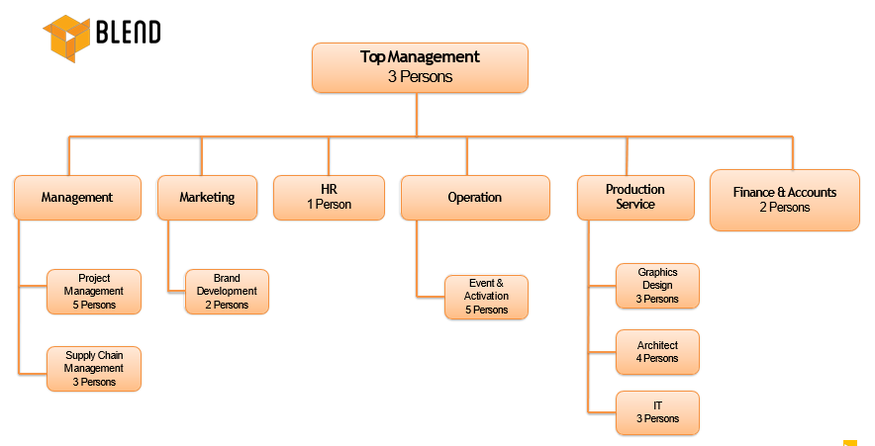2.9 Organizational Structure of Blend Private Limited

2.10 SWOT Analysis of Blend Private Limited
SWOT analysis is an organized planning method used to evaluate the Strengths, Weaknesses, Opportunities and Threats involved in a project or in a business venture. the technique is credited to Albert Humphrey. The degree to which the internal environment of the firm matches with the external environment is expressed by the concept of strategic fit. This analysis can be carried out for a product, place, industry or person. It involves specifying the objective of the business venture or project and identifying the internal and external factors that are favorable and unfavorable to achieving that objective.
Setting and objective should be done after the SWOT analysis has been performed. This would allow achievable goals or objectives to be set for the business. Documentation is also important because they can let know later steps in planning to achieve the objectives.
First, the decision makers should consider whether the objective is possible, given the SOWTs. If the objective is not possible a different objective must be selected and the process repeated. SWOT Analysis is an important tool for evaluating the company’s Strengths, Weakness, Opportunities and Threats. It helps the organization to identify how to evaluate its performance and scan the macro environment, which in turn would help the organization to navigate in the turbulent ocean of competition.

Strengths
It portrays the characteristics of the business or project that give it an advantage over others. The attribute in which clients were highly satisfied but gave less importance was tagged as the strength area of the company.

  - Company Reputation
This private company has already established a favorable reputation in the management marketing sector of the country particularly among the new comers. Within a period of five years, it has already established a grip in the service sector having tremendous profits.

  - Strong Employee Bonding and Belongingness
The employees are the major assets of this private company. The employees are knowledgeable, committed, and hardworking and have a strong sense.

  - Team work at all level
Everyone from top to bottom level of this private company has to work to the same timetable towards a different phase of the same goal, interfacing simultaneously at all level over quite a long period of time. People are eager to help each other and people in general are devoted to work.
  - Well-organized Performance
It provides disturbance free client service comparing to their other competitors. Personalized approach to the needs of clients is its watchword.

  - Workforce
The selection Blend Private Limited emphasizes on having the skilled graduates and postgraduates who have little or no work experience or eagerly interested in this company line. As already mentioned earlier, they want young people to come in to stew in the in the art of event making driver by utmost passion. Around 25 employees are assigned in this production company.

  - Staff Meetings
There occurs a staff meeting for each and every project. It helps them to know each other are thought about work and implement new ideas as well.
  - Interactive Company Culture
It has an interactive corporate culture. Unlike other event farms, the working environment is very friendly, interactive and informal. There are no hidden barriers or boundaries while interactive among the superior or the subordinates. The environment is also lively and since the nature of the event management job itself is way more flexible than other jobs, Blend Private Limited’s lively work environment boosts up the spirit and motivate the employees. At the same time, music system in the office also plays a key role in making the environment lively.

Weaknesses
Its characteristic is that place the team at a disadvantage relative to others.
  - Time Limit
In this commercial field they face shortage of time. When a project runs at that time clients will provide limited time to make the commercials. But in abroad the event farm doesn’t face this problem because they get enough time to execute their work and over here they get limited time period and in a given time they have to finish the whole project which hampers their work.
  - Budget Issue
This is a major setback for Blend Private Limited and one of its weakest areas. There is a low budget issue like the highest amount for event commercials is around one core in Bangladesh whereas in abroad the budget is way more than this. So there is no flexibility of work for them because they have to finish the commercial in one take with a limited budget.
  - Market
In Bangladesh the market is smaller and it is filled with too many competitors. A small market indicates more likely to struggle to compete financially against competitors from other event companies and may therefore also be outbid in the competition for top talent.

  - Logistic Support
There is unavailability of logistic support. Lacking in resources can include physical items, such as camera, equipment, crane and staff as well as abstract items such as time, information and energy. Logistics of physical items involves the integration of information flow, operational handling, production, portfolio, transportation, warehousing and often security.

  - Competitors
This has also become growing problem for this private company. Currently there are too many competitors but the problem is the market is small. So, for that there is an outline of losing projects.

  - Post production House
This has become a major problem for the event farm like Blend Private Limited. Due to lacking in technology there is no fully developed equipped place where they can do the editing and deliberately fulfill their requirements.

  - Low Cost
As the budget is low, they have to lower their cost and thus they are left behind from other countries terms of making exclusive commercials as there is lower cost, they can’t fulfill all the requirements as they want.

  - Human Resources Department
There is no HR department in Blend though they it in terms of managing their stuffs so this is another weak area of this event farm.

  - Centralized Decisions-Making
Over here the decisions are made by the managing director then the director after the others craft policies and strategies and then they are dropped down. As a result of this practice there is only a top down flow of communication. The scope for bottom up communication is very limited and many bright ideas or opinions are being able to climb up the ladder towards the management. Ideas remain their forever.

  - Limitations of Office Equipment’s
There are no personal computers for employees they need to carry their own laptop and for that in most cases high resolution work cannot be done properly.

Opportunities
It is the elements that the projects could exploit to its advantage.
  - Diversification
Blend Private Limited can purse a diversification strategy in expanding its current line of business. The management can consider options of by expanding their business portfolio; they can also cut their risk.

  - Possibility
There are several opportunities for this event farm to expand its scope. In this competitive environment it must expand its product line to enhance its sustainable competitive advantage (SCA).

  - Management
The management team of Blend Private Limited is expert in companying activities. The operating policies established by them are unique and unified. All the members of the team carry out their management process exceptionally.

  - Profit
It is one the experts in obtaining the making profits from event farm.

Threats
It identifies those elements in the environment that could cause trouble for the business or project.
  - Competitors
The emergence of the competitor and their rapid expansion poses a potential threat to this event farm. As mentioned earlier due to small market there are limited numbers of companies but for more competitiveness the clients mainly choose who work for them and for this private company might lose projects for its competitors.
  - Client Satisfaction
Blend Private Limited need constant progress towards its client’s service strategies and the whole service quality needs to win the clients satisfaction undoubtedly.

CHAPTER THREE

Findings and Analysis

3.1 Clients Service
Client service is the Commitment to providing value added services to external and internal clients, including attitude knowledge, technical support and quality of service in a timely manner. In other word it can be defined as the ability to provide a service or product in the way that it has been promised.

3.2 Clients Perception
Clients' perception is the way that clients usually view or feel about certain services and products. It can also be related to client satisfaction which is the expectation of the client towards the products. It also encompasses a client's impression, awareness or consciousness about a company or its offerings. Client perception is typically affected by advertising, reviews, public relations, social media, personal experiences and other channels.

3.3 Defining Service Quality
Service quality is the process of consistently communicating to every client that they are valued and that their satisfaction is paramount to your organization. Service quality is a comparison of expectations with performance. A business with high service quality will meet client needs whilst remaining economically competitive. Improved service quality may increase economic competitiveness. This aim may be achieved by understanding and improving operational processes; identifying problems quickly and systematically; establishing valid and reliable service performance measures and measuring client perception and other performance outcomes.

3.4 Service Quality Dimension (SERVQUAL):
SERVQUAL represents service quality as the discrepancy between a client's expectations for a service offering and the client's perceptions of the service received, requiring respondents to answer questions about both their expectations and their perceptions. SERVQUAL is a multi-item scale developed to assess client perceptions of service quality in service and retail business. The scale decomposes the notion of service quality into five dimensions. They are explained below:
  - • Tangibility
Tangibility refers to physical facilities, equipment, personnel and communication materials.
  - • Reliability:
Reliability refers to the ability to perform the promised service dependably and accurately.

  - • Responsiveness:
Responsiveness refers to the willingness to help clients and provide prompt service.
  - •Assurance:
Assurance refers to the knowledge and courtesy of employees and their ability to convey trust and confidence.
  - • Empathy:
Empathy refers to the individualized caring to the clients. According to my observation and
stud\ along through the clients' perception I have done a survey by providing them a questionnaire which requires:

Strongly Agree | Agree | Neutral | Disagree | Strongly Disagree
5 | 4 | 3 | 2 | 1

3.5 Measurement of Client’s Satisfaction

  - Reliability Dimension
1. When Blend Private Limited promises to do something by a certain time, it does so!
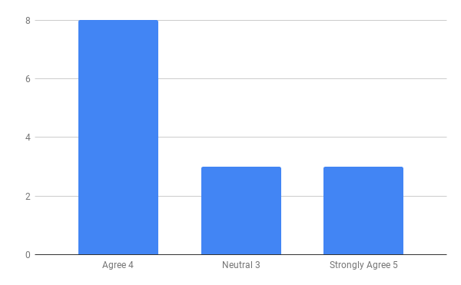

Here in this Reliability dimension, among 14 clients 8 are agree, 3 strongly agree, 3 neutral and disagree & strongly disagree is 0%.

Findings:
According to the survey analysis, it is Blend Private limited is sincere about their promises.
2. When you have a problem, Blend Private Limited shows a sincere interest in solving it.
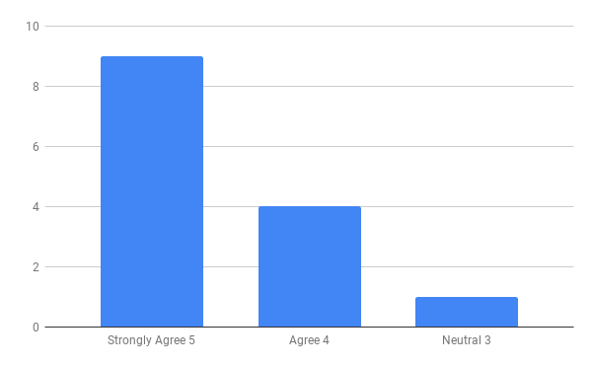

Here in this Reliability dimension, among 14 clients 9 are strongly agree, 4 agree, 1 neutral and disagree & strongly disagree is 0%.
Findings:
According to the survey analysis, it can be defined that Blend Pvt. Ltd. Is careful about their client. They are sincere and trying to solve the problems of the client as soon as possible.

3. Blend Private Limited performs the right service at first time.
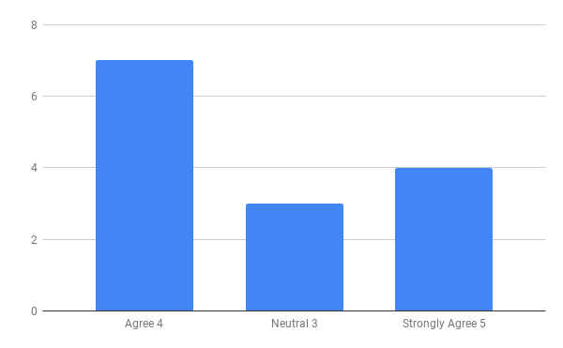

Here in this Reliability dimension, among 14 clients 7 are agree, 4 strongly agree, 3 neutral and disagree & strongly disagree is 0%.
Findings:
According to the survey analysis, it can be defined that Blend Pvt. Ltd. Provides the right service at the first time and able to satisfy their clients.
4. Blend Private Limited provides its services at the time it promises to do so.
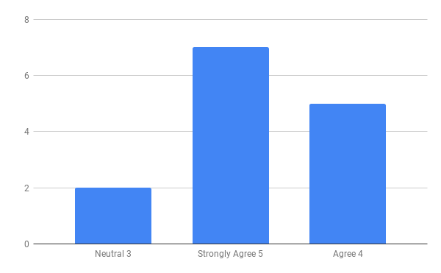

Here in this Reliability dimension, among 14 clients 7 are strongly agree, 5 agree, 2 neutral and disagree & strongly disagree is 0%.
Findings:
According to the survey analysis, it can be defined that sometimes Blend Pvt. Ltd. Is eligible to provide its services at the right time when they promise.

5. Blend Private Limited insists on error-free record.
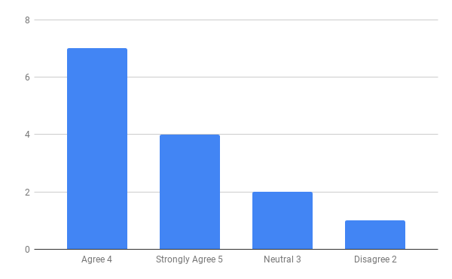

Here in this Reliability dimension, among 14 clients 4 are strongly agree, 7 agree, 2 neutral and 1 disagree & strongly disagree is 0%.
Findings:
According to the survey analysis, it can be defined that Blend Pvt. Ltd. is confident to perform error free activities.
  - Responsiveness Dimension:
6. Blend Private Limited keeps clients informed about when services will be performed.
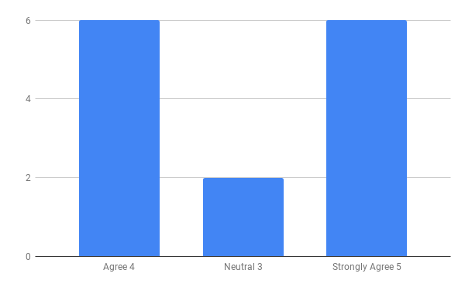

Here in this responsiveness dimension, among 14 clients 6 are strongly agree, 6 agree, 2 neutral and disagree & strongly disagree is 0%.
Findings:
According to the survey analysis, it can be defined that, though Blend Pvt. Ltd. Always keep their clients informed about the time length of service.
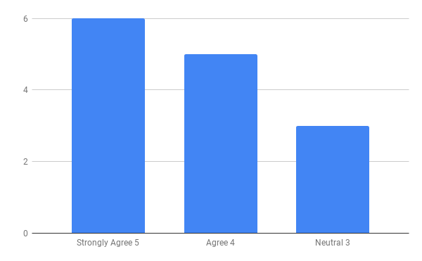
7. Personnel in Blend Private Limited provides yours prompt service.

Here in this responsiveness dimension, among 14 clients 6 are strongly agree, 5 agree, 3 neutral and disagree & strongly disagree is 0%.
Findings:
According to the survey analysis, it can be defined that, though Blend Pvt. Ltd. Is careful about the service quality that it provides to the clients.

8. Personnel in Blend Private Limited are always willing to give service at any time to the day
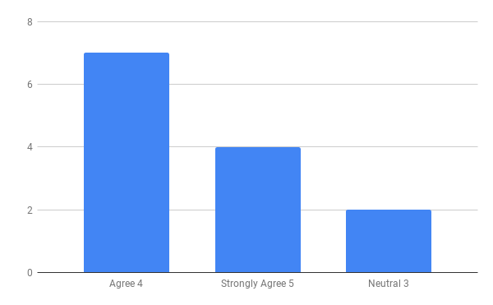

Here in this responsiveness dimension, among 14 clients 4 are strongly agree, 7 agree, 2 neutral and disagree & strongly disagree is 0%.
Findings:
According to the survey analysis, it can be defined that, the employee of Blend Pvt. Ltd are always caring and sincere for their clients. They are always there for the clients whenever they need them.
9. Personnel in Blend Private Limited are never too busy to respond to your request.
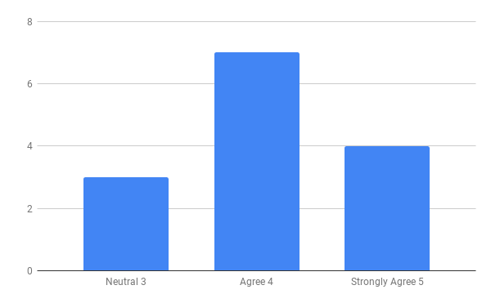

Here in this responsiveness dimension, among 14 clients 4 are strongly agree, 7 agree, 3 neutral and disagree & strongly disagree is 0%.
Findings:
According to the survey analysis, personnel Blend Pvt. Ltd are never too busy to respond to your request.
  - Assurance Dimension:
10. The behavior of employees in Blend Private Limited instills confidence in you.
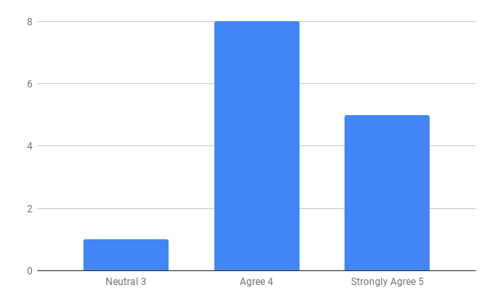

Here in this assurance dimension 5 are strongly agree, 8 agree, 1 neutral and disagree & strongly disagree is 0%.
Findings:
According to the survey analysis, it can be defined that through good communication or by fulfilling the requirements, employees of Blend Pvt. Ltd inspire confidence among the clients.

11. You feel safe in your transactions with Blend Private Limited.
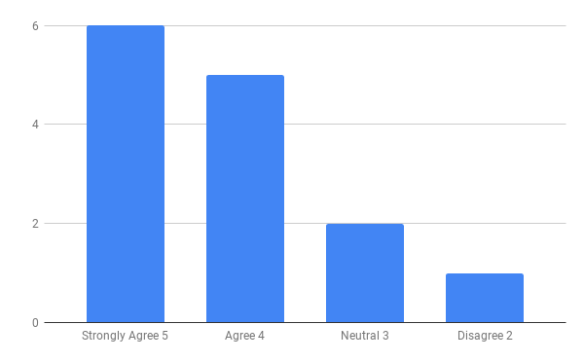

Here in this assurance dimension 6 are strongly agree, 5 agree, 2 neutral and 1 disagree & strongly disagree is 0%.
Findings:
According to the survey analysis, it can be defined that clients of Blend Pvt. Ltd feel safe in transactions.

12. Personnel in Blend Private Limited are consistently courteous with you.
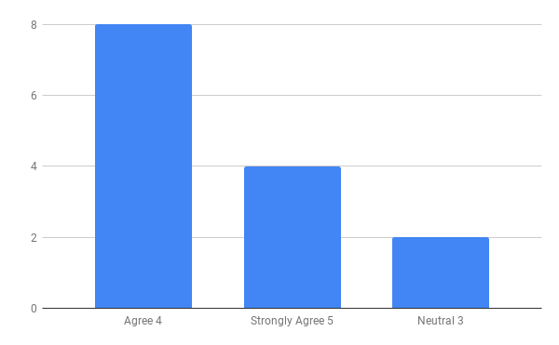

Here in this assurance dimension 4 are strongly agree, 8 agree, 2 neutral and disagree & strongly disagree is 0%.
Findings:
According to the survey analysis, it can be defined that attitude and behavior of the employees of Blend Pvt. Ltd to their clients is sober and polite.

13. Personnel in Blend Private Limited have the knowledge to answers your questions.
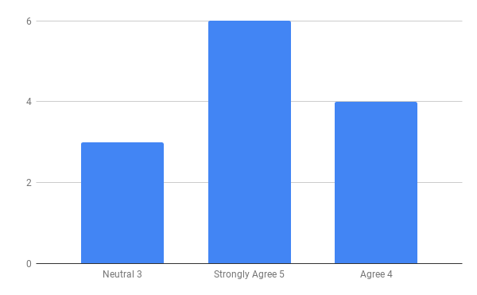

Here in this assurance dimension 6 are strongly agree, 4 agree, 3 neutral and disagree & strongly disagree is 0%.
Findings:
According to the survey analysis, it can be defined, as the employees of the Blend Pvt. Ltd are well experienced with their work, so they are very knowledgeable and smart to answer the question of their clients.
  - Empathy Dimension
14. Blend Private Limited s gives you individual attention.
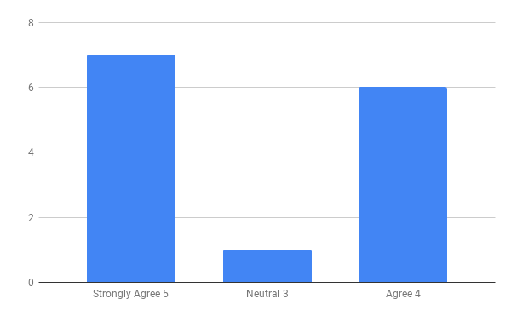

Here in this Empathy dimension 7 are strongly agree, 6 agree, 1 neutral and disagree & strongly disagree is 0%.
Findings:
According to the survey analysis, it can be defined, Blend Pvt. Ltd has employees who give their clients personal attention.

15. Blend Private Limited has employees who give your personal attention.
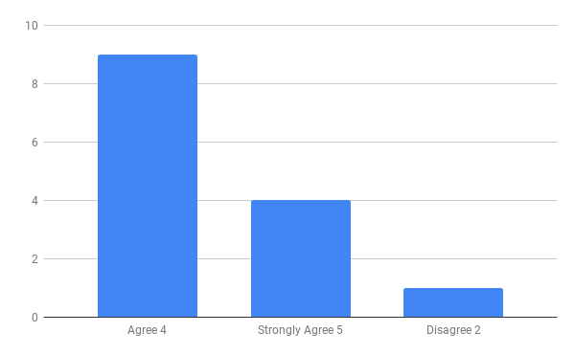

Here in this Empathy dimension 4 are strongly agree, 9 agree, 0 neutral and 1 disagree & strongly disagree is 0%.
Findings:
According to the survey analysis, it can be defined, the employees of the Blend Pvt. Ltd are given personal attention to their clients.
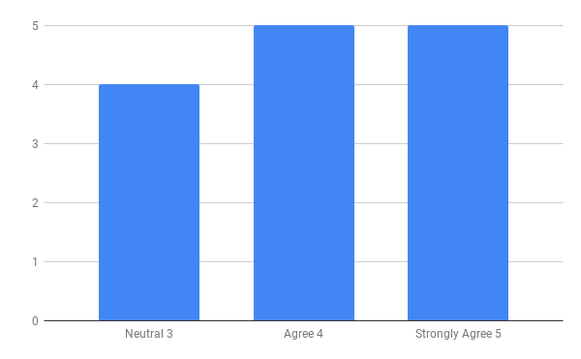
16. Blend Private Limited has your best interests at heart.

Here in this Empathy dimension 5 are strongly agree, 5 agree, 4 neutral and disagree & strongly disagree is 0%.
Findings:
According to the survey analysis, it can be defined, Provide prompt service.

17. Personnel in Blend Private Limited understands your specific needs.
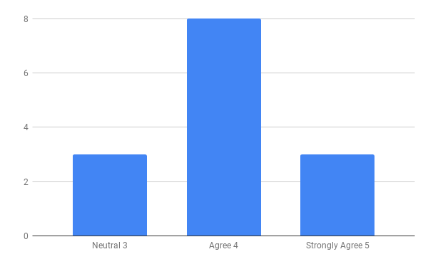

Here in this Empathy dimension 3 are strongly agree, 8 agree, 3 neutral and disagree & strongly disagree is 0%.
Findings:
According to the survey analysis, it can be defined, Blend Pvt. Ltd understands client’s specific needs to fill up.

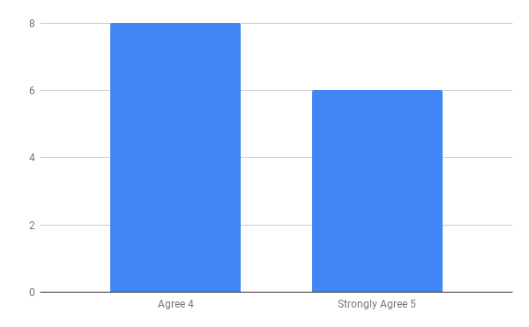
18. Blend Private Limited has operating hours that is convenient to all its clients

Here in this Empathy dimension 6 are strongly agree, 8 agree, neutral and disagree & strongly disagree is 0%.
Findings:
According to the survey analysis, it can be defined, Blend Pvt. Ltd has operating hours convenient to all its clients.

  - Tangible Dimension
19. Blend Private Limited has modern looking equipment.
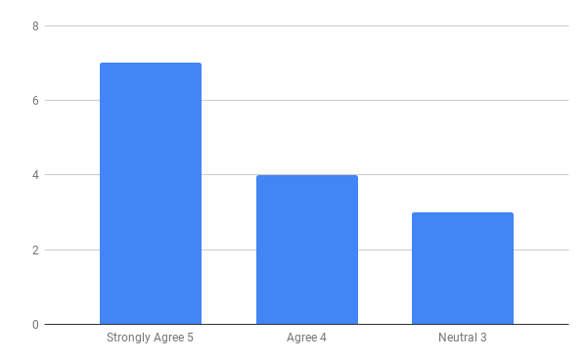

Here in this Tangible dimension 7 are strongly agree, 8 agree, 3 neutral and disagree & strongly disagree is 0%.
Findings:
According to the survey analysis, it can be defined, Blend Pvt. Ltd has enough modern equipment to perform activities. But it should always be updated with the new technologies those are coming to the market.

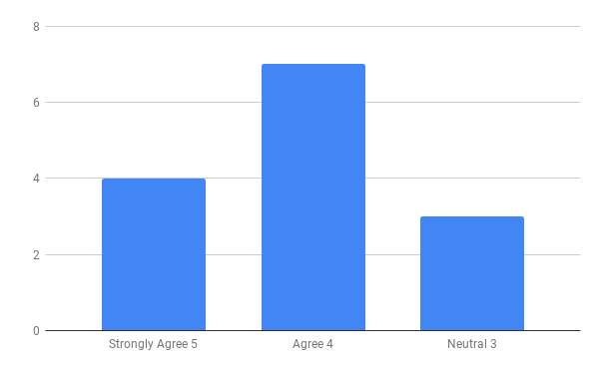
20. Blend Private Limited physical facilities are visually appealing.

Here in this Tangible dimension 4 are strongly agree, 7 agree, 3 neutral and disagree & strongly disagree is 0%.
Findings:
According to the survey analysis, it can be defined, physical facilities of Blend Pvt. Ltd are visually appealing.

21. Blend Private Limited employees appear neat.
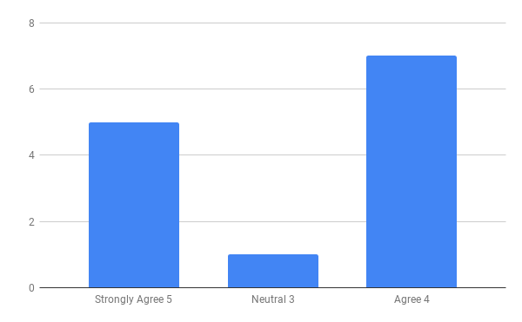

Here in this Tangible dimension 5 are strongly agree, 7 agree, 1 neutral and disagree & strongly disagree is 0%.
Findings:
According to the survey analysis, it can be defined, employees of Blend Private Limited have to be careful about their dress up.

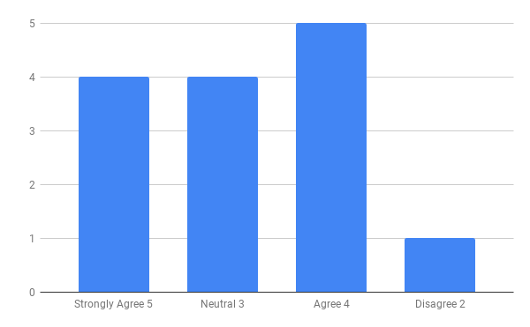
22. Materials associated with the service are visually appealing at Blend Private Limited

Here in this Tangible dimension 4 are strongly agree, 5 agree, 4 neutral and 1 disagree & strongly disagree is 0%.
Findings:
According to the survey analysis, it can be defined, materials associated with the service are visually appealing at Blend Private Limited.
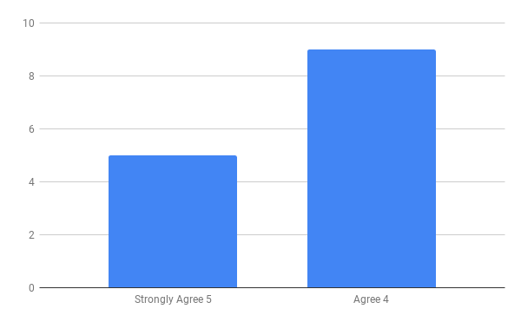
23. Blend Private Limited are always providing innovative and unique ideas to market the brands of the clients' they deal with

Here in this Tangible dimension 5 are strongly agree, 7 agree, 1 neutral and disagree & strongly disagree is 0%.
Findings:
According to the survey analysis, it can be defined, Blend Private Limited are always providing innovative and unique ideas to their client’s.
Survey result Link: https://docs.google.com/spreadsheets/d/1muLtnL8MSltac185jhYN3Gi3OcUw9JSVkFdQQQkEJb4/edit#gid=1829729044
https://docs.google.com/forms/d/1PJbdFxLduML0FFzmcrRTCBJNV7ND3XUQdMbZDDo2NSo/edit#responses

Chapter – Four

Conclusion & Recommendations

4.0 Conclusion
Blend Private Limited has been trying to operate its business successfully since 2014. The event and advertising company has been already developed good image and goodwill among its clients by offering excellent services. It is ensuring the clients perception about them; also it has to complete with their competitors as well. Today, Blend Private Limited has positive image itself as the production company. It is committed to keep up its promise to provide cordial services in advertising and events to its valued clients. This event management has always put special effort to uphold the interest and trust of their client’s by initiating new services and concentrating on the promotional parts of the client’s demand that is drawing a difference between Blend Private Limited with other third-generation advertising companies.
This research has provided some interesting insight into what kind of service the client’s give importance to and what quality service they get from this particular event and advertising company. This research revealed that only one third of clients were more satisfied with the services of this advertising company and some respondents were on the neutral side of satisfaction line. Blend Private Limited is committed to keep up its promise to provide cordial services in advertising and events to its valued clients. This event management has always put special effort to uphold the interest and trust of their client’s by initiating new services and concentrating on the promotional parts of the client’s demand that is drawing a difference between Blend Private Limited with other event and advertising companies.
This research has provided some interesting insight into what kind of service the client’s give importance to and what quality service they get from Blend Private Limited. It is quite obvious from the research that the client’s requirements are fully met and they are very satisfied with some of the aspects of this advertising company. Again the research revealed that only one third of clients were more of less satisfied with the services of the advertising company and more respondents were on the neutral side of satisfaction line. Blend Private Limited should attract this half and bring them to the positive side of the road so that strong relationship with the clients can be maintained.
In order to retain competitive edge, investment in technology is always a top agenda and under constant focus. Keeping the network within a reasonable limit, Blend Private Limited strategy is to serve the clients through capacity building across delivery channels. They are better placed and poised to take clients through fast changing times and enable them compete more effectively in the market they operate.
The main purpose of this report is to study “Clients Perception of Service Quality on Blend Private Limited.” Considering all the attributes which influence clients should be more effective for them. Due to the significantly importance of those factors they can compete in the market in the near future. Ad so strong relationship with the customers can be maintained.

4.1 Recommendations

As clients are increasing Blend Private Limited must fulfill their demands by continuous improvements of their services.
.For legal reasons, it is common within the entertainment industry for event and advertising companies not to accept unsolicited materials from any other company, talent or the general public. It is also common for advertiser to become entrepreneurs and open their own advertising companies so that they can have more control over their careers and pay, while acting as an “in-house” creative and business driving force for their company but continuing to freelance as another companies, if desired. Their IT section should be more advanced.

Appendix
  - Questionnaire
"Clients’ Perception of Service Quality-A case study on Blend Private Limited."
I am the student of BBA, United International University conducting an Internship report survey about "Clients' Perception of Service Quality; A Case study on Apple box Films". Can I borrow a few minutes from you so you can help me fill out the questionnaire? The date collected for the survey is for an internship report and will not be disclosed elsewhere.
Please put? In the boxes provided below:
Perception Statement in the Reliability Dimension
Questions | Strongly Agree  5 | Agree  4 | Neutral  3 | Disagree  2 | Strongly disagree  1
1. When Blend Private Limited promises to do something by a certain time, it does so!

2. When you have a problem, Blend Private Limited shows a sincere interest in solving it.

3 Blend Private Limited performs the right service at first time.

4. Blend Private Limited provides its services at the time it promises to do so.
5. Blend Private Limited insists on error-free record.

Perception Statements in Responsiveness Dimension
Questions | Strongly Agree  5 | Agree  4 | Neutral  3 | Disagree  2 | Strongly disagree  1
6. Blend Private Limited keeps clients informed about when services will be performed.
7. Personnel in Blend Private Limited provides yours prompt service.
8. Personnel in Blend Private Limited are always willing to give service at any time to the day
9. Personnel in Blend Private Limited are never too busy to respond to your request.

Perception Statements in Assurance Dimension
Questions | Strongly Agree  5 | Agree  4 | Neutral  3 | Disagree  2 | Strongly disagree  1
10. The behavior of employees in Blend Private Limited instills confidence in you.
11. You feel safe in your transactions with Blend Private Limited.
12. Personnel in Blend Private Limited are consistently courteous with you.
13. Personnel in Blend Private Limited have the knowledge to answers your questions.

Perception Statements in Empathy Dimension
Questions | Strongly Agree  5 | Agree  4 | Neutral  3 | Disagree  2 | Strongly disagree  1
14. Blend Private Limited s gives you individual attention.
15. Blend Private Limited has employees who give your personal attention.
16. Blend Private Limited has your best interests at heart.
17. Personnel in Blend Private Limited understands your specific needs.
18. Blend Private Limited has operating hours that is convenient to all its clients

Perception Statements in Tangible Dimension
Questions | Strongly Agree  5 | Agree  4 | Neutral  3 | Disagree  2 | Strongly disagree  1
19. Blend Private Limited has modern looking equipment.
20. Blend Private Limited physical facilities are visually appealing.
21 Blend Private Limited employees appear neat.
22. Materials associated with the service are visually appealing at Blend Private Limited
23. Blend Private Limited are always providing innovative and unique ideas to market the brands of the clients' they deal with

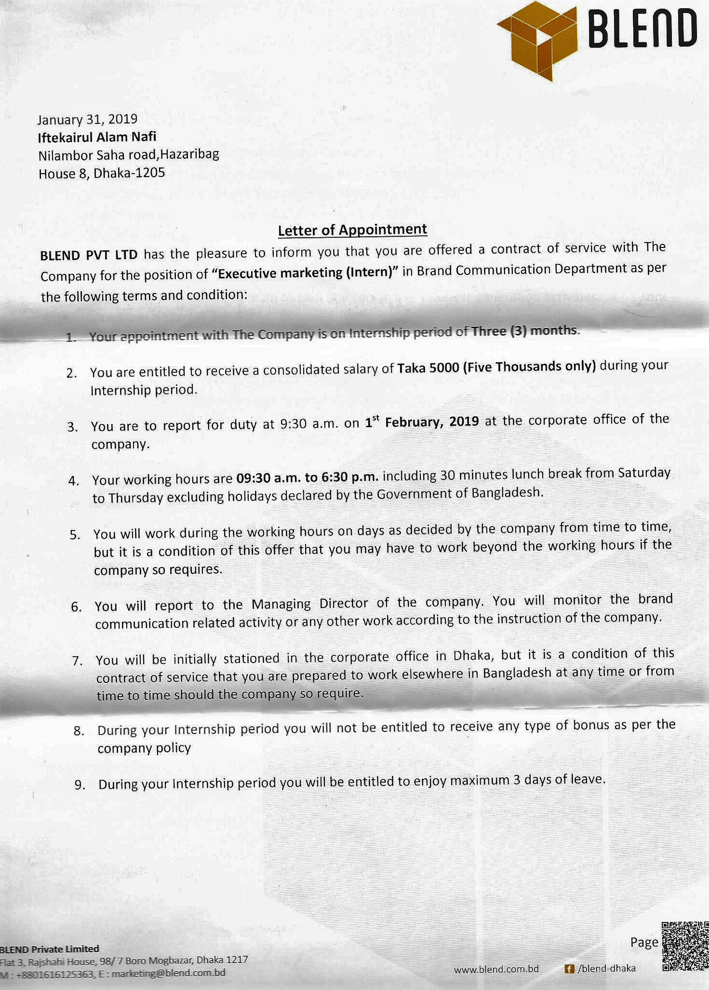
Intern Appointment Letter


Intern Completion Certificate

Bibliography / References

- https://www.facebook.com/blend.dhaka/

- http://www.blend.com.bd/

- https://www.youtube.com/channel/UCuiNuOPfOhwZ261KV2tnQiQ/featured

- https://www.floship.com/techniques-understand-customers/

- https://en.wikipedia.org/wiki/SERVQUAL

- https://www.google.com/search?q=servqual+model&rlz=1C1CHBD_enBD857BD857&oq=servqual+model&aqs=chrome..69i57j0l5.10539j0j8&sourceid=chrome&ie=UTF-8

