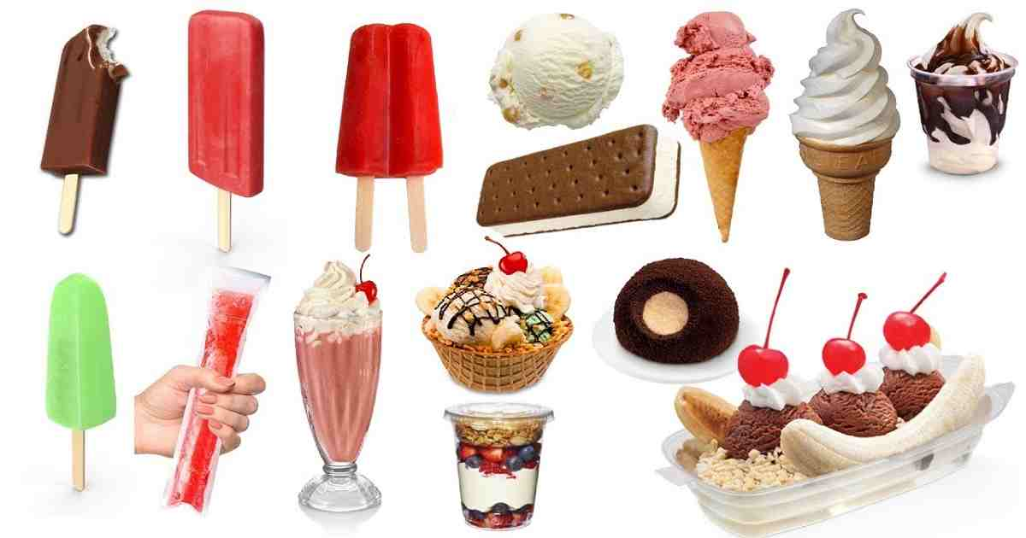

Consumer Perception of Ice Cream Brand in Bangladesh

Marzan Mithila

This report is submitted to the school of Business and Economics, United International University as a partial requirement for the degree fulfillment of Bachelor of Business Administration.

Consumer Perception of Ice Cream Brand in Bangladesh

Submitted By
Marzan Mithila
ID – 111 151 125
Enrollment: Summer 2021
BBA Program, Major in Marketing
United International University

Supervised by
Kawsar Ahmmed, PhD
Professor
School of Business and Economics
United International University

Date of Submission
March 6, 2022

Letter of Transmittal
March 06, 2022
Kawsar Ahmmed, PhD
Professor,
School of Business and Economics
United International University
Subject: Submission of Project Report.
Dear Sir,
With due respect, I am submitting my project report on “Consumer Perception of Ice Cream Brand in Bangladesh” which is a partial requirement for the degree fulfillment of Bachelor of Business Administration and the INT course 4399.
By preparing this report, I have gained theoretical knowledge about the consumer perception on ice cream brands in the context of Bangladesh. It was a great opportunity for me to complete this study and the report under your supervision and I am very happy for it. I have given by best efforts to make this report informative and standardize according your instructions and guidelines.
I hope this report will meet your expectations. I would be grateful if you would accept my internship report with the utmost appreciation.
Sincerely
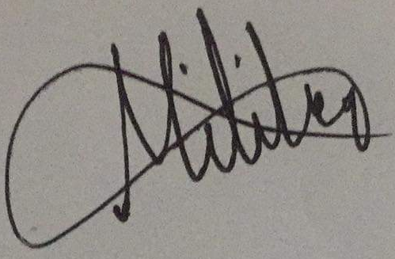
Marzan Mithila
ID – 111 151 125
BBA Program, Major in Marketing
School of Business and Economics
United International University

Declaration of the Study
I am Marzan Mithila, student of Bachelor of Business Administration, major in Human Resource Management, United International University;
I do hereby declare that
- The internship report on “Consumer Perception of Ice Cream Brand in Bangladesh” is a presentation of my original work.
- This report contains contributions from a number of individuals, who are involved with adequate references to the literature review, conducting surveys for analyzing the topics and discussions.
- And this report has been prepared under the supervision of Kawsar Ahmmed, PhD, Professor, Business and Economics, United International University.
- I hereby further declare that, in completing the report, I have not taken any unethical ways and the report has been prepared only for the academic purposes.
Marzan Mithila
ID – 111 151 125
BBA Program, Major in Marketing
School of Business and Economics
United International University

Acknowledgement
At first I would thank to Allah for providing me with the strength to perform the project report obligations and responsibilities as well as to complete the study and report within the time frame.
After that, I would like to convey my heartfelt appreciation to my project supervisor, Kawsar Ahmmed, PhD, Professor, Business and Economics, United International University for his constructive guidance and valuable support. It is true that I would not have been able to complete the report on time and with accuracy if it had not been for his valuable direction, support, and collaboration throughout the process. I am delighted to have the opportunity to complete my project report under his supervision.
As well as, I am also grateful to all respondents for participating and giving their valuable time to complete the survey on online.

Executive Summary
Consumer perception is the process by which they organize the pattern of stimuli and develop a meaningful picture. The purpose of this report of study is to analyze consumer perception towards ice cream brands in Bangladesh. Here various renowned Ice-cream brands have taken as stimuli to conduct the study. Bangladesh's ice cream business has existed for decades. An ever-evolving Ice Cream Industry has seen a great deal of innovation in terms of flavors and packaging, and it's just going to get better. For many years, people have enjoyed ice cream since the invention of fridges and deep freezers and can be found in various flavors in all the countries.

To examine the consumer perception of Ice-cream brands in Bangladesh, several variables including Brand Reputation, Brand Preference, Brand Quality, and Brand Price are taken as independent variables. A self-administered survey questionnaire with a five-point Likert scale is used to collect the primary data. We also explored various websites to gather secondary data to conduct the study. Through data analysis, several important variables have been identified that influence the consumer perception towards various Ice-cream brands. Findings show that IGLOO, Polar, Bellissimo, Kwality, and BLOOP ice cream brands are the main players in Bangladesh, which occupy 70 percent of the overall market. Igloo is the most famous brand and its sections are better than others are. It is also evident that the summer seasons are the peak time for the sales of ice cream in our country when almost everyone consumes some kind of frozen treat. Based on the findings, several recommendations are forwarded that may be beneficial for the branded Ice-cream marketer in Bangladesh.

Keywords: Consumer Perception, Ice Cream, Brand Reputation, Bangladesh

Table of Contents
Executive Summary iv
1.1 Background of the Report 2
1.2 Objectives of the Report 2
1.2.1 Primary Objective 2
1.2.2 Specific Objectives 2
1.3 Methodology of the Report 2
1.3.1 Primary Sources 3
1.3.2 Secondary Sources 3
1.4 Limitation of the Report 3
2.1 Definition and Importance of Customer Perception 5
2.2 Customer Perception on Consuming Ice Cream in Bangladesh 5
2.3 Brand Reputation 6
2.4 Brand Quality 6
2.5 Brand Preference 7
2.6 Pricing Strategy for Brand 7
2.7 Factors influencing Consumer’ Positive and Negative Perception towards Ice Cream Brand 8
PART A 11
Ice Cream Industry in Bangladesh 11
3.1 History and Current Position 11
3.2 Market Structure 11
3.3 Products and Services 13
3.4 Consumer Segments 13
3.5 Major Players in the Ice Cream Market 13
3.6 The Impact of COVID 19 in Ice Cream Industry of Bangladesh 14
PART B 15
Organization Profile: An Overview of Marketing Perspective 15
3.7 Igloo: Abdul Monem Ltd 15
3.7.1 Mission 15
3.7.2 Goal 15
3.7.3 Products and Branding 15
3.7.4 Market Share 16
3.8 Polar: Dhaka Ice Cream Limited 16
3.8.1 Mission 16
3.8.2 Objectives 16
3.8.3 Products and Branding 17
3.8.4 Market Share 17
3.9 Bellissimo: Kazi Food Industry 17
3.9.1 Mission 18
3.9.2 Objectives 18
3.9.3 Products and Branding 18
3.9.4 Market Share 19
3.10 Kwality: Kwality Foods Industry Ltd 19
3.10.1 Mission 19
3.10.2 Objectives 19
3.10.3 Products and Branding 19
3.10.4 Market Share 20
3.11 BLOOP: Golden Harvest Ice Cream Ltd 20
3.11.1 Mission 20
3.11.2 Vision 20
3.11.3 Products and Branding 20
3.11.4 Market Share 21
4.1 Variables and Research Design 23
4.2 Data Analysis and Presentation Plan 23
4.3 Analysis of Demographic Characteristics 24
4.3.1 Gender Respondents 24
4.3.2 Age 25
4.4 Analysis of Consumer Perception on Ice Cream Brand 26
4.5 Analysis of Brand Reputation and Consumer Perception on Ice Cream Brand 28
4.6 Analysis of Brand Quality and Consumer Perception on Ice Cream Brand 29
4.7 Analysis of Brand Preference and Consumer Perception on Ice Cream Brand 30
4.8 Analysis of Brand Prices and Consumer Perception on Ice Cream Brand 32
5.1 Recommendations 34
5.2 Conclusion 34
References 36
Survey Questionnaire 37

List of Figures
Figure 1.1: Factors influencing Consumer’s Positive and Negative Perception towards Ice Cream Brand 9
Figure 2.2: Dependent and Independent Variables 23
Figure 3.3: Gender Respondents 24
Figure 4.3: Gender Respondents 24
Figure 5.4: Ages of Respondents 25
Figure 6.5: Most of the time Consumers’ loving Ice Cream Brand 26
List of Tables
Table 1.1: Market Share of Ice Cream Brand in Bangladesh 12
Table 2.2: Data Analysis of Consumer Perception on Ice Cream Brand in Bangladesh 27
Table 3.3: Data Analysis of Brand Reputation and Consumer Perception 29
Table 4.4: Data Analysis of Brand Quality and Consumer Perception 29
Table 5.5: Data Analysis of Brand Preference and Consumer Perception 31
Table 6.6: Data Analysis of Brand Price and Consumer Perception 32

CHAPTER 01

INTRODUCTION

Background of the Report
This project report is prepared for a partial requirement for the degree fulfillment of Bachelor of Business Administration. I have gained hands on experiences about the ice cream companies, brands and consumer perception towards ice cream brand in Bangladesh as well as applying brand strategies and the following marketing activities in this sector. And these issues are a significant source in the main study of this report which has been done under the supervision of my course supervisor, Kawsar Ahmmed, PhD, Professor, Business and Economics, United International University.

Objectives of the Report
The objectives of my report are divided into 2 sections. In that sequence:

Primary Objective
The primary objective was to prepare a report on “Consumer Perception on Ice Cream Brand in Bangladesh.”

Specific Objectives
I have some concrete or specific objectives for studying the topic and completing this report. They are as follows:
- To get an overview of Ice Cream companies and their branding ice cream in Bangladesh.
- To find out the factors that impact on the consumer perception on Ice Cream brand in the context of Bangladesh.
- To analyze the factors affecting on the consumer perception on Ice Cream brand in the context of Bangladesh.
- To find out the challenges for developing branding strategy on Ice Cream Industry in Bangladesh.
- To provide some recommendations that help to develop effective marketing strategy for ice cream companies to build brand in Ice cream market in Bangladesh.

Methodology of the Report
All of the information for this research & study was gathered from two different sources. They are as follows: -

Primary Sources
The information for this report has been gathered from several primary sources, and I have also gathered primary information from respondents to conducting a survey for studying of the topic. Another method is used to obtain primary data:
- Direct observing the current scenario of marketing practices and activities in ice cream industry of Bangladesh.

Secondary Sources
The following sources have been used for collecting the secondary data, include:
- Journals, Newspapers, Articles, which are related to the concept of consumer perception on ice cream brands.
- Official Website of Ice Cream companies in Bangladesh.

Limitation of the Report
For me, the process of obtaining data and compiling this report for my project report was difficult. Several of them are listed below:
- The survey was conducted by a few confused participants. Participants are unwilling to participate in the survey.
- The majority of participants were unwilling to read out full of the questionnaire of the survey and they claim that they do not have enough time to complete the survey.

CHAPTER 02

LITERATURE REVIEW

Definition and Importance of Customer Perception
The view of your business or organization or items by customers is referred to as customer perception. It includes every direct or indirect interaction that consumers have had with your organization and summarizes their feelings about your brand. By tracking customer perception, your business may identify and address common user issue points, therefore improving the customer journey.
A satisfied customer is one who is satisfied with his or her experience with a product or service. The experience that a consumer has with a product serves as the foundation for the customer perception of that product. Consumer perception may build or ruin a brand's reputation. When consumers have a positive experience with their items being delivered on time, they build an impression of the organization.
- A positive customer perception is also created when customers get things that are absolutely as mentioned in the product description. When customers get outstanding after-sale service, they are more likely to have a favorable perception of the brand.
- Customers, on the other hand, who have had a terrible experience, such as defective items, no returns, no after-sales service, and so on, develop a negative perception of the brand as a result.
- When organizations try to enhance the relationship that exists between their consumers and the organization, customer perception improves, allowing them to gain a competitive advantage over their competitors.
- The perspective of customers is also important in determining the kind of image a brand wants to present.

Customer Perception on Consuming Ice Cream in Bangladesh
Hot summers and strong heat waves always compelled humans to look for some kind of relief and a means to save them from melting. This quest resulted in the development of several technological innovations and cultural traditions, but only one of them captivated our imagination and desires, allowing everyone to take advantage of their opportunities to bask in the sun and cool themselves like never before. This is a story of ice cream.
Cream and other milk products are properly blended and processed to create ice cream, a frozen dairy food (Aysha Begum, 2020). Every age group consumes this nutritionally food item, with youngsters in especially enjoying it throughout the summer months (NagatEl-Sharef, 2006). When it comes to ice cream, the highest selling season in Bangladesh is March to September.

Brand Reputation
Brands must have established a positive reputation in order to be considered successful and valuable in the marketplace (kapferer, 1997). According to (Moorthy, 1985) the reputation of an organization may frequently be preserved in the name of a brand: With the brand name, high-quality performance may frequently be transferred to another product. The idea of "reputation" is well-known, particularly in the corporate sector. Examples include whether or not to trust promises made about a product in advertising by the manufacturer or whether or not to believe delivery dates or claims made by a vendor. It is the estimate of an attribute's constancy through time that constitutes reputation (Herbig, 1997). Having a well-known brand is a valuable asset that provides a steady stream of future sales thanks to a high degree of customer loyalty. When a company has a well-earned reputation for quality and value, it may command a higher price for its products. When it comes to established companies with a solid reputation, it's essential that their image be bolstered by determining what distinguishing characteristics their devoted customers associate the company with (kapferer, 1997). Bands with negative reputations need to work on improving their image (Baldinger, 1996).
A customer's emotional connection to a brand is measured by its reputation, which is a long-standing key marketing component. There is a correlation between this score and the likelihood that a consumer would transfer brands if the one they're loyal to introduces new pricing or product features (Aaker, 2000).

Brand Quality
What a brand does with its customer is a notion of value that is often described as the collecting of customer demands. Customers, for example, expect a discount inn network to provide clean, comfortable rooms. Even if they only get a few of stars, these types of accommodations are nevertheless considered high-quality by customers because of their demands in relation to the price (Spacey, 2017).

Brand Preference
A customer's preference for one brand over another is known as brand loyalty. To put it another way, they've learned about the competition, maybe even tried a few things from other companies, and now they've decided which brand they like the most (YEC, 2021).
Brand loyalty and brand choice are inseparable. Customers that have a preference for your brand will always select your brand when given the choice. Customer loyalty and brand advocates are generated as a result of this kind of repeat business, which in turn helps you build a successful and long-lasting firm (YEC, 2021).

Pricing Strategy for Brand
Creating a strong brand is a promise you make to consumers. What they're looking for when they purchase your products or services is exactly what you have to provide. Because a price transmits a quality message, it may impact the consumer's perception of your brand's position in their minds. This is just as crucial to brand equity as other distinguishing factors.
When a company's promise to its consumers isn't clearly stated, it's common for them to under- or over-price their products.
The process of putting a price on a product or service that falls within a specified range of costs is known as "price positioning. It shows where a product stands in respect to its rivals and in the minds of various buyers in a certain market. A product's price placement also influences whether or not it is seen as inexpensive (low price) or (high price). Using a price-value matrix is a good method to represent this (below)
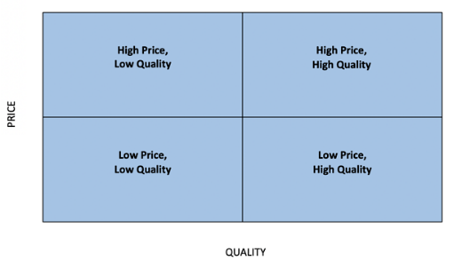
Your brand promise, competition, and price goals all factor into where your items fall in the matrix. A different location and a different price point lead to a distinct set of customers being targeted.

Factors influencing Consumer’ Positive and Negative Perception towards Ice Cream Brand
(Tadhani, 2010) Conducted an investigation on consumers' perceptions and awareness of ice cream as a functional food, finding that the majority of customers were willing to purchase functional foods and most of the customers were willing to pay a higher price for foods that provided health advantages. In the study, it was determined that consumers preferred flavored ice cream, and that advertisements and newspapers were the primary sources of information regarding functional foods for them. The majority of customers consumed ice creams on a weekly basis and preferred cup ice cream and cone ice cream.
A study on the factors that influence the consumption pattern of ice cream was conducted by (Sunilkumar, 2016) and found that the factors such as family size, type of the family, food habit and average monthly expenditure on nonfood items have a strong relationship with consumption of ice cream. It was determined that various brands of ice cream were preferred by customers since of their taste, great quality, and delicious taste.
(Kanthiraj, 2017) Conducted a study to determine the factors that influence customer satisfaction and their preferences for ice cream products. It was found that TV, Social Media & Online ads and word of mouth were the most important factors in influencing ice cream buying decisions. Researchers have found that consumers liked chocolate flavor over other flavors and that they preferred to purchase ice cream in the evening.
(Selvendran, 2018) Conducted a study on customer preferences for ice creams and observed that customers did not prefer the same kind of ice creams. And the majority of customers purchased ice creams because of their attractive colors.

According to (Md. Samiul Hasan Babu, 2016), some of the independent variables (factors) are shown in a figure that impacts on the positive and negative perceptions of consumers towards Ice Cream.
Independent Variables
- Brand Reputation
- Brand Preference
- Brand Quality
- Brand Price
Dependent Variable
Customer Perception

Figure 1.1: Factors influencing Consumer’s Positive and Negative Perception towards Ice Cream Brand
From figure 1.1, it can be concluded that:
- Customers' ice cream preferences are influenced by a variety of factors, including the taste, flavor, color, quality, brand image or reputation and creaminess of the product, as well as its brand preference and price.

CHAPTER 03

ORGANIZATION AND INDUSTRY PREVIEW

PART A

Ice Cream Industry in Bangladesh

History and Current Position
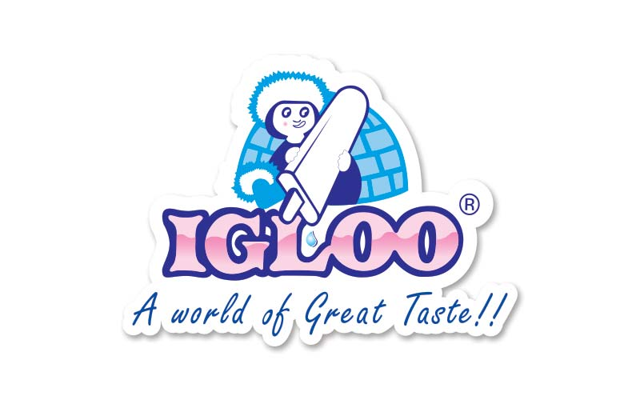
The country's first bran deed ice cream, Igloo was established in 1964 in the national area after which it was nationalized shortly after Bangladesh gained its independence.
In the late 1970s and early 1980s, Abdul Monem Ltd. purchased the company. This was the point at which Polar joined the market and the first rivalry was born. The company Igloo has risen to the top of the market in the ten years since it was privatized, due to extensive promotional efforts.

Market Structure
According to a recent report, the ice cream sector is experiencing rapid growth, due to a rise in rural consumers and a growth of per capita income across the country. As a result of the widespread electrification of the country, particularly in rural Bangladesh, ice cream has found a vast market outside of cities, with the widespread usage of refrigerators in suburbs and villages indicating a considerable increase in demand.
According to the study, the overall development on the socio-economic front, which influenced the food habits of millions, contributed to the expansion of the ice-cream market, which now surpasses its neighboring India in terms of market size and even competes with the global market in terms of market size.

Market Share of Ice Cream Industry in Bangladesh
Industry | Ice Cream (Brand) | Market Share
Abdul Monem Ltd | Igloo | 38%
Dhaka Ice Cream Indus. Ltd | Polar | 28%
Kazi Food Industry | Bellissimo + Za’ n Zee | 13%
Kwality Ice Cream Ltd | Kwality | 11%
Golden Harvest Ice Cream Ltd | Bloop | 8%
Others | Others | 2%
Table 1.1: Market Share of Ice Cream Brand in Bangladesh
According to a recent analysis by Lanka Bangla Investment Ltd, three out of six ice-cream companies currently hold 79 percent of the country's Tk1, 200 core ice-cream industries.
More than 85% of the entire market share is held by branded ice creams; premium ice creams that are more expensive than branded ones account for about 15% of the market. The branded ice cream market is expected to grow rapidly due to rising income levels, more access to energy, and changes in social structure and food preferences, according to industry stakeholders. "The market for branded ice cream is concentrated in the megacities because to concerns with electricity, cold chain, and the income level of the consumers.” They also highlighted that rural areas are becoming prospective ice-cream markets because of increased access to electricity.
According to the report, Igloo and Polar holds two-thirds of the market share (66%) in the ice cream market of Bangladesh. 79% of the market is controlled by just four ice cream industries.

Products and Services
The ice creams produced by all of these producers are sold in ice cream parlors or taken away – in single or family packs – through established distribution channels.

Consumer Segments
Generally, there are two basic consumer segments:
- Branded and premium branded ice creams are in high demand among the middle and higher middle classes.
- Those from the working class who are satisfied with the lower-priced non-brand ice cream.

Major Players in the Ice Cream Market
According to a recent analysis by Lanka Bangla Investment Ltd, 70 percent of the market is occupied by just a few major players, including the following:
- Igloo/ Mi Amore – Abdul Monem Ltd
- Polar – Dhaka Ice Cream Ltd
- Kwality – Kwality Food Products Ltd
Bellissimo, a new brand from Kazi Foods Ltd., has recently appeared in the market. The brand is directly aimed at the upper middle class residents of the urban city.
Other companies that provide services to the city's outskirts include:
- BLOOP- Golden Harvest Ice Cream Ltd
- Milk Vita – Bangladesh Milk Producers Cooperation Union Ltd.
- Savoy – Sena Kalyan Shangstha
Strategically, these two businesses are selling ice cream in the same group in order to make profit for the same cooperative fund.
The non-brand ice cream companies operating in the suburbs and rural areas make up 15% of the overall current market share.
In addition to domestic ice cream makers, foreign brands such as:
- Anderson's,
- Monvenpick,
- Buskin -Robbins and
- Haagen-dazs are available on the market today.

The Impact of COVID 19 in Ice Cream Industry of Bangladesh
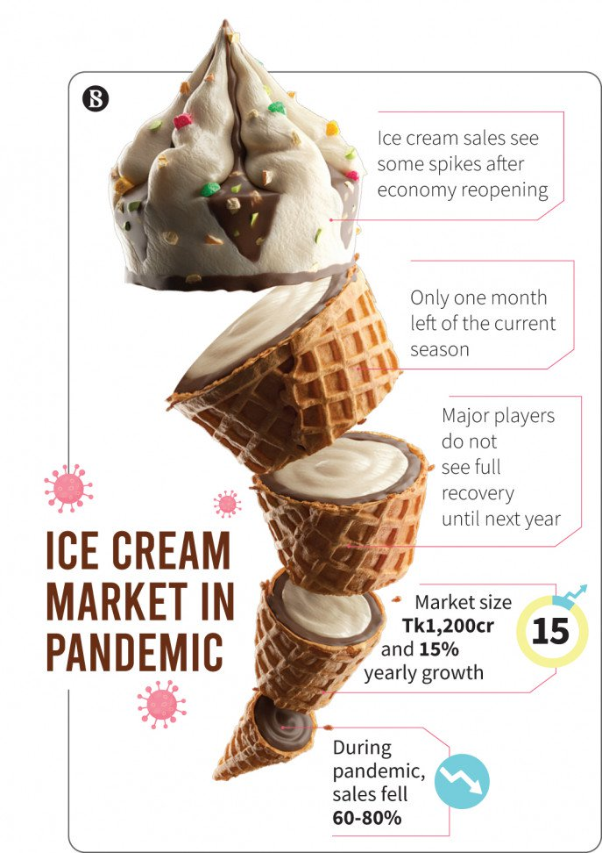
When it comes to ice cream, the highest selling season in Bangladesh is March to September. But the ongoing epidemic has affected the ice cream industry, placing a cap on the sector's expansion. Frosty desserts are in high demand throughout the sweltering summer months. As a result of this year's pandemic and nationwide shutdown, the business was significantly impacted this year (2020-2021). During the 66-day country-wide shutdown from March to May, people were deterred from leaving their homes, which also hindered the sales of ice cream.
Specifically, there are two reasons why the business is failing.
- Firstly, everyone is avoiding cold foods due to the pandemic.
- Secondly, educational institutions were closed, and the vast majority of individuals prefer to remain indoors during this period.

PART B

Organization Profile: An Overview of Marketing Perspective

Igloo: Abdul Monem Ltd
Igloo ice cream is manufactured and marketed by Abdul Monem Limited, the country's leading ice cream manufacturer. Igloo is Bangladesh's first ice cream brand, founded in Chittagong in 1964. Subsequently, in response to the growth of the industry, a second plant was built in Dhaka's Shampur Industrial Area to meet the growing demand. Currently, Abdul Monem Limited manufactures ice cream using state-of-the-art straight-line technology, which is at the forefront of the industry. In fact, Abdul Monem Limited is the first company in South East Asia to use this technology. Every day, the facility produces about 20,000 liters of ice cream, which is then distributed around the nation by the company.

Mission
Igloo Ice Cream Company, like any other business organization, stated their objective in the following manner: "A world of Great Taste," which has a direct relationship with their activities.

Goal
Igloo is devoted to building positive relationships with its customers by not just making the highest-quality products, but also delivering those products in a manner that maintains that high level of craftsmanship.

Products and Branding
Igloo offers its discriminating customers with the broadest selection of ice cream available on the market, more so than any other competition. Igloo is selling more than fifty different items, including
- The standard premium and novelty cup,
- Stick,
- And family pack items,
- As well as other novelty items.
The brand name, the packaging, and the labeling all contribute to the development of the product's personality. Igloo's goal is to provide goods that meet the needs of its customers. The company makes an effort to differentiate its goods from those of its competitors.
A minimum of two new items are introduced by Igloo every year to meet the ever-changing demands of its customers. Igloo predicts that there will be a huge range of ice creams.

Market Share
With 38 percent market share, Abdul Monem Limited's Igloo ice-cream brand is a major player in this ice cream industry of Bangladesh.

Polar: Dhaka Ice Cream Limited
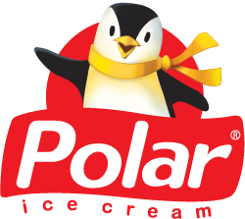
It was in 1987 that Dhaka ice cream industries Ltd. developed Bangladesh's first hygienically packaged ice cream. Thus, the "Polar" brand name was formed.
The company began its ice cream business in Dhaka, Bangladesh, with a broad variety of items and a wide variety of flavors. In 1988, the organization began distribution in the city of Chittagong, then expanded to Bogra, and eventually reached a large number of cities. At the moment, Polar ice cream can be found in stores all throughout Bangladesh. The business has expanded to become one of the country's largest makers and distributors of ice cream in recent years.

Mission
Specifically, the Polar Ice Cream Company stated its mission as follows: "Maintain the highest quality and supply in accordance with customer requirements."

Objectives
The Polar Ice Cream Organization's goal is to provide the following services and products:
- Providing outstanding customer service.
- Lead to higher profitability by selling more high-quality goods.
- To become the market leader.

Products and Branding
In order to meet the needs of their target audiences, Polar Ice Cream Factory tries to produce its goods. They make an effort to differentiate their goods from those of their competitors. There are several flavors of ice cream predicted by Polar. The product range is quite limited and those are:
- Chocobar
- Cone
- Chewy (150 mL)
- 1 Liter Family Pack
- Crunchy
- Vanilla Toffee
- Vanilla Strawberry
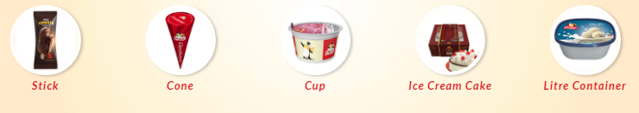
It places a high value on several important characteristics in order to assist on branding and in the growth of the market and consumer happiness. The organization attempts to establish their brands on the basis of customer segmentation by analyzing the requirements of the customers, designing and positioning the product to meet those demands, and measuring the results.

Market Share
Dhaka Ice Cream Industries Ltd’s Polar ice-cream brand is holding 28 percent market share, in this ice cream industry of Bangladesh.

Bellissimo: Kazi Food Industry
"Bellissimo and Za’ n Zee" are brand of premium ice cream manufactured by Kazi Food Industry (Kazi Farms Group Ltd), which was debuted in Bangladesh in 2013 as a high-quality, premium ice cream brand. It offers a variety of world standard goods with the guarantee of just 10 percent flat milk fat and a wide selection of tastes, according to the company. Ice cream with less than 10% milk fat is considered regular. Because it is a premium brand, its price is more than the price of a typical ice cream brand of same quality.

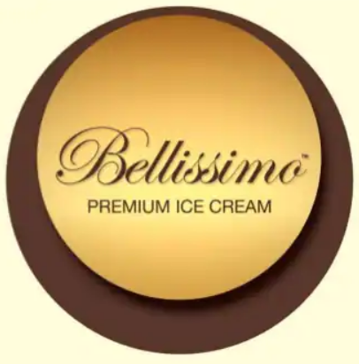
Mission
To provide an international standard of ice cream with guarantees of unmatched flavor and creaminess.

Objectives
- To meet the requirements of customers by a variety of ice cream flavors and textures.
- To maximize profits by selling more high-quality items.

Products and Branding
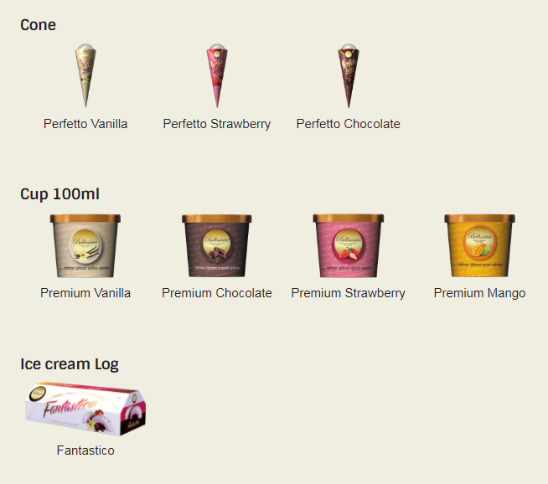
Bellissimo ice cream is made with natural flavors to provide you with a mouth-watering experience. This ice cream is creamier than others since it is made with rich, creamy milk fat rather than cheap vegetable oil. The items that they provide are as follows:
- Ice cream cups (100ml)
- Ice cream cones
- Ice cream sticks
- Ice cream Log
- Ice cream sandwiches
- 1liter container
- Tub (500ml)
Bellissimo Ice Cream is a well-known ice cream brand in the country of Bangladesh. Following in the footsteps of Igloo and Polar, Bellissimo has carved out a significant niche in the public's imagination and choice. Consumers have a high level of approval for the high premium quality and variety of flavors available. They are engaging in a variety of promotional initiatives in order to provide significant value to people's lives. Experience marketing and connection marketing are the primary emphasis of their efforts. They are increasing consumer awareness of their brand via their promotional efforts.

Market Share
Kazi Food Industries Ltd’s Bellissimo and Za’n Zee brand is holding 13 percent market share, in this ice cream industry of Bangladesh.

Kwality: Kwality Foods Industry Ltd
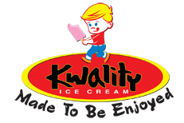
It all began back in 1997 with a simple idea. At the time, the ice cream business was controlled by three large multinational firms. But in the beginning, Kwality Ice Cream had an ambition to be a new kind of ice cream Production Company - one that would produce high-quality goods at an accessible price, while also providing the level of complexity that only a forward-thinking firm could supply.

Mission
Innovative items will be created and marketed; new customers will be gained; and consistent quality will be maintained via cooperation.

Objectives
Their ice cream-making concept is simple. The ice cream and sorbets are made using only the greatest ingredients. It's an unusual method for us to enjoy ourselves, and it's the primary reason we're still serving our customers. Consistent taste and pleasure are ensured by a hands-free automated machine for each and every product.

Products and Branding
Kwality Ice Cream is, without a doubt, the most well-known confection in the whole globe. Ice cream is a favorite of people of all ages, and they consume it on a regular basis. They've been busy producing new tastes and products throughout the years because of the increasing desire for diversity. Everybody may find a taste to their liking, from classics like Vanilla and Chocolate, to more inventive options like Kheersa, Malai, Carmelo, Green Mango Chili and Choclate Chips. They've also had a lot of fun making ice cream for diverse demographics, with the goal of making it accessible to everyone.
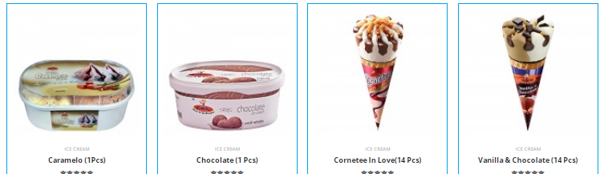
They always endeavor to go beyond the apparent in order to better understand their customers' demands and surprise them with innovative items. To stay ahead of the competition, they must anticipate and embrace change, as well as be innovative in their product and service designs.

Market Share
Kwality Food Industries Ltd’s Kwaity ice cream brand is holding 11 percent market share, in this ice cream industry of Bangladesh.

BLOOP: Golden Harvest Ice Cream Ltd
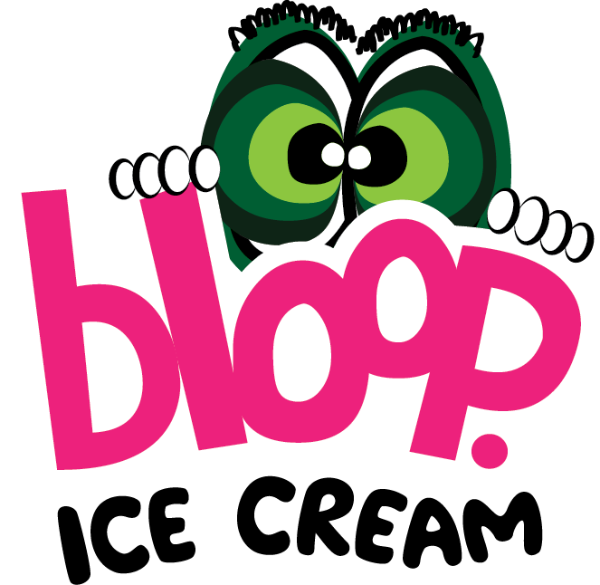
Golden Harvest Ice-Cream Ltd. presents customers Bloop Ice cream, the greatest trend in town. 50 tastes and flavors with creamy delicacies to zesty nibbles. One bite and ice cream lovers will get bloop feelings.

Mission
Delivering consistently high-quality, innovative goods and services that enhance people's quality of life is their mission.

Vision
To be the most trusted and preferred brand in Bangladesh, with every home as a customer.

Products and Branding
They have 50 flavors from rich delights to tangy treats.
- Ice cream cups
- Ice cream cones
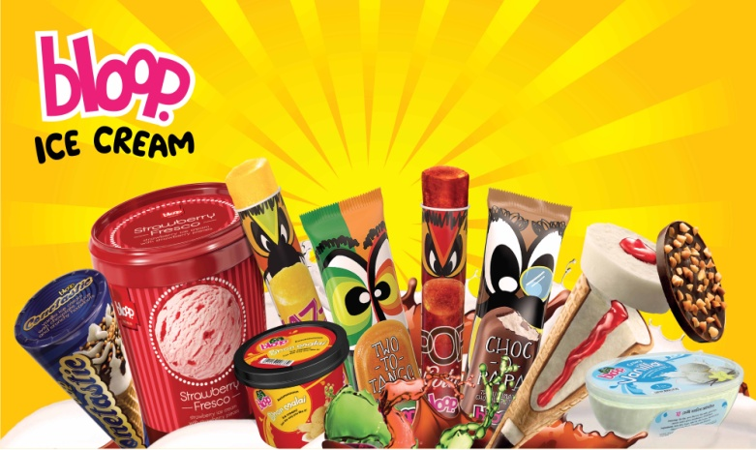
- Ice cream sticks
- Ice cream Log
- Ice cream sandwiches
- 1liter container
- Tub
Golden Harvest's 'BLOOP' is a relatively new brand. Even in Bangladesh, Golden Harvest does not follow its traditional marketing strategy to promote 'BLOOP'. BLOOP seems to be attempting to establish their brand's positioning via the delight of flavor and the association of the name BLOOP with that enjoyment. They are attempting to establish a new trend via the use of its brand association, and by stating that with one bite you will go BLOOP, I believe they are attempting to establish the brand image of BLOOP as a bundle of the experience of delectable flavor in the ice-cream industry.

Market Share
Golden Harvest Ice-Cream Ltd’s BLOOP ice cream brand is holding 8 percent market share, in this ice cream industry of Bangladesh.

CHAPTER 04

ANALYSIS AND FINDINGS

Variables and Research Design
It was necessary to include several independent variables in order to complete the study, as indicated in the figure consumer perception on Ice Cream Brand in the context of Bangladesh. The main point of this figure was to illustrate the design of the study and questionnaire of the survey. The figures of independent variables are shown below:
Independent Variables
- Brand Reputation
- Brand Preference
- Brand Quality
- Brand Price
Dependent Variable
Customer Perception

Figure 2.2: Dependent and Independent Variables

Data Analysis and Presentation Plan
This study and the report have been analyzed based on the consumer perception on Ice Cream Brand in the context of Bangladesh. Both qualitative and quantitative data have been collected in order to prepare this report. Two methods of data collection have been used:
- Conducting a survey through Google form.
- And a variety of scholarly sources, such as books and journal articles from throughout the world.
For the purpose of analyzing the topic, a standard level questionnaire has been designed. I have collected sampling data randomly and 33 responses participated on conducting this survey.
For the purpose of data collecting, five likert scales have been used to design the questionnaire which range is 1 to 5 and there are 20 statements on the questionnaire.
Google form’s link has been provided to the respondents through online platforms. The total response rate was 97 percent. For data analysis and presentation, pie charts have been used.

Analysis of Demographic Characteristics
Sample Size (n): 33 respondents participated on conducting the survey on “Consumer perception on Ice Cream Brand in Bangladesh.”

Gender Respondents

Figure 3.3: Gender Respondents
Among the 33 of respondents, 15 males and 18 females were participated on conducting the survey.
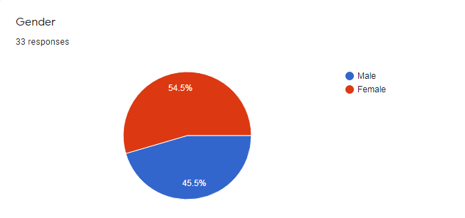
Figure 4.3: Gender Respondents
Among the respondents, 15 males (45.5%) and 18 (54.5%) females were participated on conducting the survey.
From figure 1.3, we can say the percentage of female is greater than the percentage of male respondents. So, on this survey, more participants are male.
Gender-Percentage of Participants: Female > Male

Age

Figure 5.4: Ages of Respondents
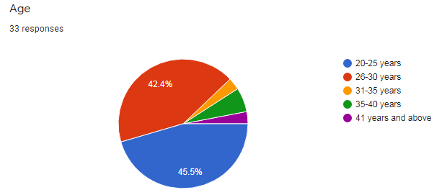
Among the respondents, 15 respondents (45.5%) were in 20-25 years, 14 respondents (42.4%) were in 26-30 years, 1 respondents (3%) were in 31-35 years, 2 respondents (6.1%) were in 36-40years (45.5%) and 1 respondents (3%) were in 41 years and above.
From figure 1.4, we can say the percentage of 20-25 years and 25-30 years respondents are greater than other ages of respondents.
Age-Percentage of Participants: 20-25 years > 25-30 years

Analysis of Consumer Perception on Ice Cream Brand

Figure 6.5: Most of the time Consumers’ loving Ice Cream Brand
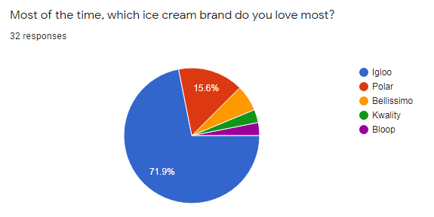
According to the survey results, the majority of consumers 71.9% love “IGLOO” ice cream brand, 15.6% consumers love “POLAR” ice cream brand, 2% consumers love “Bellissimo” and 1% love “Kwality” and “BLOOP” ice cream.

Consumer Perception on Ice Cream Brand
Most of the Loving Ice Cream Brands
IGLOO > Polar > Bellissimo > Kwality and BLOOP
01. This ice-cream brand is better than other branded ice-cream in Bangladesh. |  |  |  |  | Factors
S.A | A | N | D | S.D | Premium Quality/  Delicious Taste/  Attractive Color/  Various Flavors/  Size and Quantity/  Advertisement/  Word of Mouth/
36.40% | 51.50% | 12.1% | 3% | 0.00%
02. This ice-cream brand is much more satisfactory than other branded ice-cream.
S.A | A | N | D | S.D
36.40% | 51.50% | 9.10% | 3% | 0.00%
03. I will choose this brand in time of buying ice-cream.
S.A | A | N | D | S.D
31.30% | 43.80% | 21.90% | 3.1% | 0.00%
04. I feel that this ice-cream brand influences me to buy it.
S.A | A | N | D | S.D
25.00% | 50.00% | 18.80% | 6.3% | 0.00%
*S.A= Strongly Agree, A= Agree, N= Neutral, D= Disagree, S.D= Strongly Disagree
Table 2.2: Data Analysis of Consumer Perception on Ice Cream Brand in Bangladesh
According to survey data and the table 1.2, the majority of respondents agreed that, their loving ice cream brand is better than other branded ice cream in Bangladesh and they are much more satisfactory on it due to premium quality, having options on various flavors, colors, tastes.
From the result, it was found that majority of respondents are influenced to buying their loving ice cream by some of the factors such as family size, monthly expenditure as well as TV, Social Media & Online ads and word of mouth are the most important factors in influencing ice cream buying decisions.

Analysis of Brand Reputation and Consumer Perception on Ice Cream Brand
Brand Reputation and Consumer Perception on Ice Cream Brand
Most of the Loving Ice Cream Brands
IGLOO > Polar > Bellissimo > Kwality and BLOOP
05. This ice-cream brand has a good reputation. |  |  |  |  | Factors
S.A | A | N | D | S.D | Brand Reputation  - Positive Review/ Negative Review/  - Superior Quality/  - Social Media Presence/  - Interactions about Brand Value
35.5% | 51.50% | 12.1% | 0.00% | 0.00%
06. This ice-cream brand has a good reputation compared to other rival companies.
S.A | A | N | D | S.D
37.50% | 10.60% | 21.90% | 0.00% | 0.00%
07. This ice-cream brand has a reputation for offering good ice-cream.
S.A | A | N | D | S.D
29.00% | 61.30% | 9.70% | 0.00% | 0.00%
08. This ice-cream brand has a reputation to meet consumer taste.
S.A | A | N | D | S.D
21.90% | 65.60% | 12.50% | 0.00% | 0.00%
*S.A= Strongly Agree, A= Agree, N= Neutral, D= Disagree, S.D= Strongly Disagree
Table 3.3: Data Analysis of Brand Reputation and Consumer Perception
According to survey data and the table 1.3, the majority of respondents agreed that, their loving ice cream brand has good brand reputation compared other rivalry in Bangladesh and it offers them good quality of full of tastes and flavors of ice creams.
From the result, it was found that majority of respondents are influenced to buying their loving ice cream because of having brand reputation of their loving brand ice cream and these depend on the getting positive rewards about the brand, quality and tastes, advertisement on social media platforms about the ice cream brand value.

Analysis of Brand Quality and Consumer Perception on Ice Cream Brand
Brand Quality and Consumer Perception on Ice Cream Brand
Most of the Loving Ice Cream Brands
IGLOO > Polar > Bellissimo > Kwality and BLOOP
09. This ice-cream brand is fresh and well presented. |  |  |  |  | Factors
S.A | A | N | D | S.D | Brand Quality  - Product Quality/  - Brand Loyalty/  - Brand Associations/  - Perceived Quality
31.3% | 43.80% | 21.90% | 0.00% | 0.00%
10. This ice-cream brand is tasty.
S.A | A | N | D | S.D
37.50% | 50.00% | 12.50% | 0.00% | 0.00%
11. This ice-cream brand offers variety of ice-cream.
S.A | A | N | D | S.D
31.30% | 50.00% | 15.60% | 0.00% | 0.00%
*S.A= Strongly Agree, A= Agree, N= Neutral, D= Disagree, S.D= Strongly Disagree
Table 4.4: Data Analysis of Brand Quality and Consumer Perception
According to survey data and the table 1.4, the majority of respondents agreed that, their loving ice cream brand is fresh and well presented, offers delicious tastes and flavors.
From the result, it was found that majority of respondents are influenced to buying their loving ice cream because of standard quality , packaging of the ice cream (product quality), having attractive on the brand (brand loyalty), familiarity which leads liking, positive feelings of the brand (brand associations and perceived quality).

Analysis of Brand Preference and Consumer Perception on Ice Cream Brand
Brand Preference and Consumer Perception on Ice Cream Brand
Most of the Loving Ice Cream Brands
IGLOO > Polar > Bellissimo > Kwality and BLOOP
12. I like this brand more than any other brand of ice-cream. |  |  |  |  | Factors
S.A | A | N | D | S.D | Brand Preference  - Income Level/  - Brand Image/  - Brand Love/  - Brand Image/ Quality of Brand/  - Price of Brand
31.3% | 43.80% | 21.90% | 0.00% | 0.00%
13. This brand is my preferred brand over any other brand of ice-cream.
S.A | A | N | D | S.D
37.50% | 50.00% | 12.50% | 0.00% | 0.00%
14. I would use this brand more than any other brand of ice-cream.
S.A | A | N | D | S.D
31.30% | 50.00% | 15.60% | 0.00% | 0.00%
15. This brand meets my requirements better than other ice-cream brands.
S.A | A | N | D | S.D
16. When it comes to making a purchase, this brand of ice-cream is my first preference.
S.A | A | N | D | S.D
31.30% | 50.00% | 15.60% | 0.00% | 0.00%
17. Brand is very important to define my choice of ice-cream.
S.A | A | N | D | S.D
31.30% | 50.00% | 15.60% | 0.00% | 0.00%
*S.A= Strongly Agree, A= Agree, N= Neutral, D= Disagree, S.D= Strongly Disagree
Table 5.5: Data Analysis of Brand Preference and Consumer Perception
According to survey data and the table 1.5, the majority of respondents agreed that, their loving ice cream brand is the first choice other than branded ice cream.
From the result, it was found that majority of respondents are influenced to buying their loving ice cream according to their income level. The product image is a dynamic component of brand preference, and that image is dependent on the consumer's awareness and associated facts about ice cream brand. The price of a ice cream is the most important consideration for middle-class individuals, whereas the quality, performance, or packaging of a product brand are more important for the health. When it comes to comparing various ice cream brands choosing, the price is the most important factor for buyers. People want to buy ice creams that are of high quality at a reasonable price.

Analysis of Brand Prices and Consumer Perception on Ice Cream Brand
Brand Price and Consumer Perception on Ice Cream Brand
Most of the Loving Ice Cream Brands
IGLOO > Polar > Bellissimo > Kwality and BLOOP
18. The brand of ice-cream is reasonably priced. |  |  |  |  | Factors
S.A | A | N | D | S.D | Brand Price  - Reasonable Price/  - Income Level/  - Brand Value/  - Perceived Quality
12.5% | 59.40% | 21.90% | 6.30% | 0.00%
19. This brand of ice-cream offers value for money.
S.A | A | N | D | S.D
6.30% | 59.40% | 28.10% | 6.30% | 0.00%
20. The price of this of ice-cream brand is a good indicator of its quality.
S.A | A | N | D | S.D
21.90% | 59.40% | 12.50% | 3.10% | 3.10%
Table 6.6: Data Analysis of Brand Price and Consumer Perception
According to survey data and the table 1.6, the majority of respondents agreed that, their loving ice cream brand offers them high quality, tastes and different flavors at reasonable prices other than branded ice cream.
Results showed that the majority of people are persuaded to purchase their favorite ice cream by the amount of money they have in their bank account. Price is the most essential issue for middle-class persons, whereas quality, performance, or packaging of a product brand is more important for the health of the consumer. Price is the most essential consideration when it comes to making a choice between ice cream companies. Customers are looking for high-quality ice creams that are also affordable.

CHAPTER 05

RECOMMENDATIONS AND CONCLUSION

Recommendations
The following suggestions are made in light of the top ice cream brand analysis conducted by the study: These recommendations can help to the IGLOO, Polar, Bellissimo, Kwality and BLOOP to develop the brand strategy for increasing growth of their ice cream business in Bangladesh. With only indirect and limited influence over brand quality, brand preferences, and brand price so it's imperative that you do all you can to enhance your current brand image. The following are a few examples of how this may be accomplished in the real world for the IGLOO, Polar, Bellissimo, Kwality and BLOOP:
- For the Igloo ice cream brand: It is a more popular ice cream, they should make their prices as low as possible while yet maintaining a high level of flexibility. They could increase the quality of their products even more and create a method of cleaning plastic boxes before filling them in order to maintain a more hygienic environment. They should be involved in the development of new ice cream flavors. They should provide better working conditions for their staff. They will be more successful if they follow these guidelines.
- For the Polar ice cream company, they need work on building their marketing strategy, establishing a suitable consumer channel, creating an advertisement area, protecting packaging, and streamlining the selling process, among other things.
- For the kwality ice cream brand, they should also enhance their marketing strategy, improve their product quality, take initiatives to promote their product, and increase the variety of ice cream flavors available.
- For the Bellissimo and BLOOP ice cream brand, they should cut their prices first and foremost for consumers, expand their availability, strengthen their promotional efforts, and introduce more new things of high quality into their product line.

Conclusion
According to a recent report, the ice cream sector is experiencing rapid growth, due to a rise in rural consumers and a growth of per capita income across the country. As a result of the widespread electrification of the country, particularly in rural Bangladesh, ice cream has found a vast market outside of cities, with the widespread usage of refrigerators in suburbs and villages indicating a considerable increase in demand.
Although the Ice Cream business is a minor problem when compared to the rest of the market and other sectors of the economy, it is one in which there room to experiment with new is and innovative marketing strategies. In our country, there are a large number of ice cream manufacturers. However, only a small number of them are well-known. Companies such as Igloo, Polar, Kwality, and Bellissimo are highly recognized in the country. Each of these 4 categories has a marketing strategy that they use to promote themselves. When compared to other companies, Igloo's marketing approach is effective. Polar, Bellissimo, on the other hand, does not adhere to all of the marketing methods that a successful firm should use. The marketing strategy of Kwality ice cream is really ineffective. It should refine its marketing plan in order to go farther.
According to the study of the report, we can conclude that the overall development on brand strategy on consumer perception about ice cream brand in Bangladesh, it can be contributed to the expansion of the ice-cream market and even competes with the global market in terms of market size.

References

Aaker. (2000). Brand Leadership. New York.
Aysha Begum, M. S. (2020). Ice cream consumption in a selected area of Bangladesh: Effect of demographic, psychometric and product factors. Journal of Bangladesh Agricultural University, 18(1): 165–171.
Baldinger, A. L. (1996). Brand Loyalty: the Link Between Attitude and Behavior. Journal of Advertising research.
Kanthiraj, A. s. (2017). Factors influencing consumer satisfaction and their preferences towards ice creams. International journal of research in computer application and management, Vol. 7, Issue 10, 23-26.
kapferer, J. N. (1997). Strategic Brand Managemen.
Md. Samiul Hasan Babu, S. S. (2016). Factors Influencing Consumers' Choicce of Ice Cream: A Study on Impulsive Buying Behavior. D.U. Journal of Marketing, Vol. 16, No. 1.
Moorthy. (1985). Using game theory to model competition. Journal of Marketing Research, Vol. XXII, 262-82.
NagatEl-Sharef. (2006). Bacteriological quality of ice cream in Tripoli—Libya Food Control. 17(8): 637-641.
Selvendran. (2018). Customer’s preference towards ice creams. International Journal of Interdisciplinary Research in Arts and Humanities (IJIRAH), ISSN (Online): 2456 - 3145, Volume 3, Issue 1. 76-80.
Spacey, J. (2017). What is Brand Quality. Retrieved from Simplicable: https://simplicable.com/new/brand-quality
Sunilkumar, s. M. (2016). Factors influencing consumption pattern of ice cream in Bengaluru market. Indian journal of dairy science , vol.69, No.4, 492 – 497.
Tadhani. (2010). Consumer’s perceptions and awareness towards ice cream as functional food with respect to Ahmedabad city, India, Tourism and Hospitality management. 17-23.
What Is Customer Perception? and Why is Customer Perception Important? . (2020, February 19). Retrieved from Clootrack: https://clootrack.com/knowledge_base/what-is-customer-perception/
YEC. (2021). What Is Brand Preference And How Do You Build It? Retrieved from Forbes: https://www.forbes.com/sites/theyec/2021/02/16/what-is-brand-preference-and-how-do-you-build-it/?sh=4a4023845ff0

Survey Questionnaire
Consumer perception of ice-cream brand

Consumer perception
This ice-cream brand is better than other branded ice-cream in Bangladesh
This ice-cream brand is much more satisfactory than other branded ice-cream
I will choose this brand in time of buying ice-cream
I feel that this ice-cream brand influences me to buy it
Brand reputation
This ice-cream brand has a good reputation
This ice-cream brand has a good reputation compared to other rival companies
This ice-cream brand has a reputation for offering good ice-cream
This ice-cream brand has a reputation to meet consumer taste
Brand quality
This ice-cream brand is fresh and well presented
This ice-cream brand is tasty
This ice-cream brand offers variety of ice-cream
Brand preference
I like this brand more than any other brand of ice-cream
This brand is my preferred brand over any other brand of ice-cream
I would use this brand more than any other brand of ice-cream
This brand meets my requirements better than other ice-cream brands
When it comes to making a purchase, this brand of ice-cream is my first preference
Brand is very important to define my choice of ice-cream
Brand price
The brand of ice-cream is reasonably priced
This brand of ice-cream offers value for money
The price of this of ice-cream brand is a good indicator of its quality

