

Internship Report on
Topic Name: An Overview of Performance Appraisal in Kazi Farms Group.



Internship Report on
Topic Name: An Overview of Performance Appraisal in Kazi Farms Group.
Presented To
Mimnun Sultana
Presented By
Moumita Roy Chowdhury
ID: 111151244
School of Business & Economics
Date of Submission: 17 April, 2020

Letter of Transmittal
April 6, 2020
Mimnun Sultana
Assistant Professor
United International University
Subject: Submission of Internship report on Overview of Performance Appraisal in Kazi Farms Group.
Dear Madam,
I am very pleased to submit my internship report that is an essential requirement for the completion of BBA program. All the information presented in this report done with utmost sincerity and honesty. I have tried my best to make this report holistic and informative.
Apart from the academic knowledge gained, the preparation of this report has given me the opportunity to know about the Overview of Performance Appraisal in Kazi Farms Group. I believe that the experience I have acquired from this internship program will be a valuable asset in my life.
Working with such an interesting program has given me the opportunity to achieve experience, which will be helpful in my future professional career.
Sincerely
..........................................
Moumita Roy Chowdhury
Id: 111151244
Bachelor of Business Administration
United International University

I
DECLARATION
I am ‘Moumita Roy Chowdhury’ Student of the United International University; hereby declare that the report offered in the name “Overview of Performance Appraisal in Kazi Farms Group. I have tried my best to make my report informative as well as descriptive. I also confirm that, the report is only prepared for any requirement, not for other purposes. I also ensure that this report has not been submitted to anywhere earlier and will not be submitted to anybody in future.

..........................................
Moumita Roy Chowdhury
Id: 111151244
Bachelor of Business Administration
United International University

II
Acknowledgement
This report is the outcome of my internship work on Overview of Performance Appraisal in Kazi Farms Group.
I like to convey my feelings and gratefulness to my supervisor Mimnun Sultana, Assistant Professor of United International University, for providing me valuable guidance and suggestion in preparing this report.
Secondly I like to convey my feelings and gratefulness to my official supervisor Mrs. Aela Afroz, Senior Manager of Human Resource Department in Kazi Farms Group. My official supervisor helped me to prepare this report with sufficient information.
Thirdly I would like to express my feelings and gratitude to my second official superior Sabrina Iqbal Nisha, Senior Executive, Kazi Farms Group for helping me through a lot of information on Kazi Farms Group so that I can prepare my study perfectly.
The report might never have been completed without the essential academic knowledge, assistance of reference book, web pages, and some practical knowledge. So I would to like thank all those, especially the employees of the office for helping me through a lot of information on Kazi Farms Group.
Finally, I would like to convey my gratitude to almighty and my family members who extend their support to prepare this report.

III
Executive Summary
The Human Resource Department of “Kazi Farms Group “is a best place for learning HR related issues. In recent years, Bangladesh has been progressing at a growing rate and the role of farms sector has been vast. Kazi Farms Group has been contributing at an increasing rate in the process of developing Bangladesh. This report is prepared to show the Overview of Performance Appraisal in Kazi Farms Group. The purpose of the study is to provide deep understanding of performance appraisal in Kazi Farms Group. The report contains of performance appraisal process, method, implementation of employees, developments of employees, measures the employee result, approaches for measuring performance of employees of Kazi Farms Group.
The last chapter of this report contains analysis and findings, conclusion and recommendation. Total 30 employees interpretation about their organization have been collected as questionnaire form to conduct the survey, after collecting the data from the survey the data’s are presented in Pie and Bar Chart format. It expresses whether employees are agreed or not agreed in a particular issue about the HR field of the organization.

IV
Table of Content
Sl No. | Topic Name | Page No.
1.1 | Introduction | 1
1.2 | Background of the Study | 2
1.3 | Objective of the Study | 3
1.4 | Scope of the Study | 4
1.5 | Methodology | 4
1.6 | Limitation | 7
2.1 | Overview of Kazi Farms Group | 9
2.2 | The main concepts of Kazi Farms different from others Farms | 21
2.3 | Kazi Farms Group in Bangladesh | 22
2.4 | Objective of Kazi Farms Group | 23
2.5 | Internship Activity of Kazi Farms Group | 24
3.1 | Overview of Performance Appraisal | 27
3.2 | History of Performance Appraisal | 28
3.3 | Implementation of Performance Appraisal | 30
3.4 | Relationship of Performance Appraisal & Job Analysis | 31
3.5 | Performance Appraisal in HRM | 31
3.6 | Others performance Appraisal System | 35
3.7 | Performance appraisal method | 44
4 | Literature Review | 45
5.1 | Performance appraisals process of Kazi Farms | 50
5.2 | Performance appraisal method of Kazi Farms Group | 52
5.3 | Approaches for measuring performance of employees of Kazi Farms Group | 53
5.4 | Measures the employee result | 54
5.5 | Implementation of employee performance appraisal | 55
5.6 | Performance appraisal is the key to employee’s development in Kazi Farms Group | 56
5.7 | Reward system in Kazi Farms Group | 57
6 | Data Analysis & Findings | 58
7 | Conclusion | 74
8 | Recommendation | 75
9 | Reference | 78
 | Appendix

Chapter-1
1.1 Introduction

Among the poultry industries Kazi Farm group is one of the biggest business firms in Bangladesh. Kazi Farms group is an Argo business enterprise and currently the biggest poultry hatching and day old chick manufacture capacity in the country. It was established in 1996.It was the biggest poultry breeder of the country. Kazi Farm recognized itself as the quality organizer, and expands quickly. They use in new technology broilers and eggs collect rapidly. The amount of DOC broiler has expanded from 200,000 in 1995 to about 5000,000 now. Due to old chicks manufacture competition is larger than before. They are use in different types of product. The main products are Broiler parent chicks, and Broiler chicks, Layer Chicks and table eggs, Feed, Kazi Organic fertilizer.
Kazi Farm Groups mainly focus on poultry Hatchery. They have huge farm in Bangladesh. They are working in different district. For example: Gazipur, Rangpur, Panchagarh and Sylhet, Dhaka Ashulia. It meets up the rising demand accessible farms are enlarging their manufacture capacity. Simultaneously large numbers of latest farms are incoming into the business. Kazi farm is a renowned Bangladesh corporation which has prepared their golden path in poultry farm as well as Frozen Food, Information Technology, Ice –Cream and Television Channel.
Kazi Farms group dwell in a great picture of the total market share. Kazi Farms Group is a direction point for most of the farms. Most of the firms are trying to copy them. Like a new candidate ACI Gordej hired some personnel form Kazi Farms, who knows of lots of secrets of Kazi Farms. Another farm CP Bangladesh is rising at a challenging way. Like them most of the firm’s production increase is visible. A competitive appraisal of the poultry industry player is measured important to know the major competitors of Kazi Farms. To be aware of the competitor’s strength, weakness and competitive position assessing them based on the vital achievement factors of the poultry business are measured value studying.

1.2 Background of the Study

Among the poultry farms of the motherland Kazi Farms Group is important since its inauguration 18 years before. In 1996 Kazi Farms Group was recognized as a hatchery of imported eggs. The subsequent time it in progress it hold parent farms, and in 2004 the production was in advancement in their ancestor farm.

Considering consumer and client perspective, it goes on to stay bring up to date with the latest products and services. Kazi Farm becomes able to maintain their consumer’s and client’s faith whereas keeping their loyalty.

In 2006, they accepted the biggest and most highly developed feed mill in the motherland with technical support from Switzerland and USA.

Kazi Farm is in an exceptional position to recognize the interrelationship between nutrition, hygiene and farms care. They can do this thanks to their strong science in bio-security capacity and their locally rooted consumer insight.

Kazi Farms assigns to country take a lead in the farming segment for not only its well-built financial point, but also for innovations of goods and services. It also makes sure generating superior value for its esteemed customers and shareholders. The firm has awareness to hold services at the access way of its customers.

1.3 Objective of the Study

- To view the HRM corresponds of the company.

- To recognize the various avenues for improving the HRM polices of Kazi Farm Group.

- To study about recruitment and selection procedure of Kazi Farms Group.

- To get in dept information of the over the Human Resource Departments of Kazi Farm Groups.

- To advise some recommendations for solving the problems faced by the Kazi Farms Group in HRM polices and practice.

- To identify how performance appraisal can encourage employee and reduce turnover.

- To identify how it contributes to the organizational achievement.

- To solve the arising problems of private organization regarding employee satisfaction.

1.4 Scope of the Study

The study mainly focuses on Overview of Performance Appraisal in Kazi Farms Group. This study covers Performance appraisals of Kazi Farms Group, Performance appraisals process of Kazi Farms Group, Performance appraisal method of Kazi Farms Group, Approaches for measuring performance of employees of Kazi Farms Group, Measures the employee result, Implementation of employee performance appraisal, Performance appraisal is key to employee’s development in Kazi Farms Group, Reward system in Kazi Farms Group. This report I did try to show overview performance appraisal process, method evaluation etc.

1.5 Methodology

1.5.1 Introduction
Methodology illustrates the method used for carrying out the survey study. This specific chapter explicates the measures applied for the study.
1.5.2 Part of lessons
The study is conducted on some major factors to get the various newsletters of Kazi Farms, annual performance appraisal types of Kazi Farms, various types of brochures, different records of the farms.
1.5.3 Data Collection Process
Data is the crucial prerequisites to complete a study. It mainly gathers from two types of sources- primary and secondary source. Primary source gathered by using survey question and face to face interview. Secondary source was collected from journals, books, several research reports, several articles about Kazi Farms Group and other sources. .

Primary sources of collecting data
- Direct discussion with the executives of the departments.
- Personal interview with the employees.
- Collection of employee’s outlook by asking questions.
- Study of the HR actions.
- I used random sampling method to gather any samples and apply graphical charts to show.
Secondary sources of collecting data
- Different records of the Farm.
- Website of Kazi Farms Limited.
- Various newsletters of Kazi Farms Limited.
- Annual performance appraisals form of Kazi Farms Limited.

1.5.4 Types of research
Quantitative research is taken to collect numerical data that can be routed into functional statistics.
This study was done by qualitative analysis with some quantitative analysis to examine the factors. A large number of data was used from a number of sources. Then selected sum of analyzed data was included in this internship paper.

1.5.5 Sampling technique & Sample range
The convenient sampling technique is used in this study. The respondents were faced questions about Performance Appraisal process of Kazi Farms Group. The study is conducted among 30 people to know about the Performance Appraisal process of Kazi Farms Group.

1.5.6 Questionnaire Design
The questionnaire started with open-ended questions. These questions provided the basic information about respondents. These types of questions make respondents comfortable to respond the study. There were some core questions in this questionnaire. The respondents were asked the questions to know about the Performance Appraisal process of Kazi Farms Group. Finally, 20 questions were asked on Performance Appraisal process of Kazi Farms Group that derived quantitative data from the 5-point Likert scale.

Strongly Agree | 1
Agree | 2
Natural | 3
Disagree | 4
Strongly Disagree | 5

1.5.7 Data Analysis Tools
Data analysis is completed by using MS Word, MS Excel and SPSS. Some types of graphic representations and tables are used to study and understand data.

1.6 Limitation

The sources of the report are gathered from various desks, different documents of Kazi Farms Group. Though all the employees stay occupied all the time with their task, they helped a lot to deal with and gather information. But it was difficult to gather information from the client as it is top secret matter for the company. So I face some limitations while collecting information. These are as follows:
- Limitation of time: To prepare a report within the mentioned period is really hard.

- Busy operational atmosphere: The executives were unable to give information because of their vast task. So, I could not collect vast information on deep issues.

- Managerial Privacy: Some data could not be collected for secret issue and managerial privacy.

- Disclosing Data: There are some logical reasons of not disclosing data under their organizational policy.

- Changing method: The farm is always changing its method time to time; that is really tough to figure out the accurate performance of the employees every time.

- Kept in a volt: Sometimes it was complex task to accumulate data from their file, since vital files are kept in volt for safety.

- Lack of information from secondary sources: There was lack of information from secondary data sources. The official website and the journal about topic related issue were not enough users friendly.

- Lack of opportunity to talk with senior employee: I could not obtain opportunity to talk with higher levels of employees to obtain more information to complete my study.

Chapter-2
Organizational Overview

In 1916 Kazi Farms has developed into the largest creator of broiler and layer old-chicks in Bangladesh. They are also the prime poultry feed in Bangladesh. In Bangladesh they are franchise in Cobb-Van tress of the United State of the America for the Cobb 500 broiler. Hy line the ancient poultry reproduction business of the world and Cargill, the American feed manufacturer, are the strategic associate of Kazi Farms Group. Kazi Farms at this time operates two antecedent farms, three parent rising farms, eight percent production farms; two pellet feed mills and seven hatcheries. Kazi Farms has begun exports to the Middle East and Nepal, and is association the action of a broiler breeding farm in the Sultanate of Oman. It is quickly growing its manufacture of day old-chicks in the previous ten years. Kazi Farms has allowed the poultry farmer of the country to increase their procedures. Thus Kazi Farms take part in a main position in carrying about the ‘poultry revolutions of Bangladesh. This has increased capability to protein in the country, and has produced amazing revenue creation for probability for countryside domestic all over the country.

2.1 Overview of Kazi Farms Group

2.1 About of Kazi Farms Group: Kazi Farms Group is one of the largest poultry industries in Bangladesh. Kazi Zahedul Hasan, the managing director, was awarded business person of the year for 2004 in Bangladesh. It runs most of its office computers on Linux Software.

2.2 Background of the organization: Kazi Farms Limited was recognized in 1996 as a hatchery for imported eggs, the following year it ongoing its own parent farm. In 2004 production ongoing in our grant parent (GP Farm), which was liable for Bangladesh’s first exports of hatching eggs and day old chicks in 2004.In the year Managing Director, Kazi Zahedul Hasan, was named business person of the year by the daily star /DHL business awards.

2.3 Corporate Information:
Name of the company: Kazi Farms Group.
Type: Private.
Industry: Poultry.
Founded: 1996.
Founder: Kazi Zahedul Hasan.
Owner: Kazi Zahedul Hasan.
Head Office: Ahmed Kazi Tower, House-35, Road-02, Dhanmondi.Dhaka-1205.
Number of employees: 10,000
Member Type: General.
Phone Number: 880-2-9123432, 9134276, 9128062.
Email Adress:info@kazifarms.com

2. 4 Main 3 parts of Kazi Farms Group:
Kazi Farms Group

Kazi Media
Kazi Farms Industries
Kazi Farms Limited

Figure: Main 3 Parts of Kazi Farm Group

2. 5 Kazi Farms Group Products: Kazi Farms Group Products is given below:
1. Broiler Chicks and Broiler Parent Chicks: Kazi Farms were Grand Parent franchise of Aviagen Indian River and Cob-Van trees identify to the maximum broiler feeds globally. The boiler chicks of Kazi Farms are determined to be the most outstanding performing chicks in the household marketplace and are sold at a first-class over other broiler reared.

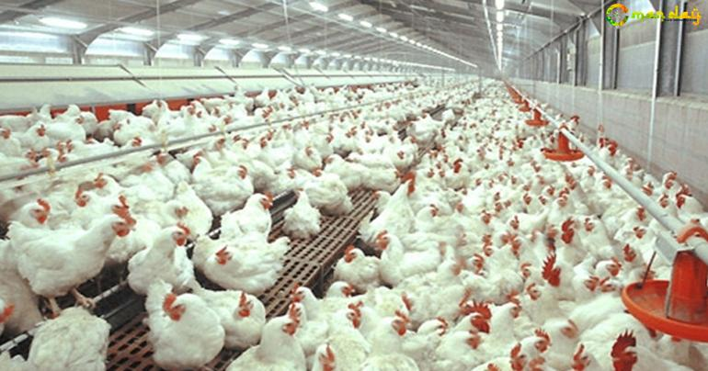
2. Level Chicks and board Eggs: Kazi farm is the supplier for Hy-line white and brown coating in Bangladesh. High-Line International is an ancient poultry Reproduction group of the world, and is the principal breeders of layers. Kazi farms have possession of business layer farms generate it the largest manufacturer of business table eggs in Bangladesh.

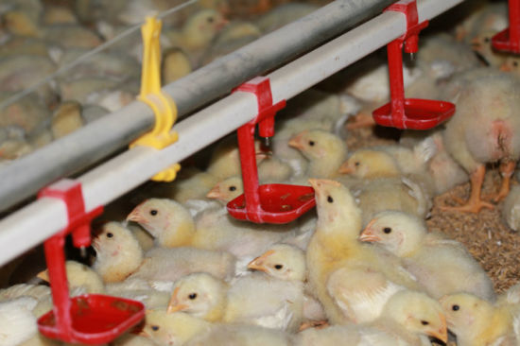
3. Feed: Kazi Farms extended its practice into poultry feed fabricate in 2006. It has become well-known as a marketplace head in cooperation quality and amount. To make sure feed superiority, Kazi Farms set technological help from Cargill USA and Buhler Switzerland to locate its marketable feed mill operations. The Gojaria feed mill employs state-of-the-art cleanses pellet mills from Buhler of Switzerland, produce of the world’s best feed tools.



4. Kazi Food Production: Kazi Food Production is a latest plan of the Kazi Farms Groups. It placed in Beron, Ashulia; KFIL makes and sells best daily ice-cream with least amount 10% milk fat below the trade name Bellissimo.



Another ice cream lolly is manufactured and sold below trade name ZaNZee.



5. Kazi Kitchen: A collection of cold food products are sold below the trade name Kazi Farms Kitchen. These are guaranteed to not comprise any antibiotic remainders, as chickens are not fed antibiotics within 7days of butcher, according to global practice. The meat is also guaranteed to be made from chicken increased on feed not holding meat according to European Standards.



6. Kazi Media: Deepto TV is a private cable and satellite television channel in Bangladesh. It is a wholly owned of Kazi Farm Group and operates under Kazi Media Limited. It launched in November 2015. Deepto TV has become the maximum rated Bangladesh channel as calculated by Total Rating Points.


7. Sysnova: Sysnova Information Systems Limited is an IT company specializing in open source solutions. It supports all Kazi Farms Group companies with Adempiere ERP.



8. Social Responsibility: Kazi Farm Group is the chief economic donor of Central Women’s University. It is the first private University established in Bangladesh for women only. Kazi Farms also distributor to the business of Kazi Zahural Hoq College. It is situated in Mary Gopinathpur, Gopalganj which is the home district of the Managing Director, Kazi Zahedul Hasan. This is a free privately managed HSC college with one of the biggest pass rates of the district.


2. 6 Mission & Vision Statement of Kazi Farms Group:
Mission: The Company of Kazi Farms Group mission statements are given below:
- The main target is achieve the customer satisfaction and providing best quality agro based products and services and thus distributing to the healthy life style people.
- Developing the quality of work life of all employees.
- They are motivating and improving an encouraged team of professionals whose mission will be presenting the vision of the organization.
- They are responding to the probability of stakeholders, society and environment.

Vision: The Company of Kazi Farms Group vision statements are given below:
- They will spend their product and process contribution to side with key customers need.
- They will spend in extended strategic partnership with branded industry influential that value good quality, food safety, innovation, corporate social responsibility, and talent and facilitate in support of their core business.
- Provides proper nutrition all over the world.
- They will manage their status and market brand to attract their select customers to their core capabilities.
- They will use community enterprise system to help us visualize, build up, purify break through solutions.
2. 7 Value:
- They exhibit unruly integrity and ethics.
- Their people are the source of progress.
- They are obsessive about their customers.
- They supply perfect quality.
- They connect improvement to drive mission serious solutions.
- They balanced environmental stewardship social responsibility and also profitable growth.
2. 8 Features of Kazi Farms Group: The main features of Kazi Farms Group are given below:
- Extremely capable and competent professionals manage the company.
- The computerized operation system in all corporate office of Kazi Farms.
- The company delivers excellence food to the market.
- The inner environment and group work encourage all quality employees to gain ultimate objective of Kazi Farms Group.
- The strict leadership along with the supervision of brilliant management directs all the offers.

2.9 Human Resource Department of Kazi Farms: Human resource department is absolutely formation as if they can deal with their company’s important asset. They are practiced each and every Human Resource Departments perfectly. Human resource departments aim to bring out the greatest in employees. Thus distributing the success of the institution .Human resource employees of Kazi Farms is not working one location. They are working two locations.
- Head Office Human Resource Dhaka: Doing work for management employees.

- Rest other Bangladesh: Doing work for non management employees. Every corporate office of Kazi Farms has Human Resource Employees, but they are ER employees in Kazi Farms.

Employees of Human Resouce Departments of Kazi Farms Group

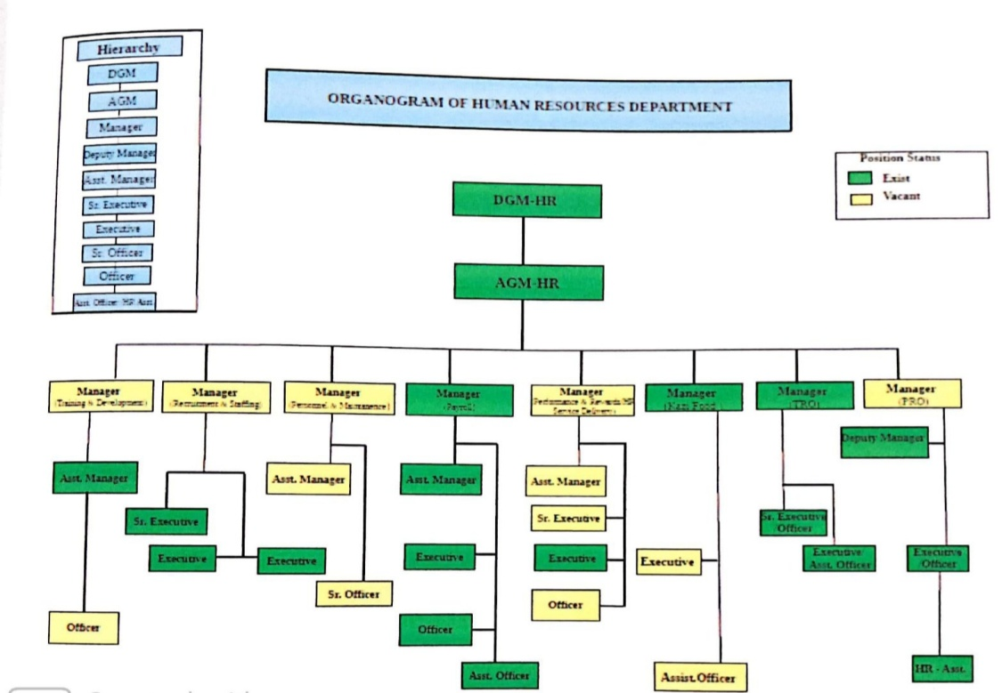

Figure: Employees of Human Resouce Departments of Kazi Farms Group
Source (jobs@kazi farms.com)

2. 10 Function of Human Resource Divison:There are four types of Human Resource Divison in the organization.
Career Development Unit
Performance Management
Compensation Management Unit
uuuUnUnitUnit
Resource planning unit

Resource Planning Unit:
- Manpower Planning.
- Recruitment.
- Hiring & Placement.
- Job Description Development.
- Human Resource Contact.
- Third Party Contact.
- Human Resource Information System.
Compensation Management:
- Short Term & Long Term Benefits.
- Income Tax.
- Power of Authority.
- Employee Loan.
- Leave Management.
- Salary Clarification.
- Human Resource Clearance.
- Employment Clarification.

Performance Management:
- Performance Appraisal.
- Disciplinary Action.
- Rewards.
- Promotions.
Career Development Unit:
- Career Planning.
- Local & Foreign Training.
- Internship.
2.11 Sisters Companies of Kazi Farms Group: Kazi Farms Group involved in different types of companies. The names are giving below:
- Kazi Hatchery Ltd.
- Kazi Breeders Ltd.
- Kazi Foods Ltd.
- North Bengal Eggs Ltd.
- Tetulia Eggs Ltd.
- Bhaluka Farms Ltd.
- Royal Bengal Chicken Ltd.
- Hybrid Farms Ltd.
- Kazi Shivpur Hatchery Ltd.
- Kazi Parents Ltd.
- Kazi Broilers Ltd.
- Kazi Chicks Ltd.
- Kazi Chicken Farms Ltd.
- Taragonj Hatchery Ltd.
- Srabon Poultry Ltd.
- Ashalata Poultry Ltd.
- Atrayee Poultry Ltd.
- Sukumoy Poultry Ltd.
- Uttara Kazi Ltd.

2.2 The main concepts of Kazi Farms different from others Farms

- Bangladesh total 55% broiler produces in Kazi Farms.

- They are use in Hy Line Layer. Bangladesh 35% Layers produces in Kazi Farms.

- They are famous in produces Tiger SASSO.

- They are use Kazi Organic fertilizer. Its automatic produces in Japan and Korean.

- Kazi Farms invented in Sysnova Information System Limited open source ERP (Enterprise Resource Planning) solutions which through any organization creates develop and quick Online Management.

- Kazi Farms kitchen sells different types of Frozen Products. Chicken meatball, chicken nuggets, Chicken Strips.

- Kazi Food Industries Limited first times sell in Bellissimo Ice Cream Internationally.

- Kazi Farms Limited Gazipur and Feni uses in modern technology. Broiler, Breeder, Layer farms have excellent customers team.

- Now a day’s Kazi Farms have five Feed Mills. It is situated in Vola, Thakugaon, and Panchagarh.

Kazi Farms Group have situated in different districts.Attray poultry, Kazi Broilers, Srabon Poultry, Boirampur Gp, Srabon Poultry, Kazi Hatchery, AkhanagarA, Akhanagar B, Kazi JaalDhaka etc.
2.3 Kazi Farms Group in Bangladesh

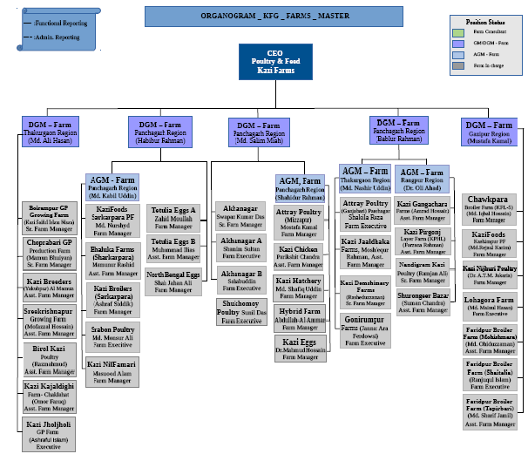

Picture: Kazi Farms around in Bangladesh
Source (jobs@kazi farms.com)

2.4 Objective of Kazi Farms Group

The main objectives of Kazi Farms Group are giving below:
- The main objective of farms are maximization profit along with the benefits of employees and customers.

- They are carrying recent farming capacity to the approach of general public through diverse farming services.

- It’s affecting economic propensity amongst people.

- They are participated in the growth of the country’s economy through useful growth of the farms properties,as well as superior diverse societal activities.

- They are linking to up to date farming apply by the greatest application superior news and techonolgy.

- They get inspiration to carry on and believe proud of farming with Kazi Farms Group.

2.5 Internship Activity of Kazi Farms Group

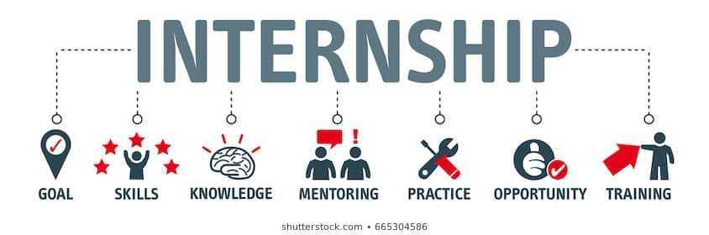

I had joined Kazi Farms Group on 1st January 2020 and my internship end 31th march 2020.In this three months I got chance to work in Human Resource Department of Kazi Farms Group (Head Office) through my internship purpose. Employees and managers of Human Resource Department are highly skilled and experienced. The internship program has given me a lot of opportunity and scope to learn and get the insights of practical works which will help me in developing my future career.
Human Resource Department employees are working with three teams.
Human Resource Department of KFG

HR Operation Team
Talent Management & Organization Development Team
Recruitment Team

1. HR Operation Team: The operation teams maintains all the disciplinary action, payroll action, policy making, doing employees exit interview, verifying employees personal file documents and given employees essential think like-laptop, mobile modern, and some other office equipments.
2. Development Team: The development team’s employees are making employee goal sheet, preparing organ gram of the organizations, training and development, succession planning of the employees, working on performance appraisal, calculated employees behavior, official performance and update their working status on database.
3. Recruitment Team: They are doing make an interview question paper of candidate, making database of interview candidate, data entire’s of selected candidate for the interview and those who are recruited. They are maintaining and updating database of the employees, file processing, verifying the documents personal file, verifying the references, sending mails, making call to customers, candidate and communicate, maintaining the external resumes, making final settlement data are the activity prepared.
Job Duties & Responsibilities: In Kazi Farms Group, I mainly worked:
- I uploaded the all employees goal sheet ERP format basis.
- Prepared organ gram of the organizations.
- Prepared job description and uploaded the all information ERP format.

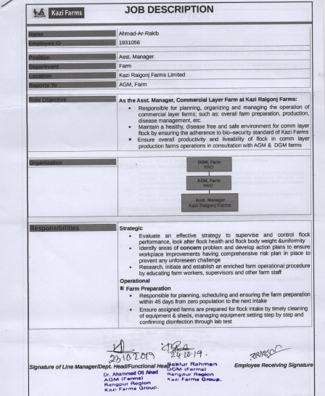

Picture: Kazi Farms Group Job Description.
Source (jobs@kazi farms.com)

Chapter-3
3.1 Overview of Performance Appraisal

Performance appraisal is the process of systematic in which the behavior and performance of an employee evaluated by the superior or manager in opposition to predescribed benchmarks, such as understanding of the employment,quality of productivity, management skills, manner toward work,attenadce,collaboration,opinion,adaptability,healthiness,initiative, and onwards. It is the unbroken practice.It is establishing the goals and evaluating individual and group accomplishments through limited time.(businessjargons.com,2014)
Dale S.Beach: Performance appraisal is the systematic method of the human being with value to his or her performance on the job and his for development.
Randall S.Schuler:Performane appraisal is a formal system.He also include that it is a structure system,assessing an employees employment related performance results to find out why and how the employee is at the moment executing on the job and how the employee can perform more effevtively in the future so that the employees,organization and society all gets advantage.
Heyel: Performane appraisal is the process of assessing the performnace and qualification of the employees in terms of the obligations of the occupation for which he is in employment,for reason of administation.
Dale Yoder: Performane appraisal comprises all structural processes accustomed to evaluate behaviours and allocations and prospectives of group associates in a working organization.It is a continuous procedure to protect information essential for creating accurate and objective resolutions on employees. (sumonresource et all,2004)

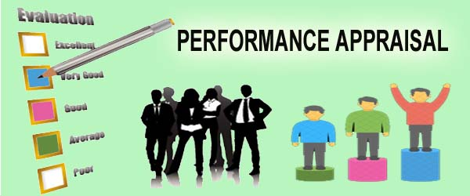
Figure:3.1 Performance Appraisal

3.2 History of Performance Appraisal

3.2 History of Performance Appraisal

3.2 History of Performance Appraisal
3.1 Introduction of Performance Appraisal

3.1 Introduction of Performance Appraisal

Peformance management is not new idea.It is the way of companies behavior appraisal has changed particularly over the last 100years.
Early 1900’s: The peformance appraisal informal beginning
Performance appraisal were made-up by WD Scott as early as world war I. WD Scott’s system was not a extensively regonized concept and it was not untill around mid-century that more official appraisal systems become implemented by a large number of businesses.
1950’s developing a Formal System
Formal performance appraisal was made-up in 1950’s.It is using in personality based system for measuring performance. In end of the 1950s however,an awkwardness at these systems began to develop,as not only was there no apply self appraisal,but the personality based approach did very little in terms of monitoring performance.

1960’s:Measuring Objectives& Goals
In 1960’s a much bigger centered on self-appraisal.Genearrly maximum performance appraisal structures were deviceed more towards seeming at what an individual might be able to attain in the future.As the 1960’s development, performance appraisal started to do a better-quality job of actual evaluating performance,by centering more on goals and objectives and together with much more by way of self-appraisal.
1970’s: Deciding Flows
The 1970’s there was a lot of disparagement about how appraisals were being carried out and numerous cases were still taken to courtyard. Several this was losing to how subjective and decision-based on mainly appriasal systems.
1980s-Early 2000s:Holistic Measures
The 20 years subsequently companies centering on employee stimulation and engagement,which directed to extra holistic advance to performance management and appraisals.The companies set up to measure brand new metrics as part of their appraisal technique, such as self awarness,communication and group work,conflict decrease and the skill to hold passions.
Modern Day Performance Management
Peformance Management has envolved with many companies drawing down the usual hirearchy in accord to more equivalent working enviroments.This has directed to increase in performance management systems that look for a variety of feedback sources when evaluating an employee’s performance- this recognized as 360 degree feedback.
Mobile technology provides us more elasticity,and with more companies recognising the value of a huge a company surroundings,they belief that the explanation of what good performance is will sustain to move,and that the people who make an organization will continue to have an even improved effort into how their peers are evaluated.(peoplehr et all,2015)

3.3 Implementation of Performance Appraisal

The implementation of performance appraisal describes are given below:
- Analyzse the job (Set up Job Description)

- Increase assesments standards and actions.

- Guide supervisors & employees on the purpose and method of the organization’s performance appraisal process.

- Supervisor conduct continuing informal appraisals (recognizing & poor performance) as part of their normal responsiblities to teach,encourage,develop or discipline employees.

- Supervisor conduct the official annual or semi annual performance appraisal and set goals and objectives for the coming year.(Slideplayer et all,2014)

3.4 Link of Performance Appraisal & Job Analysis
3.2 History of Performance Appraisal
3.1 Introduction of Performance Appraisal

3.1 Introduction of Performance Appraisal

Performance appraisal communicates to job analysis. Job analysis sets up job obligations, which transmit the analysis to benchmarks, in which performance is evaluated and consequence is defining the foundation for performance appraisal. .(businessjargons.com,2014)

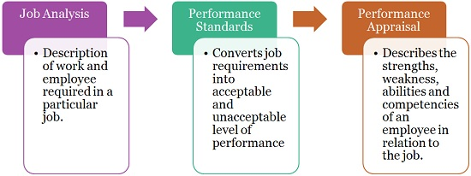
Figure: 3.4 Relationship of Performance Appraisal & Job Analysis (source:www.businessjargons .com)

3.5 Performance Appraisal in HRM

3.1 Introduction of Performance Appraisal

Performance appraisal is the systematic assessment of the employee’s present job capabilities and also his potential for growth and development by his supervisors. It can be either formal or informal.
3.5.1 Performance appraisal in HRM meaning: Performance appraisal is the method of deciding how employees do their jobs and if any problems are identified, then instantly steps are taken to cure them. (C .Heyel, 1973)
According to A.Monappa and M.S.Saiyadain Douglas Mc Gregor Formal performance appraisal plans are planned to meet up three needs.
- They provide methodical decisions to help in raising salary, terminations, transfers, demotions.
- They suggest in altering manners, outlooks, proficiency knowledge.
- They are used as a base for coaching and counseling the individual by the superior. (Gregor et all,1957)
In this system two persons are involved.
- Appraise: The person whose performs is going to be appraised by other person.

- Appraiser: The person who is going to evaluate the performance of appraises. The appraiser may be superior, subordinate, peers, self-appraisal and group.
3.5.2 Performance appraisal in HRM characteristic: The main characteristic of performance appraisal is given below:
- It should be simple and understandable.
- Any complication needs to be avoidable.
- It should be suitable to be adopted for appraisal at regular intervals because periodic appraisal enables the employees to improve.
- It should create the environment of mutual understanding and confidence.
- It should be able to fulfill the desired purpose by locating potential for promotion, increments, placements, transfers.
3.5.3 Performance appraisal in HRM objectives: The main objective of performance appraisal is given below:
- Identify the employee weakness and strength.
- Recognize and meet training needs and aspirations.
- To generate important, applicable and suitable information about employee.
- To give inputs to increments of rewards, transfers, promotion and salary administration.
- To facilitate in improving employee’s performance if he is not start to be appropriate during evaluate period.
- To make a desirable culture and tradition in the organization.
- To aid in planning career development and human resources planning based on potentialities.
- To give deadlock and research data for improving overall human resources information system.
3.5.4 Performance Appraisal in HRM system: Performance appraisal is planned, developed, implemented in the following manner:
- Establish Performance Standards: The performance standards for each and every job should be developed and discussed with the superiors after systematic of the study of the job. The standard must be clearing not unclear. It must be assessable after certain period.

- Communicate the Standards: Communicate these standards to all concerned, at least two parties.
- Appraiser.
- Appraise.
The appraiser must guarantee that the information communicated by him has been received by appraise and understood clearly.
De Cenzo and Robbins, ‘Too many jobs have unclear performance standards and the crisis is complex when these standards are set in separation and do not involve the employee.
- Measure actual performance: Generally four familiar sources are used by appraiser to evaluate real performance, personal observation, statistical reports, verbal reports and written reports.

- Compare actual performance with standards: The four systems is compare actual performance with standards. Sometimes actual performance is better than standards and sometimes it may go off the track. Any deviations between actual performance and standard performance may be noted with awareness for next action.

- Feedback to the employee: The information which received by appraise about his judgment has a great impact on his performance. Communication bad performance is complicated task for appraiser.

- Taking corrective action, if necessary: This is the last system of performance appraisal in HRM. In this stage two types of corrective action may be suggested by the appraiser.

- Positive
- Negative.
Positive: Positive means salary raise or promotion if real performance of appraise is up to the mark.
Negative: Negative means coaching and counseling may be done if the performance is bad. (Economic discussion et all, 2015)

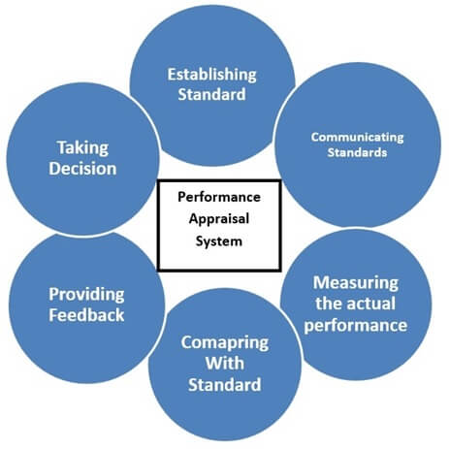
Figure3.5.4: Performance Appraisal in HRM system
3.6 Others performance Appraisal System

KPI performance appraisal system:
KPI means Key performance indicator. It is a scientific metric that reflects how fit an organization is achieving its stated goals and objectives.KPIs link organizational vision to individual action.

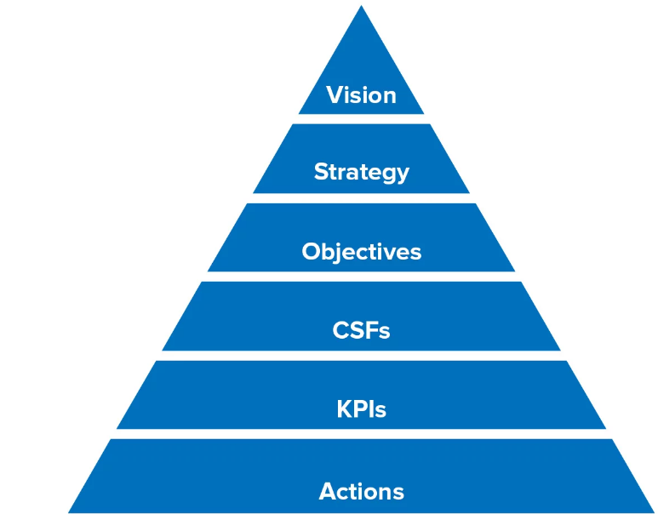

Figure: KPI performance appraisal system
Source: www.mindtools.com

Steps to create KPIs: To build KPI system for any position everyone must follow these steps.
- Classify operational objectives for construction technician monthly, quarterly, and 6 months, yearly.
- Recognize Key Result Areas for the construction technician.
- Identify work list.
- Determine work procedure for each KRA each job.
- Classify the methods to calculate the results of each KRA, job, and procedure.
- To make construction technician KPIs.(www.slidehere .net)

Types of KPI: There have many types KPIs follow in the organization. The types of KPI describes in given below:
1. Process KPI: Calculate the efficiency and productivity of a business process. For example: time to complete customer order.
2. Input KPI: Calculate assets and resources. For example: Funding For Training.
3. Output KPI: Calculate the financial and non-financial results of business activities. For example: Net profit number of clients.
4. Leading KPI: Calculate activities that have an important impact on future performance. For example: Percentage of high performance.
5. Lagging KPI: Calculate success or failure after an event. For example: Most financial KPIs.
6. Outcome KPI: Calculate benefits of performance as a result of a business action. For example: Employee satisfaction rate.
7. Qualitative KPI: Descriptive assess. Like an opinion and a nature.
8. Quantative KPI: Calculate result in numbers, uses average’s, ratio’s, percentages. For example: $ revenue per employee. (www.kaggle.com)
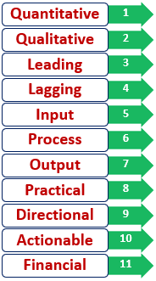
Figure: Types of KPI

KPIs to measure performance appraisal system: There are five steps to measure to identify KPI performance appraisal system.
1. Evaluate participation rate: It means completing performance evaluate can be a draw. Generally they often take lots of time to complete and there’s never a time when entirely everyone is in the office.
- It is Re-open evaluate for absent or sick employees.
- Users can easily complete them on their own schedule.
- Automatically keep drafts, so employees can pick up where they let off.
2. HR practice efficiency: It reduces the time it takes for manager and employee to complete them. This process cut down the 2months to as little as 2weeks.If Company achieve long term goal than raise productivity, saving time on performance evaluate can have a major impact.
Shortening the HR procedure: Feedback is the most valuable when it is delivered in a timely manner. If too much time passes between the instant it’s given and then received it can greatly diminish the potential impact it can have. To calculate this, purely deduct the time in days it took to complete performance appraise using old method by the time it takes with latest tool.
Old System  Date of completion–Start date | New System  Date of completion–Start date | =Days saved in performance evaluate turnaround

Reducing completing time: It calculates the potential savings begin by sending out a survey to see how long managers in organization are currently spending on performance evaluate. Deduct the figure by amount of time managers spend using the new tool. Then multiple these by the average wage of managers to find target.
Average time spend on old process- Average time spend on new process=Hours saved.
Hours saved-Average salary manager per hour=$Saved.
3. Quantity of opinion replace: It’s simply to increase the amount of feedback managers give their team can aid to clarify expectations, provide timely advice and celebrate achievements in the moment. Generally 43% highly engaged employees accept feedback at least once a week. If no give feedback managers play a key influencing role in the formation of new team habits. If Have feedback manager share opinion with their team, the morely like employees will be share feedback with each other. It tracks how often they are allocation feedback with each team member on mobile device. It reviews previous feedback given each individual. It record notes on 1-on-1conversations.
4. Opinion Quantatity: Performance management is a tool big facilitator to develop the feedback experience, but normal receiving more opinion is not enough. It’s essential to help people to learn how to give feedback more effectively
5. eNPS score: Long term goal is to raise employee engagement. It is time to begin calculating and setting eNPS goal each quarter. eNPS means Employee Net Promoter Score. It is a quick and painless way to gauge happiness within institutions continuously.
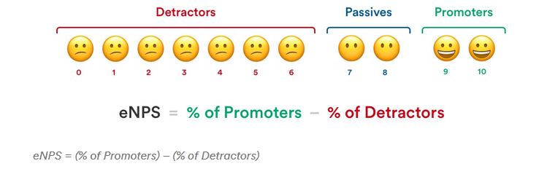

It means score 0 to detectors.
Score 7 to 8 Passive.
Score 9 to 10 Promoters.

KRA to measure performance appraisal system: KRA means Key Result Area. It areas of outcomes and department’s role is responsible. It sets activity consequent out a short term objectives. It changes from quarter, half yearly, yearly.KRA should follow SMART. That means Specific, Measurable, Achievable, Relevant and Time bound. It captures about 80% of the department’s work role.
KRA have five ways to measure performance appraisal system. Just Like:
1. Altered for all member of staff: The use of performance appraisal is to assist the employee development. This aid involved in some process.
- Assessment on Job Performance.
- Identifications of improvement needs.
- Acknowledgment of outstanding efforts.
- Understanding of individual professional goal.
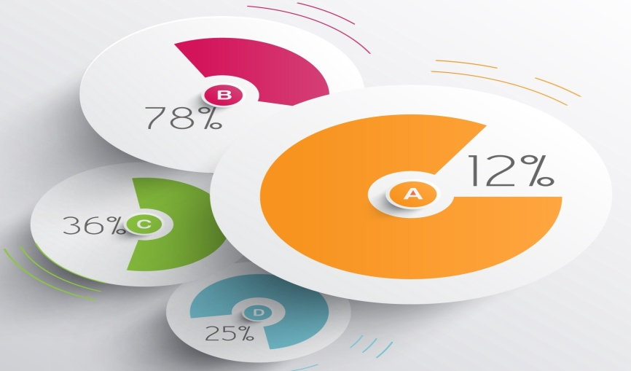

Picture: Modified for each employee

2. Alert on extensive time employee career goals too: There is an inconsistent alertness inborn to performance appraisal. Businesses and managers are aware on effects in the short term. Employees are usually more alarmed in where the path directs in the long term. The most important problem of performance appraisals is how it is typically aware on immediate job accountability and consequence while being nearly offhand on the long term perspective for the employee’s profession.


Picture: Alert on long term employee career aspirations too.
3. How concrete performance will be evaluated: It is simple to place KRAs or goals. It’s greatly more important to clarify how performance will be suitably evaluated. When employees are corresponded their goals, they should also be arrange completely obvious on the performance indicator and the methods used to determine.
4. Acceptable for both expressive and purpose measurement with open flow of qualitative efforts: The main irritation for all is the huge necessitate quantifying rate and rank during performance assessment. Managers are not regularly prepared to calculate goals or rate them without unfairness. Organization considers the key results of performance analysis are to rank employees, and design their process accordingly. The core objective of performance evaluation is to assist in the developments of the employee.
5. Weighted along with precedence as per employee’s job duties: There is no member of staff in the world with just a particular KRA. It has several responsibilities and is estimated to multi task. These support employees know the combine of their job tasks and as a result focus on their day to day obligations.
On line performance appraisal system: On line performance appraisal system describes are given below:
Reducing time: This function truly helps to reduce the time and effort waste in conducting and recording employee’s skills and behavior on the job
- Aligning employee improvement and Company strategic goals: The performance appraisal should permit managers to analysis the company’s strategic goal and align employee’s improvement plans to achieving those goals. A clear announcement of business priorities aid managers directs the work of their employees. Work that does not carry any company business needs further exploration and could be potentially discontinued.

- Consolidating and Automating Workflow: Performance appraisal should permit managers to easily track and observe a person’s status throughout the year. It maintains a separate databases, document libraries or paper copies. Online system should permit an HR Professionals to make reports for the entire company to analyze trends, spot performance gaps, identify high performers and create action plan repair problems.

- Allowing for Customization: It should permit the HR department to customize appraisal forms to reflect the company’s job descriptions. It adopts the system for use throughout a global company should not need extensive dealer involvements and additional costs. Online system implements an evaluation employee and help Companies improve employee satisfaction, retention and career developments. Online performance software system permit to company make an informed decision and simply the process of comparing software package to determine the applicability to our business.

Picture: On line performance appraisal system

Offline performance appraisal system: Offline performance appraisal format are given below:

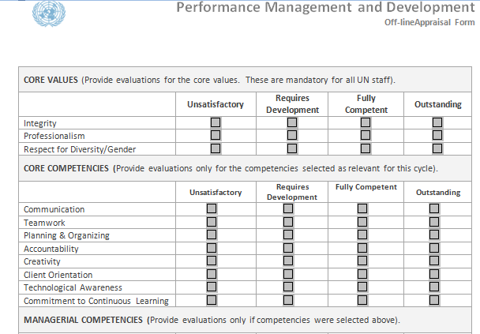
Picture: Offline performance appraisal system

3.6 Performance appraisal method

Performance appraisals follow in two types of method.
- Traditional Method.
- Modern Method.
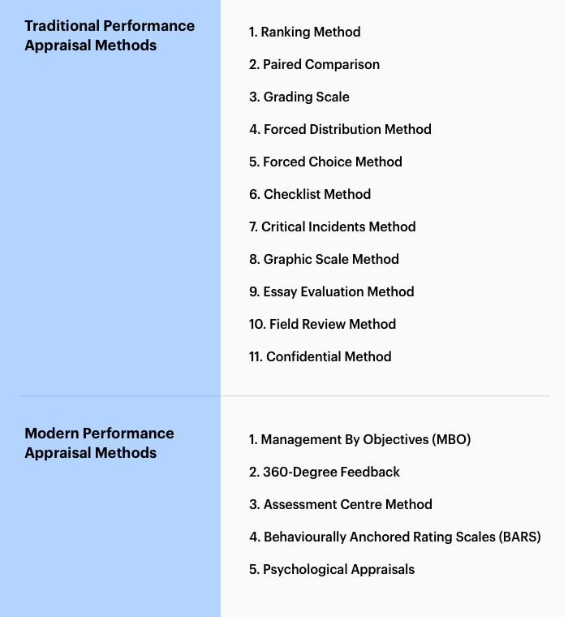
Figure3.6: Performance appraisal method

Chapter-4
Literature Review

Performance appraisal is a goal oriented method. It focuses on the situation organizational processes to maximize the productivity of employees to develop organizational performance. It includes calculating the value of the workforce and development of a plan to develop performance. Performance appraisal is an important function of Human Resource Department. It calculates and evaluates the achievement of an employee in the institutions. Performance appraisal can motivate to employees to work on improvement areas and provide more toward the success of the institution. (CIPD, 2003)
Theoretical review
A performance appraisal is a regular evaluate of an employee’s job performance and overall contribution to a company. Performance appraisal reviews an employee’s skills, achievements and growth etc.Company use performance appraisals to provide employee’s big-picture feedback on their work and justify pay raises, bonuses, terminations decisions.
Performance appraisal is a methodical, periodic, individually possible, the independent ratings of an employee’s excellence in matters relevant to his present job and to his potentialities for a better job. (EdwinB, Flippo, 1984)
Performance appraisal is the relative appeal to the company of a man’s services on his jobs. (Al Ford, Beauty, 2009)
Performance appraisal is a monitoring employee’s performance of a job in terms of conditions. (Scot, Clotheir, Spriege, 2011)
Performance appraisal engages the recognitions, measurement, and management of human performance. (Gomej-Mejial, 1984)
Performance appraisal is an official and mathematical procedure by means of which the pertinent strength and weakness of the employees are recognized, calculated, recorded and developed. (Slabbert & Swanepoel, 2009)
Performance appraisal is a process of attaining and processing the information needed to develop an individual employee’s performance and achievements. (Douglas, 2010)
Performance appraisal is a system of monitoring the employee performance and sharing information with them and seeking for ways to secure information essential for making accurate and objective decisions on employees. (Newstrom, 2018)
Performance appraisal is a identify to current level of job performance, recognize employee strength and weakness, enables employees to develop their performance and give a basis for rewarding employees in a relation their distribution to organizational goal.(Cole,2002)
Performance appraisal means define performance expectations, recognizing training and development needs, giving career counseling, succession planning, developing team, individual, corporate performance, facilitating communications and allocating financial rewards, determining promotion, encouraging and controlling employees, obtaining cultural change.(Bowels & Coats,1993)
Performance appraisal is one of the most significant HR practices as identifies individual’s responsibilities, objectives, and involved behavior with the ultimate goal to align employee’s behavior and goals with the company’s strategy. (DeNisi &Sonesh, 2011; DeNisi &Murphy, 2017)
Performance appraisal is a method of acquiring, analyzing, recording information about the relative importance of an employee. It focuses on the calculating and developing the actual performance of the employee and also the future potential of the employee. (Shelly, 1999)

Empirical Review
Bagul.B.D (2014) conducted a study on ‘Employee’s Performance Appraisal System’ where they found that at present working environment demands commitment and endeavor from employees. Performance Appraisal has to be observed as a fundamental portion of a Manager's duty. It is about developing performance as well as ultimate effectiveness. Performance Appraisal is a systematic way of ensuring that superior and their employees meet up frequently to talk about previous and current performance matters and to agree what future is suitable on mutual sides.

Dijk, V, D. (2015) researched a study on ‘Performance Appraisal and Evaluation’ and found that performance appraisal is a process of assessing employee performance and provide feedback to their superior. It is a process which can be used for administrative as well as developmental issue.
Begum,S.Sarika,K and Sumalatha,G.(2015) accomplished a study on ‘A Study on Performance Appraisal Private Sector vs. Public Sector’ and they found that performance management is an important parameter for corporate management. Managers of both sectors should hold the best talents for achieving organizational goal. Feedback system should be implied strictly to know about actual performance.
Ratnawat,G,R. and Jha,C,P.(2013) worked on ’A Commentary on Effectiveness of Performance Management’. They told that performance appraisal is a key area of human resource management. They attempted to identify the critical factors of performance appraisal system and inconsistencies in performance appraisal system.
Selvarasu,A. and Sastry, K,S,N. (2014) conducted a study on ‘A Study of Impact on Performance Appraisal on Employee’s Engagement in an Organization’ and they explored the link between perceptions of performance appraisal and employee involvement in business context.

Manufacturing of performance appraisal
Nalco, 2014 researcher found that moral and motivation of the managers is positively affected by system like a relatively high performance compensation package, other benefits offered by the company. Nalco focused on rating system significantly influenced by the use of the assessment rating for both performance related promotion and pays.
Miah Khasro M, 2012 research the performance management Retail Industry concerned for both poor and high performer with corrective action and reward respectively.
Neely, 2010 research that calculating the performance of the planning and managing activities of manufacturing industries.
Ms.Sambedna Jena, 2012 analysis that manufacturing sectors depicts that no particular system is successful in developing the performance of a firm.
Aberdeen, 2010 analyzed that employee can be looked as an expensive approaches for all types of organizational activating in different industrial sectors.
Ferreira &Otley’s, 2009 analyzed that performance appraisal consists of four elements. The four enabling machinery include the information flows, system and network, performance appraisal change system, overall strength performance appraisal, context and culture.
Sripirabba, B. & Krishnaveni, R.2009, research that monetary support by way of incentives pay raises, allocation the bonuses based on performance.

Service Company of performance appraisal
Nalla Bala Kalyan, 2018 research that the services sector covers that a wide range of activities array from monitoring is the procedure of identifying, satellite mapping etc.

Chapter-5
Overview of Performance Appraisal in Kazi Farms Group

Performance appraisal system is the method for calculating the performance of an entity and recognizes the gaps for future progress and better performance between the job and the incumbents. Kazi Farms Group employee believes that performance appraisal is an evaluation of employee and job satisfaction of employees. It is a human resource business for making business effects. Kazi Farms Group does performance appraisal for both management and non-management employee. Kazi Farms Group the performance evaluation structure follows fairly way. So the company can evaluate the objective and management skills very easily. The KRA result is defined by specific important objectives through meetings with the relationship manager. Kazi Farms Group performance review must be follow according to the performance appraisal system format which will help by the human resource start of the year.
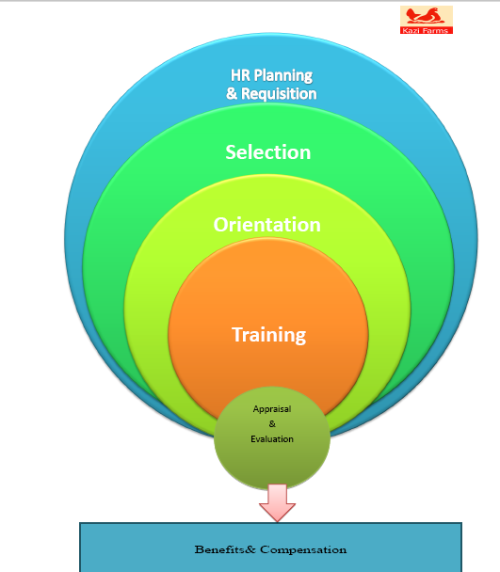
Picture 5 Performance appraisals of Kazi Farms Group

Kazi Farms Group performance appraisal process follows some guidelines.
5.1 Performance appraisals process of Kazi Farms Group

- First of all notify the staff member of the performance appraisal period. They will be soon receiving performance and employee improvement plan.

- Second inform the staff member which key 3 to 5 competencies they will address them performance plan.

- Third they collect all performance documentation for the all employees for the current appraisal circles. This might include: records to the file about the employee’s performance, praise, and other compliments received, written summaries of conversation with employees about performance, records regarding oral warnings, written warnings, and probation documents.

- Fourth evaluate a copy of the past year performance and employee development plan.

- Fifth finish the sections for staff member’s and supervisor’s information. The manager provides Penn ID number for both employees and supervisor.

- Sixth the manager describes the key goals, responsibilities the staff member had for this appraisal circle.

- Seventh the manager is calculating in time frame SMARTS criteria. It indicates that specific, measurable, achievable, result focused, times bound and stretch.

- Eighth when the manager provides feedback 3 to 5 competencies that is important to the employee’s success in the current position.

- Ninth after complete a performance appraisal sometimes the manager call a meeting if there is necessary to change performance appraisal system.

- Tenth at the end of keep a copy of the appraisal for the departmental files.

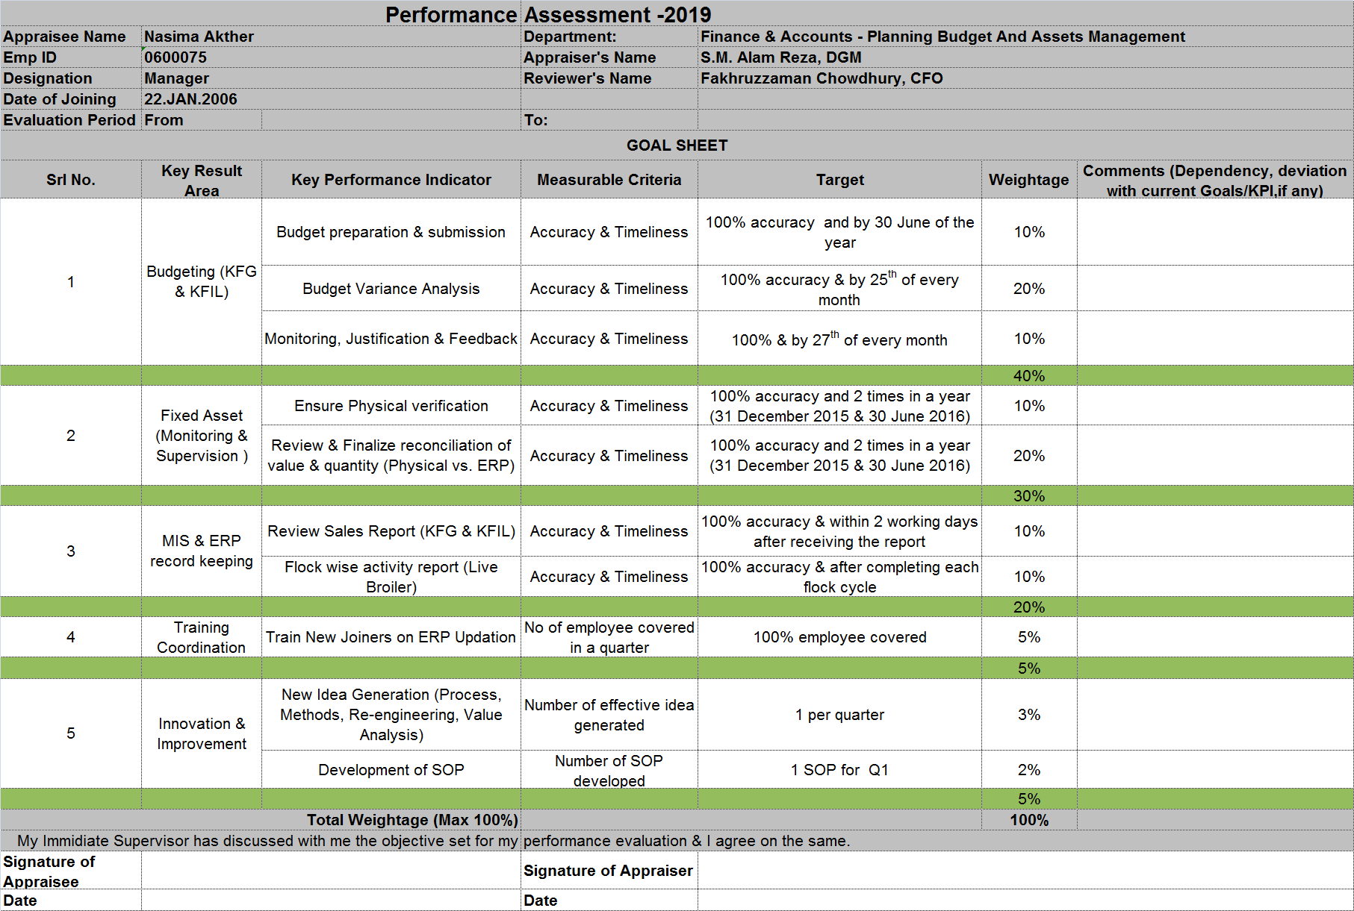

Picture 5.1 Performance appraisals process of Kazi Farms Group

Performance appraisals have many methods.
5.2 Performance appraisal method of Kazi Farms Group

- Management by objectives.
- Behavioral Anchored rating.
- Assessment centers.
- 360 degree appraisal.
- Cost accounting method.
But Kazi Farms Group uses in MBO method. This method superiors and subordinate managers of an organization jointly recognize its common goal, describe each individual’s major areas of key responsibility in terms of outcomes expected them. It uses these measures as guides for operating the unit and evaluating the distribution of each employee.

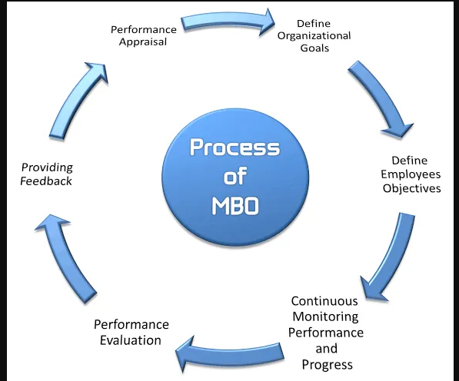

Picture 5.2 Performance appraisal method of Kazi Farms Group

Approaches for measuring performance of employees of Kazi Farms Group are the strength of character of one organization’s management. Owners of organization usually measure employee performance by assessing how much distribution the employee is making to the firm’s expansion. Kazi Farms Group employee performance depends upon a number of factors such as:
5.3 Approaches for measuring performance of employees of Kazi Farms Group

1. Favorable work environment.
2. Employment outline.
3. Reward.
4. Bonus System.
5. Job Satisfactions.
6. Business Policies.
7. Technology.
Kazi Farms Group use different policies and approaches for the use of determining performance of their employees. The organization follows in 5 approaches for raise employee performance.
Comparative approach: This approach based on Kazi Farms Group individuals who are positioned on the root of highest to the lowest performer.
Attribute approach of calculating performance: This approach basis Kazi Farms Group the employees are rated on the basis of a specific set of parameter such as crisis solving skills, Group work, communication, opinions, creativity, and innovation.
Behavioral approach of calculating performance: These approaches give a more specific description along with frequency in regards to the employee behavior for an effective performance.
Result approach of calculating performance: These approaches focus only employee monetary, customer, internal and operations, learning and growth.
Quality approach of calculating performance: This approach focuses on the evaluation for employees and their problem solving systems through group work, use of diverse sources to review performance, development of both internal and external aspects.

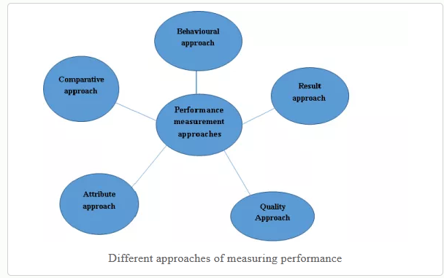
Picture 5.3 Approaches for measuring performance of employees of Kazi Farms Group

5.4 Measures the employee result

Kazi Farms group measuring result is performance standard. Kazi farms use the various terms for the performance appraisal system. The manager calculates the performance standard some ranges. Just like:
- Excellent -4.5 to 5.
- Very Good-3.5 to 4.5.
- Good-2.5 to 3.5.
- Average- 1.5 to 2.5.
- Below Average-1.0 to 1.5.

5.5 Implementation of employee performance appraisal

Implementation of employee performance appraisal

Kazi Farms Group implement employee performance appraisal considers some steps.
1. Evaluates various types of performance with their HR leader. They discuss about the advantages of compensate for performance, 360 degree evaluation, employee self evaluations etc.
2. They obtained knowledge from HR to verify how each sort of performance evaluates work greatest in Kazi Farms Group.
3. Discuss with the executive leadership team and human resource to obtain opinions on the favored program.
4. They work collectively with human resources to develop the Kazi Farms Group mission, philosophy, and principles.
5. Improve the training course for executives and supervisors to use the up to date performance assessment program.
6. Organize all employees’ conference to clarify the performance evaluation program.
7. Arrange a certain date on which the evaluation time will start and end.

5.6 Performance appraisal is the key to employee’s development in Kazi Farms Group

Implementation of employee performance appraisal

Kazi Farms Group provides a good performance appraisal process. The manager encourages employee improvement designed ensure the following:
- The manager all employees are regularly and formally evaluate regarding their career development to help them in improving to the fullest.

- The systematic calculate of an employee’s overall value to the company is recorded.

- The important information aware the strength and weakness of all employees, in relation to employee’s improvement including potential for advancement and appropriateness for other positions and training is recorded.

- The firm employees are involved in the setting of improvement goal.

- To track the progress and provide related useful feedback.

- Increasing employees to meet the company’s goal and their own personal career goal.

- To give information to employees about perceptions of their performance.

- Explain the organizational expectations of employees.

- To give information to employees about their improvement needs.

5.7 Reward system in Kazi Farms Group

Implementation of employee performance appraisal

Kazi Farms Group provides two types of rewards direct or indirect. If an employee does not receive any casual leave after end of the year they get 40% benefit.

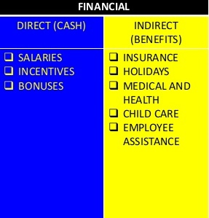
4.8 Reward system in Kazi Farms Group

Chapter-6
Data Analysis & Findings

1. Most of the respondents believe that performance appraisal is evaluation of employees. Some respondents believe that performance appraisal is job satisfaction of employees. Generally we know that performance appraisal is a regular evaluate of an employee’s job performance and overall distribution of a company.
2. Positive performance assessment influences employee performance.

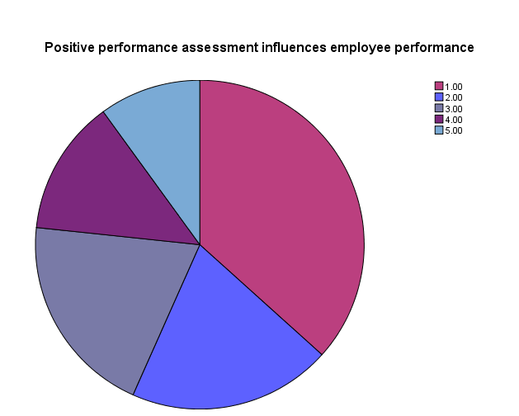
10.0
13.3
20.0
20.0
36.7

Analysis: Most of the respondents 36.7% strongly agree for positive performance assessment influences employee performance.10% respondents strongly disagree that positive performance assessment influences employee performance.
Interpretation: After analyzing that most of the people believe that positive performance assessment influences employee performance. It increases employee work efficiency and productivity.

3. Performance appraisal help people to place and to achieve significant goals

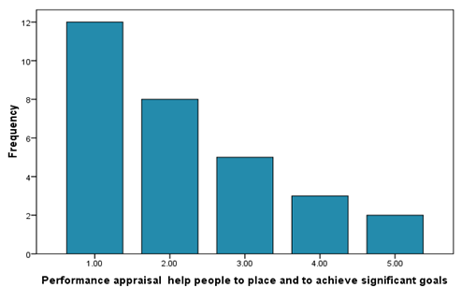
26.7
40.00
6.7
10.0
16.77

Analysis: Most of the respondents 40.0% is strongly agree for performance appraisal help people to place and to achieve significant goals. The numbers of respondents which are 6.7% response as neutral or disagree are same.

Interpretation: After analyzing that most of the people strongly believe that performance appraisal help people to place and to achieve significant goals.
4. Performance appraisal is used as a decision making device for the increasing the performance and set promotion standards.

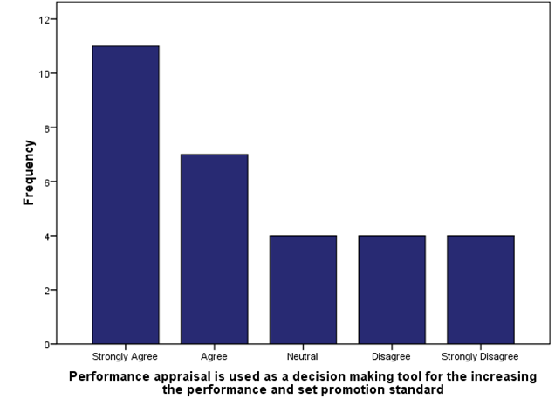
13.3
13.3
13.3
36.7
23.3

Analysis: Most of the respondents 36.7% strongly agree for performance appraisal is used as a decision making tool for the increasing the performance and set promotion standard and 13.3% people strongly disagree that performance appraisal is used as a decision making device for the increasing the performance and set a good promotion standard.

Interpretation: After analyzing that most of the people believe that performance appraisal used as a decision making device and increase the performance and set promotion standards perfect way.

5. Performance Appraisal improves motivation and job satisfaction of Kazi Farms Employee.
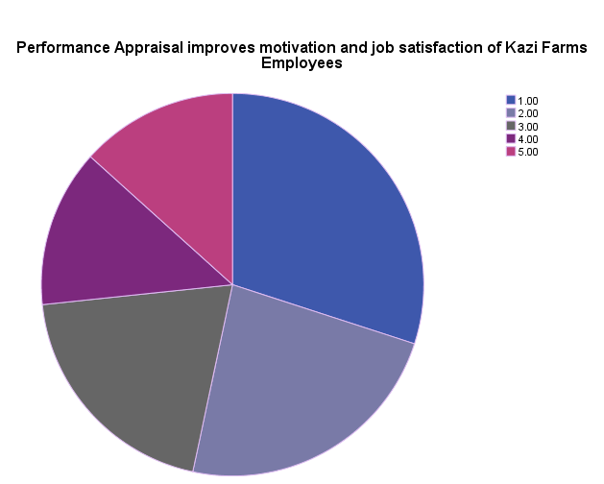
20.0
30.0
23.0
13.3
13.4

Analysis: Most of the respondents 30% are strongly agree for Performance Appraisal improves motivation and job satisfaction of Kazi Farms Employees and 13.4% strongly disagree that Performance Appraisal improves motivation and job satisfaction of Kazi Farms employees.

Interpretation: After analyzing that most of the people strongly believe that Performance Appraisal improves motivation and job satisfaction. This appraisal basis employees love to their works and they try achieve the best way the entire task complete.

6. Performance Appraisal system is easily understandable to all.

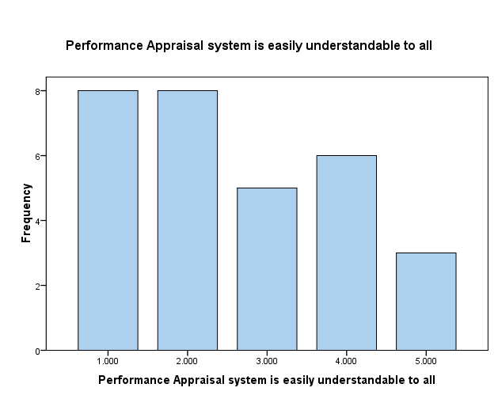
10.0
20.00
16.7
26.7
26.7

Analysis: Most of the respondents 26.7% is strongly agree for performance appraisal system is easily understandable to all and 10% strongly disagree that performance appraisal system is not easily understandable to all of Kazi Farms employees.

Interpretation: After analyzing that most of the people strongly believe that performance appraisal system is easily understandable to all of Kazi Farms employees. But some people think that Kazi Farms Group performance assessment system is very complex. So sometimes it creates mess in the organization.

7. Kazi Farms Group helps to provide an atmosphere where all are encouraged to increase performance.

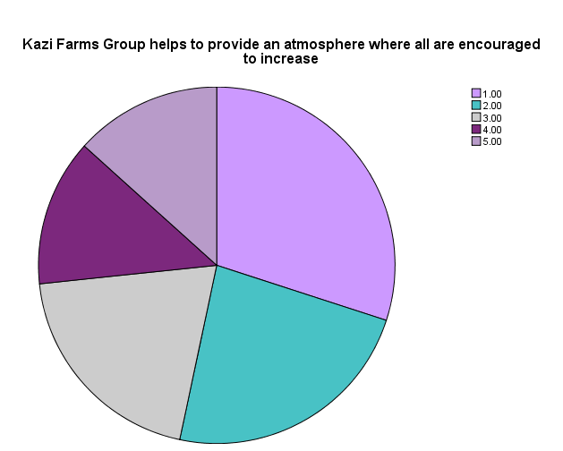
12.4
14.3
20.0
23.3
30.0

Analysis: Most of the respondent 30% Kazi Farms Group helps to provide an atmosphere where all are encouraged to increase performance. The number of respondents which is12.4% disagrees about Kazi Farms Group helps to provide an atmosphere where all are encouraged to increase performance.
Interpretation: After analyzing that Kazi Farms Group encourage to all people very perfect way. They motivate to all employees to complete any work in a perfect way.

8. Performance Appraisal helps to manager and supervisor to manage people better.

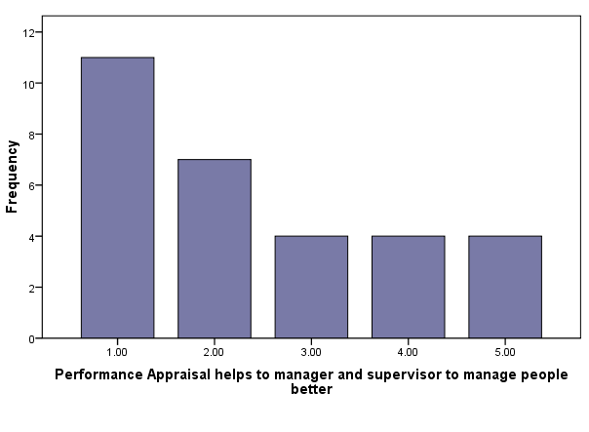
10.0
10.0

20.0
23.3
36.7

Analysis: Most of the respondent 36.7% performance appraisal helps to manager and supervisor to manage people better and 10% respondent not agree that performance appraisal helps to manager and supervisor.

Interpretation: After analyzing that Kazi Farms Group performance appraisal helps to managers and supervisors to manage people better way. So most of the time managers and supervisors maintain the entire situation very well.

9. Performance appraisal process encourages co-operations & Team spirit in Kazi Farms Group
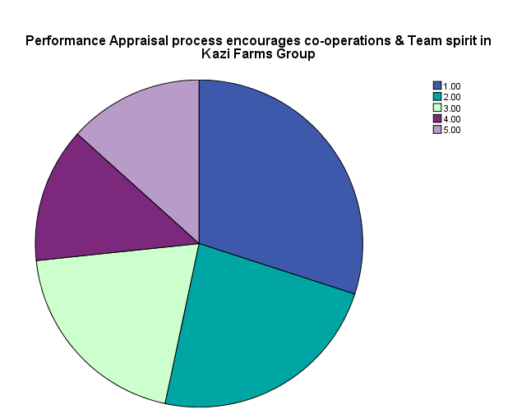
12.4
14.03
20.0
23.3
30.0

Analysis: Most of the respondents 30% performance appraisal process encourages co-operations & Team spirit in Kazi Farms Group.12.4% respondent believe that performance appraisal process discourage co-operations & Team spirit in Kazi Farms Group.

Interpretation: After analyzing that Kazi Farms Group highly encourages to employees. So it increases teamwork and employees in a comfortable way to work with other department employees.

10. Satisfied with the current performance appraisal system of your organization.

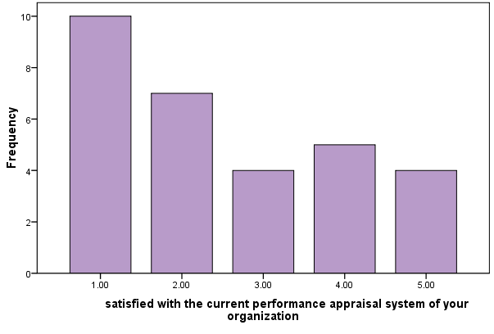
33.3
16.7
13.3
13.3
23.3

Analysis: Most of the respondents 33.3% believe that in current performance appraisal system employees are satisfied in Kazi Farms Group. 13.3 % respondents strongly disagree that current performance appraisal system is not satisfy in Kazi Farms Group. They believe that current performance appraisal system is very critical to some employees.

Interpretation: After analyzing that Kazi Farms Group highly satisfied to current performance appraisal system. It creates a good relationship among manager to supervisor, peer and subordinates.

11. Performance evaluation helps in getting expected results.

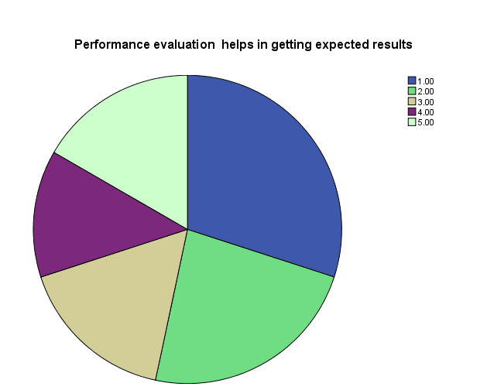
16.677
14.367
15.67
23.3
30.0

Analysis: Most of the respondents 30.0% strongly believe that performance evaluation helps in getting expected results.14.36% respondents strongly disagree that performance evaluation helps in getting expected results.

Interpretation: After analyzing that Kazi Farms Group highly satisfied to performance evaluation helps in getting expected results. So employees try to achieve the best way to complete the entire task. It increases organizational growth, employee’s skill and development etc.

12. Employee performance is effectively monitored.

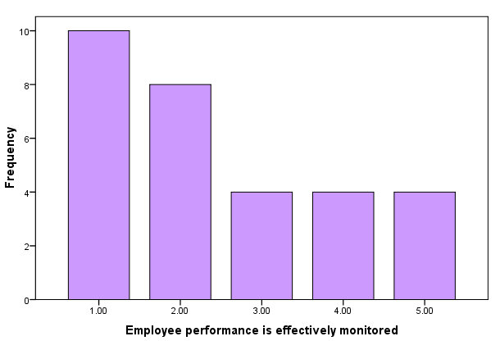
25.7
33.33
13.3
13.4
14.3

Analysis: Most of the respondents 33.3% said that the performance of Kazi Farms Group employees is effectively monitored. 13.3% respondents strongly disagree that performance is effectively monitored. They think that lack of effectively monitored is an influence to employee working environment.

Interpretation: After analyzing that Kazi Farms Group strongly believe that employee performance is effectively monitored. It increases the employee potentiality and they do entire all work complete in a conscious way.

13. KRA (Key result areas/Key performance indicators) visibly corresponded at the start of the appraisal year.

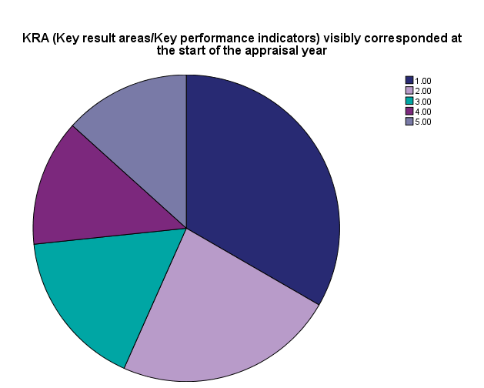
12.4
14.3
16.67
23.3
33.3

Analysis: Most of the respondents 33.3% strongly agree that performance appraisal goals KRA (Key result areas/Key performance indicators) visibly corresponded at the start of the appraisal year.12.4% respondents strongly disagree those KRA (Key result areas/Key performance indicators) visibly corresponded at the start of the appraisal year.

Interpretation: After analyzing that Kazi Farms Group strongly believe that KRA (Key result areas/Key performance indicators) visibly corresponded at the start of the appraisal year. So the employees receive accurate information in organization.

14. Performance appraisal system helpful in reducing grievance among employees.

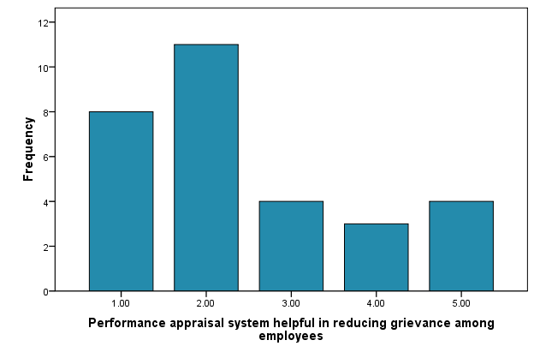
9.0
13.3
14.3
36.7
26.7

Analysis: Most of the respondents 36.7% agree that performance appraisal system helpful in reducing grievance among employees.26.7% strongly agree that performance appraisal system helpful in reducing grievance among employees, 14.3% neutral that performance appraisal system helpful in reducing grievance among employees, 13.3% disagree that performance appraisal system helpful in reducing grievance among employees.9% respondents strongly disagree that performance appraisal system helpful in reducing grievance among employees.

Interpretation: After analyzing that Kazi Farms Group agree that performance appraisal system helpful in reducing grievance among employees. It makes employees’ relationship friendly and they are communicating to other employees very comfortably.

15. Top level management biased in performance appraisal system of Kazi Farms Group.

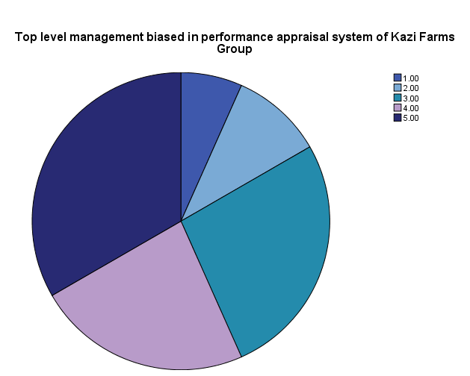
33.3
6.7
23.3
26.7
10.0

Analysis: Most of the respondents 33.3% strongly disagree that top level management biased in performance appraisal system of Kazi Farms Group. Few people 6.7% strongly agree that that top level management biased in performance appraisal system of Kazi Farms Group.

Interpretation: After analyzing that Kazi Farms Group strongly disagree that top level management biased in performance appraisal system of Kazi Farms Group. Most of the employees believe that the top level management maintains performance appraisal system of Kazi Farms Group in fair way.

16. Kazi Farms Group MBO method follows in the organization. These methods define the Kazi Farms Group key tasks for the subordinate and setting a limited number of objectives, creating criteria for evaluation objectives, determining dates for review of progress and creating modifications in original objectives during evaluate, having a final evaluation session for counseling and encouragement, setting objective for the next circle.

17. Most of the respondents believe that 30-Above performance appraisal improvement in Kazi Farms Group. Some respondents believe that10-20 performance appraisal improvement in Kazi Farms Group.

18. Performance Appraisal assists in altering actions of employees.

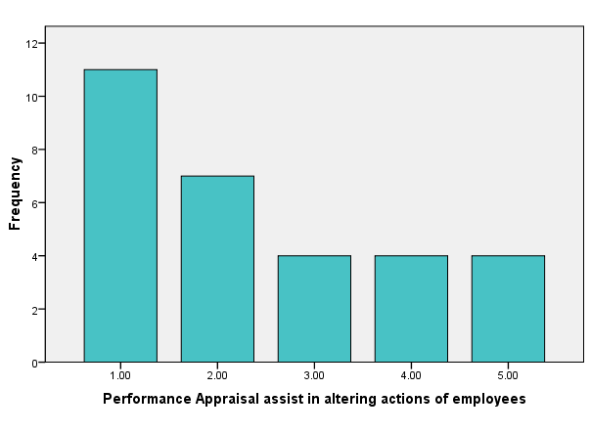
14.3
36.7
11.4
13.3
24.3

Analysis: Most of the respondents 36.7% is strongly agree for Performance Appraisal assists in altering actions of employees, 24.3% agree Performance Appraisal assists in altering actions of employees, 14.3% neutral believe that Performance Appraisal assists in altering actions of employees,, 13.3% are disagree about Performance Appraisal assists in altering actions of employees,, 11.4% strongly disagree that Performance Appraisal assists in altering actions of employees, of Kazi Farms Employees.

Interpretation: After analyzing that most of the people strongly believe that Performance Appraisal assists in altering actions of employees,. It creates a strong relationship between supervisors and subordinates.

19. After analyzing that most of the people strongly believe that Kazi Farms Group yearly evaluation is employees performed.

20. Kazi Farms Group HR Professionals and Senior Manager set the performance goals/ requirements for individual.

Chapter-7
Conclusion

Kazi Farms Group is a very famous organization now days. Kazi Farms Group is one of the leading farms in the poultry business. They maintain their agri- food sector with their region. Kazi Farms Group is a pioneer farms of the country has a made a sense of mass participation through its diversified activities over the last 17 years. They are employee number is around 7400.
Kazi Farms Group is well-known for its supervision and their consumers. It is normal for a business in operation to give customer service at high standards, at a level where standards exceed. Kazi Farms Group is dedicated to focusing all of its energy on customers and employees. Kazi Farms Group HR department guarantees future benefits and a safe place to distribute and committed a high corporate culture and high professional experience.
The report is aimed at the Overview of Performance Appraisal in Kazi Farms Group. This report described how effectively the employees are performing the job.
The company process is complete in organization guideline basis. The company main performance appraisal method is MBO.They use in different types of approaches. For example Comparative approach, attribute, behavioral, result etc. Kazi Farms group measuring result is performance standard.
They raises employee to meet the company’s goal and their own personal career goal. Kazi Farms Group provides two types of rewards direct or indirect.
I research and find that Kazi Farms Group performance appraisal technique is fair.Employees are satisfied with the present performance appraisal technique that is traditional one. As many new appraisal techniques are emerged, The Kazi Farms Group can implement modern method which would be more effective

.
Chapter-8
Recommendation

In Kazi Farms Group the manager has to identify the tactics that make parallel match among the farm resources and potentialities to the requirements of the environment so that they can exploit prospects and counteract risk and to accumulate company’s limitation constructing on the strong points. HR department of Kazi Farms Group does business planning, performance analysis, plan and service delivery, and estimation.
The following recommendations will help Kazi Farms group to improve employee satisfaction and also useful for the HR division.
- The company should be used a unique HR policy immediately.

- The company should reduce the work pressure to employees.

- In the job advertisement the HR department of Kazi Farms Group can mention their job structure in a detail way.

- Kazi Farms Group should focus on solving the problem regarding internal political issues because it might obstruct their goodwill and image.

- Kazi Farms Group can maximize the profit rate by meeting the needs of customers and employees. It has a strong power in the market.

- Promotion should be based on performance basis.
- They try to follow Bangladesh labor law, company law; the employee’s has to maintain strong bonding such as family members they have a good and trusted connection to each other.

- Pay structure should be complying with the market average.

- Kazi Farms Group should update their server continuously such as updating each employee’s personal information by oriented new employees they give proper help to old employees.

- Maximum employees of the company are satisfied with administrative support and supplied aids.

- The company should arrange training development program for increasing employee skill and development.

- The companies should focus on termination policy.

- Compensation rewards and recognition should be linked to performance measurements.

- Kazi Farms Group should formulate effective internal and external communication mechanism.

- They must improve resources and skills based on environmental needs to raise opportunities.

- HR department must set up a proper linkage within other functional department.

- Besides higher salary employees want self realization to be renowned and rewarded.

- The company should develop business plan, performance analysis, program and service delivery, and evaluation.

- They should provide motivational activities to all employees.

- The company should focus on competitors.

- They should use in conceptual framework so that employees understood all levels very easily.

Chapter-9
Reference

1. Bagul.B, D, (2014). “Study of Employee’s Performance Appraisal System”.p-287 Retrieved from https://www.academia.edu/10388057/A_RESEARCH_PAPER_ON_STUDY_OF_EMPLOYEE_S_PERFORMANCE_APPRAISAL_SYSTEM_

2. Dijk, V, D. (2015).” Performance Appraisal and Evaluation”.P-716. Retrieved from
https://www.researchgate.net/publication/282613144_Performance_Appraisal_and_Evaluation.

3. Begum, S.Sarika, K and Sumalatha, G. (2015). “A Study on Performance Appraisal Private Sector vs. Public Sector”.p- 75. Retrieved from
http://www.iosrjournals.org/iosr-jbm/papers/Vol17-issue2/Version-2/K017227580.pdf

4. Ratnawat, G, R. and Jha, C, P (2013).”A Commentary on Effectiveness of Performance Management”P-1. Retrieved from
https://www.ijser.org/researchpaper/A-Commentary-on-Effectiveness-of-Performance-Management.pdf

5. Selvarasu, A. and Sastry, K, S, N. (2014)”A Study of Impact on Performance Appraisal on Employee’s Engagement in an Organization”P-10.Retrieved from
https://www.arcjournals.org/pdfs/ijmsr/v2-i11/3.pdf

Appendix

Survey Question
Name:  Gender: Male/Female  Age:  Source: fasttrack1979@gmail.com | Education: Position: Department:  Year of Experience:

1. In your opinion performance appraisal is?
- Evaluation of Employees.
- Job Satisfaction of Employees.
- Judging performance of an Employee.
- Motivation
2. Do you think that positive performance assessment influences employee performance?
- Strongly Agree.
- Agree.
- Neutral.
- Disagree.
- Strongly Disagree.
3. Does performance appraisal help people to place and to achieve significant goals?
- Strongly Agree.
- Agree.
- Neutral.
- Disagree.
- Strongly Disagree.

4. Does Performance appraisal is used as a decision making device for the increasing the performance and set promotion standers?
- Strongly Agree.
- Agree.
- Neutral.
- Disagree.
- Strongly Disagree
5. Do you think performance appraisal improves motivation and job satisfaction of Kazi Farms Employees?
- Strongly Agree.
- Agree.
- Neutral.
- Disagree.
- Strongly Disagree.
6. Performance appraisal system is easily understandable to all?
- Strongly Agree.
- Agree.
- Neutral.
- Disagree.
- Strongly Disagree.
7. Do you think that performance appraisal of Kazi Farms Group helps to provide an atmosphere where all are encouraged to increase performance?
- Strongly Agree.
- Agree.
- Neutral.
- Disagree.
- Strongly Disagree.
8. Do you think that performance appraisal helps to manager and supervisor to manage people better?
- Strongly Agree.
- Agree.
- Neutral.
- Disagree.
- Strongly Disagree.
9. Does performance appraisal process encourage team works & Team spirit in Kazi Farms Group?
- Strongly Agree.
- Agree.
- Neutral.
- Disagree.
- Strongly Disagree.
10. Are you satisfied with the current performance appraisal system of your organization?
- Strongly Agree.
- Agree.
- Neutral.
- Disagree.
- Strongly Disagree.
11. Do you always get the expected results of the performance evaluation whatever you are expecting?
- Strongly Agree.
- Agree.
- Neutral.
- Disagree.
- Strongly Disagree.
12. Do you think that employee performance is effectively monitored?
- Strongly Agree.
- Agree.
- Neutral.
- Disagree.
- Strongly Disagree.

13. Does KRA (Key result areas/Key performance indicators) visibly corresponded at the start of the appraisal year?
- Strongly Agree.
- Agree.
- Neutral.
- Disagree.
- Strongly Disagree.

14. Do you think that performance appraisal system helpful in reducing grievance among employees?
- Strongly Agree.
- Agree.
- Neutral.
- Disagree.
- Strongly Disagree.

15. Is the top level management biased in performance appraisal system of Kazi Farms Group?
- Strongly Agree.
- Agree.
- Neutral.
- Disagree.
- Strongly Disagree.

16. Which modern method of performance appraisal is implemented in this organization?
- MBO
- 360 Degree Feedback.
- Assessment Centre Method
- Behaviorally Anchored Rating Scale (BARS)
- Psychological Appraisals
- Others.

17. After performance appraisal improvement in your performance?
- 0-10.
- 10-20.
- 20-30.
- 30-Above

18. Does performance appraisal assist in altering actions of employees?
- Strongly Agree.
- Agree.
- Neutral.
- Disagree.
- Strongly Disagree.
19. When evaluation is employees performed?
- Yearly.
- Annually.
- Quarterly.
- Monthly.
- Weekly.

20. Who sets the performance goals/ requirements for individual?
- Senior Manager
- Line Managers & Team
- HR Professionals
- Appraise
- Appraiser & Appraise

