

A PROJECT REPORT ON

Financial Inclusions in Bangladesh

2nd September 2020
UNITED INTERNATIONAL UNIVERSITY
DHAKA, BANGLADESH
A PROJECT REPORT ON
Financial Inclusions in Bangladesh

SUPERVISED BY
SHAKILA AZIZ
ASSISTANT PROFESSOR
SCHOOL OF BUSINESS AND ECONOMICS
UNITED INTERNATIONAL UNIVERSITY

PREPARED BY
SHAOWN SINGH HAZARI
ID: 111 151 074
BBA PROGRAM
UNITED INTERNATIONAL UNIVERSITY

DATE OF SUBMISSION
2nd September 2020
UNITED INTERNATIONAL UNIVERSITY
Letter of Transmittal

To
Shakila Aziz
Assistant Professor
School of Business and Economics
United International University
Subject: Submission of project report on ‘Financial Inclusions in Bangladesh’.

Dear Madam,
I am delighted to inform you that I recently finished my project report on 'Financial Inclusion in Bangladesh' where I analysed the financial overview of Bangladesh and the various ways to provide access to Bangladeshi customers to engage in different financial means. When creating the report, I collected data from both primary and secondary sources that helped me to prepare such a large study.
Financial inclusion aims to remove obstacles that prevent the financial sector from using these services to improve the lives of the people of the country, which in effect refers the efforts to make financial products and services affordable and accessible for all people, firms, and companies, regardless of the value of a single individual or the size of the company.
The study is prepared following all the formal report guidelines and utilised relevant information of Bangladesh financial inclusion. Moreover, no information is shared without any analysis or directly copied from any sources.
I, therefore, pray that your honour would be kind enough to accept my final study and oblige thereby.

Sincerely yours,
Shaown Singh Hazari
Id: 111 151 074
BBA Program
United International University

Acknowledgment

At the beginning of my studies, I would like to provide credentials to all those who played a very important role in completing my graduation, as well as helping to finish this study on time.

I would like to thank my Almighty and my parents for making me eligible and supporting me with the qualifications that have given me the courage to graduate from this four-year-long BBA degree from United International University.

I would also like to thank my finance faculty as well as my project supervisor Shakila Aziz, Assistant Professor, School of Business and Economics, United International University for preparing me for my studies in the financial Inclusions as it is highly relevant to my field of concentration. I also thankful that I have received valuable time during the study to make clear several confusions that arrived while working on the study.

I would like to thank Md. Basharul Islam, Manager in Finance and Accounts Department of BRAC Bank Limited for sharing the genuine inclusion of the people of Bangladesh and greatly appreciated the time for my research. I received a number of secondary information from him that helped me understand the true view of financial inclusion in Bangladesh.

Finally, I would like to thank all my friends and family members for encouraging me to finish my studies on time and to help me understand where I am having difficulty understanding.

Abstract

Financially inclusive, people and businesses in rural and urban areas can use basic and reasonable financial products and services to encounter their requirements, and provide these products and services in a responsible and sustainable manner. Financial inclusion denotes to equal entree to financial services. Every country in the world is trying to include all its citizens in financial inclusion, and Bangladesh, as an emerging nation, is trying to include all funded people. Several studies found that in Bangladesh only 17.6% -38.6% of adults are currently undertaking formal financial services. The reason behind this is that Bangladesh's banks and other financial institutions only pursue urban profits, so rural and less developed areas are always ignored when these areas consist of the majority of the population of Bangladesh. Only then will people in the region be subject to a formal financial review to ensure that Bangladesh is financially inclusive. The project report is prepared on Bangladesh's access to financial institutions and explains how people access it through banks, mobile financial services, insurance companies, microfinance institutions, bank agents, cooperatives, as well as ATMs and POS (points of sale). In order to provide more people with financial access to Bangladesh, various schemes have been proposed, such as researching innovative financial products and services and improving financial education for rural people by promoting government programs, financial awareness, development of appropriate infrastructure, reduction of corruption in rural areas, etc. Bangladesh can improve the economic situation of the people of Bangladesh and meet specific needs without harming the environment. With all this in mind, the study describes the overview of the financial inclusion of Bangladesh, seven ways to get financial access and recommendations for improving financial inclusion.

Table of Contents

Chapter One: Introduction of the Study
1.1 Background of the study 8
1.2 Scope of the study 8
1.3 Objectives of the study 9
1.3.1 Primary Objectives: 9
1.3.2 Specific Objectives: 9
1.4 Methodology of the study 9
1.4.1 Data Collection Process 10
a. Primary Data 10
b. Secondary Data 10
1.4.2 Data Analysis 10
1.5 Limitations of the study 10

Chapter Two: Literature Review
2.1 Financial Inclusion (FI) 13
2.2 Measures of Financial Inclusion 13
2.3 Importance of Financial Inclusion 15
2.4 The services or institutions that are not accept as Financial Inclusion 16
2.5 Accepted forms of FI in Bangladesh 17

Chapter Three: Analysis And Findings
3.1 Overview of Financial Inclusion in Bangladesh 19
3.2 Financial Access through Banks 20
3.3 Financial Access through POS & ATM 21
3.4 Financial Access through Mobile Banking 22
3.5 Financial Access through Micro-finance Institutions 23
3.6 Financial Access through Agent Banking 24
3.7 Financial Access through Co-operative Institutions 25
3.8 Financial Access through Insurance 25

Chapter Four: Recommendations and Conclusion
4.1 Recommendations 27
4.2 Conclusion 29
Reference

Chapter One:
Introduction of the study

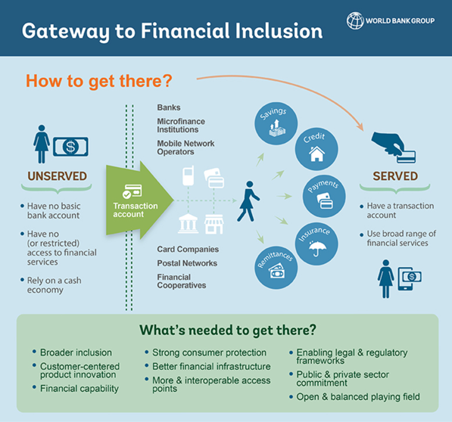

Background of the study
A project report is a combination of any student’s observation over an industry of any particular firm or company along with the theoretical knowledge he or she have learned from their university. In each semester, the students who have completed all their courses that usually finished after 12th semester have to take either an internship program or a project program. The students who take internship program have to join in any organization and work as an intern there for minimum three months to achieve practical work experience and working culture and during these timeframe they have to prepare an internship report based on that company as well as their field of concentration to achieve the graduation degree from United International University. On the other hand, in Project program, it is not necessary for students to join in any organization to learn work experience, rather they have to either observe any particular organization or a whole industry or prepare a topic depending on their field of concentration and that company/ industry.

I have chosen project program for several reason. First of all, it provides me the necessary time that are required to implement my theoretical financial knowledge on the study. Secondly, I can provide proper concentration towards the study and finally I can work with a whole industry to improve my finance knowledge at the same time what I may not gain from any particular financial institution. The project study is prepared on ‘The Financial Inclusions in Bangladesh’ that analyse the efforts of Bangladeshi financial organisations to make financial products and services affordable and accessible for all Bangladeshi people, firms, and companies, regardless of the value of a single person or the size of the company.

Scope of the study
The Scope of analysing the financial inclusion have an promising impact as the financial institutions have great impact to make Bangladesh as one of the fastest growing economy in the world. The sector is providing access several financial opportunities to the mass Bangladeshi people through making payments, savings, credit, and insurance for disadvantaged groups. Through the access to formal financial services has changed personal lives; financial institutions is also attracting the new customers by creating customer impacts that is also improving the entire economy. Therefore, new customers as well as existing customers can learn through the study about the ways financial institutions are providing them access to the financial activities and securities through which customers can raise the standard of living in Bangladesh. The study also give students to understand the similarities to their theoretical learnings with the actual scenario. Banks and other financial institutions can also generate new services as the study is going to disclose a lots of financial ways to provide customers to achieve the financial services.

Objectives of the study
The study objective represents the aims of the study for what the study is actually prepared for. Though the main purpose to prepare this report is to analyse the financial inclusions in Bangladesh, there are few other purposes. All these objectives can be separated between two parts.

1.3.1 Primary Objectives:
- To observe the financial inclusions in Bangladesh
- To prepare the report and submit within due date as it is a pre-requirement of achieving the BBA degree.

1.3.2 Specific Objectives:
- To analyse the overall financial inclusions of Bangladesh.
- To analyse the ways financial sectors are offering access to the Bangladeshi population.
- To recommend few innovative ideas so that the access can be expanded more.

Methodology of the study
The methodology is a systematic theoretical analysis combined with methods used in the field of research. It includes a theoretical analysis of methods and policies related to the branch of knowledge. Researchers make the most important method decisions grounded on the difference concerning qualitative and quantitative data. As mentioned earlier, qualitative data is in the form of descriptions based on language or image, but quantitative information is in the arrangement of quantities.

Quantitative analysis of data can be easy and grounded on a hefty number of respondents. This method is grounded on information that can be calculated "numerically" unconsciously. Moreover, it analyse the information by performing statistical analysis and numerical assessments. As a result, it seems more "scientific" and can attract people to find a clear answer to an exact pivotal question. This method frequently involves the use of software, so execution is usually faster. Due to a large number of respondents, this can be extended to a larger population than the research sample. Popular methods of quantitative study include organizing statistical records and questionnaire surveys.

On the other hand, a qualitative study is rich, usually based on topics and explanatory opinions. This research method supports a deeper understanding of the situation under consideration, and due to time constraints, usually, only a few participants are involved. Therefore, the research results are limited to the samples studied and cannot be generalized to other situations or larger populations. Popular methods of qualitative study include participant observation, semi-structured or structured interviews, and document analysis. However, the qualitative analysis usually takes longer than quantitative analysis.

1.4.1 Data Collection Process

a. Primary Data
- Through the formal and informal communication with several individuals who have enough experience on financial institutions.
- Though Annual Report of Several Bangladeshi Bank.
- Through the guidelines provided by Bangladesh Bank.

Secondary Data
- Analysed information shared in several published articles shared by several popular researcher on financial inclusions of Bangladesh.
- Through several websites and blogs.
- Through discussing my finance faculties and friends.

1.4.2 Data Analysis
The study is prepared following the explorative study methodologies where both qualitative and quantitative information are used according to the necessity of the title. All the secondary information are taken from valid sources. The complete study is conducted on MS Word and MS excel.

1.5 Limitations of the study
Each study has limitations and a clear description of the limitations of a study also shows that the researcher is a well-understood public figure in his study and is a very positive subject. In addition, clarifying the limitations of a study will allow readers to further understand what the consequences should be in explaining the circumstances. Therefore, the study limitations are:

- In Bangladesh, there are 49 banks (with 6,318 branches), including 30 private commercial banks, 10 foreign commercial banks and 9 nationalized and specialized commercial banks. The banking sector employs around 110,000 people. Analysing all the formal and informal access institutions are providing was not easy for me all alone. Therefore, the study has taken all the access that are usually common in all institutions.
- The timeframe of submitting the study is very limited which is about three months. In this short period of time, preparing such an extensive study was difficult.
- The employees of financial institutions are so busy that arranging a meeting was found very difficult.
- There are a lot of resources available on net that doesn’t carry true information and collecting reference information found tough for that.

Chapter Two
Literature Review

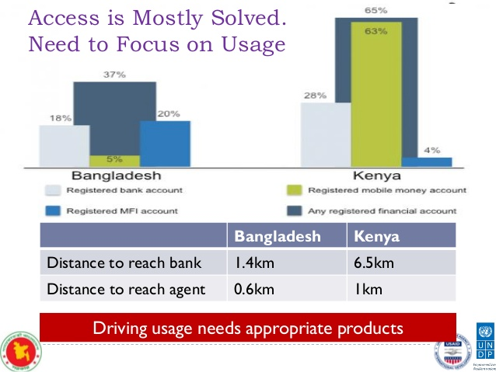
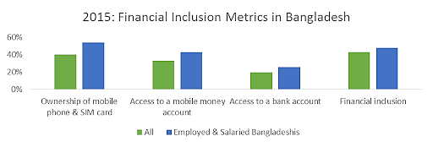

2.1 Financial Inclusion (FI)
The financial inclusion is wherever people and businesses have the opportunity to entrée basic and reasonable financial products and services that are provided in a useful and sustainable way. Financial inclusion refers to the availability and affordability of access to financial services. Being able to access a corporate account is the first step towards wider financial inclusion, as financial accounts allow people to deposit money, send and receive payments. The transactional accounts serve as a gateway to other financial services, so ensuring that business accounts are accessible to people around the world is at the heart of the World Bank 2020 Universal Financial Access Initiative.

Those who promote financial inclusion see financial services as an important positive externality when more people and companies are involved. One of its goals is to maintain homogeneity and no brand has better right of entry to financial products and services. The important perspective of financial inclusion is to provide financial services that encounter the exact requirements of consumers without any discrimination. For example, in the United States, this situation affects one-third of Hispanic communities who had born in the United States, while half of the foreign Hispanic communities living in the United States are prohibited from taking rest. In this example, it is important for any society to provide financial services to its mass population.

Access in Financial inclusions make regular daily struggles simpler and help families and organizations make arrangements from long haul objectives to crises. Being an account holders, individuals are bound to utilize other financial administrations, (for example, credit and protection) to lead and develop their organizations, oversee dangers, medical services, or put resources into instruction, and lessen other financial emergencies, that helps the, to improve their living standards.

2.2 Measures of Financial Inclusion
The G20 Global Partnership for Financial Inclusion (GPFI) has recently launched a series of "core financial inclusion measurement indicators names as Basic Set" that can assist to resolve the issues of measuring financial attachment. The publication of this indicator is timely and resembles to the sharp growth in the number of information on financial inclusion and encounters the requirements to explain the meaning of "financial inclusion" in a measurable way in the sector.

Though the Global Alliance for Financial Inclusion cannot resolve all measurement issues, it is certainly a good step. The 'Core set' includes five pointers, each of which is calculated in several ways: personal account, SME account, personal credit, SME credit, and penetration of Branches.
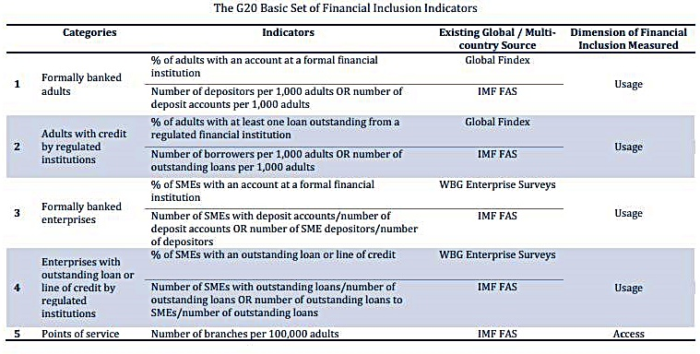
Image: "GFPI G20 Basic Financial Inclusion Indicator Set".

The combined dataset recognizes some key challenges for measuring financial inclusion:
- Financial inclusion is not limited to entrée into accounts: Although the GPFI "Basic Financial Inclusion Indicator Set" doesn’t cover all pointers (such as cellular phones), it contains personal credit, SME credit, and SME accounts.

- People can utilize financial services for business and personal purposes. The "Basic Financial Inclusion Indicator Set" includes the use of formal financial services by individuals and SMEs, as well as the monitoring of supply and demand.

- C. The proportion of financial inclusion must consider both the account's demand and supply: The “Core set” of pointers comes from the demand side resources (World Bank Group & Global Index Corporate) and puts them in the same category as the supply side data sources ( IMF surveys on access to financial services) (see column "Parameters").

- d. The availability of financial service and products: Despite its use, financial inclusion estimates should similarly include administration accessibility. To determine the entrance to the administration's objectives, the GPFI uses the amount of the IMF financial study branch for 100,000 adults.

2.3 Importance of Financial Inclusion
Financial Inclusion is necessary for everyone, especially for the world's poor workers in the informal sector. This inclusion helps people make daily payments reliably. It can help them get loans that can be used for their small-scale income-generating businesses. It can also help people save money so they can make future investments or face unpredictable risks. Financial inclusion can improve access to essential insurance products and services to address any type of corporate vulnerability.

The economically underserved population mainly includes people who live in developing or less developed regions of the world and operate in the informal economy. Lack of access to financial services has had a serious negative impact on their lives and the economy as a whole.
First of all, there is no reliable way for the poor in the world to pay and accept daily payments. The inability to make reliable transactions every day prevents them from going up. This puts them on the road to bankruptcy and plunged them into a vicious cycle of addiction: their only way of financing was through improper means.

Second, the world's poor cannot spare savings that can significantly improve their lives. Savings can help people accumulate financial resources that can be used to grow their business or improve their lives. For example, to increase production and income, farmers can save in the future to buy more livestock. Savings also protect people from uncertainty.

Third, the lack of access to financial products and services implies limited access to credit. Most of the poor in the world work in the informal sector. They are grown and raised on a small scale. Others are craftsmen who sell products to the general public, while others are small sellers who sell basic products such as food and vegetables. But despite their ability to invest more and improve their lives in small businesses, they are unable to obtain credit that can help them achieve this.

The world's poor cannot save savings that can significantly improve their lives. Savings can help people accumulate financial resources that can be used to grow their business or improve their lives. For example, to increase production and income, farmers can save in the future to buy more livestock. Savings also protect people from uncertainty.

This situation can be encountered by farmers with large savings where fatal diseases affect the livestock of farmers who kill half the population. Farmers can use this money to restore hearing and prevent breakdowns. You can keep production and revenue despite disasters. Consequently, the lack of access to financial products limits the ability of the poor to save and does not have the opportunity to improve their lives.

Finally, the lack of financial inclusion prevents the world's poor from accessing insurance. Financial risks and shocks are an integral part of any business. Insurance can help people cope with vulnerabilities associated with financial risks and crises. For example, breeders can ensure that their animals are protected from natural diseases and catastrophes. By insuring them, these farmers are protected from poverty, because the continuity of the income they receive through production can be guaranteed.

2.4 The services or institutions that are not accept as Financial Inclusion
Before knowing the financially excluded organization, we need to know the financial service market of Bangladesh, based on Financial Stability Report 2018 by Bangladesh Bank.
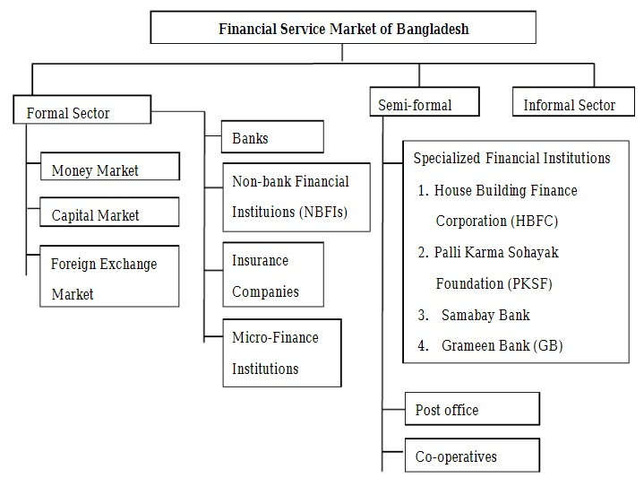
Image 2: Financial Service Market of Bangladesh (Source: Financial Stability Report 2018 by Bangladesh Bank)
Anyways, people who have accounts in organizations that are not served full-service of declared financial institutions (such as credit providers, or microfinance institutions that only provide loans) are not counted financially included companies. People who do not have a full-service account or do not use someone else's account are not counted financially. Even people who only use money guards, savers and digital top-up cards that are not associated with a bank or Microfinance institutions account are considered financially excluded.

2.5 Accepted forms of FI in Bangladesh
Access to financial services is considered to be one of the most effective tools among policymakers around the world to ensure inclusive and sustainable economic development. Bangladesh Bank has taken several initiatives to attract large numbers of economically disadvantaged people to formal financial services in order to create a sustainable socio-economic structure for the country. The attention of Bangladesh governments on financial inclusion as clear development policy, intensity, and access to financial services, especially for the poor, has increased rapidly in recent years. Today, rural financial markets are more intimate and more developed than ever. There is also a high concentration of banks and formal enterprises in urban financial markets. The financial sector in Bangladesh is mainly influenced by the banking sector. In addition to the banking sector, microfinance institutes (MFIs) also plays an important role in providing financial support to the poor. Currently, the general population, in general, has free access to the modes of use of the following financial services.

Chart 1: Encouraged forms to access into Financial Inclusion in Bangladesh

Chapter Three
Analysis and findings

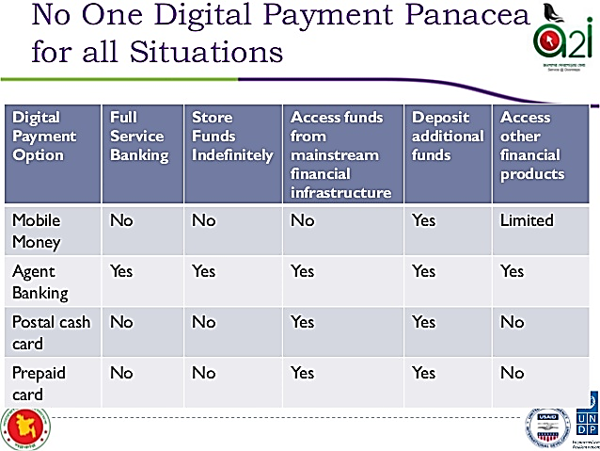
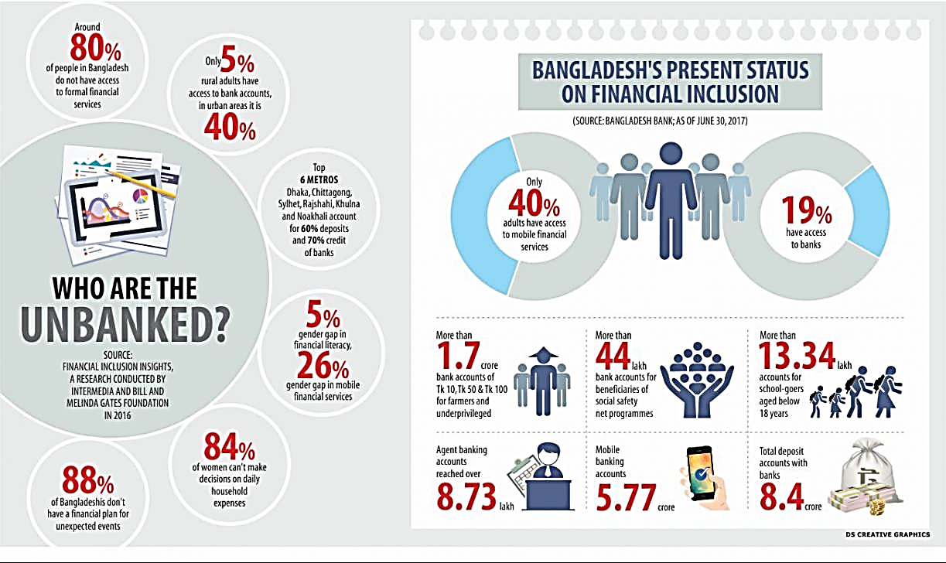

3.1 Overview of Financial Inclusion in Bangladesh
Bangladesh ranked 16th out of 21 in its financial and digital inclusion capabilities, according to the 2015 Brookings Financial and Digital Inclusion Project (FDIP) report. The report shows that one of the early leaders in Mobile Financial Services (MFS), bKash, provides useful insight into the emergence and operation of mobile money. The approaches of bKash in Bangladeshi financial inclusion have been invaluable because unlike many other mobile network providers; bKash was not a mobile network operator and therefore it had no existing customers.

Bangladesh has also benefited from the rapid improvement of mobile and internet connections, which has undoubtedly driven a significant 20% increase in the number of mobile money account holders. In 2010, only 32% of the population registered for mobile services. This number increased to 54% in 2017. During the same period, the mobile Internet connection rate increased from 26% to 33%. Of course, there is still much to do. More than 70 million people have yet to subscribe to mobile services. However, the increasing popularity of mobile phones has provided new opportunities for new providers like bKash to attract customers through mobile financial services.

So far, Bangladesh's actions and policies in inclusive banking are obviously much needed, and in the right direction, they have started to have a positive impact. Likewise, the amount of bank financing for SMEs (as a means of financial inclusion) is also different. For instance, Bangladesh Bank's SME financing target was around Tk. BDT 2,400 crore in 2009, increased to around Tk. The turnover in 2013 was 750 million rupees, in addition, the result was 115%. Loans to SMEs now represent around 30% of total loans. Many entrepreneurs have obtained a large number of loans for SMEs and each bank has an office dedicated to SMEs and women. A study by the Bank of Bangladesh shows that loans to small and medium-sized enterprises have had many positive effects on the Bangladeshi economy in terms of job creation, better living standards, empowerment of women and contribution to GDP. Coordinate and strengthen BB's financial inclusion efforts to transform the agricultural credit sector into an agricultural credit and financial inclusion sector and create two new sectors, namely SMEs, special planning services and banks, green departments and corporate social responsibility . Finally, all these financial inclusion efforts have a direct and indirect impact on promoting the country's financial stability. Technology is also an excellent driver of the BB Governor's adoption of strategies and policies related to the use of mobile financial services (MFS) to achieve financial inclusion. There are 25 million mobile bank account holders (about one sixth of the total population) and on average it is growing every day. Mobile banking generates 3.5 billion taka (about $ 45 million) every day, with more than 80% of transactions carried out by a single company through mobile banking: bKash Limited 37% of adults open accounts in banks or MFIs. Although the number of deposit accounts has increased constantly, it is still necessary to include almost 25% of the adult population in the deposits and other financial services of financial institutions.

Bangladesh is committed to expanding financial inclusion for disadvantaged people. The financial inclusion initiative is led by the Microfinance Regulatory Authority (Microfinance Institutions & Microfinance Institutions Supervisory Authority), the Bangladesh Bank (BB), and more recently by the Finance Ministry of Bangladesh. The financial inclusion and development finance movement approved by the Bangladesh Bank to maintain financial stability in marginal countries is its strategy:

- Recently, Bangladesh has fixated mostly on financial education, to expand the participation in official banking activities and to breakdown the emotional barriers of contribution. School banking is the cornerstone of the financial education plan.

- The Bangladesh Bank has dedicated its policies to encouraging innovation and promoting various products to reach different segments of the population.

- The Bangladesh Bank, as a controller, has consistently spurred and guided financial establishments towards comprehensive banking arrangements. A few banks in the economy are by all account not the only pointer of financial inclusion, however the capacity of monetary entertainers to get to the scope of differentiated financial administrations at a sensible expense characterizes financial inclusion.

The country has already been recognized in the interactions of central bank governors for their innovative tools for expanding access to the finance system in the context of financial inclusion.

3.2 Financial Access through Banks
The inclusion or access through a bank refers to the number of people who have used a bank account or registered a bank account in their own name or a joint account registered in their own name and with others.

Bangladesh's banking sector contains 4 kinds of banks. They are:
1. State’s Specialized Banks (SSB),
2. State’s Commercial Banks (SCB),
3. Foreign Commercial Banks (FCB).
4. Private commercial banks (PCB).

Currently, the entire figure of banks envisaged is 59, of which 6 standardized banks and 3 specialized banks, with 41 PCBs and 9 FCBs. The total number of branches of these banks is 5,224 are urban branches & 10,114 of which 4,890 are rural branches (Table 2.1). Though the quantity of branches has increased considerably.

From Dec-2000 to 65.3% in June 2018, the portion of rural branches went from 59.8% in December 2000 to 48.3% in June 2018. The drop in the share of rural branches is due to the strengthening of some areas rural in urban areas.
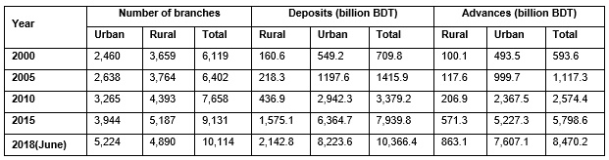
Chart 2: Branches, Advances and Deposits in the Banking sector of Bangladesh, Both urban and rural division. (Source: Bangladesh Bank statistics, Banking regulation and policy department)

3.3 Financial Access through POS & ATM
To streamline interbank electronic payments from different payment channels, for example, ATMs, Internet banking, and Points of Sale (POS), and so forth, in December 2012, Bangladesh Bank has declared the National Payment Switch Bangladesh (NPSB). The real motivation behind NPSB is to proceed as an ace switch and connection all other payment switches in Bangladesh. Of the 58 banks that lead business with cards in Bangladesh, interbank ATM exchanges of 51 banks and POS exchanges of 50 banks are communicated through NPSB. The number and volume of interbank exchanges at ATMs and outlets through NPSB are expanding quickly.

3.4 Financial Access through Mobile Banking
The mobile financial services market is at an initial stage of expansion, create agent networks with banks working to stabilize their technology, and obtain new customers that includes hiring and improving agents through training, publicizing, clients that inhabit the process and acquisition of customers through the use of account opening processes and customer knowledge. A study by the central bank of Bangladesh, Bangladesh Bank, revealed that new facilities are being available in more areas and that maximum agents and consumers are sharing thoughtful assurance approximately the value of MFS for them.

Despite the fact that more than 20 banks, including private companies and state-owned banks in Bangladesh, work in mobile financial services, there are only two banks: bKash from BRAC Bank and Rocket from Dutch-Bangla Bank Limited (DBBL) are dynamic. in the market. Both are included 100% in terms of the nation's land territory. However, some banks focus on the "banking segment" while others focus on the "cash flow". Mere "cash flow" cannot contribute to financial inclusion. As a bank-supervised model, MFS should focus on investment funds and additional loan projects and offer different types of assistance in an isolated portfolio (account). More attention should be paid to improving banking appetites among the country's population. This will bring a large amount of money into the banking channel and contribute to the nation's authentic financial inclusion and monetary development.

Bangladesh has seen significant development in the recognition of mobile banking. This segment recorded a normal development of over 60% in all main limits, as confirmed by information released by the Bank of Bangladesh.

In terms of aggregate and dynamic mobile banking customers, this portion grew 78% and 84% year-on-year, individually. As of December 2016, there were 41.08 million registered customers and 15.87 million regular mobile banking customers who actively use the MFS, contrasting with 31.84 million (total customers) and 13.23 million (dynamic customers) as of December 2015. This expansion also affected the total volume and amount of transactions. There is a 79% expansion in the total transactions and 67% more money has been made each year.

New agents are also attracted by the increasing number of customers and cash flows, there were 0.71 million agents nationwide in 2016, compared to 0.56 million operators in 2015, with a year-over-year growth of 79%.

Bangladesh had a cellular phone customer base of 120.74 million as of October 2016 and an enlisted mobile banking customer of 41.081 million (December 2016), which implies that there is enough room to attract more customers into the system. Additionally, about 58% of existing MFS customers are idle, which is a important portion for MFS vendors to start a rebirth campaign, as reviving existing customer spending isn't exactly attracting new customers.

Internal remittance by MFS has also increased 20.81% to Rs 63 million in the spring, up from Taka 5.481 million in February, the Bank of Bangladesh's latest information indicated.

Nevertheless, to show the growing illicit use of MFS in 2017, the Bangladesh Bank lowered the daily mobile payment limit to 15 thousand BDT instead of 25 thousand BDT, also lowering the largest withdrawal breakpoint from powerful to 10,000 BDT of BDT. 25,000 The largest monthly cash limit has been lowered to 100 thousand BDT from 150 thousand BDT and the more extreme monthly withdrawal limit to 50 thousand BDT from 150 thousand BDT.

3.5 Financial Access through Micro-finance Institutions
In Bangladesh, there are mainly four types of institutions involved in microfinance activities. They are:
- Grameen Bank (GB),
- Commercial and specialized banks such as Rajshahi Krishi Unnayan Bank (RAKUB), Bangladesh Krishi Bank (BKB).
- About 1500 non-governmental organizations (NGOs) such as Proshika, BRAC, ASA, CODEC, BEES, BURO-Tangail, TMSS, SUS, Action-Aid, etc.
- Government-sponsored microfinance projects/programs such as Swanirvar Bangladesh, BRDB, RD-12 and others that are implemented through various ministries, in particular the Ministry of social protection, the Ministry of Youth and Sports, the Ministry of Women's and Children's Affairs etc.

Among the above four types of MFI, number 3 only serves as financially included organization as others offer only credit without providing an opportunity to deposit and savings. Rather all programs are aimed at functionally poor rural people without a land. All MFIs offer one-year loans, mostly small and unsecured, to people from peer groups and use similar methods of lending and weekly funding to form village organizations or centres.

However, MFI in Bangladesh is an important vehicle for financial services for people who are financially excluded. The provision of credit to the poor characterizes the main impetus for the functioning of MFIs in the country. In order to institutionalize the microfinance business and make an inclusive financial sector, the Microfinance Regulatory Authority (MRA) was created as the regulator of the microfinance sector. Prior to this, the microfinance regulatory agency monitored the microfinance institutions and their activities through MRA regulations, MRA laws and circular supervision, on-site and off-site management. MRA has issued 805 MFI licenses until June 2018. In addition, it has issued a provisional license to 128 MFI to carry out microfinance undertakings. During the 2018 fiscal year, 705 MFIs with license and 128 MFIs with one provisional license spent over BDT 1,350.0 billion for 30.5 million customers and total savings in the MFI sector exceeded 270 billion BDT at the same time. (Source: Microcredit Regulatory Authority)

3.6 Financial Access through Agent Banking
The agent banking is a recent innovative financial inclusion tool that provides easy access to customized financial products for disadvantaged, rural and poor segments of the population, particularly in geographically remote areas through bank outlets where the establishment of branches is either impossible or extremely difficult. Moreover, agent banking allows meeting the financial needs of the rural population at an affordable cost.

The "Guidelines for agent banking" were published in December 2013 and, subsequently, in June 2014, a "Guidance note for the registration and operation of banking agents for banks" was issued to accelerate a safe and regular alternative to financial services for people who are not using any bank accounts. Through this, agents can offer a variety of banking services, including depositing and withdrawing cash, transferring funds, paying bills and paying salaries. To deepen inclusive growth, banks were advised for maintaining a 2:1 ratio for the opening of rural and urban outlets.

In June 2018, 20 banks obtained authorization for banking through agents, 17 of which began fully to operate the agent banking currently. The number of points of sale increased from 3,224 to 5,351 and the number of account holders increased from 0.87 million to 1.78 million in June 2017 to June 2018. The total balance of these accounts increased to 20, 12 thousand million BDT in June 2018 against 6.51 billion BDT since June 2017. Until June 2018, ex-pats from Bangladesh sent coins equivalent to 35.14 billion BDT through these accounts.

3.7 Financial Access through Co-operative Institutions
In expanding access to finance in rural areas, the cooperative sector also performs a vital role. Cooperative societies are regulated by the cooperative management in accordance with the "National Cooperative Law 2012". As of March 2018, 176,841 cooperatives were operational in Bangladesh. The number of beneficiaries was 10,684,749, including 2,386,647 women and 8,288,102 men. The total outstanding amount of loans to beneficiaries was BDT 188.84 billion.

3.8 Financial Access through Insurance
At present, 77 insurance organizations (31 disaster protection organizations and 46 non-life insurance organizations, including 2 government-owned insurance organizations) provide insurance services in the country. The regulatory agency of the insurance industry is the Insurance Development Regulatory Agency (IDRA). As of the end of 2013, the gross income were 76.78 billion BDT, contributed for 0.091% of GDP. All resources of the disaster prevention organization are Tk. 235.451 billion, the absolute resource of general insurance organizations is Tk. 77.07 billion. Despite the numerous backup plans and the rapid development of the department, there is almost no insurance service for low-paid customers.

Insurance services include takaful, general insurance, life insurance, microinsurance, and reinsurance. As of the end of 2017, the number of investors was 15,854,336, of which the number of store accounts was 16,929,199, the number of additional life secure accounts was 14,618,866, and the number of stores without disaster protection was 2,310,323. During the same period, there were 14,384,772 disaster-prevention investors and 1,469,275 non-life insurance companies.

Chapter Four
Recommendations and Conclusion

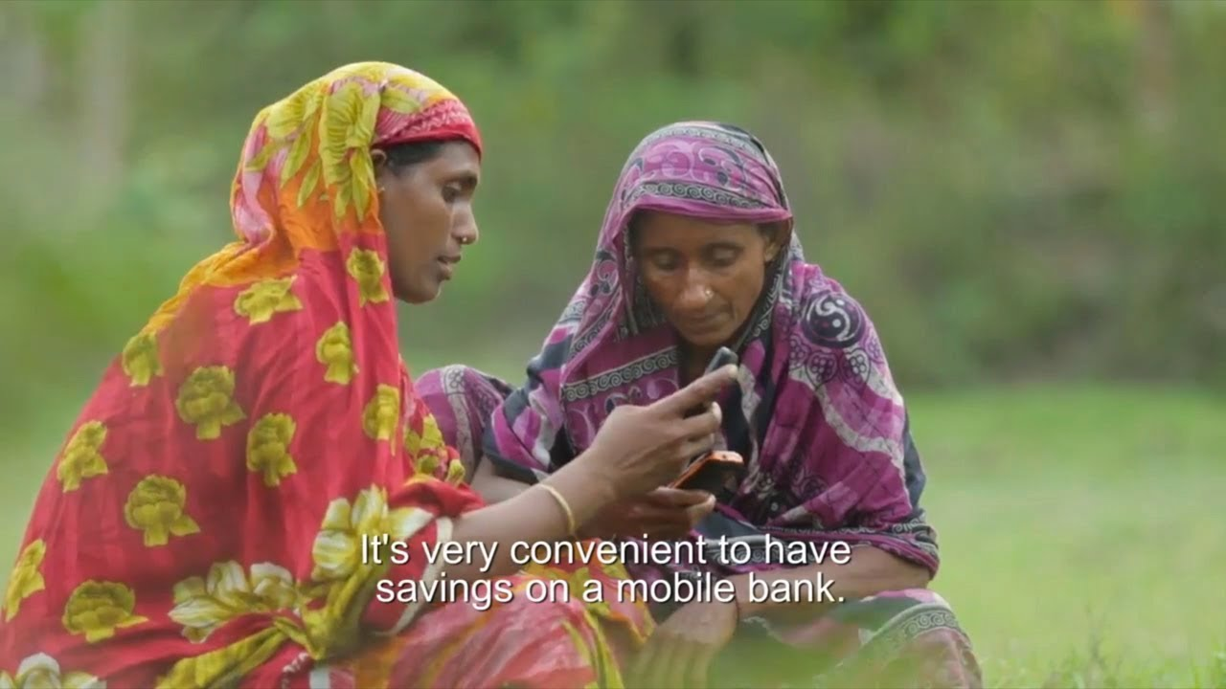
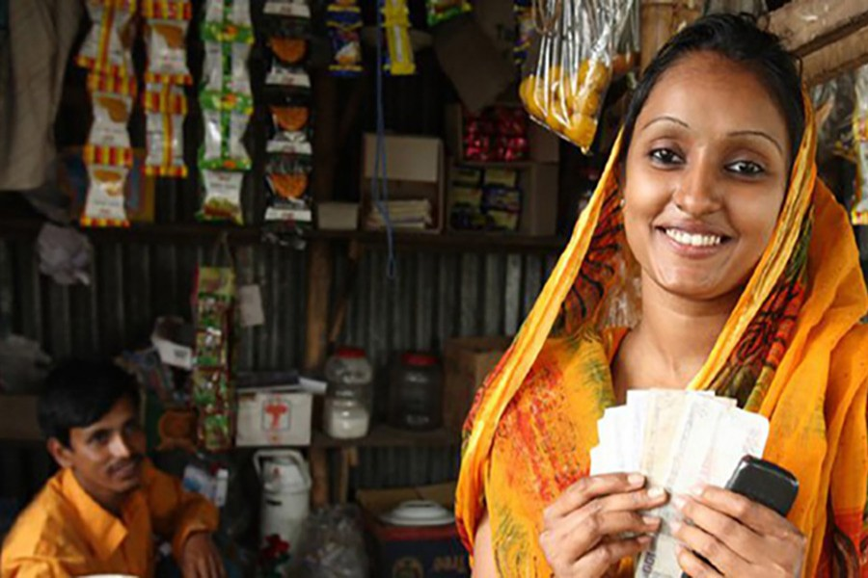

4.1 Recommendations
As mentioned earlier, more and more people in Bangladesh live in rural areas and are not included in the scope of financial inclusion. Furthermore, although it is difficult to bring such a huge population into financial inclusion, it is not impossible. As we all know that their inclusion in financial service opportunities can help Bangladesh's economy can grow rapidly. Therefore, here are some suggestions for financial inclusion challenges that make it difficult for rural residents to join the county-level financial system:

- Regional banks or specialized rural banks and rural financial institutions will have an important role to play in promoting financial inclusion for inclusive growth. The government should launch an awareness campaign because the knowledge of banks helps people understand their services and needs, thus promoting financial inclusion and inclusive growth.

- Unit banking system is a great way to provide access to all kind of rural people. Unit banking is a single bank, usually a small bank that provides financial services to local communities. A single bank is independent and has no branch banks in another region. Suppose, if a bank opens in the 'Manoharpur' area and gives it a name as 'Manoharpur Bank', locals in the Manoharpur area would be interested to open an account because it feels closer to other banks.

- There are several obstacles to the country's financial sector to stimulate financial inclusion. The first one is the lack of adequate infrastructure. Proper infrastructures should be built to encourage the banks and other finance institutions to invest in rural areas. The country's literacy rate is even lower. Technological innovation, the introduction of alternative business models and data accessibility can create a unique opportunity to build financial inclusion.

- Bangladesh is often one of the most corrupt countries in the world, according to several of the major ranking agencies. Therefore, financial institutions always focused on the high risk of corruption when operating or investing in Bangladesh. Corruption is ubiquitous throughout society, and companies have stated that they are bound by expensive and unnecessary permits and licensing requirements. Anti-Corruption Act, Criminal Law, Criminal Procedure Law, and Money Laundering Prevention Act criminalize extortion, bribery, money laundering, active and passive bribery, and holding public health or state information for personal benefit. Therefore, financial institutions are usually at high risk of corruption if they try to operate in distinctive places. Bangladesh Government should concentrate on it and implement necessary improvements to improve financial inclusion.

4.2 Conclusion
The study objective is to analyse and prepare a study on the financial inclusions of Bangladesh. Throughout the report, it has been found that Bangladeshi Banks are actually offering a varieties of financial products and services to its population, but the service rate that are provided to the people are mostly served to the urban people and only a few rural areas of Bangladesh are currently served by the banks or their branches. Moreover, Bangladesh is about 20 crores of people living here where most of them are living in the rural areas and Bank should recommend to start unit banking system there. The access to financial services are also provided through mobile banking and it is found that a lot of adults of Bangladesh are being attracted toward using this mobile financial services. The agent banking is another way to provide access to financial services but all bank pf Bangladesh should utilize it in all district as well as rural areas. The insurance facilities are not good enough and there are lack of trust for what people not insure their life or property from any insurance company. More awareness programs should be promote to educate people to know the advantages of using financial services.

Reference
(a) G20 Action Plan for Financial Inclusion: Available at http://www.gpfi.org/news/g20-action-plan-sme-financing-self-assessment-consolidated-progress-report-2019
(b) G20 Financial Inclusion Indicators, available at https://www.gpfi.org/sites/gpfi/ files/Indicators%20note_formatted.pdf
(c) Arp, Friesjov; Arvina, Alvian (2017). "Microcredit for Poverty Reduction: Does Transnational Initiative Ignore Fundamental Issues of Competition and Intermediation?" United Nations Conference on Trade and Development. 24 (3): 103-117. doi: 10.18356 / 10695889-en. UNCTAD / DIAE / IA / 2017D4A8
(d) "Financial Services for the Poor-Aid", archived at the Australian International Development Agency's (AusAID) Wayback Machine on February 12, 2014.
(e) M. Mostak, Sushanta K. Malrick (January 1, 2019). "Is financial inclusion good for bank stability? International evidence." Journal of Economic Behavior and Organization. 157: 403-427. doi: 10.1016 / j.jebo.2017.07.027.
(f) "Financial Inclusion (20012-2016) | UNDP in Bangladesh". Archived from the original on December 22, 2012. Retrieved September 22, 2019.
(g) M. Duvendack; Mader, P. (2019). "The impact of financial inclusion in low- and middle-income countries: a systematic review of reviews." Campbell's systematic review. 15. doi: 10.4073 / csr.2019.2.
(h) Country Case Study of Bangladesh on financial inclusions, Determining Appropriate Service Charges Based on Microfinance Institutions (MFIs), Available at the website of Microcredit Regulatory Authority (MRA) of Bangladesh.

