

Project report on:
The Jungle- Eco Resort Limited and its Marketing Challenges

Submitted to:
Mr. Muhammad Rehan Masoom
Assistant Professor
School of Business & Economics
United International University

Submitted by:
Samsun Nesa Samia
ID: 111-141-439
Major: Marketing
School of Business and Economics
Date of submission: 30/08/2018

Letter of Transmittal

Date: August 30, 2018
Mr. Muhammad Rehan Masoom
Assistant Professor
School of Business & Economics
United International University

Subject: project report on “The Jungle Eco Resort Ltd. and the Marketing Challenges’’
Dear Sir,
It gives me immense pleasure to submit the report on “The Jungle Eco Resort Ltd. and the Marketing Challenges’’. This report is submitted as requirements to fulfil the Bachelor of Business Administration (BBA). I am thankful to you, as you have allowed me to conduct the project and to submit the report. Actually I have enjoyed more in preparing this project report. I have tried to work hard to prepare this report. So I would highly oblige if the content of the report have been acceptable to you.

Though I have put my best efforts yet it is very likely that the report may have some mistakes and omissions that are unintentional. So, I hope that the report will worthy of your consideration.

Yours Sincerely,
____________________
Samsun Nesa Samia
ID- 111141439
School of Business and Economics
United International University

Declaration

Samsun Nesa Samia is a student of Bachelor of Business Administration (BBA) major in marketing of school of Business & Economics does hereby declare that the project report on ‘’The Jungle Eco Resort Ltd. and the Marketing Challenges’’ This is my original work and has not been submitted by me before for any degree, diploma title or recognition. It is persuade under the supervision of Mr. Muhammad Rehan Masoom Assistant Professor.

--------------------------------------
Yours Sincerely,
Samsun Nesa Samia
ID- 111-141-439
School of Business and Economics

Certification of Supervisor

This is to certify that, Samsun Nesa Samia is a student of Bachelor of Business Administration (BBA) bearing ID-111-141-439 of United International University, major in Marketing under the faculty of Business and Economics department has successfully completed project report on “The Jungle Eco Resort Ltd. and the Marketing Challenges’’. I have gone through the report and found in to be a well written report. She has completed the report by herself under my supervision.

----------------------------------
Mr. Muhammad Rehan Masoom
Assistant Professor
School of Business & Economics
United International University

Acknowledgement

I would like to express my immense gratitude towards my supervisor, Mr. Muhammad Rehan Masoom, Assistant Professor, SOBE, United International University without whom this work would not be possible. It was during times of uncertainty and blinding knowledge gap that he took the lead, paving my way towards my goal.
The report titled as “The Jungle Eco Resort Ltd. and the Marketing Challenges’’ has been prepared to fulfil the requirements of BBA degree. I am very much fortunate that I have received almost and sincere guidance, supervision and co-operation from various persons while preparing this report. Many people have responsible in making this report. I am grateful to all those people who have at least minimum effort and contribution to complete report. I feel so much lucky to get their co-operation.
Moreover, I browsed through the internet getting the information. So, I thanked modern technology for making information available for us and make our life so easier as well as provide as much as information as one needs. Finally I would like to thank my friends and family for their constant support and influence. Without the support of my family it would not be possible to be where I am and without the support of my peers I might not have succeeded in what I am doing.

Table of contents

Letter of Transmittal 1
Declaration 2
Certification of Supervisor 3
Acknowledgement 4
Executive summary 7
Chapter 1: Industry analysis 8
Future outlook and trends 8
Analysis of competitors 9
Market segmentation 9
Industry and Market forecasts 11
Chapter 2: Description of Venture 19
Services offered by Jungle Eco Resort Ltd 19
Office Equipment and Personnel 25
Chapter 3: PRODUCTION PLAN 28
Manufacturing Process 28
Machinery and Equipment 33
Names of Suppliers of Raw Materials 36
Chapter 4: OPERATIONAL PLAN 41
Description of Resort’s Operation 41
Flow of orders for goods and services 49
TECHNOLOGY UTILIZATION 50
Chapter 5: Marketing plan 55
Market Analysis 55
Situational Analysis 55
Marketing Strategies 63
Chapter 6: Organizational Plan 81
Form of Ownership 82
Organogram and Job Responsibilities: 86
Evaluation of Weakness of the Business 93
Chapter 7: FINANCIAL PLAN 97
Assumptions 97
Pro forma Income Statements: 97
Cash flow projections: 110
Pro forma Balance Sheet 122
Break Even Analysis 124
Ratio Analysis: 125
References 127

Executive summary

Tourism business in Bangladesh is now very emerging as tourists from different countries visiting frequently here. Thousands of hotels and resorts offering luxurious and target customer oriented facilities also. As a result, these hotels and resorts come out with the competitions between them. It is very challenging to introduce a new resort with the surrounding competition and situation.

Inclosing The Jungle Eco Resort Limited in the area of Bhawal National Park will not only facing a marketing challenge, but also facing a difficulties to attract local and foreign people. Again, our main target customers are the affluent class, we are providing premium and royal services at a high or premium price. People now a days love to pass their leisure time in places like fresh air and comfort. So, naturally our potential customers will be the modern people who have a sense of eco-tourism also the adventure loving people who will get the proper fun of jungle resort.

Now if we look closer into our country then we can understand the fact that, Bangladesh is gifted by many mountains, rivers and places for living with friends and family in peace. It will be easier to starting this resort with the eco comfort environment. People also love to spend their holidays in such a place with eco ambient and mood.

The main objective of this resort is to arranging an exciting and mind blowing holiday package for the target customers. As per study, the possibility of annual growth rate is 6.1% near up to 12 years. We can easily contribute to the annual growth rate by running this resort in that area.

Industry analysis

Future outlook and trends

The tourism industry is sort of a growing line of business in Bangladesh, where the evolution predominantly has been left to the local market forces. Today this market has both rural and international tourist players striving for the small-scale existing market, primarily composed of a local visitor market and overseas business market. the Bangladeshi government and private tourist zone are represented by organizations, nonetheless co-operation, strategies and policies aiming at developing a prosperous and viable tourist industry are rear - and not always implemented if they exist.
To improve the Bangladeshi tourism business successfully a local based strategy is essential - without visions, missions, goals and policies for this line of business the evolution is largely uncontrolled. Here by there is a hope that an unwanted or destroying tourist development takes place, often influent by powerful foreign tourist list. Political and/or private initiatives can control a national tourism development as well as introduce initiatives to reinforce the influence of local communities. The political history of Bangladesh seems to indicate that the private sector should have a large influence if the national tourism progress is to be sustainable and consistent. The future tourism strategy should have two primary aims.
First, the development has to be sustainable including economic, cultural and environmental considerations. The term sustainable can be determined as: “Development that meets the needs of the present without compromising the ability of future generations to meet their own needs”. As tourism often causes both positive and negative influence on a destination the phenomena and control of a sustainable development is complex. Every destination has an ultimate sustainable load, but a generally and objective definition of this sustainable limit do not exist.
The second aim for a Bangladeshi tourism strategy is that actions should be taken to increase the tourist income by raising the numbers of tourists, the income per tourist or the average length of stay. In this regard it is obvious to focus on existing local markets as well as to aim for the traditionally profitable inbound tourist market. The low existing inbound tourism demand indicates that foundation product and promotion improvement is required. To meet the expectations of the overseas market investments in the existing infrastructure and other tourism related services seems to be necessary. Likewise product development must result in a desired tourist product, which must take existing Bangladeshi attraction supply and foreign demand into account. The Bangladeshi destination already awakes life lessons and eye-opening experiences to expatriates and some of the existing product potential lies in trekking, beach resorts, wildlife and the everyday life of the Bangladeshi people.
One possible national product improvement strategy therefore is to develop the Bangladeshi tourist destination inspired by the philosophy of responsible travel. This philosophy “redefines the way people travel around the world. The responsible traveller wants a holiday that minimizes his/her impact on the environment and detrimental influence on local cultures, while simultaneously enlightening themselves about the world abroad. The responsible target market generally travel for a longer time period, they would most likely buy a guided roundtrip in Bangladesh and/or including nearby countries e.g. Nepal, India, Burma and Bhutan.
The Bangladeshi tourism industry can be criticized for lacking marketing professionalism, which is severely damaging the industry’s inbound and expatriate tourism growth. The solution is that the local operators’ provide the tourists with truthful, well researched and easy-to understand information on what a journey to the country will be like, and why it will be eventful for. In the process of accessing new foreign tourist, markets the expatriates can be considered a vital springboard, as one can never underrate the power of the word of mouth. Before Bangladeshi tour operators can do any kind of job reaching the outside world, they need to convince the expatriate market first.

Analysis of competitors

Initially The The Jungle Eco Resort Limited will have two distinct types of competitors. Mermaid Eco Resort is currently operating in Cox’s Bazar. But as The Jungle Eco Resort Limited. will be situated in Bhawal National Park area which is only 45 km from Dhaka. So there won’t be any direct competition with Mermaid Eco Resort. There is another resort named Panigram Eco Resort, which will come into operation within a few months. The The Jungle Eco Resort Limited will also have to compete with other resorts like Jamuna Resort, Padma Resort, Najimgarh Resort, Zastat Resort etc. Other hotels in tourist destinations across Bangladesh will also act indirect competitors for The The Jungle Eco Resort Limited But there is no competitor in the jungle resort sector and so it will act as a Point of difference for the business venture.

Market segmentation

Our main target customers are the affluent class, we are providing premium and royal services at a high or premium price. So naturally our potential customers will be the modern people who have a sense of eco tourism also the adventure loving people who will get the proper fun of jungle resort. Our main customers are the Dhaka city people who will need a break from there monotonous life and wanted a break from all the stressful workaholic life. Therefore, they will come to our resort because it’s a 1 hour drive from the Dhaka international Airport. It is just 45 km away from Dhaka. So they will be our main customers.

We can divide the market in these 5 classes.

Higher middle class:
They are the driving force of any economy. They inject the maximum number of money to the economy. And these types of people spend a lot in their travelling, leisure and vacation purpose. They are our one of the important customer.

Upper class People:
These class of people always looking for relaxation and comfort for these they travel mostly in the foreign countries. Now The Jungle Eco Resort Limited providing the perfect opportunity for them to spend their vacation in our eco-friendly Jungle resort.

Garment Bound Foreigners:
In the Gazipur area there are a lot of garments factory. In these garment factories each week, many foreign buyers of suppliers come to meet with the owners of the garments or to see the facilities of the garments or to place order. However, they have to go back to Dhaka city for their accommodation. Nevertheless, our Jungle Resort provides them a unique opportunity to enjoy the natural beauty of Bangladeshi cultural and they can finish their work because it is very near from the Gazipur industrial area. Therefore, the foreign buyer also can overcome the pain of travelling Dhaka and come back again in the next morning.

Foreign tourist:
Approximately 0.4 million foreign tourists visited Bangladesh in last year. The market expected to grow by 8 to 10 percent a year. Therefore, there are ample scopes for foreign tourist to come enjoy the scenic beauty of Bhawal National Park as well as our Jungle resort. It is a 5-star International standard jungle resort where we are providing all the modern amenities at a premium price. However, from our jungle resort people will get a unique opportunity to be in the countries 1st ever true eco resort. Therefore, it will be a major tourist attraction for the inbound foreign tourist.

The expatriate community:
There are no official documents related to the expatriate community, however different countries with embassies or consulates in Bangladesh can be interpreted as having a huge level of nationwide activity and interest in the country. the 40 countries with domestic consulate in Bangladesh the total numbers of expatriate is averaging 13000 -16000 foreigner, primarily from India (5000-6000 persons), America (2400-2500 persons), Pakistan (1000-2050 persons) and England (around 2500 persons). The sum of expatriated Europeans is just over 3000. Annual household earnings is in generally high; 20 % earn US$60,000 - US$79,999, 16 % US$80,000 - US$99,999, 14 % US$40,000 - US$59,999 and a total of 38 % earn more than US$60,000. Therefore, they also can be our one of the primary target customer, who wants to spend their leisure time in the calm and quiet place of the The Jungle Eco Resort Limited which is far away from the pollution from the Dhaka city, but also situated so near to the city.

In these 5 categories we can segment our market. Dhaka resident are our main customers but others cities like Shylet, Chittagong’s affluent class people is also our target customer. Because of Our The Jungle Eco Resort Limited is only one hour drive from the Hazrat Shahjalal International Airport. So they can easily reach in our The Jungle Eco Resort Limited after they reached Hazrat Shahjalal International Airport.

Industry and Market forecasts

Overview of the Tourism Industry
Bangladesh, a country situated in the Southern Asia, which has been blessed with immense bounties of nature. The country is amongst a few in Southern Asia with varied cultures for ages. The country has its unique and delicate attractions to offer for both domestic as well as foreign tourists.
The tourism industry of Bangladesh is quite young but has a huge impact upon the national economy. Recently the effect is growing since the size of the tourist market is growing. The market is small with both foreign and local players. The entire industry is multifaceted and it includes hotels, resorts, dining places, tour operations, transportation agencies and all the details that is required for catering to the tourists.
The recent government in power is promoting the country as Beautiful Bangladesh and encouraging tourism. The consumers, who are the tourists, are always keen to explore around the beauty, acquire knowledge and feel the amusement. They visit destinations that offer opportunities that involve all these. So, the tourism industry of the country has a bright future if the tourists are guided in a structured manner about the treasures that the country possesses.
We believe the industry can be exploited by investing in the components. However, there is a lack of tourist place that is just a few kilometers from the capital city, Dhaka. To enjoy a weekend the inhabitants of Dhaka have rely on just a few places. Therefore, we want to mainly emphasize on the recreational facilities available for them with a Jungle Eco Resort.

PESTLE Analysis

Political & Environmental Factors:
The government of Bangladesh is a democratic one which allows both economic and political freedom within the country. For the tourism industry, it is a blooming time, since the government in power; itself is promoting inflow of tourists and branding the country as Beautiful Bangladesh. The country is trying to establish itself as a rising star in terms of tourism in South Asia.

The government has also opened up the economy and is encouraging investments and is offering unparallel support to investors. The investment promotion agency, Board of Investment, is working towards attracting and facilitating investments. And as a result of the reformed policy structures of the government that promotes tourism and the elements incorporated with it, it would be beneficial for our The Jungle Eco Resort Limited
The political conditions of the country are usually full of aggression. However the present government is more cautious about the development of the country, they have set the vision of creating a Digital Bangladesh within 2021. They are trying their level best to remove corruption and at the same time they are promoting tourism for the country.
The country’s infrastructure and environment plays an extremely important role for the tourism industry. If the environment is not friendly all around then neither it will attract the potential investors nor will it attract the tourists in to the country. The infrastructure development is also of utmost importance for the growth of the tourism sector because if the tourists cannot reach to their desired destination then the entire tourism sector will not flourish.
The Government is eager to establish ‘Tourism sector’ as a fast growing industry. To Promote The new Slogan of promoting Bangladeshi tourism is ‘Beautiful Bangladesh’. The 2011 year has been chosen as tourism year naming 'Visit Bangladesh-2011' to welcome 1.0 million tourists and continuation of tourism promotion starting from the ICC Cricket World Cup.
Below is a document by Bangladesh Parjatan Corporation about the tourism sector of Bangladesh.
Table 1
Tourism Vision 2020

Bangladesh Parjatan Corporation has come up with a study, which once again confirmed immense prospect of country's tourism.
‘’The study Called 'Bangladesh Tourism Vision 2020' forecast that tourist arrivals to Bangladesh likely to exceed 1.30 million by 2020. If recommended actions are taken, WTO Tourism 2020 vision study forecasts average annual growth Rate of 6.10 per cent between 1995 and 2020 for south Asia and BPC's Bangladesh forecasts at least 500,000 visitor arrivals by 2020. According to recent trend in arrivals, the BPC study indicates average annual growth rate in tourist arrivals to Bangladesh would be much above the WTO estimates. "It is fairly realistic to forecast that total arrivals to Bangladesh would reach about 900,000 in 2020. Even, the number of tourists may exceed 1.30 million provided that the favorable market situation prevails". The study-tourism vision 2020 - determined that Bangladesh would cash in on the following critical factors.

- A positive image will exist and prevail.

- Political stability is firmly established.

- Bangladesh will become a single destination like Maldives, Malaysia and Singapore.

- Approximately 1.30 million tourist will visit Bangladesh each year following the year 2020 and the growth rate will continue to rise.

- Target to contribute to the GDP of Bangladesh, at least 4-5 percent from the tourism industry.

- The communication network will be well established both internally and externally.

- The investment for the sector will come from both the government and private sectors.

- The products will be diversified and improved and marketing systems will develop.

- Liberal and easy travel system will be introduced by Bangladesh and other countries.

So the Government is trying its level best to promote tourism. Moreover, we are promoting green technology and do not harm the nature. Government is encouraging new investor to invest in this potential sector. Thus in the recent 2011-2012 budget they are offering ‘Tax Holiday’ for 10 years. We are not intended to cut any of the trees in the forest. Also preserve the Bhawal National Park From any unwanted accident or encroachment. Moreover, plant tress to preserve the beauty of the Forest.’’

Economic Factors:
According to the World Bank Bangladesh Economic Update, the real GDP (Gross Domestic Product) is projected to grow at around 6.2% in the fiscal year 2011 up from 5.8% in the fiscal year 2010. This means that the domestic demand would remain strong with consumption expenditures receiving a boost from increased public and private wages and investment has likely to have increased as well. The revenue performance has also been better than expected and reveals a good economic performance of the country.
On the other hand inflation is rising; the consumer price index stands to be 10.5% in March 2011 which has been significantly contributed by a rise in food prices which is 13.9%.
The new policies that have been made portray a mixed picture. The tax reforms have gained momentum and the VAT law by the National Board of Revenue is yet to be presented to the Parliament. The tariffs on power have been increased as well.
According to the Travel and Tourism Competitiveness Report 2011 of the World Economic Forum Bangladesh is ranked 129th.

Social Factors:
The Bengali language is used primarily all throughout the country but recently there is a wide usage of English although most of the people do not know the language very well. However, for catering to the foreign tourists the ones associated with the services should have a clear and complete understanding as well as speaking skills of the language where the industry significantly lacks expertise.
There are also other social factors, which have a significant impact on the tourism industry such as negative acceptance from the local people for several tourism activities such as casino, bar etc.

Technological Factors:
With the emergence of technology, the tourism sector has also progressed rapidly. Through the assistance of internet, the consumers can access the required information of all the competitors. Therefore, the firms operating in this sector needs to take into account such factors.

Legal Factor:
The government of Bangladesh is promoting hard for increasing the number of tourist arrival in our country. Last year alone nearly 4,00,000 tourist came to Bangladesh. However, most of them coming to the country for Business purpose. To Promote the Tourism sectors in Bangladesh Government has selected this sector as a thrust sectors. Special facilities and venture capital support will be provided to export-oriented industries under "Thrust sectors". The detail policies and objective are given below:

Bangladesh National Tourism Policy
The National Tourism Policy of Bangladesh was declared in 1992. Its main objectives are:
- To create interest in tourism among the people

- To preserve, protect, develop and maintain tourism resources

- To take steps for poverty-alleviation through creating employment

- To build a positive image of the country abroad

- To open up a recognized sector for private capital investment

- To arrange entertainment and recreation

- To strengthen national solidarity and integrity

In line with the policy, the Bangladeshi Government provides incentives to attract private sector partners. The incentives include tax-holiday, loans, concession rates for taxes and duties and in specific cases, allotment of land etc.

The Porter’s Five Forces Analysis

Bargaining power of suppliers:
The tourist industry of the country is not very well structured however there are ample suppliers of the ancillary services for the tourism sector as well as the resort industry in Bangladesh. There is an abundant labor force interested to work for this industry and suppliers of the materials required to run the industry are also widely available. Therefore they have a moderate bargaining power.

Bargaining power of customers:
The customers in this industry have a moderate power however, it is moving towards high. Nevertheless, this depends on the type of tourists they are. For the ones targeting a long holiday they have both inside Bangladesh and outside the country options and so for this section of the tourist, they have a high bargaining power. On the other hand, the tourists who would seek a short holiday and that too near Dhaka have a low bargaining power since for this section there are not many options.
On the other hand the domestic tourists are not as sophisticated as the ones coming from other countries, but they are extremely willing to spend their vacations at attractive tourist places.

Threat of new entrants:
There is a high threat of new entrants, since the government of Bangladesh is promoting and encouraging tourism in the country, therefore many private as well as foreign investors will be willing to invest in the tourism industry. The increasing rates of return on the investments in tourism would also act as a catalyst for the entry of new entrants.

Threat of substitutes:
For the tourist seeking for a place near Dhaka, there is not much of a choice apart from the theme parks or other resorts that have been built. Therefore, the threat of substitutes is quite low. However for the ones seeking a longer holiday, they have the options of getting betters services abroad.

Competitive rivalry between existing players:
There is high competition amongst the private initiators and amongst the foreign investors in the tourism industry.

ABELL’s Framework

What consumer’s need:
The people living in Dhaka pass a life where they are always immersed in the noise and busy life of the city. At times they need to take some time out and relax with their family. But there are just a few places that are near by the Dhaka city, because most of the spots are located at regions far away from the capital, that they can choose from to satisfy this need.

How can the need be fulfilled:
A resort nearby Dhaka offering a unique mode of relaxation with tranquility, beauty of nature and an elegant taste of Beautiful Bangladesh.

How our organization can fulfill the need:
The The Jungle Eco Resort Limited, spreading over 20 acres of land, will be situated within the Bhawal National Park, about 45 km north of Dhaka city in Gazipur, Dhaka division. The resort would cater especially to the upper-middle and upper class citizens of Dhaka who are indulged in their busy lives and have little time to spare to long holidays. It will also cater to foreign tourists who would comprise of business delegates of the factories nearby and to tourists who come to Bangladesh for enjoying the natural beauty itself.
The ultimate aim of the resort is to provide an exclusive taste of Bangladesh as ‘The School of Life’ mentioned by Bangladesh Tourism Board and offer relaxation and serenity for the busy city dwellers as well for the foreign tourists.

SWOT Analysis

Strengths:
  - Bangladesh is a country with rich culture and history, that offers a variety of natural and cultural tourist destinations, some on the Unesco heritage list.
  - The domestic transport, whether it is by air, land or water, is affordable although the existing time-consuming transportation by road, rail and water can be an adventure with the right positive attitude.
  - Bangladesh is reasonably new and rarely visited inbound tourist destination, which can attract an adventure searching tourist market. The world image of Bangladesh can be inspired by several new sustainable tourist attractions to increase the understanding of the country’s history and growing challenges.
  - The tourism industry consists of low construction, running and salary expenses and the labor force is reliable and abundant.
  - People of Bangladesh are generally very hospitable and tourist friendly.
  - Awareness about tourist attractions among the local community is increasing.
  - Domestic tourism is increasing steadily. Due to two-day holiday in the week, the trend of moving out for recreation has increased mainly among the middle class people of the society.

Weakness:
  - Many factors, such as the amount of garbage and the condition of several attractions, indicates that the existing tourism business is not sustainable or viable.
  - The accessibility to tourist destinations and accommodations is negatively affected by non-availability of moderate infrastructure, including domestic and international transportation.
  - The condition of the structural product and promotion requires development. Tourism products should relate to the fact that Bangladesh is a modern Muslim society and a massively populated developing country, which has been historically isolated.
  - Additionally tourists, especially the tourists coming from abroad, need a guide or prominent knowledge to travel safely and responsibly in Bangladesh. Many of the tourist goods available are not up to the mark when compared to western quality of service.
  - The time required for travelling and the safety issues act as a obstacle in the industry.
  - The Bangladeshi level of investments in travel & tourism is not extraordinary, but the tourism industry is vulnerable due to a short high season and a large local market share. There is a lack of knowledgeable staff.
  - The tourism industry is still quite new in Bangladesh, and its development has been predominantly left to the local market forces.
  - The tourism development is largely uncontrolled as no marketing or developing policy exists, in spite of the fact that the Bangladeshi government and private tourist sector are represented by several organizations such as parjatan and toab.
  - There is a lack of knowledge about the demand, supply and competitors in the Bangladeshi tourism business.
  - There is also a low level of co-operation and innovation in the tourism sector. The tourism industry lacks marketing expertise, which is severely crippling the industry’s inbound tourism advancement. In the home market, every company is generally on their own when they want to promote their target. It is costly and ineffective for local operators to reach the worldwide market at the current time.

Opportunities:
- The country embraces lenient democracy, and has a homogeneous society with single prominent religion. The interim government provide travelers with a form of relative stability while struggling with corruption and bureaucratic mechanism.
- Regardless of some destructive instances, the national economy is getting better and the country is showing positive development.
- The seasonal weather is comparatively stable; especially the winter season is comfortable for travelling.
- The people speak Bengali and English – the latter by the well-educated urban people.
- The number of tourists in Bangladesh is predicted to increase due to generally growing local, regional and world tourism travel activities.
- Responsible tourism is a growing world market niche. A tourism culture is also being developed.
- Globalization is also affecting the dissemination of information and there is scope for expansion of communication media.
- Globalization is also affecting the dissemination of information and there is scope for expansion of communication media.

Threats:
  - Infrastructural advancement is needed for the tourism industry to expand; specifically the state of the roads and rails is a serious obstacle for the tourism sector.
  - Technological development is also required for the industry.
  - The climatic changes throughout the year have substantial implications for travelling in Bangladesh as the country every now and then experiences harsh storms, floods also earthquakes.
  - The country also has a worldwide image of poor land with plenty of natural catastrophes and corruption.
  - The national tourism sector is negatively affected by the lack of social and political commitment.
  - The preservation of natural and historical attractions is just one of the challenges that the Bangladeshi society has to deal with.
  - Additionally, there is a strong competition among the region that is with the neighboring countries in this industry.

Description of Venture

The Jungle Eco Resort Ltd. will be the new address of entertainment and adventure for the people who want a new flavor in passing their holidays. This resort is offering a bundle of services along with the core service of it and that is accommodation. The main objective of this resort is to arranging an exciting and mind blowing holiday package for the target customers. It is very tough to find natural beauty in the concrete jungle of the Dhaka City. It is the promise of The The Jungle Eco Resort Limited to give the guests of the resort a flavor of the real Jungle and natural beauty.

Services offered by Jungle Eco Resort Ltd

Core Service:
• It has been previously said that, our core service offered to the customers is the accommodation facility. Actually The Jungle Eco Resort is providing the bundle of natural beauty along with an adventurous trip to the forest to its guests. There are some supplementary services added to the core service. The accommodation facilities are really impressive. The Jungle Eco Resort Ltd is providing all the modern accommodation facilities to the guests. It is expected that the target group will response positively to the service. It will be an experience for the customers that they are living in a Jungle but enjoying a total 5 star accommodation facilities.

• Accommodation facilities will be of two types- cottages and single rooms. The accommodations would be built from environmentally friendly materials such as processed wood/ bamboos/ processed clay with thatched roofs. The huts would be built in different styles showing the unique mode of relaxations of the different ethnicities of Bangladesh.
• In the following section we need to describe what types of facilities are being provided along with the accommodation. Previously, we did mention that The Jungle Eco Resort Ltd is providing the 5 star accommodation facilities to its honored guests. First of all, each and every room will be air conditioned, so that the guests will not be screwed up in the summer season. Moreover, they can use room heater in the winter time. The toilets are neat and clean and the guests will get hot and cold water facility according to their demand.
• In the room there will be a cupboard for keeping clothes. A television with satellite connection and a refrigerator will be given as well for the benefit of the guests. For the smokers, we will keep a corner in each room which will be considered as the smoking zone for that particular accommodation.
• Intercom service will be provided for every room. The authority will ensure 24/7 room service for the guests visiting The Jungle Eco Resort Ltd. So, we can see that in this resort the guests will be offered a bundle of supplementary services which could be comparable with the popular 5 star residential hotels of the country.
• A waste treatment plant will recycle the waste generated at the resort. In end of the day the employees of The Jungle Eco Resort Ltd will separate the food wastes, paper and bottles for recycling. This feature will ensure the eco-friendliness of the resort. There will be an integrated waste treatment plant to sort out these wastes.
• Food wastes will be recycled to generate fertilizer that again will be used in the organic farming of vegetables the resort serves to the guests.

Transportation:
• The main target segment of the Jungle Eco resort Ltd is the habitants of Dhaka. The Jungle Eco resort Ltd targeted the people who are listed in the socio-economic class A living in Dhaka. As the target market is the premium people so they could manage their own transport to reach the venue that means Bhawal National Park. The transportation facilities provided by the entity will be available inside the national park. The guests will be transported from the national park gate to the resort by Tomtom.
• Inside the The Jungle Eco Resort Limited our guests will be offered a number of transportation facilities. Of them, the most exciting service will be the elephant ride. There will be elephant rides offered from our end if the guests want to roam inside the forest. The elephant ride will start at 9:00 am in the morning and to 6:00 pm at the evening.

• Besides the elephant ride individual guests can also enjoy Horse ride inside the jungle. This offer is specially promoted targeting the newly married couple and the young people who are fond of adventure. Besides the Horse ride, the guests can also trek inside the jungle and enjoy the environment inside the forest. Inside the forests, there will be a number of small restaurants situated in the tree houses.
• Moreover, the entity will offer transportation facilities for the foreign tourists. Here a number of minibuses will be available for picking and dropping the foreign guests from airport. The guests can reserve their cottages and rooms through the website and have the chance to contact with the authority before flying to Bangladesh, so that resort management team will have the idea of how many foreign tourists are coming to the eco resort on a particular day.

Tree Houses:
• The Tree Houses will be another interesting part of the Jungle Eco Resort Ltd. There will be around 10-20 tree houses which will serve the purpose of bird watching, enjoying the view and restaurants. It needs to be mentioned that one of our restaurant and tea stalls will be established in the tree houses. Among the tree houses 1 will be used to set a restaurant which will be used for Breakfast, Lunch and Dinner.
• Beside the restaurant, every tree house is consists of a tea corner where the guests can have tea, coffee and other refreshments. The tree house will be built in such a height that the guests can get the view of the entire resort as well they can see different types of birds and animals of the buffer zone. Moreover, it is mentionable that there is a lake inside the buffer zone. During the winter season, a number of guest birds visit this lake and that scenery can also be viewed by the guests from the Tree houses.
• Therefore, The Jungle Eco Resort Ltd is actually providing the guests a complete ecofriendly environment inside the resort and the Tree House is one of the important parts of it.

Food:
• The guests in the Jungle Eco Resort Ltd will be served with delicious and quality food. We will have two restaurants inside the resort and each of them will have a capacity of at least 700 people.
• One restaurant will be named as Beautiful Bangladesh. Here the people will get a feel of different areas of Bangladesh like: The Sundarbans, Cox’s Bazar, Hill Tracts, Tea Gardens etc. There will be different zones inside the restaurant. Respective zones will represent different lifestyle and cuisines popular in different regions in Bangladesh.

• The special cuisine will include different special dishes of different areas of the country. Like Mutton Leg piece of old Dhaka. The aim is to give a feel of total Bangladesh to our guests.
• Another restaurant will be named Global Cuisines. Here, people will have the food from different parts of the world. Like: Chinese, Thai, Indian, Continental, Italian etc. Like the Beautiful Bangladesh, this restaurant will be divided into different regions and the theme of that particular region will represent the lifestyle of that country. Like the Indian part, the people will feel that they are in front of Taj Mahal.

• Most of the vegetable that will be served in these restaurants are produced in the resort, all the vegetables will be free from any kind of chemical fertilizer, only herbal fertilizer like manure of cow or food waste will be used there.

Swimming Pool:
• There will be no traditional swimming pool inside the resort. That does not mean that the authority is not providing swimming facilities to its guests. Here, the swimming pool will be an actual ecofriendly swimming pool. What is an Eco Friendly Swimming Pool? Here we go.
• The swimming pool will be lake shaped and the tiles of the pool will be colored green. There will be a number of trees and plants in the swimming pool zone. The theme color of this area will be green. Moreover, the employees of the Jungle resort who will work inside this zone will wear an uniform which also reflects the ecofriendly concept of this area.
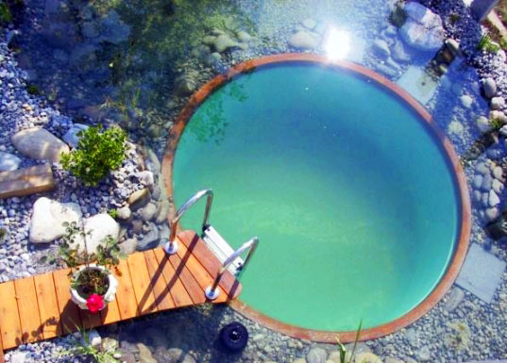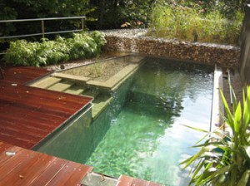

Laundry and Beauty Salon:
• The guests who will stay in the The Jungle Eco Resort Limited will get the service of the laundry and beauty salon as well. It is very natural that clothes might get dirty because the guests will roam inside the Jungle. But the laundry service will ensure that there is an opportunity for the guests they can get their attires clean and ironed within 12 hours.
• The beauty salon will have an optimum capacity of serving around 20 customers so that the customers will get a quality support inside the resort for making over.

Fitness Center:
• As the entity has promised the guests providing 5 star facilities there will be a gymnasium and yoga center. The guests can have access to these services as well. The gymnasium will be kept opened from 10:00 am to 6:00 pm every day. The Yoga center will follow the same time schedule. These services will actually add value to the Jungle experience of the guests of The Jungle Eco Resort Limited.
• Herbal Steam Bath: Even if you're used to the heat or not, these natural rock steam-rooms, with its temperatures of up to 45 degrees Celsius, is sure to open up your pores. And then there's the cool plunge-pool with its cascading waterfall, where you can lay back and relax, enjoying the view across to neighboring tropical weather.
• Private Jacuzzi Bath: The usage of water with minerals, essential oils, herbs, is always beneficial to our body, also enhanced relaxation, increases energy, freshens up body, As a result, our body and mind are more relaxing calm and metabolism is stimulated.

Conference Hall:
• Two types of conference hall will be available inside the resort. One is air conditioned and with modern amenities. The specialty of this conference hall is it is a mobile conference hall. The capacity of this hall is 150. This hall is a mobile one. It is situated on a boat. So the corporations can arrange the conference in a suitable environment and on the lake.
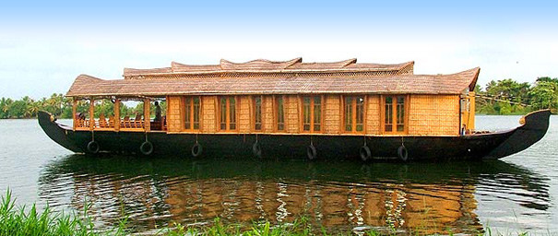

• Another conference hall will be established outside the buffer zone. This hall will consist of all modern amenities but it is not air conditioned. The hall will be built by bamboos and boards. There will be projectors and stand fans for heat removal.

Medical Facilities:
• In the part of the medical facilities, the The Jungle Eco Resort Limited will go for outsourcing. Here, we will have a medical contract with Apollo Hospitals. A fully equipped medical team of Apollo Hospitals will be present in the resort 24/7.The on duty doctor will prescribe medicines for any case of illness of the guests as well as the employees of the resort. If there occurs an emergency situation for a particular patient then he/she will be moved to the Apollo Hospitals by the ambulance. There will be one ambulance stand by for serving the emergency patient of the resort.
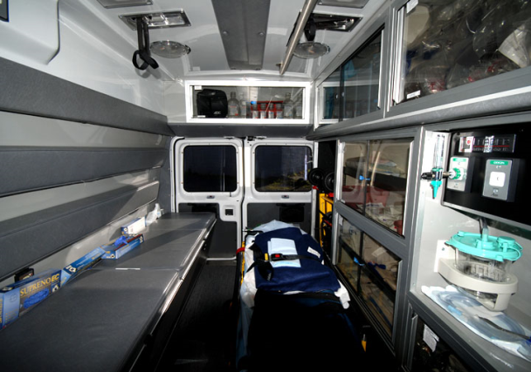

Security:
• As this is a resort consisting of, Jungle that means there will be wild animals, the Jungle Eco resort Ltd has taken the security issue as a major one. The entire resort will be bordered by wired fence and there will be CCTV camera inside and outside the buffer zone. Each of the cottages will be attached with smoke detector because the cottages will have fire places. The smoke detector will be also established inside the jungle to avoid the accident of fire. There will be metal rod inside the buffer zone which will protect the jungle from lightning and other natural calamities.

• Besides these systems, there will be a number of armed guards inside the buffer zone and in the gate. The CCTV camera will be monitored all the time and there will be a 24/7 patrol party in the resort who will also served as ERT (Emergency Response Team). The guests who will go for trekking inside the jungle will be associated with an armed guard so that they could be safe in case of unwanted incidents.

Dummy Village:
• There will be a dummy village inside the resort, which will be used for the residential purpose of the employees of The Jungle Eco Resort Limited Here, the people will live near the resort and can actually work with full motivation. The family members of the employees will be engaged into cottage industry so that they can earn a better living. The products produced from the cottage industry will be sold in the souvenir shop of the resort. Moreover, the authority has targeted the foreign tourists in this case. Here, they can actually get an idea about a village of Bangladesh.

Office Equipment and Personnel

Office Equipment:
As it is a huge project going to be launched so there will be a lot of equipment for generating the operation. These office equipment include Furnishers, Stationeries, Horses, Elephants, CCTV camera, Stand Fans, Computers, Wire, and Guns etc. In the following sections we will give a list of the equipment.

Office Equipment | Numbers/Categories
Furnishers | Beds, Cupboards, refrigerators, television, Dining Table, Sofa set a bundle of this thing for each of the room.
Stationeries
Horses | 15 for individual rides, 12 for tomtoms
Elephants | 5
CCTV Camera | 100
Stand Fans | 15 Stand Fans for the conference hall, 7 stand by.
Computers | 15 Desktop computers, 15 laptops for the high officials.
Wire
Guns
Transport | Minibuses ( 4), Hero Honda automobile (3) Station Wagon (5), Truck (2), Toyota Priyus Hybrid car (3).
Telephone | Each for the rooms, Wireless for the security personnel,  The top management will use Blackberry Enterprise Service offered by Grameenphone.
Others | It includes refrigerators for restaurants, Music system etc.

The entire organization will be paper less. It is true that paperless office is tough to find so we have to manage the hard copies of the important files. However, we will maintain a database for information regarding employees and customers thus we need to promote the paperless approach inside our organization.

Personnel
There will be a huge work force needed for accomplishing the project aims and goals. The total management will be under the board of directors. Here is the proposed organogram of the organization.

Board of Directors

CEO

COO
(Chief Operational Officer)

CCO
(Chief Communication Officer)
CTO
(Chief Technological Officer)
CMO
(Chief Marketing Officer)
CFO
(Chief Financial Officer)

Size of business
The type of business will be partnership. Where every member will be having a equal number of share. So our five partners will be having 20 % of share in the venture. It is a partnership business so our business will be formed in accordance with the partnership act 1932. And the business will be operated in line with the partnership act 1932.
It will be a medium sized business. The initial investment of our company will be around Tk. 3-4 billion. We will be taking SME loads from Standard Chartered Bank. There is a huge prospect in Eco tourism. For these purpose the government is encouraging the banks to finance in the eco- tourism projects. So we will get the loans easily. We will take up to 40% of the project finance from the bank. And the rest will be providing by us.
We will be able to serve a maximum capacity of 260 resident tourists in our resort everyday with the assistance of our 50 cottages and 30 rooms.

PRODUCTION PLAN

Manufacturing Process
The government is promoting eco tourism and for these there is a circular for all the commercial bank to give loan for the eco-tourism project. So getting finance from any of the project is not a very tuff task. We are approaching Standard Chartered Bank Ltd for the SME loan. I hope that we will get the loan amount within 3 month.
In the mean time we have to get the permission from the forest department, also we have to meet the District Commissioner of the Gazipur District and convinced him that we will not harm the environment also we will work to protect the Jungle from the encroacher. And we also have to take a clearance from the Department Of Environment (DOE), that we will not doing any harm to the environment. Therefore, we will easily get a ‘No Objection Certificate’ from the Department Of Environment (DOE).
Then we will have to get a trade license, and then register our company in the Bangladesh Hotel & restaurant Act 1982. Then we will stick a contact with the government to lease the land for 30 years, and then it will be renewed with every 5 years. In addition, the Government will lease the land at 90,000 taka per acre for every 5 years and it will then increased by 10% every year. We will acquiring 20 acres of land. After finishing all the necessary fieldwork, we can start our construction work. We have decided to give our construction project to the Concord group, who will finish the work within 1 year.

The items that need to be built for The Jungle Eco Resort Limited:

Accommodation areas:
Building the two types of accommodation facilities to be made available to the guests arriving at the resort. It would include fifty single rooms and eighty cottages which would be made from environmentally friendly materials (processed wood, processed clay, bamboo and thatched roof). The cottages would be made in different styles, keeping in mind the houses of the different ethnicities living in Bangladesh.
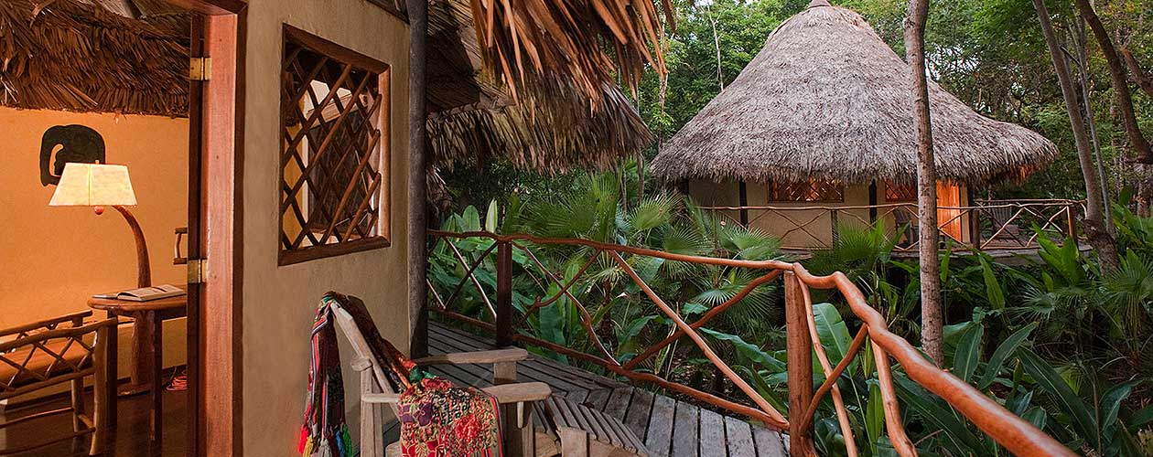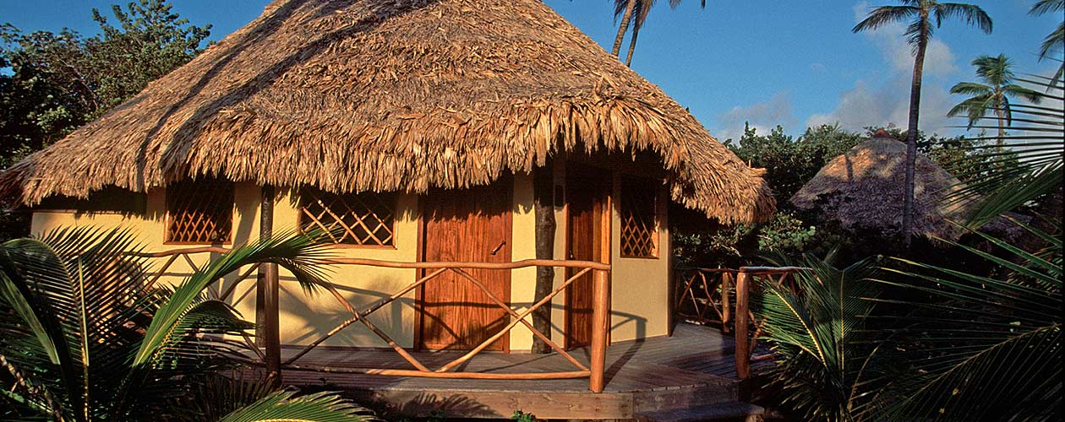

Restaurant areas:
Building the two types of restaurants with the look and feel of the names. The Restaurant named Beautiful Bangladesh would be built using the theme of the Beautiful Bangladesh School of Life video for the Tourism Board of Bangladesh incorporating each corner with the thirteen schools portrayed in the video. The other restaurant Global Cuisines which would serve the world’s top ten cuisines would be given the look and feel of the ten styles: French, Italian, Chinese, Indian, Thai, Mexican, Japanese, Spanish, Greek and Lebanese look and feel in each corner designated to serve the respective cuisines.

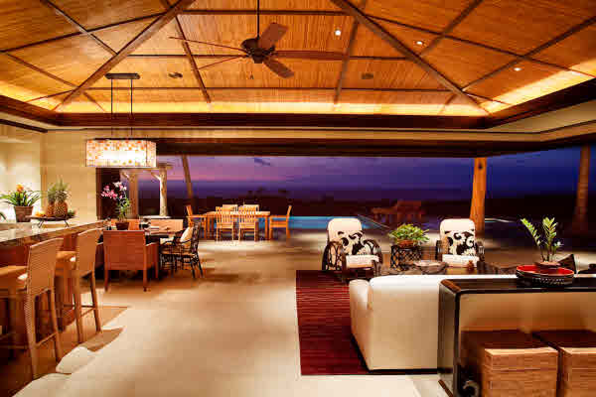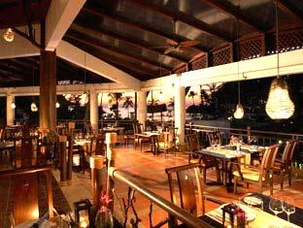

Tree Houses:
Ten structures to be built using bamboo and having a thatched roof would be set up using the support of the trees at a height from where the guests arriving can have a view of the entire resort. In all the tress houses there would be the facility of finger foods and hot and cold beverages. However, two of these houses would also serve main courses of food to the guests.
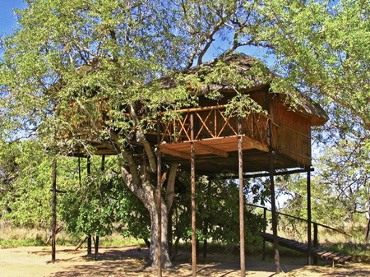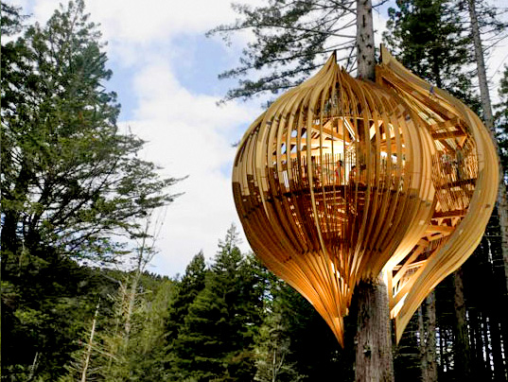

Eco friendly swimming pool:
The swimming pool will be lake shaped and the tiles of the pool will be colored green. There will be a number of trees and plants surrounding the boundary of the swimming pool zone giving it a green colored ambience.
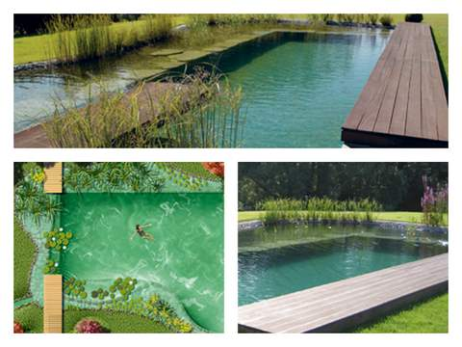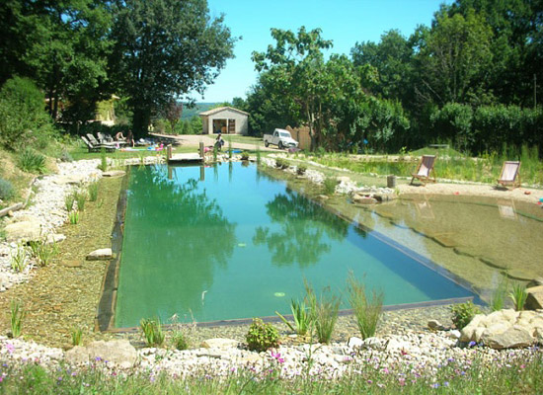

Beauty Salon:
A salon would be built within the resort premises. This salon too would give the feel of being in an eco friendly place and thus would be green themed with the exterior being fully decorated with trees and flowers.
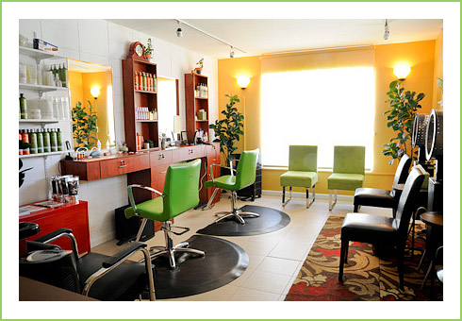


Gymnasium and Yoga centre:
Both of these would be built in midst of the jungle. The gym would have the modern amenities and the yoga centre would have a jungle and ethnic feel.
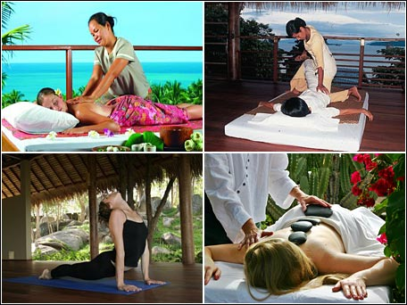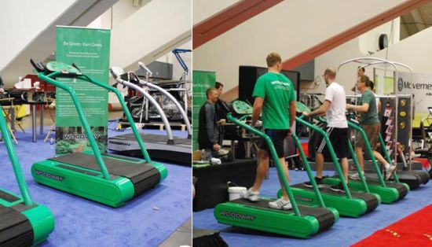

Conference Centers:
Two types of conference hall will be available inside the resort. One is air conditioned and with modern amenities. The specialty of this conference hall is it is a mobile conference hall. It is situated on a boat. So the corporations can arrange the conference in a suitable environment and on the lake. Another conference hall will be established outside the buffer zone. This hall will consist of all modern amenities but it is not air conditioned. The hall will be built by bamboos and boards. There will be projectors and stand fans for heat removal.

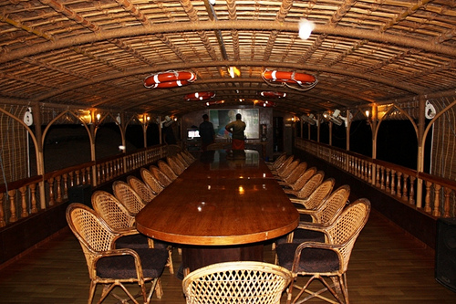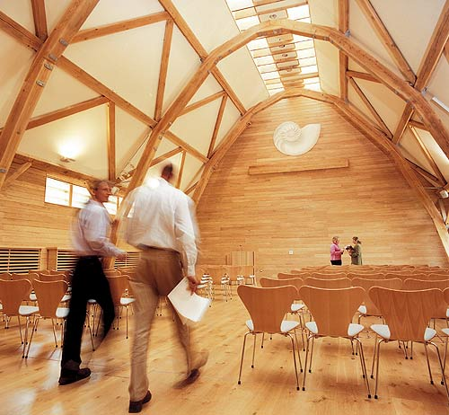

Dummy Village:
A green area for the employees of The Jungle Eco Resort to reside in and their families to engage in cottage industry providing the materials to be sold as souvenir to the guests.

Garden:
A garden preserving all the rare flowers would be set up within the premises of the resort.
- Lake for Farming fish
- Field for growing the organic vegetables
- Space for the cultural shows that is the hall named: School Of Celebration

Souvenir Shop:
The School of Happiness, a shop selling the items made by the families of the employees residing in the village

Machinery and Equipment

Equipment and materials required on site:
Table 2
Sl | Requirement | Quantity
1 | Single beds made of processed wood | 300
2 | Energy saving lights for rooms | 400
3 | Fans with low energy consumption | 150
4 | Air conditioners for rooms | 130
5 | Bathroom fixtures (the whole set) for rooms | 130
6 | Room decorations (carpets, curtains, tables, sofa set, dressing table, cupboards, chairs, telephones etc) | 130 sets
7 | Electricity generation through solar power plant
8 | Lamps for the tree houses | 50
9 | Sitting services for the restaurants ( table and chair sets) | 24 sets
10 | Kitchen settings for the restaurants (all requirements) | 2 set
11 | Laundry equipments (full set) | 5
12 | Beauty Salon ( full set up) including seating arrangements and sitting stations | 1
13 | Gymnasium with all equipments | 1
14 | Conference centre full set up for inland setting :chairs | 70
15 | Mobile conference hall (chairs) | 150
16 | Tables for conference halls | 2

Timeline for manufacturing process

2012
Item | Jan | Feb | Mar | Apr | May | Jun | Jul | Aug | Sep | Oct | Nov | Dec
Apply For Capital Acquisition
Completion of Architectural design
All Legal Paper work (Registration in hotel Act, Trade Licence, Clearance from The Department Of Environment, SME loan granted)
Acquisition of land
Land Development & Remodelling
Plantation of trees
Phase 1 Construction commences (exterior)
Phase 1 Construction ends
Phase 2 Construction commences

2013
Item | Jan | Feb | Mar | Apr | May | Jun | Jul | Aug | Sep | Oct | Nov | Dec
Phase 2 Construction commences
Phase 2Construction ends
Test run process and training
Teaser Advertisement campaign
Production ends

Names of Suppliers of Raw Materials
Table 3
Sl | Requirement | Supplier | Address
1 | Single beds made of processed wood | Otobi Group | Plot 12, Block CWS , Gulshan South Avenue, Gulshan 1, Dhaka 1212, Bangladesh.  Tel: +880 2-8833151-60, +880 2-9863219-20, +880 2-9862370.  Fax: 880 2 885207.  Email: contact@otobi.com
2 | 0Energy saving lights for rooms | TRANSCOM GROUP | Sadar Road, Mohakhali  Dhaka-1206  Tel: 8855371-80  Fax: 880-2-8810055  e-mail: info@transcombd.com
3 | Fans with low energy consumption | G.F.C Fan House | Address:  Mohan Electric Market, 142, Nawabpur Road, Shop # 1  Dhaka-1100
4 | Air conditioners for rooms | AKAI ELECTRONICS | Sales Office Address:  Jibon Bima Tower (Level-12),  10, Dilkusha C/A,  Dhaka-1000, Bangladesh.  Tel:  +88-02-9571634-6, 7171184-5  9558535, 9554048, 7171873  Fax:  88-02-9572057, 9551577
5 | Bathroom fixtures (the whole set) for rooms | Bangladesh Insulator & Sanitary Ware Factory Ltd. | Address:  BCIC Bhaban, 30-31, Dilkusha C/A Dhaka  Telephone:  +880-2-8011231, 8014115, 9000715  Fax:  +880-2-8011326
6 | Room decorations (carpets, curtains, tables, sofa set, dressing table, cupboards, chairs, telephones etc) | Otobi Group | Plot 12, Block CWS , Gulshan South Avenue, Gulshan 1, Dhaka 1212, Bangladesh.
7 | Electricity generation through solar power plant | Guangzhou Occren Energy Technology CO., Ltd | Address: No 560., Dongjiaobei Road, Yuexiu District, Guangzhou, China  Marketing center hot line: +86- 13802405683 +86-20-81802295 Fax: +86-20-81802295  Email：sales@occren.com
8 | Lamps for the tree houses | TRANSCOM GROUP | Sadar Road, Mohakhali  Dhaka-1206  Tel: 8855371-80  Fax: 880-2-8810055  e-mail: info@transcombd.com
9 | Sitting services for the restaurants ( table and chair sets) | Otobi Group | Plot 12, Block CWS , Gulshan South Avenue, Gulshan 1, Dhaka 1212, Bangladesh.
10 | Kitchen settings for the restaurants (all requirements) | Otobi Group | Plot 12, Block CWS , Gulshan South Avenue, Gulshan 1, Dhaka 1212, Bangladesh.
11 | Kitchen settings for the restaurants (all requirements) | Otobi Group | Plot 12, Block CWS , Gulshan South Avenue, Gulshan 1, Dhaka 1212, Bangladesh.
12 | Laundry equipments (full set) | Bandbox Ltd | Ashulia-EPZ Highway  East Narashinghapur  Ashulia, Dhaka  Phone: 7788131-5
13 | Beauty Salon ( full set up) including seating arrangemnts and sitting stations | Otobi Group | Plot 12, Block CWS , Gulshan South Avenue, Gulshan 1, Dhaka 1212, Bangladesh.
14 | Gymnasium with all equipments | HOSSAIN SPORTS | Shop #6, New Elephant Road, Aziz Super Market  Dhaka  Tel: 8612754
15 | Conference centre full set up for inland setting :chairs | Otobi Group | Plot 12, Block CWS , Gulshan South Avenue, Gulshan 1, Dhaka 1212, Bangladesh.
16 | Mobile conference hall (chairs) | Otobi Group | Plot 12, Block CWS , Gulshan South Avenue, Gulshan 1, Dhaka 1212, Bangladesh.
17 | Tables for conference halls | Otobi Group | Plot 12, Block CWS , Gulshan South Avenue, Gulshan 1, Dhaka 1212, Bangladesh.
18 | Transportation | Navana Motors | Navana Toyota 3S Center  205-207, Tejgaon Industrial Area  Dhaka- 1208, Bangladesh  Tel.: 9884992-4  E-mail: info@navana.com  Web: www.navana.com
19 | Elephant, Deer and Horses
20 | Structural Engineering Firm | Concord Group | Concord Center  43, North Commercial Area,  Gulshan 2. Dhaka-1212  Bangladesh.
21 | Interior Designing Firm | Shatotto | SHATOTTO architecture for green living  Apt. # 203, House # 34, Road # 9A  Dhanmondi R/A, Dhaka-1209  Bangladesh  Phone- +88 02 8119702, +88 0666 2615186, +88 01711 641175, +88 01730 427334  Fax- +880 2 8119702, Ext-115  Email- shatotto@gmail.com, info@shatotto.com
22 | Solar Water Heater | Guangzhou Occren Energy Technology CO., Ltd | Address: No 560., Dongjiaobei Road, Yuexiu District, Guangzhou, China  Marketing center hot line: +86- 13802405683 +86-20-81802295 Fax: +86-20-81802295  Email：sales@occren.com
23 | Solar Swimming Pool | Guangzhou Occren Energy Technology CO., Ltd | Address: No 560., Dongjiaobei Road, Yuexiu District, Guangzhou, China  Marketing center hot line: +86- 13802405683 +86-20-81802295 Fax: +86-20-81802295  Email：sales@occren.com
24 | Wood (bermatic and reused wood) | FFIMADIC LTD | Tejgaon, 1208 Dhaka, Dhaka  Country:  Bangladesh  Phone number:  880-2-9881831  Phone number:  +370 5 2640065  Fax number:  880-2-8812988
25 | Paint | Berger paints | Dhaka Depot & Sales Office  272 Tejgaon Industrial Area, Dhaka-1208  Phone : 02-9897717 (Hunting), 02-9892708  Fax : 02-8825770
26 | Brick & Brick Decorative Tiles | Mirpur Ceramic Works Ltd. | House # 1, Road # 28, Banani Model Town  Dhaka - 1213  Bangladesh  +880-2-9891942  http://www.mirpurceramic.com
27 | Meat | Bengal Meat | Bengal Meat Processing Industries Ltd.  Head Office: House # 19-20, Flat No - 3-D  Road No - 113/A Gulshan - 2  Dhaka-1212, Bangladesh  Phone: +880-2-9895207  +880-2-9895201  Email: bengalmeat.intl.business@gmail.com
28 | Dairy Product | Aftab Dairy | Aftab Bahumukhi Farm Limited  Head Office: Islam Chamber  125/A, Motijheel C/A  Dhaka-1000  Bangladesh  Phone : 880-2-9568903, 880-2-9566303-5  Fax : 880-2-9566311
29 | Chicken | BRAC Poultry & Feed Mill | BRAC Centre, 75 Mohakhali, Dhaka:1212. Web : www.brac.net
30 | WebSite, All IT Software & Security Equipment | E.B Solutions Ltd. | House No. 28 Road No. 5 (3rd Floor) , Dhanmondi  Dhaka-1205, Bangladesh  Phone: +880-2-9661770, 9665379  Fax: +880-2-9671815
31 | All Food Materials | Agora Super Store | Rahimafrooz Superstores Limited  Arzed Chamber,  13 Mohakhali C/A, Dhaka-1212,  Bangladesh.  Phone : +8851623-4, 9880316, 8818690, 9888441  Fax : +880-2-9889103  E-mail : info@agorabd.com  Website : www.agorabd.com

OPERATIONAL PLAN
The Jungle Eco Resort Limited has designed all the operational things according to the day to day basis. In the operational plan of this resort every day to day operation and how the services to the customers are going to be performed are included. In an essence, it could be considered as the flow of the activities performed to run the resort in a daily basis. In the following section every service action will be described in details and the flow of the service will be mentioned as well:

Description of Resort’s Operation
The Jungle Eco Resort Limited is offering a bunch of services to their guests. Here, we will see how those services are going to be delivered towards the guests from the authorities’ end.

Room Booking
There are 2 ways of booking an accommodation in The Jungle Eco Resort Limited One is booking online. Specially, online booking service is operated for the foreign tourists. But the local tourists who possess an international credit card can also book a room or cottage in the Jungle Eco Resort through online. Here, the guests need to fill up a form in the internet and pay the charges through credit card. Moreover, the local guests who do not have a credit card can book the room over telephone. In this case, the authority will request the customer to pay the booking fee within 12 hrs otherwise the booking will be cancelled.

Visa Master Card
In the The Jungle Eco Resort Limited the customers can make any sort of payments through their credit and debit cards. There is only one condition. The cards need to be Visa MasterCard. Inside the resort the authority will only accept Debit/Credit cards authorized by Visa.

ATM Booths
Inside the resort there will be approximately 5-8 ATM booths of different banks. There will be one ATM booth where the customers can draw money using their VISA Mastercard. The other ATM booths will be representing different banks. Initially the authority has decided to permit 6 banks to set up an ATM booth inside the resort. They are: Dutch-Bangla Bank Limited, BRAC Bank, Standard Chartered Bank, United Commercial Bank, HSBC and Bank Asia Limited.

Room Service
The resort authority is providing 24/7 room service for the guests. The guests can order their necessary goods and services over the intercom and the service will be delivered within 10 minutes. For instance, a guest might want to change the bed after a night of staying a hotel. In this case, he/she will order for a new bed through the intercom and the room service personnel will be at his/her service within 10 minutes from the order placement.
There will be some cottages inside the buffer zone. For these cottages the room service hotline will be different because the dwellers of these cottages will be served from another room service department. This department will be also placed in the buffer zone so that they can provide the necessary goods and services to the particular cottages within 10 minutes. This special type of room service has been designed to keep the promised time limit.

Transportation
There will be a bus service from the airport, which will take the foreign guests to the resort. This operation will be run not on a daily basis. The foreign guests who actually booked a room or cottage in the The Jungle Eco Resort Limited will be received on the airport by the resort authority, as the reporting date will be notified by the guests to the resort authority. From the main gate of Bhawal National Park, the guests of the resort will be offered a TomTom ride. That means the guests will be taken to the resort with a TomTom, a traditional ride of the old Dhaka.
Other, transportation services are Elephant and horse ride. Here, the guests will need to place an order before a day of the ride. Moreover, we have different packages for the guests. In those packages, different types of rides are included as well. By purchasing those packages the guests can avail the service as well.

Restaurants
There will be two restaurants inside the resort. One is Beautiful Bangladesh which will provide the Bangladeshi food to the guests and another will be Global Cuisines providing world famous dishes for the foreign guests as well as for the local guests. The raw materials for cooking will be delivered from different entities. Like the chicken will be supplied by the BRAC Poultry Farm, Bengal Meat and AFTAB dairies will provide the meat, milk etc. Moreover, the resort restaurants will get seasonal fruits from different locations of Bangladesh. Like Mango from Rajshahi, Jackfruit from Gazipur, Pineapple from Chittagong Hill tracts.
The Furniture inside the restaurant will be supplied by OTOBI Furniture. The electronic equipments will be purchased from AKAI Electronics.

Swimming Pool
There will be no traditional swimming pool inside the resort. That does not mean that the authority is not providing swimming facilities to its guests. Here, the swimming pool will be an actual eco friendly swimming pool. What is an Eco Friendly Swimming Pool? Here we go.
The swimming pool will be lake shaped and the tiles of the pool will be colored green. There will be a number of trees and plants in the swimming pool zone. The theme color of this area will be green. Moreover, the employees of the Jungle resort who will work inside this zone will wear an uniform which also reflects the eco friendly concept of this area.
Most of the packages will include the swimming pool facilities. However, the guests who cannot enjoy the swimming facility due to purchasing a different package which do not have the facility, they can also enjoy the cool swimming pool against paying 200 BDT per Day for the residential guest and 200/ hour for the non-residential tourists.

Conference Hall
We have a mobile conference hall in the resort. This conference hall will be established on a boat and the attendants can arrange their conference through enjoying a boat ride on the lake. All sorts of modern amenities will be provided inside the conference hall. Like the total hall will be air-conditioned and sound proof. As the conference hall is established on a boat, necessary security arrangements will be accomplished before the conference begins.

Medical Facilities
The Jungle Eco resort will make a contract with the Apollo Hospitals for necessary medical facilities inside the resort. 2 Ambulances will always remain stand by for the cases of emergency. Moreover, each and every guest will be provided a hotline number which will be used for any kind of medical queries. Our responsible doctors will receive the call and prescribe necessary medicines to the patient if required.

Souvenir Shop Inventory
The goods which will be available in the souvenir shop will be supplied from the dummy village located inside the resort. The women living in the village will be involved in cottage industry. The products produced from cottage industry will be available in the souvenir shop. It is expected the guests specially the foreigners will be attracted to the souvenir shop because all the products available here are Bangladesh branded. The products will be produced in a large number so that the authority can always keep pace with the demand and the inventories.

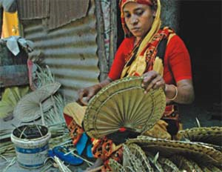

Bar
As The Jungle Eco Resort Limited is providing 5 star accommodation facilities towards the guests so a bar will be there inside the resort. This bar will be opened from 12:00 pm to 12:00 am. There will be some rules and regulations about alcohol. Like: No guest is allowed to drink outside the bar or room. Specially, they are requested not to drink in the buffer zone due to some environmental reason. If any guest wants he/she can get the drink at his room through the room service. For the cottages inside the buffer zone the drinks will be kept in the refrigerator of every cottage. So that, the hassle of the room service department will be reduced somehow.

Security System
One of the important factors in operating the resort is Security. The authority has promised the customers about multiple layers security system inside the resort. As it is a jungle eco resort so there will be animals from different species. The authority is concern about the security inside the buffer zone so that they would like to install some modern security system like: Motion detector, Smoke Detector, Scanner etc.
A group of security personnel will always kept in charge of the CCTV monitor, so that they will see anything unwanted is happening inside the resort. 24/7 patrol party will patrol inside the resort to check out whether there is any accident occur in the arena. If the smoke detector gives a fire signal then the fire rescue team will immediately rush into the spot and will fix the problem. These are all the promised security measures taken by the Jungle Eco Resort authority.

Room Decoration
The rooms and cottages will be designed in a luxurious fashion. Moreover, all the furniture which will be installed inside the rooms and cottages will be purchased from the country’s biggest furniture manufacturer Otobi. Moreover, the total room will be decorated with natural items. There will be a flavor of green nature inside the room so that the guests can have a feeling that they are in touch with the greenery of Beautiful Bangladesh. The architect who will design our project will be Md. Rafiq Azam is one of the internationally acclaimed architects from Bangladesh practicing for the last twenty year. His own "SHATOTTO architecture for green living" since May 1995 will be helping us with the design and structural engineering & construction procedure advice.

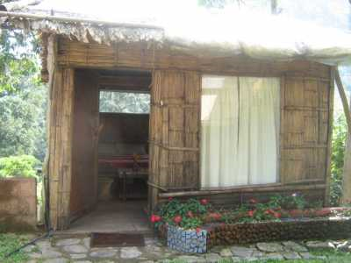

Hybrid Car
At the very start of indulging with The Jungle Eco Resort Limited, guests, when required would be escorted in a hybrid car (Toyota Prius) to give an essence of eco tourism. Inside the resort cycle rickshaw would be used as the mode of transport. Moreover, Elephant ride and horse ride will be inside the resort arena for the entertainment factor of the guests.

Tour Guide
For tourists there would be a biologist guided Bangladesh tour segmented with names used in the ‘Beautiful Bangladesh’ video published by the Bangladesh Tourism Board such as School of Adventure- a trip with trekking facilities. The tourists would be able to choose from a list of tours. Moreover, while trekking inside the Jungle the trekkers will be accompanied with an arm guard and porters to avoid any accident.

Integrated Waste Management:
A waste treatment plant will recycle the waste generated at the resort. In end of the day the employees of The Jungle Eco Resort Limited will separate the food wastes, paper and bottles for recycling. This feature will ensure the eco-friendliness of the resort. There will be an integrated waste treatment plant to sort out these wastes. We will then used the food waste to produced organic vegetables for our respected guest. We will also sort out the plastic bottles and crushed them and make plastic pallet and sell them. And use the money for the welfare of the surrounding peoples live in the nearby villages.

Power Supply in The Jungle Eco Resort Limited
For the electricity we will take a connection from Rural Electrification Board (REB). The total electricity demandof The Jungle Eco Resort Limited will be in between 100-150 Kilo-Watt. So we will own a 50 Kilo-Watt solar plant to meet the daily electricity demands. Also we will have solar water heater, swimming pool heater.
Also we will have a 67 KVa Diesel Power Generator in-case of emergency. However, due to the environmental impact of diesel generator we will not use it unless any emergency situation arrives. We will promote green energy so we will have that 50 Kilo- Watt solar power plant, which will be imported from Guangzhou Occren Energy Technology CO. Ltd, China. And we will provide our necessary power from that solar plant. If that is not sufficient then we will go for other power source.
In our The Jungle Eco Resort Limited we will promote green energy so we will not any power source which is harmful for nature (unless any emergency situation arrives). In the day-time we will prefer the sunlight as our main power source. So the cottages and the other facilities will be open and spacious, and lots of window will be there so that we do not need the artificial lighting.
In the night, we will use different types of candle for our restaurant lighting and the path ways. In the lunar light, the candles will bring a different ambience to the whole situation.

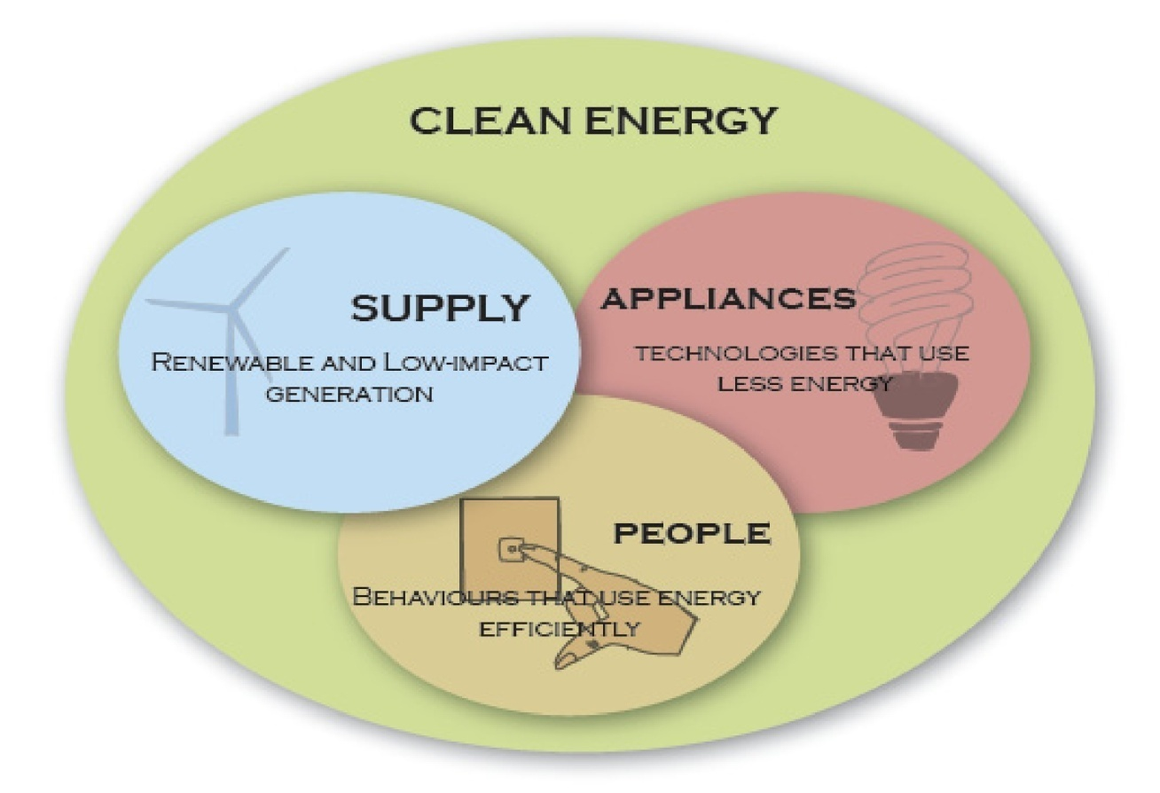

Environmental impact Of using clean energy:

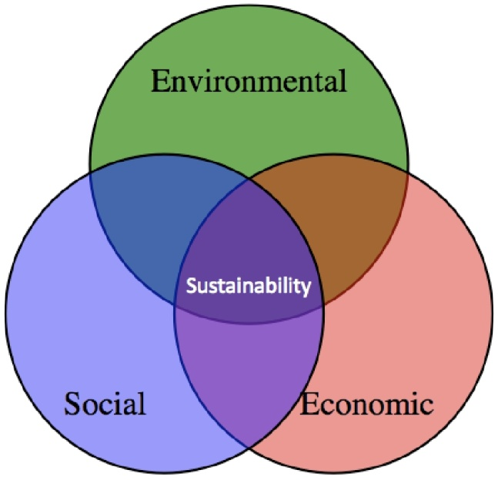

Figure: Sustainability is achieved when environmental, social and economic considerations are all in balance

The environmental benefits from applying clean energy in tourism accommodation include:
- Reducing greenhouse gas emissions
- Minimizing local air, water, soil, air and noise pollution
- Reducing stress on ecosystems (both local and ‘upstream in the energy supply chain’).

The social benefits for clean energy in tourism accommodation include:
- Providing modern electrical and other energy services suitable to meet the needs of business and development needs of the local community (particularly in developing countries)
- Improving reliability of energy supply to provide better user outcomes
- Promoting positive social and cultural outcomes in the local community
- Increasing visibility of the clean energy applications in the industry and community.
- A Best Practice Manual

The economic benefits from clean energy in tourism accommodation include:
- Increasing income through reduced cost of operation
- Making efficient use of available resources and financing
- Increasing customer satisfaction
- Increased access to new ecotourism markets
- Capitalizing on external funding opportunity.

Environmental issue
Inside The Jungle Eco Resort Limited there will be an ultimate eco friendly environment. The authority has promised that it will give the environment to some extent:
- On site rain water treatment plant
- Low flush toilets and usage of bio degradable products
- Usage of solar power as a means of power in the resort.
- Usage of non toxic materials
- All the wastes would be transferred to the recyclers instead of dumping.

School of celebration
Cultural shows would be arranged in the evenings to entertain the guests with regional cultures of Bangladesh. Events such as weddings will also be arranged within the premise. In this case, the The Jungle Eco Resort Limited will arrange different cultural shows on the national days like the Independence Day and the Victory Day. Moreover, special cultural evening will be arranged in the birthday of Rabindranath Tagore and Kazi Nazrul Islam.

Flow of orders for goods and services

Service Design
There will be an order through which the services will be delivered from the resort authorities’ end to the customers. This is actually a chain of order in which every step is important. In the following section there is the blueprint of the service chain of The Jungle Eco Resort Limited are given below,
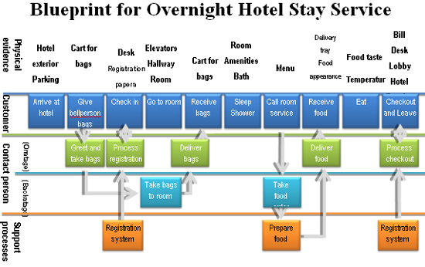

If any step of the total blueprint goes wrong then there will be a service failure. So, the authority will deploy efficient personnel to avoid any kind of unwanted circumstance. In case of service failure customer dissatisfaction will occur and that will ultimately affect the brand equity of The Jungle Eco Resort Limited So, every operational activity should be considered under scrutiny and needs to be checked before execution. The chain will be used for disciplined service performance as well as to maintain the flow of quality service activities throughout The Jungle Eco Resort Limited
The flow of service activities will start when a customer checks the availability of an accommodation in The Jungle Eco Resort Limited in the website or brochures. In the following sections there are the necessary steps of how the operation will be done on a day to day basis inside The Jungle Eco Resort Limited are stated below;

Step 1: The customer search for an accommodation in Jungle Eco Resort Ltd.
Step 2: The customer book an accommodation in the resort through website or a telephone call.
Step 3: The guests are received by the company’s personnel in the airport and in the main gate of the national park.
Step 4: The guests check in the resort.
Step 5: Guests board in the room.
Step 6: They offer the room service
Step 7: The customers avail all type of facilities inside the resort.
Step 8: The customers are offered the remarks book to leave their comments about the resort.
Step 9: The customers check out from the resort after an overwhelming and mind-blowing vacation.

TECHNOLOGY UTILIZATION
The relationship with the client can thus be improved at the information gathering and pre-arrival stage, during the arrival, check-in and stay stage, and also in the departure and post-stay stage. The ability to ‘mine’ data collected from clients and to assess the performance of individual workers and departments also makes it easier to benchmark, compare and differentiate performance across international boundaries while also creating localized improvements (van hoof 1996, 2003).
There are a number of ways that information and communications technologies can improve the performance of an accommodation business and help in gaining competitive advantage (baker et al 1999; baum and odgers 2001; buhalis 2001c; milne and pohlmann 1998). These include:
- allowing a quicker feedback time to market and immediate processing of enquiries;
- integrating various applications to allow smooth processing with reduced errors;
- sharing of resources;
- Increasing power of workflow and worker productiveness;
- Customization and /or standardization of key product offerings;
- Flexibility and the versatility needed to keep pace with a fast moving market,
- and the ability to creating communities of online suppliers and clients (murphy 2003; mutch 1998; sigala et al 2001)

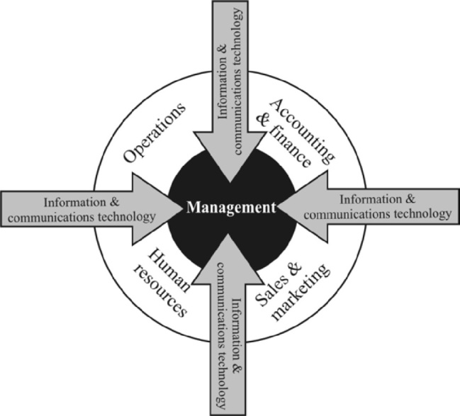

Figure: The integral role of ICT in the Tourism sector
In this 5 star facility providing The Jungle Eco Resort Limited there will be a lot of use of technological devices. All these devices will be used for ensuring a comfort accommodation as well as for the security deployment inside the resort. Moreover, the medical team will use a number of medical devices for ensuring the proper treatment of the guests. In this section, the technological devices which are proposed for use will be mentioned:

CCTV Camera:
100 CCTV cameras will be installed in different locations of the resort. These cameras will use for monitoring the overall arena so that security team can actually identify whether there is any sort of probability of occurrence of an accident or terrorist attacks.



Smoke Detector:
The smoke detector will be used for detecting any type of smoke inside the buffer zone. The guests are not allowed to smoke there. The buffer zone should be protected from fire as this area is the core area of the total resort.


Electronic Key system:
The guests will be provided a card to enter in the room or cottage instead of a key. The guests need to put the card inside a device which will work as a scanner. These devices will be installed outside every cottage and room. If the device signals green then it means that the guests will get access inside the accommodation.

Motion detector:
The motion detector will be used only in the buffer zone. The buffer zone needs to be 100% secured. So, the cottages inside the buffer zone will be under this secured zone. The authority will install motion detector before 100 meter of a single cottage. If any suspected movement is detected then the motion detector will give a signal and the security team will be in action.



Scanner:
The scanner will be used for scanning the luggage and the other materials of the guests and the company personnel. The scanner will be used here for a better secured resort.
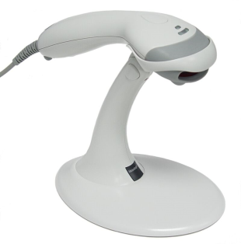

ATM Booth:
The ATM booths will be used inside the arena because of drawing the cash through the credit card or debit card. Also there will be the use of VISA Mastercard especially for the international guests as it is the worldwide accepted financial card for trading and purchasing.
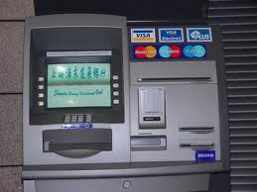

Card Punch Machine:
As The Jungle Eco Resort Limited authority used to accept visa master card in their every operational perspective so there are ample card punch machines. These machines will help the guests to make their transactions through these machines.



Running machines and Gymnasium equipments:
In the Gymnasium there will be number of modern equipments which are used for exercises. The guests will get an access to this gymnasium through extra payment. The equipments are used for different type of physical exercise.
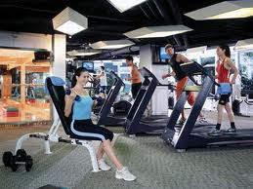

Marketing plan

Market Analysis
Forest-based tourism, commonly known as ‘eco-tourism’ that blends ‘ecology’ and ‘tourism’, is defined as environmentally responsible travel to innate areas, in order to experience and love nature that promote conservation, have a weak tourist affect and provide for beneficially active socio-economic involvement of local peoples. Forest-based tourism is regarded as an effective tool for sustainable management of forest resources and its biodiversity. It plays both maintenance and revenue earning roles. management roles are played in two ways: by keeping intact, and somewhere by improving, the existing forest resources to attract the tourists and secondly by involving the poor forest dwellers, who were removing trees and other non-timber products for their livelihood, in different income generating activities within the ecotourism area.
In Bangladesh forest tourism is a completely untapped market. Even ‘eco-tourism’ is a moderately new concept in the tourism industry of Bangladesh. As a result the jungle eco-resort limited thrives to achieve the first mover advantage and take into account a major market share in the forest eco-tourism sector within the tourism business.

Situational Analysis

SWOT Analysis
The following SWOT analysis captures the key strengths and weaknesses within the company, and describes the opportunities and threats that can be faced by The Jungle Eco Resort Limited

Strengths
- Unique scenic beauty of the forest land in Bhawal National Park.
- Cheap transportation and associated cost.
- Socio-cultural diversity in the project location.
- Favorable tropical climatic conditions for a jungle resort.
- Cheap but skilled workforce.
- Domestic tourism is increasing steadily. Due to two-day holiday in the week, the trend of moving out for recreation has increased mainly among the middle class and upper middle class people of the society.

Weaknesses
- Below par communication network up to the resort location.
- A lack of talent who can work directly face to face with the customer to generate brand and product awareness.
- The management of the resort may not have the experience of running a world class standard resort.
- Majority of raw materials needs to be imported from abroad.
- Difficulty in achieving Economies of scale

Opportunities
- Participation within a growing industry.
- Government initiatives to brand Bangladesh as”Beautiful Bangladesh”. This initiative would draw in many foreign tourists.
- Improved economic condition has resulted in an influx of domestic tourists. The resort will target these well-off tourists.
- Government incentives for setting up eco-resorts within the country.
- An abundance of cheap labor in Bangladesh.

Threats
- The country usually suffers from image crisis. The country continues to remain as an unidentified destination to the tourist generating countries.
- Degradation of natural resources in the project sector.
- Lack of awareness among the tourists relating to environmental issues of eco-tourism.
- Cheap foreign locations as a probable spot for tourism.

Market size
The most common measure of market size is the sum of the revenues of its participants. The following are examples of information sources for determining market size: Government data, trade association data, financial data from major players, customer surveys. From all this sources it can be assumed that the country demands around 500,000 units per year. And most of this demand is met by importing refrigerators from abroad.

Market trends
Changes in the market are important because they often are the source of new opportunities and threats. Moreover, they have the potential to dramatically affect the market size. The current government is supporting the tourism industry in many ways. In line with the policy, the Government provides incentives to attract private sector partners. The incentives include tax-holiday, loans, concession rates for taxes and duties and in specific cases, allotment of land etc.
There has been steady growth in the arrival of foreign tourists in Bangladesh. According to Bangladesh Parjatan Corporation, the number of foreign tourists is likely to reach a million by 2013-2014. The Jungle Eco Resort Limited plans to go into operation by the start of 2014. The growth of domestic tourism is also a major part in determining the market trends. So the tourism industry is getting vast with every passing year and there are ample opportunities to grab.

Market growth rate
A simple means of forecasting the market growth rate is to extrapolate historical data into the future. While this method may provide a first-order estimate, it does not predict important turning points. A better method is to study market trends and sales growth in complementary products. Such drivers serve as leading indicators that are more accurate than simply extrapolating historical data.
According to the market trends, the tourism industry is growing considerably at around 10 % per annum. In the product life cycle curve, the industry still features in to the introductory stage. In the eco-tourism segment of the tourism, industry the situation is much more intense. With only one company in to operations and only a couple of more companies about to enter the eco-tourism segment of this industry leaves a substantial space for growth. Moreover, The Jungle Eco Resort Limited has further distinguished itself through the inclusion of the jungle resort concept.

Foreign Visitor Arrivals by Months 2008-2016
Month | 2008 | 2009 | 2010 | 2011 | 2012 | 2013 | 2014 | 2015 | 2016
January | 25,548 | 23,711 | 22,193 | 23,670 | 20,213 | 16,382 | 16,733 | 39,345 | 28,632
February | 20,724 | 16,152 | 19,041 | 25,012 | 15,848 | 13,473 | 17,308 | 30,788 | 26,286
March | 20,062 | 17,898 | 16,506 | 24,262 | 19,853 | 13,659 | 17,579 | 30,079 | 25,114
April | 19,216 | 15,372 | 15,299 | 23,173 | 16,234 | 12,261 | 23,956 | 25,128 | 24,786
May | 15,926 | 15,771 | 17,996 | 14,959 | 18,535 | 20,971 | 20,853 | 36,929 | 23,704
June | 16,606 | 15,754 | 21,867 | 23,020 | 17,496 | 17,002 | 24,483 | 39,158 | 22,244
July | 15,517 | 14,345 | 22,957 | 26,991 | 19,773 | 25,604 | 32,223 | 42,457 | 21,780
August | 16,739 | 14,315 | 19,041 | 21,938 | 15,292 | 14,244 | 20,614 | 36,017 | 18,239
September | 11,015 | 13,022 | 17,968 | 19,860 | 13,166 | 16,823 | 18,509 | 26,723 | 14,749
October | 13,053 | 18,601 | 23,498 | 21,785 | 15,568 | 17,237 | 27,073 | 43,213 | 19,963
November | 15,265 | 17,136 | 21,028 | 27,208 | 18,399 | 14,734 | 30,308 | 39,996 | 19,336
December | 17,528 | 25,169 | 27,115 | 19,392 | 17,285 | 17,921 | 39,471 | 77,499 | 22,274
Total | 207,199 | 207,246 | 244,509 | 271,270 | 207,662 | 200,311 | 289,110 | 467,332 | 267,107
% Change | 4.01 | 0.02 | 17.98 | 10.94 | -23.45 | -3.54 | 44.33 | 61.65 | -42.84

Source: Special Branch
Foreign Exchange Earnings fron Tourism & Other Travels
(2008-2017) (Million Taka)

Month | 2008 | 2009 | 2010 | 2011 | 2012 | 2013 | 2014 | 2015 | 2016 | 2017
Jan | 273.80 | 297.50 | 259.00 | 457.00 | 450.42 | 653.71 | 561.13 | 749.28 | 649.24 | 495.98
Feb | 218.10 | 260.60 | 327.00 | 393.70 | 502.73 | 554.11 | 624.04 | 585.06 | 579.46 | 496.98
Mar | 196.10 | 336.20 | 355.90 | 425.90 | 468.50 | 538.94 | 471.90 | 527.79 | 518.90 | 565.97
Apr | 219.00 | 312.50 | 241.10 | 309.40 | 335.56 | 411.62 | 387.22 | 459.35 | 473.85 | 427.37
May | 240.50 | 282.70 | 226.30 | 305.00 | 347.95 | 452.02 | 449.95 | 423.06 | 538.21 | 342.11
Jun | 221.70 | 313.00 | 288.00 | 279.70 | 301.23 | 394.96 | 366.17 | 509.52 | 417.71 | 473.03
Jul | 207.10 | 267.50 | 302.30 | 303.60 | 296.98 | 398.14 | 346.63 | 461.98 | 453.03 | 320.97
Aug | 170.50 | 251.50 | 232.00 | 285.90 | 354.61 | 424.16 | 363.72 | 417.30 | 439.32 | 431.37
Sep | 193.40 | 245.90 | 217.30 | 293.10 | 334.14 | 362.29 | 342.54 | 464.46 | 350.65 | 368.06
Oct | 187.00 | 205.00 | 265.10 | 247.90 | 332.67 | 327.95 | 359.68 | 415.67 | 361.99 | 525.26
Nov | 234.80 | 277.70 | 224.20 | 250.42 | 324.45 | 444.50 | 440.25 | 519.39 | 461.28 | 477.14
Dec | 291.80 | 262.50 | 371.80 | 415.94 | 444.65 | 568.25 | 551.96 | 591.66 | 518.60 | 638.46
Total | 2653.80 | 3312.60 | 3310.00 | 3967.56 | 4493.89 | 5530.65 | 5265.19 | 6124.52 | 5762.24 | 5562.70
% Change | 1.02 | 24.82 | -0.08 | 19.87 | 13.27 | 23.07 | -4.80 | 16.32 | -5.92 | -3.46
Source: Bangladesh Bank

Market segments
Markets are not uniform. Therefore it is also important for investors to identify and evaluate the various segments that make up the total market. The accommodation segment of the tourism industry in Bangladesh is made up of three different market segments. There are leisure hotels, business hotels and resorts. Currently all the star-categorized hotels in the country fall under the leisure and business hotel segment. The resort segment is still unattended by the big players with a huge potential lying ahead.
The characteristics of the customers of The Jungle Eco Resort Limited are likely to be like the following model:
- Geographical: Both Bangladeshi and foreign tourists. Numbers of tourists from both the geographical locations are increasing considerably in the recent years.
- Demographic: The Jungle Eco Resort Limited will cater to be a family resort among its target market. So it will cater to demographic population which ranges from 10-60 years.
- Psychographic: People of the upper middle and the class of the society will be segmented into the target market of The Jungle Eco-Resort Limited. This model of segmentation will be confined for the domestic tourists. For international customers the resort will target the population who are aware of the environmental consequences and the carbon foot-print.

Company Positioning
The Jungle Eco Resort Limited will position itself as a premium location for jungle eco-tourism in Bangladesh. This is a purely unique concept in the context of the tourism industry in Bangladesh. The venture will position itself as a premium resort brand which will attract customers from three different segments.
The venture will attract domestic tourists from upper-middle and upper class segment. The resort is premium priced so it would not tend to attract any segment below that. The resort is being built in Bhawal National Park area which is only about 45 km away Dhaka. So the resort will try to attract the affluent population of Dhaka, to whom a place of utmost greenery is like dreamland.
The Jungle Eco Resort Limited will also cater to the increasing foreign travelers who come to visit Bangladesh every year. As the resort will be of 5-star standard with the presence of all the modern amenities and it is also only 30 min drive from Hazrat Shahjalal International Airport so it is likely to attract a considerable number of foreign tourists.
The venture will also try to attract the business travelers who come to visit the factories in the Gazipur-Bhawal belt. Beside the Bhawal National Park there is presence of hundreds of factories which consist of a considerable number of business travelers every year. With the presence of all the modern amenities, The Jungle Eco Resort Limited tends to cater to this segment as well.

Market profitability
While different organizations in a market will have different levels of profitability, they are all similar to different market conditions. Michael Porter devised a useful framework for evaluating the attractiveness of an industry or market. This framework, known as Porter's five forces, identifies five factors that influence the market profitability:

  - Bargaining power of suppliers:
The tourist industry of the country is not very well structured however there are ample suppliers of the ancillary services for the tourism sector as well as the resort industry in Bangladesh. There is an abundant labor force interested to work for this industry and suppliers of the materials required to run the industry are also widely available. Therefore they have a moderate bargaining power.

  - Bargaining power of customers:
The customers in this industry have a moderate power however it is moving towards high. But this depends on the type of tourists they are. For the ones targeting a long holiday they have both inside Bangladesh and outside the country options and so for this section of the tourist they have a high bargaining power. On the other hand, the tourists who would seek a short holiday and that too near Dhaka have a low bargaining power since for this section there are not many options.
On the other hand the domestic tourists are not as sophisticated as the ones coming from other countries, but they are extremely willing to spend their vacations at attractive tourist places.

  - Threat of new entrants:
There is a high threat of new entrants, since the government of Bangladesh is promoting and encouraging tourism in the country, therefore many private as well as foreign investors will be willing to invest in the tourism industry. The increasing rates of return on the investments in tourism would also act as a catalyst for the entry of new entrants.

  - Threat of substitutes:
For the tourist seeking for a place near Dhaka, there is not much of a choice apart from the theme parks or other resorts that have been built. Therefore the threat of substitutes is quite low. However for the ones seeking a longer holiday, they have the options of getting betters services abroad.

  - Competitive rivalry between existing players:
There is competition amongst the private initiators and the foreign investor’s is moderate in the tourism industry.

Marketing Strategies
The marketing mix is one of the most known phrases in the marketing fraternity. A marketing mix defines the marketing strategy a business masterminding need to use in order to sell their products or services to consumers. The marketing mix is a combo of the four p’s of marketing, recognized as the product, place, promotion and price. By reducing the elements of the marketing mix into these four categories, administration can cope with the marketing plan more intensively and develop a good marketing strategy. Every element is important in the mix. The objective of a business’s marketing strategy is to promote a strong marketing mix using an optimal combination of the four p’s. So to analyze the marketing strategy of the jungle eco resort limited an overview of the marketing mix is required.
But as The Jungle Eco Resort Limited will be catering in the service sector so when formulating its strategies we would be following the 7-P approach instead of the conventional 4-P approach. As the resort will produce a service so we would also focusing on the extra 3Ps: people, process & physical evidence.
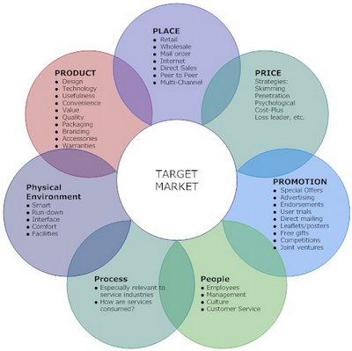

Product/Service
The Jungle Eco Resort Limited will offer accommodation as its core service for its targeted customer. The form of accommodation will be leisure and adventure. A guest in The Jungle Eco-Resort Limited will be able to reside in two different types of rooms. He/she can choose to stay in the utmost luxury of the cottages or in the relative cheap single suites.
- Accommodation facilities will be of two types- cottages and single rooms. The accommodations would be built from environmentally friendly materials such as processed wood/ bamboos/ processed clay with thatched roofs. The huts would be built in different styles showing the unique mode of relaxations of the different ethnicities of Bangladesh.

- In the following section we need to describe what types of facilities are being provided along with the accommodation. Previously, we did mention that The The Jungle Eco Resort Limited is providing the 5 star accommodation facilities to its honored guests. First of all, each and every room will be air conditioned, so that the guests will not be screwed up in the summer season. Moreover, they can use room heater in the winter time. The toilets are neat and clean and the guests will get hot and cold water facility according to their demand.

- In the room there will be a cupboard for keeping clothes. A television with satellite connection and a refrigerator will be given as well for the benefit of the guests. For the smokers, we will keep a corner in each room which will be considered as the smoking zone for that particular accommodation.

- Intercom service will be provided for every room. The authority will ensure 24/7 room service for the guests visiting The Jungle Eco Resort Limited So, we can see that in this resort the guests will be offered a bundle of supplementary services which could be comparable with the popular 5 star residential hotels of the country.

- A waste treatment plant will recycle the waste generated at the resort. In end of the day the employees of The Jungle Eco Resort Limited will separate the food wastes, paper and bottles for recycling. This feature will ensure the eco-friendliness of the resort.

- Food wastes will be recycled to generate fertilizer that again will be used in the organic farming of vegetables the resort serves to the guests.

- Transportation:

  - The main target segment of The Jungle Eco Resort Limited is the habitants of Dhaka. The Jungle Eco Resort Limited targeted the people who are listed in the socio-economic class A living in Dhaka. As the target market is the premium people so they could manage their own transport to reach the venue that means Bhawal National Park. The transportation facilities provided by the entity will be available inside the national park. The guests will be transported from the national park gate to the resort by Tomtom.

- Inside the Eco Resort our guests will be offered a number of transportation facilities. Of them, the most exciting service will be the elephant ride. There will be elephant rides offered from our end if the guests want to roam inside the forest. The elephant ride will start at 9:00 am in the morning and to 6:00 pm at the evening.

- Besides the elephant ride individual guests can also enjoy Horse ride inside the jungle. This offer is specially promoted targeting the newly married couple and the young people who are fond of adventure. Besides the Horse ride, the guests can also trek inside the jungle and enjoy the environment inside the forest. Inside the forests, there will be a number of small restaurants situated in the tree houses.

- Moreover, the entity will offer transportation facilities for the foreign tourists. Here a number of minibuses will be available for picking and dropping the foreign guests from airport. The guests can reserve their cottages and rooms through the website and have the chance to contact with the authority before flying to Bangladesh, so that resort management team will have the idea of how many foreign tourists are coming to the eco resort on a particular day.

- Tree Houses:

- The Tree Houses will be another interesting part of The Jungle Eco Resort Limited There will be around 10-20 tree houses which will serve the purpose of bird watching, enjoying the view and restaurants. It needs to be mentioned that one of our restaurant and tea stalls will be established in the tree houses. Among the tree houses 1 will be used to set a restaurant which will be used for Breakfast, Lunch and Dinner.

- Beside the restaurant, every tree house is consists of a tea corner where the guests can have tea, coffee and other refreshments. The tree house will be built in such a height that the guests can get the view of the entire resort as well they can see different types of birds and animals of the buffer zone. Moreover, it is mentionable that there is a lake inside the buffer zone. During the winter season a number of guest birds visit this lake and that scenery can also be viewed by the guests from the Tree houses.

- So, The Jungle Eco Resort Limited is actually providing the guests a complete eco friendly environment inside the resort and the Tree House is one of the important parts of it.

- Food:

- The guests in The Jungle Eco Resort Limited will be served with delicious and quality food. We will have two restaurants inside the resort and each of them will have a capacity of at least 700 people.

- One restaurant will be named as Beautiful Bangladesh. Here the people will get a feel of different areas of Bangladesh like The Sundarbans, Cox’s Bazar, Hill Tracts, Tea Gardens etc. There will be different zones inside the restaurant. Respective zones will represent different lifestyle and cuisines popular in different regions in Bangladesh.

- The special cuisine will include different special dishes of different areas of the country. Like Mutton Leg piece of old Dhaka. The aim is to give a feel of total Bangladesh to our guests.

- Another restaurant will be named Global Cuisines. Here, people will have the food from different parts of the world. Like Chinese, Thai, Indian, Continental, Italian etc. Like the Beautiful Bangladesh, this restaurant will be divided into different regions and the theme of that particular region will represent the lifestyle of that country. Like in the Indian part, the people will feel that they are in front of Taj Mahal.
Most of the vegetable that will be served in these restaurants are produced in the resort, all the vegetables will be free from any kind of chemical fertilizer, only herbal fertilizer like manure of cow or food waste will be used there.

- Swimming Pool:

- There will be no traditional swimming pool inside the resort. That does not mean that the authority is not providing swimming facilities to its guests. Here, the swimming pool will be an actual eco friendly swimming pool. What is an Eco Friendly Swimming Pool? Here we go.

- The swimming pool will be lake shaped and the tiles of the pool will be colored green. There will be a number of trees and plants in the swimming pool zone. The theme color of this area will be green. Moreover, the employees of the Jungle resort who will work inside this zone will wear an uniform which also reflects the eco friendly concept of this area.

- Laundry and Beauty Salon:

- The guests who will stay in the The Jungle Eco Resort Limited will get the service of the laundry and beauty salon as well. It is very natural that clothes might get dirty because the guests will roam inside the Jungle. But the laundry service will ensure that there is an opportunity for the guests they can get their attires clean and ironed within 12 hours.

- The beauty salon will have an optimum capacity of serving around 20 customers so that the customers will get a quality support inside the resort for making over.

- Gymnasium and Yoga Center:

- As the entity has promised the guests providing 5 star facilities there will be a gymnasium and yoga center. The guests can have access to these services as well. The gymnasium will be kept opened from 10:00 am to 6:00 pm every day. The Yoga center will follow the same time schedule. These services will actually add value to the Jungle experience of the guests of The Jungle Eco Resort Limited.

- Herbal Steam Bath: Whether you're used to the heat or not, these natural rock steam-rooms, with its temperatures of up to 45 degrees Celsius, is sure to open up your pores. And then there's the cool plunge-pool with its cascading waterfall, where you can lay back and relax, enjoying the view across to neighboring tropical weather.

- Private Jacuzzi Bath: The usage of water with minerals, essential oils, herbs, is always beneficial to our body, also enhanced relaxation, increases energy, freshens up body, As a result, our body and mind are more relaxing calm and metabolism is stimulated.

- Conference Hall:

- Two types of conference hall will be available inside the resort. One is air conditioned and with modern amenities. The specialty of this conference hall is it is a mobile conference hall. The capacity of this hall is 150. This hall is a mobile one. It is situated on a boat. So the corporations can arrange the conference in a suitable environment and on the lake.

- Another conference hall will be established outside the buffer zone. This hall will consist of all modern amenities but it is not air conditioned. The hall will be built by bamboos and boards. There will be projectors and stand fans for heat removal.

Pricing
Determining the price consumers are willing to pay and the price a business must charge in order to cover fixed and variable costs for production of the product or providing the service is the final P of the marketing mix. The first three P’s (product, place and promotion) contribute fixed and variable costs to the price of the product. The price communicates to the consumer the value the business places on the product or service. A price set too low may communicate the product is of poor quality or the service is substandard. A price set too high may communicate the business is trying to gouge consumers by charging too much for the product or service that can be obtained at a lower price from a competitor. Every business, whether offering a product or service, stands to improve on their success by researching, planning, monitoring and adjusting their marketing mix.
The Jungle Eco Resort Limited will be priced as value-pricing. It will not act as a cost leader rather it would tend to take the first mover advantage and adopt the skimming price strategy. But the venture will not overlook the threat of competitors and itself being too overpriced for its targeted customers. So the resort will price its products taking into consideration all these aspects.
- Accommodation pricing chart:
Type | US Dollar | Bangladeshi Taka
Value Suites | 75.00 | 5,250.00
Deluxe Suites | 85.00 | 5,950.00
Sunderban Cottage | 95.00 | 6,650.00
Ethnic Cottages | 120.00 | 8,500.00
The Tarzan Home | 195.00 | 13,300.00

- All prices are subject to 10% Service Charge and 15% VAT
- The above rates include complimentary breakfast for two (2) persons per room. Additional breakfast will be charged at applicable rates.
- Not more than three adults are permitted per room. The charge for extra bed is Tk.1200.00 per night. One Child below 10 years may stay free but charges will be made if extra bed is to be provided.
- Early Check in Policy: Subject to availability. We only guarantee room availability upon arrival after 12 PM.
- Late Checkout Policy: Subject to room availability. If room is available, half day will be charged up to 6 PM and full day after that.
- Guests are advised to reserve rooms in advance. One night room rent must be paid in advance for the Resort to confirm a room. This advance is non-refundable. Rooms booked without advance will be subject to availability.
There are provision for Drivers and "Ayahs". We can arrange rooms for Drivers in other places (cost approximately Tk.500-800 per room) if we are notified in advance.
Effective 2nd December 2005, the Government has introduced "No-Smoking" legislation for hotels, restaurants and all public places. As a consequence, smoking is prohibited in all parts of the hotel except in designated bedrooms where smoking is permitted.
- Pricing chart for the ancillary services:

- Food: Buffet price: Lunch: BDT 650
Dinner: BDT 850
- Swimming pool: BDT 200/day : Resident guest
BDT 200/hr: Non-resident guest

- Tree house: BDT 150/person (Admission for a single entry)

- Trekking: BDT 500/person (by jeep)
BDT 800/person (by elephant)

- Gymnasium and Yoga Center: BDT 250/hr

- Conference Hall: Boat: BDT 8000/shift
Ground BDT 5000/shift

Promotion
The third P, promotion, involves giving message to the public, or more specifically the target market, and others of the availability and benefits of the product or service the business is offering for sale. Whether the business is introducing the product or service for the first time or reminding the consumer of the product or service’s availability a promotion campaign is an important tool to the success of the business plan. Promotion of a product or service includes advertising, sales promotions, a sales force, and publicity. Determining whether to advertise on television, radio, the internet, in print or a combination of some or all, is important to ensure the specified market segment is aware of the product or service. Notifying the target market of the availability of the product or service in order to make sales is the number one goal of promoting the product. The promotion category can incorporate sales promotions such as discounts, coupons or contest to attract consumers to try the product or service. Another aspect of promotion involves the sales force. The sales force may or may not be employees of the business, however, they represent the product or service to the consumer. Lastly, publicity, which is any form of unpaid advertising, is important in order to help shape the public’s opinion of the product or service offered and the business. Promotion must gain attention, be appealing, portray a consistent message and above all else give the customer a reason to choose your product rather than someone else’s. The promotion educates the target market on the value of the product or service and helps determine the price the business will charge.
The Jungle Eco-Resort Limited will carry out the entire promotion for branding its resort and letting their target customers. In its first year of operations it will utilize 25% of its sales in managing and promoting the brand “The Jungle Eco-Resort Limited”. Similar percentage will utilized in the third year as well, because the company at that point of the time will be purely aware of its strengths and weaknesses and thus would be able to tailor made its promotional campaign for maximizing the returns. On second, fourth and fifth year 15% of sales will be used for promotion.

Promotional Break down
Promotional Vehicles | Percentile value | Details
Television Commercials | 40% | Concept building, film making, airing
Print Media | 20% | Newspaper, magazine, paid articles etc.
Links in various websites | 10% | Advertisements in popular hotel searching websites.
Trade shows | 10% | Travel Shows, Adventure Shows, Ecological forums
Website | 5% | State-of-the art website with links with tripadvisor, lonely planet, hotels.com, agoda.com
Event Sponsorships | 10% | Sponsoring events related with service
Others | 5% | Direct mail, leaflets, brochures etc.

The entire promotional campaign of The Jungle Eco Resort Limited will be managed by a professional marketing agency such as Asiatic, Grey, Bitopi, Interspeed etc. In the above mentioned a promotional breakdown has been provided to shown on which marketing vehicles the promotional budget will be used. Now a somewhat detailing version of the breakdown will be provided:

- Television Commercials:

It is the most important promotional vehicle to be used for promoting the brand of The Jungle Eco Resort Limited In the launching year two television commercials will be manufactured in order to create brand awareness amongst the minds of the consumers. The commercials will portray that an unique place of relaxation exists just beside Dhaka and show the special amenities of the resort. The commercials will be aired at a frequent basis during the prime time in the first two months of the launching. After that the frequency of airing the commercials will be brought down but will remain at a noticeable level. At the third year of the operations new commercials will be manufactured taking in to account the demand of the consumers.

- Print media:
20% of the promotional budget will be utilized in this popular promotional vehicle. Only leading newspapers and magazines plus a few local newspapers will be used to provide advertisements. Teaser advertisements will be published prior to the launching of the brand. Magazines will also be used in promoting the brand simply because usually women read magazines much more than men. And women in every family are the major decision makers in selecting the place of a family vacation. Paid articles will also be used in magazines and newspapers portraying the positivity’s of having a jungle resort at proximity of Dhaka.

- Advertisements in international websites:
for accelerating its personality in the international arena the jungle eco resort limited can contact well known websites lonely planet, rough guide, footprint, frommers, fodors, bradt, moon and other leading guidebook companies to request a listing in exchange of a payment. Give precise information on the project and invite their researchers to come and visit. Contacting guidebooks does not assure a listing, but it means they know about the project.
if you don’t approach them, they may not find about you. The company will also have to contact local listings magazines and online guides like travelfish, agoda.com, hotels.com etc. talk to tour operators and travel agents in the country to let them know about the brand. The company also needs to make sure it has all the promotional material ready so that the project looks professional. This material should include distances and journey times so that you can include it in itineraries. The jungle eco resort limited will also note down all the pricings and commissions in advance, as these are private businesses and will want to make a profit out of the experience.

- Trade shows:
A portion of the budget will also be used in setting up pavilions in various travel shows around the country and abroad. Special mention should be made for Dhaka and Chittagong International Travel Mart. The consumers of big metropolitans like Dhaka, Chittagong and Sylhet will be covered by setting up pavilions in these trade shows.

- Website:
The Jungle Eco Resort Limited will have to ensure that it possesses a state-of-the art website. A well functioning website is also of significant importance for the corporate image of the company as well as options such as online sales. For that the company needs:
  - To find a competent web designer to ensure a great look of the web page and high visibility in association with search engines like google.
  - Involve a native English speaker to make sure the texts are well written.
  - Source excellent photos, but ensure they load instantly.
  - Promote the website via other relevant websites (Facebook, twitter, trip advisor, lonely planet).
  - Blogging is now a vital part of the social media world and many people in travel and tourism write blogs or follow blogs. Having a blog increases your website’s visibility on search engines, as it ensures the website has regular new content. It doesn’t have to be a daily blog, but it must be updated on a regular basis.

- Sponsorships:
The Jungle Eco Resort Limited will carry out several sponsorship considerations which will result in creating brand recognition for the resort. The events that the company will sponsor will have to be in line with the target market that the company wants to attract. For example the company can sponsor Golf tournaments, cultural shows, Earth day sows etc. The company might also
Sponsor some fairs, exhibitions, trade shows etc to also enhance the acceptability of the company amongst the business fraternity.

- Others:
5% of the entire promotional budget will also be spent after various vehicles such as direct mail, leaflets, brochures etc. Leaflets, brochures, direct mail etc are required for carrying out bulk sales so these features must be taken into consideration when devising the promotional strategy. The Jungle Eco Resort Limited will ensure so that the leaflets and brochures are distributed in the international airports and in in-bound flights for Bangladesh.

Place
Making decisions about the fourth P, the place, of the marketing mix involves more than solely determining the actual place the consumer can purchase the product or service. Of course, the means of distributing the products or services to the consumer requires research to determine the most advantageous and profitable place to sell the product or provide the service and is a crucial decision in the marketing mix. The company must decide whether to use inclusive, selective or exclusive distribution channels to deliver the product to consumers and manage those channels to the advantage of the business. However, businesses also must determine the methods of storing, transporting and handling the product.
The Jungle Eco Resort Limited will maintain a city liaison office in the capital city of Dhaka along with the corporate headquarter which will be located in the resort area. The corporate headquarter will be located in the resort area to enhance the connectivity of the management people and the contact point of the service they are providing. If the management people are well aware of the positives and the lackings of the service they are providing then they can opt for immediate action. The liaison office will be located in the Ruposhi Bangla Hotel, which is situated beside the prime commercial zones of Karwan Bazar and Motijheel. An airport representative office will also set up in Hazrat Shahjalal International Airport to facilitate the receiving of the foreign tourists.

People
Employee Selection is the process of putting right men in the right job. It is a procedure of matching organizational requirements with the skills and qualifications of people. Effective selection can be done only when there is effective matching. By selecting best candidate for the required job, the organization will get quality performance of employees. Moreover, organization will face less of absenteeism and employee turnover problems. By selecting right candidate for the required job, organization will also save time and money. Proper screening of candidates takes place during selection procedure. All the potential candidates who apply for the given job are tested.
The Jungle Eco Resort Limited will be hiring expert people in their selected field. It is a 5-star ranked hotel so to maintain quality and control over the employees; we will follow a strict recruitment process. Only the experience in the relative field will get the job. They will have to face rigorous selection test to judge their inlet, also to find out how capable they are in working in the stress situation and can take order properly also how they talk and how they behave.
For these we have selected this procedure to select our employee. The Employee selection Process takes place in following order-
1. Preliminary interviews- it is used to get rid of those candidates who don't meet the minimal eligibility standard required by the company. The skills, academic and private background, competencies and interests of the applicant is examined during preliminary interview. Preliminary interviews are less formalized and planned than the final interviews. The candidates get a brief about the company and the job profile; and it is also examined how much the applicant knows about the company. Preliminary interviews are also called screening interviews.
2. Application blanks- the applicants who pass the preliminary interview have to fill application blank. It contains data history of the candidates corresponding to information about age, qualifications, cause of leaving previous jobs, experience, and so on.
3. Written tests- a number of written tests conducted throughout the selection procedure are aptitude test, intelligence test, reasoning test, personality test, and so on. These tests are used to objectively evaluate the potential applicant. They must not be biased.
4. Employment interviews- it is a one to one interaction between the interviewer and the potential candidate. It is used to find whether the candidate is most fitted for the required job or not. But such interviews consume time and money both. In addition the competencies of the applicant cannot be judged. Such interviews may be biased at times. Such interviews need to be supervised properly. No distractions should be there in room. There should be an honest communication between candidate and interviewer.
5. Medical examination- medical tests are conducted to ensure physical fitness of the potential employee. It will reduce chances of employee absenteeism.
6. Appointment letter- a background and reference check is made about the candidate selected and then finally he is appointed by giving a formal appointment letter.

- Workers Level
We will select 16 waiters, 35 people for overall room service, 5 drivers, 10 people in the reception (5 on each shift), 30 guards(10in each shift), 5 driver

- Employee Level
4 Cook , One Foreman, 2 Accountant, 1 Production Manager, 2 Operation Manager, 4 Shift Manager, 1 Security In-charge (Ex-Army Officer), 2 Guide, 1 HR Manager, 1 Marketing Officer, one Finance Officer.

Training
Training means improving the skills and knowledge of the employees for performing a specific job. Training helps to enhance employees’ performance in present job and prepares them for future job in the long run. The vital magnitude of training is learning. For this objective each person and employees in the jungle eco resort limited will take a 3 month proper training. In the dynamic working environment, it will strengthen their working competence.
❖ Objectives of employee training programs:
o to prepare employees to meet the changing and challenging needs of the job and organization.
o to provide knowledge and skills to new entrants and to assist them to carry out their role and work well.
o to train employees for more sophisticated and more advanced level jobs.
o to improve employees unique and innovative ways and techniques of performing job.
❖ benefits of trained employees
Training is a substantial tool for employee development. Training has simulated great importance because of phenomenal rate of change in the internal and external organizational environment. The importance/benefits of trained workforce in the jungle eco resort limited towards organizational development are as follows-
o trained staff do not require tight control and guidance as they are thoroughly aware of how to perform a job.
o trained personnel can show higher performance by making maximum and best utilization of the materials, tools, equipment’s and other resources provided to them.
o trained employees minimize wastage of resources in the corporation and work both efficiently and effectively.
o training makes employees more committed to an organization as the employees are provided with growth, advancement and learning opportunities.
o training develops a line of capable and skilled managers as it prepares employees for complicated and higher level tasks.
o trained personnel adjust to the job better and there are lower rates of absenteeism and turnover.
o trained employees generate high quality and quantity output.
o trained employees set up the company to face competition from rival firms.
o trained employees can respond and adapt to the changing technology well.
o trained employees become more proficient and, thus, their earning capacity increase.
❖ steps in employee training program
Training program involves the following steps:
o identifying the training needs- the training needs of each employee should be identified. Management should set up training that are best suited to their needs and that will improve their skills.
o prepare the trainer- the trainer must do his work well. He should know what to teach and how to teach. Time management is required by the trainer. Training must be delivered in such a way that the trainee should not lose the commitment in the job.
o prepare the trainee- the trainee need to remain active during training. He should know why he is being trained. He should ask the trainer questions and clear it if he has any doubts. The trainee should be put at ease during the training program.
o explain and demonstrate the operations- the trainer should explain the logical sequence of the job. The trainee should perform the job systematically and explain the complete job he is performing. His mistakes should be rectified and the complex step should be done for him once. When the trainee demonstrates that he can do the job in right manner, he is left to himself. Through repetitive practices, the trainee acquires more skill.
o follow up and feedback- the trainee should be given feedback on how well he performed the job. He should be asked to give a feedback on the effectiveness of training program.

Process
Processes associated with customer service are a number of processes involved in making marketing effective in an organization e.g. processes for handling customer complaints, processes for identifying customer needs and requirements, processes for handling order etc. In our The Jungle Eco Resort Limited which is a 5-star resort, one of a kind of its class in Bangladesh provides them unique opportunity to taste our hospitality and feel and enjoy the calm and resounding feeling of nature. In every aspect of our service delivery we will portray the Bangladeshi traditions and culture. In the whole we will promote all the school of “Beautiful Bangladesh”.

- At the very start of indulging with The Jungle Eco Resort Limited, guests, when required would be escorted in a hybrid car to give an essence of eco tourism. Inside the resort cycle rickshaw would be used as the mode of transport.

- Accommodation: Accommodation facilities will be of two types- cottages and single rooms. The accommodations would be built from environmentally friendly materials such as processed wood/ bamboos/ processed clay with thatched roofs. The huts would be built in different styles showing the unique mode of relaxations of the different ethnicities of Bangladesh.

- A lake shaped eco swimming pool.

- Bird watching and elephant riding facilities inside the Bhawal National Park.

- Jungle spa with therapies designed to harness the forces of nature.

- A gymnasium in the midst of the jungle.

- School of Mysticism- a yoga hut in the midst of the jungle.

- Gardens with rare flowers to preserve the natural beauty for the
future generations.

- Food: Authentic Bangladeshi cuisine prepared from the organic garden and from the fish farmed in an onsite lake. The guests will also have the provision of fishing and then have it as their meal. The restaurant would also serve Continental cuisine.

- For tourists there would be a biologist guided Bangladesh tour
segmented with names used in the Beautiful Bangladesh video published
by the Bangladesh Tourism Board such as School of Adventure- a trip
with trekking facilities. The tourists would be able to choose from a
list of tour.

- School of Celebration: Cultural shows would be arranged in the
evenings to entertain the guests with regional cultures of Bangladesh.
Events such as weddings will also be arranged within the premise.

- School of Playfulness: A souvenir shop containing the items made by
the cottage industry, from a nearby village where the people working
for the resort would be given to live in along with their families who
would be engaged in making souvenir items.

- School of Happiness: A visit to the cottage industry where the
tourists can interact with the native people.
What The Jungle Eco-Resort Limited has to offer to the environment?
- On site rain water treatment plant
- Nesting of birds and preserving flowers
- Low flush toilets and usage of bio degradable product
- Chemical free cleaning solutions
- Usage of non toxic materials
- All the wastes would be transferred to the recyclers instead of dumping.
- Restriction of motorized sports inside the resort.
- Usage of solar power as a means of power in the resort.
- Hire and train local people to work in the resort.

Physical evidence
In these process we can say the flow of order, also in the service delivery process what kind of service element we are keep contacting with .The physical process starts with when a customer is going reserve his/her room in or The Jungle Eco Resort Limited through online hotel reservation system. Also ends with when a customer checks out or we drop him/her in the Airports. The flow of service contact is given below;

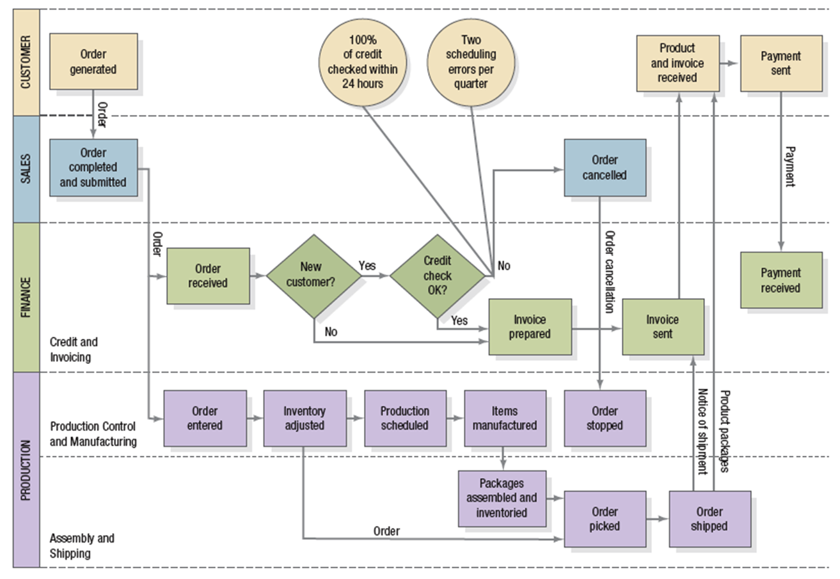

Control
After a certain time period the marketing strategy would be reviewed by the management. If any deviation from the proposed plan is taken the necessary actions will be taken accordingly. This will enable the marketing strategy to be implemented in the most efficient manner.

Organizational Plan

According to the Business Dictionary, organizational plan is defines as process of identifying an organization's immediate and long-term objectives, and formulating and monitoring specific strategies to achieve them. It also entails staffing and resource allocation, and is one of the most important responsibilities of a management team.
An organizational plan is basically a “to do” list for an organization. It lists out the plan of work, programs, and organizational growth over a period of time - six months, a year, a five years.
Below is the outline of the steps which would be used by The Jungle Eco Resort Limited for creating our organizational plan.
- Decide on Categories
First, think about all the work that our organization does, which is offer eco tourism at a place near the capital city of Dhaka and list out the general categories—for example, Fundraising, Community Outreach, Website, and so on.
- Set Goals
Secondly, we will make sure the goals for our work in each category are clear and are feasible to carry out.
- Set Tasks
Next, we will discuss each goal and talk about all the tasks that need to be done to achieve that goal. At this point, they don’t have to be in order. Some will be more specific than others; the more specific the better, in general. We may not know how to reach some goals, yet; it would be fine to have a task list.
- Plan a Schedule
When all the tasks are listed, we will number them to show a general order—what comes first, what should happen at the same time, what comes last? Then we will draft a schedule for the tasks—either when they will be completed, or (for ongoing tasks) when they will begin. The goal is to set a schedule that is challenging but realistic.
- Choose Responsibilities
We will then assign responsibilities to people who will be responsible for the goals or tasks. A person’s name next to a task doesn’t mean that they’ll do it—just that they take responsibility for making sure it gets done. The goal here will to make sure everyone has enough responsibility to challenge them, without so much work that they will burn out.
- Support
Brainstorm other individuals and organizations that can provide support, assistance or advice in helping us carry out particular tasks or achieve general goals.
- Follow through
Then we will come up with a plan to check in, support and encourage people as they carry out their tasks. This means choosing one person to regularly check on the status of different tasks and then reporting back at meetings.
- Plan Evaluation
Finally we will, set a time to revisit the whole plan as a group to evaluate how things are going and revise assignments and schedules. This may be a few months or half a year in the future.

﻿An organizational plan can help The Jungle Eco Resort Limited by:
- ﻿Setting priorities for our work
- Making sure tasks get done on time
- Focusing on one thing at a time
- Sharing work among staff, board members and managers
- See the big picture of what your organization is doing

Form of Ownership

The Jungle Eco Resort Limited would be following Partnership form of ownership for the business venture.

PARTNERSHIP DEED

THIS DEED OF PARTNERSHIP IS MADE on this 12th of August, 2018 by and
Among

Mr. Farhadur Rahman
73/9, 8/A Dhanmondi 15, Dhaka
Cell: 0167*********
Email: farhad.rahman@nsuyes.com

Ms. Tasnuva Ayesha haque
House:179,Road: 2, Mohammadi Housing Society,
Dhaka.
Cell-0171********
E-mail: tasnuva.ah@nsuyes.com

Ms. Syeda Sabera Arefin
Road no-4/a, Mohammadpur, Dhaka.
Cell-0167********
E-mail: syeda.juthika@nsuyes.com

Mr. Nafis M. Zaman
93/1,Road -8, Block-c, Niketan, Dhaka
Cell-0192********
E-mail: nafis.m.zaman@hotmail.com

Mr. Faisal Zaman
11, Paribagh, Dhaka-1000
Cell-0173********
E-mail: faisal.zaman@nsuyes.com

NAME OF WORKING PARTNER MAXIMUM BASIC SALARY NOT TO EXCEED

Name BDT.
1 Mr. Farhadur Rahman 50,000

2. Ms. Tasnuva Ayesha Haque 50,000

3.Ms. Syeda Sabera Arefin 50,000

4.Mr. Nafis M. Zaman 50,000

5. Mr. Faisal Zaman 50,000

6. That all business expenses shall be borne by the FIRM.

7. That the Profits or Losses, as the case may be, of the Partnership business shall be divided among the Partners as under :

NAME OF WORKING PARTNER SHARE OF PROFIT SHARE OF LOSS
1. Farhadur Rahman 20% 20%
2. Tasnuva Ayesha Haque 20% 20%
3. Syeda Sabera Arefin 20% 20%
4. Nafis M. Zaman 20% 20%
5. Faisal Zaman 20% 20%

The Jungle Eco Resort Limited will have to give some tax for our foreign tourist, which is adjusted later with their bill. The Tax rate is given below

Travel tax:
- Foreign Travel Tax

The Finance Act, 1980 introduced a tax on foreign travels called Foreign Travel Tax (section 12 of finance Act, 1980). Amended vide SRO NO> 209/LAW/Travel tax/2005 dated 6.7.2005, rescheduling rate of Travel tax effective from 1.7.2005 as below:
- Mode of Levy:

(i) Travel by Air - Foreign Travel Tax is payable on all foreign air travel by all Bangladeshi nationals holding Bangladeshi passports at the rate of-

(a) For travel to any country of the continents TK. 2005/-
of North America, South America, Europe,
Africa, Australia and New Zealand and any
country of the Far East.

(b) For SAARC countries TK 800/-

(c) For any other country TK 2,000/-

(ii) Travel by land and sea:
Foreign Travel Tax is payable on all foreign travels by land or sea by Bangladeshi nationals holdings Bangladeshi passports at the rate of five hundred taka per traveler by land and six hundred taka per traveler by sea.

- Tax on air line tickets: section 11 of the finance ordinance, 1986

Tax shall be levied at the rate of Tk.50 /- per issuance of domestic Air line ticket per seat for single journey.

Organogram and Job Responsibilities:

MANAGEMENT TEAM BACKGROUND:

ROLES AND RESPONSIBILITIES OF MEMBERS OF ORGANIZATION:
In our company we appoint 5 managers under the CEO for handling different managerial activities in different sectors. We mainly appoint manager for production & operation work, marketing work, planning and development work, financial work and also appoint procurement officers. We appoint mainly high qualified employee for our company. Under the all department manager we will employee some officers for minimizing the pressure of All Managers.

ENTREPRENURE/ CHAIRMAN:
Faisal Zaman, the Chairman of The Jungle Eco Resort Limited is Selected by all the partners of the company, who actually give the command over the invention and control all the departments. All the business partners and personnel’s are responsible to perform the duties as the chairmen stated. His main responsibility is to maintain the suppliers to ensure the continuity of good relations to them. The Head of the company who actually control & implement all partners‟ idea about the business. It means an individual developing something unique. The responsibilities are:
1. Initiative taking
2. The acceptance of risk or failure

HEAD OF PRODUCTION & OPERATION:
Syeda Sabera Arefin is our Head of Production, and her responsibilities are:
- Purchasing the all staff of food with better quality from food market
- Responsible for all the operations within the shops (cleanness, quality of food, timely delivery to the customer)
- Responsible all the food expenses recodes
- Responsible to works with all other managers
- Managing Labor & controlling the production system.
- Motivating the labors & making the reward opportunities.

HEAD OF MARKETING:
Tasnuva Ayesha Haque, our head of marketing, cause she has completed his graduation on Marketing major and she has good command over marketing. The main responsibilities are:
- Focus on the Customer
- Monitor the Competition
- Own the Brand.
- Find & Direct Outside Vendors.
- Create New Ideas.
- Communicate Internally.
- Manage a Budget.
- Understand the ROI.
- Set the Strategy, Plan the Attack, and Execute

HEAD OF PLANNING & PERFORMANCE MANGEMENT:
Nafis M. Zaman, our head of planning and performance management. The responsibilities are:
- Staff Induction.
- Reward and Recognition.
- Staff Retention.
- Management Development / Career Development.
- Succession Planning.
- Competency Building / Mapping.
- Compensation / Benefit programs.
- To facilitate / support the development of the Team members
- To facilitate development of staff with special focus on Line Management
- To recommend and ensure implementation of Strategic directions for people development within the organization.
- Provide counsel and assistance to employees at all levels in accordance with the company's policies and procedures as well as relevant legislation.
- Salary letters and employment contracts.
- Approve updated organizational charts on a monthly basis and maintain
- Co-ordinate the design, implementation and administration of human resource policies and activities to ensure the availability and effective utilization of human

HEAD OF FINANCE:
Farhadur Rahman, our Head of financial manager and planner, he has a great command over finance because he has a educational and financial management background. The Responsibilities are –
- Accounts Payable
- Accounts Receivable
- Audit
- Budgeting
- Cash Receipts
- Fixed Assets
- Current Assets
- Payroll / Benefits
- Utility Billing

Under them there is a 3 layer employee base.
- Top Level Management
- Administrative Employee
- Workers
- Top Level Management
There will be a huge work force needed for accomplishing the project aims and goals. The total management will be under the board of directors. Here is the proposed organ gram of the organization. The will do all the strategic level work and decision making job.

Board of Directors

CEO

COO (Chief Operational Officer)

CCO
(Chief Communication Officer)
CFO
(Chief Financial Officer)

CMO
(Chief Marketing Officer)
CTO
(Chief Technological Officer)

- Administrative Employees:

Post | Number of People
Operation Manager | 2
Shift Manager, | 4
Security In-charge | 1
HR Officer | 2
Marketing Officer | 5
Finance Executive | 3
Accountant | 2
Technology Department | 3
Administrative Officer | 13

- Workers :

Post | Number Of people
Waiters | 35
Cook | 6
Receptionist | 10
Driver | 5
Life Guard | 2
Foreman | 1
Guide | 5
Cleaner | 30

Identifying the hazards:

Firstly, we will figure out how many people could be harmed or what items possess risk in The Jungle Eco Resort Limited because it is easy to overlook some hazards, so we will be following the tips given by Health Service Executive (HSE). What we understand from the leaflet by Health Service Executive (HSE) we will be keeping a keen look at The Jungle Eco Resort Limited premises and figure out what could reasonable cause harm. This would involve talking with the employees because they might just notice a detail that might not seem very obvious to the entrepreneurs of the business. For reference and case studies regarding risks and to relate the situations the website of HSE (www.hse.gov.uk) would be visited and thoroughly searched. We will also check the guides produced for risk assessment by the various eco resorts and even resorts. For equipments and technical matters data sheets and instructions from the manufacturers would be checked for instructions regarding maintenance and other important details. For the ease of the assessment, a record would be kept regarding accidents and unwanted circumstances so that it can be reviewed at regular interval for the assessment.

Deciding who might be harmed and how:
For each item that we can figure out that would possess risk, we would track down what type of effect it would have and on whom the effect would be critical.

Evaluating the risks and deciding on the precaution:
After we are done listing down the hazards we will be taking the step of deciding what can be done to overcome the problems. In these stage, we will first be looking at what we are currently doing, figure out what controls are already there and find out the organization of the work. After getting all this information, it would be compared with ideal practices to check if there is something extra that needs to be done regarding the issue pointed out.
HSE’s leaflet gives an outline of how to go about controlling risks and The Jungle Eco Resort Limited will be following the principles. The order is as follows:
- Try a less risky option (e.g. switch to using a less hazardous chemical);
- Prevent access to the hazard (e.g. by guarding);
- Organize work to reduce exposure to the hazard (e.g. put barriers between pedestrians and traffic);
- Issue personal protective equipment (e.g. clothing, footwear, goggles etc); and
- Provide welfare facilities (e.g. first aid and washing facilities for removal of contamination).

In this entire process the staff would be involved so that we can be sure of whatever decision is implemented or formulated does not bring about new hazards.

Recording the findings and implementing them:
Implementing the formulated decisions would bring about the differences. The results of the risk assessment would therefore be written down and shared with the employees of The Jungle Eco Resort Limited.

HSE specifies that for a risk assessment we need to be able to show that:

- A proper check was made;
- We asked who might be affected;
- We dealt with all the significant hazards, taking into account the number of people who could be involved;
- The precautions are reasonable, and the remaining risk is low; and we involved our staff or their representatives in the process.

HSE also has a template which we would be using for our risk assessment. However, the template would have the necessary adjustments required to properly aid the type of business that is a Eco Resort.
To keep the standard of the risk assessment we intend to sort things out one by one and not all at once. Then formulate a plan of action which would be ordered on the basis of priority that is with the important things first and as we would proceed with them, once they are settled it would be ticked off on the list.

According to Health and Safety Executive a good plan of action would have the following:

- A few cheap or easy improvements that can be done quickly, perhaps as a temporary solution until more reliable controls are in place;
- Long-term solutions to those risks most likely to cause accidents or ill health;
- Long-term solutions to those risks with the worst potential consequences;
- Arrangements for training employees on the main risks that remain and how they are to be controlled;
- Regular checks to make sure that the control measures stay in place; and clear responsibilities – who will lead on what action, and by when.

Reviewing the assessment and updating if necessary:
Time The Jungle Eco Resort Limited would change, there will be addition of new equipments, new substances as well as changed procedures in which may lead to new hazards. Therefore there would be reviewing on a regular time interval. Every year there would be formal revisions to make sure that we are constantly improving and not sliding back.
HSE insists on reviewing by answering the following questions:
- Have there been any changes?
- Are there improvements you still need to make? Have your workers spotted a problem?
- Have you learnt anything from accidents or near misses?

The Jungle Eco Resort Limited would make sure that the risk assessment stays up to date. If there are significant changes during a year, we will be checking our risk assessment and amend it if it is necessary. Just to have more flexibility, The Jungle Eco Resort Limited would consider risk assessment when we plan to make any changes.

Evaluation of Weakness of the Business

Early stage of business:

The Jungle Eco Resort Limited is a resort, which is based on the very concept of eco tourism. The concept is relatively new in the country, a resort of such a kind near the capital Dhaka is the first of its kind, and this has no operating history. Even the jungle eco-resort concept is first of its kind in Bangladesh. Therefore, the resort, The Jungle Eco Resort Limited must be considered in light of the risks, expenditures, and risks frequently experienced and encountered by businesses, which are in their early stages of development.

Dependence on key personnel:
The performance of The Jungle Eco Resort Limited is dependent upon the continued services of its founders, executives in the upper as well as the lower tiers. This is particularly very critical to the success of the business since the resort is very young and will be undergoing development and growth. Therefore the business is highly dependent on retaining its employees in especially the higher tier that is the senior executives. To offset this risk The Jungle Eco Resort Limited intends to have a key man insurance policy on key executives whose loss could have materially adverse impact upon the business at present as well the future.

High entry barriers to the industry:
The resort industry in Bangladesh is a very dynamic one, the resort concept itself is dynamic, and it is reasonably competitive and subject to changes. Therefore The Jungle Eco Resort Limited expects competition to exist well into the future. Even though we are counting that the government of the country is promoting tourism and encouraging eco tourism there may be sudden change of policies, rules, regulations as well as laws that go against the business environment required for The Jungle Eco Resort Limited

The changing market for ancillary services:
The market for the support services required by The Jungle Eco Resort Limited is constantly undergoing changes. Important factors that need to be considered are that there are changes in the user and client relationships, requirements as well as their preferences; frequent introductions of new products and services and the evolving industry standards and practices that could render the practices and methodologies of The Jungle Eco Resort Limited as obsolete.

System failures of the business:
Success and the ability to facilitate electronic commerce depend on the efficient and uninterrupted operation of the Internet connectivity systems. The Jungle Eco Resort Limited obtains its high-speed Internet access through a third party Wimax Internet like Bangla Lion / Qubee, who can give us high speed internet connection in the remote jungle place with their superior 4G technology. Although these Wimax Companies providing quality services but they also have to maintain physical and electronic systems that are vulnerable to failure, damage, or interruption resulting from any number of possibilities, ranging from earthquakes, floods, fire, loss of power, telecommunication failures, break-ins, sabotage, vandalism, and similar events. To mitigate this risk, The Jungle Eco Resort Limited will acquire fully redundant systems, a disaster recovery plan, or alternate internet connection from local ISPs including alternate hosing services. Additionally, The Jungle Eco Resort Limited will carry sufficient business interruption insurance to compensate for potential losses that may occur.

E-commerce:
The market for the sale of resort accommodations and services over the Internet is relatively a new market in the context of Bangladesh. There can be no assurance that acceptance and use will continue to grow in the future. Moreover, there is no assurance that a broad base of consumers will adopt the Internet as a medium of communication with The Jungle Eco Resort Limited.

Intellectual property:
Copyrights and trademarks trade secrets (including methodologies, practices, and tools) and other intellectual property rights are critical to success. The Jungle Eco Resort Limited relies on a combination of trademark, trade secret protection, nondisclosure agreements, and other contractual agreements with its employees, affiliates, clients, strategic partners, acquisition targets, and others.

The services provided by the resort are not perceived as standard:
The services that are provided by The Jungle Eco Resort Limited to its guests may not be what the guests arriving at the resort expect to be and the resort does not perform as expected. So to combat this, the quality of service would be evaluated, efficiency would be improved, more standardized training will be offered to the employees and there would be a continuous process of improving the entire range of services that are being offered by The Jungle Eco Resort Limited.

Maintaining the green environment and the whole eco-system inside the resort:
The Jungle Eco Resort Limited is a resort which is counting on it’s green and eco friendly environment however maintaining the entire area and the eco system within the premises is a big challenge. A little change in ways and practices must first be evaluated in a number of ways to make sure the balance is not harmed in any manner.

Success of the business also depends on minute details:
For businesses in the resort industry minute details have to kept in mind such as smiling when the guest arrives, have everything working when they arrive, have a clean unit etc. if one such thing misses out the reputation of the business may be at stake.

Change of government policies:
The current government of Bangladesh is promoting tourism with all its might which is very favorable for our business and it even goes in line with their efforts in turning the environment an eco friendly one. However, every time the government changes, changes in policies and ways of working things out occur. Even there are changes in the laws, regulations and even business rules and regulations for industries are changed. So, if the government changes and the next government do not comply to the policies set by the current government which are in favor of the tourism industry, The Jungle Eco Resort Limited would suffer.

FINANCIAL PLAN

Assumptions
The assumptions that have been made in this business that is for The Jungle Eco Resort Limited are as follows:
We calculated:
- 25% depreciation for the furniture.
- 20% depreciation for the machineries.
- 20% depreciations for the vehicle
- 5% depreciation for land
- Tax holiday

Pro forma Income Statements:
 | 2012
Details | Jan | Feb | Mar | Apr | May | Jun
Revenues
Total Sales | 0 | 0 | 0 | 0 | 0 | 0
Cost of Goods Sold
Cost of Raw materials Consumed
GROSS Profit | 0 | 0 | 0 | 0 | 0 | 0
Operating Expenses | 3,890,380 | 3,914,809 | 3,954,072 | 3,963,172 | 3,860,268 | 3,911,137
Operating Profit | -3,890,380 | -3,914,809 | -3,954,072 | -3,963,172 | -3,860,268 | -3,911,137
Profit Before Taxation | -3,890,380 | -3,914,809 | -3,954,072 | -3,963,172 | -3,860,268 | -3,911,137
Taxation: VAT
Profit After Taxation | -3,890,380 | -3,914,809 | -3,954,072 | -3,963,172 | -3,860,268 | -3,911,137
Net Profit | -3,890,380 | -3,914,809 | -3,954,072 | -3,963,172 | -3,860,268 | -3,911,137

2012
Jul | Aug | Sep | Oct | Nov | Dec | Total
0 | 0 | 0 | 0 | 0 | 0 | 0
 |  |  |  |  |  | 0
 |  |  |  |  |  | 0
0 | 0 | 0 | 0 | 0 | 0 | 0
3,817,569 | 3,823,669 | 3,933,077 | 3,996,822 | 4,023,069 | 11,132,262 | 54220306.16
-3,817,569 | -3,823,669 | -3,933,077 | -3,996,822 | -4,023,069 | -11,132,262 | -54220306.2
-3,817,569 | -3,823,669 | -3,933,077 | -3,996,822 | -4,023,069 | -11,132,262 | -54220306.2
 |  |  |  |  |  | 0
-3,817,569 | -3,823,669 | -3,933,077 | -3,996,822 | -4,023,069 | -11,132,262 | -54220306.2
-3,817,569 | -3,823,669 | -3,933,077 | -3,996,822 | -4,023,069 | -11,132,262 | - 54,220,306

2013
Details | Jan | Feb | Mar | Apr | May | Jun
Revenues
Total Sales | 0 | 0 | 0 | 0 | 0 | 0
Cost of Goods Sold
Cost of Raw materials Consumed
GROSS Profit | 0 | 0 | 0 | 0 | 0 | 0
Operating Expenses | 4,695,646 | 4,717,793 | 4,758,442 | 4,764,451 | 4,606,894 | 4,553,511
Operating Profit | -4,695,646 | -4,717,793 | -4,758,442 | -4,764,451 | -4,606,894 | -4,553,511
Profit Before Taxation | -4,695,646 | -4,717,793 | -4,758,442 | -4,764,451 | -4,606,894 | -4,553,511
Taxation: VAT
Profit After Taxation | -4,695,646 | -4,717,793 | -4,758,442 | -4,764,451 | -4,606,894 | -4,553,511
Net Profit | -4,695,646 | -4,717,793 | -4,758,442 | -4,764,451 | -4,606,894 | -4,553,511

2013
Jul | Aug | Sep | Oct | Nov | Dec | Total
0 | 0 | 0 | 0 | 0 | 0 | 0
 |  |  |  |  |  | 0
 |  |  |  |  |  | 0
0 | 0 | 0 | 0 | 0 | 0 | 0
4,545,859 | 4,564,205 | 4,727,548 | 7,448,077 | 7,481,727 | 18,100,385 | 74964538
-4,545,859 | -4,564,205 | -4,727,548 | -7,448,077 | -7,481,727 | -18,100,385 | -74964538
-4,545,859 | -4,564,205 | -4,727,548 | -7,448,077 | -7,481,727 | -18,100,385 | -74964538
 |  |  |  |  |  | 0
-4,545,859 | -4,564,205 | -4,727,548 | -7,448,077 | -7,481,727 | -18,100,385 | -74964538
-4,545,859 | -4,564,205 | -4,727,548 | -7,448,077 | -7,481,727 | -18,100,385 | -74,964,538

2014
Details | Jan | Feb | Mar | Apr | May | Jun
Revenues
Total Sales | 6,176,400 | 6,802,800 | 7,809,550 | 8,042,875 | 5,404,300 | 4,400,955
Cost of Goods Sold
Cost of Raw materials Consumed | 100,000 | 100,000 | 100,000 | 100,000 | 100,000 | 100,000
GROSS Profit | 6,076,400 | 6,702,800 | 7,709,550 | 7,942,875 | 5,304,300 | 4,300,955
Operating Expenses | 8,844,865 | 8,778,618 | 8,959,833 | 9,001,832 | 8,526,888 | 8,346,286
Operating Profit | -2,668,465 | -1,975,818 | -1,150,283 | -958,957 | -3,122,588 | -3,945,331
Profit Before Taxation | -2,668,465 | -1,975,818 | -1,150,283 | -958,957 | -3,122,588 | -3,945,331
Taxation: VAT
Profit After Taxation | -2,668,465 | -1,975,818 | -1,150,283 | -958,957 | -3,122,588 | -3,945,331
Net Profit | -2,668,465 | -1,975,818 | -1,150,283 | -958,957 | -3,122,588 | -3,945,331

2014
Jul | Aug | Sep | Oct | Nov | Dec | Total
4,309,455 | 4,465,860 | 7,271,200 | 8,905,700 | 9,578,700 | 10,711,850 | 83,879,645
 |  |  |  |  |  | 0
100,000 | 100,000 | 100,000 | 100,000 | 100,000 | 100,000 | 1,200,000
4,209,455 | 4,365,860 | 7,171,200 | 8,805,700 | 9,478,700 | 10,611,850 | 82,679,645
8,329,816 | 8,357,969 | 8,862,930 | 9,157,140 | 9,278,280 | 21,751,258 | 118,195,715
-4,020,361 | -3,892,109 | -1,591,730 | -251,440 | 300,420 | -11,039,408 | -34,316,070
-4,020,361 | -3,892,109 | -1,591,730 | -251,440 | 300,420 | -11,039,408 | -34,316,070
 |  |  |  |  | 13840141 | 13,840,141
-4,020,361 | -3,892,109 | -1,591,730 | -251,440 | 300,420 | -24,879,549 | -48,156,211
-4,020,361 | -3,892,109 | -1,591,730 | -251,440 | 300,420 | -24,879,549 | -48,156,211

2015
Details | Jan | Feb | Mar | Apr | May | Jun
Revenues
Total Sales | 10,536,200 | 9,517,050 | 8,440,550 | 7,811,900 | 4,964,365 | 4,607,005
Cost of Goods Sold
Cost of Raw materials Consumed | 100,000 | 100,000 | 100,000 | 100,000 | 100,000 | 100,000
GROSS Profit | 10,436,200 | 9,417,050 | 8,340,550 | 7,711,900 | 4,864,365 | 4,507,005
Operating Expenses | 8,431,482 | 8,212,152 | 8,126,032 | 8,075,740 | 7,847,937 | 7,819,349
Operating Profit | 2,104,718 | 1,304,898 | 314,518 | -263,840 | -2,883,572 | -3,212,344
Profit Before Taxation | 2,104,718 | 1,304,898 | 314,518 | -263,840 | -2,883,572 | -3,212,344
Taxation: VAT
Profit After Taxation | 2,104,718 | 1,304,898 | 314,518 | -263,840 | -2,883,572 | -3,212,344
Net Profit | 2,104,718 | 1,304,898 | 314,518 | -263,840 | -2,883,572 | -3,212,344

2015
Jul | Aug | Sep | Oct | Nov | Dec | Total
4,265,130 | 5,434,680 | 7,998,650 | 9,280,300 | 10,596,850 | 12,260,600 | 95,713,280
 |  |  |  |  |  | 0
100,000 | 100,000 | 100,000 | 100,000 | 100,000 | 100,000 | 1,200,000
4,165,130 | 5,334,680 | 7,898,650 | 9,180,300 | 10,496,850 | 12,160,600 | 94,513,280
7,791,999 | 7,885,563 | 8,090,680 | 8,193,212 | 8,298,536 | 21,112,654 | 109,885,337
-3,526,869 | -2,450,883 | -92,030 | 1,087,088 | 2,298,314 | -8,852,054 | -14,172,057
-3,526,869 | -2,450,883 | -92,030 | 1,087,088 | 2,298,314 | -8,852,054 | -14,172,057
 |  |  |  |  | 15792691 | 15,792,691
-3,526,869 | -2,450,883 | -92,030 | 1,087,088 | 2,298,314 | -24,644,745 | -29,964,748
-3,526,869 | -2,450,883 | -92,030 | 1,087,088 | 2,298,314 | -24,644,745 | -29,964,748

2016
Details | Jan | Feb | Mar | Apr | May | Jun
Revenues
Total Sales | 12,232,100 | 11,982,200 | 10,369,450 | 10,024,550 | 6,569,070 | 5,484,105
Cost of Goods Sold
Cost of Raw materials Consumed | 100,000 | 100,000 | 100,000 | 100,000 | 100,000 | 100,000
GROSS Profit | 12,132,100 | 11,882,200 | 10,269,450 | 9,924,550 | 6,469,070 | 5,384,105
Operating Expenses | 10,085,209 | 9,820,220 | 9,691,200 | 9,663,608 | 9,387,169 | 9,300,372
Operating Profit | 2,146,891 | 2,161,980 | 678,250 | 360,942 | -2,818,099 | -3,816,267
Profit Before Taxation | 2,146,891 | 2,161,980 | 678,250 | 360,942 | -2,818,099 | -3,816,267
Taxation: VAT
Profit After Taxation | 2,146,891 | 2,161,980 | 678,250 | 360,942 | -2,818,099 | -3,816,267
Net Profit | 2,146,891 | 2,161,980 | 678,250 | 360,942 | -2,818,099 | -3,816,267

2016
Jul | Aug | Sep | Oct | Nov | Dec | Total
5,229,985 | 5,276,980 | 6,302,700 | 8,813,850 | 10,679,100 | 12,933,500 | 105,897,590
 |  |  |  |  |  | 0
100,000 | 100,000 | 100,000 | 100,000 | 100,000 | 100,000 | 1,200,000
5,129,985 | 5,176,980 | 6,202,700 | 8,713,850 | 10,579,100 | 12,833,500 | 104,697,590
9,280,042 | 9,283,802 | 9,365,860 | 9,566,752 | 9,715,972 | 23,955,324 | 129,115,527
-4,050,057 | -4,006,822 | -3,063,160 | -752,902 | 963,128 | -11,021,824 | -23,217,937
-4,050,057 | -4,006,822 | -3,063,160 | -752,902 | 963,128 | -11,021,824 | -23,217,937
 |  |  |  |  | 17473102 | 17,473,102
-4,050,057 | -4,006,822 | -3,063,160 | -752,902 | 963,128 | -28,494,926 | -40,691,039
-4,050,057 | -4,006,822 | -3,063,160 | -752,902 | 963,128 | -28,494,926 | -40,691,039

2017
Details | Jan | Feb | Mar | Apr | May | Jun
Revenues
Total Sales | 16,223,700 | 14,115,400 | 14,087,350 | 12,572,400 | 9,355,770 | 8,689,700
Cost of Goods Sold
Cost of Raw materials Consumed | 100,000 | 100,000 | 100,000 | 100,000 | 100,000 | 100,000
GROSS Profit | 16,123,700 | 14,015,400 | 13,987,350 | 12,472,400 | 9,255,770 | 8,589,700
Operating Expenses | 7,084,856 | 6,810,777 | 6,807,130 | 6,610,187 | 6,192,025 | 7,105,436
Operating Profit | 9,138,844 | 7,304,623 | 7,280,220 | 5,962,213 | 3,163,745 | 1,584,264
Profit Before Taxation | 9,138,844 | 7,304,623 | 7,280,220 | 5,962,213 | 3,163,745 | 1,584,264
Taxation: VAT
Profit After Taxation | 9,138,844 | 7,304,623 | 7,280,220 | 5,962,213 | 3,163,745 | 1,584,264
Net Profit | 9,138,844 | 7,304,623 | 7,280,220 | 5,962,213 | 3,163,745 | 1,584,264

2018
Details | Jan | Feb | Mar | Apr | May | Jun
Revenues
Total Sales | 19,354,075 | 18,612,950 | 16,777,150 | 15,000,950 | 11,542,660 | 9,058,170
Cost of Goods Sold
Cost of Raw materials Consumed | 100,000 | 100,000 | 100,000 | 100,000 | 100,000 | 100,000
GROSS Profit | 19,254,075 | 18,512,950 | 16,677,150 | 14,900,950 | 11,442,660 | 8,958,170
Operating Expenses | 7,695,093 | 7,435,903 | 7,197,249 | 6,966,343 | 6,516,765 | 6,993,781
Operating Profit | 11,658,982 | 11,177,047 | 9,579,901 | 8,034,607 | 5,025,895 | 2,064,389
Profit Before Taxation | 11,658,982 | 11,177,047 | 9,579,901 | 8,034,607 | 5,025,895 | 2,064,389
Taxation: VAT
Profit After Taxation | 11,658,982 | 11,177,047 | 9,579,901 | 8,034,607 | 5,025,895 | 2,064,389
Net Profit | 11,658,982 | 11,177,047 | 9,579,901 | 8,034,607 | 5,025,895 | 2,064,389

2018
Jul | Aug | Sep | Oct | Nov | Dec | Total
9,014,430 | 8,624,840 | 13,449,350 | 14,737,150 | 17,175,650 | 20,752,450 | 174,099,825
 |  |  |  |  |  | 0
100,000 | 100,000 | 100,000 | 100,000 | 100,000 | 100,000 | 1,200,000
8,914,430 | 8,524,840 | 13,349,350 | 14,637,150 | 17,075,650 | 20,652,450 | 172,899,825
6,188,095 | 6,137,448 | 6,764,635 | 6,932,049 | 7,249,054 | 14,690,038 | 90,766,453
2,826,335 | 2,487,392 | 6,684,715 | 7,805,101 | 9,926,596 | 6,062,412 | 83,333,372
2,826,335 | 2,487,392 | 6,684,715 | 7,805,101 | 9,926,596 | 6,062,412 | 83,333,372
 |  |  |  |  | 28726471 | 28,726,471
2,826,335 | 2,487,392 | 6,684,715 | 7,805,101 | 9,926,596 | -22,664,059 | 54,606,901
2,826,335 | 2,487,392 | 6,684,715 | 7,805,101 | 9,926,596 | -22,664,059 | 54,606,901

2019
Details | Jan | Feb | Mar | Apr | May | Jun
Revenues
Total Sales | 20,346,105 | 18,662,530 | 17,742,905 | 16,669,655 | 13,145,025 | 10,454,510
Cost of Goods Sold
Cost of Raw materials Consumed | 100,000 | 100,000 | 100,000 | 100,000 | 100,000 | 100,000
GROSS Profit | 20,246,105 | 18,562,530 | 17,642,905 | 16,569,655 | 13,045,025 | 10,354,510
Operating Expenses | 7,866,524 | 7,647,659 | 7,528,108 | 7,388,585 | 6,930,383 | 6,580,616
Operating Profit | 12,479,581 | 11,014,871 | 10,214,797 | 9,281,070 | 6,214,642 | 3,873,894
Profit Before Taxation | 12,479,581 | 11,014,871 | 10,214,797 | 9,281,070 | 6,214,642 | 3,873,894
Taxation: VAT
Profit After Taxation | 12,479,581 | 11,014,871 | 10,214,797 | 9,281,070 | 6,214,642 | 3,873,894
Net Profit | 12,479,581 | 11,014,871 | 10,214,797 | 9,281,070 | 6,214,642 | 3,873,894

2019
Jul | Aug | Sep | Oct | Nov | Dec | Total
9,995,785 | 9,713,970 | 11,952,530 | 13,785,355 | 17,055,430 | 19,733,255 | 179,257,055
 |  |  |  |  |  | 0
100,000 | 100,000 | 100,000 | 100,000 | 100,000 | 100,000 | 1,200,000
9,895,785 | 9,613,970 | 11,852,530 | 13,685,355 | 16,955,430 | 19,633,255 | 178,057,055
6,520,982 | 6,484,346 | 6,775,359 | 7,013,626 | 7,438,736 | 12,262,853 | 90,437,777
3,474,803 | 3,229,624 | 5,177,171 | 6,771,729 | 9,616,694 | 7,470,402 | 88,819,278
3,474,803 | 3,229,624 | 5,177,171 | 6,771,729 | 9,616,694 | 7,470,402 | 88,819,278
 |  |  |  |  | 29577414 | 29,577,414
3,474,803 | 3,229,624 | 5,177,171 | 6,771,729 | 9,616,694 | -22,107,012 | 59,241,864
3,474,803 | 3,229,624 | 5,177,171 | 6,771,729 | 9,616,694 | -22,107,012 | 59,241,864

Cash flow projections:
2012
Details | Jan | Feb | Mar | Apr | May | Jun
Incomes
Balance b/d |  | 73,509,620 | 66,844,811 | 59,460,739 | 54,477,567 | 42,617,299
Cash Sales | 0 | 0 | 0 | 0 | 0 | 0
Paid in capital | 40,000,000
Loan from Standard Chartered Bank | 50,000,000
Working Capital Loan | 10,000,000
Angel Investors
Total Cash Inflow | 100000000 | 73509620 | 66844811 | 59460739 | 54477567 | 42617299
Expenditure:
Production Costs | 22,600,000 | 2,750,000 | 3,430,000 | 1,020,000 | 8,000,000 | 22,000,000
Operating Expenses | 3,890,380 | 3,914,809 | 3,954,072 | 3,963,172 | 3,860,268 | 3,911,137
Add Depreciation
Total Cash Outflow | 26,490,380 | 6,664,809 | 7,384,072 | 4,983,172 | 11,860,268 | 25,911,137

2012
Jul | Aug | Sep | Oct | Nov | Dec | TOTAL
16,706,162 | 8,388,593 | 1,564,924 | 2,931,848 | -4,064,975 | -1,288,044 | 321,148,544
0 | 0 | 0 | 0 | 0 | 0 | 0
 |  |  |  |  |  | 0
 |  |  |  |  |  | 40,000,000
 |  |  |  |  |  | 50,000,000
 |  |  |  |  |  | 10,000,000
 |  | 10,000,000 |  | 10,000,000 |  | 20,000,000
16706162 | 8388593 | 11564924 | 2931848 | 5935025 | -1288044 | 441148544
 |  |  |  |  |  | 0
4,500,000 | 3,000,000 | 4,700,000 | 3,000,000 | 3,200,000 | 2,900,000 | 81,100,000
3,817,569 | 3,823,669 | 3,933,077 | 3,996,822 | 4,023,069 | 11,132,262 | 54,220,306
 |  |  |  |  | -7065000
8,317,569 | 6,823,669 | 8,633,077 | 6,996,822 | 7,223,069 | 6,967,262 | 128,255,306

2013
Details | Jan | Feb | Mar | Apr | May | Jun
Incomes
Balance b/d | -8,255,306 | -7,750,952 | -15,068,745 | -21,927,188 | -29,071,639 | -36,058,533
Cash Sales | 0 | 0 | 0 | 0 | 0 | 0
Paid in capital
Loan from Standard Chartered Bank
Working Capital Loan | 10000000
Angel Investors
Total Cash Inflow | 1744694 | -7750952 | -15068745 | -21927188 | -29071639 | -36058533
Expenditure:
Production Costs | 4,800,000 | 2,600,000 | 2,100,000 | 2,380,000 | 2,380,000 | 29,470,000
Operating Expenses | 4,695,646 | 4,717,793 | 4,758,442 | 4,764,451 | 4,606,894 | 4,553,511
Add Depreciation
Total Cash Outflow | 9,495,646 | 7,317,793 | 6,858,442 | 7,144,451 | 6,986,894 | 34,023,511

2013
Jul | Aug | Sep | Oct | Nov | Dec | TOTAL
-70,082,044 | -75,907,903 | -82,252,108 | -89,229,656 | -99,927,733 | -107,409,460
0 | 0 | 0 | 0 | 0 | 0
-70082044 | -75907903 | -82252108 | -89229656 | -99927733 | -107409460 | -632941265
1,280,000 | 1,780,000 | 2,250,000 | 3,250,000 | 0 | 0
4,545,859 | 4,564,205 | 4,727,548 | 7,448,077 | 7,481,727 | 18,100,385
 |  |  |  |  | -122795594
5,825,859 | 6,344,205 | 6,977,548 | 10,698,077 | 7,481,727 | -104,695,210 | 4,458,944

2014
Details | Jan | Feb | Mar | Apr | May | Jun
Incomes
Balance b/d | -2,714,250 | -5,382,716 | -7,358,534 | -8,508,817 | -9,467,773 | -12,590,361
Cash Sales | 6,176,400 | 6,802,800 | 7,809,550 | 8,042,875 | 5,404,300 | 4,400,955
Paid in capital
Loan from Standard Chartered Bank
Working Capital Loan
Angel Investors
Total Cash Inflow | 3462150 | 1420084 | 451016 | -465942 | -4063473 | -8189406
Expenditure:
Production Costs
Operating Expenses | 8,844,865 | 8,778,618 | 8,959,833 | 9,001,832 | 8,526,888 | 8,346,286
Add Depreciation
Total Cash Outflow | 8,844,865 | 8,778,618 | 8,959,833 | 9,001,832 | 8,526,888 | 8,346,286

2014
Jul | Aug | Sep | Oct | Nov | Dec | TOTAL
-16,535,692 | -20,556,053 | -24,448,162 | -26,039,892 | -26,291,332 | -25,990,912
4,309,455 | 4,465,860 | 7,271,200 | 8,905,700 | 9,578,700 | 10,711,850 | 106,107,751
-12226237 | -16090193 | -17176962 | -17134192 | -16712632 | -15279062 | -102004847
8,329,816 | 8,357,969 | 8,862,930 | 9,157,140 | 9,278,280 | 21,751,258 | 118,195,715
 |  |  |  |  | -14059000
8,329,816 | 8,357,969 | 8,862,930 | 9,157,140 | 9,278,280 | 7,692,258 | 104,136,715

2015
Details | Jan | Feb | Mar | Apr | May | Jun
Incomes
Balance b/d | -22,971,320 | -20,866,602 | -19,561,704 | -19,247,186 | -19,511,027 | -22,394,599
Cash Sales | 10,536,200 | 9,517,050 | 8,440,550 | 7,811,900 | 4,964,365 | 4,607,005
Paid in capital
Loan from Standard Chartered Bank
Working Capital Loan
Angel Investors
Total Cash Inflow | -12435120 | -11349552 | -11121154 | -11435286 | -14546662 | -17787594
Expenditure:
Production Costs
Operating Expenses | 8,431,482 | 8,212,152 | 8,126,032 | 8,075,740 | 7,847,937 | 7,819,349
Add Depreciation
Total Cash Outflow | 8,431,482 | 8,212,152 | 8,126,032 | 8,075,740 | 7,847,937 | 7,819,349

2015
Jul | Aug | Sep | Oct | Nov | Dec | TOTAL
-25,606,943 | -29,133,811 | -31,584,694 | -31,676,724 | -30,589,636 | -28,291,323
4,265,130 | 5,434,680 | 7,998,650 | 9,280,300 | 10,596,850 | 12,260,600 | 121,077,299
-21341813 | -23699131 | -23586044 | -22396424 | -19992786 | -16030723 | 121077299
7,791,999 | 7,885,563 | 8,090,680 | 8,193,212 | 8,298,536 | 21,112,654 | 109,885,337
 |  |  |  |  | -14059000
7,791,999 | 7,885,563 | 8,090,680 | 8,193,212 | 8,298,536 | 7,053,654 | 109,885,337
-29,133,811 | -31,584,694 | -31,676,724 | -30,589,636 | -28,291,323 | -23,084,377 | 11,191,962

2016
Details | Jan | Feb | Mar | Apr | May | Jun
Incomes
Balance b/d | -23,084,377 | -20,937,486 | -18,775,505 | -18,097,255 | -17,736,312 | -20,554,412
Cash Sales | 12,232,100 | 11,982,200.00 | 10,369,450 | 10,024,550 | 6,569,070 | 5,484,105
Paid in capital
Loan from Standard Chartered Bank
Working Capital Loan
Angel Investors
Total Cash Inflow | -10852277 | -8955286 | -8406055 | -8072705 | -11167242 | -15070307
Expenditure:
Production Costs
Operating Expenses | 10,085,209 | 9,820,220 | 9,691,200 | 9,663,608 | 9,387,169 | 9,300,372
Add Depreciation
Total Cash Outflow | 10,085,209 | 9,820,220 | 9,691,200 | 9,663,608 | 9,387,169 | 9,300,372
Net Cash Flow from Operating Activities | -20,937,486 | -18,775,505 | -18,097,255 | -17,736,312 | -20,554,412 | -24,370,679

2016
Jul | Aug | Sep | Oct | Nov | Dec | TOTAL
-24,370,679 | -28,420,736 | -32,427,558 | -35,490,717 | -36,243,619 | -35,280,491
5,229,985 | 5,276,980 | 6,302,700 | 8,813,850 | 10,679,100 | 12,933,500 | 133,960,451
-19140694 | -23143756 | -26124858 | -26676867 | -25564519 | -22346991 | 133960451
9,280,042 | 9,283,802 | 9,365,860 | 9,566,752 | 9,715,972 | 23,955,324 | 129,115,527
 |  |  |  |  | -14059000
9,280,042 | 9,283,802 | 9,365,860 | 9,566,752 | 9,715,972 | 9,896,324 | 129,115,527
-28,420,736 | -32,427,558 | -35,490,717 | -36,243,619 | -35,280,491 | -32,243,314 | 4,844,924

2017
Details | January | February | March | April | May | June
Incomes
Balance b/d | -32243314 | -39328170 | -29915247 | -22606977 | -15129814 | -8749439
Cash Sales | 0 | 16223700 | 14115400 | 14087350 | 12572400 | 9355770
Paid in capital
Loan from Standard Chartered Bank
Working Capital Loan
Angel Investors
Total Cash Inflow | -32243314 | -23104470 | -15799847 | -8519627 | -2557414 | 606331
Expenditure:
Production Costs
Operating Expenses | 7,084,856 | 6,810,777 | 6,807,130 | 6,610,187 | 6,192,025 | 7,105,436
Add Depreciation
Total Cash Outflow | 7,084,856 | 6,810,777 | 6,807,130 | 6,610,187 | 6,192,025 | 7,105,436
Net Cash Flow from Operating Activities | -39,328,170 | -29,915,247 | -22,606,977 | -15,129,814 | -8,749,439 | -6,499,105

2017
July | August | September | October | November | December | TOTAL
-6499105 | -3966823 | -1095288 | 1786595 | 7898179 | 15934565
8689700 | 9089560 | 9555770 | 13062400 | 15192625 | 16772800 | 18956125
2190595 | 5122737 | 8460482 | 14848995 | 23090804 | 32707365 | 18956125
6,157,418 | 6,218,025 | 6,673,887 | 6,950,816 | 7,156,239 | 16,016,071 | 89,782,867
 |  |  |  |  | -9526000
6,157,418 | 6,218,025 | 6,673,887 | 6,950,816 | 7,156,239 | 6,490,071 | 89,782,867
-3,966,823 | -1,095,288 | 1,786,595 | 7,898,179 | 15,934,565 | 26,217,294 | -70,826,742

2018
Details | Jan | Feb | Mar | Apr | May | Jun
Incomes
Balance b/d | 26217294 | 18522201 | 30440373 | 41856074 | 51666881 | 60151066
Cash Sales | 0 | 19354075 | 18612950 | 16777150 | 15000950 | 11542660
Paid in capital
Loan from Standard Chartered Bank
Working Capital Loan
Angel Investors
Total Cash Inflow | 26217294 | 37876276 | 49053323 | 58633224 | 66667831 | 71693726
Expenditure:
Production Costs
Operating Expenses | 7,695,093 | 7,435,903 | 7,197,249 | 6,966,343 | 6,516,765 | 6,993,781
Add Depreciation
Total Cash Outflow | 7,695,093 | 7,435,903 | 7,197,249 | 6,966,343 | 6,516,765 | 6,993,781
Net Cash Flow from Operating Activities | 18,522,201 | 30,440,373 | 41,856,074 | 51,666,881 | 60,151,066 | 64,699,945

2018
Jul | Aug | Sep | Oct | Nov | Dec | TOTAL
64699945 | 67570020 | 70447001 | 72307207 | 78824508 | 86312604
9058170 | 9014430 | 8624840 | 13449350 | 14737150 | 17175650
73758115 | 76584450 | 79071841 | 85756557 | 93561658 | 103488254
6,188,095 | 6,137,448 | 6,764,635 | 6,932,049 | 7,249,054 | 14,690,038 | 90,766,453
 |  |  |  |  | -7726000
6,188,095 | 6,137,448 | 6,764,635 | 6,932,049 | 7,249,054 | 6,964,038
67,570,020 | 70,447,001 | 72,307,207 | 78,824,508 | 86,312,604 | 96,524,216

2019
Details | Jan | Feb | Mar | Apr | May | Jun
Incomes
Balance b/d | 96524216 | 109003797 | 120018668 | 130233465 | 139514535 | 145729177
Cash Sales | 20346105 | 18662530 | 17742905 | 16669655 | 13145025 | 10454510
Paid in capital
Loan from Standard Chartered Bank
Working Capital Loan
Angel Investors
Total Cash Inflow | 116870321 | 127666327 | 137761573 | 146903120 | 152659560 | 156183687
Expenditure:
Production Costs
Operating Expenses | 7,866,524 | 7,647,659 | 7,528,108 | 7,388,585 | 6,930,383 | 6,580,616
Add Depreciation
Total Cash Outflow | 7,866,524 | 7,647,659 | 7,528,108 | 7,388,585 | 6,930,383 | 6,580,616
Net Cash Flow from Operating Activities | 109,003,797 | 120,018,668 | 130,233,465 | 139,514,535 | 145,729,177 | 149,603,071

2019
Jul | Aug | Sep | Oct | Nov | Dec
149603071 | 153077874 | 156307498 | 161484669 | 168256398 | 177873092
9995785 | 9713970 | 11952530 | 13785355 | 17055430 | 19733255
159598856 | 162791844 | 168260028 | 175270024 | 185311828 | 197606347
6,520,982 | 6,484,346 | 6,775,359 | 7,013,626 | 7,438,736 | 12,262,853
 |  |  |  |  | -4426000
6,520,982 | 6,484,346 | 6,775,359 | 7,013,626 | 7,438,736 | 7,836,853
153,077,874 | 156,307,498 | 161,484,669 | 168,256,398 | 177,873,092 | 189,769,494

Pro forma Balance Sheet
Details | 2012 | 2013 | 2014 | 2015
 | (BDT) | (BDT) | (BDT) | (BDT)
Source of Funds:
Paid in Capital | 40,000,000 | 40,000,000 | 40,000,000 | 40,000,000
Retained Earnings | -54,220,306 | -74,964,538 | -48,156,211 | -29,964,748
Angel Investors | 20,000,000
Loan Funds:
Term Loan: AB Bank Ltd | 50,000,000 | 40,000,000 | 30,000,000 | 20,000,000
Capital Employed | 55,779,694 | 5,035,462 | 21,843,789 | 30,035,252
Fixed Asset:
Land | 2,700,000 | 2,700,000 | 2,700,000 | 2,700,000
Machineries |  | 6,118,000 | 5,474,000 | 4,830,000
Land Development & remodeling | 3,400,000
Buildings | 33,800,000 | 32,110,000 | 30,504,500 | 28,979,275
Vehicles | 15,600,000 | 11,700,000 | 7,800,000 | 3,900,000
TOTAL ASSET | 55,500,000 | 52,628,000 | 46,478,500 | 40,409,275
Current Asset:
Stock
Stock of Inventory | 1,200,000 | 1,200,000 | 1,200,000 | 1,200,000
Cash at bank | 9,079,694 |  | 4,669,789 | 17,405,252
TOTAL CURRENT ASSET | 10,279,694 | 1,200,000 | 5,869,789 | 18,605,252
Current Liablities:
Working Capital Loan | 10,000,000 | 10,000,000
Bank overdraft |  | 47,332,538
TOTAL CURRENT LIABILITIES | 10,000,000 | 57,332,538 | 1,500,000 | 1,500,000
Net Worth | 55,779,694 | -3,504,538 | 50,848,289 | 57,514,527

Details | 2016 | 2017 | 2018 | 2019
 | (BDT) | (BDT) | (BDT) | (BDT)
Source of Funds:
Paid in Capital | 40,000,000 | 40,000,000 | 40,000,000 | 40,000,000
Retained Earnings | -40,691,039 | 41,874,589 | 54,606,901 | 59,241,864
Angel Investors
Loan Funds:
Term Loan: AB Bank Ltd | 10,000,000
Capital Employed | 9,308,961 | 81,874,589 | 94,606,901 | 99,241,864
Fixed Asset:
Land | 2,700,000 | 2,700,000 | 2,700,000 | 2,700,000
Machineries | 4,186,000 | 3,542,000 | 2,898,000 | 2,254,000
Land Development & remodeling
Buildings | 27,530,311 | 26,153,796 | 24,846,106 | 23,603,801
Vehicles | 3,900,000
TOTAL ASSET | 38,316,311 | 32,395,796 | 30,444,106 | 28,557,801
Current Asset:
Stock
Stock of Inventory | 1,200,000 | 1,200,000 | 1,200,000 | 1,200,000
Cash at bank |  | 74,432,589 | 87,808,901 | 93,087,864
TOTAL CURRENT ASSET | 1,200,000 | 75,632,589 | 89,008,901 | 94,287,864
Current Liablities:
Working Capital Loan
Bank overdraft | 2,677,039
TOTAL CURRENT LIABILITIES | 2,677,039 | 6,800,000 | 7,800,000 | 8,800,000
Net Worth | 36,839,272 | 101,228,385 | 111,653,007 | 114,045,665

Break Even Analysis
Break Even Analysis for the Year Ended 31st December 2019

Cost | Amount in BDT
Fixed Cost | 133390000
Variable Cost | 753013603
Total Cost | 886403603

Total Revenue: BDT. 1007599058

So we reached break even on the 2019 around the month of June.

So, Our Return on Investment is = Total Revenue/Total cost

1007599058/886403603=1.14

Ratio Analysis:

Ratios | 2012 | 2013 | 2014 | 2015
Current Ratio | 1.028 | 0.0209 | 3.913193 | 12.4035
Total Asset Turnover | -0.977 | 1.4244 | -0.73832 | -0.35071
Debt ratio | 1.0811 | 0.9501 | 0.64546 | 0.494936
Debt-Equity Ratio | 1.0757 | 9.9296 | 1.373388 | 0.665884
Equity Multiplier | 0.995 | 10.451 | 2.127767 | 1.345395
Interest Coverage | -0.128 | -2.458 | -1.78228 | -0.73606
Net Profit Margin |  |  | -0.45384 | -0.24748
Net Profit Margin in Percentage |  |  | -45.38% | -24.75%
Return on Assets: | 0 | 0 | 0.33505 | 0.086801
Return on Assets in Percentage |  |  | 35.05% | 8.68%
Return on Equity | 0 | 0 | -2.40781 | -1.49824
Return on Equity in Percentage | 0 | 0 | -240.78% | -149.82%
Return on Investment | 0 | 0 | -1.0361 | -0.74153
Return on Investment in Percentage | 0 | 0 | -103.61% | -74.15%

Ratios | 2016 | 2017 | 2018 | 2019
Current Ratio | 0.44826 | 11.12244 | 11.4114 | 10.7145
Total Asset Turnover | -0.60595 | 2.095665 | 2.73726 | 3.11016
Debt ratio | 0.26099 | 0 | 0 | 0
Debt-Equity Ratio | 1.07423 | 0 | 0 | 0
Equity Multiplier | 4.11607 | 0.395676 | 0.3218 | 0.28776
Interest Coverage | -1.20588
Net Profit Margin | -0.30375 | 0.209943 | 0.24795 | 0.26125
Net Profit Margin in Percentage | -30.38% | 20.99% | 24.79% | 26.12%
Return on Assets: | 0.18409 | 0.43988 | 0.67857 | 0.81237
Return on Assets in Percentage | 18.40% | 43.98% | 67.85% | 81.23%
Return on Equity | -2.03455 | 2.093729 | 2.73035 | 2.96209
Return on Equity in Percentage | -209.37% | 209.37% | 273.03% | 296.20%
Return on Investment | -1.06198 | 1.292593 | 1.79368 | 2.07445
Return on Investment in Percentage | -106.20% | 129.25% | 179.36% | 207.44%

Conclusion
The Bangladeshi tourism industry can be criticized for lacking marketing professionalism, which is severely damaging the industry’s inbound and expatriate tourism growth. We, the new face of business have to introduce the factors by which the local and foreign people will show their interest in visiting the resorts.
Even, bad marketing practice by the management and the owner must have be minimized. Competition is the natural part of the business but, two is better than one! It means, if various business run along with their own potentiality, then it might be help the country to increase the annual growth rate rapidly.
Again, as the target audiences of the resorts are not same at a time. Some are offering for the platinum and some are for the economical. So, it will be a great opportunity for us if we can successfully attract our targeted audiences into us.
Besides, the recent government in power is promoting the country as Beautiful Bangladesh and encouraging tourism. People who love to spend their leisure are always keen to explore around the beauty of nature and the amusement. So, we can make it sure that the tourism industry of the country has a bright future if the tourists are guided in a structured manner about the treasures that the country possesses.

References

Sea of Art Productions. (Producer). The Gokarna forest resort/ Kathmandu, Nepal.
Gokarna forest resort. Retrieved from http://www.gokarna.com/

The World Bank.Bangladesh. (May 2011). Bangladesh economic update. Retrieved
from http://www.worldbank.org.bd/WBSITE/EXTERNAL/COUNTRIES/SOUTHASIAEXT/BANGLADESHEXTN/0,,contentMDK:22905267~pagePK:141137~piPK:141127~theSitePK:295760,00.html

https://www.slideshare.net/
http://www.freeonlineresearchpapers.com/

World Economic Forum. Travel and tourism competitiveness report 2011. (n.d.). Travel
and tourism competitiveness index. Retrieved from http://gcr.weforum.org/ttci2011/

Asian tourism fair 2011. Market potential. (n.d.). Retrieved from
http://www.lib.wsc.ma.edu/webapa.htm

The Krishna jungle resort.(n.d.) Service and facilities. Retrieved from
http://www.jungleresort.in/krishna-jungle-resort/krishna-jungle-resort-service.htm

Tripadvisor. Island jungle resort. Retrieved from
http://www.tripadvisor.com/Hotel_Review-g293892-d396933-Reviews-Island_Jungle_Resort-Chitwan_National_Park_Chitwan_District.html

The Krishna jungle resort.(n.d.) Pench tiger reserve. Retrieved from
http://www.jungleresort.in/national-parks/pench-tiger-reserve.htm

Eden jungle resort. (n.d.) Retrieved from http://www.edenresort.com.np/

The thick forest. (n.d.). Guest facilities. Retrieved from
http://www.theteakforest.com/guest_facilities.html

Bangladesh forest department. (n.d.). Eco tourism in Bangladesh. Retrieved from
http://www.bforest.gov.bd/bhawal.php

Sustainable tourism directory. (n.d.). Ecotours and ecotourism. Retrieved from
http://www.sustainabletourism.travel/ecotourism.html

Thomsen, Majbritt . (September 15, 2010). Promoting tourism in Bangladesh. Retrieved
from http://www.viewsontourism.info/2010/promoting-tourism-in-bangladesh/

SME tool kit . Preparing your production plan . (2011). Retrieved from
http://www.smetoolkit.org/smetoolkit/en/content/en/907/Preparing-Your-Production-Plan

Gayout guy oh . Top 10 Eco-Resorts Worldwide . (2011, June 24) . Retrieved from
http://www.gayot.com/hotels/bestof/10best_ecoresorts.html

Gayout guy oh . Top 10 Green Hotels in the U.S. . (2011, June 27) . Retrieved from
http://www.gayot.com/hotels/bestof/10best_greenhotels_us.html

Hub pages . Steps in Writing a Production Plan . (n.d.) . Retrieved from
http://hubpages.com/hub/Steps-in-Writing-a-Production-Plan

Star delta construction . Swimming pool . (n.d.) . Retrieved from
http://www.indiamart.com/stardelta/swimming-pool.html

Islam, Z., Akhter, N., Hossain, Z.M., & Akhter, N. (2010, December) . Ethnic housing
pattern to cope with the environment in the Chittagong hill tracts . Retrieved from
http://salekseraj.com/TP5.pdf

Hotel club travel blog . Top 10 Most Tasty Cuisines in the World . (2008, April 08) .
Retrieved from http://blog.hotelclub.com/top-10-international-cuisine/

Eco village mission beach . Ecovillage facilities and features. (2009) . Retrieved from
http://www.ecovillage.com.au/facilities.htm

About.com environmental issues . How to Make Eco-Friendly Home Improvements .
(n.d.) . Retrieved from
http://environment.about.com/od/greenlivingdesign/a/green_homes.htm

Nature's green remedy . Things to Consider if You Are Building an Eco-friendly Home .
(2011, May 7) . Retrieved from
http://naturesgreenremedy.com/things-to-consider-if-you-are-building-an-eco-
friendly-home/

The sexy green home.com . Going green! eco-friendly products & solutions at home .
(n.d.) Retrieved from http://www.thesexygreenhome.com/

The sexy green home.com . Environmentally friendly flooring tips. (n.d.) Retrieved from
http://www.thesexygreenhome.com/tips-on-environmentally-friendly-flooring.html

Eco living experts . Eco Friendly Building & Construction: The Benefits & Methods .
(n.d.) . Retrieved from http://www.ecolivingexperts.com/eco-friendly-building/

Coopers pools . Build Eco-Friendly Swimming Pools Sydney . (n.d.) . Retrieved from
http://www.swimmingpoolssydney.org/uncategorized/build-eco-friendly-
swimming-pools-sydney/

Street directory.com . Boutique Hotels Adopting Technology to Lure Guests . (n.d.)
Retrieved from
http://www.streetdirectory.com/travel_guide/216478/hotels_and_hostels/boutique
_hotels_adopting_technology_to_lure_guests.html

Street directory.com . How to use an online hotel reservation system? (for hoteliers).
(n.d.) . Retrieved from
http://www.streetdirectory.com/travel_guide/210611/hotels_and_hostels/how_to_
use_an_online_hotel_reservation_system_for_hoteliers.html

