Islamic Microfinance:
A Comprehensive Review of Its Potential and Significance in Bangladesh

Islamic Microfinance: A Comprehensive Review of Its Potential and Significance in Bangladesh

Submitted to
Ms. Nusrat Farzana
Assistant Professor
School of Business & Economics

Submitted by
Jahanara Farin
ID: 111 161 326
Major: Finance
Trimester: Fall 2020

Date of Submission: 28.11.2020

Letter of Transmittal

November 28, 2020
Ms. Nusrat Farzana
Assistant Professor
School of Business and Economics
United International University
Subject: Submission of Project paper on “Islamic Microfinance: A Comprehensive Review of Its Potential and Significance in Bangladesh”
Dear Ma’am,
With due respect and humble submission, it was a great opportunity for me to prepare the project paper on “Islamic Microfinance: A Comprehensive Review of Its Potential and Significance in Bangladesh” under your supervision. By using different data I tried to give a fair idea about the significance and potential of Islamic Microfinance in Bangladesh and what is the current scenario. This project paper has helped me to enrich my knowledge as well as to gain experience. I have put my sincere effort to give this paper a presentable shape and make it as informative and precise as possible. If any explaining is required, I would be honored to oblige. I hope this project will meet your expectations and you will excuse trivial mistakes.
Thank you for guiding me throughout the project period.

Sincerely yours,
Jahanara Farin
ID: 111 161 326
Certification of Similarity

01. | Name of the Student | Jahanara Farin
02. | Project Supervisor | Ms. Nusrat Farzana
03. | Title of the Project | Islamic Microfinance: A Comprehensive Review on Its Potential and Significance in Bangladesh
04. | Name of the Institution | United International University
05. | Similarity Content (%) | 10%
06. | Plagiarism Detection Tool Applied | Turnitin
07. | Date of Plagiarism Check | November 22, 2020

I am going to declare that this project paper is original, and it doesn’t contain more than % plagiarized contents.

Checked By
………………………………………….
Ms. Nusrat Farzana
Assistant Professor
United International University

Declaration of the Student

I hereby declare that this project paper entitled “Islamic Microfinance: A Comprehensive Review on Its Potential and Significance in Bangladesh” is a record of an original work submitted to the United International University, conducted between period of June’20- November’20 and done by me under the supervision of Ms. Nusrat Farzana, Assistant Professor of School of Business and Economics. The information submitted is true and original to the best of my knowledge. Again, where references of other works have been cited, full acknowledgment has been given. This project work has never been submitted in whole or in part in any other institution for any purpose.

Jahanara Farin
ID: 111 161 326
Major in Finance
School of Business and Economics
United International University

Acknowledgment

At first, I want to thank our Almighty from my heart. Without His blessings, nothing would be possible for me.
Then, I want to show my gratitude to my parents. My parents always help me both directly and indirectly. Actually, the parents are one of the main reasons that I am now in UIU and able to do this kind of project work.
Finally, before thanking this person, I can say that I am very fortunate to have this faculty member as my project supervisor who is very committed to her studies. She taught me many new things related to the project with the practical demonstrations. This project paper is mainly based on “Islamic Microfinance: A Comprehensive Review on Its Potential and Significance in Bangladesh” and this person helped me in every way possible to complete this work. The person I am talking about is none other than, my honorable supervisor, Ms. Nusrat Farzana. I will be grateful to her.

Table of Contents
1.Introduction 1
2.Objective and Methodology 3
2.1 Objective of the paper 3
2.2. Methodology 3
3.Literature Review 4
4.Concepts of Islamic Microfinance 15
4.1. Difference Between Conventional Microfinance and Islamic Microfinance 15
4.2. Current Status of Islamic Microfinance in Bangladesh 16
5.Islamic Microfinance: Models and Funding Modes 19
5.1.Models of Islamic Microfinance 19
5.2.Funding Modes of Islamic Microfinance 19
6. Financing Mode and Products of Islamic Microfinance 22
6.1.Partnership Based 22
6.2.Sale Based 22
6.3.Miscellaneous 23
7. Islamic Microfinance as a Financial Inclusion tool 25
7.1.Scope and Significance of Islamic Microfinance in Bangladesh 25
7.2. Challenges of Islamic Microfinance in Global Context 26
7.3. Challenges of Islamic Microfinance in Bangladesh 28
8.Conclusion 30
9.References 31

1.Introduction
Islamic Microfinance is emerging market in Islamic Finance: Islamic Microfinance served the underserved segment who are excluded from the traditional banking policy in the society. Microfinance in general has the same target but Islamic Microfinance coupled Microfinance with Islamic Finance Tool which makes it halal ( Allowed by the shariah). Islamic Micro finance Projects should be charitable or have the essence to help to develop the economy of a country. Utilizing Correctly Islamic Microfinance have the capacity to help the 650 million Muslims living less than minimum amount of money and include them into the financial service.
Excluding the poor from the financial service acts as a major deterrent in the developing process of the economy. That’s where Microfinance come from. Islamic finance and Microfinance has some major factors in common, both of them put emphasizes on ethical, social, moral and religious factor. Many elements of the Islamic finance are aligned with the core of Microfinance and Islamic microfinance is one of the major segment of Islamic Finance. Islamic Microfinance has been working on advocating risk sharing and entrepreneurship. Specially for women. Some studies indicated that empowering women and making them financially stable can be the ultimate step of turning the economy for better. Islamic Microfinance and various elements related to the Islamic Microfinance has been the focus subject of the first international conference on "Inclusive Islamic Financial Sector Development: Enhancing Islamic Financial Services for Micro and Medium Sized Enterprises". From the papers that was submitted in the conference it was found that the basic thing that distinguish Islamic Microfinance from mainstream finance was the handling of collateral that comes from the joint liability. in simple term Group loaning also can be used. Nothing wrong with the method from the shariah point of view. However it was also noted that the main Islamic Microfinance Institutions were not very much enthusiastic about the inclusion of microfinance in their portfolio. Except that despite the effort put behind the micro finance majority of the segments are still out of reach of the microfinance. The higher interest rate of the conventional Microfinance can be one of the reason for this. also the reluctance of religious people to take interest based also plays an important role from keeping them from the conventional financial system. Against this drawback, Islamic microfinance based on Zakat and other equally unique funding models can emerge as an effective financial inclusion tool to fight all types of poverty in the Muslim countries, especially in Bangladesh. Inspite of being a Muslim majority country and experiencing robust growth of Islamic banking, Bangladesh is lagging behind in promoting Islamic microfinance. The interest based conventional microfinance industry belongs to 95 percent market share of the microfinance industry while Islamic microfinance industry accounts for only 5 percent share of the market in Bangladesh. Which leaves a major portion of opportunity to utilize by the Islamic Micro finance segment.

2.Objective and Methodology
2.1 Objective of the paper
The objective of this paper is to review the evolution process of Islamic Microfinance and its current status, effectiveness, necessity as a form of financial inclusion. This paper is mainly focused on how effectively Islamic Microfinance is being utilized as Financial Inclusion tool in Bangladesh. The comprehensive objective of this papers are:
- to highlight the models of Islamic Microfinance and how it works.
- to identify the effectiveness of Islamic Microfinance as a form of Financial Inclusion tool.
- To examine the challenge Islamic Microfinance face in Bangladesh
- to assess how Islamic Microfinance is providing a option for poverty alleviation in the economy.
2.2. Methodology
This Paper employs the qualitative and descriptive approaches for reviewing all the articles collected from the various source. First all relevant articles are collected from the secondary source, mainly internet. The timespan of the articles varies from wide range of time, so that this paper can showcase the early stage of Microfinance alongside with the most recent development in Islamic Microfinance. Information is also accumulated by using the best knowledge and also comparing and contrasting between the article that provides the uniformed idea but in a different way.
Secondly, some variable that has been the base of this paper is growth of the Islamic Microfinance, Interest rate specially how the Interest rate or riba in Islamic Microfinance differs from the conventional microfinance and the contribution to the developing process in the economy as a financial inclusion tool.

3.Literature Review
Author | Country | Methodology | Variables | Research Findings
(Chapra, 2008a) | United States, United Kingdom | Qualitative Approach | Sale of debt, Short sales, excessive uncertainty and Gambling | Incorporating Islamic Finance into traditional finance can inject stability through the input of financial discipline into otherwise instable financial system.
(Wilson, 2007) | Bangladesh, Pakistan | Empirical Study, Wakalah Model | Interest Rate, Potential Islamic Microfinance Instruments | Shariah Compliant Microfinances are best handled by non-Banking or specialized institutes rather than Banks though there are still scope for commercial undertakings.
(Khaleequzzaman & Shirazib, 2012) | Pakistan | Counter Factual Combined Approach | Poverty Status of Borrowed Household, Poverty Status of Non Borrowed Household | Islamic Values provided by the Islamic finance can work as a trust source for both MFI and clients as Islamic finance are partly responsible for any loss clients might partake in the business.
Author | Country | Methodology | Variables | Research Findings
(Santoso & Ahmad, 2016) | Indonesia | Qualitative Approach | Rule of Law, Political Stability, Regulatory Quality, Government effectiveness | Society, community willingness, religion, tradition local wisdom, beliefs as well culture should be considered while developing Islamic Microfinance Branchless Banking in Indonesia.
(Nakagawa, 2009) | Malaysia | Empirical Study | Investment, Dividend, Price of goods. | Although Profit sharing system is the center of Islamic finance, the option is not popular. to alleviate that more information transparency needed.
(DRISSI, 2017) | Germany | Qualitative Approach | Value of Microcredit. | Economic and Financial science should not be the only compatible angle that deal with Islamic Microfinance as there are still room for sociology, psychology, politics and culture.
Author | Country | Methodology | Variables | Research Findings
(Wolters, 2013) | Kazakhstan, Tajikistan, Uzbekistan, Turkmenistan. | Qualitative Approach | Social Security, Religious Awakening, Free Market Development, Global Financial Crisis. | If the creation of Islamic finance is being  pursued in the five republics, it can be expected that its growth will have implications for the  public formation of questions about justice and solidarity.
(Komijani & Taghizadeh-Hesary, 2018) | Malaysia, Indonesia, Bangladesh, Pakistan. | Qualitative Approach | Financial Derivative, Maturity of the contract. | Other than Religious beliefs growing middle class and improvement in the living standard can be another determinant of flourishment in Islamic Finance.
Author | Country | Methodology | Variable | Research Findings
(Banihani, 2012) | Bangladesh | Empirical Study | Household expenses, Existing credit schemes | Islamic Finance can be mapped out solution of poverty alleviation.
Author | Country | Methodology | Variables | Research Findings
(Noipom, 2013) | Thailand | Qualitative Approach, Triangulation method, Coding Method | Nominal Interest rate | Islamic Microfinance has become a important tool for poverty Alleviation but still has room for further study.
(H. Ahmed, 2009) |  | Qualitative Approach | Institutional Level Risk, Market Stability | Islamic Economic has contended that Islamic Microfinance has the element to mitigate the crisis of capitalist financial system.
(Chapra, 2008b) | United States | Empirical Study | Net foreign Indebtness, Percentage of GDP | Group Lending method can be one of the way to reduce the risk of default in Islamic Microfinance.
(Obaidullah & Latiff, 2008) | Syria, Bangladesh, Australia, Indonesia, South Africa | Empirical Survey | Business Skill, Business Reputation, Business Commitment, Financial Report( of the mudarib), Length of the Contract. | Many Elements of Microfinance are compatible with Islamic Finance as they both promotes entrepreneurship and risk sharing through finance.
(S. Hassan, Rahman, Bakar, Mohd, & Muhammad, 2013) | Malaysia | Qualitative Approach | Interest Rate, Investment, Pooled Fund | Islamic Microfinance can be the way forward for the obstacle that has been present in the conventional microfinance.
Author | Country | Methodology | Variables | Research Findings
(Nabi, Islam, Bakar, & Nabi, 2017) | Bangladesh | Empirical Study | Charity Based Mode, Profit based mode | Islamic Microfinance might act as a financial inclusion tool to reduce poverty as it seems that conventional microfinance lacks connection with the hardcore poor which occupy the majority of the poor section, because of the higher interest rate.
(Obaidullah, 2008) | N/A | Qualitative Study | Riba, Gharar | The Islamic approach is more inclusive than the conventional Microfinance.
(Obaidullah & Khan, 2008) | Saudi Arabia | Empirical Study | Equity of Islamic Microfinance institute, Islamic Microfinance Instrument | Multilateral institutions like the IsDB can play a  major role in micro as macro-level initiatives to strengthen the  Islamic microfinance industry
Author | Country | Methodology | Variables | Research Findings
(H. Khan & Bashar, 2008) | Singapore | Qualitative approach | Regulatory Framework, Tax Structure | Through its strategy of integrated financial and  economic development, Singapore can create new opportunities for Islamic  finance and related financial products in the region.
Author | Country | Methodology | Variables | Research Findings
(El Qorchi, 2005) | Bahrain, Malaysia, Pakistan, Indonesia, UAE | Qualitative Study | Debt Instruments, Quasi Debt Instruments, Profit-Loss Sharing Instrument. | A sound, well-functioning Islamic financial system  can pave the way for the regional financial integration of the countries involved.
(M. S. N. Khan, Hassan, & Shahid, 2007) | Bangladesh | Comprehensive Profile Analysis, Chi Square test, t Test | Age & Educational Background of the customer, Tenure of the Relationship with the bank. | One of the finding was customer’s awareness of borrowing instruments tend to depend on how long customer’s relationship with the bank is.
Author | Country | Methodology | Variables | Research Findings
(A. Hassan & Saleem, 2017) | Bangladesh | Structured Questionnaires’ Survey | Expectation from Islamic Microfinance Program, Circumstances behind Effective Islamic Microfinance | One of the element of Islamic Microfinance is to empower Women and in studies it is showed that the growth in women’s revenue and resources has been key factor in developing women’s freedom.
(Rozzani, Mohamed, & Yusuf, 2016) | Malaysia | Case Study Method, Interview Session | Benefits and Problems on mobile banking related to Islamic Microfinance | Though Majority are comfortable with the disbursement process in the mobile banking, some are still reluctant about the process because of some highlighted risk.
(Yusof & Bahlous, 2013) | Malatya, Indonesia, UAE | Through Panel Cointegration Analysis, Variance Decompositions  (Vdcs) And Impulse Response Functions | Islamic Finance Tools, Growth Nexus | Islamic Banking is found to contribute in the development on the economics m=both in the long run and short run.
Author | Country | Methodology | Variables | Research Findings
(Begum, Alam, Mia, Bhuiyan, & Ghani, 2019) | Bangladesh | Qualitative Study | Level of Poverty | Islamic microfinance is more of an ethical practice rather than the conventional motives to  Maximize the profit
(Abbas & Shirazi, 2015) | Pakistan | Field Survey | Perceptions of Traders and Islamic Bankers | From the study  It is found that Islamic microfinance is inhibited by lack of knowledge, experience and professionalism of  the supporting stakeholders of Islamic Microfinance
(Alaro & Alalubosa, 2019) | Nigeria, Bangladesh | Analytical and Qualitative Method | Islamic Microfinance and Proposed Scheme | The study suggested that Shariah tools are reliable and sustainable in launching  microfinance projects in the Nigerian context.
Author | Country | Methodology | Variables | Research Findings
(R. A. Rahman & Dean, 2013) | Afghanistan, Syria, Yemen, Indonesia | Conceptual Method | Market Penetration Level, Fund Mobilization, Administrative Cost | Among the challenges some noteworthy are low market penetration, sustainability of MFIs due to lack of  fund mobilization and costs of high administrative, and the effectiveness of Islamic Microfinance in reducing  poverty.
Author | Country | Method | Variable | Research Findings
(A. Ahmed, 2010) | USA | Divergence Approach | International Finance and New Banking Business Model | It is found that in Islamic finance there  is always a close link between financial flow and productivity.
(Fianto, Gan, Hu, & Roudaki, 2018) | Indonesia | Panel Data Model, Double DD Approach | Rural Household Annual Income and Expenditures | Financing by Islamic MFIs has a positive, notable impact on rural household’s welfare, especially  developing their income.
Author | Country | Methodology | Variables | Research Findings
(A. Hassan, 2015) | India | Theoretical Discussion | Income, Policy Makers, Islamic Micro financial Service, Economic Enlistment, Financial Inclusion | The paper finds that there are quite few opportunities that will help to improve the economic  condition of the neglected Muslim communities through some unique and sustainable approaches.
(Kassim, 2016) | Malaysia | Bi Variate Approach | Islamic Asset, Real Economy | Islamic Finance has also adopted the role of Contributing to the real economy by creating and channeling pool of fund into the investment.
(Maulana, Razak, & Adeyemi, 2018) | Indonesia | Structure Equation Modeling | Elative Advantage, Compatibility, Awareness, Complexity-Uncertainty, Normative Beliefs,  Self-Efficacy, Facilitating Conditions, Attitude, Subjective Norms | The study shows that among the other beliefs, only perceived behavioral control  towards BMT (Baitul Maal wat Tamwil) was found to have positive impact.
Author | Country | Methodology | Variables | Research Findings
(Mirakhor & Iqbal, 2012) | Bangladesh, Pakistan, Philippines | Qualitative Approach | Redistributive Risk sharing, Inheritance Rules | This paper revealed that Islamic finance provides a comprehensive framework for financial inclusion.
(A. R. A. Rahman, 2010) | Bangladesh | Conceptual Paper | Poverty Line, Existing Interest Rate | Islamic finance offers different range of ethical schemes and instruments that can be approached and  adapted for the purpose of microfinance.
(Tamanni & Besar, 2019) | India | Mixed Methods | Islamic Microfinance Tools | The finding shows Islamic microfinance has not changed, despite increasing adoption of  financial or banking performance measures.
(Ahmad & Ahmad, 2009) | Australia | Qualitative Approach | Islamic Microfinance Techniques | In Australia there is room for merging of Islamic cooperatives with each other for their potential  growth and development through pooling more capital fund

4.Concepts of Islamic Microfinance
Islamic Microfinance refers to the financial service that serve the extreme poor of the society based on the Islamic Shariah. Conventional Microfinance mainly operates on Interest which is prohibited in Islam. Islamic Microfinance offers an alternative way for poor people who maintains religious belief that acts also as a poverty alleviation. There are several mode for Islamic Microfinance. Those are mainly charity based and profit based. These two modes works to serve different segment of clients. Based on the mode Islamic Microfinance products can be divided into three categories, Micro credit, Micro Equity and charity. Micro credit is where the IsMFIs purchase the asset or lease the asset to the client instead of loan with interest and Micro equity based is when the client and institute works as a partner to build a business , where client provides monetary capital and institute provide human capital. at the end of the operation both parties share profit and loss ( if any) between them in a predetermined rate.
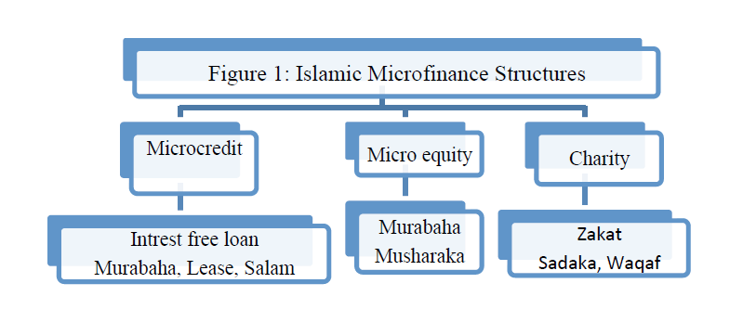
4.1. Difference Between Conventional Microfinance and Islamic Microfinance
Both Conventional and Islamic Microfinance have the same goal about serving the poor, poverty alleviation and employment generation by offering credits, training and other service. However they have differences as well as similarities. The table below shows the differences between them.

Particulars | Islamic Microfinance | Conventional Microfinance
Target Segment | Family | Women
Objective for the Target Group | Creating Availability | Empowerment of women
Pricing of Instrument | Profit-Loss, Mark up and rental based | Interest Based
Serving the extreme Poor | Not enough reach | Successful to reach the target audience
Liability of the Loan | Recipients and Spouses | Just Recipients
Funds Transfer | Goods and Other materials | Cash
Work Incentive of Employees | Religious and Monetary Value | Monetary Value
Dealing with Default | Group/Spouse/Islamic Ethic/Center | Group/threat or center
Source of Funds | Religious institution, Islamic Charitable organizations, foreign donors, national clients. | Foreign donors, Multilateral, national agencies and government.
Source: (Nabi et al., 2017)

4.2. Current Status of Islamic Microfinance in Bangladesh
Bangladesh has a concentrated size of Islamic Microfinance Market that includes 4 Islamic Bank, 20 Islamic Microfinance Institute and some conventional MFI offers Islamic Microfinance program. AMWAB- Association of Muslim Welfare Association of Bangladesh works as a wholesale fund provider for Islamic Microfinance to some extent. The center of Islamic Microfinance, Islamic Bank Bangladesh Limited (LBBL) is accounted for 78.84 percent of market of Islamic Microfinance.(Nabi et al., 2017). IBBL has operated Islamic Microfinance under rural development sector (RDS) since 1995 in Bangladesh.

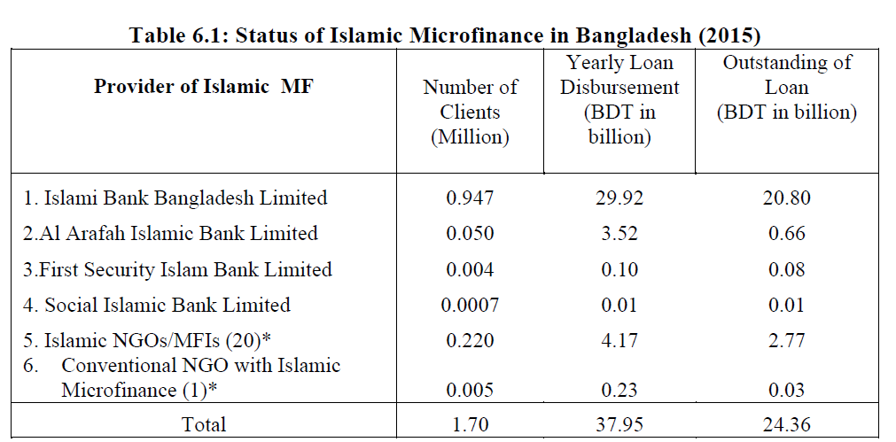

Though Islamic Bank and other Islamic Microfinance Institutes are running smoothly, it is quite prominent that Islamic Microfinance are lagging behind when it comes to the Microfinance market as whole. The Client of Islamic Microfinance stands at a significant lower rate then the conventional microfinance. The scenario is same when it comes down to loan disbursement.
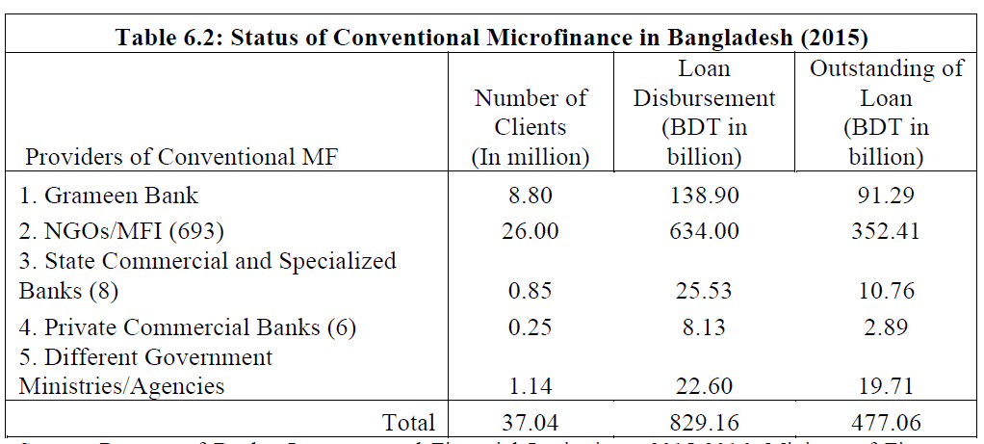

Source: (Nabi et al., 2017)
It’s very clear that Islamic Microfinance only accounts for only 3-5% despite the majority of population being Muslim and Success of the Islamic Bank. The small share of Microfinance is shown below:
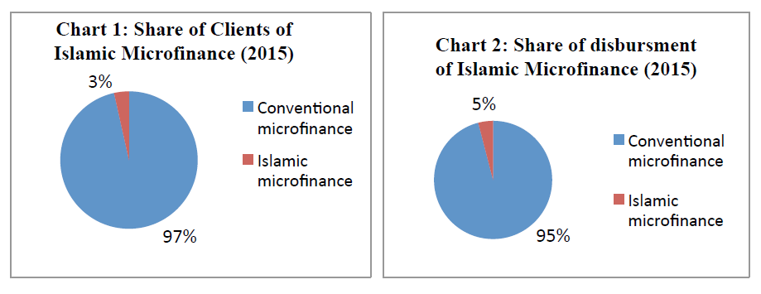
Source: (Nabi et al., 2017)

5.Islamic Microfinance: Models and Funding Modes
Islamic Microfinance has distinct, innovative and comprehensive framework to serve several categories of poor ranging from moderately poor to radical poor. (Nabi et al., 2017)
5.1.Models of Islamic Microfinance
Islamic Microfinance has inclusive framework to include moderate poor to extreme poor in serving categories. Islamic Microfinance can be classified into two parts: Charity based and profit based. Charity based model serve extreme poor and marginal poor that are above the poverty line based on Zakat, Sadaqa, Waqf and Qard Hasan. Profit based model based on Qard Hasan and Commercial Funding serve only for low income poor.
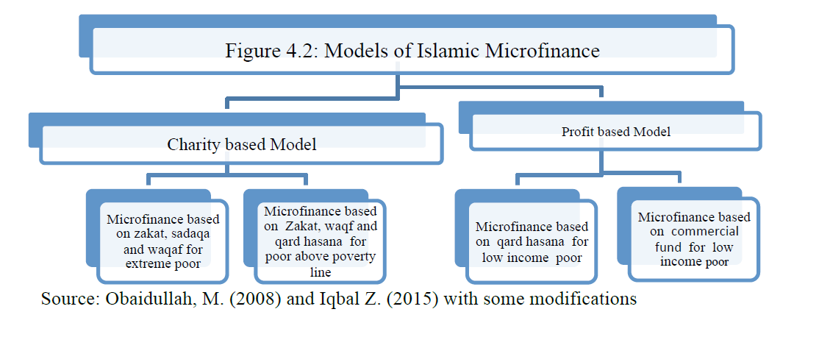
5.2.Funding Modes of Islamic Microfinance
Islamic Microfinance has also funding modes charity and profit based as shown in the figure. The funding modes ensures that all segment of the poor can be served- charity based mode is for extreme poor and moderate poor who are marginally above the poverty line while profit based mode are for the low income poor.
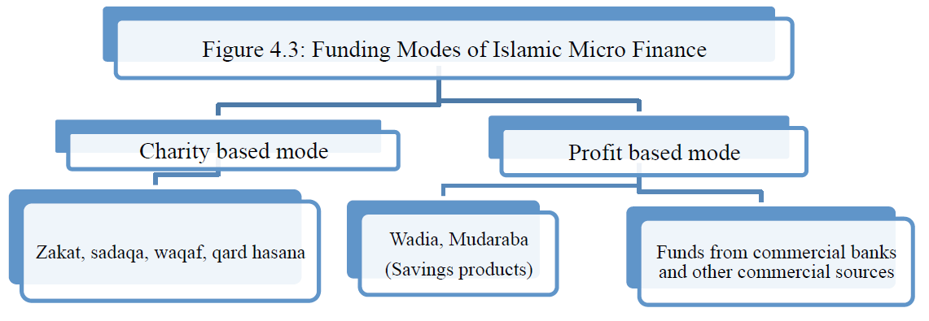
5.2.1.Zakat: Zakat is the third of five basic pillars of Islam. Zakat is a compulsory action imposed towards Muslim which acts as a transfer of wealth from a capable person who has enough wealth to afford to share his wealth with others to who needs it. It is a part and parcel of Islamic Society as the right of the poor. It has been declared rights of the poor in the wealth of the wealthy person. That’s why zakat also works as a financial inclusion and a tool of distribution wealth and sustainable charity based source of Islamic Microfinance.(Nabi et al., 2017)
5.2.2.Sadaqa: It means voluntarily distribution of wealth by Muslim to alleviate the hardship of the poor people. Islam considers that its duty of everybody to help people in need especially the poor. Numerous verses of the Holy Quran has suggested to help the poor if one has the ability to. Islam teaching urges the capable to distribute his wealth among the poor to earn blessings from Allah. funds collected from Sadaqa can be a viable source for Islamic Microfinance.(Nabi et al., 2017)
5.2.3.Waqf: The term Waqf is a legal Islamic Term which means protecting an asset to refrain as being used, and in future it can utilized as charity. There are five types of Waqf in Islam. Philanthropic Waqf is welfare for the general public. Religious Waqf and Family Waqf is the spread of religion and welfare of family respectively. Waqf of Usufruct is usufruct of the property that is used for Waqf and lastly Financial Waqf is only the income generated from for can be used as Waqf. Waqf that come from the income worked as another source. (Nabi et al., 2017).
5.2.4.Wadiah: Wadiah Saving account is basically a saving account for safekeeping and regular withdrawals like conventional saving account, but client will not get any pay or return from the money they are putting into the account. Generally, Clients are required to become a member first so that they can contribute to member’s share. (Noipom, 2013)
5.2.5.Mudarabah: The Microfinance Client can choose to open Mudarabah account with IsMFIs to save surplus fund. Under this account clients are imposed to share the risk and profit with the IsMFIs at the predetermined ratio. (Nabi et al., 2017)

6. Financing Mode and Products of Islamic Microfinance
There are different financing mode in Islamic Microfinance, they are also called the product of Islamic Microfinance. This financing Mode can be classified into three parts that are Partnership based, sale based and miscellaneous.
6.1.Partnership Based
6.1.1.Mudarabah Investment Account: This is another account form of IsMFIs. This particular account targets those who have high income and is able to invest a large amount money for a longer period of time. Most Islamic Microfinance Institute offers three month ,six month, nine month and twelve month Mudarabah investment account. In this type of account client and the IsMFIs help each other where the other is lacking. Client provide the institution with a large amount money to use as a capital and the institute provide the client with human capital to settle the business venture. Among the contribution the client make, majority of them are spend on microfinancing where the residual portion are used on fisheries or farm or other new business venture. The clients gets return on a predetermine ratio that was set by the institute and the client according to the term of the contract. (Noipom, 2013)
6.1.2. Musharaka Account: Under this account every partner has to contribute in the equity funding in the partnership business. Both the IsMFIs and the client of the account share the right to partake in the management of the operation. But in some instances the IsMFIs can opt to take the client lead of the operation of the whole business. The profit is divided between the institute and the client at a predetermined ratio. In case of loss, it is hsared by both party according to the capital ratio. (Nabi et al., 2017)

6.2.Sale Based
6.2.1.Murabahah Microfinancing : Murabahah contract is sale based microfinancing contract. In which Clients ask the IsMFIs to buy them the good they desire to buy and sell it to the clients within a reasonable price which includes profit for the institution. The clients are supposed to make the repayments in installments or in lump sums.
However, in reality murabahah microfinancing can be executed in a different way. A client can gather knowledge about the good such as price and where to buy from and ask the institute to buy it for them or IsMFIs staff will purchase the good directly and resell it to the client. There are also some case when the client was given cash for the goods also some guidance from the agents, they were assigned to so that the agent can oversee the purchase and receive receipt after the transaction. Many IsMFIs have contracted supplier from where Client can get the goods directly. This happens mostly goods such as motorcycle and construction hardware. Collateral can be member share, Personal guarantor or asset maybe require depending on the previous credit history of the clients and the amount of microfinancing the client is getting from the IsMFIs. (Noipom, 2013)
6.3.Miscellaneous
6.3.1. Pilgrimage (Haj) Account: Some Countries also offers Pilgrimage(haj) Account. It is a type of Mudarabah contract where the account holder gets annual return. The service is designed for a specific group of clients. Namely who has plan to go to the Pilgrimage(haj). The account holder might even decide to go to Makkah even before the desired amount has been reached. (Noipom, 2013)
6.3.2. Pawn Service ( Ar Rahn) : This service doesn’t have any legal ground. That’s why some of the IsMFIs include it as a part of the Islamic Microfinance segment which deals with emergency loans. When the time to report the service, it is reported separately. In reality Clients are required to put gold or other jewellery as a form of pledge and take money from the institute and then take the pledged item after returning the money full amount with a small fee. (Noipom, 2013)
6.3.3. Insurance Scheme: Another Primary type of service is Insurance Scheme which is there to assist the client with medication and funeral expenses. Clients are required to contribute a small annual fee which acts as a part of the insurance fund. In conventional term this annual fee is also called as premium. It also works as a cooperative fund to other clients. (Noipom, 2013).
6.3.4. Qardhul Hasan: Another concept of advanced for microfinance is Interest Free Loan which means Qardhul Hasan. In Arabic Qardhul Hasan means “Beautiful loan” as it is used to ease someone’s pain by sharing the wealth without getting anything in return. Perhaps the word Hasan stood for a person is helping another in need by giving him loan knowing fully that they will not get anything in return, they are just doing it to please the almighty. The Difference between Qardhul Hasan and Sadaqa is Qardhul Hasan in needed to be paid where Sadaqa is purely charity (A. R. A. Rahman, 2010).

7. Islamic Microfinance as a Financial Inclusion tool
Inspite of the minor share in Microfinance Market, Islamic Microfinance has shown some potential growth in Bangladesh market. The mentioned can be some factor that plays an important part of Islamic Microfinance in Bangladesh.
7.1.Scope and Significance of Islamic Microfinance in Bangladesh
Promoting Financial Inclusion to Religious People: Islamic Microfinance has great potential in Bangladesh where great conventional Microfinance was unable to reach the extreme poor people. As Conventional Microfinance is based on Interest Loan, which is explicitly forbidden in Islam. For that some people choose not to take loans resulting in financial inclusion. This interprets that Islamic Microfinance can be a way forward for this particular problem by imposing Islamic regulation in the microfinance which will result into financial inclusion.
also there is another segment that cannot afford to bear interest expense, removing interest from loan as Islamic Microfinance does serves that segment too. Islamic Microfinance can be solution for all Interest based loan related issue.(Nabi et al., 2017)
Success of Islamic Banking: Bangladesh is one of the star performers of Islamic Banking among the all Muslim countries in the world. In Bangladesh currently 8 private sector banks out of 56 commercial bank are serving Islamic Banking service along with the Islamic Bank and other Islamic Microfinance institute. Total investment and deposit of Islamic Banking is accounted for more than 21% of the total banking system at the end of December. Now more than 10 million people are account holder of some kind of Islamic Microfinance scheme indicating a wide range of acceptance of Islamic Banking in Bangladesh. It also indicates that the ground has already been prepared to use Islamic Microfinance as a financial inclusion tool in Bangladesh. (Nabi et al., 2017).
Excess Liquidity of Islamic Bank: Bangladeshi Islamic Bank has excess liquidity due to the fact that there is deficit of appropriate investment instrument. Islamic Microfinance might be reliable investment instrument for Islamic Bank to use the surplus fund. This will ensure that Islamic Bank can invest in shariah based instrument that is Islamic Microfinance.(Nabi et al., 2017)
Promoting Micro and Medium Enterprise: Bangladesh is a country that has millions of youth that has Micro and Medium enterprises as their business means that need to be promoted. Conventional Microfinance is not viable option for the higher interest rate. Islamic Microfinance can mitigate that problem.
Potential Zakat Fund: Bangladesh has a zakat board that oversee and collect all the zakat and distribute it to the poor accordingly which are managed by the social organizations and government. But their performance are far lower than the potential this zakat fund possess. Introducing proper scheme might enhance zakat fund collection that can play an important role in playing vital role in improving charity based Islamic Microfinance model in Bangladesh.
Attracting Foreign Funds: Foreign Funds specifically from Middle eastern major Muslim countries, Islamic Development and other international financial institution might be attracted to any proper scheme that is introduced under Islamic Microfinance. (Nabi et al., 2017).
7.2. Challenges of Islamic Microfinance in Global Context
Though there are many potential of Islamic Microfinance there are still some hurdle that needs to be to overcome. Every country has their own set of limitation when it comes to implanting Islamic Microfinance, but the general problem is same for every country. Those challenges are mentioned below:
7.2.1. Versatile Organizational Structure: The majority of IsMFIs in south Asian countries are set as NGOs. The main principle of NGOs is, they are allowed to make profit but not take the profit. But there are also several IsMFIs that share their profit with the shareholder. In some countries Private Banks also offers Islamic Microfinance scheme and they have a different set of rules how they would share the profit they are making. Also in many cases the organization that are providing microfinance scheme are not even registered and they are operating informally. Registered firm also gets many benefits such as fund raising from the formal banking. on the other hand unregistered organization might suffer from lower credibility risk. having diverse organization operating on the same field without any uniformed rules is a limitation to Islamic Microfinance. (Obaidullah & Khan, 2008)
7.2.2.Shariah compliance: Shariah Compliance is the main factor that distinguish between the conventional microfinance and Islamic microfinance. Islamic Microfinance not only should incorporate shariah in their products, activities but they should also perceived by the client the same way. Major Islamic Microfinance institutes set shariah based Supervisory to meet up the customers perception that they are following shariah based activity. Also when it comes to client’s perception, they have a wide range of perception of Mudarabah, Murabahah and Qard Hasan. Client might not be enough knowledgeable about what is the difference between them and what might be the appropriate approach for them. the proper mechanism of each of the funding mode should be introduced to each target group. Most worrisome perception clients have is they think Qard Hasan is free. Borrower don’t need to repay the loan. The clients have informed time to time about the difference between Sadaqa and Qard Hasan, but it still come off as a challenge for Islamic Microfinance.(Obaidullah & Khan, 2008)
7.2.3. Lack of Product Diversification: Despite the richness of versatile product of Islamic Microfinance, Islamic Microfinance is highly Murabahah centric. It might be the result of Client’s lack of awareness. the actual number of organization that offer other Islamic financial product such as zakat, qard al hasan , awaaf is nowhere near the number of institution that offers the mainstream Islamic financial product. (Obaidullah & Khan, 2008).
7.2.4. Association with Bank and Capital Market: If Islamic Microfinance wants to build a sustainable financial inclusive system then it needs to have a connection with bank and other capital market. But the absence of such linkage is presenting as a major challenge for some countries except for Malaysia and Indonesia. there is hardly any trace of connection between Islamic microfinance provider and capital market. The absence of linkage between Islamic Microfinance institute and the capital can be result of many reason such as the lack of awareness from the Islamic Microfinance Provider’s side. The agency that rates the credibility and default risk of any loan can also play a big part in the absence of connectivity between them.

7.3. Challenges of Islamic Microfinance in Bangladesh
Inspite of having a huge potential Islamic Microfinance still has 3-5% of market share in the market. The key challenges Islamic Microfinance faces are: First of all there is no detailed guideline about how Islamic Microfinance should operate from Microfinance Regulatory Authority (MRA). Another issue was lack of motivation from Islamic bank management. Also Absence of Suitable Islamic Microfinance Institutes are another deterrent factor. There is lack of appropriate Human resource to take on the job too. Overall there are some limitation in the context of Islamic Microfinance in Bangladesh.
7.3.1. Lack of guideline: Many different organization serve as an Islamic Microfinance provider in Bangladesh, not all of them are under Islamic bank Bangladesh Limited. Some of them are NGOs, some are private bank. Different organization have different set of organizational rule that they follow. Such as NGOs are allowed to make profit but not take the profit. In Bangladesh this problem could have been mitigated if there was a uniformed guideline to guide the Islamic Micro financial institutes. But the lack of guideline from MRA is creating quite a challenge for Islamic Microfinance to operate on Bangladesh.(Nabi et al., 2017).
7.3.2. Lack of Suitable Instrument: There is lack of awareness among client. There are different funding mode that offers different service to cater the need of the customer. many organization now are working on the fact that clients are thoroughly confused about which funding mode cater to their specific need and suitable for them. The most common confusion is between Qard Hasan and Sadaqa (Obaidullah & Khan, 2008). Both of them are a form of Charitable mode but in Qard Hasan clients are required to repay the loan they got. As customers don’t know what type of instrument is suitable for them, they tend to make wrong choice and ultimately falls into default which results in higher default risk.
7.3.3. Agency problem with PLS scheme: Another Key criteria of Islamic Microfinance is they offer profit and loss sharing scheme in a predetermined ratio. The uncertainty of Profit can cause problem between the institution and the client. and Bangladesh has a large number of Micro and Macro Enterprises. Islamic Microfinance has a significant opportunities to work on them as many of the startup business can’t afford to take interest based loans.(Nabi et al., 2017). But the main problem that comes from serving the micro and macro enterprises holder that they don’t have a structured financial statement and it presents a huge problem when it comes to share the profit and loss (Obaidullah & Khan, 2008). Also PLS scheme demands that Clients and Institution both stay in a haul to share their work and share and loss, but which is not possible for the business that is opened recently.
Despite the large number of challenges that Islamic Microfinance is facing globally , these are the challenges that presents in Bangladesh that can be mitigated through a comprehensive design targeting these specific challenges.

8.Conclusion
With a large number of poor women and men enable to get included in the financial service because of religious restriction and beliefs, it becomes important for every stakeholders that include Government, Private sector and Islamic Microfinance institutes to support in developing and designing proper Islamic Microfinance scheme that will act as a driving force of Islamic Microfinance as financial tool. The beauty of Islamic Microfinance is it’s not only for the Muslim but also for the non-Muslim too. Anyone who needs the help from the Islamic Microfinance can get it.
Islamic Microfinance not only works on the religious belief, but it also mitigates the problem of interest rate which is prohibited in the shariah. The particular segment in the society who are unable to get financially included because they are unable to repayment the loan, Islamic Microfinance also works with them through charity based funding mode. It is also necessary to have a supportive environment where all the stakeholder might be able to work on developing a proper scheme. An effective proposal for Islamic Microfinance would need concentrated and combined effort from all the stakeholders- the clients, the cooperatives, the NGOs, Islamic Bank etc. It is also implied that the poor who is the client of some funding modes of Islamic Microfinance should have knowledge, education and skill about what type of loan they are getting and what is the benefit of it. The NGOs should act as a catalyst between all the schemes and the client who are potential account holders. Combining all the effort from all the stakeholder might lead to an effective strategy for the Islamic Microfinance to act as financial Inclusion tool in Bangladesh.

9.References

Abbas, K., & Shirazi, N. (2015). The key players’ perception on the role of Islamic microfinance in poverty alleviation. Journal of Islamic Accounting and Business Research.
Ahmad, A. U. F., & Ahmad, A. R. (2009). Islamic microfinance: the evidence from Australia. Humanomics.
Ahmed, A. (2010). Global financial crisis: an Islamic finance perspective. International Journal of Islamic and Middle Eastern Finance and Management.
Ahmed, H. (2009). Financial crisis, risks and lessons for Islamic finance. ISRA International Journal of Islamic Finance, 1(1), 7-32.
Alaro, A. A.-M., & Alalubosa, A. H. (2019). Potential of Sharī’ah compliant microfinance in alleviating poverty in Nigeria. International Journal of Islamic and Middle Eastern Finance and Management.
Banihani, S. (2012). Scaling up Islamic microfinance in Bangladesh through the private sector: experience of Islami Bank Bangladesh Limited (IBBL). Bureau for Development Policy, United Nations Development Programme (UNDP), New York, NY.
Begum, H., Alam, A. F., Mia, M. A., Bhuiyan, F., & Ghani, A. B. A. (2019). Development of Islamic microfinance: a sustainable poverty reduction approach. Journal of Economic and Administrative Sciences.
Chapra, M. U. (2008a). The global financial crisis: can Islamic finance help minimize the severity and frequency of such a crisis in the future. Paper presented at the A paper presented at the Forum on the Global Financial Crisis at the Islamic Development Bank on.
Chapra, M. U. (2008b). Innovation and authenticity in Islamic finance. Paper presented at the Eighth Harvard University Forum on Islamic Finance: Innovation and Authenticity.
DRISSI, S. (2017). Islamic Microfinance: Locomotive In The Service Of Financial Inclusion. European Journal of Islamic Finance(7).
El Qorchi, M. (2005). Islamic finance gears up. Finance and Development, 42(4), 46.
Fianto, B. A., Gan, C., Hu, B., & Roudaki, J. (2018). Equity financing and debt-based financing: Evidence from Islamic microfinance institutions in Indonesia. Pacific-Basin Finance Journal, 52, 163-172.
Hassan, A. (2015). Financial inclusion of the poor: from microcredit to Islamic microfinancial services. Humanomics.
Hassan, A., & Saleem, S. (2017). An Islamic microfinance business model in Bangladesh. Humanomics.
Hassan, S., Rahman, R. A., Bakar, N. A., Mohd, R., & Muhammad, A. D. (2013). Designing Islamic microfinance products for Islamic banks in Malaysia. Middle-East Journal of Scientific Research, 17(3), 359-366.
Kassim, S. (2016). Islamic finance and economic growth: The Malaysian experience. Global Finance Journal, 30, 66-76.
Khaleequzzaman, M., & Shirazib, N. S. (2012). Islamic Microfinance–an Inclusive Approach with Special Reference to Poverty Eradication in Pakistan. International Journal of Economics, Management and Accounting, 20(1).
Khan, H., & Bashar, O. K. (2008). Islamic Finance: growth and prospects in Singapore.
Khan, M. S. N., Hassan, M. K., & Shahid, A. I. (2007). Banking behavior of Islamic bank customers in Bangladesh. Journal of Islamic Economics, Banking and Finance, 3(2), 159-194.
Komijani, A., & Taghizadeh-Hesary, F. (2018). An overview of Islamic banking and finance in Asia. Retrieved from
Maulana, H., Razak, D. A., & Adeyemi, A. A. (2018). Factors influencing behaviour to participate in Islamic microfinance. International Journal of Islamic and Middle Eastern Finance and Management.
Mirakhor, A., & Iqbal, Z. (2012). Financial inclusion: Islamic finance perspective.
Nabi, G., Islam, A., Bakar, R., & Nabi, R. (2017). Islamic microfinance as a tool of financial inclusion in Bangladesh. Journal of Islamic Economics, Banking and Finance, 113(6218), 1-28.
Nakagawa, R. (2009). The evolution of Islamic finance in Southeast Asia: the case of Malaysia. Journal of Applied Business Research (JABR), 25(1).
Noipom, T. (2013). Assessing the Performance and Scope of Islamic Microfinance in Thailand: Developments and Prospects. Durham University.
Obaidullah, M. (2008). Introduction to Islamic microfinance. Mohammed Obaidullah, INTRODUCTION TO ISLAMIC MICROFINANCE, IBF Net Limited.
Obaidullah, M., & Khan, T. (2008). Islamic microfinance development: Challenges and initiatives. Islamic Research & Training institute Policy Dialogue Paper(2).
Obaidullah, M., & Latiff, H. S. H. A. (2008). Islamic finance for micro and medium enterprises. Islamic Research & Training Institute Islamic Development Bank, Centre for Islamic Banking, Finance and Management Universiti Brunei Darussalam.
Rahman, A. R. A. (2010). Islamic microfinance: an ethical alternative to poverty alleviation. Humanomics.
Rahman, R. A., & Dean, F. (2013). Challenges and solutions in Islamic microfinance. Humanomics.
Rozzani, N., Mohamed, I. S., & Yusuf, S. N. S. (2016). Technology for Islamic microfinance’s disbursement and repayment system. International Journal of Social Economics.
Santoso, B., & Ahmad, K. (2016). Islamic microfinance branchless banking model in Indonesia. Intellectual Discourse, 24.
Tamanni, L., & Besar, M. H. A. H. (2019). Profitability vs Poverty alleviation: has banking logic influences Islamic microfinance institutions? Asian Journal of Accounting Research.
Wilson, R. (2007). Making development assistance sustainable through Islamic microfinance. International Journal of Economics, Management and Accounting, 15(2).
Wolters, A. (2013). Islamic finance in the states of Central Asia: Strategies, institutions, first experiences. Retrieved from
Yusof, R. M., & Bahlous, M. (2013). Islamic banking and economic growth in GCC & East Asia countries. Journal of Islamic Accounting and Business Research.

