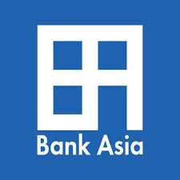

FOREIGN TRADE ACTIVITIES
IN
BANK ASIA LIMITED



Internship Report
On
“Foreign Trade Activities in Bank Asia Ltd”

Prepared by:
Md. Zafrulalam Mahin
Id: 111 141 229

Prepared for:
Dr. Seyama Sultana
Assistant Professor, SOBE

Date of Submission:19th September 2018

Letter of Transmittal

19th September, 2018
Dr. Seyama Sultana
Assistant professor
School of Business and Economics,
United International University
Subject: Submission of internship report

Dear Madam,
It is my pleasure to submit this report that has been a prerequisite for the completion of my internship program. The Report named "Foreign Trade Activities in Bank Asia Ltd". In Bank Asia Ltd I have learned numerous frameworks and numerous things about the Banking arrangement. I need to attempt my level best to whole this report altogether and precisely, as much as practical. I do assume that the exhausted exertion will assist you with getting fore with the kind of the risk. I have begun my internship at Bank Asia Ltd, Principal Office Branch, Motijheel.
I value your kind counsel, collaboration, tolerance and recommendations with respect to this report which will assist me with going ahead as a splendid rule. I will be accessible for any inquiry and clarification in regards to this report at whatever point vital.

Sincerely yours,


Md. Zafrulalam Mahin
Id: 111 141 229

Acknowledgement

At first, I might want to express my appreciation to almighty Allah as I have finished this entry level position write about the theme "Foreign Trade Activities in Bank Asia Ltd" effectively by His leniency. I might likewise want to thank my decent chief Dr. Seyama Sultana, Assistant Professor of School of Business and Economics, United International University for whom I have arranged this report. I might want to recognize and stretch out my ardent appreciation to her in light of her crucial consolation and support and help. I might likewise want to express gratitude toward Mr. Subroto Kumar Paul, AVP, Mr. Saeef Ahmed, FAVP and in addition Ms. Shamima Haque Munni, SEO of Foreign Trade Dept. in Bank Asia Ltd, for their participation in the association.

I am likewise thankful to my folks and the majority of my companions for their persistent help and to each one of the individuals who have somehow added to the readiness of this report. Last however not the minimum; I am appreciative to every one of the respondents for quietly outfitting the required data, which was required for effective fruition of this report.

Executive Summary

The financial advancement of a nation depends generally on the exercises of business Banks. Particularly a nation like Bangladesh, our agrarian, modern and monetary advancements are especially relying upon smooth activity of Banks. Along these lines, we should guarantee the proficient and powerful execution of this part.
In Bangladesh the Bank Asia Limited is one of the leading banks among others. The primary goal of the Bank is to give all of managing an account administration at the doorsteps of the general population. The bank assumes a spearheading job in taking care of Foreign trade exchanges. This internship report is gone for giving an extensive picture to the zones of "Foreign Exchange Activities" of Bank Asia Limited. Foreign exchange task is one of the critical elements of the bank. Foreign exchange holds the Import & the Export area and foreign remittance division holds the inwards & the outwards remittance. Every one of the statements and steps are unmistakably said. The insights about Letter of credit such as arrangement of letter of credit, letter of credit opening method, kinds of letter of credit, letter of credit installments inclinations, necessary reports, records checking and transmitting letter of credit amendment, why it is necessary and when it will be required and the lodgment framework. At the point when record is going out resign what the final advance of retirement and reports to the Bangladesh Bank. And furthermore, reveal the issue about fare system. The strategy started to receive the ERC by boss controller of the import and the fare office. From that point forward, accepting the letter of credit and prompting letter of credit, essential archive accumulation and furthermore reports to the Bangladesh Bank. Toward the finish of fare area, bank will issue the PRC for the exporter. Last yet not the rundown, the foreign exchange remittance process and execution investigation.

Contents
CHAPTER ONE: INTRODUCTION 7
Introduction: 8
Origin of The Study: 8
CHAPTER TWO: LITERATURE REVIEW 9
Industry Overview: 10
Historical Background of Bank Asia Ltd: 10
Slogan, Mission, Vision and Core Values: 11
Product/Services of Bank Asia Ltd: 13
Corporate Information: 14
Formation of Bank Asia Ltd: 15
Hierarchy of Bank Asia Ltd: 16
Competitor of Bank Asia Ltd: 17
CHAPTER THREE: JOB RESPONSIBILITIES 18
Working Environment: 19
Specific Job Responsibilities: 19
Significance of My Work: 19
Foreign Exchange: 20
Meaning of Foreign Exchange: 20
Activities of Foreign Exchange Division: 21
Foreign Exchange: 21
Foreign Trade Department: 21
Foreign Remittance Department: 30
Performance Analysis: 32
CHAPTER FOUR: FINDINGS 34
Obstacle Faces While Working: 35
CHAPTER FIVE: CONCLUSION & RECOMMENDATION 36
Conclusion: 37
Recommendation: 37
REFERNCES 38
APPENDIX 39

CHAPTER ONE: INTRODUCTION

Introduction:
Commercial Banks are set to give high caliber money related administrations and items to add to the improvement of monetary states of a nation through exchange and trade, enhancing the industrialization in a broad way, boosting up fare, making the greater work opportunity, working in a destitution mitigation, enhancing our way of life and in general financial advancement of the nation. Presently multi day's amassment money area is growing its turn in numerous budgetary occasions each day. In the meantime, the keeping money process is winding up quicker, less demanding and is getting to be far reaching. It very well may be finished by just appropriate understanding, learning and usages of those things. Preparing and Development is a standout amongst the most critical issues in Human Resource Management frameworks. By utilizing Training and Development process any bank can enhance their execution and furthermore action level in their organizations.

Origin of The Study:
The accomplishment of a program like Bachelor of Business Administration is controlled by how effectively the understudy of this program actualized in the reasonable life, which they gained from this program. The universities find a way to make connect between the scholarly learning and genuine business world occasion of BBA understudies and this internship program is one of them.
As a necessity of the fulfillment of the Bachelor of Business Administration degree Major in Marketing at United International University, I was doled out to do my entry level position at the Principal Office Branch of Bank Asia Limited for a time of as an intern. The report is a methodical paper of this temporary job program.

CHAPTER TWO: LITERATURE REVIEW

Industry Overview:
The Banking industry in Bangladesh is for the most part separated into two segments, for example, Specialized Banks (SBs) and Commercial Banks (CBs). The Specialized Banks are the banks that arrangement with particular segments in an economy. For example, Bangladesh Krishi Bank just manages the rural division in an economy; Bangladesh Shilpa Bank just manages the mechanical part in an economy, and so on. Then again, Commercial Banks are the cadaster Banks that are working in the nation under the guidelines and controls of the Bangladesh Bank. Business banks could be assembled as The Nationalized Commercial Banks, The Foreign Commercial Banks and The Private Commercial Banks including the three unique portions, for example, the first Generation Private Commercial Banks, the second Generation Private Commercial Banks, and the third Generation Private Commercial Banks. Business Banks in Bangladesh are not permitted to work together other than simply keeping money. After the freedom banks working in Bangladesh were nationalized. These banks were consolidated and gathered in 6 business banks. Of the aggregate six business banks, Pubali Bank Ltd. what's more, Uttara Bank Ltd. have in this way been exchanged to the private area with impact from January 1985. Also, at present there are 51 planned banks working all over the nation. Among these banks Nine are state-possessed Thirty are private business banks and the rest of the Twelve are outside business banks.

Historical Background of Bank Asia Ltd:
The Bank Asia Ltd began its procession on November 27, 1999 with an intend to be completely client centered through rendering innovation driven imaginative items and administrations by a gathering of fruitful business visionaries of the nation with the essential target of getting superb administrations the managing an account area and effectively taking an interest in the development and extension of the national economy. Bank Asia Limited is a planned business Bank under private segment in Bangladesh built up under the Banking Company Act, 1991 and fused as a Public Limited Company under the Company Act, 1994 on September 28, 1999. The Bank acquired Certificate of Incorporation and Certificate of Commencement of Business on September 28, 1999 and saving money permit on October 06, 1999. Bank was recorded with Dhaka Stock Exchange (DSE) and Chittagong Stock Exchange (CSE) on January 06, 2004. Since beginning Bank Asia is working effectively and accomplishing a solid conspicuous position in saving money part. Following 14 years of task, today Bank Asia gladly remains among the first-class banks of the nation with a broad system of business outlets involving traditional managing an account branches, Islamic windows, seaward saving money unit, financier branches, horticultural branches, and SME focuses.
Amid this limited ability to focus time the Bank had been fruitful to position itself as a dynamic and dynamic budgetary foundation in the nation. Moreover, a large portion of the city regions under Dhaka and Dhaka are secured by ATMs with 24 hours keeping money offices for the clients. As of end 2013, Bank Asia had 1,600 committed workers for serving its customers the nation over offering a full suite of money related items and administrations. With its advantages of more than Tk. 163,778 million, Bank Asia directions huge piece of the pie in the two stores and advances with Tk. 113,489 million and Tk.104, 911 million separately. The Bank exceptionally accentuates on the robotization of the saving money exercises using web based managing an account, M-Banking, Telebanking, and Internet Banking, every day ATM administrations so on. The center business of the Bank includes exchange back, term fund, working capital fund and corporate back.

Slogan, Mission, Vision and Core Values:
It is a 3rd generation public ltd bank. In Sep 28, 1999 this bank got the certificate of incorporation and this bank starts its task on Nov 27, 1999. Presently following 12 unwavering long periods of devoted and dependable administrations this bank has made a desirous place within the main banks of the nation that has taka 112 billion of wealth, has the saving 95 billion taka as well as 127 branches everywhere throughout the nation. Yet, in particular, this bank has an amazing inheritance connected with its picture.

Slogan:
“FOR A BETTER TOMORROW” does not need to kept with the constrained administration rather improved existing administration and raised new administrations with the end goal to their current and dynamic customers for create the existence simpler.

Vision:
Bank Asia Limited vision is to have a destitution free Bangladesh in course of an age in the new thousand years, mirroring the national dream. Bank Asia’s vision is to fabricate a general public where the human pride and the human need get the most noteworthy thought alongside decrease of neediness.
Mission:
- To help with conveying top notch administration to our clients and to take part in the development and extension of our national economy
- To set exclusive requirements of respectability and convey add up to fulfillment to our customers, investors and workers
- To turn into the most looked for after bank in the nation, rendering innovation driven inventive administrations by our committed group of experts
Core Values:
- Place client premium and fulfillment as first need and give tweaked managing an account items and administrations
- Value expansion to the partners through accomplishing magnificence in keeping money activities Maintain high moral standard and straightforwardness in dealings
- Be a consistent establishment through holding fast to every administrative prerequisite
- Contribute altogether for the improvement of the general public
- Ensure higher level of inspiration and noble workplace for the human resource
- Committed to ensure the earth and make strides toward environmental friendliness

Product/Services of Bank Asia Ltd:
- Deposit pension scheme is a 3, 5, 7, 10-and 12-years term. Regularly scheduled payment ascending from BDT 1000/ - to BDT 10000/-
- Monthly benefit plus is 3-and 5-years conspire that gives you a chance to acquire month to month advantage of BDT 1000/ - (before assessment) for store of BDT 1, 00,000/ - or its different.
- Double benefit plus is a six-year plot. The store will be twofold out of multi-year.
- The Minimum beginning store for the plan is BDT 1, 00,000/ - or its various, most extreme is BDT 25, 00,000/ - under single name. and BDT 40, 00,000/ - under joint name.
- Triple benefit plus is 9 years half year plot. The store will be tripled in 9 years a half year. Least store for the plan at first BDT 10, 00,000/ - or its different, most extreme is 25, 00,000/ - under a solitary name. BDT 40, 00,000/ - under joint name.
- Fixed deposit rate 1 months and 2 months residency beneath 2 center 10% for every annum. 2 or more 12% for each annum. 3 months, a half year, and 1 year any sum will get12% and 1 year above will get 11% for any sum

Corporate Information:

Number of Branches | 127
Number of Promoters | 22
Number of Directors | 14
Number of SME centers | 4
Number of Islamic Wing | 5
Number of Brokerages Branches | 5

Formation of Bank Asia Ltd:

Hierarchy of Bank Asia Ltd:

Chairman of Bank Asia
MD- Managing Director
DMD-Deputy Managing Director
SEVP-Senior Executive Vice President
EVP-Executive Vice President
SVP-Senior Vice President
VP-Vice President
FVP-First Vice President
AVP-Assistant Vice President
FAVP-First Assistant Vice President
SEO-Senior Executive Officer
EO- Executive Officer
SO-Senior Officer
JO-Junior Officer
AO-Assistant Officer
BO- Banking Officer
TO- Trainee Officer

Competitor of Bank Asia Ltd:
Bank Asia’s main competitor is Premier Bank Ltd. In case of foreign trade performance in between two banks then Bank Asia performs better. So, in the event we can say that Bank Asia perform better. Since the bank asia’s development growth is steadier at that point in premier bank. Despite the fact that Bank Asia’s growth from the foreign exchange on benefit is diminished just one year among this multiyear however Premier Bank is in diminished development wreath and inside this multiyear its development position in diminished wreath step by step. The Bank Asia likewise faces a diminishing development wreath yet this had just 1 year then its development wreath is expanding.

CHAPTER THREE: JOB RESPONSIBILITIES

Working Environment:
The working criteria and my primary obligations and duty is to know and bolster my associates in their everyday work environment and the entire condition is substantially more agreeable and accommodating with me which urge me to acquainted with nature. Everybody attempted to influence me to comprehend what to do, when to do and how to deal with this and how these functions being finished. My working division essentially which I have been put is the Foreign Trade Department where the day by day exchanges is being done through remote monetary forms.

Specific Job Responsibilities:
For the most part, I worked in export & import section of trade dept. In the export aspect, I prepared the passport endorsement, the advance payment and reporting to Bangladesh bank, the service payment and reporting to Bangladesh bank, to perform and assist the outward remittance related activities of Trade Finance Dept, to Assist the proceed realization such as maintaining the register and also prepare the forwarding of Foreign Demand Draft, opening and maintaining the student file, visited multiple branches in Dhaka, other tasks as assigned by branch management from time to time. I refreshed this data in Microsoft exceed expectations and MS Word and furthermore the enroll. In import area, I topped off import shapes, I refreshed Letter of Credit opening the register. I arranged the check chart for the Letter of Credit record, excluded check chart for the Letter of Credit document. Online Banking Software Which Bank Asia utilizes is an authorized programming named the Stellar here consistently everybody's duty is that in the wake of finishing their work they have to refresh it in this product. There are two symbols, one is entitled Bangladesh Bank and the second is the Stellar. The organizer entitled Bangladesh Bank, where subsequent to clicking, we will go the entrance to provide the workers Id and secret key and after that it will be necessary to select from what section my data is being given.

Significance of My Work:
A. Travel
- Release of foreign exchange for travel abroad
- Endorsement on passport and ticket
- Release of foreign exchange to the resident Bangladesh nationals travelling abroad
without visa
- Release of foreign exchange for travel on health ground
- Official or semi-official visits by employees of government/autonomous semi-autonomous bodies
- Release of foreign exchange for attending seminar, conference, workshop, training etc. abroad
B. Student file private remittance
- Pension payments
- Membership fees, fees for application, registration, admission, examination, etc.
- Release of foreign exchange for study abroad
C. L/C and remittance against imports
- LC covering imports
- Terms on which LCs may be opened
- Verification of import price
- Period of opening of LCs
- Firm contracts and credit reports
- Approved methods of payment
- Applications for remittances against imports
- Payment of import liability
Foreign Exchange: It is a crucial and inevitable part of commercial banking. It will be very advantageous and profitable activities for the bank, if it is performed successively according to the rules. In order to perform foreign trade activities successively the Foreign Trade Regulation Act, 1947 performed on the 11 March 1947 provided by British- India pays the legitimate basis for controlling bills and payoffs and conducts to the foreign trade and indemnity. The certified trader in foreign trade must obey the rules and regulations provided by Bangladesh bank.
Meaning of Foreign Exchange: It means to exchange the currency of one country to another in case of the goods enlists the savings, loans, balance chargeable, manuscripts, bill of exchange, Letter of Credit etc. It is very well settled business form in the world. In Bangladesh all contracts in foreign trade must follow the Bangladesh Bank law. In Bank Asia Ltd foreign trade dept. is very crucial than all other dept.
Activities of Foreign Exchange Division: Activities of Foreign Exchange Department can be divided into three parts:
- Export
- Import
- Remittance
Within a shorter period of time Bank Asia is one of the acknowledged private commercial banks in Bangladesh and has been created a reputed picture in the banking sector in spite of existing plentiful competitors. From its inauguration to till now Bank Asia is strongly determined to give a better-quality service to the clients and at the same time the authority is giving a worthy advantage to the employees. Its holds three departments at a time.
- General Banking
- Credit & Marketing Department
- Foreign Exchange
Foreign Exchange: we already know that Foreign exchange stands for exchanging of currency in terms of goods from one country to another. Bank Asia’s foreign trade holds the following departments:
1. Foreign trade department
2. Foreign Remittance department

Foreign Trade Department: It stands for exchanging of foreign currency for the purpose of trading between two nations. Foreign Trade Dept. has two sections which are given below-

Import Section.

Export Section

Before going to discuss the import and export section, we all have to be clarified about some concepts related to foreign trade.
The Concepts: Crucial concepts of foreign exchange as per the UCPDC discussed below:
- The Applicant/Opener/Importer/Buyer: All the names are using for the same motive. The applicant sakes the partner on whose apeeal the loan is granted.
- The Opening Bank/Issuing Bank: The bank is issuing the loan on behalf of applicant to the contrast partner.

- The Exporter/Seller/Beneficiary: It means the partner in whose favor a loan will grant.

- The Advising bank: It means the bank that advises the loan at the appeal of the granting bank.

- The Conforming bank: The bank that adds its conformation to a loan upon the granting bank’s authorizations known as conforming bank.

- The Negotiating bank: It means the bank that deals the bill of exporter written under the loan is known as negotiating bank.

The Methods of Payment in International Trade: Now a days it becomes the ultimate goal to get succeed in today’s global marketplace and wins sales against foreign rivalries. So, to achieve this the exporters must offer their clients lucrative sales terms supported by the proper payoff process. The ultimate goal for each export sale is to get the payoff in full on time, and must be very conscious about their proper payoff process to reduce the payoff risk while also providing the needs of client. In international contracts there will be 3 initial process of payoff.
The Advance Payment: It means the importer will pay in advance before the shipment date. Payoff in advance could be the less attractive opinion for an importer or a buyer because it makes adverse cash inflow. The Foreign purchaser are anxious that the products won’t be sent if the payoff is created in an advance.

- The Consignment Payment: It is a payoff which is given to the exporter, here the foreign suppliers can sell only the products to the final clients which means an exporter creates the transmission to his certified contractor in importing country so that the contractor sells the products and create revenue to the exporter. The exporter is not a guaranteed payment that’s why it is very much risky. And it is a most practiced process in flourished countries.
- The Letter of Credit (L/C): In international business a letter of credit is the most used process of payoff. In the import L/C, the importers bank, the importer bank ensured the provider about the payoff to the contract when the provider fulfill the law of L/C. Letter of Credit runs the centric role in that process of payoff to assist to finish the business.

Method to open Letter of Credit (import and export aspect):

- According to the contract they have made, the Applicant and the Beneficiary deal terms of the Letter of Credit.

- Then the issuing bank will issue the Letter of Credit on an appeal form when the applicant appeals.
- Then the Issuing Bank look at the following papers from the applicant:

- There must be a Formal contract in between the importers and the exporters.
- There must be the existence of Pro-forma receipt
- There must be an order of buyer’s buying.

Then the issuing bank issues the forwards and the Letter of Credit to the advising bank after observing all the papers.

- Then the obvious genuineness of the Letter of Credit will be checked by the advising bank and also advises the Letter of Credit to the beneficiary.

- Then the beneficiary will check the Letter of Credit, does it really consent with the formal deal, only then the goods will send to the importer whether all the words and agreements are written in the Letter of Credit must be satisfied.

- Then all the necessary documents are mentioned in the Letter of Credit such as checks all the papers for imbalance with the Letter of Credit will be gathered by the beneficiary.

- Then all the papers and manuscripts will be checked by the advising bank, does it really comply with the agreements as written in Letter of Credit. After all these activities the advising bank will send it to the issuing bank.

The Arrangement of Letter of Credit: The Bank Asia Principal Branch offers three types of Letter of Credit which are given below:
- The Sight Letter of Credit: When the papers have been accepted by the exporter then the payoff should be formed under 5 working days.
- The Deferred Letter of Credit: The payoff should be formed within or after the due date. The deferred L/C can be opened for Sixty days, ninety days and One hundred twenty days which relies on the partner need.
- The Back to Back Letter of Credit: Deferred L/C actually created by the exporter. When the exporter wants to import wealth to formulate the mentioned goods then the exporter must create a Letter of Credit in opposition to the prime Letter of Credit.

Import: It stands for purchasing of services and wealth from other countries. When the govt. of Bangladesh or any company buys goods from other nation to fulfill their essential needs is known as Import. In a short description the import is the transaction of wealth and services from one country to another through the economic dealers.
The L/C issuing It is the first step to import issuing the Letter of Credit. To get the payoff appropriately in the correct time the L/C is the most feasible sources. This kind of contract actually create when the exporter in UK and importer in Bangladesh make a deal of sale. This deal handles all significant issues such as the quantity of goods or the value, the accurate date of transmission, procedure of payoff and so on.
To open a Letter of Credit it needs some papers which are described below:
- The Letter of Credit appeal forms that holds all the necessary issues about the applicant and the beneficiary. Letter of Credit appeal form that holds all the necessary information about the applicant and the beneficiary. Letter of Credit amount, products and services country of origin which means the production areas, the payoff method such as CFR, FOB etc.
- The import forms hold the HS code which expose to range of product. The Quantity of goods, the invoice value, the registration number of Letter of Credit grant form with the Bangladesh Bank tie sector. The importer must offer the import forms in harmonious.

- The Letter of Credit Authorization form that contains various system and principle in case of imported items. This LCA will be issued by the importer’s bank.

- The explicit bond within the clients will be mentioned in the agreement form.
- The Charge papers.

Now they have to fulfill other documents which are given below:

- They have to fulfill the Business License.
- They have to have the IRC.
- They have to create the Income Tax Declaration of TIN no.
- They have to have the Membership Certificate.
- They have to fulfill the MOA.
- They must have the Registered Formula.
- They have to have the necessary photograph.
- They must have the pro forma receipt copy.

The Transmitting L/C the Letter of Credit will be transmitted to the advising bank in three ways. The first one is telex, the second one is courier and the third one is swift. SWIFT is the most used method by Bank Asia Ltd when Letter of Credit compose in the given way:

- The advising bank for beneficiary will get the first 2 copies and the second copy will be provided for the advising bank.
- One copy will be provided to the principal office.
- One copy will be provided to the importer.
- One copy will be provided to the Bangladesh Bank.
- One copy will be provided to the chief controller of imports and exports.
- As office copy one copy will be kept.
The Amendments: it will be needed to change some of the conditions of the loan or to remove or to assemble something after the loan will be issued. The same bank which actually advised the loan will communicate all the modifications have been taken. The corrective will be more than one to the loan.
The corrective action can be done in various ways and the causes are given below:
- The stretch of shipment date.
- The stretch of draft amount in the Letter of Credit limit.
- The classification in quantity or price, commodities which will import should be altered.
After all the above activities the exporters will show the following papers for interlocution which are given below:
- The bill of interchange
- The bill of belongings
- The Insurance flair
- The Inspection credentials
- The Commercial consignment
- The Packing charts.

The Document checking It is another procedure of Letter of Credit. For further process they need to check the papers. Following papers should be attained by the issuing bank:

- The principal office sanctions.
- The Pro forma receipt.
- The Letter of Credit appeal form.
- Letter of Credit appeal form requires Guarantor’s signature.
- The import form must be signed.
- The LCA accurately fill.
- The value added tax registration certificate.
- The income tax certificate should be okay.
- The goods must be checked; does it have any embargo.

The Lodgment It means payoff of import bills. Hither Letter of Credit issuing bank will fix up to create payoff in opposition to Letter of Credit through swift. A telex message will be transferred to the respondent bank by SWIFT which will ensure that the payoff has created. After observing all the papers related with import and there is no flaw then it will be accepted by the bank. But If there are some flaws found then the bank will inform to the importer whether the bank will accept it or not.

The Retirement & Reports These are the last step to process. Then the branch makes the retirement vouchers to gleam the amount of cost and this will happen when the import bill pays.
Steps should be followed in retirement are:

- There should be a calculation of self-interest.
- Should Entry in the book.
- The approval should be made on the back of bill of interchange as accepted payoff.
- From the importer the cost memo of office copy should be accepted and recognized.
- Should fill up the office copy.

Export When goods are transferred from one place to another is called export. An exporter should give responsibility on services exported. It is a mandatory task by the exporter to attain registration from the chief controller office. The activities of export in the country will be observed by the import and export control act 1950. Number of formalities will be maintained by the exporter.
The Advising L/C In export, advising Letter of Credit is the first step for a bank. It is not mandatory to advise Letter of Credit in terms of advance payoff and papers collections. To attain the sales agreement, the exporter will ask the buyer for L/C terms of export and payoff. Then the bank will send an advising letter to its beneficiary exhibit that Letter of Credit has been issued and that only happens when export Letter of Credit is transferred. Then two copies of Letter of Credit will be sent by the issuing bank.
The Issuing of Export It is the second step of export. The fares must be announced on the export from which the branch to their customers occupied with fare exchange supplies. Then the branch will guarantee that the exporter will be enlisted with the CCI and E before confirming any fare from. An export form must have the given criteria:
1. The name and information of the approved merchant.
2. Particulars of the ware to be sent out with code.
3. Nation of goal.
4. Port of goal
5. Letter of Credit esteem in remote money.
6. The Terms of offers.
7. The name and information of the shipper.
8. Name of minding vessel.
9. Bill of replenishing.
10. The Number and date.
11. Seaport of shipment.
12. The land custom post
13. The Shipment date
14. The name and information of the exporter

The Collection of Document The exporter creates shipment of products and plan archive according to the assertion. The exporter must present every one of the duplicates of the export from alongside alternate reports covering the fares to the branch inside fourteen long periods of shipment. The Exporter readies the required reports specified in Letter of Credit are in that capacity:
- The Bill of trade: The method for gathering send out installment to the shipper.
- The Bill of Lading: A bill of replenishing is a record issued by the delivery organization or its specialist, recognizing the receipts of products.
- The Certificate of root: A declaration of beginning pronounces the place of real producer or development of the products.
- The Inspection endorsement: These authentications guarantee the item precision as indicated by Letter of Credit.
- The Commercial receipt: A rundown, in which hold the aggregate depiction about the item.
- The Packing list: The rundown would hold the subtle elements of products contained in individual bundles. This aides in distinguishing the substance of determined bundles and along these lines may encourage evaluation by the custom.
- The Full set of transportation archive: The records to be gathered from or embraced by the traditions house.

All These reports ought to be dedicated to the bank for arrangement. The individual officer must check every above record and ensure about the terms are correct or off-base. From there on, the assigned bank conveys the full archive to the merchant bank.

The Realization of Export Proceeds The merchant bank can just dispatch the cash when all reports are conveyed to them. Named bank understood the fare continues inside one hundred days. This season recommends by the Bangladesh Bank inside which exporter must get full remote trade continues of exporter in 4 months if the acquirement of the full continues of any shipment is deferred past the period without an uncommon expert from the Bangladesh Bank.
The Reports Subsequent to getting the installment, the branch confirms on the invert of the triplicate duplicate of the shape which held with them and forward it to the Bangladesh Bank with the typical return. The quadruplicate duplicate is held by the branch for the record. The selected bank should report copy export shape to the Bangladesh Bank inside fourteen long stretches of shipment.
The Issuing Proceeds Realization Certificate It is the last advance of fare process. The named bank will issue Proceeds Realization Certificate to the exporter. Once the fare continues are understood, the exporter needs to plan bank testament. PRC ought to be submitted in the standard arrangement issued at Bangladesh Bank for which an exporter get decrease of a measure of cash from their pay assess.
Foreign Remittance Department: It refers to the exchange of store starting with one nation then onto the next either through the workplace channel suppose managing an account channel, post office or the casual channel. In Bangladesh still, casual market is assuming a crucial job. Notwithstanding, we will constrain our talk inside the official channel. The Bank Asia’s corporate branch is an approved merchant. It speaks to of outside money accepting and changing over.
There are two sorts of foreign remittance which are described below:
The Inward Foreign Remittance: It covers buy of remote money as outside the T T, the DD & bills and so forth sent from to another country supporting a recipient in Bangladesh. In fare continue implies in the wake of getting the wares and after that installment. The purpose of inward foreign remittance is given below:
- The Family controls.
- The Indenting commission/repeating specialist commission.
- Acknowledgment of fare continues
- The Export dealers commission.
The T.T. (Telegraphic Transfer): It is a request for installment of cash sent by wire or Cable. Assets are paid to the recipient in the outside focus more often than not around the same time. No loss of intrigue or costs on stamp obligation and so on.
The M.T. (Mail Transfer): It is an instrument issued by a transmitting bank to the paying bank educating in writing to make installment with respect to certain add up to particular recipient.
The F.D.D. (Foreign Demand Draft): It is a debatable instrument issued by a bank written on another bank with the guidance to pay of certain add up to the recipient of interest.
The T.C. (Travelers Cheque): Individuals as a rule utilize TC to meet their costs for abroad ventures. It decreases the danger of conveying money notes. These are attracted unreservedly exchangeable cash.
The Outward remittance: It covers offers of remote cash through issuing outside the T.T. Drafts and so on and also offer of outside trade. Offer of remote trade is accounted for to Excel control dept of Bangladesh flank on frame T/M.
Reasons of outward remittance is given below:
- Learning purpose
- The Import Purpose
- Exam charges.

Performance Analysis:
Import:

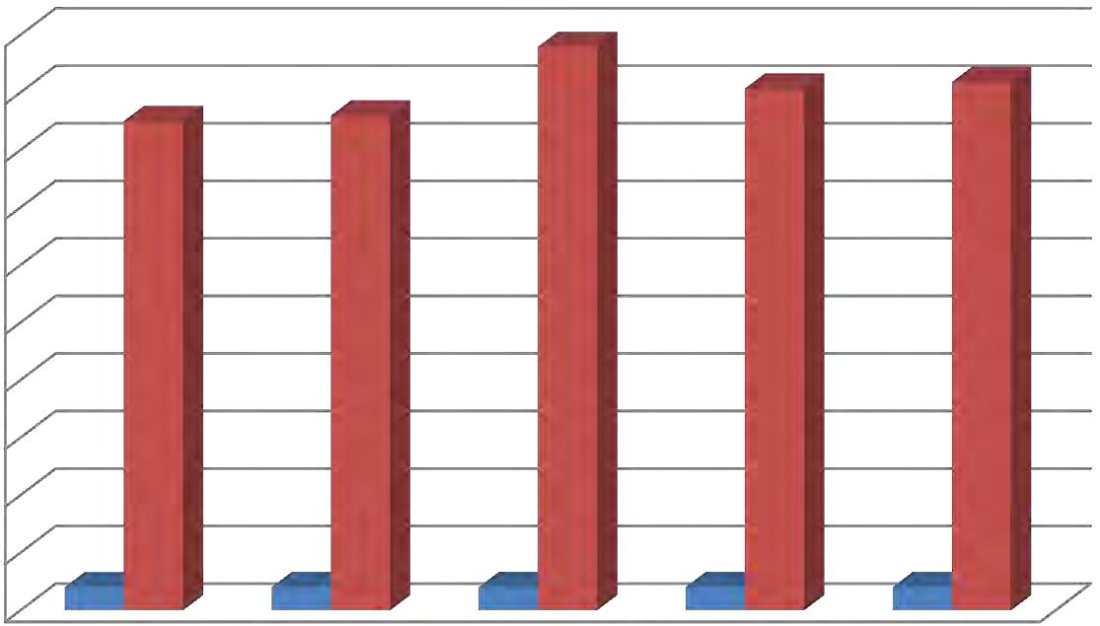

 |  |  | 100000
 |  |  | 90000
 |  |  | 80000
 |  |  | 70000
Million |  |  | 60000
 |  |  | 50000
 |  |  | 40000
 |  |  | 30000
 |  |  | 20000
 |  |  | 10000
 |  |  | 0 |  | 1 |  | 2 |  | 3 |  | 4 |  | 5
 |  |  | year |  | 2012 |  | 2013 |  | 2014 |  | 2015 |  | 2016
 |  |  | amount |  | 41500 |  | 42000 |  | 48000 |  | 45000 |  | 45900
Source: Bank Asia Website

From this graphical introduction we can see resulting ascents of import year to year. In 2012 the aggregate import is 41500 million takas. In the middle of 2012 and 2013 the development of import is 500 million takas from the earlier year and the aggregate import is 42000 million takas. After the following financial year implies 2012 the import likewise expanded 48000 million takas. In 2015 the import was diminished 45000 million takas. Development rate was negative in 2015 as a result of tremendous political distress as shippers couldn’t bring their coveted merchandise for making items. At long last, later checked year 2016 development is happened.
Export:

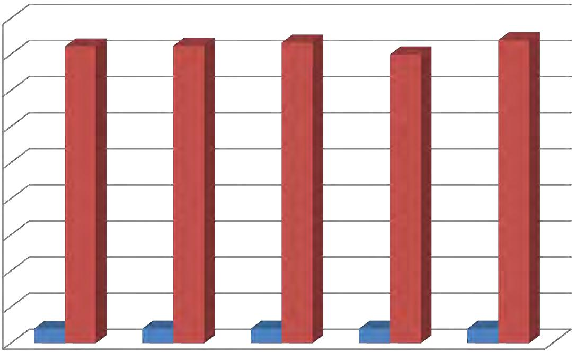

 |  | 90000
 |  | 80000
 |  | 70000
 |  | 60000
Million |  | 50000
 |  | 40000
 |  | 30000
 |  | 20000
 |  | 10000
 |  | 0 |  |  | 1 |  | 2 |  | 3 |  | 4 |  | 5
 |  |  | year |  | 2012 |  | 2013 |  | 2014 |  | 2015 |  | 2016
 |  |  | amount |  | 40000 |  | 40500 |  | 41200 |  | 39000 |  | 43000
Source: Bank Asia Website

As 2012 to 2016 fare additionally expanded yet the situation dislike import. In 2012, the aggregate fare sum is 40000 million takas. For the following year in 2013 the aggregate fare is 40500 million taka which improved by 500 million takas. Similarly, in 2014 fare is increment at 700 million takas by the aggregate sum of 41200 million takas. In 2015 aggregate fare sum is the fare was diminished 39000 million takas. Development rate was negative in 2015. As I specified before that political agitation was the key explanation behind scaling back of fare. In 2016 fare sum is 43000 million taka which expanded by 4000 million takas than the earlier year.

CHAPTER FOUR: FINDINGS

Obstacle Faces While Working:
A few officers are being met and addressed with respect to the issues I looked in my working environment. Their answers are like my experience as they additionally need to sit tight for significant lot of time in the framework programming Staler. Their perspectives are that the framework programming should have been refreshed, else, it is substantially more tedious as every single day tremendous volume of exchanges are required to be prepared, so it is intense for them to work if the specialist sits sit out of gear and do nothing in regards to the issue. They specified another business-related issue, that is, their Export Register isn't accessible in the framework so it is troublesome for them to work.
Heaps of issues have emerged while working in Bank Asia. Most regular issue is in the framework programming named Staler, where heaps of data are required to refresh. I for one feel that these are a portion of the accompanying issues I have confronted while playing out my errands
1.Sometimes the product is hanged and it turns out to be slow to the point that it is hard to take a shot at it which is the reason we have to sit tight for quite a while to make it easy to understand.
2.Sometimes the working environment makes me dull on the grounds that it is hard to focus on a similar work over and over.

CHAPTER FIVE: CONCLUSION & RECOMMENDATION

Conclusion:
I have arranged this report while I was doing my temporary position at the Principal Office Branch of Bank Asia Ltd. In Bangladesh Banking sectors are in development stage. Fare and import are assuming key job to our nation's economy and every one of bank is behind this monstrous achievement. Each bank develops with an alternate action on which they are specific so as Bank Asia is particular on Export and Import exercises. From the earliest starting point of this report I attempted to indicate how Bank Asia does their fare and import exercises and based on their exercises how they performed in most recent five years. From the execution investigation we have seen that if government hold nation's political circumstance stable than development of both fare and import rises. In 2012 and 2013, Bank Asia had positive development in fare and import however later in 2015, development was negative in the two areas. In the event that we investigate their future projection of development, we see that in 2016 Bank Asia has an expanding development rate. We additionally examination the level of commitment from outside exchange on benefit and found that Bank Asia is performing great.

Recommendation:
In spite of the fact that Bank Asia is outstanding amongst other banks and it is likewise performing great however this bank particularly Principal Office Branch need to center around a few elements. Getinge extemporized the fare and import segment of Bank Asia Limited, I have prescribed to the organization (Principal Office Branch) which elements ought to be given more significance.
These are following beneath
- Bank Asia should watch out for the development of fare and import while it tends to transform into negative.
- Bank Asia Principal Branch is very much embellished and furthermore having an ability draw of representatives there is no uncertainty, yet there is a lack of workers so Bank Asia ought to get upgraded the worker in remote exchange.
- Bank should more focus on the entirety of classification's customer.

REFERNCES

Bank Asia Limited. (n.d.). Retrieved from http://www.bankasia-bd.com/
Bank Asia Limited. (n.d.). Retrieved from http://www.bankasia-bd.com/home/annual_reports
Bank Asia Limited. (n.d.). Retrieved from http://www.bankasia-bd.com/home/student_file_service
Bank Asia Limited. (n.d.). Retrieved from http://www.bankasia-bd.com/home/foreign_remittanc
Bank Asia Limited. (n.d.). Retrieved from http://www.bankasia-bd.com/home/about
Bank Asia Limited. (n.d.). Retrieved from http://www.bankasia-bd.com/home/vision

APPENDIX

