

A Study on Short-term Financial management
of IDLC

Submitted To

Mosabbir Uddin Ahmad Assistant Professor

School of Business and Economics
United International University

Submitted By

Tania Akter

ID: 111 182 001

School of Business and Economics
United International University

Date of Submission: 20th December, 2022

Letter of Transmittal

Date: 20th December, 2022

Mosabbir Uddin Ahmad Assistant Professor,
School of Business and Economics,
United International University,
Madani Avenue, Badda, Dhaka 1212

Dear Sir,

This project, which I performed as part of the coursework for my Bachelor of Business Administration degree, gives me great joy to submit. A Study on Short-term Financial Management of IDLC is the project's topic.

Without your advice and help, this endeavor would not have been feasible. The project was subject to various restrictions. Working on this project under your direction was truly amazing. I made an effort to complete the assignment in light of the anticipated demand. However, if any simplification is required, I would be honored to insist. It would be very appreciated if you would accept this humble attempt and forward my research and conclusions on the problem.

Your sincere,

Tania Akter
ID: 111 182 001

Acknowledgement

I've had the good fortune to receive help, encouragement, and support from a variety of people. In the beginning, allow me to offer our gratitude to (Almighty Allah) for allowing us to successfully finish this report.

Second, I want to express my gratitude and appreciation to Assistant Professor Mosabbir Uddin Ahmad and the rest of our distinguished professors at United International University for their support, direction, counsel, and insightful supervision.

I consider myself really fortunate to have had the chance to put this report together with his supervision and direction. We couldn't have finished this report satisfactorily without his instructions.

Thirdly, I want to express our gratitude to those who sent us important information that was crucial to finishing this project. My sincere thanks and greetings go out to my distinguished supervisor, Mr. Mosabbir Uddin Ahmad, for his cooperation, assistance, and support in getting this research finished.

I also want to recognize and appreciate each of the "Finance Faculty" teachers I had throughout my academic career because I learnt a lot from them and used it in this article.

I want to sincerely thank each and every one of them. This Research would not have been feasible without their invaluable assistance. There might be some gaps in the report despite my best attempts. If there are any such unintended errors, I apologize.

Table of Contents

CHAPTER ONE: 7
Abstract 8
Findings and analysis 9
Methodology 11
CHAPTER TWO 12
Introduction 13
Company overview 16
CHAPTER THREE: 19
Inventory management 20
CHAPTER FOUR 25
AFN (Additional Fund Needed) 42
Defensive interval 44
NWC to Debt 46
CHAPTER FIVE: 51
Statistical Analysis 52
Conclusion 58

Table of Figures

Figure 1: Inventory management of IDLC 22
Figure 2: Receivable management of IDLC 23
Figure 3: Supplier Financing Management of IDLC 25
Figure 4: OC & CC of IDLC 28
Figure 5: Current ratio 30
Figure 6: Quick ratio 31
Figure 7: Cash Ratio 34
Figure 8: Current liability ratio 35
Figure 9: Receivables 37
Figure 10: WC to debt 39
Figure 11: Working capital turnover ratio 40
Figure 12: Cash to current assets ratio 41
Figure 13: AFN of IDLC Compare to Industry Benchmark 44
Figure 14: Defensive interval 45
Figure 15: Net Working capital to debt ratio 47
Figure 16: Net Working Capital to Revenue Ratio 48
Figure 17: Net liquid balance 50
Figure 18: Cash efficiency ratio 51

CHAPTER ONE:

Abstract

Findings and analysis Methodology

Abstract

Using information from annual reports for the years 2017 through 2021, the current study examines the short-term financial management of non-banking financial institution IDLC, its position in the industry, as well as the historical relationship between working capital management practices and IDLC's profitability. By analyzing the management of inventory, receivables, and supplier financing, as well as the use of various ratios, the effects of aggressive working capital investment and financing strategies have been assessed. If managers take a cautious stance when it comes to working capital finance and investment programs, they can generate value. The survey also reveals that stocks of companies that take an assertive stance in managing their short-term liabilities are favored by investors.

Findings and analysis

Budgeting and financial planning for time frames of one year or less are part of short-term financial management. The research has brought to light a bunch of interesting data and information, below is the summary of major findings that have been yielded. I have considered a 5 years’ annual report and extracted balance sheets as well as profit/loss statements to get better findings. All the findings are described below.

The current ratio is a liquidity ratio that determines a company's capacity to meet short-term debt and commitments. Current ratios for the company IDLC are 1.29, 1.30, 1.06, 1.06 and 1.13 consecutively for the years of 2017, 2018, 2019, 2020 and 2021. So, they have enough liquidity to meet their creditors.

Receivables to Current Liability ratio refers to the firm’s ability to meet its short-term obligations by using the receivables of the business. Receivables to Current Liability ratio for the company 6.27, 6.72, 6.49, 4.48 and 2.50 consecutively for the years of 2017, 2018, 2019, 2020 and 2021. All the ratios over the past 5 years have above the benchmark of 1. This indicates that the IDLC will not face trouble to meet the short-term debts with only the receivables of the business.

In times of weak sales or a downturn, the company may find it difficult to meet abrupt financial obligations without enough liquid assets. Additionally, it is more challenging to get funding because banks evaluate creditworthiness based on factors like the liquid assets to net worth ratio. From the analysis it has been seen IDLC can run its operation for quite a long time with its available current assets and its Net Liquid Balance is in a good condition.

The operating cycle of the firm ranged from 88 to 105 days over the past five years, the highest being in the year 2020. The cash conversion cycle is positive for all the years indicating that the firm’s receipts from sales arrive later to its disbursement to suppliers for purchase.

An exceptionally high working capital turnover ratio may be a sign that a business lacks the capital to sustain its sales growth and that its demise is impending. Working capital to debt ratio of 2017 is 0.86, 2018 is 0.88, 2019 is 0.89, 2020 is 0.83 and 2021 is 0.73 respectively. The working capital to debt ratio of IDLC is in between 0.73 and 0.86 during these five years. If concluded, then it can be understood that the working capital of the company IDLC can pay off 73% to 86% of the debt of the company according to the data of this five years.

The amount that a business needs to borrow from outside sources in order to pay for the expansion of its assets necessary to sustain higher levels of sales is known as additional funds needed (AFN). Additional funds needed (AFN) is also called external financing needed. AFN of IDLC is negative in every year in the last 5 years. It indicates That IDLC has more internal financing. So, they do not really require any additional funding. With their internal fund, they can pay off debt, payback stock, buy short term investment as well.

Whereas the facts that should be taken into consideration are IDLC’s cash ratio, inventory turnover, Days payable outstanding, Days sales outstanding as well. IDLC’s cash ratio for these 5 years (2017-2021) is not that good 0.14, 0.13, 0.14, 0.19, 0.29 in the years 2017, 2018, 2019, 2020 and 2021 respectively. But they are improving slowly. So, company is trying to maintain cash to meet their supplies.

In the year ending at 30 June 2016, IDLC had as high as 0.54 inventory in its current asset. However, the ratio reduced steadily in the subsequent years to become 0.13 at 30 June 2021. Nonetheless, despite slow inventory turnover, the firm was able to keep its inventory level low in its working capital.

Days payable outstanding is the average number of days it takes to pay the suppliers from the time of commitment given for inventory purchase. It can be seen that the highest number of days payable outstanding is 166.84 days. However, the average time taken to pay the suppliers fluctuates largely for IDLC which can be a concern for suppliers.

Days sales outstanding shows the average number of days it takes for the firm to convert its receivables into cash. Following the year 2017, IDLC has experienced a sharp decrease in the number of days’ sales outstanding. This might have occurred due to more rigid credit terms following the year 2018. In the recent two years can be attributed to the economic downturn (due to Covid-19 pandemic), reducing sales and inventory turnover as a consequence. Following the year 2017, IDLC has experienced a sharp decrease in the number of days’ sales outstanding.

.

Methodology

The report has been prepared using components of secondary research, yielding both primary and secondary data, in order to conduct meaningful analysis and interpretations. After collection of data from publicly available sources, analysis has been done using quantitative methods and in both written format and excel sheet analysis and interpretation has been presented.

Types of research: The report has been prepared by using a mixed type of research. It contains components for secondary research. The study involves both interpretations as well as previously established information.

Types of data: The study includes secondary data. The combined outcome of both new and revised bunch of information formulates crucial analysis.

Data collection method: The data have been collected through online platforms. This data has been used to formulate meaningful information and draw logical interpretations.

Data analysis method: The data has been analyzed using a quantitative method.

Data presentation method: The data have been organized and presented in excel sheets.

CHAPTER TWO:

Introduction Company Overview

Introduction

Obtaining a loan for a purchase with a period of less than a year is known as short-term finance. One can minimize their risk and quickly accomplish financial goals by investing in the short term. For almost all businesses, from small startups to huge established businesses, short-term financial planning is crucial. Even major companies with ostensibly solid income statements have filed for bankruptcy because they were unable to pay their present debts. Budgeting and financial planning for time frames of one year or less are part of short-term financial management.

However, short-term financial management often entails balancing short-term income and expenses. Some long-term financial responsibilities, such as mortgage payments, must be taken into account. To make sure that debts are settled with creditors and that enough money is produced to cover other impending expenses, organizations, governments, and people all need to develop short-term financial plans. In the corporate world, managers create departmental budgets that include short-term expenses like inventory purchases, overtime fees, marketing, and one-time costs like out-of-pocket payments for equipment or buildings.

If predicted short-term expenses exceed anticipated profits, a company may cut the scheduled hours of the employees or eliminate discretionary spending. Without budgets and other short-term financial management tools, businesses run the risk of going bankrupt since cash shortages wouldn't be discovered until finances were completely gone. Loans play a significant role in organizations' short-term financial planning. Instead of obtaining a single long-term loan, which lenders often charge higher interest rates for, many business owners choose to take out a number of short-term loans in an effort to reduce costs.

Because short-term interest rates are more susceptible to political and economic changes than long-term interest rates, this strategy may not always be successful. For example, long-term interest rates are less likely to rise as a result of a single event, such as a stock market decline. The main sources of short-term capital are trade credit, secured loans, commercial bank loans, commercial paper, a specific type of promissory note, and commercial paper.

Typically, firms buy their supplies and materials from other companies on credit, and they record the debt as an account payable. Trade credit is the most common type of short-term finance.
if there are too many inventories, cash on hand, and accounts receivable, and too few account payables, the company will have overinvested in current assets, which will lead to overcapitalization.

The focus of the corporate finance literature has typically been on the analysis of long-term financial decisions, in particular decisions about investments, capital structure, dividends, or firm valuation. However, given their large contributions to overall assets, a close examination of short-term assets and liabilities is required. Managing these short-term assets and liabilities requires careful research because working capital management is essential to a company's profitability, risk, and value. The efficient management of working capital is a crucial part of the overall corporate strategy in creating value for shareholders. Businesses try to keep their working capital levels as optimal as possible.

The ability of the company to bridge the gap between its short-term assets and short-term liabilities is ensured by working capital management, which is typically perceived from the Chief Financial Officer's (CFO) perspective as a straightforward and basic concept. However, a "Total" approach is favored because it may take into account all of the company's activities in relation to suppliers, clients, and goods. In fact, working capital management has emerged as one of the most important issues facing firms, and many finance executives struggle to identify the key variables that affect working capital and the appropriate level of working capital. Therefore, by understanding the purpose of working capital management and its driving forces, firms may lower risk and improve overall performance.

A corporation may decide to utilize an aggressive working capital management approach with low current asset to total asset ratios or it may decide to use high current liability to total liability ratios when making financing decisions. High current asset levels may have a detrimental effect on the company's profitability, while low current asset levels may lead to restricted liquidity and stock outs, making it challenging to maintain effective operations. (Replying author. Lecturer at the management sciences department of Pakistan's COMSATS Institute of Information Technology (CIIT), Lahore. Dean of the business administration department of Pakistan's COMSATS Institute of Information Technology (CIIT), Lahore. send an email to snazir@ciitlahore.edu.pk To contact Talatafza, email talatafza@ciitlahore.edu.pk. The IUP Journal of 20.15, No. 8, 2009

The fundamental aim of working capital management is to maintain an ideal equilibrium between all of the elements of working capital. The prosperity of the company depends heavily on the financial executives' ability to manage inventory, receivables, and payables effectively. (Businesses can decrease their financing costs and/or improve the amount of money available for growth projects by lowering the amount of investment tied to present assets. The majority of the time and effort put forth by financial managers is used to raise current asset and liabilities levels from unfavorable levels.

for best. It would be ideal to have a working capital level that balances efficiency and risk. Continuous monitoring is required to keep the correct level in all of the different working capital components, including cash receivables, inventories, and payables.

Current assets are typically thought of as one of the most important components of a company's overall assets. While renting or leasing equipment may allow a business to reduce its investment in fixed assets, it is not possible to use the same approach to reduce working capital requirements. The high level of current assets may lower the risk of liquidity associated with the opportunity cost of money that may have been invested in long-term assets. Although the impact of working capital restrictions on profitability is extremely significant, there haven't been many empirical research done to look into this connection. This study investigates the potential linkages between aggressive and conservative policies using a panel data set spanning the years 2017 through 2021.

Company overview

The German Investment and Development Company (DEG), the Kookmin Bank and Korean Development Leasing Corporation of South Korea, the Aga Khan Fund for Economic Development, the City Bank Limited, IPDC of Bangladesh Limited, and Sadharan Bima Corporation created IDLC Finance Limited in 1985. The initial 49% foreign shareholding progressively declined as the company grew, and local sponsors finally acquired the remaining 1% in 2009. A multi-product Non-Bank Financial Institution of Bangladesh, the company concentrates on the corporate, retail, and small and medium-sized enterprise (SME) sectors almost equally. Additionally, the capital markets have a strong presence for IDLC. The merchant banking branch of another IDLC wholly-owned subsidiary, IDLC Investments Limited, engages in investment banking across the country, while IDLC Securities Limited, through its stock brokerage section, conducts business as a broker corporation. The company's headquarters are in Dhaka. They claim this

Financing is Much More Than Just a Monetary Transaction. Every Transaction Has a Purpose, and Our Purpose is to Finance Happiness.

35 years after it was founded as a lease lending company with one product and five employees, it has expanded to become the largest multi-product, multi-segment non-banking financial institution in the nation. IDLC Finance Limited, one of the most well-known financial brands on the market, enjoys a solid and diversified position in the Corporate, SME, Retail, and Capital Market categories. The German Investment and Development Company (DEG), the Kookmin Bank and Korean Development Leasing Corporation of South Korea, the Aga Khan Fund for Economic Development, the City Bank Limited, IPDC of Bangladesh Limited, and Sadharan Bima Corporation created IDLC Finance Limited in 1985. Currently, IDLC employs over 1,500 people across 39 locations and booths in over 24 cities, people to serve more than 45,000 customers. Even if we want to accomplish more, saying that we just work in the finance sector would be too restrictive. We work to assist individuals in achieving their objectives, such as the desires to purchase a home, send their children to a better school, go on a picnic in the backseat of the family car, establish or grow a business, create more jobs, and take the nation to new heights.

Somewhat more significant to us than either the number of people we employ or the number of clients we serve is the number of lives we have changed. While achieving financial success is important to us, we also enjoy knowing that we are the reason for many people's smiles.

Mission of IDLC:
We will focus on quality growth, superior customer experience, and sustainable business practices.

Vision of IDLC:
We will be the best financial brand in the country (https://idlc.com/, 2022)

Values of IDLC:
- Integrity
- Customer Focus
- Equal Opportunity
- Trust and Respect
- Passion
- Simplicity
- Eco-Friendly

Company overview of Rivals

In 1981, the Industrial Promotion and Development Company of Bangladesh Limited (IPDC), the country's first private sector financial institution, was established by the Government of Bangladesh, the International Finance Corporation (IFC), the German Investment and Development Company (DEG), the Aga Khan Fund for Economic Development (AKFED), the Commonwealth Development Corporation (CDC), and the United States. profitability. The business offers financial services and goods. Since its creation, IPDC has had a significant impact on the industrial landscape of developing nations. In the early stages of many of Bangladesh's most well-known corporate entities, we had partnered with them. No other financial institution in the nation has contributed as significantly to the growth of the private sector. Several groundbreaking projects that were the first of their kind in Bangladesh involved IPDC as a partner. There are more on this list, but we just highlight a select handful from various industries here to help the reader comprehend. (2022; http://www.ipdcbd.com)



In 1997, Sampath Bank Limited, a major commercial bank in Sri Lanka, and First Gulf Asia Holdings Limited, a multifaceted asset management and investment banking firm based in the Kingdom of Saudi Arabia, established LankaBangla Finance Limited (LBFL), a joint venture multiproduct financial institution. The business offers a broad range of corporate services, card operations, deposit plans, and credit and investment products. One of the main dealers in treasury instruments is LankaBangla. Its headquarters are in Dhaka. As a joint venture financial organization with international cooperation and a license from the Bangladesh Bank under the Financial Institution Act of 1993, LankaBangla Finance Limited began its journey. Currently, LankaBangla is the nation's top supplier of integrated financial services, including stock broking, corporate consulting, corporate financial services for SMEs, corporate financial services for corporations, and wealth management services. We are the only financial institution that offers credit cards (MasterCard and VISA) under the broadest category of goods and services. LankaBangla has been listed in Bangladesh's DSE and CSE since 2006. (2022; www.lankabangla.com)



CHAPTER THREE:

Inventory Management Receivable Management Supplier Financing Management

Inventory management

The definition of the inventory to working capital ratio is a measure for determining how much of a company's inventory is funded with its available cash. For companies that keep inventory and rely on cash flow, this is crucial. In general, a company's liquidity is higher the smaller the ratio. The ratio of inventory value to working capital, however, varies by industry and business. In conclusion, using the industry average as a comparison is preferable.

Working capital can be better understood by pointing out that inventory is a crucial sign of a business' operational effectiveness. Keep in mind that a low inventory to working capital ratio of one or less indicates that a business has excellent current asset liquidity. High value inventory to working capital ratio indicates that a business is maintaining too much inventory in stock, yet it may also indicate insufficient stocks. Excessive inventories are unfavorable for management since they can put a significant strain on a company's cash resources. Finding the ideal inventory levels and reducing the cost associated with them is crucial for a business to increase the efficiency of its operations.

Inventory plays a crucial role in a company's cash flow cycle. For IDLC, inventory is much more crucial because it is a financial organization. Effective inventory management guarantees that cash is released on time and that the company has enough money on hand to pay its creditors and suppliers. On the other hand, ineffective inventory control can result in stock piling up, lower profitability and cash flow, and eventually lower company value.

The effectiveness of inventory management of IDLC has been assessed in the light of its inventory to working capital ratio, turnover ratio and days inventory held. The results are shown in Table 1.

Inventory management of IDLC
Ratio | Formula | 2017 | 2018 | 2019 | 2020 | 2021
Inventory to Working Capital Ratio | Inventory/Working Capital | 0.54 | 0.45 | 0.46 | 0.39 | 0.13
Inventory Turnover Ratio | COGS/Inventory | 0.62 | 0.95 | 1.23 | 0.88 | 1.02
Days Inventory Outstanding | Inventory*365 / COGS | 49.39 | 29.03 | 48.02 | 49.34 | 105.98

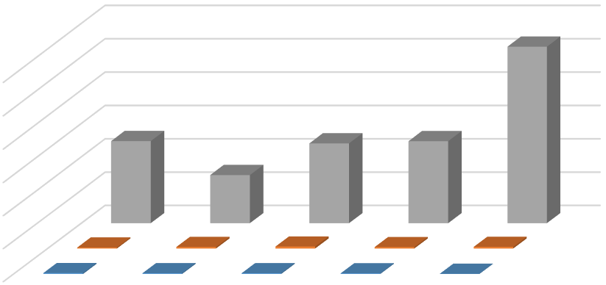
20.00
00.00
80.00
60.00
40.00
20.00
0.00
Days Inventory Outstanding
Inventory Turnover Ratio Inventory to Working Capital Ratio
1 2 3 4 5
Inventory management of IDLC
1
1
Inventory to Working Capital Ratio
Inventory Turnover Ratio
Days Inventory Outstanding
Figure 1: Inventory management of IDLC

The inventory to working capital ratio reveals the percentage of current assets that are locked up as stock. Since inventory is the least liquid of all current assets, reducing its level in working capital enhances the company's liquidity and cash flow. For the fiscal year that ended on June 30, 2016, IDLC had a maximum of 0.54 inventory as current assets. The ratio, however, gradually decreased during the following years, falling to 0.13 at the end of 2021.

Inventory turnover demonstrates how frequently a company changes raw materials in its inventory into finished products, which are then sold in a given year. Inventory turnover and days of inventory retained are inversely correlated because the length of time that inventory is held by the company grows as conversion frequency declines. Inventory to sales conversion took IDLC an average of 1.02 days in 2021. It makes sense that the process of turning inventory into sales takes more time. However, the economic slowdown (caused by the Covid-19 epidemic) can be blamed for the increase in DIH during the past two years, which has resulted in lower sales and inventory turnover. The company was able to maintain a low inventory level in its working capital despite the delayed inventory turnover.

Receivable management

Another important element of a manufacturing company's working capital investment is trade receivables. Receivables management affects the business's credit policy and has a big impact on how much money is made domestically and internationally. Giving consumers more lenient terms, however, could necessitate a greater and possibly less liquid current investment in receivables. Based on the ratio of receivables to current assets and the number of days that receivables are outstanding, Figure 2 shows how IDLC manages its receivables.





The average number of days it takes for the company to turn its receivables into cash is shown by the days sales outstanding. After 2017, IDLC saw a significant drop in the amount of days' sales outstanding. This might have happened because lending terms were stricter after 2018, which also explains the flat sales increase throughout those years. The DSO and working capital investment in trade receivable have both lowered as a result of the rigorous credit terms.
Receivable management of IDLC
60.27
5
2.21
44.72
45.86
44.97
83.87
Receivables to Current Assets Ratio Days Recievale Outstanding

4.85 | 5.17 | 6.12 | 4.23
1 | 2 | 3 | 4

Figure 2: Receivable management of IDLC

The Receivables to Current Asset Ratio indicates the proportion of receivables in the overall current asset. The quantity of receivables in current assets and the opportunity cost associated with it can be determined as a percentage of current assets; the larger the proportion, the higher the cost of carrying receivables. Therefore, it is preferred that a business hold the fewest percentage of receivables possible without having an impact on sales. If this ratio is extremely high, it could indicate that the company's credit policy is weak and that too much money is being held in accounts receivable. If this money wasn't trapped in receivables, it could have been invested to.

Supplier Financing Management

Trade credit from suppliers is a major source of spontaneous financing for a firm. Supplier financing is crucial to invest in short term operating assets. It is imperative to manage trade creditors properly to maintain long term business relations and good reputation with suppliers. A basic evaluation of supplier financing management efficiency is to compare the credit terms with days payable outstanding, to identify whether the firm is able to pay the supplier within the credit term. Days payable outstanding is the average number of days it takes to pay the suppliers from the time of commitment given for inventory purchase. It can be seen that the highest number of days payable outstanding is 166.84 days. However, the average time taken to pay the suppliers fluctuates largely for IDLC which can be a concern for suppliers.

OC & CC of IDLC
 |  | 2017 | 2018 | 2019 | 2020 | 2021
Inventory to Working Capital Ratio | Inventory/Working Capital | 0.54 | 0.45 | 0.46 | 0.39 | 0.13
Inventory Turnover Ratio | COGS/Inventory | 0.62 | 0.95 | 1.23 | 0.88 | 1.02
Receivables to Current Assets Ratio | Trade & Other receivables / Current Asset | 4.85 | 5.17 | 6.12 | 4.23 | 2.21
Inventory to Current Asset Ratio | Inventory/Current Asset | 0.54 | 0.45 | 0.46 | 0.39 | 0.13
Days Recievale Outstanding | Accounts recievable*365 / Sales | 44.97 | 83.87 | 60.27 | 45.86 | 44.72
Days Payable Outstanding | Accounts payable*365 / COGS | 166.84 | 129.12 | 106.78 | 119.51 | 163.14
Days Inventory Outstanding | Inventory*365 / COGS | 49 | 29 | 48 | 49 | 106
Operating Cycle | DSO+DIO | 94.36 | 112.90 | 108.30 | 95.20 | 150.70
Cash Cycle | DSO+DIO-DPO | -72.47 | -16.21 | 1.52 | -24.31 | -12.44

 | 1 | 2 | 3 | 4 | 5
Cash Cycle | -72 | -16 | 2 | -24 | -12
Operating Cycle | 94 | 113 | 108 | 95 | 151

Figure 3: Supplier Financing Management of IDLC
Supplier Financing Management of IDLC
100%
90%
80%
70%
60%
50%
40%
30%
20%
10%
0%
Operating Cycle
Cash Cycle

CHAPTER FOUR:

Operating Cycle & Cash Cycle Ratio Analysis
AFN

Operating cycle

Operating cycle is the length of time taken from credit purchase of inventory of raw material until cash from receivables are collected. It is the summation of days’ inventory held and days inventory outstanding. In particular, using days receivable outstanding and days inventory held provides a more appropriate view of short term liquidity management of the firm than that is provided by the conventional solvency ratios such as current ratio and acid-test ratio. This is because management decisions that result in increase in less liquid current assets like inventory and receivable will create an impression of greater liquidity through its current ratio and despite lengthening the timing of cash inflow in the business. Operating cycle recognizes that the life expectancies of inventory and receivables affects the timing of cash flow. Nonetheless, such can result in inability to pay suppliers financing or short term obligations as they fall due.

Cash cycle

However, the operating cycle concept is flawed in that it ignores the liquidity constraints placed on a company by the time dimension of its operating liability commitments. For the purpose of doing a liquidity analysis, it is crucial to contrast the time pattern of the operating cycle with the time pattern of the cash outflow requirements imposed by a firm's suppliers. The difference in time between the actual cash payment for the acquisition of productive resources and the eventual recovery of the cash received from sales is known as the cash conversion cycle. It demonstrates how long it takes to turn a dollar of cash outlays into a dollar of cash inflow from a company's normal course of business.

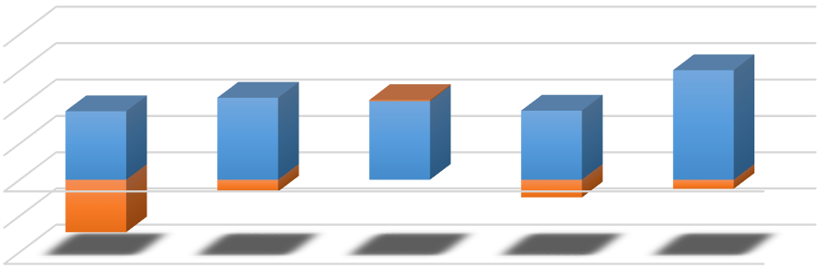
Figure 4, illustrates the operating cycle and cash conversion cycle of IDLC. The operating cycle of the firm ranged from 94.36 to 150.70 days over the past five years, the highest being in the year 2021. The cash conversion cycle is positive for all the years indicating that the firm’s receipts from sales arrive later to its disbursement to suppliers for purchase. On an average there is a huge gap between the operating cycle and the cash conversion cycle. The figure also depicts the close relation of the cycles. Negative cash conversion cycle is shown in the figure which is desirable for the firm because it represents firms don’t need any spontaneous financing.
OC & CC of IDLC
200.00
150.00
100.00
50.00
0.00
-50.00
1.52
150.70
94.36
112.90
108.30
95.20
-16.21
-12.44
-72.47
-24.31
Operating Cycle Cash Cycle

-100.00 | 1 | 2 | 3 | 4 | 5
Cash Cycle | -72.47 | -16.21 | 1.52 | -24.31 | -12.44
Operating Cycle | 94.36 | 112.90 | 108.30 | 95.20 | 150.70

Figure 4: OC & CC of IDLC

Current ratio

A liquidity ratio called the current ratio assesses a company's ability to pay off short-term debt and obligations, such as those that are due within a year, using the assets shown on its balance sheet. An alternative name for it is working capital ratio. A current ratio of one or greater is preferred by investors. The corporation might not be able to pay off its short-term debt if the current ratio is less than one. On the other side, a current ratio greater than one can mean that the business has too much cash or unsold goods.

The formula for calculating Current Ratio is given below:

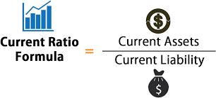

Depending on the industry, firm size, and economic climate, current ratios can vary. Contrary to cyclical industries like construction, which have greater current ratios, consumer products businesses have lower current ratios. Current ratios can differ widely, even within the same industry. For instance, supplier agreements may have an impact on the volume of liabilities and assets. During times of economic expansion, investors favor lean corporations with low current ratios and demand dividends from businesses with high current ratios. During recessions, investors are drawn to businesses with high current ratios because these businesses have current assets that can help them weather the storm. Current ratios are not always a reliable gauge of a company's liquidity because they presume that all inventory and assets can be promptly converted to cash. This isn't always the case, especially in tough economic times.

0.00 | 2017 | 2018 | 2019 | 2020 | 2021
Series1 | 1.29 | 1.30 | 1.06 | 1.06 | 1.13

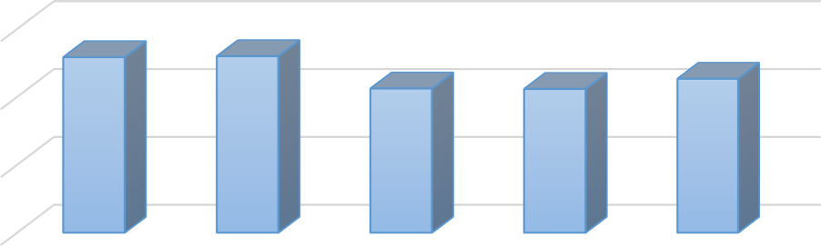
Figure 5: Current ratio
Current Ratio
1.50

1.00

0.50
Series1

In 2017, the current ratio of IDLC was 1.29, which was the second highest compared to the other years. It indicates that IDLC has done well pretty well in 2017 in terms of the current ratio.

In 2018, the current ratio of IDLC increased to 1.30, which is the highest compared to the other years. This indicates that the company is in a good position to meet the current liabilities or obligations with the current assets they have.

In 2019, the current ratio of IDLC decreased a little bit to 1.06, which is in the fourth place compared to the other years.

In 2020, the current ratio of IDLC remained to 1.06, which is the lowest among all the years. But this does not mean a bad current ratio. Any ratio above 1 is good for the companies and investors also look for the companies to invest whose current ratio is above 1.

In 2021, it increased a little bit from the last year, which also indicates a strong liquidity position of the company. Overall, we can say that IDLC has a good current ratio over the years and they are in a very good liquidity position to meet the current obligations.

Quick ratio

Another name for the fast ratio is the liquidity ratio or acid-test ratio. It determines if a corporation has the cash on hand to meet its short-term financial obligations. Analysts typically use it to determine how creditworthy a company is or how quickly it can pay off obligations that are now due. The term "quick assets" refers to assets that can be turned into cash in less than a year. The fast ratio might be beneficial for evaluating a company's liquidity. An asset-to-asset ratio greater than one indicates that a business has enough assets to pay off its creditors promptly. Conversely, a fast ratio of less than one suggests that the business would find it difficult to pay its short-term debts without selling any of its larger assets. It follows that
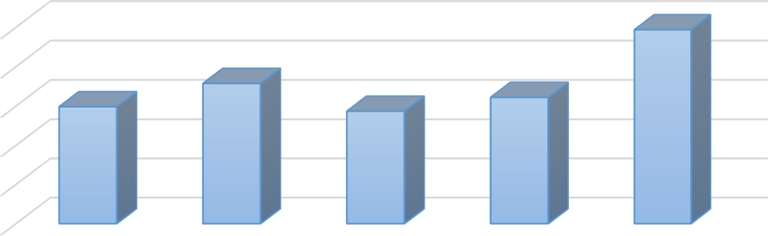
The formula for calculating Current Ratio is given below:
Quick ratio
1.00
0.80
0.60
0.40
0.20
Series1

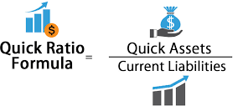

0.00 | 2017 | 2018 | 2019 | 2020 | 2021
Series1 | 0.60 | 0.72 | 0.57 | 0.64 | 0.99

Figure 6: Quick ratio

In 2017, the quick ratio of IDLC was 0.60, which is below the benchmark level.

In 2018, the quick ratio increased to 0.72, which is also below the benchmark level but better than previous year.

In 2019, the quick ratio dropped even more to 0.57, which is the lowest quick ratio in the past few years.

In 2020, the quick ratio increased to 0.64, which is better than previous year.

In 2021, it the quick ratio increased to 0.99, which is the highest in the previous few years.

As we can see from the graph above that all the quick ratios of IDLC are below the standard of 1, which indicates that the company may have difficulty meeting its short-term obligations without selling some of its larger assets. This also indicates that IDLC may experience liquidity crisis, which could result in financial distress or bankruptcy.

Therefore, we can clearly say that IDLC is not in a good liquidity position and they might face difficulty to satisfy the short-term financial obligations using available cash. This is an alarming thing for such a big company like IDLC. IDLC should clearly work on this to improve the quick ratio of the company.

The quick ratio gauges a company's capacity to cover its immediate liabilities with its quick assets, which include cash and cash equivalents, marketable securities, and accounts receivable. A larger ratio indicates that the company has a lot of cash on hand or is having trouble collecting accounts receivable. They do not have to rely heavily on inventory.

Cash Ratio

Total cash and cash equivalents divided by current liabilities constitutes the cash ratio, a metric used to assess a company's liquidity. The indicator gauges a company's capacity to pay down short-term debts with cash or assets that can be quickly converted into cash, including easily tradable securities. This data can be used by creditors to decide whether or not they are willing to lend a company any money at all. As opposed to other liquidity ratios, the cash ratio only takes into consideration a company's holdings of cash or cash equivalents, leaving other assets like accounts receivable out of the calculation. This makes it a more conservative indicator of a company's ability to satisfy obligations and commitments.

The formula for a company's cash ratio is:

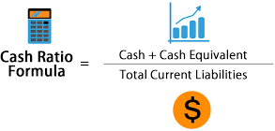

A metric used to evaluate a company's liquidity is known as the cash ratio, which is the ratio of total cash and cash equivalents to current liabilities. The indicator measures a business' ability to settle short-term obligations with cash or assets that can be swiftly turned into cash, such as easily tradable securities. Creditors can use this information to determine whether or not they are willing to give a business any money at all. Compared to other liquidity ratios, the cash ratio is a more cautious estimate of a company's capacity to meet obligations because it only considers holdings of cash or cash equivalents, leaving other assets like accounts receivable out of the calculation.

0.00 | 2017 | 2018 | 2019 | 2020 | 2021
Series1 | 0.14 | 0.13 | 0.14 | 0.19 | 0.29

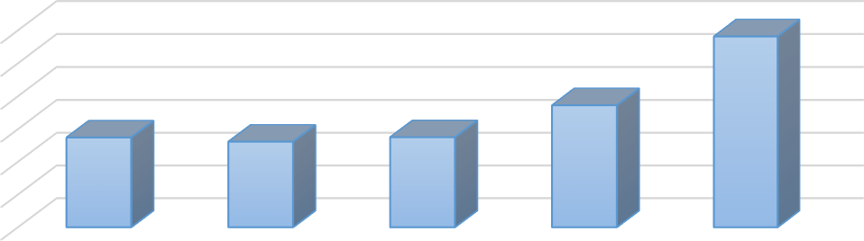
Figure 7: Cash Ratio
Cash Ratio
0.30
0.25
0.20
0.15
0.10
0.05
Series1

The cash ratios of IDLC are 0.14, 0.13, 0.14, 0.19, 0.29 in the years 2017, 2018, 2019, 2020 and 2021 respectively. As we can see from the above graph that all the cash ratios of IDLC over the last 5 years were below the standard or benchmark of 1. It means that IDLC has more current liabilities than cash and cash equivalents. This indicates that IDLC does not have enough cash or cash equivalent items to pay off its short term debts. This reflects a very weak liquidity position of IDLC in terms of cash ratio. However, this low cash ratio does not always show the clear picture. IDLC has a lot of receivables and prepayments in their current asset section which they can use to pay off their short term obligations easily. For an organization like IDLC, maintaining large amounts of cash and close-to-cash assets to pay current liabilities is not practical. Large cash balances on a company's balance sheet are sometimes viewed as poor asset utilization because they may be repaid to shareholders or utilized in other ways to produce higher returns.

The ability of a corporation to pay off short-term debt commitments with cash and cash equivalents is gauged by the cash ratio, also known as the cash asset ratio. Square Pharma's cash ratio during the five years from 2017 to 2021 is strong. Thus, the business keeps cash on hand to cover its expenses.

Current liability ratio

The term "current liability ratio" refers to a metric that determines what percentage of total liabilities are due soon. Because it does not assess the company's ability to pay its debts, the current liabilities ratio is regarded as a secondary measure of liquidity.

The formula for calculating Current Liability ratio is:

Current Liability Ratio = Current Liabilities / Total Liabilities

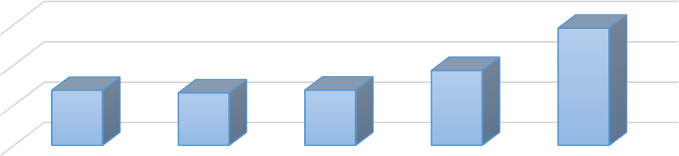
Liquidity metrics can be used by investors to assess a company's long-term viability in terms of its financial health. This is often assessed on the balance sheet by looking at accounts receivable, inventories, accounts payable, and short-term liabilities. One method to assess the overall liquidity of a corporation is to compute its current liability ratio. The current liability ratio, which measures the percentage of total liabilities that are due soon, may not accurately reflect the company's capacity to meet short-term obligations. As a result, it is believed that the current liability ratio is a supplementary indicator of liquidity that should be utilized in addition to more conventional liquidity indicators. like the current ratio
Current liability ratio
0.30
0.20
0.10
Series1

0.00 | 2017 | 2018 | 2019 | 2020 | 2021
Series1 | 0.14 | 0.13 | 0.14 | 0.19 | 0.29

Figure 8: Current liability ratio

The current liabilities ratio of IDLC are 0.14, 0.13, 0.14, 0.19, 0.29 in the years 2017, 2018, 2019,
2020 and 2021 respectively.

This indicates that almost 90% plus of the total liabilities are from current liabilities.

The rising current liability ratio suggests that IDLC may be depending more heavily on short-term loans.

This data supported the company's deteriorating financial status that the fund manager had noticed in more conventional liquidity measurements.

Current liabilities are the financial obligations of the business that are due within a year. Obviously, a higher current ratio is advantageous to the company. A corporation should have a current ratio of between 1.2 and 2, meaning that it should have twice as many current assets as liabilities to pay off its debts.

Receivables to current liabilities

In assessing a company's continuous capacity to settle its debts when they become due, the ratio of accounts receivable to current liabilities is crucial. We can observe that IDLC's liabilities exceed its accounts receivable.

Receivables to current liabilities ratio is calculated using the following formula:

Receivables to current liabilities ratio = Accounts receivables / Current Liabilities

0.00 | 2017 | 2018 | 2019 | 2020 | 2021
Series1 | 6.27 | 6.72 | 6.49 | 4.48 | 2.50

Figure 9: Receivables

Receivables to Current Liability ratio refers to the firm’s ability to meet its short-term obligations by using the receivables of the business. The standard of a firm is to maintain the ratio of 1.

In 2017, IDLC had the ratio of 6.27, which is satisfactory.

In 2018, the ratio increased to 6.27, which is also which is also satisfactory for a firm. In 2019, the ratio decreased a little bit to 6.49.
In 2020, it also decreased to 4.48 and in 2021, it decreased to 2.50.

We can clearly see that all the ratios over the past few years have the ratios above the benchmark of 1. This indicates that the IDLC will not face trouble to meet the short-term debts with only the receivables of the business.

WC to debt

By examining elements on the balance sheet such as accounts receivable, accounts payable, short- term obligations, etc., liquidity measurements help investors and analysts determine a company's ability to sustain its financial health.

Calculating the working capital to debt ratio of a firm is one of the greatest approaches to comprehend its overall liquidity condition.

However, there is one thing analysts and investors need to watch out for when using the working capital to debt ratio as a measurement in stock investment analysis. A business with a lot of stock but a poor turnover rate may have trouble using its working capital to pay off its debt on schedule since inventory is typically less liquid than accounts receivable and, in particular, cash.

The working capital to debt ratio computation may also be wisely limited to a company's short- term debt in order to provide a more accurate picture of the amount of current debt that needs to be repaid.

Inventory, cash, and accounts receivable all constitute working capital. Total debt includes both short-term commitments like loan payments and credit card balances as well as long-term liabilities like mortgages and loans with long maturities.

A company's capacity to pay off all of its debts using its working capital is shown by the working capital to debt ratio. For companies that are about to go out of business, this indicator is especially important. They can determine whether or not they can pay off their debts entirely with working capital by employing this ratio.

0.00 | 2017 | 2018 | 2019 | 2020 | 2021
Series1 | 0.86 | 0.88 | 0.89 | 0.83 | 0.73

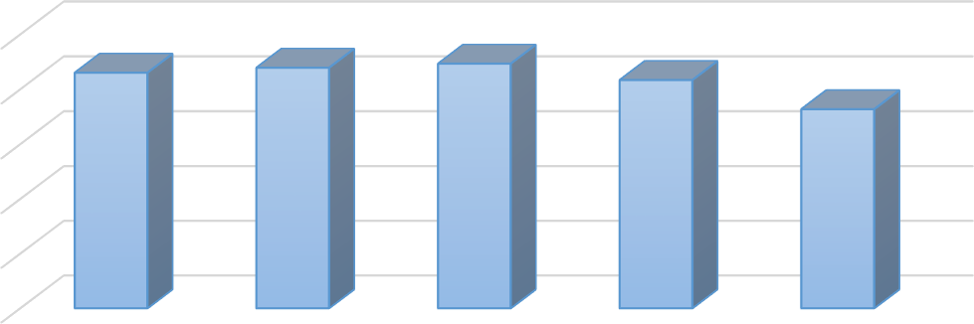
Figure 10: WC to debt
WC to debt
1.00

0.80

0.60

0.40

0.20
Series1

When the working capital to debt ratio is 1, the company is entirely able to pay off all of its debts using only its working capital, if necessary.
When the working capital to debt ratio is less than 1, it can indicate that the company's finances are in jeopardy. This isn't always the case, though. A smaller ratio may occasionally have a more uplifting explanation. However, further research on this ratio is necessary to provide a more complete understanding of the relevant circumstances.

In case of IDLC we can see that the Working capital to debt ratio of 2017 is 0.86, 2018 is 0.88, 2019 is 0.89, 2020 is 0.83 and 2021 is 0.73 respectively. It can be observed from the graph that the working capital to debt ratio of IDLC increased in 2018 and then again increased in 2019 and slightly decreased in 2020. Again, the working capital to debt ratio decreased a lot in 2021 compared to that of 2020. The working capital to debt ratio of IDLC is in between 0.73 and 0.86 during these five years. If concluded, then it can be understood that the working capital of the company IDLC can pay off 73% to 86% of the debt of the company according to the data of this five years.

Working capital turnover ratio

The ratio can also be thought of as how frequently working capital is used to generate sales per year. A high ratio typically means that management is effectively using the short-term assets of the organization. With sales, they are assisting. There is little doubt that Square Pharma can generate sales without a significant amount of operating capital.
Calculating working capital turnover ratio is as follows:
working capital turnover ratio = Sales/WC

Figure 11: Working capital turnover ratio

A business that lacks the funds to support its sales growth and is on the verge of failure may exhibit an abnormally high working capital turnover ratio. Since it demonstrates that management is unable to pay its bills when they fall due, a very big accounts payable component of working capital is a very powerful indicator.

In the example of IDLC, we can observe that the working capital turnover ratio for each of the years 2017 through 2021 was 0.12, 0.13, 0.14, 0.13, and 0.11, respectively. The graph shows that the Working Capital Turnover Ratio of the IDLC grew in 2018, increased once more in 2019, and then marginally declined in 2020. Once more, the turnover of working capital
The number of net sales produced from an investment of one dollar in working capital is determined using the analytical method known as the working capital turnover ratio.

The company is effectively utilizing its short-term assets and liabilities to increase sales if the working capital turnover ratio is high.

Low inventory to working capital turnover may indicate that the company's sales are insufficient to pay its working capital expenses. The net working capital to revenue ratio is calculated using net sales and average working capital. You may think of the ratio in terms of money or time.
By dividing available cash by all of a company's current assets, the cash-to-current-asset ratio is determined. Analysts or investors can see exactly how much cash is contained in a given amount using this ratio.
in current assets. This ratio is regarded as the most cautious indicator of a company's capacity to settle its debts.

Cash to current assets ratio

How much cash and cash equivalents make up a company's current assets is determined by a liquidity ratio called cash to current assets. Any assets that can be quickly sold or depleted in less than a year are considered current assets for a corporation. These resources are required by firms in order to pay short-term liabilities like employee salaries and other ongoing operating costs.

Current assets consist of short-term investments such cash and cash equivalents, accounts receivable, inventories, pre-paid expenses, and marketable securities. The current assets that can be converted into foreign currencies the quickest are cash, cash equivalents, and marketable securities (collectively referred to as "cash").

By dividing available cash by all of a company's current assets, the cash-to-current-asset ratio is determined. This ratio results in
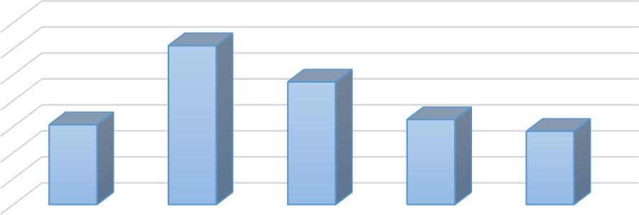
The model for calculating cash to current assets ratio is given below:
Cash to current assets ratio.
0.04
0.03
0.03
0.02
0.02
0.01
0.01
Series1

cash to current assets ratio = Cash / Current Asset

0.00 | 2017 | 2018 | 2019 | 2020 | 2021
Series1 | 0.02 | 0.03 | 0.02 | 0.02 | 0.01

Figure 12: Cash to current assets ratio

A high or rising ratio indicates that cash and other assets with a high degree of liquidity make up a bigger part of the company's current assets. This is always a sign of successful operations. The company may need to use other current assets, such as accounts receivable, to pay its debts because it has few highly liquid assets, according to a low cash to current assets ratio.

In the year 2017, IDLC’s Cash to Current Asset Ratio stood at a decent 0.02, indicating sufficient level of liquidity as a decent portion of the firm’s current assets consisted of cash and cash equivalents. This equates to higher solvency and lower probabilities of bankruptcy.

In 2018, the trend continued and the Cash to Current Asset Ratio for IDLC rose even more to an impressive 0.03, meaning good liquidity for the company, which is always an attractive sign for potential investors.

By end of the year 2019, the liquidity for IDLC took a hit as the cash to current asset ratio fell quite a bit, resulting to 0.02. Thus, it was a concerning time for IDLC.

In 2020 the company continued same liquidity, as the Cash to Current Asset Ratio for IDLC was 0.02, This means, currently the company is not on the right track, maintaining inadequate levels of liquidity and averse to risks of bankruptcy

In 2021, due to the emergence of COVID-19, the liquidity level of IDLC fell to its lowest among the last 5 years, as the company’s cash to current asset ratio decreased to 0.01. These were alarming times for the firm as the economy had hit recession, and cash flow was halted throughout the economy.

A liquidity ratio called cash to current assets calculates how much of a company's current assets are made up of cash and cash equivalents. A company's current assets are any assets that can be swiftly sold or used up in less than a year.

One would be the best cash asset ratio. It shows that a business is both able to settle its immediate liabilities using its most liquid assets and does not have an excessive amount of cash on hand. We can observe that Square Pharma's current ratio is not materially higher than cash.

AFN (Additional Fund Needed)

AFN for IDLC |  |  |  |  |  |  | AVG | Industry Benchmark
 | 2017 | 2018 | 2019 | 2020 | 2021
Current asset | 14,727,890,684 | 16,235,614,541 | 15,099,981,046 | 21,995,805,714 | 41,564,645,296 |  | 21,924,787,456 54,742,223,921
Current Sales | 8,892,872,138 | 11,162,932,726 | 13,183,089,035 | 12,100,085,456 | 10,541,776,398 | 11,541,786,399 | 11,176,151,151 8,366,460,277
Change in sales | 2,270,060,588 | 2,020,156,309 | -1,083,003,579 | -1,558,309,058 | 1,000,010,001 |  | 529,782,852 476,391,907
Current liabilities | 11,400,359,336 | 12,496,240,919 | 14,227,773,689 | 20,790,990,945 | 36,674,079,415 |  | 19,117,888,861 14,734,562,550
PM | 0.26 | 0.19 | 0.13 | 0.21 | 0.20 |  | 0.20 0.15
Retention ratio | 86% | 85% | 95% | 83% | 85% |  | 87% 82%
AFN | -1611807256 | -1511470490 | -1546215873 | -1984384800 | -1507712693 |  | -1,663,469,605 2,374,082,502

All the firms need to know regarding AFN

Because the company can assess realistically whether they will be able to raise the additional funds and subsequently reach the greater sales level.

The amount that a business needs to borrow from outside sources in order to pay for the expansion of its assets necessary to sustain higher levels of sales is known as additional funds needed (AFN). External financing is another name for additional funds required (AFN).
A company's assets, such as its inventory, accounts receivable, property, plant, and equipment, must increase in response to an increase in sales. An increase in retained earnings and a portion of a naturally occurring increase in responsibilities like accounts payable, taxes, etc. partially offset this growth.

AFN
= ( A0
* ΔS ) −L S0
* ΔS
S0
- S1

* PM *b

Where, Ao = current level of assets Lo = current level of liabilities
0
ΔS/So = percentage increase in sales. For instance, change in sales divided by current sales S1 = new level of sales
PM = profit margin
b = retention rate = 1 – payout rate

Implications of AFN for Short-Term Financial Planning
- If AFN is positive, firm must secure additional financing.

- If AFN is negative, firm have more financing than is needed.
Thus: Pay off debt, buy back stock, buy short-term investments as well.

It the table, it is depicted that AFN of IDLC is negative in every year in the last 5 years. It indicates That IDLC has more internal financing. So, they do not really require any additional funding. With their internal fund, they can pay off debt, payback stock, buy short term investment as well. (https://www.oreilly.com/library/view/working-capital-management/9781118933831/, 2022)



AFN of IDLC Compare to Industry Benchmark
90,000,000,000
80,000,000,000
70,000,000,000
60,000,000,000
50,000,000,000
40,000,000,000
30,000,000,000
20,000,000,000
10,000,000,000
0
-10,000,000,000
1
2
3
4
5
6
7
8
9
AVG of IDLC
Industry Benchmark
Figure 13: AFN of IDLC Compare to Industry Benchmark

It the graph, The AFN of IDLC Compare to Industry Benchmark is reflected
. It shows that the IDLC’s performance compare to its industry benchmark is quite appreciable.

The amount that IDLC must get from outside sources in order to finance the expansion of assets necessary to sustain an increase in sales volume is considerable. External financing is another name for additional funds required (AFN).

Defensive interval

Because the DIR compares assets to costs rather than assets to liabilities, some market observers think it is a more insightful liquidity ratio than the quick ratio or current ratio. The DIR is widely used as an extra financial analysis ratio in addition to the quick or current ratio to evaluate the financial health of a firm because the values of the DIR and fast or current ratio can differ significantly. A business with numerous expenses but little to no debt could serve as an illustration.

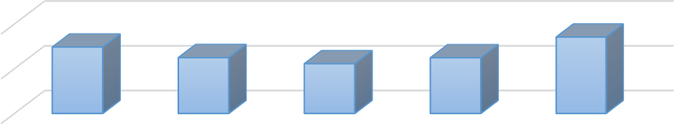
The defensive interval ratio, which is determined by dividing the total current assets of the company by its daily running expenses, is a measure of how many days the business can function without needing non-current assets or outside financial resources.
Defensive interval
20

10
Series1

0 | 2017 | 2018 | 2019 | 2020 | 2021
Series1 | 15 | 12 | 11 | 12 | 17

Figure 14: Defensive interval

The defensive interval ratio (DIR), which aims to determine how many days a business can run only on liquid assets. Comparing daily costs to current assets yields the defensive interval ratio. Monitoring the defensive interval ratio over time might show whether a corporation has more or less liquidity to cover its costs. Even if a higher DIR score is recommended, there is no particular number that identifies what is correct or better to aim for.

As we can see from the chart the DIR of IDLC has increased in the first four years and it is about the same in the year 2018 and 2019. The DIR of IDLC on 2017 is 14.82, 2018 is 12.46, 2019 is
11.10 , 2020 is 12.43 and for 2021 is 17.06.

So from this values it can be determined that for how many days IDLC can operate its activities without using its non-current asset or external financing.

So it is seen that the DIR of IDLC has decreased throughout the years which is not a good sign for the company.

In the year 2017 the company had 14.82 DIR which means that they were capable of operating about 15 days without using its non-current assets and external financing.

But that value has increased which is 17.06 days in the year of 2021 so now the company has the ability to carry its activities for about 17.06 days without using its non-current assets and external financing which is a good progress for the company.

The defensive interval ratio (DIR), also referred to as the defensive interval period (DIP) or basic defense interval (BDI), is a financial indicator that determines how long a company can operate without noncurrent assets, long-term assets whose full value cannot be realized in the current accounting year, or additional outside financial resources. It seeks to establish the maximum amount of time that a company can run only on cash.

We can see that Square pharma can run its operation for quite a long time without needing to access noncurrent assets.

NWC to Debt

Net Working capital to debt ratio between 1.0 - 2.0 is considered good. The working capital to debt ratio takes the sum of working capital (accounts receivable, cash, and inventory) and subtracts accounts payable. This value is then divided by the debt of the company. The metric is only useful under certain conditions, such as a decision to liquidate the assets of the company.

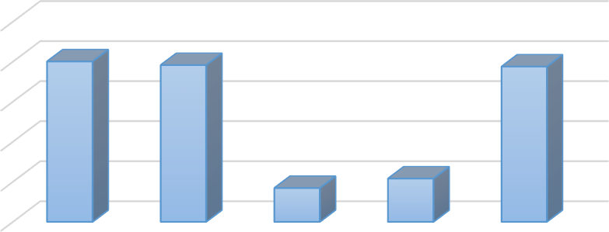
The model for calculating Net Working capital to debt ratio is given below:
NWC to Debt
0
0
0
0
0
Series1

Net working capital to debt ratio = NWC / Total Liabilities

0 | 2017 | 2018 | 2019 | 2020 | 2021
Series1 | 0 | 0 | 0 | 0 | 0

Figure 15: Net Working capital to debt ratio

As we can see that IDLC’ Net Working capital to debt ratio is below 1 over last 5 years, we can say they should look at this and increase their NWC compare to debt that they take in order to avoid the risk of liquidate assets.

NWC to Revenues

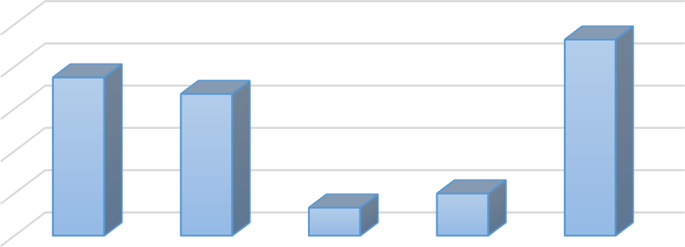
An efficiency and activity ratio is the net working capital to revenue ratio. It's used to evaluate how effectively a business is using its working capital to produce revenue. It shows the business how many net sales were produced for every dollar of working capital invested. Generally speaking, a high ratio indicates that management is making effective use of the company's short- term assets. They are assisting with sales. A low ratio, on the other hand, indicates poor power management in the company, which leads to an increase in inventories and accounts receivable. A low ratio suggests that the products cannot be traded. As a result, sales on credit are occurring since they are taking longer to be turned into cash. As a result, there are too many accounts receivable generated. This can damage the business. As the inventory ages, accounts receivable are written down as bad debt. The following is the formula for determining the ratio of net working capital to revenue:
NWC to Revenues
1
0
0
0
0
Series1

0 | 2017 | 2018 | 2019 | 2020 | 2021
Series1 | 0 | 0 | 0 | 0 | 0

Figure 16: Net Working Capital to Revenue Ratio

The Net working capital to revenue ratio for IDLC in 2017 stood at 37%. This means, in 2017, IDLC was able to make the second best and efficient use of its short-term assets and liabilities to support sales. In 2018, IDLC’s Net working capital to revenue ratio took a dip and it fell down to 33%.

This means the firm wasn’t able to the best and most efficient use of its short-term assets and liabilities to support sales. IDLC thus, needed to emphasize on its short-term management aspects.

The fall in Net working capital to revenue ratio continued as it hit 7% in 2019. IDLC really struggle to make proper utilization of its working capital. This also indicates reduced contribution of non- current assets to generate sales. And the fall just kept on continuing till 2020, when the Net working capital to revenue ratio hit rock bottom among the past 5 years for IDLC. This dip in performance can be contributed for by the arrival of the coronaviruses in that particular year, causing many businesses to take a loss.

However, the tides turned for IDLC in the following year. In 2021, IDLC’s net working capital to revenue ratio catapulted to 46%, which is the second highest in the past 5 years. This means IDLC was again able to make close to the best and most efficient use of its short-term assets and liabilities to support sales

Net liquid balance

Net liquid assets are simply the total amount of a company's cash and other liquid assets less its current liabilities. You may calculate the overall net worth of the company's liquid assets by deducting these current liabilities.

0 | 1 | 2 | 3 | 4 | 5
Series1 | 2017 | 2018 | 2019 | 2020 | 2021
Series2 | 19,625,943,645 | 23,175,821,496 | 23,612,157,992 | 29,603,267,597 | 47,019,875,512

Figure 17: Net liquid balance

In figure 17 it is depicted that Net Liquid Balance of IDLC has been increasing from 2017 to 2018.

2017 | 2018 | 2019 | 2020 | 2021
19,625,943,645 | 23,175,821,496 | 23,612,157,992 | 29,603,267,597 | 47,019,875,512

In times of weak sales or a downturn, the company may find it difficult to meet abrupt financial obligations without enough liquid assets. Additionally, it is more challenging to get funding because banks evaluate creditworthiness based on factors like the liquid assets to net worth ratio. On the other side, having an excessive amount of net liquid assets may not necessarily be viewed favorably by investors since it suggests that the company may not be adequately investing its funds in expansion. The IDLC Net Liquid Balance is good, as can be seen.

Cash efficiency ratio

Cash efficiency ratio reflects the proportion of revenues that a company transform into the OCF to increase the value of the firm.

The model for calculating Cash efficiency ratio is given below:

Cash efficiency ratio = Operating Cash Flows /Sales revenues

2017 | 2018 | 2019 | 2020 | 2021
0.09 | 0.23 | 0.18 | 0.22 | 0.32

0.00 | 2017 | 2018 | 2019 | 2020 | 2021
Series1 | 0.09 | 0.23 | 0.18 | 0.22 | 0.32

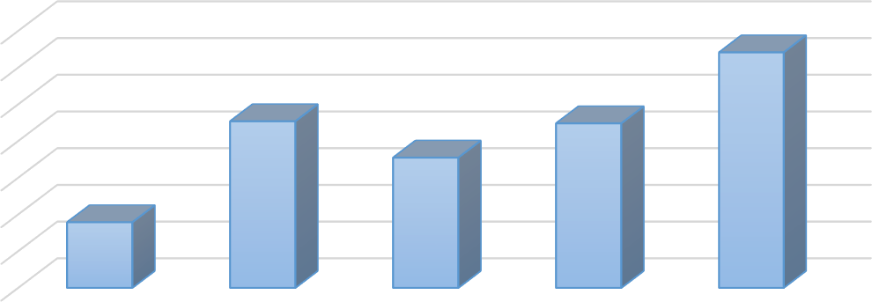
Figure 18: Cash efficiency ratio
Cash effeciency ratio
0.35
0.30
0.25
0.20
0.15
0.10
0.05
Series1

We can see that IDLC’s cash efficiency ratio is below 50% in every year which indicates poor performance.

CHAPTER FIVE:

Statistical Analysis Conclusion

Statistical Analysis

Net interest income |  | Interest income | Interest on deposits and borrowings etc.
Net interest income | 1
Interest income | 0.412103558 | 1
Interest on deposits and borrowings etc. | 0.165518333 | 0.966780133 | 1

SUMMARY OUTPUT
Regression Statistics
Multiple R | 1
R Square | 1
Adjusted R  Square | 1
Standard  Error | 0.08895493
Observations | 5
ANOVA
 | df | SS | MS | F | Significance  F
Regression | 2 | 7.05181E+17 | 3.53E+17 | 4.45585E+19 | 2.24424E-  20
Residual | 2 | 0.01582596 | 0.007913
Total | 4 | 7.05181E+17

Regression statistics show that the predictor variable can accurately and error-free describe both the perfect linear connection and the response variable.

The Anova table in the following section displays the regression model's degrees of freedom, sum of squares, mean squares, F statistic, and overall significance.

There are 4 degrees of freedom altogether.
Utilizing Regression SS/Regression df, the regression mean squares are computed. Regression MS in this instance = 7.05181E+17/ 2.

The f statistic is computed using the residual MS and the MS from the regression. This statistic demonstrates whether the regression model accurately represents the data in comparison to a model with no independent variables.
In essence, it assesses the regression model's overall usefulness. The total F statistic is typically not statistically significant if none of the model's predictor variables are.
In this case, the F statistic is 3.53E+17/0.007913=4.45585E+19.
The final result in the table represents the p-value for the F statistic. By comparing the p-value to a significance threshold, you can determine the overall regression model's significance. The most common choices are.01,.05, and.10.
There is sufficient information to conclude that the regression model more closely matches the data.

Coefficients |  | tandard Erro | t Stat | P-value | Lower 95% | Upper 95% | Lower 95.0% | Upper 95.0%
Intercept | -2.84917164 | 0.492865138 | -5.78083 | 0.028644448 | -4.969799171 | -0.728544106 | -4.969799171 | -0.728544106
Interest income | 1 | 1.07412E-10 | 9.31E+09 | 1.15373E-20 | 1 | 1.000000001 | 1 | 1.000000001
Interest on deposi | -1 | 1.16262E-10 | -8.6E+09 | 1.35167E-20 | -1.000000002 | -1.000000001 | -1.000000002 | -1.000000001

For each term in the regression model, the last part displays the coefficient estimates, the standard error of the estimates, the t-statistic, the p-values, and the confidence intervals.

The quantities required to construct the predicted regression equation are provided by the coefficients: $\hat{y}$ = b₀ + b₁x₁ + b₂x₂

p-values, standard error, and T-statistics
The estimated coefficient for each variable is subject to a specific level of uncertainty, which is measured by the standard error.
The t-stat is produced when the coefficient is divided by the standard error. For example, the interest income t-stat is 1/1.074.

The following column shows the t-p-value. stat's This number tells us whether a certain response variable is significant in the model. In this case, the interest income's p-value is
1.153, while the p-value for interest on deposits and borrowings, etc., is 1.351. This suggests that while interest on loans, deposits, and other types of interest is not a major predictor of future financial performance.
Interval of Confidence for Coefficient Estimates
In the final two columns of the table, the lower and upper bounds of a 95% confidence range for the coefficient estimates are provided.

One area where there is some debate is the coefficient estimate of 1 for interest income. However accurate this coefficient may be, we can never be sure. As a result, a 95% confidence interval gives us a selection of likely values for the true coefficient.
In this case, the 95% confidence interval for interest income is (1,1.0000001). Given that there is no "0" in this confidence interval, we may be quite assured that the true value of the coefficient is non-zero or a positive number.
The interest confidence interval at 95%

Similarly, more regression analysis has been done below with more observations

SUMMARY OUTPUT
Regression Statistics
Multiple R | 0.990453582
R Square | 0.980998297
Adjusted R Squ | 0.92399319
Standard Error | 216630969.9
Observations | 5
ANOVA
 | df | SS | MS | F | Significance F
Regression | 3 | 2.4228E+18 | 8.07599E+17 | 17.20895434 | 0.174954391
Residual | 1 | 4.6929E+16 | 4.6929E+16
Total | 4 | 2.46972E+18

Coefficients |  | Standard Error | t Stat | P-value | Lower 95% | Upper 95% | Lower 95.0% | Upper 95.0%
Intercept | 13071130768 | 2523541451 | 5.179677459 | 0.121413449 | -18993503564 | 45135765100 | -18993503564 | 45135765100
Investment inc | -1.696308315 | 0.756029781 | -2.243705682 | 0.266912388 | -11.3025775 | 7.909960866 | -11.3025775 | 7.909960866
Commission, e | 7.375534478 | 1.705843337 | 4.323688065 | 0.144695757 | -14.29926021 | 29.05032916 | -14.29926021 | 29.05032916
Other operatin | -23.63780758 | 6.914737415 | -3.418467855 | 0.181174594 | -111.4978769 | 64.22226171 | -111.4978769 | 64.22226171

Total operating income Interest income Interest on deposits and borrowings etc. estment incoon, exchange and boperating in |  |  |  |  |  | come
Total operating income | 1
Interest income | -0.354084899 | 1
Interest on deposits and borrowings etc. | -0.550873579 | 0.966780133 | 1
Investment income | 0.758445246 | -0.540011569 | -0.584955171 1
Commission, exchange and brokerage | 0.776160951 | -0.770796361 | -0.904158951 0.552221446 | 1
Other operating income | -0.203879693 | -0.362974449 | -0.377794523 -0.52168215 | 0.373123688 | 1

SUMMARY OUTPUT
Regression Statistics
Multiple R | 1
R Square | 1
Adjusted R Square | 65535
Standard Error | 0
Observations | 5
ANOVA
 | df | SS | MS
Regression | 10 | 1.31968E+17 |  | 1.31968E+16
Residual | 0 | 0 |  | 65535
Total | 10 | 1.31968E+17
 | Coefficients | Standard Error | t Stat |  | Lower 95% | Upper 95% | Lower 95.0% | Upper 95.0%
Intercept | 711512170 | 0 |  | 65535 | 711512170 | 711512170 | 711512170 | 711512170
Salaries and allowances | 0.813295498 | 0 |  | 65535 | 0.813295498 | 0.813295498 | 0.8132955 | 0.813295498
Rent, taxes, insurance, electricity etc | 0 | 0 |  | 65535 | 0 | 0 | 0 | 0
Legal expenses | 0 | 0 |  | 65535 | 0 | 0 | 0 | 0
Postage, stamp, telecommunication etc. | 0 | 0 |  | 65535 | 0 | 0 | 0 | 0
Stationery, printing, advertisements etc | 0.43958188 | 0 |  | 65535 | 0.43958188 | 0.43958188 | 0.43958188 | 0.43958188
Managing Director's salary and benefits | 0 | 0 |  | 65535 | 0 | 0 | 0 | 0
Directors' fees | 0 | 0 |  | 65535 | 0 | 0 | 0 | 0
Auditors' fees | 0 | 0 |  | 65535 | 0 | 0 | 0 | 0
Depreciation and repair of Company's assets | 0.165757095 | 0 |  | 65535 | 0.165757095 | 0.165757095 | 0.1657571 | 0.165757095
Other expenses | 1.164443967 | 0 |  | 65535 | 1.164443967 | 1.164443967 | 1.16444397 | 1.164443967

Conclusion

This report has discussed so far about the components and importance of net working capital of a company, drawing on the financial data from IDLC. Investment in working capital is financed either through spontaneous sources or non-spontaneous sources. Working capital provided by suppliers in the ordinary course of a firm's operations is spontaneous financing. On the other hand, investments supported by formal financing arrangements are non-spontaneous sources. It is the risk of The main justification for changing the operational cycle idea to a cash conversion cycle concept of liquidity analysis is the liquidity management issues brought on by higher working capital financing requirements. (https://idlc.com/, 2022)

The operating cycle of IDLC shows that the diverse conglomerate is experiencing difficulties in recovering its investment in working capital. Therefore, working capital management must be conditioned to reduce the time taken to convert inventory into sales and recover cash from credit customers. (https://idlc.com/, 2022)

However, the overall performance of short term management of IDLC is appreciable. But, there is room for improvement for them. The main sources of short-term capital are trade credit, secured loans, commercial bank loans, commercial paper, a specific type of promissory note, and commercial paper. Typically, firms buy their supplies and materials from other companies on credit, and they record the debt as an account payable. As it is frequently referred as, trade credit is the largest single category of short-term loans. A discount for on-time payments is typically included in loan terms. By effectively utilizing these sources, IDLC can improve in the future.

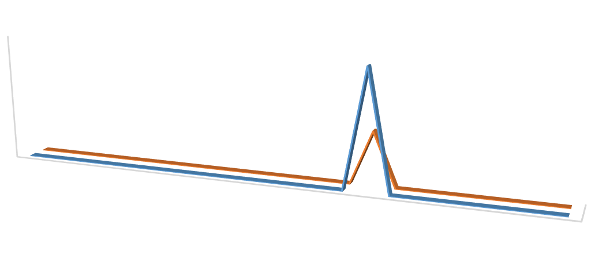
ST RATIOS OF IDLC COMPARE TO INDUSTRY BENCHMARK

Avg Industry Benchmark
30000000000.00
28,607,413,248
20000000000.00

10000000000.00
12,967,024,327
0.00
1.147.480 0.820
1 2
0
3
0.70
0.110
0.610
4
0.180 0
0.18
5
6
5.290
3.300
7 8
9 10 11
0.840 0 0.01.3110
0.99
0
12 13 14 15
0.020
0.010
0
0
0.290
16 17 18 19 20
0.210
13.5080
6.48
0.030
0.600
5.93
21 22 23 24 25
0.2A7vg


AFN of IDLC Compare to Industry Benchmark
90,000,000,000
80,000,000,000
70,000,000,000
60,000,000,000
50,000,000,000
40,000,000,000
30,000,000,000
20,000,000,000
10,000,000,000
0
-10,000,000,000
1
2
3
4
5
6
7
8
9
AVG of IDLC
Industry Benchmark

References
https://idlc.com/. (2022). From https://idlc.com/: https://idlc.com/idlc-at-a-glance https://www.ipdcbd.com/. (2022). From https://www.ipdcbd.com/: https://www.ipdcbd.com/aboutus/ataglance
https://www.oreilly.com/library/view/working-capital-management/9781118933831/. (2022). From https://www.oreilly.com/library/view/working-capital-management/9781118933831/: https://www.oreilly.com/library/view/working-capital-management/9781118933831/ https://www.statology.org/read-interpret-regression-table/. (2022).
From https://www.statology.org/read-interpret-regression-table/: https://www.statology.org/read-interpret-regression-table/ www.lankabangla.com/. (2022). From www.lankabangla.com/: https://www.lankabangla.com/about-us/

Appendix
https://docs.google.com/spreadsheets/d/1Q4rYg0lSuQipa0tEu69ZEOr_xzplQzUX/edit?usp=sha ring&ouid=110428748679680267643&rtpof=true&sd=true

https://drive.google.com/file/d/197SQRA5chy67Gzua0srMkJY2rrlCCDtH/view?usp=sharing https://drive.google.com/file/d/1LYwfzqwn5XnKMgr6recR6rynrt5uj0G2/view?usp=sharing https://drive.google.com/file/d/1tu9NhOiotuGaFsJWZuv6XS0eueGabc_f/view?usp=sharing https://drive.google.com/file/d/1FJLO3XY9Zr_gMyzcnYY6RmCHks9R-F59/view?usp=sharing

