

Performance Management System Optimization:
Enhancing Feedback and Recognition

Prepared for:
Md. Kazimul Hoque
Assistant Professor
School of Business and Economics
United International University

Prepared by:
Nizam Uddin
115-183-015
MIHRM 801

Master in International Human Resource Management (MIHRM)
6th August, 2023
Declaration

- It is officially acknowledged that the project report I have presented is entirely original and was produced as part of my MIHRM program at United International University.

- Except where properly cited by complete and precise referencing, the report does not contain any previously published or written by a third-party material.

- The report contains no content that has been authorized or submitted for another degree at a university or other institution.

- I have acknowledged all the main sources of assistance.

Nizam Uddin

Md. Kazimul Hoque

United International University

Letter of Transmittal

Md. Kazimul Hoque
School of Business and Economics
United International University
United City, Madani Avenue, Dhaka 1212
Subject: Submission of Project Report on Performance Management System Optimization: Enhancing Feedback and Recognition.
Dear Sir,
I am submitting my project research paper for the MIHRM program, "Performance Management System Optimization: Enhancing Feedback and Recognition" with gratitude and great pleasure.
The potential of compiling all the necessary data for the study for this report is quite enormous. I did my best to research the topic thoroughly and prepare a report that was both adequate and thorough. I'd like to thank you for your excellent advice.
I believe that this report will provide a tremendous opportunity for additional study on the topic. I humbly request that you review the report again and account for any inaccuracies that may have sneaked in despite my best efforts.
Therefore, it gives me great pleasure to submit my research report. If any additional corrections are required, kindly give me the opportunity to make them.

Sincerely Yours,

-----------------------------
Nizam Uddin
Master in International Human Resource Management
United International University
Date: August 6, 2023

Non-Disclosure Agreement

This agreement was made and entered into by and between SQ Group and the undersigned student of United International University. During my project time, I discovered that I had access to knowledge about the organization's diverse business activities, data-related information, and textual material. I want to make it clear that I will not reveal any confidential information about the company in my research report, which could jeopardize the organization's values and reputation.

-----------------------------------------
Shahriat Hossain
Group General Manager
Human Resource Management
SQ Group

Acknowledgement

August 6, 2023

Respected Sir,
I would like to express my profound gratitude for your help and support during this research project. Your helpful suggestions, criticism, and insights have greatly shaped my understanding of the subject and enhanced the caliber of my work.

I would also like to extend my heartiest gratitude to the management & human resource team of SQ Group for their cordial assistance and prompt responses of my queries.

Please accept my sincere gratitude for allowing me to work on this project and for the knowledge and skills I have gained as a result.

Sincerely Yours,

-----------------------------
Nizam Uddin
Master in International Human Resource Management
United International University
Date: August 6, 2023

Executive Summary

A Performance Management System is an organized approach of incorporating a company's employees as individuals as well as members of a team, with the primary goal of boosting organizational effectiveness while attaining organizational mission and goals. SQ GROUP HRD has a dedicated component called the 'Performance Management Unit' to identify each employee's performance. The Performance Management Team works tirelessly to offer the highest management with a thorough picture of employee performance. It works to expedite the organization's progress. SQ thinks that employees' capacity to perform well is dependent on correct supervision, qualities, abilities, and competences.
The Performance Management Team creates a performance evaluation system for employee performance evaluation, which encourages staff members and their managers to enhance their knowledge, abilities, and output. The Performance Management Team ensures ongoing structure improvement by enhancing supervisors' abilities to assess employee performance, revising formats in accordance with realistic PMS requirements, facilitating and improving assessment processes, putting awards and reward decisions into action, implementing appreciation programs, and giving each employee useful feedback on their performance.
I truly felt honored to share my knowledge with the Performance Management Unit of SQ GROUP because I worked for such a prestigious company. The history of SQ GROUP is primarily covered in the first section of this internship report. The second half focuses entirely on the specifics of SQ GROUP's Performance Management System. I have primarily concentrated on the SQ GROUP's Performance Management System in this research, including how it is run and how staff performance is gauged. After that, I was able to identify several restrictions and gaps in the treatment of PMS, and I also tried to suggest some potential fixes. Because information about HR and PMS is sensitive and personal, none of the data was made public.

TABLE OF CONTENTS

1. Chapter 1: Introduction 1
1.1 Title of the Study 1
1.2 Background of the Study 1
1.3 Scope of the Study 2
1.4 Objective of the Study 3
2. Chapter 2: Literature Review 5
3. Chapter 3: Company Overview 8
3.1 Overview of the industry 8
3.2 Overview of the company 8
3.2.1 SQ CELSIUS LTD.: 11
3.2.2 SQ BIRICHINA LTD.: 12
3.2.3 SQ HUES LTD: 13
13
13
3.3 Mission, Vision and Business Strategy 14
3.4 Business Process 15
3.5 Products 16
3.6 Company structure: 17
3.6.1 Manpower Overview: 19
3.6.2 Departments 19
4. Chapter 4: Key HR Processes 21
4.1 Future targets & Plans 23
5. Chapter 5: Performance Management Systems 25
5.1 Performance appraisal 25
5.2 Performance Management System Automation at SQ 27
5.3 Criticism of performance appraisal 30
5.4 Fundamental Purpose 31
5.5 Viewpoint of Employees 31
5.6 Purpose of Performance Appraisal 31
5.7 Performance appraisal Principles 33
5.8 Consideration of Performance appraisal 36
5.9 Process of Performance Appraisal System 36
5.10 Performance Appraisal Errors 40
6. Chapter 6: Takeaways from this research: 42
6.1 Key takeaways: 42
7. Chapter 7: Conclusion & References: 43
7.1 Conclusion: 43
7.2 References and Bibliography: 45

Chapter 1: Introduction

Title of the Study

Performance Management System Optimization: Enhancing Feedback and Recognition; A Study on SQ Group, Bangladesh.

Background of the Study
Background research and analysis of the adoption of Performance Management System in the business are the main focuses of the study internship at SQ Group RMG HR department. The internship was designed to provide knowledge about Performance Management System Optimization: Enhancing Feedback and Recognition in the SQ group.
The performance management system plays a crucial role in organizations by aligning employee goals with organizational objectives and fostering employee development. However, many traditional performance management systems suffer from several limitations, including inadequate feedback and recognition mechanisms. This study aims to explore ways to optimize performance management systems by enhancing feedback and recognition processes.
The student also had the opportunity to explore QPMS, the local performance management solution that SQ Group Bangladesh are using for maintaining the effective performance management system and based on the performance score they are using the 09 box performance grid to identify and retaining the top talents. These technologies have enabled the company to automate its performance management process and improve communication with its employees.
Through the internship, the student gained a deeper understanding of the challenges and opportunities in the RMG industry, as well as the scope of enhancing the feedback and recognition of PMS system. The insights and recommendations generated from the internship can inform future HR strategies and practices, contributing to the company's ongoing efforts to optimize its operations and provide better work experience for its employees.

Scope of the Study
The goal of the internship at the SQ Group RMG HR department was to explore and analyze how the implementing the performance management process, the optimizing of PMS and the opportunity of enhancing the feedback as well. The study's specific objectives are:
- To critically analyze the existing performance management system within the organization and identify the shortcomings and limitations related to feedback and recognition processes.
- To explore best practices, theories, and models of performance management systems, feedback mechanisms, and recognition strategies from relevant literature and research.
- To investigate the impact of feedback and recognition on employee motivation, engagement, job satisfaction, and overall performance.
- To identify the specific areas within the performance management system that require improvement to enhance feedback and recognition processes.
- To propose practical recommendations and strategies for optimizing the performance management system by implementing enhanced feedback and recognition mechanisms.
- To assess the feasibility and potential challenges of implementing the proposed improvements in the organization's performance management system.
- To evaluate the anticipated outcomes and benefits of optimizing the performance management system through improved feedback and recognition processes, such as increased employee engagement, motivation, and overall organizational performance.
- To contribute to the existing body of knowledge by providing insights, practical guidance, and empirical evidence on the significance and impact of feedback and recognition within performance management systems.
- To create awareness among organizational leaders and HR professionals about the importance of effective feedback and recognition in driving employee performance and organizational success.
- To provide a foundation for future research and studies in the field of performance management systems, feedback mechanisms, and recognition strategies.
By achieving these objectives, the thesis aims to enhance understanding and provide actionable recommendations for organizations to optimize their performance management systems through improved feedback and recognition practices, ultimately leading to improved employee performance, engagement, and overall organizational effectiveness.

Objective of the Study
Gaining knowledge of the adoption of HR automation processes in the business and assessing their effects on efficiency, productivity, and employee satisfaction Ire the goals of the study for the internship at SQ Group RMG HR department. The study's particular goals Ire as follows:
- Clarity of Performance Expectations: The system should clearly define performance expectations and goals for each employee. This includes setting specific, measurable, achievable, relevant, and time-bound (SMART) objectives that align with the organization's overall goals.
- Regular Feedback: The system should provide timely and ongoing feedback to employees regarding their performance. This includes both positive reinforcement and constructive criticism. Feedback should be specific, actionable, and focused on improving performance.

- Performance Measurement: The system should have reliable and valid performance measurement criteria and methods in place. These criteria should accurately assess employee performance and provide a basis for fair evaluations.

- Performance Reviews: The system should conduct periodic performance reviews or evaluations. These reviews should be conducted consistently and fairly across the organization. Reviews should involve open and honest discussions between managers and employees about performance strengths, areas for improvement, and goal setting.

- Development and Training Opportunities: The system should identify employee development needs and provide opportunities for growth and training. This can include skill-building workshops, mentoring programs, or job rotations to enhance employee capabilities and support career progression.
- Employee Engagement: The system should promote employee engagement by involving employees in goal setting, providing them with a sense of ownership over their performance, and encouraging their active participation in the process.

- Recognition and Rewards: The system should incorporate a fair and effective recognition and rewards mechanism to acknowledge and appreciate outstanding performance. This can include monetary rewards, promotions, public recognition, or non-monetary incentives such as flexible work arrangements or additional responsibilities.

- Alignment with Organizational Strategy: The system should ensure that individual performance goals and evaluations are aligned with the broader organizational strategy. This helps to ensure that employees' efforts are directed towards achieving the organization's objectives.

- Continuous Improvement: The system should be regularly reviewed and refined to address any identified shortcomings or changing organizational needs. This involves gathering feedback from employees, managers, and other stakeholders and making necessary adjustments to enhance the system's effectiveness.

- Employee Satisfaction and Performance Outcomes: The ultimate measure of effectiveness lies in employee satisfaction and performance outcomes. Assessing employee satisfaction through surveys or feedback mechanisms and analyzing key performance indicators (KPIs) can provide insights into the system's impact on individual and organizational performance.
By attaining these goals, the study hoped to offer insightful information about the overall scenario of performance management system optimization: enhancing feedback and recognition. Future PMS policies and practices can be influenced by the study's recommendations, supporting SQ Group RMG Bangladesh's continuous efforts to streamline processes and improve employee satisfaction.

Chapter 2: Literature Review

According to Armstrong and Baron (1998), the Performance Management System (PMS) is a planned and comprehensive method for ensuring an organization's ongoing success by fostering employee growth that enhances both individual and group performance. It is also known as the system where all employees are cognizant of completing individual objectives that will result in the attainment of overall organizational objectives as well as the organization's vision in addition to being aware of the level of performance commitment anticipated from them in specific roles. The method of managing people that will provide success for both the person and the company can be clearly described as this. According to McAdam, Hazlett, and Casey (2005), performance management system is a planned and integrated process that helps firms achieve sustained success by enhancing employee performance and raising individual contributions and aspirations.

Additionally, this system is regularly integrated to make sure that the employee is performing the tasks for which they have been hired in an efficient and pleasant manner while also recognizing them for their contribution to the overall corporate goals. However, a performance management system is crucial because it is required to deal with a dynamic and competitive environment, align with the organization's goals and objectives with continuous implementation and development, particularly for public organizations in developing countries. These organizations must retain a range of views in measuring performance by employing a balance scorecard, which will be finished with feedback for employee performance based on multidirectional data.

One of the primary approaches used in the performance management system is performance. Target-setting techniques include goal setting, ongoing evaluation and feedback, a 360-degree performance evaluation, Six Sigma, an employee recognition program, a performance ranking method, KSA-based measurement, supervisor ratings, an individual development plan, a balanced scorecard, and management by objectives.

The idea of a performance management system is already becoming more popular. Armstrong and Baron (1998) highlighted the paradigm shift, which recommended a shift away from the organizational system to one based on process and structure. a management orientation in which the organizations select their own constitution to be used.

In Bangladesh, local private organizations primarily use the Performance Management System, however there are disparities in the procedures used, how often they occur, and who participates. 2011 (Ali, Akter). Bangladesh, a developing nation, is consistently increasing employee satisfaction, particularly in the private sector, thanks to firms that implement and use performance management systems.

Additionally, in order to assure profitability through sustainable growth, the current bureaucratic performance management system used by the majority of firms must be upgraded into a more sophisticated, target-oriented PMS (Chowdhury, 2011). The new Performance Management System implemented by the public sector is the Annual Performance Agreement. To tie it to this system, it also falls under the provisions of the Medium-Term Budget Framework (MTBF). The goal of this is to make the public organization more result oriented. In addition, 200 of the 252 surveyed enterprises were small, local businesses, while 52 were multinational corporations. MNCs are setting the standard for managing performance management systems in emerging nations like Bangladesh, where local businesses place less focus on HRM practice (Islam, 2006). Several MNCs have been operating successfully in Bangladesh for the past 20 years, despite the fact that few MNCs are adept at managing HR efficiently in a changing international setting (HR Practices Survey BD 2006). According to a survey of employees from several firms, the importance of PMS in various sectors is depicted in the diagram below (Chowdhury, 2011).

Strategic PMS eventually contributes considerably to the degree of an organization's progress, according to the research (Ghorpade & Chen 1995; Golhar & Deshpande 1997; Lublin 1994; Storey & Sisson 1993). As a result, companies who have successfully integrated the outcomes of their strategic application of PMS with other Human Resource Management decisions are enjoying enormous benefits, such as greater productivity, improved strategic capabilities, and organizational advancement. Dessler 2008; Dessler, Griffith, and Lloyed-Walker 2004; Haunstein 1998; Landy 1980).

However, some data also suggests that the Performance Management System concepts are not operating or are not being fully implemented in the context of Bangladesh. The idea of performance management is neither widely accepted nor clearly defined in most firms; it essentially amounts to checking boxes on a form. According to Shafiullah, Alam, and Quader (2011), current management practices include a highly bureaucratic and hierarchical structure as well as a lack of managerial skills. Some of the issues stemmed from the integration of the PMS with other crucial HRM tasks, necessitating considerable adjustments in those areas.
For instance, there is a significant gap between the PMS and HRIS (Human Resource Information System) integration. Therefore, its absence in some locations prevents timely and economical communication. Only a relatively small number of local, privately owned businesses keep track of and store PMS data in their HRIS database. For the more conventional industries like RMG, manufacturing, and business conglomerates, the percentages were considerably lower. As a result, there is a lack of transparency in the performance appraisal system, and most PMS are implemented poorly and on paper with surveys.

Chapter 3: Company Overview

Overview of the industry
As of 2023, the Bangladesh RMG industry is one of the largest garment exporters in the world, accounting for a significant portion of the country's GDP and employing millions of workers, mostly women. The industry has made strides in improving worker safety and labor standards following several high-profile incidents in recent years, but challenges remain in areas such as workers' rights, wages, and environmental sustainability. Despite these challenges, the RMG industry in Bangladesh is expected to continue its growth trajectory in the coming years.
The RMG sector in Bangladesh has grown significantly in recent years, and by 2021, its annual export value was projected to exceed $34 billion. Almost 4 million people are employed in the field, mostly women. Nonetheless, the industry has encountered several difficulties, such as worries about safety, low pay, and unfavorable working conditions. There is certainly potential for improvement, despite the fact that the government and industry stakeholders have taken initiatives to address these problems, including putting in place safety measures and raising the minimum wage.
In recent years, the business has experienced many difficulties, such as worries about worker safety, wage disputes, and political unrest. Yet, the sector has been expanding and continues to play a crucial role in the economy of the nation, supporting millions of jobs and generating a sizable number of exports. The industry is anticipated to increase in response to initiatives to enhance worker safety and working conditions as Ill as ongoing investments in infrastructure and technology.

Overview of the company
Leading Bangladeshi conglomerate SQ Group engages in ready-made garments (RMG) business. The business was founded in 1982 and has since expanded to become one of Bangladesh's biggest garment producers, with over 19,000 workers across 5 manufacturing facilities.
SQ Group is known for its commitment to quality, sustainability and innovation. From spinning yarn to producing finished clothing, the company uses a vertically integrated supply chain that gives it better control over the manufacturing process and guarantees high-quality goods.
For major brands and stores around the world, the company makes a wide variety of clothes, including knit and woven clothing. The product line of SQ Group consists of accessories, sportswear, formal clothing, and casual wear with an emphasis on ethical and sustainable production methods.
Also dedicated to social and environmental responsibility, the company has programs that assist neighborhood development, worker welfare, and efforts to lessen production's negative effects on the environment. The business has won numerous accolades and certifications for its environmentally friendly operations, including the LEED Platinum certification for the architecture of its plant.
With the start of company, SQ blazed the road and established industry standards for Knitwear manufacturing. Securing first place in Knitwear, SQ later ventured into Lingerie production.

Figure 1 SQ Manufacturing Facility

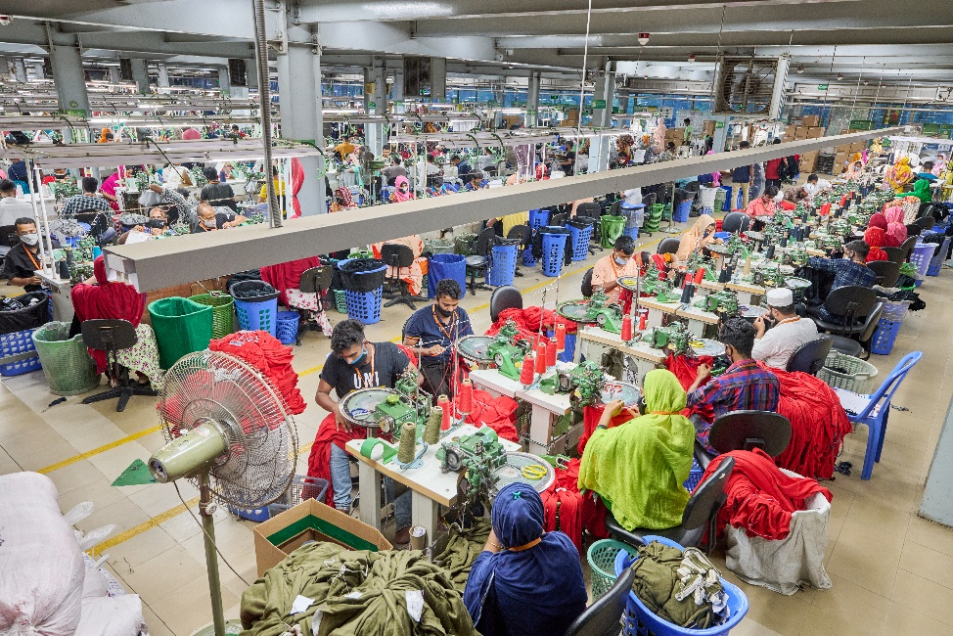
Figure 2 SQ Manufacturing Facility
Today SQ Group is one of the leading apparel manufacturers in Bangladesh, operating under three business clusters:
- SQ Celsius Ltd. (Knitwear)
- SQ Birichina Ltd. (Lingerie)
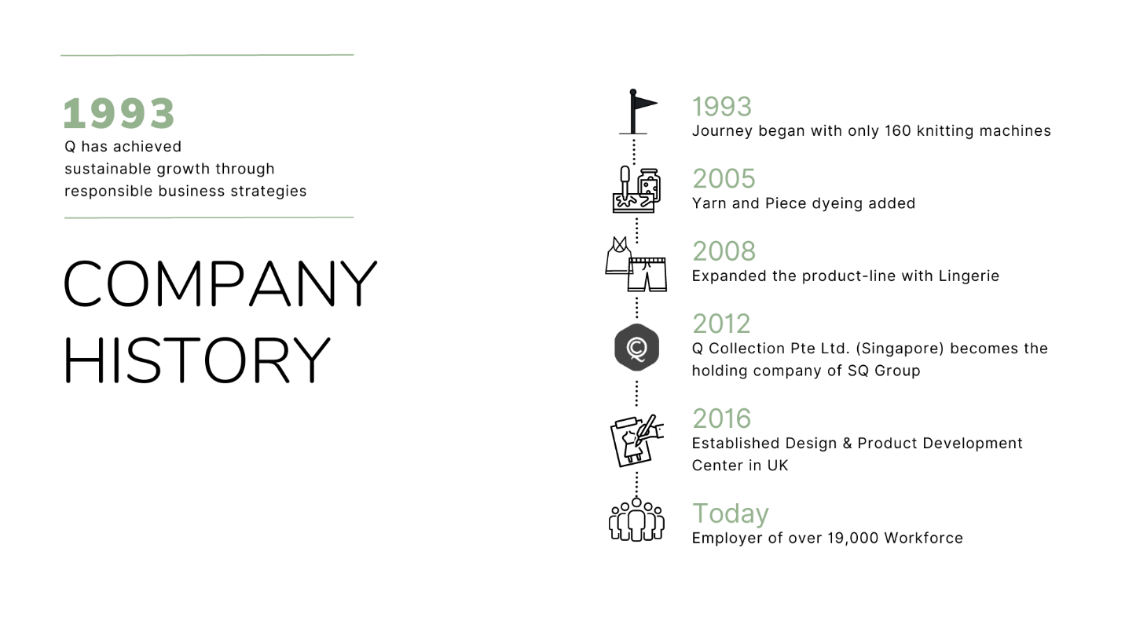
- SQ Hues Ltd. (Vertical Integration)
Figure 3 Company History

SQ CELSIUS LTD.:
Knitwear, the cornerstone of SQ, continues to be the Group's primary business. The merchants and other stakeholders strongly identify the name/brand SQ with knitwear.
The organization is considered as the top supplier to well-known high-end international brands and stores. Celsius Unit-1 received Gold Certification from the US Green Building Council (USGBC) in December 2015, while Celsius Unit-2, a cutting-edge automated knitwear production facility, began operations in 2014 and received Platinum Certification. Advanced Green elements were a major consideration when developing and building these facilities.
Figure 4 SQ Celsius 1

Figure 5 SQ Celsius 2

SQ BIRICHINA LTD.:
The company is appropriately named SQ Birichina Ltd. Birichina means "naughty" in Italian, which is a clever way to convey the sensitivity of the clothing. Birichina, a leading manufacturer of lingerie and underwear in this area, was founded in 2008. Using cutting-edge technology, such as seam-free bonded products and ultrasonic laser cut applications with exquisite quality and design, Birichina provides its customers with a highly distinguished personal Air. SQ Birichina Ltd. received the esteemed Leadership in Energy and Environmental Design (LEED®) designation in April 2016. The program is the most prestigious green building certification system in use today.

Figure 6 SQ Birichina 1



Figure 7 SQ Birichina 2

SQ HUES LTD:
It is the Vertical Integration facility providing support including Yarn dyeing, Garment dyeing, Fabric knitting, etc., Manufacturing. It was established in 2005 as an independent business unit to cater to the internal requirements of the Group. The plants are set up within SQ Station with highly efficient European machineries. It has a modern laboratory accredited to meet quality levels for many leading buyers.


Figure 8 SQ Hues



Figure 9 SQ Hues

Mission, Vision and Business Strategy
While the company is in process of creating a well-defined Mission statement and Vision in alignment with the business goals and Sustainability, for now what I have is the Way of Life which is represented by “Stand Tall or Naught”.
"SQ's tagline, which consists of four words, sums up its philosophy. If something is worthwhile, it is worthwhile to execute it poorly. SQ is confident enough to claim that it will not pursue an endeavor if it cannot stand tall in it yet modest enough to admit that it is not invincible. Superior Quality was the name given to SQ at birth, and I won't accept anything less.
One can properly comprehend what SQ stands for by digging further into the principles of our motto stand tall or nada. The posture of a man who stands tall essentially conveys his sense of pride in his actions or accomplishments. Being the best at something is valued at SQ, but only if doing something correctly.


Figure 10 SQ Logo and Tagline

Business Process
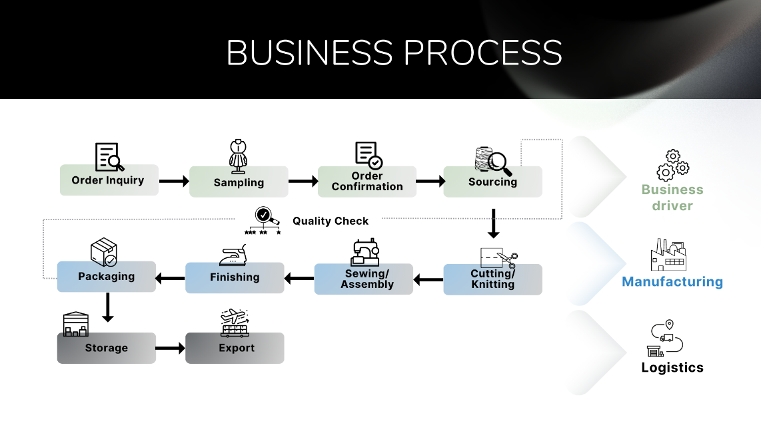
The RMG division of SQ Group's HR department is vital to ensuring that the company has the right people in the right positions and that they are properly trained to provide high-quality goods and services. Here, I'll talk about the goods and services the HR division of SQ Group's RMG division provides.

Figure 11 Business Process of SQ

Products
The HR department of the RMG sector in SQ Group is responsible for managing the organization's workforce and ensuring that it is well-trained, motivated, and productive. The department offers a range of products and services, including recruitment and selection, employee onboarding, performance management, and employee engagement and development.

Figure 12 Products: SQ Celsius


Figure 13 Products: SQ Birichina

Figure 14 Brands

Company structure:
The HR department in the RMG sector of SQ Group is structured in a way that enables it to effectively deliver its products and services. The department is led by an HR director who is responsible for providing strategic direction to the department. The department is divided into several teams, including the recruitment and selection team, the employee onboarding and development team, and the performance management team. This structure enables the department to efficiently manage the organization's workforce and deliver high-quality HR services.
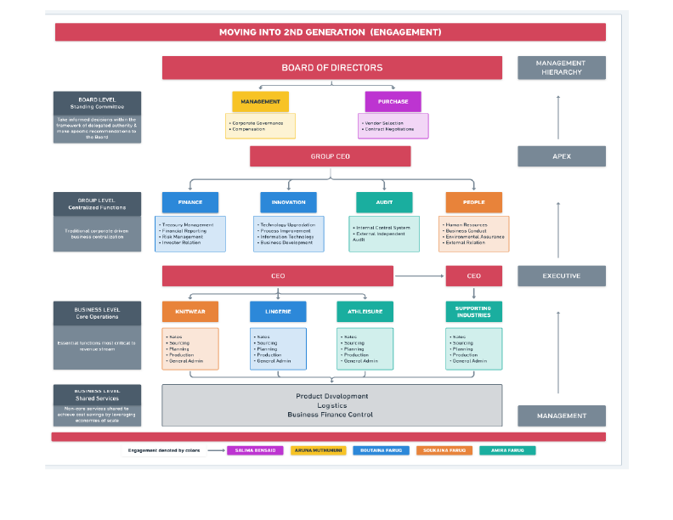
Figure 15 Management Structure

Manpower Overview:
Total workforce:
- Non-management (Associates & Factory Staff): ~18900
- Corporate staff (Executives and above): 907

Departments
- Leadership:

The organization's essential element, the leadership department, strives to have a beneficial impact on the business through strategic decision-making. This division is in charge of creating and putting into action plans that support efficient leadership techniques within the company.

- Marketing & Merchandising:

This division is in charge of creating and executing plans to advertise the business's goods and boost sales. To produce and promote clothing that satisfies consumer demands and preferences, the department collaborates closely with the design, production, and sales departments.

- Production:
The production department oversees the entire manufacturing process, from raw material sourcing to finished product assembly, ensuring that garments are produced efficiently, cost-effectively, and to the required quality standards.
- Product Development:
The product development team is responsible for the entire process of designing, developing, and launching garments, from concept to production.

- Quality:
The quality department is responsible for ensuring that the products and services provided are meeting or exceeding customer expectations, complying with regulatory requirements, and adhering to industry standards.
- Audit:
The main purpose of the audit team is to review and evaluate the company's financial statements, operations, and internal controls to ensure compliance with regulations, identify potential risks and areas for improvement, and provide recommendations for corrective action.
- Industrial Engineering:
This department is responsible for optimizing the organization's manufacturing and production processes. The team works to improve efficiency, productivity, and quality by analyzing data, identifying areas for improvement, and implementing solutions.
- IT, Infrastructure, Architecture & Automation:
The IT, Infrastructure, Architecture & Automation department is responsible for designing and maintaining the technology infrastructure of an organization. They ensure that all systems and networks are secure, scalable, and accessible to employees. The department also automates processes and implements solutions to improve efficiency and productivity.
- Center of Excellence:
The CoE department is responsible for driving innovation, best practices, and continuous improvement across the organization with new policies, strategies and inventions.

Chapter 4: Key HR Processes
The HR department of SQ Group RMG Bangladesh is responsible for managing the company's human resources, from recruitment and onboarding to performance management and employee engagement. The department ensures that all HR policies and practices comply with local laws and regulations, as Ill as international standards for responsible business conduct. The HR department is also responsible for promoting a positive and inclusive work culture that values diversity, equity, and inclusion. Additionally, the department oversees training and development programs to enhance the skills and capabilities of the workforce. SQ Group RMG Bangladesh's HR department is committed to leveraging technology and automation to optimize its processes and improve the work experience for its employees.
The HR Department of SQ Group is separated into two parts:
- Central HR
The management of the organization's overall HR strategy and policies falls under the purview of this division of the HR department. They are in charge of managing employee engagement, performance management, salary and benefits, training and development, and HR compliance at all SQ Group factories and offices. The HR Information System (HRIS) for the entire company is likewise managed by central HR.
2. Factory HR
This part of the HR department is responsible for managing HR operations at the factory level. They handle recruitment, onboarding, training and development, performance management, compensation and benefits, and employee engagement for factory workers. They also manage employee relations and grievance handling at the factory level, ensuring that employee concerns are addressed in a timely and satisfactory manner.

The specific department-wise tasks of the HR Department are:
- Recruitment and Onboarding:
The HR department at SQ Group is responsible for the entire recruitment process, from creating job postings, sourcing candidates, shortlisting resumes, conducting interviews, and selecting candidates. They also manage the onboarding process for new employees, which includes orientation, introduction to company policies and procedures, and providing necessary training.
- Performance Management:
This department manages the performance evaluation process, which involves setting performance objectives, conducting regular reviews, providing feedback, and creating performance improvement plans if necessary. The department also ensures that the performance evaluation process is fair, consistent, and aligned with the company's goals.
- HR Operations:
This department manages the company's overall HR strategy and policies, as Ill as the implementation of HR operations at the factory level. This includes recruitment, onboarding, performance management, compensation and benefits, employee engagement, HR information management, employee relations, grievance handling, and HR compliance. The department aims to ensure that all HR practices are consistent, efficient, and aligned with the company's goals.
- Employee Engagement:
The HR department promotes employee engagement through various initiatives such as employee surveys, training and development programs, team-building activities, and Illness programs. They also create opportunities for employees to provide feedback and suggestions on how to improve the workplace.

- Compensation and Benefits:
The HR department manages the compensation and benefits packages for employees, ensuring that they are competitive and aligned with industry standards. This includes salary and wage management, bonuses, benefits such as health insurance, retirement plans, and other incentives.
- HR Information Management:
The HR department manages employee data, including personal information, employment history, and performance data, using an online HR management system. This system enables the department to maintain accurate and up-to-date employee records, manage leave and attendance, and generate reports for management.

Future targets & Plans
Moving forward, there are several targets and plans that the SQ Group RMG HR department could consider optimizing its HR automation procedures. These include:
- Extending the use of technology to more HR activities, such as performance reviews and employee enquiries, which are not yet automated.
- Investigating how to further automate staff support using chatbots and other AI techniques.
- Adding features like gamification, personalization, and mobile accessibility to the current HR automation platforms Kormee and Kinship to improve their usability and user experience.
- Providing training and support to employees to ensure they are familiar with the new technology and can benefit from it.
- monitoring and assessing the efficiency of the HR automation processes over time to spot problem areas and make the necessary corrections.
- collaborating with other RMG organizations to share information and experience in order to encourage the adoption of innovative and ethical HR practices.
To further ensure that their requirements and perspectives are taken into account, the company may consider involving employees in the design and implementation of new HR automation methods. This could promote a culture of innovation and ongoing development within the business and enhance employee buy-in and engagement with the new technology.
Future goals and strategies for the SQ Group RMG HR department center on maximizing HR automation processes to raise employee engagement, satisfaction, and productivity. The business may keep improving its HR procedures and serve as an industry leader by utilizing technology and emSQ Grouping employee feedback. With this strategy, the SQ Group RMG HR department can continue to set the bar high for ethical and progressive HR procedures within the RMG industry.

Chapter 5: Performance Management Systems

Performance appraisal

The history of performance reviews is succinct. It began during Taylor's period, which is the twenty-first century. The fact that everything was talking about contemporary human resource management made it less effective. More than 65 years ago, the performance following World War Two was evaluated formally. From the very beginning, the appraisal system is used worldwide.
Dolowitz (1989) asserts that evaluation is a fundamental human ability for selecting both employees and individuals. It is a ubiquitous and important procedure. Without a fair system of evaluation, people will assess others' work.
McGregor, a management expert, defines performance management as a formal strategy created to fulfill the goals of the organization for making the right decisions on wage increases, employee terminations, and job transfers. The performance review assists the employees in understanding their own performance as well as what needs to be altered in light of their attitude, behavior, skills, and job knowledge as well as the requirement for training and development on the part of their managers.

Despite having the same aptitude for the job, receiving the same kind of compensation, and having the same talents, a study discovered that people's motivation and performance levels would still differ. These findings are supported by empirical studies. The rate of salary and other tangible factors are significant, but there is also another factor that is tied to an employee's performance. An employee's self-evaluation and confidence level are both crucial. For this reason, motivating employees solely through the provision of rewards is ineffective.

Evaluation is a fantastic tool for employee growth and motivation. In the United Nations, it has been known since the early 1960s. In the modern day, appraisal is an organized system that connects the boss and employees, identifies their strengths and weaknesses, and offers them the opportunity to develop both personally and professionally. Even so, not all businesses apply the assessment system; rather, this particular business uses it only to reward its staff. The appraisal system is used to identify the top performers within the organization's workforce in order to provide bonuses, promotions, and pay raises.
The lowest performance is also identified and is provided growth training or receives a demotion, termination, salary reduction, etc. In that instance, the company should terminate the employees while keeping in mind local laws and regulations.
Giving rewards and punishments to employees is an essential application of performance appraisals, but it is also a highly drawn-out procedure.
Employee performance is evaluated as part of the performance evaluation process, which also identifies areas for improvement. An efficient method is to learn about everyone's accomplishments. Because an assessment system is a crucial tool to establish and familiarize personnel with, using one can be advantageous for both businesses and individuals. (2018) Murphy
The manager provides performance review feedback, and by doing so, the fear of the employees is replaced with a friendly relationship and excellent work is produced. However, occasionally workers don't like it since they feel the boss isn't good enough at coaching them. Many people consider performance reviews to be superfluous work since they require time. For this reason, it is viewed as a burden for the employees rather than as a beneficial tool. McKenna, 1972
Evaluation of employee performance, employee motivation, and organizational growth are the three main purposes of performance appraisal. By filling out an appraisal form, the employees' performance is evaluated. Employees put forth extra effort to complete their work correctly when they are aware that their performance is being reviewed in the hopes of receiving a promotion, incentive, recognition, etc. (1976; Levinson)
An efficient performance appraisal is crucial for accomplishing the organization's objectives and goals. Employees' latent talents as well as areas in need of training can be discovered during performance reviews. The organization can provide training to the staff and improve their effectiveness by identifying training needs through performance appraisal, which eventually leads to customer and client satisfaction. Enhancing employees through performance reviews is beneficial and can increase productivity, which can provide them an advantage over rivals. (Azim, 2007)

Performance Management System Automation at SQ
Performance management system (PMS) in place is essential to create a transparent evaluation system, help employees develop their KSA, and align individual goals and objectives with those of the organization. A digital PMS system is viewed as a crucial aspect of the company culture, which is a win-win for both the organization and employees. The digital platform used here is called QPMS. It is an online platform where the employees can access their own goal sheets and areas of improvement as well.
PMS provides a framework for setting goals and objectives that align with the overall organizational strategy. By aligning individual goals with those of the organization, employees understand their role in contributing to the overall success of the company. This clarity of purpose leads to higher job satisfaction, motivation, and engagement.
Moreover, PMS provides a structured way for employees to receive feedback on their performance, identify areas for improvement, and develop their KSA. This helps employees to gain a clear understanding of their strengths and weaknesses and take the necessary steps to develop their skills and become more empowered. Additionally, PMS provides a mechanism for employees to have open and honest conversations with their managers about their career aspirations, ensuring they are aligned with the organizational goals.
From an organizational perspective, PMS provides a transparent evaluation system that helps to identify top performers and potential leaders. This enables the organization to make informed decisions regarding employee development and succession planning.
The benefits of having an effective PMS are numerous. By aligning individual goals and objectives with those of the organization, employees feel empowered to contribute to the success of the organization while also developing their KSA. The result is a win-win for both the organization and employees. I encourage all employees to emSQ Groupe the PMS culture at SQ Group and take advantage of the opportunities it presents.
Having a robust PMS in place is particularly important and beneficial for employees. It provides a clear understanding of what is expected of them, which helps them to focus their efforts and prioritize their work accordingly. Additionally, regular feedback and evaluation provide employees with the opportunity to identify areas for improvement and take proactive steps to develop their skills and knowledge. This, in turn, helps them to achieve their personal and professional goals, leading to higher job satisfaction, motivation, and engagement. Furthermore, PMS also helps to ensure fairness and equity in the evaluation process, which promotes a culture of trust and transparency. Ultimately, having a strong PMS culture is critical for creating a supportive and empowering work environment where employees can thrive and achieve their full potential.
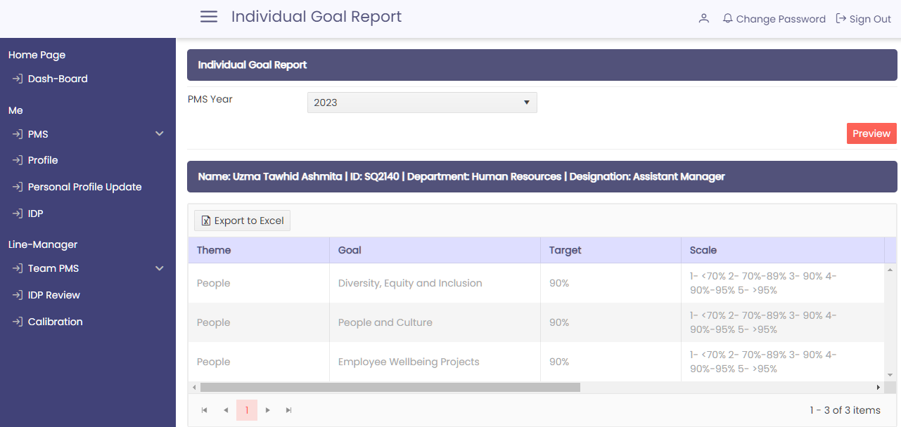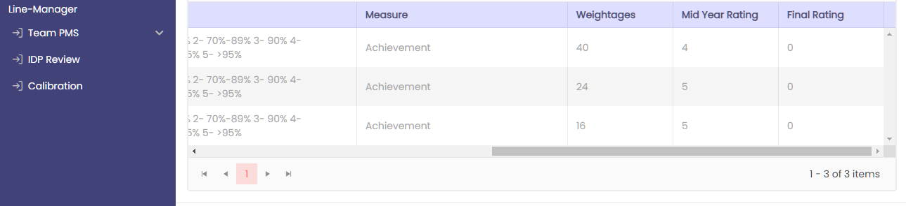
Using this system, employees can access their performance metrics in real-time, providing valuable feedback and insight into their progress. The KPIs are tailored to each employee's role and responsibilities, ensuring that they are relevant and meaningful.
The performance management system also enables managers to easily track the progress of their team members, identify areas of improvement, and provide targeted feedback and coaching. This helps to ensure that everyone is aligned with the company's objectives and working towards achieving them.
In addition to tracking progress towards performance goals, the KPI-based performance management system allows businesses to identify high-performing employees and reward them accordingly. This can help to improve employee engagement and retention, as Ill as drive better overall performance.
In addition to being aligned with the company's overall objectives and strategies, KPIs are considered to be SMART - Specific, Measurable, Achievable, Relevant, and Time-bound. This ensures that they are clear, concise, and actionable, and that progress towards achieving them can be easily tracked and measured.
When setting KPIs, it's also important to consider the employee's current level of performance, as Ill as any areas where improvement may be required. By setting realistic and achievable goals, employees are more likely to stay engaged and motivated, and are more likely to achieve their targets.
In some cases, KPIs may be set in collaboration with employees, allowing them to provide input and feedback on the goals they are expected to achieve. This can help to ensure that the KPIs are relevant and meaningful, and that employees are more invested in achieving them.
In addition to setting KPIs, this comprehensive performance management system includes other elements such as:
- Regular performance reviews:
These are typically conducted on a regular basis (e.g. annually, quarterly) and provide an opportunity for managers and employees to discuss progress towards achieving KPIs, identify any areas of improvement, and set goals for the future.
- Ongoing feedback:
This entails providing staff with both positive and constructive feedback on their performance on a regular basis. This keeps employees motivated and engaged while also providing them with the knowledge they require to improve their performance.
- Development plans:
These plans are designed to help employees build their skills and capabilities and prepare for future career opportunities. They may include training, coaching, or mentoring, and are typically aligned with the employee's career goals and the company's strategic objectives.
- Recognition and rewards:
These are intended to acknowledge and thank personnel for their accomplishments and services to the organization. This can include bonuses, promotions, or other types of recognition that can assist drive staff to keep working well.
By implementing a comprehensive performance management system that includes KPIs, regular performance reviews, ongoing feedback, development plans, and recognition and rewards, businesses can create a culture of high performance and continuous improvement. This can help to attract and retain top talent, drive better results, and achieve long-term success.

Criticism of performance appraisal
An individual evaluates the performance of other people and identifies areas for improvement in a performance appraisal, which is a mechanism for governing society that is conducted annually. Many academics assess the efficacy of performance reviews. Many people believe that conducting the appraisal process is quite difficult, and that perfecting it is a very difficult task as well. Many people argue that doing performance reviews within an organization is not required, while others argue that doing so would be biased. Many people consider appraisals to be a waste of time, while others think they are demotivating and have a bad impact on the workers.
If I imagine a scenario in which the assessment is completed and a reward is granted based on it, then no employees will discuss a work-related issue. The populace won't display any weakness at that moment. Many appraisers find it difficult to accurately assess the staff because of this. Most of the time, the supervisor is acquainted with their staff and maintains a cordial relationship with them. Employee productivity declines as a result of disagreement that is brought on by appraisals, which can also harm relationships and the office environment. There is an additional argument that the award that will be given to the deserving employee based on their performance, effort, and merit must be tied to the appraisal.

Fundamental Purpose

The organization has two main techniques to rate its staff. One is a system for evaluation, and the other is a system for feedback. Finding the gap between the employees is the major goal of the appraisal system. The gap develops when the organization's performance does not match the standard for performance appraisals. Employees receive feedback so they are aware of the characteristics of their performance. When it is viewed from the perspective of others, the primary purpose of the appraisal will be satisfied.

Viewpoint of Employees

The employee believes that a performance review should include information on what they need to accomplish, praise for a job well done, suggestions for how to improve their performance, and rewards commensurate with that accomplishment.

Purpose of Performance Appraisal

The supervisor and employee perspectives are taken into consideration in the performance appraisal system. For the various work positions, an evaluation system is required. Steps must be mentioned in order for performance reviews to be successful.
Strategic Purpose

The goal is to accomplish the strategic business objectives. It can be accomplished by connecting the personal goal to the objective of the organization. They are crucial to the onboarding process, which transforms new hires from outsiders to insiders of the organization. It helps new employees understand the principles and culture of the company and the kinds of actions and outcomes that are recognized and rewarded.

Administrative Purpose

It helps in information confirmation, information utilization, and staff decision-making. The system for awarding rewards is based on the data provided by the administrator. The Turkish government has prioritized maintaining the performance evaluation system in order to prevent corruption and bias.

Informational purpose

It supports staff decision-making, information use, and information verification. The administrator's data forms the basis of the method used to distribute prizes. In order to combat bias and corruption, the Turkish government has made preserving the performance rating system a priority.

Developmental purpose

The most crucial component of a performance review system is feedback. It can be utilized as a tool for development. Use this to mentor your staff and improve your management skills. Giving employees feedback enables the company to identify each employee's strengths and weaknesses. When employees respond positively to feedback, it can be helpful. The feedback culture should exist in the company so that it is not intimidating, gives importance to conduct, guides employee growth, and helps people individualize their careers. For the sake of development, both short- and long-term development are included.

Organizational Maintenance Purpose

Performance appraisal is used to provide information that can be used in workforce planning. It comes with a system that assists in detecting needs that develop within and outside of the firm, determining priorities, and allocating personnel where they can deliver their best performance. The most significant factor in that industry is talent inventory. It also includes determining the employees' future training needs, reviewing performance management at an organizational level, and determining if training helps them perform well or not. This cannot be effectively guided if the performance appraisal is not completed correctly.

Documentation Purpose
Performance appraisal aids in the gathering of vital information about personnel, which aids in the documentation of that information. Performance data was used to validate the just completed selection procedure. If a computer literacy test is administered, the results can be compared to those obtained through performance appraisal. If the exam scores and evaluation results are related, the outcome can be used to fill the next administrative post. It also aids in administrative choices. It delegated to managers the obligation of providing a reward that is more effective in motivating employees. This also disseminates strategic and informational goals. Managers can meet the needs of their staff by meeting with them and addressing the issue, as well as taking notes if one arises. This directs employees to the areas in which they need to improve and provides proof if any action is required.

Performance appraisal Principles
Management time management is a constant practice in people matter advancement. Performance defines the organization's goals from short to long term in order to increase employee performance. It aids in discussions with each employee to improve performance.
Strategic congruence
The evaluation should be consistent with the organizational plan and unit. The organizational aim must be related to the individual's goal.
Context congruence
The appraisal should reflect both the cultural setting of the country and the culture of the company. If an organization has a communication problem and maintains a rigid relationship with each other, 360-degree appraisal cannot be performed since its employees are appraised by their peers, supervisors, and subordinates.
Thoroughness

The system should contain four dimensions: all personnel, including supervisors, all job assignments and conduct, and results should be assessed. The complete review period should be present, not just a few weeks or months. Feedback has to be offered in both good and negative terms so that staff can see where they could improve.

Practicality
An effective and simple-to-use system should be in place so that it is user-friendly and can assist managers in making decisions. Time and effort should be managed so that it does not take longer than necessary.

Meaningfulness
Appraisal; I should maintain the standards so that job functions are available. Appraisal should strengthen the areas over which employees have authority. Appraisal should be done on a regular basis since if only one evaluation is done, it would be ineffective, thus a quarter review system should be in place, as well as continuous feedback to help appraisers grow their skills.

Specificity
The appraisal should be specific and provide staff with clear direction on what is expected of them and how they might meet those expectations.

Identification of effective and ineffective performance
The appraisal should allow for the collection of information that can distinguish between the best and worst performers. If the system does the same evaluation, it will be ineffective.

Reliability
The appraisal should ensure that the performance evaluation is fair and error-free. If there are two supervisors and they both evaluate an employee at the same time, the rating number should be the same.

Validity

The degree to which the assessment process accurately evaluates an employee's performance on the job is referred to as the validity of a performance appraisal. In other words, it assesses the degree to which an employee's performance is accurately reflected in the appraisal. Making fair and informed judgments about employee growth, salary, promotions, and other human resource-related issues requires a reliable performance appraisal system.

Acceptability and fairness
The appraisal should be agreeable and fair to all parties in order to avoid employee conflict. The evaluation and the reward should be combined. Rating and feedback systems should have a beneficial impact.

Inclusiveness
The appraisal should be completed with the well-being of all employees in mind. Employees should be included in the development of the appraisal system, and individual viewpoints on various cultural values should be considered. Before the appraisal meeting, the employees must gather the necessary information, and all employees must participate.

Openness
Employees should be given performance feedback on a regular basis, and the quality of their performance should be ensured by them. There should be a two-way communication system in place where information can be exchanged between employees and managers. There should be performance standards in place, and staff should be aware of them. Communication had to be open, honest, and efficient.

Correctability
Performance evaluation is not without flaws. So, if an employee makes an error, there should be a framework in place where they can amend their behavior and discuss it.

Standardization
The supervisor conducts an appraisal in order to manage personnel and time. For this, training should be provided to each individual supervisor to ensure that no errors remain.

Ethicality
There should be ethical norms. Personal self-interest should not be present during the appraisal process. Employee privacy should be protected, and individuals should be evaluated based on performance dimensions.

Consideration of Performance appraisal
Performance appraisal helps in motivating employees and in getting the best performance from them. For setting the goal, performance appraisal helps the most. Performance appraisal finds out the poor performers and improves them to meet the organization's standard. Performance appraisal helps in rewarding the best employees. Performance appraisal decides the individual need for training and helps in lowering the layoffs from the organization.

Process of Performance Appraisal System
There are numerous techniques for the appraisal system that aid in producing the greatest results. Employees will be satisfied only when they believe they can openly express and debate their opinions. This enables staff to accomplish future objectives. They also believe that appraisal is done honestly if they are treated equally and given the opportunity to appeal the evaluation they have received. If negative feedback is given, employees should be informed that it was given for them to improve their performance in the future. Employees will feel more at ease and less fearful of criticism if appraisals are conducted in this manner. Unfair and negative performance appraisal information can enrage colleagues, cause friction, and spark conflict in the workplace. Setting goals for the organization is a crucial part of motivating people. Employees are empowered by goals. When employees are given demanding, specific, and acceptable goals, they perform better than when they are given an easy and ambiguous goal. An appraiser should have all of the information needed to complete the appraisal, as well as an understanding of the personnel.

Balanced Scorecard: This section defines what management means by performance and how it is measured. How can performance be defined and measured in accordance with the mission and vision statements displayed.
The benefits of balanced Scorecard
- It provides an organized strategy that is simple to describe.
- Using it makes department and division alignment easier.
Disadvantage balanced Scorecard
- It necessitates strong leadership and rigidity.
- More expensive and time-consuming

Behavioral Checklist
The rater knows the job evaluation, on-the-job effective and ineffective behavior is described by the rater in this manner. On a specific paper, we must identify numerous characteristics and evaluate them based on that criterion.
Advantage of behavior Checklist:
- It is very simple to use and understand because a list of KSAs is provided; we can easily obtain qualitative data; and determining the score of each employee is simplified.
- We can get information on what is required in a more objective manner.
The disadvantage of behavior Checklist:
- When evaluating an employee, what is stated based on this evaluation is not conceivable, and people may feel impersonal and distant. When employing scale point, it is done at random. Most of the time, people do not distinguish between the highest and lowest priority.
- Though it is based on KSAs, it is difficult to provide feedback because it is not written what the employees' strengths and weaknesses are and how they may improve them. Very time-consuming and expensive.

Graphic rating scale
An employee’s level of performance is checked by the manager here and it is the most widely used method. In here the detailed duties and responsibilities of the employees are written in a form.
Advantage of the graphic rating scale:
- It is quite useful and precise.
- If we want to analyze a person based on position, we can find out what duties and obligations, abilities are required.
- It is useful for evaluating the large number of personnel.
- Very simple to grasp and see.
The disadvantage of the graphic rating scale:
- It takes a long time and requires a lot more resources.
- It is quite difficult to do since we need to find out each job description and what the competence is.
- Very subjective and focuses on specific characteristics of individuals.

Behaviorally anchored rating scale (BARS)
The performance of the employees is assessed depending on certain conduct. It is a combination of the critical incident technique and the graphic rating system.
Advantage & Drawback: It takes a lot of time to complete and is very focused on the expected behavior and the particular work.

MBO (Management by Objectives)
As part of this process, employers set goals for their employees. Prizes are awarded in accordance with performance, which is routinely examined. It concentrates more on what needs to be done than on how to do it.
Advantage of MBO (Management by Objectives):
- It emphasizes initiatives, outcomes, and plans for effective employee performance. employees' dedication to reaching the organization's aim.
The disadvantage of MBO (Management by Objectives):
- There is a greater emphasis on short-term goals than long-term goals; it takes a lot of time; and it is only effective if the supervisor has received training.

360-degree method
Employees are assessed using this method based on the comments made by those around them. Employees are assessed here by their coworkers, superiors, and subordinates.

Advantage of the 360-degree method:

- Biases are diminished by the knowledge acquired from various sources.
- Employees' dedication to their jobs is increased and they are more aware of the demands of their peers, customers, and other stakeholders.
- Employees now have a higher opinion of their own performance, which gives them more self-assurance and empowers them to manage their careers.

The disadvantage of the 360-degree method:
- It takes a lot of time, and individual preferences might lead to conflict between coworkers.

Performance Appraisal Errors
Performance appraisal is handled by managers and supervisors. It varies depending on the circumstance, state of mind, and location that influences their choice. Since they are also people, their preferences and decisions vary. It is only natural for this to result in mistakes. Effective measures, however, can reduce this issue. This method is susceptible to numerous faults.
Rater error
The typical mistakes that can occur and their root causes were discovered. It increases accuracy by reducing unintended rater error or by exposing raters to a wider spectrum of potential faults.
Like me error
In this, the appraiser frequently favors the person who likes them. When doing an evaluation in this situation, the supervisor gives the highest rating to the person whose attitude, behavior, race, gender, and personality are similar to his own.
Contrast error
In contrast, supervisors' mistake rates are determined by employee comparisons rather than performance requirements. This occurs when the supervisor simultaneously completes several forms based on assumptions.
Leniency error
This type of inaccuracy may occur if the supervisor gives all or most of the employees better ratings. It is a deliberate mistake that is made to encourage workers by providing merit-based base pay and prevent disagreement inside the company.

Bias errors
It depends on a person's attitude. Some can be highly strict or easy during the appraisal process. It's possible that the employees' actual performance won't be assessed as well. In general, it has an impact on everyone in the company.

Relation rating error
If two tasks are related during evaluation, errors may occur because the appraiser places a high value on logic.

Halo effect
These mistakes occur as a result of the appraiser's partiality, which occurs when they prioritize one task while ignoring others. As a result, assessments may be incorrect. In this, even if an employee may not always achieve the performance standards, they are nevertheless awarded a higher rating. For instance, if a supervisor grades a worker based on flawless attendance, she will receive a lower rating for effectiveness and dedication.
Primacy error
The appraiser's bias, which happens when they prioritize one duty while ignoring others, is the cause of these errors. Assessments may be inaccurate as a result. In this, employees still receive a higher rating even if they don't always meet the performance standards. For instance, a worker will obtain a lower rating for effectiveness and dedication if her supervisor assesses her solely on her impeccable attendance.
Recency error
When performance data is gathered in the last stages of the review period, this issue occurs. The most important factor in the rating is the final review period event. All of the rating sectors are given equal weight by it.
Negativity error
When managers prioritize information that is bad over information that is neutral or positive. Given that people tend to remember the negative things the most, let's say a supervisor witnesses a negative interaction between a customer and an employee. Despite the fact that there are many other instances where a positive interaction occurs and increases the customer's satisfaction, the customer may still rate the employees negatively.

First impression error
when managers pass judgment on someone favorably or negatively without taking into account the relevant information. When this occurs, the person acts as the supervisor would.
Spillover error
This kind of inaccuracy happens when a person's prior ratings affect how they rate their current performance. The manager believes that a person who has consistently produced the finest results in the past will continue to do so in the present.
Proximity Error
The manager in this situation assesses the best performer and has high expectations for the other performers. He judges everyone uniformly, which is problematic.
Rating inflation
Only the performer who meets the highest standard is given a rating by the supervisor. He does it based on his mood rather than on logic. Both individual and group performance may be harmed. Bias evaluation is possible here. (S, 2017)

Chapter 6: Takeaways from this research:

Key takeaways:

In conclusion, my internship at SQ has given me a great chance to learn about the rapidly evolving world of RMG Manufacturing in a practical way. I have had the honor of working with a bright and committed team throughout my internship, who have exposed me to a variety of opportunities and challenges in creating and sustaining a successful HR Automation platform.

I have developed a greater grasp of the value of user experience, data analytics, and innovation in promoting engagement and growth via my work on various projects. I have also come to understand the value of teamwork, communication, and problem-solving.

I've been exposed to many facets of the platform's development during the course of my internship along with day-to-day HR operations, including user research, product design, and data analysis. Additionally, I've had the chance to work on difficult projects that have forced me to hone my technical and problem-solving abilities.

Chapter 7: Conclusion & References:

Conclusion:

Enhancing Feedback and Recognition" emphasizes the importance of feedback and recognition in improving employee performance and overall organizational effectiveness. Through a comprehensive review of the existing performance management system and an exploration of best practices from literature and research, the thesis has provided valuable insights and recommendations for optimizing the system.

The study revealed the shortcomings and limitations of the current performance management system, particularly in the areas of feedback and recognition. Insufficient feedback mechanisms and ineffective recognition practices were identified as key areas requiring improvement. The thesis highlighted the significance of clear performance expectations, regular and timely feedback, and fair and meaningful recognition in driving employee motivation, engagement, and job satisfaction.

By proposing practical recommendations, the thesis has offered actionable strategies for enhancing feedback and recognition within the performance management system. These recommendations include implementing effective feedback mechanisms, providing training to managers on delivering constructive feedback, establishing a culture of continuous feedback, and designing a fair and transparent recognition and rewards program. Additionally, the thesis emphasized the need for aligning individual performance goals with organizational objectives and fostering employee development through targeted training and growth opportunities.

The anticipated outcomes of implementing the proposed improvements include increased employee engagement, motivation, and overall performance. By optimizing the performance management system, organizations can create a positive work environment, strengthen employee-manager relationships, and enhance organizational productivity and success.

The thesis contributes to the existing body of knowledge by providing empirical evidence, insights, and practical guidance on the significance and impact of feedback and recognition within performance management systems. It also highlights the importance of continuous improvement and data-driven decision-making in performance management practices.

Overall, the thesis on "Performance Management System Optimization: Enhancing Feedback and Recognition" serves as a valuable resource for organizational leaders and HR professionals, providing them with a foundation for improving their performance management systems. By implementing the recommended strategies, organizations can optimize feedback and recognition processes, leading to improved employee performance, engagement, and ultimately, organizational effectiveness.

References and Bibliography:

- Q PMS Policy and Guidelines of SQ Group
- Annual and Half-Annual PMS Reports of SQ Group
- SQ Group Website (www.sqgc.com)
- Armstrong M, Baron A (1998). Performance Management, The new realities, Inst. Personnel Dev, London.
- Research paper of University of Strathclyde (https://www.strath.ac.uk/)
- M. Chowdhury (2011), Performance Management Practices in Organizations Operating in Bangladesh: A Deeper Examination,
https://www.academia.edu/4901125/Performance_Management_Practices_in_Organiz ations_Operating_in_Bangladesh_A_Deeper_Examination
- Hewitt associates 1994 the impact of performance. (1994).
Retrieved from Course Hero: https://www.coursehero.com/file/p4ckvnf/Hewitt-Associates-1994-The-Impact-of- Performance-Management-on-Organizational/
- Aguinis, H. (2012). Performance Management (3rd Edition) Pearson.
- Dessler, G. (2022). Human Resource Management (13th ed.).

