The Practices of Human Resource Management of the ‘City Bank Ltd’.



Course: Internship
Code: INT 4399
Report
On
The Practices of Human Resource Management of the City Bank Ltd
Prepared For:

FARHANA RASHID
Assistant Professor- HRM (SOBE)

Prepared By:

PUSPA TABASSUM
ID: 111 151 492

Submission Date: 22 October 2019


Letter of Transmittal
22 October, 2019
Farhana Rashid
Assistant Professor
United International University

Subject: Submission of Report on the Practices of Human Resource Management of the ‘City Bank Ltd’.

Dear Madam,
With due respect, I’d wish to inform you that I even have accomplished the report. The report could be a gathering of my learning; increase my data regarding Human Resource Management Practices of City Bank Ltd. The most purpose of report is to find out regarding theoretical data and relate these to realize structure goal. My abstract understanding of the report is that the medium to demonstrate our ability to use it during a planet situation.
All your directions about the structure of preparing the report are adhered to once writing the structure of report which I’m willing to shed light-weight on any discrepancies that will arise.
Thank you for giving me a chance to figure with flexibility and independence. I required most to boost my insight during this report.
I build to confirm you that if you've got any question concerning any matter aggregation info relating to this report thus please request from me and that I can best attempt to answer you.

Sincerely,

__________________________
PUSPA TABASSUM ID: 111 151 492

Acknowledgement

Thanks to almighty God for special blessing in concluding the report. A report usually falls short of its prospect if not guided by the right person at the right time. Success of a report is an outcome of sincere efforts, channeled in the right direction, efficient supervision. Because I think it is a very intricate task to report on “Human Resource Management Practices of the City Bank Ltd”.
First and foremost, I would like to allow my heartiest appreciation and indebtedness to Farhana Rashid, Assistant Professor, School of Business and Economics, United International University, for her regulation, supervision and help in all stages of carrying out our work. Without her critical valuation and suggestions at every stage of the report, this report could not have reached its present form.
She deserves my special thanks for giving me her priceless time in spite of her busy schedule for reviewing my script very tolerantly.

Executive Summary
The City Bank Limited is a distinguished non-public business bank that's operating expeditiously within the People's Republic of Bangladesh industry. City bank is golf shot forth associate in nursing exceptionally tailor-made and peaceful shopper profit. They examine what modern wants of the shopper and provide the administrations that best suit them.
After completion of twelve semester of BBA program of the department of the School of Business and Economics, United International University, I have completed my billet inside City Bank Ltd, one in all the biggest and honors banking concern in People's Republic of Bangladesh. The target was to explore the human resource practices of the City Bank; however they modify their client, customer’s satisfaction level, the bank’s capability to recover load throughout the stipulated time and also the management potency.
The key intention of the report has been to come up with a sensible understanding of the practices of Human Resource department of the City Bank LTD. Their recruitment policy, training and development policy, performance appraisal methods, rewards, compensation etc has been discussed in the report.

Table of Contents
Chapter 1: Introduction 6
Background of the Study 7
Problem Statement 7
Objectives of the Study 8
Limitation of the Study 8
Chapter 2: Methodology of the study 10
11
Chapter 3: Literature Review 13
Chapter 4: Overview of the Organization 16
The City Bank Ltd ( CBL) : 16
History of The City Bank Ltd: 19
Vision, Mission and Values: 20
Objectives of the City Bank Ltd 22
Product and Services 22
Business Model 28
Chapter 5: Human Resource Management Practices in The City Bank Ltd 29
Human Resource Management Department of CBL: 29
Recruitment Process of The City Bank Ltd: 30
Training and Development Process of The City Bank Ltd 40
Compensation administration of The City Bank Ltd 50
Promotional practices of The City Bank Ltd 55
Performance Appraisal policies 57
Compensation Administration: 60
MIS and Strategic Planning: 63
SWOT Analysis of City Bank Limited: 64
Chapter 6: Findings and Recommendation 67
Major findings 68
Recommendations: 69
Conclusion: 69
Bibliography 71

Chapter 1: Introduction

Introduction

In all sphere of existence and business, antagonism has become supplementary and supplementary furious. Each obdurate tries to induce and preserve economical employees to satisfy the long term challenges. because the antagonism is obtaining higher, getting and retentive the leading work force has become terribly very important, as workers area unit the key factors that build a firm energetic and turn out to the trail of turnover. The course below BBA program aforethought with Associate in nursing astonishing grouping of theoretic and prudent aspects. Once the BBA program is accomplished, the scholar’s area unit sent to completely different institute to accumulate some realistic revelation in numerous sectors which might facilitate them in buildup skilled career. United International University has undertaken ninety days of place program for its BBA students, as a very important and essential demand of the BBA program. I actually have tried my best to use this prospect to counterpoint my data on Human Resource Management and additionally add in my data, that I actually have learned from my categories.

Background of the Study
I have done my internship at the City Bank Limited with the recruitment team of Human Resource division. After affecting my internship I encompass to construct a Report. The report includes Human Resources Management Practices of the City Bank. This report will make a case for the character and objectives of the Human Resource Division also as its implementation. As a totally banking concern, The City Bank Limited is being managed by a highly professional and fanatical team with long understanding in banking. Human Resource Division of the City Bank Ltd. focuses on the enlisting of best staff to understanding and anticipating client desires. As the data of Human Resource Division area unit not to be disclosed and responsive in nature, so I tried to construct this report with the help of available information.

Problem Statement
It is the City Bank which is one of the very few local banks that do not follow the established, decentralized, geographically managed, branch based trade or profit model. Instead the bank manages its business and operation vertically from the high point administrative center through five divergent Units namely-Business, Branch Banking, Risk, Operations and Support.
Underneath a synchronized online banking stand, these 5 diverse Units are reinforced at the sponsor by vigorous service deliverance or operations association and also a clever IT strength of character. Such federal business section based business & operating model ensure dedicated manner and services to the bank's special client segments. The bank presently has total 102 branches or sales and service center for retail and SME. It also has Commercial Banking services and Trade Services in both Dhaka and Chittagong. In addition to these routine release points, the bank is also very energetic in the unusual delivery area. It presently has 163 ATMs of its personal; and ATM distribution display with co-worker banks that has more than 1150 ATMs in place; SMS Banking; Internet Banking and more. It already started its Customer Call Center business and Agent Banking System to provide banking service in far-off areas of Bangladesh. Recruitment for all these branches is no easy task. It requires strict policies, critical process & in time flexibility in practice. Through this report- recruitment policy of The City Bank, its applied process, external & internal sources of recruitment, problems and prospects of this process will be discussed in light of the academic concept of Human Resource Management.

Objectives of the Study
The principal objective of this study is to find out an apt comprehensive understanding of Human Resources Administration Practices at the CBL.

Particular Objectives:
a. In the direction of discover the Human Resources Management Practices and policies of CBL
b. To discover the Recruitment Process of City Bank Limited.
c. To gain knowledge of more about policies in practice at a presumed organization like The City Bank Limited.
d. To understand the responsibility of each stage in the recruitment process.
e. To find out the area of flexibility in recruitment policy at The City Bank Limited.
f. To learn about the magnitude of records at each cover of recruitment process and proper way to organize them.

Limitation of the Study

To reach flawlessness any research needs to overwhelm some hindrances. The present study was not out of limitations. But it was a great opportunity for me to know the Human Resource activities of Bangladesh especially City Bank Limited. The study carried on has the following limitations:

Classified Information: As the in sequence of Human Resources Management Practices of The City Bank Ltd is very much classified, it was hard-hitting to collect information.

Face-to-face interviews: Key part of the report is based on the face-to-face interviews, which consists of views and opinions of those people. In some cases, some of them were not able to supply real facts or statistics. In this case, some assumptions had to be made.

Websites of the bank: The website of the bank is not provided enough information.

Incompatible: Data from different sources like annual report varied because of corrections made to the balance sheet.

Limitation of time: Limitation of time was one of the most imperative factors that reduced the present study. Due to time constraints, many aspects could not be discussed in the present study.

Rush hours associate degree business: Rush hours and business was one more reason that acts as an obstacle whereas gathering knowledge. The officers were quite busy with their regular activities.

Primary sources of data: I had additional dependence on the first sources, thus there may well be some level of quality with those collected data.

Chapter 2: Methodology of the study

Research Design
This is an explanatory research, which focuses on “Human Resources Management Practices of City Bank Limited”. Secondary data are mainly used to prepare the report. Taking into consideration the nature of the study only qualitative research tools is used. Observation and conversation method is applied for primary data collection. Because of the authorization issues at respective organization interviews and questionnaire method cannot be applied. For secondary data authorized use of websites and other printed documents provided by the authority is applied.

Sources of Data Collection
Fundamental knowledge sources each primary and secondary open area measure branded which can be mandatory to comprehensive and overall the study. To congregate up the necessitate of data, primary data are used and instruction also requires interviewing the administrator and personnel were obligatory.

Primary Data Collection
For setting up this report the information has been collected through the following sources-
Ø The largest part of the data for this study is composed throughout chat with HR executives at The City Bank Ltd.
Ø Convenient desk work
Ø above Phone data collection

Secondary Data Collection
Human Resources Practice is crucial for any organization and thus confidential. So, all the secondary data cannot be used.
Ø Records at HR division,
Ø Recruitment policy of City Bank Ltd. & other sustaining documents is used.
Ø Bank's Annual Report
Ø Diverse circulars, manuals and files of the bank

Data Analyzing Tools
With indication to the study because of demoralizing impact of human behavior on the process and also for inadequate access to information no quantitative data analyzing tools is used. In support of this study qualitative data analyzing tools like ethnography, observation & personal judgment is the key tools for analyzing data for this study.

Chapter 3: Literature Review

Literature Review
Human Resource Management (HRM) is an anticipated approach to supervision people lucratively for performance. It aims to construct a more open, bendable and compassionate administration style so that employees will be provoked, industrial and managed in a way that they can furnish of their greatest to carry department’s missions. Good HRM practices are implicated in selection reach departmental objectives and add to productivity. Edwin Flippo defines- Human Resource Management as “planning, organizing, directing, and controlling of procurement, development, compensation, incorporation, safeguarding and partition of human resources to the end those entities, directorial and social objectives square measure achieved.”The National Institute of Personnel Management (NIPM) of India has clear human resources – personal administration as “that part of management which is apprehensive with people at work correlate in tending with their bond inside an enterprise. Its mean is to assemble and amend into an efficient organization of the boys and girls UN agency structure enterprise and having regard for the well – being of the people and of operating teams, to enable them to make their best contribution to its success”. According to Decenzo and Jerome Robbins, “Human Resource Management is concerned with the people dimension in management. Since each organization is made from people, acquiring their services, developing their skills, motivating them to higher levels of performance and ensuring that they continue to maintain their commitment to the organization is important to attain organizational objectives. This is true, regardless of the type of organization – government, business, education, health or social action `.Parry & Wilson (2009) stated that “recruitment includes those practices and activities carried out by the organization with the first purpose of characteristic and attracting potential employees”. As success of service sector as within the case of civil aviation trade depends upon the human capital, recruitment & selection of the right people into the service business is crucial to achieve organizational success Raymond J. Stone (2005) inside the fifth edition of his book Human Resource Management defines deed as a result of the strategy of in quest of and attracting a pool of candidates from that trained candidates for job vacancies within an organization can be preferred.’ According to the recruitment sources are strictly associated to the managerial tricks as presentation of employees, employee turnover, employee fulfillment, worker needs and therefore the assurance of the association. This enlisting method ought to be done at every and each sector for fulfilling their structure goals (Nartey, 2012). Mohammed Nurul Absar (2012) says the importance of achievement and choice in his paper by considering each public and personal producing company in Bangladesh (M.M.Absar, 2012). Some of the analysis professionals and students say that there's an in depth linkage between the achievement choice worker satisfaction organization performance and 60 minutes practices (Gorter, 1996). Here accomplishment and mixture of public workers: a world compendium of current trends and practices say that the consequence of discrimination equipment within the success and choice process for updating the organizational resources (Hays, 2004). Ongori Henry and Temtime Z (2009) pronounce that in their paper the recruitment and selection practices of the small and medium enterprises and make them to progress their HR practices (R.D.Omolo, 2012). French says that the importance of sure choice and achievement activities within the organizations (G.R.French, 2012). The selection course of action is a progression of particular advances used to choose which volunteers ought to be enlisted. The course of action starts in the time of initiates request for business and closures with the toning choice. As indicated by Dale Yoder, “selection is the progression by which candidates for employment are separated into two classes those who will be presented for employment and those who will not.”According to Griffen, “training usually refers to the schooling equipped or mechanical employees how to do the job for which they are hired.”

Chapter 4: Overview of the Organization

The City Bank Ltd (CBL):
Inauguration 1983 till date, City Bank has been a case study in evolution, having changed over time from a habitual organization to a critically highly praised multi-faceted institution that embraces global best practices and chooses to be at the forefront of technological initiatives.
CBL is Bangladesh's foremost non-public division bank. The Bank has worked since 1983 with join together permitted capital. 1.75 billion Bottom the leadership of twelve leading specialists and leaders of the state. The respectable can behind the start of this bank was the popularity of subjective changes keeps cash and budgeting. These days the Bank of town serves its shoppers within the country and abroad with seventy eight branches distributed throughout the country and around three hundred overseas correspondents covering all the most urban areas and business purpose of meeting the planet.
Now have ninety nine on-line branches and one SME advantage centers and eleven SME/Agri branch cover the length and wideness of the country that consolidates a much fledged Islamic Keeping money branch. Spaced out from these ancient movement centers, the bank is in like manner particularly powerful within the elective transport zone. In recent times its 294 ATMs of its own; associated ATM giving strategy to an associate bank that has over 1150 ATMs set up; SMS Saving money.
CBL is blameworthy of all tasks coordinative the issue of the new MasterCard’s, contains journal, consumer profit, credit administration and charge approvals, and showcasing the cards in the country. City Bank in toting up given elite edges to the cardboard people underneath the American Stock Exchange chooses project of People's Republic of Bangladesh. It in addition offers exceptional points of interest everyplace throughout the planet with excess of 12500 applications at more than 9500 vendors in eighty eight nations (The City Bank Ltd, 2012).

History of the City Bank Ltd:
The City Bank Ltd. salutes the origin fathers of this institution. It was the imaginative private enterprise of twelve young businessmen UN agency braved the Brobdingnagian reservations with heroism and keenness so as to line up the country’s 1st non-public bank in 1983. They are always in our memory and we wholeheartedly pay tribute to the grand step they took toward making history. They are (from left to right) Mr. Monowar Ali, Mr. Ibrahim Mia (Late), Mr. Abdul Hadi (Late), Mr. M.A. Hashem, Mr. Anwar Hossain, Mr. Abdul Barik Choudhury (Late), Mr. Deen Mohammad, Mr. A.B.M. Feroz, Mr. Md. Ali Hossain, Mr. Azizul Haque Chowdhury, Mr. N.A. Chowdhury, Mr. N.A. Chowdhury (Late) and Mr. A.K. Mehmood.

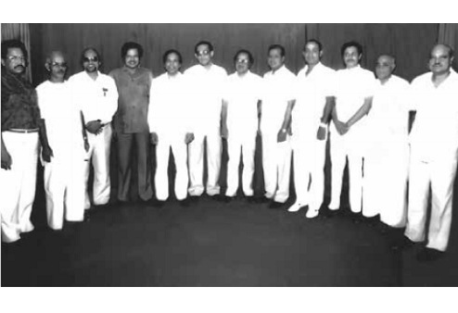

Vision, Mission and Values:
Vision:
The money food market with an appealing Culture giving satisfying Experiences.

Mission:
- Recommend a wide array of products and services that differentiate and excite all customer segments
- Be the "Employer of choice" by giving Associate in Nursing surroundings wherever individuals stand out and leaders square measure created
- Constantly face up to processes and platforms to boost value and effectiveness
- sponsor innovation and automation with a read to guaranteeing and enhancing excellence in commission
- Make certain respect for community, sensible governance and compliance in everything we have a tendency to do

Values:
- Outcome Driven
- Responsible & Transparent
- Spirited & Respectful
- Occupied & Inspired
- Paying attention on Customer Delight

What is Codes of Conduct?
The Codes of Conduct (CoC) could be a foremost document that sets out the eminence of potential of the City Bank restricted (CBL) from its staff. It describes a way to behave and maintain a skilled and moral relationship with customers, suppliers, colleagues and therefore the community normally that CBL serves. Everyone related to CBL is accountable to stick to the current CoC that is made on CBL's basic values and sets the tone for the Policies of this Bank.
This CoC doesn't illustrate, prejudice or pick at any or all of the laws that we do not have a tendency to square measure subject to, nor will it cowl each moral issue; and in those circumstances all applicable laws, CBL policies and practices, principles of natural Justice, shall perpetually apply.
CBL and its staff can fits all applicable laws of the land, restrictive demand and CBL CoC also because the policies and processes. Within the event of any conflict between CoC and/or any laws or principles of natural justice, the laws and therefore the principles of natural justice shall prevail whereas within the event of any conflict between CoC and the other CBL policies and practices, CoC shall prevail while not prejudice and derogating the fundamental principles and values of the Bank.
As CBL worker, it's our duty to scan and follow this CoC. Line managers are accountable to form positive that everybody is alert to and complies with this CoC. Failure to fit this CoC or CBL policies and processes shall amount to misconduct reckoning on the severity and should result in disciplinary action. Choices for disciplinary action will vary reckoning on the severity of the failure and therefore the employee’s service record. For the aim of following this CoC, it's expected that it's taken seriously and revered by all staff.
1. Company accomplish each employee shall deal reasonably with the CBL's customers, suppliers, competitors and colleagues. None ought to take unmerited improvement of anyone through manipulation, concealment, abuse of privileged data, false statement of facts or the other unfair or unlawful follow. CBL staff square measure to blame for knowing and obliging with the necessities applicable to their work activities, together with those delineated during this CoC and people delineated in CBL policies, processes, manuals, standards and restrictive directions. CBL staff square measure expected to use the entire out there resources, and logic, to guide their actions and choices.
One mustn't violate laws, laws, policies, standards, or processes in any case; notwithstanding he or she thinks doing this would lower prices, increase revenues, or profit a client.
2. Conflict of Interests CBL worker won't be disturbed in any affairs which can fabricate conflict between own interest of the worker and interest of CBL. Service to CBL shall ne'er be subordinated to non-public gain or advantage. Staff of CBL should not use CBL property, data or their position for secretive gain.
Conflicts of interest may involve, however not restricted to — customers, suppliers, and contractors, existing or prospective staff, and competitors or outside business activities, immediate relations. If worker has any doubt a couple of bound state of affairs, s/he ought to contact supervisor to hunt recommendation.
3. Combat concealing & terrorist finance CBL powerfully opposes all kinds of concealing and shall take steps to stop its money communication by others to launder cash. Staff to culpability for gap accounts square measure needed to fill in “Know Your Customer” (KYC) type And dealing Profile at the time of gap an account and review the accounts sporadically as per restrictive rules. Any account or dealing suspected of getting used for concealing ought to be reported each internally and to Bangladesh Bank as per CBL pointers.
City Bank aims at hostility any kind of concealing and revolutionary finance motion. Staff square quantify strictly proscribed to have relations, collaborate, support etc. in such reasonably activity, either directly or indirectly.

Objectives of the City Bank Ltd
The goal of CBL is not merely to receive profit but as well to maintain the societal commitments and to make certain its support to the human being of all rank to the entrepreneur, manufacturer and others self encouragement activities.
Tactical objectives:
- For achieving affirmative measure additional (EVA) annually.
- On the way to be market leader in product innovation.
- Toward be one among the highest 3 financial organization in Asian nation in terms of price potency.
- On the way to be all told one amongst one in every of the highest 5 financial organization in Asian nation in terms of marketplace share in the entire vital market segments we tend to provide.
Corporate Slogan of the City Bank Ltd
“Making Sense of Money”

Product and Services
Hence City Bank Ltd is a bank all the services are given below:
Credit Cards
1. American Express: AMEX into the Bangladesh has franchised by City Bank Ltd at 2010 through 3 categories and they are:
- Silver
- Gold
- Platinum
2. VISA: a global and it problems in each native Currency (Taka) & Foreign Currency (US Dollar) in a pair of classes and conjointly obtainable in twin currency mode:
● Silver
● Gold
Debit Cards or ATM Cards
1. Master Card: CBL issued the master card as default card for any account holder, thus so it's no specific classes as compared to credit cards.
2. VISA Electron: Others charge account credit issued by the CBL with some special privileges. In recent times this VISA lepton restricted by CBL.
Special Cards
1. City Maxx categorical Card: It’s a completely a specialized card which might be used as yank categorical however as charge account credit system.
Retail Banking Service:
● All the final banking services, like Bank Accounts, Student Accounts etc.
●Various sorts of Schemes are offered by retail baking, like Deposits, Savings, RMG Accounts etc. varied sorts of Loans, like personal loan, Education loan, Heath Loan etc.
●SME Banking Service
● CBL have big selection of SME banking services through three individual wings
● Medium phase SME Service.
17 little phase SME Service
● Agro SME Service.
Wholesale Banking Service
CBL conjointly conferred a good array of services beneath the wholesale banking service, those are outlined as,
● Future Finance
● Midterm Finance
● Structured Finance
● Cash Management
● Project Management
Beside all those services there ar plenty of servicers conjointly offered by CBL which might be listed as below-
● Priority Banking Service
● company Banking Servicer
● City bit (Advance web Banking)
● Trade Services (Foreign and Local)
● City Alo Women banking
CBL Subsidiaries:
The City Bank restricted has subsidies 2 completely different individual and that they are:
● City Capital Resource
● City Brokerage

Employee of the City Bank Ltd:
There are diverse kinds of employees working in better positions in The City Bank ltd.
Permanent employee:
It is the regular employee who is known as the permanent employee of The City Bank Ltd. So they get the additional, helpers and distinctive rewards with their basic pay rates.

Temporary Employee:
The workers who work mainly on the basis of any agreement or contract according to the policy of City Bank. They get benefits according to HR policy of CBL.
Management Trainee Officer (MTO):
It is the Management Trainee Officers who are the best eligible understudies of CBL. They must understand as an understudy inside CBL for the time of one year. Subsequent one year in the event that they can conclude their erudition period in actual fact and they will close stages up being a superior officer specifically as of the MTO.

Organ gram of The City Bank Ltd:

Fig: Organ gram of The City Bank Ltd
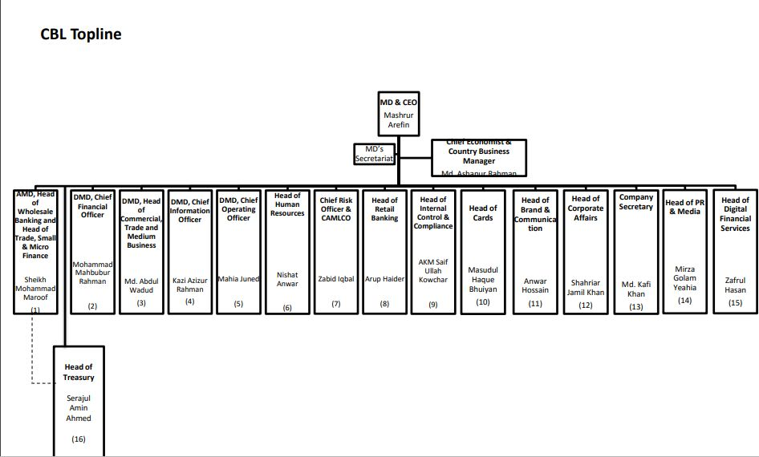
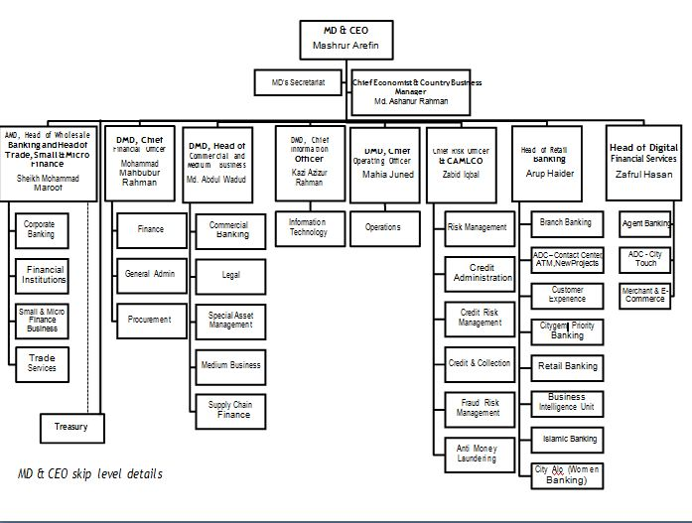

Business Model
It is the City Bank which is not like the local banks which follows the established, decentralized, organically managed, area office based industry or yield model. As a replacement for the bank manages its company and procedure perpendicularly from the head office from side to side five different Units and they are- Business Unit, Branch Banking, Risk Unit, Operations Unit, Support.
Fig: Business Unit Model of the City Bank Ltd
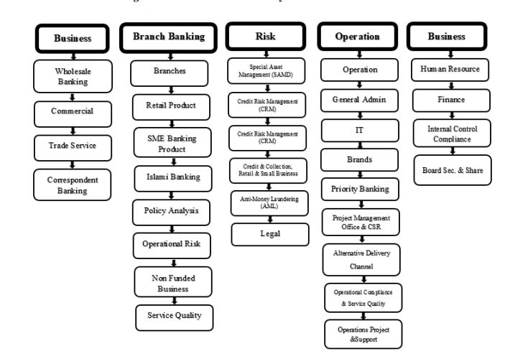

Chapter 5: Human Resource Management Practices in The City Bank Ltd

Human Resource Management Department of CBL:
The Human Resource Department in The City Bank ltd. helps out to support people and relationship to accomplish their objectives. CBL go up and doing aligned with diverse dilemma rising from the solicitations of the agents, the attachment and the overall inhabitants. In the adjacent and general circumstances are particularly unstable in light for creating troubles similarly reason for consistently developing regulations, especially rules that know the necessity of ascend to work potentiality. These confinements, the HR division of CBL must add to the affiliation's "essential concern" in a form which is effective (The City Bank, 2012, pp 29-33)
Human Resource Division’s Wings:
Human Resource Division of the City Bank Limited conducts their functions with six wings. The wings are-Recruitment, Administration, Training, Pay and Benefits, Performance Appraisal, MIS & Strategic Planning.

Recruitment Process of the City Bank Ltd:
It is the Human Resource Management that could be a martial science advance of dispensation or recruiting, emergent, maintaining Associate in nursing utilizing the human resources of an institute. However a firm’s aggressiveness depends on its men, after the business role answerable for exploit, coaching evaluative and compensating that men WHO must play a significant role within the firm’s success. As a section of an organization, Human Resource Management ought to be able to trot out the results of the dynamic world of labor. This suggests understanding the implications of globalization, technology changes, work-force diversity, ever-changing ability needs, continuous improvement initiatives, the contingent men, localized work sites, and worker involvement. Choice Associate in nursing achievement is an integral a part of any organization that heavily depends on their men to with success perform their mission and deliver the goods their vision within the long-term. So applicable choice of candidates to affix within the men could be a necessary a part of Human Resource Management, which is ensured by the Human Resource Division in town Bank restricted. In town Bank Ltd. each achievement and choice method is known as achievement method and so achievement method in town Bank is assessed into 3 classes.

Those are:
- Recruitment from External Sources
- Recruitment from Internal Sources
- Intern Recruitment and Selection
RECRUITMENT FROM EXTERNAL SOURCES
External Recruitment is the foremost source of recruitment at City Bank Ltd. It is comprised of the following steps and measures.

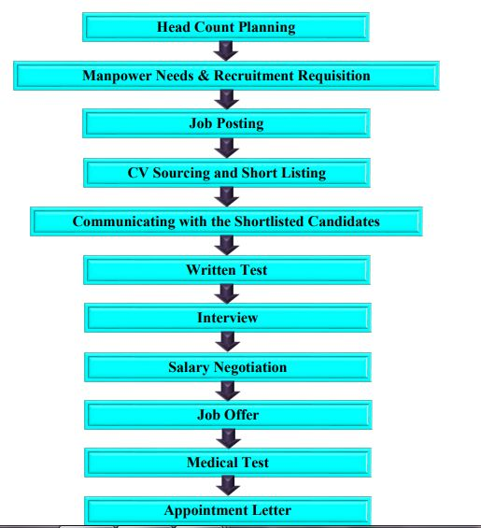
Fig: Recruitment Process of CBL

Preparing Headcount Budget
Headcount Budget is an integral part of the bank’s overall business plan. It started immediately after receiving the approved business plan. While developing the Headcount Plan every division analyze the pertinent factors including potential workload, and expertise requirements and ensure the optimum and effective utilization of the Human Resources for the whole bank, both for current and future requirements, forecasting employee turnover and any potential transfer promotion or any such relevant factors. Divisional head will prepare the Headcount Plan for his own division and give it to the HR division then HR will forward the Head Count Plan to Managing Director to present in the Board Meeting where the Board of Directors will approve the Headcount Plan. Approved head count is communicated to division by HR and recruitment for any vacant and new position is done as per the approved headcount.

Manpower Needs and Recruitment Requisition
Concern division fill up a Recruitment Requisition Form while requesting for filling the replacement of vacant position or new position and forward that to approval divisional head for his/ her approval. Subsequent to getting approval from divisional head requisition form is sent to HR. The requisition is made for approved headcount. Without receiving the recruitment requisition from the concerned division no recruitment is processed. A copy of the job description and the approved organ gram has to be attached with the recruitment requisition. If requisition is made for new position out of approved headcount plan then appropriate reason has to be provided by the respective division. The requisition then sent to divisional head, Head of HR and Managing Director for their approval. And if they approve the requisition HR process the requisition for recruitment.

Job Posting in Appropriate Medium
Subsequent to getting appropriately permitted take over from line division, HR placement job opportunity outwardly on the right intermediate. Usually City Bank Ltd uses its own online CV database, different job website and occasionally Campus recruitment program in different renowned universities for job posting. The job posting have all the information of the job, required qualification, the application deadline and posting or mobility related issues where appropriate.
Acquiring CV and Short listing
Short listing methodology is finished on the premise of critical data on the appliance kind within the light-weight of job specification of a footing. The duty criteria square measure critically reviewed throughout short listing. The short-listing methodology is qualitative one wherever social control judgment plays a vital role. Before short listing of candidates for tests, job criteria square measure set by time unit and line manager. There square measure general and technical job criteria that a candidate must meet for thought of future step of choice. Time unit determines general criteria whereas line manager determines technical criteria. Each the kinds of criteria square measure important; but, it's the character of job that determines which kind of criteria ought to offer a lot of priority.
Communicating with the Shortlisted Candidates
HR will communicate with the applicant whose CVs are shortlisted 48 hour prior to their scheduled interview or written test date. Such communication can be made in the form of Email or SMS or both. Often a phone call is made to ensure he/she gets the email or SMS.
Administering tests and interview
After short listing of prospective candidates, applicable employment tests like written tests, oral tests or the other tests as deemed work square measure organized to assess candidates’ quality for the position. Through the take a look at selected psychological factors like intelligence, aptitude, temperament and perspective of the candidates’ square measure measured and determined. The most focuses of employment tests square measure on:
- Job related questions to assess in-depth knowledge of the candidates
- Assessment of mental ability, reasoning, memory etc
- Assessment of potentiality and ability to learn
- Proficiency in performing tasks
Assessment in line with job analysis the selection is made on the basis of successive hurdles approach. The candidates are rejected following each of the stage or test being administered.
Written Test
If the applying is for the post of temporary or officer short listed candidates are demanded a written take a look at. Written take a look at isn't obligatory for candidates applying for the post of senior officer or higher than, however written take a look at are often taken at the discretion of Human Resource Division and also the line manager. Time unit drafts the written take a look at questionnaires. a collection of queries of a technical nature is written by line managers and sent to time unit. Few questionnaires from that list are enclosed within the take a look at by time unit as random basis. Whereas finalizing take a look at question, time unit considers the task necessities of the position and maintains connection, consistency and normal on the pattern of queries. The kind of question depends on the character of the position. Typically a mixture of multiple and narrative kind of queries is about within the written take a look at. It’s the responsibility of time unit to pick and decision candidates for sequent take a look arts supported the performance of written test. Candidates World Health Organization area unit sitting for the written take a look at should secure sure marks to proceed within the accomplishment method Candidates World Health Organization area unit sitting for the written take a look at should secure sure marks to proceed within the accomplishment method.

Interview
Candidates qualified in the written test are called for an interview. The candidate informed about the interview time venue and date two days before the interview. Selection interview is an in-depth discussion between interviewer and interviewee. Head of HRD generally HR conduct all the process of recruitment and selection, however, for some senior management level position, outside recruitment may be permissible. Executive Search/ Professional Consulting Firms may be contacted by HR for this purpose. The interview board members ask questions that are relevant to the performance of the job including questions regarding required skills. The type of questions may be mixed of open-ended, behavior-oriented; competency based and stresses type questions. The nature of questions varies according to the level of position. The interview board members rank all candidates and recommend candidates best suited for them. The basis of preliminary selection is marks obtained in oral tests and their judgment about the candidates fit for the position an interview board is formed with the minimum of three members one from the line division, one from HR, and one cross functional. The interviewers sitting in the interview hold a higher position than the position for which the applicants being interviewed. Some time there can be two rounds of interviews. The final interview is taken by the divisional head from the position of Executive Officer and above. Candidates who are not qualified in the interview get a computer generated regret letter in the form of email.
Salary Negotiation
Candidates who are qualified in the interview get an email or SMS requesting to send his/her pay slip which shows the candidates recent salary in the present organization. After getting the pay slip HR calculate the candidates proposed salary considering his/her current salary and proposed grade and negotiate with the candidates to know he/she is agree or not with the proposed salary and grade given. This salary negotiation is only done for the permanent employees; there is no salary negotiation for temporary employees.
23

Job Offer
An approval form is made including the candidates who are agreed with the proposed grade and salary and signed by the appropriate authority. Then a job offer is made to the candidates, on the of the job offer the candidates are sent for medical test at bank selected diagnostics. Individual joining as officer go through a probation period but employee who join above officer level need not go through any probation period.

Medical Test
In City Bank, the duty provides is conditional to passing scrutiny conducted by the chosen diagnostic center. The scrutiny is conducted once preliminary call for accomplishment is created however the use provides has not however given. The aim of a scrutiny is to get info on the health standing of the somebody being thought of for employment and to work out whether or not the somebody is physically and mentally capable of performing arts the duty. For the permanent worker price of medical take a look at beard by the town Bank restricted. And just in case of temporary worker candidate have to be compelled to collect his medical fitness report from any MBBS doctor.
Appointment Letter
Based on affirmative report on physical condition standing from the center, and positive reference check, the candidate is chosen for appointment. At this stage, the chosen candidate is gettable employment with town Bank. The appointment authority of city Bank issues an appointment letter to the chosen candidates. The appointment letter includes:
● Job title, Grade/Step and pay
● Nature of appointment
● Place of posting
● Name of section or department
● Effective date of appointment
● Probationary quantity, conditions of confirmation and spot quantity

The appointment letter and description will become valid exclusively once signing by the Director hr and so the employee, among the world provided for the aim.
Release Order
Individuals who are employed with another organization must provide release to HR at the time of joining with City Bank Ltd. Resignation acceptance letter can also be accepted to accelerate the joining process.
Photograph
Candidates must have to bring 5 copies of passport size photos of him/her at the time of joining.
Educational Certificates
The candidates must submit photocopies of all of his educational certificates from school level to University. If the original certificate is not provided by the institution, probationary certificate, transcript/ mark sheet is accepted.
Checking Reference
There must be at least two references provided by the candidates. In case of fresh candidates then he/she have to have one reference from educational institution, and if the candidate employed in other organization he/she must have one reference from his /her last organization, preferably by the supervisor.

INTERNAL RECRUITMENT PROCESS
City Bank Ltd. wants its employees to grow within and for this it give equal chance to recruit suitable candidates internally against any vacancies. Internal Recruitment process comprise of the following steps.
Job Posting
For any job openings internal announcement are created together with the external advertisement. The inner job posting is formed on town Bank Ltd. Intranet. Internal candidates UN agency have an interest within the job posting can apply for the duty. If the candidate spent minimum six months in his/ her current role he/she is ready to use for lateral internal move, and minimum one year in his/her recent role to be able to apply for a gap in higher position. The candidates take approval from the road manager and divisional head within the given kind before applying for internal enlisting and submit it to the 60 minutes with his/ her CV. Interested temporary candidates can apply for the position given that he/she fulfills all the wants of Temporary to permanent conversion policy. The temporary worker takes approval from the road manager and divisional head before causing the appliance to 60 minutes.
.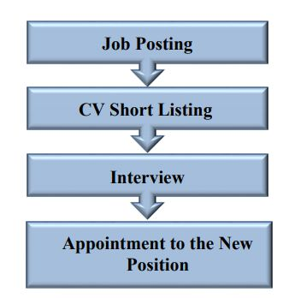
Fig: Internal Recruitment Process

Short listing CV
Internal candidates are then short listed on the basis of their fit for vacancy, performance record and potential to perform in the vacant position. Short listed employees are then notified through an email.
Taking Interview of the Candidates
As City Bank beliefs equal opportunity to everyone, short listed candidates face an interview with the divisional head and HR, along with external shortlisted candidates. The candidate is informed if he/she is finally selected.
Appointing the selected Employee to the New Role
The home and the host division mutually agreed on the joining date and the agreed timeline is followed by both divisions. The transfer/ promotion/ regularization is formalized through defined process and due time.
INTERN RECRUITMENT AND SELECTION
Internship is provided to students from all reputed and UGC approved universities by City Bank Ltd. Students with the minimum CGPA level determined by the City Bank Ltd. is qualified for the internship selection process.
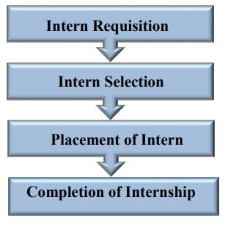

Circulating and Receiving Intern Requisition Form
An intern requisition form is circulated by HR 45 days preceding the start of the internship cycle. Concern requestor fills up the form. Project detail will be added to the form. The requestor’s line manager and divisional head must sign the form and send that to HR. Requisition then finalized by the HR. Number of intern in one cycle is limited.
Selection
An interview is taken by HR of qualified students.
Placement of the Intern
Students qualified in the Interview is placed on different projects by the HR. Placement is made on the basis of the educational major of the students and the requirements specified in the requisition. The accepted students then gave a letter of acceptance to their universities. Intern Requisition Intern Selection Placement of Intern Completion of Internship
Internship Completion
A report has to submit to their supervisor and HR on the work they have done through out there internship period with City Bank Ltd by the intern on the conclusion of the internship period. He/ she have to submit a hard copy and soft copy burned in CD of their report.
The Process of Training and Development
Human resource enhancement is an elementary pre-imperative to accomplish reliable objectives. Regular preparation of the representatives and administrators is gone for limit and professional ability working without fail. The City Bank Limited has a set up resourceful preparing foundation. At City Bank Ltd. (CBL) they tend to believe that folks square measure our major assets and so we'd like to speculate behind the event of our abilities to arrange them for additional career and leadership growth. The Bank believes that acceptable kinds of training/learning interventions and sanctionative opportunities contribute to Human Resources development by the manner of upgrading the purposeful competencies, leadership competencies and existing potentials that advantages each the worker and also the organization.
Apart from institutionalized coaching, on the task coaching, coaching, mentoring, distribution difficult jobs and alternative interventions of comparable kind will be finished worker development.

On – the – Job Training:
Approximately all comprehensively used strategy for development happen at job. This is recognized to the ease of those techniques and the effects which undertaking are fewer wasteful to this activity. On - the - job is offered in the CBL to their employees to enrich their work knowledge.
Off- the -Job -Training:
Off-the-job planning reach special strategies classroom addresses, films displays, relevant examinations and other multiplication works out, and changed the rules. The workplaces condition for each one of these methodology moves for little stopgap classroom to an itemized succession center with huge address entryways, supplemented by small assembling rooms with present day fluctuating media equipment, an extreme number of mirrors, and each one of the decorations.
The City Bank Ltd. Training institute offers some courses and they are given below:
Executive Courses:
- Risk Based Capital Adequacy under Basel –II
- Executive Development Course
- General Courses:
- Foundation Course for Executive officers
- Foundation Course for Assistant Executive officers
- Foundation Course for Assistant Executive Officers-Teller
- Industrial Credit & Project Financing Course
- International Trade Finance & Foreign Exchange
- English Language Course (Evening)

Course Objectives:
- To strengthen the capacity of the participants on over all banking procedure.
- To transform a bunch of officers into economical bankers.
- To increase the resources of the bank to strengthen future capacity.
- To transform trained officers to quality of the bank in industrial running of branches
- To increase profitability through banking by trained staff.
- To enhance human & material resources for achieving the goals of the bank branches
- To create permanent resources in branches of the bank.

Rewards & Control Systems:
Reward and Control systems are cautiously developed to make stronger accomplishment that is regarded considerable to evolution the commercial center. The representatives who don't hold prompt to the social and accomplish standards of the association, because of disharmony between the estimations of the entity and the estimations of the association; are given a rational cautioning to either take care of business or ship out.

Training Need Identification
At CBL, development desires of workers area unit known through a two-layered approach, specifically macro. The macro approach tends to spot the key development areas (both practical and leadership) of individuals within the organization, which can have an immediate impact on the success of the business strategy. This can be done through AN interactive discussion between the divisional high team and 60 minutes employing a structured ‘needs analysis matrix’.
The small approach tries to find the event areas of a personal through the annual performance appraisal method. Below this approach, the individual’s desires area unit known in line with the performance gaps within the current role and future career aspirations. It’s the first responsibility of the road managers to spot individual coaching desires for his or her workers with integrated support from the workers themselves and also the divisional head.

Training Categories in the City Bank Ltd
Training and development interventions cater for 2 major purposes, one it helps people obtain the talents to try to their current job properly and second it aids in developing the employee’s skills to maneuver to future level. All coaching and development initiative at CBL can specialize in developing useful competencies and leadership skills of CBL staff. The subsequent area unit the classes of coaching at CBL.

Local training:
This refers to all or any training interventions done regionally at through external native or international vendors. Native training is any of the 2 following sorts –

Local In house:
This is done by internal resources of CBL and these area unit usually custom-built coaching.
Local External:
These area unit trainings catered by external vendors at native institutes or through international vendors. Also, custom-built coaching by external vendors is classified underneath this class of coaching.

International Training
This refers to all or any training programs command outside Asian countries.

Identifying Training Vendors
In case of native or international training it’s primarily the responsibility of the hour to decide on the coaching vendor/institute. The various divisions can give help wherever necessary. It’ll be the only real responsibility of hour to speak with all coaching suppliers & trainers. Just in case activity communicates with any trainer/training institute, it'll do therefore in conjunction with hour.
Training Calendar
Leading series of all the requirements and finalization/choice of training vendors, HR will put together a yearly training calendar primarily based at the renowned training desires of the employees. The power team will evaluation and approve the calendar earlier than execution.
Training Approval
All training suggestions must be permissible by line manager and divisional head before the worker will attend the coaching. Just in case of international coaching the coaching and travel approval should be taken from MD. For details of advance assortment method and policy for international travel please follow the CBL TADA policy. Following accepted nominations, final list of participants for coaching are going to be finalized by 60 minutes in consultation with the divisional heads.

Training Cost
When an employee has been selected by CBL to attend a particular training, all training costs will be borne by CBL

Training Bond
Training bond will be appropriate in case of international training only and an employee needs to sign a bond as per the following schedule:

Training Cost | Bond Year
BDT 100,000 – 300,000 | 1 year
BDT 300,000 – 500,000 | 1.5 years
BDT 500,000 and above | 2 years

A worker attending over one foreign coaching/workshop should sign bond for every training singly.

- The time length in Agreement can begin from the date of completion of the primary training/ workshop. Just in case of coincidental coaching quantity the quantity the number} applicable for the worker are the addition of the 2 bond amount and also the date until the bonds are applicable are counted from the newest coaching completion date.
- During this in agreement amount if the worker needs to depart the Bank, the worker shall have to be compelled to reimburse/ compensate the bond quantity on a prorated basis.
The bond quantity can embrace all prices related to the coaching. Hour can inform the participant concerning the bond quantity and length. Solely once confirmation from the participant that he/she can attend the coaching upon linguistic communication the bond, hour can proceed with the windup of the coaching execution. Participation at international or native business conferences, conferences, seminars and also the likes won't be thought of as coaching.

Responsibility
Training could be a joint responsibility of the oldsters, supervisors and of the corporate. The responsibilities for coaching area unit divided as follows:
- The Human Resources/Division - is accountable for coordinative native and foreign coaching for CBL staff consistent with the wants of the Divisions. Additionally, hour is additionally accountable for coming up with, coordinative and implementing in-house management coaching programs. Hour should learn of any coaching organized among divisions. hour can finalize the participants list for coaching in consultation with division heads.
- Division/Department (line manager) - is primarily accountable for an individual's development and identification of coaching wants of the staff and choice of participants for specific external course.
- Participants – it's the first responsibility of the participant to form the foremost of their learning intervention. If Associate in Nursing worker fails to hitch a training/orientation/induction or the other learning intervention, for alternative business priorities, he/she should give notice hour a minimum of three days before the program with due approval from division head in writing (email).
- Eligibility all permanent and written agreement staff of CBL is eligible for coaching and development initiative taken by CBL. Training and development of temporary worker are catered through native coaching just in case of special would like.
Training analysis:
HR is accountable for aggregation the coaching analysis feedback from the participants to be ready to build helpful assessment concerning the course, the trainer and therefore the coaching institute. This step could be a part of the method of continuous improvement that CBL desires to drive.
Training History
It is the responsibility of hour and therefore the individual worker to stay the coaching history of every CBL worker updated.

Withdrawal from Training
In case a participant has to withdraw from coaching for any emergency, he/she should initial inform the road manager and divisional head. If the explanation is assumed even by the divisional head he/she shall advocate the withdrawal of the participant to move of our in case of native trainings and MD in case of international trainings. Upon approval from Head of HR and MD irrespective cases hour shall do the mandatory to deal with the withdrawal. During a scenario wherever an alternate participant is important, it'll be the responsibility of hour and therefore the line duty to rearrange for it.
New Employee Orientation Policy
When a brand new worker joins the corporate, she or he must be introduced to his/her job similarly on the corporate. The targets of the orientation area unit to welcome the incumbent orient him/her or so the business enterprise's ingenious and discerning, reason, values, carrier rules, primary divisional sports then forth. This can create a novel recruit feel that s/he is an element of the agency.
HR can established 2 orientation program at the last week of every month for the novel joiners of that month. The representatives from each division can create divisional presentation. Every employee needs to attend subsequent offered orientation program from the date of his/her connection.

New Employee Induction Policy
The Induction program may be an additional in depth program that the Orientation and helps the worker get a hands on feel and understanding of the business. The Induction are a five day program and a worker are eligible for the induction program a minimum of three months once connection.

Management Trainee Development Policy
The Management trainee program plays an important role within the development and strengthening of town Bank Limited’s Talent Pipeline. The MT Program may be a one year program wherever the MT spends a pair of days in Orientation, one month in Foundation Program and eleven months in cross practical rotations (business awareness development) supported by structured employment & mentoring sessions and formal leadership coaching programs. The MT Program needs few enablers to form the execution swish and sure-fire.

- The Coach, United Nations agency acts because the line manager for the MT amount of one year. The Coach is liable for the sure-fire implementation of the MT Program.
- Assignments Managers (AM) United Nations agency area unit the practical specialists or managers from the blocks wherever MTs can have the cross practical rotations.
- Mentor, United Nations agency may be a senior government from the Management Committee to support within the leadership development of the MT.
- Unit of time can play a significant role in terms of coming up with and facilitating the MT program.

Learning & Development Initiatives: 2017
In 2017, the educational interventions of City Bank Learning & Development unit reached new milestones. By the top of 2017, L&D lined the best range of participants within the coaching history of town Bank; even larger than the previous year’s record. The feats undertaken by L&D were a hit as a result of the 2 parts of coaching management were completed smoothly- the primary phase consisting of corporal punishment the existent calendar of 2017, and also the second part being conducting the whole coaching would like analysis and making ready the great calendar of 2018 circumscribing the necessities of all the divisions. Allow us to take a glance at L&D initiatives in 2017 with a Veronica chamaedrys perspective.
The City Bank Learning & Development unit started off the year with composed goals: produce in-House specialists within the method of development of employees; invite the most effective seasoned trainers out there within the market; increase the quantity of training hosted through reducing relative training price and making certain most participant coverage whereas maintaining optimum effectiveness. In 2017, with the in agreement objectives, L&D organized a complete of 149 trainings in 256 sessions. Amongst these there have been eighty five planned sessions and 171 ad-hoc sessions. 5145 participants in total were lined in native coaching inside that 2775 participants were lined through planned trainings and 2370 participants were lined through ad-Hoc trainings. L&D exceeded the entire coaching participation range in 2017 by 658 participants compared to 2016 that is AN incomparable high for L&D team.

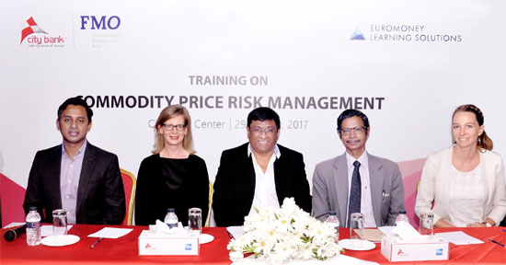

Compensation administration of The City Bank Ltd
Pay & Benefits
Proper Compensation, edges and rewards works as primary psychological feature factors for many staff. Planning a good compensation and edges set up conjointly works to retain well-motivated, economical staff within the organization.
The compensation of staff includes Basic remuneration, House Rent, Medical Allowance.
Temporary workers don't have any appointed job grade. The contract can have a consolidated payment per month and there'll be no different entitlements applicable except commission supported job criteria.

Major worker edges are given below:

- Retirement plans
- Health promotion programs
- Paid day without work
- Family edges
- Insurance
- Educational

Objectives of Pay & Benefits:
- Reduce fatigue
- Discourage labor unrest
- Satisfy worker objectives
- Aid achievement
- Reduce turnover
- Minimize overtime price
Basic Salary:
The pay which is given to the employees by CBL without any allowances is the basic salary. In CBL salary range is different on the basis of employee position.
Travel Allowance:
The reimbursement has a standard traveling allowance corresponding with the status of employees of different categories.
Daily Allowance:
The daily allowance is allowable as per policy framed by the board from time to time.
Incentive bonus:
The board of directors at its discretion provide incentive bonus as and when deemed necessary.
Festival Bonus:
The workforce or staff is permitted to get two festival bonuses to celebrate religious festivals.
Employee Benefits:
CBL guarantees that provident store profits are given to the eligible staff of the organization as indicated by the code of belief of Provident Fund constituted under a fixed trust. CBL has similarly presented 'Superannuation Fund' rather than Group life coverage strategy for the representatives. Those representatives, will's uniqueness ready to persuade particular criteria said in the approach of the reserve, will be permitted for the benefit of Superannuation Fund.
CBL compensation and benefit packages:

Allowance | Incentives/Benefits
- House Rent allowance 75% of basic  - Medical allowance  20% of basic  - Conveyance  30% of basic  - Lunch  Tk.200 per working day | - Yearly:  · Leave fare  · Deposit target bonus  · Two festival bonuses  · Performance bonus  - Long term:  · Provident fund  · Gratuity  · Insurance benefit  · Medical benefit

Gratuity:
A gratuity is approved to or on account in the incident of:
- Death while in the service of the organization.
- Termination of service or compulsory retirement resulting from permanent incapacity due to physical or mental infirmity provided this has not been caused by the irregular or inappropriate habits.
- Termination of service or early retirement resulting from the abolition of his post or bona-fide retirement.

The subsequent categories of employees are not suitable for gratuity:
1. Those who are dismissed from the organization or
2. Those that left or discontinued their service without the permission of the organization.
The amount of gratuity permissible to an employee is a summation equal to two month's basic pay for each completed year at the rate of last pay drawn.

Leave
The City Bank allows their employees the following leaves:
- Annual Leave: CBL employees will wind up qualified for yearly leave about twenty four working days after conclusion of individual timetable year.
- Casual/Sick Leave: Over fourteen days as sick leaves is allowed to them only who are sick all on a sudden.
- Maternity Leave: Female workers will get four months maternity live and they can have this opportunities two times in their working life.
- Study Leave: Study Leave is acknowledged to a worker Study leave of greatest 2 years must be permissible to a representative without pay and remittances gave he/she has put in no less than three years of administration.
- Leave without Pay: Leave without pay might be approved to a worker in special conditions where no other leave is permissible under this code of belief. In the event of Leave without Pay, the period does not exceed 60 day
- Encashment Facilities of Annual Leave: Yearly leave encasement offices might be allowable to the representatives for the most extreme of 90 days (based on last basic) at the season of workers leaving the bank.

Promotional practices of The City Bank Ltd
Promotion is the rewarding process to enlarge professionalism who is the great talent of the company. As rewarding and motivating factor the standardized promotion criteria are maintained by the company.
Objectives of the promotion:
Ø Providing enough opportunity for the executives and officers to build up high professionalism.
Ø to ensure smooth career path for the deserving executives or officers.
Ø to motivate, reward and make dedicated as well as trustworthy employees.
Ø to create belongingness for the employees.
Ø to encourage knowledge, wide experienced and dedicated employees.
Promotion Time:
The topic of promotion CBL is handled once a year which is recognized as year wise promotion. The standard of the promotion is June 30th of every year. Those who complete the minimum compulsory length of service set for promotion criteria within June 30th can be considered for promotion.

Criteria for promotion:
Ø Promotions for the worthy persons who fulfill the promotional criteria are always encouraged and maintained by the managing authority.
Ø For regular promotion, an employee at least requires two years’ constant service in the same rank with satisfactory performance for the immediately past two years, who had undergone and complete the training and other promotional exams successfully are taken into consideration for the promotion.
Ø Regular promotion for any post below the bank’s 3rd tire is considered by the management while the promotion for the post of 3rd tire and above is considered by the board of directors as per CBL’s policies.
Ø the employees have to pass the promotional exam getting the qualifying marks for the next immediate higher post. The mode of written test is in English.
Ø Senior executive officers also have to face the promotion exam for next higher post. The examination question of the Senior Executive Officers is prepared by outside professionals.
Ø Senior officer and senior executive officers below the rank of 3rd tire have to face viva voce and required to get minimum qualifying marks.
Ø The viva board is conducted by MD who selects the other personnel of the Board.

Performance Appraisal policies
Performance Management:
Performance appraisal is that the method of assessing employee’s past performance, primarily for reward, promotion and employees development functions. Performance appraisal may be a method that identifies, evaluates and develops worker performance to fulfill structure goals.

Purposes of Performance appraisal within the City Bank Limited:
- To review past performance
- To assess coaching desires
- To help develop people
- To audit the talents at intervals a corporation
- To set targets for future performance
- To identify potential for promotion
- To provide legal & formal justification for employment call
- To diagnose the hidden issues of a corporation
Performance Appraisal Process

- Supervisors
- Subordinates
- Peers
- Clients / Customers
- Self appraisal
- 180/360 degree approach

Approaches to menstruation worker performance within the City Bank Limited:

There are numerous reasonably methodology for menstruation performance appraisal. Solely 2 kind of Performance methodology square measure at bellow:

360-degree feedback: One presently widespread strategies of Performance appraisal is named 360-degree feedback. With this methodology manager’s peers, supplier’s square measure raise to finish form. The form is usually protracted.

Experience based: town Bank restricted measures the performance of worker by expertise. For instance adult male. X has been operating within the organization for 3 years and adult male, Y has been operating within the town Bank restricted for 2 years. Therefore the town Bank favors adult male. X for his additional expertise.

Job Evaluation
Meaning of Job analysis: Job evaluation is an–
Orderly and systematic techniques of determinative the relative price of assorted jobs at intervals the organization, thus on developing Associate in Nursing evenhanded wage and regular payment structure.

The two most typical strategies of job analysis that are used square measure 1st, whole job ranking, wherever jobs square measure taken as a full and graded against one another. The second methodology is one amongst the subsidization points for numerous aspects of the task. Within the points system numerous aspects or components of the task like education and knowledge needed to perform the task square measure assessed and a point’s price awarded- the upper academic necessities of the task the upper the points scored.

Policies of Performance Appraisal of the City Bank Ltd
- The City Bank Ltd performance appraisal strategies are different than others.
- Objective of Performance appraisal in The City Bank Limited:
- To review past performance
- To assess training needs
- To help develop individuals
- To audit the skills within an organization
- To set targets for future performance
- To identify potential for promotion
- To provide legal & formal justification for employment call
- To diagnose the hidden problems of an organization

Compensation Administration:
Employee edges & services were once referred to as fringe edges and these edges were primarily the in-kind payments workers receive in addition to payments within the type of cash. Workers exchange work for rewards. Most likely the foremost necessary reward, and definitely the foremost obvious, is money. During this choice we tend to visit answer the question, what quantity should a worker be paid? Explore for this answer throws U.S. directly into the subject of Compensation Administration.
Employees edges are typically inherent parts of the non-compensation system are created on the market to workers that provide:
- Protection just in case of health & accident
- Income upon retirement & termination.
Employee relation:
Employers and workers each have their own sets of wants and values, and victorious relationship between these 2 sides’ needs that some style of balance be smitten. This balance usually takes the shape of a psychological contract, AN understood agreement between leader and workers that defines the work relationship.
The City Bank restricted is maintaining 3 channel classes’ worker relationships those are:
- Employee safety
- Employee health
- Employee operating condition
Worker Safety:
The City Bank restricted provides the worker safety. It makes sure the all types of job safety like insurance of every worker not this give insurance to the labor.
Employee health:
Free medical checkup; give health care and necessary medical facilities for every worker.

Employee operating condition:
The operating condition of worker is incredibly hygienically as a result of it invariably supported “Right work for the proper person.”
Goals of Compensation Administration
The goals of Compensation Administration is to style the lowest-cost pay structure that may attract which conjointly are perceived as honest by these workers fairness may be a term that often arises within the Administration of AN organization’s Compensation program. It balance usually takes the shape of a psychological contract, AN understood agreement between leader and workers that defines the work relationship. This contract with or while not support of a proper dialogue, agreement influence the result come through by both sides.

Government influences on Compensation Administration
- Collective bargaining and therefore the choice method are heavily strained by government rules and rules.
- In distinction, this influence is minimum in these areas of human resource designing and socialization.
- Compensation Administration falls into the previous class.
- Government policies set minimum wages and edges that employers should meet, and these policies give protection certainly teams.

Incentives of City Bank Limited:
Incentives raise base pay: It controls prices as a result of the worker is being procured his/her further effort and for the advantages delivered to the organization.
Motivates employees:
- Individual
- Group
- Company-wide
Individual incentive plans:
- Awards based on individual worker Performance vs. company standards
- Awards based on individual Performance standards exploitation Objective & subjective criteria
- Quantity and / or quality goals
- Quantity of labor output what number units created
- Quality of labor output what the standard of the merchandise or service being created.
- Monthly sales what quantity sales was generated
- Work safety record what number hazard or errors are being reduced
- Work group action If the absent is reduced or group action is sweet.
- Group incentives:
- Group incentive plans
- Customer satisfaction
- Official value savings
- Material value savings
- Reduction in accidents
- Services value savings
Company-Wide Incentives:
- Wide Performance Measures Company
- Wide incentives plans
- Company profits
- Cost containment/prevention
- Market share Sales revenue

MIS and Strategic Planning:
The Management data system (MIS) & Strategic designing section doesn't follow any procedure of labor, as most of the functions are project or assignment based mostly. City Bank ltd. totally different completely different} departments and divisions use different Management data system, there's no centralized system fashioned however. So Management data system (MIS) and Strategic designing doesn't glide by any specific work procedure. The Manager, of Management data system (MIS) & Strategic designing is accountable of the Projects/Assignments and presently the Management data system (MIS) & Strategic designing section is maintaining the “E-Learning” system that is a worker Development program supported on-line coaching. workers will sit for on-line exams at intervals the geographic point and it's the duty of the Management data system (MIS)& Strategic designing Manager to gauge the electronic scripts and distribute the results when analysis.
The current comes of Management data system (MIS) & Strategic designing are development of 2 computerized systems named “E-Attendance” and “E-PM”, one for worker group action management and therefore the different is for employees’ performance activity matter severally.

.

Chapter 6: Findings and Recommendation

Major findings
Ø There is problems in the job analysis, human resource planning, recruitment and selection policy of CBL is not standard. The explanation behind this fact is the manager of HRD is unable to control the various HRM functions.
Ø There is lack of truthfulness in subsequent the performance appraisal because of some discrimination, favoritism and nepotisms are exercised.
Ø The Pay Packages of the Bank isn't focused in complementary with other Bank working in Bangladesh.
Ø Outside training for employees doesn’t organize properly because of inadequacy of training program planning.
Ø Despite the fact that the organization isn't in lack of representatives, however I think there is missing of genuine workers that implies “lack of right people in the right place”.
Ø The human resource management of CBL does not run standard pay structure for employees.
Ø Just the head office contains HR division and all the HR movements are controlled from the head office. As a result, when at times any HR issues raised staff need to sit tight for quite a while to settle it. Also, this office isn't very organized.
Ø Sometimes employees feel demotivated for lack of clearness in promotion policy because of preference and nepotism.
Ø Talent acquisition managers are not up to date with the strategies of choosing the most excellent candidates.

Recommendations:
On the basis of the findings of the study, my recommendations are given below:
The human resource department of CBL should be perused the modern HRM system, and produce the HRM function to each department properly because the HRM policy explore as the foundation of all human resource functions in an organization.
The standard performance appraisal has to be equipped by the HRD manager of CBL because the success and failure of an organization is incredibly dependent on the accurateness of human resource performance.
The manager of HRD needs to work the standard pay structure for the employees of CBL to minimize the rate of high turnover of employees.
Training should be provided by expert consultation with the training division in the central level and mid-level.
The authority of The City Bank Limited should set up a structure performance appraisal policy. HRD manager has to avoid the biases so that efficient employee can get appropriate reward for their performance. “Right man in the right position”
The HRM authority should try to reduce the additional workload of the employee in order to decrease employee turbulence and turnover.
The organization should modify their reimbursement program to retain highly qualified, competent and promising employees.

Conclusion:
It is the trendy business world that is one in all the quickest flow of competition that growing wider and wider. To possess property throughout this competitive world the organization unit of measurement formulating new strategies and business discovered with most efficiency levels in all sectors. Thanks to competition it's terribly tough to create a robust base for bank and uphold the image of the bank. Banking is becoming loads of and loads of necessary for economic development of People's Republic of Bangladesh, in mobilizing capital and alternative resources. City Bank Ltd. being a 3rd generation bank is additionally extending such contribution on the advancement of the socio financial condition of the country. City Bank Ltd. has some problems but it's encouraging that they are creating a shot to beat these obstacles. To stay pace with current demand town Bank Ltd. ought to be a lot of responsive. Behind each success or failure, town Bank Ltd. unit of time activities are thought-about the last word deciding issue. That’s why town Bank Ltd. perpetually offers high priority in HRM practices. The success of a billboard bank depends for the most part on the standard of service rendered to the purchasers. Quality of service depends on the competence and additionally the standard of the employees of the organization. Therefore, the authority of town Bank Ltd. must be careful in recruiting the correct person for each job. I believe its unit of time policy in town Bank Ltd. is good, however if any drawback arises then they must cut back it in a very correct means. To prosper, they have to develop their human resource or capital properly. As I’m done post at town Bank Ltd. unit of time Division, it's inconceivable to travel to the depth or every activities of division due to concern of speech act & time limitation. However, highest effort has been given to realize the objectives throughout the post program and have gathered large information throughout the precise period of time. Therefore I’m terribly grateful to the authority and town Bank Ltd. family. I do believe that City Bank Ltd. Ltd. is the leading banking organization in People's Republic of Bangladesh for its potential Human Resources Division.

Bibliography
Book References:

H.B, J. (2003). Human Resources Management: An Experimental Approach. New Delhi: McGraw-Hill.
Kenneth J. McBey, M. B. (2004). Strategic Human Resources Planning. Thomson/ Nelson.
Khan, P. A. (2013). Bangladesh Labor and Industrial Law. Udayan Publication.
M.M, A. (2012). Recruitment & Selection Practices in Manufacturing Firms in Bangladesh. The Indian journal of Industrial Relations 436-448.
P. Nick Blanchard, J. W. (2014). Effective Training. PEARSON.
Website References:
https://www.thecitybank.com
https://www.thecitybank.com/report/annualreports
https://www.thecitybank.com/vision
https://www.thecitybank.com/download/CODES%20OF%20CONDUCT_City%20Bank.pdf

