
United International University (UIU)

A Study on the

Effectiveness of HRIS of United Commercial Bank Ltd (UCBL)

Prepared by

Sikder Md. Atiqur Rhaman
ID# 115183001
Course: Project
Term Year: Summer 2019
Desired Credit Hours: 3
Program: Masters in International Human Resources Management-MIHRM
UIU- United International University
United City, Madani Ave, Dhaka 1212

To,

Project Supervisor
Prof. Dr. Mohd. Hasanur Raihan Joarder
Director - IBER
UIU- United International University
United City, Madani Ave, Dhaka 1212

Submission on: February 12, 2020

Students Declaration

Project Report

A study on the Effectiveness of HRIS of United Commercial Bank Ltd (UCBL)

Submission Date: 12th February, 2020

[This is a project report prepared on United Commercial Bank Ltd (UCBL) and this is an original work done by Sikder Md. Atiqur Rhaman, All rights reserved. So, photocopying, rearranging, reproducing or, transmitting in any form or by any means strongly prohibited. No one is allowed to use this report paper without prior permission from Sikder Md. Atiqur Rhaman, student ID # 115183001 Student of MIHRM Program in United International University.]

For farther information please Contact:
Sikder Md. Atiqur Rhaman
ID# 115183001
Student of MIHRM Program
United International University

Letter of Transmittal

12th February, 2020
To
Prof. Dr. Mohd. Hasanur Raihan Joarder (HRJ)
Director – IBER
Project Supervisor
UIU- United International University
United City, Madani Ave, Dhaka 1212

Subject: Submission of Project Report on “ A study on the Effectiveness of HRIS of United Commercial Bank Ltd (UCBL) ”

Dear Sir,

With due respect & humble submission, I’ve got the consideration to state that I’m Sikder Md. Atiqur Rhaman is submitting my project report on “A study on Effectiveness of HRIS of United Commercial Bank Ltd (UCBL) ” for your kind consideration as an element of requirement in completing my MIHRM program.

I would wish to express my heartiest gratitude for your kind cooperation and guidance in making this project paper informative and time oriented. There may have some unintentional mistakes and lapses. I hope you may be gracious enough to think about those mistakes.

Therefore, I hope that you simply will appreciate my effort and that i are going to be very grateful if our report is accepted for the suitable purpose.

The study contains a comprehensive study on HRIS effectiveness of UCBL. The study focuses upon various relevant factors. I have provided some key findings and analysis and suggested some implementable recommendations.

I would try my best and shall be obliged to provide you with any clarification regarding the report.

Thank you.

Sincerely,

Sikder Md. Atiqur Rhaman
ID# 115183001
Student of MIHRM Program
United International University
Acknowledgement

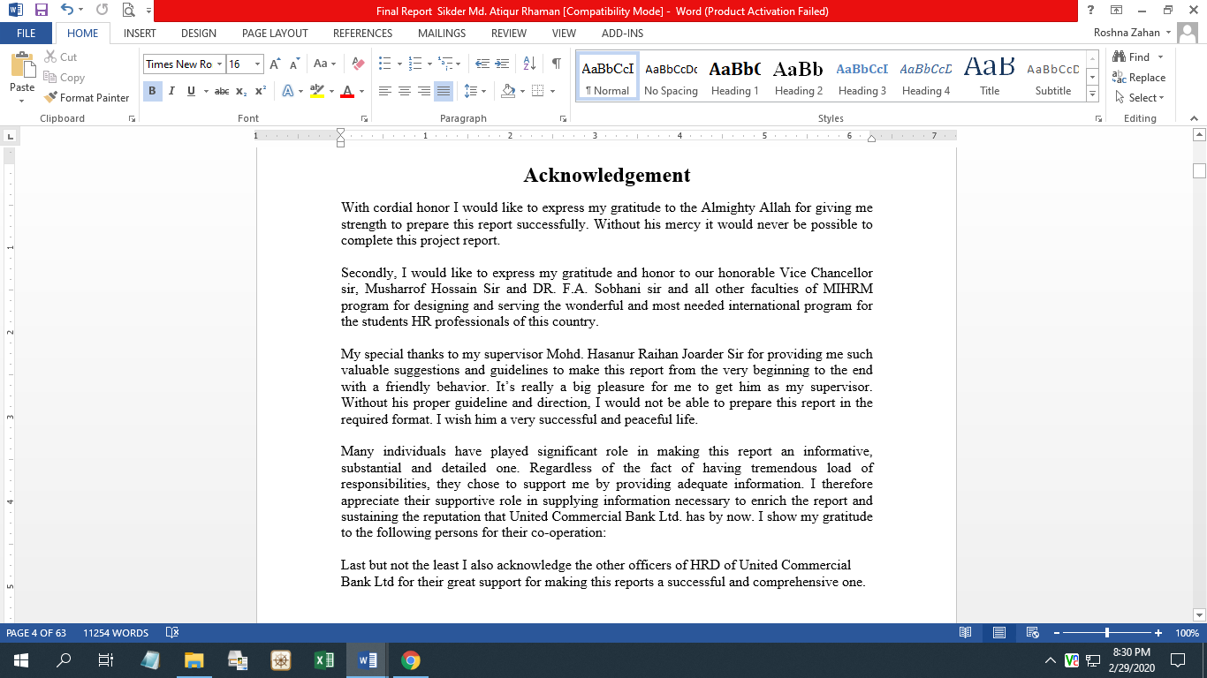

Executive Summery

United Commercial Bank Ltd (UCBL) is one of the largest banks in Bangladesh. In Bangladesh it has successful financial turnover. In this report mainly deal with Human Resource division and Human Resource Information System.
Based on my knowledge & practical experience I have made this report. I have surveyed questionnaire among 7 people who are directly associated with HRD. I have prepared my report based on information & data supplied by human resource department of united Commercial Bank Ltd. I have also personally tried to collect information regarding this particular topic. I have tried to use various source like internet, field data, and questionnaire.
The banking system plays a critical role in underpinning economic development. Against the background of Financial Sector Reform Policy in Bangladesh here United Commercial Bank Limited (UCBL) is one of the first generation private sectors Banks in Bangladesh, commenced its commercial operations from mid-1983 and has since been able to establish one of the largest networks of 139 branches in seven different Divisions. The bank has 4500 employees in all over the branches. So they have many employees as well as they have so many positions or designations to serve the banking work to the customers. To maintain the huge amount of employees, they have HR department in their Head office. United Commercial Bank Ltd. offers all kinds of Commercial Corporate and Personal Banking services covering all segments of society within the framework of Banking Company Act and rules and regulations laid down by our central bank. Diversification of products and services include Corporate Banking, Retail Banking and Consumer Banking right from industry to agriculture, and real state to software.
This report includes how HRD works by using HRIS, what are the possible divisions and work distribution in an HRD, how HRIS effect on recruitment process, training and development initiatives, compensation and benefits planning, personal appraisal management. United Commercial Bank Limited, since its inception, has placed equal emphasis on all the four key functions of the process of HRM-acquisition, development, motivation and retention.
An effective HRIS provides information on just about anything the UCBL needs to track and analyze about their employees, former employees, and applicants. UCBL selects a Human Resources Information System and customize it to meet their needs.

Table of Contents
Points | Particulars | Page Number
 | Students Declaration | 1
 | Letter of Transmittal | 2
 | Acknowledgement | 3
 | Executive Summery | 4
 | Chapter-1  Introduction & Organizational overview | 7-19
1.1 | Introduction & Profile of the Organization | 8-10
1.2 | Corporate Culture | 12
1.3 | Basic Functions | 12
1.4 | Organization Hierarchy | 13
1.5 | Commercial Governance | 14
1.6 | Corporate Social Responsibility (CSR) | 14-15
1.7 | Divisions of United Commercial Bank Limited | 15-19
1.8 | Products and Services of UCBL | 19
 | Chapter-2  Literature Review | 20-30
2.1 | Rationale of the Study | 21
2.2 | Statement of the Problem | 21
2.3 | Scope & Delimitation of the Study | 22
2.4 | Objectives of the Study | 23
2.5 | Methodology of the Study | 23
2.6 | HRMD of UCBL | 24-25
2.7 | Division of HR | 25
2.8 | Organogram of HRD | 26
2.9 | HR Function | 26-30
 | Chapter-3  HRIS of United Commercial Bank Ltd (UCBL) | 31-41
3.1 | Human Resource Information System of UCBL | 32-33
3.2 | Reasons to use an HRIS | 33
3.3 | ERP features of HRIS | 34-41

 | Chapter-4  Findings & Analysis | 42-48
4.1 | Analysis and Interpretation of the Data | 43-46
4.2 | Findings | 47-48
 | Chapter: 5  Conclusion and Recommendation | 49-62
5.1 | Recommendations | 50
5.2 | Conclusions | 51
5.3 | References | 52-53
5.4 | Appendix | 54-62

Chapter: 1
Introduction
&
Organizational overview

1.1 Introduction & Profile of the Organization
United Commercial Bank Limited (UCBL) is a Bangladesh based financial institution that provides banking services. The services include personal and business banking, loans, credit cards, online banking and money transfer services. The bank primarily operates in Bangladesh, where it is headquartered in Dhaka. They have added 139 branches with 21 Authorized Dealer (AD) branches with their name. They have total online banking facilities along with no charge in the local transactions. They have Automated Teller Machine (ATM) Booth in all over Bangladesh. But they also have the contract with all other renowned bank to use their booths in all over Bangladesh by the UCBL customers.
With its strong duty to the monetary improvement of the nation, the Bank has just made an unmistakable imprint in the domain of Private Sector Banking through customized administration, imaginative practices, dynamic methodology and proficient Management. The Bank, expecting to assume a main job in the monetary exercises of the nation, is immovably occupied with the advancement of exchange, business and industry exhaustive an imaginative credit arrangement.
United Commercial Bank Limited was intertwined as an open compelled Bank on 26 June 1983 under the Companies Act 1994. The bank got approval to start business with sway from 26 June 1983 and started banking assignments on 29 June 1983 with an endorsed capital of Tk 100 million confined into 1 million ordinary bits of Tk 100 each. The settled up capital was Tk 35.5 million. A short time later, both endorsed and settled up capital were extended a couple of times and on 31 December 2000, they stayed at Tk 1,000 million and Tk 230.16 million independently. Of the total settled up capital, Tk 101.56 million were settled up by 37 benefactors; Tk 114.54 million by 3,048 people from standard financial specialists and the remaining Tk 14.06 million were purchased in by the organization of the People's Republic of Bangladesh. Hold resources of the bank included statutory spares and general stores of Tk 334.78 million out of 1999 as against Tk 85.88 million out of 1990.
The bank is recorded with Dhaka and Chittagong Stock Exchanges. The organization of the bank is consigned in a 20-section administering body with the regulating official as the CEO. The bank does all sort of business banking works out. On 31 December 2000, the benefits of the bank were regarded at Tk 15,919.7 million and the awry sheet things signified at Tk 19,906.1 million. Full scale stores of the bank meant Tk 12,158.2 million which included venture supports stores Tk 3,988.21 million, fixed stores Tk 2,925.7 million, current stores Tk 1,654.5 million and other chance records Tk 3,589.8 million. Financing cost offered by the bank on the various types of stores changed between 7.5%and 10%. Credits and advances made by the bank up to the reference date totaled Tk 9,443.9 million.
These included medium, long stretch and working capital advances to tremendous, medium and little scope present day units, housing, charge and import financing, and credit to trade and exchange. Advancing rates moved some place in the scope of 10% and 16.5%. Of its total advances and advances, 33.79% was named per advance portrayal rule in power in the country. Adventures of the bank other than advancing at the completion of December 2000 were Tk 2,655.14 million which included traditional bits of associations Tk 52.25 million, debenture Tk 87.63 million, prize bonds Tk 5.26 million, 5% 3-years T&T Bonds Tk 50 million, 5% 3-years Biman Bond Tk 50 million, government Treasury Bills Tk 1,160 million, and Grameen Bank Bond Tk 150 million. Outside exchange business of the bank was kept to convey changing and import financing and the entirety during the year 1999 totaled Tk 19,768 million that included admission upgrading Tk 5,616 million and import financing Tk 14,151 million.
The bank has journalist associations with 130 outside banks and budgetary foundations. The bank has an immense measure of its total advances and advances as late that transformed into non-performing credits. These were characterized and the obligatory provisioning for them from its benefits influenced the gaining limit of the bank's advantages, which thus diminished its productivity.
Corporate Slogan: happy banking

Corporate Logo:
Corporate Information:
Name of the Organization | United Commercial Bank Limited
Status | Public Limited Bank
Date of Incorporation | 2nd June, 1983
Chairman | Mr. Mr. M. A. Hashem
Managing Director | Mr. Mr. Muhammed Ali
Authorized Capital | Tk. 2200 million
Paid up Capital | Tk. 760.16 million
Total Branches | 139
Proposed Branches | 16
Deposits | 45000 million
Investment | 4900 million
Total Employees | 3400 Person
Corporate Office | 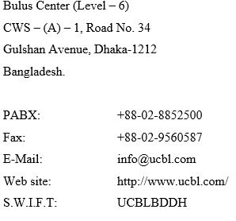

Banks’ Mission, Vision and Values:
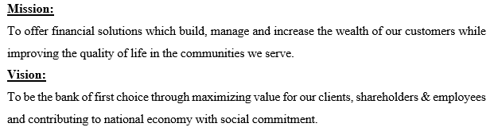

Values:
- Placing the interests of clients and customers first
- Giving more emphasize on professional ethics
- Believe in being a responsible corporate citizen
- We sat what we believe in
- We foster participative management
- A continuous quest for quality in everything the company does
- Treating everyone with respect and dignity
- Conduct that reflects the highest standards of integrity
- Teamwork from the smallest unit to the enterprise as a whole
Professionalism

Growth
Diversity
Values

Accountability
Dignity

Integrity

1.2 Corporate Culture

The bank has in its administration a mix of profoundly talented and famous brokers of the nation of fluctuated understanding and ability effectively drove by Mr. Muhammed Ali a unique broker, as its overseeing chief and knowledgeable youthful, lively and committed officials working with preacher energy for the development of the organization. The consideration as of now of the bank is to turn into a most restrained manage an account with unmistakable corporate culture. In UCBL we have confidence in shared importance, shared understanding shared sense making. Our kin see and get occasions, exercises, items and circumstance. In an unmistakable manner we can suit the motivation behind the bank and the requirements of the worker.

  - Basic Functions
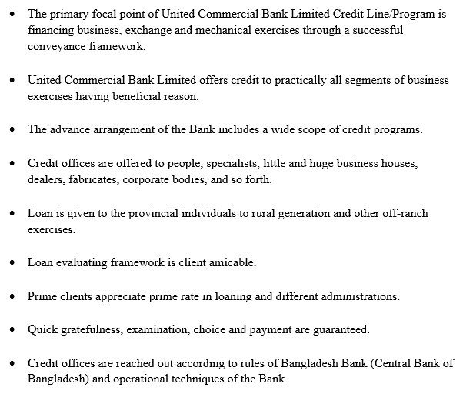

  - Organization Hierarchy:

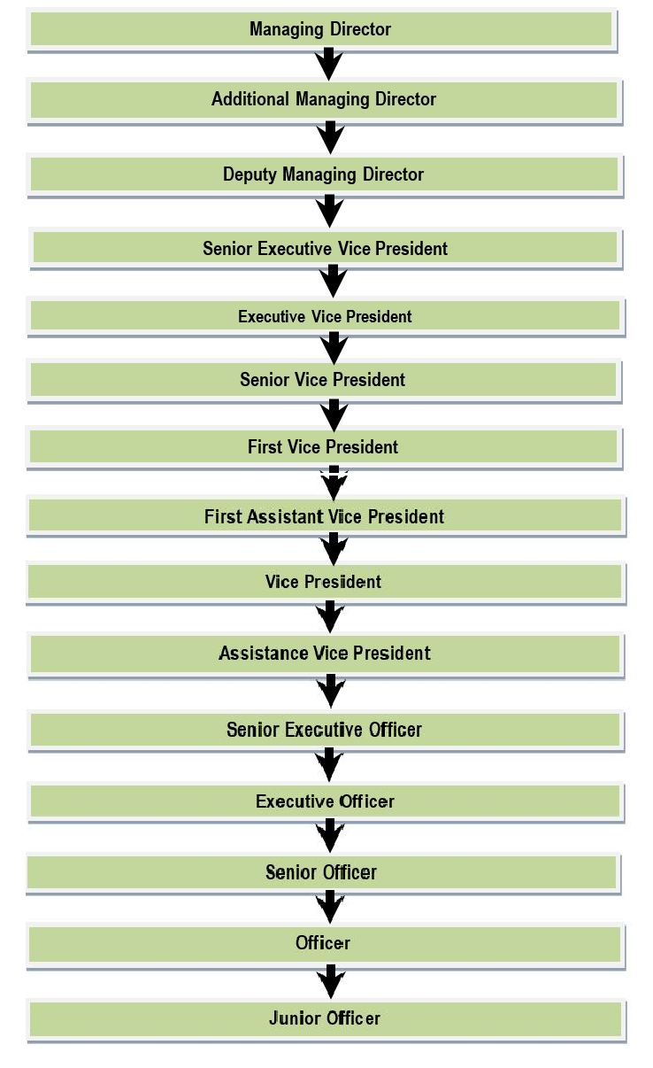

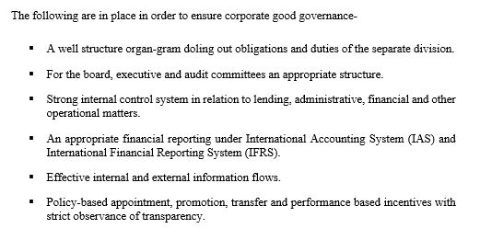
  - Commercial Governance:

1.6 Corporate Social Responsibility (CSR):

For the Clients:
" To fulfill the extraordinary needs of our clients by offering security to their trust, give development and adaptability in conveyed administration that makes an incentive for their business in this way upgrading their business achievement and, thus, our own. To take due consideration and persistence in guaranteeing that administrative standards are not ruptured in stretching out assistance to clients and different constituents."

For the Shareholders:
“ Safeguard shareholders’ investment and to create and add economic value. ”

For the Employees:
" To perceive that representatives are our most noteworthy resource and to guarantee that they have a sheltered and favorable workplace with evenhanded and serious terms and states of administration. The Bank advances a culture of trust, and the improvement and best of human ability and asset."

For the Community:
" To be a capable corporate resident and lead business in a way that advances practical improvement for both UCBL and the network it serves. This includes full consistence with neighborhood laws and administrative specialists, and giving due thought to social, social and natural effect in every single business choice."

1.7 Divisions of United Commercial Bank Limited:
- Internal Compliance and Control:
The principle capacity of this division is to give lawful help to the branches and execute recuperation methodology for stood up credit and to guarantee severe adherence of rules and approaches by completely associated of the bank through daily schedule and shock investigation and review. Screen the individual cases concerning their protections, estimation of protections lastly survey of probability of recuperation of banks stood up arranged credit.

- H R Division:
The employees of United Commercial Bank Limited are the most important resource for the bank. Having able and proficient representatives is getting progressively significant in the present serious world, and UCBL has a huge upper hand right now. A considerable lot of its representatives have worked here from the earliest starting point of the bank and in this way have immense involvement with their particular field. Likewise the new representatives are enrolled with high scholarly foundation and given legitimate preparing after enlistment to prepare up for their duties. All parts of the representatives took care of by the Human Resource Division. HR division is capable principally for enlistment, Development, Rewarding and Benefits of the staffs. The statement of purpose of HR division is "we will guarantee the gifted jobs where we will work with fun and pride"
- Board Division:
The company secretary works in Board Division. They run the organization properly and take decision.

- Share Division:
Customer approves Limited to share, part, trade with all data identified with the subtleties and exchange the past of the Customers to its banks related organizations/credit authorities/offices/support in any media transmission or electronic payment system as might be legally necessary, standard practice, credit detailing, measurable investigation and credit scoring, check or hazard the board and will not hold Limited at risk for use or exposure of this data.

- Finance and Accounts Division:
The main objectives of Finance Division are:
- Retain treasury bills, debentures, daily call money, placement of fund, liquidity positions etc.
- Monthly-accrued interest valuation of all interest bearing accounts, amortization of all fixed and other assets and inter branch assessment.
- Preparation profit and loss account & the statement of accounts for the Bank.
- Cost of fund breakdown
- Fulfilling the reportage requests of Bangladesh Bank.
- Maintenance of Provident Fund, income and expenses posting accounts, salaries, etc.

- Credit Risk Management:
The Credit Risk Management Department is helped by the Credit Division which is for the most part worry with the post-endorsement elements of the division. Obligations and duties of Credit Division are excessively centered on documentation, sitting the breaking point of framework, checking and dispensing of credit items.
- Retail Banking:
UCBL offer two kinds of loan under retail banking, these are:
- Unsecured Loan
- Secured Loan
The Unsecured loans are:
  - Auto Loan
  - Easy Loan (For Executives)
  - Gold Grace - Jewelry Loan.
  - House/Office Furnishing/Renovation Loan
  - Staff Loan
  - Education Loan
Personal Loan
Secured The loans are:
  - Personal Loan
  - Personal Overdraft

- Corporate Banking Division:
At United Commercial Bank gives total scope of answers for meet Corporate Customers prerequisite. UCBL Corporate Banking arrangements incorporate a board range of items and administrations sponsored by demonstrated, current advances. UCBL master terms offer a complete help giving account to huge and medium-sized organizations situated in Bangladesh. Here advance sum is more than 1 corer.
- Information Technology Department:
The technique at Information Technology (It) is to give creative, coordinated arrangements and administrations that set us apart as the main application programming and administrations supplier to the money related administrations and human services enterprises.
- Investment Banking Division:
They generally introduced four types of Investment Banking Services.
- Merchant Banking Wing  - Custodial Service | - Brokerage Service  - Future Products

- SME Banking:
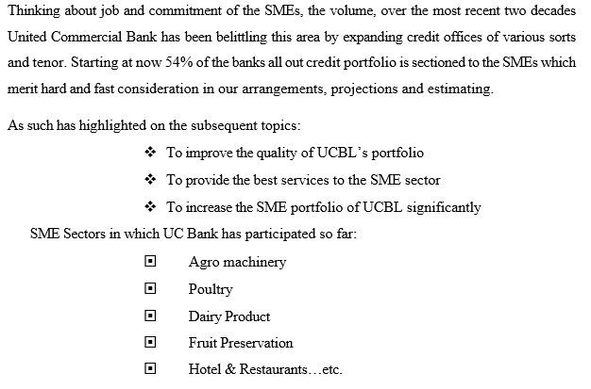

- Card Division:
In the present-day setting of banking business on the planet, Card is the eventual fate of any bank. Electronic installment framework is presently controlling the world and a few days from now money exchanges framework will transform into a history discovered uniquely in the content book. Joined Commercial Bank Limited is one of the main original private part business saves money with Branch Network everywhere throughout the nation. The Bank began giving VISA Credit Cards additionally also it have credit and debit card section.

- General Banking Division:
General Banking is the starting point of all the banking operating. General Banking department aids in taking deposits and simultaneously provides some ancillaries services. It provides those customers who come frequently and those customers who come one time in banking for enjoying ancillary services.

- International Division:
Universal Division implies buy and offer of uninhibitedly convertible outside monetary forms as acceptable under Exchange Control Regulation of the nation. The exchange of the approved vendor in remote trade includes either outward or internal settlements of outside trade starting with one nation then onto the next. As an approved seller the Local Office Branch of UCBL gives its client remote settlement by FBC, LEBC, deal, and acquisition of FTT, FDD, travel's check, FBP. The Bank gives the outside settlement offices to the understudy concentrating on board. Bank additionally gives remote trade looking like explorer's checks to the planning guests.

1.8 Products and Services of UCBL:
The Bank provides a broad range of financial services to its customers and corporate clients. The Products and Services UCBL offers are:
- UCB Multi-Millionaire  - UCB Money Maximizer  - UCB Earning Plus  - UCB DPS Plus  - Western Union Money Transfer  - SMS banking Service  - Online Service  - Credit Card  - One Stop Service  - Time Deposit Scheme  - Monthly Savings Scheme  - Deposit Insurance Scheme  - Inward & Outward Remittances  - Travelers Cheques | - Import Finance  - Export Finance  - Working Capital Finance  - Loan Syndication  - Underwriting and Bridge Financing  - Trade Finance  - Industrial Finance  - Foreign Currency Deposit A/C  - NFCD ( Non Resident Foreign Currency Deposit Account )  - RFCD ( Resident Foreign Currency Deposit Account )  - Consumer Credit Scheme  - Locker Service

Chapter 2

Literature Review
2.1 Rationale of the Study:
Today, professionals in the Human Resources area are important elements in the success of any organization. Their jobs require a new level of sophistication that is unprecedented in Human Resource management. Not surprisingly, their status in the organization has also been elevated. Even the name has changed. UCBL has a well decorated computer based HRM Division. UCBL implement the HRIS in their bank. The Human Resources Information System provides details on administration, payroll, recruitment, and training. This system is expected to deliver valuable results to Human Resources division and organization as a whole. It is an essential tool that aids management in making strategic decisions. HRIS all in all essentially improves data sharing and correspondence between the organization and the representatives. HRIS made it simple for the HR division to easily work all segments. With the exact and target following of pay and advantages, representatives' resolve and inspiration increments. The Human Resource Information System decreases cost and time spent on manual information solidification. It permits the HR the board directors to concentrate more on settling on choices and ventures instead of administrative work.

2.2 Statement of the Problem:
Bangladesh is a democratic country with a presence of an uncountable number of both private and government corporations working in numerous business sectors in the form of large, small or medium companies. But sometimes lack of proper treatment of human is hampering the organization. HRIS is a system where UCBL can get proper information of every single employee. UCBL used it as their search engine to find information about a employee. They first keep information in file then posting it on system. They improve the system by automatically update employee retirement date, succession plan, leave date and other task. UCBL use HRIS as their search engine to find out the file. HRIS is not the final decision until the file has the same information. If there is a mistake in data entry it wills supper the whole procedure.

2.3 Scope & Delimitation of the Study:
Scope:
This report covers the UCBL .HRIS. How they generate it and how they implement the HRIS in their HR Division. In HRIS include Employee personal info data base. In employee personal info data base contents Name, Family info, Gender, Join date, Designation, Contact address, Education qualification, Birth date, Salary info, Career (Promotion, Transfer, Separation type).
To give this input in HRIS UCBL can get output like Employee of a particular branch, Employee for retirement, Employee for transfer, Employee for promotion, Employee Career status, Employee Salary process, Designation wise/ Gender wise/ Age wise / Location wise report. In this report also covers UCBL’s management & organizational structure, HR functions performed by UCBL. To prepare this report I talk with the employee of HRD about HRIS on the job time.

Delimitations:
- Time shortage is a big constrains because it is very difficult to prepare report and concentrate on official work by doing regular 10am to 6pm office.
- Due to conservatism in sharing data due to high information Security of the organization, any statistical data or other relevant data cannot be included since survey is quite restricted.
- Confidential data will be difficult to collect because of their secrecy that is not revealed.
- Certain market complaints data are approximate figures due to the company privacy policy.
- Adequate books, distributions, raw numbers are not accessible. This tighten limited the extent of exact investigation if this impediments were not been there, the report would have been progressively valuable and appealing.
- The accuracy level of the collected Primary data is not confirmed.
- Lack of enough cooperation due to high workload.

2.4 Objectives of the Study:

Broad Objective:
To discover the factual settings of how the HR division is conducted HRIS within the organization which affects the work activities and long term success of the business and their practices for the organization based on Human Resource management system.

Specific Objectives:
- To collect complete knowledge on overall banking functions of UCBL
- To identify the weakness and problem in successful/effective information management system.
- To understand the need and objective of Human Resource Information System
- To have an idea of the existing systems of HRIS practiced in UCBL.
- To evaluate the existing HRIS system effectiveness.
- To give some recommendation to improve the HRIS system.

2.5 Methodology of the Study:
The primary data has been collected from face to face interview, and the secondary data has been collected from their annual reports and from web sites.
The main source of data was secondary though primary data sources were also utilized.

Primary Sources:
- Personal observation of the HRIS process.
- Informal interview with the HR specialist.
Secondary sources:
- Relevant journals, newspapers, books etc.
- Periodic reports.
- Published official papers.
- Office circular.

2.6 HRMD of UCBL:
HR development & the Executives has been demonstrated as one of the most basic parts of accomplishing authoritative adequacy. Human Resource Management (HRM) is worried about the 'individual’s measurement in the executives'. Joined Commercial Bank Limited, since its origin, has set equivalent accentuation on all the four key elements of the procedure of HRM-securing, advancement, inspiration and maintenance. The different projects embraced by the UCBL to enhance the nature of human asset are principally planned for expanding proficient information and ability levels of representatives through preparing and advancement, so as to frame a well-prepared work power for offering brilliant types of assistance to the clients.

Additionally, top official of the Bank are often send to another country for empowering them to know the capacities and instruments of monetary, cash and security market of the created nations and furthermore to investigating business openings. Quit a large numbers of managers and officers of the Bank have so far been trained at Bangladesh Institute of Bank Management (BIBM), Bangladesh Bank Training Academy (BBTA) etc. covering divers areas of the financial system including commercial banking as carefully selected are principally concentrated around core banking issues like credit management, international trade, treasury management, audit and inspection, loan review & monitoring and project management.

Different Kinds of Employees:
United Commercial Bank Limited has in various representative's criteria. There are various sorts of representatives working in better places inside United Commercial Bank. Types of employees are-
- Full time / Regular
- HR Contractual
- Management Trainee Officer (MTO)
- Outsource Staff
- Intern
Regular/ Full time employee:
In full time class, workers are joined as trial for a half year or one year relying upon work classification. They likewise need to sign a deed for a long time. The standard workers are permitted to get the extra, impetuses and different recompenses with their fundamental pay rates.

HR Contractual:
Contractual employees are taken for specific period like six months basis. They accomplish their objective which controlled by association. HR impermanent agreement are for those classes whose Job depiction is such, where he/she should be under the immediate supervision of Bank's position, whose presentation is checked by the Bank Management.

Management Trainee Officer (MTO):
The Management Trainee Officers are fixed employee of the bank but they have to study as a student inside United Commercial Bank for the period of a year. After a year if they can finish their learning period fruitfully then they will become an Executive officer promoted from MTO.

Outsource employees:
Other legally binding representatives are not entitled for any assistance understanding. They will be enrolled through redistribute organizations. The necessity of any care staff through re-appropriate office must come through HR marked by the Division Head.

Intern students / employees:
To empower and help human asset improvement in the monetary business the Bank may choose to offer entry level position projects to people or instructive organizations. The choice to enter such a commitment will be chosen by the MD&CEO on the suggestion of the Department Head.

2.7 Division of HR:
In United Commercial Bank HRD is divided in two parts. They divided their work according to their own policy. To complete work earlier and get an efficient output from the employees they divided HRD in Two parts:
  - HR Development (Human Resource information system, training, Recruitment)
  - HR Operation

2.8 Organogram of HRD:

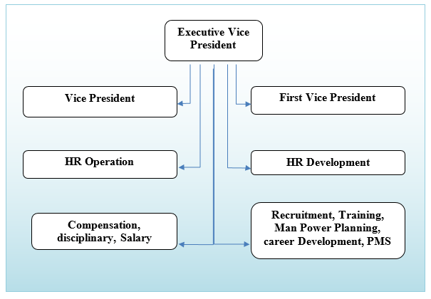
2.9 HR Function:
The presentation of the HR work is estimated generally regarding representative and consumer loyalty input measurements. Budgetary pointers, for example, rate of return for HR exercises are additionally methodically utilized over the organizations, however are all around perceived as a restricted proportion of useful viability. The foundation of the HR work is progressively for HR administrators to have had line understanding. For getting best output United Commercial Bank has a planned work outline. The H R Department now has some different wings. These are:

- Recruitment  - Training & Development  - Compensation Benefits  - Organization & Development | - HR Administration  - Man Power Planning  - Performance Management System  - Career Development  - Disciplinary

Job Requirement Analysis

For powerful enlistment and choice HR faculty of United Commercial Bank jobs necessity examination from the outset. In which post they need what number of employee(s), what ought to be capability of that employee(s), in which time they need the employee(s), for country branch or outside of Dhaka branches from where they need to select employee(s) and so on. Without this necessity examination an association can't remunerate successfully and productively.

Recruitment

Enlistment alludes to procedure of discovering ideal individuals for the correct activity or capacity, for the most part embrace by Human Resource Department. Distinctive employment required various abilities. In this way, appropriateness for an occupation is commonly evaluated by searching for aptitudes, for example relational abilities, PC aptitudes. Proof for abilities required for a vocation might be given as capabilities (instructive or proficient), involvement with work requiring the applicable aptitudes or the declaration of references.
There are two main recruitment methodologies employed by banks presently:-
- In-house Recruitment: This embroils filling vacancies through in-house means from current employees.
- External Recruitment: To meet requests and opening from outside sources for ability brought almost by development, want for new thoughts or to supplant representatives who take off, banks intermittently turn to the exterior labor advertise.

The most popular external recruitment sources are:-
- Job consultants
- Campus Placement
- Online Application
- Recruitment advertising
- Referrals
Training Needs Analysis (TNA)
Training needs analysis (TNA) could be an orderly strategy for deciding what caused execution to be less than anticipated or required. The center of preparing is execution advancement. A TNA is critical since it makes a difference to decide whether a lack can be redressed through preparing.

Training Methods:
When the association has chosen to prepare workers and have distinguished their preparation needs and objectives, the association needs to configuration fitting preparing program. The most common training methods using by the organization are-
- On the Job Training: The most broadly utilized preparing strategies happen at work. The ubiquity of this technique can be credited to their effortlessness and the feeling that they are less expensive to work. Hands on preparing places the representatives in real work circumstances and causes them to give off an impression of being right away.
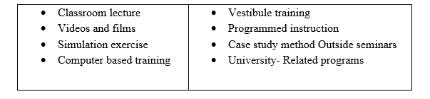
- Off the job: This training includes a number of methods –

HR Development
The preparation work, presently prominently called HR development. Worker advancement, by configuration is increasingly future situated and more focused with instruction than representative occupation – explicit preparing. Advancement in this manner, concentrates more on the representative's staff development.

Performance Appraisal System
Despite the fact that regularly downplayed or even denied, assessment is a genuine and significant goal of execution evaluation. Be that as it may, the need to assess (i.e., to pass judgment) is additionally a continuous wellspring of pressure, since evaluative and formative needs appear to every now and again conflict. However at its most fundamental level, execution examination is the way toward looking at and assessing the presentation of a person. The key goal of Performance Appraisal System is to pass judgment on the exhibition of a worker against the objectives set ahead of time. This is a chance to survey the exhibition of a representative with the end goal of remunerating him/her as additionally to set a restorative instrument to comprehend the help required and formative needs the worker needs to arrive at the objectives.

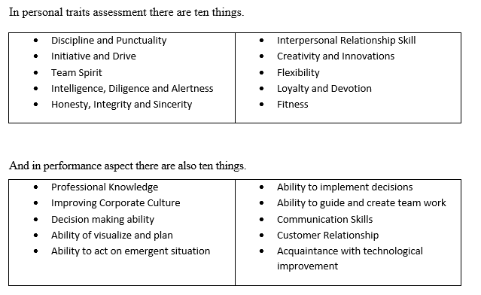

Compensation and Benefits

- Compensation: Workers pay alludes to all types of pay or rewards going to representative and emerging from their business, and it has two principle parts. There are immediate money related installments as wages, compensations, motivating forces, commissions, and reward and there are circuitous installment as budgetary advantages like business paid protection and excursions.
- Benefits: Advantages incorporate compulsory insurance programs, pay for time not worked, and discretionary assurance programs, private retirement plans and a wide assortment of different administrations.

Working Hours & Attendance:
- The Bank will have 5-day full working day. From Sunday to Thursday, the office time is 10:00. am to 6:00. pm with an break of 30 minutes for lunch and prayer.
- Employees are required to sign their attendance register by 9.30 a.m. however there will be grace period of 30 minutes. If any employee needs to come to the office late hours, he /she must get permission from Head of respective division/branch with specific reasons on previous day or in the morning of the day of occurrence.
- The worker will be checked missing on the off chance that he/she has not marked in the participation register. If there should be an occurrence of nonappearance, worker will be at risk for disciplinary activity.
- In the event that any representative needs to move out of the workplace in any capacity whatsoever aside from during lunch hours, he is required to get earlier endorsement from his/her prompt supervisor.

Provident Fund: The Managing Director shall cause to be established and maintain in the Bank a Provident Fund Account (hereafter called the Fund) by contributions to be made partly by the members and partly by the Bank in accordance with the provisions of the rules made by the Bank.

Welfare Fund: The intention behind beginning the welfare fund is to be able to provide the steady confirmed employees from JO to SPO with economic support for incidents or events when the cost may not be reasonable for the employees.

Termination: The Bank may terminate the service of an employee or call upon him to resign from the service of the Bank without assigning any reason. In either case he/she shall be entitled to notice in writing or salary in lieu thereof for the period of:
- 90 days in case of confirmed employees.
- 30 days in case of temporary employees, employees on probation and probationary Officers.
- Over and above the notice or salary in lieu thereof, such employees shall be entitled to other benefits as may be admissible under the law for the time being in force.

Chapter: 3
HRIS of United Commercial Bank Ltd (UCBL)

  - Human Resource Information System of UCBL

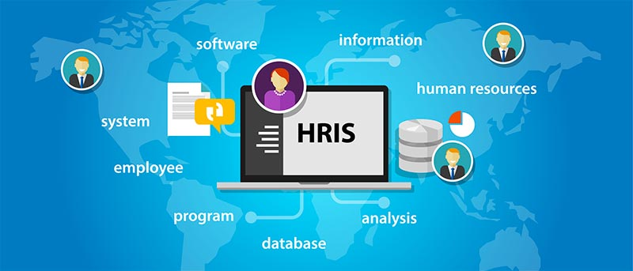

The Human Resource Information System (HRIS) is a software or online solution for the data entry, data tracking, and data information needs of the Human Resources, payroll, management, and accounting functions within a business. Normally packaged as a data base, hundreds of companies sell some form of HRIS and every HRIS has different capabilities.
An effective HRIS provides information on just about anything the UCBL needs to track and analyze about their employees, former employees, and applicants. UCBL selects a Human Resources Information System and customize it to meet their needs.
With an appropriate HRIS, Human Resources staff enables employees to do their own benefits updates and address changes, thus freeing HR staff for more strategic functions. Additionally, data necessary for employee management, knowledge development, career growth and development, and equal treatment is facilitated. Finally, managers can access the information they need to legally, ethically, and effectively support the success of their reporting employees.

Typically, the better The Human Resource Information Systems (HRIS) provide overall:
- Management of all employee information.
- Reporting and analysis of employee information.
- Company-related documents such as employee handbooks, emergency evacuation procedures, and safety guidelines.
- Benefits administration including enrollment, status changes, and personal information updating.
- Complete integration with payroll and other company financial software and accounting systems.
- Applicant tracking and resume management.

The HRIS that most effectively serves companies tracks:
- Attendance and PTO use,
- Pay raises and history,
- Pay grades and positions held,
- Performance development plans,
- Training received,
- Disciplinary action received,
- Personal employee information, and occasionally,
- Management and key employee succession plans,
- High potential employee identification, and
- Applicant tracking, interviewing, and selection.

3.2 Reasons to use an HRIS
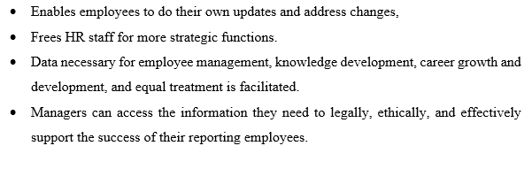

3.3 ERP features of HRIS
Office Organizer: In office organizer include the personal services where employee can get the basic thing of their need. The duty and responsibility of the employee are written there.
Personal Services: In personal service include To Do, Task Manager, Wallet Manager, Profit updates, my templates, Requisition, Personal Information Display.
Human Capital Management: Human Capital Management helps organizations analyze workforce strengths and vulnerabilities, while surfacing opportunities and strategies that allow business leaders to proactively manage human capital. By providing a holistic view of your work force, the solution gives you the consistent and accurate answers needed for strategic decision making. In this part include recruitment, personal directory, time attendance, leave management, payroll, welfare fund, final settlement, disciplinary action, appraisal management, succession planning and training management. Most of the task of HRIS which used UCBL in their HR activities are from Human Capital Management.
Recruitment: Recruitment is the process of searching for and attracting an adequate number of qualified job candidate, from whom the organization may select the most appropriate to field its staff needs. The process begins when the need to fill a position is identified and it ends with the receipt of résumés and completed application forms. The result is a pool of qualified job seekers from which the individual best matching the job requirements can be selected.
Job Reason Setup:
In this portion job openings are identified through human resource planning or manager request. Why UCBL need to recruit its clearly written here.
(a) Requisition:
Recruitment Requisition workflow is to be used to request that a position be posted to the UCBL Board of Directors. In order for a position to be filled, this recruitment workflow must be completed. This action can be set up to go through departmental approvals but the final approval must be made by the HR Representative before being posted.

(b)Requisition Approval:
Once your requisition has been entered into HRIS, it then needs approval from the appropriate people in department of Human Resources. The approval process begins in HRIS. To get your requisition approved, to initiate the approval process by opening the requisition in HRIS and clicking "Edit Requisition.". In the "Job Status" field, choose "Pending Approval" from the drop down menu. This is a simple step-by-step procedure how to approve a request to recruit. When board of directors of UCBL thing they want to recruit some people in a particular position. They asked to the HR division is this position suitable to proceed or not. In approval part HR approve and written the cause why they need it.

(c)Requisition Allocation:
To communicate to HR departments the process for establishing new budgeted positions, reallocating existing vacancies to a different classification and requesting recruitment activity to fill budgeted, allocated positions. This policy applies to all HR departments who establish allocated positions within their budget. The Position Allocation and Job Requisition process provides for the establishment and monitoring of approved positions and budgeted funds through coordinated efforts of the Department of HR and the Division of the Finance Department. Recruitment activity may commence only after positions are allocated and funded with Budget approval. This includes positions in the allocated position listing including all regular full time, regular part time, job share and limited term positions.

Notice:
To know every one that HR going to recruit for a particular position written in the notice of recruitment portion.

Candidate Search:
In candidate search part HR sort-out the list of the candidate who fulfill the requirement for a position.

Resume Management System:
United Commercial Bank Ltd. use a software name Resume Management System. They ask people to apply on online. When people registered on online they get a tracking number. By using this software automatically get information of the candidate fill up on online. By using RMS UCBL mail the sort listed candidate for interview. This software have auto generated system to give the update of the condition of the total recruitment.

Joining Confirmation:
This last part of recruitment procedure. In that portion added that candidate name who finally selected. By this all other user of HRIS knows about the selected candidate which helps them to further procedure.

Personal Directory:
Personal directory is the important part of the HRIS. In UCBL personal directory is more usable. HR division use HRIS personal directory as search engine for an employee. It includes all employees, former employees, and representatives of employees contents of their personnel file with advance notice to Human Resources staff. Documents that relate to the employee's qualifications for hire such as the application, promotion, disciplinary action, and transfer are viewed. By using personal directory HR staff can easily know the update of the employee. It’s a mirror of an employee for HR division.

Personal Info:
This core part of HRIS maintains all relevant employee related information, including different types of personal information, detailed qualifications and work experience, job related information, basic payroll, etc. Picture of employee is included as well. Information captured in this module is utilized by all other modules, thus eliminating data redundancy.

Features include:
- Personal information (Date of birth, SSN, nationality, ethnic race etc.)  - Color picture  - Contact details  - Emergency Contact(s)  - Dependents  - Nominee  - Immigration details (Passport & Visa info)  - Job information  - Payment details (Pay Grade & Salary) | - Employee reporting structure (Assign Supervisor)  - Work Experience  - National ID  - Education details  - Skills  - Confirmation Date  - Assign Languages  - Attachments
Transfer/ Adjustment: In transfer and adjustment segment of HRIs include new posting of the employee and their previous posts. Which branch employee is transfer and from when effective for their new office are written here. To make sure that system knows about the present situation of the employee. In this part UCBL HR easily identify from where one employee transfer.
Increment: In personal directory UCBL HR include the increment information of the employee. By using HRIS HR staff easily knows the increment situation of the employee. How many increment they got on which day.
Promotion: In promotion part of HRIS input the information of promotion. Including last promotion of the employee. By using HRIS change the employee’s present rank to new rank. Also include new payment scale.

Power of Attorney: In every branch one or two employee get power of attorney who can give the legal authority of any decision. They are the authorities’ person to signature in any legal paper. Basically branch manager, operational manger and senior officer get the power of attorney. In HRIS mention the list of the power of attorney. When someone signature as power of attorney UCBL HR staff match with list.

Time Attendance: Attendance include manage incident based and regular time off, track accrual pay and all attendance plans; create reports easily. The module powers time tracking related processes. The presented functionality enhances the UCBL’s performance by eliminating paperwork and manual processes associated with time and attendance needs. The sophisticated module helps to efficiently organize labor data, improve the workforce management and minimize errors in enforcement of UCBL’s attendance policies.

Features:
- Define organization's customers and projects.
- Create time sheets.
- Administration and management of your own and your subordinates' time sheets.

In time attendance include Time & Shift, Roster Policy, Employee Roster Policy, Roster Process, Monitoring & Approval, Attendance Summery, Fault Attendance, Manual Attendance Register, and Roster Status.
Leave Management: UCBL HR has a thorough leave the executives module, with broad potential outcomes of characterizing leave types and the sky is the limit from there. It cooks for all application and endorsement forms and can show data on leave privilege, balance, history and so on. Because of the web-empowered and self-administration ideas, it fundamentally streamlines all leave related strategies, wipes out desk work and spares costs.
Features:
- Define Leave Types
- View Leave Summary of all employees in one screen
- Define Days-off (weekends and specific holidays)
- Apply for and assign continuous leave
- Receive auto notification e-mails after performing leave related operations.

UCBL HRIS include Policies, Application, Approval, Direct Apply and Approval, Leave Summery Leave Time Reference, Leave open, Manual Leave Register, Maternity Leave Process.
Payroll: It automates the entire payroll process by gathering and updating employee payroll data on a regular basis including employee attendance, calculating various deductions and taxes on salaries, generating automatic periodic paychecks and handling employee tax reports. Finance utilizations in Pay by any payroll interval, Daily, Weekly, Biweekly, Semimonthly, Monthly, Quarterly, Semiannually or Miscellaneous, Import Employee data , Import timecard data Create Eligibility Controls , Check User Balances, Automatic expense calculations, User modifiable Tax Tables, Exemption on representative's government and common returns, Additional administrative and state retaining , Earnings including quarter-to-date, year-to-date, and client characterized period , Employee protection premium/Worker's remuneration/Other retention by quarter-to-date, year-to-date, and client characterized periods, Creates tweaked and combined reports, Supports different State and City Tax Tables, Unlimited Payroll Employee accounts, Create numerous organization accounts ,Create separate compensation represents Hourly, Salaried, Commissioned and non-representative contractors .

Features:
- Payroll processing, pay slips, salary statements
- Complete handling of PF / ESI / PT / IT (TDS)
- PF / ESI challenges & reports
- Loans & reimbursements
- Payroll arrears calculations
- Powerful full & final settlement module
- Extensive payroll reports
- Electronic bank transfer files for faster salary disbursement
- Excel import and export of payroll information
- Special features for large enterprises: batch processing, multi-user, multi-company, digital signatures, fine-grained security and more.

Welfare Fund: Welfare includes anything that is done for the comfort and improvement of employees and is provided over and above the wages.UCBL provide welfare in housing schemes, medical benefits, and education and recreation facilities for employee families help in raising their standards of living.
In HRIS include nature of welfare, chart of accounts, period, bank information, general statement, financial statement, contribution ledger, profit distribution, loan issue, final settlement.
Provident Fund: Provident fund is a fund that provides benefits to the employees of a company upon termination of their employment. Both the employees and the employer are required to make contributions to the fund in accordance with the predetermined rates.
In HRIS chart of accounts, period, bank information, general statement, financial statement, loan policy, accounts voucher, profit distribution, loan issue, contribution ledger, provident fund apply, provident fund approve. Welfare fund and provident fund procedure is more or less same in HRIS software.

Final Settlement: Employees Full & Final settlement can be prepared based on resignation of employees either in the current month or in the previous month. Automatically calculates outstanding loan balances, Notice pay and leave encashment, gratuity and recovers all loan balances and income tax. In UCBL when an employee submit resignation its duty to the HR to clean up his all liability and fulfill the other financial or other activities which related with UCBL. HRIS include final settle rule and final settle statement.

Disciplinary Management: Discipline management is a process for dealing with job-related behavior that does not meet expected and communicated performance standards. The primary purpose for discipline is to assist the employee to understand that a performance problem or opportunity for improvement exists. In general, discipline should be restricted to the issuing of letters of warning, letters of suspensions, or actual termination. Employers should refrain from “disciplining” employees by such methods as altering work schedules, assigning an employee to do unpleasant work, or denying vacation requests. In UCBL disciplinary management include, warning, increment held, suspension, show cause.

Appraisal Management: Performance management eliminates the performance appraisal or annual review and evaluation as the focus and concentrates instead on the entire spectrum of performance management and improvement strategies. These include employee performance improvement, performance development, training, cross-training, challenging assignments, 360 degree feedback and regular performance feedback.
The performance appraisal is also included in the personnel file and is referred to in regard to salary increases, transfers, promotions or any other change in employment status. Should one’s overall performance indicate that one is not meeting expected levels, one will not be eligible for a salary increase for the current review. Subsequent increases will depend on whether the employee’s performance improves to expected levels. As a way of monitoring performance and assisting an employee in his/her job, the UCBL uses an appraisal system. Once the employee has been working in the Bank for over a year, then he/she will be appraised once a year on July 1st of the following year. UCBL has a policy to evaluate employee performance by Annual Confidential Report (ACR) is the evaluation report on the work performance and personal skills. In a ACR report there will be the basic information like employee’s personnel information, period of evaluation start to end, remarks (if any), rate name etc. This evaluation based on four liker scale (Below average 1, average 2, good 3, very good 4 and outstanding.
In UCBL head of HR doing this confidential work himself with the help of HRIS specialist. To evaluate the performance need employee others information which available in HRIS. In HRIS include question setup, form setup, create assignment, final refines of performance appraisal.

Training Management: Training managers oversee development of training programs, contracts, and budgets. They may perform needs assessments of the types of training needed, determine the best means of delivering training, and create the content. To United Commercial Bank Ltd. spending in training programs for employees is not an expense, but an investment. Each and every permanent employee must have 30 days of training. There are many methods of training, but in the banks of Bangladesh two methods are commonly used, lecture and on-the-job training. Many institute and banks like BIBM, IBA, ICSB, SEDF (South Asia enterprise development facility) World Bank, Asian Development Bank, Bangladesh Bank, Citi Bank etc. arrange varies kind of training. United Commercial have its own training institute FTC (Foundation training courses) also this bank arranged many type of training in its corporate office and other banks employees can contribute these trainings.
In HRIS for training management include Training Setup, Training Institute, Training Information, Training Schedule, and Training Participation. Training management software automates the entire training management process.

Chapter: 4
Findings & Analysis

4.1Analysis and Interpretation of the Data
Employees of UCBL are aware about Human Resource Information System (HRIS). I went to 6 employees of United Commercial Bank Ltd. about the existence of the HRIS software.
Analysis- After analyzing the first question, it can be said 100% employee under HR department knows about the existence of the HRIS software in the company.

Training for using HRIS:
UCBL provide training how to use HRIS software. In conversation I talk with 6 employees that did they get any sort of training on using HRIS.

All the 100% employees get the training on HRIS. It’s important to give training. For proper implementation of HRIS training must.

Type of Training:
UCBL provide different training program on HRIS such as classroom training, online training, on the job training, off the job training. In 6 employees, 83.5% of them are getting On the job training and rest 16.67% get classroom training.

HRIS Feature:
In UCBL HR division try to make HRIS features more usable. When asking about HRIS features employee give mixed feedback.
66.68% employees think that HRIS features are fully documented, but 33.34% of them are thinking that it is not fully documented.

Performance of HRIS software:
Employee talk about the overall service of the HRIS software they used. Employee used HRIS more or less but all are need this.
About 66.68% of them are satisfied to use the HRIS software but 33.34% of them are dissatisfied. UCBL need to make HRIS more updated and usable.

Personal Directory of Employee:
Personal directory include employee personal information, contact information, transfer info. This is the most usable part of HRIS.
100% employees think that personal directory is effective for HR. It is used for a search engine to HR staff.

Time Attendance:
UCBL want to strictly follow the time attendance system of HRIS. It is help HR to track the employee when they entry and leave. How many days one employee absent it s automatically identify by time attendance system. 66.68% of them say that time attendance system is not updated and 33.34of them say its okay. UCBL need to upgrade the time attendance management in HRIS.
Leave Management:
Leave management is a continuous process. Employee takes leave in different purpose. HRIS help leave management by providing information about the employees leave balance. Out of 6, 66.68% employee think there is no problem using HRIS in leave management. But 33.34% of them think it will be more updated. Sometimes it quiet difficult to use.
Payroll management:
For payroll management UCBL use HRIS. There is an automatic setup in payroll option. To fill up the employee information, then select the salary grade and click on the payroll setup button. It automatically set the employees designation wise payroll.
Out of 6, 83.35% employees think that the present software of HRIS is not enough. 16.67% employee it’s quiet enough. So need to upgrade the system for payroll management.
Performance Appraisal:
UCBL performance appraisal based on performance every year employee makes.
Out of 6 employees, 83.35% of them think HRIS not effective for performance Appraisal management and rest 16.67% of them think it is quiet effective in current system.
Welfare Fund:
To find how many employees used HRIS for welfare Fund management. Out of 6, 50% employee directly used the welfare Fund in HRIS, and 50% of them not using it.
Final Settlement:
To find out how many employees use HRIS for final settlement. It is a critical work in HR.
Out of 6 employees, 83.35% of them are not using HRIS for final settlement and only 16.67% employee doing this. in HRIS.

Succession Planning:
For succession planning UCBL did not doing it in HRIS. Employee has no idea about it. About 100% employees not use HRIS in succession planning. Software has feature on succession planning but UCBL HR did not use it.

4.2 Findings:
To work at United Commercial Bank Ltd. as a intern. I saw that they use the HRIS in their HR division. But some of the part of HRIS they not use. In my findings I found some problem they face in HRIS which is discusses below.
Succession Planning:
United Commercial Bank Ltd. followed the all HR function in their organization. They also have some succession planning. But in their HRIS software there is no succession planning. By using HRIS, there is no way to do succession planning. As internee at UCBL I see that they doing their succession planning by recruiting MTO. But in ERP software no activities on succession planning.
Time Attendance:
In time attendance include Time & Shift, Roster Policy, Employee Roster Policy, Roster Process, Monitoring & Approval, Attendance Summery, Fault Attendance, Manual Attendance Register, and Roster Status. But in ERP software of UCBL there is no such thing they use. UCBL need to upgrade the system in terms of time Attendance.
Payroll Management:
In UCBL HRIS payroll management part is not decorated. There is a limitation of work in HRIS for payroll. Mostly payroll management is done manually. If they input properly in HRIS get quick information about payroll. UCBL not use fully payroll management in HRIS.
Leave Management:
United Commercial Bank Ltd. doing their leave management manually. They take little help from HRIS to search the designation of the employee, Leave balance, file number. But they not do full procedure by HRIS. In HRIS they include name who allow getting the leave.

Welfare Fund:

Welfare includes anything that is done for the comfort and improvement of employees and is provided over and above the wages.. UCBL manually doing welfare fund Management. By using HRIS they only provide the notice. There is a full option in ERP software but they doing it in paper document.

Final settlement:

In final settlement HRIS use only to know info about employee joining date. Others work they do in manual paper.

Appraisal Management:

Performance management eliminates the performance appraisal or annual review and evaluation as the focus and concentrates instead on the entire spectrum of performance management and improvement strategies. UCBL use a modern software but them doing their performance appraisal in manually. They follow the traditional method of evaluation by the paper and previous year’s performance record in personal file.

Transfer Management:

Although they have access in transfer management but they using a small part of HRIS to do transfer. Check only the changing designation, previous posting, new posting. And other doing by paper based form.

Chapter: 5

Conclusion and Recommendation

5.1 Recommendations:
UCBL should concern with the above factors. To through my research on UCBL HRIS I have some recommendation for those findings.

For Succession Planning, at first they must know about the importance of succession planning .If they doing it through HRIS it will make the work easier. If UCBL input the data of employee in a way that employee’s age wise they easily know who when retired. They setup a reminder which shown that who will retired after 3 months. If this activity doing properly then HR staff have opportunity to prepare one who can replace that employee.

For Time Attendance, UCBL HR implements a system where an employee entry directly connects with HRIS. Automatically count the attendance as well as in performance appraisal sheet. They active of the task of Roster Policy, Employee Roster Policy, Roster Process, Monitoring & Approval, Attendance Summery, Fault Attendance, Manual Attendance Register, and Roster Status.

For Payroll Management, UCBL HR should fill up the portion of HRIS software. After that system automatically update the payroll feature.

For Welfare Management, UCBL should doing the welfare fund in HRIS. It is reducing their time. They put the information of employee who are apply for getting welfare. They should follow the welfare fund Apply, Welfare fund approve, Welfare Benefit part.

For Final Settlement, UCBL should apply the HRIS ERP software feature such as Final settle Rule, Final Settle Statement.

For Appraisal Management, UCBL should apply the HRIS feature, Question Setup, Form Setup, Create Assignment, Assignment and Final Refine.

5.2 Conclusions:
United Commercial Bank Limited is probably the best bank as far as total assets with 16 branches and 3220 workers. The crucial the bank is to effectively take an interest in the financial improvement of the country by working a monetarily stable financial association. The HR division of United Commercial Bank Limited assumes an essential job in holding its representative's presentation and mental piece. Consistently new workers are enlisted and chose. The enrollment and choice procedure is very reasonable and powerful. To improve the authoritative execution it is essential to give formal preparing remuneration by which the representatives can fulfill themselves, and make openings where each worker can take an interest. To a degree it is imperative to choose the correct sort of representative for increment authoritative execution, however the greatness of straightforwardness and quality United Commercial Bank Limited applies in its worker determination process renders it adequate to just proceed with the present practice.

UCBL one of the leading private bank in Bangladesh who use HRIS software in their organization. UCBL is a progressive bank can face problem to keeping track of their huge human resources requirements. Even a relatively small workforce can present a number of logistical problems, particularly when it comes to the administration of things like benefits, sick leave, promotions and so on. Thankfully, technology has provided a potential answer: HRIS, or Human Resources Information Systems. HRIS packages provide businesses with a means by which they can keep track of their human resources needs, and fulfill those needs in a cost- and time-efficient manner. HRIS systems are, in essence, large databases. Depending on the size and nature of the organization, HRIS system might consist of a single database or a number of interconnected ones. These databases will store basic employee information (such as personal details, company role, salary etc), as well as information regarding benefits administration, payroll and an almost limitless range of other aspects of human resources. To improves UCBL information sharing and communication between the company and the employees. HRIS made it easy for the human resources department to smoothly operate all components.

5.3 References:

Books:

- Calculating return on investment for HRIS – by Roberts, B. (1999), Vol. 86, No.2, pp. 356–366.
- HRIS: A review and model development” – by Milton Mayfield, Jacky Mayfield and Steve Lunce (2003)Vol.33,No. 2, pp. 249-264.
- Human resource information systems: a review and empirical analysis – by Ngai, E.W.T. and Wat F.K.T. (2006) Vol. 90, No. 1, pp. 144–152.
- D. Gray, (2006). Human Resource Management (eastern economy10th ed.). New Delli,ND: Prentice-Hall of India Private Limited. Fundamentals of Human Resource Management by David A. Decenzo & Stephen P. Robbins.(Seven Edition ), Willy, 2002, ISBN: 0471397857, 9780471397854.

Human Resource Information System, (Basics, Applications, and Future Directions) by Michael J. Kavanagh & Mohan Thite. (Second Edition), SAGA Publication Inc, USA Library of congress. ISBN: 9781412991667

Journals:

- Ball, K. S. (2001). The use of human resource information systems: A survey. Personnel Review, Vol. 30 No. 6, pp. 677-693.
- Haines, V.Y., & Petit, A. (1997). Conditions for successful human resource information systems. Human Resource Management, Vol. 36 No. 2, pp.261-275
- Lengnick-Hall, M. L., & Moritz, S. (2003). The impact of e-HR on the human resource management function. Journal of Labor Research, Vol. 24 No. 3, pp.365-379.
- Journal of Human Resource and Sustainability Studies
Vol.2 No.2(2014), Article ID:46129,7 pages.
- Beadles, N. A., Lowery C. M., and Johns K. (2005). The Impact of Human Resource Information System: an Explorartory Study in Public Sector. Communications of IIMA, pp. 39-46.
- Beckers, A. M., Bsat, M. Z. (2002). A DSS classification model for research in human resource information systems. Information Systems Management, 19(3), pp. 41-50.
- Broderick R., Boudreau J. W. (1992). Human Resource Management, Information Technology and The Competitive Advantage, Academy of Management Executive, 6 (2), 1992, 7–17.
- Burbach, R. and Dundon, T. (2005). The Strategic Potential of Human Resource Information Systems: Evidence From the Republic of Ireland. Intentional Employment Relations Review, 11(1\2), pp. 97-117.
- Cedar (2009). Human resources self-service survey. Baltimore: Cedar Inc. Dessler G., Griffiths J., and Lloyd-Walker B. (2004), Human Resources Management, 2nd ed. Frenchs Forest, New South Wales: Pearson Education Australia, pp. 97–99.

Websites:
The official website of United Commercial Bank Ltd. : http://www.ucbl.com/

Others:
- Annual report, 2012 & 2013 of UCBL.
- Promotion policies of UCBL
- HRIS Software Guidebook.
- Human Resource Manual of United Commercial Bank Limited
- Different types of products of United Commercial Bank limited i.e. Leaflets, Brochures, also some measurement forms etc.
- Companies different Journal

5.4 Appendix:
QUESTIONNAIRE for the study of HRIS implementation in UCBL
Name of the Employee: ________________________________________
Designation of the Employee: ___________________________________
Experience In HR: _______________

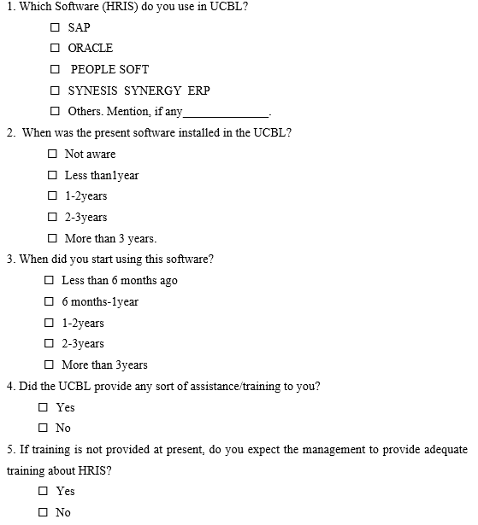
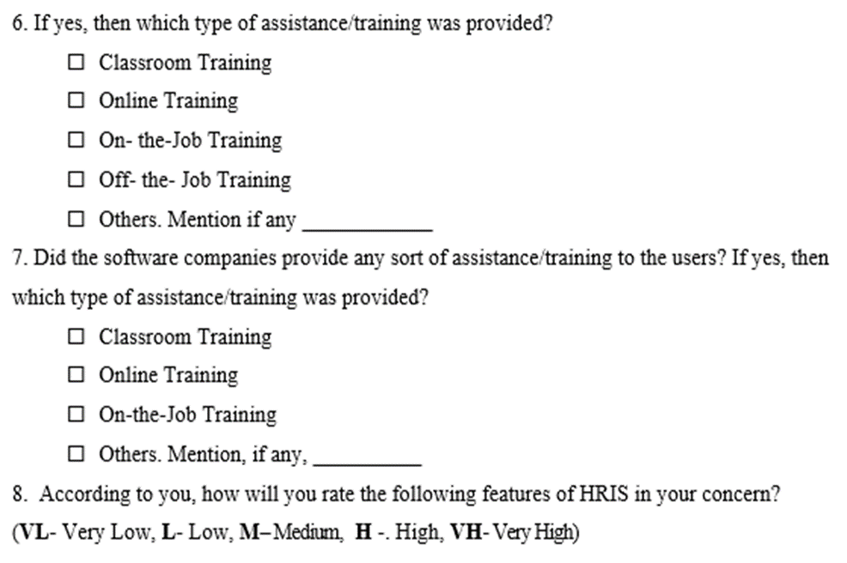
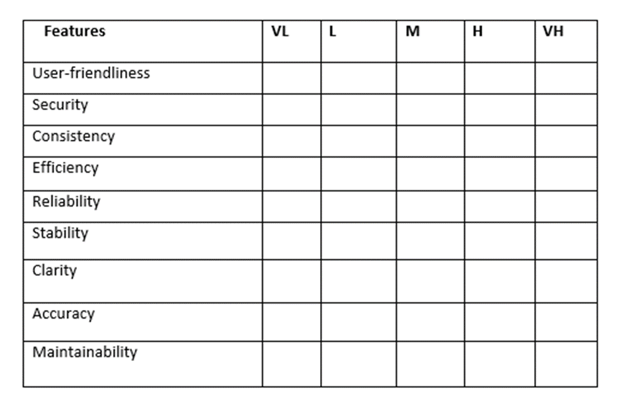

9. What is the role played by HRIS in your organization for work and decision making?
- More routine operational level use
- More medium level decision making or policy determination role
- Strategic use of HRIS for long-term planning
10. Are all the features and utilities of HRIS fully documented?
- Yes
- No
11. Is HRIS integrated with all functions of HR department?
- Yes
- No
12. How would you rate the overall service of the HRIS?
- Satisfied
- Highly Satisfied
- Neither
- Dissatisfied
- Highly Dissatisfied
13. Do you think HRIS effective for Recruitment?
- Yes
- No
14. Do you think HRIS is effective for update the Personal directory of Employee?
- Yes
- No
15. Are you satisfied to maintain the Time attendance by HRIS?
- Yes
- No
16. Is there any problem to using HRIS for Leave management?
- Yes
- No
17. Do you think that the present software of HRIS is enough for Payroll management?
- Yes
- No
18. Do you think HRIS is effective for Provident fund management?
- Yes
- No
19. Are you use the HRIS for welfare fund?
- Yes
- No
20. Are you doing the Final settlement by using HRIS?
- Yes
- No
21. Is HRIS effective to take Disciplinary action?
- Yes
- No
22. Did you get any advantages of HRIS for Appraisal management?
- Yes
- No
23. Do you think HRIS is effective for Training management?
- Yes
- No
24. Do you use Succession Planning in HRIS?
- Yes
- No

HRIS features of ERP (software)

Office organizer | Personal Services | - To Do  - Task Manager  - Wallet Manager  - Profit update  - My Templates  - Requisition  - Personal Information Display
Office organizer | Corporate Services | - Office Notice  - Office Directory  - E- Library  - Meeting Manager  - Activity Management  - Requisition Approval
Office organizer | Communication | - Company  - Contact  - Notice Viewer
Human Capital Management | HR Configuration | - Configuration
Human Capital Management | Recruitment | - Job Reason Setup  - Requisition  - Requisition Approval  - Requisition Allocation  - Notice  - Candidate Search  - Interview  - Candidate Selection  - Joining Confirmation
Human Capital Management | Personal Directory | - Job Group  - Organogram  - Resume  - Personal Info  - Transfer/ Adjustment  - Increment  - Promotion  - Power of Attorney  - Bills  - Bills payment
Human Capital Management | Time Attendance | - Time & Shift  - Roster Policy  - Employee Roster Policy  - Roster Process  - Monitoring & Approval  - Attendance Summery  - Fault Attendance  - Manual Attendance Register  - Roster Status
Human Capital Management | Leave Management | - Policies  - Application  - Approval  - Direct Apply and Approval  - Leave Summery Leave Time Reference  - Leave open  - Manual Leave Register  - Maternity Leave Process
Human Capital Management | Payroll | - Rules Setup  - Employee Wise Payment  - Salary Formula Setup  - Loan/ Advance  - Assignment OT  - Special Allowance/ Dedication  - Salary Process  - Salary Adjustment  - Pay Salary  - Manual Salary Entry
Human Capital Management | Provident Fund | - Nature  - Chart of Accounts  - Configuration  - Period  - Bank Information  - General Statement  - Financial Statement  - Loan Policy  - Accounts Voucher  - Un posted Voucher  - Contribution Ledger  - Profit Distribution  - Loan Issue  - Accounts Voucher  - Un posted Voucher  - Contribution Ledger  - Profit Distribution  - Loan Issue  - Final Settlement  - Contribution  - Distribution  - Provident Fund Apply  - Provident Fund Approve
Human Capital Management | Welfare Fund | - Nature  - Chart of Accounts  - Configuration  - Period  - Bank Information  - General Statement  - Financial Statement  - Loan Policy  - Accounts Voucher  - Un posted Voucher  - Contribution Ledger  - Profit Distribution  - Loan Issue  - Final Settlement  - Welfare Fund Apply  - Welfare Fund Approve Fund Approve  - Benefit Rule Setup  - Welfare Benefit
 | Final Settlement | - Final Settle Rule  - Final Settle Statement
 | Disciplinary Management | - Warning  - Increment Held  - Suspension  - Show Cause
 | Appraisal Management | - Question Setup  - Form Setup  - Create Assignment  - Assignment  - Final Refines
 | Training Management | - Training Setup  - Training Institute  - Training Information  - Training Schedule  - Training Participation  - Training Management
 | Succession Planning | - Setup
System Setting | Setting | - Business Unit
Synergy Analytics | Dynamic Report Generation | - Dynamic Report Generation  - Customer Report

