
United International University
Internship Report
on
Effectiveness of AKIJ Food and Beverage Ltd.'s Training & Development Process
Submitted to:
Mohammad Amzad Hossain
Assistant Professor-AIS
School of Business and Economics
United International University
Submitted by:
Syed Mahmud Ali Chowdhury
ID: 114 173 006
United International University

Date of Submission: 12.12.2022

Letter of Transmittal

12th December 2022

Mohammad Amzad Hossain
Assistant Professor-AIS
School of Business & Economics
United International University

Subject: Submission of Internship Report

Dear Sir,
This is to inform you that I, Syed Mahmud Ali Chowdhury, a student at United International University's business school, has successfully completed a four-month internship at Akij Food & Beverage Limited under your direction.
I'm happy to turn in the report you asked me to write about the effectiveness of AFBL's training and development process. I thoroughly researched and studied the assignment given to me before putting them together into this report for my reporting purpose. I tried my level best to prepare this report without any errors, but it was impossible to make any report without any mistakes for which I beg your apology in advance. I'm hoping that you'll consider any errors with kindness.
I would be inspired by your acceptance and any form of gratitude. I welcome your entire questioning and reserve the right to respond.
Sincerely Yours
………………
Syed Mahmud Ali Chowdhury
ID: 114 173 006

Table of Content
Contents
Letter of Transmittal ii
Executive Summary v
Chapter 1 1
Introduction 1
1.1 Human Resource Management 2
1.2 Managerial Functions of HRM 2
1.3 Operational Functions of HRM 3
1.4 Practice in training and development: 4
1.5 Employee Training and Development Techniques 5
1.6 Model of Training Procedure 7
1.7 Training Transfer 9
1.8 Training & Development Service Provided by Akij Food & Beverage Ltd. 10
Chapter 2 11
Organization Background 11
2.1 Company Profile 12
2.2 AFBL's Core Values 12
2.3 AFBL's Mission Statement 13
2.4 Mission Statement of AFBL 13
2.5 Goal 13
2.6 Departments of AFBL 13
2.7 Products and brands owned by AFBL 15
Chapter 3 19
Objectives of the Study 19
3.1 Primary Objective: 20
3.2 Secondary Objectives: 20
Chapter 4 21
Methodology of the Report 21
4.1 Type of Data 22
4.2 Study's Restrictions 22
4.3 Data Collection Process 22
Chapter 5 23
Analysis & Findings 23
5.1 Key Performance Indicator (KPI) 24
5.2 Management (trainer) interview: 25
5.3 Survey of Employees: 27
5.4 Findings: 34
Chapter 6 35
Conclusion and Recommendations 35
6.1 Recommendations: 36
6.2 Conclusion 36
Chapter 7 38
Appendix 38
7.1 References: 39
7.2 Questionnaires Management: 39
7.3 Questionnaires Employees 39

Executive Summary

Training development process, being essential for human resource development process, is gaining its popularity day by day. That’s my report focus on the effectiveness of training program of a reputed organisation of Bangladesh. This report's preparation was primarily focused on Akij Food and Beverage Limited's training and development program. It is very difficult compare the scenario between theory- and practice-based research in terms of the parallels and differences between the studies, the report discovered throughout my internship program. Therefore, the study encountered certain obstacles.
The training and development strategies used by the AFBL are fully covered in this study. The report includes all relevant information regarding training and development process of AFBL. This report is divided into five chapters. The first chapter of this study deals with introduction of the report, objectives for the report, practice and model of training and development program. The second chapter of this study deals with organizational background, mission and vision of the company, company profile. The third chapter of this study deals with methodology of the report, data collection process, types of data. The fourth chapter is about the different types of analysis and findings on survey of employee, KPI and management interview. The fifth chapter discusses the conclusions and recommendations which made after examining the entire report. The sixth chapter of this study deals with appendix and references.
The main findings of the study are as follows: The report discovered that employees are more inclined to participate in training sessions, Employees are satisfied the quality of training programs, AFBL training sessions can meet the gap between employees and job task, The T&D program affecting positively in the annual turnover amount of AFBL.
Some recommendations of the study are: To encourage staff to attend training sessions, AFBL should enhance the number of incentives based on attendance, The training program's quality should receive more attention from AFBL. They ought to appoint more capable outside resource people, AFBL should evaluate their employee by their KPI rather not evaluate by only work experience timing, AFBL can start a reward system for T&D program topper, AFBL must held responsible for their employee for a lower KPI & lower annual turnover.

Chapter 1

Introduction

1.1 Human Resource Management
According to Byars & Rue In order to efficiently manage people at all levels of a company and achieve organizational goals, human resource management is defined as a system of actions and methods.
According to Leon C. Megginson from the perspective of the individual firm, they represent the sum of innate abilities, acquired knowledge, and skills as exemplified in the talents and aptitudes of its employees. However, the knowledge, skills, creative abilities, talents, and aptitudes acquired in the population.
According to Dunn and Stephens All manager line and staff are attracted, retained, and motivated through the HRM process.

1.2 Managerial Functions of HRM
1. Planning: Setting goals and targets for the organization requires careful planning. HR uses strategies and guidelines to carry out those objectives. The main goal of planning is to foresee vacancies, make a list of task requirements, and choose the sources for induction. In order to take into account, the strategic objectives of the company and each job market, the HR supervisor forecasts demand and supply for each job group.
2. Organizing: The next crucial HR component is to expand and develop the corporate structure into a plan. This is among its components:
- Workers are organized into the roles or tasks they will be handling.
- Assign different people to perform certain tasks.
- Assign authority in accordance with the commitments and duties that have been agreed upon.
3. Direction: Through direction, human resources are supported in achieving organizational goals. At this point, the supervisor uses a variety of motivational techniques and cultivates cordial relationships with the workforce. The HR manager of a firm will find this stage to be quite difficult. The HR manager needs to be able to identify personnel needs and solutions. Here, motivation may be a never-ending process since, even if earlier desires are satisfied, new ones may still arise.
4. Controlling: The final managerial function in the cycle is controlling. Go to planning after regaining control of HR. Here, the HR Manager examines the results in light of the standards that were established during the strategy development stage to see whether there are any deviations from the standards. Therefore, any deviation may be fixed in the subsequent cycle.

1.3 Operational Functions of HRM
1. Employment: The main operational component of human resource management is employment. For every section of any firm, the HR supervisor is responsible for carrying out this activity. The HR department works with all of the organization's departments to coordinate the development of manpower policies, rules, and guidelines. Employment includes finding and hiring professionals with critical skills necessary for achieving the organizational objective and objects.
2. Training and Development: Training is a concerted effort made with an employer's support to assist employees in acquiring knowledge about job-related competencies. Training is a key component in HR development. It involves honing a particular ability to a desirable level through practice and instruction. A particularly helpful tool that can put a worker in a situation where they can accomplish their job correctly, effectively, and conscientiously is training. Training is the process of enhancing a workforce's knowledge and abilities to do a certain task.
The learning of KSA is referred to as development, and it is the intended result of the training exercises. Development is the creation of opportunity to support human resource growth.
3. Remuneration and Benefits: To compare with other businesses in the market, a corporation established its compensation and benefits. They work to establish a uniform salary and benefit structure. The following list of compensation and benefits plans:
flexibility in the workday, reimbursement for children's education, dental and medical insurance, extra time off, and maternity and paternity leave.

4. Maintenance: The HR manager must provide their employment security if they want to keep the effective and knowledgeable workers in the company. To work efficiently, the HR department must provide a pleasant work environment.
The HR manager should offer recreational activities at work while making sure they won't interfere with productivity. Transportation options and a canteen should be made available to the staff by the HR manager.
5. Performance Appraisal: The HR department can assess workers based on how they perform at work. The HR manager can use this function to assess a worker's effectiveness within the company and determine whether they need to improve in any other areas. Using this tool, the HR staff creates specific development plans for employees who don't meet the job's minimum standards.
6. Ensuring Legal Compliance: This task is essential for safeguarding the business. Every workplace's human resource department must adhere to all laws and regulations on hours worked, job status, working circumstances, tax advantages, minimum wage, etc. The continued existence of a corporation is very much dependent upon compliance with such laws.

1.4 Practice in training and development:

Training: Training is an intentional effort made by a corporation to help employees learn about job-related competencies. A straightforward idea in human resource development is training. It is concerned with raising a certain ability to a desired quality through practice and education. A worker can be placed in a position where they can accomplish their job accurately, successfully, and conscientiously with the help of training, which is a very helpful tool. Training is the process of improving a worker's knowledge and abilities to perform a certain profession.
Training's main objectives are to help participants build their KSA—knowledge, skill, and apply them in their day-to-day activities.
Development: The learning of KSA is referred to as development, and it is the intended result of the training activities. Development refers to chances made to help employees advance. At work, motivation is no longer just about money. People who work for businesses are looking for more from their work than just employment.

1.5 Employee Training and Development Techniques
On the job training:
With this strategy, unskilled or new employees watch peers or their supervisors perform their duties and seek to mimic the behavior.
Various forms of on-the-job training
- Job rotation: Two types of job rotation-
- Vertical job rotation: Every employee has access to a vertical work position. Vertical job positions are created based on job positions, and duties change from one position to the next.
- Horizontal job rotation: Rotation of jobs horizontally only for exceptional performers. Opportunities exist to improve many skills. Branch manager, as an example, etc.
- Assistant to positions: The employee picks up their daily tasks from the assistant. Such training is offered in Bangladesh by companies like GP and Banglalink.
- Committee Assignment: A group of trainees solves a particular organizational challenge through discussion. This encourages teamwork. For instance, a multi-task/project team or a cross-functional team.
- Internship training: Internships are a widely popular form of on-the-job training. Students majoring in business, engineering, or medicine must take it. Students basically receive this training for a set amount of time, like 3 or 6 months.
Off-the-job instruction: Off-the-job instruction training is carried out in a location specifically designated for training. It might be close to where you work or far from where you work.

Types of off the job instruction:
- Case study method: Any business-related issue is resolved by a trainee under the direction of the HR manager. The case is assessed, and the trainee comes up with all workable options. This method can help a trainee think more analytically and critically.
- Simulation exercises: Under this strategy, the HR supervisor creates a hypothetical circumstance and asks the trainees to respond to it.
Role play: A challenging issue is presented to the trainee during the role-play, and HR instructs them to replicate the role of a certain character in the circumstance. HR captures the entire performance and provides trainees with a chance to evaluate their own work.
Games-Based Training: Students engage in a series of decision-making exercises that let them explore the effects of different tactics on various participants without endangering themselves or the organization. Companies that deal with rules, laws, or technology employ game-based training. Companies like Microsoft, IBM, and others use this training strategy.
Experimental learning: Employees who participate in experiential learning procedures learn how to approach issues and develop long-lasting solutions. Activities included in experiential learning procedures also help to raise the bar for knowledge sharing, which improves everyone's understanding of the material being covered.
- Outdoor training: Outside of the office, training is offered. a modern approach to training.
Practical implementation: Survival training and cross functional team.
Theoretical: Training abroad that is theoretical. The likes of Google, IBM, Intel, etc. offer this kind of training.
- Vestibule training: Technology- or machine-based training. Employers who work with tools and machinery are trained by HR supervisors via vestibule training. The HR supervisor is in charge of providing this training away from the real work area.
- Soft skill development: Soft skills are interpersonal abilities that are ingrained in a person's personality and define how you connect with others at work. For instance, excellent leadership, great communication, forming a team, creating strong habits, etc.

1.6 Model of Training Procedure
ADDIE Model: "ADDIE was established by the Center for Educational Technology at Florida State University for the U.S. Army and then promptly adapted by all the U.S. Armed Forces," claim Branson, Rayner, Cox, Furman, King, Hannum, and Watson. The ADDIE Model has four steps:
Step 1- Analysis phase: Utilizing the analytical step, the organizational gap is found. Current performance gaps include things like a low level of client satisfaction, poor profitability, a high turnover rate, etc. A training need analysis is another name for the analysis step (TNA). TNA does, in fact, gather data on each employee's performance shortcoming. The analysis step is where the performance gap's root causes are found.
TNA Form:
Job Obligations | Required Competencies & Skills | Actual competencies & Skills | Gaps | Recommendation
Head of HR Signature
Supervisor Signature
Employee Signature

Step 2 Drafting Stage: The creation of training objectives is an essential strategy in the design stage. These give guidance on what will be trained and how, respectively. Identifying the organizational restrictions that will be addressed through training is a further step in the design process. The main outcomes of the design process were finally determining the components required in the training program to assist learning and its application back on the work.
Step 3- Development phase: HR develops an instructional plan in the development process using the guidelines from the design phase to achieve the training objectives. The instructional strategy outlines the tactics and aspects that will be used in the training program's order, timing, and overall synthesis to achieve the program's goals. The program improvement priorities are centered on the training objectives, and the design segment's advice establishes the guidelines for what will and won't continue to function. The phase's output consists of everything required to implement the training program.
Step 4- Phase of Implementation: All of the training process's earlier phases come together during the implementation phase. Conducting a pilot program before the training is actually delivered is beneficial. HR can test the training program at this stage and make any necessary adjustments before the training is prepared to go live.
Step 5- Evaluation phase: There are two different evaluation types. Procedure evaluation first determines how well a certain training process accomplished its objectives. Or, to put it another way, did the trainer adhere to the advised training methodology? At the conclusion of training, outcome evaluation is done. The training aim serves as the benchmark in this kind of evaluation of training. Process success depends on a positive outcome judgment. If the result falls short of expectations, the procedure will repeat itself and go back to the analysis step.

Analysis

Design

Development
Implementation

Evaluation

1.7 Training Transfer
We can guarantee learning outcomes by using this kind of instruction. There are three different types of transfer, according to Simons: from existing knowledge to new knowledge, from knowledge to application, and from knowledge to new knowledge. Training transfer is always goal-oriented.
Before and after training performance are the two items we need to compare. Positive performance results following training are referred to as a successful transfer of learning.
Transfer of training factors include the following:
- Characteristics of Trainee: The transfer of instruction is based on the traits of each student.
- Training Design: The organization's character affects the design of the training program.

1.8 Training & Development Service Provided by Akij Food & Beverage Ltd.
- Vertical job rotation
- Horizontal job rotation
- Assistant to positions
- Committee Assignment
- Internship training
- Off-the-job instruction
- Case study method
- Games-Based Training
- Outdoor training
- Soft skill development

Chapter 2

Organization Background

2.1 Company Profile
A $250 million project was launched by the parent company, Akij Group, in 2006 under the name Akij Food & Beverage Ltd. A vast variety of fast-moving consumer goods, including snacks, carbonated beverages, fruit drinks, and other food items, are produced by AFBL for both the domestic and global markets.
Director Sk. Shamim Uddin oversees AFBL. By constantly producing high-quality products with cutting-edge technology and an empowered and motivated workforce, AFBL aims to be a sustainable business that benefits society. Among the various items supplied by AFBL are fruit drinks, soft drinks, molted beverages, drinking water, energy drinks, milk and milk-based products, chips, mango bars, and pickles. AFBL helps the local small and medium-sized farmers through contract farming for milk from Pabna and Rajshahi and mango from Rajshahi and Chapainawabganj.
AFBL has received various awards and certifications throughout the years. It has received the Best Brand Award four times. National and international certifications such as BSTI, HALAL, ISO, and HACCP attest to the company's quality. The best quality food products are created by AFBL using locally produced and imported raw materials, as well as cutting-edge equipment imported from renowned producers like Tetra Pak, Krones, Alfa Laval, and Spa, among others.

2.2 AFBL's Core Values
Integrity: Honesty, Transparency, and Compliance In whatever we do, we are devoted, we take responsibility for our actions, we are honest, we are methodical, and we have a strong work ethic.
Trust & Respect: Mutual Respect and confidence for the chance to develop We are open, upbeat, trustworthy, and reliable, and we respect and trust each other's opinions.
Innovation: First Mover Advantage, Export Opportunities, and Trained Personnel. We influence change, we dominate the market with cutting-edge goods produced by an effective workforce, and we'll explore new markets for our goods.
Customer Focus: Customer-driven means that we put extra effort into giving our customers an enjoyable experience.
Team Work: One AFBL, One Team. We collaborate as a single team to fulfill our vision and objective.

2.3 AFBL's Mission Statement

Being the most recognized and high-quality food and beverage company in Bangladesh.

2.4 Mission Statement of AFBL
- Consistently high-quality goods
- An empowered and motivated employee
- State-of-the-art technology
- The society as a whole benefit

2.5 Goal
To attain market leadership, financial success, responsible business behavior, and sustainable growth.

2.6 Departments of AFBL
Akij Food and Beverage Limited's divisions include:
SL. | Departments of AFBL
1. | Human Resource
2. | Admin
3. | Training and Development
4. | Business Development
5. | Research and Development
6. | Brand
7. | Sales and Trade Marketing
8. | Accounts and Finance
9. | Dairy
10. | Export
11. | Media
12. | Design
13. | IT
14. | Event
15. | Outdoor Management
16. | Corporate Sales
17. | Clemon Sports
18. | MIS

2.7 Products and brands owned by AFBL
Popular brands and products of Akij Food and Beverage Limited:
Category | Company Name | Outlook and Tagline
Soft drinks | ` | 
Soft drinks | Mojo Light | 
Soft drinks | Clemon | 
Soft drinks | Lemu | 
Soft drinks | Soft drinks  Twing | 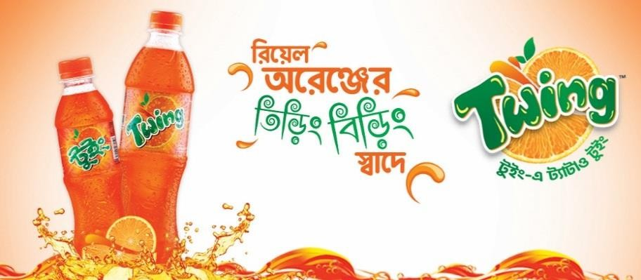
Energy drinks | Speed | 
Energy drinks | Malt Beverage  Wild Brew | 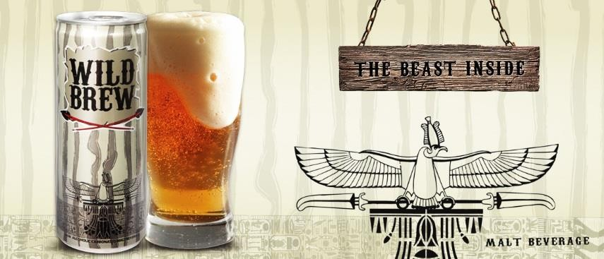
Juice | Frutika | 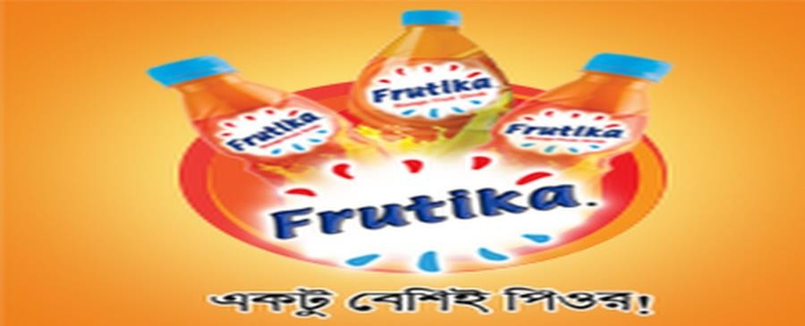
Drinking Water | Spa | 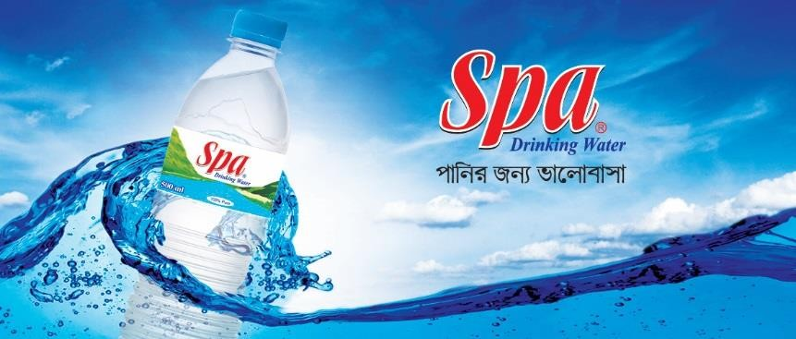
Chips | Cheese Puffs, O’poteto | 
Milk | Farm Fresh UHT  Milk | 

Chapter 3

Objectives of the Study

3.1 Primary Objective:
United International University's BBA program used this report as a partial supplement. Each student must complete an internship program in an organization for a set amount of time to properly complete the BBA degree and gain experience in the business sector. I have been assigned a four-month internship at Akij Food & Beverage in Tejgaon at Akij House to fulfill the criterion. My internship will run from April 10, 2022, to July 31, 2022. The subject of my internship report is "Training and Development Practices of Akij Food & Beverage Limited." I have been given permission to write this report by my supervisor, United International University’s Assistant Professor Mohammad Amzad Hossain.

3.2 Secondary Objectives:
To evaluate the training & development department of the Akij Food & Beverage Limited is the main objective of this study. After reading this complete report, anyone may understand about the "Akij Food & Beverage Limited" training process and how they can further support their employee growth.
- To investigate Akij Food & Beverage Limited's T & D procedures.
- To evaluate how training and development process affects KPIs, turnover rates, of the company.
- To pinpoint the issues with Akij Food & Beverage Limited's training and development methods.
- To offer some suggestions for resolving the issues with Akij Food & Beverage Limited's training and development methods.

Chapter 4

Methodology of the Study

4.1 Type of Data
The study gathered data from both of the following data sources:
Primary Data
- By questioning Akij Food & Beverage Limited staff members.
Secondary Data
- The AFBL website
- Reading of numerous reports, books, and lectures in class.
- The organization's training handbook
- Official documents

4.2 Study's Restrictions
- Due to HR's need for privacy and the rivalry between competing businesses, some information was withheld from me.
- Some employees didn't want to participate in the interview.
- I have some experience limits because I'm a student.

4.3 Data Collection Process
I collect data using a basic random sampling approach, utilizing 11 samples from the management and staff of AFBL, taking into account the entire AFBL's training and development practices are explored utilizing a questioner technique with 20 questions—10 for management and 10 for personnel.
Sample Size: 11
Sampling Technique: Questioner Technique
Area: Akij House
Time: 9AM to 5PM (Office Time), Sunday to Thursday

Chapter 5

Analysis & Findings

5.1 Key Performance Indicator (KPI)
A key performance indicator (KPI) is a quantifiable figure that shows how well a business or employee is accomplishing its main goals. KPIs are used by organizations to assess their progress and success in achieving goals.
AFBL measure their employee’s work performance via KPI. Here is an example of AFBL’s KPI dashboard.
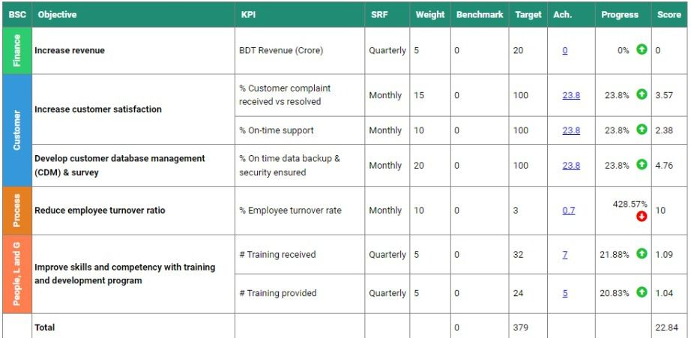
Each employee has their own customized objectives based on job responsibilities. Any score of below 80% add a negative remark to the employee, so all employee has to maintain grater that 80% progress.
According to AFBL HR T&D have a positive impact on employees KPI. AFBL stared their T&D program from 2015 and since then HR team can notice that every employee’s KPI increase after T&D program.
T&D increase employee’s work performance and it’s directly affecting positively in the annual turnover of AFBL. The net revenue for 2014 was 9.4cr BDT, 2015 it was 9.9cr BDT, 2016 it was 10.2cr BDT, 2017 it was 11.3cr BDT and it increased year by year. In last 2021 the annual turnover was almost 14.5cr BDT.
T&D helps an employee to perform well in their job task and when it’s happening then the whole business chain doing well because each employee attaches into the business chain and finally, we can see increasing annual turnover figures as big picture.

5.2 Management (trainer) interview:
- Which training techniques do you employ in your company?
Ans. A variety of combinations of training techniques are used in AFBL depending on the needs and demands of the employee as well as the stylistic preferences.
- How is training need analysis (TNA) carried out in your company?
Ans: TNA is carried out by AFBL through yearly evaluations and online surveys.
In the TNA process, the supervisor chooses the training that their subordinates need, but the subordinate also has the right to choose the training that they need. The candidate for a leadership position has the power to determine their own training requirements.
- What connection exists between the KPI and the AFBL's available/provided training/workshops?
Ans: Training and KPI are related to one another. According to KPI, AFBL offers functional training, such as effective communication and professionalism, to underperformers. For great performers, AFBL offers leadership and team-building training as part of succession planning.
- How do employee compensation packages, business profitability, and turnover rate all relate to training?
Ans. Employees at AFBL receive both functional and soft skill training. Training in soft skills acts as a catalyst, and training in functional skills boosts workforce productivity. Because employees feel motivated when they receive training workshops, training workshops function similarly to indirect pay. Employee motivation helps to improve performance, which in turn serves to raise productivity at AFBL. Profitability increases with increased production. Because motivated employees are more committed and supportive of AFBL, training also aids in lowering the incidence of employee turnover.

- Who in your organization receives training more frequently?
Ans: According to AFBL's requirements, it depends.

- How frequently does your company hold training sessions?
Ans: According to AFBL's requirements, it depends. However, they often don't provide training workshops on the first, last, and eighth days of each month.
- Increases in training program quality and quantity. Do you concur with this assertion?
- Strongly agree
- Agree
- Neutral
- Disagree
- Strongly disagree

- Is the money you spend on training and seminars worth the results you obtain from them?
- Yes
- No
- How is training feedback gathered?
- Online
- Offline
- Meeting in person
- Through a phone call
- All of them

- What are the main obstacles to training and growth in your company?
Ans: The training and development department of AFBL is constantly supported in providing employees with the necessary training they require, but there are certain obstacles as well, such as:
- Time
- Some workers' negative outlook
- The presence of an outside training resource person

5.3 Survey of Employees:
Q1- How many training sessions do you go to annually?
Number of degrees | Less than 10 | 10-20 | 20-40 | 40 to more
Number of opinions | 7 | 4 | 0 | 0
Percentage | 63.64% | 36.36% | 0 | 0

Interpretation: Based on the poll, I may infer that 36.36% of workers attend 10 or more training sessions annually, compared to 63.64% of employees who attend less than 10.

Q 2 - Does your company often hold training sessions?
Number of degrees | Yes | No
Number of opinions | 10 | 1
Percentage | 90.91% | 9.09%

Interpretation: Based on the poll, I can state that 90.91% of workers claimed that AFBL regularly arranges training programs, while just 9.09% of employees answered that they don't.
Q 3 - The amount of time allotted for the training period is:
Number of degrees | Sufficient | To be extended | To be shortened | Manageable
Number of opinions | 5 | 1 | 0 | 5
Percentage | 45.45% | 9.09% | 0 | 45.45%

Interpretation: According to the study, 45.45% of the employees felt that the training period's allotted time was enough and manageable. Only 9.09% of workers believe it should be prolonged.
Q 4 - Your participation at training programs is improving your level of job performance. Do you concur with this assertion?
Number of degrees | Strongly agree | Agree | Neutral | Disagree | Strongly disagree
Number of opinions | 2 | 7 | 1 | 1 | 0
Percentage | 18.18% | 63.64% | 9.09% | 9.09% | 0

Interpretation: According to the poll, 63.64% of AFBL workers agreed, 18.18% strongly agreed, 9.09% were indifferent, and 9% disagreed that attending training sessions had improved their level of job performance.
Q 5 - The resource person has excellent subject matter expertise. Do you concur with the assertion?
Number of degrees | Strongly agree | Agree | Neutral | Disagree | Strongly disagree
Number of opinions | 3 | 4 | 4 | 0 | 0
Percentage | 27.27% | 36.36% | 36.36% | 0 | 0

Interpretation: According to the study, 36.36% of AFBL workers strongly agree with the assertion that the resource person's area of expertise was outstanding, while the remaining 27.27% are neutral.
Q 6 - The facilities for the training program were of the greatest caliber. Do you concur with this assertion?
Number of degrees | Strongly agree | Agree | Neutral | Disagree | Strongly disagree
Number of opinions | 4 | 5 | 0 | 1 | 0
Percentage | 36.36% | 45.45% | 0 | 9.09% | 0

Interpretation: We learned through the poll of AFBL workers that the company's training program facilities met the highest standards of quality since 45.45% of respondents agreed with this statement, 36.36% strongly agreed, and just 9.09% disagreed. That indicates that AFBL offers its staff the greatest facilities.
Q 7 - How would you rank the caliber of the training courses you have taken?
Number of degrees | Poor | Very poor | Average | Good | Very good | Excellent
Number of opinions | 1 | 3 | 0 | 5 | 0 | 1
Percentage | 9.09% | 27.27% | 0 | 45.45% | 0 | 9.09%

Interpretation: According to a poll of AFBL workers, we can tell that the company's training programs are of high quality because 45.45% of respondents rated them as good, and 9.09% as exceptional. Because 27.27% and 9.09% of their employees deem their training programs to be extremely and poor, respectively, AFBL should pay special attention to their training program quality.
Q 8 - What are the most common criticisms of the training session?
Number of degrees | Takes too much time of employees | Too many gaps between employees | Training sessions are unplanned | No complaints at all
Number of opinions | 0 | 1 | 2 | 7
Percentage | 0 | 9.09% | 18.18% | 63.63%

Interpretation: According to the survey, the majority of AFBL employees are happy with their training programs because 63.63% of them have no complaints at all, 18.18% of them have complained that the training sessions are impromptu, and the remaining 9.09% have complained that there are too many gaps between the employees.
Q 9 - Does the training assist to strengthen interactions between employees and employers?
Number of degrees | Yes | No
Number of opinions | 10 | 0
Percentage | 90.91% | 0

Interpretation: All workers, it appears from the AFBL poll, think that training strengthens employee-employer relations.
Q 10 - Was the training course beneficial to your personal development?
Number of degrees | Yes | No
Number of opinions | 9 | 1
Percentage | 81.82% | 9.09%

Interpretation: According to this study, the majority of AFBL workers feel that training programs are useful in their personal improvement since 81.82% of respondents agree and just 9.09% disagree. 9.09%.

5.4 Findings:

- In this entire poll, the report discovered that employees are more inclined to participate in training sessions.
- Employees are satisfied the quality of training programs.
- AFBL training sessions can meet the gap between employees and job task.
- After speaking with the trainer, I learned that employees are joining the training program happily and also ask about their job difficulties so that they can overcome.
- The T&D program affecting positively in the annual turnover amount of AFBL.

Chapter 6

Conclusion and Recommendations

6.1 Recommendations:
- In order to encourage staff to attend training sessions, AFBL should enhance the number of incentives based on attendance.
- The training program's quality should receive more attention from AFBL. They ought to appoint more capable outside resource people.
- In order to revamp their training session, AFBL should contact with an HR consultancy business. Additionally, it will aid in closing the gap between personnel.
- Since AFBL should be supportive in this situation, employees occasionally choose not to participate in training programs due to their schedules. The manager should extend the deadline so that the staff feels free to attend training sessions.
- After every training session, the trainer should administer an assessment to gauge the level of knowledge of each learner as well as the program's efficacy.
- AFBL should evaluate their employee by their KPI rather not evaluate by only work experience timing.
- AFBL must interrogate their employee for a lower KPI & lower annual turnover.
- AFBL can start a reward system for T&D program topper.

6.2 Conclusion
There are several FMCG companies in Bangladesh, and AFBL is important to the country's economy. After satisfying domestic demand, they export their goods to other nations. I was given the opportunity to work as an intern for the T&D Department for some times.
In writing this report, I did my best to adhere to all the instructions provided by my teacher and to identify every step in AFBL's training and development process.
I've learned so much about T&D issues since I joined AFBL as an intern. Due to data limitations, I encountered several issues when preparing this report. Due to the highly private nature of the HR Division's data, I was not permitted to examine all T&D related information. I created this report using my academic expertise, my AFBL job experience, and information easily available online. Because of this, I only utilized a little amount of data to create my report. Although my time spent doing an internship was one of the finest learning experiences of my professional life, I still hope that this experience will help me further my career.

Chapter 7

Appendix

7.1 References:
https://studiousguy.com/human-resource-management/
https://www.akijfood.com/
https://www.yourarticlelibrary.com/human-resource-development/methods-of-training-on-the-job-training-method-and-off-the-job-methods/32369
http://www.whatishumanresource.com/off-the-job-methods

7.2 Questionnaires Management:
- Which training techniques do you employ in your company?
- How is training need analysis (TNA) carried out in your company?
- What connection exists between the KPI and the AFBL's available/provided training/workshops?
- How do employee compensation packages, business profitability, and turnover rate all relate to training?
- Who in your organization receives training more frequently?
- How frequently does your company hold training sessions?
- Increases in training program quality and quantity. Do you concur with this assertion?
- Is the money you spend on training and seminars worth the results you obtain from them?
- How is training feedback gathered?
- What are the main obstacles to training and growth in your company?

7.3 Questionnaires Employees
- How many training sessions do you go to annually?
- Does your company often hold training sessions?
- The amount of time allotted for the training period is:
- Your participation at training programs is improving your level of job performance. Do you concur with this assertion?
- The resource person has excellent subject matter expertise. Do you concur with the assertion?
- The facilities for the training program were of the greatest caliber. Do you concur with this assertion?
- How would you rank the caliber of the training courses you have taken?
- What are the most common criticisms of the training session?
- Does the training assist to strengthen interactions between employees and employers?
- Was the training course beneficial to your personal development?

