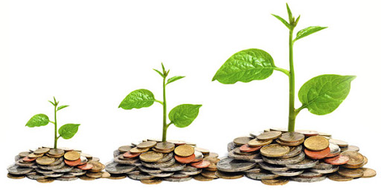
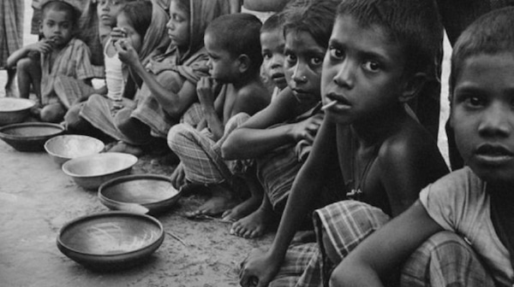
MICRO-CREDIT & NGO:
A MEANS TO ALLEVIATE POVERTY IN BANGLADESH


Project Report on
MICRO-CREDIT & NGO:
A MEANS TO ALLEVIATE POVERTY IN BANGLADESH
Submitted by
Zahid Hossain
114 161 031
BBA in AIS
Submitted to
Lamia Alam
Assistant Professor
School of Business and Economics

Date of Submission: Friday, June 19, 2020

Letter of transmittal
June 19, 2020

Lamia Alam
Assistant Professor – AIS
United International University

Subject: Submission of project report on “Micro-credit & NGO: A means to alleviate poverty in Bangladesh”

Dear Mam,
With due respect, I would like to inform you that, it is a great pleasure for me to present my research report on “Micro-credit & NGO: A means to alleviate poverty in Bangladesh”, under your supervision as a requirement for obtaining my BBA degree from United International University.
I have tried my best to prepare the report with the necessary information and your guidelines. I hope that this report will satisfy you and fulfill your expectations and able to meet your approval. Lastly, I would like to thank you for guiding me and allowing me the opportunity to submit this report.

Sincerely Yours,
Zahid Hossain
114 161 031
BBA in AIS
United International University

Acknowledgment
At first, I would like to show my gratitude and give special thanks to almighty Allah for giving me the opportunity and knowledge to write and complete my project report. I would also like to show my sincerest gratitude to my supervisor Lamia Alam for giving me proper guidelines, necessary suggestions, and excellent support to improve and complete my project report.
I am also grateful to the officials of ASA for providing me the necessary information and thankful to the respondents of the interview whose information has helped me a lot to draw findings and conclude the report.

Abstract
The study is about whether micro-credit facility by NGOs impact the rural poor people of Bangladesh to alleviate poverty. This study is done to examine the role of micro-credit in reducing poverty by giving the poor an access to finance to engage in income-generating activities and improve their living standard. Seven borrowers of micro-credit loans of ASA were selected randomly from Salika Upazila, Kushtia district, Bangladesh as a sample of the study. A qualitative method has been used to analyze and draw conclusions and recommendations from the data gathered through interviewing the borrowers through the telephone. This report tries to cover the role of micro-credit on the daily life of the rural poor people and how it reduces poverty in Bangladesh. Based on the finding and analysis, it is established that micro-credit has a positive impact on the life of the borrowers and it increases their income level, makes them self-employed, their basic needs can be fulfilled and overall their living standard can be improved to reduce poverty, It was also established that if the micro-credit loan is used for an unproductive purpose and personal consumption, then it has a negative impact on the borrower and creates more burden which makes them fall deep in the poverty cycle. Thus proper utilization of the micro-credit loan is required to alleviate poverty in Bangladesh.

Table of Contents
Letter of transmittal i
Acknowledgment ii
Abstract iii
List of Figures vii
List of Tables viii
List of Acronyms ix
Chapter 1: Introduction 2
1.1 Background 2
1.2 Objectives of the study 3
1.3 Scope & limitation of the study 4
1.3.1 Scope of the Study: 4
1.3.2 Limitation of the study: 4
1.4 Organization of the study 5
Chapter 2: Literature Review 7
Chapter 3: Overview of Micro-credit, Poverty & NGO 11
3.1 Concept of Micro-credit 11
3.1.1 History of Micro-credit 11
3.1.2 Defining Criteria of Micro-Credit: 12
3.1.3 Classification of microcredit according to Grameen Bank (GB): 12
3.1.4 Role of Micro-Credit: 13
3.2 Brief History of Bangladesh 14
3.3 Theoretical concept of poverty 16
3.3.1 Classification of Poverty: 18
3.3.2 How Poverty is Measured 20
3.4 Background and definition of NGO 22
3.4.1 Definition: 22
3.4.2 History: 23
3.5 NGOs in Bangladesh 23
3.5.1 Role of NGOs in Bangladesh: 25
3.6 Sustainable Development Goal (SDG) 26
3.6.1 SDG of Bangladesh: 26
3.6.2 Role of NGO in achieving SDG: 28
Chapter 4: NGO and Micro-credit 31
4.1 GrameenBank (GB) 31
4.1.1 Introduction to Grameen Bank (GB): 31
4.1.2 Vision of Grameen Bank: 32
4.1.3 Mission of Grameen Bank: 32
4.1.4 Objective of Grameen Banks: 33
3.1.5 Sixteen (16) Decision of Grameen Bank: 35
4.1.6 Grameen Bank’s Micro-credit 37
4.1.7 Features of Grameencredit: 38
4.2 Brac 39
4.2.1 Introduction to BRAC 39
4.2.2 Vision of BRAC: 40
4.2.3 Mission of BRAC: 40
4.2.4 Objective of BRAC: 40
4.2.5 Values of BRAC 42
4.2.6 BRAC’s Micro-credit: 42
4.2.7 Micro-credit Scheme of BRAC: 43
4.2.8 Programmatic Area of BRAC: 44
4.3 ASA 44
4.3.1 Introduction to ASA: 44
4.3.2 Vision of ASA: 45
4.3.3 Mission of ASA: 45
4.3.4 Objective of ASA: 45
4.3.5 Core Values: 46
4.3.6 Organogram of ASA: 46
4.3.7 ASA’s Micro-credit: 48
4.3.8 ASA offers three types of loans: 49
Chapter 4: Research Methodology 51
5.1 Introduction 51
5.2 Target Population & Sampling 51
5.3 Data collection 52
5.3.1 Primary data 52
5.3.2 Secondary data 52
5.4 Data Processing 52
5.5 Data Analysis 53
5.6 Problem Faced in Data Collection 53
Chapter 6: Research Findings and Analysis 56
6.1 Qualitative findings from borrowers of ASA 56
6.1.1 Rubel Hassan: 56
6.1.2 Zakir Hossain: 57
6.1.3 Rokia Begum: 57
6.1.4 Jameel Chowdhury: 58
6.1.5 Aleem Khan: 59
6.1.6 Ameena Khatun: 59
6.1.7 Mokbul Hossain: 60
6.2 Summary of Findings 60
6.3 Analysis 62
6.4 Criticism of microcredit 63
Chapter 6: Discussion 65
7.1 Conclusion 65
7.2 Recommendation 67
References B
Appendix D

List of Figures
Figure 1: Role of Micro-Credit 13
Figure 2: Map of Bangladesh 15
Figure 3: Overview of Bangladesh 15
Figure 4: Poverty headcount ratio at national poverty lines (% of the population) – BD 17
Figure 5: Global Extreme Poverty Rate (1990-2015) 19
Figure 6: Poverty headcount ratio at national poverty lines (% of the population) - BD 22
Figure 7: Types of NGO in BD 24
Figure 8: 17 Sustainable development goal (SDG) 26
Figure 9: Organizational Chart of GB 34
Figure 10: Organizational Chart of Brac 41
Figure 11: Values of Brac 42
Figure 12: Brac at a glance 42
Figure 13: Organizational Chart of ASA 47
Figure 14: ASA at a glance 48
Figure 15: Affect of micro-credit 67

List of Tables
Table 1: Poverty Headcount ratio at $1.90 a day (PPP) (% of the population) 17
Table 2: Percentage of Poor in Bangladesh (CBN) 20
Table 3: Percentage of poor in Bangladesh (DCI) 21
Table 4: Trend in the MF sector of Bangladesh 24
Table 5: Overview of Grameen Bank 32
Table 6: Overview of Brac’s MicroFinance 43

List of Acronyms
ASA: Association for Social Advancement
BD: Bangladesh
BDT: Bangladeshi Taka
BRAC: Building Resources Across Communities
CBN: Costs of basic needs
DCI: Direct Calorie Intake
GB: Grameen Bank
HCI: Head Count Index
HIES: Household Income and Expenditure Survey
MFIs: Micro Finance Institutions
MRA: Micro-credit regularity authority of Bangladesh
NGOs: Non-government Organizations
PPP: Purchasing Power Parity
SDG: Sustainable Development Goal
USD: United State Dollar
VO: Village organization

CHAPTER 1
INTRODUCTION

Chapter 1: Introduction

1.1 Background
Bangladesh is a developing country where poverty is an issue. In Bangladesh, various aspects of poverty involve people having low income, low consumption, poor health and nutrition, lack of education, proper housing, and a very low standard of living. According to the World Bank, the annual income per capita of Bangladesh is $4,549 based on Purchasing Power Parity (PPP). In 2019, the estimated (as per IMF data) income per capita (PPP) of Bangladesh is $5,028 and Bangladesh ranked 137th. So Bangladesh remains the densely populated and one of the poor countries as the poverty level is high and the income of people is low.
During the 1970s the poverty rate of Bangladesh was above 50% and rural people had no access to finance because the conventional banks do not give loans without physical collateral, a minimum level of education, income source, and certain unfavorable criteria. In 1976 Muhammad Yunus saw this problem and started a new type of loan called micro-credit. It serves the poor people by giving them a small amount of loans so that they can access finance and use the capital for income-generating activities without any physical collateral, education level, and requirement of income source. The idea is to give loan to a small group of poor people who is responsible for each other’s repayment of the loan and this creates social collateral. After the, 1970s many NGOs adopted the Grameen model of micro-credit for the development of rural poor people. Currently, there are 758 licensed MFIs which includes more than 2500 NGOs serving millions of poor people to alleviate them from poverty.
Along with financial services, NGOs also provide non-financial and social services related to education, basic needs, health, training, hygiene, and many more to enhance the life of poor people. These non-financial services make poor people improve their social status, living condition, and standard of living. The micro-credit facility of NGOs is playing a vital role to give financial access to the rural poor people of Bangladesh than the conventional banking system. It is important and necessary to evaluate the role and performance of the micro-credit system of NGOs in poverty alleviation in Bangladesh.

1.2 Objectives of the study
Micro-credit loan is widespread in developing countries like Bangladesh. With a population of around 162 million people, most of the Bangladeshi people live in rural areal and around 33 million poor people take micro-credit facilities. NGOs and MFI offer micro-credit services to alleviate poverty from Bangladesh.
The main objective of the study is to find out the role and impact of Micro-credit and NGOs to alleviate poverty in Bangladesh.

Other objective includes:
- To identify whether micro-credit gives effective financial access to rural poor people.
- To identify if micro-credit and NGOs help poor people to engage in income-generating activities.
- To examine the impact of micro-credit and NGOs in the development of poor people’s life and improvement in the standard of living and social status.
- To identify whether microcredit helps the poor to fulfill basic needs.
- To analyze the impact of micro-credit and NGO on rural poor people’s income, savings, occupation, and other socio-economic aspects.
- To draw recommendations for improving the micro-credit programs.

1.3 Scope & limitation of the study

1.3.1 Scope of the Study:
The purpose of the study is to explore the impact of micro-credit and NGOs to alleviate poverty in Bangladesh. Bangladesh being a developing country suffers from poverty and many NGOs are working in Bangladesh to solve this problem. I have given an overview of leading micro-credit organizations in Bangladesh like ASA, BRAC, and Grameen Bank. The study covers the impact of micro-credit programs of ASA on the rural poor people’s daily life. The study only covers a micro-credit facility offered by ASA in Salika Upazila, Kushtia district, Bangladesh. I have done qualitative research through interviewing 7 borrowers of micro-credit loans from ASA in Salika Upazila, Kushtia district, Bangladesh.

1.3.2 Limitation of the study:
Doing research takes time and no research or work is free from limitations and problems. I have also faced some problems in conducting the research which are given below:
- To explore the scope of the study, the time provided was short due to the tight academic calendar.
- The survey only represents the borrowers of ASA’s micro-credit loan from only Salika Upazila, Kushtia district, Bangladesh. Due to time and resource constrain it is not possible to cover other NGOs and the borrowers of other areas.
- As the survey was carried on rural poor people, it was difficult reaching them due to network problems.
- Most of the respondents were illiterate. So, some of them could not give adequate and accurate answers to the questions asked. Some of them did not know their age, exact year of loan taken, the exact amount of loan and interest, so some of them gave an approximate figure.
- Some of the respondents felt shy and some did not have confidence in answering the questionnaire.
Despite all the limitations, the study has been conducted properly and this limitation is not exclusive for only this study, they are also common in any field of study. The proper design of questionnaires, methodology, and techniques have been used to overcome these limitations.

1.4 Organization of the study
This report has been carefully and effectively organized into six chapters to make the reading experience easy and understandable.
Chapter One is the introduction chapter which contains the background, objectives of the study, scopes & limitations of the study, and the organization of the study.
Chapter Two is a literature review that discusses the concept of micro-credit, history of Bangladesh, the concept of poverty, background, and definition of NGOs and NGOs in Bangladesh.
Chapter Three identifies and discuss some of the leading NGOs of Bangladesh and their micro-credit and non-financial services
Chapter Four discusses the research methodology with a brief discussion of the target population and sample, how the data was collected and the sources of data, how data was processed, the problems faced in collecting the data.
Chapter Five explore the research findings and analysis of the research which include qualitative finding from borrowers of ASA, summary of those findings, and analysis of the findings.
Chapter Six discuss the conclusion and recommendation of the report based on the findings
Finally, the report is concluded with reference and appendix
Chapter 2
Literature Review

Chapter 2: Literature Review
In this study, I am trying to find out the impact of NOGs micro-credit loan on the alleviation of poverty in Bangladesh. Many studies have been done in the past regarding micro-credit and the rural poor people’s income, the standard of living, wellbeing, self-employment, and life. Most of the studies done have found that there is a link between micro-credit and the alleviation of poor as poor are deprived of the access to capital needed to grow their business and become self-employ. So micro-credit opens the door for them to engage in income-generating activities to come out of poverty and improve their standard of living. The NGOs play a great role in providing not only micro-credit to alleviate poverty, but also offer many other basic services such as education, health, and entrepreneurial training which are a link to solve poverty in Bangladesh.
However, only a few studies found micro-credit does not alleviate poverty because the credit puts an extra burden of debt on the shoulder of the poor people and if they do not utilize the finance properly and efficiently, then they go deep into poverty cycle. Some found that micro-credit help only moderately poor people than people who are in extreme poverty. Many studies concluded that poor people only getting finance is not enough because they do no know how to use the fund properly. So, the NGOs eliminate this problem by enhancing their knowledge through various non-finance programs. Islam (2009), a study was conducted in the Mymensingh district where few NGOs were selected. The financial and non-financial services of a few NGOs were investigated. It was found that the services provided by the NGOs alleviated poverty and had a positive impact on the social and economic development of Bangladesh. So they are the key to improve the financial and non-financial condition of the destitute and poor rural people and though NGO and micro-credit poverty can be eliminated.
Micro-credit and NGOs have also empowered women and improve their social status. In the study (khandker 1998), an empirical study was conducted on the rural poor women of Bangladesh to see the impact of micro-credit on women, schooling of their children, women’s consumption. It was concluded that financial services such as micro-credit increase the status of the women, increase their household consumption, and empowers them. Micro-credit does not only affect the poor people of Bangladesh, it is a worldwide approach to alleviate poverty and empower women. A recent study (Haider.et.al 2017) was conducted on the women of Pakistan to find how micro-credit influences women’s empowerment. The study found that women are empowered and their standard of living improves through micro-credit.
Another mentionable study (Elahi & Danopoulos 204) found that micro-credit has five characteristics as a poverty alleviation tool. 1. Micro-loan, the loans are given according to the ability and capacity of the borrowers 2. NGOs focus more on the women whose access to finance is very little. 3. Proper utilization of the loan so that borrowers can become self-employed and increase their earnings. 4. No physical collateral, rather it creates social collateral where group-based liability forms to enforce payment. 5. Borrowers requiring to open a savings account to accumulate funds and for safety. If the NGO providing micro-credit follows these five characteristics, then they are successful in alleviating poverty from a country.
(Khan 2001) A study on the relationship between food, income, education, and poverty. If these things are insufficient, then poverty can not be alleviated. It was found that NGOs are providing non-financial programs such as health family planning, informal education, savings, self-employment opportunity, and training which is responsible for reducing the poverty level.
However, the micro-credit program does not always create a positive impact on poor people. In a journal paper: “Does Microcredit Reach the Poor and Vulnerable? Evidence From Northern Banglades” (Sajeda Amin 2003) examines the reach of micro-credit programs to the relatively poor and extremely poor people. The study was conducted on 229 households in two villages of Bangladesh and the micro-credit program of Grameen Bank. It was found that the relatively poor people can successfully impact positively to the relatively poor people, while micro-credit is not successful in reaching the vulnerable or poor at high risk. Also in the study (Coleman 2001), it was found that micro-credit programs impact positively on moderately poor people than the vulnerable and extremely poor people.

So micro-credit should reach the vulnerable and extremely poor people to reduce poverty. Also, NGOs should impose more restrictive conditions and monitor and guide the borrowers to reduce poverty. This is because most of them are illiterate and have little knowledge about the proper utilization of the fund. In a study (Zaman 1997) conducted on 1,072 households who are borrowers of Brac, suggested that extremely poor people did not benefit much from the micro-credit program of Brac.
Although many studies have been carried out to find the impact of micro-credit and the alleviation of the poor, still the numbers are not enough to know the true impact at different times. So this study is done using a quantitative approach to know the impact of NGOs ’ micro-credit and the alleviation of poverty in the Kushtia District of Bangladesh.

Chapter 3
Overview of Micro-credit, Poverty & NGO

Chapter 3: Overview of Micro-credit, Poverty & NGO

3.1 Concept of Micro-credit
We can divide the financial sector into two sectors, formal and informal sector. The formal sector comprises traditional commercial and government banks that offer loans that require collateral, a minimum level of education, income source, good standard of living. The formal financial sector serves around 20% of the population and hard-working poor people cannot take these services due to lack of collateral, proper source of income, and education.
Due to this problem, the informal financial sector was born which provides loans to poor people without any collateral, credit history, and steady employment. Microcredit basically is a sub-sector of microfinance that where individuals can obtain a very small amount to loan without collateral which helps them to become self-employed, entrepreneurs, develop a small business, or to alleviate the poor because these borrowers have very low income and cannot afford traditional loans. Not only that, but microcredit also empowers the women in the rural area and alleviate poverty in developing counties.

3.1.1 History of Micro-credit
Before the 70s the word microcredit did not exist and was not commonly used among people. However, now it has become an important part of microfinance and become a common and buzz word. This is because the concept of microcredit was first introduced By Muhammad Yunus in 1976 in Bangladesh. He was a professor of Economics at the Chittagong University of Bangladesh and in 1976 he found that poor people cannot take a loan and to overcome the limitations and open the door of financial services to the poor people he invented a new financial method called microcredit. In 1976, Yunus loaned a group of women $27 to finance their small business as a pilot project to provide financial resources to the poor in the rural area at reasonable terms and conditions and the women successfully repaid the loans and was able to grow their business.
Basically, the idea and core principle of microcredit are to provide loans to individuals within a group of people who cannot bear traditional financial services. Each individual is mutually responsible for everybody’s repayment which creates social collateral rather than physical collateral. As the project was successful, later on, Muhammad Yunus established a financial institute know as Grameen Bank (GB) and won the Nobel Peace Prize in 2006.

3.1.2 Defining Criteria of Micro-Credit:
- The size and amount of loans are very small in size and micro.
- Micro-credit programs are targeted at low-income people, micro-entrepreneur, rural people, and women who do no meet the eligibility of traditional loans.
- Microcredit is used to support the growth of microenterprise, income generation of poor people, and to support the poor people.
- The terms and conditions of micro-credit loans are very convenient, easy to understand, flexible, and targeted to people according to the conditions of the local community.

3.1.3 Classification of microcredit according to Grameen Bank (GB):
- Traditional informal micro-credit: It includes moneylender’s credit, loans from friends and family, consumer credit (it is a personal debt taken on purchase of goods and services) in the informal market, etc
- Activity-based micro-credit through conventional or specialized banks (such as agricultural credit, livestock credit, fisheries credit, handloom credit, etc.)
- Rural credit through specialized banks.
- Cooperative micro-credit (cooperative credit, credit union, savings and loan associations, savings banks, etc.)
- Consumer micro-credit.
- Bank-NGO partnership based micro-credit.
- Grameen type microcredit or Grameen-credit.
- Other types of NGO microcredit.
- Other types of non-NGO non-collateralized microcredit.

3.1.4 Role of Micro-Credit:
Microcredit plays an important role in creating rural employment, reduce poverty, empower women, increase income and consumption, and living standards of poor and alleviate the poor to come out of poverty. The traditional banking system do not open doors for poor people with collateral and stable income source to borrow money. So micro-credit is the only way for poor people in rural areas to borrow money. Micro-finance acts as a means to give financial services to the poor population including loans, collecting money as deposits, providing insurance, and credit facilities to borrowers and users.
For an economy to develop, finance plays a crucial role and as the poor cannot obtain finance from the traditional financial institutes, microcredit is their only means to get hands-on cash. People in a rural area who holds less than half an acre of land can avail micro-credit programs where they are granted credit facilities to start a new business or grow their existing business. This allows poor people to become self-employed and contribute to the development of the economy. So microcredit plays a vital role to take poor people out of poverty and empower the women through easy access to finance to improve their lifestyle and living standard.
The role of Micro-Credit

Figure 1: Role of Micro-Credit

3.2 Brief History of Bangladesh
Microcredit is an integral part of any economy and the growth of the economy. Growth in micro-credit ensures the financial and macroeconomic stability of the country. Micro-credit has a huge impact on Bangladesh and its development.
Bangladesh, officially known as the People’s Republic of Bangladesh had to cross many difficulties to reach this state. It is located in South Asia, surrounded by India, Myanmar, and Bay of Bengal. Before 1971, Bangladesh was a part of Pakistan. Pakistan was divided into two parts East and West Pakistan and had different languages: Urdu in West Pakistan and Bengali in East Pakistan. After the liberation war in the 1970s between the two-part, modern Bangladesh emerges from East Pakistan and now known as the People’s Republic of Bangladesh.
With a population of 162 million people, Bangladesh is one of the densely populated counties in the world. Bengali is the official language of Bangladesh. The majority of the population is Muslim consisting of around 90%. Bangladesh comprises of 8 divisions namely: Barisal, Chittagong, Dhaka, Khulna, Mymensingh, Rajshahi, Rangpur and Sylhet, where Dhaka is the capital city of Bangladesh. Poverty is widespread and one of the main problems of Bangladesh. However, recently Bangladesh has tremendously progressed in poverty reduction through sustainable economic growth. According to the World Bank, Bangladesh has managed to reduce poverty from 44.2% in 1991 to 14.8 % in 2017 based on the international poverty line of $1.90 (using PPP exchange rate) a day. Also, the literacy rates, life expectancy, and per capita food production of Bangladesh have increased drastically. In 2015, the country reached a lower-middle-income country status due to rapid growth. Micro-credit programs have contributed to the economic growth of Bangladesh and have reduced the poverty of the country.
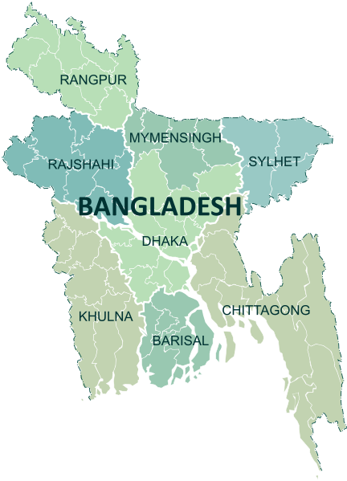
Geographical Location of Bangladesh
Figure 2: Map of Bangladesh

Officially Known As | The People’s Republic of Bangladesh
Location | Southern Asia
Area | 147,570 km²
Population | 162 million people
Capital | Dhaka
Language | Bengali
Religion | The majority are Muslim. Also consists of Hindu, Buddist, and others
Currency | Taka (BDT)
Life Expectancy | 69 years (Men) and 70 years (women)
GDP 2019 (Million Taka) | 26,604,164
GDP per capita (US$ PPP) | 5,028
Overview of Bangladesh:
Figure 3: Overview of Bangladesh

3.3 Theoretical concept of poverty
There is no exact and precise definition of poverty as it is a multidimensional concept. There are various definition and concept of poverty that varies from country to country, family to family, society to society, and individual to individual.
Poverty can be defined as a condition or state where an individual lacks financial resources and income level from employment is so low that minimum living standard or basic human needs can not be fulfilled or met. Traditionally, basic needs can be defined as proper food, shelter, and clothing. The modern definition included sanitation, education, and healthcare along with food, shelter, and clothing. It means the minimum resources (financial and non-financial) in terms of the consumption of goods necessary for long-term physical well-being.
According to Glewwe & Gaag, 1990, a household is defined as poor if their food, clothing, medical, education, and other needs are not met.
According to Haughton & Khandher, 2009, and World Bank, poverty means a low level of incomes and inability to get the basic goods and services, low level of health and education, poor sanitation, lack clean water, and physical security and insufficient capacity to make one’s life better and improve living standard.
“Fundamentally, poverty is a denial of choices and opportunities, a violation of human dignity. It means a lack of basic capacity to participate effectively in society. It means not having enough to feed and clothe a family, not having a school or clinic to go to, not having the land on which to grow one’s food or a job to earn one’s living, not having access to credit. It means insecurity, powerlessness, and exclusion of individuals, households, and communities. It means susceptibility to violence, and it often implies living in marginal or fragile environments, without access to clean water or sanitation”. — (Cited in Gordon, 2005)
In summary, poverty means a low level of income which cannot meet the basic needs of an individual. The poverty line is defined as the amount of income required to satisfy those basic needs. The poverty line varies from country to country and each country has its own measurement or line that determines how many people are living in a state of poverty.
Poverty headcount ratio at $1.90 a day (PPP) (% of population)
Region | 1990 (%) | 2002 (%) | 2018 (%)
East Asia & Pacific | 61.3 | 12.33 | 1.3
Europe & Cental Asia | 1.2 | 1.28 | 1.2
Middle East & North Africa | 6.1 | 1.69 | 7.2
South Asia | 47.4 | 33.44 | 16.1
Sub-Saharan Africa | 54.9 | 42.63 | 42.3
Latin America & Caribbean | 15.2 | 9.08 | 4.4
Table 1: Poverty Headcount ratio at $1.90 a day (PPP) (% of the population)

Poverty headcount ratio at national poverty lines (% of the population) – BD
Figure 4: Poverty headcount ratio at national poverty lines (% of the population) – BD

Bangladesh is a developing county and one of the problems the country has faced since liberation is poverty. Poverty is widespread in Bangladesh. However, the poverty level of Bangladesh has drastically reduced from 2005 to 2017 as shown in the chart above. , Bangladesh has managed to reduce poverty from 40% in 1990 to 14.8 % in 2017 and in 2020 the poverty level dropped to 4% based on the international poverty line of $1.90 (using PPP exchange rate) a day.

3.3.1 Classification of Poverty:
Poverty can be divided into two broad categories, absolute and relative poverty. Both of the categories of poverty focuses on income and consumption level of an individual.

Absolute Poverty:
It is a condition where an individual has a household income below the minimum level where the person is unable to afford basic human needs and unable to maintain a basic standard of living like food, shelter, housing, freshwater, health care, education, etc. It is the most serious type of poverty which can be seen in underdeveloped and developing countries.
Absolute poverty is defined as “A condition characterized by serve deprivation of basic human needs, including food, safe drinking water, sanitation facilities, health, shelter, education, and information. It depends not only on income but also on access to services.” - Gordon (2005)
In this state, the people live below the poverty line and it does not only include lack of finance rather it also includes all the things that are related to our daily life. People in absolute poverty are not affected even if the country they live in is economically booming. However, micro-credit concentrates on absolute poverty and tries to alleviate the poor and reduce poverty in developing countries like Bangladesh
In 2010, the urban population of Bangladesh living in extreme poverty was 7.7% and it slightly dropped to 7.6% in 2016. Given that Bangladesh continued to urbanize during this time, there are now more people living in extreme poverty in urban Bangladesh (3.3 million) than in 2010 (3 million).
Global Extreme Poverty Rate (1990-2015)
Figure 5: Global Extreme Poverty Rate (1990-2015)

Relative Poverty
It is a condition where an individual has a household income that is a certain percentage below the median income of the country or society. In other words, it means the income or resources of an individual is such that it is lower than others within a country or society. The threshold of median income varies from country to country and it could be for example set to 40 or 60% of the median income of a country.
It measures the inequality of income distribution rather than the deprivation of resources or basic needs. It is a measurement of income inequality of a country that depends on social context and it is measured on a person's yearly income and as a percentage of the population with income less than the median income of the country.
People in relative poverty have some money but this money is not enough for them to afford anything above the basic needs, for example, lack of internet, decent clothing, and housing, reasonable education, etc. This type of poverty changes with the economic condition of the country. If the country is booming, then the living standard will be high and the threshold will be set higher than the countries that have a poor economic condition.

3.3.2 How Poverty is Measured
Poverty is usually measured according to the consumption and expenditure of an individual. However, there are various methods to measure poverty and there is no single accepted method in measuring poverty. A threshold is used known as the poverty line to measure poverty. It can be the level of income and expenditure an individual require to meet basic needs to maintain a healthy and productive life.
Poverty can be measured in various ways by international organizations, policymakers, and governments as poverty is multidimensional and comprise of various factors. In Bangladesh, poverty is measured by consumption, and expenditure and data are collected from Household Income and Expenditure Survey (HIES) by Bangladesh Bureau Statistics.
Some of the methods used to measure poverty are mentioned below:
Cost of Basic Needs (CBN) Method: This method was developed in 1994 whereby the poverty line is represented by the cost of a bundle of essential goods and services needed to ensure that basic needs are met. Any person with a level of per capita expenditure below this amount is considered as poor. In Bangladesh, a bundle of foods consisting of 11 items has been used to create the threshold.
Percentage of Poor in Bangladesh (CBN)
Year | Upper Poverty Line | Lower Poverty Line
1991-1992 | 56.7 | 41.1
1995-1996 | 50.1 | 35.2
2000 | 48.9 | 34.3
2005 | 40.0 | 25.1
2010 | 31.5 | 17.6
Source HIES Bangladesh Bureau of Statistics
Table 2: Percentage of Poor in Bangladesh (CBN)

Direct Calorie Intake (DCI) Method: In this method, the calorie intake is considered when setting the poverty line. The data from household expenditure surveys on quantities of food consumed is converted into calories and if per capita intake to maintain normal health is less than the required calorie, then the household is considered poor. This method was used by Bangladesh and the Bangladesh Bureau of Statistics estimates the poverty line as follows:
- Absolute Poverty: Daily intake of fewer than 2112 calories of energy per capita per person.
- Hardcore Poverty: Daily intake of fewer than 1805 calories of energy per capita per person.
- Ultra Poverty: Daily intake less than 1600 calories of energy per capita per person

Percentage of Poor in Bangladesh (DCI)
Year | Absolute Poverty | Hardcore Poverty
1985-1986 | 55.7 | 26.9
1995-1996 | 47.5 | 28.0
2000 | 44.3 | 20.0
Source Bangladesh Bureau of Statistics
Table 3: Percentage of poor in Bangladesh (DCI)

Head Count Index (HCI): It simply measures the proportion of the population living in households with a per capita consumption below the poverty line. It is the most widely and common method to measure the poverty of a country.

Poverty headcount ratio at national poverty lines (% of the population) – BD
Source: World Bank
Figure 6: Poverty headcount ratio at national poverty lines (% of the population) - BD

3.4 Background and definition of NGO

3.4.1 Definition:
NGO stands for a non-governmental organization, it is a non-profit organization that is founded and run by individuals and citizens that is established for a cause. NGO’s are operated independently of government and operates for the wellbeing of the society, interests of the poor, development, aid and any other activities
It is defined as "private organizations that pursue activities to relieve suffering, promote the interests of the poor, protect the environment, provide basic social services, or undertake community development" – World Bank
NGOs play an important role in the development and aiding the poor and reducing poverty. The term NGO is very popular and well known in Bangladesh. There are thousands of NGOs in Bangladesh and they are widespread across the country. Micro-credit was first introduced to the world by Grameen Bank (GB) an NGO in Bangladesh in the 1980s. Usually, microcredit is widespread and provided by NGOs along with some commercial banks and Government Organization (GO). Not only that, along with providing micro-credit, NGOs also do services for the wellbeing of the poor and society related to education, women empowerment, poor empowerment, health, and basic need.

3.4.2 History:
From the beginning of mankind, people used to live in a small clan and help and support each other in times of trouble and needs. Back then, society was very small and people used to live in a small clan. Whenever any people from a clan used to face any problem or trouble, the powerful and strong persons among the clan help the person in trouble and support the poor and needy people. Today, the society has expanded, the population has increased, new socio-economy has emerged and due to globalization, it is not possible fo any single person to carry out that support for the long-term benefit of the problems. So these kind and social wellbeing activities are carried out by NGO’s today.
NGO’s have been around for centuries in different forms and different names. However, NGOs were first discovered and came into the spotlight during the 1980s and 1990s and assumed to have far greater responsibilities and role in development than previously. They mainly emerged as solutions to long-term development problems because an inefficient and ineffective government could not bring solutions to such problems. They deliver services to people in need, promote human rights, landscape development, do environmental and humanitarian action, resolve conflicts, and many more. They are a key sector in the development of a county and alleviating the poor.

3.5 NGOs in Bangladesh
We can visualize the presence and emergence of NGOs in Bangladesh just after independence. After the liberation war, the NGO sector was born in Bangladesh to support and provide food to the people of war and the hunger and the victims of the war. After that, NGOs shifted their focus from the provider of aid and relief to microfinance providers through microcredit to support and help the poor to become self-employed and to reduce poverty.
The NGO sector of Bangladesh is vast and there are thousands of NGOs in Bangladesh working and aiming to reduce poverty, empower the rural and extremely poor, and empower the women. Mainly an NGO can register through the Social Welfare Ministry, Company Act, or Bangladesh Bureau. The NGOs of Bangladesh can be divided into MFI NGOs that provide microcredit and Development NGOs that take different development projects for the wellbeing of society.
Types of NGO in Bangladesh
Figure 7: Types of NGO in BD
The trend in the MF sector of Bangladesh (2013-2017)
Year | Total Loan Disbursement (BDT in Billion) | Loan Disbursement per Borrower (BDT)
2013 | 432 | 22432
2014 | 462 | 23787
2015 | 634 | 31154
2016 | 787 | 33805
2017 | 1046 | 42092
2018 | 1208 | 47410
2019 | 1487 | 52676
Table 4: Trend in the MF sector of Bangladesh

In 2019, the total loan disbursement through the MF sector in Bangladesh is 1487 billion BDT and the table shows an increasing trend in loan disbursement. Most of the borrowers of micro-credit in Bangladesh are female (around 90%). There are a total of 758 licensed MFIs in Bangladesh as of 31st December 2019. Some of the most important and big NGOs in Bangladesh are BRAC, Association for Social Advancement (ASA), Thengamara Mohila Sabuj Sangha (TMSS), Buro Bangladesh, Society for Social Service (SSS), Sajida Foundation, PROSHIKA, International Urban Planning Organization (IUPO), AGA Khan Foundation, Mothers and Infants (OMI) and Juba Jibon Unnayan Samity, etc.

3.5.1 Role of NGOs in Bangladesh:
NGOs are established with different purposes and there are many roles of NGOs. But the main purpose of NGOs is to reduce the poverty level and support the deprived people and create schemes according to the region and local demand. In Bangladesh, poverty is widespread and NGOs have some major role to alleviate the poor and the development of the poor.
- Providing financial support through micro-credit so that poor people can become self-employed, reduce dependency, and come out of poverty.
- Prove special training to women to empower them and to develop their socio-economic condition.
- Provide non-formal education to reduce the illiteracy rate and educate the rural people who can not afford traditional education.
- Providing health and nutrition development services
- NGOs acts as associates of the government
- Assessing socio-economic problems and providing aid and services based on the region for the wellbeing of the society
- Rural and urban development through slum development, infrastructure development, and providing housing facilities at a low cost, etc.

3.6 Sustainable Development Goal (SDG)

3.6.1 SDG of Bangladesh:
What is SDG?
Sustainable Development Goals (SDG) are a collection of 17 goals that were adopted by the countries under the United Nations (UN). These goals were set in 2015 to achieve a better and sustainable future for all by ending poverty, protecting the planet, and ensuring peace and prosperity. The aim is to achieve these ambitious 17 life-changing goals by the year 2030 and all countries must work together and pledge to leave no one behind to make the world socially, economically, and environmentally sustainable.
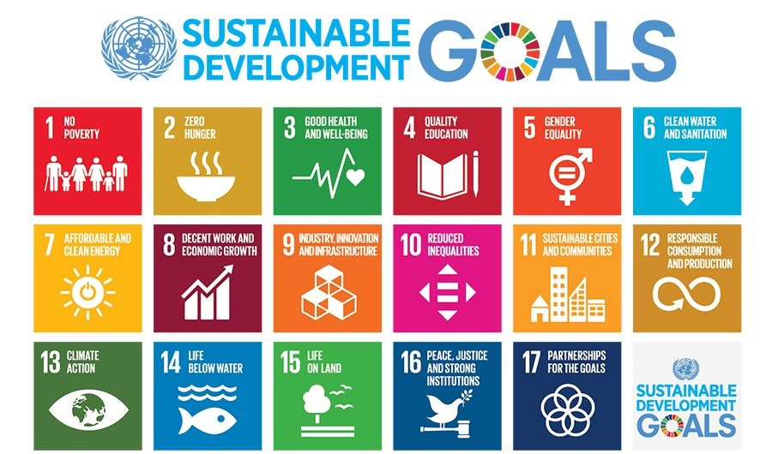
These 17 goals include 169 targets and each target contains 1 and 3 indicators, in total there are 232 indicators to measure progress towards achieving the targets. The goal is to ensure that social needs like education, health, job, and social protection are fulfilled and factors that restrain development such as inequality, improper consumption, negative impact on the environment, etc are controlled and tacked to have sustainable development. Bangladesh is one of the members of the UN and the country is progressing well to achieve these goals with its limited resources by 2030.
Figure 8: 17 Sustainable development goal (SDG)
17 life-changing SDG of Bangladesh:
- End every shape and form of poverty from everywhere.
- End hunger by achieving food security, improving nutrition, and promoting sustainable agriculture.
- Ensure healthy lives
- Ensure quality of education and promote lifelong learning opportunities for all
- Achieve gender equality and empower all women and girls
- Ensure availability and sustainable management of water and sanitation for all
- Ensure access to affordable, reliable, sustainable and modern energy for all
- Promote sustainable economic growth, productive and efficient employment and adequate work for all
- Build robust infrastructure, promote sustainable industrialization and encourage innovation
- Reduce inequality within and among countries
- Make cities and human settlements inclusive, safe, resilient and sustainable
- Ensure sustainable consumption and production patterns
- Take urgent action to fight climate change and its impacts
- Conserve and use the oceans, seas and marine resources in such a way that it maintains and brings sustainable development
- Protect, restore and promote sustainable use of terrestrial ecosystems, sustainably manage forests, combat desertification, and halt and reverse land degradation and halt biodiversity loss
- Promote peaceful and inclusive societies for sustainable development, provide access to justice for all and build effective, accountable and inclusive institutions at all levels
- Strengthen the means of implementation and revitalize the Global Partnership for Sustainable Development

3.6.2 Role of NGO in achieving SDG:
he agenda of SDG is vast and needs a collective involvement of all the ministries of the government, private sector, civil society organizations, development partners along with NGO. However. NGOs play a vital and significant role in nurturing, achieving, and implementing a sustainable development goal. Previously, NGOs had played a big role in achieving the Millennium Development Goals (MDGs). They offer financial and non-financial services that help to reach the targets of the SDG.
The most important and first component of SDG is alleviating poverty. Poverty is widespread and a phenomenon of Bangladesh where one in five Bangladeshi live below the poverty line and the average income (wage) is less than five dollars a day. One of the main factors that create a barrier between poverty alleviation is the lack of access to finance. Poor people are hard-working and skillful, however, as they can not take a loan from a conventional bank, many are deprived of being self-employed. So the NGOs such as Grameen Bank, ASA, Brac, CARE, and many more help the poor people to obtain funds through their financial services such as micro-credit.
To end poverty, Bangladesh has set two targets: 1. Reduce the proportion of the population living below the extreme poverty line below 3%. 2. Reduce the proportion of the population living below the national poverty line below 10%. The NGO is helping to achieve these targets by offering cost-effective micro-credit loans to poor people so that they can become self-employed, expand their business, and improve the standard of living. ASA alone disburses TK 310 billion loans, reaching 6.8 million people. So NGOs are making people financially stable through micro-credit and as a result pushing Bangladesh to achieve SDG of ending poverty.
Only facilitating finance does not end poverty. Multiple disciplines are required to solve the poverty problem in Bangladesh. For example, Sustainable food and nutrition (SDG2), ensuring healthy lives (SDG3), Ensuring quality of education (SDG4), gender equality (SDG5), ensuring proper sanitation, water and hygiene (SDG6) and decent and productive employment (SDG16) are all required to help alleviate poverty. The NGOs ensure that these goals are met through their non-financial services.
Brac a leading NGO helps to ensure quality education through their ultra-poor graduation program where 43,682 households graduated from ultra-poverty and 3.3 million people had access to learning opportunities. It also provides health, nutrition, water, sanitation, and hygiene programs where 158,836 people accessed safe water, 6,753 malaria cases were treated, and many more. They also work for gender equality, where 1.2 million women accessed different social safety services.
This is a small example of only one NGO in Bangladesh helping to achieve sustainable development goals. There are 2554 NGOs in Bangladesh offering different types of financial and non-financial services to alleviate poverty and to achieve the SDG by 2030.

Chapter 4
NGO and Micro-credit

Chapter 4: NGO and Micro-credit

4.1 GrameenBank (GB)

4.1.1 Introduction to Grameen Bank (GB):
Grameen Bank (GB) originated in Bangladesh in 1976, is a microfinance organization that works for the development of the community and to the financially deprived and poor people that provide microloans known as Grameen credit without the requirement of collateral. The bank also provides services like deposits and run various businesses like energy and fabric business etc that are oriented for the development of the economy and social welfare.
The name Grameen Bank has a deep meaning. In Bengali, the word “gram” means “village or rural”. So it is a bank for rural people to fight poverty and serve the development of the socio-economic situation of the deprived and poor people as poor people can not attain loans from traditional banks which requires many formalities like collateral, income source, employment, etc. The loan or micro-credit given to the borrowers are group-based. This means, a group of people in need of finance are given the credit and it creates social collateral rather than physical collateral.
This organization was launched by Muhammad Yunus who was a professor at the University of Chittagong. In 1976, Yunus was doing a research project. The main theme was to provide financial support for people who cannot acquire loans from traditional banks. He chose 42 females in Jibra Village and gave them a small loan of $42 to start-up their own business without any collateral and high-interest rates. The study came to be very positive because the poor females became self-employed which reduce their poverty and could repay the loan. Yunus believed that if such a small amount of loans are offered to deprived people in a larger population, then startups could flourish and it will reduce rural poverty in Bangladesh. In October 1983 the Grameen Bank was authorized by the government as an independent bank. In 2006, the founder of GB, Dr. Muhammad Yunus won the Noble Peace Prize for the effort to reduce poverty and create social and economic development.
Overview of Grameen Bank (Amount in Million BDT)
Year | Cumulative Disbursement (Loan) | Total Deposits | No. of Members | Number  of  Villages  covered | Number  of  Branches | Profit/Loss  (For the  Year)
1976 | 0.008 | - | 10 | 8 | 1 | 1
1990 | 7590.7 | 851.43 | 869538 | 19536 | 781 | 3.10
2000 | 130559.1 | 6611.85 | 2 2378356 | 40225 | 1160 | 11.14
2010 | 594460.61 | 104478.43 | 8340623 | 81376 | 2562 | 757.24
2018 | 1899240.95 | 266064.36 | 9084503 | 81677 | 2568 | 3485.29
Table 5: Overview of Grameen Bank

GB is one of the largest and powerful NGOs in Bangladesh with 9.6 million members in 2019. Most of the members (97%) are women. During 2018, GB has 2568 branches with 18105 employees that provide services to 8167 villages with a loan disbursement of 1899240.95 million BDT.

4.1.2 Vision of Grameen Bank:
Providing comprehensive financial services to create a healthy and developed Bangladesh free of poverty, hunger, and empowering the poor and women of Bangladesh to release their potential and increase their standard of living.

4.1.3 Mission of Grameen Bank:
The core mission of GB is to alleviate poverty from Bangladesh.

4.1.4 Objective of Grameen Banks:
- Provide banking facilities to the poor sector of the country
- Moneylenders take advantage of the poor and misuse them. GB eliminates that exploitation.
- Provide financial service and opportunity to people in the rural area of Bangladesh for being self-employed and to create an income-generating source
- To reverse the cycle of low income means low saving means low investment into a virtuous cycle where low-income people can get micro credit to invest more and increase income and savings which lead to more investment and more income
- To promote women empowerment by helping the poor women of the household to come to an organizational format.

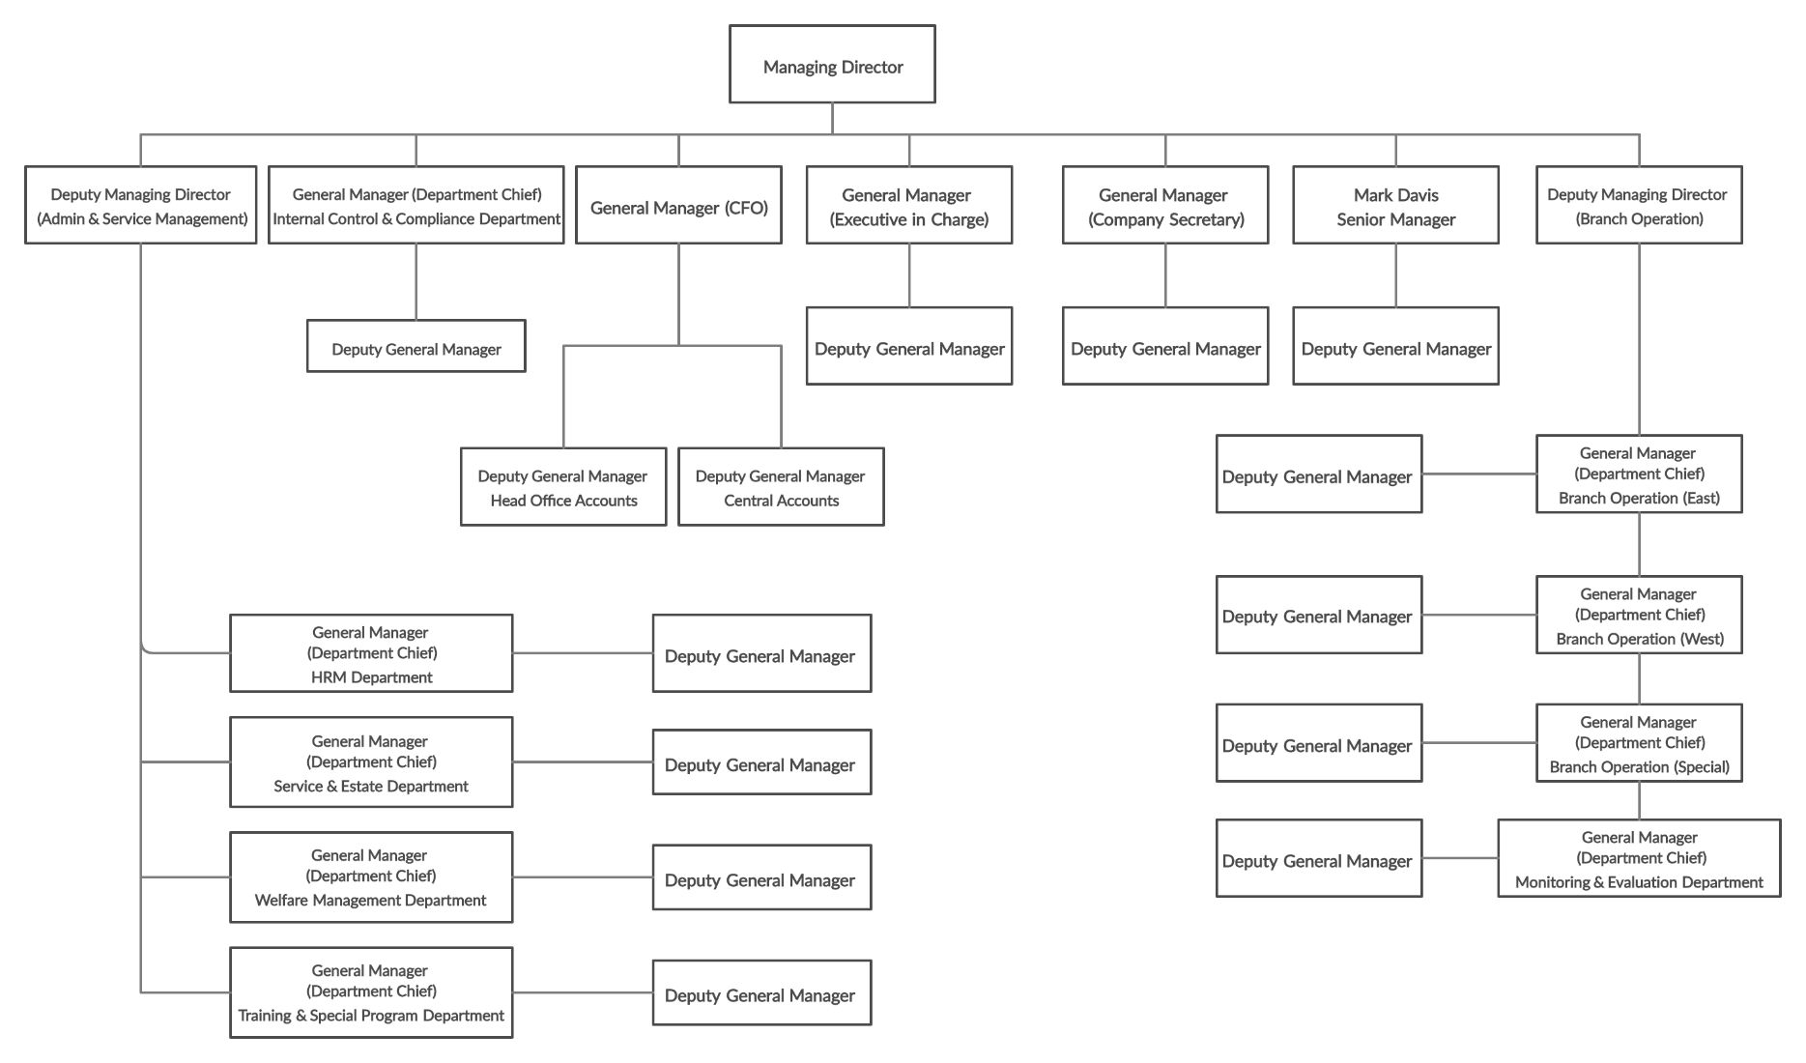
Organizational Chart:
Figure 9: Organizational Chart of GB

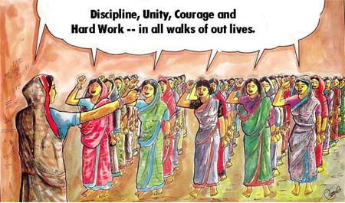
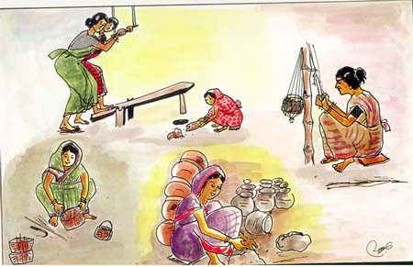
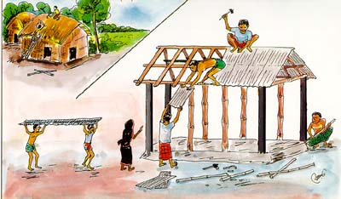
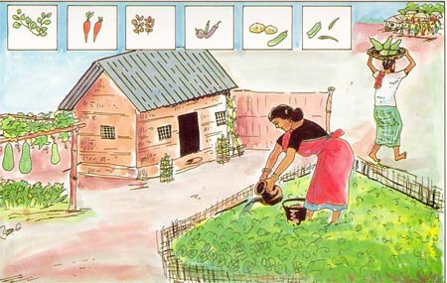
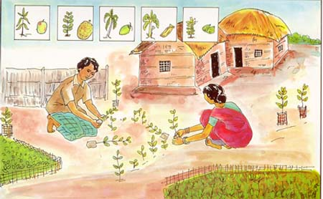
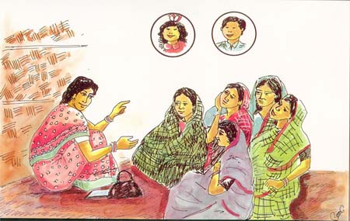
3.1.5 Sixteen (16) Decision of Grameen Bank:
1. We shall follow and advance the four principles of Grameen Bank — Discipline, Unity, Courage and Hard work – in all walks of our lives.
2. Prosperity we shall bring to our families.
3. We shall not live in dilapidated houses. We shall repair our houses and work towards constructing new houses at the earliest.
4. We shall grow vegetables all the year round. We shall eat plenty of them and sell the surplus.
5. During the plantation seasons, we shall plant as many seedlings as possible.
6. We shall plan to keep our families small. We shall minimize our expenditures. We shall look after our health.

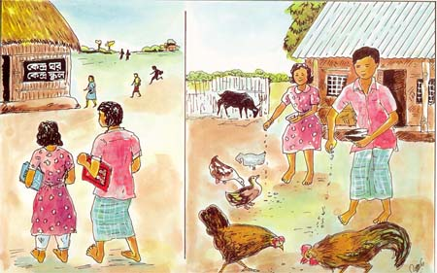
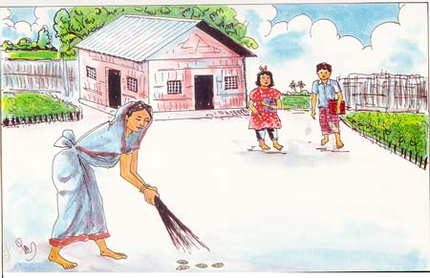
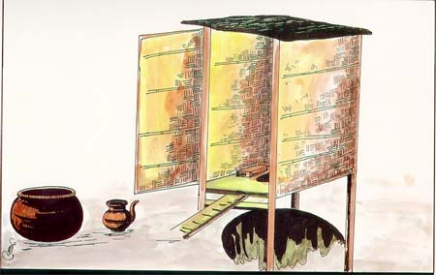
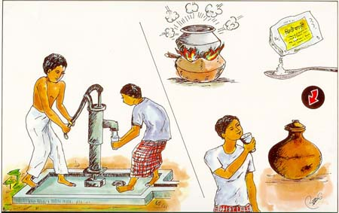
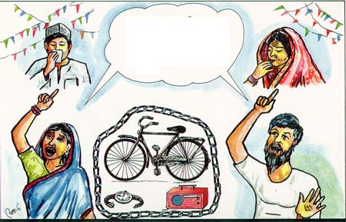
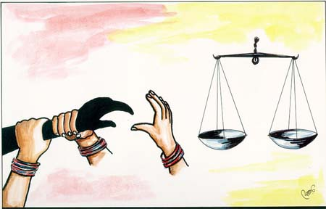
7. We shall educate our children and ensure that they can earn to pay for their education.
8. We shall always keep our children and the environment clean.

9. We shall build and use pit-latrines.
10. We shall drink water from tubewells. If it is not available, we shall boil water or use alum.
11. We shall not take any dowry at our sons’ weddings, neither shall we give any dowry at our daughters wedding. We shall keep our centre free from the curse of dowry. We shall not practice child marriage.
12. We shall not inflict any injustice on anyone, neither shall we allow anyone to do so.

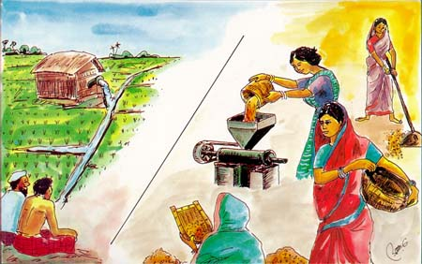
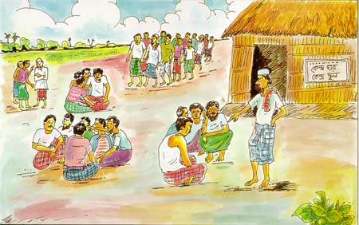
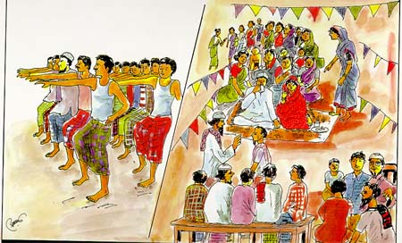
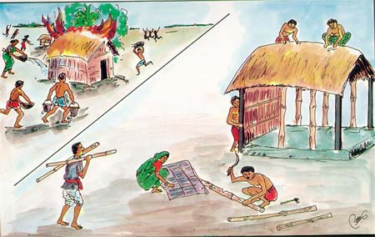
13. We shall collectively undertake bigger investments for higher incomes.
14. We shall always be ready to help each other. If anyone is in difficulty, we shall all help him or her.
15. If we come to know of any breach of discipline in any centre, we shall all go there and help restore discipline.
16. We shall take part in all social activities collectively.

4.1.6 Grameen Bank’s Micro-credit
Grameen Credit: It is a small loan given to poor, women, and illiterate people who do not have access to traditional financial services and do not know how to invest and generate income. The credit ranges from Tk 5000 to 50000 which should be paid in 44 installment and installments are made weekly at an interest rate of 20%
GB believes that poverty is not created by poor people rather it is the financial institutes and policies that are around poor people. Grameen Bank believes the financial systems and policies must be changed to reduce poverty. Poor people have skills but cannot utilize their skills due to a lack of financial support. GB also believes that charity only helps poverty to continue because it creates dependency as the person accepting charity may not incur any income generation activities and in the long term poverty is not eliminated.

4.1.7 Features of Grameencredit:
- It states that credit is a human right
- It is targeted mainly at poor people especially women to come out of poverty
- It is based on trust rather than collateral or legal procedures
- It helps the poor people to come out of poverty by engaging them toward income generation rather than increasing consumption
- It challenges the traditional banking system which rejects to give loan to poor people for not being creditworthy
- It is based on the bank should go to serve people rather than people going to the bank
- The borrower must be a part of a group of borrowers to obtain a loan
- The borrower can continuously take new loans if previous loans are repaid
- Repayments are weekly basis
- The borrower can take multiple loans at the same time
- The interest rate is set to a minimum level so that poor people can bear it

4.2 Brac

4.2.1 Introduction to BRAC
BRAC formed in 1972 under the Societies Registration Act 1860, is one of the largest international non-governmental development organizations in the world. Subsequently, it was registered as NGO under the Bureau of the Government of Bangladesh.
It was established by Sir Fazle Hasan Abed at Shallah Upazillah in the Sunamganj district of Bangladesh. After the liberation war of Bangladesh, people were returning home, and to help and support and help the refugee a small scale of relief and health project was carried out by BRAC. Thousands of homes and fishing boats were rebuilt along with several medical centers that were made to support the refugee within nine months.
Back then, BRAC was known as the Bangladesh Rehabilitation Assistance Committee. Then when Bangladesh went into poverty it changed BRAC changed its name to Bangladesh Rural Advancement Committee. Now it is known as Building Resources Across Communities (BRAC).
Although Bangladesh is rich in natural resources, it is developing and still suffers from poverty because the natural resources are not being properly used or extracted. This is due to a lack of technical knowledge and skills among poor people. To make efficient use of these natural resources and to achieve substantial economic and socio-economic growth, BRAC works directly with the poor and women to make then skillful and take them out of poverty.
BRAC operates various economic, health, education, social empowerment, enterprise development, and microfinance programs across the world. It has reached 110 million people across the world, operating in 14 countries. BRAC is also widespread in Bangladesh, covering 64 districts and 36999 villages of Bangladesh with over 7 millions of microfinance members and thousands of informal primary schools and health volunteers, BRAC has supported and created an opportunity for more than one million poor people with the help of 120000 employees. It is the largest NGO in terms of employment where most of the employees are women.
BRAC is a large organization that has spread its business to many sectors. Some of the successful commercial enterprises of BRAC include BRAC Bank, BRAC University, BKASH (Microfinance), Aarong (Chain of handcraft retail), BRAC Dairy, BRAC Nursery, and BRAC Fisheries, etc. BRAC is mostly self-funded and most of the funds come through its social enterprise such as Aarong and from food and dairy projects.

4.2.2 Vision of BRAC:
“A world free from all forms of exploitation and discrimination where everyone has the opportunity to realize their potential.” -BRAC

4.2.3 Mission of BRAC:
“Our mission is to empower people and communities in situations of poverty, illiteracy, disease, and social injustice. Our interventions aim to achieve large scale, positive changes through economic and social programs that enable women and men to realize their potential.” –BRAC

4.2.4 Objective of BRAC:
BRAC has two main objectives: Poverty alleviation and empowerment of poor and women.

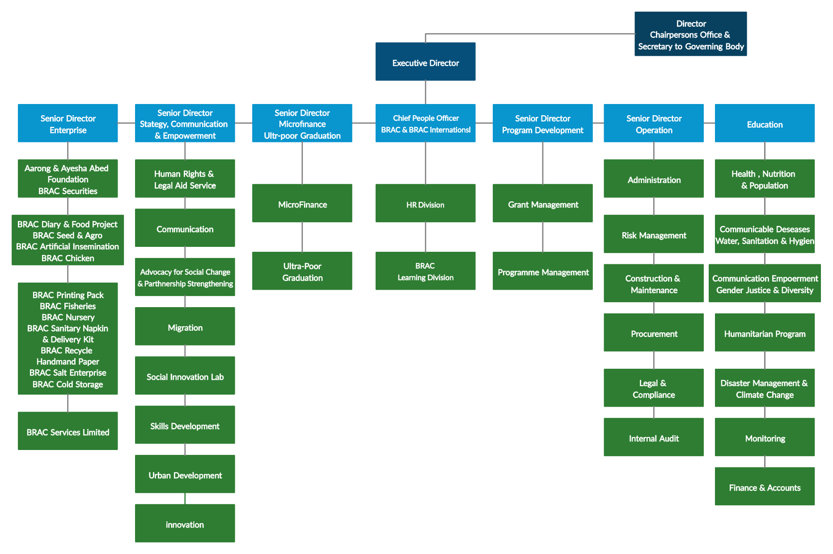
BRAC Organisational Chart

Figure 10: Organizational Chart of Brac

4.2.5 Values of BRAC
Figure 11: Values of Brac
Inclusiveness
Integrity
Innovation
Effectiveness

BRAC at a Glance (2018)
USD 4 billion disbursed in loans (an increase of 21% from 2017) | 7.1 million total clients reached with microfinance (an increase of 10% from 2017) | 43,682 households graduated from ultra-poverty
90% of targeted households in hard-to-reach regions received healthcare | 90,118 people accessed human rights and legal aid education | 3.3 million children, young people, and adults had access to learning opportunities
5,723 houses rebuilt after fire incidents in urban slums | 319,337 children aged 3-5 years accessed early childhood development and preprimary programs | 158,836 people accessed safe water
Source: BRAC Annual Report 2018
Figure 12: Brac at a glance

4.2.6 BRAC’s Micro-credit:
BRAC’s microcredit system is unique and they believe in the credit-plus approach. Each of the microcredit schemes and the program is carefully made and customized according to the needs of the rural women, poor, farmers, micro-entrepreneur, and migrant workers. First, the problem and needs of the people are identified and then financial products and services are tailored to best solve the specific problem.
Another feature of BRAC’s microcredit is Village Organisations (VO). Here, 15 to 40 women form an organization from the local community which acts as a platform to share their information, raise awareness, receiving health, and legal support.

4.2.7 Micro-credit Scheme of BRAC:
Dabi: This scheme is for economically active poor women who are members of the Village Organization (VO). Loan amounts ranging from $100 to $1,000 and repayments should be done in 46 weekly installments that are spread over one year. The loan is given without any collateral to help low-income women to engage in income-generating activities and to empower the poor women in the rural area.
Progoti: This micro-credit scheme is targeted at the entrepreneur of both gender who is not eligible for taking loans from conventional banks. The loan amount ranges from $1,000 to $10,000 with an interest rate of 15%. The borrower has the option to repay the loan in equal monthly payments that should be paid within one year or two years. This microcredit program financially helps the deprived and micro-entrepreneurs to finance and grow their existing business.

Unnoti: This micro-credit loan is targeted at small and marginal agro-farmers who need little money to carry their activities. The loan amount is very small and the borrowers need to attend a meeting with BRAC that are held weekly. The interest rate is 15% with an equal monthly payment of over 12 or 18 months.

Overview of BRAC’s MicroFinance
Village Organizations (VOs) | 281,336
VO members | 5.72 million
Total Loan Borrowers | 4.10 million
Total Disbursement | 10.6 billion BDT
Savings Deposits | 26.9 billion BDT
Table 6: Overview of Brac’s MicroFinance

4.2.8 Programmatic Area of BRAC:
BRAC has successfully launched and operating various programs and schemes to alleviate the rural people and empower the women and for the socio-economic development to reduce poverty. Currently, BRAC has eight financial and non-financial programs targeted to improve the life of poor people. They are:
- Eliminating extreme poverty
- Expanding the financial choices of people living in poverty
- Employable skills for decent work
- Climate change and emergency response
- Gender equality
- Universal access to healthcare, nutrition, water and sanitation
- Pro-poor urban development
- Investing in the next generation

4.3 ASA

4.3.1 Introduction to ASA:
In 1971, Bangladesh went through a drastic and painful war and became independent where millions of people died. After the liberation was, the country was left behind in a poor economic, natural, and ravaged condition. Moreover in 1974, great starvation hit Bangladesh and people were dying and poverty rose. Bangladesh is rich in resources and it depends mostly on agriculture. However, post-war, the country had an inexperienced and inefficient government and policies, the unemployment rate was booming and the country was in a chaotic state. At that time, many small scale NGOs were born to support the people of Bangladesh and make the economy stable and to eliminate poverty.
At that devastating and tough time, MD. Shafiqul Haque Choudhury (the founder of ASA) and a group of people were working for an NGO and saw that more effective and efficient steps could be taken to empower the poor and alleviate poverty in rural areas. In 1978, ASA (Association for Social Advancement) was born at a remote village Tapra with a mission to eliminate exploitation of the rural poor people and for the wellbeing of the poor.
From 1978 to 1991, ASA went through the foundation phase where they focus on socio-economic development through health, sanitization, raising awareness, and aiding deprived poor people. However, in the middle of 1992, ASA entered into program specialization phase and shifted its focus to microcredit. Because aiding people through donation does not make them come out of poverty rather it creates donor dependency. Since 1992, ASA solely focused on microcredit programs to make the poor people self-sufficient to eradicate poverty from Bangladesh.
They believe economic development is the most important factor to eliminate poverty and economic development means people’s income will increase and it will improve social development and solve the problem of poverty. Today, ASA is considered to be the fastest-growing and one of the powerful NGOs around the world that has a successful cost-effective microfinance model.
As of 2020, ASA is serving 6.8 million clients covering over 66,000 villages. It has a total of 3,073 branches throughout Bangladesh and a total of 26,526 employees are working to alleviate poverty from Bangladesh. ASA also was ranked number 1 in the Top 50 MFIs of Forbes 2007 considering its Scale, Efficiency, Risk, and Returns.

4.3.2 Vision of ASA:
“The vision of ASA is to establish a poverty-free society.”

4.3.3 Mission of ASA:
“The institutional mission of ASA is to support and strengthen the economy at the bottom of the socio-economic pyramid by facilitating access to financial services for the poor, marginalized, and disadvantaged.”

4.3.4 Objective of ASA:
The objective of ASA is to eradicate poverty from Bangladesh through cost-effective microfinance programs and making it easy to access finance to make the poor people self-sufficient and to improve their living standards.

4.3.5 Core Values:
“Innovative and non-conventional management for achieving cost-effectiveness and sustainability.”

4.3.6 Organogram of ASA:
The organizational structure of ASA is divided into two tiers: The central office and the branch office. It also has a District office that acts as a middle connects the central and branch office.
Branch Composition:
ASA has a decentralized structure where each branch is operated independently and at its own cost and profit. Each branch consists of one Branch Manager (BM) who maintains the accounting and transactional accounts and one Assistant Branch Manager (ABM). On average, each branch employs 4 to 6 Loan Officer (LO). They are also responsible for maintaining daily accounts.
District & Region Composition:
Each district has a District Manager (DM) and under them works a team of Regional Managers (RM) who is responsible to control and monitor 8 to 10 branches. On average, a district consists of a minimum of 20 branches and it can go up to 114 branches.
Divisional Composition:
A divisional zone comprises 5 to 6 districts and a Zonal Manager (ZM) is responsible for looking after these districts. The responsibility of ZM is to monitor the administrative activities and give direction to the district branches.
Head Office Composition:
The head office is composited of the President of ASA who directs the central office such as HR, Operation, MIS, Accounts Section, IT, Audit, and R&D section.

Organizational Chart of ASA

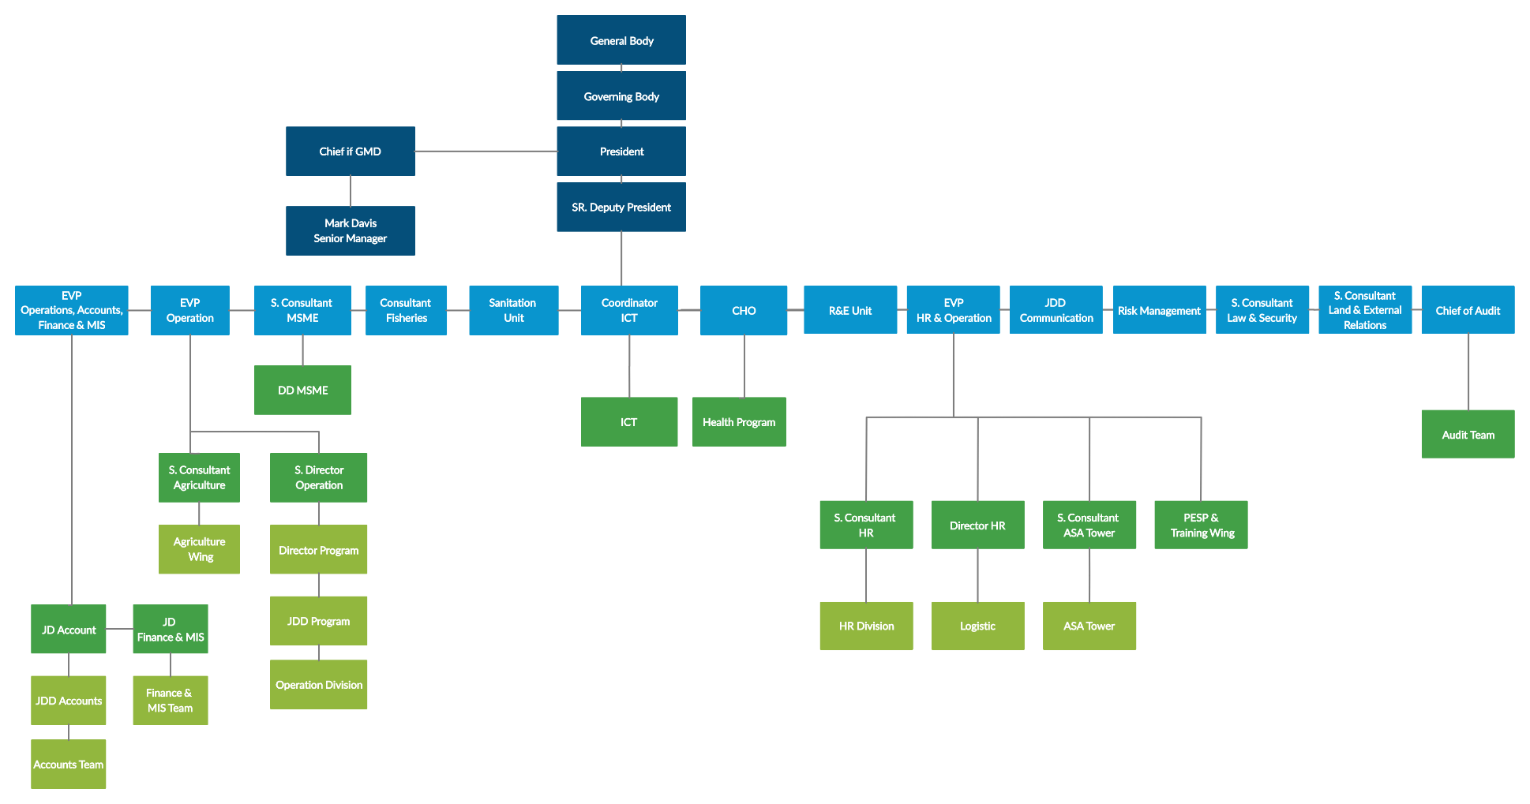

Figure 13: Organizational Chart of ASA

ASA at a Glance
400,000 Underprivileged Children Render Tuition Aid | 3,073 Branches Across Bangladesh | 763,000  People Receive Primary Healthcare
6 Million  People Are Being Aware Of Good Health | BDT 310 Billion  Loan Disbursed In 2018 | 7 Million  Clients Were Reached
Over 6.8 Million Members | Over 5.9 Million  Active Borrowers | 26,526  Regular Employees
Total 66,930 Villages Were Covered | Total of 511  Upazilla/Thana Covered Through Our Poverty Elevation Pro | BDT 170 Billion  Loan Outstanding
Figure 14: ASA at a glance

4.3.7 ASA’s Micro-credit:
ASA offers many financial and non-financial programs to alleviate the poor. Non-financial programs include Primary Education Strengthening Program, Health Program, Physiotherapy Program, Health Assistance Program, Sanitation Program, and Agriculture Support Program. However, providing micro-credit services is their main focus.
They believe that providing financial service tailored according to the needs of rural people is the key to reduce poverty. ASA’s micro-credit loan is one of the most cost-effective loans with low-interest rates so that poor people can afford it. With this loan, active poor people can grow their business and adopt income-generating activities. They have been recognized as the most cost-effective and efficient MFI in the world. They provide financial services such as Loan, Savings, Loan Security & Risk Fund, and Foreign Remittance Program.

4.3.8 ASA offers three types of loans:
Primary Loan: This loan is targeted at poor people who are economically active and can generate income if they are given financial support. The loan amount ranges from BDT 5,000 to BDT 99,000. In special cases, a borrower can obtain a loan of 5,000 or lower. The interest rate is 24% and the loan can be repaid weekly or monthly installment in a 4,6 or 12-months period.
Special Loan: This type of loan is targeted at informal or formal micro-enterprise who wants to grow their business and upscale production and increase the employment generation rate. The loan amount is larger than the primary loan, which ranges from BDT 100,000 to BDT 1,000,000 depending on the client. The interest rate is 24% and the loan can be repaid weekly or monthly installment in 12, 18, 24, or 30-months periods.
MSME Loan: This loan is targeted at micro, small & medium enterprise who has the capability for potential business growth and creates jobs and contribute to the economic growth. The loan amount ranges from BDT 300,000 to BDT 2,000,000. The interest rate is 22% and can be repaid monthly installments in 6, 9, 12, 18, 24, 30, 36-months.

Chapter 5
Research Methodology

Chapter 4: Research Methodology

5.1 Introduction
This chapter discusses how the data was collected, processed, and analyzed to fulfill the objective of the study. The methodology is an important and essential part of any report writing to make the report understandable to the readers. To conduct effective research and to get a rational outcome, field research is necessary. To know the impact of micro-credit on the life of rural people and to answer the question “Does micro-credit alleviate poverty”, I have done a survey, interviewing some of the borrowers of micro-credit over the phone, who lives in the rural area of Bangladesh and who are in poverty. A qualitative approach was used because it gives the perception of the respondent about the impact of micro-credit on their daily life, income generation, and reduction of poverty from their life. Both primary and secondary data were used in this study to get the best outcome of the research.

5.2 Target Population & Sampling
The study covers the micro-credit activity of the ASA NGO of Salika Upazila, Kushtia district, Bangladesh. A sample of 7 borrowers of micro-credit from ASA was chosen and interviewed over the phone. In Bangladesh, over 32 million people take loans from MFIs and it is impossible to get the consensus or interview each of them. So a small size of the sample was chosen. Such sample size may not fully represent the population of borrowers of micro-credit, however, it gives us an idea whether micro-credit alleviate poverty or not and how it influences the rural poor people in their daily life because of all the respondents. To make the same free from any bias, it was designed inappropriate manner which ensures reliability and viability for the research.

5.3 Data collection
Both primary and secondary data were used for this research.

5.3.1 Primary data
Primary data are the first-hand data where the respondent answers the questions. Primary data are important for any research work because the information is collected for specific research purposes. It produces accurate and consistent information about the research. Primary data can be collected through interviews, surveys, experiments, observation, questionnaires, etc.
For this study, interview of some borrowers of micro-credit of ASA over the telephone to know how micro-credit influence the poor rural people. The interview was structured and open-end questions were asked to get the best output of data. Also, the interview of some officials of ASA was done to know to get the basic idea of micro-credit programs, loan procedures, rules, and regulations. Also, I collected the numbers of some borrowers of ASA to carry out my interview with the borrowers. An interview is the best tool for getting quantitative data because it opens door to get more information based on each interviewee and there is an interaction between the respondent and interviewer.

5.3.2 Secondary data
I have also used secondary data for this report. Secondary data was collected from articles, books, publications, newspapers’ reports, research work and websites of World Bank, Grameen Bank, ASA, Brac, Micro-credit regularity authority of Bangladesh (MRA), BBC, etc. The information collected from secondary data helped me to prepare an effective report and draw objectives, purpose, conclusion, and analyze the problem.

5.4 Data Processing
Data processing is an essential and vital part of any research. To do the interview effectively, I followed some steps. First I analyzed the problem and then I drafted what information I actually need to collect for this research. Then I chose and interview some of the officials of ASA to get the contact number of borrowers and lastly I selected the appropriate person for the interview.
I prepared the questionnaire very carefully and specific to the purpose of this research and then carried out my interview with the borrows. Each interview duration was around 15 minutes and I collected all the necessary information needed for this research.
After completing the interview session and collecting the necessary details, I wrote down the information given by the interviewee. I checked carefully for any irrelevant information and remove that information.

5.5 Data Analysis
Immediately after collecting the data, they are not ready for analysis. Following certain steps is required to turn the raw data into useful and effective information because all the data collected may not be required for the study.
First, I reduced the data and eliminate irrelevant data by selecting, simplifying, and focusing the data into meaningful information that is needed for the study. I have taken only those data that are appropriate for drawing an effective conclusion and recommendation.
After selecting the relevant information, I have organized and assemble them to draw my conclusion. I have used graphs, charts, and display of quantitative information to draw an effective and understandable conclusion.
Basically, I have reduced the data given by the borrowers and taken on relevant information and organize this information to conclude.

5.6 Problem Faced in Data Collection
Collecting data from the primary source is not easy. Collecting data from a primary source like interview requires time, patience, and good communication skill. Some of the limitations that I faced during the interview session are:
- Most of the people interviewed are illiterate or have little knowledge about micro-credit and the interview. So a great amount of time and patience is required to make them understand and acquire accurate information.
- As a telephone interview was carried out, most of the time respondents did not answer the phone or could not connect to them due to network problems in the rural area. So it took multiple calls to reach them.
- Some respondents had no confidence in the research and felt hesitant to give certain information. So it took some time to convince them and gain confidence.
Despite all the limitations and problems, I have tried my best to gather as much accurate information as possible.

Chapter 6
Research Findings and Analysis

Chapter 6: Research Findings and Analysis

6.1 Qualitative findings from borrowers of ASA
The main purpose of this report is to find the answer to the question “whether micro-credit alleviates poverty”. To answer this question, I have interviewed 7 borrowers of ASA who are in poverty. I have found that most of the respondents used the loan from the NGO to invest in their existing business or to become self-employed. I have analyzed the answers from the interview and has systematically arranged the findings in a story type qualitative information:

6.1.1 Rubel Hassan:
Rubel Hassan is a 40 years old male living in Salika Upazila, Kushtia district, Bangladesh. He as not formal education and he has a small family of wife and one son. He works at a small agricultural firm and his son is in high school. They had a tough life because his wife was unemployed and he earns a very small amount of wage from working and they could not cope with his son’s school payment.
To come out of poverty, Rubel took BDT 15,000 primary loan from ASA in 2015, and along with some borrowings from friends and family, he purchases a small land to cultivate onions. He is a very productive person, working for an agricultural firm and also producing onions in this land to pay for his son’s education and to come out of poverty.
In the first year, he sold the onions and had profited from that and successfully repaid the loan. To grow his cultivating business, he again applied for a primary loan of BDT 25000 in 2016 and received the loan to purchase another small land. His business was growing and he left his job and put all his focus in this business. In 2018, he diversify from only producing onions to many agricultural products by taking another BDT 30,000 primary loan.
Now, Rubel Hassan has a happy life and a steady source of income and can pay for his son’s education. He is also taking a saving scheme from ASA of BDT 150 per month. He believes that NGOs have given him a better opportunity to become self-employ and come out of the poverty cycle.

6.1.2 Zakir Hossain:
Zakir Hossain is a 45 years old male living in Salika Upazila, Kushtia district, Bangladesh. He completed his primary education. He and his wife have 2 sons and 1 daughter. His sons are in high school and his daughter is in elementary school. He had a small store where he sells tea and biscuits and his wife works at a neighbor’s house.
They had a financial crisis and bearly could afford their children’s education and family expenditure. Still, Zakir continued to make his children educated because he said “Education is the key to success”. In 2012, he took a BDT 10,000 primary loan from ASA to expand his business. He successfully adjusted the loan and again applied for a loan of BDT 20,000 in 2013. With enough capital, he shifted his business from tea and biscuits to the departmental store and was earning a good amount. In 2015, he moved to a large store by taking a loan of BDT 30,000. He Is an enthusiastic entrepreneur and to expand his business, he applied for a Special loan of BDT 100,000 from ASA and open another departmental store that is now run by his wife.
Now, they are living a great life and he also got his daughter married and one of his sons now studies in university. He said that “I am happy that I could get financial support from NGOs, without that I could not have come this far because a person like me can't get financial support from the conventional bank”. He is also taking a saving scheme of BDT 250 per month from ASA. They have come out of the poverty cycle and living a standard life.

6.1.3 Rokia Begum:
Rokia Begum is a 30-year-old female living in Salika Upazila, Kushtia district, Bangladesh with his husband and two sons who study in primary school. Her husband was a rickshaw puller. Her husband is the only income-generating person in the family.
In 2015 a drastic accident made her husband disable and he could not work. Their income source came to halt and had a miserable life back then. Her children had to stop studying due because they had no income and could not bear the tuition fee. They also had days were hey would one eat one meal a day. So, Rokia started working at a neighbors house, and still, the payment she got was insufficient to bear the family expenditure. To increase income, she sold the rickshaw of her husband and took a primary loan of BDT 10,000 from ASA in 2016. With the money, she bought chickens and started growing them in her house. During the year she sold chickens and eggs in the market and made some profit to repay the loan and to bear family expenditure.
In 2017, she again applied for a primary loan of BDT 15,000 and received the loan to expand her poultry business. She again took a loan of BDT 20,000 in 2018 from ASA. Her business grew and had a steady income source to continue her children’s education. Now she is taking care of her husband, children and can afford the basic needs. She said, “Although we have not come out of poverty, however, NGO has allowed us to improve our life and I believe soon we will come out of poverty”. She plans to take further loans soon to expand her poultry business to come out of poverty. She has no saving scheme and is regularly repaying the loan amount.

6.1.4 Jameel Chowdhury:
Jameel Chowdhury is 40 years old male living in a small village of Kushtia district, Bangladesh. He and his wife have one son who is studying in secondary school. He is a farmer by profession and his wife works at a neighbors house.
Jameel rented a land back in 2010 to cultivate rice and his income was enough to fulfill the basic needs and education of his child. In 2017, he took a primary loan of BDT 10,000 to pay the rent for the land and to grow the business. He successfully repaid the loan amount and in 2019, again he applied for a loan of BDT 20,000 and received it. He was selling his crops in the local market and was earning a steady income to feed his family.
However, in 2019, a storm hit the village during the cultivation period and ruined most of his crops. He sold the remaining crop but it generates a small amount of money. Now, he cannot pay the rent of the land and installments also became irregular. So he had to stop the rent of the land and now is working as a guard in a local building. However, the payment is very small and his wife became sick and could not continue her job. Now he can not bear the installment and the education of his son, so he had to bring his son out of the school.
His saving scheme of BDT 100 per month also stoped and he is going through the worst time of his life. He said “I have to lead a life of poor and currently I am in the worst situation. The storm along with the debt from micro-credit loan made my situation worst as I had to stop my cultivation profession and now I am in debt.” So micro-credit could not bring any good to Jameel’s life and he is still in the poverty cycle.

6.1.5 Aleem Khan:
Aleem Khan aged 50 lives in Salika Upazila, Kushtia district, Bangladesh. He is a married man with one son and one daughter. He has completed his secondary school and is an agro-farmer and his wife is unemployed. His son is studying in a university and his daughter is in high school. Recently, he got his daughter married.
His life was not like this year back. He went through a tough time financially. He had two goats and a cow back in 2012 and his income was not high enough to pay for the education of his children. So he took a loan of BDT 50,000 from ASA to buy some cows and goats. He successfully generated enough income to repay the loan. Then again in 2015, He took ASA special loan of BDT 120,000 to expand this agro. Now his business is large and he is regularly paying his installment and can meet his children’s education fee and their basic needs are fulfilled.
He is planning to take the MSME loan offered by ASA to grow his business. Currently, he also has a saving scheme of BDT 500 per month. He said “I am thankful to NGO for giving me access to finance, otherwise I could not come this far. Also without it, my children could not continue their study.” He has successfully come out of poverty due to micro-credit.

6.1.6 Ameena Khatun:
Ameena Khatun is 41 years old female living in with her husband in a small village of Kushtia district, Bangladesh. She has two sons and one daughter. She had no formal education at all and works at a neighbor’s house. Her husband is a rickshaw puller and due to poverty, his children only had primary education level. One of his sons works at a local shop and the other son is unemployed.
Recently, her daughter got married and Ameena took a loan of BDT 10,000 from ASA, BDT 10,000 from Grameen Bank, and BDT 10,000 from BRAC. Without investing the money in income-generating sources, she spent most of the money on her daughter’s wedding ceremony. She thought the income from her husband, son, and herself is enough to repay the installment.
However, the incomes are not enough to bear the loan, as a result, repayments got irregular and their financial crisis became worst. She said, “The process of taking a loan was so easy and as I have no knowledge about micro-credit, I took the loan. Now I am unable to repay the loan and fulfill my family’s basic needs. Poverty has hit us hard.” She had no saving scheme and NGO could not change her life rather she fell deep into the poverty cycle.

6.1.7 Mokbul Hossain:
Mokbul Hossain is a young man aged 26, who lives Salika Upazila, Kushtia district, Bangladesh. He has completed his primary level education and by profession, he is a fisherman. He has no children and recently got married. Her wife is unemployed and his income is not high enough for both of them.
So, he took a primary loan of BDT 10,000 from ASA two years back to invest in his fishing business and it helped to grow his business. Last year, he applied for a primary loan of BDT 20,000 and received the amount which helps him to expand his business more. His income and standard of living increased. Now he can fulfill the basic need and the income is enough for the couple.
Currently, he has no saving scheme and also he joined the agricultural program of ASA to enhance his knowledge about fishing. He said “As I was newly married, I needed to increase my income to feed my wife. Without NGOs like ASA, it would be impossible for me to collect money and improve my financial condition”. He is planning to take more loans to expand his business and planning to open a saving scheme for the betterment of the future. Micro-credit has improved his life and alleviated him from poverty.

6.2 Summary of Findings
To make the research more effective and understandable to the reader, I have summarized the information gathered from the borrowers of micro-credit into a table. It represents the name of the borrower, type of loan & saving scheme, total amount of loan, occupation, whether income level has increased or decreased after taking the loan, the purpose of the loan, and the effect of micro-credit in poverty alleviation.

Name | Type of loan & Saving Scheme | Total loan amount (BDT) | Occupation | Change in income level | Purpose of loan | Affect of micro-credit in alleviating poverty
Rubel Hassan | Primary loan &  Saving scheme of BDT 150 per month | 70,000 and regular installment | Farmer (Agriculture) | Increase | Start an agricultural business | Affected positively
Zakir Hossain | Primary & Special loan & Saving Scheme of BDT 250 per month | 160,000 and regular installment | Departmental store business | Increase | Shifting and expanding from tea seller to departmental store | Affected positively
Rokia Begum | Primary loan & No saving scheme7 | 45,000 and regular installment | Poultry business | Increase | Start a poultry farm | Affected positively
Jameel Chowdhury | Basic loan & saving scheme of BDT 100 per month stopped | 30,000 and irregular installment | Guard (Current)  Farmer (Before) | Decrease | Grow his rice cultivating business | Affected Negatively
Aleem Khan | Basic & Special loan & planning to take MSME loan & Saving scheme of BDT 500 per month | 170,000 and regular installment | Agro farmer | Increase | Expand his agro-business | Affected positively
Ameena Khatun | Basic loan & No saving scheme | 10,000 from ASA & 20,000 from other NGOs and irregular | Works at neighbor’s house | Decrease | The wedding ceremony of the daughter | Affected Negatively due to using the loan for other purposes
Mokbul Hossain | Primary loan & No saving Scheme | 30,000 and regular installment | Fisherman | Increase | Expand his fishing business | Affected positively
Table 7: Summary of findings

6.3 Analysis
We can see from the summary table, that micro-credit impacts the life of rural poor people. Micro-credit helps poor people access to finance and increase their income level. Almost all the borrowers of micro-credit benefit from the loan. However, there are some exceptions. Like, in the case of Ameena and Jameel. Both of their income levels decreased and when into extreme poverty after taking micro-credit loans. This is because they did not properly utilize the loan, used it for personal consumption or due to natural disaster, the business incurs a huge loss. So proper utilization of finance is the key to increase income and breakthrough poverty cycle. Knowledge is also important when it comes to the utilization of loans. Prior experience means it will be easy to invest the money to increase income and the loans can be repaid in time.
We can also see that after repaying the first loan, borrowers tend to apply and increase their loan size to expand their business. Income generation will increase gradually and the borrower comes out of poverty gradually as coming out of poverty is a lengthy process. The NGOs also disburse loans according to the ability and capability of the borrowers so that they do no default payment. Failing to pay installment will put the extra burden and will not improve the lifestyle of a borrower.
Micro-credit acts as a means to alleviate the poor people to come out of poverty by increasing their income level. If their income increases, then it will also affect other parts of their life such as social life, basic needs, educating their children, savings, business growth, and improve their standard of living. In summary, micro-credit helps the poor to access finance and they engage in income-generating activities, which increases their income. As income rises, their basic needs are fulfilled, consumption increases, their savings increase, and overall their living standard rises, which helps them to come out of poverty.

6.4 Criticism of microcredit
It is very common that borrowers use micro-credit loans for personal consumption of durable goods rather than investing in a business or income-generating activities because the MFIs do not strongly monitor the borrower. So at the end of the day, income is not generated properly, as a result, they can not repay the money, and default increases which creates more burden on the borrower, and alleviation of poverty is not achieved.
Generally, field managers collect the installment from the user of microcredit and if the borrower fails to pay the installment, sometimes the collector behaves rudely which creates a negative social impact.
Starting a business may require a huge amount of capital and as micro-credit providers only give a small number of loans, the borrower may borrow from multiple MFIs and even from their friends and family and involve themselves with more burdens to repay the money.
Also, successfully running a business and getting a return from the business quickly is very difficult. They may incur a loss at the starting point of the business and may not generate any income, however, they are left with the burden to pay high-interest rates and installments.
Sometimes micro-credit imposes a dual burden on women, the burden to do income-generating activity, and the burden of household labor. As a result, they may not be able to generate enough income to repay the loans and may have to depend on their husbands instead to repay the loan which increases the burden of both of them.
During the disbursement time, the borrowers are charged with the first installment from the loan. So they do not the full amount and have to pay the first installment without using the loan.

Chapter 7
Discussion

Chapter 6: Discussion

7.1 Conclusion
In this report, I tried to find out whether microcredit acts as a means to alleviate poverty from Bangladesh. Bangladesh is a developing country and most of the people of Bangladesh live in rural areas and are not financially stable. This is because although they may be hardworking and productive, they lack financial access. They cannot avail loans from the conventional banking system as it requires collateral and many more formalities like employment, income source, etc. However, micro-credit give poor people access to finance without any physical collateral. NGOs in Bangladesh like ASA, BRAC, Grameen Bank, and Proshika, etc are making offering innovative and efficient micro-credit programs that encourage active rural poor people to take a loan and become self-employed or expand their business.
During the interview session, some of the respondents complained that the amount of loan is very small to start a business or to expand their business. However, this small amount will give them the ability to repay weekly in small amounts and reduce burden as their income level may not be high enough to pay a large amount of installments. However, most of the respondent was happy with the small amount of loan because with this loan they had a starting point and felt less burden.
Many rural poor people of Bangladesh live in poverty and earns below $1.9. So they cannot afford their basic needs like food, shelter, and clothing let alone affording education, medical treatment, and other things. The micro-credit system has enabled them to create an income source so that they can meet their basic needs.
Other than micro-credit services, NGOs also provide other financial services such as saving schemes, insurance, and credit to the businessman. These services along with micro-credit help to poor to improve their life. Saving is an important service because saving ensures future safety. Many poor people have benefited from the NGOs' saving scheme. The future funds are used by poor people to get their daughter married, save for their children's education, and use the fund in future expansion if needed.
Along with financial services, NGOs also provide nonfinancial services such as education programs, health programs, training programs, education programs, awareness services, and many more. Along with financial services, these services are also important for poor people to come out of poverty because services such as training or agricultural program increase their knowledge about the business and with that, they can expand and run a successful business. Conventional financial institutes do not provide this kind of service as they think their clients have a higher standard of living than the poor people. However, people taking micro-credit cannot fulfill these needs, so NGOs help them to fulfill these needs.
The system of the conventional financial institute is such that they cannot reach the poor people of Bangladesh. The economy of Bangladesh will not grow without the improvement of rural poor people’s income, social status, and education level. During 2000, the poverty level of Bangladesh was around 50% and it gradually dropped down to 4% in 2020 based on the international poverty line of $1.90 (using PPP exchange rate) a day. NGOs and micro-credit play a vital role in the reduction of poverty in Bangladesh because they make funds accessible and available to the poor people which made them engage in income-generating activities. In 2017, the total loan disbursement of MFI was BDT 1046 Billion. In 2019, Grameen Bank reached 9.6 million poor people and served 8167 villages of Bangladesh. In 2018, BRAC had 7.1 million clients, disbursing BDT 10.6 billion and saving a deposit of BDT 26.9 billion. ASA gave a loan to 6.9 million poor people. NGOs are reaching rural poor people of Bangladesh and help them to come out of poverty. After my observations and findings, I can conclude that micro-credit plays a vital role in alleviating poverty from a developing country like Bangladesh and improve the life of rural poor people.
Affect of micro-credit on poor people
Figure 15: Effect of micro-credit

7.2 Recommendation
Although the poverty level is decreasing day by day, it is still a phenomenon of Bangladesh. Most of the underdeveloped and developing countries face the problem of poverty due to the poor lack of access to finance and lack of development in their living standard. Many people of Bangladesh are in extreme poverty and the government along with the NGOs should focus more on them to alleviate poverty from the country. Based on my findings, there is some recommendation that should be considered to eliminate poverty from the life of rural poor people.
Most of the NGOs require repayments after a week of getting the loan. This puts a burden on the poor people and installments should start after at least one month of getting the loan.
The effective interest rate of most of the NGOs like ASA, BRAC, and Grameen Bank is around 20% to 30%. This interest is considered high for the poor people and the interest rate should be reduced to support the poor rural people.
Also, the loan and interest should transparent so that people with no education or knowledge can easily understand the loan they are taking. Most of the NGOs micro-credit loan starts from BDT 10,000 and they give loan according to the capacity of the borrowers. They should judge the capacity more carefully. Because of the study, I have observed that many borrowers have the potential ability to grow their business more, however, due to a small amount of loans, they are unable to unlock their full potential. So the amount of loan disbursed to an individual should be raised.
Some of the poor people have little knowledge about the business, so they cannot efficiently utilize finance. So training on entrepreneurship and how to effectively use the loan should be given to the borrowers.
Although NGOs focus more on the rural poor people than the conventional banks, still, their objective is to recover the loan and to earn a profit. Their main focus and sole objective should be eliminating poverty through efficient and effective micro-credit facilities rather than profit-making. The government should also support the NGOs so that they can survive and bring development to the life of the people who are in poverty.

Reference
And
Appendix

References
- 16 decision of GB. (2020). Retrieved from Grameen Bank: http://www.grameen.com/16-decisions/
- About the sustainable development goals. (n.d.). Retrieved from UN.org: https://www.un.org/sustainabledevelopment/sustainable-development-goals/
- (2017). Annual report of ASA. ASA (Association for Social Advancement).
- (2018). Annual Report of GB. Grameen Bank.
- ASA at a glance. ((Overview)). Retrieved from ASA: http://www.asa.org.bd/Overview/AtAGlance
- ASA's vision, mission, and values. (2020). Retrieved from ASA: http://www.asa.org.bd/Overview/VisionMissionValues
- BRAC Annual Report. (2018). Retrieved from Brac: http://www.brac.net/publications/annual-report/2018/
- Brac's vision, mission & values. (2020). Retrieved from Brac: http://www.brac.net/vision-mission-values
- Chowdhury, M. J. (2009). Progress in development studies. The Impact of micro-credit on poverty.
- Classification of micro-credit according to Grameen Bank. (2020). Retrieved from Grameen Bank: http://www.grameen.com/what-is-microcredit/
- Foster, J. E. (May 1998). Absolute versus Relative Poverty. American Economic Association.
- FRANCO, S. (2007). Defining Poverty in the Developing World. Palgrave Macmillan UK.
- Friedman, R. D. (2007). Poverty: Definition and Perspective. American Enterprise Institute for Public Policy Research, 1965.
- GDP per capita, PPP (current international $) - Bangladesh. (2018). Retrieved from World Bank: https://data.worldbank.org/indicator/NY.GDP.PCAP.PP.CD?locations=BD
- Global extreme poverty rate. (1990-2015). Retrieved from World Bank: https://www.worldbank.org/en/news/feature/2018/12/21/year-in-review-2018-in-14-charts
- Global Goals. (n.d.). Retrieved from Sightsavers: https://www.sightsavers.org/policy-and-advocacy/global-goals/?gclid=Cj0KCQjwoaz3BRDnARIsAF1RfLdKJcirn7OwgINZKDVv8b2PaK4m9QrMEeYIRtu8C_Mudc1x6i2DetkaAvCGEALw_wcB
- Golafshani, N. (2003). Understanding reliability and validity in qualitative research. The Qualitative Report.
- Information about ASA. (Overview). Retrieved from ASA: http://www.asa.org.bd/
- Information about Brac. (Overview). Retrieved from Brac: http://www.brac.net/
- Information about Grameen Bank (GB). ((Overview)). Retrieved from Grameen Bank: http://www.grameen.com/
- Khan, F. C. (2009). Recreating the Commons? NGOs in Bangladesh. Bangladesh Development Initiative.
- List of Licensed MFIs as of Dec 31, 2019. (2019). Retrieved from MRA: https://mra.gov.bd/index.php?option=com_content&view=article&id=115&Itemid=95
- Microfinance of Brac. (2020). Retrieved from Brac: http://www.brac.net/program/microfinance/
- Microfinance program of Bracc. (2020). Retrieved from Brac: http://www.brac.net/sites/default/files/microfinance.pdf
- Micro-credit loan of ASA. (n.d.). Retrieved from ASA: http://www.asa.org.bd/FinancialProgram/LoanProducts
- Organizational Chart of ASA. (2020). Retrieved from ASA: http://www.asa.org.bd/AboutUs/Organogram
- Poverty. (Definition). Retrieved from Investopedia: https://www.investopedia.com/terms/p/poverty.asp
- Poverty headcount ratio at $1.90 a day % of the population). (Poverty data). Retrieved from World Bank: http://povertydata.worldbank.org/Poverty/Home
- Poverty headcount ratio at national poverty lines (% of the population) - Bangladesh. (2016). Retrieved from World Bank: https://data.worldbank.org/indicator/SI.POV.NAHC?end=2016&locations=BD&start=2000&view=chart
- Sabina Alkire, J. E. (December 2014). Multidimensional Poverty Measurement and Analysis.
- SDG Tracker Bangladesh's Development Mirro. (n.d.). Retrieved from SDG Tracker: https://www.sdg.gov.bd/
- Sustainable development goal Bangladesh. (2020). Retrieved from UND Bangladesh: https://www.bd.undp.org/content/bangladesh/en/home/sustainable-development-goals.html
- The World Bank In Bangladesh. (2020). Retrieved from World Bank: https://www.worldbank.org/en/country/bangladesh/overview#1
- What is micro-credit? (Definition). Retrieved from Investopedia: https://www.investopedia.com/terms/m/microcredit.asp
- Yunus, M. (January 8, 2008). Banker to the poor, micro-lending and the battle against world poverty. Public Affairs, a member of Perseus Books LLC.

Appendix
Study on “Role of micro-credit on alleviating poverty in Bangladesh”
Questionnaire
Name: _ _ _ _ _ _ _ _ _ _ _ _ _ _ _ _ Age: _ _ _ _ _ _ Gender: Male Female
Marital status: Single Married Divorsed Widowed
Latest educational qualification: Primary school High school
University No education
Family Information:
Number of children: _ _ _ _ Nature of family: Nuclear family Joint Family
Name Age Education Level Occupation Relationship

Loan Information:
Is this your first loan:
Yes No
Year Amount of loan No. of installments Outstanding amount & installment Default

Are you a member of other NGO?
No Yes, Name of NGO: _ _ _ _ _ _ _ _ _ _ _ _ _ _ Amount of loan: _ _ _ _
Use of Loan: _ _ _ _ _ _ _ _ _ _ _ _ _ _ _ _ _ _ _ _ _ _ _ _ _ _ _ _ _ _ _ _ _ _ _ _ _ _ _ _ _
_ _ _ _ _ _ _ _ _ _ _ _ _ _ _ _ _ _ _ _ _ _ _ _ _ _ _ _ _ _ _ _ _ _ _ _ _ _ _ _ _ _ _ _ _ _ _ _
Before taking loan After taking loan
Occupation:
Income:
Expenditure:

Did you face any problem taking the loan:
No Yes, _ _ _ _ _ _ _ _ _ _ _ _ _ _ _ _ _ _ _ _ _ _ _ _ _ _ _ _ _ _ _ _ _ _ _ _ _ _ _ _
Basic needs (food, shelter, education, health) fulfilled after taking loan: No Yes
Are you taking any saving scheme?
No Yes, _ _ _ _ _ _ _ _ _ _ _ _ _ _ _ _ _ _ _ _
Do you have enough income to repay the installments?
No Yes
Do you have plan to take further loan after replaying the current loan?
No Yes
Are you taking any other non-financial services from NGO?
No Yes
What are the services? _ _ _ _ _ _ _ _ _ _ _ _ _ _ _ _ _ _ _ _ _ _ _ _ _ _ _ _ _ _ _ _ _ _ _ _ _ _ _ _ _ _ _ _ _ _ _ _ _ _ _ _ _ _ _ _ _ _ _ _ _ _ _ _ _ _ _ _ _ _ _ _ _ _ _ _ _ _ _ _ _ _ _ _ _
Is the other services helping you to come out of poverty? No Yes
Is micro credit services from NGO alleviating you from poverty?
_ _ _ _ _ _ _ _ _ _ _ _ _ _ _ _ _ _ _ _ _ _ _ _ _ _ _ _ _ _ _ _ _ _ _ _ _ _ _ _ _ _ _ _ _ _ _ _
_ _ _ _ _ _ _ _ _ _ _ _ _ _ _ _ _ _ _ _ _ _ _ _ _ _ _ _ _ _ _ _ _ _ _ _ _ _ _ _ _ _ _ _ _ _ _ _
Do you think micro-credit improve your overall standard of living?
No Yes
How? _ _ _ _ _ _ _ _ _ _ _ _ _ _ _ _ _ _ _ _ _ _ _ _ _ _ _ _ _ _ _ _ _ _ _ _ _ _ _ _ _ _ _ _
_ _ _ _ _ _ _ _ _ _ _ _ _ _ _ _ _ _ _ _ _ _ _ _ _ _ _ _ _ _ _ _ _ _ _ _ _ _ _ _ _ _ _ _ _ _ _ _
Any other information:

