INTERNSHIP REPORT
ON

DIGITAL MARKETING AND SALES STRATEGY OF CODERSTRUST BANGLADESH



INTERNSHIP REPORT
On
Digital Marketing and Sales Strategy of CodersTrust Bangladesh
Submitted To
Md Shariful Alam, Ph.D.
Professor & Deputy Director
BBA Program
School of Business and Economics
United International University
Submitted By
Atika Khanam
ID – 111 153 201
School of Business and Economics
BBA Program, Major in Marketing
United International University
Date of Submission: May 15, 2023



Acknowledgment
To begin, I would want to express my gratitude to the Almighty Allah, who has provided me with the tenacity and self-assurance necessary to successfully complete both my internship program and my course.
I would like to take this opportunity to my supervisor, Md Shariful Alam, Ph.D., professor at SOBE United International University for all of his valuable guidelines and supports. He has been really encouraging and supportive all along. During my internship, he insisted that I put in a lot of extra effort in order to produce a quality report, and he gave me the piece of advice to include something novel in my work report. Since of his open attitude and his support, I was able to complete the report study while he was monitoring me, which was a genuinely amazing opportunity for me since it provided me with the additional energy I needed to overcome any barriers that came in the way of my achievement. The possibility to do so was also granted to me by his transparent attitude and drive.
In addition, I would like to express my gratitude to every single member of the Coders Trust Bangladesh team who offered their input and support when I was compiling this report. I maintained an honest dialogue with them, made an effort to express their points of view, and crafted my report from the standpoint of my one-of-a-kind vantage point, which was inspired by what I found out. In closing, I would like to extend my appreciation to everyone who has taken the time to read this report and who, both now and in the future, stands to benefit from the information and analysis that has been provided here.
I would want to take this opportunity to convey my gratitude to all of my faculties for their support, assistance, direction, and inspiration over the last four years as I have worked to develop the skills necessary for a career in the corporate world. To be more specific, I would want to express my gratitude to those professors for preparing me for a career in the business sector.

Letter of Transmittal
May 15, 2022
Md Shariful Alam, Ph.D.
Professor
School of Business and Economics
United International University
Subject: Submission of Internship report.
Dear Sir,
This report on my internship course, which has been required of me as a significant part of a course for the "Bachelor of Business Administration" degree that I am pursuing at United International University, is being submitted to you with a great deal of pleasure, and I thank you for your time and consideration in this matter. In addition, it is an honor for me to hand over to you the report for my internship, which is named "Digital Marketing and Sales Management Activities of Coders Trust Bangladesh."
I have done all that was in my power to do the assignment in line with your directions, as well as my subjective judgement and appraisal of my willingness. As a result, I would be grateful if you could go through this report and share your informative criticism. In the event that you have any queries about the elaboration of this point, we would be delighted to hear from you.
Sincerely

ATIKA KHANAM
Student ID: 111 153 201
Bachelor of Business Administration
Major in Marketing
School of Business Economics
United International University

Table of Contents

Executive Summary v
Chapter 01: Introduction
1.1 Introduction of the Report 2
1.2 Objectives of the Study 2
1.2.1 General Objectives 3
1.2.2 Specific Objectives 3
1.3 Methodology of the Study 3
1.3.1 Primary Sources 3
1.3.2 Secondary Sources 3
Chapter 02: Company Profile
2.1 Company Profile 5
2.2 Success Story 5
2.3 Mission 7
2.4 Vision 7
2.5 Slogan 8
2.6 Organogram 8
2.7 Product and Service Line 8
2.8 Operational Activities of Coders Trust Bangladesh 9
2.9 Competitive Analysis 11
2.10 SWOT Analysis 12
2.10.1 Organizational Strengths 14
2.10.2 Organizational Weakness 19
2.10.3 Environmental Opportunities 22
2.10.4 Environmental Threats 24
Chapter 03: Analysis and Findings
3.1 Sales and Digital Marketing Strategy of Coders Trust Bangladesh 27
3.2 Marketing Mix Strategy (7Ps) of Coders Trust Bangladesh 31
3.2.1 Products and Services (Training Courses) 32
3.2.2 Place (Coverage Location in Bangladesh) 34
3.2.3 Prices (Fees of Courses) 35
3.2.4 Promotions 35
3.2.5 People 36
3.2.6 Physical Evidence 37
3.2.7 Process 37
3.3 Sales and Customer Relationship Management of Coders Trust Bangladesh 38
3.3.1 Sales Campaign in Zoho CRM 40
3.3.2 Sales Order 41
3.3.3 Invoice 41
3.3.4 Potential Clients List/ Lead 41
3.3.5 Contacts 42
3.3.6 Accounts 43
3.3.7 Sales Forecasting 43
3.3.8 Modules 43
3.3.9 Recording 43
Chapter 04: Recommendations and Conclusion
4.1 Recommendations 46
4.2 Conclusion 48
References 50

Executive Summary
Digital marketing and sales management activities have become increasingly important for businesses in Bangladesh, especially in recent years. With the rise of internet penetration and social media usage, companies are looking to capitalize on the opportunities presented by digital channels to reach and engage with customers. Sales management activities are also being digitized to streamline processes and improve efficiency. Many companies are adopting customer relationship management (CRM) systems to better manage customer interactions and sales data. Sales teams are using digital tools to automate processes, track leads, and sales, and analyze performance metrics.
The primary objective of this study is to conduct an analysis of the concept of digital marketing and sales management strategies which is followed by which Coders Trust Bangladesh, an organization that specializes in the training and development of skills, manages its income by employing a variety of sales and marketing strategies. This will be accomplished through the use of primary and secondary sources of data. In conclusion, some recommendations are made for Coders Trust Bangladesh based on several proven areas that have been identified as needing to be addressed, such as live consultancy, improvement of client satisfaction, advanced customer responsiveness, increasing the number of campuses and branches, campaign on the university to assist the company in increasing both their sales volume and the development of the organization. Live consultancy, improvement of client satisfaction, advanced customer responsiveness, increasing the number of campuses and branches, and campaign on the university are some examples of these proven areas. To aid the firm in expanding both its sales volume and overall growth, the company should implement live consultation, increase client satisfaction, enhance customer response, expand the number of campuses and branches, and an awareness campaign at universities.

CHAPTER 01
INTRODUCTION

Introduction of the Report
Bangladesh has become the world's second biggest exporter of online labor as a result of its rapidly rising digitalization and high proportion of educated people that is jobless. Many developing countries, such as Bangladesh, are shifting their focus to the digital economy, which is a global market for digital outsourcing, as a direct result of the quickening pace at which the process of digitalization is progressing. One nation that is a good example of one that has made this shift is Bangladesh. When a country's economy becomes more digitalized, it not only encourages innovation in the service sector, but it also generates more jobs at home, which in turn speeds up economic growth in that country. Large businesses in developed countries such as the United States, the United Kingdom, and Australia are becoming more reliant on information technology (IT) outsourcing from developing nations such as Bangladesh. This trend has resulted in a huge increase in the number of individuals working as independent contractors (Zamana, 2019).
Freelancers and corporations alike are able to find individuals to outsource their work because to the proliferation of freelancing and outsourcing marketplaces. Coders Trust is an example of one of these businesses. These self-taught masters not only continue to hone their craft, but they also share their expertise with others all around the globe. They are confident, but not too so, that Bangladesh will join the ranks of other prosperous exporters. The primary objective of this report is to do research on the marketing tactics that Coders Trust Bangladesh use in order to raise the amount of money the firm makes from sales and to boost the overall effectiveness of the business.
Many individuals all around the country now have access to a far wider variety of alternatives and possibilities as a result of the proliferation of the web and the internet. People were encouraged to seek careers as freelancers rather than moaning and groaning about the lack of job opportunities in the traditional labor market. This was done in lieu of sitting about and complaining. According to BASIS (Bangladesh Associations for Software and Information), more than 5.5 million people living in Bangladesh are participating in a freelance labor market that is unlike any other.

Objectives of the Study
The goal of the research is to get an in-depth comprehension of the business's marketing and sales tactics, as well as the company's strong points and weak points, as well as the opportunities and dangers that are external to the organization. Through participation in this internship, one might acquire both theoretical knowledge and practical experience. The following is a list of the goals that the study aims to accomplish:

General Objectives
- To analysis on the sales and digital marketing tactics used by Coders Trust Bangladesh.

Specific Objectives
- To have an understanding of the overall structure of Coders Trust Bangladesh.
- To determine Coders Trust Bangladesh's strong points, weak spots, potential possibilities, and potential dangers.
- To analysis of the business practices of Coders Trust Bangladesh's sales and digital marketing departments.
- To analysis on the company's sales and customer relationship management in Bangladesh Coders Trust.
- To find out the difficulties faced by digital marketing efforts that have an effect on the total number of sales achieved by Coders Trust Bangladesh.
- To provide ideas and proposals for developing Coders Trust Bangladesh's digital marketing strategies and procedures.

Methodology of the Study
Both of these distinct sources were used to compile the information that was included in the reports:

Primary Sources
- A number of interviews were conducted with members of the Coders Trust Bangladesh team in order to collect the necessary information and data.
- Some of the material was gleaned from real-world experiences and first-hand accounts of working in the marketing department at Coders Trust Bangladesh.

Secondary Sources
- The Authoritative Website of Coders Trust in Bangladesh.
- Magazines, articles, and books that are pertinent to the business idea of digital marketing and sales in training institutions and industries of commerce.
- The Coders Trust (Global) Annual Report.

CHAPTER 02
ORGANIZATION PROFILE

Company Profile
Coders Trust is, in fact, a global organization with a purpose, and that goal is the development and training of IT talent. It was founded with the intention of bettering the lives of those who were less fortunate in society as a whole, particularly those who were impoverished, less powerful, or otherwise disadvantaged. Their primary concern is for the state of the younger generation, especially the young women who are a part of that group.
The mission of Coders Trust is to provide students and trainees in underdeveloped regions of the globe with training in both hard skills and soft skills. They believe that if they provide them access to the necessary resources for acquiring skills that are now beyond their reach, then they will have a far greater chance of entering the labor in other parts of the world. As a result of this, their primary objective is to devise a teaching methodology that places an emphasis on information technology (IT).
On the other hand, the amount of money required for their education is not in any way exorbitant. In addition, individuals who are unable to do so due to financial constraints have the opportunity to submit an application for one of their scholarship programs. They have been helped by the United Nations Development Programme (UNDP), the Danish International Development Agency (DANIDA), the World Bank, the Dutch Foundation, the World Food Programme (WFP), Swanirvar Bangladesh, CARE Bangladesh, BRAC, the Ministry of Information and Communications Technology of Bangladesh, the Ministry of Expatriates' Welfare and Overseas Employment, and PKSF. All of these organizations are part of the United Nations Development Group (UNDG). Because of how well they conduct their training and mentoring program, we have been awarded a distinction from the Information and Communications Technology Division of Bangladesh, the National Skill Development Authority (NSDA), BASIS, and BITAC. These accolades were bestowed upon us as a sign of their appreciation. They have always put a significant emphasis on the creation of new training programs as well as the improvement of current facilities.

Success Story
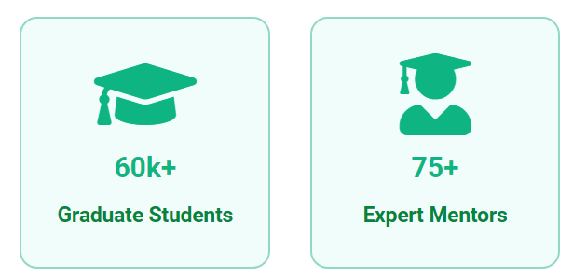
Coders Trust was founded in 2014 by proud Bangladeshi-American programmers Captain Ferdinand Kearwolf and Mr. Aziz Ahmad, a worldwide business leader. Their mission was to make practical instruction available to the general public at a price that was affordable. The goal of this programme is to raise the employment rate to a level that is enough to fulfil the requirements of the global workforce and to make it possible for individuals to earn a living via the acquisition of up-to-date digital skills.
Coders Trust is an organization that was established in New York City and has collaborated with a variety of worldwide organizations. These organizations include the United Nations Development Programme (UNDP), the World Bank, the World Food Programme (WFP), Save the Children, and the Rockefeller Foundation. In addition to the United Nations Development Programme and the Danish International Development Agency, our activities were supported by contributions from a number of venture capital firms located in a variety of countries throughout the world.
As of the year 2015, their company in Bangladesh consists of one campus and one lab. They have around 150 people working for them throughout Dhaka's five modern campuses and 11 labs that are fully stocked with equipment. One contains residential amenities. Chittagong and Khulna are the first two cities in Bangladesh that we wish to expand their business into after Dhaka.
One of Bangladesh's most recognized skill development organizations, CodersTrust Bangladesh, can credit its success to the fact that it has assisted more than 60,000 people in achieving financial independence via participation in global information technology initiatives.

Mission

The goal is to connect underprivileged and underserved groups of individuals to educational opportunities and online labor markets in order to significantly expand the range of high-quality income-earning opportunities available to them and to help them achieve economic independence. When education and the generation of jobs are brought together, a very special atmosphere is produced. In this location, people from all over the world collaborate for the sake of the community as a whole. The following is a list of the goals that Coders Trust Bangladesh has set for itself:
- To establish ourselves as the preeminent supplier of cutting-edge solutions towards the establishment of a digitally advanced nation.
- To have the institution become known as one that organizes successful career sessions.
- Offer organizations talent development and training services of the highest international standard.
- To establish ourselves as the only comprehensive outsourcing assistance and solution provider in the sector by becoming a one-stop shop.
- If you want to save money without sacrificing quality, choose an education or training organization that cares about the environment.
- Making online education available to students at no cost or at reduced rates.
- In order to triumph over the challenges that come along with having no job.

Vision
- The goal is to create the Coders Trust Ecosystem in order to increase job and education opportunities all around the globe. They provide a venue for customers who want to hire freelancers, and users may take use of their services to improve the skills that are important to their careers. They are prepared to remove obstacles in order to make education and training in the field of skill development outsourcing available to people of all ages and genders, and it offers excellent earning potential.

Slogan
"BECOME A ROCKSTAR FREELANCER" is the tagline or slogan for this company.

Organogram
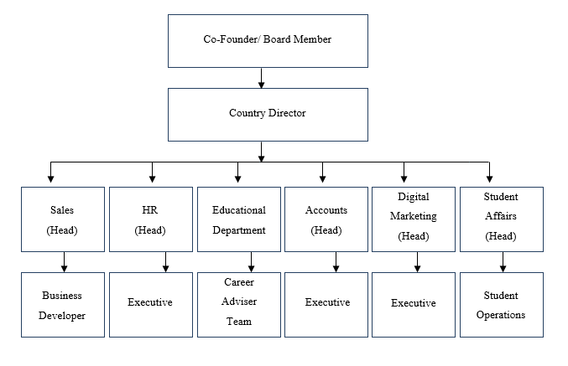
Figure 2.1: Organogram of Coders Trust Bangladesh

Product and Service Line
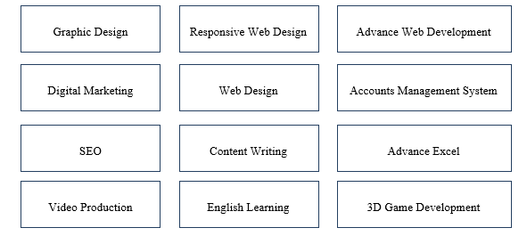
Figure 2.2: Product and Service Line of CodersTrust Bangladesh

Operational Activities of Coders Trust Bangladesh
Since the company's inception, Coders Trust, Bangladesh has been responsible for all six of these departments.
- HRD: The function of human resource management in these companies is to ensure that their personnel are maintained in a systematic way in order for those employees to be able to effectively carry out their job responsibilities to the best of their ability. To be more specific, they carry out each step as described below:
  - Initially, the organization offers its job adverts, sources applicants, filters applications, and performs preliminary two-face interviews. Additionally, the organization organizes recruiting operations with managers, who are ultimately responsible for making the final selection of candidates.
  - Coders Trust offers new hires comprehensive orientation programmes that are designed to assist them in adjusting to the culture of their new job, as well as their new surroundings and mentors.
  - The company is responsible for determining employee pay and doing research to ensure that it is comparable with the compensation practices of other businesses.

- Accounts Department: This department is in charge of all aspects of the company's finances, including all financial transactions:
  - Managing cash flow by paying bills and keeping tabs on whether invoices have already been paid (Cash Flow).
  - Taking in incoming payments and processing them (also known as "Cash unflow").
  - Making certain that each and every worker is compensated for their work (via payroll),
  - Putting together various financial reports, including budgets, balance sheets, and statements of financial status.
  - Maintaining control over monetary operations in order to forestall errors, fraudulent activity, and theft.

- Educational Department: The group of career consultants acts as the department's supervisors. Each of the courses that Coders Trust provides has been assigned to a mentor who has an exceptionally high level of expertise. Mentors must have a scientific background and substantial computer experience in order to be eligible for this role. Additionally, candidates must be self-employed or operate as freelancers. The construction teams follow the timetables that they have created, and at regular intervals, they enrol in traditional classroom settings as well as online learning environments to complete the coursework required of them. They provide their independent consulting services at a variety of periods both during and after the training. In addition to this, it is also their responsibility to organise and timetable all of the classes, examinations, and culminating projects for the students. In addition, there is a business that operates online and offers round-the-clock support to career counsellors and students who are experiencing technological issues or have queries about orders placed by clients or employment.

- The Student Affairs Department: This department assists all of the students who are currently enrolled in the school by offering career guidance, additional training outside of the classroom, and other related services. After a student has been accepted into a course, they will receive an email, a phone call, and a text message informing them when the course will begin. Because of the student affairs department, it is an extremely important component of the organization. This is really necessary in order to keep the students on the right path. The other students were aware of any instances in which a student did not attend a lecture or contributed information that was helpful.

- Business Developer: The enterprise developer team collaborates closely with the company's leaders when it comes to exploring new markets and making strategic decisions. It is of the utmost importance that the team working on the commercial business development maintain up with current responsibilities, such as modernizing the database, policies, and structures. They have conversations with students that fall within their sphere of influence and provide further help with the admissions process in order to ensure the continued financial sustainability of their current business.
The individuals working in the business development department are accountable for a diverse variety of goals, both internal and external to the company. They investigate the offerings and goings-on of other organization’s and, if appropriate, they provide consulting services to other organizations. In addition to this, they investigate the company's surrounding environment, which includes the laws and regulations imposed by the government. Analysts working in the area of business development put their findings to use to increase revenue and profitability at the companies where they are employed. The commercial company developer's division comes across fresh prospects for sales every now and again.
- Consulting and Assistance with Marketing and Pitching.
- Making certain that productive ties are maintained with the clients who have already been acquired.
- Putting together storefront displays and PowerPoint presentations for the purpose of marketing products.
- Keeping in contact with clients in order to inform them of any new alterations that have been made to the services that are provided by the organization.
- Developing financial projections and strategic strategies for the company.
- Communicating with one another face-to-face, over the phone, and over email all during the course of the negotiating process.
- Establishing the sales goals for the team and making every effort to meet or exceed those goals.
- Providing instruction to staff members and workers, as well as aiding other members of the team in the cultivation of their skills.

- Coders Trust’s Digital Marketing Department: The vast bulk of the company's marketing efforts are carried out online. They use a range of different approaches to sell themselves on the internet. The principal priorities of this section are, among other things, promotion, internet advertising, social media marketing, the development of advertising research files, and the compilation of market survey records. The Department of Marketing is responsible for these as well as a number of other concerns. The marketing department publishes frequent updates on social media platforms in order to draw attention to the most recent enhancements to their machines, price reductions, and new product offerings, in addition to forthcoming intake dates and other perks.

Competitive Analysis
Using a competitor analysis model or tool, an organization can evaluate how effectively its marketing strategy stacks up against that of its competitors. Utilizing this idea, one could create a diagram that serves as a guide for conducting an investigation into marketing. An industry's immediate competitors are the subjects of a competitive analysis, which seeks to identify their income sources, company goals, and marketing tactics. During the process of evaluation, the information that has been gathered is structured using a model for competitor analysis. The S.W.O.T. analysis is one of the methods that may be used to detect competitive analysis. (Competitive Analysis – What It Means, Some Examples Of It, And Why It's Important, 2021).

SWOT Analysis
An evaluation of a company's "strengths," "weaknesses," "opportunities," and "threats," abbreviated "SWOT" for short, has become an essential instrument for businesses to use in uncertain times in order to evaluate their position in the market. The acronym "SWOT" comes from the acronym for the phrase "strengths," "weaknesses," "opportunities," and "threats." Rozmi (2018) states that an additional popular use for this kind of study is the examination of the internal and external environments of companies. Depending on whether it is an internal or an exterior portion, each of the four sections will signify either an internal or an external element. The facets of a business that help the organization move closer to realizing its goals are referred to as the organization's strengths, whereas the facets of the organization that work against the organization's efforts to realize its goals are known as the organization's weaknesses. Together, a company's strengths and weaknesses make up what is known as the company's strengths and weaknesses. These are both good and bad qualities of a business. Opportunities for a firm are not limited to things in the outside world that may aid it in reaching its goals; rather, opportunities may also be possibilities to fill in gaps and start new initiatives. Opportunities are not restricted to goods in the outside world that may assist it in achieving its goals. On the other hand, organizational risks are variables from the outside world that may or may not prevent an organization from achieving its goals (Jehad S. Aldehayyat, 2008).
Coders Trust Bangladesh is able to do a SWOT analysis in order to evaluate the present status of
The organization with relation to both its internal and external circumstances. The picture presents
Coders Trust Bangladesh's overall strengths, weaknesses, opportunities, and threats. It was
Created to illustrate these categories.
Strengths | - The Organization's Culture and the Environment It Functions In  - The Company's Reputation in the Market  - Skilled and Experienced Mentors.  - An Efficient Sales Team and Employees  - A Support System for Trainees and Students.  - A Diverse Offering of Training Programmes and Courses.  - BTEB Approved.  - Success Rate.  - Collaboration Robi Axiata.
Weakness | - A low turnover rate among workers and staff members.  - A restricted number of campuses and branches.  - The cost of the classes is rather expensive.  - Students Who Have Left School.  - • A deficit in internet marketing efforts.
Opportunities | - Increasing the number of courses for independent contracting.  - Expanding the capacity for on-campus service around the nation.  - Providing online facilities and services.  - The expansion of the opportunity to suggest individuals who have shown potential.  - The reduction of unemployment rates.  - The expansion of programmes that provide training outside of camps.
Threats | - Participating in new educational institutes.  - A critical evaluation.  - The state of the economy in which the target market operates.  - The assistance and policies of the government.
Figure 2.3: SWOT Analysis of Coders Trust Bangladesh

Organizational Strengths

The trait that sets anything apart from everything else and helps it stand out from the crowd is strength. When contrasting two different things, "strength" refers to the aspect of one that is more advantageous than the other. When used in this context, the word "strength" refers to a quality that is not only favorable and progressive but also beneficial and inventive. According to Thompson and Strickland (1989), an organization's strength may be defined as "anything that the organization is excellent at doing or a trait that the organization possesses that provides it with an essential capacity." Within the scope of this conversation, the term "strength" refers to a resource, skill, or other advantage that an organization has in relation to its competitors and the demands of the markets that it now serves or wants to serve in the future. It is a one-of-a-kind capacity that gives the firm an advantage over its rivals in the market area. It's feasible that we excel in specific areas, such as our financial resources, image, market leadership, buyer/supplier connections, and other factors. Other areas include: (Pearce and others, 1991).
The skills of an organization that contribute to its success in achieving its goals are referred to as the organization's strengths. An organization has to have a thorough understanding of its own potential as well as the qualities that give it an advantage over its competitors before it can take any action in response to a problem or an opportunity. The capacity of an organization to learn from its errors and make the most of available chances is critical to the organization's long-term success. If this is not done, there is no way to capitalize on the opportunities that the outside world has to offer. As a consequence of this, the organization has to capitalize on its advantages in order to meet the challenges posed by the wider world. All of these issues highlight how important it is for a firm to capitalise on its strengths. (Pearce and others, 1991).
Strengths of Coders Trust Bangladesh
Coders Trust Bangladesh has a number of key competitive advantages that set it different from other current firms in the market, which allows it to stand out from the competition in the area of skill development. The advantages of Coders Trust are broken down into the following categories:
- Organizational Culture and Environment
At Coders Trust Bangladesh, you may be certain that the culture will be entirely organized. Every worker is motivated, by the culture of the organization, to make a positive contribution to the lives of others and to improve their marketability to a variety of potential employers. In this environment, workers are actively encouraged to take on obligations outside of their usual job responsibilities that are connected to the growth of the organization and the support of another group. These activities may be tied to the improvement of the organization or to the aid of another group. Because of this, it is much simpler for representatives to push themselves to reach their utmost ability.
- Market Reputation
Coders Trust is an international firm, and as a result, it has always had a good reputation on the market. Additionally, the management team at the company is able to properly manage both its workers and its clients. This is due to the fact that Coders Trust is able to effectively manage both groups.
- Experienced and Skilled Mentors
Because of the extensive knowledge of its mentors, CTBD has a significant competitive advantage over its contemporaries. The CTBD has chosen highly qualified teachers for a wide range of offline and online classes as a consequence of a number of different considerations. They take into consideration a wide range of aspects, including those that are detailed down below:
- Uphold a minimum requirement for elementary schooling.
- Varied depths of common knowledge and specialized skill pertaining to a particular field.
- Consideration is given to both the applicant's professional experience as well as their professional performance.
- Knowledge and experience in the fields of education and training, as well as the capacity to understand students of varying aptitudes.
- The ability to communicate effectively with students enrolled in a wide range of academic programmes.
- Expertise in the field of freelancing professionally, in addition to the ability to make money via freelancing.
- Qualified and in a position to financially support oneself via freelancing.
- Certification according to an international standard that is recognized all over the globe in this field.
- Self-sufficient, able to work well with others, and proficient in communication with both students and teachers.
- Being able to perform well under pressure, in a fast-paced environment, while adhering to strict deadlines, as well as working in a dynamic workplace, are all talents that are highly sought.
It is not uncommon for mentors to take on additional responsibilities, such as recognizing and responding appropriately to the views and concerns of other people, as well as maintaining a high level of moral integrity and diplomacy in a context that is politically sensitive and extremely complicated.
- Effective Sales Team and Employees
The most talented salespeople work for CTBD, and the contribution those individuals make to the organization's overall success cannot be overstated. Because the vast majority of people in Bangladesh are unaware of what freelancing is or that it is possible to earn money through it, sales workers play an important role in this context. This is because the vast majority of people in Bangladesh are uninformed about the possibility of earning money through freelancing. The following are some instances of salespeople employed by companies:
- Establish communication with the person who has shown an interest in the CTBD (either by registering for the CTBD website or the CTBD Facebook page or by sending a message through the messenger).
- You are obligated to provide customers with information (course particulars, duration, and importance), as well as encouragement in reference to freelancing.
- Send them an e-mail or text message informing them about a recent discount or special offer, as well as providing them with the material for the course and your contact information.
- You should provide customers the appropriate direction in order for them to choose the appropriate course of study for their educational history and their professional goals, and you should do this by providing them with the required assistance.
- Additionally, make registration mandatory for anybody who shows interest.

- Support System for Trainee and Students
Coders Trust provides an extensive community of support for all of its members. CTBD makes a convenience available to all of its members in order to make their travels as stress-free as is humanly feasible. They consist of ELMS Talents, a student support group, a support group on Facebook, a team dedicated to student issues, and other groups. They can all be accessed 24 hours a day, 7 days a week online.
- Varieties of training Programs and Courses
Coders Trust Bangladesh caters to its students' individual needs by providing them with a wide range of courses to choose from. Some courses not only instruct participants on how to be successful as a professional freelancer, but they also instruct participants in skills that can be applied to other types of employment, such as those that are more traditional. For example, some courses teach participants how to be successful as a graphic designer.
- BTEB Approved
The Bangladesh Technical Education Board (BTEB) is in charge of regulating and developing secondary technical and vocational education in Bangladesh. This falls within the board's purview of duties.
This organization is responsible for deciding what courses will be offered, developing educational materials, accrediting schools that provide technical and vocational education, managing admissions, and administrating examinations.

- Success Rate
Ignoring the guidelines and policies is the single most essential thing that can be done to improve a student's overall performance. The academic affairs department maintains a careful check on the current situation in each and every class, as well as monitors the development of each and every individual student. The proportion of students who are able to successfully graduate from the CTBD is much greater when compared to the rates of graduation seen at other educational institutions in Bangladesh. The CTBD guarantees that the level of quality and availability of each and every step of the route is maintained throughout the whole of the learning process. This includes ensuring that each and every stage of the route is accessible. The quality and accessibility of a wide range of different aspects, including highly effective management teams, highly skilled mentors, and efficient operations management systems; in addition, they monitor the individual mentoring activities that take place inside the course itself. Students sometimes have their teachers or advisors push regular core tasks, quizzes, and other activities on them. These are some of the things that are expected of them. This is one of the things that students have their mentors put onto them, as it is one of the keys to gaining a bigger student success rate and one of the things that are essential to attaining this. An effective student boundary is maintained during the length of the course as well as after it has ended by using various social media platforms. In a nutshell, this is how the circumstance illustrates the higher student enrollment rate overall.
- Collaboration Robi Axiata
Students enrolled in the CTBD who live in rural areas will be eligible to get a free 30-GB Robi operator for a period of three months. As a result of the agreement, coding aficionados have the opportunity to become professional freelancers on the worldwide web as well as in their local marketplaces. Robi Axiata Limited will provide a 4.5G modem equipped with high-speed digital connectivity in order to facilitate the national dissemination of freelancing training. The CTBD intends to communicate with independent contractors located in rural areas of Bangladesh. This arrangement may be of assistance to CTBD in the execution of freelancing training in the rural areas of Bangladesh, which need access to high-speed internet and network infrastructure. In Bangladesh, Robi Axiata Limited is a well-known and respected 4G mobile phone provider. Robi Axiata Limited provides excellent network coverage in geographically remote areas.

Organizational Weakness

When we speak about weaknesses, we indicate that anything is missing the necessary form and skill. This might apply to anything. When compared with another, it is clear that one thing has a greater number of negative features than the other. This trait is sometimes referred to as weakness. In the context of this discussion, a quality known as weakness is one that is seen as negative and unfavorable traits.
Organizational weaknesses are situations in which an organization's actual existence and capabilities are weaker than those of other organizations or those of its rivals. One example of such a situation is when an organization's competitors have stronger capabilities than it has. It is possible to describe the weaknesses of an organization as those parts or activities that are less effective and efficient in comparison to those of the organization's competitors. Because of this, the entire performance of the organization is negatively impacted, which, in turn, makes it less competitive. As a consequence of this, the organization is unable to respond to a possible threat or opportunity, and it is also unable to adapt to different circumstances.
A situation or set of circumstances that puts an organization at a competitive disadvantage is referred to as a vulnerability. According to Thompson and Strickland (1989), a weakness may be defined as everything that an organization either does not possess or does poorly in comparison to other organization’s. In the context of this conversation, the term "a weakness" refers to a constraint or shortfall in resource, skills, and competences that substantially affects the efficient operation of an organization. These three categories of deficiencies are referred to together as "weaknesses." According to Pearce (1991), a company's buildings, financial resources, management competencies, marketing capabilities, and brand image might all be potential points of vulnerability.
It is necessary for organization’s to evaluate both their strengths and their faults. Owing to the fact that flaws can never form the basis of a plan. Find the organizational flaws that might be contributing to inefficiency and ineffectiveness, and then fix them. This is a necessary step. It is essential to address present challenges that obstruct long-term objectives and plans, as well as to plan for challenges that may arise in the future.

Weakness of Coders Trust Bangladesh
The vulnerabilities that Coders Trust Bangladesh (CTBD) is plagued with are detailed in the following list:
- Limited number of campuses and branches
The Coders Trust maintains a presence in Dhaka via its network of branch offices, which has five campuses in total. At the present, it is a commercial enterprise that is increasing at a fast rate. It is only very lately that it has advanced above the level of beginners. It will, however, take some time before this company is able to spread its operations throughout the nation. Despite this, Coder Trust is putting in a lot of effort to quickly expand its operations to other places around the country as quickly as they possibly can. It is possible that, in the near future, some limitations that have been imposed, in particular on rural populations, may be removed.
- Turnover rate of employees and Staffs
One of the most troublesome characteristics of this organization is the fact that it has the highest personnel turnover rate available on the market. This issue is due to the low pay scale, and employees have said that they do not want to remain in their employment for an extended period of time. A high staff turnover rate may also be the consequence of other situations, such as a high degree of working pressure, large sales objectives, and the absence of a set work schedule, amongst other things.
- Fees for courses are high
The price of this class is far more than that of any other establishment that provides opportunities for skill development, and it is even more costly to get training in a conventional classroom format. A sizeable fraction of those who are interested in taking the classes end up deciding against it because of the price tag attached to them.
- Drop out Students
It is usual practice to refer to the antecedents of a participant's decision to drop out as the "pivotal event" in the chain of events leading up to the participant's final failure. Coders Trust is going to have to work to overcome this obstacle. Because of the following factors:
- Boredom: The most common reasons for a participant's departure from CodersTrust are boredom or a lack of interest. According to Psychology Filled, their students often comment that the material covered in the courses does not apply to their real-world situations. Children, parents, educators, and educational organization’s all have a responsibility to combat the issue of childhood boredom.
- Academic Struggles: Because students focus more on Coders Trust coursework, the students' grade point averages might suffer as a result of this shift in their academic priorities. Coders Trust also serves the academic community. Having said that, this is of a semi-academic nature. Participants have chosen to leave from Coders Trust due to the fact that they were unable to provide enough attention to both topics.
- Family and Economic Issues: If issues that were not expected develop, there is a possibility that the family's financial stability may be jeopardized. It is possible that as a result of these modifications, a significant number of people may be need to take part-time jobs in order to provide for themselves and their families. It's possible that students who are already dealing with a lot of stress might have their situation made worse by family-related events like a death in the family or a breakup. People who are concerned about maintaining a healthy balance between their academic and extracurricular responsibilities might choose to forego conducting any research at all.
- Students are Unfamiliar on Online Courses: Students who take their classes online regularly report feelings of unease. Despite the fact that it is not difficult, kids are not used to doing it. They may be found in a variety of locations. Many students are still required to study face-to-face with a book as part of the conventional educational system, which is applicable to teachers. People's ways of living are altered so that they may better conform to the requirements of modern society.
- Lack on online marketing
Numerous companies now offer their services to customers via the internet. The advertising of online services is, to put it nicely, a costly endeavor. Organizations should make advantage of social media platforms like Facebook, Twitter, and YouTube in order to promote their online service offerings. In addition to this, it is more economical. Many people choose to disregard the promotions because they aren't interested in them. They don't put a lot of effort into digital marketing via social media and other channels, including Google Ad Words, thus they don't get very good results. They should explain to the students the benefits of enrolling in the course and using the online service and market their present and upcoming online courses and services to the students. In addition, they should advertise their courses online.

Environmental Opportunities

The word "opportunity" is used to refer to a situation or environment that provides favourable conditions for participating in a certain activity. The idea of opportunity encapsulates not only the possibility of achieving one's goals but also the drive necessary to pursue those goals. As a result of this, it has a characteristic that carries with it the potential to be useful and advantageous.
When it comes to the management of a company, the term "opportunity" refers to a time or circumstance in which it is feasible for the business to achieve the goals it has set for itself. Conducting a thorough analysis of the organization's surroundings enables better identification of opportunities that may result in favorable outcomes for the business. Companies are given access to a variety of options as a result of intense rivalry and hard labor. Opportunities are conditions in the external environment that make it possible for an organization to capitalize on its strengths, overcome its weaknesses, or mitigate the effects of environmental dangers. (2005) According to Harrison.
Opportunities of Coders Trust Bangladesh
The following is a rundown of the vacancies that are currently available at Coders Trust Bangladesh:
- Introducing more freelancing courses
In order to get a better understanding of the entire skills of the individuals living in these nations, CTBD is currently offering courses in computer science and business experience that range from beginner to intermediate level. The CTBD may provide a high or advanced level, as well as an upper advance level, depending on the student's needs. The CTBD is capable of extending the potential since it is a global chain business. Because there is no other way or higher level of expertise to handle this situation, global collaboration is the only way to solve the problems.

- Spreading capacity for countrywide On-campus service
Coders Trust Bangladesh (CTBD) is working aggressively to implement its goals to immediately establish several sites all throughout the nation. There is a chance that they will be able to provide service to their customers located in every region of the world. This platform does not provide users access to each and every one of the obtainable online course options. As a result, this presents an outstanding opportunity for CTBD to provide assistance to students on campus.
- Providing online facilities and services
In order to maintain its position as a market leader and provide its customers with the most convenient and effective service possible, Coders Trust Bangladesh has made the decision to move its operations to an online-only platform. Coders Trust was able to get in touch with a greater number of students during the CORONA epidemic, which contributed to the program's overall level of success.
- The possibility to propose meritorious candidates expands
Students who have shown exceptional academic achievement are offered the opportunity to participate in a variety of co-op job experiences. CTBD is responsible for carrying out all of the duties. The CTBD's several departments each provide their own unique selection of classes. CTBD student affairs include numerous divisions for different courses. Every single class will have one or two students who are particularly outstanding or deserved, and this will be determined by the mentors based on the students' daily performance in the classes, their assignments, their quizzes, and any other relevant criteria. At the end of each course, the mentors hand over the students who have shown exceptional academic achievement to the CTBD student affairs wings. Therefore, the CTBD student affairs wings search for applicants in their immediate area. In most cases, famous companies in our country provide awards to eligible CTBD student candidates who have applied for jobs because they have amazing abilities. A beneficial chance for students of CTBD to discover such industry. CTBD students are successful in the local business community.
- Reducing unemployment
Coders Trust Bangladesh (CTBD) is a learning and revenue network that offers endless mentor support around the clock in addition to the most effective tools to promote the freelancing profession. These tools cover everything from gaining proficiency in coding to becoming an expert in internet marketing, and their purpose is to prepare people for the 50,000 jobs that are regularly listed on freelance portals. Students are required to compose cover letters, deal with cultural diversity, learn how to market oneself across multiple freelancing platforms, and so on and so forth. Refrigeration is only one of these requirements. Their path to education and financial independence was designed to teach coding and foster the development of capable freelancers.
- Increase program for off-camping training
Coders Trust Bangladesh offers programming classes ranging from those designed for novices to those designed for more experienced coders. Additionally, market research is something that is done by the company in order to determine which emerging topics are of the most interest to students. As a direct consequence of this study, Coders Trust routinely offers new classes in order to fulfil the requirements of its customers.

Environmental Threats

A situation or circumstance that creates an environment in which the achievement of an objective may be jeopardized is referred to as a threat. It is a way of referring to a situation that is unfavourable to one's interests. As a consequence of this, it has an unfavourable attribute that designates it as something that should be avoided at all costs.
Anything that makes it harder or impossible for an organization to achieve its goals is considered to be a threat to that organization's success. Threats are situations that arise as a result of changes in the immediate or distant environment. They are unfavourable for the organisation because they would prevent it from being able to continue existing or would cause it to lose its competitive edge. Threats may be classified as either immediate or long-term. (2005) According to Harrison.
It is important to recognize that the future success or failure of an organization may be influenced by a variety of external factors, including but not limited to those in the following areas: economics, social and cultural trends; demographics; the environment; politics; legal and regulatory frameworks; technology; and market forces. This is something that needs to be taken into consideration. Recognizing this is important because it is important to acknowledge that the future success or failure of an organization may be influenced by a variety of external factors. Recognizing this is important because it is important to acknowledge that this. The possibilities and dangers that are essentially outside the control of a given company are referred to as being "external" to that company. The controlled activities of an organization that are carried out in a particularly successful or poorly executed manner are referred to as the internal strengths and weaknesses of the organization, respectively. Management, marketing, finance and accounting, production and operational research and development, and management information systems are all examples of business activities that a firm engages in. The process of determining a company's functional strengths and weaknesses and making an assessment of them is required by strategic management. Attempts are made by organization’s to execute strategies that make use of their own internal strengths and weaknesses as well as capitalize on those strengths. (David, 2003).
Threats of Coders Trust Bangladesh
The following dangers are faced by Coders Trust Bangladesh:
- Entering new training institutions
Coders Trust may run into issues due to the competition of some of the other consultancies operating in this industry, such as Creative IT Institute and Careers Hub Bangladesh, and this may have a substantial detrimental impact on the expansion of the organization.
- Negative Review
Coders Trust Bangladesh is an organization that does not make a profit. It is not unusual to get negative comments from students as well as from the sponsored agents of other training schools. As a direct consequence of this, both Coders Trust’s reputation and its market growth will suffer significantly.
- Economic condition of the target market
Students are discouraged from enrolling in skill development programmes as a direct result of the current state of the economy in our nation, which has a direct effect on the expansion of their enterprises.
- Government support and policies
Coders Trust is a company that has operations in many countries throughout the world. As a result, multi-national corporations are sometimes required to comply with a diverse range of rules and regulations. There are circumstances in which such restrictions provide significant challenges for international firms.

CHAPTER 03
ANALYSIS AND FINDINGS

Sales and Digital Marketing Strategy of Coders Trust Bangladesh
According to Aimin (2016), the success of many businesses may be attributed to their capability of putting into action the marketing plan alternatives that they have chosen, in addition to their well-developed marketing strategies that describe where, when, and how they will compete in the market. According to Jayachandran (1999), In order to properly steer the deployment of the limited resources that are available via the company's marketing skills in the pursuit of desired goals and objectives, it is vital to have marketing strategies that are both appropriate and efficiently implemented. The choices on market segmentation and targeting are handled by the standard STP framework for marketing strategy. This framework places a primary emphasis on market segmentation, target, and positioning. The substance of a firm's marketing strategy determines the markets in which it will compete in order for the company to meet its strategic marketing and sales objectives.
Coders Trust Bangladesh focuses a great deal of attention on the people who will be using its services. The organization engages in market research to ascertain its ideal customer profile in order to better serve them. Following an analysis of the findings of the research, the company classifies the characteristics of the typical group that comprises Coders Trust’s target audience. These characteristics include the individuals' behaviors, appearances, and demographic information. They are mostly contemplating in terms of:
- The subject of how one should approach their target demographic is an essential one to consider.
- In order to pique the interest of the readers in the specific content that will be shown on the page.
- Which of their marketing techniques do they believe has the most potential for success?
- Will they do so on their own will in order to get the course?
- What is the maximum amount that they are willing to spend?
The firm gains a variety of benefits as a result of this evaluation of Coders Trust Bangladesh's target audience, which also contributes to an increase in the company's overall sales volume.
- Thanks to the data that they have at their disposal, CodersTrust is in a position to locate and focus their marketing efforts on the specific clients who have a need for the products and services that they provide.
- The establishment of long-term connections with customers is the means through which the greatest possible levels of customer satisfaction may be maintained.
- Maintaining a lower overall operating cost.
- It helps to an increase in the number of potential customers and the success rates of the clients.
- It gives a business an edge over its competitors..
The following people make up Coders Trust Bangladesh's major emphasis, often known as its target consumers:
- Freelancers: The word "freelancer" refers to those who are already working as freelancers but have the intention of expanding their knowledge and capabilities by enrolling in a variety of IT classes. A significant proportion of self-employed people are now enrolled in training programs in order to develop existing skills or acquire new ones. This Freelancer group is particularly important to Coders Trust Bangladesh as it accounts for 25% of the company's total income.
- Universe Students: Students at the university level have access to courses that might help them enhance their skills. Students who want to get the most out of their academic educations and prepare for jobs as independent contractors really need to take classes like this one. Over 15% of Coders Trust Bangladesh's student body is comprised of students from this demographic.
- Job Holders: At this moment, a lot of people are looking at freelancing training because they are considering becoming freelance as a method to increase their income. More than twenty percent of students at Coders Trust Bangladesh are from the aforementioned group.
- Unemployed People: Over thirty-five percent of the students who are enrolled in the freelancing programs at Coders Trust Bangladesh are a part of the thirty-five percent of students who are currently unable to find work in their home country because there are not enough jobs there. This is due to the fact that there are not enough jobs there. This is the situation since there are not sufficient employment opportunities in that area.
- Retired Person: Freelancing is becoming more common among retirees in today's culture. This is likely due to the fact that freelancing enables seniors to put their leisure time to productive use while also providing a significant source of money for them. This is one of the reasons why freelancing is getting more popular among retirees. It has come to our knowledge that a lot of people who have been laid off are planning to go to Bangladesh in order to join at Coders Trust Bangladesh and get training in freelancing. In addition to that, there is a need that a minimum of 5% of the total student body be composed of people accepted from this group.
The following picture is a visual representation of the customer acceptance percentages obtained by Coders Trust Bangladesh:
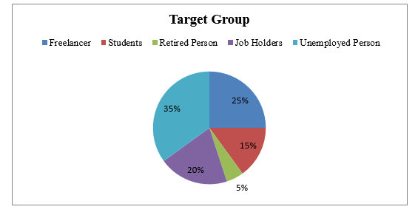
Figure 3.1: Target Customers of Coders Trust Bangladesh
While Coders Trust Bangladesh is in the process of defining its Target Audience, there are a few more steps that need to be taken before they can begin conducting in-depth research on their target audience: define common characteristics of their typical customers. As a consequence of this, Coders Trust Bangladesh puts a great priority on knowing the demographics of the country's population, which includes their requirements, preferences, aversions, possible difficulties, and other factors. Coders Trust Bangladesh will be able to take part in a wider variety of market activities, each of which will provide the company with a greater possibility of acquiring new customers.
Demographic and Geographic Segmentation
In their day-to-day operations, Coders Trust Bangladesh depends largely on demographic data, which refers to the major characteristic or description of their target audience, customer base, or population. The demographic analysis provided by Coders Trust provides users with access to a variety of important components, including:
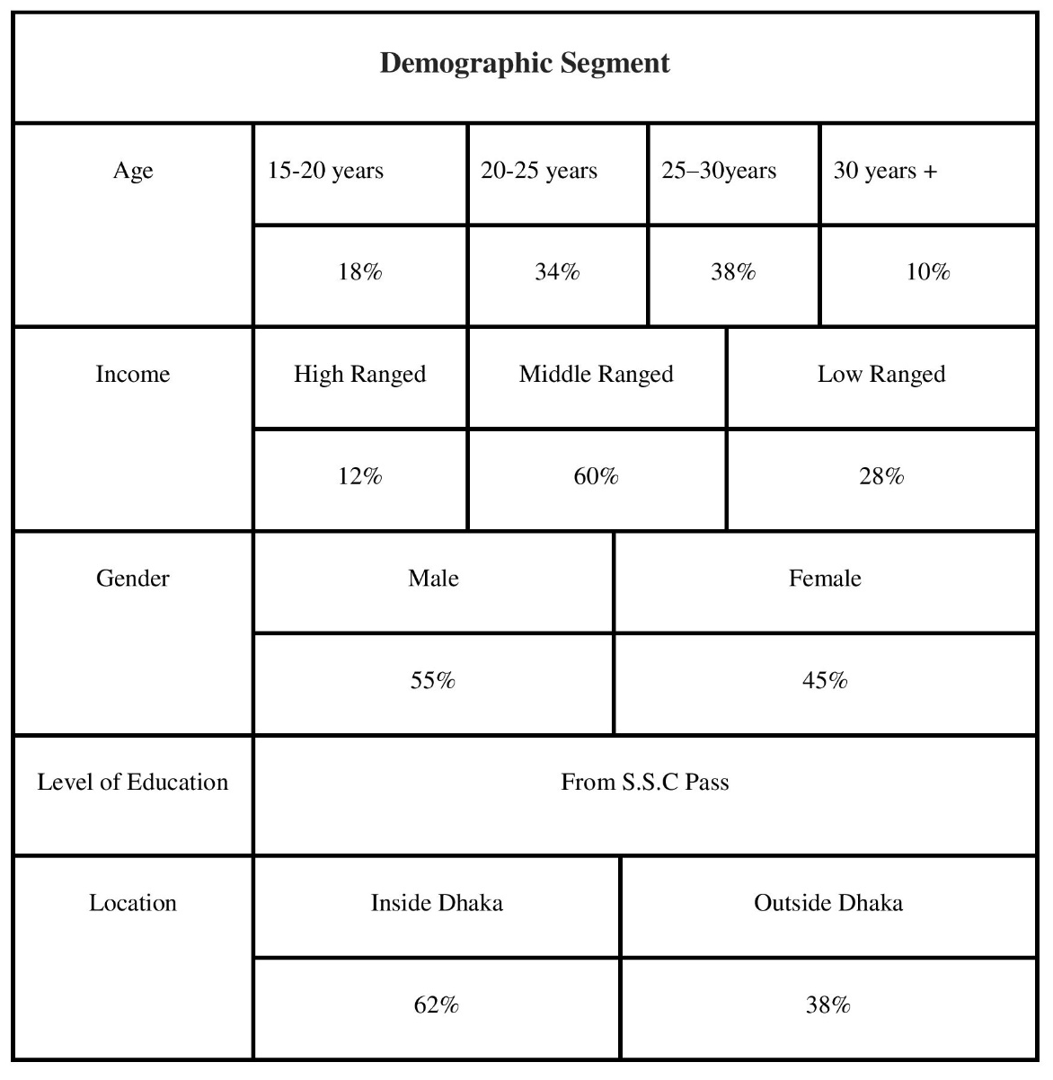
Table 3.1: Demographic Segments of Coders Trust Bangladesh

Marketing Mix Strategy (7Ps) of Coders Trust Bangladesh

The term "marketing mix" refers to a set of marketing tools, both strategic and tactical, as well as controlling components of the business, that allow a firm to make a product or deliver a service to a consumer in keeping with the demand of the market. These techniques include direct marketing, personal selling, public relations, search engine optimization, and online advertising. Some of the marketing approaches that are included in this category are called "direct marketing," "personal selling," "public relations," "search engine optimization," and "internet advertising." This collection of marketing tools may be broken down into two primary categories: direct marketing tactics and interactive marketing strategies. Both of these categories are subsets of inbound marketing. Both of these approaches to marketing fall under the category of what is known as direct marketing. It is the responsibility of the business or organization to connect the marketing mix in order to demonstrate the product or service on a target market, and the quality of this connection is what will determine whether or not the consumer demand for the product or service is met. In addition to this, it is very beneficial when doing research and planning for marketing, putting new strategies into action, and revealing more prospects for market targeting (Badi, 2018). In order for a business or organization to be financially successful, it is essential for them to have the ideal product, the proper pricing, the ideal time, the ideal location, and the appropriate product promotion. For the firm or organization to be successful in achieving its aims and objectives, it is very necessary for this to be done.
In this portion of the study, the primary emphasis is placed on the components of Coders Trust Bangladesh's marketing strategy that are of the utmost significance. As a consequence of this, we will examine the 7Ps of marketing and investigate the ways in which they are interrelated.

Products and Services (Training Courses)
The product or objects themselves, according to Coders Trust Bangladesh, are the most significant component. The goods offered by Coders Trust are well-liked and helpful to a diverse group of students as well as professionals working in the commercial sector. These solutions are, in their most basic form, a compilation of educational resources for a wide range of distinct categories of occupational competencies. Coders Trust Bangladesh has developed a solution that is not only aesthetically pleasing but is also very effective and can be tailored to meet the particular requirements of each individual client. This is the area in which Coders Trust focuses the majority of its emphasis on product variety, product differentiation, and product elimination, all of which are determined by the requirements of its clients. Students have the option of shopping for the necessary items either online or at traditional stores in their local areas.
Coders Trust has established systems that provide freelancers with a regular income while also being in high demand on the market for freelance work. The duration of the programs offered by Coders Trust ranges from three to ten months, depending on the nature of the subject matter and the level of difficulty involved in the programming. The company gives young people the opportunity to participate in private tutoring sessions as well as educational lectures in the hopes of inspiring them to further their education. They have lately worked on plans to give free freelancing training to 2,000 female students by the year 2022 as part of a project dubbed "Women skill development and empowerment." This project will be completed in 2022. They seek to accomplish this objective by means of the project. In addition, customers who are economically disadvantaged or handicapped may get a discount of fifty percent off their purchase from Coders Trust. The following is a list of Coders Trust’s options for its short-term courses; the company also provides options for its longer-term programs.

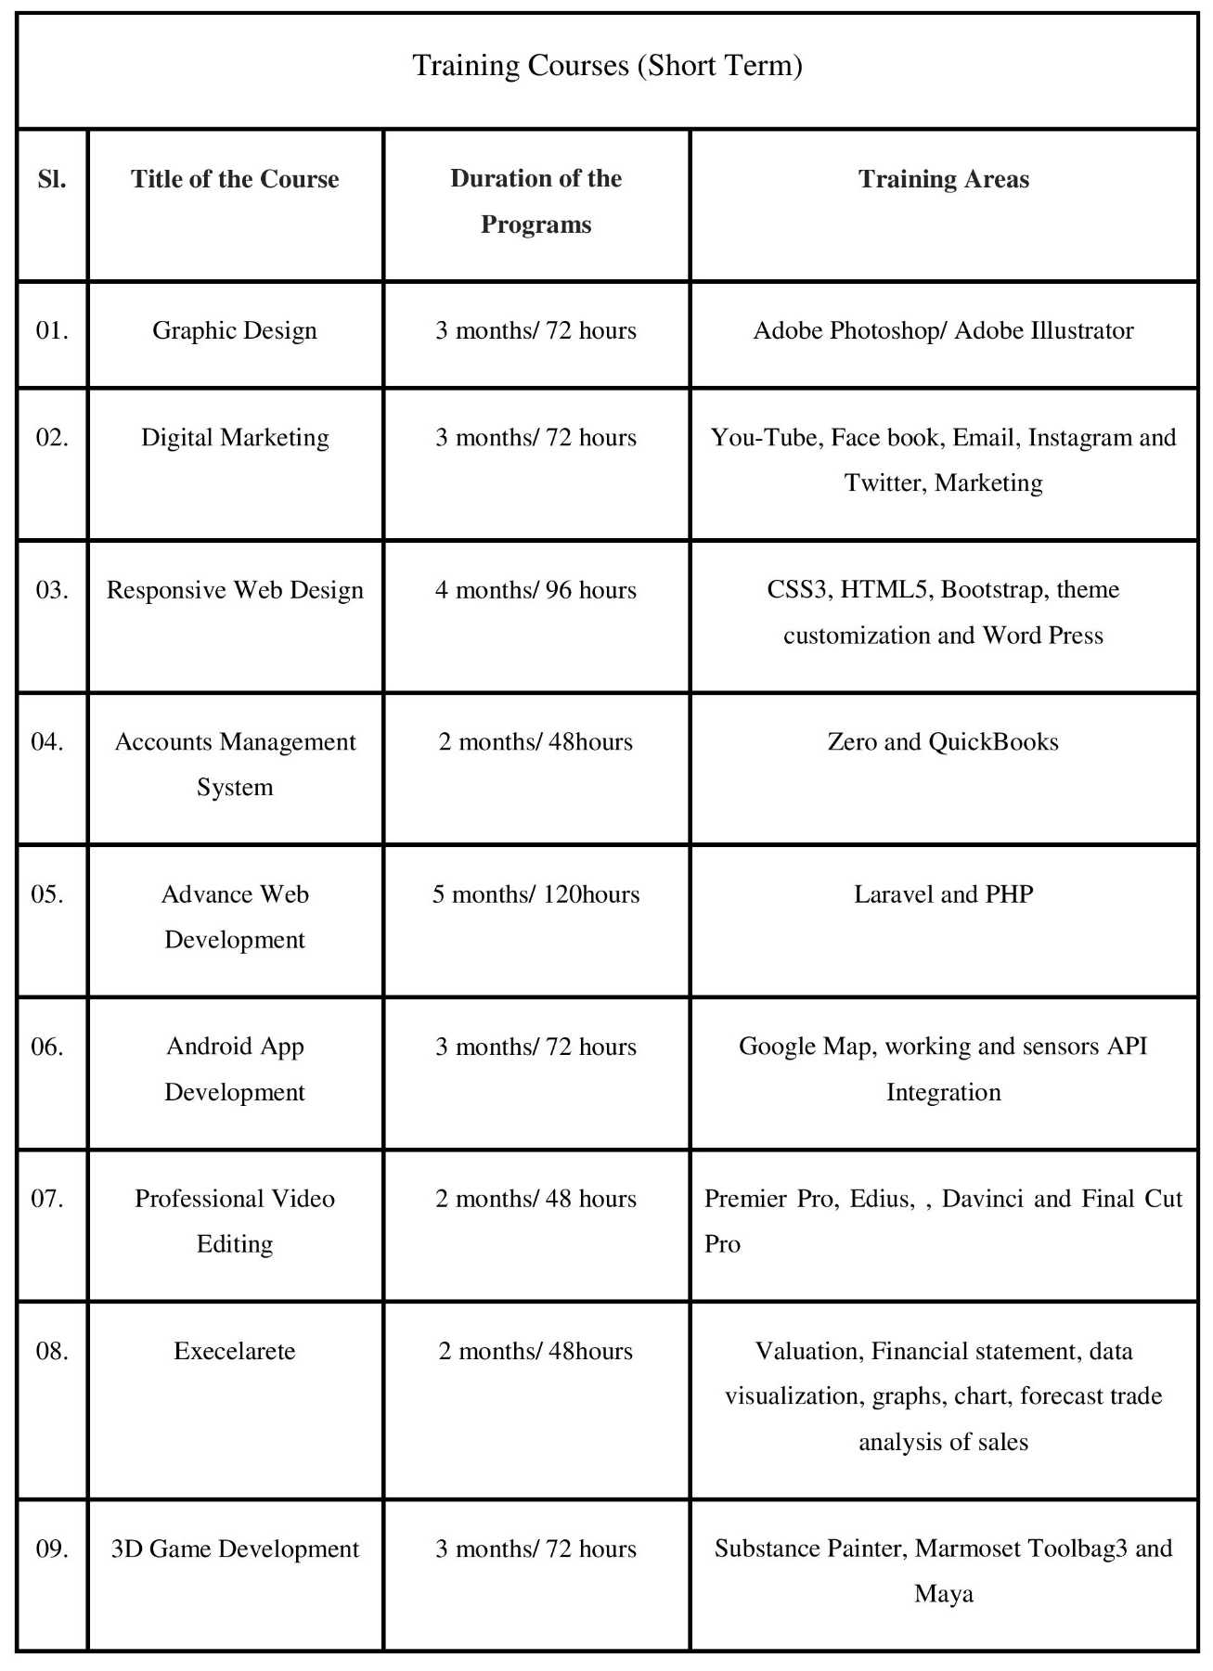
Table 3.2: Training Courses at Coders Trust Bangladesh
In addition, Coders Trust offers Diploma Courses, which may be finished over a longer period of time and consist of specialized services for businesses and other organizations. These services include lifelong assistance (mentors may contact this organization at any time and get service from the team), as well as the awarding of an international certificate upon the successful completion of the diploma courses.

Table 3.3: Diploma Training Courses at Coders Trust Bangladesh

Place (Coverage Location in Bangladesh)
The organization has handled projects in 11 countries spanning Asia and Europe, including India, Kosovo, Malaysia, Bangladesh, Bhutan, Iraq, Kenya, Honduras, Poland, and Jordan. These nations include India, Kosovo, Malaysia, Bangladesh, Bhutan, and Iraq. The organization's headquarters are located in Denmark, and it also has offices in Bangladesh, the United States of America, and Kosovo. At their Center, they are the exclusive providers of skill development and information technology training in Bangladesh. They provide a total of five different venues dotted all across the metropolis of Dhaka.

Table 3.4: Number of Branches and Campuses of Coders Trust Bangladesh
They just recently made the statement that they want to create an additional 8 sites in a variety of districts all throughout the nation, and they have big hopes for expanding their business. They have already begun construction on their Chittagong site, and their goal is to begin offering lessons there as soon as physically practicable.

Prices (Fees of Courses)
When it comes to the creation of a brand-new product, pricing is one of the most essential considerations, as it has an immediate impact on the financial results of the business. According to Badi (2018), the price of a product is established by a variety of elements, the most important of which are the product's target market, its production costs, the capacity of the product's target market to bear those costs, and the economy as a whole. Because of its dedication to providing high-quality goods and services at reasonable costs, Coders Trust Bangladesh has been able to capture a significant portion of the Bangladeshi market for businesses that specialize in the training and development of human resources.

Promotions
In today's market, a product must be successfully conveyed to potential clients in order to spark their interest in acquiring the product and have it be successful. If this is not done, the product will not be successful. Marketing a product in such a way that it is successful is very necessary. In order to promote its products, Coders Trust runs ads on television, organizes events, participates in BP activation, organizes conferences and publishes related content; it also uses billboards, social media, and corporate advertising.
- Billboard Advertisement: The city of Dhaka is home to a number of Coders Trust billboards, which can be seen in a variety of locations. These billboards will be placed in strategic locations across the city, such as universities and administrative districts. The material that is shown on Coders Trust’s billboards is updated on a regular basis, and it is updated to reflect new courses, new facilities, and discount deals.
- Social Media Marketing: Coders Trust makes effective use of the social media platform, which is now the most popular platform for advertising, by using a variety of strategies, including pop-up advertising, updating site pages, marketing on YouTube and Instagram, search engine optimization, and more.
- Advertisement on Television: Coders Trust Bangladesh is able to reach a large audience via the use of television advertising; hence, the company maintains the production of captivating ads that are shown on a variety of television channels in order to disseminate information on its products.
- Website: The website of Coders Trust Bangladesh, which has a server that has been thoroughly optimized, makes each and every facility and service accessible to users. The information on the website about the products, the discounts, and the phone number are all routinely updated. As a consequence of this, the website accessible at https://coderstrustbd.com/ also plays a significant role in helping to disseminate information on it.

People
When it comes to the promotion of any goods or products, the most important aspect of marketing management is undoubtedly the management of people. In addition to this, it guarantees that the massage procedure is integrated with the personnel of the organization. Members of Coders Trust Bangladesh's business development and digital marketing teams are tasked with filling this function on the company's behalf. More than one hundred people are now employed by the company in Bangladesh, and they act as ambassadors for the business in several locations around the nation. The marketing staff at the company is experienced in providing excellent customer service and is actively involved in the community. Two of the most important obligations that fall on the shoulders of a sales staff are the upkeep of healthy customer connections and the management of the company's sales. They make an effort to make the procedure as simple and uncomplicated as it can possibly be for prospective clients by calling them and requesting them to come in for a personal consultation. If the customer has indicated that they are interested in taking the class, the administrative staff will take their payment and start the admissions process.

Physical Evidence
Coders Trust Bangladesh is the most successful information technology company in Bangladesh at the moment. Getting customers to look away from the product and toward the one being advertised by a rival is one of the most difficult challenges in advertising. The image of the brand is the single most essential consideration when attempting to evaluate the desirability of a product. As a consequence of this, the image of the brand might be anything from traditional to cutting edge. The marketing approach of Coders Trust Bangladesh places a significant emphasis on brand management. They supply their staff with branded things such as t-shirts, mugs, cups, and pencils in addition to other items. In addition to this, they provide a selection of different classes to cater to the requirements of the market. As a result of this, they use a variety of strategies in order to enhance the quality of their products and services. Some of these strategies include the hiring of employees with a high level of expertise, the development of new communication services, the provision of high-quality training and educational resources, and other similar strategies.

Process
The process of delivering a service refers to the myriad of delivery modes that are available to meet the requirements of the individual customer. As a direct consequence of this, several options for delivering the service are already available. Coders Trust Bangladesh has a number of processes that begin with customer or client interaction and effectively conclude with a course evaluation. These phases are part of the strategy that they use for their service delivery process.
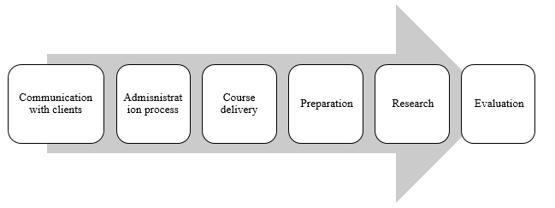
Figure 3.2: Product Solution Process of Coders Trust Bangladesh
Extended selling is a method that, within the realms of business and sales literature, is understood to have a number of distinct meanings. Some people see procedures as a way to accomplish a given goal, such as acquiring a thirty-first market share by putting a sales plan into action. Others view procedures as an end in themselves.

Sales and Customer Relationship Management of Coders Trust Bangladesh

As was just discussed, customer relationship management (CRM) procedures are a crucial component of the position that a firm has in the market. Not only do they make it possible for companies to maintain a strong contact with the prospective consumers they already have, but they also make it possible for companies to streamline their business plans, which in turn helps them raise their sales and their profitability.
The CRM practice that Coders Trust Bangladesh has been employing in order to continue attracting potential students, maintaining past students, and collecting different student papers from spreadsheets in order to update their data in Zoho CRM is now being maintained via the usage of Zoho CRM. This is being done in order to continue luring potential students and to maintain engagement from former students. Coders Trust maintains a record of the following information on pupils for the whole of this process:
- Obtain the student's name, email address, phone number, and current postal address from Facebook and other websites, and then put that information into a database. This process is referred to as KYC, which stands for "know your customer."
- Constructs spreadsheets in Zoho CRM using the KYC information.
- It is recommended that a comprehensive check of the data be carried out in order to exclude the potential of mistakes and entries that are duplicated.
- If there are any mistakes or duplication found in the content, you are responsible for making any required modifications to it.
- If the information has not been duplicated, the student worksheet file should be marked with a green checkmark as the last step in the process.
As soon as the company developer is satisfied that the information has been acquired exhaustively and accurately, it will be sent to the sales manager. After reading over all of the client information and deciding that it is appropriate, the director of the department will only give the go-ahead to work with these trainees if he or she is satisfied with it. As a direct consequence of this, a rundown of the responsibilities that are delegated to the sales team and business developers may be seen below:
- By contacting the customers who have already registered via the website and the Facebook page, you should get in touch with the customers who have already signed up.
- Get to know their goals by welcoming them with friendliness when you first meet them, and inquire about whether or not they want to continue enrolling in the course that they first expressed interest in taking.
- If the student gives a negative answer to this question, you should note that they are not interested in Zoho CRM as a potential career path.
- If the response to the question is "yes," then the business developers will take note of the student's academic past.
- You should ask the students whether or not they have the appropriate prior knowledge for the course, since the majority of courses need a particular set of prerequisites before enrolling in the class.
- It is essential to keep consumers up to date with material pertaining to the course, and in the event that some customers are showing a lower level of interest in the program, the company developer may try to build these customers' confidence by sharing their accomplishments and urging them to keep continuing.
- It is common practice to inquire of clients, prior to scheduling an appointment, if they would be interested in visiting the office to learn more about the available programs and services.
- When customers reject to come into the office, the consultant gives them information that is pertinent to their situation instead. After that, they will have an understanding of the costs associated with receiving training both online and in-person from the business development team and adviser of the firm.
- At last, the customers are given a few days to make a choice, and they are told that representatives from Coders Trust will get in touch with them once again to have a better understanding of which option best suits their needs.
At the Bangladesh office of Coders Trust, an orientation session will be held for new students. During this session, the new students will learn about the previous students of their tutor and how those students have gone on to become successful business owners. It has been brought to our attention by a number of students that they are struggling to meet their financial obligations and thus are unable to register for the whole semester at once. They provide the choice of making the first payment before to the beginning of the segment, as well as the option of paying the remaining balance in two installments once a month has passed. The next step is for the student to provide their personal information in the form of an online registration, which also includes the contact information of a reference. As soon as CodersTrust has accomplished all of the relevant paperwork and processes, they quickly update their list of winning offers inside the Zoho CRM platform and begin producing cash revenue by filling out the admission forms, charging students for their tuition, and providing receipts. During the final phase of registration, there are only a handful of spots available for brand new students.

Sales Campaign in Zoho CRM
Utilizing Zoho CRM, you are able to organize and keep track of the total cost of your marketing efforts. The campaign being run by Coders Trust may be recognized at a variety of different stages, and all activities, events, and contacts can be connected to one another. A comprehensive overview of all of the marketing activities in which a single customer is engaged is one of the additional services offered.

Sales Order
When a customer places an order with Coders Trust based on a quote from Coders Trust, the order confirmation that is delivered to the client by Coders Trust is referred to as a sales order. Offers may be turned into customer orders with only the click of a button for marketers.

Invoice
A seller would often send an invoice to a customer in order to collect payment from the client for any goods or services that the seller has already given to the client. With the click of a single button, offers have the ability to be converted into sales orders or invoices.
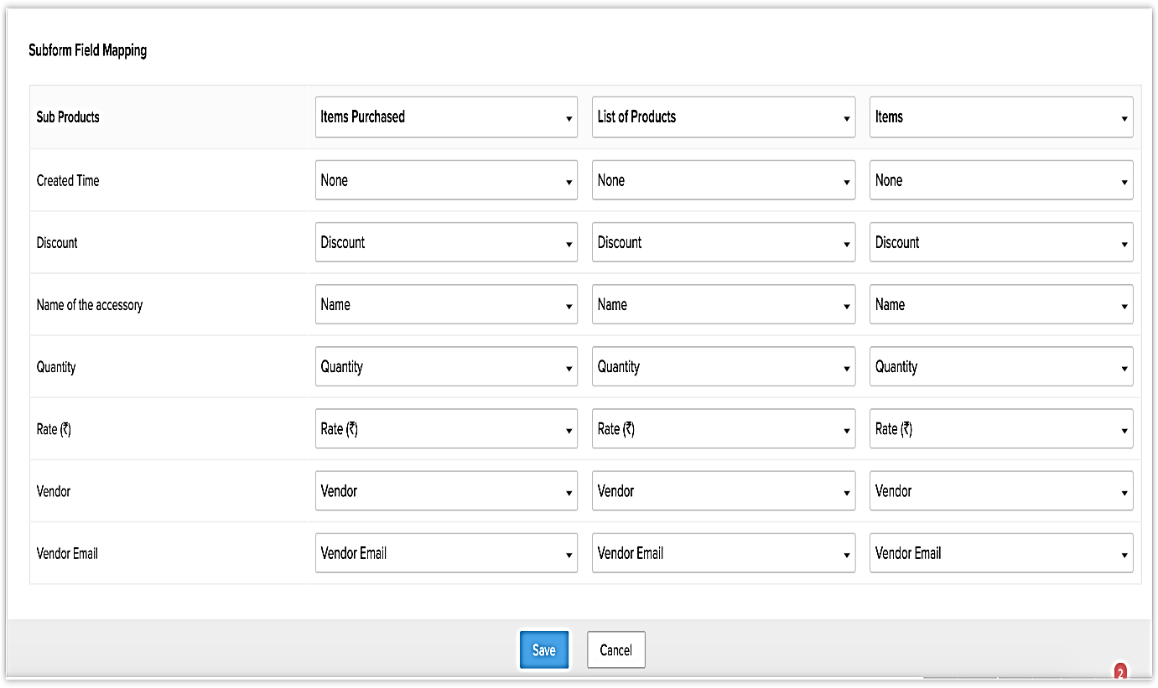
Invoice Page in Zoho CRM

Potential Clients List/ Lead
The customer prospect list provided by Coders Trust is helpful in the process of developing new sales opportunities. The information was acquired on individual people or organizations via various sorts of promotional outreach such as trade exhibits, seminars, commercials, and other forms of public outreach. When leaders in Zoho CRM match the requirements, customers, contacts, and transactions (opportunities) will be automatically generated for those leaders.
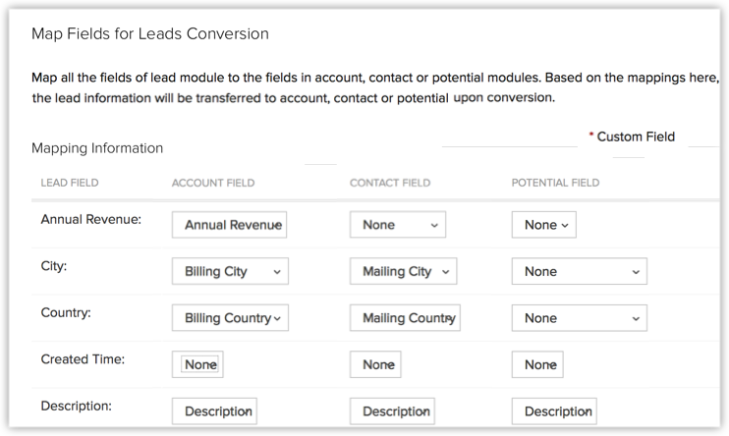
Zoho CRM's page for lead generation
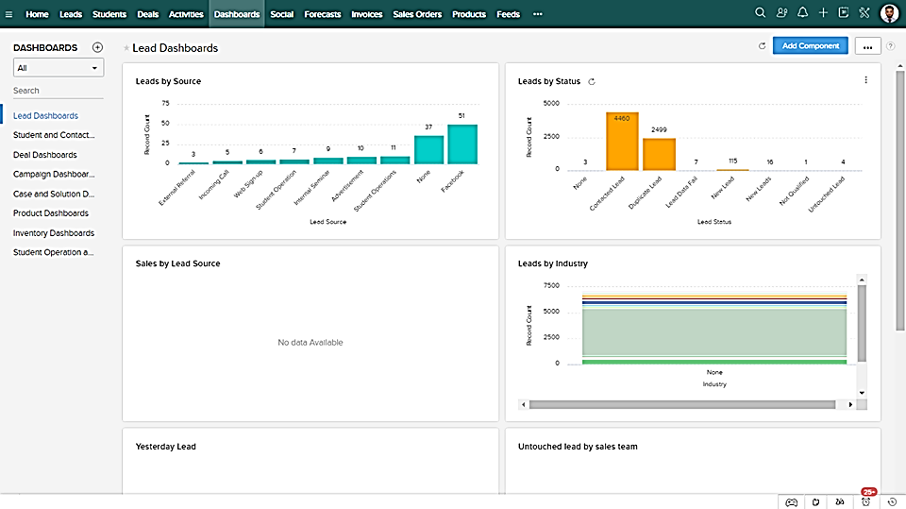
Dashboard for Prospects and Leads in Zoho CRM

Contacts
Respectable programmers are engaged in conversation with companies (like Up work and Fiverr) in order for the companies to discover job opportunities. There are likely to be several connections from the same company scattered across this list, as well as contacts from a variety of departments. CRM contacts are often created by converting qualifying leads, importing contacts from an existing list, or adding contacts to Coders Trust’s database on the basis of a business link.

Accounts
An organization or department inside an existing company that makes use of CodersTrust's services is referred to as a Coders Trust account. With Zoho CRM, a company can link as few as one contact to a particular account as well as as many as one hundred contacts to that account. When one company sells its products or services to another company, one of the most important aspects of doing business in the B2B market is to maintain accurate records of key information on the receiving company.

Sales Forecasting
As the owner of a business, proper forecasting is necessary for arriving at sound decisions and accurately estimating future sales. Individual, real-time perspectives of Coders Trust’s business are made available for the purpose of monitoring and bettering Coders Trust’s internal sales operations.

Modules
The data stored in Zoho CRM is partitioned into subsets according to the degree to which they are comparable to one another. The term "table" refers to any department that collects data in a way that is analogous to the method in which data is collected by another department. In the case of a lead module, for example, it is responsible for storing all of the pertinent information on a company's leads. Some of the additional modules that may be used are customers, contacts, quotations, and quotes. In addition, there are two basic kinds of modules that are available in Zoho CRM: preconfigured and user-generated modules.

Recording
Any content in a module that has been captured on audio or video is referred to as a recording. If there are 10 leads in the Leads module, then each one of those leads is a record. For instance, if there are 10 contacts in the Contacts module, then each of those ten contacts constitutes a record.
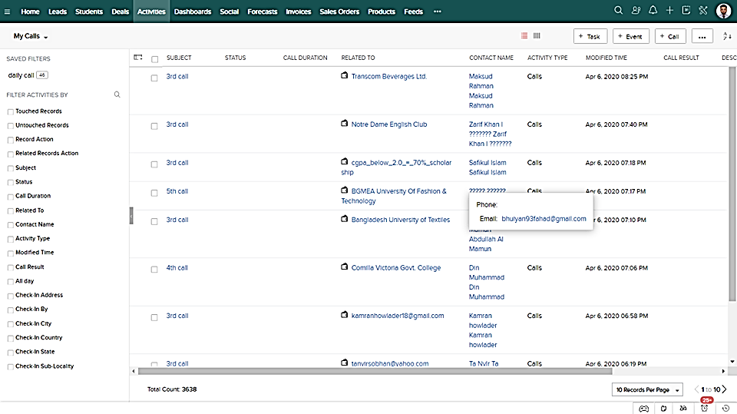Documentation related to customers' leads

CHAPTER 04
RECOMMENDATIONS AND CONCLUSION

Recommendations
The CTBD are followers of the autocratic style of leadership. If the company's leadership is effective, the whole atmosphere of the business is more responsive to variety. In the last section on CTBD's shortcomings, I said that the company had a problem with a high staff turnover rate. Because it takes a lot of time and energy to train a single employee, it is very important for an organization to keep the employees that they already have. An organization requires strong leadership that can offer a healthy atmosphere and make it so that workers can easily accomplish their duties in order to keep its employees. This will allow the business to retain its personnel. As a consequence of this, I think that CTBD should seek to employ a person who is not only knowledgeable and talented but also has a talent for leadership. In addition, the following recommendations, which are based on a few proven areas of development, are presented in order to assist Coders Trust in regaining its sales management in this competitive business environment. Coders Trust hopes to reclaim its sales management with the assistance of these suggestions, which are described below:
- Increasing customer participation by offering live consultation and several other types of real-time help
According to a research that was conducted out by the (Aberdeen Strategy & study), businesses who employ visualization tools have observed a rise in yearly income of 83 percent, as well as a decline in the amount of workload scores customer feedback by 2.7fold. Customers do not need to be concerned about directly participating in any financial transactions at any moment when receiving support through face-to-face video chat that is made available by a technology that detects vulnerabilities in real time. As a direct consequence of this change, consumers will have an easier time keeping track of their own money. Co-navigation solutions have a major influence on an agent's ability to access a client's browser and on the agent's capacity to give online customer support by completing help or forms on the appropriate page. This is because co-navigation solutions allow agents to access a client's browser more easily. This is due to the fact that co-navigation solutions make it simpler for agents to access the browser that is being used by a client. Real-time supports, such as live streaming, are examples of vital communication channels that educational institutions need to have in order to improve their level of engagement with their instructors and students. These organizations also need real-time assistance, such as live streaming, in order to function well. Given that real-time help is one of these channels, Coders Trust Bangladesh should make real-time support accessible to the users of its platform. Coders Trust Bangladesh might discover that it is able to gain a significant competitive advantage by doubling down on its efforts to boost the level of customer satisfaction and by developing a variety of different journeys for customers to take with the company.
- Improve Client Satisfaction
The ease of the service, the client's emotional engagement in the process of receiving the service, and the level of success experienced by the service are the three factors that determine customer service expectations. According to the findings of the research (Avila, 2008), these three aspects are interrelated. It is our goal at Coders Trust to provide our customers with a satisfying experience from the moment they visit on our Bangladesh website all the way until the point at which they become one of our paying customers. The level of customer satisfaction experienced by Coders Trust Bangladesh might be improved by prioritizing meeting the expectations of its clients and working diligently to do so.
- Advanced Customer Responsiveness
Customers in Bangladesh who have previously used Coders Trust have left the company since there is a risk that they would get a delayed response. If a business does not immediately answer to a query made by a customer, there is very little that can be done to boost the degree of enjoyment and fulfillment that the consumer will feel as a result of the interaction. According to the findings of a survey that was carried out by Ubisend, one customer out of every five believes that communicating with a chat box is the easiest way to communicate with a company. Because of this, Coders Trust is in a position to rethink what it means to provide excellent customer service in Bangladesh. By using the most advanced chatbots, the company can automatically shorten the amount of time it takes for customers to respond to inquiries, engage with one another, and express their interests. The value of real-time services may be enormously increased in both the maintenance of current connections and the formation of new ones. Chatbots might also be of use to Coders Trust Bangladesh in the following ways:
- Recognizing and providing answers to the questions that are most commonly asked, in order to ensure that responses to questions asked by subsequent customers follow a standardized format.
- Directing customers to previous responses on the same topic is the second method that can be used to help manage the space on a website.
In addition, Coders Trust Bangladesh has to take a few initiatives in order to increase the amount of their sales, which are:
- In the not-too-distant future, Coders Trust Bangladesh ought to increase the number of courses it provides in response to the widespread demand for this.
- There is a need to expand the number of locations they have across Bangladesh.
- The campaign should be prioritized by Coders Trust Bangladesh at colleges and other institutions in order to increase public awareness.

Conclusion
Research for the paper is intended to accomplish many aims, including doing an analysis of the notion of sales and marketing strategies, conducting an analysis of the sales and CRM practices used by Coders Trust Bangladesh, and giving suggestions for changes to Coders Trust Bangladesh's sales management. According to the findings of the research that was conducted on the report, Coders Trust Bangladesh makes use of Sales Management, which is a mix of marketing strategies, practices, and customer relationship management technology, in order to manage their customer experiences and data across the whole of the lifetime of their customers. The goal of this is to improve customer service and to support customers in sustaining and driving growth in sales. Coders Trust is a Danish company that has established a branch in Bangladesh with the goal of assisting the economically disadvantaged students of that country in gaining access to online education. The organization is giving a diverse selection of educational options not just to retain the students it now has but also to get new students to join. Coders Trust makes use of the Zoho CRM software in order to maintain an up-to-date database of all of its students' fundamental information. Because of the programs, Coders Trust is able to maintain communication with its students and keep them abreast of any modifications made to the curriculum. Students may get assistance in fulfilling their unique needs from tutors, academics, and business professionals who are all easily accessible via the platform of Coders Trust. As a consequence of this agreement, students who make use of Talent ELMS will also have access to the Facebook group as well as the online aid center that is open around the clock. In addition, Coders Trust publishes a number of success stories written by alumni on its website and Facebook page. These tales are intended to help current students and prospective students learn how former students have used the ideas taught in Coders Trust to achieve success. In order to boost the level of customer service that the business provides and to speed up the growth of its sales, the firm need to establish live streaming services, automated chat-bots, and incorporate its customers in all of the tales and updates about the organization.

References

Aberdeen Strategy & Research. (n.d.). Retrieved from Custom Research Solutions: https://www.aberdeen.com/
Aimin, N. M. (2016). Exploring the Value and Process of Marketing Strategy: Review of Literature. International Journal of Management Science and Business Administration, Volume 2, Issue 2, 7- 18.
Avila, S. A. (2008). Preparing the next generation of sales professionals through social, experiential, and immersive learning experiences. Journal for Advancement of Marketing Education , 13(4), 47-55.
Badi, K. S. (2018). The Impact of Marketing Mix on the Competitive Advantage of the SME Sector in the Al Buraimi Governorate in Oman. Business and Management - Research Article, Volume: 8 issue: 3.
Company Profile. (n.d.). Retrieved from Coderstrust Bangladesh | Global Skills Development and IT Training Institute: https://coderstrustbd.com/
Competitive Analysis – Meaning, Examples And Importance. (2021, November 8). Retrieved from Harappa Diaries: https://harappa.education/harappa-diaries/competitive-analysis/
David, F. R. (2003). Strategic Management-Concepts and Cases, (9th Edition). USA: Pearson Education.
Harrison, J. S. (2004). Foundations in Strategic Management. USA: South Western.
Jayachandran, P. R. (1999). Marketing strategy: An assessment of the state of the field and outlook. Journal of the Academy of Marketing Science, 27(2), 120−143.
Jehad S. Aldehayyat, J. R. (2008). Strategic planning tools and techniques in Jordan: awareness and use. Strategic Change, 17(7‐8), 281-293.
Pearce, J. a. (1991). Strategic Management (4th Edition) . USA: Irwin, Inc.
Rozmi, A. N. (2018). The perception of ICT adoption in small medium enterprise: A SWOT analysis. International Journal of Innovation Business Strategy, 19(1), 69-79.
Thompson, A. A., & Strickland, A. J. (1989 ). Strategy Formulation and Implementation (4th Edition). USA: Irwin, Inc.
Zamana, A. (2019, June 23). A freelancing boom is reshaping Bangladesh and its economy. Retrieved from Online Article: https://theprint.in/world/a-freelancing-boom-is-reshaping-bangladesh-and-its-economy/252971/

