“Overview of Foreign Exchange policy Department at Bangladesh Bank and Its Impact on Reserve and Economy”



“Overview of Foreign Exchange policy Department at Bangladesh Bank and Its Impact on Reserve and Economy”

Submitted To:
DR. Md. Qamruzzaman
Associate Professor
School of Business and Economics

Submitted By:
Name: Tanzina Ahmed
ID: 111 152 146
Major: Finance
Trimester: 211

School of Business and Economics
UNITED INTERNATIONAL UNIVERSITY

DATE OF SUBMISSION: 18- 10- 2023

Letter of Transmittal
18th October, 2023
DR. Md. Qamruzzaman
Associate Professor
Department of Accounting and Finance
Subject: Submission of the Internship Report on Bangladesh Bank.
Dear Sir,
With due respect, I want to inform you that I am submitting my internship report on "Overview of Foreign Exchange Policy Department at Bangladesh Bank and its impact on reserve and economy". The 12 weeks internship program has been a great experience to me as it provided with wide experience to the professional environment. I have tried my level best to follow the guidelines that school of business and economy provided. The whole experience of this internship program enabled me to get an insight into the real life situation as well as the corporate world.
I sincerely hope that this report meets your approval and requirements and demonstrate my ability to present internship report. I would be glad to explain you with any clarification if required. Please contact at tahmed152146@bba.uiu.ac.bd for any further query or criticism regarding this report.
Sincerely yours,
Tanzina Ahmed
ID No: 111 152 146
Major: Finance in BBA Department.

Office Letter
18th October, 2023
General Manager
Forex Reserve and Treasury Management Department
Head Office, Bangladesh Bank, Motijheel Dhaka 1000
Subject: Application for Internship Certificate.
Dear Sir,
With due respect state that, I am Tanzina Ahmed a student of United International University & I attended the internship program of of Bangladesh Bank, Forex Reserve and Treasury Management Department, which started on 1 April 2021 & ended in 30 June 2021. In this time frame of three months, I had the opportunity for having supervisor Shamma Tabassum mam, joint director in forex reserve section in Bangladesh Bank. I submitted my internship report titles as Forex Reserve and Treasury Management Department of the Central Bank of Bangladesh. With the proper guidance & co-operation of my supervisor, I was able to witness all the activities of Forex Reserve and Treasury Management Department & obtain an experience to go through varies cases. According to the internship terms & conditions, bank will provide an Internship Certificate to the internship.
I therefore, hope that the authority would be kind enough to provide with the pocket money & obliged thereby.
Sincerely yours,
Tanzina Ahmed
ID No: 111 152 146
Major: Finance in BBA Department

To Whom It May Concern

This is to certify that the internship report on "Overview of Foreign Exchange Policy Department at Bangladesh Bank and its impact on Reserve and Economy" for the partial fulfillment of the degree Bachelor of Business Administration (BBA) major in Accounting and Finance to North South University is a record of practicum report carried out by Tanzina Ahmed, ID: 111 152 146 under my supervision.

Shamma Tabassum
Joint Director

Acknowledgement
First of all, I would like to express my gratitude to Allah for enabling me to complete the report in due time.
I would like to thank my parents for helping and guiding me throughout this phase of the internship as well as throughout my academic life. Without their guidance and faith in me, I could not have come this far in my life.
I would like to express my sincere gratitude to my faculty supervisor Md. Qamruzzaman, Associate Professor, Department of Accounting and Finance of United International University for providing me with detailed feedback and advice on this report. As he always gave me suggestions in my whole BBA life.
I like to express my thanks and deepest gratitude to Bangladesh bank, HRD for giving me the opportunity. I also want to acknowledge the guidance of the General Manager, Deputy General Manager, Assistant Director, Deputy Director and Join Director of Foreign Exchange Policy Department Of Bangladesh Bank, Head Office, who spared their valuable time for me. I will never forget their kind and friendly behavior.
Specially, I would also like to express my gratitude towards Bangladesh Bank, for allowing me to conduct my internship journey. I am very much thankful to Shamma Tabassum Mam, Joint Directors of Forex Reserve & Treasury Management Department, for helping me with my internship report, without her support I could not be able to gather internal information about General banking department. I am humbly thankful to her. I would also like to convey my special thanks to my supervisor, Md. Anowar Hossain, Joint Director, Forex Reserve & Treasury Management Department.
Finally, I would like to give thanks to Authority of United International University (UIU) for making this internship program mandatory for the BBA students. This internship honestly helps students to get idea about the corporate world which helps students in future doing their official tasks.

Executive Summary
Bangladesh Bank, the national bank of Bangladesh, was building up in Dhaka after the freedom on sixteenth December in 1971. The Foreign Exchange Policy Department (FEPD) of Bangladesh Bank excels at handling Bangladesh's foreign exchange. The report incorporates the exercises of foreign exchange on the general economy of Bangladesh which in oversaw by the diagramming Foreign Exchange Policy Department at Bangladesh. I have accumulated viable learning about the Foreign Exchange Policy Department through working apathetic segments. This experience has filled in as a genuine showing of work at an association and it has given me the chance to get involvement about the corporate culture which would be a point of reference in my profession. This is a cover the subject "Overview of Foreign Exchange Policy Department at Bangladesh Bank and its Impact on Reserve and Economy" done as a prerequisite of my specialty as a course think about. I am doing my internship at Bangladesh Bank. In this report, I have shared my encounters and discoveries from this entry level position and other related data.
In the report, I have quickly presented the theme, errand dole out as an assistant, criticalness of the examination, technique and has been talked about the Bank profile with brief history and Bank's main goal, vision, vital plans and destinations. The principle body is containing data about Foreign Exchange Policy Department and that is the most essential piece of this report, the genuine assignment part contain data about what undertaking I had done in my internship period and project part containing the data about the improving export service in Bangladesh through Bangladesh bank. At last I have given the discoveries and proposal in view of the experience.

Table of Content
Contents
Letter of Transmittal 3
Office Letter 4
To Whom It May Concern 5
Acknowledgement 6
Executive Summary 7
CHAPTER 1 14
INTRODUCTION 14
Origination 15
Purpose of the study 16
Goal of the report 17
Scope regarding the report 17
Significance of the study 18
Limitation of the study 18
Methodology of the Study 19
Primary Data: 19
Secondary Data: 19
Learning and Objective from the Internship Report 19
Practical Tasks Assigned as an Intern 20
Some Definition of Key Terms 20
CHAPTER 2 23
BACKGROUND OF THE ORGANIZATION 23
Introduction of the Organization 24
History of Bangladesh Bank 24
Head of the Bangladesh Bank 25
Core Functions 27
Vision and Mission of Bangladesh Bank 27
Vision: 27
Mission: 27
Department of Bangladesh Bank 28
Corporate Information 30
Branch of Bangladesh Bank 31
Organization of Bangladesh Bank 32
Bangladesh Bank Trend and Growth 33
Operations of Bangladesh Bank 34
SOWT Analysis of Bangladesh Bank 35
STRENGTH 36
WEAKNESSES 36
OPPORTUNITIES 36
THREATS 37
CHAPTER 3 38
"Foreign Exchange Policy Department at Bangladesh Bank and its impact on Reserve and Economy" 38
Definition of Foreign Exchange 39
Functional Section of Foreign Exchange Policy Department 40
Licensing and Drawing Arrangement 40
Licensing procedure: 42
Foreign Exchange Market Policy 43
Foreign Investment 43
Foreign and Local Borrowings 45
Convertibility on Trade Account 45
Exchange Facilities for Exporters 45
Function of this section 46
FOREIGN EXCHANGE ASSETS, LIABILITIES AND CONTINGENT LIABILITIES: 47
Remittance policy 48
Permission for: 48
Sources & use of foreign remittance In Bangladesh: 49
Use of foreign remittance: 49
Use in households: 49
Savings/Fixed deposit: 49
Investment in Business: 49
Repayment of loan: 49
Gift/donation to relatives: 49
Furniture: 49
Home construction / repair: 50
Remittance Impact on the economy: 50
Impact on the GNP: 50
Impact of remittance on consumption: 50
Increase savings: 50
Increase capital: 50
Impact of remittance on investment: 50
Increase employment: 50
Impact of remittance on import: 50
Bangladesh Remittances: 51
Source of Bangladesh Remittances: 52
Remittances by Country: 53
Wage earners' remittance: 53
The pie chart show the % of major destinations of migrants from Bangladesh- 55
Wage Earners Remittance inflows: Selected Country wise (Monthly) 55
Export Policy 58
Function of this section 58
Process of export 59
Current situation of export in Bangladesh 60
Export Impact on the Economy 62
Share of economic sectors in the GDP in Bangladesh 2022 63
Export Impact on Exchange Rate 63
Foreign Reserve 65
Reserve adequacy measures for Bangladesh and excess reserves (in billion US dollar) 67
Import Policy 67
Import policy of FEPD 67
Give decision 68
Approval 68
Monitoring 68
Issuance 68
Import procedure 69
Major Import Commodities of Bangladesh: 76
Bangladesh Imports 77
Bangladesh Imports In Chart 78
Current situation of Import in Bangladesh: 78
Bangladesh GDP Annual Growth Rate: 79
Monetary and Credit Program for FY23: 80
Global Economic Growth: 81
Import Impact on the economy of Bangladesh: 82
Balance of payment: 82
Accounting and Non-Funded Business Policy 83
Funded facilities: 83
Working Capital Loans: 83
Overdraft Facility: 83
Cash Credit (CC) Facility 84
Working Capital Demand Loans (WCDL): 84
Long term loans: 84
Trade Finance: 84
Pre-shipment loans: 84
Post-shipment loans: 84
Non-Funded Facilities 85
Trade Finance Intermediaries: 85
Letter of credit: 85
Cash in advance: 85
Open account or credit: 85
Cash Management Services (CMS): 86
Credit Evaluation: 86
Facility Structure: 86
Credit Monitoring: 86
Bank Guarantees: 86
Permission for: 87
External Debt & Guarantee 87
Function: 87
Bangladesh Government Debt to GDP: 88
Bangladesh recorded a Government Debt to GDP of 28.20 percent of the country's Gross Domestic Product in 2022. 88
Bangladesh Outstanding External Debt: 89
Sources of Debt: 89
Domestic Debt: 90
External Debt: 92
External Debt in Bangladesh increased to 57.63 USD Billion in 2022 from 50.88 USD Billion in 2021 93
Bangladesh External Debt 93
Foreign Aid and External Debt Repayment: 94
Discount Policy 95
Function: 95
Legal Compliance & Enforcement 96
Human Resource Management 97
Chapter 4 98
Recommendation, Findings & Conclusion 98
Recommendation 99
Findings of the Study 99
Conclusion 100
Reference & Bibliography 102
Appendix 104
Journal 105

CHAPTER 1

INTRODUCTION

Origination
An unfair graduation requirement is an internship. Any student who wants to learn more about the practical world has a fantastic opportunity to do so. The preparation of an internship report, which improves logical skills and makes for an effective graduate, is also a hard experience. Since the beginning of the BBA program, my main goal has been to do an internship in this kind of financial institution because the banking industry has become the most significant factor in our economy and they also provide a fervent environment for professional development.
I am doing my internship in FEPD of Bangladesh Bank. This department in one of the most important departments of Bangladesh Bank. It provides opportunities for the economic department of Bangladesh. So its activities are more sensitive and responsive. So this department works with more consciousness and responsibility so that all sectors of the economy get equal facilities from this department. As an intern in this department I don't have any major duties and responsibilities to do. But I had to attend in the working days and had to communicate with other respective officials of different section to collect the information about their desks to know how they perform their activities. Most of the days I went to the bank and meet with my co-coordinator sir, Md.Anowar Hossain( Joint Director), talk with him about the function of the bank as well as the FEPLD Sometimes I went to other sections which are managed by him. When I went to that desk followed how they work, how they manage their activities, how they communicate with his colleagues and I saw the file that is related to his desk. I heard their speeches and took note all the information that was provided by them.
The internship program is done to accumulate the viable information about the working spot. It is a course as the prerequisite for finishing Bachelor of Business Studies (BBA). As an understudy of BBA I have connected with the Bangladesh Bank as the intern for 3 months length in FEPD. Bangladesh bank is the central bank of the nation. It was built up in 16th December, 1971 by presidential request no-127 of 1972. It is critical piece of the banking sector of Bangladesh, which is continually assuming an imperative part to enhance the keeping money framework in this nation. To know the different banking system, Bangladesh Bank is the best on account of its immense and sound financial framework. I think FEPD is a fundamental piece of the Bangladesh bank. The economic advancement of Bangladesh can't be conceivable without FEPD. The checking and administration approach of FEPD is best for economic experience and advance of Bangladesh. It bargains all the business through 10 segments of this department. All in all, the FEPD of Bangladesh Bank is taken after the best administration arrangement of the banking divisions of Bangladesh. These departments do all the works of monitoring system through remittance policy, import policy, export policy, import policy, licensing and drawing arrangement, legal compliance, borrowing from abroad, market policy etc. by its different sections which are divided into different desks.
As an understudy of Accounting and Finance department, I have picked the FEPD of Bangladesh Bank to know these procedures. I think FEPD assumes a vital part to build up the economy of Bangladesh. On the off chance that the FEPD screens the market legitimately, at that point the economy advance is conceivable. What's more, if FEPD neglects to do its capacity well entire economy of Bangladesh will be hampered and the improvement of Bangladesh will be damaged. So the exercises and capacities pulled in me to do my intern in this department. In this undertaking, I have endeavored to demonstrate an unmistakable picture of FEPD of Bangladesh Bank alongside the difference in its arrangements in various circumstances to control the economy in better path with my down to earth learning and experience.

Purpose of the study
A central bank is the primary financial organization involved in the overall well-being and economic uniformity of the nation; it works to preserve pricing rigidity and carries out numerous financial operations while remaining under state authority. One of the most significant tasks of a central bank is managing foreign exchange, which includes setting the exchange rate of foreign currencies, managing foreign reserves, and monitoring and controlling the foreign exchange market.
Bangladesh Bank also decides where we can invest our reserves and which industries are profitable enough. Different policies are employed to manage Bangladesh's treasury and overall foreign reserve. Basically, the goal of this study is to reveal how various market stabilization measures are implemented under various conditions, as well as to identify the variables that influence the reserve and the impact of foreign reserves on our economy.

Goal of the report
As for why this subject was chosen, the following descriptions should help to better maintain the main purpose of the teaching clear. Since the banking industry in nearly all of the countries has dealt with foreign exchange and behaved diplomatically while doing so, it has become a verb to describe how banks cover foreign exchange, which means that the following would be the study's rational and half-important goal:
- To identify key foreign policy players and issues.
- Map Bangladesh's primary foreign policy issues in light of recent changes to the regional and global environment
- To visit the organization in order to learn more about its activities, overall foreign exchange policy, and significance. to gain practical understanding and firsthand experience with the ideas, methods, and overall character of foreign exchange policy.
- To describe the word "foreign exchange" and how it relates to the domestic and international banking industry.

Scope regarding the report
Students who intern have the opportunity to gain real-world experience in the practical areas of corporations. The student has a fantastic chance to align with their acquired organizational competencies. The student is competent in the organizational context but committed to a certain culture. The Bangladesh Bank is responsible for keeping sufficient reserves of foreign currency, monitoring exchange rates, advising the government on matters relating to foreign exchange, and establishing guidelines for dealing in foreign currencies. Here is the breadth of my knowledge regarding FEPD, which I gathered in conjunction with my theoretical understanding. As the nation's central bank, Bangladesh Bank has great knowledge of both treatments and foreign exchange, which aids me in creating a report that, is truly unique.

Significance of the study
The Foreign Exchange Policy Department of Bangladesh Bank is affected by the learning focus of capacities in relation to various banking, economic, export, and import sectors of Bangladesh. The Foreign Exchange Policy Department's benefits to Bangladesh's financial sector are also discussed. I generally made an effort after Bangladesh Bank's coverage accelerated the focus on issues relating to foreign trade.

Limitation of the study
- Time Limitation: Absolute time constraints were one of the biggest challenges encountered while preparing this study. Only three months are allotted for the internship, which is completely insufficient to comprehend such a vast field as banking.
- Data Confidentiality: Data related to banking is crucial and unique. Facts confidentially used to be the main obstacle to preparing that report. Even though I observed how banks use technology to evaluate key operations and uphold internal processes, I was advised not to disclose too much in my internship report.
- Place limitation: I was no longer able to venture into deep departments that are related to or closely associated with foreign trade, such as the Foreign Exchange Operations Department (FEOD) and the Foreign Exchange Investment Department (FEID), which are both exceptionally related to foreign exchange because I used to only be attached to the Foreign Exchange Policy Department.
- Information Validity: Information was gathered through observation and conversation with bank employees. So, only a portion of FEOD's policies were enabled in accordance with knowledge. Since I was working with FEPD.
- Lack of Information: The relevant paper that is incomplete is no longer published. Numerous procedural issues are handled directly in the operations by the highest level of management, and they may also partially relate to constraints.

Methodology of the Study
Between natures, this report is qualitative. In-depth interviews with Bank personnel are conducted and a variety of professional files are analyzed in order to obtain information. Personal interviews were conducted with officials from the Foreign Exchange Policy Department's exclusive wings. The study contains a significant amount of information yet information. After gathering the information, I held accompanied incomplete methods. This report is being prepared in accordance with:
- Primary Data.
- Secondary Data.
Primary Data: For collecting primary data I have followed interview method like face to face conversation with the head of the department, respective officials of Bangladesh bank. Observation of the officials' activities and their attitudes and discussion of my supervisor also helped me to collect primary data.
Secondary Data: I gathered secondary data using a variety of published sources, including the Bangladesh Bank Annual Report, the Bangladesh Bank Order of 1972, the Bangladesh Bank Level Rules, the Organizational Chart for the Bangladesh Bank General Regulations, Journals, and pertinent books, files, and documents.

Learning and Objective from the Internship Report
I had the responsibility of learning about the Foreign Exchange Policy Department of Bangladesh Bank when I started working there as an intern.
I have learnt many things during my internship period. Like:
- I have learnt about guidelines of foreign exchange transaction.\ I have gathered knowledge about export, import, remittance etc.
- I also learnt about the realization of export proceeds, bill of entry, discount policy and many other export policy, import policy and remittance policy.
- I also learnt about the rules and procedure of maintaining the policies.
- Foreign currency account, bank guarantee, disc bonds, L/Cs etc.
- I have learnt about nostrum account reconciliation.

Practical Tasks Assigned as an Intern
My internship has taught me a lot of new things. Here, I discovered several fundamental distinctions between theoretical understanding and real-world implementation.
I carried out the following:
Preparing observation: The department of foreign exchange policy has granted a bank guarantee in favor of the applicant. In situations involving disputes involving exports and imports, I'm getting ready to provide evidence.
Arrange the files: The FEPD maintains records for every case related to the daily tasks it performs. For the purpose of preserving the records of Bangladesh's foreign exchange transactions, it keeps roughly 15 files. In order for them to find all the information they require, I had to organize all the files. After finishing my task, I filed the document in the appropriate folder.
Maintain register: Account and non-funded business policy departments communicate with AD banks frequently by letter. They therefore keep two registers of letters sent and received with precise information. Maintaining these registers was another obligation I had.

Some Definition of Key Terms
Big Bath: Big Bath is an earnings management strategy used in accounting where a one-time charge is made against income to deplete assets, which lowers future expenses. The asset is reduced or removed from the financial books as a result of the write-off, which lowers the year's net income.
Poison pill: A strategy employed by a corporation threatened with an unwanted takeover proposal to make the bidder undesirable the feat.
Leverage Buyout: The cash flow of the company is used as collateral to secure and repay the borrowed money when a company is purchased using a combination of stock and debt.
Financial Leverage: The use of debt to acquire additional assets.
Stratified Sampling: In this probability sampling technique, the researcher divides the entire population into different subgroups or strata before randomly selecting the final participants proportionately from the various strata.
Census: A formal tally or survey of a community, usually containing detailed information about individuals
Bill of Entry: A statement made by an importer or exporter detailing the precise nature, exact quantity, and value of goods that have arrived or are being sent out. It is prepared by a licensed customs clerk or broker, and customs authorities check it for accuracy and adherence to the tariff and rules.
IMP form and its use: The form used by importers to request compensation against imports into Bangladesh from ADs is known as the IMP. The importer or his lawfully appointed representative must submit the IMP forms in one original. To make a remittance against import, the AD must sign off on the approval on the reverse of the IMP form in the designated area. After payment, AD will submit the IMP online; if Bangladesh Bank does not request it, AD won't submit the IMP to it. AD will compare the details of the IMP and the Bill of Entry.
Form C: Whenever any emigrant sends money to home country, he/she needs to fill up a form, which is named Form C.
CFR: The initials CFR stand for Cost and Freight. Cost is the price of the items, while freight is the total cost of all the ways the things are transported. It means that the seller must have marine insurance against the buyer's risk or loss to the goods during the carriage in addition to paying the costs and freight required to deliver the goods to a specified port of destination.
Euro Account: Any account that deals with currencies other than the one's own is referred to be a euro account. Any currency that is not the native currency is referred to as a "euro currency."
Nostro Account: Any time a bank opens an account abroad, the account is given the designation Nostro Account.
Bistro Account: When a bank manages a foreign bank's account, the home country bank refers to it as a "bistro account."
Loro Account: Any third party will call a Nostro or Bistro account as Loro Account.
Square Position: When a currency dealer's buy and sell positions are equal, it is said to be offsetting. This phrase is used in foreign exchange trading.
Balance of tread: The value of a country's exports of products and services is measured against the value of its imports.
Balance of payment: The record of all foreign financial transactions carried out by a nation's citizens is known as the balance of payments.
Charter party: Transfer of goods directly to the other country. Which means goods will go by one ship.
Transshipment: Transshipment refers to the transportation of products or containers from one location to another.
Credit rating: The ability and desire of any issuer to satisfy its financial commitments in full and on time is expressed by an agency's credit ratings, which include governments, financial institutions, corporations, insurance companies, and structured finance.
Open market Position: This refers to actions taken to increase or decrease the amount of money in the financial system, such as buying and selling government assets on the open market.

CHAPTER 2

BACKGROUND OF THE ORGANIZATION

Introduction of the Organization
I've signed up for an internship with Bangladesh Bank. Since its founding, Bangladesh Bank (BB) has operated as the nation's central bank. Its principal duties include issuing money, keeping track of foreign exchange reserves, and providing facilities for all kinds of public monetary transactions. The formulation and execution of the government's monetary policies are also under the control of Bangladesh Bank.
A nine-member board, headed by the governor, is in charge of running the Bangladesh Bank. In addition to its Dhaka headquarters, it has nine other locations, including two in Dhaka and one each in Chittagong, Rajshahi, Khulna, Bogra, Sylhet, Rangpur, and Barisal.

History of Bangladesh Bank

The Bangladesh Bank was created in Dhaka as a body corporate pursuant to the Bangladesh Bank Order, 1972 with effect from the 16th of December 1971. It serves as the country's central bank and the top regulatory body for the monetary and financial system.
On April 7, 1972, the government of Bangladesh passed the Bangladesh Bank Order, 1972, which reorganized the Dhaka branch of the State Bank of Pakistan into Bangladesh Bank, the nation's central bank and the top regulatory body for the nation's monetary and financial system. This came after the Independence War and Bangladesh's eventual independence.
Asian clearing house membership belongs to Bangladesh Bank. Additionally, it is the first central bank in the entire globe to establish a special hotline for the general public to report any issues relating to banks. At the 2012 United Nations Climate Change Conference, which was held at the Qatar National Convention Centre in Doha, Dr. Atiur Rahman, the organization's previous governor, was given the title "Green Governor," making it the first central bank in the world to issue a "Green Banking Policy."
A pro-socialist agenda was followed by the Mujib administration in 1972. In order to prioritize lending to the industries and agricultural sectors that sought to rebuild the war-torn nation, the government decided to nationalize all banks in 1972. These sectors included industry and agriculture. The first reform program was launched in 1982, and as part of it, two of the six nationalized commercial banks were denationalized and allowed to participate in the banking industry alongside private local banks. To address the issues in the banking sector, a National Commission on Money, Banking and Credit was established in 1986. Since then, several measures have been implemented, including establishing recovery goals for the nationalized commercial banks and development financial institutions and banning defaulters from receiving new loans. However, there was no way to increase the banking industry's efficiency.
In 1990, agreements with the World Bank led to the creation of the Financial Sector Adjustment Credit (FSAC) and Financial Sector Reform Programmed (FSRP). Through these initiatives, the government's distortions and financial repression were to be lessened. The FSRP required banks to deploy contemporary computerized systems, including accounting software, and to maintain a certain level of capital adequacy. It compelled the central bank to relax banking regulations, lower interest rates, and tighten oversight of the credit sector. The capital market, which was also having trouble, was also fostered by the government. In 1996, FSRP was abolished. After that, the Bangladeshi government established the Bank Reform Committee (BRC), albeit it mostly ignored its recommendations.
Currently, the organization has 11 offices in Bangladesh, which are located in Motijheel, Sadarghat, Chittagong, Khulna, Bogra, Rajshahi, Sylhet, Barisal, Rangpur, and Mymensingh. There were 5807 people employed overall as of March 31, 2015.

Head of the Bangladesh Bank
Mr. Abdur Rouf Talukder, a former Senior Finance Secretary in the Government of Bangladesh, was appointed as the 21st Governor of the Bangladesh Bank on July 12, 2022. Mr. Abdur Rouf Talukder began his professional career as a member of the Bangladesh Civil Service on February 15, 1988. (Administration Cadre). He worked in the government for more than 34 years in various capacities. On July 17, 2018, he was appointed Finance Secretary, and on October 31, 2020, he was promoted to Senior Secretary. He spent more than 18 years in various positions within the Finance Division before being appointed Finance Secretary.
He has made significant contributions to the Finance Division in areas such as budget reform, macroeconomic management, and the implementation of IT in PFM. He was instrumental in the implementation of the Government's Medium-Term Budget Framework (MTBF). He was instrumental in the implementation of payroll automation for government employees, EFT for pensioners, Shariah-based bond Sukuk, and National Saving Certificate automation. He made a significant contribution to both the Surplus Revenue Act of Autonomous Bodies and the Public Money and Budget Management Act of 2009. 2022 will see the implementation of the Universal Pension Management Act.
As Finance Secretary, he served on the boards of Bangladesh Bank. He served also Chairman, Bangladesh Infrastructure Finance Fund Limited; Chairman, National Human Resource Development Fund; Vice-Chairman, IDB-BISEW; Deputy Chairman, SABINCO; Director, Board of Biman Bangladesh Airlines; Director, Infrastructure Development Company Limited; Member of the Board of Governors of BIDS, Bangladesh Judicial Service Commission, BPATC, BIISS and National Defense College etc.
Mr. Talukder received the 'National Integrity Award for 2020-21.' In addition, he led the Finance Division to the 'Public Administration Award 2021.'
Mr. Talukder has a master's degree in science. in Development Management from the University of Birmingham in the United Kingdom, as well as an MBA from the Institute of Business Administration (IBA) at the University of Dhaka. He also took professional development courses at Harvard Kennedy School of Government in Boston, the IMF Institute in Washington, DC, the Crown Agents Professional Development Center in London, the National Graduate Institute for Policy Studies (GRIPS) in Tokyo, Japan, and the Institute of Public Finance (IPF) in Dhaka, among others.

Core Functions

The Bank carries out all the duties that a central bank of any nation is supposed to carry out, including managing the nation's foreign exchange and gold reserves, ensuring price stability through economic and monetary policy measures, and overseeing the banking industry. Bangladesh Bank, like the majority of central banks of other countries, exercises monopoly over the issue of currency and the banknotes. Bangladesh Bank, like all other central banks across the world, is both the Government's banker and the banker's bank, a "Lender of the Last Resort."

Vision and Mission of Bangladesh Bank

Vision: The Bangladesh Bank (BB) will manage the nation's monetary and financial system in order to stabilize the internal and external value of the Bangladesh Taka and promote the rapid growth and development of the economy. This will be done by ensuring the quality of services and the expertise of its staff.

Mission: The Bangladesh Bank's mission is to maintain and advance macroeconomic and price stability in accordance with the Bangladesh Bank Order of 1972 and to support the vision by:
- Creating and putting into effect a sound monetary policy that is in line with the nation's long-term development objectives.
- Implementing sensible rules to ensure the Taka's stable internal and external value.
- Determining the government's top policy priorities by analyzing the transmission channels, interactions of monetary policy with other macroeconomic policies, such as exchange rates and taxes, and effects on the whole economy.
- Putting out the required legislative proposals to achieve the goals of the central bank.

Department of Bangladesh Bank
There are 53 departments in Bangladesh Bank which are actively doing performing their activities. The department is created for making the work easily as the requirement of the Bangladesh bank. The permanent departments of Bangladesh bank are:
Head Office Departments
Accounts & Budgeting Department | Agricultural Credit Department
Bangladesh Bank Library | Bangladesh Bank Training Academy
Bangladesh Financial Intelligence Unit | Bankers' Selection Committee Secretariat
Banking Regulation and Policy Department | Chief Economist's Unit
Common Services Department-1 | Common Services Department-2
Credit Guarantee Department | Credit Information Bureau
Cyber Security Unit | Debt Management Department
Department of Banking Inspection 1 | Department of Banking Inspection 2
Department of Banking Inspection 3 | Department of Banking Inspection 4
Department of Banking Inspection 5 | Department of Banking Inspection 6
Department of Banking Inspection 7 | Department of Banking Inspection 8
Department of Communications and Publications | Department of Currency Management
Department of Financial Institutions and Markets | Department of Foreign Exchange Inspection
Department of Off-Site Supervision | Deposit Insurance Department
Equity and Entrepreneurship Fund Unit | Expenditure Management Department-1
Expenditure Management Department-2 | Financial Inclusion Department
Financial Institutions Inspection Department | Financial Integrity and Customer Services Department
Financial Sector Support and Strategic Planning Department | Financial Stability Department
Foreign Exchange Investment Department | Foreign Exchange Operation Department
Foreign Exchange Policy Department | Forex Reserve & Treasury Management Department
Governor Secretariat | Grihayan Tahbil & Fund Management Unit
Human Resources Department 1 | Human Resources Department 2
ICT Infrastructure Maintenance and Management Department | Information Systems Development and Support Department
Integrated Supervision Management Department | Internal Audit Department
Investment Promotion & Financing Facility II (IPFF II) Project Cell | Law Department
Monetary Policy Department | NFIS Administrative Unit
Payment Systems Department | Research Department
Secretary's Department | Security Management Department
SME & Special Programmers Department | Special Studies Cell
Statistics Department | Sustainable Finance Department

Bangladesh Bank Monogram | 
Headquarter | Dhaka, Bangladesh
Established | 16th December 1971
Governor | Mr. Abdur Rouf Talukder
Central Bank | Bangladesh
Currency | Taka
IOS 4217 | JBJ
Reserves | 30.1 USD BN
website | www.bb.org.bd

Corporate Information

Branch of Bangladesh Bank
At present the Bangladesh Bank has 10 branches located at Motijheel, Sadarghat, Chittagong, Khulna, Bogra, Rajshahi, Sylhet, Barisal, Rangpur, and Mymensingh in banladesh. These branches are:
- Motijheel office | - Mymensingh office
- Sadarghat office | - Rangpur office
- Bogra office | - Khulna office
- Chittagong office | - Sylhet office
- Rajshahi office | - Barisal office

Organization of Bangladesh Bank

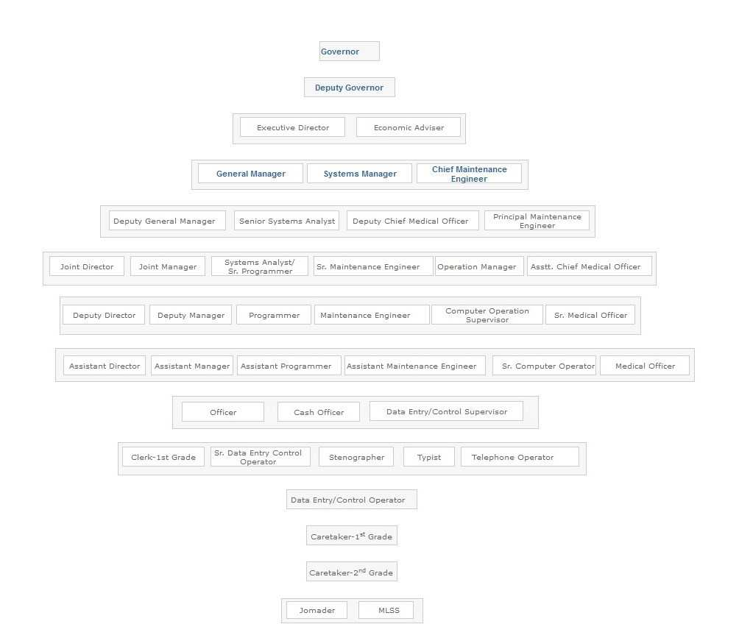
Governor: Head of the Bangladesh Bank.
Deputy Governor: The Deputy Governor assists the Governor.
Executive Director: The Executive Director assists the Deputy Governor.
Executive Director: The Executive Director assists the Deputy Governor.
Economic Adviser: Bangladesh Bank has economic adviser to its governor, to support the financial sector development and reform agenda, the central bank.
General Manager: General Manager performs his functions as a department head as well as all activities are monitoring by him.
Deputy General Manager: The Deputy General Manager assists General Manager to perform the all activities.
Joint Director: Joint Director performs his duties according to departmental activities. Generally Joint Director heads of the wing of the department.
Deputy Director: Deputy Director performs his/her functions to departmental desk.
Assistant Director: Assistant Director assists DD to perform the activities.
Officer: Officer is the first stage of employees. He/she do initial activities of the department or desk.

Bangladesh Bank Trend and Growth
Positively, Bangladesh's economy has made a significant recovery from the shock of the Covid-19 pandemic, recording real GDP growth rates of 6.94% and 7.10% in FY21 and FY22, respectively.
Compared to April 22, when it climbed by Tk 163263.2 crore (10.88%), Tk 148486.4 crore (8.93%) more broad money increased in April 23. In April 23 compared to April 22, broad money increased as a result of a rise in net domestic assets of Tk. 195112.4 crore (14.86%) and a decline in net foreign assets of Tk. 46626.0 corer (13.29%).

Operations of Bangladesh Bank
Banks With six nationalized commercial banks, three state-owned specialty banks, and nine foreign banks, Bangladesh's financial sector got off to a strong start following the country's independence. With the entry of private banks, the banking sector experienced substantial growth in the 1980s.
Currently, there are mainly two types of banks in Bangladesh:
Scheduled Banks: The banks that are still included in the list of banks kept in accordance with the Bangladesh Bank Order, 1972.
Non-Scheduled Banks: Banks that are not Scheduled Banks but that were founded for a specific, specific purpose and operate as such. These banks are unable to carry out all of the duties of scheduled banks.
Bangladesh Bank, which has the authority to do so under the Bank Company Act of 1991 and the Bangladesh Bank Order of 1972, fully controls and supervises all 61 scheduled banks in Bangladesh. The categories of scheduled banks are as follows:
- State Owned Commercial Banks (SOCBs),
- Specialized Banks (SDBs) ,
- Private Commercial Banks (PCBs),
- Conventional PCBs,
- Islami Shariah based PCBs,
- Foreign Commercial Banks (FCBs).
There are now 5 non-scheduled banks in Bangladesh which are:
- Ansar VDP Unnayan Bank,
- Karmashangosthan Bank,
- Grameen Bank,
- Jubilee Bank,
- Palli Sanchay Bank
Non-bank financial institutions (FIs) are the categories of financial institutions governed by the Financial Institution Act of 1993 and under the direction of Bangladesh Bank. In Bangladesh, 35 FIs are now in operation; the first one was founded in 1981.

SOWT Analysis of Bangladesh Bank
S.W.O.T., or strengths, weaknesses, opportunities, and threats, is an abbreviation. An orderly list of your company's top strengths, weaknesses, opportunities, and threats is known as a SWOT analysis.
Within the company are its own strengths and weaknesses (think: reputation, patents, location). They can be altered over time, but not without effort. Threats and opportunities are external (consider suppliers, competitors, and prices) and exist in the market whether you like it or not. They are unchangeable.
Existing companies can do a SWOT analysis at any moment to evaluate their environment and take proactive action. In fact, I advise holding a strategy review meeting that starts with a SWOT analysis at least once a year.
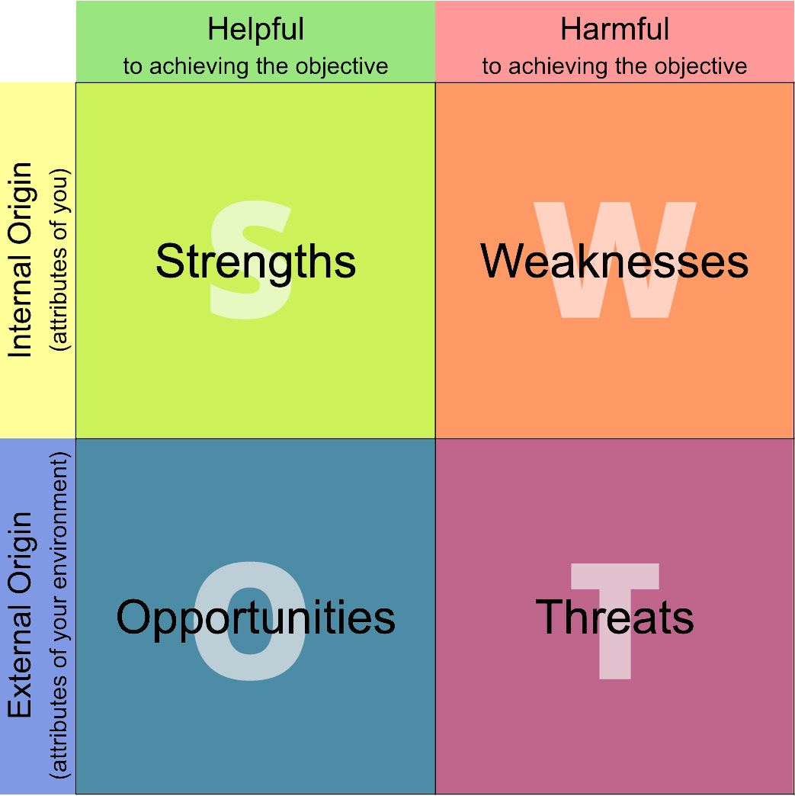

Each department at Bangladesh Bank's head office and 10 branches identified its strengths, weaknesses, opportunities, and threats when carrying out its different tasks and responsibilities.
Extracts from the SWOT analysis are as follows:

STRENGTH
- As a Central Bank, we are in a unique position.
- Public trust and a positive perception of the central bank.
- Experienced, capable, enthusiastic and innovative staff.
- Presence of basic ICT infrastructure and manpower with 'can do' attitude.
- Technical and financial supports of the Development Partners.

WEAKNESSES
- Inadequacy of training, professionalism and shortage of specialists.
- Skewed aging pattern of senior management staff.
- Lack of efficient MIS and effective communication channels.
- Improper workload distribution resulting in dependency on few experienced staffs.
- Inadequate HR policy including appraisal system, career planning, succession planning, job rotation, training need assessment, and staff welfare.
- Overbearing demeanor of BB staff in regulatory duties.
- Low remuneration package resulting in job dissatisfaction and turnover.
- Inclination of sticking to existing process resisting change.

OPPORTUNITIES
- Easy access to information on global norms and standards of regulation, supervision, monetary management and other central banking functions.
- Exploit autonomy of BB and technical supports from Development Partners.
- New ICT platform (intranet, ERP, Data warehousing etc.) to enhance efficiency.
- Innovation of new instruments and expansion of new technology in the banking system.
- Increased autonomy and authority provided by changes in laws and regulation
- Expanded programs undertaken for staff training abroad.

THREATS
- Contagion effect of national or international financial crisis.
- Failure to attract and retain talented officials.
- Increased risk of systemic breakdown and cyber piracy due to automation of work processes.
- Failure of ICT projects and user acceptance.
- Undue influence from government and pressure groups on independent decision making.
- Media misreporting and more Government control.

CHAPTER 3

"Foreign Exchange Policy Department at Bangladesh Bank and its impact on Reserve and Economy"

Definition of Foreign Exchange
Foreign exchange refers to the trading of one currency for another. In a free economy, a country's currency is valued according to supply and demand. To put it another way, a currency's value may be correlated with the value of another country's currency, such as the dollar, or even a basket of currencies. The value of a currency may also be determined by the government of a country. However, because most countries allow for unrestricted currency exchange with those of other countries, there is constant volatility.
Any currency's value is influenced by market forces that take into account trade, investment, tourism, and geopolitical risk. A tourist, for instance, is required to use the local currency whenever they enter a new nation to make purchases. Consequently, a visitor must convert his or her own currency for the local currency. One of the demand reasons for a certain currency is this form of currency exchange. When a foreign corporation looks to conduct business with a company in a particular country, this is another crucial demand component. Usually, the foreign business must exchange its local currency for payment from the domestic business. Other times, it may be preferable for an investor from one nation to make an investment in another; in that case, the investment would also need to be made in the local currency. The need for foreign exchange is created by each of these conditions, which also explains why there are such significant foreign exchange markets. Globally, banks handle foreign exchange, and the Bank of International Settlements is in charge of all transactions.
The rate at which one currency is converted into another is called the foreign exchange rate. This rate is influenced by a variety of variables, including the local supply and demand for foreign currencies, the country's trade balance, the health of its economy, and others.
Treasury management involves a company's collections, disbursements, concentration, investment, and funding activities. In larger companies, it might also include trading in bonds, currencies, financial derivatives, and the related financial risk management. The majority of banks have entire departments devoted to treasury management and serving their clients' needs in this area. Large banks held a monopoly on the sale of treasury management goods and services until recently. However, smaller banks are increasingly launching and/or expanding their treasury management functions and offerings due to the market opportunity provided by the current economic climate, the availability of highly-experienced treasury management professionals, access to industry standard, third-party technology providers' products and services tier-based according to the needs of smaller clients, and investment in education and other best practices.

Functional Section of Foreign Exchange Policy Department
The Foreign Exchange Policy department consists of 10 sections and every section performs different duties. These sections are:
- Licensing and Drawing Arrangement.
- Foreign Exchange Market Policy.
- Remittance policy.
- Export Policy.
- Import Policy.
- Accounting and Non-Funded Business Policy.
- External Debt & Guarantee.
- Discount Policy.
- Legal Compliance & Enforcement.
- Human Resource Management.

Licensing and Drawing Arrangement
Payment System Operator (PSO) and Payment Service Provider (PSP) licenses are granted by the Bangladesh Bank for the use of payment systems and payment services in Bangladesh. Certain cross-border payment system activities whose operations have an impact on Bangladeshi payment systems must be authorized by the Bangladesh Bank.
- Without a valid license from the Bangladesh Bank, no one may offer payment services, such as the creation and management of payment instruments, or operate a system; Any person or organization wanting to operate a payment system or provide payment services must apply for a license from the Bangladesh Bank by submitting the required paperwork and supporting documentation as specified by this regulation and other Bangladesh Bank-issued guidelines for those specific services relating to payment systems. Fees for submitting an application may be charged by the Bangladesh Bank;
- An applicant may be required to maintain capital adequacy at levels as determined by the Bangladesh Bank from time to time in order to receive a license from the bank. The type of service, average payment amount, total amount, and other elements as assessed by Bangladesh Bank as necessary will determine capital level;
- The maintenance of accounts with Bangladesh Bank by Bank Companies and Financial Institutions for the purpose of satisfying the Cash Reserve Requirement does not necessitate the acquisition of a new license in order for them to function as payment service providers, but they are still subject to the regulations governing the supervision of licensed entities in this Regulation and must follow Bangladesh Bank's instructions and reporting requirements. For the purpose of operating Payment Systems and offering Payment Services, they must in any case get a license.
- If an entity doesn't comply with the rules outlined in these regulations, the Bangladesh Bank will decide whether to allow operations to continue until the rules are met. either implement a timetable and procedure for the winding down of such payment system activities, or be met in conjunction with a corrective program;
- The Bangladesh Bank reserves the right to accept or reject any application to provide payment services or payment systems.
- The Bangladesh Bank has the right to examine the license of any Payment System Operator or Payment Service Provider to evaluate whether its operations are appropriate and pertinent for the safe and effective provision of payment services. It may remove the license and order the system's or service's activities to halt if it concludes after examination that these purposes are not best served by the payment system or service;
- When granting a license for a payment system, the Bangladesh Bank must specify the type of system, together with its approved/authorized characteristics and attributes and the degree of regulation that is necessary.
- Licensed Payment System Operators and Payment Service Providers must adhere to all applicable legal requirements, anti-money laundering/counter-terrorist financing (AML/CFT) protocols, and Bangladesh Bank regulations and guidelines.
- Bangladesh Bank has the right to accept or reject any license application and to withdraw any license that has already been granted.

Licensing procedure:
- After receiving an application, the Bangladesh Bank may conduct a preliminary investigation to see whether the information provided by the applicant is complete and all necessary details have been provided.
- The Bangladesh Bank shall either initiate a comprehensive procedure as described in this Article's paragraph 3 or ask the applicant for more information. The applicant will use all reasonable efforts to comply with any deadlines that the Bangladesh Bank may specify for the provision of such information.
- If the investigation under paragraph 1 of this Article finds that the application is complete in all material aspects, the Bangladesh Bank shall initiate a primary procedure to assess whether it complies with the requirements of this Regulation or associated measures adopted by the Bangladesh Bank.
- After receiving a comprehensive application, the Bangladesh Bank will answer in ninety (90) days. If the Bangladesh Bank believes that the application should be rejected, it must notify the applicant in writing, outlining the reasons why. However, no such application shall be rejected unless the applicant is given a chance to be heard; The concession of an individual license may be subject to specific conditions imposed by the Bangladesh Bank following an exchange of opinions with the applicant regarding the most appropriate methods to address any shortcomings identified by the Bangladesh Bank.

Foreign Exchange Market Policy
This component primarily keeps an eye on the market to reduce sharp fluctuations in the currency rate and prevent harm to the home economy. The market's supply and demand dynamics for the various currencies serve as the foundation for determining the exchange rate. Banks are free to buy and sell foreign currency in the forward markets on the foreign exchange. However, this portion serves as the market regulator for foreign exchange in order to prevent any exceptional volatility in the exchange rate.
In accordance with Article VIII of the IMF Articles of Agreement, the Bangladesh Taka was deemed convertible for current account operations on March 24, 1994. The proclamation marked a turning point in the nation's mechanisms for managing its currency and setting exchange rates. Prior to this proclamation, Bangladesh Bank's reforms to loosen restrictions on international payments and exchange rate agreements were intensified. The next paragraphs provide a summary of these adjustments as well as the additional ones that followed. The information is contained in the pertinent FE Circulars/Notifications.

Foreign Investment
Investment in Bangladesh: Foreign investors are permitted to invest in industrial enterprises in Bangladesh, with the exception of a few industries that are reserved. A business company may be founded in partnership with local investors or even entirely owned by foreign investors. When entrepreneurs use their own money to start these businesses, no approval is required. Entrepreneurs and sponsors are recommended to register for registration with the Board of Investment in order to take advantage of the services and institutional assistance offered by the government (BOI). The Chief Controller of Imports and Exports (CCI & E) office specifies the grounds for and terms of import entitlement for items on the control list.
Investment in shares/securities by non-residents:
- Non-residents are free to send or bring foreign currency into Bangladesh and invest in shares and other securities listed on stock exchanges.
- Additionally, they may invest in fresh, upcoming public offers of Bangladeshi shares and instruments. Investors are not required to transact in such circumstances through any registered brokers or stock exchange members. When a firm goes public, 5% of the shares are set aside for non-resident Bangladeshis (NRB). Through a "Foreign Currency Account for IPO" that the issuing business has formed specifically for this purpose, Non-Resident Bangladeshis (NRB) may buy or subscribe to stocks in foreign currency. After the necessary processes are completed, excess subscriptions may be returned.
- Shares issued to non-residents in exchange for their interests in joint ventures in Bangladesh may be transferred without Bangladesh Bank's prior approval.
- Shareholders who are not citizens of the United States are permitted to sell their shares to other non-citizens.
Remittance of profits: Without seeking Bangladesh Bank's prior approval, international banks, insurance firms, and financial institutions with branches overseas are allowed to transfer their post-tax profits to their home headquarters via banks that are permitted to deal in foreign currencies (referred to as Authorized Dealers). Payment of royalties and technical fees: Industrial businesses can sign agreements for the payment of royalties, fees for technical expertise, and fees for technical assistance without needing prior approval, so long as the total fees and other costs related to technology transfer do not exceed-
- 6% of the business's previous year's sales, as reported in their tax filings,
- Or 6% of the cost of newly developed projects' imported machinery, whichever is greater. However, notice of and registration of these agreements with the Board of Investment are required (BOI). Any agreements that deviate from these general guidelines must first receive permission from the BOI. ADs may pay royalties and technical know-how/assistance fees due under agreements registered with or approved by BOI without the prior approval of Bangladesh Bank.

Foreign and Local Borrowings
Foreign loans: With the previous consent of the Board of Investment (BOI), industrial businesses in Bangladesh—whether domestic, foreign, or joint ventures—may borrow overseas. Without first obtaining Bangladesh Bank's approval, remittances can be done using ADs for the purpose of paying interest and repaying the principal of a loan that has been approved by the BOI.
Local borrowings: On the basis of a standard banker-customer relationship and without referring to Bangladesh Bank, Bangladeshi banks may grant working capital loans or term loans in local currency to foreign-controlled or foreign-owned firms/companies (manufacturing or non-manufacturing) operating in Bangladesh. Up to the extent of short-term foreign currency loans secured from abroad, banks in Bangladesh are free to provide joint venture industries in EPZ with local currency loans.

Convertibility on Trade Account
For the settlement of trade-related transactions, the Bangladesh Taka is completely convertible. For the import of goods not on the control list, an import license is not necessary. For the import of any item not on the control list as well as for the import of any item on the control list with a general or special authorization from the office of the Chief Controller of Imports and Exports, an importer has automatic access to foreign currency.

Exchange Facilities for Exporters
New Exporters: For new exporters, a US $ 6,000 annual foreign exchange cap has been introduced for international business trips. On written request with supporting documents, Bangladesh Bank will accommodate genuine need over US $ 6000.
Retention Quota for merchandise exporters: Exporters of goods are permitted to hold up to 50% of the realized FOB value of their exports in accounts denominated in US dollars, euros, or Japanese yen. The retention quota is 10% for export commodities with substantial import contents, such as naphtha, furnace oil, bitumen, ready-made clothing, etc. The exporters of computer software and data entry/processing services are also permitted to hold up to 50% of the actual export profits in accounts in foreign currencies. These accounts' funds may be used to cover legitimate business expenses, such as travel for business purposes, attendance at export trade shows and seminars, and the import of raw materials, equipment, and spare parts. These accounts' funds may also be utilized, without Bangladesh Bank's prior consent, to open offices abroad. Exporters have the option of keeping the foreign money in Bangladesh in interest-bearing, revolving term deposit accounts with a minimum balance of USD $2,000 or GBP 1,500 equivalent.
Retention Quota for Service Exporters: Exporters of services are permitted to hold 5% of their remitted income in foreign currency accounts. These accounts may be used to withdraw money to cover legitimate business expenses abroad. A renewable term deposit account with interest may likewise be used to store this quota. However, since these revenues derive from Bangladeshi sources, foreign exchange earnings on account of indenting commission or agency commission for export from Bangladesh may not be deposited to such accounts.

Function of this section
- Imposing a limit on open foreign exchange positions for all banks with authorized dealers.
- Compiling and analyzing daily exchange position reports received from AD banks as well as keeping an eye out for departures from established limitations in order to take the appropriate action.
- Compilation and evaluation of the state of the monthly and quarterly bank nostro account reconciliation.
- Information is provided to the IMF, MOF for Bangladesh Economic Review, Annual Budget Speech, various Bangladesh Bank departments for Annual report, Bangladesh Bank quarterly, etc., as well as other government organizations, parliament, banks, and other organizations in response to information periodically requested.
- Examining the exchange rates of various AD banks using the BAFEDA statement.
- To assess Bangladesh's sovereign credit rating and conduct the annual rating review, a variety of tasks must be completed, such as hiring an international credit rating agency in accordance with the public procurement act of 2008, setting up meetings between rating agencies and various counterparts, including government agencies, various ministries, the world bank, the IMF, ADB, and business organizations, creating a country presentation book, and gathering and providing data on Bangladesh to the rating agency.
- Compilation of foreign exchange transactions between banks.
- Creating a policy for unique foreign exchange products and transactions, and approving unique foreign exchange derivative items.

FOREIGN EXCHANGE ASSETS, LIABILITIES AND CONTINGENT LIABILITIES:
The banking sector's foreign exchange holdings and liabilities, which were valued at USD 24.4 billion and USD 22.8 billion, respectively, at the end of December 2021, showed a consistent growth pattern. However, the magnitude of FX assets and liabilities only makes up a minor part of total assets and liabilities obligations of the banking industry. Following two straight years of declines in 2019 and 2020, contingent liabilities rose throughout the review period.
The overall FX assets and liabilities of the banking industry are on the rises. A significant increase in "Foreign Currency Bills Purchased," "Investment in OBU," and "other assets" led to an overall increase in FX assets of 21.26 percent in 2021 over 2020, according to analysis of the FX asset structure. As of the end of December 2021, "other liabilities" and "Back-to-Back L/Cs" accounted for 76.10 and 10.90 percent of total liabilities, respectively. 'Other liabilities' had a significant surge of 27.62 percent, accounting for the majority of the 23.29 percent increase in liabilities.

Remittance policy

The money an expat transfers back to their home country by wire, postal mail, or online transfer is known as a remittance. For many of the nations that receive those, these cross-border peer-to-peer transfers of money are economically significant.
According to the World Bank's definition, remittances include all money transfers made by migrants, employees, and workers. The balance of payments remitters and receivers can be used to find all of these. However, the International Monetary Fund does not include "migrant transfers" because they are frequently false and unrelated to remittances. In this context, the term "transfer of migrants" refers to financial assets that migrants transfer while living abroad for longer than a year.
In this section FEPD mainly doing work with outward remittance other than import.

Permission for:
Remittance of foreign currency (for membership, registration, training, consultation, legal, survey, professional, audit, testing, certificate, agency fee)
Remittance transfer of foreign currency under various contracts between Petro Bangla, BAPEX, BPC, and Foreign Oil Company
Remittance payment of foreign funds for a variety of government projects with the intention of making a profit or to fulfill a contract under a joint venture company agreement or GOB contract.
Remittance payment of IT-related expenses in foreign currency by banks, financial institutions, international corporations, mobile companies, etc.
Remittance sending money abroad more cheaply or buying an aircraft.

Sources & use of foreign remittance In Bangladesh:
Sources of Remittance:
Countries from which most of our wage earners remittance comes are as follows:
Bahrain | Australia | Kuwait | Hong Kong | Oman | Italy
Qatar | Malaysia | K.S.A | Singapore | UAE | UK
Libya | USA | Germany | Iran | South Korea

Use of foreign remittance:
Use in households: Families spend a portion of the remittance on a variety of things, including food and clothing, the acquisition of property, weddings and other ceremonies, trading, education, healthcare, and other things. They spend more on buying food and clothing than on buying land or building homes, and they spend less on respect.
Savings/Fixed deposit: People in our country save a portion of their remittances in various banks. For their future demands, they make large fixed deposit deposits.
Investment in Business: Remittance funds are also used to expand or start new businesses. The company could be big or tiny. According to the funds they received after being remitted.
Repayment of loan: Remittance funds are typically used to compensate one person who has borrowed money from many banks or individuals. Because the majority of persons who migrate as workers finance their move by borrowing money from various banks and individuals.
Gift/donation to relatives: This money will either be donated temporarily or used to buy gifts for family members.
Furniture: Most members of the lower or middle classes rely on this funding to buy furniture for their homes.
Home construction / repair: In many cases, the majority of remittance funds go toward building new homes and home repairs.

Remittance Impact on the economy:
It is difficult to fully characterize how international remittances contribute to the rise in living standards. Thus, the significance of international remittances to Bangladesh's economy is well known and needs little to be reiterated.
Impact on the GNP: The national income rises as foreign remittances rise. The country's population consumes more commodities in tandem with rising national wealth. As a result, more items are produced by various groups. It raises the GNP of our nation.
Impact of remittance on consumption: People in the receiving countries consume more items as remittances rise.
Increase savings: The amount of our funds is rising thanks to remittances from several industrialized nations. The money sent back to our country is being saved in various banks through long- or short-term deposits.
Increase capital: Remittance received from different developed countries which is saving in different banks a big source of capital. This huge amount of money is investing is different project by the bank.
Impact of remittance on investment: The amount of our funds is rising thanks to foreign remittances from several industrialized nations. The money sent back to our country is being saved in various banks through long- or short-term deposits.
Increase employment: The employment in our nation grows along with the investment. People in our nation are finding work in a variety of projects, businesses, or industries.
Impact of remittance on import: It negatively affects our economy. It encourages consumption of foreign goods by raising remittances. People have enough money to buy foreign goods, even though the government is working to save our domestic businesses by putting in place the appropriate rules and regulations. Foreign product imports are also rising day by day.

Bangladesh Remittances:
By the conclusion of this quarter, remittances to Bangladesh are projected to total $2200.00 USD million, according to forecasts made by analysts and Trading Economics' global macro models. Our econometric models predict that Bangladesh Remittances will have a long-term trend of roughly 2300.00 USD Million in 2024.
From 1595, 17 USD in November 2022, remittances to Bangladesh grew to 1699, 70 USD in December.
According to the most recent World Bank study, Bangladesh is expected to receive $21 billion in inward remittances this year, placing it as the seventh-highest recipient internationally.
However, the global lender projects that Bangladesh's remittance inflow will decrease by $1 billion from the $22 billion it received in the previous year.
Bangladesh Remittances
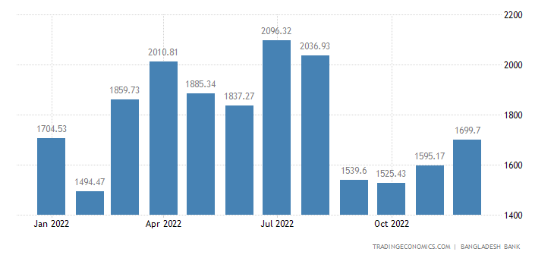

Related | Last | Previous | Unit | Reference
Balance of Trade | -236.20 | -224.50 | BDT Billion | Oct 2022
Current Account | -83.37 | -190.59 | Billion BDT | Oct 2022
Current Account to GDP | -1.10 | -1.40 | percent of GDP | Dec 2021
Imports | 619.51 | 627.20 | BDT Billion | Oct 2022
Exports | 383.30 | 402.69 | BDT Billion | Oct 2022
Capital Flows | 3.74 | 0.65 | BDT Billion | Oct 2022
Remittances | 1699.70 | 1595.17 | USD Million | Dec 2022
Foreign Direct Investment | 1355.00 | 1510.00 | USD Million | Dec 2021
External Debt | 49.50 | 44.20 | USD Billion | Dec 2021

Source of Bangladesh Remittances:
In Bangladesh, Remittances refers to inflows of migrants’ and short-term employee income transfers. Remittances from more than 10 million citizens abroad are very important for Bangladesh and along with garment exports are key source of foreign exchange. Saudi Arabia has been the largest source of remittances, followed by UAE, Qatar, Oman, Bahrain, Kuwait, Libya, Iraq, Singapore, Malaysia, the US and the UK.
This page includes the most recent reported value for Bangladesh Remittances along with historical high and low values, short- and long-term forecasts, an economic calendar, survey consensus, and news. The most recent update to the actual data, historical chart, and publication schedule for Bangladesh Remittances was made in November 2022.
Actual | Previous | Highest | Lowest | Dates | Unit | Frequency
1699.70 | 1595.17 | 2598.21 | 856.87 | 2012 - 2022 | USD Million | Monthly

Remittances by Country:
World Europe America Asia Africa Australia G20
Country | Last | Previous | Reference | Unit
Brazil | 390 | 371 | Nov/22 | USD Million
France | 19 | 19 | Sep/22 | EUR Million
Germany | 533 | 533 | Oct/22 | EUR Million
India | 18079 | 16285 | Sep/22 | USD Million
Indonesia | 2452 | 2388 | Sep/22 | USD Million
Italy | 124 | 111 | Jun/22 | EUR Million
Mexico | 15449 | 15043 | Sep/22 | USD Million
Netherlands | 30 | 28 | Sep/22 | EUR Million
Russia | 610 | 600 | Dec/21 | USD Million
Spain | 3063 | 3431 | Sep/22 | EUR Million
Turkey | 13 | 9 | Nov/22 | USD Million

Wage earners' remittance:
The FEPD's drawing arrangement section strives to increase remittance from wage earners. They have used some pencils to make a representation of the agreement between the Bangladeshi bank and the foreign exchange firm. The policy has adopted a more thorough and effective approach to supervising drawing arrangement setup.
In Bangladesh, the annual average pay is 312,000 BDT (Bangladeshi Taka). According to the exchange rates from April 2023, that amounts to about 2,944.70 USD annually.In 2022, Bangladesh's minimum wage would continue at 8000 BDT (73.262 USD) per month. The monthly minimum wage for employees was 5300 BDT, and the monthly maximum was 8100 BDT.

WAGE EARNERS' REMITTANCES INFLOWS [Monthly]

(TOP 10 SOURCE COUNTRIES)
(In million US$)
Items | 2021-22^{R}  July-Nov | 2022-23^{RP}  July-Oct | 2022-23^{P}  July-Nov | % Changes  4 over 2
Saudi Arabia | 2065.0 | 1307.5 | 1602.7 | -22.39
United States of America | 1423.8 | 1233.5 | 1538.3 | 8.04
United Arab Emirates | 694.8 | 958.8 | 1143.6 | 64.59
United Kingdom | 734.0 | 619.1 | 760.2 | 3.57
Kuwait | 700.1 | 535.7 | 662.0 | -5.44
Qatar | 569.0 | 494.0 | 615.2 | 8.12
Italy | 415.7 | 430.3 | 515.8 | 24.08
Malaysia | 444.9 | 395.3 | 464.7 | 4.45
Oman | 419.1 | 219.8 | 269.4 | -35.72
Bahrain | 220.0 | 170.2 | 202.0 | -8.18
Other countries | 922.5 | 834.2 | 1019.2 | 10.48
Total | 8608.9 | 7198.4 | 8793.1 | 2.14

The pie chart show the % of major destinations of migrants from Bangladesh-

Wage Earners Remittance inflows: Selected Country wise (Monthly)

(USD in Million)
Country | 2017-2018 | 2018-2019 | 2019-2020 | 2020-2021 | 2021-2022 | July  2022-2023 | August  2022-2023 | September  2022-2023 | October  2022-2023 | November  2022-2023 | December  2022-2023 | Total
Bahrain | 541.62 | 470.08 | 437.18 | 577.74 | 566.61 | 44.50 | 41.50 | 33.73 | 50.46 | 31.84 | 18.34 | 220.37
Kuwait | 1199.70 | 1463.35 | 1372.24 | 1886.50 | 1689.59 | 141.87 | 143.50 | 117.90 | 132.44 | 126.29 | 100.80 | 762.80
Oman | 958.19 | 1066.06 | 1240.54 | 1535.64 | 897.40 | 78.24 | 51.24 | 40.62 | 49.69 | 49.84 | 43.47 | 313.10
Qatar | 844.06 | 1023.91 | 1019.60 | 1450.18 | 1346.47 | 106.89 | 131.41 | 113.80 | 141.87 | 121.23 | 84.06 | 699.26
K.S.A. | 2591.58 | 3110.40 | 4015.16 | 5721.41 | 4541.96 | 349.64 | 341.71 | 307.66 | 308.50 | 295.25 | 306.39 | 1909.15
U.A.E. | 2429.96 | 2540.41 | 2472.56 | 2439.99 | 2071.85 | 304.86 | 304.86 | 178.39 | 170.69 | 184.76 | 193.57 | 1337.13
Libya | 2.36 | 7.84 | 4.02 | 6.96 | 2.34 | 0.12 | 0.12 | 0.20 | 0.16 | 0.22 | 0.19 | 1.01
Iran | 0.04 | 0.00 | 0.01 | 0.01 | 0.11 | 0.01 | 0.01 | 0.00 | 0.01 | 0.00 | 0.00 | 0.03
Sub Total | 8567.51 | 9682.05 | 10561.31 | 13618.43 | 11116.33 | 1026.13 | 1014.35 | 792.30 | 853.82 | 809.43 | 746.82 | 5242.85
Australia | 56.56 | 57.15 | 61.32 | 141.77 | 128.54 | 13.07 | 14.72 | 9.65 | 8.07 | 9.36 | 9.24 | 64.11
Hong Kong: SAR of China | 21.25 | 20.08 | 17.09 | 21.36 | 20.61 | 1.68 | 1.46 | 1.18 | 1.38 | 1.67 | 1.51 | 8.88
Italy | 662.22 | 757.88 | 699.15 | 810.90 | 1054.20 | 129.66 | 126.93 | 86.56 | 87.18 | 85.49 | 95.10 | 610.92
Malaysia | 1107.21 | 1197.63 | 1231.30 | 2002.36 | 1021.85 | 139.32 | 107.06 | 78.39 | 70.57 | 69.36 | 78.75 | 543.45
Singapore | 330.16 | 368.33 | 457.40 | 624.86 | 385.24 | 31.92 | 33.27 | 24.88 | 26.20 | 29.76 | 29.84 | 175.87
U.K. | 1106.01 | 1175.63 | 1364.89 | 2023.62 | 2039.23 | 197.78 | 182.04 | 128.84 | 110.48 | 141.15 | 150.86 | 911.15
U.S.A. | 1997.49 | 1842.86 | 2403.40 | 3461.68 | 3438.41 | 363.34 | 358.73 | 277.70 | 233.69 | 304.91 | 428.29 | 1966.66
Germany | 40.20 | 60.62 | 52.75 | 66.89 | 83.50 | 9.26 | 8.13 | 6.21 | 6.38 | 7.00 | 8.69 | 45.67
Japan | 31.44 | 49.54 | 49.35 | 79.54 | 69.29 | 12.29 | 13.22 | 5.47 | 4.72 | 7.77 | 10.36 | 53.83
S. Korea | 96.29 | 112.51 | 177.83 | 209.16 | 135.46 | 20.96 | 15.02 | 7.99 | 8.78 | 10.71 | 13.35 | 76.81
Others | 965.35 | 1095.35 | 1129.22 | 1717.14 | 1539.02 | 150.91 | 162.00 | 120.43 | 114.27 | 118.56 | 126.89 | 793.06
Sub Total | 6414.18 | 6737.58 | 7643.70 | 11159.28 | 9915.35 | 1070.19 | 1022.58 | 747.30 | 671.72 | 785.74 | 952.88 | 5250.41
Total | 14981.69 | 16419.63 | 18205.01 | 24777.71 | 21031.68 | 2096.32 | 2036.93 | 1539.60 | 1525.54 | 1595.17 | 1699.70 | 10493.26

Export Policy
Under the export policy of Bangladesh, the exporter must obtain a valid export registration certificate (ERC) from the chief controller of export & import in accordance with Bangladesh's export policy (CCI&E). The ERC must be renewed annually. On export forms and other papers related to exports, the ERC number must be included.

Function of this section
- To distribute a decision on the issues brought up by banks, exporters, or associations in connection with the rules for the payment of monetary incentives or export subsidies.
- To communicate a decision regarding a banking matter that was brought up by a government authority (NBR, Customer, Bond Commission Rate, BEPZA, etc.).
- To make a decision about concerns brought up by banks regarding foreign exchange transactions involving exports.
- To provide feedback on questions posed by the ministry of commerce, the Bangladesh tariff commission, and EPB regarding bilateral trade, the WTO, GATSA, SAPTA, BIMSTEC, etc.
- To go over meeting minutes from various government entities and take appropriate action if reading export is necessary.
- To allow exporters in Bangladesh to act as an agent for international imports where the agency commission exceeds 5%.
- To give consent for the employment of a foreign agent to promote Bangladesh export.
- To respond appropriately to concerns made by exporters.
The government has unveiled a new export strategy for the three years (2019-2022) that places an emphasis on 12 industries as having the "greatest potential" and 14 others as needing "special development."
The new export policy prioritizes 12 industries above all others: high value-added RMG accessories; software and IT-enabled services and ICT products; shipbuilding; footwear and leather goods; jute and jute-based goods; plastic goods; agricultural goods and agriculturally processed goods; furniture; home textiles and terry towels; home furnishings; and luggage.
Numerous jute-based products, electronic and electric goods, ceramic goods, light engineering, value-added frozen fish, printing and packaging, rough diamond and jewelry, paper and paper goods, rubber, silk goods, handicraft and cottage goods, lungi and tent industry goods, and coconut coir are among the 14 special development sectors.
The 17 export-prohibited goods included in the new export policy include edible oil, wheat, onions, garlic, all types of pulses besides processed ones, regular rice besides fragrant rice, jute seed, and items related to armaments and ammunition.

Process of export
A person must take the following actions in order to export if they possess a TEN certificate.
Step 1: A corporation or individual holding a trade license is qualified to conduct export business. However, he or the business must first get an export registration certificate (ERC) from the CCI&E office, located at 111-113 Motijheel Commercial Area in Dhaka. For the most part, obtaining an ERC requires a trade license, a bank balance certificate, and membership in the relevant trade groups.
Step 2: It begins with registering the company name at the Office of the Registrar of Joint Stock Companies & Firms when beginning a business in Bangladesh. 24-25 Dilkusha, Commercial Area, Dhaka is where the office is situated. This office grants registration of companies, associations, and partnership firms under the Companies Act and other relevant legislation, rules, and orders, and guarantees that they are managed legally.
Step 3: The location's city corporation should issue the new entities with a trading license as well. A license or certificate from BSTI, BRTA, etc. may also be required, depending on the type of business.
Step 4: Exporters must get quality assurance certificates for some items from organizations like BSTI, the Department of Fisheries (DOF), the relevant Trade Associations, etc.
Step 5: The exporter has the option to export with or without a letter of credit (LC). The Contract/Agreement with Foreign Buyer, CAD, Advance TT techniques etc. are also permitted for export. The exporters then produce a bill of export and submit the EXP form to the bank. Exporters approach the customs office at the port where they intend to ship their exportable with all of this paperwork in hand. The customs authority examines all the paperwork before approving their request to export, and after the goods have been boarded, the authority issues them a bill of lading. The customs authority ensures them by stamping a seal on the back of the bill of lading and providing an Export General Manifest after shipping (EGM).

Current situation of export in Bangladesh
By the end of the current fiscal year, the government predicts that the garment sector would be able to earn $12.496 billion in exports from July through September 2022, or over 80.06 percent of the total earnings.
After releasing the data on Sunday, Commerce Minister Tipu Munshi told the reporters at the secretariat, "I think we will be able to meet our aim.
From 1972 to 2022, Bangladesh's exports totaled an average of 63.84 BDT billion, with a record high of 428.60 BDT billion in August 2022 and a record low of 0.05 BDT billion in February 1972.
Despite the ongoing global economic crisis, Tipu Munshi, the country's minister of commerce, predicted that the nation will reach its $67 billion export revenue target in 2022–2023FY.
Together, woven and knitted clothing, clothing accessories, and home textile exports made for 80.06 percent of Bangladesh's $12.496 billion in total exports during July to September 2022. Exports of knitwear (Chapter 61) grew more slowly than exports of woven RMG. Knitwear exports grew to $5.649 billion in July–September 2022 from $5.164 billion in the corresponding months of the previous fiscal year, a 9.40% rise.
According to the data, woven textile exports increased by 18.73% to $4.624 billion during the study period from $3.895 billion from July to September 2021.
Products | Export for  2021-22 | Export  Target of  2022-23 | % Change of export performance  July-Jan. 2022-23 Over  July-Jan. 2021-22
Frozen & Live Fish | 532.94 | 634.00 | -22.83
Agricultural Products | 1162.25 | 1394.12 | -25.86
Manufactured Commodities | 50387.47 | 55971.88 | 11.18
Chemical Products | 364.07 | 429.55 | -19.14
Plastic Products | 166.25 | 200.00 | 40.12
Rubber | 46.82 | 60.00 | -38.03
Leather & Leather Products | 1245.18 | 1440 | 7.37
Handicrafts | 42.83 | 50.00 | -34.10
Jute & Jute goods | 1127.63 | 1280.00 | -21.22
Carpet | 36.81 | 44.00 | -31.96
Specialized Textiles | 314.82 | 387.00 | -32.06
RMG | 42613.15 | 46800 | 14.31
Home Textile | 1621.93 | 1980.00 | -16.65
Data Source: NBR

Export Impact on the Economy
Bangladesh has one of the world's fastest developing economies. Following the global epidemic, Bangladesh's GDP grew by 7.2%. Since 1996, Bangladesh's economy has risen by about 7.5% annually despite protracted periods of political unrest, subpar infrastructure, widespread corruption, insufficient electricity supply, and a sluggish pace of economic transformation.
The global corona virus pandemic's effects on the Bangladeshi economy have been recovering steadily. From 7.88% growth in the year prior to the pandemic, the GDP growth fell sharply to 3.45% in FY 2019–20. Nevertheless, GDP growth picked up and reached 6.94% in FY 2020–21. The GDP growth is anticipated to be 7.25% in FY 2021–2022, according to the BBS's provisional forecast. The per capita GDP and GNI during that time were $2,723 and $2,824 USD, respectively. . In the preceding fiscal year, the GDP and GNI per capita were $2,462 and $2,591, respectively. The pandemic has had the least impact on the agriculture sector, which grew by 3.42 percent in the 2019–20 fiscal years. A small slowdown in the sector's growth to 3.17 percent in FY 2020–21 was followed by a severe decline to 2.20 percent in the current fiscal year. In FY2019–20, industry sector growth fell precipitously. Industrial sector growth dropped during this time, from 11.63 percent in the year prior to the pandemic to 3.61 percent. The industrial sector has since turned around, with growth in FY 2020–21 standing at 10.29 percent.
The industry expands despite several high-profile workplace mishaps that have resulted in more than 1,000 worker deaths and oppressive strikes, including a statewide transportation blockade that was staged by the political opposition during the first few months of 2021. Bangladesh's continued economic growth and expanding foreign exchange reserves are largely due to the garment industry's steady export growth and remittances from Bangladeshis living abroad, which in December 2022 reached $5.36 billion.

Share of economic sectors in the GDP in Bangladesh 2022

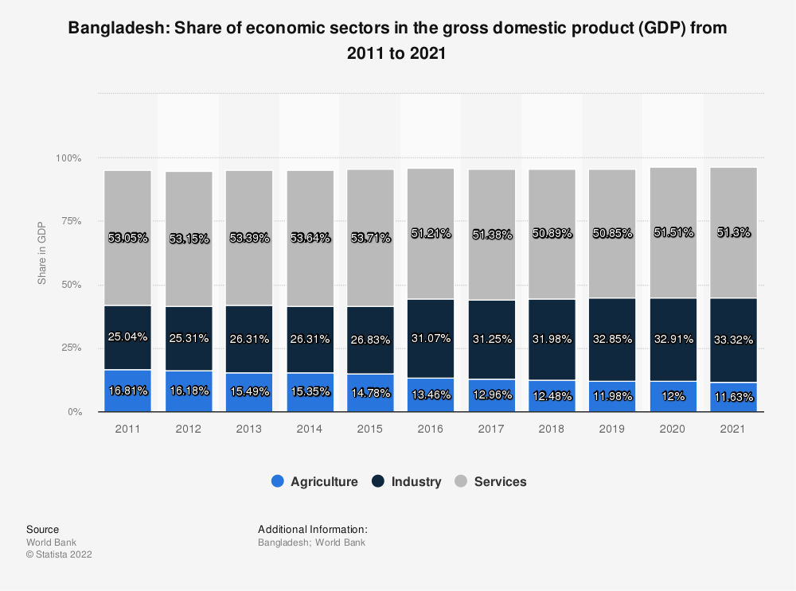

Export Impact on Exchange Rate
At the end of October 2022, the private sector's credit growth rate, which has been exponentially rising recently, was 13.9 percent. The Bangladeshi economy has been experiencing external sector vulnerabilities throughout periods of rapid private sector credit growth. These vulnerabilities are primarily the result of higher import costs brought on by rising global commodity prices and a significant depreciation in the value of the Bangladeshi Taka (BDT) relative to the US dollar.
Bangladesh was not an exception to the COVID-19 pandemic's negative effects on economic activity. During the COVID-19 period, central banks, which regulate financial institutions, particularly banking systems, had great hurdles to sustain macroeconomic and financial stability. Commercial banks, as major market participants in the financial sector, were seen to be somewhat hesitant to offer new loans during the COVID-19 period because to the uncertainty about the upcoming economic environment. Even the BB employed an easy monetary policy in the midst of the Government's extensive stimulus packages to counteract the pandemic effects, credit growth, in especially the private sector credit growth, slowed dramatically during the constrained time of COVID-19 periods.
Bangladesh's economy successfully recovered from the COVID-19 impact with continuing growth-supportive policy measures, as real GDP rose by 6.94 and 7.25 percent in FY21 and FY22, respectively, reaching the pre-pandemic growth rates. The Russia-Ukraine war struck Bangladesh's economy, as with most other economies, just as it began to pick up speed and accelerate its recovery from the recession. In actuality, Bangladesh began to experience the effects of the conflict in its external economic sectors, primarily through channels related to the price of commodities globally. From March 2021 to June 2022, there was extremely high, close to or above 50%, global inflation. Even if the inflation rate dropped in September 2022 to 28.3 percent, it was still exceedingly high. Since the first quarter of 2021, Bangladesh's import expenses have significantly increased as a result of the consequences of rising commodity prices globally. Import growth increased by 32.3, 72.9, 47.6, and 60.5 percent over the course of the first four quarters of 2021, which put tremendous pressure on the BDT/USD exchange rate.
This policy paper makes many assumptions to calculate the increase of private sector lending after adjusting for exchange rates. First, export-import financing and other loans are separated from the overall amount of private sector credit. The amount of credit provided by the private sector that is not export-import financing is known as other credit. The depreciation effect of the BDT-USD exchange rate is therefore eliminated by merely converting the export-import financing into USD terms. Comparing the growth rates of export-import financing in BDT and USD terms, it is clear that the growth of export-import financing in USD recently sharply declined, especially since March 2022, while the growth of export-import financing in BDT continued an upward trend during the same period, reflecting exchange rate depreciation as a key factor in the recent high growth of export-import financing.
In comparison to the previous month, when the exchange rate for Bangladesh was 97.620 BDT/USD, it averaged 98.850 BDT/USD in December 2022. Data on Bangladesh's exchange rate against the US dollar is available from May 1970 through December 2022, and it is updated every month. A record high of 98.850 was attained in December 2022, while a record low of 7.338 was attained in March 1972 for this data.
Growth of credit to trade: BDT vs. USD

Foreign Reserve

Bangladesh's foreign exchange holdings were valued at 30.0 USD billion in December 2022 as opposed to 30.1 USD billion the month before. Bangladesh Foreign Exchange Reserves: USD data is available from December 1972 to December 2022 and is updated once every month. The statistics peaked at $44.6 billion in August 2021 and fell to a record low of $42.5 million in August 1974.
However, due to a large import payment obligation and a dearth of dollars available, Bangladesh's foreign exchange reserves fell to $32.29 billion on January 26. On December 28, 2022, the reserves had decreased to $33.83 billion from a record high of $48.6 billion in August 2021. The Bangladesh Bank paid the Asian Clearing Union $1.12 billion for the months of November and December. In the Asian Clearing Union, participants settle payments for intra-regional transactions on a net multilateral basis through the participating central banks.
In order to help banks fulfill their import payment obligations, the BB injected more than $7.8 billion into the financial system between July and December of 2022. A lack of dollars on the market caused the central bank to sell $7.62 billion in cash to banks directly in FY22. Import payments had dramatically decreased in 2021 while exports and remittance revenues saw rise. This was due to a variety of limitations and the slow economic environment caused by the Covid 19 epidemic. The demand for both foreign and domestic currencies increased significantly during the pandemic's recovery, however, depleting the nation's reserves of both currencies because the supply did not keep up with the unexpected increase in demand.
Bangladesh's ability to pay for imports has been weakened as a result of the nation's reserves declining by $16.31 billion from $48.6 billion a year earlier. The central bank created a $7 billion fund for exporter development out of the total amount, but it is still regarded as reserves and the IMF has already voiced its disapproval for it. The nation's reserves would drop to $24.2 billion if the EDF were not included in the calculation. In order to protect the reserves by limiting imports, the government and central bank have already taken a variety of actions.
Compared to $23.78 billion in FY21, the country's trade imbalance in FY22 reached a record $33.24 billion. From July to November of FY23, the trade deficit totaled $11.79 billion. The nation's import payments increased from $31.16 billion to $32.53 billion in the first five months of FY23 from the same period the year before. On September 14, 2022, the central bank authorized the dollar's floating rate. The US dollar is now trading between Tk. 103 and Tk. 105 on the interbank market. From Tk 2.03 lakh in June 2022 to Tk 1.45 lakh at the end of December 2022, the country’s banking sector's surplus liquidity fell by Tk 57,707 crore.
After the nation's import payments grew, the surplus liquidity decreased, according to bankers. The call money market has seen an upsurge in interbank borrowing recently as a result of a lack of liquidity. By December 31, the weighted average call money rate had risen to 5.76 percent. On January 25, it increased to 7%.

Reserve adequacy measures for Bangladesh and excess reserves (in billion US dollar)
Comparing 2021 to 2020, many reserve adequacy indices declined somewhat. However, the current reserve level was sufficient to protect against perhaps bad events, as measured by compliance with several widely accepted international norms.
Gross foreign exchange reserves reached USD 46.15 billion at the end of December 2021, 6.92 percent more than in 2020, and they appear to be sufficient to fulfill the requirements of the three separate benchmarks for reserve adequacy. This suggests that Bangladesh's financial system may anticipate continuing to be resilient to potential external sector risks. First, the stockpile was sufficient to handle six months' worth of potential imports.
Second, the FX reserve to M2 ratio (broad money) at the end of December 2021 decreased marginally to 24.43 percent, although it was still higher than the global average. Thirdly, due to a considerable growth in STD, the ratio of short-term external debt (STD) to foreign exchange reserves grew from 25.45 percent in 2020 to 39.19 percent in 2021. The FX reserves' ability to cover this short-term foreign debt, meanwhile, remained strong.

Import Policy
According to Bangladesh's import regulations, imports must obtain a valid import registration certificate (IRC) from the chief controller of export and import (CCI&E).

Import policy of FEPD
- Sales made in connection with import bills under LCs or contracts must be reported when the transactions are completed upon receipt of import documentation rather than when importers retire the bills.
- All import-related sales must be accompanied by an original copy of the IMP form (Appendix 5/11, vol.1). It might not be able to present an original copy of the IMP form that has been properly signed by the importers due to the time gap between the date of receipt of the import bills and the date that the importers retire them. In this situation, Authorized Dealers must complete the IMP form in quadruplicate and submit it with the pertinent schedule and the summary statement. After the importer has signed the IMP form, the original copy must be delivered.
- The transactions for import bills received on a collection or CAD basis shall be recorded on schedule E-2 and supported by the original IMP form.

Give decision
- Regarding difficulties brought up by banks in relation to import foreign exchange operations.
- To publish the decision regarding the inclusion of the realization clause in the L/C.
- To publicize the decision regarding import without an L/C and LCAF revalidation

Approval
- Advance payment.
- Relating to off-shore banking.
- Back-to-back L/Cs against deferred payment L/Cs and deferred payment L/Cs with deferred payments.
- Changes in service import and service payment.
- To endorse or express an opinion on EPZ Enterprises.
- Standby and revolving L/C.
- Related to export/ re-import.

Monitoring
- Non-payment of import bill.
- Non-payment of accepted bills (local & foreign).

Issuance
- Based on a public announcement by the relevant government agency, to issue circular letters.
- Issuance of a NOC for the sale of an IGM amendment or for the acquisition of an additional IGM.
- Issuing a NOC for the purchase of an additional IGM or the selling of an IGM modification.
- Must respond appropriately to numerous import-related issues.
- To share opinions on matters pertaining to multi-lateral and bilateral trade.

Import procedure
Import shall be made as per following procedure:
- Import License not required: No import license will be required, unless otherwise stated, for the import of any goods.
- Import against LCA Form: Unless otherwise stated, regardless of the source of financing, LCA papers are required for all import transactions made through a bank (L/Cs, bank drafts, remittances, etc.).
- Import through L/C: If not instructed differently, import will only be effected by opening an irreversible L/C:
- Assuming that capital equipment, regardless of price, can be imported against an LCA Form without a Letter of Credit and that each consignment of quickly perishable food items worth US$50,000 via the Teknaf Customs Station, essential food items and raw materials for industry worth US$10,000, and capital machinery regardless of price limit via other custom land stations are permitted;
- Additionally, it is provided that the requirement in Subparagraph (6) should be consistently applicable and that importers shall register with an approved dealer bank for importation without a letter of credit.
- Import against LCA Form but without opening of Letter of Credit (L/C): In the following circumstances, import against an LCA form may be permitted without the opening of a Letter of Credit:
- On the basis of a sight draft or use bill, the import of books, journals, magazines, and periodicals;
- Only during each fiscal year against remittance made from Bangladesh is the import of any authorized goods for a sum not exceeding US$100,000 (hundred thousand). However, in the case of Myanmar-
- Importation of rice, pulses, maize, beans, ginger, garlic, soybean oil, palm oil, onions, and fish goods priced at no more than 50,000/- (fifty thousand) US dollars in a single consignment and other commodities valued at 30,000/- (thirty thousand) US dollars and
- Rice imported under the Public Sector may be imported without a letter of credit up to a value of US$2 million in a single consignment; in this instance, the yearly ceiling of US$100,000 is not applicable.
- Import under commodity aid, grant or such other loan for which there are specific procurement procedures for import of goods without opening any L/C: and
- Import of "international chemical references" through Bank drafts by recognized pharmaceutical industry on the approval of Director, Drugs Administration for the purpose of quality control of their products.
- Import against Import Permits and in special cases against Clearance Permit (for clearance of goods on payment of fine): In the following circumstances, neither the LCA Form nor the opening of an L/C will be required; nonetheless, the importer will still be required to get an import permit (IP) or clearance permit (CP), as in the following examples:
- Importation of books, periodicals, journals, magazines, scientific equipment, and lab supplies in exchange for the return of UNESCO coupons;
- Import under the Pay-As-You-Earn Scheme in the following circumstances only with the Bangladesh Bank's approval:
- New or not more than ten years old plant and machinery of permitted specification;
- New or not more than five year old motor vehicles.
- Steel or wooden bodies with steel or wooden bodies for cargo or passengers, as well as new or less than fifteen-year-old refrigerated vessels of any capacity: With the caveat that antique ships capable of ocean travel must be under 25 years old to be importable;
- Import of equipment for industrial facilities focused on exports with the relevant sanctioning authority's approval;
- Trawlers and other fishing vessels, either newly constructed or not older than 25 years: As long as the importer applies to the CCI&E with the required paperwork for prior authorization and the sanctioning authority of the import sends a copy of the sanction letter to the Chief Controller;
(c) Import of item(s) by a passenger traveling from abroad that exceeds the amount or value permitted by the applicable luggage rules, provided that the import of the said item(s) is permitted by the applicable baggage rules;
(d) Import of samples, promotional objects, and gifts that exceeds the ceiling set out in paragraph 12 of this Order;
(e) Only medications and herbal remedies may be imported under the bonus system, but only under the condition that the benefit must be distributed to consumers by the involved importers. The Drugs Administration Director will develop the necessary protocol in this regard.
(f) Import of capital equipment and spare parts as a proportion of the foreign shareholder's capital for a joint venture that has been approved or an industrial unit that is currently established or is going to be established with 100% foreign investors;
(g) Import of any additional products that are not explicitly exempt from a permit.
6. Import on Deferred Payment Basis or Against Supplier's Credit: Imports on a delayed payment basis or using a supplier's credit may be permitted subject to the limitations and restrictions in this order by following the guidelines established by the Bangladesh Bank in this regard.
7. Import against direct payment abroad: Any importable goods, regardless of value ceiling, may only be sent overseas in the name of any Bangladeshi national living in Bangladesh by Bangladeshi nationals living abroad. The import documentation must include the consignee's name and address in this situation.
- The Import Control Authority's authorization or import permit is not required;
- In this situation, a document identifying the applicant as a foreign exchange earner must be presented from the Bangladeshi embassy there. That certificate must include the sender's name, passport number, employment, yearly income, length of stay abroad, etc.;
- The Embassy will need to certify the items' payment receipt.
8. Time limit for opening of L/C:
- Unless otherwise stated, all importers must obtain a letter of credit within 150 days of the date the LCA form was issued or registered for cash foreign exchange imports: With the caveat that the Chief Controller of Import and Export may extend the aforesaid time restriction for as long as necessary;
- L/Cs must be opened within the time frame that may be specified by the Chief Controller for imports covered by foreign aid, grants, and barter/STA.
9. Validity of shipment for goods:
- Unless otherwise stated, shipping of goods must be made within 9 months for all other products and 17 months for machinery and replacement parts from the day the bank issues the LCA Form.
- Goods under commodity aid/grants, account trade arrangements, and counter trade arrangements must be shipped within the time frames that the Chief Controller may notify;
- The Chief Controller may extend the time restriction for shipping goods in cases where it was impossible to do so during the validity period owing to factors beyond the importer's control.
10. Restriction on L/C after imposition of ban/restriction: After a ban or restriction has been placed on any item(s), neither the nominated Bank nor the Import Control Authority may provide a Letter of Credit an extension of the date of shipment, an amendment to the Letter of Credit, or an increase in the value or quantity of the items.
11. Document required to be submitted along with LCA Form: In order to open a Letter of Credit, importers in both the public and private sectors must submit the following documentation to their designated Banks with the L/C Authorization Form:
- L/C Application Form with the importer's proper signature;
- a proforma invoice acquired from the overseas supplier, when applicable, or indents for items produced by Indentor;
- Insurance Cover Note.
12. Additional documents to be furnished by public sector importers: Public sector importers must also present an authenticated photocopy of the sanction letter from the relevant administrative Ministry, Division, or Authority in addition to the paperwork listed in subparagraph (11) above;
13. Additional documents to be furnished by private sector importers: Private sector importers will be required to submit the documentation listed below in addition to those indicated in sub-paragraph (11) above, including:
- A valid membership certificate from the locally registered Chamber of Commerce and Industry or other trade association founded in Bangladesh on the basis of any particular trade or company;
- Certificate of renewed import registration for the relevant fiscal year;
- A statement made in three copies showing the importer has filed or paid their tax obligations for the previous year;
- TIN documentation is required for all imports, except those for personal use;
- Any document that may be needed in accordance with a public notice or an order made from time to time under this Order by the Chief Controller;
- Any paperwork or documentation required by this Order;
- Insurance Cover Note, which must be presented to the Customs Authority before the discharge of goods, must be issued by Sadharan Bima Corporation or by any other Bangladeshi Insurance Company and must be accompanied by a properly stamped insurance policy against this cover-note.
14. Violation of the requirement of LCA/LC:
- Shipments made before the nominated bank issues the L/C Authorization Form, before the L/C is opened, or after the L/C Authorization Form or L/C has reached the end of its valid period of use, will be deemed to be imported in violation of this Order.
- The L/C Authorization Form shall be deemed null and void ab initio if it was acquired using false, incomplete, or fraudulent information.
15. Import against indent and pro-forma Invoice: L/C may be opened against an indent issued by a local registered Indentor or against a pro-forma invoice issued by a foreign manufacturer/seller/supplier.
16. Procedure to be followed by banks for acceptance/issuance of LCA Forms: Banks will follow the following procedures in the case of accepting or issuing of LCA Form:

- Acceptance of LCA Forms by the nominated banks-
- Recognized private sector manufacturing units and registered commercial importers must submit LCA Forms and other pertinent documents to their designated bank in order to import goods by creating an L/C.
- The designated banks must ensure that the importer in question has a valid Import Registration Certificate (IRC), that the necessary renewal fees for the IRC for the relevant financial year have been paid, and that the details of the treasury chalan proving payment of the renewal fees have been properly recorded in the IRC of the said importer before accepting LCA Forms from the private sector importer. LCA Forms cannot be accepted from private sector importers unless they are expressly excluded from IRC, and L/C cannot be opened in their favor without a valid and lawfully renewed IRC.
- When importing through land, the relevant L/C will explicitly mention the name of the land port of destination in Bangladesh;
- However, a letter of credit (L/C) may be created without an Import Registration Certificate (IRC) and without requesting an exemption certificate from the Chief Controller for the import of capital equipment and initial spares for the establishment of a new industrial unit. In regards to industrial units operating in the open market, no official approval from the sponsoring authority is required for such imports against foreign currency paid in cash;
- A certificate from the responsible bank stating that the import cost would be paid in cash foreign exchange from the equity of the foreign investor is necessary in cases where a foreign investor is importing capital machinery and replacement parts;

(b) The accurate registration of the applicable H.S. Code Number on the LCA Form or L/C is a requirement for processing any LCA Form or opening an L/C by banks. The Bangladesh Bank is responsible for monitoring how well the foregoing standards are being met by the scheduled banks.
(c) Registration of LCA Form- Whether an import is made with or without a credit line, the authorized dealer bank must register the LCA Form and submit copies to Bangladesh Bank, the importer, the Customs Authority, the Chief Controller of Imports and Exports, and each of these parties along with the monthly statement following payment. The authorized dealer bank must also retain 1 copy at the bank. The dealer bank must provide all registration-related data in a monthly statement to the relevant Bangladesh Bank office.
(d) Exceptions to the registration requirement for LCA Forms against Government Allocations Following the recording of the information contained in the LCA Form, the designated bank should send the LCA Form or LC Application Form, along with other relevant papers, to the designated bank with a request to open LC in the event of import under a loan, grant, barter, or special trade arrangement. The chosen bank must then provide the third and fourth copies of the LCA Form to the Import Control Authority within 15 (fifteen) days after opening the L/C.
(e) A legible copy of the L/C and a copy of any amendments thereto, if any, must be forwarded by the L/C opening banks to the relevant Import Control Authority for their record within fifteen days in all situations.
(f) Dispatch of Income Tax Declarations Filed by Private Sector Importers- The Designated Bank of the Concerned Private Sector Imports shall retain one copy of the Income Tax Declaration Filed by the Importers and forward or other copy to the Director (Research and Statistics), National Board of Revenue.
(g) Alter of Nominated Bank: If neither bank objects, the Controller of Imports and Exports may alter the nominated bank within the authority of any specific Regional office. In this situation, a copy of the no objection certificates from both banks must be presented to the relevant import control authority. 3.7.7- Major Product – Wise Import of Bangladesh Major Import Commodities of Bangladesh Amounts in Millions USS.

Major Import Commodities of Bangladesh:
By the end of this quarter, experts and Trading Economics' global macro models predict that imports in Bangladesh would total 410.00 BDT billion. Our econometric models predict that the Bangladesh Imports will have a long-term trend that will most likely be between 610.00 BDT Billion in 2024 and 720.00 BDT Billion in 2025.
From 484.44 BDT in April 2023 to 587.90 BDT in May, imports increased in Bangladesh.
Bangladesh imports primarily fuel and oil (11 percent of total imports), textiles (10 percent), and food (9 percent). Other items are yarn, plastic and rubber products, chemicals, edible oil, and iron and steel (7%) among others.

Bangladesh Imports

Actual | Previous | Highest | Lowest | Dates | Unit | Frequency
587.90 | 484.44 | 709.25 | 0.57 | 1976 - 2023 | BDT Billion | Monthly

Related | Last | Previous | Unit | Reference
Balance of Trade | -235.60 | -183.20 | BDT Billion | May 2023
Current Account | -82.08 | 4.31 | Billion BDT | May 2023
Current Account to GDP | -4.10 | -1.10 | percent of GDP | Dec 2022
Imports | 587.90 | 484.44 | BDT Billion | May 2023
Exports | 352.35 | 301.19 | BDT Billion | May 2023
Capital Flows | 0.38 | 3.02 | BDT Billion | May 2023
Remittances | 2199.01 | 1691.66 | USD Million | Jun 2023
Foreign Direct Investment | 1160.00 | 1355.00 | USD Million | Dec 2022
External Debt | 57.63 | 50.88 | USD Billion | Dec 2022

Bangladesh Imports In Chart
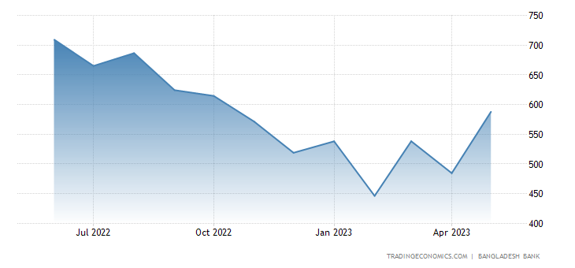

Current situation of Import in Bangladesh:
- Bangladesh's total imports reached USD 5.3 billion in March 2023 as opposed to USD 4.4 billion the month before.
- Bangladesh Total Imports data, available from July 1986 to March 2023, is updated monthly and has an average value of 1.1 billion USD.
- The information peaked at 7.7 USD bn in June 2022 and hit a record low of 98.8 USD in November 1987.
Bangladesh's total imports reached USD 5.3 billion in March 2023 as opposed to USD 4.4 billion the month before. For more information,
See the table below.

LAST | PREVIOUS | MIN | MAX | UNIT | FREQUENCY | RANGE
5,279.6Mar 2023 | 4,419.2Feb 2023 | 98.8Nov 1987 | 7,706.7Jun 2022 | USD mn | monthly | Jul 1986 - Mar 2023

Bangladesh GDP Annual Growth Rate:
The largest economic sector in Bangladesh is the service industry, which generates 52% of the country's GDP. The three most significant categories within services are: wholesale, retail, and trade; transportation, storage, and communication; and real estate, tenancy, and business activities (7%). Construction and manufacturing make up the majority of industry, which contributes close to 34% of GDP. Agriculture, forestry, and fishing together account for the remaining 14%.

Bangladesh GDP Annual Growth Rate
Actual | Previous | Highest | Lowest | Dates | Unit | Frequency
7.25 | 5.47 | 8.15 | 3.51 | 1994 - 2022 | percent | Yearly

Related | Last | Previous | Unit | Reference
GDP Growth Rate | 7.25 | 5.47 | percent | Dec 2022
GDP Annual Growth Rate | 7.25 | 5.47 | percent | Dec 2022

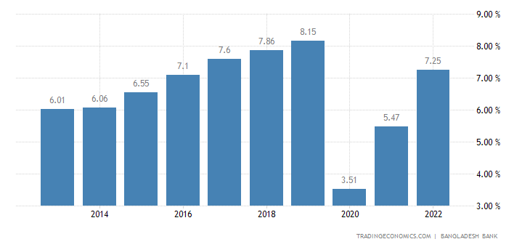

Monetary and Credit Program for FY23:

Item | 22-Jun  Actual | 22-Dec  Actual | Program for Jun-23  Original | Revised
Broad money | 9.4 | 8.4 | 12.1 | 11.5
Net Foreign Assets* | -11.9 | -22.6 | -2.1 | -11.9
Net Domestic Assets | 17.2 | 18.5 | 16 | 17.9
Domestic Credit | 16.2 | 15.1 | 18.2 | 18.5
Credit to the public sector | 29.1 | 26.6 | 36 | 37.7
Credit to the private sector | 13.7 | 12.8 | 14.1 | 14.1
Reserve money | -0.3 | 17.4 | 9.0 | 14.0
Money multiplier | 4.93 | 4.63 | 5.07 | 4.82
NCG (Crore Taka, during the respective fiscal year) | 62,540 | 32,249 | 1,06,334 | 1,11,608
Source: Monetary Policy Statement, January-June 2023, Bangladesh Bank. NCG= Net credit to government from the banking system, P=Provisiona *lCalculated using the constant exchange rates of end June 2022. @Announced in June 2022.

Global Economic Growth:
According to the most current World Economic Outlook (WEO) report from the IMF, published in April 2023, the pace of global economic development is predicted to slow from a projected growth rate of 3.4 percent in 2022 to 2.8 percent in 2023 before increasing to 3.0 percent in 2024. It is predicted that global growth in 2023 would be 1.0 percentage points lower than it was in the January 2022 WEO Update. It is only projected that this growth gap would gradually shrink during the following two years.
Output Growth of Global and Selected Regional Economies (in percent)

10
2020
2021
2022
2023*
2024*
World output Advanced economies Emerging market and developing economies Emerging and Developing Asia

8

6

4

2

0

-2

-4

-6
Source: World Economic Outlook, April 2023, IMF

Import Impact on the economy of Bangladesh:

Balance of payment:
Since H2FY22, the external sector of Bangladesh's economy has begun to experience headwinds due to rising import payments, driven by post-Covid recovery-driven strong import demand and elevated global commodity and energy prices, as well as declining export receipts and remittance inflows amid weak global growth recovery in the face of high inflation, protracted monetary contraction by the majority of advanced and emerging market economies intended to control inflation, and geo-ecological factors. As a result, the current account deficit kept growing and reached its peak in FY22 at USD 18.64 billion (4.0 percent of GDP), up from a modest deficit of USD 4.58 billion (0.9 percent of GDP) in FY21. Due to this increase in the current account deficit, the total balance of payments (Bop) fell from a surplus of USD 9.27 billion in FY21 to a deficit of USD 5.38 billion in FY22.
- Export: The export of ready-made clothing (RMG), which climbed by 12.17 percent in the first nine months of FY23 but much less than the 33.80 percent rise in the same period of FY22, accounted for the majority of the growth of the overall export. The primary markets for RMG exports during this time were European nations, where they increased by 11.1%, while exports to the USA decreased by 5%.
- Import: A significant devaluation of the BDT, the government delaying low-priority foreign exchange-related purchases, and many policy steps implemented by BB to reduce import demand all contributed to the decline in imports in FY23. Import payments decreased 12.3 percent from July to March of FY23, falling to USD 53.94 billion after a high rise of 35.95 percent in FY22. The trade imbalance was reduced to USD 14.61 billion in this time from USD 25.03 billion in the same period of FY22 thanks to the decline in import payments.
- Remittance: Following a drop in FY22, remittance inflow increased by a moderate pace of 4.8 percent to USD 16.0 billion in July–March of FY23. In the first nine months of FY23, the current account deficit decreased to USD 3.64 billion as a consequence of the positive development of remittance inflows and the declining trade deficit In the same time of FY22, the current account deficit reached a peak of USD 14.3 billion. Although BB has taken several supportive policies3 to revitalize the remittance inflows, official remittances inflows have yet to keep pace with the high growth of overseas employment in FY22 and FY23.

Accounting and Non-Funded Business Policy

Funded facilities:
Working Capital Loans: They often last for less than a year. If the gestation time for working capital is greater, for example, the length may be. Boeing
Overdraft Facility: Overdrafts, often known as ODs, are recurring loans against current accounts that are unsecured in nature. The borrower may withdraw more money than is available up to the predetermined limit. Only the money utilized for the time of the withdrawal is subject to daily compounded interest. Some nations charge a commitment fee on the unused limitations. Because it is challenging to secure repayment, regulate how the money is used, and control costs, ODs are bad for the banker. The bank's liquidity is impacted by ODs.
Cash Credit (CC) Facility: A bank evaluates the typical value of a company's inventory and receivables. A bank sets the ceiling for a cash credit facility at 60–70% of the asset value based on these assets as collateral. Borrower is allowed to draw from this limit just like an OD. Margin is the name given to the bank's 30–40% reserve. The margin is bigger for riskier assets. The interest on CC is typically determined on a recurring basis and is based on a benchmark rate. In contrast to OD, which is unsecured, CC is secured.
Working Capital Demand Loans (WCDL): This is a short-term revolving loan arrangement provided for the business's need for operating capital. Depending on the current cost of funds, a bank will provide a rate on WCDL, and the consumer must accept it. Although the WCDL maximum is predetermined, the borrower must always negotiate the rate with the bank. Contrary to CC, which is more typical of small businesses, WCDL is more popular with medium and big businesses, who have significant working capital needs. Banks like WCDL over CC because it gives them greater control over the terms and interest rates, which is advantageous in a setting where interest rates fluctuate.
Long term loans: In order to finance business growth, purchase real estate or machinery, banks offer these long-term loans.
Trade Finance: International trade is facilitated by corporate banking. Banks provide the seller loans to cover his financial needs until he receives payment. It's comparable to working capital, Joan.
Pre-shipment loans: This is working capital used to pay for raw materials, process, and package export-oriented goods. The most typical type is a packaging credit, which offers the exporter low interest rates.
Post-shipment loans: When exporting on a credit basis, these loans assist exporters in bridging their financing needs.
- Bill discounting is an illustration. The exporter receives liquidity from it. The trade bill that the buyer accepts and endorses to the bank will be discounted by the bank. A part of the face value of the trade bill will be advanced to the exporter by the bank.
- Forfeiting is the procedure used when an exporter and bank have an agreement for the bank to discount all of the exporter's medium-term receivables (not just one bill).
- Factoring is the procedure when an exporter enters into a contract with a bank to have all of his short-term receivables discounted (not just one bill).
- Bill discounting and factoring are both possible in domestic transactions.
- The bank has recourse against the seller since the seller is responsible for making up the difference if the customer fails to make a payment after the credit term has expired.
- There is always remedy with bill discounting
- A bank can reduce bills through factoring with or without recourse and even with some recourse. Assignment of Receivables is the name for this.

Non-Funded Facilities
Trade Finance Intermediaries: In international transactions, banks can serve as middlemen for the movement of papers and money since bank-to-bank transfers are more secure.
Letter of credit: Another name for it is Documentary Credit (DC). The buyer borrows the bank's promise to pay. Additionally, as long as the seller ships the items and follows the conditions of the contract, the bank guarantees payment to him. Instead of the buyer, the seller now assumes the bank's credit risk. The importer receives credit from the bank and is not required to pay in advance.
Cash in advance: Buyer pays vendor before items are shipped. This is most beneficial to the vendor and least beneficial to the consumer.
Open account or credit: This indicates that payment will be paid at a predetermined future date. Unless the seller has a very close relationship with the buyer or the buyer has good credit, this is quite dangerous for the seller. There are no promises, and getting paid is sometimes a laborious process.
Cash Management Services (CMS): For the bank, there is no credit risk. It is purely a business administrative service. The bank has only one account that the client keeps open. Receivables management, payables management, and liquidity management are all included in cash management. By integrating to ERP systems, banks are utilizing improved technology for cash management.

Credit Evaluation:
The bank does this to decide whether or not to lend money to the client. This process evaluates the client's believability. A credit rating is assigned based on the evaluation, and this rating affects the quantity, rate, tenor, security, and frequency of monitoring.
Analyzing a company's qualitatively and quantitatively is necessary for credit evaluation. Qualitative analysis focuses on ephemeral variables that cannot be quantified, such as the reputation of the promoter, the state of the business, historical performance, the level of competition, etc. A credit line for each client is set using quantitative analysis, which compares the financials over time to assess performance. It provides the greatest exposure/risk the bank is willing to assume with regard to the client.
Facility Structure: Here, the bank determines the different loan parameters and builds the loan. It follows the conclusion of the credit evaluation.
Credit Monitoring: The bank must guarantee both the integrity of the collateral and the appropriate use of the cash. Additionally, it should examine the inventory to see whether the working capital demand is reasonable and whether the business has enough insurance to protect the bank from any unanticipated events. In a typical monitoring report, an ageing analysis will also be included to indicate whether loans or interest payments are past due and for how long. The loans are categorized based on their maturity. These reports are produced by a bank's basic banking system.
Bank Guarantees: Through a bank guarantee, the bank assures the beneficiary of the fulfillment of a contract or the non-occurrence of an event, such as a default event. Bank guarantees may be either monetary or performance-based.
When the guarantor or issuing bank guarantees the applicant's capacity to carry out a contract satisfactorily, this is known as a performance guarantee. A financial commitment, such a loan or security deposit, is secured by financial assurances.
For instance, if a supplier accepts money in advance to deliver high-value items, he is required to offer the customer a performance guarantee.

Permission for:
- Opening foreign currency account,
- Transaction in FC accounts and give maintain approval, cancellation FC correspondence of related cases, renewal of FC account.
- Approve, renew and dispose the Bank Guarantee.
- Approve bank guarantee of general sales agent (GSA) and Umbra agent.
- Approval for international roaming facility, bid bonds and stand by letter of credits.
- Acceptance of the performance guarantee, security guarantee, and advance payment guarantee.
- Cases involving FCY issues are resolved, inbound remittances are approved, undeclared FCY/FMJ forms are permitted, unlawful FCY is permitted to be transmitted by mail, and form A-7 is approved.
- Give permission for release of-
1) Permit the discharge of any surplus foreign money that exceeds the specified limit.
2) Foreign cash from the relevant guarantee is in question.

External Debt & Guarantee
The percentage of a nation's overall debt that was funded by foreign governments, commercial banks, or other financial institutions. These loans must typically be repaid in the currency used to make the loan, plus any applicable interest.

Function:
- Projects including various state loans, soft loans, grants, etc.
- L/C opening authorization sponsored by IDA and ADB.
- Granted authorization for the opening of a different loan agreement.
- Payment agreement in accordance with the France-Bangladesh funding protocol.

Bangladesh Government Debt to GDP:
According to projections from Trading Economics' global macro models and analysts, Bangladesh's government debt to GDP is anticipated to reach 37.00% of GDP by the end of 2023.
Generally, investors often evaluate a country's government debt as a percentage of GDP to assess its capacity to make future debt payments, which has an impact on the cost of borrowing for that country and the rates on its government bonds.

Bangladesh recorded a Government Debt to GDP of 28.20 percent of the country's Gross Domestic Product in 2022.
Bangladesh Government Debt to GDP
Actual | Previous | Highest | Lowest | Dates | Unit | Frequency
28.20 | 29.20 | 50.00 | 25.70 | 1995 - 2022 | percent of GDP | Yearly

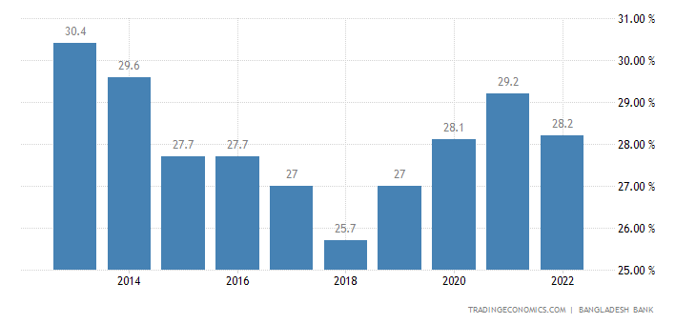

Bangladesh Outstanding External Debt:
Bangladesh's external debt rose from 50.88 USD billion in 2021 to 57.63 USD billion in 2022. USD mn data is available from September 2011 through December 2022 and is updated quarterly.
The statistics peaked at 96.2 USD billion in December 2022 and to a record low of 22.1 USD billion in March 2012.
Bangladesh Outstanding External Debt
LAST | PREVIOUS | MIN | MAX | UNIT | FREQUENCY | RANGE
96,246.0Dec 2022 | 92,694.5Sep 2022 | 22,055.1Mar 2012 | 96,246.0Dec 2022 | USD mn | quarterly | Sep 2011 - Dec 202

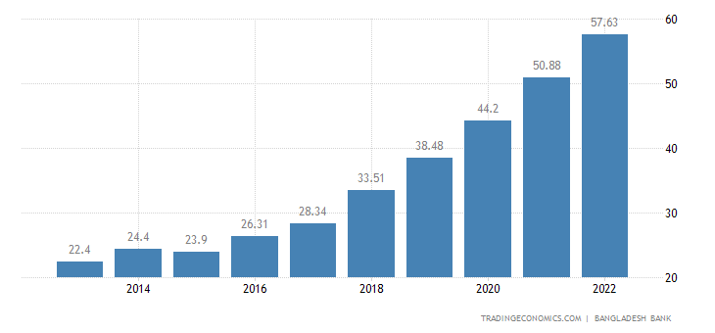

Sources of Debt:
Domestic and foreign debt make to Bangladesh's total government debt. Through the Annual Development Programmed (ADP) and budget support mechanisms, borrowing from bilateral and multilateral organizations to fund projects is closely related to external debt. Along with managing intra-year cash flow, domestic borrowing is used to finance the budget deficit in chunks. Long-term obligations often need external borrowing, whereas short-, medium-, and long-term commitments typically call for domestic financing.

Domestic Debt:
Internal debt, also known as domestic debt, refers to the portion of a nation's overall public debt that is owing to lenders domestically. The opposite of internal government debt is external government debt. Commercial banks and other financial institutions are the principal funding sources for internal loans.
- Government Domestic Borrowing Target for FY22: Government net borrowing from the banking system during the same time of FY23 was Tk. 61,431.5 crore (55.0 percent of the revised aim made in the national budget), compared to Tk. 13,767.0 crore (15.8 percent of the objective set in the national budget) in FY22.

- Borrowing from Other Domestic Non-banking sources: During the period of July through March of FY23, the government's net borrowing from domestic non-banking sources totaled Tk. 4,034.2 crore (13.4 percent of the revised national budget target), compared to Tk. 20,053.9 crore (54.2 percent of the target set in the national budget) during the same period of the previous fiscal year.

Budget Target and Actual Government Domestic borrowing (net)
Banking system*
87287.0
Other domestic non-bank sources**
22366.6
37001.0
Total borrowing
54797.7
124288.0
Actual during July-May, 2022
Target (revised) during the whole FY22
Taka in Crore
32431.1

-24,000
-16,000
-8,000
0
8,000
16,000
24,000
32,000
40,000
48,000
56,000
64,000
72,000
80,000
88,000
96,000
104,000
112,000
120,000
128,000
136,000

Sources: Debt Management Department, Statistics Department, Bangladesh Bank; Department of National Savings; and Ministry of Finance (MOF).

- Total Domestic Borrowing: From July to March of FY23, the government's total net domestic borrowing (from the banking sector as well as domestic non-banking sources) was Tk 65,465.6 crore, or 46.2 percent of the updated objective stated in the national budget. In the period from July to March of FY22, the government's net domestic borrowing was Tk. 33,820.9 crore, or 27.2% of the goal outlined in the national budget.

Net government domestic borrowing as of June 2022 was Tk. 678738.5 billion. This compares to Tk. 583155.3 billion in June 2021.

Source-wise Outstanding and Flow of net Government Domestic Borrowings
(Taka in Crore)
Sources | July-May FY22 |  | July- May FY21 |  | % Changes (May’22  over June’21#) | % Changes (May’21  over June’20##)
Sources | Outstanding at end May’22 | Flow  (July-May 2022) | Outstanding at end May’21 | Flow  (July-May 2021) | % Changes (May’22  over June’21#) | % Changes (May’21  over June’20##)
Banks* | 230301.2 | 32431.1 | 176418.0 | 5230.5 | 16.4 | 3.1
Other domestic non-banking sources ** | 407651.8 | 22366.6 | 380010.1 | 39115.5 | 5.8 | 11.5
Total | 637953.0 | 54797.7 | 556428.0 | 44346.0 | 9.4 | 8.7

Sources: Debt Management Department, Statistics Department, Bangladesh Bank; and Department of National Savings.

External Debt:
The part of a nation's debt that is borrowed from foreign lenders, such as commercial banks, governments, or international financial institutions, is referred to as its external debt. A nation is considered to be in sovereign debt and to be in a debt crisis if it is unable to pay its foreign debt.
Bangladesh's external debt increased from 92.7 USD billion in the previous quarter to 96.2 USD billion in December 2022. Bangladesh External Debt: USD mn data is available from September 2011 through December 2022 and is updated quarterly. The statistics peaked at 96.2 USD billion in December 2022 and to a record low of 22.1 USD billion in March 2012.
Data in USD million is available from Sep 2011 through Dec 2022 and is updated quarterly.The statistics peaked at 96.2 USD billion in December 2022 and to a record low of 22.1 USD billion in March 2012.

External Debt in Bangladesh increased to 57.63 USD Billion in 2022 from 50.88 USD Billion in 2021

Bangladesh External Debt
LAST | PREVIOUS | MIN | MAX | UNIT | FREQUENCY | RANGE
96,246.0Dec 2022 | 92,694.5Sep 2022 | 22,055.1Mar 2012 | 96,246.0Dec 2022 | USD mn | quarterly | Sep 2011 - Dec 2022

Foreign Aid and External Debt Repayment:
Foreign Aid Receipts and Debt Repayments*
(million US Dollar)
Particulars | FY20 | FY21R | FY22P
1. Receipts | 7381.71 | 7957.56 | 10008.38
i) Food Aid | 10.71 | 16.50 | 2.53
ii) Project Aid | 7371.00 | 7941.06 | 10005.85
2. Repayments (MLT)* | 1733.98 | 1914.81 | 2117.58
i) Principal | 1256.54 | 1418.63 | 1606.35
ii) Interest | 477.44 | 496.18 | 511.23
3. Outstanding external debt (MLT) as of end June | 44095.12 | 50879.95 | 57625.05
4. Outstanding debt as percentage of GDP | 11.79 | 12.22 | 12.52
5. External debt services payment (MLT)  as percentage of exports | 5.40 | 5.19 | 4.30

- Debt outstanding is not equal to loan disbursed minus loan paid due to other adjustment such currency fluctuation, loan writes off etc.; i
- Repayment does not include loan write-offs, IMF Credits and Some Special Borrowings by Ministry of Food, Bangladesh Shipping Corporation, Bangladesh Biman, Bangladesh Petroleum Corporation, Defense and Private sector.
* Excluding transactions with the IMF;
R= Revised; P= Provisional; MLT= Medium to Long Term
Source: (i) Economic Relations Division (ERD), Ministry of Finance, (ii) Statistics Department, Bangladesh Bank.

Discount Policy
All claims for discounts made by importers in relation to shipments of ready-made clothing should be submitted to the discount committee through the foreign exchange operation department for recommendation or decision. These claims may be based on inconsistencies in the documents, short or late shipments, conservative arrests, quality issues, etc. But before sending such a matter to the committee, the AD must be certain in its validity and worth.

Function:
- Making preparations for the bank by recording various kinds of discount and stock-lot situations and quarries.
- Grant pre- and post-facto permission for stock lot and discount cases.
- Meeting with the discount committee.

A high-powered committee creates the discount policy in order to offer discounts. There are nine people in it, all from different corporate groups. It is the only committee in Bangladesh that has the authority to grant discounts to exporters from our nation; no other bank or institution has this authority.
Beneficiaries of usance export bills against direct and presumed exports of goods made in Bangladesh may arrange for rapid funding by discounting the bills through their own approved dealer banks, provided that the following guidelines are followed by:
- The usance bills offered for discounting must be from legitimate direct or presumed export transactions, according to ADs.
- ADs may set up funds for the foreign exchange discounting of US Treasury bills through their own OBUs/correspondent banks, foreign financial institutions, or international financing institutions.
- Customers' bill-discounting costs, including all commissions, fees, levies, and interest, cannot total more than 6% (all in).
- AD banks must submit statements to the Department of Foreign Exchange Policy,

Legal Compliance & Enforcement
The Legal Compliance & Enforcement division is in charge of performing the following tasks in the event of import and export.
- Filing a lawsuit in the event that a bill of entry is not submitted, export revenues are not repatriated, foreign exchange is transferred unlawfully, an indenting commission is not repatriated, or any other provision of the Foreign Exchange Regulation Act of 1947 is violated.
- Taking the appropriate actions to convene a meeting with the criminal investigation department, authorized dealer banks, and anti-corruption commission (ACC) addressing FC counterfeiting.
- Taking measures to keep the foreign exchange tribunal case going.
- Authorizing the police authorities to file FERA, 1947 charges related to illicit transactions and individual FC detention.

Human Resource Management
The term "human resources" is used to refer to both the individuals who work for a business or organization and the department in charge of managing resources pertaining to personnel.
- The list of EMT cases that are still ongoing;
- The transfer, posting, and selection of the officer for training.
- To set up all IT equipment types. For instance, a computer and a copier.
- Submission of a monthly statement to the ministry of finance detailing foreign exchange reserves, L/C opening and settlement, export results, and inward remittance.
The Human Resources Department-1 (HRD-1) is in charge of centrally managing the bank's workforce on the job sites through resourcing, placement, performance, etc. The focus is on Human Resources (HR) tasks that are strategic and value-adding, including developing, revising, and altering HR policies and procedures for ongoing improvement.
The following wings are where HRD-1's tasks are carried out to address the aforementioned issues:
Planning, Promotion & Transfer Wing.  Recruitment & Outsourcing Wing.  Recognition and Reward Wing.  Performance Management Wing. | Organization & Development Wing.  Enterprise Resource Planning (ERP) Unit.  Branch Office Service Unit (BOSU).  Regulation Desk

Chapter 4

Recommendation, Findings & Conclusion

Recommendation
The Foreign Exchange Policy Department is a crucial division of Bangladesh Bank. The nation's economy is developed through its activities and functions. To function successfully, though, it must overcome certain challenges. During my internship, I have noticed a few issues that should be addressed to ensure Bangladesh's economy may grow.
- Every year, the department's rules and regulations must be modified to ensure that they continue to meet needs.
- This department needs more staff members in order to operate effectively.
- SAP had to be widely utilized to improve services.
- Only for in-depth foreign exchange activity must a yearly financial report be published.
- Giving the bank more discretion over accepting foreign exchange risks won't increase export.

Findings of the Study
Bangladesh has an extremely conservative and constrained foreign exchange policy. During the global recession, the country overcame obstacles thanks to its conservative foreign exchange strategy. Additionally, this sensitivity to foreign exchange hazards assists in efficiently managing foreign exchange risk by lowering the risks. The management of the exchange rate needs to take a more aggressive strategy due to the practices of foreign exchange.
I have obtained practical experience concerning foreign exchange activities throughout the little time I have been participating in an internship program, from beginning a deal to creating a monthly report about it. I found some key findings that given below:
- Bangladesh Bank’s FEPD department determines the dollar, pound sterling, and euro exchange rates on the Bangladeshi market based on foreign exchange reserves, investments, and total market foreign exchange flow.
- On behalf of the government, this department also contributes to market stability by using various monetary systems.
- Through ACU, this agency promotes healthy connections between South Asian nations. It also manages all foreign loans and grants, including those from the OPEC, ADB, IDA/IBRD, and France Treasury. Japan's government makes grants on its behalf.
- This sector is in charge of the Treasury Management for several commercial banks as well as Bangladesh Bank. This department reserves, oversees, and pays back foreign aid and receipts.
- This department keeps track of all of commercial banks' international affairs.
- Helps for preparing budget of Bangladesh.
- Evaluating Benchmarks and proposing new benchmarks.
- This department also manages all foreign grants and loans, including those from the OPEC, ADB, IDA/IBRD, and France Treasury. Japan's government makes grants on its behalf.
- On behalf of the government, this department also contributes to market stability by using various monetary systems.
- This department also determines the overall investment situation and prospective foreign exchange investments.

Conclusion
The national bank of Bangladesh is called Bangladesh Bank. Its actions are essential given Bangladesh's development. The Bangladesh Bank's Foreign Exchange Policy Department is a crucial division. Bangladesh can surface a cutting-edge then deliberate financial system by thriving in that department. The Bangladeshi economy contributes to the strength and support of the FEPD with regard to Bangladesh Bank. The FEPD in charge of the Bangladesh Bank is aware of and sensitive to global challenges. The formulation and correct application of the Bangladesh Bank's policies will result in real financial development and overall economic progress. Bangladesh imports more than it exports, but I believe we can increase our export by increasing the export services offered by the Bangladesh Bank. I had no prior professional experience and expertise when I was a student. I had no idea how an organization could be founded, endure in a nation, achieve success, or create policies to carry out its operations. Working with Bangladesh Bank as an intern at FEPD is such a fantastic opportunity for me to learn about the respective field because by doing this internship in Bangladesh Bank I have gained a lot of experiences and knowledge about the professional life, which is truly a new knowledge for me as a student.
Only the Bangladesh Bank's Foreign Exchange Reserve and Treasury Management was the subject of my report. I also tried to learn about the elements that influence the reserve and the impact of the foreign reserve on our economy, as well as how various measures are used to stabilize the market under various conditions.

Reference & Bibliography
- Bangladesh Bank:
https://www.bb.org.bd/en/index.php/about/index
- Source of Bangladesh Remittances:
https://www.google.com/url?sa=t&rct=j&q=&esrc=s&source=web&cd=&cad=rja&uact=8&ved=2ahUKEwjI-bXw99P8AhU0HrcAHYksDWEQFnoECAwQAQ&url=https%3A%2F%2Ftradingeconomics.com%2Fbangladesh%2Fremittances&usg=AOvVaw09ATHmDQDQDzD5SNwG1pJU
- Wage Earners Remittance inflows: https://www.google.com/url?sa=t&rct=j&q=&esrc=s&source=web&cd=&cad=rja&uact=8&ved=2ahUKEwjf6-X5idT8AhWd7HMBHYiIBoYQFnoECBAQAQ&url=https%3A%2F%2Fwww.bb.org.bd%2Fen%2Findex.php%2Fecondata%2Fbop_remittance%2F1&usg=AOvVaw1uVFRSbE-Z3L_UIAe-40V6
- Inflation on Private Sector Credit in Bangladesh:
https://www.google.com/url?sa=t&rct=j&q=&esrc=s&source=web&cd=&cad=rja&uact=8&ved=2ahUKEwjm2-bB4Yv9AhVB9zgGHZXjBMgQFnoECAkQAQ&url=https%3A%2F%2Fwww.bb.org.bd%2Fpub%2Fresearch%2Fpolicynote%2Fpn2203.pdf&usg=AOvVaw2a3oacYGKh_zSegbBBsRSZ
- Bangladesh Foreign Reserve:
https://www.google.com/url?sa=t&rct=j&q=&esrc=s&source=web&cd=&cad=rja&uact=8&ved=2ahUKEwj7y7iF44v9AhXuTWwGHQ3fC-0QFnoECB4QAQ&url=https%3A%2F%2Fbdnews24.com%2Feconomy%2Fhhxsakwehy&usg=AOvVaw3Zi0qjngArS2_PVVvPr5uF
- Impact of Exchange Rate and Global Commodity Price: https://www.bb.org.bd/pub/halfyearly/monetaryprev/mpr_01062023.pdf
- Others:
https://tradingeconomics.com/bangladesh/imports
- https://www.bb.org.bd/monetaryactivity/mps/mps(jan-jun2023).pdf
- https://www.bb.org.bd/en/index.php/Investfacility/invesfac
- https://tradingeconomics.com/bangladesh/government-debt-to-gdp
- https://tradingeconomics.com/bangladesh/external-debt
- https://www.bb.org.bd/econdata/govtdomdebt.pdf
- https://www.ceicdata.com/en/indicator/bangladesh/external-debt
- https://www.bb.org.bd/en/index.php/econdata/debtserv
- https://www.bb.org.bd/en/index.php/financialactivity/bankfi

Appendix

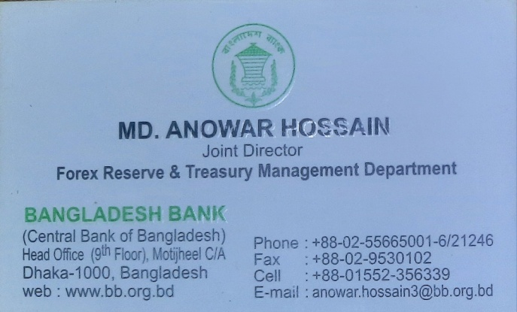

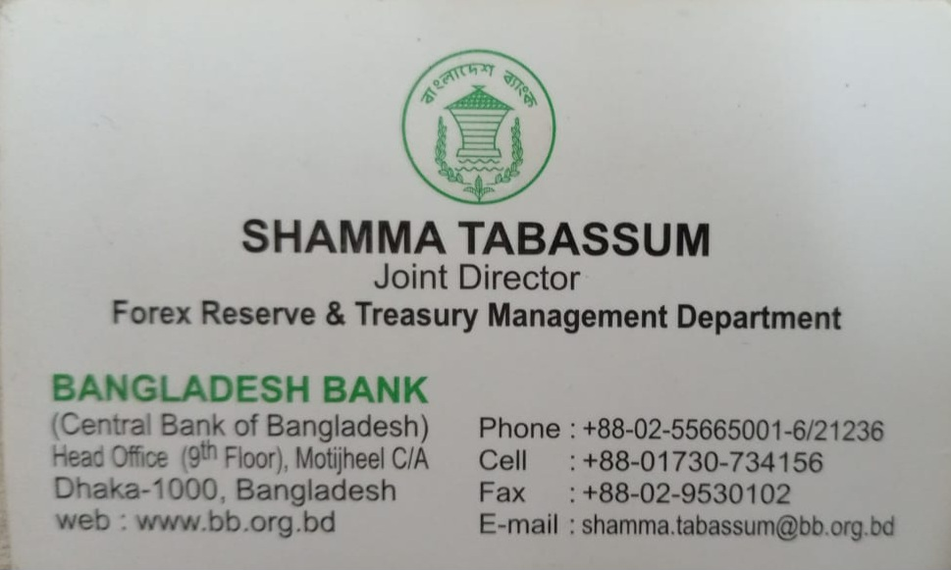

Journal
Journal No. 1 (Week No. 1)
(2nd to 9th) may 2021, I was successful in getting a job as an intern at one of the best banks in the country. I think it is a great honor and opportunity that I am working on my internship at Bangladesh Bank. I was invited to the bank's main office to begin my internship. Md. Nazmul Huda, Director of Assistance for the Human Department. They typically desire to continue using the established financial system. They follow the authoring document process for gathering their documentation. I went through a quick orientation process to understand the roles of the many sections in this department. My boss, Shamma Tabassum Mam (Joint Director), and other coworkers first assisted me in understanding the essentials. My honorable boss first introduced me to some fundamental financial concepts, like Big Bath( Big Bath in accounting is an earnings management technique whereby a one-time charge is taken against income in order to reduce assets, which results in lower expenses in the future. The write-off removes or reduces the asset from the financial books and results in lower net income for that year), poison pill (A tactic used by a company threatened with an unwelcome takeover bid to make itself unattractive to the bidder), Leverage Buyout (A company is purchased with a combination of equity and debt, such that the company's cash flow is the collateral used to secure and repay the borrowed money), Financial Leverage (The use of debt to acquire additional assets), Stratified Sampling (Is a probability sampling technique wherein the researcher divides the entire population into different subgroups or strata, then randomly selects the final subjects proportionally from the different strata), Census (An official count or survey of a population, typically recording various details of individuals). This sort of word was unfamiliar to me. The supervisor then briefly explained the Foreign Exchange Policy Department to me. Ten sections make up this department. There are several activities in each segment. I made an effort to determine how to act appropriately among everyone. I was really astounded by the atmosphere they were sustaining within the company. The department is really well organized. Additionally, everyone I met had quite strong personalities. My first visit was to the outward remittance division. My understanding of their activity is guided by Md. Anowar Hossain, the joint director. She explained to me how much cash a person can bring with them when traveling, receiving medical care, or using import service benefits abroad. She tells me that a person may carry $12,000 for travel and $10,000 for medical expenses. This section is primarily used to create new policies or add additional rules for special circumstances. For instance, if someone need more than $100,000 for medical reasons, they must obtain further approval and present appropriate documentation. She then proceeds to give me some examples so I can comprehend. I came across a case involving Nestle. Nestle wants to recruit an international auditing firm. There is no policy in place for this. In this instance, this section examines the justifications for choosing an international audit company over a domestic one. They grant authorization if the justification is credible. Then I noticed a different report that is Then I saw another report which is about Teletalk. If the justification is reliable, they provide consent. Then I discovered another report that is Then I came across another report concerning Teletalk.She then proceeds to give me some examples so I can comprehend. I came across a case involving Nestle. Nestle wants to recruit an international auditing firm. There is no policy in place for this. In this instance, this section examines the justifications for choosing an international audit company over a domestic one. They grant authorization if the justification is credible. Then I came across another report concerning Teletalk. They want authorization for SMS and ISD calls. I learned from studying the instances that banks favor strong personalities who can grow business. Additionally, regular clients benefit from expedited advise and permission processes. When performing tasks for the company, it is crucial to use caution. The atmosphere at work is quite welcoming, and the departments have excellent relationships with one another. On the day I started, every area was explained to me, and the work was organized for me. At the end of the first week, I had a sense of assurance in my skills and knowledge, which signaled that I was ready to handle my assignment. Indeed, it was a wonderful week.
Journal No. 02 (Week No. 02)
16th to 23th May, It is a great opportunity for me to do my internship in the central bank of Bangladesh. As I have mentioned in my previous journal that I am working at foreign exchange policy department under the supervision of Miss Shamma Tabassum, Joint Director, Bangladesh Bank. In addition, this department consists of nine sections. Last week I worked in the remittance section, but this week I worked in the import section.
There are 5 officers in import section. We worked with two senior officers of this section named Shamma Tabassum & Anowar Hossain( Joint Director). At the beginning, they taught me some terminologies that are required in the import section. These terminologies were new to me because I did not do any import related course at UIU. Therefore, at first, I learned import sections working materials and then I dealt with some real life cases. Terminology Bill of Entry: A declaration by an importer or exporter of the exact nature, precise quantity and value of goods that have landed or are being shipped out. Prepared by a qualified customs clerk or broker, it is examined by customs authorities for its accuracy and conformity with the tariff and regulations. IMP form and its use: The form, which is used by importer to apply to ADs for payments against imports into Bangladesh, is called IMP. The IMP forms needs to submit in one original by the importer or his duly authorized representative. To affect remittance against import, AD shall endorse its approval on the reverse of the IMP form in the space provided for the purpose. After payment, AD will report the IMP through online; AD will not submit the IMP to Bangladesh Bank, if not demanded by it. AD will match the particulars of IMP with those of Bill of Entry. Form C: Whenever any emigrant sends money to home country, he/she needs to fill up a form, which is named Form C. CFR: CFR is the abbreviation of Cost and Freight. The terms "cost" and "freight" both relate to the price of the items, but "cost" is the price of the goods itself. It means that the seller is responsible for covering the costs of transportation and freight to get the products to the specified port of destination, as well as for obtaining maritime insurance to protect the items from loss at the hands of the buyer. Real Life Case Bangladesh Bank always deals with the cases that are out of the written policy. A book titled "Foreign Exchange Policy" is available from the Bangladesh Bank. These policy texts don't describe the situations they deal with. The situation I observed had Bangladesh TITAS asking a Japanese business for some equipment. Once more, this Japanese corporation requests the equipment from a different Bangladeshi company. This time, a Bangladeshi company imports certain pieces of machinery from Singapore. Once that is done, they export it to the Japanese corporation, which then exports it to TITAS. TITAS requires payment in this instance in the amount of USD105, 000. Therefore, in order to spend the foreign currency, they want authorization from Bangladesh Bank.
Accidently, the government declares unscheduled holidays for all organizations in the case of Covid-19. So, I began my investigation on Google and the Bangladesh Bank's official website since I was unable to focus on the Bangladesh Bank. Then I submitted my application and the necessary paperwork to the bank after August 18th, 2021

