
United International University

Internship Report
On
Market Development Strategy of a Technology-Based Firm:
A Study on TechnoMagic

Submitted To:
Muhammad Hasan Al-Mamun
Assistant Professor
United International University

Submitted BY:
Syed Mahamudul Ahsan
id: 111 151 200
BBA Program
School of Business and Economics
United International University

ACKNOWLEDGEMENT

At the very beginning, I would like to express my deep gratitude to almighty Allah for giving us the strength to finish the “INTERNSHIP” report within the scheduled time. Preparing a report is copious task. We required enormous time and attention in every step of it. However, it gave me a true feeling of creation and helps us to understand my ability of work.

At first, I would like to express my sincere gratitude and appreciation to my supervisor Mr.Muhammad Hasan Al -Mamun, Assistant professor of United International University. It was a great chance for learning and professional improvement. It would not have been possible for me to complete this report without his help, advice & overall supervision. His constant encouragement & supervision throughout the period of this study have been the greatest inducement for me and directly contributed to the accomplishment of the task.
I take this opportunity as a big milestone in my career development. I will always strive to use gained skills and knowledge in the best way and hope to continue cooperation with all of you in the years ahead.

LETTER OF TRANSMITTAL

May 05, 2019
To
Mr.Muhammad Hasan Al-Mamun,
Assistant professor, United International University
School of Business and Economics
Subject: Submission of the Internship Report

Dear Sir,
With due respect and humble submission, I have the honor to state that I am Syed Mahamudul Ahsan is submitting my internship report on “Market Development Strategy of a Technology-Based Firm: A Study on TechnoMagic” for your kind consideration as a part of requirement in completing my BBA program. In this report I have analyzed the development scenario and the activities of TechnoMagic Pvt Ltd as a leading IT company in Bangladesh.
I would like to express my heartiest gratitude for your kind cooperation and guidance in making this project paper informative and time oriented. There may have some unintentional mistakes and lapses. I hope you will be gracious enough to consider those mistakes.

Sincerely Yours,

Syed Mahamudul Ahsan
Id: 111 151 200
BBA Program
United International University
Executive Summary

TechnoMagic is a startup organization for providing the next generation digital technology solutions to Bangladesh. Investors behind TechnoMagic have been importing electronics technology from abroad for close to 10 years and have many business relations and contacts to genuine advanced technology manufacturer and suppliers in abroad. TechnoMagic is a sister concern of Olympia Holdings. TechnoMagic is one of the most popular IT company for its Innovative products and solutions. This is the first company who introduced different types of Multi-touch Kiosks in Bangladesh and they make a tremendous change in Bangladeshi Cartoon Content because TechnoMagic was the first ever to make a series called SIKHI ANA. There are many competitors but the main difference is that in favor of TechnoMagic in terms of product quality, service and customer feedback.
Though they have very few employees in the key functional teams of the organization, their skills can easily outmatch those of the key competitors. Core functional teams include IT Team, and Technical Specialist and Business Development Team. The carefully selected and recruited employees since its inception adhere to customer-oriented & demand-oriented, up to date in the latest technology in the field, and have always been committed to the development of electronic equipment in the field of information service.
We always put the technological innovation as the key to build the core competitiveness of enterprises. Such technological innovation is guided by the company’s understanding of key customer requirements.
Key Words: Market Development Strategy, Technology-Based Firm

Table of Contents

1.1 Topic in Hand: 1
1.2Context of the Study: 2
2.0 Organizational Perspective of TechnoMagic Pvt Ltd 2
2.1 Organogram & Management Profiles 4
2.2Core Products & Services 4
2. 3 Mission and Vision Statement of TechnoMagic: 5
Mission Statement: 5
Vision Statement: 5
Different Types of solution 5
1. Augmented Reality: 5
VR Architectural Visualization: Olympia Holdings 7
Virtual Reality Mobile Game: PRAN Snacks Hunt 8
3.2D/3D Animation 9
4. Mobile APP Development 11
NUI Based Application for ROBI: 12
Feedback Kiosk with Content Management System at SUST 16
Virtual Assistant 18
3.0 Competitive Scenario: 20
3.1 SWOT ANALYSIS of TechnoMagic Pvt Ltd 22
4.0 Objective of the Study: 24
Methodology of the Study: 24
Primary Sources 25
Secondary Sources 25
5.0Findings of the Study 25
5.1 Capability and Availability of Logistic and Other Resources 26
5.2Company Team Members List 26
5.3Administrative & Logistic Facilities 27
Administrative Facilities: 28
5.4 Sales Report of TechnoMagic Pvt Limited 30
6.0 Recommendations 31
Conclusion 32
References: 33

1.0 Introduction

1.1 Topic in Hand:

In Market Expansion Grid we already know that there are four parts: In this grid in Market Penetration there is existing product with existing market, in Product Development, Existing Market with a new product line, In Diversification Both Market and product is new and finally

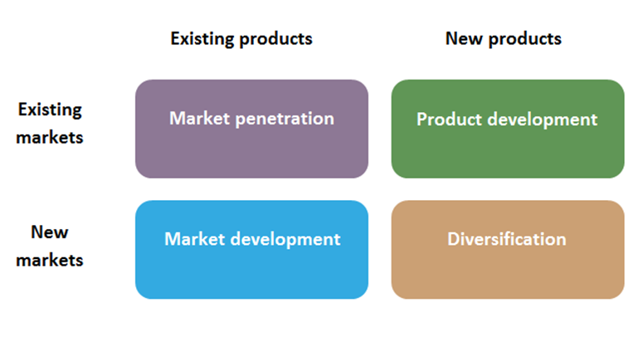

“Market Development Strategy creates growth through the introduction of current products to new markets. This strategy is mainly used when a company has identified markets that were previously unidentified or when it wants to expand its market reach. It expands sales in new markets through expanding geographic representations”. Ansoff, I. (2009). An organization’s current product can be changed, improved, and marketed to the existing market. The product can also be targeted to another customer segment. Either way, both strategies can lead to additional earnings for the business.

1.2Context of the Study:

TechnoMagic Pvt ltd is one of the leading IT Company in Bangladesh which mainly provides Software and Hardware solutions. –TechnoMagic exists to harvest the greatest technologies from the Mobile and Interactive world and employ local talents to design, develop and deploy custom-made solutions for its clients.
Company registered (legal) name: TechnoMagic Pvt. Ltd.
Date and State of Incorporation: 9th October, 2013, Dhaka

2.0 Organizational Perspective of TechnoMagic Pvt Ltd

TechnoMagic Pvt. Ltd. Is one of the younger but progressive & forth looking company in Bangladesh to fit up rapidly growing businesses, media and providing the latest technology based solutions. TechnoMagic mainly offers Multi-touch, more interactive and augmented reality (AR), augmented media screen solutions of communication and generate user propensity that help certain customers and also general customers who in past not aware of technology. Now the customers are easily correlated with cutting-edge technology and take different services from this Company when they need. TechnoMagic is a sister concern of Olympia Holdings who are the well-known faces of past Olympia Bakery which was stated (1951) and Olympia restaurant. Olympia bakery and confectionery Ltd (OBCL) is the first company of Olympia Family. OBCL broke new grounds in production of bakery items and became the most trusted name in Bangladesh by ensuring purity and quality of products over the last 63 years. The second entity of the group is Olympia machinery the manufactures power tools, hand tools, machinery for furniture making and fire protection equipment. Olympia palaces Hotel and restaurant is the third company of the group that runs 3 extremely popular restaurants in Dhaka city specialized in preparing and serving of Thai, Chinese, Indian and Italian cuisine and finally the fourth concern of the Olympia family is Olympia Holdings Limited established 2015 by MR. Jamil Uddin and Mr .Shakil Uddin. So as they are real estate company now they want to achieve the highest position of real estate sector. Already they started from January 2016. Olympia plaza will start in Ashulia and will be completed by December 31st of 2018. They said that Olympia plaza will be one of the biggest commercial buildings in Asulia with in total land of 46 Katha with 2 car parking facilities, a 16-storied building. Their per floor size is 25000(Approx.) square feet that they declared. Their shops will be till 4th floor and in 5th floor there will be a huge space for food court and entertainment that could provide a great facility for children and from the 7th floor there will be commercial spaces. Mission of Olympia holdings is to develop the finest residential and commercial for their client with a minimum price. They turn into core position in real estate business in future with the help of excellent team, performance, technological support and so on. Their Vision is they can prove themselves and operate real estate itself as a premier real estate company both locally and globally. They will materialize their vision by giving priority to their clients first, proving top quality product and service, maintaining trustworthiness to their clients. Recently they have started a new project for residential in Bashundhara residential area Block H, per flat is 2020 square feet. In 2019 February, they participated in REHAB Fair where they could provide all their services and give many offers for their clients. TechnoMagic gives them an idea of VR tour for their upcoming project in Residential and Olympia holdings successfully achieve a great response from client. So this achievement is because of TechnoMagic Pvt Ltd.

2.1 Organogram & Management Profiles
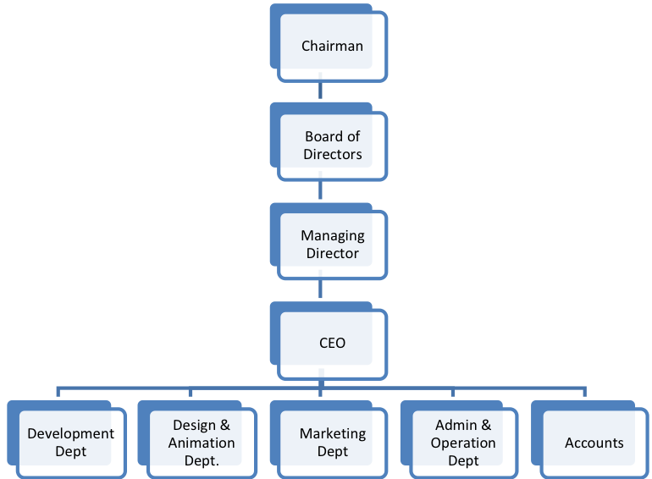

2.2Core Products & Services
- Animated Cartoon Series Development
- Mobile Applications & Games
- NUI Applications & Games
- Interactive Media Solutions
- Virtual Assistant Solutions
- Information Display Solutions
- Multi-Touch Display Products
- LED displays
- Augmented Media Solutions
- Animated content development/ CGI
- 3D Visualization.

2. 3 Mission and Vision Statement of TechnoMagic:

Mission Statement:
We want to fuse art and technology to produce something beautiful; to produce world class animated series, games, and AR/VR solutions for our clients.

Vision Statement:
TechnoMagic Pvt Ltd. aspires to be the powerhouse of cutting edge technology and leaders in the animation and game development industry. Our vision is to build the future that we once dreamt of.

Different Types of Solutions

In Their software part they provide different types of solution and that will be given below
- Augmented Reality: “(AR) is an interactive experience of a real-world environment where the objects that reside in the real-world are "augmented" by computer-generated perceptual information, sometimes across multiple sensory modalities, including visual, auditory, haptic, somatosensory, and olfactory.” Huffington. (2016,May 15) The overlaid sensory information can be constructive (i.e. additive to the natural environment) or destructive (i.e. masking of the natural environment) and is seamlessly interwoven with the physical world such that it is perceived as an immersive aspect of the real environment”. With the help of augmented reality application companies can show their products 3D models, animation or videos just by scanning a 2D image. Already they have an AR App in Google Play store called Trimetric. Recently they have working on a project with PRAN (Good Luck) and make an AR APP.
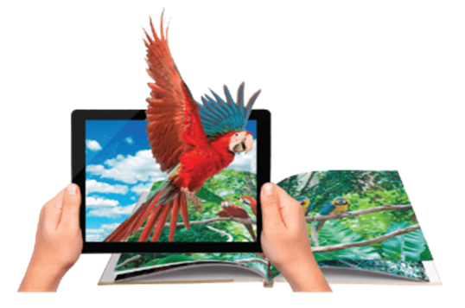

TechnoMagic provided Augmented Reality Games and 3D Projection Animation to Akij Food and Beverage Ltd pavilion in DITF 2016. AR games were on their brand Frutika, where player has to collect mangos from tree virtually with body movement. The projection animation was on their popular brand Mojo to show the total evolution of Mojo.

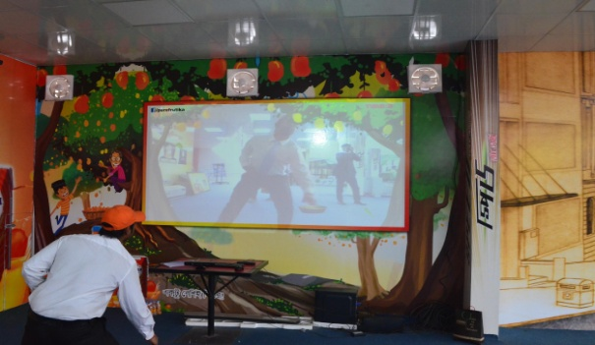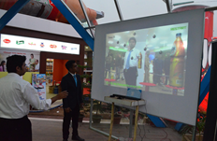
Catch the mangoes Have a drink Game

2. Virtual Reality: Virtual reality is the computer-generated simulation of a three-dimensional images or environment. It can easily give real or physical feelings by a person using special electronic equipment. TechnoMagic Pvt ltd is doing many Virtual realities solutions for their business purpose. They have a deal with PRAN Company. They made a VR games and that games have already been shown on Trade fair PRAN stall. They also made a project on VR (Wow box) For GRAMEEN. This Project was very much popular with the GP fans because TechnoMagic arranged a Virtual game for their lovers, people find wow box offer from specific placard Phone. They have launched their recent project deal with Olympia Holdings.
TechnoMagic made a virtual tour for Olympia holdings so that their clients can easily identify what they really do and this solution is mainly made on the basis the expressed customer requirements. This VR gave them 3D architectural visualizations. So that people can easily interact with anything what they really want.

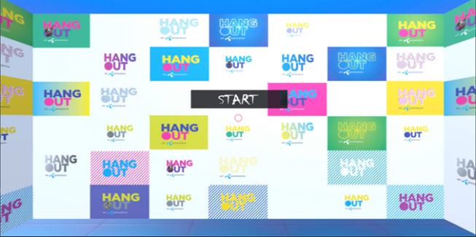
“The promise of virtual reality has always been enormous. Put on these goggles, go nowhere, and be transported anywhere. It’s the same escapism peddled by drugs, alcohol, sex, and art — throw off the shackles of the mundane through a metaphysical transportation to an altered state. Born of technology, virtual reality at its core is an organic experience. Yes, it’s man meets machine, but what happens is strictly within the mind” Matthew Schnipper. (2017, March 7)

VR Architectural Visualization: Olympia Holdings

Name of Project: VR Architectural Visualization for Olympia Holdings
Short Description: Olympia Holdings wanted to exhibit their under-construction residential flat to their clients through an interactive medium.
Developed Using: Unity 2017
Format: 3D
Summary of Project: Olympia Holdings is a renowned real-estate company in Bangladesh, they wanted to exhibit their under-construction residential flat to their clients through an interactive medium. So, TechnoMagic Pvt. Ltd. gives them a unique solution of VR Architectural Visualization to exhibit their upcoming project.

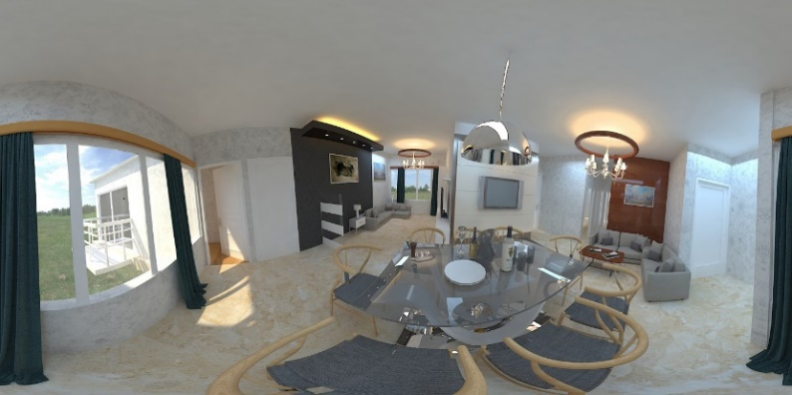

Virtual Reality Mobile Game: PRAN Snacks Hunt

Name of Project: Good Luck Stationary AR Bangla Font scanning mobile application.
Short Description: This mobile application will scan all kind of Bangla font and will show a background history of that font.
Developed Using: Unity 2017
Format: 3D
Summary of Project: This mobile application will scan all kind of Bangla font and will show a background history of that font.

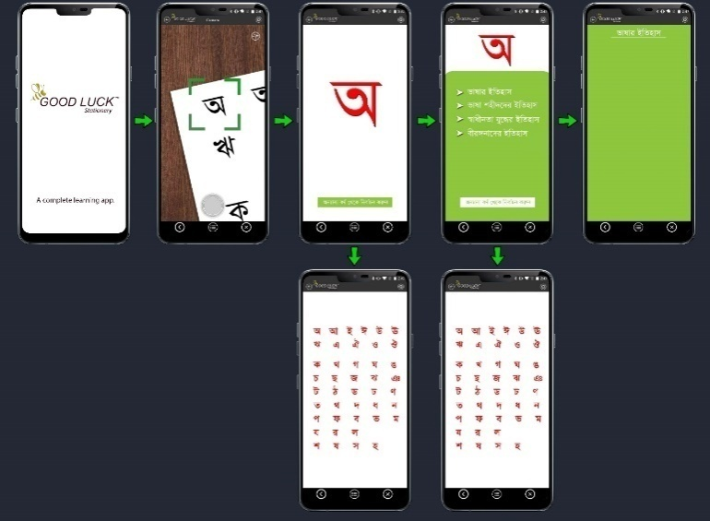

3.2D/3D Animation: “Animation is a method in which pictures are manipulated to appear as moving images. In traditional animation, images are drawn or painted by hand on transparent celluloid sheets to be photographed and exhibited on film. Today, most animations are made with computer-generated imagery (CGI). Computer animation can be very detailed 3D animation, while 2D computer animation can be used for stylistic reasons, low bandwidth or faster real-time renderings. Other common animation methods apply a stop motion technique to two and three-dimensional objects like paper cutouts, puppets or clay figures.” TechnoMagic also create much 3d animation for their clients. They make a CGI for UNITECH refrigerator. They also created Baisakhi Greetings Advertisement for Kingstone Group broadcasted in Ekushey TV


Development of an animated advertisement for Kingston Group in the occasion of Pahela Baishakh. This ad was telecasted in several TV channels throughout the day. This ad was developed within single day due to the urgency of the client.
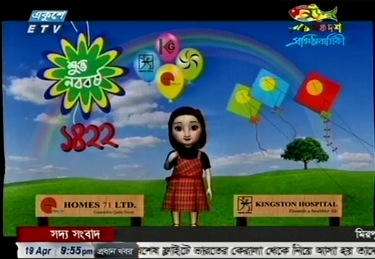
Our TechnoMagic creative team came up with breath-taking adventure storyline based on a trio bound Shiki, Aana and Shikha for the children our country. Its story set is in medieval times with the underlying themes of developing friendship, becoming a responsible adult, selfless acts and heroism.
It will have elements of fantasy, magic, with humor and comedy in its storyline and dialogues. The story revolves around three friends and their actions and adventures. There are three main characters- Shiki who is the leader of the group of friends and very witty and intelligent. Aana who is very strong in power but lack in intelligence. Finally, we have Princess Shikha who is courageous but arrogant and has anger management issues. Through their journey together, these characters will learn about friendship, selflessness, responsibility, patience and helping others in need.
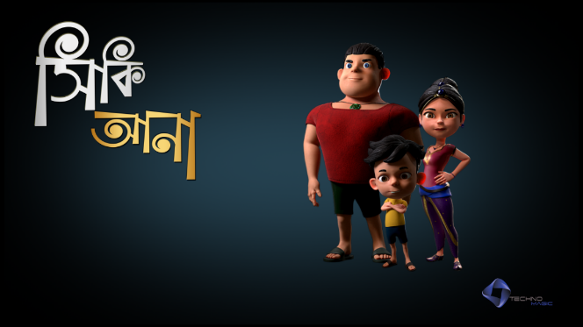
TechnoMagic can develop animated contents for corporate and brands based on their requirements.
3D Visualization
TechnoMagic can build 3D Visualization video for real estate companies and projects.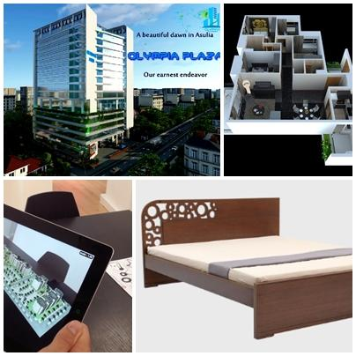

4. Mobile APP Development: TechnoMagic Pvt ltd making many Mobile apps that is given on Google play store. Such as – Meena & Raju, Animal Puzzle Bangla, Ananta The Drug Hunter, BornoJagat 1 Bangla Alphabet, 3D View etc. SO these types of application they mainly do for their customers. TechnoMagic can develop mobile applications and games for corporate and brands. These games can be made available at Google Play Store or Apple Store.

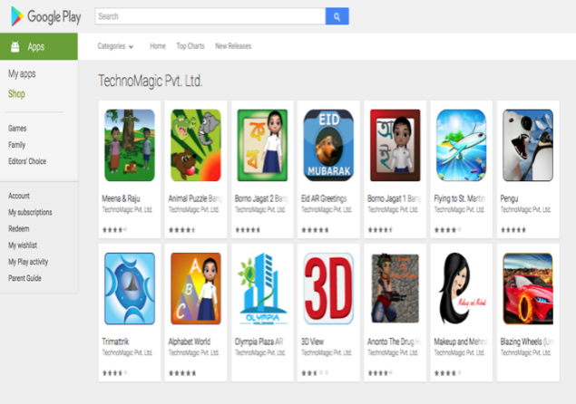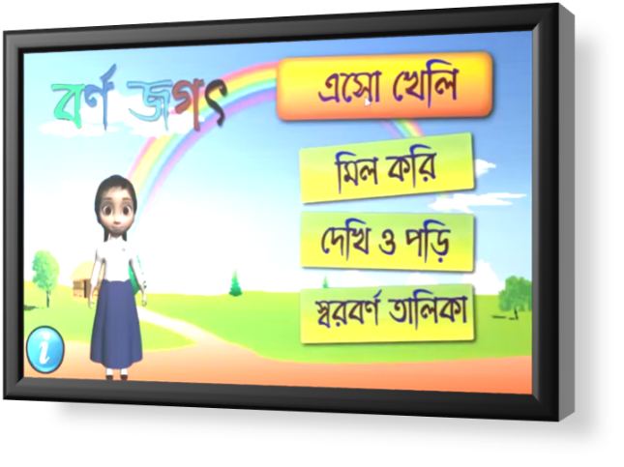

5. Kinetic Camera: Kinetic Photography (kinetic meaning “caused by motion”) is an experimental photographic technique in which the photographer uses movement resulting from physics to create an image. This typically involves the artist not” directly holding the camera, but allowing the camera to react to forces applied to it in order to make a photograph. This can include, but is not limited to; holding and shaking the wrist strap of the camera while taking a picture, dropping the camera off of objects while taking a picture, throwing or spinning the camera up in the air while taking a picture (called a camera toss), or rigorously moving the camera while taking a picture, etc. As the photographer has surrendered control over the camera to physical forces, this technique tends to produce abstract, random or blurred-motion photographs. TechnoMagic also make and provide many kinetic camera solutions. For Frutika. TechnoMagic can develop Natural User Interface (NUI) based applications and games for corporate and brands. In this type of applications, the user can interact with movement and gesture of his/her arms and body.
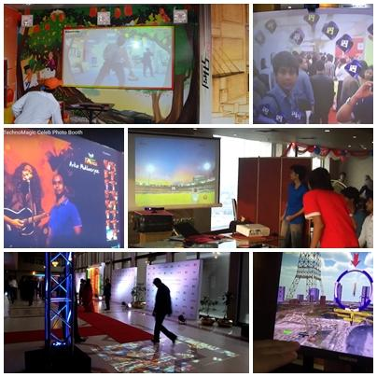

NUI Based Application for ROBI:
TechnoMagic has also developed an NUI based application for ROBI Axiata through which people can activate their internet packages without touching or using any computers or mobile phone. This technology was however not on display due to political turmoil in the country when it was designed. So this project was shelved.

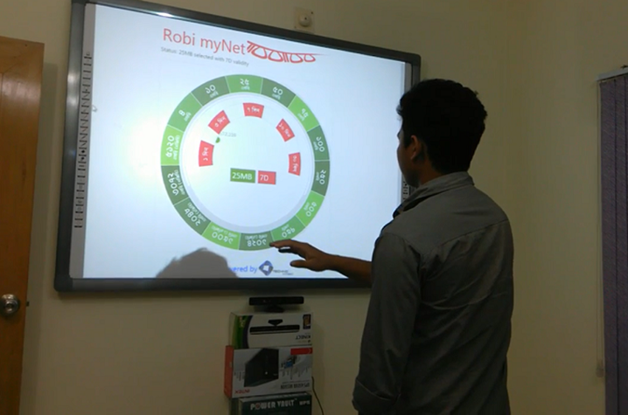

Delivering Natural User Interface (NUI) based game called “S-Wing” to Advanced Media Lab, Saudi Arabia having joint collaboration with NGM Lab, Dhaka. The project was about development of a physiotherapy related serious game where people with disability in their arms and wrists can exercise and the game will capture the movement data so doctors or physiotherapist can later check the progress of the patient. It was developed using Microsoft Kinect v1 and Leap Motion Controller. The objective of the game was to fly an aircraft through several obstacles having the player to turn the aircraft left to right, up and down through its journey over Paris, France.
6. Creative LED: TechnoMagic also provides Indoor /Outdoor Advertising LED for their clients. The positive aspect of this LED is Vivid Display, High Resolution, Water and dust proof, Energy Saving, longer life, Environment Friendly and Easily Maintenance. TechnoMagic provided the largest curve LED display at ROBI Experience Center. TechnoMagic can provide different types of information display solutions like Multi-Touch Kiosks, Multi-Touch Tables, Indoor LED, Outdoor LED, curved LED, any shape LED, etc.
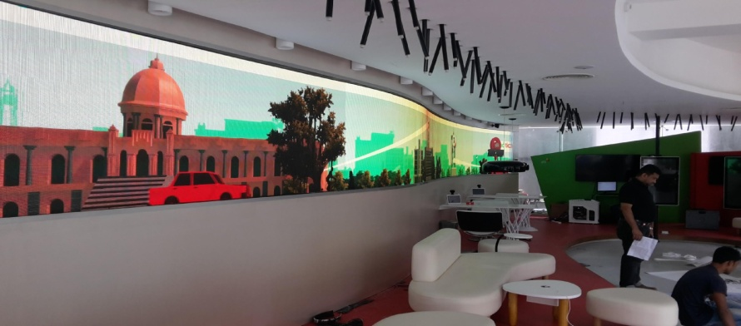

7. Augmented Media Screen: Augmented media screen is very much interesting solution that mainly make and provide for customers . TechnoMagic attended Digital world fair and used this media screen .With the help of this screen, any one can take a picture with any celebraty or public fiugure which seems like they really stand beside anyone. TechnoMagic can develop Augmented Media based applications and games for corporate bodies and brands. In this type of applications, the user can interact with 3D objects on the screen with the movement and gesture of his/her arms and body. There may be other types of augmented media solutions which can submerge the user in a combination of reality and 3D effects.

Otherside technoMagic pvt also provde Hardware solutions for the betterment of the company and clients. Those solutions will be given below :

1. Multi Touch Kiosk: It is mainly a small structure with one or more open side that is used to vend merchandise like Newspaper or service like Film Developing. There are many positive aspects of using this kiosk. These are- information browsing, collection, taking customer feedback, display and commercial offers, showing outlet direction, showing service and category display. TechnoMagic imports kiosk from china. They modified software or anything to the customer/client requirement wise with the help of their IT team and sell it. ROBI, RAK Ceramics, Bproperty etc. are all our clients who purchase many times to this kiosk. The first Multi-Touch Kiosk machine was delivered to Islami Bank Bangladesh Ltd. for its new chain of service booths. Using the Kiosk, the customers of Islami Bank can take several self-service like account information queries, applying for a product, checking out the latest services, use the internet banking portal, etc. This is a top-quality Kiosk machine having Core i5 all-in-one PC with the highest configuration of that time. TechnoMagic also delivered kiosks to Uttara Club. They are using this device for their internal office work and branding purpose.
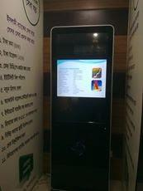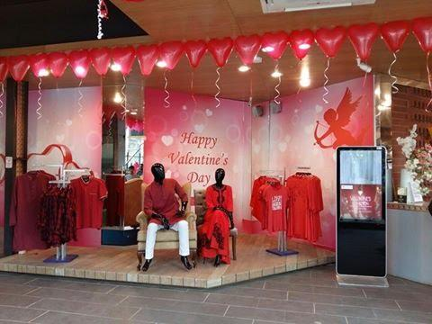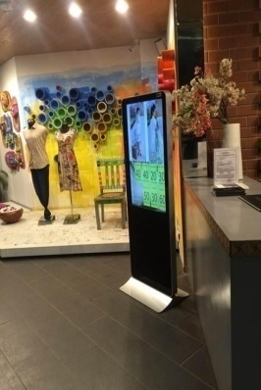

TechnoMagic delivered Kiosk to renowned fashion house in Bangladesh, YELLOW. Yellow purchased 5 units of kiosk for their different outlets in Dhaka to show product information and advertisement videos.
Kiosk at the National Parliament
TechnoMagic delivered kiosk to The National Parliament via UNFPA for the purpose of showing different activities and information of UNFPA. They also provided kiosks to the renowned architectural firm Vitti Sthapati Brindo Ltd. They use kiosks to display information in their various events and exhibitions.

Feedback Kiosks with Content Management System at Aarong
TechnoMagic delivered Kiosk to renowned lifestyle brand in Bangladesh, AARONG. AARONG purchased 5 units of feedback kiosks for their different outlets in Dhaka to show product information, contents and to manage displaying advertisement videos.

Kiosk at bKash

TechnoMagic delivered Kiosk to renowned Mobile Financial Service provider in Bangladesh, bKash. bKash purchased the kiosk for their different outlets in Dhaka to show product information, contents and to manage displaying advertisement videos.

Feedback Kiosk with Content Management System at SUST

TechnoMagic delivered Kiosk to renowned Science & Technology university in Bangladesh SUST (Shah Jalal University of Science & Technology). SUST purchased a kiosk for displaying important academic information and services through the content management system.

2.Content Management Software: Content Management Software is a high definition multimedia display software used for showcasing images, pictures, animation, texts, documents, web pages, information data and other information into a wonderful program. The user can control the Media Display Devices distributed in various places from one specific location targeting the audience in the specified place showcasing wonderful images, videos, and information over the network
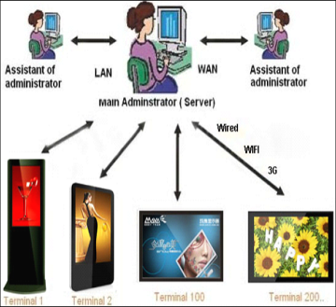

3. Interactive Whiteboard: Interactive whiteboard is already used by many organizations, universities, and NGOs. It is basically a large interactive display that connects to a computer. A projector projects the computers desktop on the board’s surface. Users control the computer using e-pen, finger, stylus or any other devices.

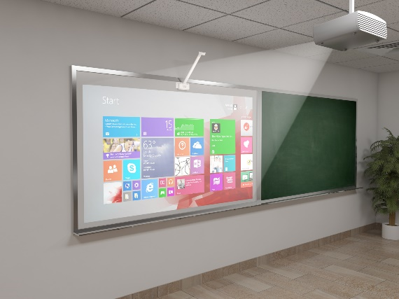

THREE UNIQUE FEATURES of this Interactive whiteboard
- Touch Recognition.
- Write using any devices like pen, fingers, stylus etc.
- Whiteboard special Software.
4. Interactive Wall:
TechnoMagic has developed an Interactive History Wall using which a user can slide through photos and videos of historical importance from a distance without requiring touching anything or using any computing device. The technology is motion and gesture based so the movement of the arms of the user triggers action in the software. They also delivered Interactive Wall gaming technologies to BRAC University for its residential weekend program at BRAC CDM, Gazipur in April 2014. The students of E-MBA had a wonderful time and they also got an opportunity to learn about the latest trends in motion technologies. SSL Wireless, a reputed software development firm took its full technical team to an outing at the fabulous Capricorn’s Sky watch restaurant at the top floor in Bashundhara City, Dhaka. There, it installed the Interactive Wall gaming technology to provide amazingly fun and entertaining moments for its team members. They played several games using these motion based technologies. They enjoyed specially the locally developed Cricket Catch game along with other super cool games.

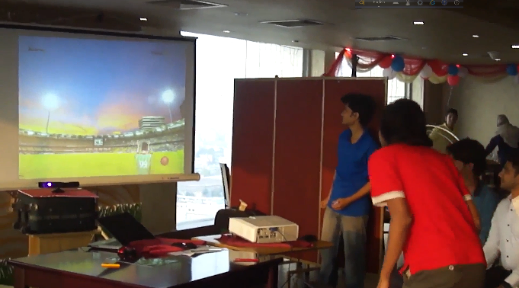
Employees of SSL Wireless is playing different games through movement of body

5. Interactive Floor: Delivering Interactive floor gaming technologies to GREY Advertising Bangladesh Ltd. for providing entertainment to guests at the Radisson Blue Water Garden Hotel, Dhaka was also a break-through technology. While walking through the auditorium floor, people witnessed optical illusions and visual effects projected on the floor. The movement of people over the projection triggered changes in the effects on the floor. This created lots of excitement to guests and provided a lot of fun and entertainments.

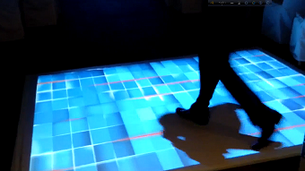

Virtual Assistant: TechnoMagic can build virtual assistant for corporate bodies and brands which can share product information just like a normal person non-stop and without errors. TechnoMagic has developed a Virtual Assistant for the first time in Bangladesh. A Virtual Assistant can provide information and critical messages to passers-by non-stop. The message delivery can be ensured to 100% accuracy. It cannot make any mistakes and never stops talking. It caught a lot of attention in the Digital World 2015.

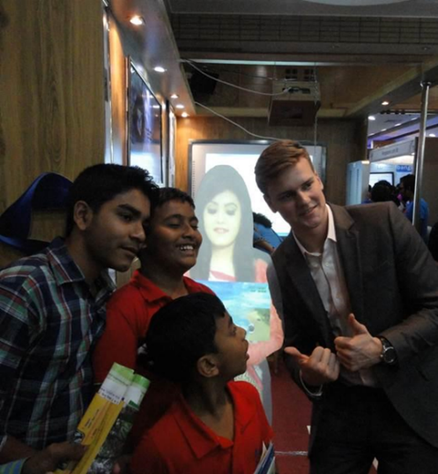

6. Network Media player (Multiple Display Management Solution): Network media Player mainly control your outlet display devices smartly, remotely and easily. It is simple to use this device. Just connect one network Media Player with your Display Device. It will automatically download your Data and command from your Server through Internet. The interesting point is that you can upload videos and play it anywhere you want. Available connectivity options here you can connect it with the help of LAN, WIFI, USB modem as a result no more hustle to deliver your message, videos or images. Anyone can also use display for different purposes.
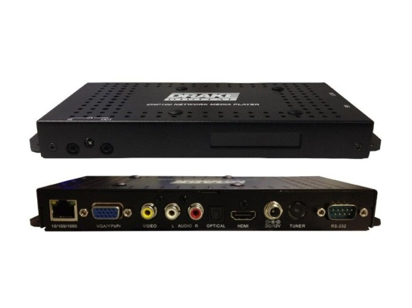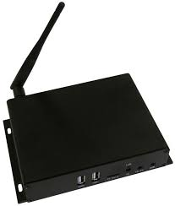

3.0 Competitive Scenario:
There are some competitors those doing their business as like us such are-
- Brain Station 23: They are also one of the largest software and IT companies in Bangladesh. They mainly do different types works the company initiated with the outstanding products into the global market and at the beginning they mainly started their journey as Software Company. Brain station 23 provides different service like- ERP 23, Mobile App, AR-VR, Cloud Migration, Software outsourcing, Ecommerce, SharePoint, Banking solution.
2. Battery Low Interactive: Battery low interactive is also an IT Company. They provide different types of services such as – web development, Game development, Inventory Management ERP, Application Development and Creative Marketing. In their gaming sector, they introduced new technology that we are already aware about that AR and VR in their full potential in the game industry in Bangladesh. Battery low Interactive started their own in house application project and they did a huge number of application projects for their corporate clients and several competitors.

3. Alienide Interactive: Alienide Interactive is mainly Dhaka-based gaming studio who works with various gaming sectors. They have worked with different gaming devices like Microsoft XBOX Kinect, P53 Move and ps3. They also make VR and AR games apps development. There do many project such as – Boropukuria coal Mine VR, Clemons VR Dive, Mojo World - VR, Rexona Agent fresh, BanglalinkNoukabaich: these types of project they already have done before and are still doing to provide services to a wide range of customer groups.

4. Cycore Studios: Cycore studio is basically a motion graphics company. It provides also high quality motion design and also work on special FX and advanced solutions they mainly provide. They also provide various types of services as like video editing, jingle making, event management, color correction, video FX still graphics multimedia solutions, printing solutions, and advanced designing solutions. Their core area is motion graphics and they do anything whatever their client requirements are form technological perspectives.
5. DreamerzLab: They are also a well-known competitor of TechnoMagic They mainly provides branding solutions. They mainly provide different services such as Virtual reality, Augmented Reality, Mobile app development, Game Development, E- commerce and web development.

According to Their competitors we can say that TechnoMagic have some Strength, Weakness, opportunities and threats that are summarized below:

3.1 SWOT ANALYSIS of TechnoMagic Pvt Ltd

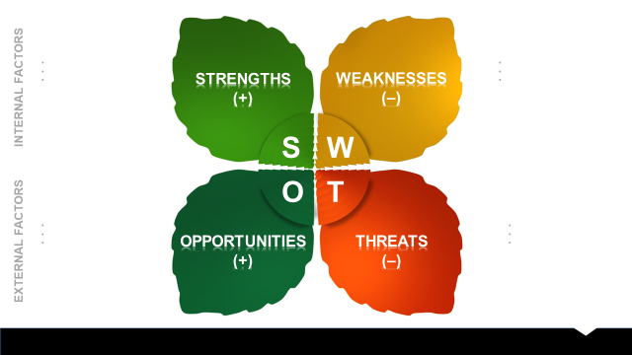

- Strength:
- Ability to maintain R&D performance and size in accordance with customer preferences while keeping trends with market design and improvements.
- Quality that separate TechnoMagic from its competitor.
- Internal Resources such as skilled, knowledgeable staff.
- Technological Proof of concept data.
- TechnoMagic follows very transparent marketing activities; there is no Confusing or Deceit, that’s why they enjoy a Better Fame in the market.



- Weakness:
- Resource Limitations.
- Lack of Diversification skills among founders.
- High startup research and development cost.
- Powerful linkages between industry and academia which are essential for growth of the industry is absent in TechnoMagic.


- Opportunities:
- Few competitors in this area.
- Press/Media coverage for their company.
- Early partnership with key industry players.


- Threat:
- Characteristics of a business which make it disadvantageous relative to competitors.
- Changing customer’s attitude toward company.
- Inability to attract necessary finances.
- Small number of discover.

4.0 Objective of the Study:

For any report there has been a common ground that is to fulfill the academic requirements but this unique report has so many secondary objectives behind it. The major objectives are summarized below:
- To meet the academic requirement
- To learn how to Develop the Market for an IT company called TechnoMagic Pvt Ltd
- How the organizations respond with the use of Market Development.

Methodology of the Study:

The study of this report is mainly a systematic procedure that starts from selection of the topic to final report preparation. The inner part was to find and collect the data, they were classified, analyzed, interpreted and presented in a step by step and this one is the vital point. For smooth and accurate analysis, I have decided to impute both primary and secondary Sources of information.

Primary Sources:
Primary source provides original source of information about any topic which is very important for survival in a firm. A primary source can be a person with direct knowledge of a situation or document written by that person Primary sources information are those types information that provide first-hand accounts of the event.so this information is collected from:
- Practical desk work
- Face to Face conversation with Managing Director, CEO, Assistant Manager
- Direct Observation
- Most important and easily benefited in the source of Face to face conversation with our Client Visit.

Secondary Sources:
Secondary data refers to data which is collected by someone other than the user. Secondary data analysis can save time that would otherwise be spent collecting data and particularly in the case of quantitative data. Secondary sources can give the additional opinions on a past record, event on a primary source so this information is collected from:
- Different website related to the Technology based IT Sector Company.
- Annual sales report of TechnoMagic 2017.
- Different Academy Figure provided by Respecting Senior Executive, Assistant Manager and files of the organization.

5.0Findings of the Study

TechnoMagic Pvt Limited has already visited and deals many times with their clients. It has almost 2145 clients. They have a very successful relationship building capacity. TechnoMagic mainly follow corporate marketing, majority of their clients being different organizations rather than individual clients. Their corporate marketing strategy is mainly based on door-to-door visits with the purpose of understanding the customer requirements and matching their products and services to the identified customer requirements.
It begins with the formal calling section, after that they take a time from their clients and then if their client requirement are matching with the Company then the Business Developer team send a formal Quotation for the specific needs of their client and finally finishing of the negotiation process then The Company Handle their Product, services to their client and client will also give payment.

5.1 Capability and Availability of Logistic and Other Resources
TechnoMagic has the full capability of developing mobile games. Following are the logistics and resources available in TechnoMagic: -
Particulars | Availability
Office space | Yes
Computer /Laptop /Mobile | Yes
Skilled Staff | Yes
Development Tools | Yes
Testing Software | Yes
Internet connectivity & others | Yes

5.2Company Team Members List

The following staff will be involved in the project subject to their availability at the time of finalization of the contract.
Number of Employees and Technical Engineers
Number of Employees | Technical  Engineers
25 | 05

Customer Support & Service
We are providing customer supports & services according to client’s requirements.
We have feedback form.

5.3Administrative & Logistic Facilities

Logistic Facilities:
1. 2000 sq. Office situated in a Pleasurable and Amenity location having windows and Auricle.
2. At least 3ftx3ft Table for every single individual in company of Static.
3. Workstations for everyone, other side provides high resolution and Great configuration (Core i7) PC available for all developers and graphic designers. Because of various work pressure and Time Limit They provide multiple monitors and that only given Lead, Chief designers and Game Developer.
4. Techno Magic also provide High speed Internet service (8 MBPS) which is available for Employee, staff and Entrance to the Internet is also open for (R & D) research and development.
5. Android based handsets also prove helpful for different issues like when they make any AR APP project that time they use android phone for testing the APP and also used this phone for making Gigantic Game and these all are handled by Business Developer.

Administrative Facilities:

1. TechnoMagic maintain hierarchy and maintain command from Top TO bottom (corporate Culture structure) to Conform Obligation and Rules and regulations that around the office and different tasks.
2. Technical team that we also called Animation team and Business Development Team sit in different rooms and any issues or any proposal when came it is mandatory for Developer team to come it success.
3. Business Development team maintains an online CRM to conform track of clients and leads.
4. Lead Operations and any actions and suggestions mainly handled by Chief Executive Officer.
5. Mobile bills, Conveyance are allocated Only for Business Developer Employee. Because of the mainly handled all the client and going outside by anytime when they need.
6. Lunch, snacks facilities are available for both Employee and staff.
9. “SMOKING” is strictly prohibited in TechnoMagic.

Customers are an important part of marketing. For any company firstly they must ensure "quality customer first, service first" as its purpose and never stops goodwill they earn from their customers.
- pre-sales service
- The company is resisted to provide details of related products and quality of the situation.
- The company is responsible to provide users with technical issues related products, including product use and maintenance, product features and other technical issues, where the user needs to provide services, the company will try their heart and soul to provide the best engineering and technical solutions for their loyal and general customers.
- Company also saw is their customer facing any difficulties or not and they always found what their customers totally wants.
- sale of services
- When they found and potential customer they will contact through the marketing department within a week by telephone contact with customers, ask to the acceptance of goods, including whether the product quality really meet their customer needs or not, way of transport, packaging and other issues or requirement of customers.
- When there developed of a new product, require perfect to the person that introduced the product to users and to help users to install and the use of methods and technical requirements.

5.4 Sales Report of TechnoMagic Pvt Limited
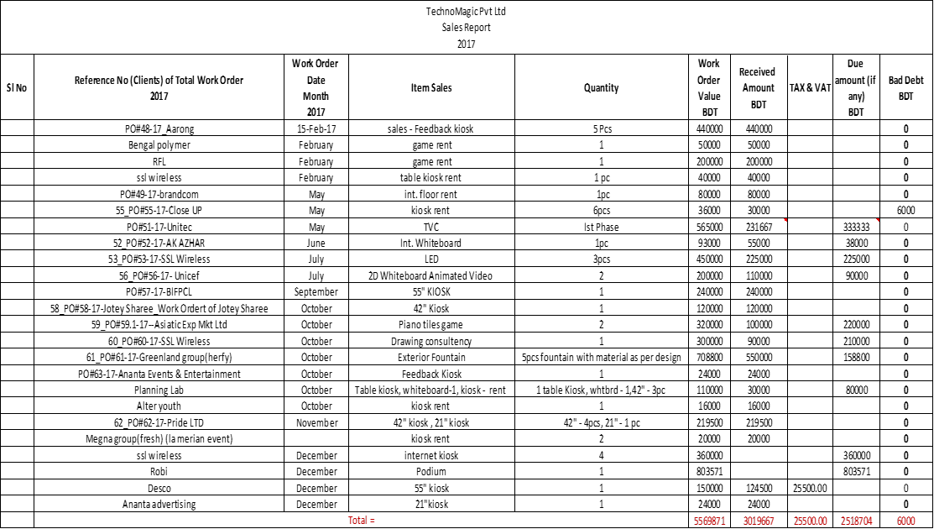

6.0 Recommendations

They should improve the promotional quality. The promotional offer of TechnoMagic will be beneficial for both themselves as well as client. They should have maintained it properly because without it any client feel that they charge very high if they compare our product in real market . So these types of confusion will be free of mind when we maintain our branding promotional activities because Attractive promotional items are necessary to satisfy the corporate clients.
The company must develop the infrastructure and the network more efficiently: The scenario of today’s market is very much competitive. As a beginner they also try hard to fill up these situations and it is possible because of their fantastic Animation Team, planning and Developer team and for most the effective Person of the company MD, CEO&GM because without them it is ever possible to recover and developed the company’s activities for better future. They should improve the performance of the billing system in the soonest possible time.

Conclusion

TechnoMagic Pvt Ltd. is a professional organization engaged in intelligent queuing system, multimedia information publishing, touch one machine, customer service evaluation system and other electronic equipment research, development, production and sales of high-tech enterprises. The company has advanced science and technology research and development team and equipment. It has a complete quality assurance system and perfect after-sales service system. Their services have been widely used in medical, financial, government, communications, transportation, industry and commerce, taxation and other industries. The company, since its inception, adheres to customer demand-oriented, technology strength, software development as the focus, has always been committed to the development of electronic equipment in the field of information service. They always put the technological innovation as the key to build the core competitiveness of enterprise.

References:

Huffington. (2016,May 15). The lengthy history of augmented reality. 2.
Matthew Schnipper. (2017, March 7). Seeing is Believing. The State of Virtual Reality, p. 5. Retrieved from https://www.theverge.com/a/virtual-reality/intro
Ansoff, I. (2009). the Product Market Expansion Grid. What are the Product Market Expansion Grid Strategies?, 3. Retrieved from https://product2market.walkme.com/product-market-expansion-

