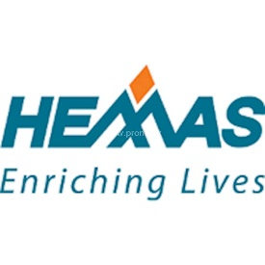
COMPANY NAME
COMSUMER KNITEX LTD (CKL).
Internship Report
On
Managing Marketing Communications:
A Study on Hemas Consumer Brands Bangladesh Limited

Submitted To
Muhammad Hasan Al-Mamun
Assistant Professor
School of Business & Economics
Submitted By
Md Monir Hossain Melon
ID - 111 142 213
BBA Program
United International University

Date of submission:
15th September, 2018

Letter of transmittal

15th September, 2018
Muhammad Hasan Al-Mamun
Assistant Professor
School of Business & Economics
Subject: Submission of internship report on “Managing Marketing Communications: A Study on Hemas Consumer Brands Bangladesh Limited”.
Dear sir,
Glad to submit my report on “Managing Marketing Communication: A Study on Hemas Consumer Brands Bangladesh Limited”. I have conducted my internship program at Hemas Consumer Brands. This is a part of the entire requirements to complete BBA program.
While preparing this report, I have followed all the instructions that you have given to me. I tried my best to prepare this report and believe that all the ideas from this report will help me in my future practical life. I will be grateful to you if you accept this report.
I hope that you will find this paper worthy of my labor.

Sincerely yours,
Md Monir Hossain Melon
ID: 111 142 213
BBA Program
United International University

Acknowledgement

At the very beginning, I would like to express my deepest gratitude to the almighty Allah, the most merciful for blessing me with patience and tenacity of mind to complete the requirements for the degree successfully.
I would like to express my sincere gratitude to my academic supervisor Muhammad Hasan Al-Mamun, Assistant Professor, School of Business & Economics, United International University for his constant guidance, supervision and feedbacks which enabled me to prepare a report in a well-organized manner. This report would not have attained its current shape without his encouragements and supports. I would like to express my deepest gratitude to my parents for their continuous support, constant inspiration and loving care given and shown to me during my studies.
Then, I specially want to acknowledge Mousumi Rahaman, Senior Brand Executive at Hemas Consumer Brands for her tremendous supports, guidance and patience. Without their kind supervision, preparing this report would have been very complex. I am also appreciative to them for providing me all the significant and available information to have a clear concept on the subject.
I would also like to thank the authority of “Hemas Consumer Brands” for giving me the opportunity to do my internship in their well renowned multinational organization and supplying me necessary information and published papers.

Executive Summary

Hemas group is producing products under several consumer brands and distribute these directly and indirectly around the world. It always try to enrich human lifestyle via innovation, trustworthy, and in exceptional way. Hemas is the market leader in personal care sectors and it also encompasses a range of products for adults and babies in skin care, hair care, toiletries, fragrances and oral care. Hemas Consumer Brands run its business by following the mission is “To Passionately deliver Outstanding Products and Services thus Enriching the Lives of our Customers and creating Superior Value to our Shareholders”. The strength and weekness are also mentioned in this report, the strength are natural ingredients, best quality products, strong sales team, regular updated market informations and so forth. The weaknesses are weak distribution channel, less strong marketing team, less TV advertisement, or newspaper advertisement and so on.
The last part of the report represent the usages of Integrated Marketing Communication Tools (Advertising, direct marketing, online marketing and so forth) of Hemas Consumer Brands. My activities and learning that I did in my three months internship period are also given in the last part of the report, market audit informations(procedures of market audit, number of territory, audit reports) , activation activities, contribution on digitial marketing informations, marketing communications informations with agencies and TSO/TSM.
Key Words: Marketing Communicaitons

Table of contents

Letter of transmittal ii
Acknowledgement iii
Executive Summary iv
Introduction 3
Significance of this report: 3
Objective 4
Limitations: 4
Background of Hemas 5
Hemas Holdings PLC in Sri Lanka 5
Diversified sectors of Hemas Group 6
Fast Moving Consumer Goods (FMCG) 7
Healthcare of Hemas Group 9
Transportation service of Hemas Group 10
Leisure Business of Hemas Holding PLC 12
Hemas Consumer Brands in Bangladesh 14
Specialized Brands of Hemas Consumer Brands Pvt Ltd 14
Kumakira 15
Kumarika Hair oil 16
Kumarika Soap 18
Kumarika Shampoo 19
Kumarika 20
Sunny Day 21
Organizational structure of Hemas Consumer Brands 23

Integrated Marketing Communication (IMC) Tools of Hemas Consumer Brands (Pvt) Ltd 24
Advertising: 25
Sales Promotion 26
Internet Marketing 27
Direct Marketing 28
Public Relation 30
Work Undertaken at Hemas Consumer Brands 31
Market Audit 31
Monitoring Kumarika Activation 35
Monitoring Digital Marketing 35
Communicating with agencies 37
Communicating with TSO/TMS 37
Survey and report preparation 37
Conclusion 38
References 39

Introduction

The Fast Moving Consumer Goods (FMCG) sector is one of the largest sectors in the economy of Bangladesh with well-established distribution networks, intense competition between the organized and unorganized segments, and low operational costs. Being a developing economy, Bangladesh is gradually becoming a large market, especially for the FMCG. In the last few years, the FMCG industry in Bangladesh has experienced a dramatic growth; both qualitative and quantitative improvements have occurred in the consumer durable items. While purchasing high involvement products like electronic goods, luxury items or lifestyle products, the prior in-home decisions of purchase are not usually altered in the store environment. On the contrary, for the convenient and low involvement products like salt, flours, pens, chocolates, etc., a significant level of distortion from the prior decision of brand choice is frequently observed. These convenient and low involvement products are also known as FMCG in marketing. Hemas Consumer Brands is one of the growing participants in this industry.

Significance of this report

As we know that education will be the most beneficial when theoretical and practical knowledge mix together. Through this practical knowledge and theoretical knowledge, we get perfection. This report works as a bridge to reduce the gap between practical and theoretical knowledge. We already know that there is no alternative to practical knowledge. The main reason of this study is to become more familiar with practical business world, to attain practical knowledge and to know about the FMCG sector and corporate world. It is so much important for each and every student to meet the escalating growing challenges for the purpose of getting into the job market.

Objectives of the report
- To acquire a clear knowledge about the activities of the Sales and Marketing department.
- To achieve the practical knowledge of corporate environment.
- To apply theoretical knowledge in the practical field.
- To observe the working environment and learn office etiquettes.
- To evaluate the promotional efforts of the organization in terms of the specific components of the promotional mix elements.

Limitations of the report
When I was preparing my report I also face so many problems. The list of this limitation is given bellow:
- Limitations of time.
- Limitation of secondary data.
- Limitation of primary data.
- Limitation of secondary data.

Background of Hemas

Hemas Holdings PLC in Sri Lanka
Hemas is one of the leading Multinational Company in Sri Lanka which has strong presence in the diversified sectors. It started its journey in 1948 as a pharmaceuticals and trading enterprise, founded by Sheikh Hasannally Esufally (MBE). In Sri Lanka it has strong presence in FMCG, Pharmaceutical, Hospital, Transportation and Leisure and some of others sectors.
A short history of Hemas is given below in terms of the key milestones:
Year | Description
1948 | Started its journey as Hemas (Drugs) Ltd
1962 | Started manufacturing toiletries in the collaboration with French Multinational
19670 | Diversified its journey in travel and tourism
1978 | Started exporting business
1990 | Lunched Clogard Toothpaste
1992 | Re-entry into apparel manufacture and freight and logistics
1993 | Hemas Drugs renamed as Hemas Holdings (Pet) Ltd
1994 | Started Airlines Business
1998 | Acquisition of Goya perfume Brands
2003 | Hemas Holdings listed in Colombo Stock Exchange
2003 | Established Power Plant
2003 | Entry into Food Sectors
2008 | Established Hemas Hospital
2010 | Started business In Bangladesh as “Hemas Consumer Brands Ptv Ltd.

Diversified sectors of Hemas Group
Hemas is successfully operating in several industries in Sri Lanka as well as and managing businesses in various markets. It is also expanding its market in the international market.

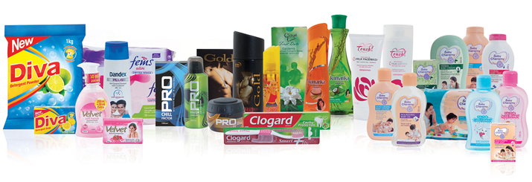

Fast Moving Consumer Goods (FMCG)
Hemas group is producing products under several consumer brands and distribute these directly and indirectly around the world. It always try to enrich human lifestyle via innovation, trustworthy, and in exceptional way. Hemas is the market leader in personal care sectors and it also encompasses a range of products for adults and babies in skin care, hair care, toiletries, fragrances and oral care.
FMCG Brands of Hemas Group
Logo of Hemas FMCG Global Brands
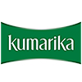
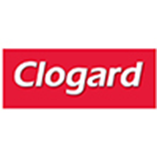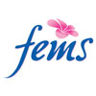
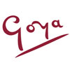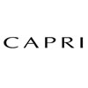

FMCG International Market of Hemas Group
This group is now exporting its FMCG products in 12 countries around the worlds.
International Marketplace of Hemas Group.
- The Maldives | - Zambia
- Lebanon | - Malaysia
- Belize | - Pakistan
- Bangladesh | - Australia
- New Zealand | - The Middle East

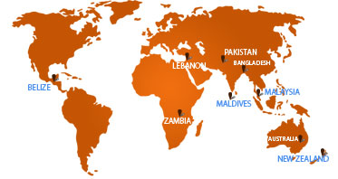
International marketlace of Hemas Holding PLC

Healthcare of Hemas Group
Hemas group is the largest private health care service provider in Sri Lanka and also the dominant distributor of pharmaceuticals, surgical & diagnostic products in Sri Lanka.
It owns and manages 3 separate hospitals in different states of Sri Lanka. All the hospitals are of international standards and accredited by the Australian Council for Healthcare Standards (ACHSI). Hemas hospital always provides better services to its patient at affordable price and keep updated with modern innovation.



Transportation service of Hemas Group
Transportation issue is one of the major problems in all over the World. Hemas always tries to solve major problems in a country they operate. So it started its transportation business in 1970. Now it becomes one of the top transportation companies in Sri Lanka.
It is operating its business in various transportation modes. It creates a distinctive and trusted service with its partners company in all over the world.


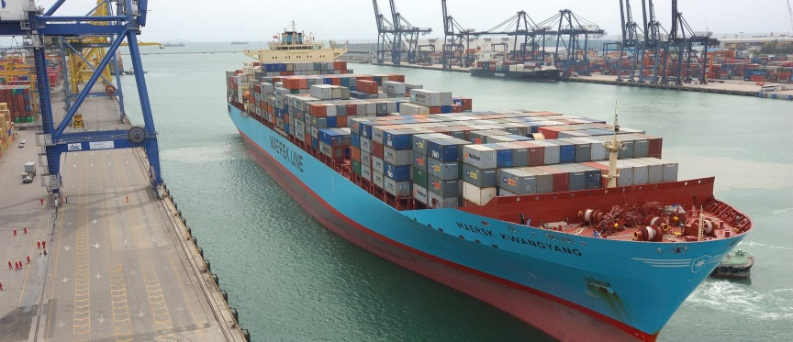
Key Factors of Transportation Business
- Hemas is the Leader in Airline General Sales Agency business in Sri Lanka for both passenger and cargo
- It is Ranked amid Top 3 travel agencies companies in Sri Lanka
- It becomes number 1 player in empty container haulage, Top 3 player in container depot operations
- Exclusive feeder operator to key East Coast and Bay of Bengal ports

Leisure Business of Hemas Holding PLC
Hemas diversified its business portfolio in leisure sectors in 1970. It offers a great holiday experience from exotic relaxing holiday on golden beaches to adventure filled experience within the tropical island.

Hemas Leisure Business consists of four medium-classes to up-market hotels in the key locations of Sri Lanka, offering high quality personalized services. These 4 international class hotels are managed by Serendib Leisure Management (Pvt) Ltd.

S.L | Name of the Hotels
 | - Club Hotel Dolphin
 | - AvaniBentota Resort & Spa
 | - Hotel Sigiriya
 | - AvaniKalutara Resort

Key features of the Hotels
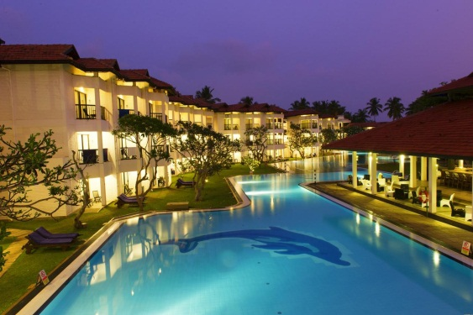n 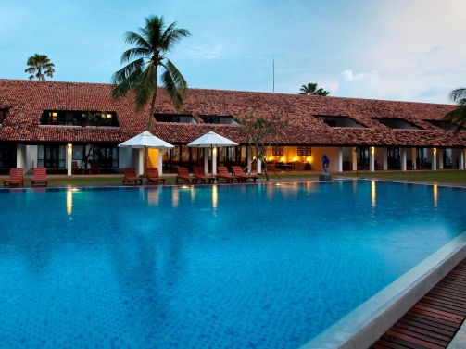

Serendib Leisure Management (Pvt) Ltd is fully subsidiaries of Hemas Holding PLC. It is pioneer company in Sri Lanka that offers diversified hotel management and destination management service in Sri Lanka. it offers quality driven, customized Sri Lankan travel experiences for individual travelers, groups travelers, private and corporate travelers, Meeting Incentives Conventions Exhibitions (MICE) requirements, as well as tailor made holidays in the Maldives via Diethelm Travel.

Hemas Consumer Brands in Bangladesh

Hemas consumer Brand started its journey in Bangladesh on 15 February In 2010 under the company act of 1994. Hemas Consumer Brands is one of the bedrocks of the Hemas group. It started its journey in Bangladesh with a specific brands of “Kumarika oil” through Transom distribution, afterward it added another brand named by “Sunny Day” in Bangladeshi market.
in the last eight years the, company experiences extraordinary growth and has emerged as a strong player in the value Added Hair Oil market of Bangladesh with its Brand Kumarika. At present Kumarika Hair oil becomes one of the market-leading brands in Bangladeshi hair oil market.

Specialized Brands of Hemas Consumer Brands Pvt Ltd

Hemas consumer Brands Pvt Ltd is operating in Bangladesh with two specialized brands in Bangladeshi market:

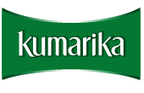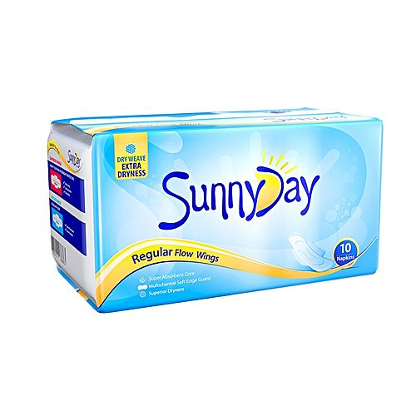

Hemas consumer brands produce its products with natural and herbal ingredients. Under these two brands several product lines are added.

Kumakira

Kumarika Brand is one of the most known brands in Bangladesh. This brand creates a vibes in Bangladeshi market within short period of time. Kumarika has several products category, including the following:

Kumarika is now competing in the market place by fighting with others companies. In this competitive market, Kumarika hair oil is the market leader in the herbal oil market in Bangladesh. In the herbal hair oil market, Kumarika hair oil gains 33% of total market share within a very short period of time.

Competitor of Kumarika
Kumarika Hair oil | Parachute oil, Cute, Emami 7Oils ,Sesa Oil, etc.
Kumarika | Himalaya , Clean and clean, Garnier , Lotus etc.
Kumarika Soap | Dove, Neem, Lux, Sandalina, Lifebuoy, Dettol, Savlon etc.
Sunny Day | Senora, Freedom, Staysafe, Joya etc
Kumarika Shampoo | Sunsilk, Dove, Pantene, Clear, Tresseme, Garnier etc.

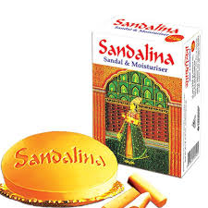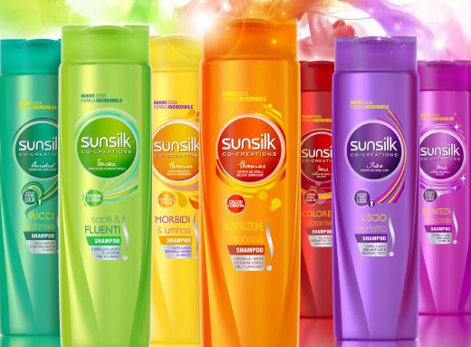

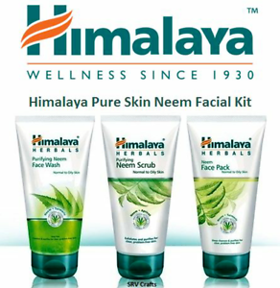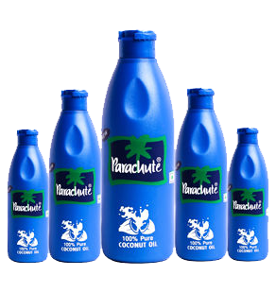

Kumarika Hair oil
Hemas consumer brands started its journey in Bangladesh with hair oil brands, this brands gain tremendous growth in Bangladeshi market within a very short period of time.
Kumarika hair oil is the unique combination of natural and herbal extracts of Brahmi, Amla, Aloe Vera, Coconut, Mukunuwenna and Vetiver - contained in Kumarika Hair Oil provides extra nourishment to help control hair fall. Makes hair lively and lustrous. When used regularly it replaces the natural oils that the hair loses on a regular basis and strengthens each strand.
Hair oil category has three different variations
Category | Variation | Available SQU | Price
Hair Oil | Herbal Hair Fall Control | 415ml, 200ml, 100ml, 50ml | 415ml-290, 200ml-160, 100ml-80, 50ml-40
Hair Oil | Anti-Dandruff Hair oil | 200ml | 200ml-150
Hair Oil | Henna & Honey Split End Control | 200ml | 200ml-150
Hair Oil | Revitalize Cooling Hair Oil | 200ml, 100ml | 200ml-170, 100ml-90

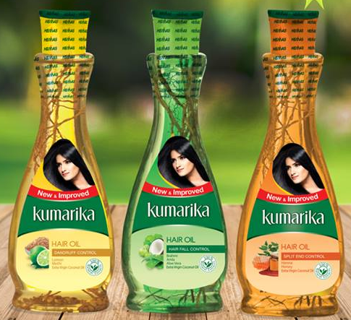

Kumarika Soap
Soap is one of the biggest and most competitive fmcg categories in Bangladesh. To cater to the 99% penetrated market we launched an unique soap, Kumarika herbal beauty soap enriched with 100% natural extracts of Neem, Aloe Vera and Cucumber that makes skin clean, soft and fresh. Neem deep cleanses, washes away dirt and germs. Aloe Vera moisturizes Cucumber refreshes and tones the skin. This has been positioned into a new platform of “Herbal beauty soap”.
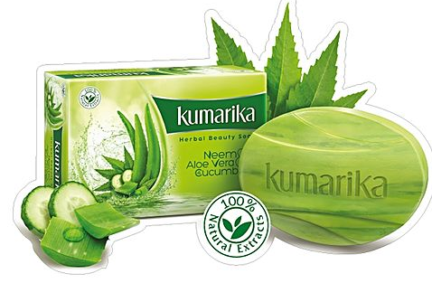

Soap Category | Weight | Price
Herbal Beauty Soap | 100 GM | 36
Kumarika soap market demand is gradually rising in Bangladeshi soap market, to meet these demand Hemas consumer brands established a soap manufacturing industry at Gazipur.

Kumarika Shampoo

After the tremendous success of oil, Hemas consumer brands introduced a range of herbal shampoo into our portfolio. The ingredients that are used in producing shampoo are all natural and herbal.
Kumarika shampoo products cleanses hair thoroughly removing oils, dirt, skin particles, dandruff, environmental pollutants and other contaminant particles without damaging you . It's designed not to strip your hair and scalp of natural oils,leaving your hair with more strength, moisture, manageability and better color retention. The most prominent natural ingredients include avocado oil; shed butter, green almond oil, fruit vitamins, coconut, Black Oliver, black seed, rosemary, orange etc.

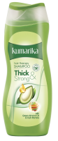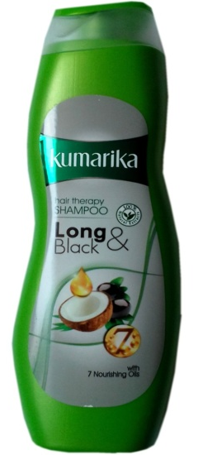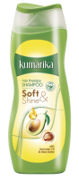
SKU Chart of Kumarika Shampoo
Product Name | Product Weight
Kumarika Soft and Shine Shampoo | 200ml
Kumarika Long and Black Shampoo | 200ml
Kumarika Thick and strong Shampoo | 200ml

Kumarika

To cater to the growing needs of Bangladeshi people we launched Kumarika . Kumarika Oil Control and Pimple Control is enriched with the natural goodness of Lemon, Cucumber and neem, aloe vera. Kumarika has been well appreciated by its consumers and gradually getting into the households
Kumarika Have two variation in category
- Pimple Control
- Oil Control
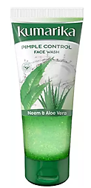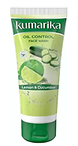
Oil control enriched with the natural goodness of Lemon and Cucumber it deeply cleanses and washes away excess oil and dirt leaving your skin clean, fresh and naturally glowing. Lemon is well known for its deep cleansing and astringent properties that wash away oil and restrict oil build up. Cucumber refreshes and tones the skin. And its special micro beads containing “Vitamin E” provides mild exfoliation and helps to nourish the skin.
Pimple control Enriched with the natural goodness of Neem and Aloe Vera the soap free formulation gently removes impurities and prevents pimples. With proven Anti-Bacterial and Deep Clean properties, Neem washes away impurities and controls pimple causing bacteria. Aloe Vera soothes the skin and helps reduce pimple marks. And its special micro beads containing “Vitamin E” provides mild exfoliation and Helps to nourish the skin.

Sunny Day

In Bangladesh only 17% women use sanitary napkins. To cater to this growing demand we launched Sunny Day sanitary napkin in 2017. The Dry weave top sheet of Sunny Day napkin ensures 5x dryness and reduces the chance of rash and infections. It’s a category with untapped potential
There are two variation of sunny day

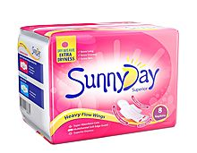

Organizational structure of Hemas Consumer Brands Private Limited is given below.

The head office consists of 5 Departments, Finance, Supply Chain, Marketing and HR-Admin.
HR-Admin Department: It is responsible for providing administrative, human resources, payroll, acquisition and communication.
Sales Department: It deals with all the sales of its branded products.
Finance Department: It deals with all kinds of payments associated with Hemas Consumer Brands Pvt. Ltd and this department also works for maintaining integrity for all other departments.
Supply Chain: Handles all kinds of import-export activity and buys for all the factory’s items-equipment’s needed for everyday operations and production.
Marketing Department: Marketing department is responsible for promoting Kumarika and sunny day.

Organizational structure of Hemas Consumer Brands

Country Director
Accountants Executive
Head of
Finance

Head of Marketing
Head of
Supply Chain
Head of
Sales
Head of Human Resources

Sales Manager
Sr. Marketing Executive
Sr. Commercial Executive
Sr. HR and Admin Executive

Intern
Sales Executive
Intern
Commercial Executive
Marketing Executive

Figure 1: Organogram of Hemas Consumer Brands Private Ltd.

Integrated Marketing Communication (IMC) Tools Used by Hemas Consumer Brands (Pvt) Ltd

There are several integrated marketing communication tools which are used by national and international organizations to communicate, promote, and sale of their products and services. In this business world, the uses of these tools are varied by organization to organization. Hemas Consumer Brands use several marketing communication tools for the purpose of promoting and selling goods and services and achieving its business goals.
The most important IMC tools are

Advertising:
Advertising is the most common mess channel of communication in the world. According to Kotler's definition “Advertising is paid form of presenting ideas, goods or services to customer by an identical sponsor(Principal of marketing-13th edition). Each and every organization does advertising for the purpose of promoting their products and service
Hemas Consumer Brands (Pvt) Ltd also are doing advertising by selecting their target market and customer. Adverting has several media by which a company can promote its products and services.

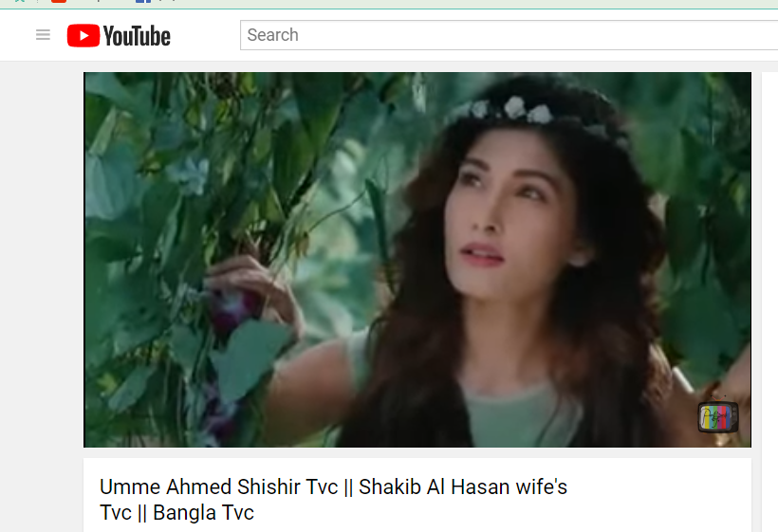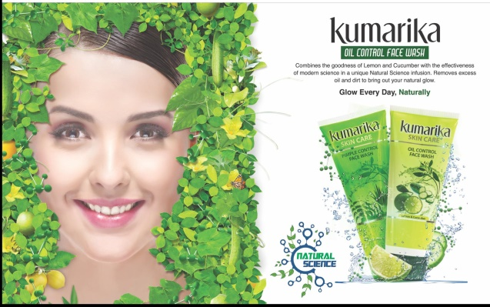
Kumarika Advertisement at Television, Magazine and newspaper

Sales Promotion
Sales promotion is a pull marketing technique which is undertaken by an organization to promote products and to increase in sales or increase the usage of trial of products and services. Sales promotion is a short term tactic to boost up sales. There are two types to sales promotions
- Consumer sales promotions
- Trade Sales promotions
It is only used for short term boost up sales for long term is not suitable for a company.
Techniques for sales promotion
- Discount vouchers
- Money off coupons
- Free gifts
- Point of sale materials
- Loyalty cards
- Discounted prices
- Free samples
- Buy-One-Get-One-Free
- Customer Relationship Managemen
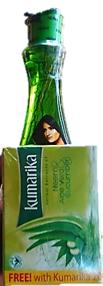
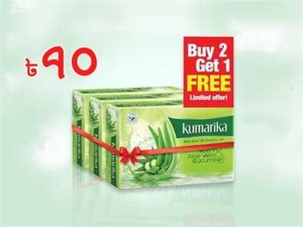
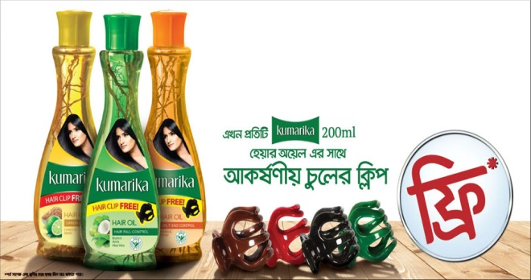

Hemas Consumer Brands Ltd. uses some of the sales promotion technique for boosting up their short times sales.
- Free gifts- A Kumarika soap is free with 400ml Kumarika oil.
- Discounted prices- 25tk off for 100ml FaceWash.
- Buy-One-Get-One-Free- Buy 1 get 1 free for Sunnyday napkin.
- Free samples- Kumarika FaceWash free sampling program at Motijil Ideal College.

Internet Marketing
Internet marketing is a set of tools and methodology used by an organization for promoting it brands, products and services through internet platform. In the competitive market each and every company is using internet platform to reach more target audiences.
Media of online marketing
- Social media
- Email marketing
- SEO- Search engine optimization
- Content marketing
- Affiliate marketing
- SMS
Hemas Consumer Brands is not different among others companies, it also uses internet platform for promoting products and services, create awareness and to communicate more customers.
- Social Media- Hemas Consumer Brands Ltd. promote its products and service through social media platform, like- Facebook, Instragram, Youtube and many other platforms.
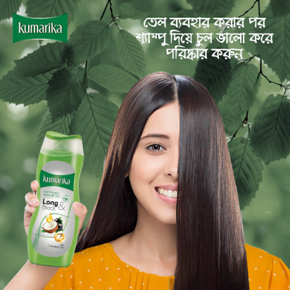

- Content Marketing-As Hemas consumer brands is working with natural products, it develops different types of contents based on the benefits of natural elements.
- Affiliate Marketing - This company also develops and maintains affiliation with different merchants for promoting its own brands

Direct Marketing
Direct marketing is a method of advertising where a company promotes its products and services directly to customers without using any advertising middleman. It is the most common and popular method of marketing in the world.
There are several direct marketing channels that are being used by companies, some of these are following –
- Direct presentation by seller
- Direct mail
- Email marketing
- Telemarketing
- Direct response marketing
- SMS marketing
- and many more
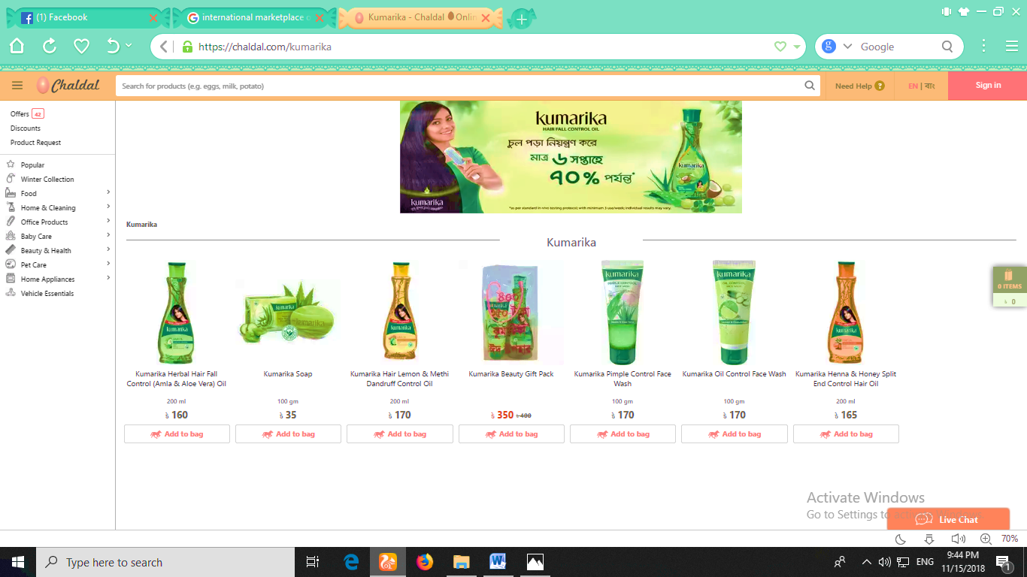
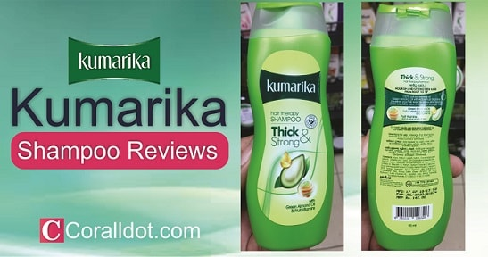

Kumarika Products at Online shop

Hemas Consumer Brands commonly used some of methods in their promotional programs
- Direct presentation by sales person- Hemas consumer brands is operating its business in the whole Bangladesh with its sales team. It has a Territory sales manager or territory sales officer in each district. The TMS or TSO presents Kumarika products to customer with the help of retailers and sales executive.
- Online Marketing- Facebook, YouTube, Instagram.
- Direct response marketing- Hemas marketing agencies regularly communicate with customers who comment or inbox on Facebook page, YouTube channel and instagram site.
- Telemarketing-Heams Consumers Brands are using telemarketing platform to reach its target audiences.

Public Relation
Public relation is a strategic communication process by which organizations create and maintain a profitable relationship with others organizations and its publics. Organizations need to maintain a good relationship with various partners such as - suppliers, wholesalers, customers, vendors, marketing agencies, financial institutions, social organizations, auditing farms and so on for doing regular business.
Hemas Consumer Brands Ltd. maintains relationship with its all social and corporate and financial partners in Bangladesh. This organization produces products by collecting materials from inventories providers, promote products through marketing agencies, supply its consumer’s products to end consumers through wholesalers and retailers, transportation agencies carry out products at all districts.

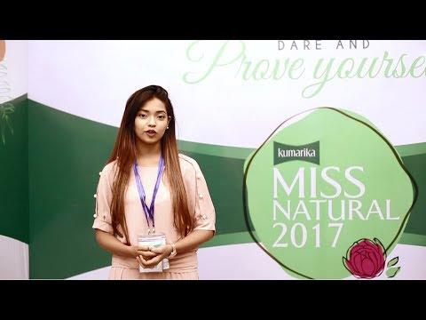

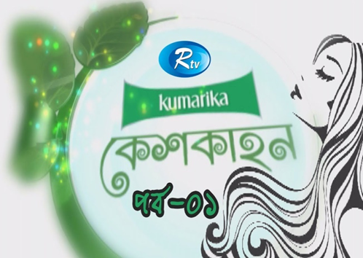

Work Undertaken at Hemas Consumer Brands

Market Audit

Hemas consumer brands are now running its business in the 65 districts in Bangladesh with established brands “Kumakira” and “Sunny Day”. In my three month internship period i have visited several territories in Dhaka city. I went most of the retailer shop and checked out the Kumarika display conditions in each of the territory. In my internship period I was totally responsible for Audit Kumarika market

Hemas consumer brands distributes its products in two distribution Channels.

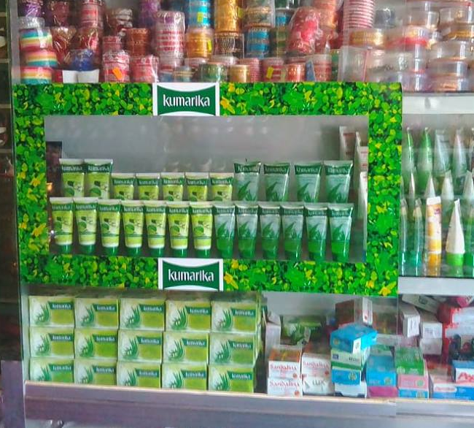
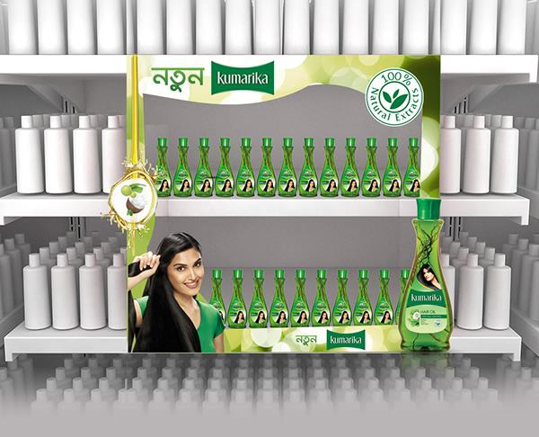
Procedure of Market Audit

Retail Distribution
Retail distribution is a process by which Hemas Consumer Brands distribute its products to customer through retailers. In my internship period I have visited 12 territories retail stores in Dhaka metro. In every retail store i have checked out the products availability, Display Location, Category Shelf, Shelf Talker, Planogram, Booklet, Repurchase Amount, verify Bkash number etc.
The list of the visited territories age given below

Territory Name | Number of visited  Display | Territory Name | Number of visited  Display
Badda | 30 | Shantinogor | 15
Uttara | 60 | Mohammadpur | 88
Tongi | 35 | Savar | 18
Jatrabari | 14 | Mirpur | 83
New Market | 46 | M/SAthentik Distribution | 34

Findings of the Retail Audit
- Identify the lower retailers benefits compare to others companies’ that were hampered the Kumarika sales.
- Identify the shelf talker issues that were dislike by the retailers.
- Find out the display that doesn’t have any shelf talker.
- Find out the Wrong Bkash number/ Deactivated numbers.
- Find out the display that contains others companies .
- Find out the display that place in an inappropriate position
- Identifying the display that doesn’t follow the appropriate size, the standard set by the company.
- Identify the small display.
- Find out the retailers who didn’t get display payment.
- Identify payment related problems.
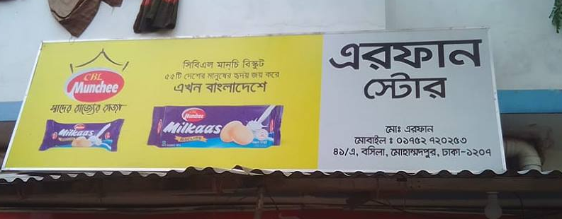
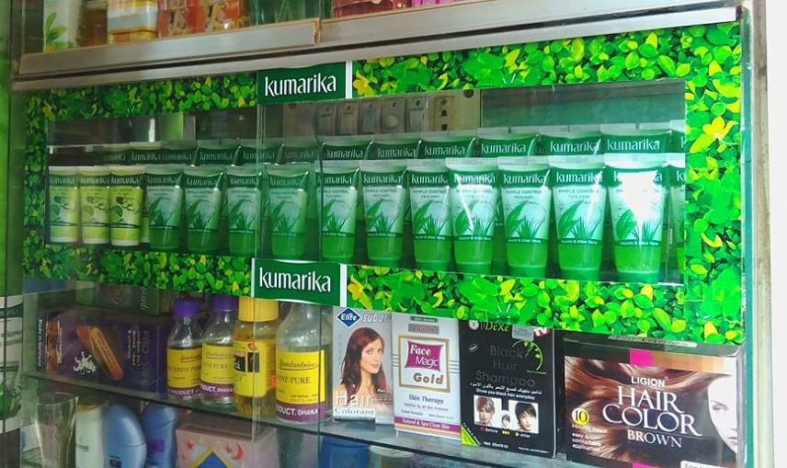
Modern Trade
The process by which Hemas Consumer brands distribute its products to customers through Super Shop like Meena Bazer, Aagora, Sopwno etc. “kumarika” and “Sunny Day” two brands of Hemas consumers brands are available most of the modern trade center all over the Bangladesh.
I have visited several super shop in different territories in Dhaka city and find out that products availability in the super shop, (all category of products are available or not), company free offer are available or not, monitoring the products feedback from customers etc.
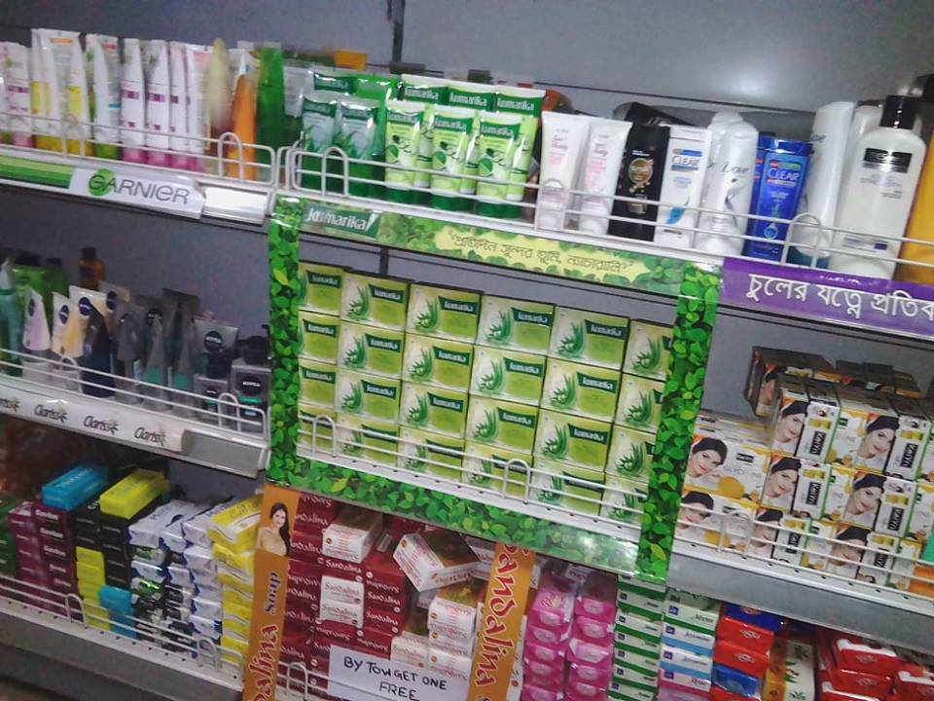

Monitoring Kumarika Activation

Marketing activation is the execution of the marketing mix as part of the marketing process. Every company develop activation program to make known their products to end consumers. In the internship period i have monitors Kumarika activation program in different school, college, women hostels and more others.

Activities in the activation program
- Communicate with agencies about activation date, time, place, sales volume.
- Checking out the activation starting and ending time’
- Monitoring Brand Promoter (BP’s) activities.
- Monitoring sales.
- Updating activation to Head office.
- Collecting feedback about from consumers.
- Providing reports to supervisor.
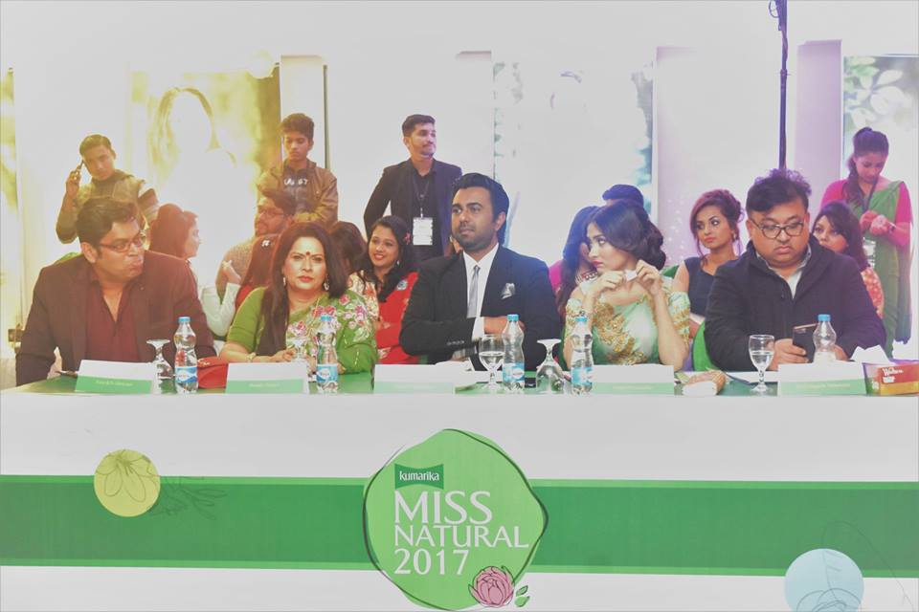

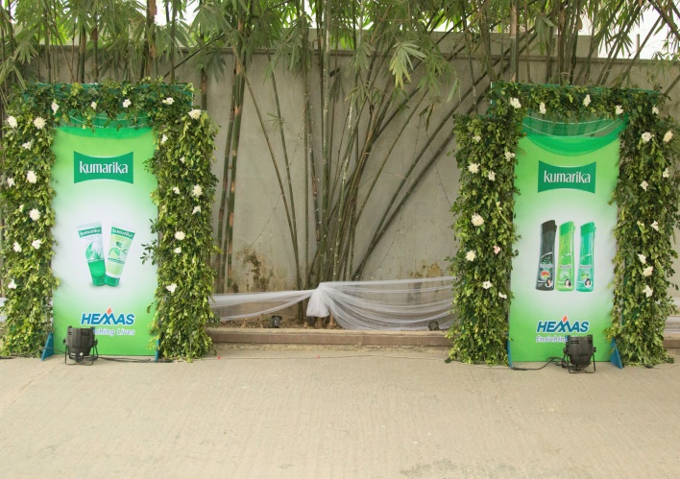

Monitoring Digital Marketing
Digital Marketing is one of the most important tools in marketing communication which is used to promote companies products and services. Hemas consumer brands also maintain various digital marketing tools like Facebook, YouTube, and Instragram
I was responsible for doing several digital marketing task. My supervisor always given a pre-plan for digital marketing activities that are done by different agencies.
- I have checked out Kumarika page
- Monitoring comments and replays of Kumarika Facebook page that are done by customers the agencies.
- Informing the agencies personnel for any types of comments and posts.
- Monitoring Instragram post
- Monitoring YouTube contents post.
- Informing supervisor about of the agencies.




Communicating with agencies

Agencies are the helping hand of a company, they provide different types of service that can’t be done by own. Hemas consumer Brands has its own agencies that provides marketing services and develop marketing promotional plan according to company’s needs and demands.
In my internship period I was directly communicate with them and collect all required information that are necessary for the company.
- Providing required information to agencies.
- Collecting update about plan, reports and others information that were assigned to me.

Communication with TSO/TMS

Hemas consumer brands divide the Bangladeshi market in different territories, and each of the territories are run by either Territory Sales Officer (TSO) or Territory Sales Manager (TSM). TSO/TMS are responsible for selling Kumarika product to retailers through sales representative.
I have communicate with them for several reasons.
- Collecting sales update.
- Developing Database of cosmetics market.
- Updating about his market condition after market audit
- Informing after find out any problem regarding display in his market.

Survey and report preparation

I have served the quality of Kumarika within the organization. All the employees were filled out the questioners after using the kumarika , after collecting the survey feedback then I was prepared a graphical report and compared the quality of kumarika between Sri Lanka and Bangladesh.

Conclusion

My learning from Hemas Consumer Brands will enrich my knowledge and add value in career. This three months helped me to identify my shortcomings on marketing, communication, market auditing and corporate environment and so on, it also helped me to take necessary steps for strengthening my skills and knowledge.
Hemas Consumer Brands is one of the growing brands in Bangladesh, I hope It will be number one brands in Bangladeshi oli market if it can maintain its quality, promote products with strongly to end users, make their sales team with more training and career oriented programs.

References
- http://www.hemas.com
- http://www.kumarika.com.bd
- https://www.facebook.com/kumarikasrilanka
- https://www.facebook.com/kumarika.care
- http://www.ijiee.org/papers/202-X3029.pdf
- https://bizfluent.com/info-8361708-8-elements-marketing-communication-imc.html
- Marketing Management: A South Asian Perspective (Old Edition) Paperback – Dec 2008

