Advantages of Using Database Approach in a Medium Student Organization in a University: A Study on UIU MIS Forum

Advantages of Using Database Approach in A Medium Student Organization in A University: A Study on UIU Mis Forum

Submitted to
Name: Ahmed Imran Kabir
Designation: Course Instructor
Major: Management Information System (MIS)

Submitted by
Name: Md. Pervez Islam Rakib
Id: 111 152 112
Major: Management Information System (MIS)
Trimester: 14th

Scholl of Business and Economics
United International University

Date of submission: 17/05/2020

Letter of Transmittal

May 17th, 2020
To
Ahmed Imran Kabir
Adjunct Faculty
Scholl of Business and Economics
United International University
Dhaka-1209

Subject: Project paper on “Advantages of using Database approach in a medium student organization of a university: A study on UIU Mis forum’’
Here is my project paper on “Advantages of using Database approach in a medium student organization in a university: A study on UIU Mis forum’’ You have assigned me to prepare this project paper as a part of my BBA program.
This report will help you to know about the Advantages of using Database approach in a medium student organization in a university. I have tried to gather accurate information about these topics by researching for about four months. I believe that this project will help me in the near future.
Throughout this report I have tried to provide the relevant information regarding the mentioned topics. Without your co-operation & proper guidance the making of this report would have never been possible. I am really thankful to you for such act.
This report is not completely free of mistakes due to some unavoidable circumstances. I really apologize for any unintentional mistakes in the project paper & I hope that you will consider the matter graciously. And I sincerely hope this project paper will meet your approval. I would be glad to furnish you with any clarification if required.
Sincerely Yours,
Md. Pervez Islam Rakib
ID: 111 152 112

My Declaration

I hereby announce that this paper on “Advantages of using Database approach in a medium student organization in a university: A study on UIU Mis forum’’ is my original work and it was done to fulfill the requirements of my project necessary to complete my Bachelors of Business Administration (BBA) with Major in Management Information Systems (MIS). All the information I have collected has been properly referenced and presented in a logical manner.

Md. Pervez Islam Rakib
111 152 112

Acknowledgment

First, I would like to thank the Almighty of Allah for giving me the sufficient knowledge, spirit, patience & courage to complete this project paper. I am really thankful to a member of individuals; without whose assistance this project paper would have never been completed. My first gratitude goes to my faculty Ahmed Imran Kabir for guiding me in the best possible while preparing the project paper. I would also like to show my gratitude for giving the opportunity to work with him & giving me great support and for providing me with the relevant information needed to prepare the project paper.
I am responsible for errors and mistakes presented in the project paper and a positive and constructive criticism will always be welcomed.

Abstract Summary
Information is data organized in a logical manner. Such data helps to create a database. A single piece of data is useless. It cannot say anything on its own other than its own value. So, we could say that a database is made from collecting and organizing of data to help bring meaning to data. A database can take many forms it may be written; it could be stored digitally using software in spreadsheets or in CDMS’s which stands for Computerized Database Management Systems. There exist many types of such systems. In this report we will mainly use 2 of these systems- Excel and Access. This will aid us in creating a database to fulfill our criteria.
Database Management System is often treated as a mediator between the person or user and the information stored in the data-base. The construct itself is stock as an accumulation of data files, so that we can access the data in those files through the database management system. The database management system meets all application programs that requests and interpret them into the complex operations required to fulfill those requests. Database management system hides complex application program form its user. It adapts a simplified system for authorized users to work with ease. The more well-built the system the more efficient it will be for the users and it will lead to better management.
This is a project paper on the “Advantages of using Database approach in a medium student organization in a university: A study on UIU Mis forum’’. In this project we have tried to find out how to create a database and how to manage it in proper way, here first I making flat file database for MIS Forum around 200 students’ personal information. Then I import data to Access. Then I make tables in Access and Link the table Relationships. Then in final part I created a report. I have used a synthetic Microsoft excel database of a medium sized forum and created tables, queries, forms and report in Microsoft Access. The entire process is broken down into small steps which need to be carefully implemented. Any error leads to problems in the further steps.
In writing part, I used screenshots which I take from project which I created in Microsoft access. In every part I explained how to I make it. Basically, I show here how-to using Database approach in a medium student organization in a university and I made it for MIS forum in UIU. For control efficient manner and to stay in line with the competition it becomes necessary for any forum to handle and organize its personal data properly. Databases enable users to quickly access complex information put up protected storage for sensitive data and offer analysis tools for real-time decision making. Databases also play an important role with a forum presence on the internet. Web base database have the able to stock information for the forum members.
Through this project any student or individual will know how to utilize Microsoft Access to build a rational database. In finally I can say that this database will be very much beneficial for the forum members in UIU. To use this database, they can easily store information and also add or delete information if it is necessary. MIS is a topic that is in its infancy in many developing countries and is unheard of in most underdeveloped countries. However, it the developed countries it has soared to great heights, having implementation in the infrastructure of organizations large, mid-level or small. In every organization keep database for that reason I made this database so that Forum members can easily maintain their information.

Table of Contents
Chapter I: Introduction 13
1.1 Background of the Study 13
1.2 Statement of the problem 14
1.3 Objectives of the study 14
1.4 Theoretical Framework and Research Hypotheses 14
1.5 Motivation of the study 17
1.6 Scope and limitations of the study 18
Chapter II: Research Methods 20
Step 1 20
Step 1 –Making Flat File Database for MIS Forum 22
Step 2 22
Step 2 – Importing data to Access 23
Step 3 24
Step 3 – Making tables in Access 26
Step- 4 27
Step 4– Link the table Relationships 28
Step 5 – Build a Form for inputting information 32
Step 6 – Develop Queries 36
Step 7 37
Step 7 – Form a Report 38
Chapter IV: Discussion 40
4.1 Conclusions 40
4.2 Suggestions for Future Research 40
4.3 Recommendations 40
References 41

List of Figure
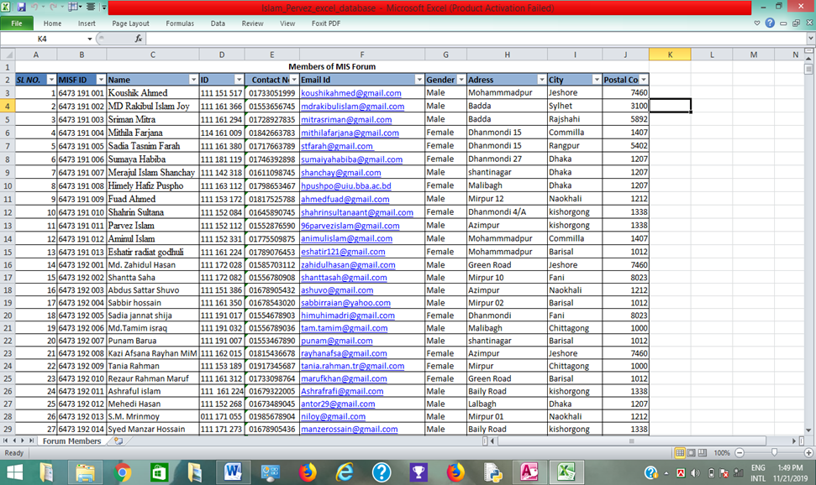

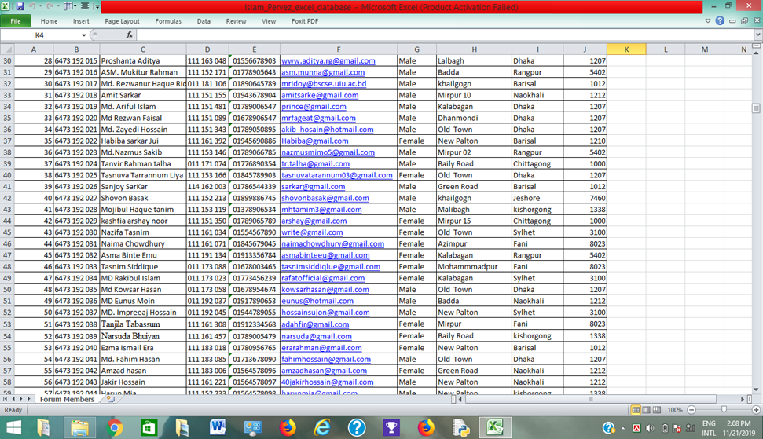

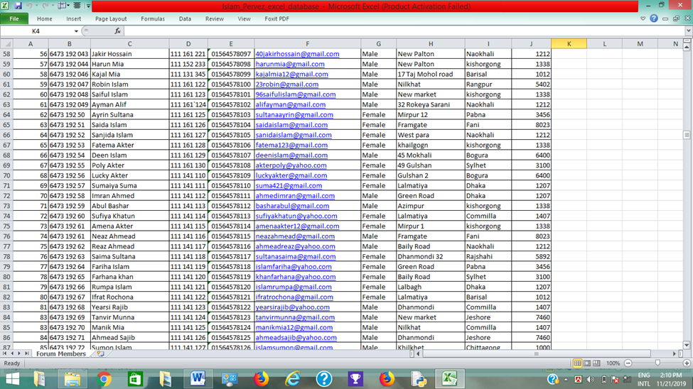

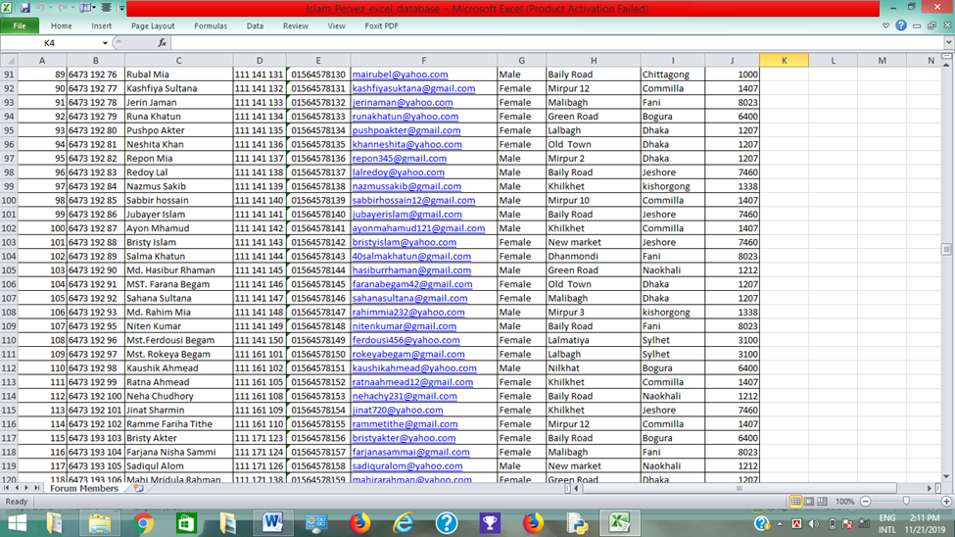

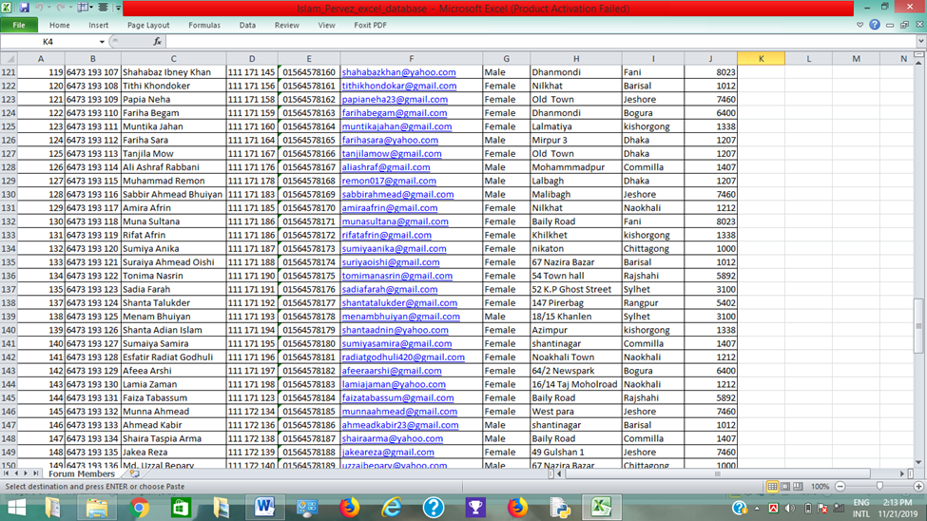

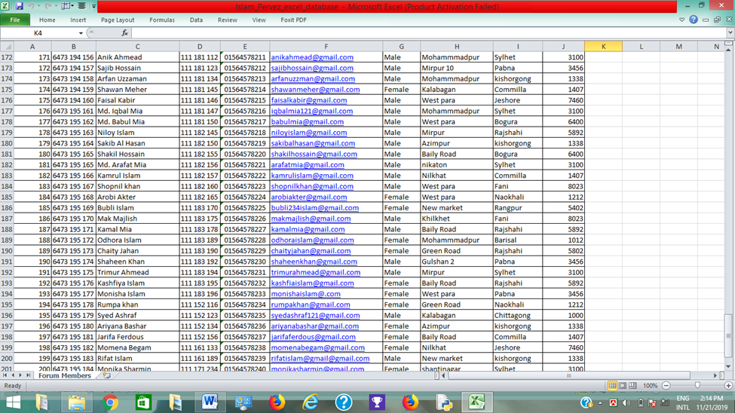

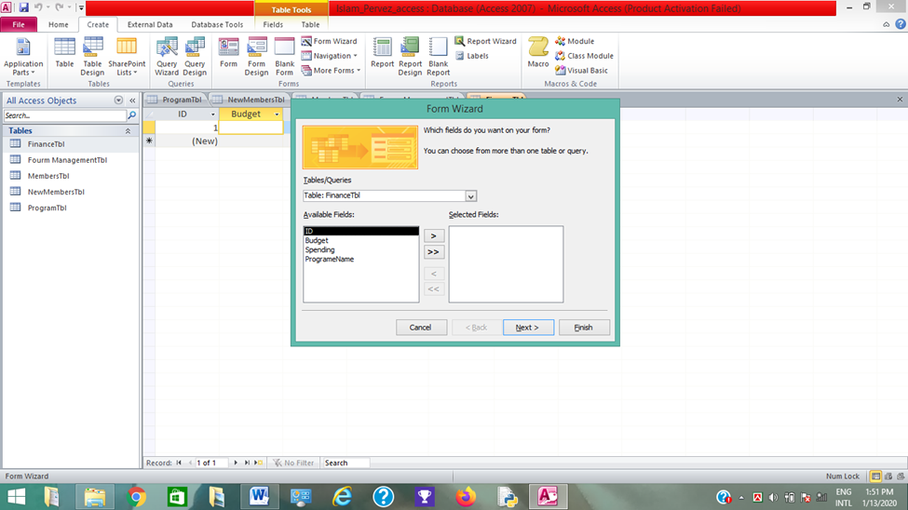

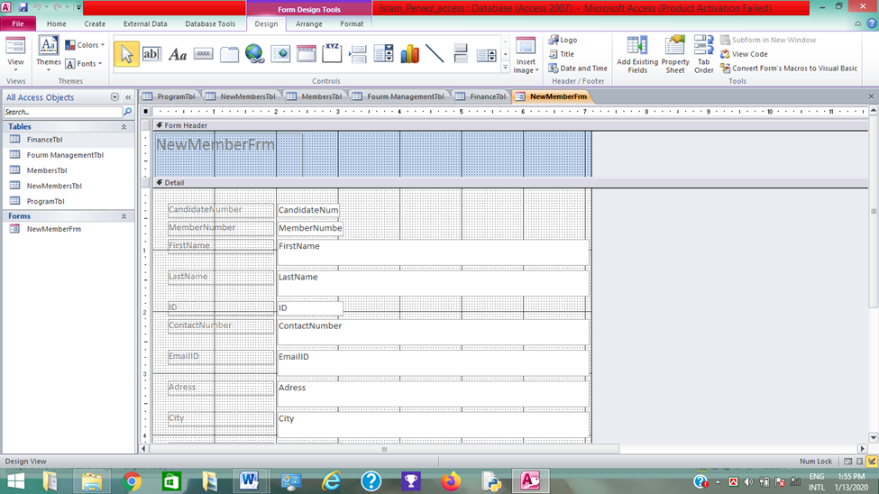

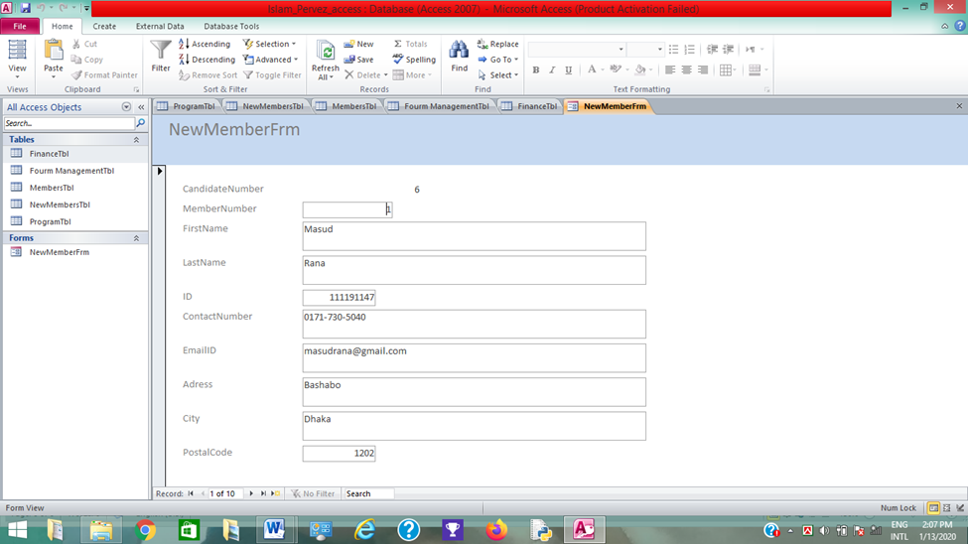

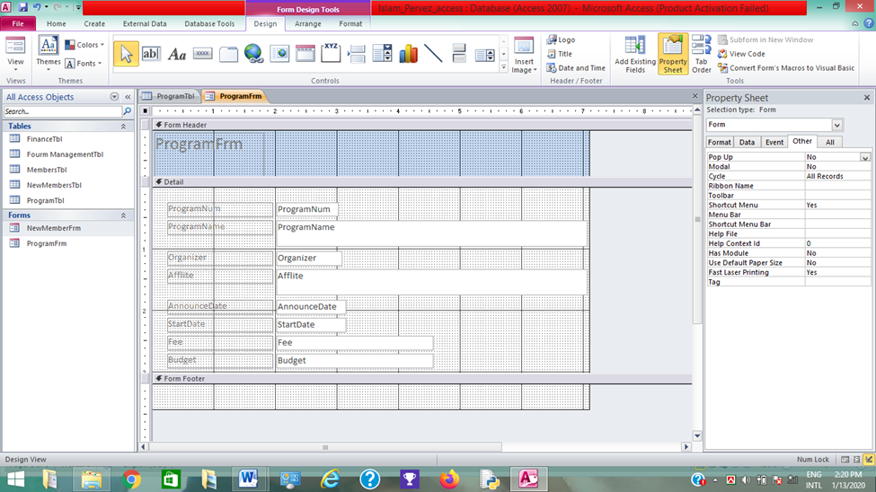

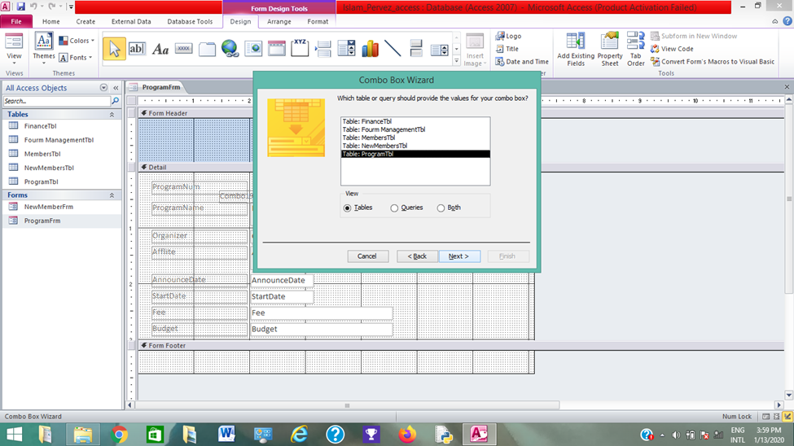

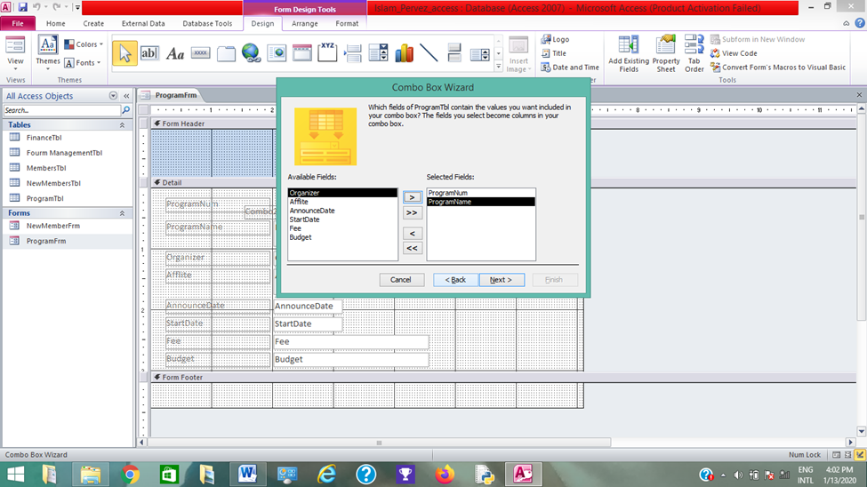

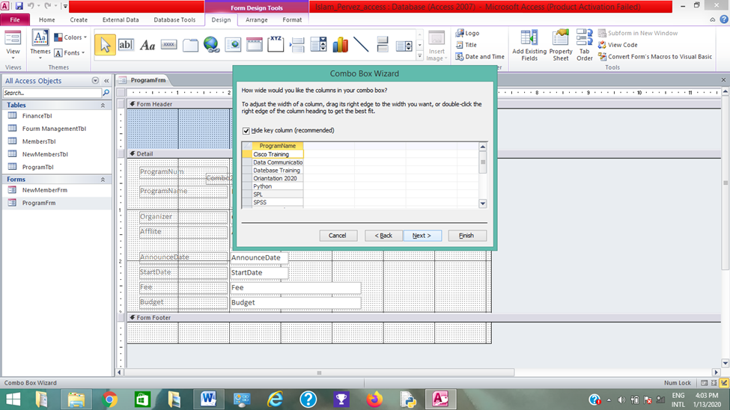

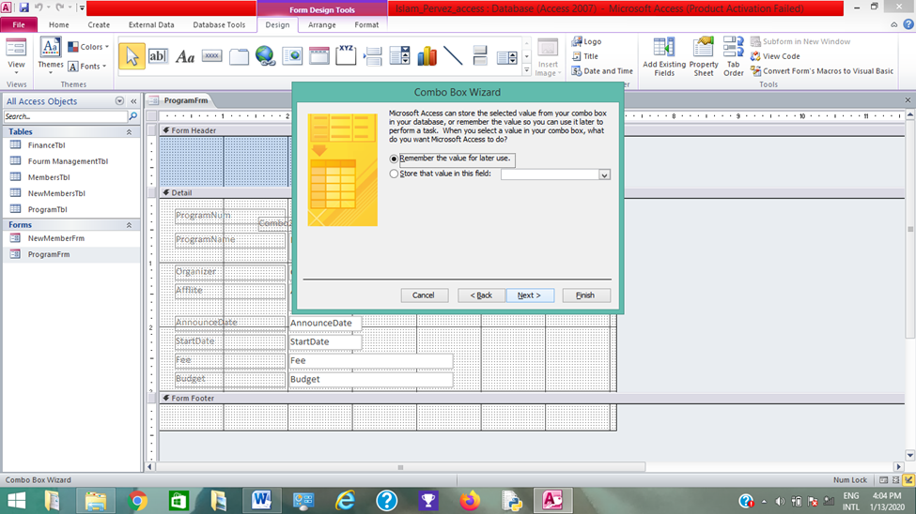

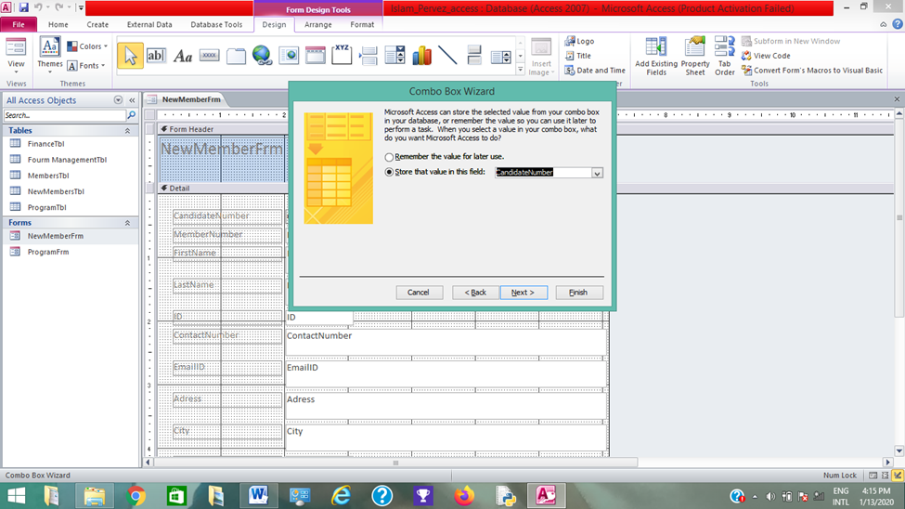

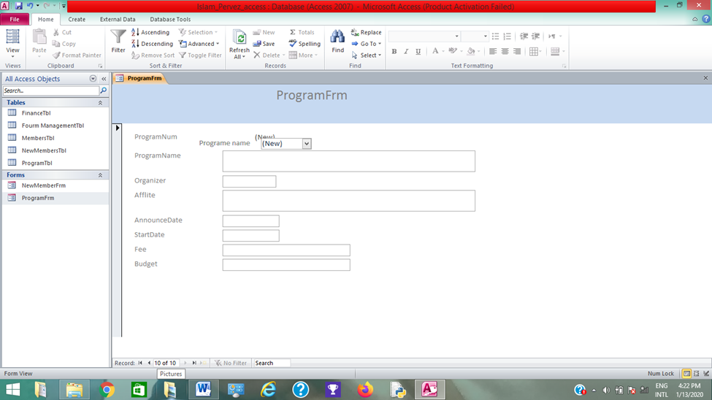

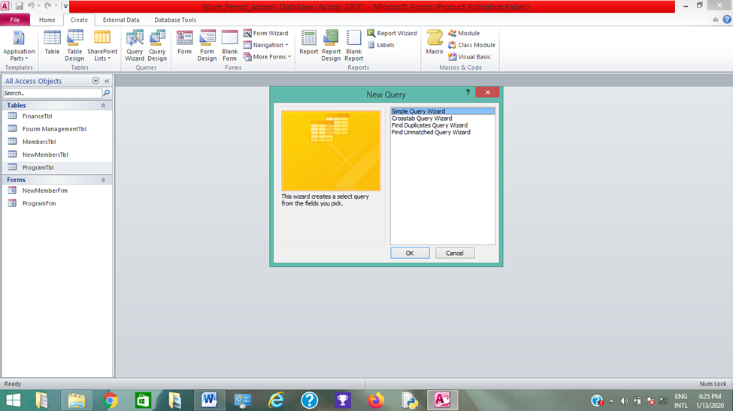

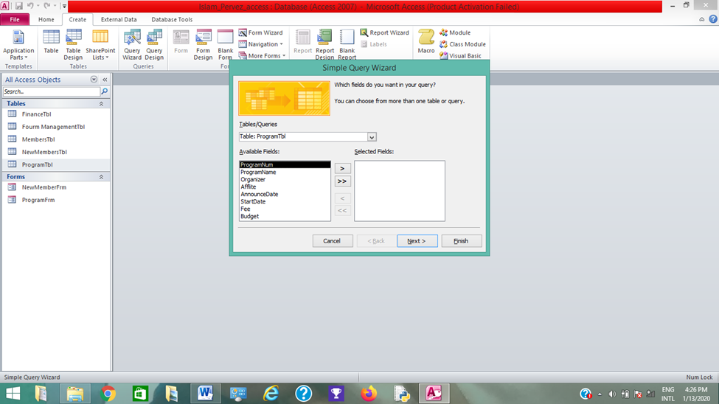

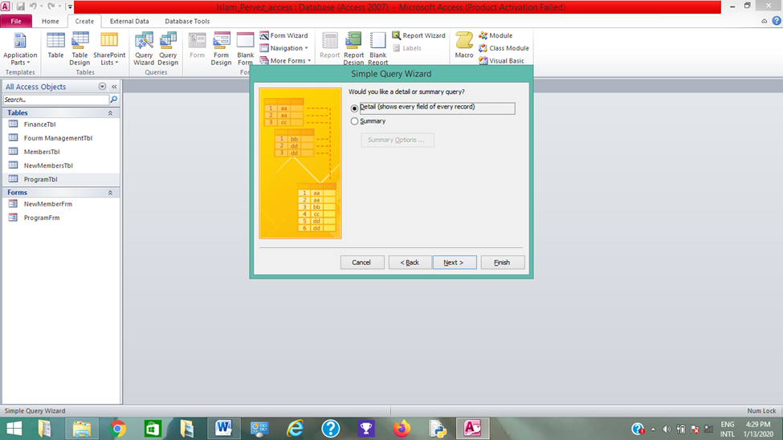

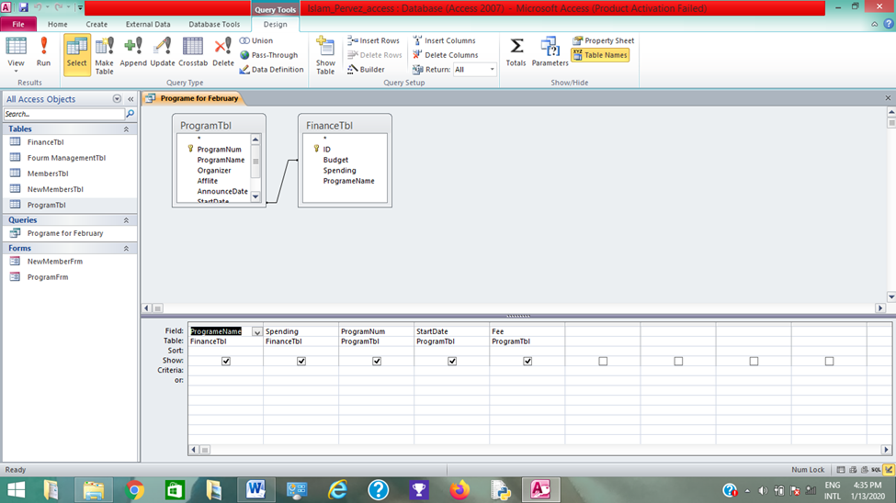

Chapter I: Introduction

1.1 Background of the Study
Database Management System (DBMS) is essential when it comes to efficient information maintenance. Efficiently and incapacitate its users to complete various task with expertise. DBMS store and maintain a large amount of information within designated software. Using the Database Management System (DBMS) can increase the overall performance of any organization and also reduce the overall expenses of the organization.
Database Management Systems (DBMS) are complex for any other organization because it provides highly effective techniques for maintain multiple types of data. Some data are easily maintained within such applications. Such as employee reports, student information, personal information, accounting, project control, inventory and library books. Database management system is made to be outstandingly talented.
Without its assistance tasks would have needed to be executing by hand plus it would take a lot of extra time to complete that task. To using the database management system, we can save our valuable times. Database maintains the information in proper manner for that reason data or record can be safe. Data is store on the database system and enroll on a regular basis by authorized users. Every user may have an authorized password to reach entrance to their part of the database system. The big advantages that database can offer to permit multiple users can use the database system at the same time in the different location.
For an example, a university uses the database system to maintain student information to use this software the university can able to store the information and they can use this information if it is needed. If the university can store the student information by manually then it takes too much time to using the database it can be easy. There are six major elements that database can be included such data, hardware, software, people and procedures. A database has basically several spreadsheets with row or record for the data and columns that explain the data component. Suppose a student record book the table Colum’s explain the data component such as- Name, Id, Gender, Address, City, State, phone number. While a table row or record contain the data for each student in the book.
Basically, I create this database for the student of MIS forum in united international university. In this database can use to keep the information those who are involved in MIS forum and the actives that the forum performed. Here I create new member form if the new member can attain the forum, they can easily join the forum to fill up an online form. I think this database helps the forum a lot.

1.2 Statement of the problem
In an organization if it is large it becomes difficult to manage the information of all the members, projects, programs, budgets and many more essential information’s. It is necessary to have a means by which all this data is organized to suit the needs of managers and stakeholders in an efficient manner. To solve this, I have chosen to use Microsoft Office I.e. Excel and Access tools which will help manage the information in systematic method.

1.3 Objectives of the study
- To create a relational database using Microsoft Access.
- To obtain better knowledge about flat database.
- For building cost effective and time efficient database.
- To understand the selected software’s
- To create a research paper which will aid in future research in the field,

1.4 Theoretical Framework and Research Hypotheses
The theoretical framework for my research paper is based on the concepts primarily learned in the Database management course and data communication. In Here I build relationship between Forum Management tables with Members table, Program table with finance, also Members table with Program table, new members table with Members table.

1.5 Advantages & Disadvantages of using database
Advantages and Disadvantages of Database Management System:

Advantages
Data sharing: Only authorized user can shared data in the organization. The database administrator manages the data and gives rights to users to access the data.
Independence of data: without modifying the application program we can change the structured of the database.
Recovery & Backup procedures: Database provided its user recovery & Backup procedures for that reason if any data need to restore its create automatically a sub system that can be backup the data.
Disadvantages
Hardware & software cost: When we process high speed data its need large size of memory to run the database management software.
Damage database: In the organization data are managed in to a single database, so if the database has to damaged due to some electric failure the important data may be lost forever.
Training cost of staff: Database management systems are most complex system so its require to training to its employees & it is requiring all the level of the organization such as: application development, programing & database administration. For that reason Company has to paid lots of money for employees training purpose to active the Database management system.

Relationship types
- One to one relationship: One to one relationship means one table creates relationship with another table. Here Forum management table create relation with Members table that’s way it called one to one relationship.
- One to many: One to many relationships means one table create relationship with many others tables that’s way it calls one to many relationships. Here Forum management tables create relationships with members table, program table, Program table. Finance table, and new member table.
- Many to many relationships: when several tables create relationship with several tables then its call many to many relationships. Here Members tables and Forum table create many to many relationships with others tables.
Relational Database
A Relational database uses several tables and interprets comparable factors utilizing an outline in data elements. Information and data elements are taken from each table and is merged based on the query which is displayed in the form.
Flat file
Flat file is a database stock information in simple text format. In a relational database, a flat file admits a table with other tables. Different flat files create different table, user can manage data in flat file in descending order or ascending order. Data stocks in flat files have no folders or paths connected with them. Procedures of a Flat File: Give 4 steps, Example
Query
Query is most commonly known as a call for certain selected data or record from a database table or sequence of tables within the system. Data may create as sequence run by structured program language. Different queries language used different platform to complex database queries. Structured program language is most well-known and widely used query language. Example:
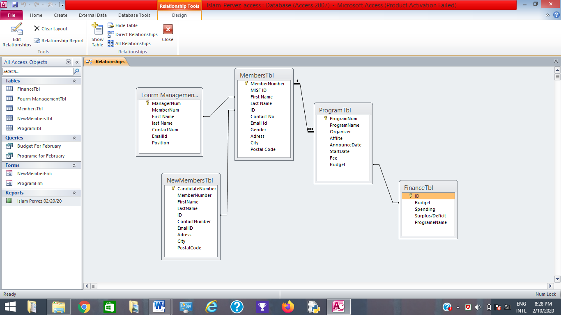

The image shows the relationship between the multiple tables in Microsoft access.
In this table I build up relation with five difference tables which I create I Microsoft Access. First I made revelation ship Forum ManagementTbl with MembersTbl here I create one to one relationship and then I made relationship MembersTbl with ProgramTbl here I create I one to many rotation ship. Then I build up relationship ProgramTbl with FinanceTbl and the final I will build up MembersTbl with new MembersTbl.

1.5 Motivation of the study
The key motivation of the study is to see the advantages of using a database approach in organizing various data sets into a coherent form which can help decision making and analysis. Almost all organization of significant size use some sort of database management tools to analyze large amount of information on a daily basis. These organizations used tools which are expensive and small organization cannot afford them. So, this project aims to create a cheaper and easy to use alternative which can help smaller organization. A database management system has to be streamlined process which reduce time and energy spent in data input and output so that further motivates us to create this study.

1.6 Scope and limitations of the study
- Limited scope of information
- Time restraint
- Limitation in analytical ability
- No primary research was conducted
- Unable to collect personnel information of actual organization due to privacy issues

Chapter II: REVIEW OF THE LITERATURE

2.1 Introduction to Database Management System:
DBMS means Database management system we can write it like this DBMS= Database+ Management system. Basically database is a collection of data management system is a process of store data in a logical manner. Its helps people to manage large amount of data. When database working with big amount of data there are two things that are needed to optimize those are storage of data & retrieval of data. When data are storing in a systematic manner it is important database can ensure that when we find a data it must be retrieved it as much as short time.
2.2 Applications of DBMS
- Hierarcahical and natwork system
- Flexibielity with relatitonal database
- Object orietnted applicaition.
- Interchanuging the data on the web for ecommerce.

2.3What is MYSQL?
Mysql is multithrteaded, multi user sql database management System called (DBMS). It basically provide server multiuser access in the database. We can also called mysql is a database the data that mysql are store in a database obkect call table. A table is a collction of ralated data entrie and it consits of columns and rows. The databases are useful when storing information systematically. MySQL database include TYP03, MODx, Joomla, WordPress, PHPBB, MyBB and Drupal.
2.4 MYSQL Command Syntax
If we try to use MySQL we must have to maintain six commands. Which is select to use retrieve rows from one or more tables form refer the table we have to select the attributes. Where we are given the indication or command that we must be choose the attributes and if the condition is expression that means we have evaluates to true for each of the row that we have select. The statement that we choose for the entire row and if there are no values the clause the table group by that used the values must be same group values. If we used group by the row and output are stored according to group name and by coloumns as if we had & order by the same table that we are choose.
2.5MySQL-related Libraries
The MySQL extenysion is light weight wrappers on top of a client library. The extenstions can either use the mysql and library or libmysql client library. Chosing a library is a compile time decision. The mysqland library is part of like lazy connctions and querry cacheing, feattures that are not availaeble with the libmysqlclient, so using the builit in library are highly recommended. It is recommvended to use the mysqland library insteawd of the mysql client server. Both libraries are supptorted and consteantly being impiroved

Chapter II: Research Methods

Step 1
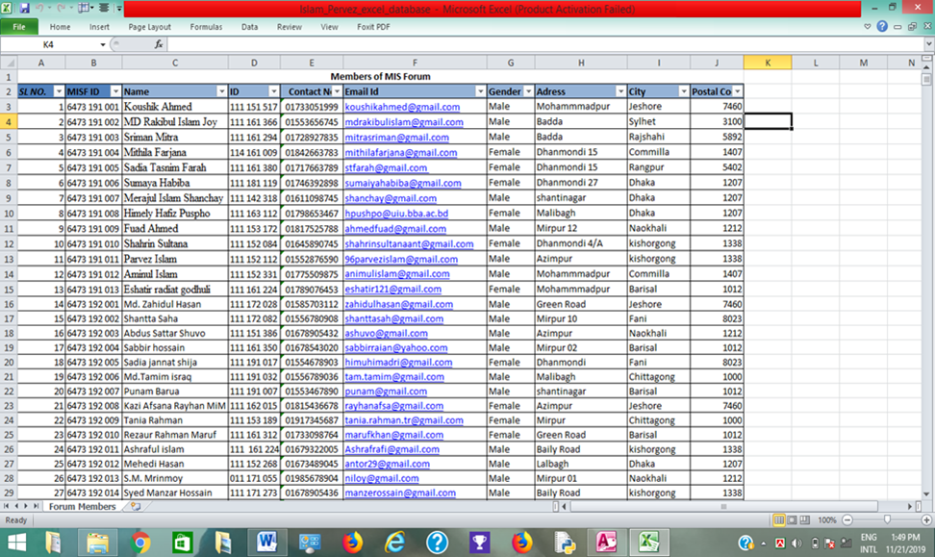

Step 1 –Making Flat File Database for MIS Forum
First, I open Microsoft office Excel 2012 then renamed the sheet name Forum members for my working purpose. Then I delete sheets 1 & 3 then I combined cells A1 to K1 and rename it as “Members form MIS forum”. Then form A2 to K2 I enter the headings which are Serial number, MISF ID, first name, Last name, ID, Contract number, Email Id, Gender, Address, City, Postal code, beginning in row three I input 200 student information those are involved in MIS forum. In the format table of student, I include the heading in row 2. Then I changed salary column to symbol for money so, that it shows the dollar sign and set the decimal point to 0 so, that it does not show. Then I select the cell A2 to K12. Then in format tab I select the define name button. Then define the working area ‘Member list’ then I press OK button. Then I saved the file as my islam_pervez_database.xlsx.

Step 2

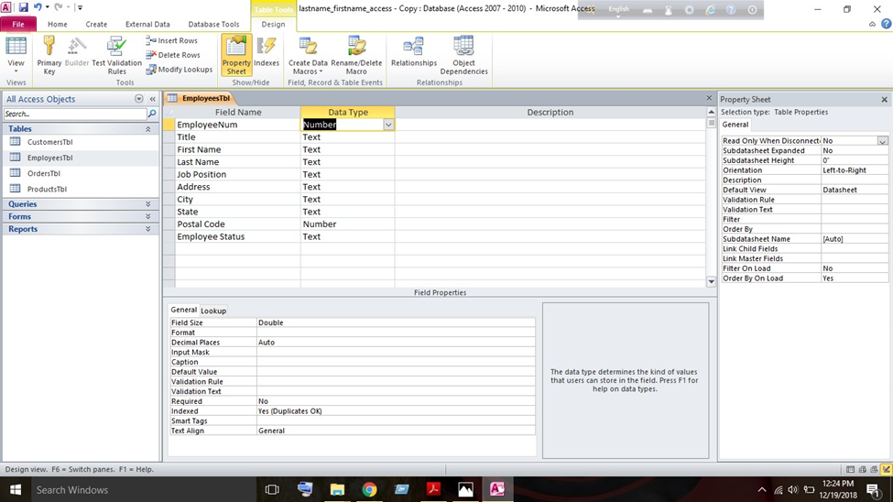

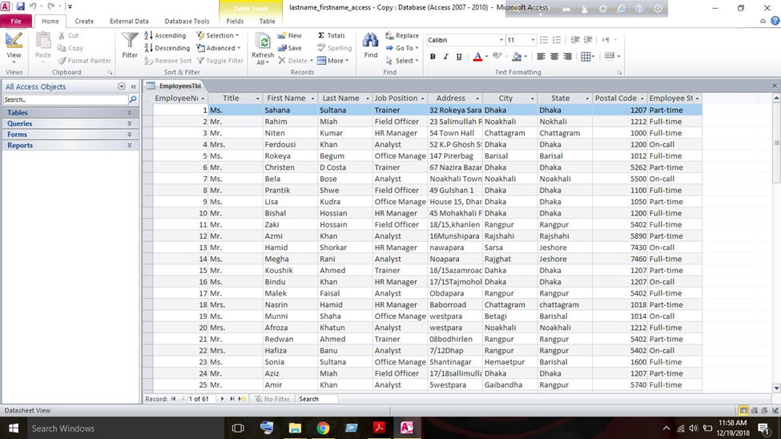

Step 2 – Importing data to Access
In part two I will import information in my database those I made in stage 1. Then open Microsoft Access 2012, then point out the blank database then I select right button and saved it as my lastname_firstname_access.accbd. To save my file I click on the browser tab to change the location. From the tap I click on the create button then click external data tab then tab on the excel button. The window of the external data I use the browser tab to locate my excel that I was made in stage 1. In the import source of data into new table I select the current database then press the ok button. To select “show Named Ranges” I click import spreadsheet wizard window then tab the range of “Member list’’ the click the forward button to go the wizard step. Then press the next button for choose the Row contains column heading. In the radio button I choose my own primary key. I select MemberNum using the pull-down button then press button. To import MemberTbl I filed text table import then press the finish button then close it. Press the home tab I open my Members table in the design view. In the design view option, I press the pull-down icon.
By right click I delete gender and salary field on the field row pressing the delete row option then press the Yes button Permanently remove the selected field. For added a new field table I type “Members status in the blank cell in the name column. In the lookup wizard option, I set the data type. After passing the next button I select I will pay in values that I want on the radio button. In the following option I selection in the first three cells: Full time, part time and on call then press the next button. After press finish button I choose the Limit to list checkbox. By pressing the pull-down option, I opened MemberTbl on datasheets view. Then I added Members status in the Member table to add status by pressing on pull down menu. When I finish the task by right clicking, I choose the name of MemberTbl then press the close option.

Step 3
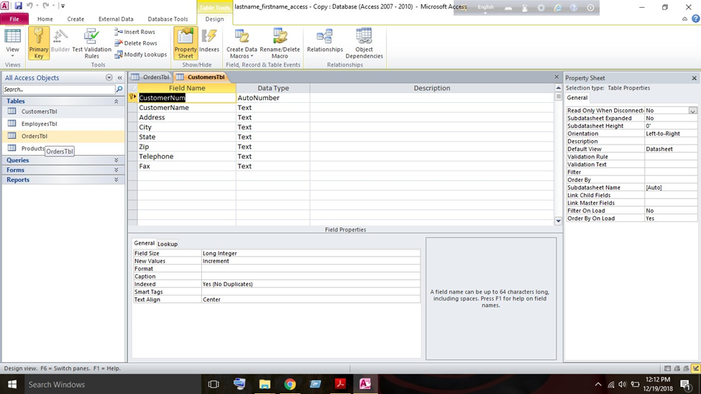

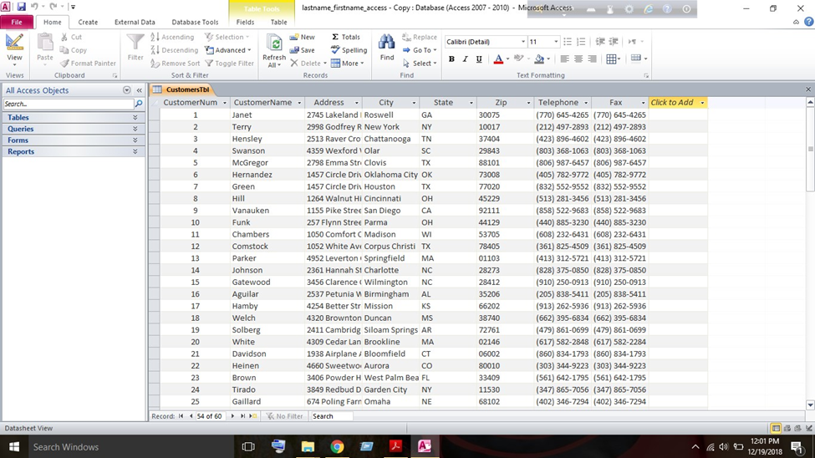

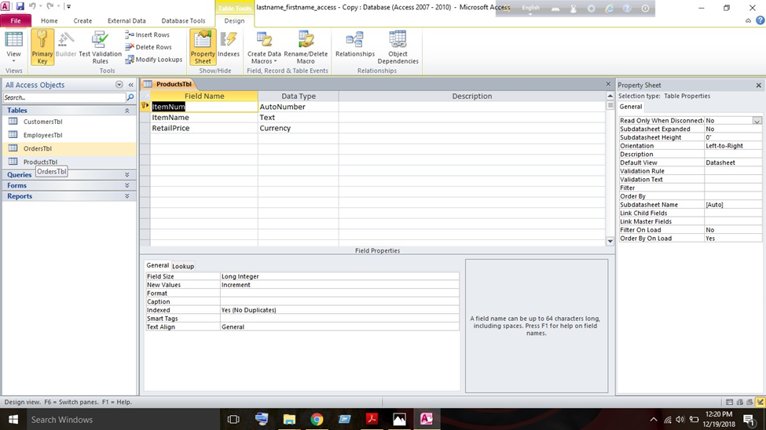

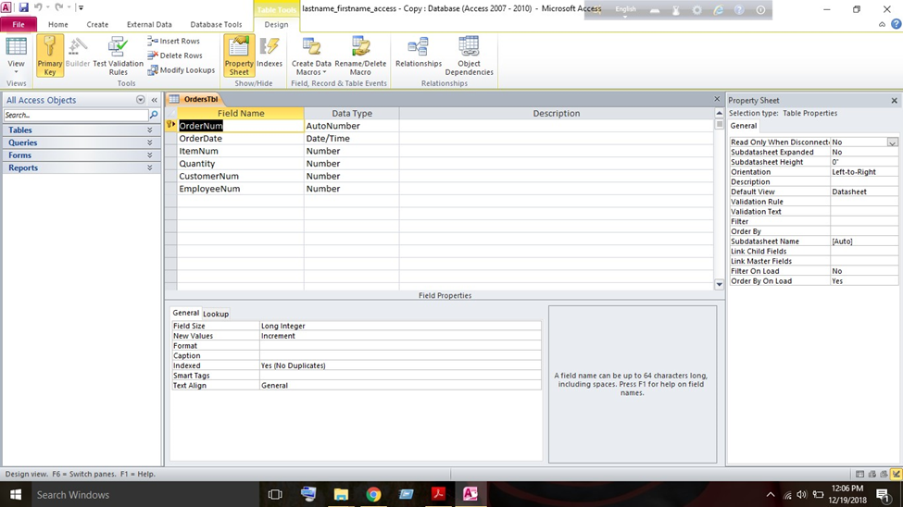

Step 3 – Making tables in Access
While working on this stage I faced the problem of the Excel file not corresponding with the Access file such that some of the columns columnar data was not bring supported. In this stage the purpose was to build five more tables- Forum ManagementTbl, MemberTbl, ProgramTbl, New MemberTbl, & FinanceTbl. Here I build a Forum managementTbl that will store the Forum relegated importation. In the design view option, I press the create tab. Design view option let me know to create a new table. In the design tab view, I am choosing the primary key icon then I set up my key field to selecting the MemberNum field. Then I save It and named it MemberTbls. I the contract field I set up the input musk. The pattern of input mask is as follows (01746-2898) for all data that I enter the field. In MemberTbl I press contract row in field properties I press the general tab. To obtain the desire pattern I want into the input mask row and selected the Builder icon to activate input mask wizard. In this window I choose the contract number option where I will set up desire pattern and then press Next to finish my action. The Email field has also a similar procedure using the input must.
Next, we add 20 student’s information into the table using the its datasheet view. When it is closed the new entries are automatically saved. Then I build a program Tbl for the program which are done by MIS forum and the fees & Budget. I used primary key in ProgramNum then I saved the table and named it programTbl. Then I switch the datasheet view and insert 12 more different program into the table. then I close the table. Then I build the Forum ManagementTbl and this table will store forum related information & I will create relationship with this on previous table.
To build a programTbl I follow the previous pattern and did same thing again. Then I set the programNum as the primary key. Then I set the programTbl an inport mask for programDate field and select the short date option. And then it saved it programTbl. Then I set up a lookeup values for the ProgramNum. Then I set up lookeup values for forum management field.
Then lookup values for the MemberNum field then I switch the datasheet view option and insert 20 more different program into the Tbl and finally saved and close the Tbl.

Step- 4
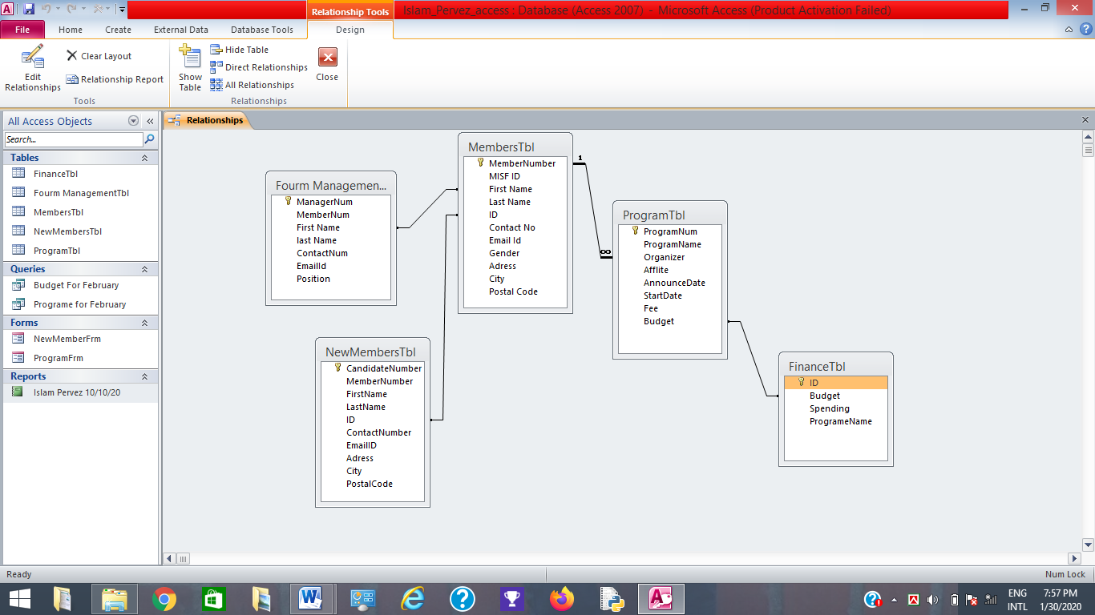

Step 4– Link the table Relationships
In this step I build relationship with five different tables. Using Enforce Referential Integrity I set us the relationship between the including tables. Between related tables MS access enforces to maintain consistency using the Referential integrity because it is a set of rules to update data in a database. To choose relationship option I press the Database tools to create relationship. In add option I press on Show table button and select all five tables in shown above I arranged the tables. In next stage I press hold and drag the MembersNum Field in the Forum ManagementTbl field in the ProgramTbl. In the create button I press Enforce Referential Integrity checkbox and checkmark edit relationships window. In this stage I press hold and drag the MemberNum field in the MembersTbl over the MemberNum field in ProgramTbl. In create button I press the edit relationship window then press the close button to save the relationship and its change. Then I am trying testing the relationship by adding Program for non-existent member.

Step 5

Step 5 – Build a Form for inputting information
In stage five I create an input for a new member & ne programs then I create another input for the Member table. In the form wizard option click on the press on the create tab. I used the pull-down menu to choose the table for the tables/queries option. In the MemberTbl I select all the fields from MemnerTbl by pressing the >> button then press on the next button. The columnar radio button I select the layout then press the next button. I enter MemberFrm of my title form. In design option I choose the Modify the form option then press the finish button. Under the design tab I press the property sheet button then select the MemberNum input field. I will be displayed on right hand side in the property sheet. In format tab I choose property sheet. I select transparent option for the black style property then I select broader option for the transparent option. Select yes option for the lock tab & select data tab. Then I select no option for the tab stop property then select another tab. Then I manage the format of the form and change the table and saved my form. From view option I select pull down menu then it will show the new form. Now I will create my second form call NewMemberFrm.
In this stage I press the create tab the press form wizard option. I choose the pull-down menu for table/queries option. Then I choose the three following fields: ProgramNum, PrigramDate, and ProgramFees the press the next button. I choose columnar radio button for the layout then I will press the next button. For the title of the form I insert NewMemberFrm then I press the modify the form option then press the finish option.
Then I set the following the property for the programNum and ProgramDate field object:
Then I select the following property for the ProgramFees field object:
Then I manage the four field groups which are currently on my form as shown the sample at the top of the page. I add a Combo box for the MemberNam and MemberNum. I press the combo box icon under the design tab. Then I object of my form I drag and outline the location and then comboo box wizadrw will be opendt hen press the next buttom.
In the last stage I will make sure the tab index proparty is set for 4 then I saved my form design. View my ProgramFrm in the form view then I will add 10 more different programs using the new blank record.
From the MemberName and amaemberNumber I set a combo box I select the combo box under the design tab option. For my form I drag the outline and the object and then the combo box will be open. Now I select the values for the combo box form another table or queries then I press the next button. Then in the query option I will select the table: MemberTbl then press next buttom. Then I will add > buttom for the following fields: MemberNum and MemberName then I press the next buttom. I will set the MemberName in ascending order then press the next buttom. Then I checkmark the hide button then press the next buttom. Then I will store the value for MemberNum then press the next buttom. Press the MemberName for the lavel then press the finish buttom. In property field I press the other tab ann then I set an index property to 0 for the MemberName and MemberNumber I add a combo box by using the combo box wozard.
a) For the Tbl I choose Table: MembersTbl.
b) Choose the followinig two filds: MemberNum and LastName
c) Soret by Last name in asceneding ordear.
d) Stoare the valuee in the fild MemberNum.
e) Labal the field MemberNum.
f) Seat the Index property to 3
For the item I added comboo box by using the combo box wizard.
a. For the label I select Table: ProgramTbl.
b. Selecting the followiing two filds: programNum and ProgramName.
c. Soret by Last Name in ascending order.
d. Stoare the value in the field ProgramNum.
e. Labal the fild ProgramName.
f. Seat the Index proparty to 2

For the fees field, I make sure the Tab index property is set to 6 then I saved my form design. View my program form in the Form view. Using the new blank record icon at the very bottom of the form to added 10 Programs.
Step 6

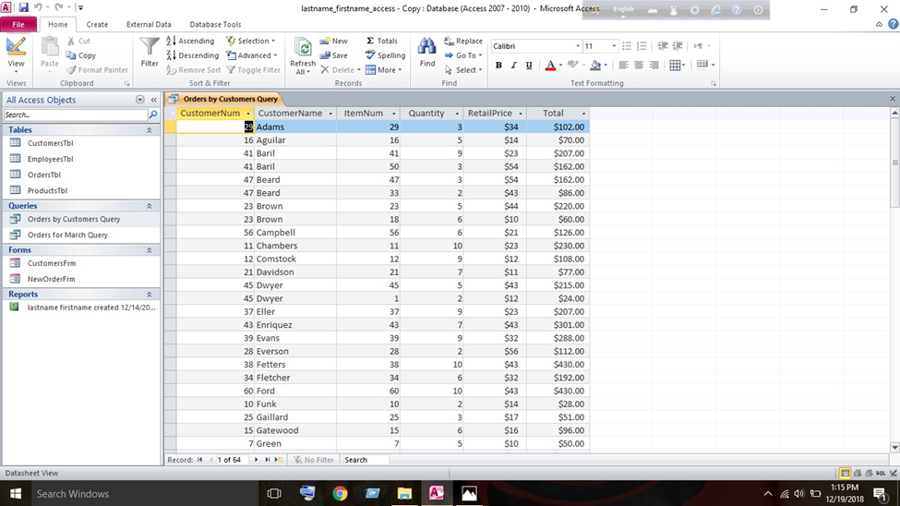

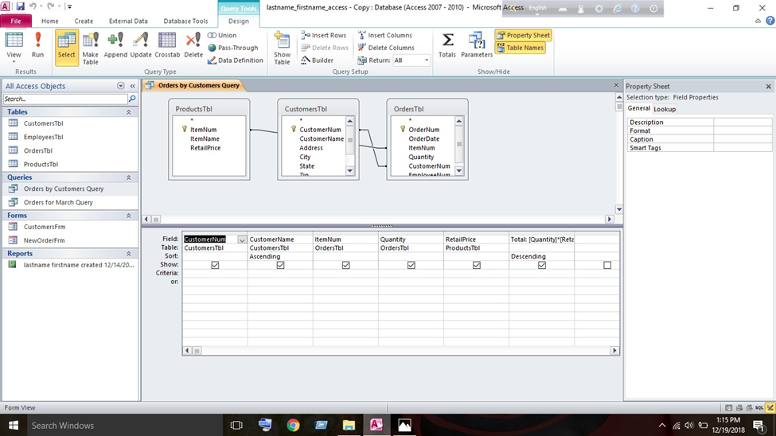

Step 6 – Develop Queries
In this stage I am going to create two queries for this purpose I create made two queries and both queries will extract data form the two tables and the information will be displayed in manner and both queries will include a formula.
First, I press on the create tab then I press the query tab I select sample query option the in the new query window the press ok button. I choose the table in the table/ query option now programTbl will be appear here then I choose two of following fields: ProgramDate & ProgramFees. Then I select ProgramTbl in the table/query option and then I choose two fields which are ProgramNam & ProgramFees and then I press next button. Then I choose the detail tab and press ok button. For the title of the form I insert NewMemberFrm then I press the modify the form option then press the finish option. Then I choose Budget collumn and draag it berwern ProgramName & ProgramFees column. With the ProgramDate collumn I set a formula by typing #4/20/20 & #5/20/20 in the row of criteria.
Now I will shift to datasheets view for the query result. Then I will creade second querty to a list program by the member. Then the simple query wizard I made programNum by member query. Then I sort information by date select ascerding form the poll down within the ProgramDte column then I will add collamn of informartuon for the total. On the fielg row in the back collun then I insert following total then I will switch the datasheets view query results then I will ceate my create second query to program by member using the simple queries results then I create name program by member queries.

Step 7
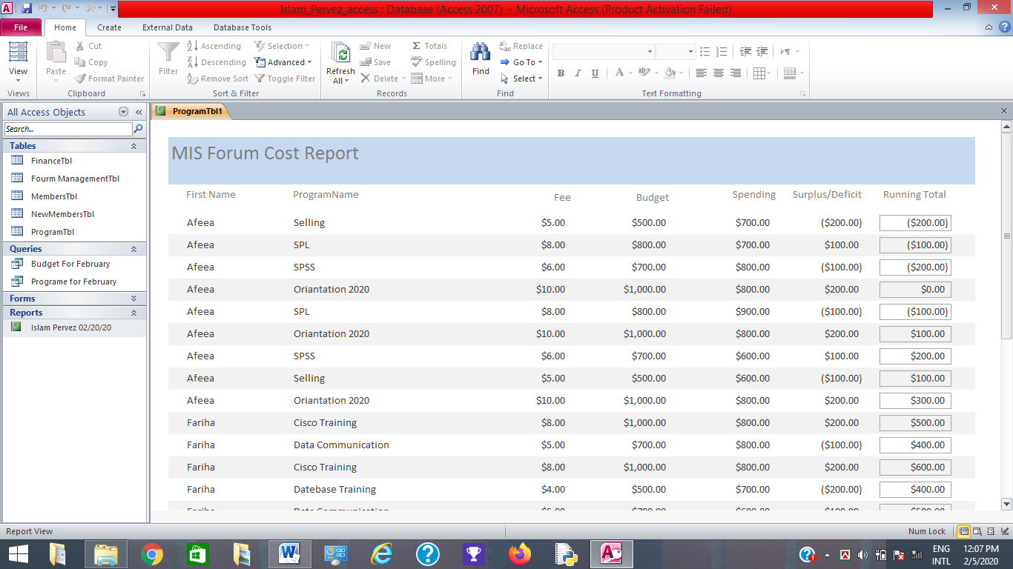

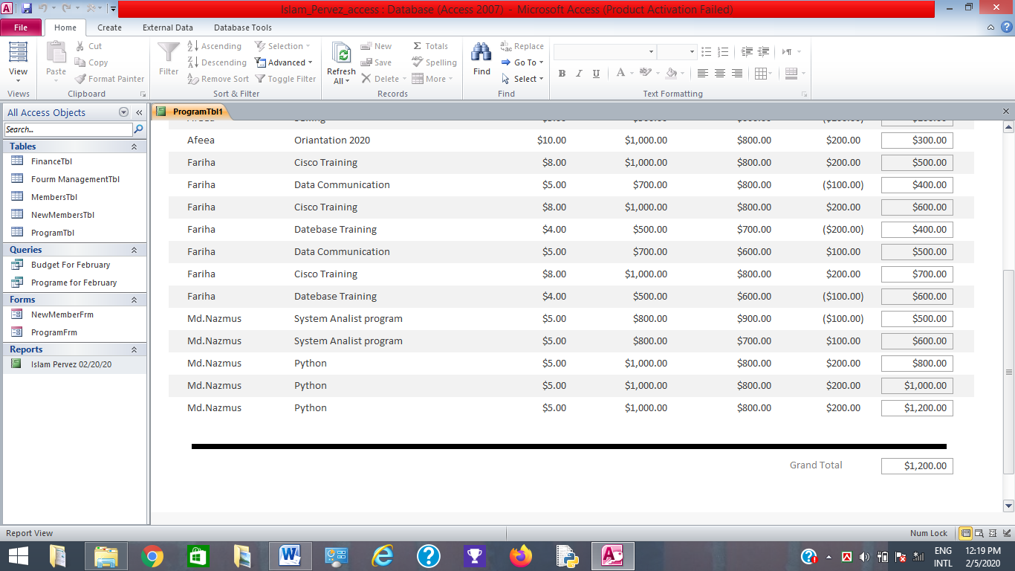

Step 7 – Form a Report
In this stage I am going to report that will collect information form the five tables. To calculate the running total and grand total I used a formula. The report named is islampervez 28/02/20. First, I press on the create buttom and then press report wizard. From the five tables I will take queries fields. I choose ProgramTbl for the viewing the data. In the ascerding order I will choose MemberName then select Tabular in the layout icon. In the orientation purpose I will choose landscape and the title I insert islampervez 28/02/20 Before pressing the finish buttom I modify the report design. Using the label tools, I add the total field then press design icon in the controls section and then select lavel icon (Aa).
In the report header I will darw the report object within the page. Here I adjust size and location through lavel box tools and then draw the field option in the controls option. Then I will choose the unbound control section and the property sheets I will set the control source [Fees]* [Budget] and then I choose the format tab and I choose the currency and then adjust size and location for the new field. Using the adding level, I choose the report header section and add running total. In this stage I will repart part 3 & 4 for the make total level and total field. In the report header section, I changed the name which is MIS forum cost report and then I shift the report view option and verify the report resemble and then it will calculate all values that I used in the report and then finally I saved & close the report.

Chapter III: Research Findings
In research findings we found MIS forum cost report base on selective data. Here we are basically shown the cast of MIS Forum report.

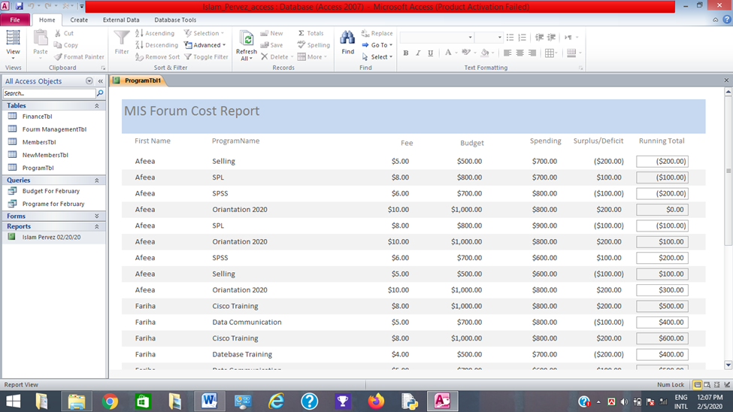

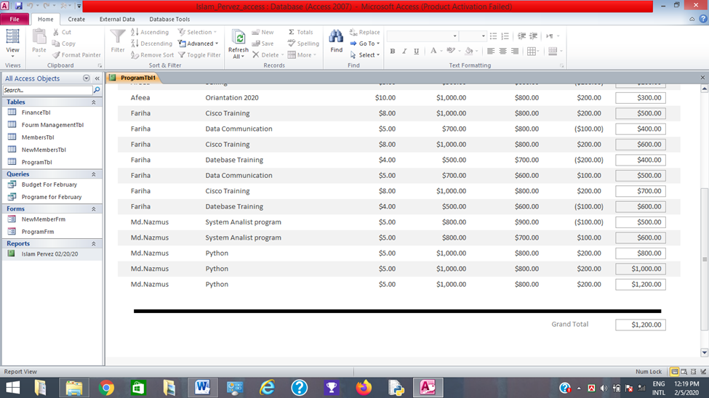

Chapter IV: Discussion

4.1 Conclusions
In doing this project paper were motivated to create a database system which can be used by organization in an inexpensive manner. We found out that it is easy to create a database using a Microsoft Excel and Microsoft access. In every organization have and their own database for that reason I made it for my MIS forum members.

4.2 Suggestions for Future Research
In future research it will good to use more advance features of Excel and Access to create a database to solve more complex calculation, to make it efficient, to make it more useful, to make it more understandable. Also, further software’s should be experimented with such as EAMbrace Asset Management, SmartDevice BI/MIS System, E2shop system and manufacture system, Areana PLM, Sistrade.

4.3 Recommendations
  - Provide training on Microsoft Excel and Access to organization members
  - Should update their information regularly
  - Build good communication to the organization members
  - Data should be update in logical manner

References
Anto, F. (n.d.). REPORT ON FILE SYSTEM AND DATABASE MANAGEMENT SYSTEM. Retrieved from academia.edu: https://www.academia.edu/7423594/REPORT ON FILE_SYSTEM_ AND_DATABASE_MANAGEMENT_SYSTEM
foley, B. (2018). how to write an effective excecutive summary. Retrieved from surveygizmo: https://www.google.com/amp/s/www.surveygizmo.com/resources/blog/how-to-write-executive-summary/amp/
Harkins, S. (2015, June 08). Make summarizing and reporting easy with Excel PivotTables. Retrieved from techrepublic.com: https://www.google.com/amp/s/www.techrepublic.com/google-amp-reporting-easy-with-excel-pivottables/
IBM. (n.d.). what is database management? Retrieved from IBM: http://www.ibm.com/analytics/database-management?
Kabir, A. I. (2018, 12 19). Database Management(MIS 4182). Retrieved from Weebly.com: https://ahmedimrankabir.weebly.com/database-mangement-mis-4182.html
Microsoft. (2019). Create a form in Access. Retrieved from support.office.com: https://support.office.com/en-us/artical/create-a-form-in-access-5d550a3d-92e1-4f38-9772-7e7e21e80c6b
Microsoft. (2019). Create,edit or delete a relationship. Retrieved from support.office.com: http://support.office.com/en-us/article/create-edit-or-delete-a-relationship-dfa453a7-Ob64-4c34-a128-fdebc7e686af
My Reading Room. (n.d.). What is DBMS? Advantages and Disadvantages of Database Management System(DBMS). Retrieved from myreadinggroom.co.in: http://www.myreadingroom.co.in/notes-and-studymaterial/65-dbms.html
Research Methods: Writing: Conclusion. (n.d.). Retrieved from linguistics.byu.edu: http://lingustics.byu.edu/faculty/henrichsenl/ResearchMethods/RM_3_06.html

