Internship Report
on
Corporate Social Responsibility Activities of DBBL

Supervised by
Mofijul Hoq Masum
Assistant Professor
School of Business & Economics (SoBE)
United International University

Submitted by
Nusrat Amin Anonna
ID: 114 151 030

Department: BBA in Accounting and Information System

CERTIFICATE
It is certified that Nusrat Amin Anonna, ID: 114 151 030 has completed the internship report titled “Corporate Social Responsibility Activities of DBBL” under my supervision. I have fully monitored his effort in the process of completing this report required for attaining his BBA Degree from the Department of BBA in Accounting & Information System of United International University.
I, hereby, acknowledge his work & wish him all the success.

Thanking you.

…………………………………...
Mofijul Hoq Masum
Assistant Professor
School of Business & Economics (SoBE)
United International University

LETTER OF ACKNOWLEDGEMENT
At the very outset, I am very much obliged to my Almighty Allah for giving me soundness to finish this report completely. Except His profound favor, it would have been so massive for me to finish both internship periods along with internship report in due course correctly.
I am highly obligated to my respectable supervisor Mofijul Hoq Masum, Assistant Professor, Department of business and economics aspects, United International University, for his direction and consistent supervision just as for giving me all the fundamental data with respect to my internship report and furthermore his help and support to finish this precisely.
I am also grateful to all the executives and officers of Dutch Bangla Bank Limited, Mirpur Branch from whom I gathered practical knowledge that how to work in an organization and collected data affiliated to my Internship report. I would like to express my huge gratitude to Md. Shahidul Islam, Manager, Dutch Bangla Bank Limited, Mirpur branch for providing me the necessary information for this report during my internship period. I will always be very much thankful to Mr. Fayezul Azam, Deputy Manager and all the officers of that branch for giving me such attention and time and teaching me all the corporate manners as well as the implementation of educational knowledge in corporate life.
Obviously, I shall never forget the help I took from books and journals of famous authors, online sources, newspaper articles, previous term paper etc.
And of course, there will always be huge gratitude and gratefulness to my beloved parents and I am very much thankful to all the friends and well wishers for their inspiration that leads me to go ahead.
Concededly, I thank United International University for providing me right set of circumstances to gather knowledge as well as to work and gain experience in the professional field.

LETTER OF TRANSMITTAL
Oct 14, 2019
Mofijul Hoq Masum
Assistant Professor
School of Business and Economics
United International University
Subject: Submission of the Internship Report

Honorable Sir,
With greater appreciation, I might want to introduce my Internship paper on the Topic, "Corporate Social Responsibility Practices in Dutch Bangla Bank Limited" as that has been set up as an essential piece of my degree necessity. I have attempted my best to follow your guidelines and instructions as well as those given by my Bank supervisor while preparing this report. My report has been concluded based on my experience that I have gathered while doing my Internship at Dutch Bangla Bank, Mirpur Branch. I hope my contribution on this report will meet at least nearly of your level of expectation.
My greater acknowledgement is for you to dedicate your valuable time, assistance and expert guidance on me. I gave my best effort to complete this report entirely as much as possible. I would be grateful to receive any of your suggestions or comments regarding this. I take pride to answer any sort of inquiries you may have concerning this report.

Sincerely Yours,
Nusrat Amin Anonna
ID: 114 151 030
Major: Accounting and Information System
United International University

DECLARATION OF STUDENT
I am Nusrat Amin Anonna, a student of BBA in AIS Department bearing the ID Number: 114151030 from United International University hereby announcing that the report of my internship titled “Corporate Social Responsibilities of Dutch Bangla Bank Ltd” has been prepared during the period of my internship program at Dutch Bangla Bank Limited. I additionally declare that the report of the internship is completely arranged for a scholastic reason and has not been utilized for different purposes or not put together by me earlier on anyplace. In the event that there is any doubt or mix-up, I will be completely responsible for that. On the off chance that there is any bother happened accidentally, I earnestly complaint for that and I will consistently be accessible for any explanation required.

………………………
Nusrat Amin Anonna
ID: 114 151 030

TABLE OF CONTENTS
1 CHAPTER- 1: INTRODUCTION 9
1.1 Corporate Social Responsibility: 9
1.2 Brief thought about DBBL: 9
1.3 Rationale of the study 10
1.3.1 Corporate social responsibility 10
1.3.2 Impact on Profitability from Corporate social responsibility 11
1.4 Objectives of the Study 11
1.5 Scope 12
1.6 Limitation 13
2 CHAPTER- 2: METHODOLOGY OF THE STUDY 14
2.1 Data design 14
2.2 Sample design 14
2.3 Analytical tools 15
3 CHAPTER- 3: ORGANIZATIONAL BACKGROUND AND INDUSTRY PERSPECTIVE 16
3.1 Banking Industry 16
3.1.1 Background of banking industry 16
3.1.2 Contribution in economy 17
3.1.3 Scopes 18
3.2 Historical Background of the organization 18
3.2.1 Vision 19
3.2.2 Mission 19
3.3 Operational activities of the Organization 20
3.4 Corporate social responsibility analysis 30
3.5 Critical Observation: 31
3.6 SWOT Analysis 31
3.6.1 Strengths of DBBL: 31
3.6.2 Weakness of DBBL.: 32
3.6.3 Opportunity of DBBL.: 32
3.6.4 Threats of DBBL.: 33
4 CHAPTER- 4: FINDINGS OF THE STUDY 34
4.1 Overall findings on CSR practices of DBBL 34
4.1.1 Contribution to Education Sector in 2018: 35
4.1.2 Contribution to Health Sector in 2018: 38
4.1.3 Contribution to Disaster Management: 41
4.1.4 Contribution to Social Development: 42
4.1.5 Contribution to create social Awareness: 42
4.2 Correlation Analysis 43
5 CHAPTER- 5: EXPERIENCES DURING INTERNSHIP TENURE 46
6 CHAPTER- 6: CONCLUSION AND RECOMMENDATION 48
6.1 Conclusion 48
6.2 Recommendation 48
1 CHAPTER-7: APPENDIX A

EXECUTIVE SUMMERY
This report is mainly based on my academic theory and analysis of Dutch Bangla Bank Limited. This is my internship report. It was a great opportunity to experience and gather knowledge about different types CSR activities of banking sector and how the corporation operates their social welfare for support the poor people. My course instructor helped a lot on this report.
The main concept of Corporate Social Responsibility (CSR) is to fulfill the responsibility towards the country and the people of the country who are not well maintained. The financial segment of Bangladesh has been effectively taking a shot at different social exercises. In this report the general CSR exercises of DBBL has been talked about. It is to be discovered that there are diverse segment they really served their social commitment to. The principle part of their CSR exercises are education segment, health segment, social development segment, city beautification segment, sports segment and so forth. Their commitment in this area is fundamentally high substantially more than other bank and budgetary establishments. At the end, DBBL has the reputation for their great CSR activities. To sustain in the banking industry DBBL needs to compete with other bank. For this it should focus on the innovation and development by competing itself so that it can uplift its own standard from the previous standard.

Key words: CSR, DBBL, CSR in Education, CSR in Health and Welfare, Regression Analysis, CSR impact on profitability etc.

CHAPTER- 1: INTRODUCTION
The purpose for this report is to get thought regarding the corporate social duties of Dutch Bangla Bank Limited. It is showed in following parts like Introduction of the CSR and how it works, brief idea about DBBL, objective of the study, rational of the study, scope and limitations.

Corporate Social Responsibility:
Corporate social responsibility is a self regulatory business model that helps a company to be socially responsible. By rehearsing CSR, likewise called corporate citizenship, organizations can be venture a genuine sort of effect, which they are having on all parts of society including monetary, social, and ecological. To take part in CSR implies, in the typical course of business, an organization is working in manner that upgrades society and the earth, rather than contributing adversely to them.
Katie Schmidt, the originator and lead fashioner of Passion Lilie, said CSR can emphatically affect your business by improving your organization picture, fabricating your image and inspiring you as an entrepreneur. "What the public thinks of your company is critical to its success," Schmidt revealed to Business News Daily.

Brief thought about DBBL:
Dutch-Bangla Bank Limited (DBBL) is a planned joint venturous business bank between local Bangladeshi gatherings by M Sahabuddin Ahmed (Founder and Chairman) and a Dutch organization FMO. DBBL was set up under the Bank Companies Act 1991 and consolidated as an open constrained organization under the Companies Act 1994 in Bangladesh with the essential target to continue a wide range of banking business in Bangladesh. DBBL started formal activity from June 3, 1996. The Bank is recorded with the Dhaka Stock Exchange Limited and Chittagong Stock Exchange Limited. The bank is regularly conversationally alluded to as "DBBL", "Dutch Bangla" and "Dutch Bangla Bank". (DBB.Limited )
They offer many things,
• ATM organize
• Internet installment
• Social work

Rationale of the study
There are numerous things which show that corporate social duty is significant. They are depicting underneath,

Corporate social responsibility
CSR is an advancing business practice that fuses economical improvement into an organization's plan of action. It positively affects social, financial and environmental concerns. By practicing CSR, also called corporate citizenship, companies can be project a serious kind of impact.
Its importance’s are
- Corporate performance.
- Avoid conflicts.
- Enhance investors.
- Enhance valuation of the company.
- Reduce risk.
CSR in Bangladesh:
A top to bottom investigation of CSR in Bangladesh can presents a 10,000 foot perspective on how CSR connection are in effect very much considered inside organizations with other specific elements, redid counseling firms, NGOs, examine associations or the administrative power. The possibilities of organization arranging were additionally found among firms in Bangladesh. Enquiries on common affiliation, outlook from vital organization, partner commitment were raised and from different portions 14 organizations were straightforwardly pushed toward. The August 2007 issue of The Executive Times gave dependable optional data on CSR exercises performed by certain organizations (16) that was distributed on corporate viewpoint of corporate heads or concerned departmental heads.
Some business firms partner CSR with corporate liberality pointed towards the essential and optional data. What's more, it was the basic modification in perspective between the neighborhood specialists at corporate sites and fanciful story of abroad worldwide organizations. As on the grounds that corporate gifts had ended up being a piece of key guide of the association, generally in the perspective of Bangladesh, the thought of CSR was not surrounded with regards to given cash.
In view of an unequivocal thought process and its dealings with the marking, CSR was executed by specific organizations in Bangladesh. Moreover, the administration of these association expected to think about them as responsible corporate natives on the side of their inclusion to the security of society.

Impact on Profitability from Corporate social responsibility
Profitability is the amount of money which is the company can get after deducting their all expenses from their total revenue. In the long run, profitability is essential for a company’s survival.
Importances of profitability’s are,
- Reward for their shareholders.
- Compensations for owners and employees.
- Impact on stock price.
- Measure of the growth of the company.

Objectives of the Study
Broad Objective & Specific Objective
Board Objective: For the purpose of the study, this report objective has been noted down the broad objective.
- To identify the trend of CSR in DBBL.
- To identify the effects and impact of CSR on profitability of DBBL.

Specific Objective: For the purpose of the study, this report objective has been noted down the specific objectives.
- To identify the CSR practices on educational sector of DBBL.
- To identify their CSR activities on health sector.
- To identify their CSR activities in Disaster Management.
- To identify their CSR practices on Infrastructure development and other social awareness segment of DBBL.

Scope
The report plots CSR exercises of Dutch Bangla Bank Limited and its activity. The data comprises of the perception and investigation gained all through the course addresses. It has been set up as indicated by their hierarchical CSR exercises and activities. It will help to get a perfect vision of the corporate social responsibility which DBBL follows. This study will add some value with the present knowledge of their work and the corporate social responsibility they follow.

Limitation
The limitations are:
- Gathering data was tough.
- Unable to find all the necessities. As all the information if the company is not properly available.
- Company CSR information is not properly available in annual report.
- Not having access to some required information due to confidentiality of the bank.
- Limited time of experience.
- Frequent allocation to a different division (such as: customer service and account opening) for most of the period as duration of my internship is only three month.
- Lack of technical expertise and insufficient data.

CHAPTER- 2: METHODOLOGY OF THE STUDY
Research is an orderly strategy for discovering answers for issues. It is basically an examination, a chronicle and an investigation of proof to pick up information. Research includes characterizing and rethinking issue, figuring speculation or recommended arrangements, gathering, sorting out and assessing information, arriving at resolutions, testing resolutions to decide if they fit the detailed theory. The investigation utilizes two kinds of strategies in the event of information accumulations, one is subjective strategy and another is quantitative technique.
Sources of Data: In request to make the investigation progressively significant and respectable, two wellsprings of information and data had been utilized. The wellsprings of information are:
Primary Sources: I have gathered essential information by doing a basic study where I gave a poll to the GB in control and the officials which I made by the assistance of Google Docs. I likewise had an eye to eye discussion with the representative chief and the director of this branch.
Secondary Sources: To gather the optional information I have experienced:
- DBBL’s Annual Report- 2018
- DBBL’s Personal website
- All CSR related articles published by DBBL
- Some periodical publications of DBBL
- Brochures of DBBL
- Different written documents and different journal and researches paper of CSR activities of DBBL
- And lastly, I used Microsoft Excel to specify analytical data to prepare the graphs and represent them clearly.

Data design
The secondary data collection process is used in this report. Here the main data collection source is DBBL website and other websites.

Sample design
The sample company in this report is Dutch Bangla Bank Limited which is from the Dhaka Stock Exchange listed company. I have gathered all the CSR related information and data of DBBL of the efficient years from 2014-2018 to set up this report with respect to CSR practices of Dutch-Bangla Bank Limited.

Analytical tools
The analytical tools I used in this report are:
- MS Word
- MS Excel
- Pie Chart
- Bar Chart
- Gantt Chart
- Classified information table etc.

CHAPTER- 3: ORGANIZATIONAL BACKGROUND AND INDUSTRY PERSPECTIVE

Banking Industry

Background of banking industry
Bank is a financial institution which accepts deposits from the public and creates credit. For their significance in the financial stability of a country, banks are highly regulated in most countries. Loaning exercises can be performed directly or indirectly. To different guidelines proposed to guarantee liquidity, banks are commonly dependent upon least capital prerequisites dependent on the global capital norms, the Basel Accords. Most countries have regulated a framework known as partial hold banking. Throughout the entire existence of banking, various financial traditions – remarkably, the Medicis, the Fuggers, the Welsers, the Berenbergs, and the Rothschilds – have assumed a focal job over numerous hundreds of years. The most established existing retail bank is Banca Monte dei Paschi di Siena, while the most established existing dealer bank is Berenberg Bank.
History:
The concept of banking may have begun in ancient Babylonia, but ancient Greece and ancient Rome with merchants offering loans of grain as collateral. Archaic exploration from this period in old China and India likewise shows proof of cash loaning. Truly they got cash on store on premium, and thusly loaned it a higher premium like in Mesopotamia and with the Etruscan.
Progressively current banking can be followed to medieval and early Renaissance Italy, to the rich urban areas in the inside and north like Florence, Lucca, Siena, Venice and Genoa. One of the most well known Italian banks was the Medici Bank, which is set up by Giovanni di Bicci de' Medici in 1397. The soonest realized state store bank, Banco di San Giorgio (Bank of St. George), was established in 1407 at Genoa, Italy. Present day banking works on, including partial hold banking and the issue of banknotes, developed in the seventeenth and eighteenth hundreds of years. Traders began to store their gold with the goldsmiths of London. Trade for each store of valuable metal, the goldsmiths gave receipts confirming the amount and immaculateness of the metal they held as a bailee; these receipts couldn't be relegated; just the first contributor could gather the put away products.
Gradually the goldsmiths began to lend the money out on behalf of the depositor, which led to the development of modern banking practices; promissory notes were issued for money deposited as a loan to the goldsmith. The goldsmith paid interest on these deposits. Since the promissory notes were payable on interest, and the advances (credits) to the goldsmith's clients were repayable over a more drawn out timeframe, this was an early type of partial hold banking. The promissory notes formed into an assignable instrument which could flow as a sheltered and advantageous type of cash supported by the goldsmith's guarantee to pay, enabling goldsmiths to propel credits with little danger of default. In this way, the goldsmiths of London turned into the trailblazers of banking by making new cash dependent using a loan.
The Bank of England was the first to start the perpetual issue of banknotes, in 1695. The Royal Bank of Scotland built up the principal overdraft office in 1728. The Rothschilds spearheaded global money on an enormous scale, financing the acquisition of the Suez trench for the British government. By the start of the nineteenth century a brokers' clearing house was built up in London to enable various banks to clear exchanges.

Contribution in economy
The economic functions of banks include:
- Issue of money- Issue of money in the form of banknotes and current accounts subject to cheque or payment at the customer's order. These cases on banks can go about as cash since they are debatable or repayable on interest, and henceforth esteemed at standard which are viably transferable by simple conveyance, on account of banknotes, or by drawing a watch that the payee may bank or money.
- Netting and settlement of payments – Banks go about as both gathering and paying operators for clients, taking an interest in interbank clearing and settlement frameworks to gather, present, be given, and pay installment instruments. This empowers banks to streamline on stores held for settlement of installments, since internal and outward installments balance one another.
- Credit intermediation – Banks borrow and lend back-to-back from their own account as a medium.
- Credit quality improvement – Banks lend money to ordinary commercial and personal borrowers, but are high quality borrowers. The improvement originates from expansion of the bank's advantages and capital which gives a cradle to assimilate misfortunes without defaulting on its commitments.
- Asset liability mismatch/Maturity transformation – Banks get more on interest obligation and momentary obligation, yet give all the more long haul advances. With a more grounded credit quality than most different borrowers, banks can do this by collecting issues and recoveries , keeping up stores of money, putting resources into attractive protections that can be promptly changed over to money if necessary, and raising substitution subsidizing as required from different sources.
- Money creation/destruction – At whatever point a bank gives out a credit in a fragmentary hold banking framework, another entirety of cash is made and on the other hand, at whatever point the head on that advance is reimbursed cash is crushed.

Scopes
The brand name "Your trusted partner" related with DBBL's everyday tasks. Dutch Bangla Bank Limited has set up this way of thinking in their dealings with their clients and offers them items and administrations that guarantees them to the embodiments of relationship of association dependent on trust and certainty and maintaining and keeping up commonality of premium. Deserting its rivals, DBBL has had the option to gain relentless ground regarding business development, winning the certainty of its clients or more all making a long term image of the bank in all the circle regions of business banking activities, including the general public. The bank is engaged with all of exchange money, term fund, working capital financing and as of late included lease and real estate financing in its activity. It is likewise taking an interest in the syndicate financing to an enormous venture.

Historical Background of the organization
DBBL as a dependable corporate body is completely mindful of its obligation about how its operational exercises sway its partners, the economy, the general public, its staff and nature. DBBL since its initiation in 1996 had embraced the arrangement of adding to the social reason. It has been proceeding with its exertion during the most recent 18 years as a pioneer in the financial area and has turned into the pioneer much in front of different banks. To that end in view the Bank set up Dutch-Bangla Bank Foundation which has been rendering administrations to different fields tirelessly where it is important covering the zones of instruction, social insurance, and common catastrophes just as man-made fiasco. Considering the quantity of such understudies is gigantic the Bank has intended to expand the grant number to an inconceivable degree of 30,000 including a measure of Taka 1.02 billion every year from the year 2016.
Dutch-Bangla Bank began activity is Bangladesh's first joint endeavor bank. The bank was an exertion by local investors led by M Sahabuddin Ahmed (originator director) and the Dutch organization FMO. The reason of being that the assembling division sends out Bangladeshi items around the world. Consequently financing and focusing on this segment enables Bangladesh to accomplish the ideal development. DBBL's different center is Corporate Social Responsibility (CSR). Despite the fact that CSR is currently a banality, DBBL is the pioneer in this area and named the commitment basically as 'social duty. DBBL additionally works the country's biggest ATM armada and in the process radically cut buyer expenses and charges by 80%. In addition, DBBL picking the low productivity course for this segment has astonished numerous pundits. DBBL had sought after the mass mechanization in Banking as a CSR movement and never expected productivity from this division. Dutch-Bangla Bank stock set the precedent at the highest share cost in the Dhaka Stock Exchange in 2008.After flimsiness and incessant administration changes in its underlying years, DBBL defeated these deterrents to set up fast development since the year 2000. In March 2008, DBBL offer costs came to Tk. 14325.80 in the Dhaka Stock Exchange, establishing the precedent at the most elevated stock cost throughout the entire existence of Bangladesh. It is additionally one of only a handful couple of banks that doesn't partake in dealer/venture banking (which can prompt sporadic growth).Dutch Bangla Bank is noted to be the sole nearby bank in Bangladesh to have a robotized banking framework. This fast increment in DBBL's ATM system has driven most of different banks to consent to sharing arrangements as opposed to seeking after their own ATM organize. In the 2007 DBBL became the first bank in Bangladesh to offer SMS Banking services. In 2010 most imparting understandings to outside banks have been suddenly ruined due Visa card's new arrangements authorized upon DBBL. In light of Visa's choice to end its ATM offices with DBBL, Union compensation drew nearer DBBL to change over the whole retail system to acknowledge Union compensation cards.

Vision
Dutch-Bangla Bank dreams of better Bangladesh, where arts and letters, sports and athletics, music and entertainment and above all a society based on morality and ethics make all our lives worth living. DBBL’s essence and ethos rest on a cosmos of creativity and the marvel-magic of a charmed life that abounds with spirit of life and adventures that contributes towards human development.

Mission
Dutch-Bangla Bank engineers enterprise and creativity in business and industry with a commitment to social responsibility. “Profits alone” do not hold a central focus in the Bank’s operation; because “man does not live by bread and butter alone”.

Operational activities of the Organization
During my internship period I was place in nearby office of Dutch-Bangla bank ltd. General banking of this branch comprises of various segments, in particular Account opening area, check book issue, dispatch segment, settlement segment, clearing and bills segment, money segment.
General area is considered as the immediate client assistance focus. It is the starting phase of all the money related action. It opens new records, takes stores, transmits reserves, issues bank draft, respect checks and pay order and so on. General banking is otherwise called retail banking. These are the huge section in General banking:
- Account opening segment
- Clearing segment
- Remittance segment
- FDR segment
- Cash section
Account Opening Section
As indicated by the law and practice the financier – client connection emerges just from agreement between the two. What's more, opening of record is the agreement that builds up the connection between an investor and a client. So this area assumes a significant job in pulling in client and accordingly ought to be taken care of with additional consideration.
As indicated by the global set of accepted rules banks ought to keep up following advances with respect to their clients:
• Banks will act decently and sensibly in the entirety of their dealings with their clients.
• Banks will enable clients to see how their records work look to give them a decent comprehension of banking administrations.
• Banks ought to keep up trust in the security and uprightness of banking and installment frameworks.
Individual or firm expected to open record in the branch applies for opening record in a recommended structure. The structure is appropriately filled in by the candidate himself. The candidate is likewise required to fill the example mark sheet. Candidate must submit required archives with application structure. Various types of record are required for various types of record. For individual just presentation by another record holder of the bank is adequate. Be that as it may, for firm and others, important reports must be submitted. At that point the approved official investigates the presentation and inspects the records submitted. In the case of everything seems good, at that point he opens account.
Types of Account
These are the types of account opened by the Dutch-Bangla Bank in general:
- Current Deposits Account
- Savings Deposits Account
- Short Term Deposit
- Fixed Deposit
- Bearer Certificate Deposit
- Monthly Term Deposit
Savings Deposits Account
In according to DBBL's recent annual report, Dutch-Bangla bank ltd. is offering interest on every day’s balance in savings account @ 8.50% P.A.
Requirements for opening a Savings Deposits Account:
- Introducer
- Signature card
- Photographs
To open a sparing record client should top off an application from provided by the bank. The structure contains following points of interest:
- Name of the applicant
- Name of father/husband of the applicant
- Profession of the applicant
- Two Photographs
- Present address
- Permanent Address
- An Introducer who has an account of DBBL.
- Verification by the concerned officer of the branch.
- Signature of the applicant.
After subsequent filling the structure candidate should sign thrice on the example mark card. Most significant thing is that these marks must match with the mark on application structure. These archives are then checked by the concerned official and sent to the administrator of the branch. Director rechecks all the data and converse with the candidate to find out about him/her. When he is completely fulfilled he put his mark on the structure and confirms the mark. In the event that any unique guidelines are required administrator record it toward the finish of the example mark card.
The structure and the example mark card at that point sent to the official who put a record number on the structure and on the card. After fulfillment of the previously mentioned conventions another record is opened with the bank for the new client. Record can be open in joint name by at least two gatherings however who will work the record it ought to be referenced in the application. To acquire a check book the new record holder must store at any rate Tk. 3000/= in the record. This sum may fluctuate contingent upon nature of the relationship of the individual with the bank.
Short Term Deposit Accounts (STD)
Short term deposit or STD account opening procedure is like that of the saving account. The interest rate on this type of account is 6.5% per annum. The deposits those are held in STD A/C are payable on short notice.
Requirements for opening STD A/C:
- Account opening agreement form.
- Specimen signature card.
- Approval of authority
Fixed Deposit Receipt Account
Fixed Deposit Receipt Account deposit is generally taken for some maturity period.
Requirements for opening FDR A/C:
- Account agreement form
- Amount and time period of deposit must be mentioned clearly
- Specimen signature card
- Approval of the authority
- Photograph
Fixed deposit is the sum saved by the client for a fixed timeframe in Dutch-Bangla bank ltd. This timeframe is least three months and most extreme three years or more. The term and the rate of interest on 1,00,000-9,00,000 distinctive time period FDR is presented in the table below:
Table: 1 Distinctive time period
Duration | Rate of Interest
3 months | 11.00%
6 months | 11.25%
12 months | 11.50%
24 months | 11.75%
36 months | 11.75%

Opening procedure of FDR Account
• Bank gives the interested customers a fixed deposit form.
• Customer fills up the form, which contains name of the customer, amount of cash, time period, and rate of interest and so on.
• After filling the form customers pay the cash in cash or a cheque.
• After receiving the form from the customer the regarded office search for the cash seal or transfer seal. In the event that any of these are available and the structure is appropriately seared the official gives a signature card to the customer.
• Customer signs thrice on the example mark card alongside his/her complete name.
• At a similar time regarded official issue a fixed store receipt on the particular FDR square.
This square has two sections, one for customer and another for the bank, containing same data on the two sections. These are:
• Name of the client
• Amount of cash stored
• Date on which the cash is stored
• Due date – on which the FDR will be developed
• Duration for which FDR has been made
• Rate important to be paid
Current Account
The local office of Dutch-Bangla bank ltd. encourages clients with various kinds of current record. There are current records for people, ownership firms, organization firms, Joint Stock Company and corporate body.
Record opening structures for these classes are extraordinary. A few terms and archives may contrast however the general procedure of record opening is like that of the sparing record. Here I like to state what sorts of data to be outfitted in the structure and which reports client ought to give.
Requirements of CD record may change upon individual, lawful status of organization and clubs, social orders and partners.
Individual CD A/C
- Name of the Applicant
- Profession or Business of Applicant
- Address of the Applicant
- Photographs of the Applicant
- An Introducer who has an account of DBBL.
- Signature on the Application form
- Signature on the Specimen Signature card
- Verification of all details and signatures by an authorized officer.
Joint CD A/C
All the need of individual CD a/c must be fulfilled what's more with the mutual help should be referenced.
These are how the accounts will be operated.
Sole Proprietorship
- Introducer
- Ph;otographs
- Account agreement form
- Trade license
- Specimen signature card
- Rubber-stamp impression
Partnership
- Introducer
- Partnership deed
- Memorandum
- Photographs
- Specimen signature card
- Account agreement form
- Letter of Partnership
- Trade License
Limited Liability Company
- Registration certificate that is given from register of joint stock companies
- Certificate of Incorporation
- Memorandum of Association
- Articles of Association
- Annual audit report
- Copy of Board Resolution containing
- Name of the persons approved to operate the bank account on behalf of the company
- Specimen signature card
- Account agreement form
Bearer Certificate Deposit
This is transferable by only delivery. This certificate doesn’t contain any information about the depositor. Opening of this type of account doesn’t require any kind of document.
Closing of an Account
A customer can close the account whenever he/she wants by submitting an application to the administrator or to the Branch in charge. The account of the customer has to be checked how much cash is still in it. The customer is then asked to draw a last check for the credit sum in the account barring account closing charge and other coincidental charges. The customer at that point gives up outstanding checks to the regarded officer. Vouchers are then given charging the specific account and crediting coincidental charges account.
And for the joint account, the application to close the account must be signed by the holders despite the fact that the account is operated by both of them. All the joint holders should likewise sign the last check for withdrawal of the accessible amount in the record.
Remittance Section
Customers of a bank need to move his fund or cash to anyplace inside the nation they can do it through the remittance section of the bank. This remittance section of general banking deals with just local remittance. During my internship period I have watched local office branch manages four sorts of local remittance. These are:
- Demand Draft (DD)
- Telegraphic Transfer (TT)
- Pay Order (PO)
- Mail Transfer (MT)
Pay Order (PO)
It resembles cash yet not actually the cash. It is an instrument which is given from a specific part of a bank and should be encased from a similar branch. In contrast to check, there is no possibility of dishonoring pay order in light of the fact that before giving compensation request bank takes out cash of the compensation request ahead of time. It's anything but a negotiable instrument since it can't be endorsed or crossed.
Pay order or PO gives payee the privilege to guarantee installment from the giving branch. As it were it is an endeavor by the giving bank to pay a specific whole of cash to the payee or to arrange on interest.
Telegraphic Transfer (TT)
If there should be an occurrence of TT the issuing branch sends a telegram to another branch to pay a specific some of cash to a named payee account. Test code must be furnished on the TT message for its protection. By and large for such sort of exchange, payee ought to have account with the paying bank; else it is exceptionally hard for the paying bank to perceive the accurate payee.
At client's required branch moves fund to another branch through wire and it is known as the TT, in short. TT facility is accessible just in that branch having message advantage.
Mail Transfer (MT)
Where there is no telex machine or telephone line, at that point this strategy is utilized. It is the least utilized procedure for moving fund since it is little bit risky and consuming on the grounds that mail might be missed.
The exchange of fund starting with one branch then onto the next happens via mail is called MT. The procedure of TT and MT is almost similar, just contrast is the media. Methodology of giving and installment of a MT is talked about below:
1. Custom is given the MT form
2. Customer has to fill up the form, deposit the sum of amount to be sent along with the exchange and mail or telephone charge
3. A cash memo is then given for the customer mentioned the sum paid by the customer, name of the drawee branch, name and record number of the payee and the date. The officer at that point signs it and offers it to the customers.
4. An MT is then given on a recommended block, known as the MT block. Two approved officers sign it and a test number is put on it.
5. The number of MT is gone into the MT issue register alongside different information, for example, name of the drawee branch, name of the payee, date of issuance, exchanged amount, name of the drawer and test number.
6. If it is to be sent via mail then the branch mails it by typical post or by Currier. It's completely dependable upon drawer's wish.
7. If it is to be sent over phone, the message is sent over phone with test number as quickly as time permits and the sentence is composed on the MT block – "Message is conveyed over telephone"
8. This block is then sent via mail.
Cash Section
Cash is the most liquid resource and it ought to be managed cautiously. So this division is truly given with serious consideration. This division begins the day with cash in vault. All the cash receipts and installments are made through this division.
Cash department is an exceptionally delicate organ of the branch and handle with additional consideration. I was not approved to bargain in this area as a result of its sensitivity. But I was fortunate enough to know the systems of this area. Activity of this area starts toward the beginning of the financial hour. Money official creatures his/her exchange with taking cash from the vault, known as the opening cash balance. Vault is kept in a much verified room. Keys to the room are monitored of cash officer and branch in charge. The measure of opening cash parity is gone into a register. After entire day's exchange, the surplus cash stays in the money counter is returned in the vault and known as the ending balance. Cash is received and paid in this area.
FDR Section
This area manages Fixed Deposit Receipt and Bearer Certificate Deposit. FDR is a significant element for the bank and volume of FDR represents the investment bases of the bank.
Clearing & Bills Section
DBBL's local office branch gets various kinds of instruments, for example, check, PO, DD and so on from its customers for collection. It likewise pays in the interest of its customers for those instruments that come to it through clearing house. At the point when instruments of DBBL are sent for collection or got for installment through clearing house it is called Inter Bank Clearance or IBC. These are treated in a little unexpected way in comparison to instruments of different banks.
At the point when the checks are introduced to a bank by different banks for collection of fund and to credit that into the collection's record, the instrument must be cleared through Bangladesh Bank clearing house. Receiving officers receive check by a deposit slip over the counter.
Short Collection (SC)
DBBL has numerous branches, which are not part o clearing house. At the point when instruments of these branches go to the branch for collection, an alternate technique is pursued known as short collection. At the point when an instrument lands for short collection following methodology is applied:
• The instrument is crossed with intersection seal.
• Sealed with SC seal all over.
• Endorsed by the official and 'The account will be credited on realization' is composed on the back of it by the official.
• The instrument is then sent to the drawee branch.
• Upon accepting the instrument the drawee branch charges the account and sends a charge TRV with LSC number.
• After receiving the LSC branch enters it in the LSC register and credits the collection's record giving a credit voucher.
Dispatch Section
Dispatch section assumes an extraordinary job in banking business. Since all documents coming in the branch or going out of the branch must pass this segment. This segment keeps up all records of the document send to different branches or banks and tries to send these reports securely and effectively. This area likewise gets documents come through various medium, for example, postal service, Currier service, by means of messenger and so on.
Getting the document the officer drives them into a register kept in his/her work area and distribute them to the proper areas. Whenever papers or reports are sent for authority reason the officer enters them in another register, record the location on the envelope and send them through appropriate channel.
Dispatch area of nearby office branch plays out another obligation. It enters the exchange instruments in the scroll book and afterward sends those to the PC segment.

Corporate social responsibility analysis
Corporate Social Responsibility is something that is mutualy benificial, both for the association in the matter of company goodwill and interaction with the individuals and the network the extent that financial liberation is concerned. Each bank has its own particular procedure without that the foundation of a bank is unthinkable. Dutch Bangla Bank Ltd. Likewise has a particular procedure with the focal point of one counter support of the customers. Dutch Bangla Bank Ltd. is a second era business private bank which supports social work broadly and is one of the biggest private givers in Bangladesh. They have their most prominent commitment in Corporate Social Responsibilities (CSR). Their engaged territories of CSR are basically training, wellbeing, calamity alleviation, sports, social mindfulness and social improvement. To do so they have to make both their workers and clients upbeat.
This report contains the different activity positions and offices given by the bank. Moreover, this report likewise contains the CSR of the bank. DBBL isn't just dedicated to meet the moral qualities yet additionally has its financial culture and condition great. As they put the majority of their benefit in CSR exercises in this way they have to extend their social welfare exercises and mindfulness a great deal with the goal that individuals may become more acquainted with a ton about the offices. Likewise they ought to extend their limited time exercises to rival the contenders. In any case, the constant procedure of administrations and advancement will surely put the bank in the best position inside 10 years. It will make both long haul productivity and manageability of the bank just as improve the notoriety of the bank in the general public.
Right off the bat, I made an observation to stand out enough to be noticed to satisfy my prerequisites. At that point I gathered the appropriate responses from the GB in charge as well as from the senior officers who are as yet working in this bank since most recent years. They didn't have adequate time to record the data so they gave away their data orally and recommended me to take information from their latest yearly reports and half yearly budget summary up to 30th June, 2019.

Critical Observation:
Different banks have various rules and guidelines which they expect to pursue each day. Being an intern in DBBL it was an extraordinary opportunity for me to fundamentally watch the inner condition and the parts of the representatives here.
Despite the fact that my experience shared here depends on the Darus Salam Branch, the data and conduct I got and saw here are practically like different parts of DBBL. For instance, in this branch, lobbyism is regularly done in the event of recruiting senior representatives and also freshers. Salary is paid by the degree of position not the degree of execution.
Elevated levels of representatives frequently get paid before because of their position while juniors don't even a leave for a single day. Every single employee needs to contribute in other offices' works because of complete it earlier. These are just unmistakable to the individual who works inside regardless of the individual is a trainee official or just a gatekeeper here. Working on the bank and furthermore looking through increasingly more on CSR exercises gave me numerous thoughts regarding that.

SWOT Analysis

Strengths of DBBL:
- DBBL is the main Bangladeshi-European Joint endeavor Bank in Bangladesh.
- DBBL Directors or potentially their relative's don't keep up any kind of financial balance with DBBL, since its initiation.
- DBBL chiefs don't benefit of any office or even any expense/compensation from the Bank for going to Meetings of the Board/Executive Committee/Audit Committee.
- DBBL's supporting investors didn't take any profit for the underlying 5 years so as to build the capital base of the Bank.
- DBBL permits every single nearby settlement, for example, TT, DD, and PO and so forth free of expense.
- DBBL's grouped advance as on December 31, 2004 is just 0.16% of all out credits and advances.
- DBBL's Regulatory capital as on December 31, 2004 remained at Taka 1.43 billion (for example Taka 143 crore).
- DBBL's Capital Adequacy Ratio (CAR) as on December 31, 2004 remained at 10.13% as against Bangladesh Bank's base prerequisite of 9.00%.
- DBBL keeps up general arrangement on unclassified Loans and Advances @ 3% rather than least necessity of 1% as set out by Bangladesh Bank's administrative arrangement.
- DBBL expands free therapeutic offices under its "Country Health Service Program" to the individuals from the overall population around the rustic branches.
- DBBL underpins helpful and altruistic exercises and causes and spends a significant sum from its pay for these reasons.
- DBBL advances distinctive socio-social and sports exercises.
- DBBL granted 53,710 scholarships to worthy and poor understudies of the nation till this year. From the year 2004, the quantity of grants will be 1250 for which the Bank is giving Taka 3.75 Crore every year.
- DBBL gives 27% of its absolute advances as Term Loan and a generous sum as working capital advance to help mechanical improvement and lift up fare income of the nation.
- DBBL has set up the Dutch-Bangla Bank Foundation for completing social and beneficent exercises. From the most recent year, 5% of the Bank's yearly working benefit is reserved for the Foundation which was 2.50% before.
- DBBL circulates up to 2.50% of its yearly benefit among its workers as benefit sharing.
- DBBL, notwithstanding its Statutory Auditor, A. Qasem & Co. Chartered accountants have drawn Special Auditor to lead detail review Committee of the Board and along these lines help the Committee to release its obligations all the more expertly and precisely. This remarkable advance has been taken by the Boards of Directors of DBBL with the end goal of bringing total straightforwardness and responsibility in the general execution of the Bank.
- DBBL's goal isn't just to make benefit, yet in addition at the same time contribute towards social and human advancement through different liberal exercises.

Weakness of DBBL.:
- Absence of labor in different work regions and branch.
- Client's disappointment because of inadequate reserve for withdrawing cash.
- Tremendous work burden prompts recheck or reconsider every single errand.
- Absence of restricted time works out.
- Absence of manageability of organizations.
- Absence of limited time exercises.
- Absence of supportability of administrations.

Opportunity of DBBL.:
- For diminishing business hazard, DBBL can expand their business portfolio by starting seller banking, or by improving into leasing and assurance region.
- DBBL can target clients for instance the office class people as a huge bit of the masses are common laborers nowadays.
- DBBL can stretch out item offering to battle with the contenders.
- They can offer extraordinary plan for their exceptional clients or record holders.
- DBBL can start unmistakable limited time exercises activities for grabbing the attention of the people.

Threats of DBBL.:
- All transnational and other corporate banks can be dangers to DBBL.
- The default danger of the bank should be restricted because of proceed in the monetary market.
- Their low compensation process for the mid level and low level delegates lead to reluctance to work for the organization or dreary life which over the long haul manufactures the turnover rate. So these things ought to be managed.
- Default risk which can minimize profit

CHAPTER- 4: FINDINGS OF THE STUDY

Overall findings on CSR practices of DBBL
From start to finish of my assessment on fundamental and secondary data and information along with having analysis from the survey I have assembled a few information, for instance,
- Dutch-Bangla Bank is the promoter of CSR exercises in our country.
- They are giving a large number of money for their exercises.
- They have various segments in where they are doing CSR exercises practically.
- Along with all other divisions, instructive area has been contributed by them.
- The most recent five years of their measure of commitment has just expanded along with extended in numerous zones.
- In 2001 Ducth-Bangla Bank Foundation (DBBF) has been founded that is offering its administrations various parts.
- DBBl has helped the earth and its mass individuals, yet in addition, they have contribution in making social mindfulness.
- They have been keeping their all CSR exercises long haul and feasible thus they are concentrating on expanding investors' an incentive just as satisfying duties to clients and society.
- DBBL has additionally fortified all center hazard the executive’s frameworks for diminishing the general dangers and fortifying its resources base.
- All the identified informations with upcoming activities are kept secret as contenders are expanding step by step. For instance, "Dutch Bangla Mobile Banking" framework has just got the most grounded contender called "Bkash" which is increasingly well known and won the individuals' heart.
- Nonetheless, DBBL is completely mindful of its duty as it has to affirm whether it is directing their business in a moral way or not.
Dutch-Bangla Bank Limited has been performing its corporate social responsibilities where they imagine that its basic and they have organized it as different divisions, for instance,
- Education
- Educational Infrastructure Development
- Public Health
- Health Infrastructural Development
- Sports
- Social Welfare
- Making social Awareness
- Contribution on Natural upheavals similarly as Man-made Disasters
As per the yearly report of 2018, I got the information of their commitment. In instructive division they have contributed 65%, in Health 11%, in social development 1%, in disaster Management 21% and rest are contributed in different parts. To determine them a diagram is given beneath:
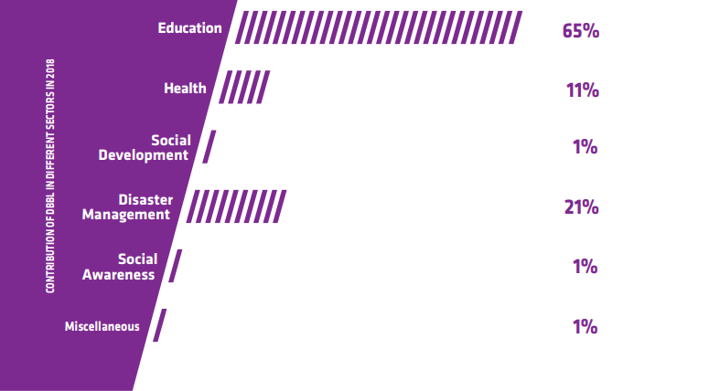

Contribution to Education Sector in 2018:
As I recently referenced that DBBL has for the most part contributed in the instructive division it implies they have done various exercises for improving the nature of training just as expanding the quantity of taught individuals. For instance, they have a huge Contribution on progression of guidance, they reinforced financially in Ganit and material science Olympiad. In addition, they have organized conceding awards to the excellent understudies. They have organized in three one of a kind levels, for instance,

- HSC Level
- Graduation Level
- M.Phil/PhD/PostDoctoralLevel
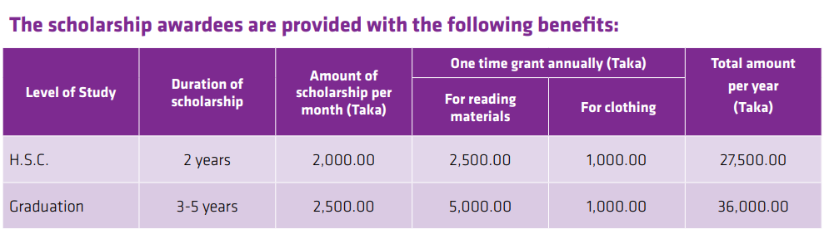

In instructive division about 96% of commitment was given in the grant, in gaitphysics Olympiad it was about 3% just and in instructive segment infrastructural advancement it is just 1%. In any case, they have contributed a little rate on the infrastructural improvement; they are considering extending it in the most ideal manners.
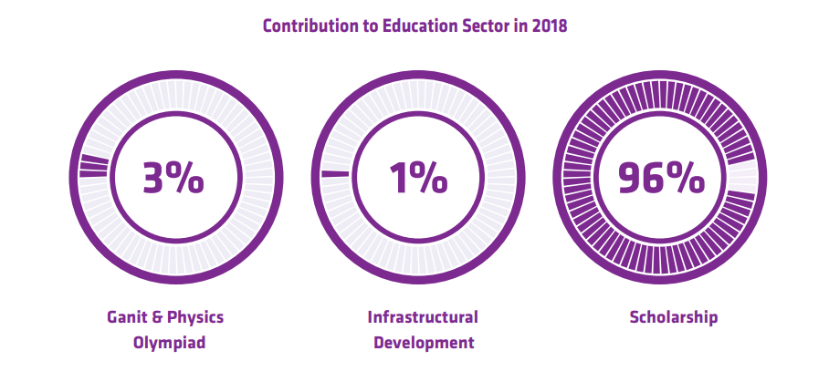
In HSC level, they have just granted 34,124 scholarships of which 3,031 new scholarships were granted in 2018. In graduation level they have granted 19,586 scholarships of which 7,518 were new and given in 2018. DBBL likewise grants 50 associations of tk. 5,000 every month consistently. They have given around 90% of the total scholarships to the rural students and 50% to the female students. These are for the understudies of ace's level explicitly the individuals who are learning at various state funded colleges at M.Phil, PhD or Post-Doctoral Level. So far they have granted around 129 cooperations.
As a major aspect of their CSR exercises they have additionally given a measure of Taka 9,73,00,000 to Dhaka University for building an examination community for higher investigations which is known as "Place for Advanced Research in expressions and Social Science Bhaban". They have likewise given for building up a cutting edge Braille printing press which will later on assistance the visually impaired individuals who are happy to concentrate further.
In most recent five years their money related development in grant area has just expanded and not decreased.
Understanding the way that consistently numerous understudies in country territories are halting their examination because of destitution however they have possibilities, DBBL has expanded the quantity of grants hugely. Hence, 53,710 understudies of both HSC and graduation levels were granted grant under this program in 9 distinct stages up to December 2018 as point by point underneath.
The Math Olympiad which was named as Dutch-Bangla Bank-Prothom Alo Ganit Utsab was held in 35 unique areas of Bangladesh in the time of 2018 which were Rangpur , Thakurgaon, Panchagarh, Joypurhat, Naogaon, Pabna, Kushtia, Dinajpur, Bogura, Rajshahi, Jessore, Khulna, Goplalgonj, Shariyatpur, Noakhali, Lakshmipur, Faridpur, Barisal, Bhola, Patuakhali, Comilla, Brahmanbaria, Mymensingh, Tangail, Gazipur, Kishoregonj, Khagrachori, Bandarban, Moulvibazar, Sunamgaonj, Narshingdi Chittagong, Cox's Bazar, Sylhet and ultimately Dhaka. Around 25,000 understudies have taken part on the projects where among them 1,300 understudies got equipped for the national round. From 2014 to 2018, 5 back to back years the measure of commitment has just expanded. In 2014 the measure of taka was 7.39 million, in 2015, 7.503 million, in 2016 it was 7.5 million, in 2017, 8 million and in conclusion in 2018 it was 8.50 million taka. A diagram is appeared underneath to determine the development. 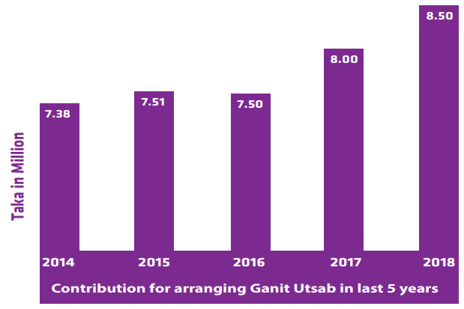
Bangladesh Physics Olympiad Committee has been masterminding Bangladesh Physics Olympiad for most recent four years where DBBL is sorting out it by giving money related help at the pace of tk. 2,500,000/ - in 2013, tk. 2,500,000/ - in 2014, tk. 3,130,000/ - in 2015, tk. 3,500000/ - in 2016 and tk. 3,500,000/ - in 2017. Later on in 2018, it has expanded into tk, 5,000,000/ - which is a positive sign for both the bank and the members. The fourth material science Olympiad was held in 14 districts where around 10,000 understudies had partaken in the program.
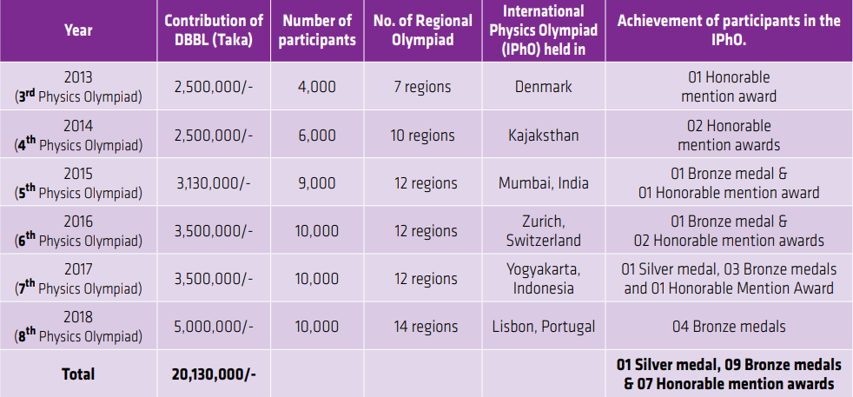

Contribution to Health Sector in 2018:
Health is one of the prime parameters to accomplish Millennium Development Goal (MDG). The requirement for social insurance is expanding ordinarily because of fast development of populace. DBBL has distinguished social insurance as a need part and made better medicinal services offices at a less expensive expense for the impeded populace. In this association Dutch-Bangla Bank expanded its help for the accompanying projects in 2018.
The greatest lift came in 2004 when Dutch-Bangla Bank gave Tk. 4 crore to the reason i.e., for development of the whole ground floor (39,230 sft) of the emergency clinic building. This early gift of DBBL propelled different associations to approach for giving to Ahsania Mission to develop the present most current 15 celebrated Aania Mission Cancer Hospital building.
The 15 celebrated structure has just been finished and begun working at ground floor from the multi week of April 2014, without Patient Department, 30 in-quiet beds, Operation Theater, Radiation Therapy Unit, Day Care Center, Diagnostic Facilities and so forth.
So as to finish the rest of crafted by the emergency clinic and to make it completely operational, Dhaka Ahsania Mission still needs to assemble a tremendous measure of reserve from the contributors. Dutch-Bangla Bank because of the equivalent suddenly declared extra budgetary help of Tk. 15 crore to finish the rest 3 stories and to that end gave over a check for Tk. 15 crore to the Honorable Prime Minister. Besides, responding to the request of BAB, DBBL has provided donation of tk. 25.00 million only to “Cure and Smile Bangladesh Limited” for their health project namely “Daktar Bari Health Care” this recent year.
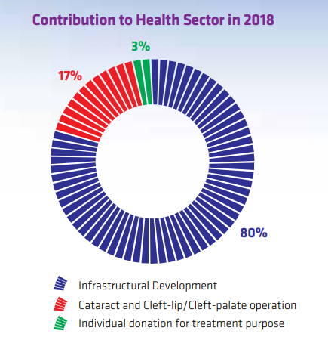
Wellbeing area commitment has the greater part of the emphasis on Infrastructural improvement and tad of commitment at waterfall and congenital fissure activity and individual gift reason.
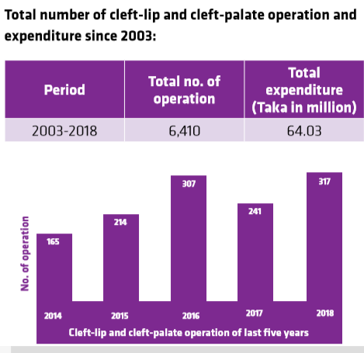
DBBL has given in different zones for further advancement of the mass individuals' wellbeing.
• In 2004, DBBL stepped up to the plate and give in Dhaka Ahsania Mission Cancer and General Hospital where there will set up an undeniable 500 bed Cancer Hospital at Uttara which will keep running on "no misfortune no benefit premise" where least of 30% of administrations will be accessible for the poor patients.
• DBBL has likewise contributed of around 23 crore of tk to CMH , The Combined Military Hospital so as to give present day offices just as gathering up the expense of restorative administrations which have been expanding step by step.
• DBBL likewise gave in SHEBA wellbeing focus as they were mentioned by them to give gifts. In this way, DBBL has been giving a measure of taka one hundred thousand on a month to month reason for a time of 3 years successful from May 2014 to April 2017.
• DBBL has spent taka 49.43 million for congenital fissure and congenital fissure activity under "Grin Brighter" program since 2003.
DBBL likewise began helping 12,000 visually impaired individuals by giving complex waterfall medical procedure (intra Ocular Lens) all through the nation in stages since 2008.
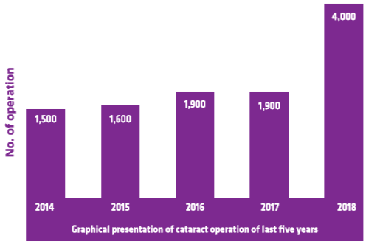

Contribution to Disaster Management:
Bangladesh faces various sorts of basic catastrophes such as cold, storm, flood, twister, tidal bore, etc in reliably. DBBL has introduced following exceptional activities considering the sufferings of normal residents for the people of the affected locales:
- Dbbl gave 10000 spreads to seismic tremor setbacks of Nepal.
- Donate to 350 dejected gatherings of B.Baria territory affected by Tornado.
- Money related help for rebuilding of land slide losses of Chittagong.
- Recovery of wrecking flood misused individuals.
- Recovery of fierce breeze 'Sidr'- hit people.
- Water separating tablets, oral saline and Cholera saline for the Flood abused individuals.
- To ensure clean sanitation structure DBBL gave 460 amounts of clean bathrooms for the inhabitants of Angorpota and Dahagram enclave.
- They moreover offered assistance for ensuring unadulterated drinking water by giving 50 hand chamber wells to them.
- Donation of 1,25,000 blankets to the cold affected people of the country in the year of 2018

Contribution to Social Development:
DBBL contributes in welfare and advancement as well as runs mass mindfulness projects to make individuals mindful. These are the consuming issues about which individuals should be cognizant and concerned so DBBL took the assistance of press and electronic here. Some of them are as per the following:
- Save the country from revile of dowry
- Stop corrosive viciousness
- Right of cripple kids
- Prevent medication misuse
- Financial backing to the street mishap unfortunate casualties
- City beautification and saving the earth
- Developing eco-accommodating society for sound human life
- Tree ranch program
- Donation for construction of Bridge

Contribution to create social Awareness:
For making mindfulness and catching the eye of people in general, DBBL utilizes trademarks which are extremely inspirational. Some of them are given underneath:
- Hope and love make us exquisite
- Stop Acid Violence
- Willpower is sufficient to work superbly
- Stop Demand for Dowry
- Uphold Justice
- Good Behavior with mentally retarded persons, an ethical obligation
- Human for humankind
- Combat Aids
- Drug addiction- a Menace to Destroy life
- Plant tree, save environment
- Contribution to environmental beautification
As a whole, DBBL spent almost 1,370,000/- taka in 2018 for creating awareness and spent almost 834.83 Million taka for CSR activities in this recent financial year.
Considering, all the past ventures and current speculations, DBBL really took choice to further give in the CSR exercises. In addition, they mastermind executive gathering about talking about them in a nutshell. Anyway such things are simply just be advised by different workers to understudies or else we don't approach enter any executive gathering.

Correlation Analysis

Here we can see that DBBL’s profit increase with the contribution in CSR. Within 5 years company earns higher than previous. So we can conclude that in DBBL earnings CSR has a positive impact.

In this line graph it is clear that within 5 years DBBL’s contribution in CSR is a constant amount which fluctuates a little. But the profit shows up word line graph, means in 5 years profit is increasing. And CSR is one of the forces which help the company to earn more profit.

As we know CSR has a positive impact on investors which these graphs can assure that. Within 5 years the EPS is increased almost double.

CHAPTER- 5: EXPERIENCES DURING INTERNSHIP TENURE
I worked out there at Darus Salam Branch from July 18, 2018 to September 17, 2018 and these three months adventure of my temporary job with Dutch-Bangla Bank Limited was exceptionally magnificent.As I filled in as an understudy there, I was doled out at various work areas of the considerable number of divisions of bank.
As an intern, I had no specific responsibilities there. I observed activities of almost all the departments. But gradually I started taking responsibilities and learned a lot of things. The internship opportunity has allowed me to experience the corporate culture from a different point of view. The procedures about banking that we learnt from our text books during our whole BBA program are not completely in line with the procedures of the bank. Bank modified some of the previously known rules from the textbooks according to their internal regulations as well as the guidelines provided by the Bangladesh bank. One thing that I learnt during my internship is how to abide by the rules of the bank and maintain a positive customer relationship at the same time. I was assigned there as a customer representative in almost all divisions of that branch.
During the internship period I had some duties and responsibilities to perform towards the bank in a regular basis. The duties and responsibilities are given below:
- First I was appointed to the customer service section for a couple of weeks where I had to help customers regarding account openings, account opening information or helped them in voucher writing.
- I have invested a huge time and energy in that office and learnt many things about bank from the employees. My works there were to help the customers filling the record structure, handling check books, Express cards and so forth.
- I have learnt about the clearing procedure of a check as far as possible and also got to know when the check gets rejected and how many times a check can be taken. I had accepted the cheque on behalf of the duty officer and inputted all of them in excel sheets.
- I have input the loan related documents in word files. I have also provided alert about their consciousness over the telephone, kept record in excel files about customers and their loan amount, interest, outstanding, expiry date and so on.
- I helped in the entire handling of cheques according to necessities. I have likewise done voucher arranging and auditing in an everyday schedule.
- Besides, I provided statements to the customers according to their expected time duration. And sometimes, I also gave them solvency certificate along with the signatures of manager and GB in charge.
- I also did NID verification of the customers, found out the compliance link, crop their photos and linked them with their signatures and finally documented all of their information and learned to give system input for a proper account opening on the bank system.
- Sometimes, I also did modifications of many wrongly inputted accounts of the customers of the past years’ and reedit those for internal audit which accounts had limited or wrong information provided.
I have attempted my level best to contribute in those divisions; I was set in and done accurately whatever they request. I trust I have carried out my responsibilities as quicker as possible.

CHAPTER- 6: CONCLUSION AND RECOMMENDATION

Conclusion
Bangladesh has lots of problems as a third world country. Government almost always finds them helpless when it comes to the issue of solving problems throughout the country. So as entrepreneurs of this nation they are considered as a piece of the general public they can contribute some more definitively towards the advancement of the general public. Company like DBBL should endeavor to contribute to the society; it will help to create their social branding as well as contributor to the society. DBBL is a promoter by whom Corporate Social Responsibility is vastly expanded. DBBL has a very significant risk management system which plays a considerable role in the portfolio of development. During my internship period which I vastly observed that DBBL keeps the Bangladesh Bank administers proficiently and furthermore advise customers to pursue and value it.
At last, DBBL has been set up welfare arranged banking through CSR that would lead to our society.

Recommendation
DBBL should cause open care as for to CSR among the mass people, scholastics, heads, and various accomplices so they see CSR fair and get advantage from it when the endeavors practice it. CSR guidance can be spread at all level of our informative system. Be that as it may, they can extend their business and widen their segment of social obligation by the accompanying terms:
- Primary school area is exceptionally in reverse in our nation. DBBL can support their social duty in this root area. They can offer grant or disparage this part and accordingly nation can profited just as play a job of social duty by this area.
- SME is additionally a root segment where this bank can apply credit equation or Belittle this division. In this manner it can presumably grow its social picture. They additionally can supply credit at a low loan cost that can improve this division as per its social duty.
- Microcredit is prevalent among root individuals in our nation. The Principle favorable position of microcredit is that an individual can take advance with no security. In the event that DBBL begins to give microcredit than it will help the individuals a great deal. Then again it will build the social picture of DBBL.
- They should build the system interest in CSR practices by propelling a CSR altruistic social talk. DBBL should base on purchasers just as powerful trade with various accomplices is critical for the accomplishment of CSR.
- Well made clear principles including the division astute CSR benchmarks, rules, and methodologies should be made as fast as time grants.
- Various improvements of exercises should be made for both the inside and outside get-togethers. Capacities and instruments are basic to empower accomplices to accept their activity properly. For this, DBBL can make fitting institutional structures which grant partners to meet and examine CSR matters.
- Ensure straightforwardness along with construct trust on the CSR exercises of DBBL. They should cause the partners to accept that they are truly thinking about them, for society, and for more extensive condition all in all.
- Besides these, all the employees must have the equal rights.
- Interns and low rank officers should be trained properly.
- Facilities should be liberal.

CHAPTER-7: APPENDIX
- https://www.dutchbanglabank.com/investor-relations/financial-statements.
- https://en.wikipedia.org/wiki/Bank
- Annual Report of DBBL-2018.
- https://www.scribd.com/doc/226753147/Dutch-Bangla-Bank-Ltd
- http://dspace.bracu.ac.bd/bitstream/handle/10361/28/Role%20of%20information%20&%20communication%20technology%20(ICT)%20in%20rural%20poverty%20allev?sequence=1
- https://reviewbangla.com/en/business/dutch-bangla-bank-velanagar-branch/
- https://issuu.com/md.papon/docs/liquidity_and_profitability_analysi_ce2a84589fa187
- https://www.bankbazaar.com/fixed-deposit/fd-rates-above-9percentage.html
- https://www.academia.edu/15534140/CSR_activities_of_DBBL
- https://issuu.com/lawjuris/docs/report_8a1b18a8c53c2e

