

Internship Report
On
Inbound Value Chain Management of Shoplover Limited

Submitted To

Muhammad Hasan Al-Mamun
Assistant Professor
School of Business and Economics
United International University

omics

Submitted By

Sadia Jannat Shija
ID: 111191017
BBA Program
School of Business and Economics
United International University

Submitted By

Sadia Jannat Shija
ID: 111191017
Batch: Spring 19
Major: Marketing

Submission Date
December 26, 2023

Inbound Value Chain Management of

Shoplover Limited

Acknowledgement

It has been a great experience for me to work on this report. I am going to express my sincere thanks to a number of people and organizations for providing me an actual working community, challenges, experiences, and opportunity to develop proficiency in works related to my area. I am grateful to them for their assistance in completing my internship and coming up with this report.

Before anything else, I would like to thank United International University for giving me the education, knowledge, and understanding I need to deal with problems in the actual world by transferring the opportunity. These are exceptionally high requirements for corporate life as well as exciting.

The second-place acknowledgement is for, Muhammad Hasan Al Mamun, Assistant Professor, School of Business and Economics at United International University, who was exceptionally accessible and helpful in guiding me to write this internship report. He is also giving me the motivation for doing something unique and fresh approach to my work.

Lastly, I would want to express my gratitude to my reporting boss, Ashadul Islam Sourov, Head of Procurement at Shoplover. In the present moment, he taught me the first lesson about corporate life. He additionally demonstrated his knowledge and suggested me how to do assignments. He answered any questions I had regarding the job. He was always willing to have a discussion with me constantly encourage me and show me admiration.

Letter of Transmittal

December 26, 2023

Muhammad Hasan Al Mamun
Assistant Professor
School of Business & Economics
United International University
United City, Madani Ave, Badda, Dhaka-1212

Subject: Submission of Internship Report.

Respected Sir,

I hereby submit my Internship report titled “Inbound Value Chain Management of Shoplover Limited” which is a mandatory part of completing my BBA degree from the School of Business and Economics, United International University.

I have done my best to communicate effectively all aspects of the company including my responsibilities, tasks, evaluations, outcomes, objectives, and limitations during my three months as an intern. I have the opportunity to apply the academic knowledge that I obtained at my institution to new aspects of corporate life. I genuinely believe that the practical knowledge and on-hands skills I have gained from my internship program will greatly benefit me in the future. I have tried to make sure that this report is as highly accurate and reliable as possible.

I hope that my efforts for this report will be able to match your expectations. If you are looking for any clarification regarding any aspect of this report, it will be my pleasure to provide it.

Sincerely yours,

Sadia Jannat Shija

ID: 111191017
BBA Program
School of Business & Economics
United International University

Executive Summary

The e-commerce industry has expanded in size because of everyone’s easy access to today’s technologically advanced world of internet and online communication. Shoplover Limited has been eager to jump on this opportunity to provide services to actual as well as potential customers in this industry. They expanded dramatically in response to the growing demands from customers. Shoplover Limited was founded in 2021. It still operates its operation on a pilot trial. It will be launched soon. It was founded as a sister concern of US Bangla Group.

I have completed my internship in the procurement department of the aforesaid organization. The procurement service division of Shoplover Limited is the focal point of this report. I will elaborate on the work experiences I have gained from working in this department and I will evaluate the inbound value chain management process handled by this department. This report also means to inform the readers about the nature of the e-commerce industry’s procurement working process.

In evaluating the inbound value chain management process of the Shoplover Limited, Porter’s value chain model was used. By implementing Porter’s value chain analysis, the procurement department of Shoplover keeps vigilant eyes on strategic sourcing, supplier evaluation, negotiation, and contracts with management to maximize the value derived from suppliers with highest quality goods.

Shoplover’s procurement department initiates the process by strategic sourcing of suppliers. This stage primarily involves identifying and selecting the suppliers. The factors considered here include suppliers’ abilities, quality standard, delivery reliability and overall suppliers’ reputation.

At the second stage, they go for supplier evaluation. They evaluate suppliers by some previously set criteria, such as, on-time delivery, product quality, pricing, and responsiveness of suppliers. Such minute evaluation tends to minimize the risks in getting the high-quality goods.

Finally, the process ends in contact management. Contact management plays a crucial role in obtaining maximum value from the suppliers. They focus on negotiating with suppliers for getting favorable prices with high quality products.

Shoplover Limited was found to manage all these inter-related stages of inbound value chain management process quite efficiently to ensure the continuous supply of the needed goods with desired quality.

Key Words: Inbound Value Chain Management, Shoplover Limited

Contents
Inbound Value Chain Management of 2
Shoplover Limited 2
Acknowledgement 3
Letter of Transmittal 4
Executive Summary 5
Chapter 1: Introduction 7
Topic in Hand 8
Context of The Study 11
Chapter 2: Organizational Background and Competitor Analysis 13
Organizational Background 14
About US Bangla Group: 14
About Shoplover 15
Company Tagline, Mission Vision 15
Departments of Shoplover Limited: 15
Shoplover Limited Management Network Organogram: 16
Marketing Mix of Shoplover 17
Competitor Analysis 22
SWOT Analysis for Shoplover 23
Chapter 3: Objectives and Methodology of The Study 25
Objectives of the Study: 26
Methodology of the Study 27
Chapter 4: Findings of the study 28
Findings of the Procurement Department at Shoplover Limited: 29
Chapter 5: Recommendations and Conclusions 32
Recommendations 33
Conclusion 39
References 40

Chapter 1: Introduction

Topic in Hand

The topic of the internship report is the Inbound Value Chain Management of Shoplover. Basically, a value chain management refers to the assembly of some processes that an organization takes from the starting point of a product to the finished product. It links up an organization’s core functional parts to add value at each subsequent stage. It connects with the various activities and procedures associated with creating product or performing a service. It refers to multiple stages such as management, finance, legal, planning, marketing and sales, research and development, as well as everything in between as the value adding stages. Professor Michael Porter linked two areas together:

- “The added value that each part of the organization contributes to the whole organization; and
- The contribution to the competitive advantage of the whole organization that each of these parts might then make.”
He has made a diagram about this which is split into two parts. These are known as primary activities of production, including the production process itself and the supportive activities, acting as human resources management that give the necessary background for the running of the organization. The following diagram is given bellow:
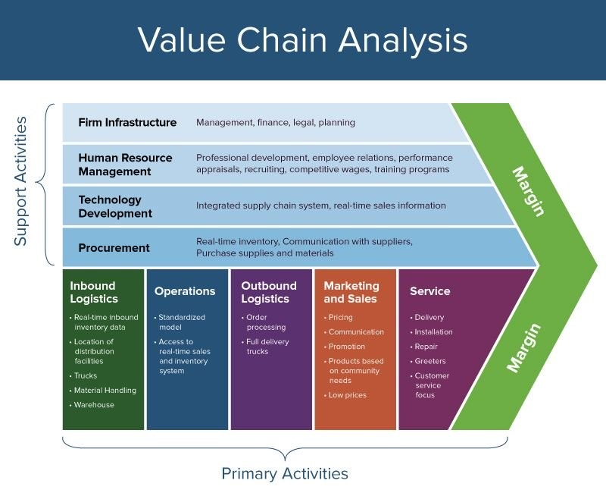
Figure: The Value Chain

Value Chain

Value analysis is a strategic approach which is a management framework constructed by Michael Porter. It sets up organizations for evaluating and categorizing their internal operations through primary and secondary activities in order to acknowledge how every activity contributes to the creation of value for consumers and the organization’s overall competitive advantage. An organization can use this method for identifying the possible areas for cost reduction, unique selling points, and competitive advantages.

The value chain analysis can be categorized into two areas; primary activities and supportive activities.

Primary Activities
- Inbound Logistics: Inbound logistics is a core activity of primary activities in value chain analysis. It goes through some procedures like receiving goods or products from suppliers, keeping them until they are required by operations, handling and distributing them within the organization. These are conducted for the production process. It also contains tasks like purchasing resources, inventory management, and distribution. An organization is going through inbound logistics procedure because of the fact that it can save costs and get smoother production process.

- Operations: In primary activities of value chain analysis, it includes transferring raw materials into finished products or services. The crucial process of changing inputs into finished products or services is known as or referred to as operations. This core activity is necessary for the value chain and may include producing, maintaining, storing, distributing and other industry-specific operations. Operational activity has the potential to directly impact product quality, production time, and cost effectively as well as efficiently.

- Outbound Logistics: These functions are responsible for delivering the finished products to the customers. In a multiproduct business, outbound logistics are involved in selecting and organizing product combinations. Outbound logistics are also involved once the products are ready. It contributes for managing the distribution and delivering the finished products to customers or distribution points. In this activity, customer’s satisfaction may increase through on time delivery, combined distribution networks, and products safety.

- Marketing and Sales: This activity is responsible for analysing customers’ needs and wants as well as brings the attention of customers to the products and services the organization has for sale. The important elements of marketing are advertising and promotions fall in this territory. Advertising and promotions are meant to push customers for purchasing the appropriate products. It is conducted through marketing and sales operations. It has various parts including marketing research, segmenting, branding, advertising, promoting, campaigning, and customer relationship managements. There are also some tactics for establishing brand loyalty, customer acknowledgement, and customer’s engagement.

- Service: The service activity is dedicated for after sale service and ensuring customer satisfactions. It concerns with technical supports, warranty services, and repairs or return service. There are some strong service components including customer loyalty, repeat business, and positive word of mouth (WOMs), and recommendations.

Support Activities:
- Procurement: In many organizations, there is a sperate department which is responsible for purchasing goods or services that are then used for that certain organization. This department’s target is to achieve the lowest prices of products with highest quality for the organizational activities. On the other hand, it just only for purchasing materials or products, not for the subsequent production of the goods. It is responsible for procuring the resources, materials, and components which are required for procurement operations. Procurement process brings effective result of cost savings, dependable supply chains and high-quality inputs.

- Technology Development: This activity is crucial for new product or service development in any organization. It will also cover existing technology for a mature industry. Continuous training and knowledge will allow any organization to remain efficient and up-to-date. Technology and development are focused on research, development, and innovation for improving processes, products and services. Technological advancement can contribute to competitive advantage through new product offerings, improvement in the process and operational efficiencies.

- Human Resource Management: Effective human resource management is critical. This calls for effective strategy formulation and implementing. Major tactical issues include personnel recruiting, training, performance management, employee’s skill development. Employees, those are skilled and motivated, add to an organization’s competitive advantage.

- Firm Infrastructure: Infrastructure is a one kind of principal activity for running any organization smoothly. Accounting, finance, general management, and legal supports are examples of such domains. Infrastructure is responsible for ensuring seamless operations, compliance, and optimal resource allocations.

Here are supportive activities; we can see the procurement component. According to Porter, the value adding function is concerned with purchasing the products and materials that are used for company’s operation.

Context of The Study

As an intern of commercial department of Shoplover Limited, I was assigned to deal with the Group Procurement of US Bangla Group Concerns. I was hired for working at inbound value chain management where all activities are conducted at the group-level hierarchy of the organization. There is a separate functional unit which is responsible for purchasing products or services, and materials then used at group concerns as their needed. Shoplover Limited procurement department’s functions is to achieve lowest prices with the highest quality of goods for the concerns. It is not responsible for producing products. It has the power of purchasing the products and materials, and support services

Procurement plays a crucial role in the procurement department itself. It is a part of supportive activities. By implementing Porter’s value chain analysis; this department keep an eye on strategic sourcing, supplier evolution, negotiation, contract with management for maximizing the value derived from suppliers with highest quality goods. They conduct their business by going through some interrelated stages. These stages are briefly described below:

- Sourcing and Supplier Selection: It plays a crucial role in the procurement department. It is the main part of procurement process. Best suppliers can give good quality products. So, choosing the best suppliers affects product quality, pricing, reliability, and delivery time. After identifying possible suppliers, assessing their skills and making a final decision got the most attention and time. A good supplier can source best quality products for purchasers.

- Negotiation: Negotiation is necessary for getting low priced products with high quality. It adds value in any organization by creating the greatest negotiation term. Maintaining breakeven point between quality and price is necessary for this. It has some factors like prices, favourable terms on procurement, and quality to be considered here.

- Purchase Order Creation: POs are important for keeping the track in every step in this process. It involves information on the product or services being ordered, such as quantities, features, delivery dates, and agreed upon costs.

- Supplier Relationship Management: Supplier relationship management is meant to ensure smoother interactions with suppliers, handling of any issues that may occur, and promoting collaboration for mutual benefits within buyers and suppliers. That is why it is important to establish and maintain excellent relationships with suppliers.

- Contract Management: Since its main concern is purchasing products or materials. So, they need to manage terms and conditions, warranties, and other legal aspects of contracts and agreements with suppliers, ensuring that the contracts terms are followed by both parties.

- Market Research and Trend Analysis: The role of marketing research is to keep up with the changes in supplier landscapes, technical advancement, and market trends to make accurate choices about this department’s strategy.

- Cost Analysis and Cost Reduction: Cost analysis and cost reduction is another main concern of procurement process. This department is constantly evaluating procurement related expenditures, looking for opportunities for cost reduction, and implementing cost cutting initiatives into implementation.

- Supplier Performance Evolution: If suppliers fall short of expectations, implementing corrective action is required. They need to monitor and evaluate supplier performance based on aspects including responsiveness, activity, and quality. So, supplier performance evaluation is necessary for getting good outcomes.

- Internal Collaboration: Internal collaboration for collaborating closely with a different departments and areas, like manufacturing, logistics, accounts, finance to understand their needs and make ensuring the process adheres to corporate goals.

Shoplover’s procurement department is found to start their process by strategic sourcing of suppliers. Such a start calls for identifying and selecting the suppliers. Decisions are made considering some factors such as suppliers’ abilities, quality standard, delivery reliability and overall suppliers’ reputation.

After that, they go for supplier evaluation. It is also another important aspect. They evaluate suppliers by on-time delivery, product quality, pricing, responsiveness of suppliers. By doing these, it minimizes the risk and ensures getting the high-quality goods.

Finally, the process ends in contact management. They play a crucial role for obtaining maximum value from supplier. They focus on negotiating with supplier for getting a favourable price with standard quality products.

Overall, by conducting all these steps, they can maintain their procurement process effectively. Shoplover’s procurement process involves identifying reliable suppliers with favourable and standard quality products.

Chapter 2: Organizational Background and Competitor Analysis

Organizational Background

US Bangla Group

US Bangla Group is one of the most prominent groups in Bangladesh. It was founded in 2009 with US Bangla’s supports and assets. The group became a renowned real estate company in Bangladesh. It owns the Green University of Bangladesh and Purbachal American City as their bigger projects of real estate. Overa the years, US Bangla Group increased the number of their sister concerns. After that they opened US Bangla Leather, It was operated as hundred percent export-oriented concern. Later, they opened a medical college which is US Bangla Medical College and Hospital. With that concern they try to provide internationally comparable sophisticated education. In 2014, this group introduced US Bangla Airlines. Now it is the leading aviation company of the country. They provide premium quality service both domestic and international flyers at affordable prices. Another sister concern of the group is USB Express. It is an international and national courier service. Then introduced Vibrant. It is an ethnic fashion footwear and lifestyle retail brand. This company launced US Bangla Media and Communication; It has daily newspaper, named Ajker Patrika.

US Bangla Group will launch two concerns very soon. They are “Foodi” and “Shoplover”. These two concerns are running in trail process. They are in startup situation. Foodi is being visioned as a premier food delivery app. On the other hand, Shoplover is being run as an e-commerce site. There is also upcoming Hi-Tech industry under this. It will be known as US Bangla Hi-Tech Industries while electrical and electronics items will be manufactured and gradually expand its operation in many other electronics fields that will provide the requirements for every aspect of modern life.


Figure: US Bangla Group Logo

Shoplover

Shoplover Limited is a new sister concern of US Bangla Group. It is mainly a new e-commerce company. It is founded in October, 2021. Shoplover Limited gives the best possible discounts on products as customers everyday desire. It wants to give better purchasing experience to the customers online. It has some priorities for running their business smoothly such as good quality products, fastest delivery, safe online payments, and quick return policy.

It has 24,000 followers on its official Facebook account. Its reviews are in peak according to other e-commerce platform. It has 4.4 review out of 5.00. Its previous account was hacked by some hackers in 2023. It had some bad impact on the official page. On the other side, it has over 30,000 hits on a day in its website; it has a great response within the first 6 months.

Few days ago, Shoplover launched its new app which is more user experience friendly from the previous one. The company is also getting more responses from this one. It is user friendly and smoother for browsing. The company also regularly updates its website according to customers feedback and it is continuously trying to rank its website high through SEO experts.

Company Tagline, Mission Vision

Tagline: “Advancing Life”.

Mission: Shoplover’s mission statement is to improve customers’ lives nationally and internationally by providing cutting-edge technology and fast rate services.

Vision: To make Bangladesh compliant with international e-commerce standards.

Departments of Shoplover Limited:

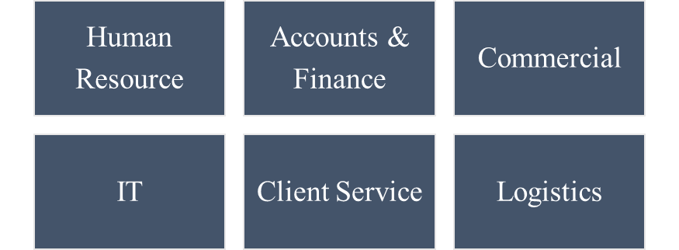

Figure: Departments of Shoplover Limited

Shoplover Limited Management Network Organogram:

Figure: Management Organogram

Marketing Mix of Shoplover

Marketing mix is nothing but a set of controllable elements. In this case, I will clarify some elements of marketing mix in the context of Shoplover Limited.

Product: Shoplover’s business model is B2C standing for Business-to-consumer model. It is an online retailer and shopping company that sells products by internet. It has 16 different categories of products for serving the customers. In these categories, there are also some sub categories so that customers can sort out their desirable products according to their needs. These categories are given bellow-

- Women Lifestyle
- Men Lifestyle
- Mobiles and Devices
- Consumers Electronics
- Grocery and Food
- Book & Stationary
- Kids & Moms
- IT Products
- Health & beauty
- Home & Living
- Digital Goods
- Toy & Games
- Sports & Accessories
- Automobiles
- DIY Tools & Materials
- Bags & Travels.

Price: Shoplover has more than 30 thousand products for consumers. The price range may vary from category to category, product to product, and item to item. Shoplover tries to give their great deal to the customers. Sellers give their prices of their products and Shoplover Limited get commission from each sale. The commission percentage varies from product to product and from categories to categories.
For their own products, they set price using the cost plus pricing, value-based pricing, and competitive pricing. At first, they initiate with cost-plus pricing. They set a price where they can add fixed amount or percentage to the cost of a product. After that, they compare it with their competitors. They fix a price based on competitors’ prices and customers’ perceived value of a product.



Place: Shoplover is online retailer and shopping store. E-commerce stands for all business operations, including product sales taking place in the internet. Shoplover does not have a real store where customers can purchase products. Customers can order products from home by visiting the official website and Facebook page. And the ordered products are delivered to the customer’s locations by the riders of their own. They have also their own courier system.

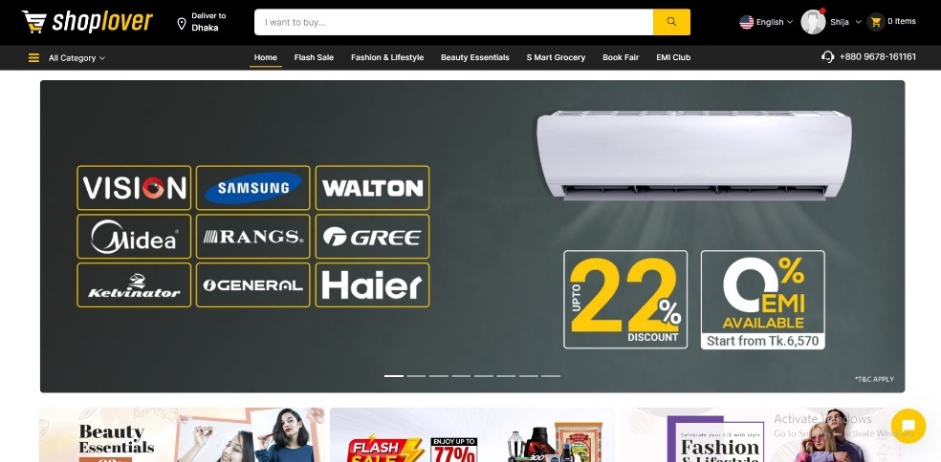

Promotion: Shoplover Limited has several ways to promote their business to the customers. Since they have not launched their business yet, they do not advertise in mass media yet. They are doing different activities to connect with the customers and build a strong relationship with them. They follow several strategies for promotion. The efforts of the company to promote and communicate with the target market can be briefly summarized below:

- Search Engine Optimization: Shoplover Limited always tries to optimize their website to improve their organic rankings. They try to gather more traffic in their website. They focus on keyword, on page SEO, off page SEO, backlines to increase visibility of their website. They also regularly post blogs at their website.

- Social Media Marketing: They were able to establish a strong presence in social media platform by promoting their business. They publish advertisement on Facebook, YouTube, and Instagram. Their page was once hacked by some hacker but they retrieved it very quickly. They also share engaging posts and run ads on social media. They also upload push banner for reminding their actual customers.

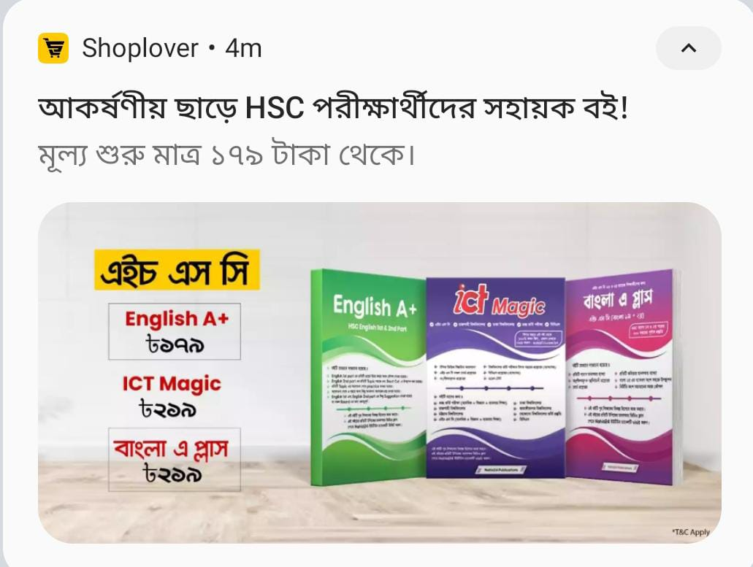

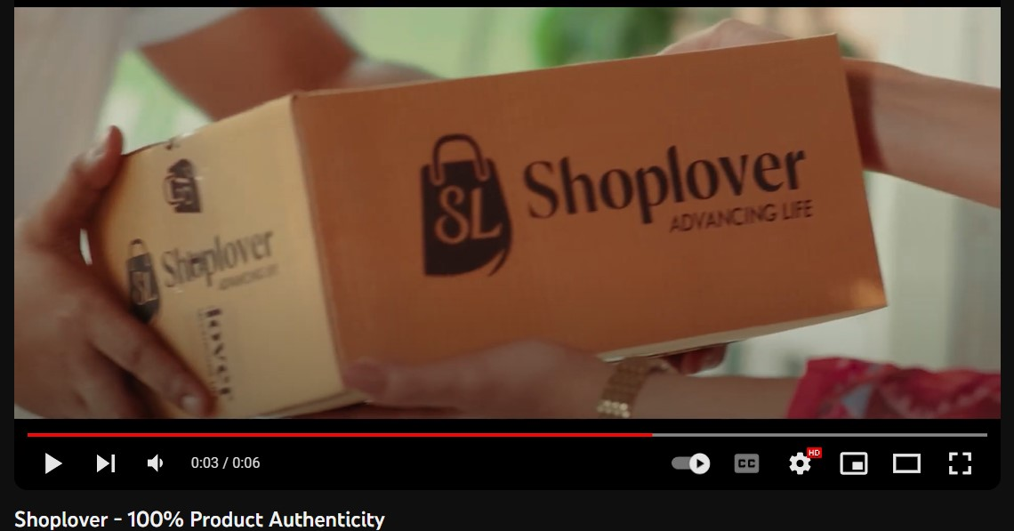

- Content Marketing: In the e-commerce industry, content marketing’s job is uploading product, making live of their product, publishing and unpublishing their products on website. They mainly work on website’s back-end. Their main concern is focused on website insights.

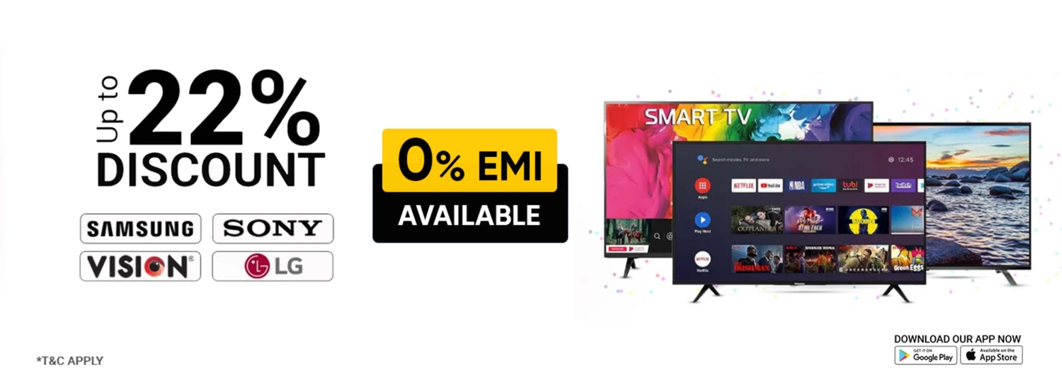

- Collaboration: Shoplover Limited collaborates with different brands for expanding their business territory both geographically and volume-wise. They are collaborating with Unilever for selling their products on Shoplover’s website. After collaborating with other brands, it helps to achieve new audience from that specific brand. This influences the cross communicating benefits for each of the brand.

People: More than 200 people work at Shoplover Limited. Every three months, they give circular for hiring interns. They also deliver their products by their own logistic department by their own. They have sufficient manpower in every department.

Physical Evidence: Since Shoplover limited is an online retail and shopping shop, they do not have any physical shop. They have virtual shop where customer can purchase their desirable products. Shoplover has their own leather shop but it is also virtual. But there are some renowned brands in that website. They are most of the IT and Mobile Devices products. Such as-

- Samsung
- Oppo
- One Plus
- Realme
- iPhone
- Infinix
- HP
- Apple
- Lenovo
- Dell
- Acer
- Asus

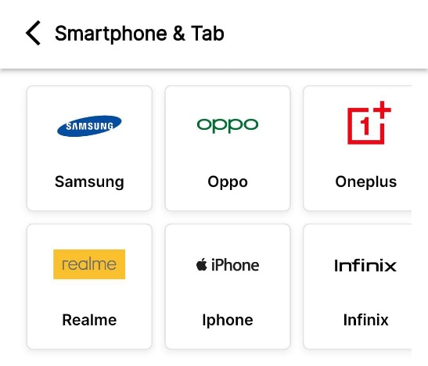
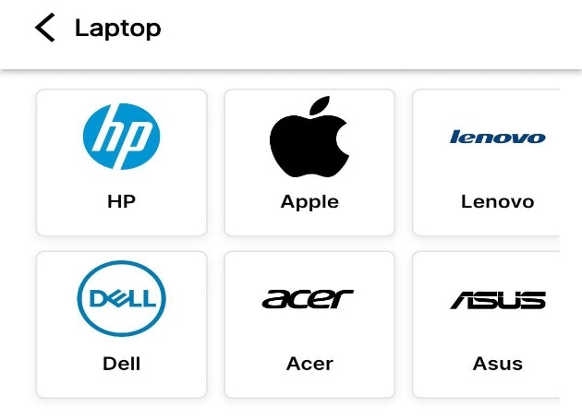

Process: We all know one thing that online purchase is different from offline purchase. Online purchase is making customer’s life more convenient and take less time for shopping. E-commerce will be more reliable by their proper actions such as on time and safe delivery, good quality products, and nice behaviour from agent.

CRM department helps tracking the order by inbound and outbound calls effectively. In this department social media team also do contacts with customers.

Packaging is also a main concern for E-commerce. Logistic department handles this issue of concern. They make module for the delivery of the products.

On the other hand, delivery module also helps the third party for tracking the delivery process. Customer and company can see the delivery status by this module as well as they can track their parcel.

Competitor Analysis

For the competitor analysis, I would like to make a relative comparison between Daraz Bangladesh with Shoplover Limited. Daraz Bangladesh is the largest e-commerce in our country. Shoplover limited and Daraz Bangladesh are doing their business in the same business model using a very similar value proposition.





- Employee Count: Around 3000  - Management Structure divided into 6 departments.  - Category Number: 12  - Brand Category includes Women’s & Girls’ Fashion, Health & Beauty, Watches, Bags, Jewellery, Men’s & Boys’ Fashion, Mother & Baby, Electronics Devices, TV & Home Appliances, Electronic Accessories, Groceries, Home & Lifestyle, Sports & Outdoors, Automotive & Motorbike.  - Ownership: They don’t have 100% ownership of their own. | - Employee Count: Around 200  - Management Structure divided into 4 departments.  - Category Number: 16  - Brand Category includes Mobile & Devices, Consumer Electronics, Grocery & Food, Kids & Mom, IT Products, Health & Beauty, Home & Living, Digital Goods, Men Lifestyle, Women Lifestyle, Toy & Games, Sports & Accessories, Automobiles, Book & Stationary, DIY Tools & Materials, Bags & Travel.  - Ownership: 100% to Shoplover Limited.

Alibaba Group is a mother concern of Daraz Bangladesh, a global leader of E-commerce industry. Alibaba made a deal with a previously operating company and came to Bangladesh to operate under the name of Daraz. They have been since 2018, and their brands are well known among online customers. Shoplover Limited still a new venture, they have not launched their presense formally yet. However, if we look at Daraz Bangladesh’s marketing strategy, we observe that their customer interaction with their brands has only increased and expanded over the time, but Shoplover Limited has never demonstrated any market coverage or consumer engagement activities yet. Alternatively, Daraz Bangladesh puts more money into its products; Shoplover Limited is trying to lower costs in every manner possible. Daraz Bangladesh works on their customer interaction through a variety of projects throughout the year. Shoplover limited did not run offline campaigns for acquiring customers. Daraz Bangladesh has run many offline campaigns and seminars. If we consider Daraz Bangladesh from the perspective of a brand manager, we can see that they have not only established their brands but also guaranteed that they are #1 in e-commerce company in the industry. Shoplover Limited has the mission to establish themselves as a number 1 e-commerce company.

SWOT Analysis for Shoplover

SWOT analysis is a strategic plan that provides assessment tools for the concerned company. It has included some core strengths, weakness, opportunities, and threats. SWOT analysis is conducted by evaluating an organization’s internal strengths, weakness as well as external opportunities, and threats. Strengths will increase organization’s profit and weakness which is identifying company’s lacking points that are utilized by rival companies to make better version of them. Additionally, opportunities identify new business opportunity in the market which is helpful for expanding the business and threats negatively affect the business from outside. It might be supply chain problems, shortage of recruitments or any other similar issues with negative implications. Shoplover needs this assessment through SWOT analysis for their business. The major findings from the SWOT analysis can be summarized below with necessary details:

Strength:
- They have fastest delivery system
- They give free delivery for grocery items
- Their return policy is the quickest policy
- Their app is smooth and user friendly
- They have strong hierarchical policy
- They have well known brands in their category of products
- Their sellers are trustworthy

Weakness:
- Promotional activities need to be increased
- Number of employees need to be specific in some of their departments according to the volume of tasks
- They have high employee turnover
- Not many high-end products are available in their website
- Grocery coverage is limited
Opportunity:
- In this era, e-commerce industry is booming all over our country. So, Shoplover Limited has huge opportunity to grab the market to get a larger portion of the pie.
- Most of the customers are more interested for online shopping to save money and time.
- Shoplover can give discounts to attract potential customers.

Threat:
- In Bangladesh, competition is huge on this level. There are giant e-commerce companies like Daraz, Chaldal, Rokomari, Pickaboo etc.
- Turbulence can hamper the delivery system.
- Rural areas customers cannot get this advantage at ease.
- It will be a risky decision for new entrants in this industry unless they have a unique strategy.

Chapter 3: Objectives and Methodology of The Study

Objectives of the Study:

The objective of this report is to evaluate the inbound value chain management of Shoplover Limited. The broad and specific objectives behind this report are clarified below.

Broad Objectives:
The main goal of this report is to evaluate the inbound value chain management of the procurement department in the value creation of Shoplover Limited.

Specific Objectives: The following specific objectives can be summarized below:
- To analyze the supplier management practices at Shoplover Limited.
- To assess the cost reduction initiatives in procurement department at Shoplover Limited.
- To specify the quality assurance process of the procurement department of Shoplover Limited.
- To elaborate the process to collaborate with stakeholders for conducting procurement process at Shoplover Limited.
- To clarify the supplier evaluation process for conducting the business effectively at Shoplover Limited.

Methodology of the Study

This study has been conducted based on my internship experience. I will give a comprehensive overview of what I have learned in the procurement function, how Shoplover Limited operates their business, how the workplace culture is unfolding, and my contribution as an intern. In this report, I have used both primary and secondary data. Primary data includes my observations about various aspects of the operation of the Shoplover Limited and some confidential information which cannot be shared.

Secondary sources include previous background information, analysis and study. There are also some secondary data sources used in this study. All secondary sources are mentioned below
- Internet Sources
- Online Blog Post
- Company Website
- Online Newspaper
- Report from other websites
- Social Media

Chapter 4: Findings of the study

Findings of the Procurement Department at Shoplover Limited:

As an intern, I was assigned with some responsibilities. These assigned responsibilities can be briefly described below:

I took order from different concerns of US Bangla Group. They mailed me with their order quotations. Then I talked with different vendors for certain products. I negotiated with them for the price and ensuring the products quality. They sent me their final prices and I finalized the purchasing. I prepared bill and challan for delivering the products. After that I delivered the products through logistics and collected the payment from those who are concerned. I submitted the invoice to the audit. Audit checked the invoice and passed it to the accounts department.

As I have completed my internship under the department of commercial at procurement section, I have talked with distinctive people to know all the process and based on that findings I have prepared my report. The noteworthy aspects are briefly described below:

- Supplier Relationship Management: The procurement department’s main concern is to establish and maintain good relationship with selected suppliers. Shoplover’s procurement department has done this effectively. They are successful to build a stronger relationship with suppliers. They have nurtured the relationship by concentrating on some specific areas. These are given below:

Communication is one of the main factors to nurture effective relationship with suppliers. Shoplover’s procurement team members have done this smoothly. They are doing their communication transparently and openly. It’s a two-way communication. At first, they tell their product requirements, quality, prices, and delivery charges. Then they give floor to sellers. In that case, they can negotiate or give feedback to the procurement department.

There is another reason for maintaining good relationship. They will get better quality products with cheaper rate. They were able to establish strong relationship with suppliers.

Shoplover’s procurement department discusses with their suppliers for improving their services; how it will be good. They schedule a meeting and discuss about their projects. This system keeps their relationship longer and stronger. Both sides give value to each other’s decisions. They also envision future projects in such meetings,

This is how they maintain good relationship with their suppliers.

- Cost Reduction: Procurements system is getting the better products with low cost. So, they are concerned about maintaining this status. Procurement’s basic strategy is to optimize the cost. Their purchase volume is huge. They purchase in bulk. They look for good products and sourcing for better products. Shoplover maintains this very process. By doing this, they are able to get benefits such as financial benefits, improved purchasing, and increasing competitiveness.

Since Shoplover’s procurement department can reduce their cost, they can reach to profit margins and mature financial stability. It keeps good impression on bottom’ line of their profitability.

Cost reduction can also make a company competitive. It helps a company for being competitive in this industry. By reducing the purchase cost, they can significantly reduce cost of opertions and increase customer value.

After reducing the cost, now Shoplover procurement department is able to increase their purchasing amount. Now they can buy more products than they have previously bought.

- Quality Assurance: It is one of the crucial parts of procurement process. Quality assurance is focused on meeting the customers expectations. It expands the business by providing better quality products or materials than other competitors. Shoplover do not forget their plans for quality assurance. They go by their plans and executes them. Their first strategy is to keep the good relationship with the suppliers. They are doing it nicely. That is how, they get good quality products at lower price. After that, they deliver the procured products to the customers. For maintaining product quality, the follow below-explained process-

They get their products from suppliers. So, they give maximum attention to supplier selection and quality standard. They actually evaluate potential suppliers along with actual suppliers for understating suppliers’ capabilities of products management. After that, it comes to quality agreements. Shoplover’s procurement department crystally define their duties and responsibilities. They also inspect their products with utmost attention.

This department believes in collaboration. They collaborate with suppliers for improving their product quality and get the best price of products or materials. They are also encouraging their suppliers for improving their product quality and service over the period of time.

They give feedback to suppliers regularly on their performance and products. They have established some specific rules in this regards. They make documentation for assessment, inspections, taking proper actions, doing clear communication for maintaining product quality.

- Collaboration with Stakeholders: Shoplover’s procurement department work closely with stakeholders. They collaborate with accounts, audit, content team. Procurement department gets payment from accounts department. After that they submit their bill to the audit. Audit cross-check the submitted documents and send them to the accounts department. Lastly, procurement collects it and make updates at the website.

- Supplier Evaluation: Supplier evaluation is the first process for procurement product purchase process. Since, suppliers give the products so they need to be perfect. Shoplover also should keep an eye while selecting them. They have to communicate with suppliers early and clearly. They need to focus on their products and profit requirements while selecting them. Delivery time, negotiating way is the ultimate requirement.

This company has key metrics for evaluating suppliers. Their metrics are on time delivery, product quality, responsiveness, cost reducing, and innovative ideas.

These findings provide valuable insights into efficiency, effectiveness and strategic fact of the procurement department of Shoplover.

Chapter 5: Recommendations and Conclusions

Recommendations

Shoplover is new venture. They started their journey in 2021. The company is now in the growth stage and they maintain the satisfaction of their actual customers as well as the try to attract potential customers. While I was working as an intern, I observed some facts and processes. I am recommending some areas using my judgment and experience on the basis of those observations:

- Interviewer should be more focused on hiring process. They should hire someone who is fit for the organization. They should be more concerned about employee’s behaviour and corporate eitquette. Whether he/she is going with the work culture. By following some process, they can improve their hiring process-

They need to take aptitude test for making sure his/ her basic knowledge about Math, English, and Analytical Abilities. After that they need to take situational questions for assessing their instant decision-making ability.

They need to check their contact reference which is given in CV/Resume whether it is real or fake. Interviewer needs to check their work history, strengths, dedications on work by contacting people given in the reference. This might be helpful to know the candidate’s authentic information.

In the interview board, interviewer should include the member of the specific department. She/ he can observe the candidates directly.

- Management expectations should be specific about employees. They should give attention on certain person’s job responsibilities. They have to understand employee’s capability. It will be more helpful for employees to do their job efficiently.

Management needs to understand employee’s capacity and set the goals according to this. It will make productive work environment. They should make standard for performance, goals, and objectives for employees.

Management should keep an eye on time management. They need to convince their employees about time management, and the importance of maintaining the deadlines. They need to give employees proper guidance or training about it. Shoplover has an attendance portal which is intended to ensure the appropriate amount of time spent in the office.

On the other hand, they need to focus on employee’s professionalism, adaptability with corporate culture and work life balance. They have to give guidance about time management, dress code, way of communication, and handling of the challenging situation. They do not give employees proper break time. They only give lunch time for 30 minutes. Sometimes, they do not give employees leaves even for real and pressing reasons. So, HR needs to motivate their employees by nurturing their mental health and giving value to the work-life-balance. They also need to encourage employees to help one another.

Shoplover management do not bother about employee’s growth and ethical behaviour. They have to focus on employee’s wellbeing, career, mental stage, and conflict resolution. They have to make employees understandable so that employees can accept feedback from team leader and higher hierarchy. Management should give courage employees for improving their skills, training and developing them for advancing their careers.

Management needs to make their employees to comply with the corporate culture, professionalism and value of others. Making sure that staff members are aware of their ethics, requirements and ideals is the responsibility of the top management.

Employees should learn to handle situations effectively and efficiently. They need to be more respectful and professional. When they can not deal the situation, management should help them.

- Shoplover needs to increase manpower in some departments. Right now, our department is suffering from lack of manpower. It gives excessive pressure on us. They need to hire more capable employees in certain departments.

Since, Shoplover limited is a sister concern of US Bangla Group. Management hopes that workload and demand for products or materials may grow as the business operation will intensify and will add more clients. They need to be more serious about their operations and product quality.

This startup company can grow exponentially by adding premium quality service, more capable employees, and flexible work rules. By recruiting large body of capable employees, management can handle more production, will give the fastest delivery, will make innovative ideas, and take bigger projects.

They need to hire more specialized people in every department. Every employee should only focus on their job responsibilities. Management rotates their employees regularly. It hampers employee’s productivity. So, they need to give their employees specific job responsibilities as its workforce grows.

For executing their services, they can recruit more employees. So that they can get big projects and get of those projects accomplished by these employees. With more capable employees, they can work faster, grab the opportunities, and stay one step advanced from others.

Since Shoplover Limited is growing and expanding their business, they need to manage large number of employees. They also need to give excellent customer service which is becoming increasingly important for establishing a strong customer base. Customer service department needs more employees for handling customer queries, and service requests.

By increasing number of employees, management could be able to negotiate proper prices, and get the highest discounts.

Shoplover Limited needs to increase the number of their employees. They need to hire talented and skilled employees to expand their business. Hiring large number of people with proper skill sets may help to be more creative, adapting, changing the situation and innovative.

- Management should introduce more benefits as incentives to motivate employees. Some suggestions are made here in this regard:
For understanding their employees need, management needs to take time to understand their employees’ psychology about their needs and wants before making increments of incentives and bonuses. They need to obtain their information by talking with employee’s team leader about their performance.

They give less salary comparing with the current offerins of the job market. They should offer competitive salary according to the job market. They need to make their basic payment is high as their job responsibilities demand so.

They do not give any bonus accept EID. They can give performance bonus to the employees. Employers could get rewarded for their performance by achieving target. This will give inspiration to the employees.

This may give recognition and appreciation for an employee. When any employee can get the public acknowledgement and value for his/her work, he/she will be more motivated. HR should celebrate employee’s achievement, praise their performance, and give appreciation publicly.

They may give flexible work time. For example, HR can provide roaster system for female employee who can manage their job at home. This will improve work life balance, and increase job satisfaction.

Management can make savings system and retirement money for employee to show how dedicated the company is for theiremployees. In this case, employee would be more motivated and secured in their jobs.

The other benefit could be performance review and feedback of employees. They can conduct evaluation of performance. In this case, employee do their work more efficiently. On the other side, they can make a meeting for reviewing their performance.

They can arrange career sessions for improving their skills. It will be benefited for defining their roadmap in the corporate world. Employees can pursue their desirable career. This opportunity will be visible to employees as a positive effort from the company.

Conclusion

The e-commerce industry of Bangladesh is booming day by day. Costumers rely on the e-commerce to purchase their daily products. Nowadays, online sellers provide authentic products to customers. It is the part of success for their business.

They try to ensure the customers satisfaction with their good quality products or services. It should be their ultimate goal.

Since Shoplover is new venture, they should be more dedicated for providing their excellent premium quality products or services. Their supply chain management department should be more conscious about delivering the product safely.

Shoplover Limited is well aware of this industry’s competition. They try to provide the authentic products for which they are committed to their customers. They also know that if they can gain the trust from customers, their business will be booming rapidly. Shoplover Limited is now making attempts for establishing a strong customer base. Shoplover is also creating the job opportunities for freshers and experienced people. They give young talents a platform for proving themselves.

Finally, the period with Shoplover limited was really a great journey for me with so many ups and downs. They introduced me to the corporate world and gave training for managing the real time scenarios. With the knowledge that I gained from the Shoplover Limited, I am very confident to launch my career. This experience as well influenced me both professionally and personally. Now, I believe that I am prepared to enter corporate world and achieve my dreams.

References
About Us. (n.d.). Retrieved from USBassets : https://www.usbassets.com/about/
Cecil C. Bozarth, R. B. (2006). Introduction to Operations and Supply Chain Management. Pearson .
Chai, W. (2023, February). DEFINITION Value Chain. Retrieved from TechTarget: https://www.techtarget.com/searchcio/definition/value-chain#:~:text=A%20value%20chain%20is%20a,market%2C%20and%20everything%20in%20between.
Damini. (2023, February 07). Cost Reduction Strategies in Procurement. Retrieved from Deskera Home: https://www.deskera.com/blog/cost-reduction-strategies-in-procurement/#:~:text=Cost%20reduction%20strategies%20include%20negotiating,reduce%20the%20cost%20of%20procurement
Lee J. Krajewski, L. P. (2005). Operations Management: Processes and Supply Chains. Pearson Prentice Hall.
Lynch, R. (2015). Strategic Management. Pearson.
Shoplover. (n.d.). Retrieved from Shoplover.com: https://shoplover.com/
TARDI, C. (2023, March 23). Value Chain: Definition, Model, Analysis, and Example. Retrieved from Investopedia: https://www.investopedia.com/terms/v/valuechain.asp
US Bangla Group. (2020). Purbachal American City. Retrieved from US Bangla Group Web site: https://www.usbassets.com/about/us-bangla-group/

