Internship Report
On
Product Management of
Kazi Food Industries Limited


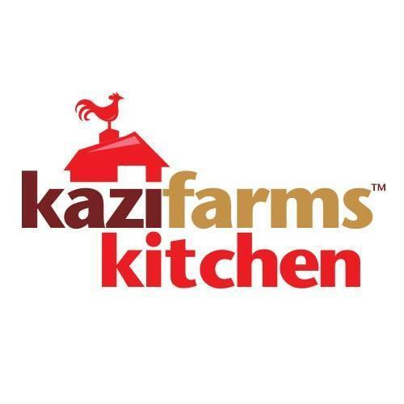
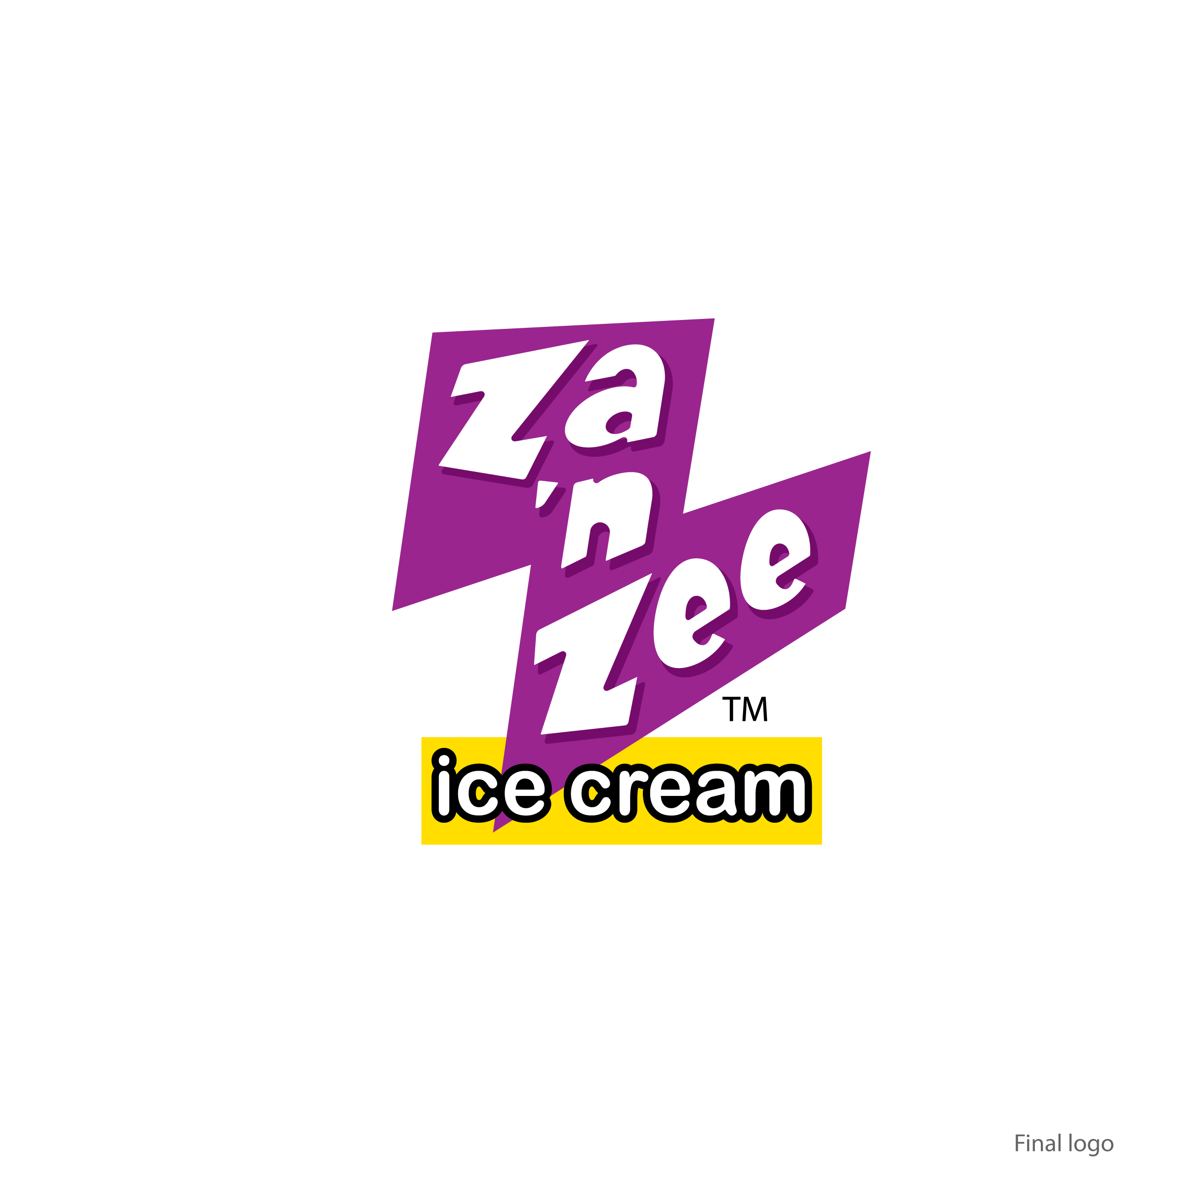

Internship Report
On
Product Management of Kazi Food Industries Limited

Submitted To:
Muhammad Hasan Al-Mamun
Assistant Professor
School of Business & Economics
United International University

Submitted By:
Ruka Binte Mirza
ID: 111 143 239
United International University
Submission Date: January 16, 2023

Letter of Transmittal

Muhammad Hasan Al-Mamun
Assistant Professor
School of Business & Economics
United International University

Subject: Submission of Internship on Product Management of Kazi Foods Industries Limited.

Dear Sir,
I am delighted to notify you that for the partial fulfillment of my BBA Program, my internship program at Kazi Food Industries Limited has been completed. I am submitting the internship report on Product Management of Kazi Food Industries Limited. This report will cover how the company handles product management of their three brands. I have placed my maximum effort to gain substantial experience and acquire information about the topic. I am submitting the report for your kind perusal and acceptance. I have learnt a lot which will help me in my practical life while preparing this report.
I will be obliged, if you kindly accept this report. It would be pleasure for me if this report can
serve its purposes and I will be available to explain your queries, if you feel necessary.

Sincerely,

___________________
Ruka Binte Mirza
ID: 111 143 239
School of Business & Economics
United International University

Table of Contents
Executive Summary 1
Part 1: Introduction 2
1.1 Introduction to the Background of the Report 2
1.2 Introduction to the Frozen Food Industry 2
Part 2: Organizational Background 5
2.1 Kazi Foods Industries Limited 5
2.2 Mission and Vision of Kazi Foods Industries Limited 6
2.3 Goal of Kazi Foods Industries Limited 6
2.4 Philosophy of Kazi Foods Industries Limited 6
2.5 Corporate Social Responsibility of Kazi Foods Industries Limited 6
2.6 Corporate Information Summary of Kazi Foods Industries Limited 7
2.7 Kazi Foods Industries Limited Factory 8
2.8 Kazi Farms Groups Management Profile 9
2.9 Kazi Foods Industries Limited Brands Overview 10
2.9.1 BELLISSIMO PREMIUM ICE CREAM 10
2.9.2 ZA ‘N ZEE ICE CREAM 12
2.9.3 KAZI FARMS KITCHEN 13
Part 3: Objectives and Methodology 14
3.1 Objectives of the Report 14
3.1.1 Broad Objective of the Report: The general objective of this report is to go over the product management of Kazi Foods Industries Limited. Hence; the product management of its 3 brands;- Kazi Farms Kitchen, Bellissimo, and Za n’ Zee. 14
3.1.2 Primary Objectives of the Report: The primary objectives of this report includes outlining and understanding the product management process of KFIL; which will include Product Development Processes and Product Marketing Processes. In short; 14
3.1.3 Secondary Objective of the Report:To break it down even further this report will aim to; 14
3.2 Methodology of the Report 14
3.2.1 Types of Data 14
3.2.2 Sources of Data 15
3.2.3 Limitations of the Study: 15
Part 4: Findings of the Study 16
4.1 Product Management 16
4.2 Product Development 17
4.2.1 IDEA GENERATION 17
4.2.2 RESEARCH AND DEVELOPMENT 17
4.2.3 TESTING 18
4.2.4 ANALYSIS 18
4.2.5 ROLLOUT 18
4.3 Product Marketing 18
4.3.1 INTRODUCTION TO THE THEORETICAL ASPECTS OF PRODUCT MARKETING 18
4.3.2 MARKETING MIX OF THE BRANDS 22
4.4 SWOT ANALYSIS 42
Part 5: Recommendations & Conclusion 44
5.1 Recommendations: 44
5.2 Conclusion: 45
Part 6: Bibliography 46

Executive Summary

This report on Product Management of Kazi Foods Industries Limited is completed based on the knowledge from the experiences gathered from this internship and the report provides actual information from the working procedures as well as the marketing and branding practices in Kazi Food Industries Limited.

The demands for the food and beverage industry are continuously increasing and because of this the industry itself in Bangladesh is growing rapidly. And due to this exponential growth, many competitors entered into this sector with new food and drink products. To stand out from these competitors, Kazi Food Industries Limited differentiates themselves by activities like collecting the raw material from their own sources, processing the materials with collaboration of foreign production managers, storing the final products, and supplying the products through distributors by developing an integrated product management value chain..

The basic intent of the report is to present the product management, which can be split in to product development and product marketing. It covers the strategies of Kazi Food Industries Limited to enhance the value of brand and product in a very complex and competitive environment (product development). Their product development process was found to be data-driven and market-oriented. Consumer perception of a number of alternative brands, advertising and promotional activities, market share and growth are also shown in the report (product marketing) as they affect the outcome of the marketing activities of Kazi Food Industries Limited. Finally, some suggestions were made in the form of recommendations so that the organization may improve its marketing performance and overall profitability.

Keywords: Product Management, Kazi Food Industries Limited

Part 1: Introduction

Introduction to the Background of the Report
Kazi Food Industries Limited (KFIL) is one of the highly recognized private food & beverages companies in Bangladesh. A frozen food leader of which I was a part of during my brief employment as intern which aided in my preparation of this report under the supervision of reliable executives and the team members of Kazi Food Industries Limited marketing & branding department. KFIL began its operations not so long ago in 2013 and since then have been applying appropriate product management and marketing techniques, which has helped it to become one of the leading foods and beverage providers in Bangladesh.
This industry of Food and Beverage has grown immensely as population increases at a rapid pace. As the industry grows so does the demand and KFIL has not just handled this demand in one sector with one brand; but it has 3 brands with 3 different product lines. For one company to handle 3 different product lines KFIL has fully synced its product management process and marketing aspects. In order to understand how KFIL has consistently develop new market offerings while maintaining their position for all three brands it is undoubtedly imperative to understand not only how product management plays an important role in an organization but also how it works in sync with the marketing mix and aspects. Which is the topic that will be covered in this report.

Introduction to the Frozen Food Industry
One of the industries in Bangladesh that are growing at an impressive rate is the Frozen Food Industry. The population of major cities in Bangladesh have been increasing at a rapid pace; with an increasing population comes a busier city life. Young people, couples, adults and all sorts of nuclear and secular families alike, all want easy and “ready to cook” meals that don’t take up much of their limited time. This is the main reason why the citizens of Bangladesh are happily adapting to all sorts of frozen foods and “ready to cook” meal options. KFIL has kept up with this with their most well known brand Kazi Farms Kitchen.
Where there is demand, there is competition! To stay ahead of it all companies have to be an adaptable leader. What is meant by that is they need to be first! First to come up with new innovative angles to their products. First to acquire maximum market share in a particular area. First to notice changes in consumers' consumption patterns and react accordingly to it. Kazi Farms Kitchen started its operations in this industry in November 2013 and has successfully done all the above.
The frozen foods domestic market in Bangladesh can be broadly divided into four broad segments;
- Frozen Ready to Cook Snacks- Quick, easy small portions of food; aka snacks. This includes traditional snacks like Aloo Puri, Dal Puri, Singara, Samosa, Spring Roll, Parata; as well as more westernized snacks like Fish Cakes, Fish Ball, Chicken Tenders, Meat Balls, Chicken Nuggets, Momos, burger patties.
- Frozen Ready to Cook Meat- Under this we can find large pieces of beef, mutton, lambs and chickens. These are currently available for order by institutions like fast food shops and restaurants.
- Frozen Ready to Cook Vegetables- The hassle of preparing vegetables can be completely avoided with frosted and flash frozen vegetables like JackFruit seeds, Bean seeds, Kakrol, Patol, and Ladies Finger.
- Frozen Ready to Cook Fishes- It's common to want fresh fish but in today's day and age ready to cook fish has also become popular. Currently the market includes Keski, Mola, Foli, Hilsa, Koi, Pabda, Baila, Batashi and Ayer.
Taking in account local and international companies, there are more than 20 competitors in the frozen food industry of Bangladesh. The growth and potential of this industry attracts much more competition each day. The competition includes;
Domestic Competition
Golden Harvest | Kazi Farms Kitchen
Brac’s | Crown Farm
Pran (Jhatpat) | Cp
Rich | Zay
Aftab’s | Sazi’s
Essensial | Abir’s
Bengal Meat | Food Papa
Lamisa | Ayamas
Paragon
Foreign Competition
Daux | Mccain
Ocean Ria | Al Khabeer
Jodi

In this highly competitive industry a company can only keep up with innovation, forward thinking and implementation. KFK understands this very well which is where their product R&D plays a key part to trying new products and updating old ones regularly.

Part 2: Organizational Background

2.1 Kazi Foods Industries Limited
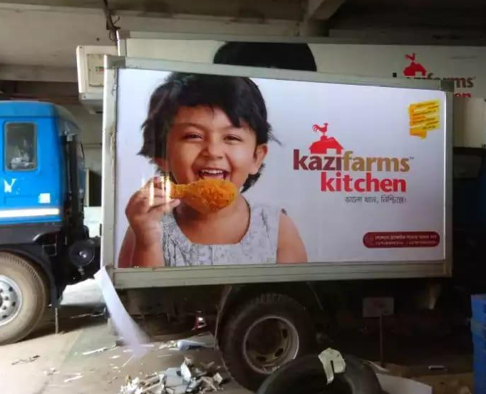
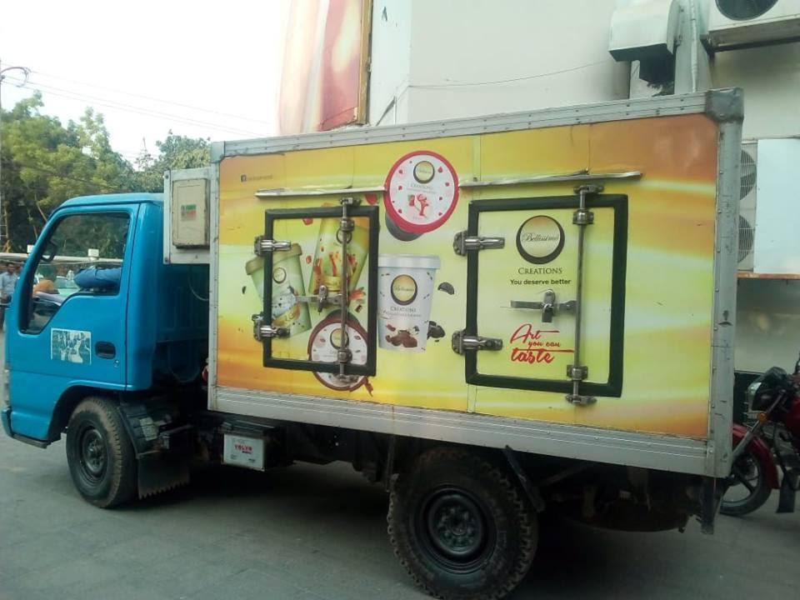
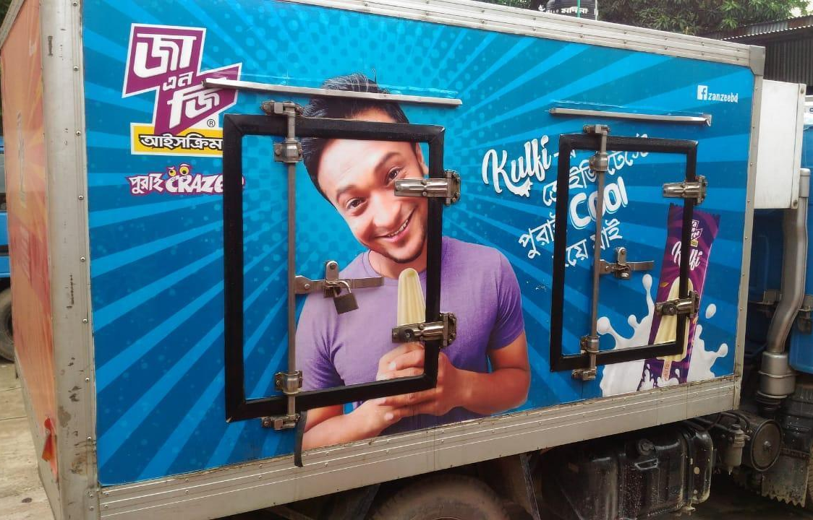
Kazi Farms Group started its venture, Kazi Foods Industries Limited in 2013 with a factory in Beron, Ashulia and head corporate office in Dhanmondi, Dhaka. Since then it has grown vastly and has increased its resources so that they can continue to provide the best quality of products and service that they are known for. Till date, they have 55 delivery vehicles, 12 depots, 300 dealers and distributors and now even a separate slaughterhouse in Gazipur so that cross contamination does not occur.
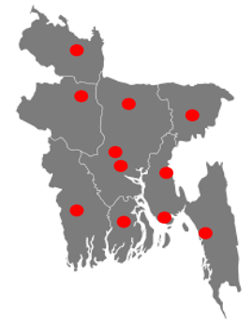
Its initial brand, Bellissimo Premium Ice Cream, was announced at the Dhaka International Trade Fair in 2013.
Kazi Foods Industries Limited also has second ice cream brand which is Za ‘n Zaa.
Both ice cream brands were established to develop specific product offerings to two different consumer segments.

Their most popular product offering however would have to be one that is non ice cream.
On to its most well-known brand, Kazi Foods Industries Limited produces frozen food products that are sold under the brand name Kazi Farms Kitchen.
Figure: Locations of Depots all Over Bangladesh

2.2 Mission and Vision of Kazi Foods Industries Limited
The mission of Kazi Foods Industries Limited is to provide consumers with food products that are innovative and are of the highest quality at affordable prices.

Its vision is to be one of the most trusted and well reputed consumer food companies in Bangladesh.

2.3 Goal of Kazi Foods Industries Limited
Kazi Foods Industries Limited's people, products and processes are aligned to meet the demand of their discerning customers. Its goal is to achieve a distinction like the luminaries in the sky. They strive to deliver quality that demonstrates a true reflection of their vision.

2.4 Philosophy of Kazi Foods Industries Limited
Kazi Foods Industries Limited believes in Innovations, Quality, and Rapid Progression.

2.5 Corporate Social Responsibility of Kazi Foods Industries Limited
Kazi Foods Industries Limited has two main educational concerns; Central Women’s University (www.cwu.edu.bd) and Kazi Zahural Huq College (kzhcollege.edu.bd).
Kazi Farms Group is the fundamental financial donor of Central Women’s University, which is the first only women private University established in Bangladesh. Kazi Foods Industries Limited also gives students of CWU priority when scouting for interns and for when hiring for vacant roles in its personnel.
Kazi Farms Group also contributes to the operation of Kazi Zahural Huq College in Mary Gopinathpur, Gopalganj, which has one of the highest pass rates of the district.

2.6 Corporate Information Summary of Kazi Foods Industries Limited
Name of Company: Kazi Foods Industries Limited
Company Type: Private Limited Company
Industry Type: Food and Beverage
Head Office: Ahmed & Kazi Tower, House 35, Road 2, Dhanmondi, Dhaka 1205
Factory: Beron, Ashulia
Establishment Year: 2013
Company Founder: Mr. Kazi Zahedul Hasan
Telephone: 880-2-9123432, 9134276, 9128062
E Mail: info@kazifoodindustrieslimited.com
Brands: Bellissimo
Za ‘n Zaa
Kazi Farms Kitchen

2.7 Kazi Foods Industries Limited Factory
On a large acre of land in Beron, Ashulia the factory of Food Industries Limited is established. There are three separate buildings for Bellissimo, Za ‘n Zee, and Kazi Farms Kitchens separate production & manufacturing. There is also a four storied administrative building for the officers, which has a board meeting room, hall room, prayer room, store room, and kitchen. The whole factory has a power generator system in a separate huge room..
Here is some data on the capacity of the factory;
- Production Area (Frozen) : 40,000 sq. feet
- Average Production Capacity (Frozen) : 150 MT/Month
- Production Area (Ice Cream) : 37,000 sq. feet
- Average Production Capacity (Ice Cream) : 16,50,000 Liter/Month
- RM Cold Storage Capacity (Frozen) : 20 MT
- FG Cold Storage Capacity (Frozen) : 20 MT
- FG Cold Storage (Distribution) Capacity (Frozen) : 20 MT
- Ice Cream Cold Storage Capacity : 80,000 Liter
- Ice Cream Cold Storage (Distribution) Capacity : 80,000 Liter

2.8 Kazi Farms Groups Management Profile
The founder and managing director of Kazi Farms Group is Kazi Zahedul Hasan. He was previously the founder and managing director of “Kazi Fashion Limited” for approximately twenty years before selling it in 2002 so that he could focus on poultry. As for his education, Mr. Hasan is an architect/engineer who has obtained his degree from Harvard University, USA. Progressing to his career he was a professor of the Department of Architecture at Bangladesh University of Engineering and Technology (BUET), Dhaka and in the School of Environmental Design, King Abdulaziz University, Jeddah, Saudi Arabia. He also has extensive experience as an architect in the USA and Saudi Arabia. He is a member of The American Institute of Architects as well as the Royal Institute of British Architects as well.

The Director of all companies in Kazi Farms Group is Dr. Perween Hasan. She has an M.A. in English from Dhaka University, and another M.A. and a Ph.D. (History of Fine Arts) from Harvard University, USA. Presently she is also a professor at the University of Dhaka.

The Director of Kazi Farms Limited and its sisters’ companies is Mr. Kazi Zeeshan Hasan and he is directly involved in maintaining the management of sales and raw materials purchases. He is well equipped for this responsibility as he has received training in feed milling and raw materials evaluation from Cargill Indonesia. He has completed his B.A. in Economics from Oberlin College, USA, his M. Theological Studies from Harvard University USA, and his M.Sc. (Management of Information Systems) from the London School of Economics, UK)

Mr. Kazi Zahim is also the director of Kazi Farms Limited and is the one responsible for the production operations of Kazi Farms Group for more than fifteen years. He has received training in poultry in the USA and Thailand. Prior to that he completed his B.A. (Economics) from Oberlin College, USA, and his Master of Public Administration degree from Columbia University, USA.

2.9 Kazi Foods Industries Limited Brands Overview

2.9.1 BELLISSIMO PREMIUM ICE CREAM

Premium ice cream was a concept unfamiliar to the population of Bangladesh before Bellisimo was introduced in January 2013 at the Dhaka International Trade Fair. The simple, natural, and original “ice creams” of Bangladesh, known to every child, would have to be the ice “gola and kulfi”. Bellissimo enhances this “all natural” idea and takes it to a premium level by using 10% milk fat and real ingredients.



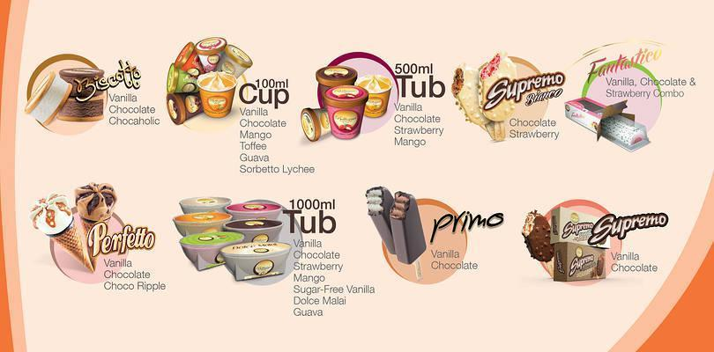

Bellissimo also has its sub brand, Bellissimo Creations, which are parlor ice cream flavors for its Bellissimo Cafe. The Café Flavors are made with natural flavors and 15% milk fat which enhances the creamy texture and flavor. So not only providing unique flavors but also maintaining the premium quality that Bellissimo is known for.

The Bellissimo Creations Café offers flavors unheard of like Mango Ripple, Vanilla Caramel Ripple, Vanilla Chocolate Brownie, Honey Almond among others, which can be taken as a scoop or cone. Different variations of the ice creams include sundaes, smoothies, shakes, floats and in combination with other baked desserts like brownies, pies, pancakes and waffles.
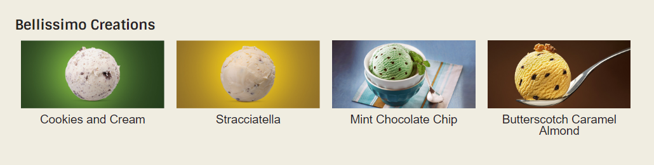

The points of interests of Bellissimo include;
- First premium ice cream brand in Bangladesh and has established a position as a premium ice cream brand in consumers’ eyes.
- The only ice cream brand in Bangladesh to use at least 10% milk fat and premium ingredients.
- Has successfully established a high level of awareness among the core target group and is a market leader of premium ice cream.
- Interesting, eye catching and well positioned billboards that capture consumers’ attention.
- Dominates in the digital communication media

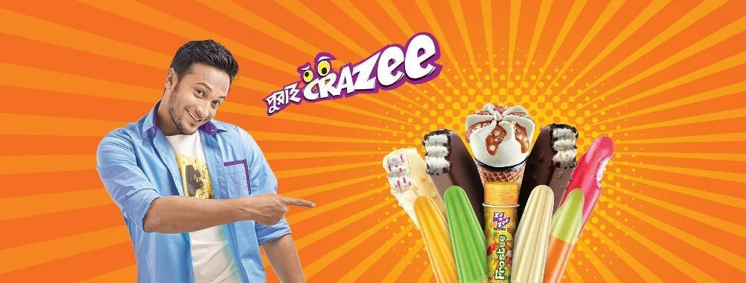
2.9.2 ZA ‘N ZEE ICE CREAM
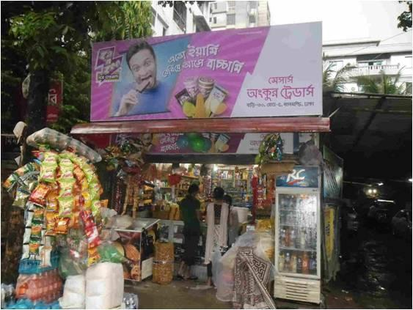
After establishing Bellissimo in the high end market Kazi Foods Industries Limited moved on to introduce Za ‘n Zee in order to provide a product offering to the masses. Za ‘n Zee has interesting and fun ice creams at reasonable prices for all ice cream lovers in Bangladesh. In order to appeal to the majority of the population the brand ambassador of Za ‘n Zee is Sakib Al Hasan.
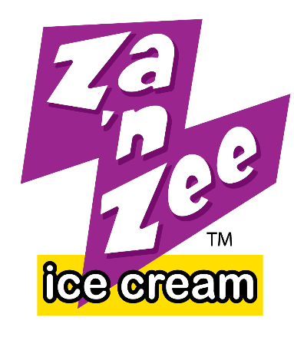
The points of interests of Za ‘n Zaa;
- Positioned as a new and exciting ice cream brand.
- Reached to the target market successfully.
- Interesting, effective placement and display of billboard, shop signs have captured the attention of consumers.
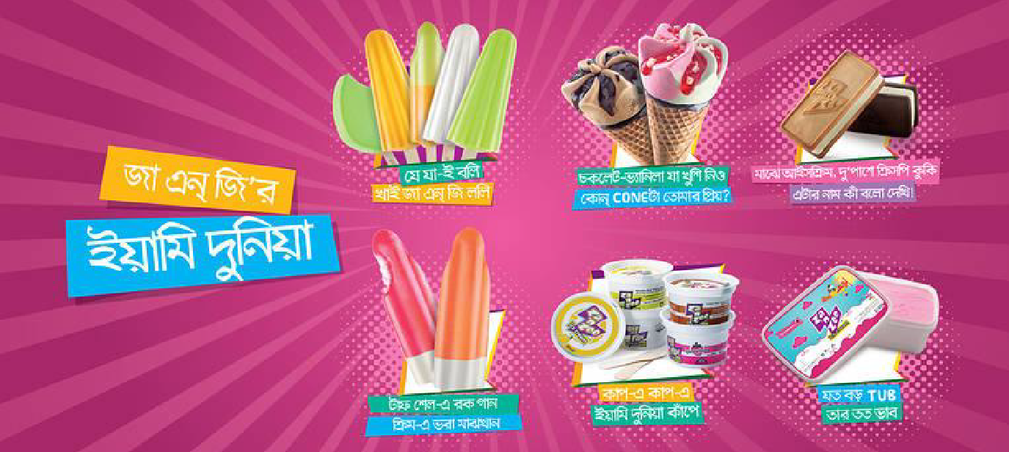

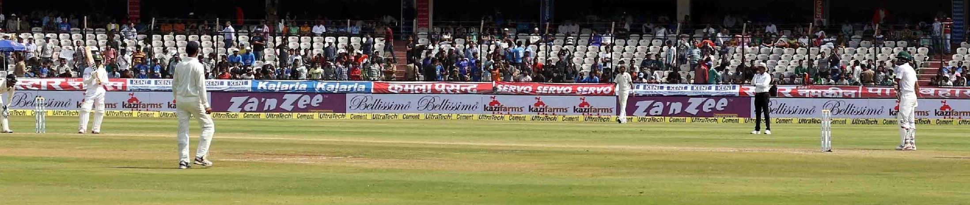

2.9.3 KAZI FARMS KITCHEN
The most well-known brand of Kazi Food Industries Limited can be argued to be Kazi Farms Kitchen. KFK brings ready to cook, ready to eat frozen food products to the market.
They initially launched in superstores in November 2013 and with resounding success they moved on to their first franchise outlet opening in October 2014. KFK franchises and frozen products are now loved by children, their parents and the public in general.
The reasoning of the wide popularity of the snack items of KFK would have to be the high standard of production that has been maintained. Starting from the beginning of the production line, the chicken that are used in the products are vegetable fed and there is no antibiotic residue in the meat. Also during manufacturing, none of their products have added MSG, Nitrate, or tasting salt. Nitrates are a preservative that could damage blood vessels and lead to heart disease, MSG and tasting salt are usually added to frozen foods to increase the flavor however have negative side effects on the consumer leading to various underlying illnesses. So KFK, thinking about the consumer first, does not add these ingredients which lead to an increased standard of production and the best quality.
Some of the other points of interests of Kazi Farms Kitchen include;
- One of the leading frozen food producers in the country and already a stand out brand in a saturated market.
- Around 100 franchise outlets in Dhaka and around Bangladesh.
- 100% halal to fit the Muslim majority of Bangladesh.

Part 3: Objectives and Methodology

3.1 Objectives of the Report

3.1.1 Broad Objective of the Report: The general objective of this report is to go over the product management of Kazi Foods Industries Limited. Hence; the product management of its 3 brands;- Kazi Farms Kitchen, Bellissimo, and Za n’ Zee.

3.1.2 Primary Objectives of the Report: The primary objectives of this report includes outlining and understanding the product management process of KFIL; which will include Product Development Processes and Product Marketing Processes. In short;
- To understand the Product Management & Product Development Process of Brands
- To understand the Marketing Concepts of STP and Marketing Mix

3.1.3 Secondary Objective of the Report:To break it down even further this report will aim to;
- Form a picture of Kazi Food Industries Limited (KFIL) and its 3 brands.
- To outline the product management cycle.
- The above will include product development; comprising of: idea generation, research and development, testing, analysis, and rollout.
- It will also include product marketing and the different marketing practices taken up by the brands of KFI.
- To relate real world practical experiences with theoretical knowledge.

3.2 Methodology of the Report

3.2.1 Types of Data
There are essentially two types of data used; which include Primary Data (data and information collected during my first hand experience at KFIL) and Secondary Data (information collected by a third party)

3.2.2 Sources of Data
The sources of data collected under each type of data include; personal observations, first hand experiences, office files, weekly reports, annual reports and interviewing individuals with knowledge of the frozen food industry and food industry for Primary Data. As for Secondary Sources they include websites and online articles.

3.2.3 Limitations of the Study:
To the best of my ability this report was done given certain circumstances which include the following limitations;
- Secondary sources of data are inaccurate and insufficient for my purpose.
- Company policies regarding Privacy of information.
- Due to unforeseeable circumstances of my immediate employment prior to my internship there was a delay in my ability to complete immediately. Due to this there may be discrepancies in the information that was collected during the time of my internship.

Part 4: Findings of the Study

4.1 Product Management
At its core, project management is a process that remains through the lifecycle of a product and consists of the development, marketing and sale of a product to the customer. Product management coordinates the product, the organization and the customers together.
The general business purpose of project management is to make the product value for its target market while also balancing and producing measurable remunerations; like profit margins and revenues. Another responsibility of project management is to provide information about a specific product to the entire company and extend the supply chain in combined efforts with the product life cycle. This helps create a coordinated well-balanced production system and also minimizes miscommunication and errors.

The person in the lead position of managing a product is normally referred to as the Project Manager. They are the individuals responsible for managing multiple teams that operationalize tasks and keep an eye on market conditions; in such a way as to guide the new features of a project in the direction towards catering for customer needs and to grab development opportunities. In the case of Kazi Foods during my understanding the individual that played a role most in line with that of a project manager was the General Manager. He mainly worked with the R & D department and Marketing making sure that what was being produced was represented to the target market in an effective way. As to fulfill the customers’ needs. He also works closely with sales managers and the directors to properly coordinate all activities during the lifetime of a product.
Product management specialists play a strategic role in determining the necessary actions for achieving these responsibilities and goals.

In order to do this there are multiple tasks involved in product management. They can be split into two different but balancing areas that work well together; Product Development and Product Marketing. These two areas must work together in order to get the most out of sales revenues and profit margins and, consequently, its market share.
In the following sections we will look at Product Development and Product Marketing more in detail.

4.2 Product Development

4.2.1 IDEA GENERATION
Idea Generation refers to the development of creative new offerings to satisfy new and constantly changing consumer needs. Organizations do not solely rely on personal brainstorming for ideas but also look in a number of places. These may include customer surveys, collection of customer requests, suggestions collected on social media, etc. During this whole process it is imperative we identify and understand market needs with questions such as;
Is there a gap in satisfied customer wants in a market? Corporations must analyze the market and see if there is any such consumer want that has not been satisfied by the current market offerings. One of the ideas that were generated during my time at KFIL was the “Ice Cream Log Cake” or later named Fantastico. KFIL noticed that the ice cream and frozen desserts market was lacking a premium ice cream cake and accordingly they developed one that not only tasted good but also set itself apart with its unique rigged log shape and combination of 3 flavors.

4.2.2 RESEARCH AND DEVELOPMENT
Without research a company would not be able to find new market opportunities, or ways to improve their current performance. Market Research also helps you identify areas of the failings of a company and how it may be improved on. It is also necessary to target the ideal consumer as well.
Things to keep in mind while conducting market research include; being aware about available data, source credibility, data relevance and sample sizes. There are multiple market research methods. At Kazi we used Primary Research mostly in the form of surveys, and focus group interviews. We would regularly gather a group of consumers and take feedback in order to get a better understanding of the current situation. Some Quantitative Research that we would use would include sales figures and financial trends. By keeping an eye on the sales of the products we would be able to see which are doing well and which maybe need more improvement and development.

4.2.3 TESTING
This stage is one that is very satisfying in the way that it is rewarding to finally see a generated idea turn into a prototype to be tested. Developing a prototype or a “test dummy product” lets a company dip it’s toes in the water before actually jumping in. It also helps to test the feel, outlook, and in our case the taste of any product to get a better understanding of if the product is ready to be available to the consumers or not. The testing stage for different prototypes at KFIL included multiple different recipes for new and old products all marked in different uniform bags. These would then be presented to a focus group and the reactions and feedback would be taken into account.

4.2.4 ANALYSIS
A prototype that passes the testing state then requires a more in depth business analysis. An analysis helps to determine the costs involved in the product development, and predict the profits that may be made from that specific product, in the future. The costs of developing a product are significant so analyzing the product is necessary. It will also help to eliminate non beneficial ideas and avoid needless costs.

4.2.5 ROLLOUT
A Product Rollout refers to an operations strategy, business strategy and marketing strategy that deploys a new product to their consumers. During new product launches KFIL promotes it via social media and different promotional offers at supershops.

4.3 Product Marketing

4.3.1 INTRODUCTION TO THE THEORETICAL ASPECTS OF PRODUCT MARKETING
- Segmenting, Targeting, Positioning (STP); The STP is usually implied to be a process where segmentation is done first and then one or multiple of these segmented target markets are chosen so that finally positioning of the product can be implemented. The steps, when working together properly, deliver a top-level marketing strategy. The strategy which is executed via the marketing mix.
The aim of the STP Process essentially is to steer the company to the development and proper implementation of an appropriate marketing mix
Before moving on to the marketing mix however, it is important to understand the breakdown of STPs into the three important marketing concepts;
- Segmenting: Market Segmentation is the method of splitting a complete market into different sets based on consumers having similar qualities. In the past “mass marketing” was more commonly used rather than segmentation; it would assume that one singular marketing mix would appeal to the majority of the population. However, this approach was not effective and is no longer suitable; hence segmentation is used in order to meet the needs of selected target markets. This allows marketers to give a customized approach to meet each the needs of each group according to the characteristics they have been segmented by. There are many ways to split target markets;
  - Demographic- personal attributes such as age, marital status, gender, ethnicity, education, or occupation.
  - Geographic- by country, region, state, city, or neighborhood.
  - Psychographic- by personality, risk aversion, values or lifestyle.
  - Behavioral- by consumer loyalty, benefits they seek, or how they use the product.
- Targeting: After segmenting the markets then comes the process of reviewing, evaluating, and selecting specific markets. A target market is one or multiple market segments that has been intentionally selected by a corporation, with the intention of concentrating and specializing their marketing efforts. There are multiple assessment factors that Kazi Foods Industries Limited also utilizes, when analyzing a specific market;
  - Strategic Direction- this includes expectations of magnitude of goals and alignment of proposed market strategy with the firm's strategic direction.
  - Structural Attractiveness- this includes the situation of competitors and availability of appropriate distribution channels.
  - Financial Issues- this includes segment size, possible segment growth rate, and profit margins.
  - Opportunity Cost- the range of other opportunities available for growth to the firm.
  - Marketing Expertise- this includes capability to develop market appropriate products, role of brand and its current place and possibility in the market and are there resources available to enter the market.
- Positioning: After targeting comes the next step to decide how the product is planned to be perceived in the chosen target markets. This distinct and clear consumer “mental image” of the product is built by the company via the designing and promoting of their products. This promotion is done by highlighting various selling points, product features, competitive advantages, and benefits. If companies can create a distinct and clear product positioning then the product becomes the product of choice for the specified target market. In layman terms it becomes the consumers “go to” brand for that product.
- Marketing Mix
The Marketing Mix and 4Ps were established over time by specialists to guarantee the formation and implementation of a successful marketing strategy. The main try is to satisfy both the customer and the seller. When properly understood and utilized, this mix has proven to a key factor in a Marketing Mix product’s success.
The popularity of the marketing mix concepts rooted from an article titled “The Concept of the
Marketing Mix” by Neil Borden published in 1964. The author described how he started using the
term inspired by James Culliton who in the 1940s described the marketing manager as a “mixer
of ingredients”. Borden’s article detailed these ingredients as product, planning, price, branding,
distribution, display, packaging, advertising, promotions, personal selling among many others.
Eventually E. Jerome McCarthy gathered these many items into four high level groups
that we now know as the 4 P’s of marketing. “Its elements are the basic, tactical components of
a marketing plan”. Together, elements in these four categories help develop marketing strategies
and tactics.
- The Four Ps
- Product: When we refer to products, we refer to a tangible good or an intangible service that is designed to meet a specified customer need or demand. It is key to identify the potential customer then understand the problems they are facing and how the product will attempt to solve said problems. The product offerings or “benefits” along with all its features need to be developed in such a way that it is serving what the customer wants. The company must also understand the product benefits and develop an understanding of how they will present their unique selling propositions to the identified potential buyers. Additionally, all products go through a rational product lifecycle and it is vital for marketers to recognize and develop a strategy for the various stages and their unique challenges.
- Price: The price is an important factor that directly affects the sales of a product as it is the actual monetary amount that the consumer is expected to pay for a product. The effect on sales is linked to the “perceived value” (how useful the offering from the viewpoint of the customers) of the offering in the customer's eyes rather than the actual objective product costing. If the product is priced without considering the perceived value, it will not sell to its potential. If there is a positive perceived value then a product's sale may be successful even with a higher price (monetary value). On the other hand, if the perceived value is less then in order to make sales it may need to be underpriced. Other than having an impact on sales, price may be impacted by competitors’ price, distribution plans, and the overall value chain costs.
- Place: The key element of placement is distribution. The distribution and placement strategy will help to assess what channel is the most suited to a product. An important factor that needs to be in sync with the strategy is how a product is to be assessed by the end user. What is meant by this is that if the product is perceived to be high end then it would be wiser to not make it as widely available as, let’s say, a regular everyday household commodity. In the case of the household commodity, since the customer perceives it as more of a necessity; the wide availability would be a convenience and thus have a positive impact on sales.
- Promotion: The marketing communication strategies and practices all can be found under the promotion heading. It is important to understand that promotion is just the communication aspect of the entire marketing function. There are multiple communication channels that may be used like special offers, public relations, sales promotions and advertising. It is vital for the correct channel to be used in correspondence to the suitable product, price and end customer.
- The Extended Marketing Mix (The Other Three Ps)
- People: The people inclusive and in relation to an organization are just as equally important as all the other elements of the marketing mix. It is vital to make sure that employees represent and are in sync with the company’s broader message.
In the case of a services, such as (for example) in the education industry, people themselves are the product. When this is the case, each individual has an effect on the public perception of an organization as much, as a tangible good would have.
To ensure that people align with the company’s image and represent a favorable perception they must be treated fairly and earn sufficient benefits and financial wages to support their daily lives. Also, an organization must hone their ability to select, recruit, hire and retain the appropriate individuals, with the skills and abilities to do the job.
- Process: Process denotes to the all the procedures involved in delivering the product benefits to the end customer. It can represent the steps taken by an employee when doing their job. I can also be that some people a/ re responsible for managing more that one process at a time; a lot of the time this can be seen in the case of managers in an organization who are in general required to overlook multiple aspects. Having good processes in place will help to consistently deliver the same standard to customers while simultaneously increasing efficiency by saving time and money.
- Physical: This refers to the non-human, tangible aspects of the customer encounter; including equipment, furniture, facilities, interior design, color schemes, layout, etc. Some physical evidence may also be lasting proof that the service has taken place like invoices, mementos, souvenirs, etc. Tangible goods are proof of to what extent the seller has provided the customer with what they were expecting; this is why physical evidence is important to customers. The more attractive the physical environment that encompasses a product is, the more people are willing to take part.

4.3.2 MARKETING MIX OF THE BRANDS
Marketing Mix of Bellissimo Premium Ice Cream
- Product:
The target of Bellissimo was to create ice cream that was dense, creamy, flavorful and that could meet international standards of ice cream. The dedication towards international quality ice cream led them to use real ingredients and a higher percentage of milk fat which also lead to developing new flavors and textures.
There are a variety of options like classic well-loved flavors like vanilla to more fun, less common flavors like Butter Chocolate Almond and Vanilla Chocolate Almond Crunch. By providing a wide variety Bellissimo provides a flavor for all taste buds. Five forms of ice cream Bellissimo provides are stick ice cream, cone ice cream, premium cup ice cream, log ice cream and sandwich ice cream. Their Bellissimo Ice Cream Parlor flavors are also available as Bellissimo Creations in tubs. Consistent innovation and research is also being done to develop new flavors and forms of ice cream at Bellissimo.

Categories | Flavors
1 Liter Container | Premium –Mango  Premium –Strawberry  Premium –Chocolate  Premium –Vanilla  Premium- Guava  Dolce Malai  Sugar-free Vanilla
Bellissimo Creations | Vanilla Fudge Brownie  Chocolate Midnight Cookies  Strawberry Cheesecake  Cookies and Cream  Stracciatella  Mint Chocolate Chip  Butterscotch Caramel Almond  Mango Ripple  Honey Almond  Strawberry Ripple  Vanilla Chocolate Almond Crunch  Chocolate with Chocolate Ripple  Bellissimo Mocha  Vanilla Caramel Ripple  Classic Mango  Mango Sorbet  Vanilla Chocolate Chip  Coffee Chocolate Chip  Vanilla Chocolate Brownie  Dark Chocolate Chip  Classic Vanilla
Cone | Perfetto- Vanilla  Perfetto- Chocolate  Perfetto- Strawberry
Cup 100 ml | Premium Vanilla  Premium Chocolate  Premium Strawberry  Premium Mango
Ice Cream Log | Fantastico
Ice Cream Sandwich | Biscotto Strawberry  Biscotto Vanilla  Biscotto Chocolate
Stick | Supremo Bianco  Supremo Nano Strawberry  Supremo Nano Chocolate  Supremo Nano Vanilla  Supremo Strawberry  Supremo Chocolate  Supremo Vanilla
Tub 500 ml | Premium Vanilla  Premium Chocolate  Premium Strawberry  Premium Mango

- Place:
Bellissimo has 13 distribution centers and about 200 dealers all over Bangladesh to help with the distribution to super shops, retails and franchised outlet (there are about 70 KFK franchised outlets that carry Bellissimo Ice Cream). The products are distributed using a cold chain.
There are a few different ways that Bellissimo Premium Ice Cream reaches customers.
The first way of distribution is direct distribution; by selling directly to the consumer through events of occasions like weddings or parties.
Consumer
Producer/ Manufacturer

Another way in which customers may receive Bellissimo is through retailers; for example, when consumers buy from their local shops.
Retailers

Producer/ Manufacturer

Consumer

On the contrary retailers may acquire their supply through wholesalers; through distribution through wholesalers.
Retailers
Wholesalers
Consumer

Producer/ Manufacturer

- Price:
The pricing of Bellissimo is on the higher end as it has established itself as a “premium” brand that incorporates high quality ingredients. Due to the relatively higher manufacturing costs each product is priced in a way that is reasonable in comparison to the value of the product.

The following is a concise list of prices;
Category | Name | Volume | Carton Size | Piece Price (MRP Tk.) | Carton Price (MRP Tk.)
1 Liter Container | Premium  Premium Guava  Premium Toffee  Dolce Malai  Sugar Free Vanilla  Mango Yoghurt | 1000 ml | 1 | 325  380  380  380  425  375 | 325  380  380  380  425  375
Bellissimo Creations | Creations | 900 ml | 1 | 395 | 395
Cone | Perfetto | 121 ml | 10 | 70 | 700
Cup 100 ml | Premium | 100 ml | 12 | 40 | 480
Ice Cream Log | Fantasico | 733 ml | 1 | 375 | 375
Ice Cream Sandwich | Biscotto | 54 ml | 16 | 30 | 480
Stick | Supremo Nano  & Supremo | 70 ml (Nano)  102 ml (Supremo) | 24 (Nano)  12 (Supremo) | 50 (Nano)  70 (Supremo) | 1200  840
Tub 500 ml |  | 500 ml | 1 | 170 | 170
- Promotion:
Bellissimo gives a high importance on promotion in order to make its target customers aware about its products and services. They use different types of media for promotion like digital media, physical environment and traditional practices. The majority of promotional activities are run via outsourcing to a third party who assists them in visualizing promotional tools.
The following include some digital promotional and engagement tools used by Bellissimo;
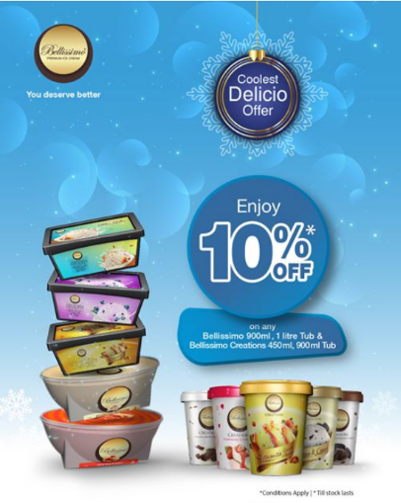
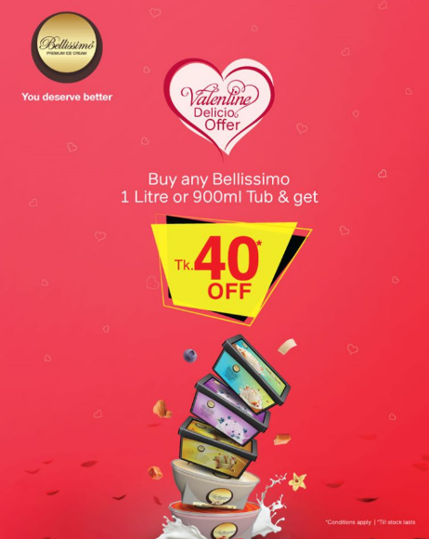
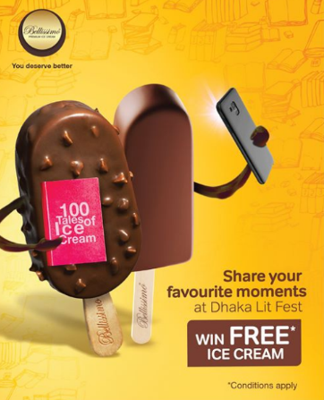

Promotional activities are also held in physical environments at special events like concerts, festivals, trade shows, and in super stores of departmental stores. These promotional activities along with interaction in the field allow for spontaneous purchases.
Some of the tools used include;
- Sponsorships; Bellissimo Premium Ice Cream sponsors different fairs, magazines, concerts, movie premiers, science fairs, and academic functions through either financial contributions or by providing products. This helps maintain brand awareness among the target market.
- Brand Promoters; Bellissimo Premium Ice Cream is represented at various events via brand promoters. These promoters are outsourced individuals that persuade sales, share information about the brand and have answers to the queries that a customer has.
- Superstore Activation; Bellissimo Premium Ice Cream conducts superstore activations when a new product is launched or offers are available in order to increase awareness about these offerings. Since the customers are unaware of the new offerings or discounts usually these are promoted by a promoter in order to stimulate sales.
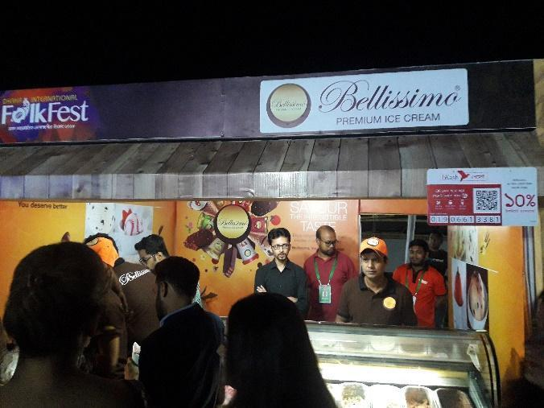
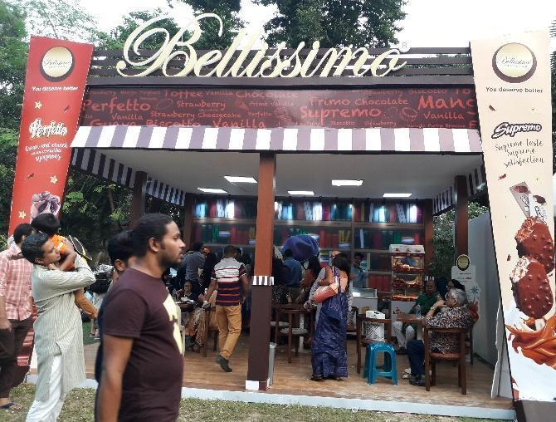

As for traditional media, this includes print media (newspapers and magazines), electronic media (radio and television) and outdoor media (banner and billboards).
A breakdown in reference to Bellissimo;
- Advertisements; Initially advertisements were focused on to create demand for the company. As the demand increases they are further increasing focus in order to remain in the eyes of the customer. The broadcast of products was prevalent in a few TV Channels however the shift has also changed to TVCs that can be run on their YouTube Channel.
- Radio Commercial (RDC); Commercial Radios make a majority of the revenue by selling airtime to advertisers; through radio commercial endorsement. The endorsed product is usually spoken about by the RJ during the allotted time.
- Point of sales material advertising; POS (Point of sale) materials advertisements are proposed for enticing attention and promoting brands precisely at points of sale. The primary goal of POS-materials is in persuading the consumer to make a purchase. Bellissimo Premium Ice Cream use different point of sales materials like attractive bill board, light box, poster, X banner, festoon, dangler, press ad, cut out, leaflet etc. to attract customer.
- Digital Media & Marketing; Digital media comprises of, but is not limited to the use of internet, social networking and social media sites. It is a modern way for brands to interact with consumers quickly as it releases news, information and advertising from the technological limits of print and broadcast infrastructures. Bellissimo Premium Ice Cream gives much significance to digital marketing also for the suitability of this media to attract target customers. Their website ‘www.bellissimobd.com’ surrounds all the data about their product and services. They have a Facebook page named ‘Bellissimo’. This page helps keep their targeted customers updated about their new offerings, discounts, opening of new franchise outlets etc.

- People;
People are essential and companies are reliant upon them; from the sales staff to the managing director every human is an asset. It is crucial to invest in good human resources as they are as much a part of your business offering as the physical manufactured product.
Under the careful supervision of its resilient management team Bellissimo implements its daily business activities with a harmonized workforce. Employees perform their specific activities in teams;
- Production Team- the production team of Bellissimo comprises factory employees who are responsible for producing the ice cream according to sales demand, a forecast of which is given by Bellissimo management team.
- Accounts Team- accounts team is in authority of keeping up different accounts of Bellissimo Premium Ice Cream like costs, income, etc.
- Key Account Team- Bellissimo Premium Ice Creams Key Accounts team is responsible for corporate sales (selling large amounts of products in super shops like Unimart) and maintaining frozen food items in various super shops, department stores, and retail stores. They also are continuously exploring new opportunity of investment like events to sponsor or opportunities to give company branded freezers to retail or super shops.
- Franchise Team- The franchise team is responsible for making sure that the Kazi Farms Kitchen outlets that carry Bellissimo Ice Cream, always have it available for customers. Apart from that they analyze the opportunities to establish franchise stores in different areas based on the potential demand of that area (taking into factors like demand, customer buying power, population, capability of franchise, etc.)
- Research and Development- The Research and Development team looks after developing new products, improving existing products, observing market conditions, and changes in customer behavior, needs and demand. Always coming up with new innovation will insure sustainable business growth.
- Sales- The sales team confirms the sale of products to the dealer and retailer who eventually sell the products to the final consumers. Different benefits and rewards are associated with a fixed target number of sales given to each sales employee, so that they are motivated to achieve that number. To further increase motivation to sell, in turn sales, employees get bonus, rewards, and promotion based on their performance.
- Marketing and Branding- The marketing and branding team was the section responsible for performing marketing activities to increase brand awareness. Advertising, promotion, communication and positioning Bellissimo in the mind of consumers is the main goal of the marketing and branding team.

- Processes;
The two different forms of Bellissimo, Bellissimo Ice Cream and Bellissimo Creations, have two different process;
- Bellissimo Ice Cream is sold in different super shops, retail stores, department stores and KFK franchise outlets. Customers choose their preferred ice cream items on their own or with the assistance of the sales person and then pay for it; thus completing the purchasing processes.
- Bellissimo Creations are sold in tub containers and also available in the Bellissimo Café in scoops or in different desserts. Customers give their flavor preference order to the salesperson to have in their preferred way. If the ordered items are ready to serve it is given to the customer instantly. If the ordered item is not ready to serve like in the case of brownies or waffles, then the customer will have to wait till it is freshly prepared.

- Physical Evidence;
This includes the material part of service and it is important as customers tend to rely on physical cues to help them evaluate the product before they buy it. In the case of Bellissimo the physical evidence is represented by the promises to customers wellbeing by upholding a positive atmosphere. We can consider the design of point of sale material (billboard, sticker & X banner) and freezer as certain components of the physical evidence.
Another place we can see that physical evidence comes into play would be at the Bellissimo Cafes. The sales people are providing a service of preparing the dessert ordered by the customers. The physical evidences that are present here would be the atmosphere of the café, the furnishings and decorations.

Bellissimo Premium Ice Cream Target Market;

Demographic
Age | No Limit
Gender | Male and Female
Occupation | All
Marital Status | All
Income | >10000 Monthly
Education | All
Geographic
Country | Bangladesh
Psychographic
Social Class | Higher Middle Income and above

Consumer Opinion on Bellissimo Premium Ice Cream
Bellissimo has established themselves in their target market of the urban areas and higher middle class and above income groups. And they have accordingly catered very creatively, efficiently, and consistently. They have also used their financial resources well by minimizing wastage and maximizing attention using viral, digital platforms.

Marketing Mix of Za ‘n Zee Ice Cream
- Product; Fun loving, exciting, crazy were the impressions that Za n’ Zee was introduced with as a new ice cream brand initially. It aims to connect to the inner juvenile personality of the customers. With its new thrilling image, it has established good competition with other already established renowned ice cream brands.
As Bellissimo had already targeted the high-end market, Za ‘n Zees main target market is children and the young generation and they are focused on providing a reasonable price on a customer satisfying product.
Za ‘n Zee Ice Cream has six types of different ice cream products; Stick Ice Cream, Cone Ice Cream, Cup Ice Cream, Cake Ice Cream and Tub Ice Cream.
- Price; Za n’ Zees prices are reasonable but it doesn’t compromise high quality. Each product is priced fairly to its value and provides options available to the range of target consumers.

Category | Product | MRP of Per Pc (BDT) | Size of Ctn | MRP of Ctn (BDT)
Stick | Mango, Strawberry, Chocolate, Vanilla  Eureka  Epic  Doodh Malai  Rock & Roll  Za n’ Zee Vanilla Bar  Ice Lolly Heart Shaped (Orange and Lemon and Ice Lolly Leaf Shaped (Mango and Lemon) and Ice Lolly Rocket Shaped (Orange, Lemon, Mango, Mango and Lemon)  Ice Lolly Umbrella Shaped (Orange/Lemon/Mango) and Ice Lolly (Green Mango and Lychee) | 20  40  35  16  18  25  15  12 | 18  24  24  24  20  24  20  24 | 360  960  840  384  360  600  300  288
Cone | Vanilla, Chocolate,  Vanilla+ Chocolate, and Vanilla+Strawberry | 40  40 | 12  12 | 480
Sandwich | Za n’ Zee Ice Cream Sandwich | 20 | 18 | 360
Tub 500ml | Vanilla, Chocolate, Strawberry, Mango and Banana | - | - | MRP of per Tub: 100
Tub 1000ml | Vanilla, Chocolate, Strawberry, Mango and Banana  Double Fundae and Shahi Malai | - | - | MRP of per Tub: 210  270 and 290
Tub 2000ml | Vanilla, Chocolate, Strawberry, Mango, and Banana | - | - | MRP of per Tub: 350
Tub 5000ml | Vanilla, Chocolate, Strawberry, Mango | - | - | MRP of per Tub: 775
Cake | Za n’ Zee Ice Cream Cake (Triple Rocker) | MRP of 1 cake: 280 | - | 280

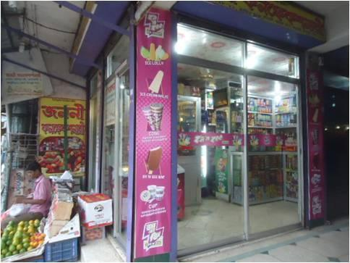
- Place; Za ‘n Zee has 13 distribution centers around the country and about 200 dealers to help distribute. Za ‘n Zee uses the similar distribution channels as Bellissimo; direct, retailers and whole sellers. Being able to supply to a wide number of areas ensure that consumers will opt for the product due to convenience.
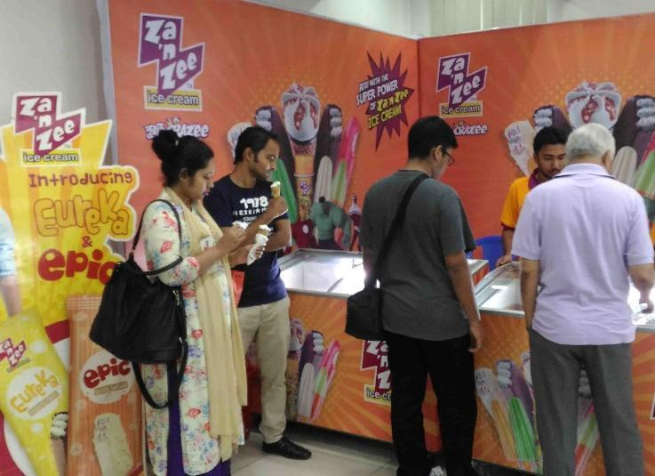
- Promotion; Za ‘n Zees loud image is always maintained in its promotion activities through the different promotional channels. Maintaining the same image throughout various channels forms a clean, streamline, not confused imprint in to the consumers’ mind that allows them to recognize Za ‘n Zee of the bat. Speaking of bat, the brand ambassador is nationwide loved, cricket star, Sakib Al Hasan. Thanks to the coordinated marketing and use of Sakib Al Hasan, when consumers hear “purai crazee” they immediately associate the good feelings to Za ‘n Zee.
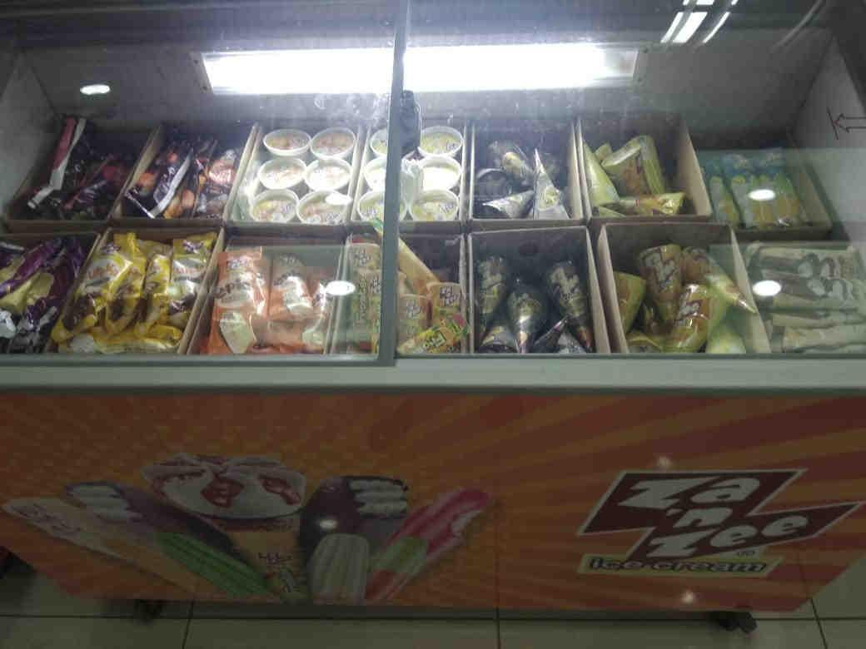
Similar to Bellissimo, Za ‘n Zee helps promotion in physical environments such as festivals, concerts, and in the field like grocery and departmental stores. They sponsor different events such as Toycon, other festivals, or concerts. Sponsorships may be financial of by providing the product at said event. When product sponsoring takes place, they usually use brand promoters at such events so that they could provide the customers with all the relevant information and promote sales.
Traditional Media promotion also takes place for Za n’ Zee as well; like radio, television, banner, and billboards or posters, festoons, cutouts, X banners (for point of sales material advertising). Digital Marketing is a highly looked after method of promotion as well. Through their website, Youtube and Facebook page, “Zaa ‘n Zee” they keep engagement with consumers and update them regarding any new offerings, discounts, etc.
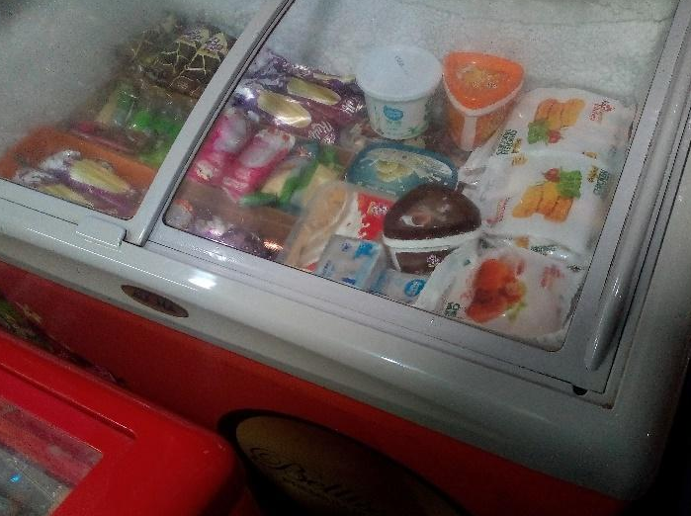

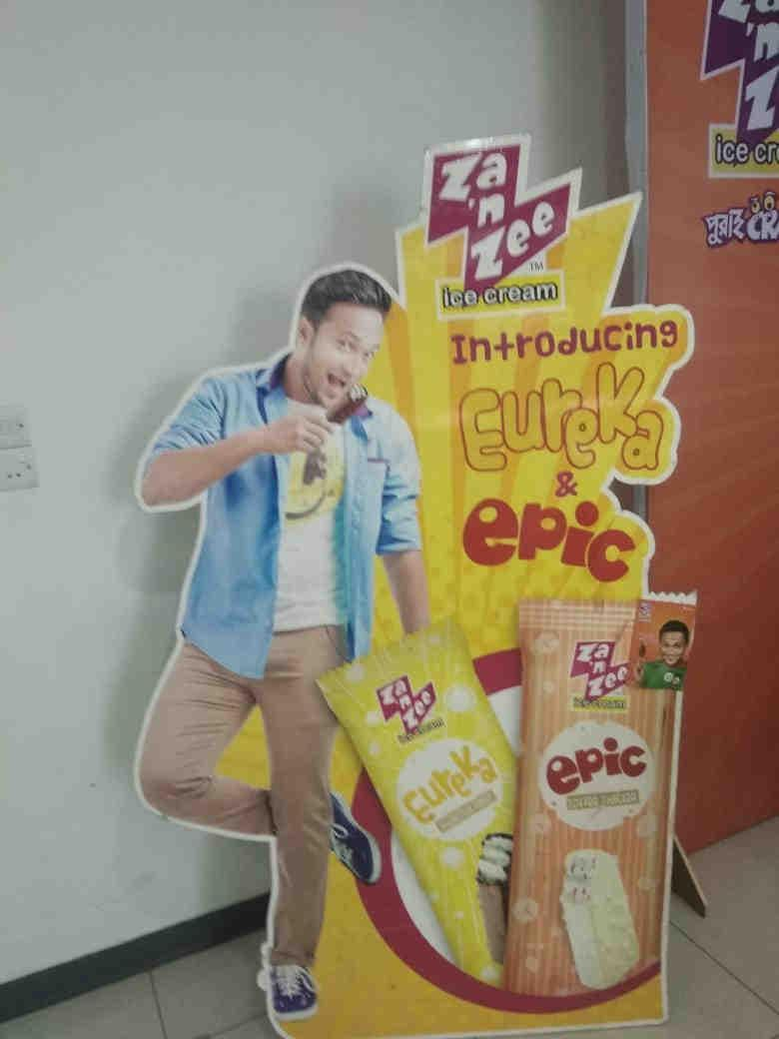

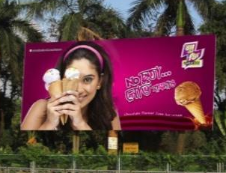

- People; Under Kazi Foods Industries Limited all the coordinated teams; production team, accounts team, purchase team, key accounts team, research and development team, sales team, marketing and branding team; all work together to make sure that all processes run smoothly (from production to marketing to sales).
- Processes; Za ‘n Zee Ice Cream, unlike Bellissimo, offers their products in a single form. The products are sold in various super shops, retail stores and department stores from where customers can buy to their own accord during their regular shopping.
- Physical Evidence; In reference to Za ‘n Zee the physical evidence would be the design of point of sale material like billboards, stickers, branded freezers and X banners
Za ‘n Zee Ice Cream Target Market;
Demographic
Age | Children to Young Adults
Gender | Male and Female
Occupation | All
Marital Status | All
Income | >5000 monthly
Education | All
Geographic
Country | Bangladesh
Psychographic
Social Class | Middle income and lower families

Marketing Mix of Kazi Farms Kitchen
a) Product; Products of Kazi Farms Kitchen are produced in its own plant located in Baron, Ashulia. Kazi Farms Kitchen has these types of products -Meat-based Frozen Products, Fish-based Frozen Products, Flour-based Frozen Products, Dried Fish Products, Jam-Jelly and also Fresh Eggs.
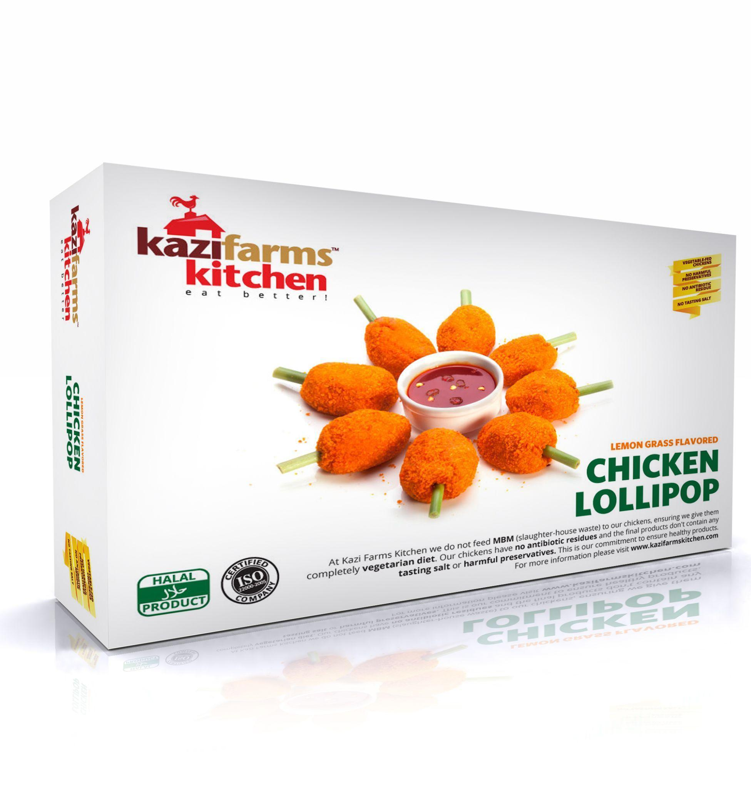
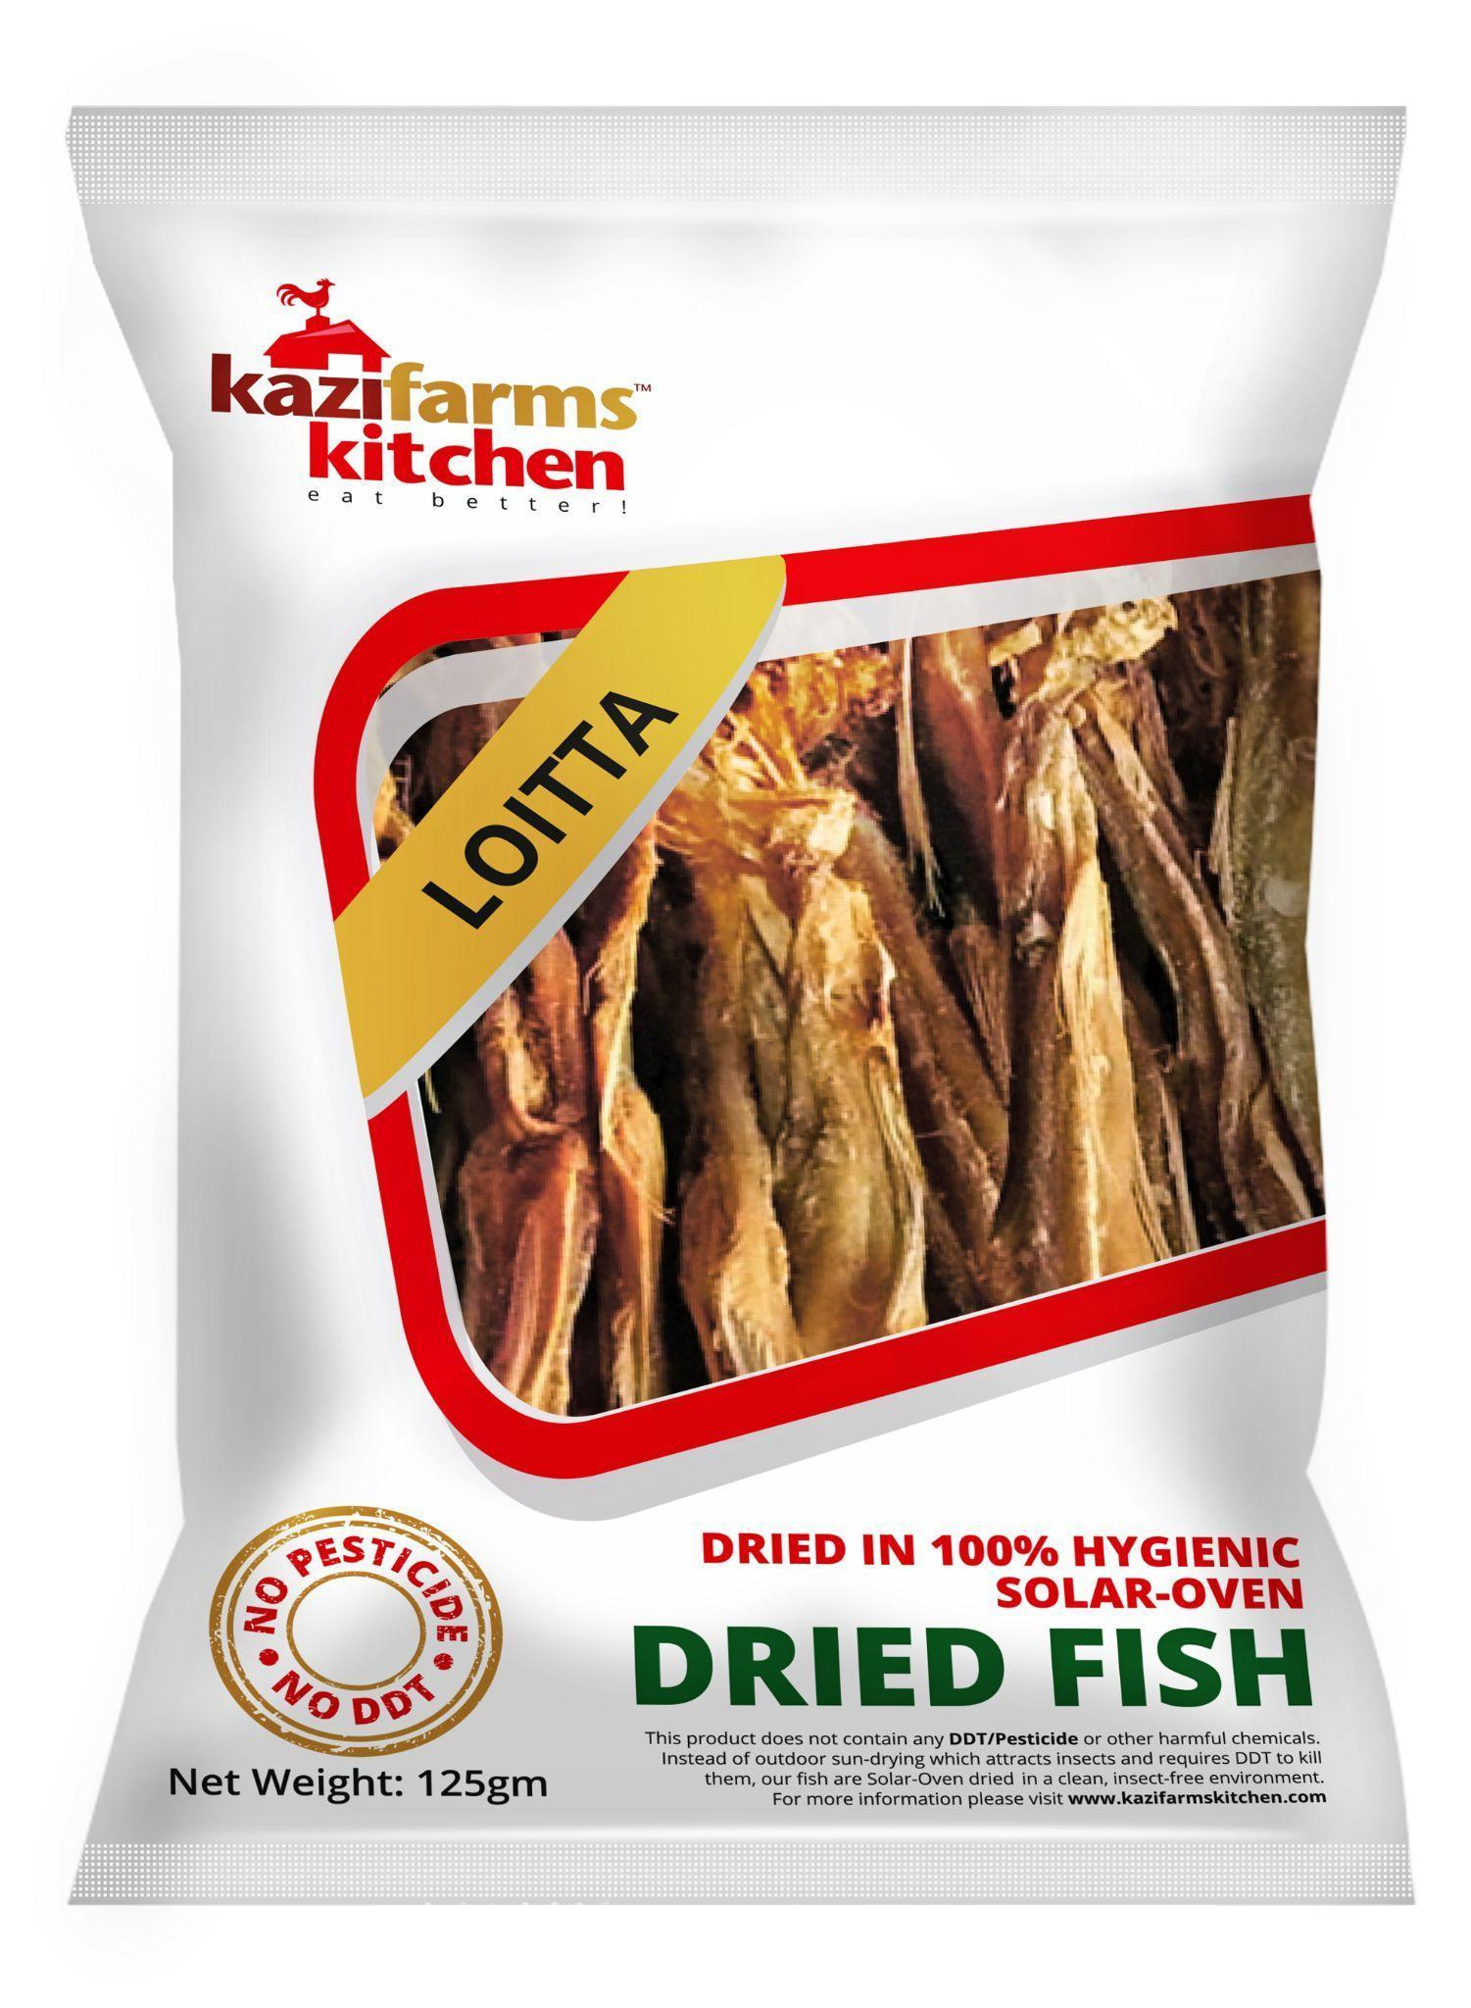
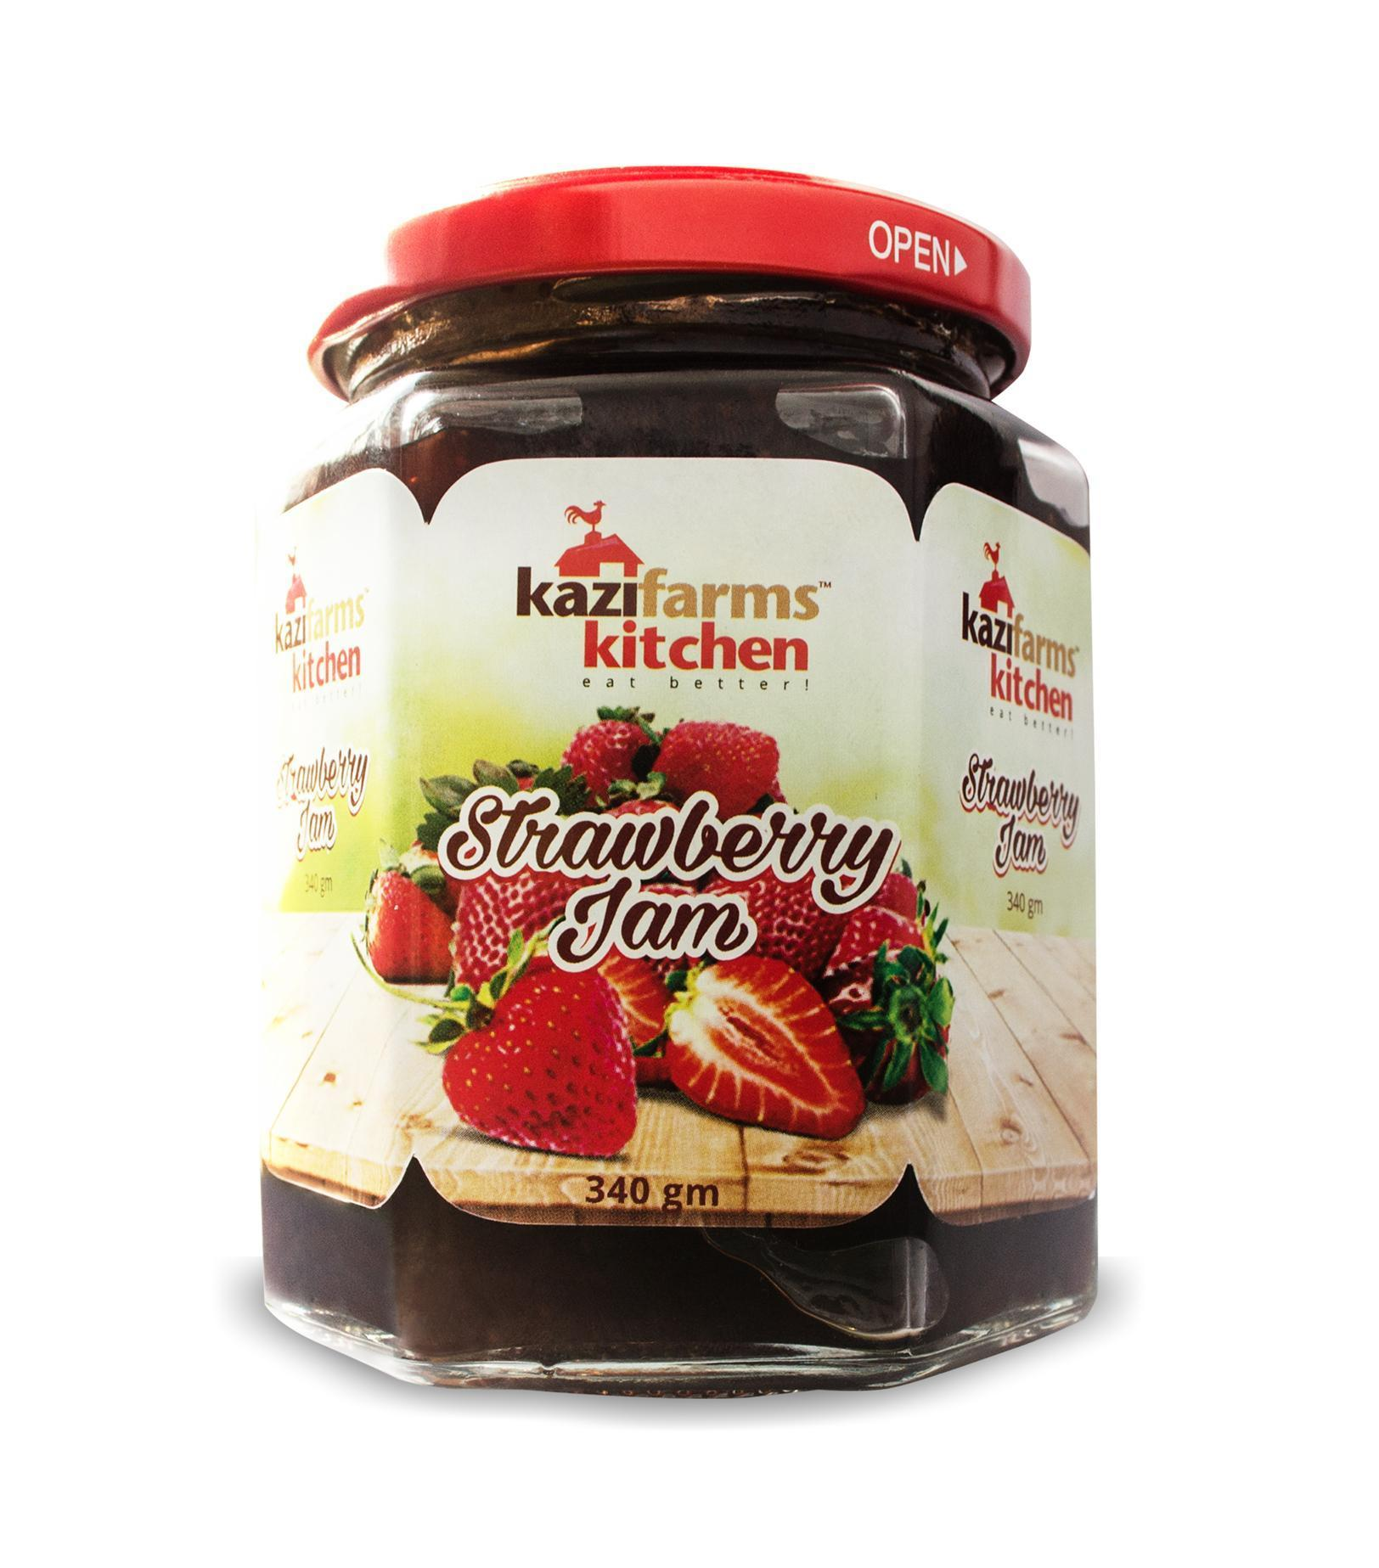

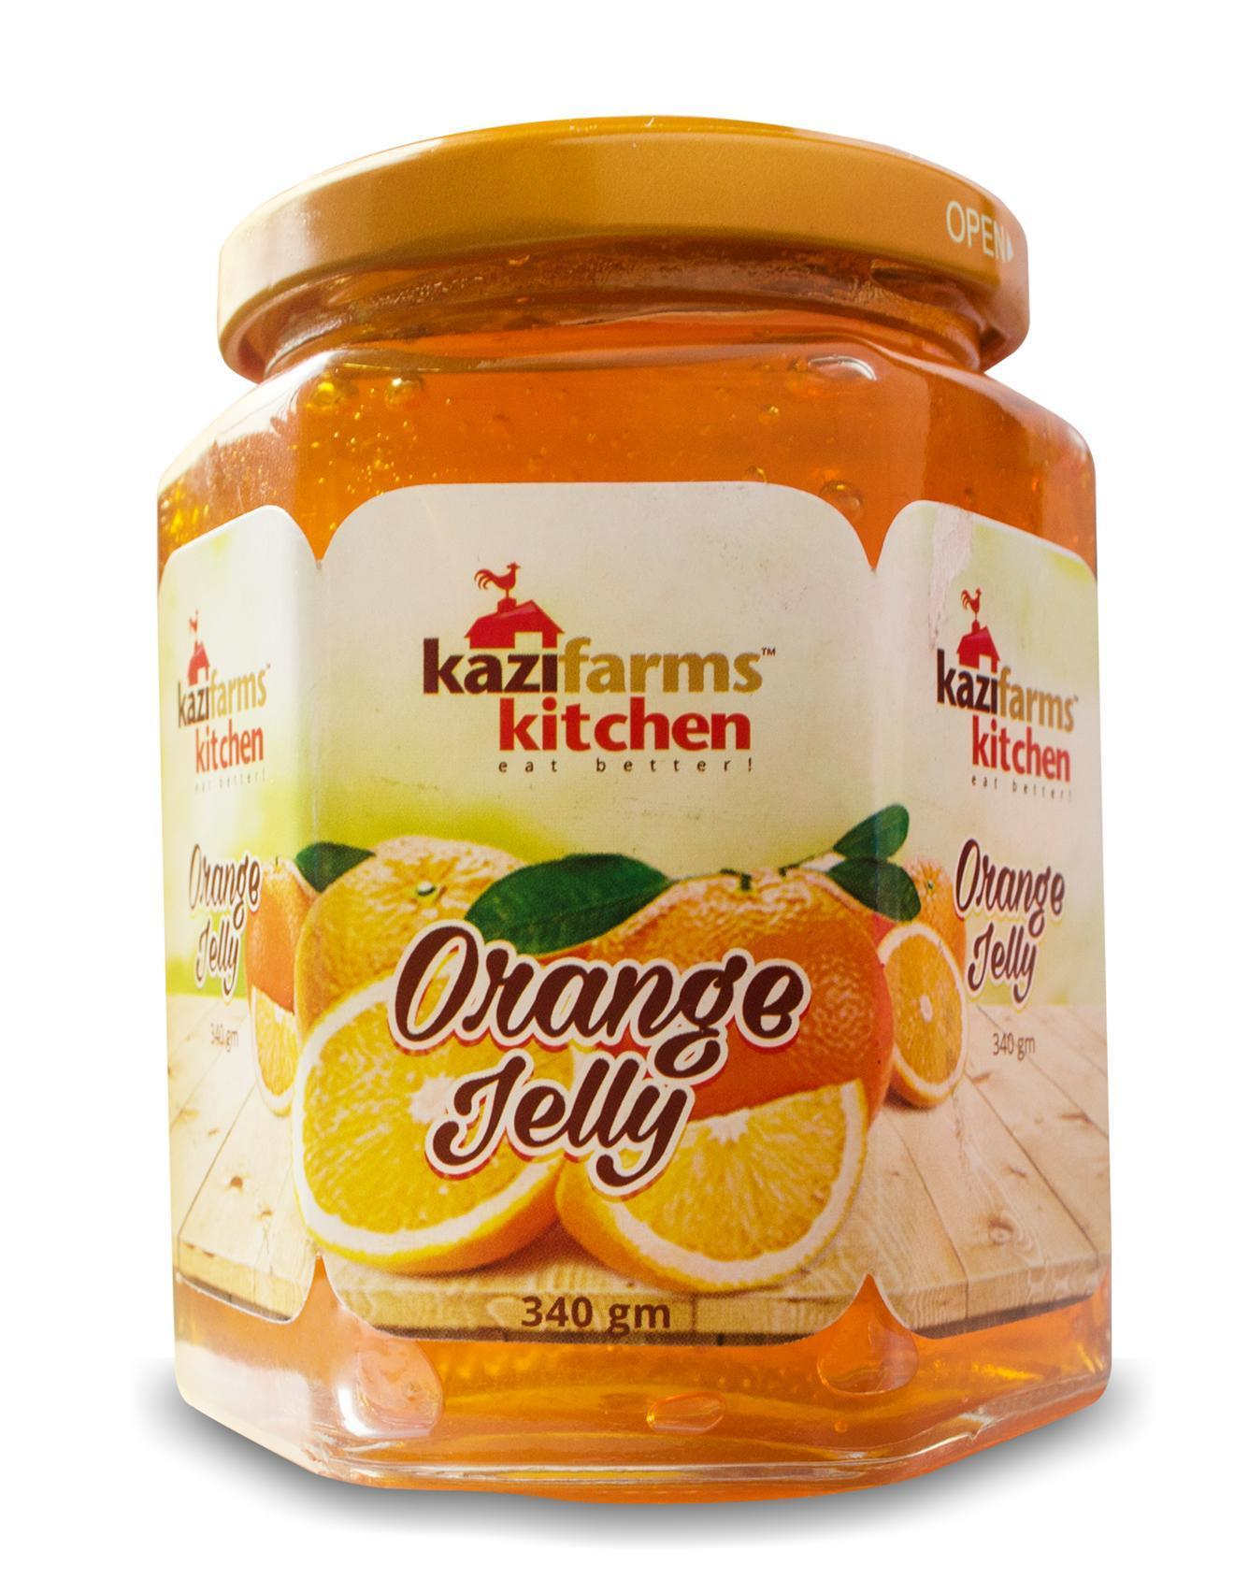
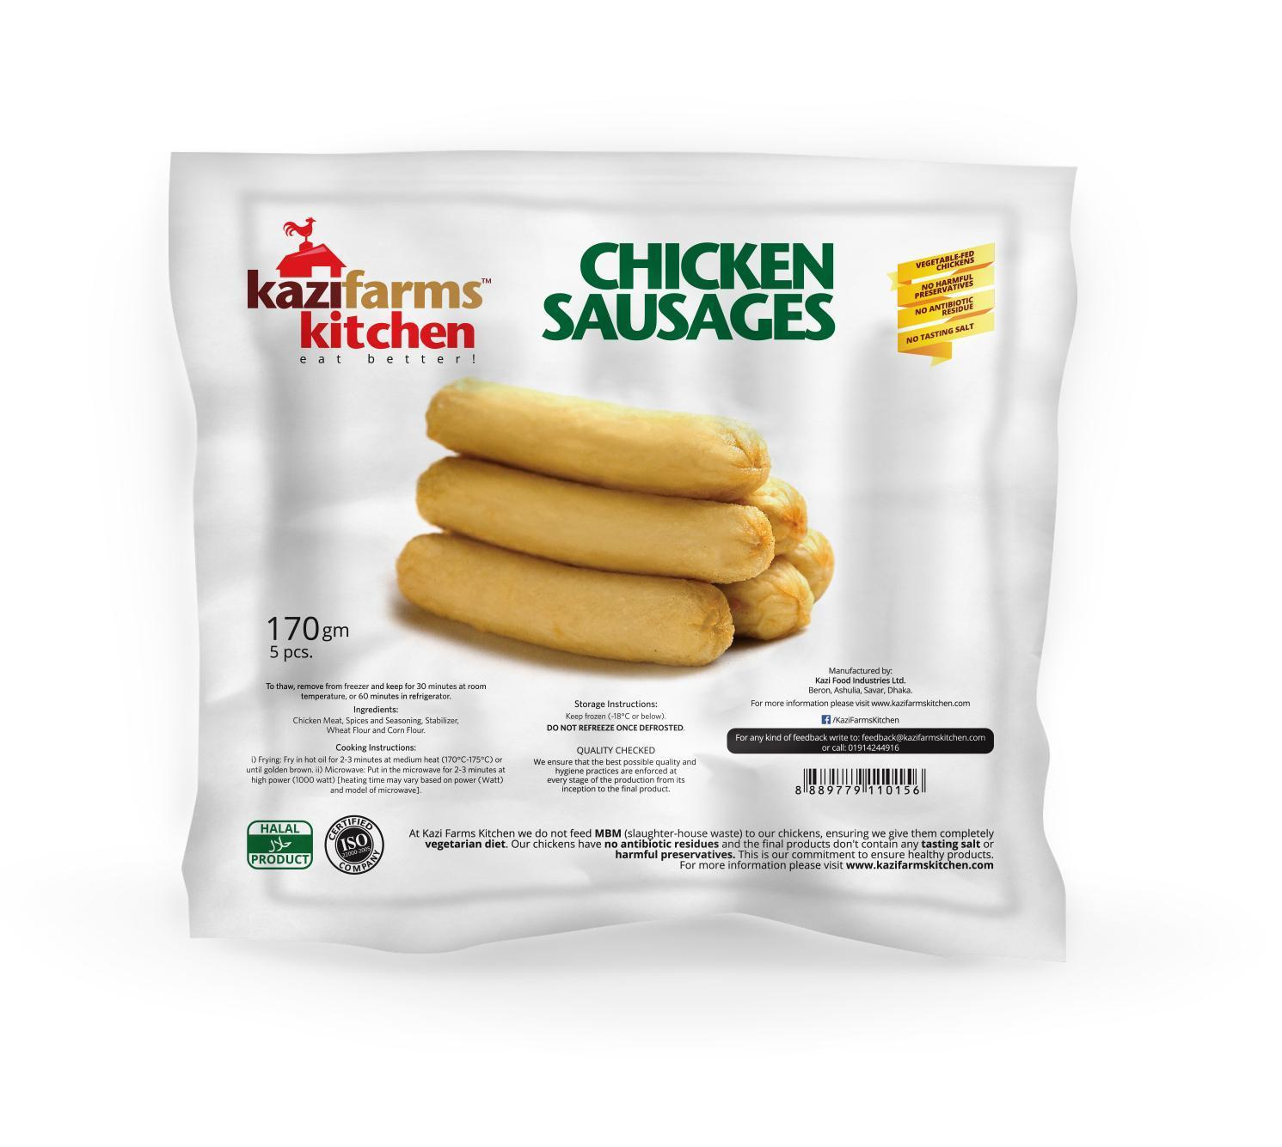
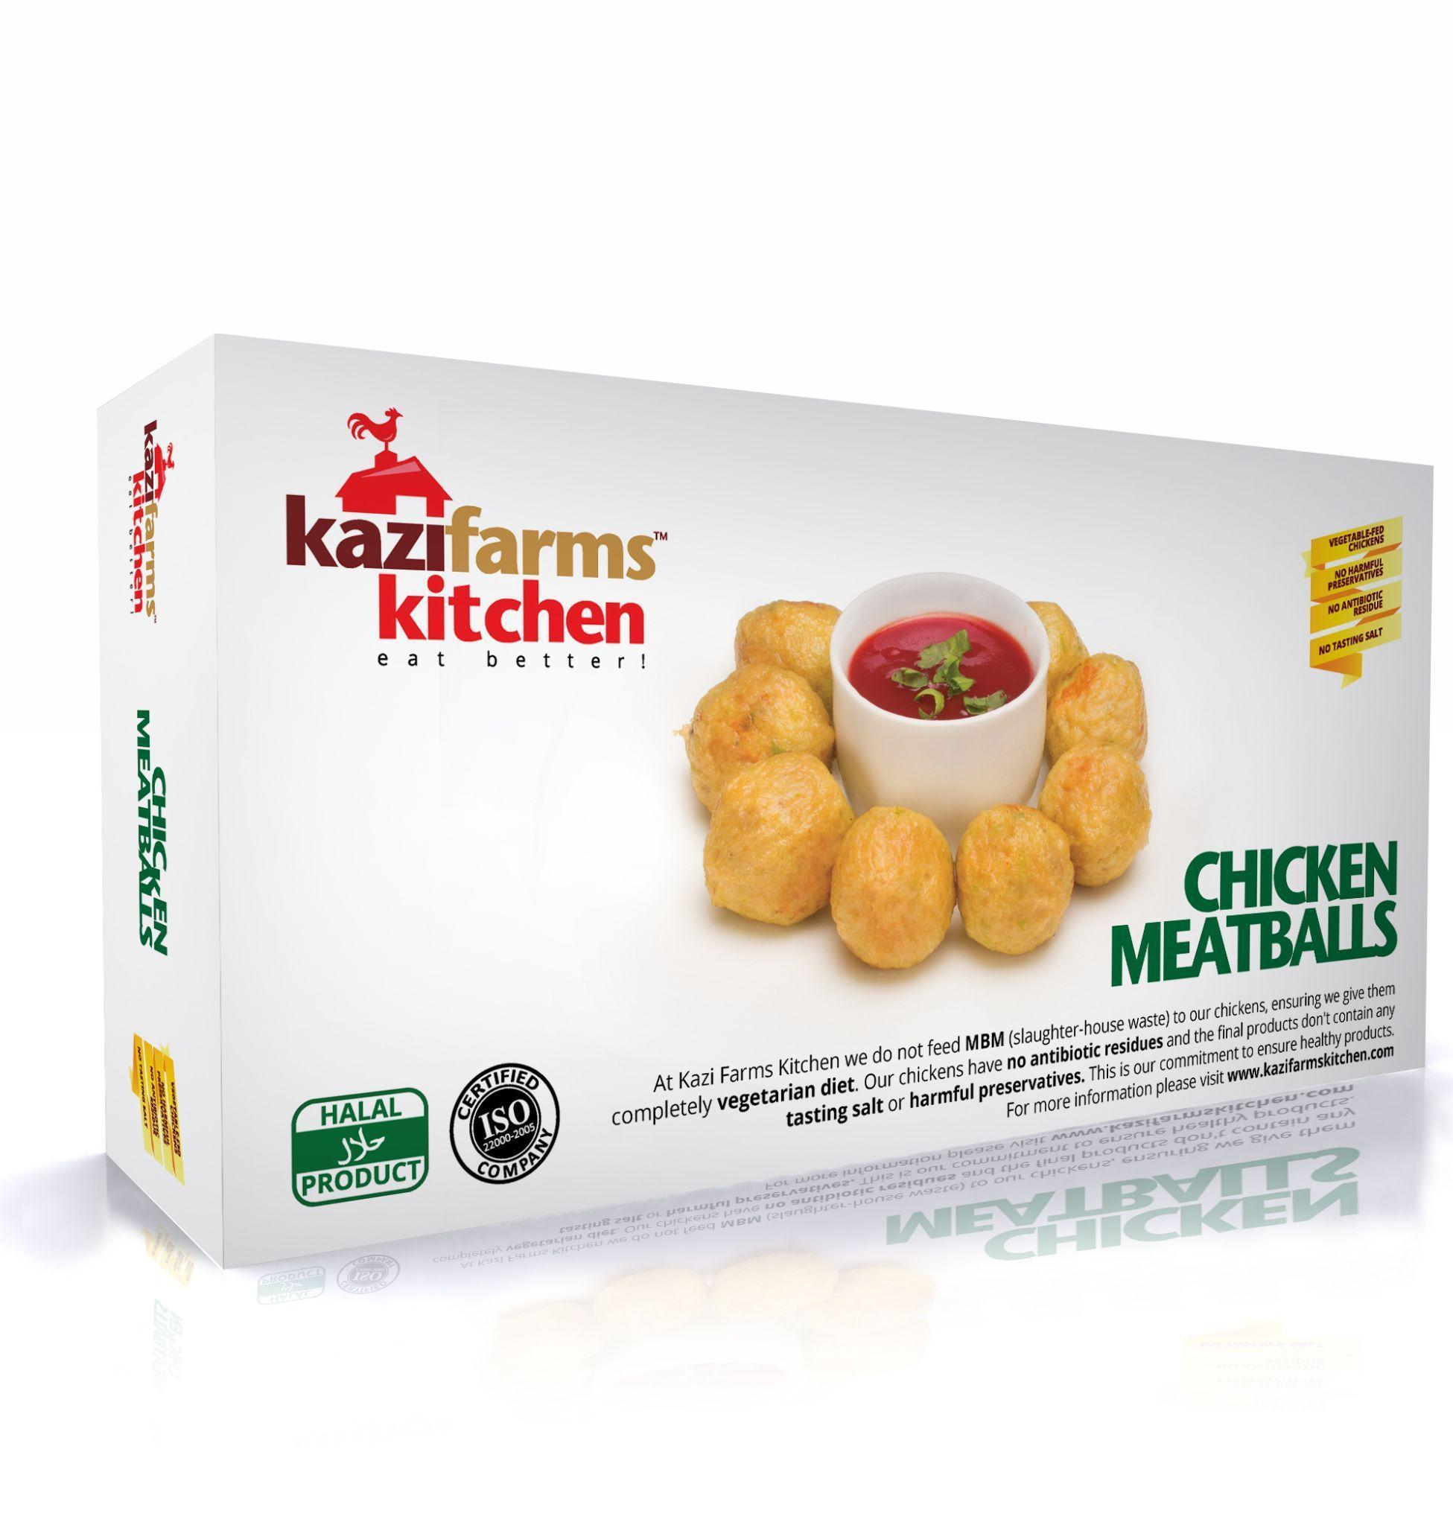

Category Wise Kazi Farms Kitchen Products:
Categories | Product Name
Meat Based Frozen Products | Chicken Burger  Chicken Cutlet  Chicken Nuggets Kids  Chicken Nuggets Original  Chicken Nuggets Spicy  Chicken Strips  Chicken Teasers  Chicken Meat Ball  Chicken Spicy Meat Ball  Chicken Drum Sticks  Chicken Sausage-Plain  Chicken Sausage-Plain  Chicken Sausage-Spicy  Chicken Sausage-Spicy  Chicken Keema Paratha  Chicken Lollipop
Flour Based Frozen Product | Aloo Puri  Chicken Samosa  Chicken Spring Roll  Dal Puri  Filo Pastry  Plain Paratha Regular  Plain Paratha Family  Vegetable Singara  Vegetable Samosa  Vegetable Spring Roll
Dried Fish Products | Lottia  Churry  Keski  Shrimp Small
Fish Based Frozen Products | Shrimp Spring Roll  Shrimp Samosa
Jam and Jelly | Orange Jelly  Strawberry Jam
Egg | Fresh Chicken Egg

b. Place;
Kazi Farms Kitchen has 13 distribution centers around the country and approximately 200 + dealers all over Bangladesh to help them to get their products to different retailers, super shops, and its own franchise outlets. Kazi Farms Kitchens has over 150 outlets and both Push strategy and Pull strategies combined are used as distribution strategy. How the frozen foods are distributed using a cold chain;-
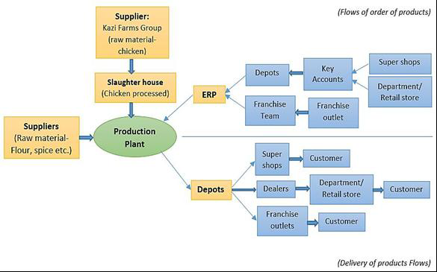

c. Price; Kazi Farms Kitchens product pricing is done by combining value based pricing and cost based pricing. Convenience to customers and fairness of value is taken into account when each product is priced. Keeping that in mind, there are also other factors that need to be taken into account, that may affect the prices like; raw materials price, demand changes, environmental factors, brand value, importing raw materials cost.

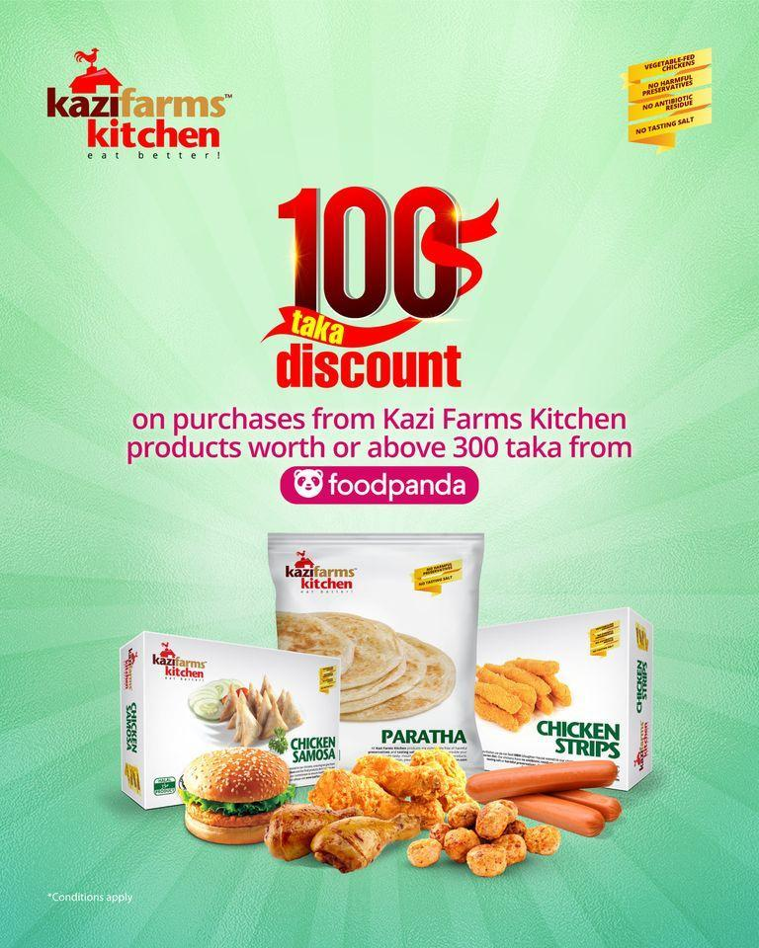
d. Promotion; Promotions are key at KFK in order to make the target market be aware about its products and services. Different media is used for promotion like digital, traditional media as well as in a physical environment. Third parties are used to carry out certain promotional activities. They help in actualizing designing POSM and other tools for promotion. For example on digital;
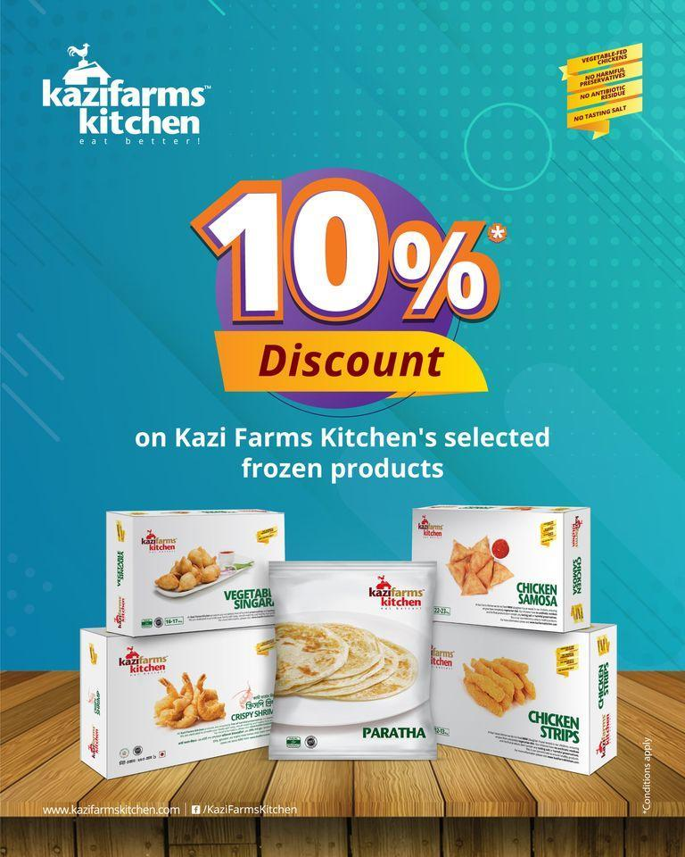
Event Promotion;
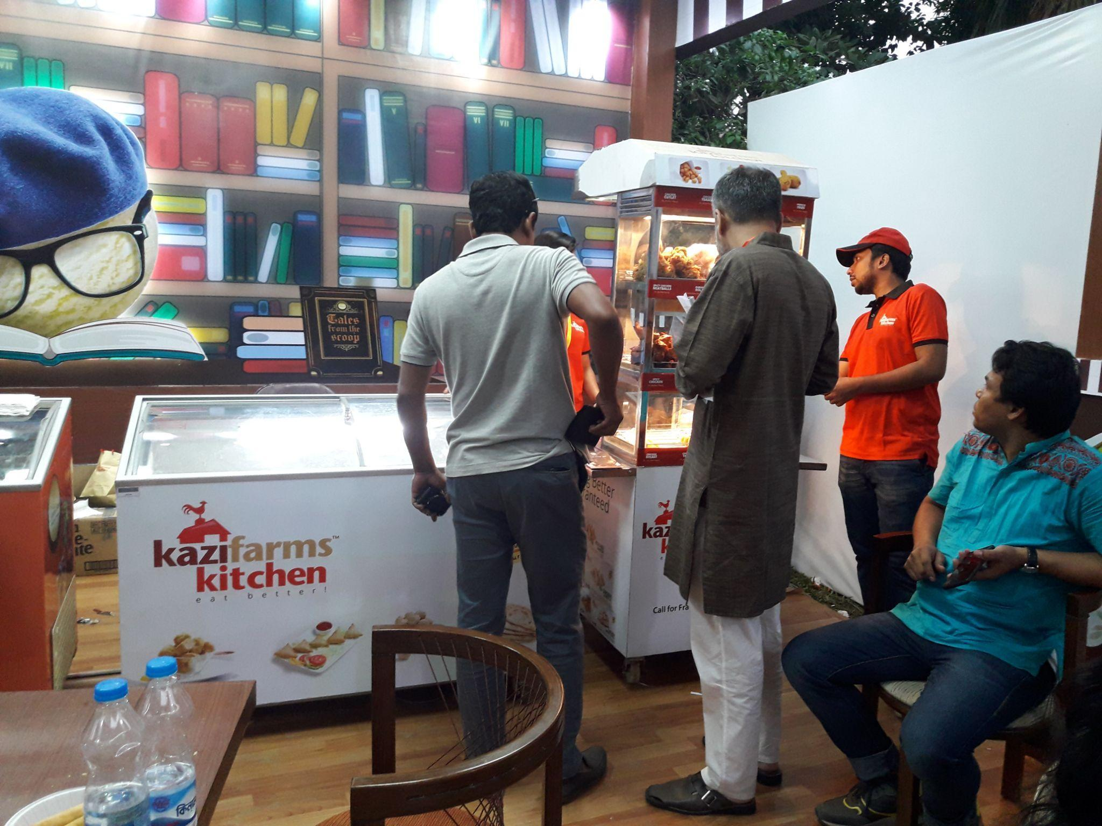
Interactions in the field, at events, allow for instant purchases. Special events that allow for promotions include festivals, concerts, trade shows. Other than events physical promotions can take place at super stores and groceries.
- Sponsor: Through the providing of products or even financially, Kazi Farms Kitchen sponsors different Fair, Magazine, Concert, Science Fair, Academic Function (study tour, rag day, seminar etc.). Anyone who would want a sponsorship would need to submit a proposal that would then be reviewed, and assessed before deciding to sponsor or not.
- Brand Promoters: Brand Promoters speak to the customers in order to share information about a brand, give answers and promote the differentiation. We would hire third party brand promoters, who were professional, for physical promotions.
- Activation at Superstore: Activation at superstore is done when companies launch new products. A Lot of the time different discounts would be given to attract consumers.
Traditional Media;
Print Media includes newspapers & magazines; other traditional media include TV, radio, billboards and banners. These all allow companies to reach the mass markets for any promotions.
- TV Advertisement: Initially this was the main focus for KFKs products as the brandawarness was being developed. Now the demand has been established and continues to increase.
- Radio commercial (RDC): Commercial radio stations sell "airtime" to companies looking to advertise. Sometimes spots are booked for station airing or sometimes companies pay for mentioning them on air. Kazi Farms Kitchen promotes their product through Radio Commercial Endorsement. In KFIL radio commercial endorsements, RJs of different radio programs speak about the company.
- Point of sales material advertising: Kazi Farms Kitchen uses different points of sales materials like an attractive billboard, light box, poster, festoon, cut out, dangler, X banner, press ad, leaflet etc. to attract customers.
- Digital Media & Marketing: In this digital age, internet and social networking/media sites are a key way for companies to engage with customers. It allows companies to give real time updates, information, advertising; that would be impossible through traditional marketing media. This is why KFK gives digital marketing the importance that is necessary to maintain its brand image and customer engagement. We would regularly create post schedules and stay active on social media; with promotions, updates and even different competitions. They have a Facebook page named ‘Kazi Farms Kitchen’ which keeps their targeted customers updated about their new offerings, discounts, opening of new franchise outlets etc. Their website, which is constantly updated ‘www.kazifarmskitchen.com’ contains all the information about their product and services. During my time at KFIL I was even given the responsibility, by the GM, of auditing the content on the site. And changes were made accordingly to improve.
e. People: Having the right people is essential because they are as much a part of your business offering as the products/services you are offering. Kazi Farms Kitchen carries out its business activity with a coordinated workforce under the supervision of strong management. Different teams of people include;
- Production Team: Produces products according to sales demand of Kazi Farms Kitchen‟s products.
- Accounts Team: Maintains multiple accounts of Kazi Farms Kitchen like cost, income etc.
- Purchase team: Source raw materials and negotiate with possible suppliers to get products at a reasonable price to minimize cost.
- Key Accounts team: Manages corporate sales and manages frozen food items in different super shops, department stores, retail stores. They also find new investment opportunities.
- Franchise team: This team analyzes opportunities to establish franchise outlets in different areas based on the growth potential of that area.
- Research and development: Develops new products, upgrading/improving existing products, observes market factors, competitors, and consumers changing behavior and needs and demands.
- Sales: Ensures sale of products to the dealer and retailer who eventually sell the products to the final consumers. They are motivated with a sales target each month; along with a bonus/ reward/ promotion based on their performance.

g. Processes:
Kazi Farms Kitchen has 2 forms of products- frozen and fried. Process of delivering
services differ lightly for Kazi Farms Kitchen‟s frozen and fried products.
- Frozen food items are sold in different super shops, retail stores, department stores and Kazi Farms Kitchen’s franchise outlets. A customer can grab it according to their own convenience.
- Fried Items are sold in Kazi Farms Kitchen‟s franchise outlets. Customers order their food from the salesperson and pay him as well. After the order is placed, if the item is already fried, it’s presented instantly to the customer. If the items are not fried, the sales person quickly and properly fries it and this allows the customer to have an even fresher experience. They may enjoy the outlet or may take it away.

h. Physical Evidence:
Physical Evidence, or the physical outlook of a company in action during service, influences people in shaping their attitude toward an organization and allows customers to make their purchase decision. Kazi Farms Kitchen services are in case of its fried products
that are sold in their Franchise outlets. A neat and clean atmosphere upholds KFKs promise of customer wellbeing. The design of the point of sale material (all physical marketing materials), employee dress code, cooking material/machinery (KIOSK, freezer, display case), sitting arrangement, etc. are similar in all the franchise outlets of Kazi Farms Kitchen in order to maintain a certain image and level of quality.

4.4 SWOT ANALYSIS

Strengths of KFIL:
- The team behind it all is another big asset to KFIL; they hire experienced and dedicated employees and keep a favorable environment for work. Happy employees results in overall best business processes and services
- Kazi Foods Industries Limited has a well thought out marketing plans that diversify their marketing budget throughout multiple medias. This ensures that customer engagement is always taking place and sales are being generated.
- Profit is Revenue - Cost; and because Kazi Foods knows this they keep their costs low without hampering quality. They are able to use lower costs to also provide the best value pricing to customers.
- A large part of Kazi Foods success can be credited to their highly competitive pricing.
- The strong brand image. KFIL is not only known but also trusted among the market.
- The methodical distribution chain is another asset for KFIL. It ensures that the products are ready and available to customers at convenient locations.
Weaknesses of KFIL:
- Not a big enough R&D team and Kazi Foods has not allowed them to grow to their full potential.
- Not enough awareness that Zaa n Zee is a Kazi Foods brand.
- The market (superstores that store and sell the products) still is coming to terms with the fact that frozen goods must be kept at a very specific temperature to ensure the highest product quality. This causes mishandling of merchandise due to temperature fluctuations and in result the customer relieves a faulty product.
Opportunities of KFIL:
- They have an opportunity to expand into the new “vegan” market of frozen foods as well. In recent years more people are adopting a lifestyle in which meat is avoided; this is a niche market that still hasn’t been taken care of in Bangladesh. This opportunity would allow KFIL to have a first movers advantage.
- KFIL has an opportunity in the frozen vegetable industry. In Bangladesh most families still depend on the raw, organic vegetable and this is an opportunity for KFIL to introduce a more convenient alternative in this fast paced world.
- There is an opportunity to grow internationally. KFIL has established themselves in the nation which now presents an opportunity to grow outside of the nation.
- Increasing customer self sufficiency is an opportunity. More and more customers are making the change to self sufficiency and frozen foods is a lifestyle offering that can help with that. Thus self sufficient is an opportunity to capitalize on.
- Another market that is an opportunity for KFIL to grow in is the frozen “ready meals” sector. If they are able to offer ready to eat meals that just need to be heated in the microwave it will introduce an extraordinary offering to the market.
Threats of KFIL:
- Copycat stores that are not actually franchisees of Kazi Foods are popping up and becoming more common. This threatens the brand image of KFIL because these copy cats don't maintain the same high quality, thus ruining the customer experience.
- With a growing industry there is a growth of more competition.
- Power outages are a threat to product quality all over the nation. It’s reasonable to see how this would negatively affect ice creams and frozen food products.

Part 5: Recommendations & Conclusion

5.1 Recommendations:
- KFIL should ensure that their products; although high end in quality, are available to all areas. It is often difficult to find Belissimo in a regular neighborhood retail shop.
- As maximum respondents prefer self-service, KFIL should give importance to this fact and ensure that their products are present in attractive condition & position in the freezers and within the reach of the consumer.
- Regarding the supply chain, a regular monitoring system should be in place to ensure only the best and freshest products are being put in front of customers.
- Even if the customer doesn't tell you what went wrong they will definitely spread negative word of mouth; so taking care of the problem would prevent that from happening. This is why they should encourage customers to make complaints and then proceed to take necessary steps for resolving those complaints.
- They should do an audit and “weed out”, take an initiative against the fake franchises that are across some areas. It hampers quality perception of the customer.
- KFIL should add more team members dedicated solely to research and development.

5.2 Conclusion:
Competition is on the rise for KFIL with the increasing demand. It's high time that the key factors be identified and implemented to sustain in the competition as well as to achieve leadership of the frozen food sector of Bangladesh.
Market leadership needs the maximum market share in a particular area. That company must be ahead to present an innovative product in the market, ahead to catch changes in buying behavior/ consumption pattern, and ahead to respond accordingly to the customers changing demand etc. many things need to be thought of in regards to product management.
Since its origin KFIL has gained the trust of people and their admiration of its consumers. Customers have a positive mindset about KFIL and can rely on their promises for their wellbeing. Kazi Food Industries Limited is doing better & holding good percentages of market share in the food & beverage industry sector.
As long as they continue to engage their customers and keep an eye on the changes and opportunities in the market, and respond accordingly they will be able to sustain their success for a long time.

Part 6: Bibliography
https://www.pipefy.com/blog/product-roadmap/product-management-definition/
https://www.business.qld.gov.au/running-business/growing-business/becoming-innovative/developing-products/new-products/strategy
https://wellsfargoworks.com/marketing-center/tip-sheet/five-phases-of-new-product-or-service-development
http://www.bellissimobd.com/?page_id=207
https://study.com/academy/lesson/what-is-product-management-definition-tools.html
https://www.entrepreneur.com/article/70824
https://www.segmentationstudyguide.com/stp-process/what-is-the-stp-process/
https://futurestartup.com/2019/01/16/seizing-the-frozen-food-opportunity-tanvir-haider-chaudhury/
https://ctb.ku.edu/en/table-of-contents/structure/strategic-planning/create-objectives/main
https://www.scribbr.com/dissertation/methodology/

