SMARTPHONE PURCHASING BEHAVIOUR AND ATTITUDE OF DHAKA CITY RESIDENTS

A Project Report on
Smartphone purchasing behaviour and attitude of Dhaka city residents



SUBMITTED TO
S. M. Asif Ur Rahman
Assistant Professor
School of Business & Economics
United International University

SUBMITTED BY
Shakhawat Hossain
ID: 111 152 173
BBA Program
School of Business & Economics
United International University

DATE OF SUBMISSION
28th September, 2021

Transmittal Letter
28th September, 2021
S. M. Asif Ur Rahman
Assistant Professor
School of Business & Economics,
United International University
Subject: Submission of project report on "Smartphone purchasing behaviour and attitude of Dhaka city residents".

Dear Sir,
You will be pleased to know that I have completed my thesis on "Smartphone purchasing behaviour and attitude of Dhaka city residents". This topic was chosen based on our discussion of the overall growth of the smartphone market and its demand, which enables local manufacturers to start lucrative businesses. The title also aroused my curiosity, because I want to know how smartphone-related factors affect the brand selection behaviour of smartphone buyers in Bangladesh. In addition, so far, I have followed all the report requirements and recommendations you gave me, and I want to make sure that all the information contained in the research is related to the title and will not be copied directly from any previously published content.

Therefore, I pray and hope that you will generously review and accept my project report.

Your most obedient,
Shakhawat Hossain
ID: 111 152 173
BBA Program
School of Business & Economics
United International University

Acknowledgement
In the beginning, I thanked Almighty Allah and my parents for their patience, strength and courage. In all the blessings of the past two years, I finally completed the BBA program at United International University. I would like to express my sincere thanks to the authoritative organization of United International University for this thesis project. It allows students to apply their theoretical knowledge to real platforms before entering the business world.
Thank you very much to everyone who participated in the survey portion of this research. Special thanks to my project supervisor, the respected professor of the School of business and economics at the United International University, S. M. Asif Ur Rahman, Assistant Professor, for his teaching methods, suggestions and efforts in prompting me to write this report.
Last but not the least, I want to thank all my friends and classmates who have supported me in the concept theory process. Without cooperation and mutual support, it is impossible to accomplish all the tasks.
Table of Contents
INTRODUCTION
I.1 Origin 2
I.2 Background of the topic 2
I.3 Literature Review 3
I.3.1 Mobile phones and its types 3
I.3.2 Consumer Buying Behaviour 4
I.3.3 Smartphone Market in Bangladesh 5
I.4 Purpose Statement 7
I.5 Scope & Limitation 7
I.5.1 Scope of the Study 7
I.5.2 Limitations of the Study 8
1.5.2.1 The lack of brand awareness of the client limits the results: 8
1.5.2.2 Other Restrictions: 8
I.6 Methodology 8
1.6.1 Research type 8
1.6.2 Data type 8
1.6.3 Sample size (n=123) 9
1.6.4 Date collection method 10
1.6.5 Data analysis method 11
1.6.6 Data presentation method 11
I.7 List of Abbreviation & Technical Terms 11

FINDINGS AND ANALYSIS
2.1 Introduction: 13
2.2 Factors influencing consumers while choosing a smartphone brand 17

RECOMMENDATIONS AND CONCLUSION
3.1 Suggestion & Recommendation 22
3.2 Conclusion 23
References
Appendix- Survey Questionnaire
List of figures and tables

Figures
 | Page Number
Figure 1. Market share of leading mobile brands in Bangladesh in 2021 | 6
Figure 2. Total sample size – Gender and Age wise distributed | 9
Figure 3. Number of smartphone consumers’ use at a time | 13
Figure 4. Types of usage of smartphones | 14
Figure 5. Top preferred smartphone brands | 14
Figure 6. Time Interval of purchasing a new smartphones | 15
Figure 7. The people from whom customers het influenced mostly | 15
Figure 8. Preferred shops/stores for purchase smartphones | 16
Figure 9. One-time budget for smartphones | 16
Figure 10. Interest for recommendations | 17
Figure 11. Factors of smartphones that influence in purchase decision making | 17

Tables
Table 1: Occupation of the participants | 10
Table 2: Monthly income of the respondents | 10

Executive Summary

Consumer behaviour analysis is an ongoing behavioural process that evaluates the effect of different elements connected to a certain product on clients during a given period. Research and analysis of consumer behaviour can not only help market specialists to understand which variables influence consumer buying decisions, but also allow consumers to meet their needs. In particular, many variables connect to the choice of final purchases of mobile phones in Bangladesh when selecting a certain smartphone with a specific brand. In addition, mobile phone marks are perplexed when understanding the growing consumption requirements that influence these variables.
The study aims to evaluate the factors affecting customers by selecting a brand of smartphones. In the study also, the prospects on the most influenced elements and the less aspects that affect the behaviour of consumers have been highlighted by the investigation as a whole.
The study reveals that compared with domestic brands (such as Walton, Symphony), Dhaka's customers are mainly attracted by foreign brands (such as Xiaomi, Samsung, Apple, Huawei, OPPO and Vivo). They buy mobile phones mainly to surf the Internet. Send and receive phone calls, navigate through the Internet, text and MMS, send and receive emails, and social media video chat sites, including Facebook, YouTube, and Instagram. They hope that their mobile phones can be used for at least 1-2 years. The purchase decision is influenced by their friends, family members or others. Authorized stores are their first choice for buying mobile phones, as well as second-hand appliances and online gadget stores. A one-time budget of 11000-40000 BDT can also be used to purchase smartphones. Finally, customers in Dhaka City will suggest whether a brand can meet their needs. The survey also shows that price; operating system; battery life, storage, brand value, user experience and performance are important variables that affect consumers' smartphone purchasing decisions. All the research results hope that global and local smartphone companies can understand the current perceptions of consumer behaviour and formulate strategies to stay in a highly competitive market.

INTRODUCTION

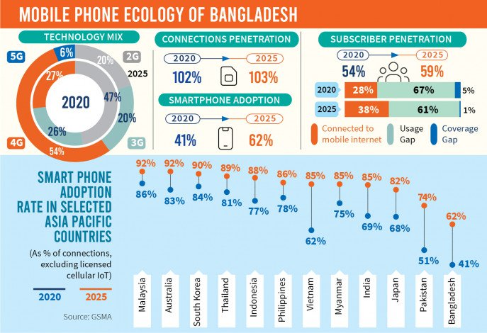

I.1 Origin
The project report is a prerequisite for obtaining a bachelor's degree in business administration from United International University. As a marketing student, I had to show my marketing-related knowledge in a practical document, and upon request, I chose to prepare my project report "Smartphone purchasing behaviour and attitude of Dhaka city residents". Research on consumer buying behaviour is the most important for marketers because they can understand consumer expectations. It helps to understand what motivates consumers to buy the product. It is important to evaluate the types of products consumers like so that they can publish. In addition, a smartphone is a necessity for everyone because it helps users connect with each other and keeps them busy while browsing websites, playing games, listening to music, and watching movies. If anyone is travelling. You can check their e-mail and work from anywhere. This is why for a marketing degree student like me, studying consumer behaviour is a very important concept. Previously, based on feedback received from residents of Dhaka City, the study is focused on customer attitudes and buying behaviour toward smartphones purchase decision making process.

I.2 Background of the topic
The smartphone market in Bangladesh is growing rapidly and high quality and cheap mobile phones are on the rise. The study attempts to investigate the factors that influence the choice of cell phone brands among consumers in Bangladesh. As demand continues to grow, the new company has great potential to launch such products. It should also be noted that as the government and policy makers aim to establish closer cooperation with global cell phone brands, the business environment in Bangladesh is becoming more and more favourable. Many events have already taken place, including several trade fairs in Bangladesh in 2020. This can make Bangladesh a future technology hub and reduce dependence on imports from other countries.

In today's world, all the service industries are delivering goods to customers is a big challenge for businesses and organizations of all sizes. Once considered a luxury, today smartphones have become a staple for every family and one of the most reliable means of rapid communication. It is estimated that the average global population spends 3.25 hours per day on mobile phones, and 20% of smartphone users spend more than 4.5 hours per day on devices (Adrienne Matei, 2019). Therefore, today's businesses strive to create unique brands so that customers can see their products as ideal products.

In addition, internet use in Bangladesh is largely influenced by daily use of smartphones, social media platforms, checking email and calendar management, as well as occasional use for original purposes (i.e. making calls). Smartphones are a particularly lucrative area of ​​investment in the global economy because of their critical importance. In addition, the whole ecosystem has evolved to focus on smart phones, with start-ups providing smart phone related products and services.

However, for many businesses, brand awareness is the most important competitive advantage they have. For an organization to be successful, it must have a strong brand. With the rapid growth of the smartphone market, it is important to influence consumers' buying behaviour through research on consumer behaviour. When choosing a competitor's brand of smartphones, the goal of this research is to determine the factors that affect the purchasing behaviour of consumers in order to better understand the value of the brand in the business. A wide range of smartphone-related industries will benefit greatly from this research because it helps them adjust their marketing mix and marketing strategies based on consumer attributes to increase sales. Moreover, students and future scholars interested in consumer behaviour will be able to learn from it.

I.3 Literature review

I.3.1 Mobile phones and its types
Users can use mobile phones to make and receive calls, which are portable wireless devices. Mobile phones have evolved from simple phones that can only make and receive calls to more complex devices that can run games, online browsers, facial recognition, cameras and panoramas, video players, and navigation. Because they provide additional voice and data functions, mobile phones are now often referred to as “smartphones” instead of “cell phones” or “cell phones” in the past.

As part of their "integrating mobile devices into development projects", Woodard et al. (2014) introduced three different types of mobile phones. Basic phones, Feature phones, and Smartphones are all examples. Here, the basic phones is a small mobile phone with text and voice functions and some basic built-in applications (such as calendar, calculator, etc.). Most people in rural Bangladesh are likely to use basic phones. The term “feature phones” or “functional phones” refer to a phone with features other than voice and text. Therefore, users of these feature phones, can choose to use a mobile web browser to connect to the Internet.

In terms of complexity, smartphones are currently the most advanced phones on the market. Some of the features that set smartphones apart include their large screen and touchscreen capabilities, as well as their graphical user interface and WiFi and GPS capabilities. Therefore, the camera of a smartphone is often better than that of a multifunction phone. These gadgets have complex operating systems and complete applications, and have many similarities to portable devices in terms of functionality. For example, the app shows how flexible multifunction phones (such as GPS) are and can be used in a number of ways.

I.3.2 Consumer Buying Behaviour
Consumer buying behaviour refers to the behaviours (including online and offline) performed by consumers before purchasing products or services, including online and offline behaviours. The consumer behaviour, as defined by Sarma (2017), refers to the study of customers and their behaviour when choosing products that meet their needs. Consumption research looks at people's motivations to buy and use various things. In order to analyse customer behaviour, people may use a variety of methods, such as using search engines, participating in social media discussions, or a combination of these methods (Lake, 2009). Therefore, companies can better adjust their marketing efforts based on previous marketing efforts that have successfully attracted consumers to purchase.

I.3.3 Smartphone Market in Bangladesh
Citycell brought Bangladesh into the mobile world in 1993. The cost of mobile phones was higher than that of mobile phones without BDT. From 1993 to 1996, ordinary people or middle-class mobile phones were unimaginable, but now they are everywhere. A number of telecommunications companies subsequently received government approvals, including Grameenphone, Banglalink (formerly Sheba World), Robi (formerly Aktel), and Airtel (formerly Warid).

According to the Global Quarterly Mobile Phone Tracking Report on the "International Data Corporation (IDC)" website (2020), the annual growth rate of Bangladesh's mobile phone market in 2019 was 4.1%, with shipments of 29.6 million units. 76.6% of the shipments of 22.7 million multifunctional mobile phones are multifunctional mobile phones, with an annual growth rate of 4.9%. The shipment of smartphones this year is 6.9 million units, an increase of 1.4% over 2018. Global mobile phone shipments continued to grow in the fourth quarter of 2019. This category of mobile phones increased by 19.5% year-on-year and 16.2% year-on-year. Last quarter. , Contributed 8.8 million mobile phones during the year.

Therefore, Chinese manufacturers continue to introduce smartphones with lower prices and higher specifications. Because of this, the ASP (average selling price) of smartphones in 2019 increased by 5.7% year-on-year, reaching an average of US$99. The number of 4G-enabled devices increased to 69%, and the annual growth rate in 2019 was 50.4%. Even so, today 3G mobile phones still account for 31% of the total US market share. Since these phones are less than half the price of 4G-compatible smartphones, they have a larger market share than 4G phones. Due to the limited coverage and poor quality of 4G networks, customers are reluctant to upgrade their equipment.

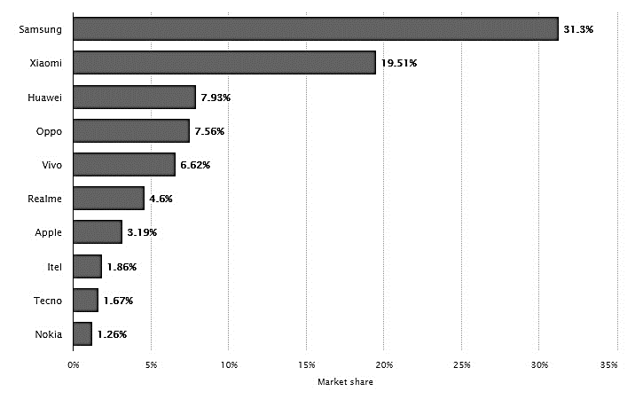
Figure 1. Market share of leading mobile brands in Bangladesh in 2021
(Source: Statista.com)

According to Statista.com, Samsung will have a 31.3% market share in Bangladesh in 2021. Interestingly, compared with Xiaomi (19.51%, Huawei 7.93%), Oppo (7.56%) and Vivo, Samsung is the most popular smartphone brand (7.56%). (6.62%). In 2021, Nokia's share of the mobile phone supplier market in Bangladesh was 1.26%, making it the most unpopular brand in the country.

With moderate growth, local production has changed. Compared with a quarter of the smartphones shipped in the first quarter of 2019, three-quarters of the smartphones shipped in the fourth quarter were produced locally. Since they assemble all the equipment across the country, Walton is one of the top local manufacturers. Although Samsung is one of the world's largest smartphone manufacturers, the company still imports multi-function phones from other countries to meet demand. In addition, Oppo and Vivo has already started local production in the second half of 2019, and there will be more in the next few years.

I.4 Purpose statement
Preparing this project report has as its prime purpose to identify the key influences on the buying attitudes and behaviours of smartphone users in Dhaka City. To help readers and consumers of the study better grasp the study's principal purpose, the following objectives are listed:
- To learn more about the mobile phone industry in Bangladesh.
- To analyse consumer behaviours and attitudes, as well as their influencing factors and processes on smartphones and brands.
- To conduct data collection surveys on factors that influence consumer behaviour when choosing a mobile brand.
- To analyse the factors that influence consumers to choose cell phone brands and interpret these factors.
- To suggest recommendations for the betterment of the smartphone brands.

I.5 Scope & Limitation

I.5.1 Scope of the study
The psychology of consumers is different when they shop and make financial decisions. With the help of this project report, cell phone brands can better understand the physiology of consumers in specific places and markets ((particularly like, Dhaka City). Their understanding of shoppers' thinking, reasoning, feelings and decision-making processes was also enhanced. Additionally, this project report will help mobile brands better understand consumer expectations for their products and industries. Through training on products and services, even if customers know little about it, the company can influence them. Plus, understand consumer behaviour and attitudes. Businesses can influence consumer buying behaviour by educating consumers about the importance of their products and the consequences of their purchases. Consumer decisions are also driven by factors such as after-sales service and the quality of service from brands and distributors. The level of service provided to consumers has a major impact on their decision to choose one mobile phone company over another. When choosing a mobile brand, it is also beneficial for customers to consider the factors that determine consumer behaviour, as it helps them decide which product to buy and how it will affect them.

I.5.2 Limitations of the Study
The project report initially aimed to determine the factors that influence consumer behaviour when choosing smartphone brands for the consumers of Dhaka City. However, although the study found interesting and important results, the study preparation process crossed several limitations, as follows:

1.5.2.1 The lack of brand awareness of the client limits the results:
When it comes to brand awareness, most people in Dhaka only know about two or three brands, and some people are so obsessed with just one brand. Their responses can be biased as they don't know what mobile brands need to deliver. This may impact the baseline data for this study.

1.5.2.2 Other restrictions:
The exclusivity of the study was hampered by many restrictions on its preparation. First, there is a time limit. The study lasted three months. Due to the Covid-19 situation, we are all learning to work from home and keep some distance. It also has an impact on survey data and secondary research data collection. I also need to ditch structured interviews as the primary method of data collection to avoid social distancing, and instead build online questionnaires to collect data.

I.6 Methodology

1.6.1 Research type
This survey will use descriptive research methods. We know that this method describes the characteristics of the variable being investigated. Descriptive research is a part of quantitative market research or social research, including the use of quantitative variables to study market research tools or social research tools.

1.6.2 Data type
This research will follow mixed types of data, where qualitative and quantitative data will be used. We know that the term "mixed method" refers to an emerging research method that promotes the systematic integration or "mixing" of quantitative and qualitative data in a single survey or survey plan. However, all the data will be used from the primary sources, and can be referred as primary data as well.

1.6.3 Sample size (n=123)
In order to obtain 123 feedbacks from randomly selected customers with recent mobile phone purchasing experience, a survey questionnaire is designed to determine the variables they are taking into account while selecting mobile phones. A total of 14 mobile phone brands that are extremely competitive are elected to find which of those 123 respondents favour the brand customer. The following smartphone brands are chosen:

Walton | Samsung | Motorola | Sony | LG | Oppo | Apple
Symphony | Xiaomi | Nokia | Huawei | Lava | Vivo | HTC

Finally, the 18 variables that influence clients to pick a mobile brand among other competing brands are also identified.

Figure 2. Total sample size – Gender and Age wise distributed
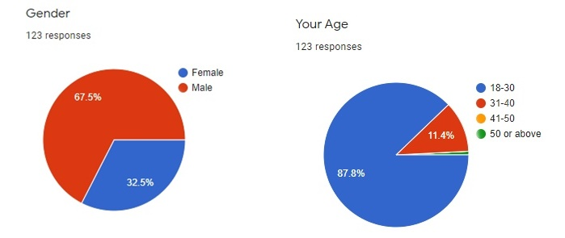
Out of the total sample population size, 67.5% are male customers and 32.5% are female customers. Four age groups are given and found that most of the participants are from the 18-30 years of age group which constituted 87.8% of the total respondents. 11.4% are participated are from 31-40 years of age group. Only 1 participant or 0.8% are 50 years or above age.

Table 1: Occupation of the participants
Occupation | Percentage
Student | 48.8% or 60
Job-holder | 32.5% or 40
Self-dependent | 15.4% or 19
Unemployed | 3.3% or 4
Total | 100%

Out of the total respondents, 48.8% or 60 participants are students; 32.5% or 40 participants are job-holder; 15.4% or 19 participants are self-dependent; and only 3.3% or 4 participants are found who are unemployed.

Table 2: Monthly income of the respondents
Monthly Income | Percentage
Below BDT 15000 | 49.6% 61
BDT 16000-30000 | 35% 43
BDT 31000-45000 | 13% 16
BDT 46000-60000 | 1.6% 2
Above BDT 60000 | 0.8% 1
Total | 100%

Among the 123 respondents, 49.6% or 61 earn below BDT 15000; 35% or 43 earn BDT 16000-30000; 13% earn BDT 31000-45000; 1.6% or 2 participants earn BDT 46000-60000; and only 0.8% or 1 participants earn above BDT 60000.

1.6.4 Date collection method
The study contains both primary and secondary data.
  - Primary sources:
- From the survey conducted with 123 smartphone customers.
- From the observation of the mobile market of Bangladesh.

- Secondary sources:
- From academic marketing books and newspaper articles
- Research papers and books of prominent authors understanding of the theoretical and conceptual knowledge.

1.6.5 Data analysis method
The data will be analysed on the Microsoft Excel. Mostly the findings will be shared based on the feedbacks of the smartphone users. Therefore, the options that got marked by the majority of the respondents will be highlighted.

1.6.6 Data presentation method
The data will be presented by pie and bar charts with proper interpretation of the each figure. The presentation will be shared on the findings and analysis chapter of this study.

I.7 List of Abbreviation & Technical Terms
- Consumer Behaviour: Consumer behaviour, including consumers’ emotional, intellectual, and differentiated responses, and their procedures for selecting, using (consuming) and disposing of goods and services. Consumer behaviour, including psychology, biology, chemistry, and economics, includes concepts from various fields.

- Consumer Attitude: Consumers’ attitudes can be characterized as good or bad feelings towards a person. It is mainly composed of beliefs, emotions and intentions about certain objects.

- Descriptive Research: In order to collect data on various subjects, descriptive survey research employs surveys. This information is intended to know to what degree various circumstances between these subjects may be produced.

FINDING & ANALYSIS

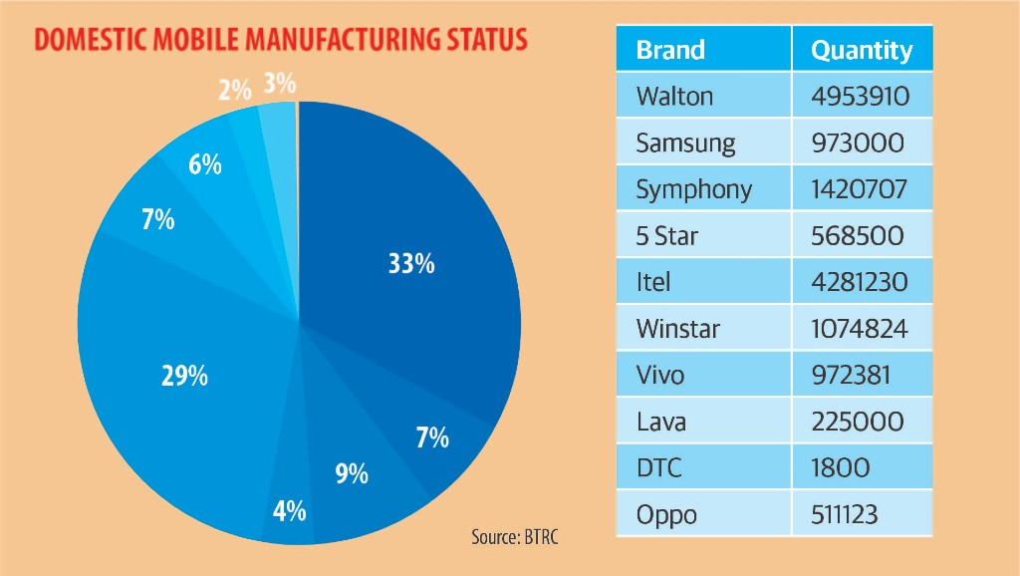

2.1 Introduction:
This part analyses the survey feedbacks of the smartphone consumers’ smartphone purchase behaviour and attitudes. It also presents the findings of this study with pie/bar charts along with proper explanations.

As mentioned earlier, the survey was conducted on 123 randomly selected respondents, which included answers to closed and open questions. It was found that of the 123 respondents, 83 customers were men and only 40 customers were women. Most customers (87.8%) are between 18-30 years old, 11.4% are between 31-40 years old; respondents over 50 years old account for only 0.8%. In terms of occupation, students accounted for 48.8%, or 60; 32.5% or 40 participants were jobholders; 15.4% or 19 participants were self-reliant, and only 3.3% or 4 participants were found to be unemployed. In terms of monthly income, 49.6% or 61 people earn less than BDT 15000; 35% or 43 people earn BDT 16000-30000; 13% earn BDT 31000-45000; 1.6% or 2 participants earn BDT 46000- 60000; Only 0.8% or 1 participant earns more than BDT 60000.

Figure 3. Number of smartphone consumers’ use at a time
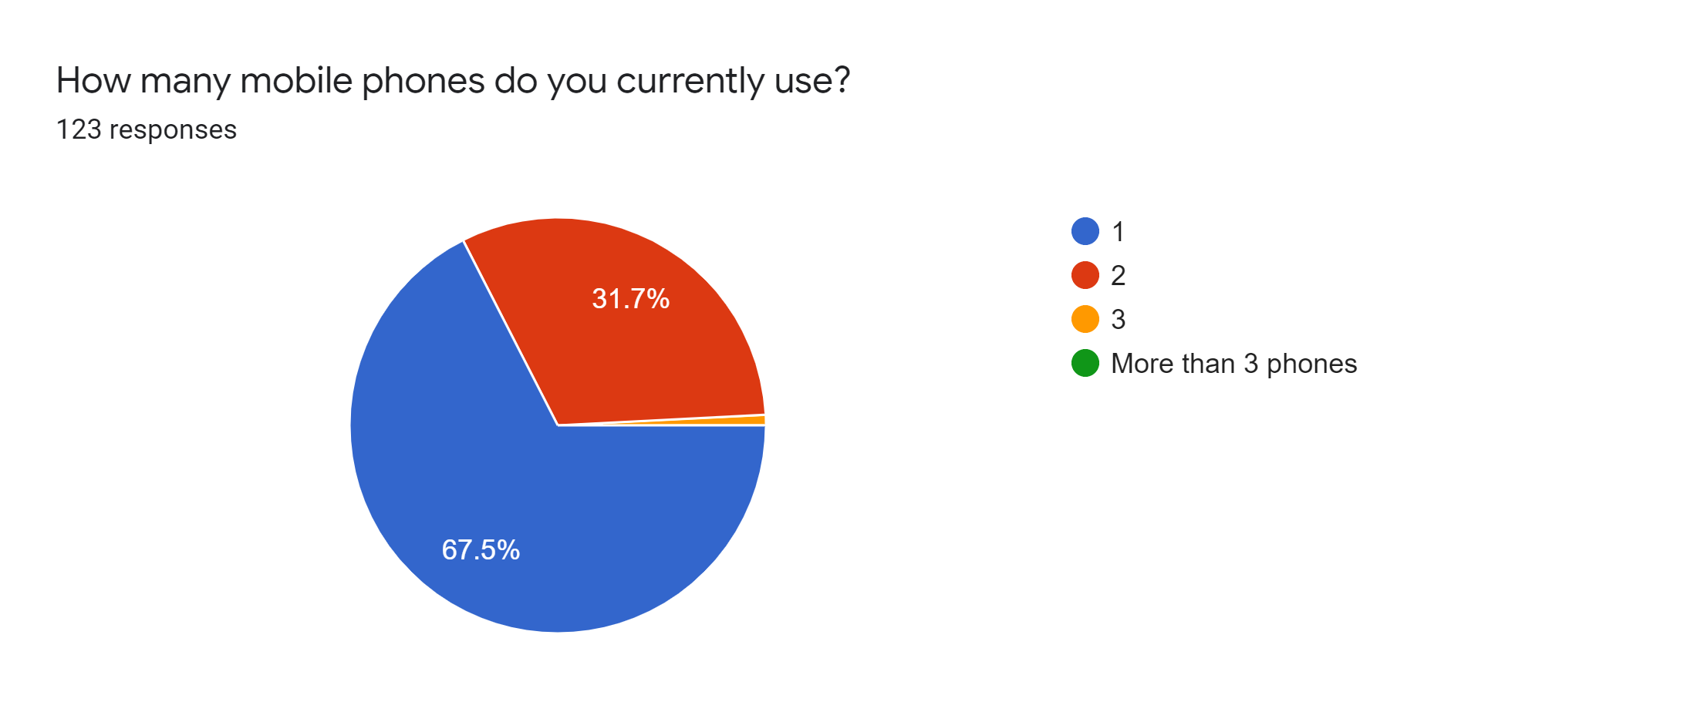
Out of 123 respondents, about 67.5% are using only one smartphone while 31.7% are using 2 smartphones at a time. However, 0.8 or 1 person is also found who use 3 smartphones at a time.

Figure 4. Types of usage of smartphones
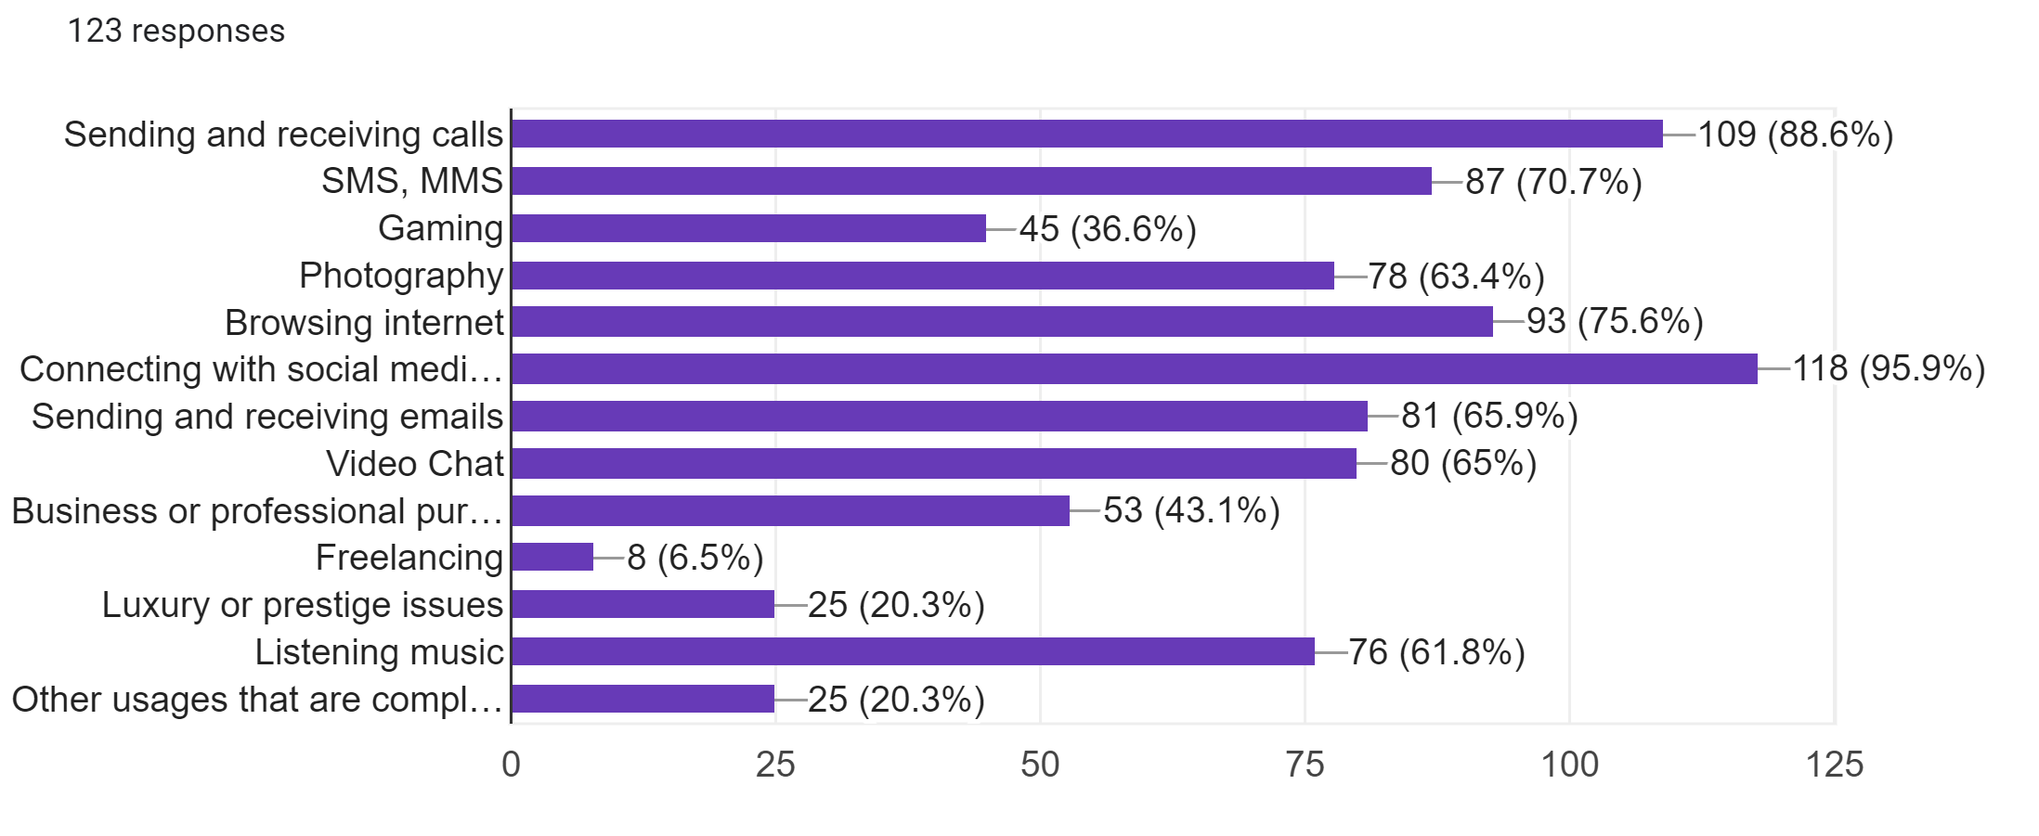
To identify the purpose of buying a smartphone, this statement were given. It is found that the Bangladeshi smartphone consumers mostly (about 95.9% or 118) purchase smartphone for the connection of social media sites (i.e. Facebook, YouTube, and Instagram); Sending and receiving calls (88.6% or 109); browsing internet (75.6% or 93); SMS & MMS (70.7% or 87); Sending and receiving mails (65.9% or 81); and Video chats (65% or 80 respondents).

Figure 5. Top preferred smartphone brands
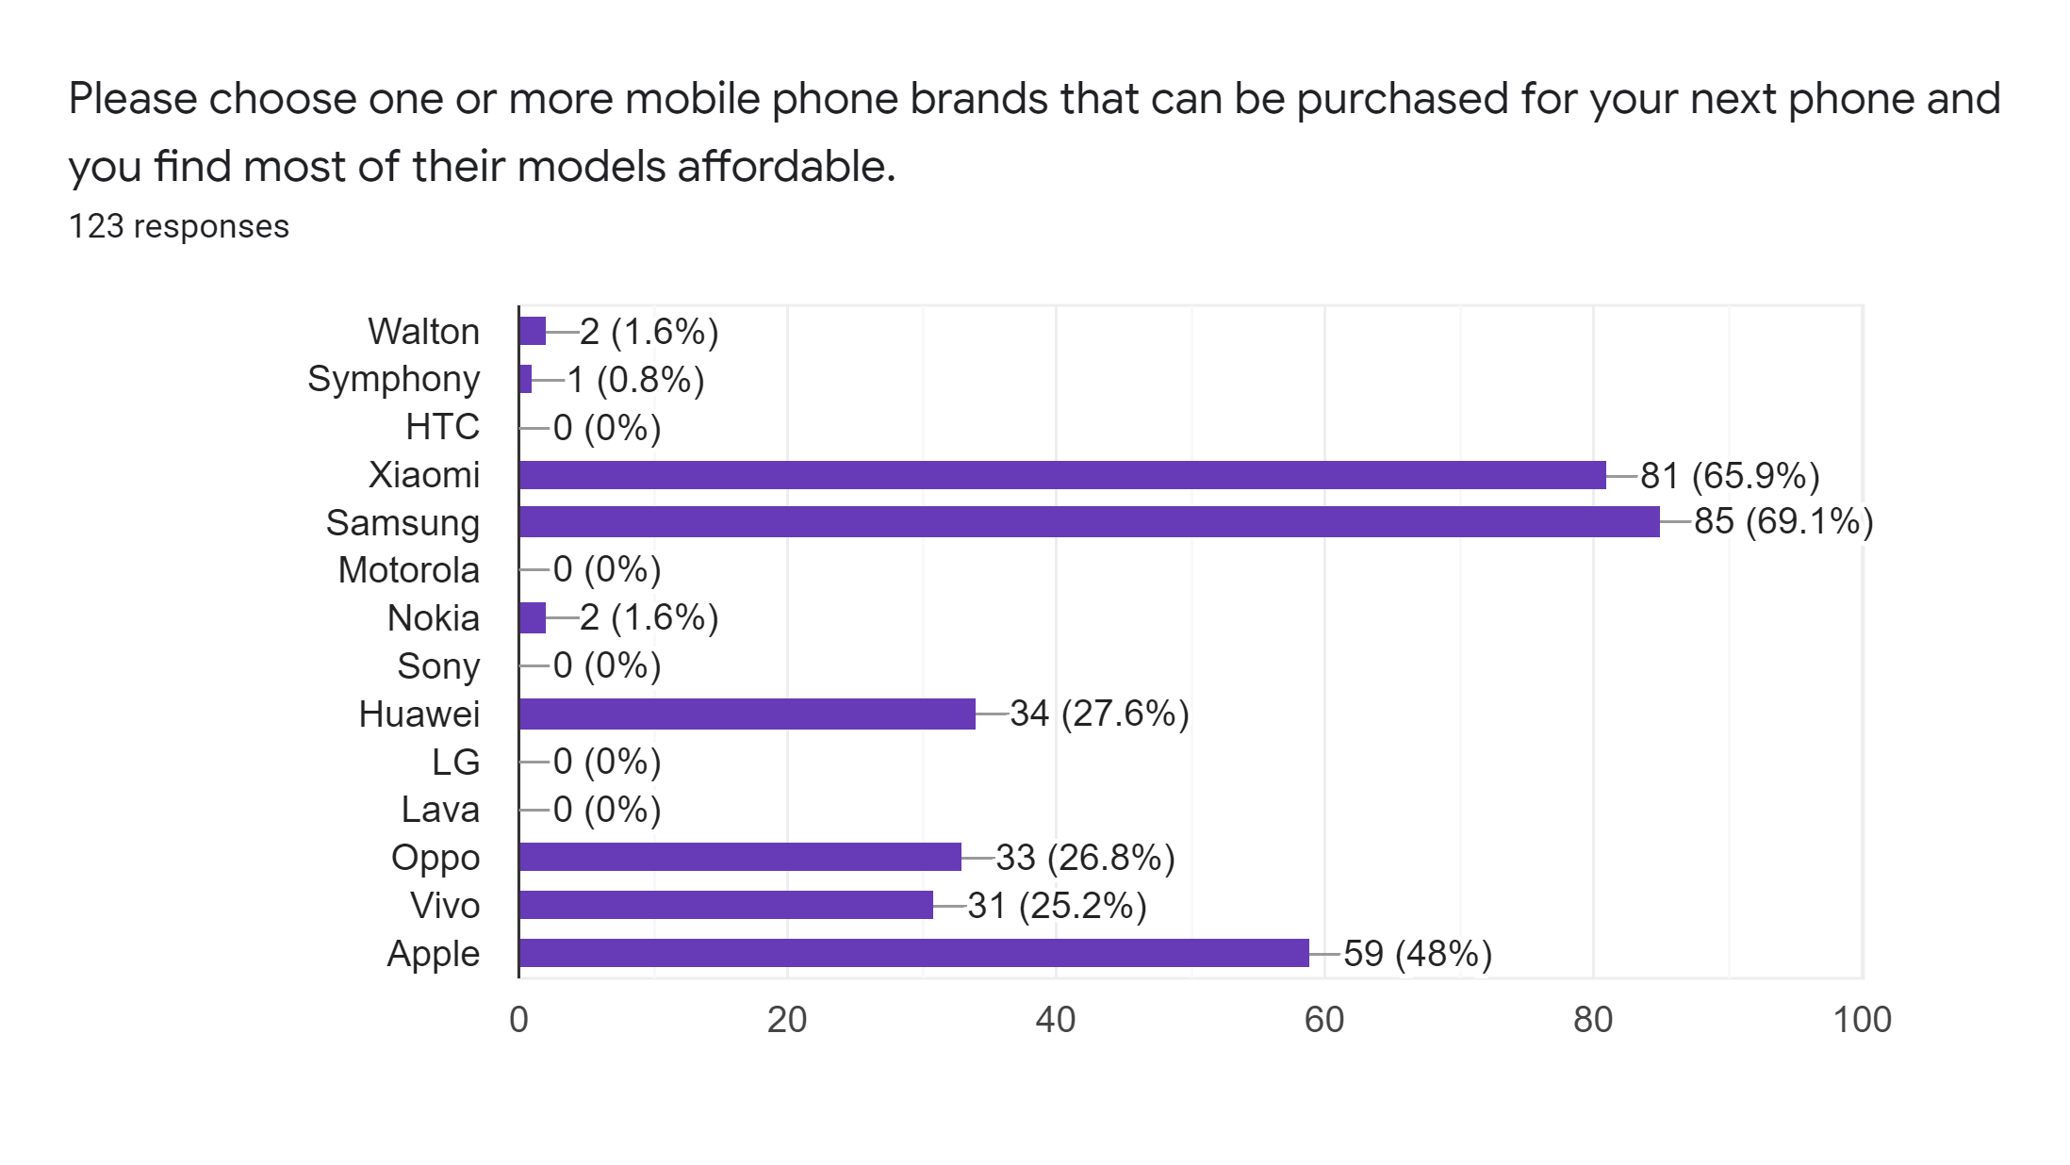
This statement identifies the most preferred smartphone brands of the buyers in Bangladesh. It is found that Bangladeshi people mostly prefer Samsung (69.1% or 85); Xiaomi (65.9% or 81); Apple (48% or 59); Huawei (27.6% or 34); Oppo (26.8% or 33); and Vivo (25.2% or 31).

Figure 6. Time Interval of purchasing a new smartphones
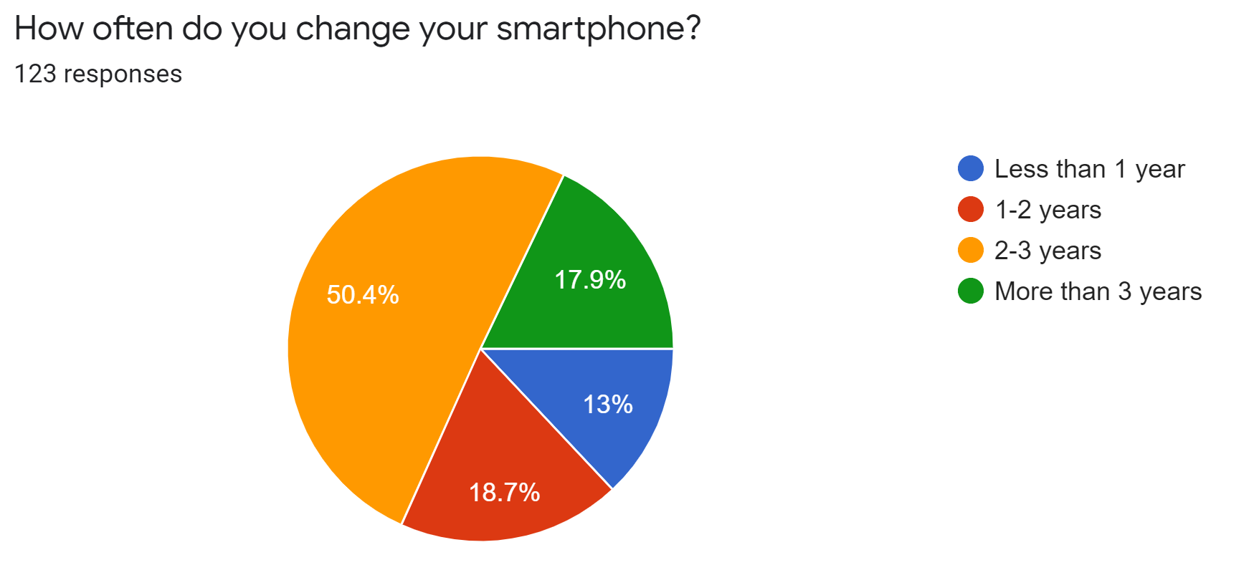
This statement initiates to identify the time period consumers use their smartphones at a stretch. The majority of the respondents (50.4%) use their smartphones 2-3 years; 18.7% use 1-2 years; 17.9% use more than three years; and 13% use for less than 1 years.

Figure 7. The people from whom customers het influenced mostly
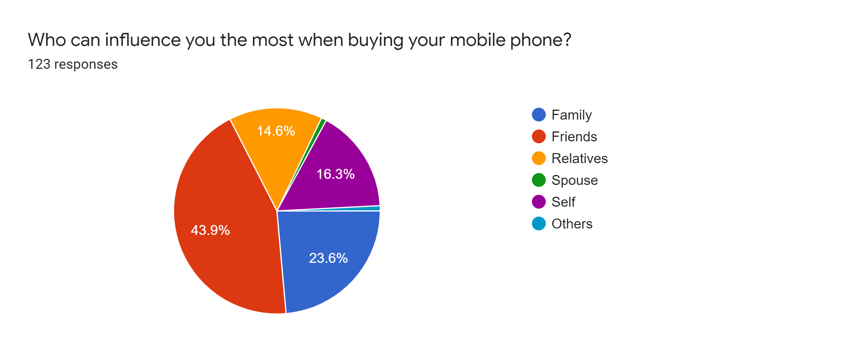
To know the people who have the influence commonly on the buyers, this statement were added. It is found that the majority (43.9%) of the Bangladeshi customers are influenced by their friends while purchasing their smartphones. 23.6% of the customers are influenced by family; 16.3% influenced by themselves; and 16.6% are influenced by relatives.

Figure 8. Preferred shops/stores for purchase smartphones
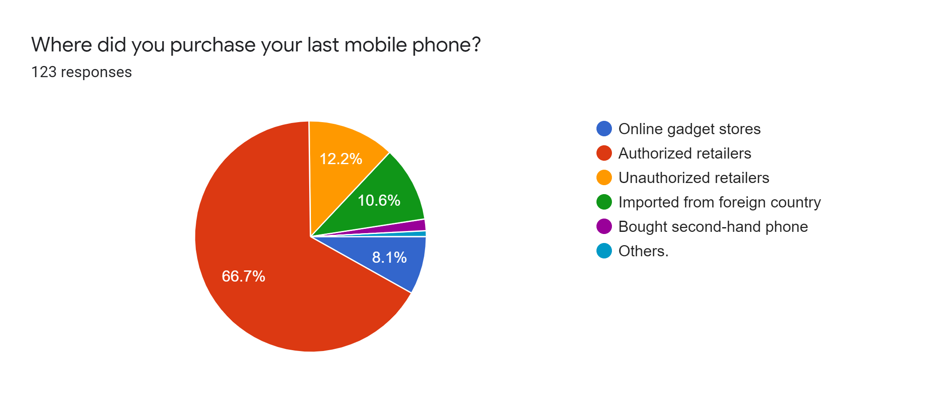
Among the types of stores, consumers mostly prefer authorized retailers (66.7%) while purchasing their smartphones. Few of them (12.2%) also prefer unauthorized retailers as well. However, only 10.6% customers are found those who imported their smartphones from foreign countries. Among all the respondents, the least preferred purchase destinations are online gadgets stores and buying second hand devices.

Figure 9. One-time budget for smartphones
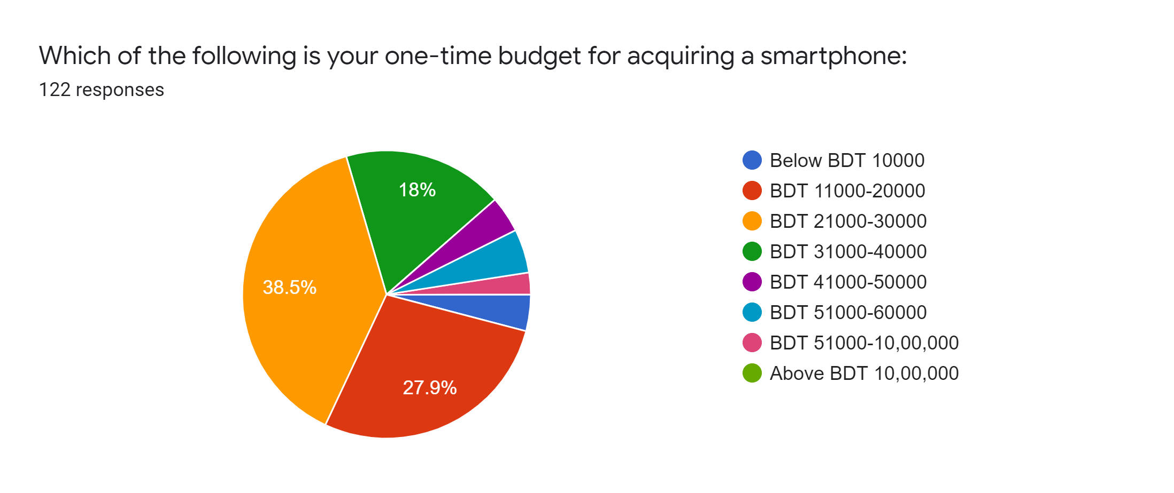
The statement provided in order to know the one-time budget of the customers for buying a smartphones. It is found them Bangladesh customers mostly spend between BDT 11000 to BDT 40000 as the majority of the respondents (38.5%) respondents have marked BDT 21000-30000; 27.9% have marked BDT 11000-20000; and 18% have marked BDT 31000-40000.

Figure 10. Interest for recommendations
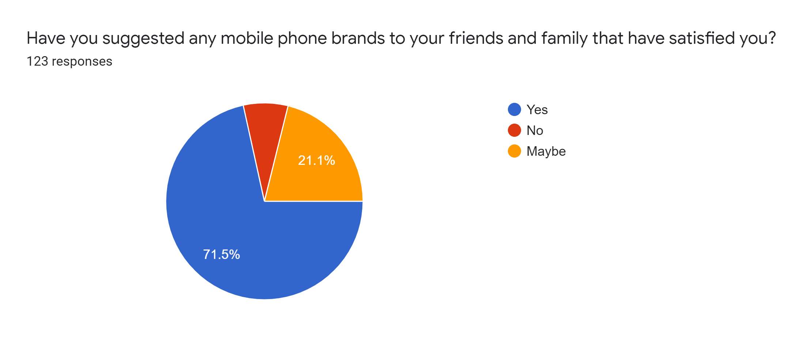
To know whether customers recommend a brand to others that have made satisfy them. It is found that most of them (71.5%) recommended; only 7.3% didn’t recommended to anyone; and 21.1% are not sure about the recommendations. Therefore, it can be said that it the Bangladeshi customers usually make recommendations if a brand can fulfil their desired needs.

2.2 Factors influencing consumers while choosing a smartphone brand

This research provides a total of 18 main factors that influence consumers' willingness to buy smartphones. These factors are found in some second-hand sources and previously published articles by well-known authors.

Figure 11. Factors of smartphones that influence in purchase decision making

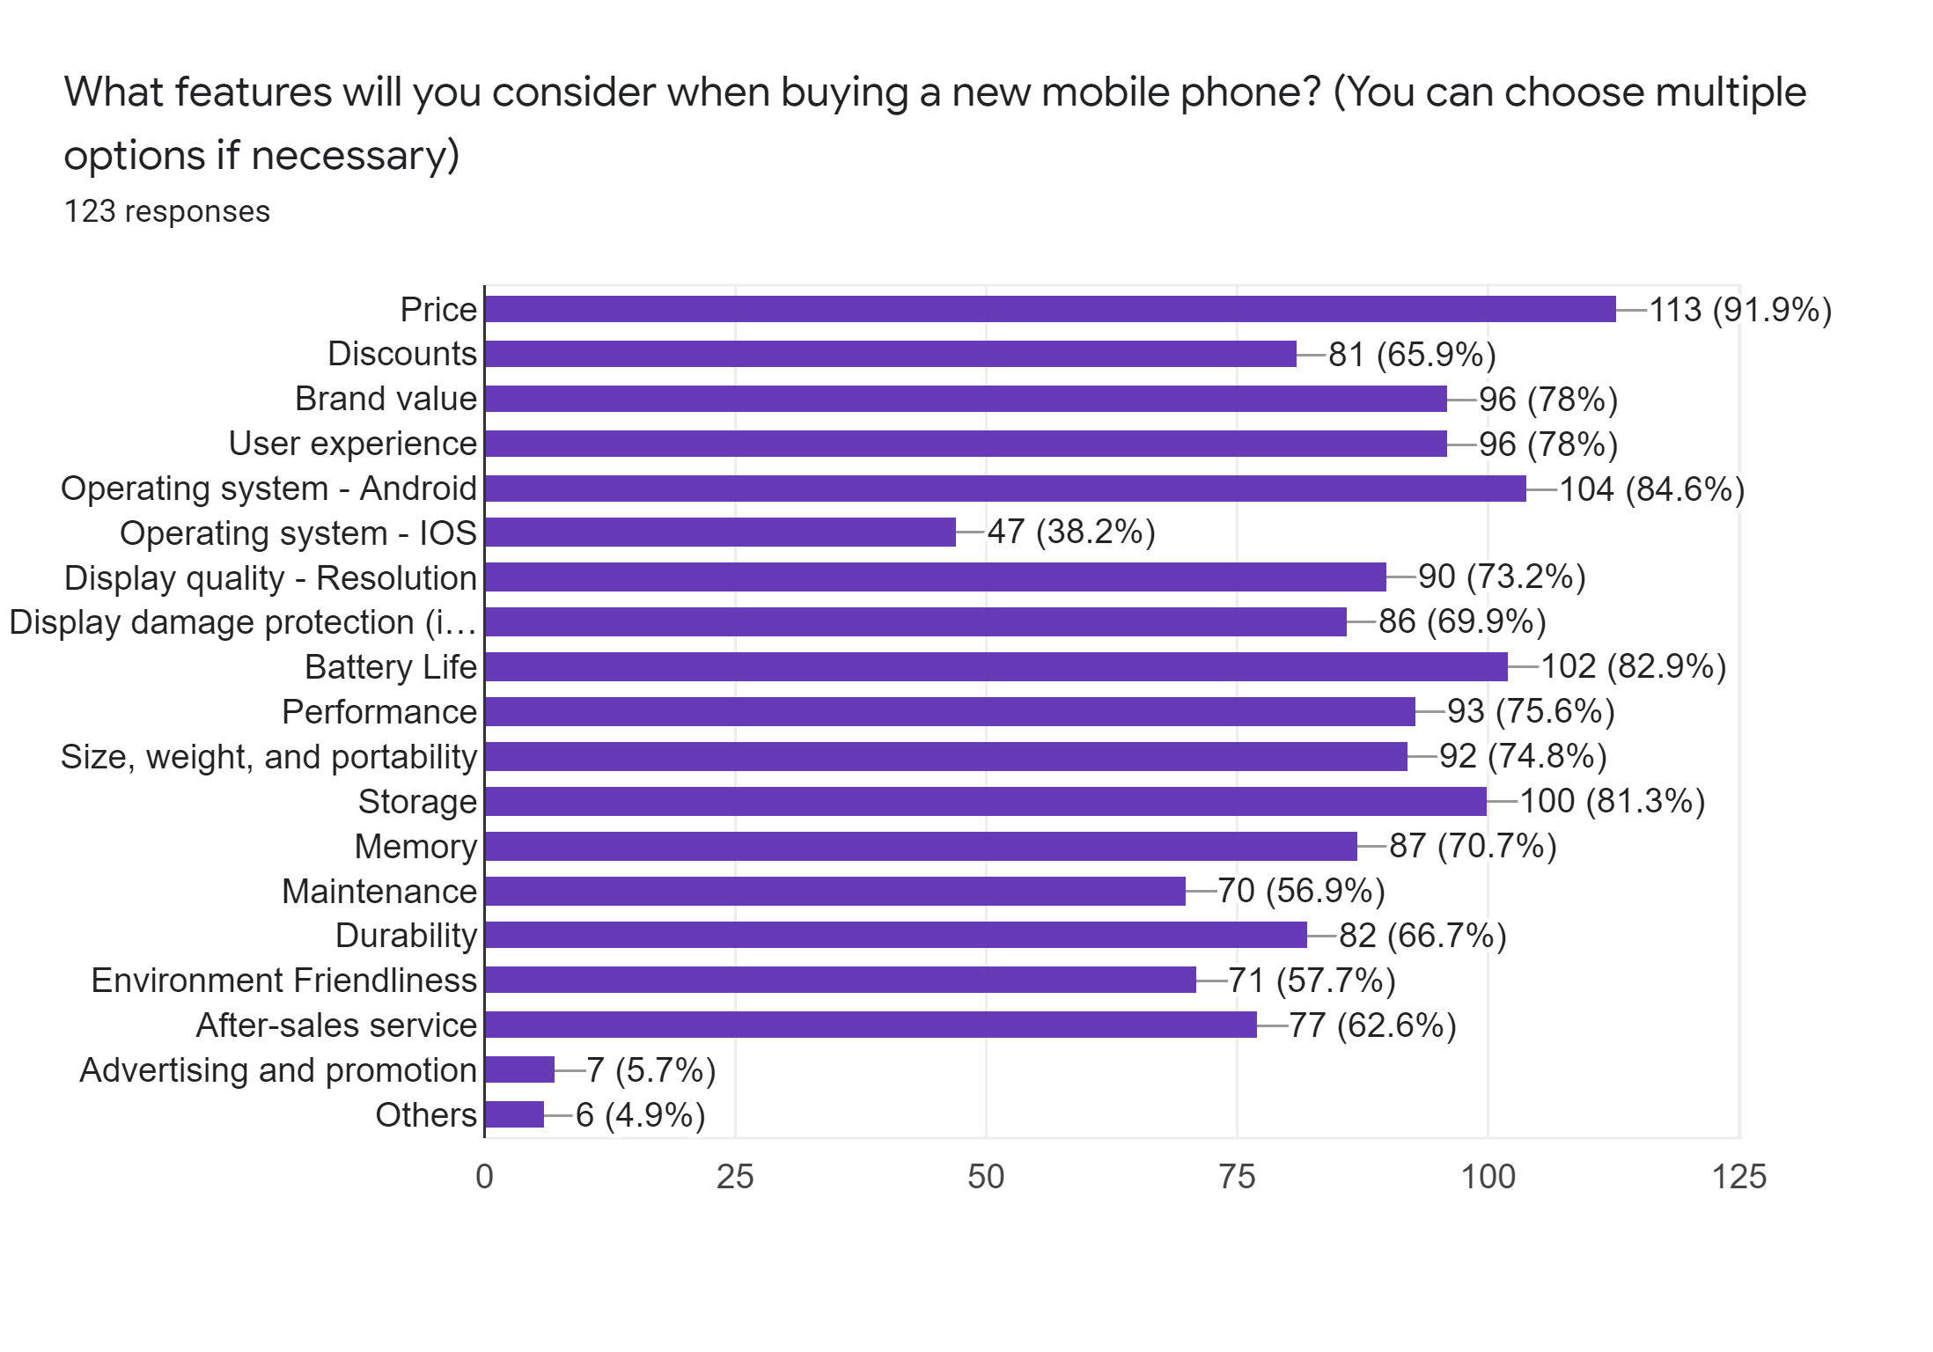
To know the factors that influence customers while making purchase decision of a smartphone, this statement were given. It is found that Price (91.9) is the most influential factor that impacts customers purchase decisions. Compared to IOS operating system (38.2%), the customers mostly prefer android operating system for their smartphones (84.6%). After operating system, battery life (82.9%) is one of the most influential factor for customers. Storage (81.3%), brand value (78%); user experience (78%); and performance (75.6%) of the smartphones are other most influential factor that impact on customers buying decisions.

The key factors influencing customers' purchasing decisions are described below:

- Price: Customers in Bangladesh have always regarded price as an important aspect. Smartphone consumers are divided into three categories according to socioeconomic class: the poor, the middle class, and the wealthy families. Income earners from the middle class may also be divided into middle and middle-low income groups. Only high-priced or high-priced smartphones can be afforded by high-income and wealthy customers. Others are trying to buy cheap mobile phones. Therefore, the most important factor influencing consumers' purchasing decisions is the price (91.9%).

- Operating system: The operating system is one of the main driving factors that affect the purchase decision of Bangladeshi customers. Compared with IOS (38.2%), most users prefer their smartphones to use the Android operating system (84.6%).

- Battery life: Bangladeshi users in particular regard Bangladesh’s battery life (82.9%) as a basic element for selecting and deciding smartphone brands after the operating system is running.

- Performance: The third most popular aspect is smartphone performance, 42% or 84% of respondents said. Performance may be the efficiency of any smartphone information or the entire phone. For example, performance can define the functionality, efficiency of an application, or how pleasant it is to use it in the internal application of a mobile phone.

- Storage and memory: The storage capacity of smartphones (because it affects 81.3% of customers) is growing day by day. 128 GB of storage space can already be used on mid-range cheap phones, and compared with 64 GB of memory, these consumers can save a lot of data.

- Brand value: The brand value of mobile phones (78%) is the fifth most important factor in choosing a brand to buy mobile phones in Bangladesh.

- User experience: Mobile user experience (78%) includes the user's impressions and feelings before, during, and after contact with a mobile device (through browser or application interaction). The use of mobile devices, from low-end phones to high-end mobile devices, can remain the same.

- Quality display: Provides a range of display resolutions, such as 4k Ultra HD, 2k, 1080p, 720p, etc. Display quality: Among their models, most smartphone companies usually offer screens of various resolutions. Approximately 90% or 73.2% said that they considered the display resolution when buying a smartphone.

RECOMMENDATIONS
AND CONCLUSION

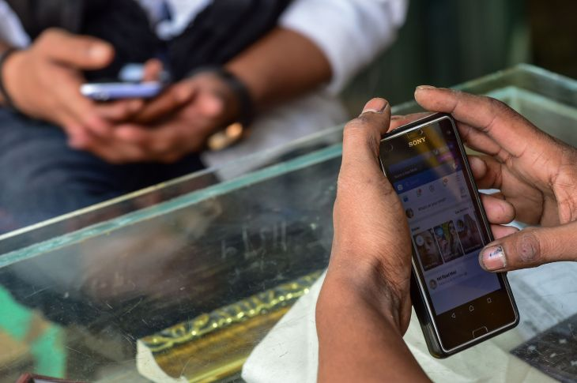

3.1 Suggestion & Recommendation
The study found interesting facts about the Dhaka city residents’ smartphone purchase behaviour and attitude. Marketers and brands should have concentrated on the influential factors of the customers in order to create satisfaction and brand loyalty. Following are some recommendations provided in order to help the smartphone brands to satisfy and retain their customers, based on the findings of Dhaka city residents.

Smartphone brands should take advantage of smartphone channels and features to better understand and manage consumer issues through support agencies. Enabling customers to make the most of the capabilities of their mobile devices also helps develop unique support experiences. A smartphone-centric approach to customs assistance can be the difference between winning consumers and losing customers to competitors in today's highly competitive economy, with experience in everything.

Compared with authorized retailers, customers are very reluctant to buy from online stores because they are afraid of losing money when ordering online and may damage the product. This often happens, consumers cannot get immediate support from the store, which prevents them from buying electronic products online. Brands can help them send photos or videos directly to support agents to speed up the support process and reduce the time customers spend answering repetitive questions about their questions and the reason for contact. Not only can customers send photos and videos directly to the agent, they can also provide a visual background before logging in to support. Sending visual context such as photos or videos while the customer is waiting can provide the agent with general information and be able to start assessing the situation before greeting the customer.

However, the practical implication of this study is that it provides a basic insight of Dhaka city customers with several limitations. As the sample size of this study is not too large, future research can be conducted on large size of population sample from Bangladeshi respondents. Future research can also be conducted on the issues of ordering from online stores faced by the customers.

3.2 Conclusion
The purpose of this study is to analyse the influence variables of Bangladeshi consumers' preference for smartphone brands. Bangladesh now influences various variables and behaviours of smartphone brand customers when choosing a brand or smartphone model according to some basic needs. The survey found that customers in Dhaka, compared with domestic brands (such as Walton, Symphony), are mainly attracted by international brands (such as Xiaomi, Samsung, Apple, Huawei, OPPO, and Vivo). They buy smartphones mainly to connect to the Internet. Social media sites (ie, Facebook, YouTube, and Instagram); send and receive calls; browse the Internet; text and MMS; send and receive emails; and video chat. They want their smartphones to last for at least 1-2 years. It is their friends, family members or themselves who influence their purchase decision. Authorized retailers are their first choice to buy smartphones, and at the same time, their least favourite destinations are online gadget shops and buying second-hand devices. In addition, the one-time budget for purchasing a smartphone is between BDT 11000-40000. Finally, consumers in Dhaka City will recommend whether a brand can meet their needs. The study also found that the influencing factors that affect consumers' smartphone purchase decisions are price; operating system; battery life, storage, brand value, user experience, and performance. It is hoped that all the research results can help international and domestic smartphone brands understand current insights into customer behaviour and formulate strategies accordingly to maintain themselves in a highly competitive market.

Reference

Woodard, J., Weinstock, J., & Leshe, N. (2014). Integrating mobiles into development projects. Retrieved August 30, 2021.

Lake, L. (2009). Consumer behaviour for dummies. John Wiley & Sons.

Sarma, S. (Ed.). (2017). Global observations of the influence of culture on consumer buying behavior. IGI Global.

International Data Corporation, (2020). “Bangladesh Mobile Phone Market Registers a Modest 4.1% Growth in 2019; Vendors Shift Gears to the Local Assembly, IDC India Reports”. Available at https://www.idc.com/getdoc.jsp?containerId=prAP46077520

Sarma, S. (Ed.). (2017). Global observations of the influence of culture on consumer buying behaviour. IGI Global.

Lake, L. (2009). Consumer behaviour for dummies. John Wiley & Sons.

Woodard, J., Weinstock, J., & Leshe, N. (2014). Integrating mobiles into development projects. Retrieved September 20, 2021.

Adrienne Matei. (2019). Shock! Horror! Do you know how much time you spend on your phone? The Guardian. Retrieved September 12, 2021, from https://www.theguardian.com/lifeandstyle/2019/aug/21/cellphone-screen-time-average-habits

Survey Questionnaire

