An Internship Report on

THE IMPACT OF JOB ANALYSIS ON TALENT MANAGEMENT AND ORGANIZATIONAL DEVELOPMENT: A STUDY ON KAZI FARMS GROUP

Submission Date: 20th July 2019
United international University
Dhaka, Bangladesh

An Internship Report on
THE IMPACT OF JOB ANALYSIS ON TALENT MANAGEMENT AND ORGANIZATIONAL DEVELOPMENT: A STUDY ON KAZI FARMS GROUP

Supervised By
Nasrin Akter
Assistant professor,
School of Business and Economics
United International University

Prepared By
Jannatul Ferdous
ID: 111 143 114
BBA Program
United International University

Letter of Transmittal
To,
Nasrin Akter,
Assistant Professor,
School of Business and Economics
United International University
Dhaka, Bangladesh
Subject: Submission of Internship report.
Dear Madam,
You will be glad to know about my successful completion of internship program from Kazi Farms Limited and during my internship program at Kazi Farms, I have aggregated all the information that are highly important to prepare my internship report. Moreover, I have completed my internship report on the title named “The impact of job analysis on talent management and organizational development: a study on Kazi Farms Group”.
Madam, the report format and all the efforts you had provided during the preparation of this report was highly appreciable. Additionally, the report format helped me to understand how to prepare my report and arrange data chronologically well. I have followed all the guidelines you had provided to prepare the report and want to ensure you nothing has been directly copied from anywhere without checking the appropriateness of the information.
I, therefore pray and hope, that your honor would be kind enough to accept my internship report and oblige thereby.
Sincerely yours,
Jannatul Ferdous
ID: 111 143 114
BBA Program
United International University

Acknowledgement
At this part, I want to begin my report with thanking and showing proper appreciation to my ALMIGHTY ALLAH for all the blessings I have received till now and for making me able to complete the long length 4 year’s BBA program from United International University.
I want to thanks and show my gratitude to my course faculty as well as my internship supervisor NASRIN AKTER, Assistant Professor, School of Business and Economics, United International University for her efforts and time that I have received during the internship period. The report would not be an efficient one if I didn’t get the appreciation and encouragement from her. The report format, what I received from her, was the center point where I can understand how to prepare the report step by step. Therefore, it’s proved very important to me.
Additionally, I want to thank my office supervisor, ALEA AFROZA, Senior Human Resource Manager, & UZMA TAWHID ASHMITA, Executive HR, Kazi Farms Group, who gave me the opportunity to work as an intern in their organization. I have to deal a lot of workloads and few of the job found highly tough to perform where I found him as a tutor who had done not only his duty but also monitors my few work responsibilities so that I can learn how to finish those task in time.
Last but not least, I want to thanks all my friends and colleagues who helped me a lot to collect information during the time. Truly, because of all your help, the report has been completed well.

Executive Summary
The internship report is the pre-requirement to achieve the BBA degree from United International University. All students have to go through this program before completing their Bachelor of Business Administration degree. At this stage, students join in an organization as an intern and learn to handle real life work responsibilities. After completing the three months internship program, students have to submit their internship report according to their internship supervisor’s guideline. I, luckily, got an opportunity to work as an intern in the City Bank Limited and successfully performed my job responsibilities there. The report topic “The impact of job analysis on talent management and organizational development: a study on Kazi Farms Group” is very relevant to my work responsibilities that I had performed for last few months at Kazi Farms Group.
From the young days, Kazi Farms Limited started its journey in 1916, it became the biggest producer of broiler and chicken in Bangladesh. They are now the largest producer of poultry feed in Bangladesh. Kazi Farm now operates three farms, 3 parents’ farm, 8 parent broiler producer farms, 7 nurseries, and 2 chicken feed mill. Their current production capacity is 1.8 million chicken a day. About 35% of the broiler sold in Bangladesh come from the Kazi farm. Kazi Farms has started exporting to the Middle East and Nepal and is operating a broiler farm in the Sultan of Oman.
The report consists of five exploratory chapters. First chapter, named INTRODUCTION is a discussion of the study that includes background, scope, objectives, methodology and limitations of the study. The next, 2nd chapter is LITERATURE REVIEW, what tries to make clear about the concept of job analysis, talent management and organizational behavior. The 3rd chapter is about the ORGANIZATIONAL OVERVIEW what consists of discussion based on Kazi Farms Group. The 4th and the most important chapter is the ANALYSIS AND FINDINGS chapter what discussed the how the job analysis process of Kazi Farms impact on the talent management and organizational behavior.
The final chapter, 5th chapter, is RECOMMENDATION AND CONCLUSION, where I have tries to provide few suggestion based on my theoretical learning and knowledge for the betterment of the Kazi Farm’s job analysis Process. Hopefully, the shortcomings can be easily fulfilled if careful concern is given in these sites.
Theoretically, the job analysis and the talent management process are very co-related to each other that means a proper job analysis can also help to retain and maintain the talent management in an organization. The process or steps of job analysis consists of eight steps that are: a. Decide what position to fill, b. create a pool of eligible candidates, c. collect properly filled application form from the applicants, d. Apply selection procedures, e. Provide offer letter to the most eligible employees, f. arrange orientation and training programs for new employees, f. select performance appraisal procedures, g. Reward employees, compensate them and ensure safety for future.
Furthermore, the report consists several discussion on the organizational development of Kazi Farms Group. Kazi Farm's success is difficult to ignore the importance of organizational development because it affects all aspects of the decision-making process. Organizational development is defined as the use of organizational resources to improve efficiency and productivity at the workplace. An effective organization can increase employee morale because employees can feel more empowered and valuable when their business is well-organized. The importance of organizational development also applies to how the organization solves the problem and how it analyzes the process of how to implement it. Implementation of organizational development requires time and money investment. But when the Kazi farm began to understand the importance of organizational development, in addition to the role of organizational development, the organization helps to determine the firm direction for its business, how it supports the cost.

Table of Content
Introduction
1.1 Background of the study 2
1.2 Scope of the study 2
1.3 Objectives of the study 2
a. Primary objectives: 2
b. Secondary objectives: 2
1.4 Methodology of the study 3
a. Methods of data collection: 3
I. Primary Sources: 3
II. Secondary Sources: 3
b. Data presentation: 3
1.5 Limitations of the study 3
Literature Review
2.1 Concept of Job Analysis 5
2.1.1 The importance of job analysis 5
2.2 Job Analysis Process 6
2.3 Concept of Talent Management 9
2.4 Concept of Organizational Development 9
2.4.1 The Basic Values of Organizational Behavior 10
2.4.2 The objectives of Organizational Development 10
Organizational Overview
3.1 Background of Kazi Firms Group 13
3.1.1 Mission 13
3.1.2 Vision 13
3.2 Product and services served by the Organization 14
3.2.1 Layer chicks and table eggs 14
3.1.2 Feed 14
3.1.3 Chickens and Broiler Chickens 15

The impact on talent management and organizational development of Job analysis
4.1 The impact on talent management through job analysis in Kazi Farms Group 17
4.2 Flowchart Job Analysis Process that manages and resources talent at Kazi Farms Group 21
4.3 The Impact on Organizational Development through job Analysis Process. 22
4.3.1 Organizational Development of Kazi Farms Group through Job Analysis 22
I. Recruitment capacity 23
II. Business sense 23
III. Maintain consistency 23
IV. Strategic planning 24
L Findings, Recommendations, and Conclusion
5.1 Findings 26
5.2 Recommendation 28
5.3 Conclusion 29
Reference

Chapter One
Introduction


Background of the study
The internship report is the pre-requirement to achieve the BBA degree from United International University. All students have to go through this program before completing their Bachelor of Business Administration degree. At this stage, students join in an organization as an intern and learn to handle real life work responsibilities. After completing the three months internship program, students have to submit their internship report according to their internship supervisor’s guideline. I, luckily, got an opportunity to work as an intern in the City Bank Limited and successfully performed my job responsibilities there. The report topic “The impact of job analysis on talent management and organizational development: a study on Kazi Farms Group” is very relevant to my work responsibilities that I had performed for last few months at Kazi Farms Group.

Scope of the study
The scope of the report is to provide the general overview of Kazi Farms and the job analysis process the organization is maintaining to retain its talent and improve organizational development. A reader can easily understand about the job analysis process, talent management, and organization development if they go through the report properly. A university student can understand how a job analysis is performed in a real organization so that they can compare them with their theoretical knowledge.

Objectives of the study
- Primary objectives: The primary objectives of the report is to submit the report successfully in order to complete the BBA program from United International University.
- Secondary objectives: The secondary objectives are:
- An analysis of Kazi Farms Limited
- To analyze the job analysis process.
- To show how job analysis of Kazi Farms Group impacts on the organizations talent management.
- To show how job analysis of Kazi Farms Group impacts on the organizational development.

Methodology of the study
- Methods of data collection: The information that utilized here are taken from several valuable and relevant sources. The sources are:

Primary Sources:
- From current employees through formal communication.
- From my practical work experiences in the organization.
- From the annual report and websites of Kazi Farms Limited.

Secondary Sources:
- From several published article and books that are relevant.
- From online blogs and websites.
b. Data presentation: The report is an exploratory one in nature where all the information are used qualitatively.

1.5 Limitations of the study
During the internship period, I have to go through a lot of work responsibilities and pressures that was sometime unbearable. During such hard times preparing the report was difficult. At this part, I am going to provide some limitations that are given below:
- Short duration: The internship program is for three months and during these months, I have to work in the bank as well as prepare my internship report what found difficult to me.
- Confidentiality: As a leading farm in poultry sector, Kazi Farms Group maintains a lot of secrecy in their business and do not allowed me to disclose few information.
- Work pressures: As an intern, I have to work a lot of job responsibilities and during the day hour work pressures are very high as there are a lot customers who visit the farm.

Chapter Two
Literature Review


2.1 Concept of Job Analysis
Job analysis is a specific search that studies and records responsibilities, work, skills, responsibilities, work environment, and skills necessary for specific work. It determines the relative importance of work, responsibilities and physical and mental ability for a particular job. All these factors determine the need for a job and a worker should be productively working.
Job Analysis involves a thorough investigation to control the results of the success of the work. The process identifies the needs of a particular service and what a potential worker can offer. Apart from working titles, work, work summary, an action involving, working environment, potential risks, and equipment, tools, types of equipment, determining a job description, help and materials must be used by the user. Existing or potential employees
However, the process is not limited to determining this reason. Expand to find out the skills of people to do it. This includes the education level, experience, justice, training, initiative, leadership, physical skills, communication, responsibilities, psychological features, and sensory requirements. Unusual. These factors depend on the risks involved in the type, level of seniority, industry and paid jobs.

2.1.1 The importance of job analysis
The details collected during the job analysis play an important role in controlling the results of a particular job. Determining job success depends on a neutral, accurate and thorough analysis of the job. It helps to hire the right people for a specific job. The main goal of the whole process is to create and establish perfect matches between employees to employees.
Job analysis helps to decide the package of the help of human resources managers and additional stimulus for specific tasks. It effectively helps to assess training needs and performance of existing staff. The process is the basis of designing and establishing the strategy and principles of organization's goals and objectives.
However, a specific job analysis does not guarantee that getting the desired results of managers or organizations. In fact, data collection and recording for a specific job involved various complications. If the job information is incorrect and checked from time to time, an employee cannot perform well. As long as he knows what he is supposed to expect from him, it is probably a mere waste of time and energy devoted to a particular job analysis of human resources. Therefore, when a job analysis should be taken care of.
The convenience of a thorough and neutral investigation or investigation manager and employees in a specific task. Hire the manager and why. They can fill a place with the right person. On the other hand, existing or prospective workers can find out how they work and how they should be done and what results they want. Job analysis creates the right match between the work and the employee.

2.2 Job Analysis Process
The one of the main purpose of job analysis is to search 5 question answer. They are:
- How to determine the new needs of the organization's staff?
- Where are the employees in the best position to use their skills and talents?
- How to define realistic performance measurement values?
- How to eliminate unnecessary work?
- How to identify a job and prepare a plan to fill it?
Luckily, these questions can be answered through the job analysis process. The manager must deal with these problems in the daily activities of the company, which must meet the needs of the organizations in terms of grants, selection, performance, satisfaction and reduction of human resources, as well as adding responsibilities and additional tasks, to be effective. And there is no possibility that they can avoid the risk of making mistakes.
Effective job analysis is a great way to have an efficient and accurate process. This helps to maintain the good quality of the employees, to measure their performance on realistic values, to evaluate their training and development needs and to increase their productivity. We discuss the job analysis process and find out how it works. A general job analysis process model can be like:
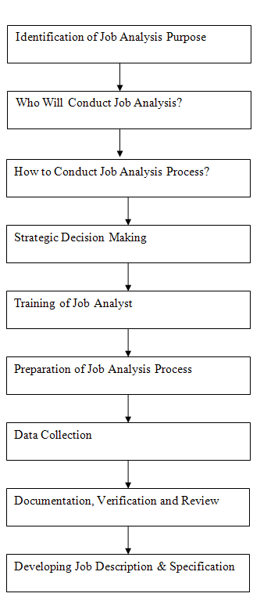
- Identifying the Job Analysis Objective or Purpose: Well, any process is useless until its purpose is identified and defined. Therefore, the first step in the process is to determine the need and the desired outcome. Spending human effort, energy and money are useless until human resource managers know why the data needs to be collected and what needs to be done.
- Who will perform the task analysis: The second most important step in the job analysis process is deciding who will do it. Some companies prefer to do this through their own human resources department, while others rely on consultants for job analysis. Job analysis consultants can be extremely helpful because they offer unbiased advice, guidance, and methods. They do not have a personal preference for analyzing a job.
- Leading the process of job analysis: Deciding how the task analysis process should be conducted is certainly the next step. To study a specific job, a planned approach is needed to integrate the whole process.
- Making of the Strategic decisions: The time has come to make a strategic decision. This involves determining the degree of employee involvement in the process, the level of detail to be collected and recorded, the sources from which the data is to be collected, and the methods of data collection, processing and separation.
- Work Analyst Training: The next step is to train the working analyst to conduct the process and use the selected methods for collecting and recording work data.
- Preparing the Job Analysis Process: The next step is communication within the organization. Human Resources Managers must properly communicate the entire case so that employees provide full support to the Labor Analyst. The phase also includes the preparation of documents, questionnaires, interviews and feedback forms.
- Data Collection: We then collect work-related data, including the qualifications of the employees, the skills and abilities required to perform the work, the working conditions, the work activities, the hierarchy, the human characteristics required, the work activities, the tasks and responsibilities involved and the behavior of employees.
- Documentation, verification, and revision: The correct documentation is performed to verify the authenticity of the collected data and then to examine them. This is the latest information used to describe a specific job.
- Development of the job description and job specifications: the time has come to separate the collected data into useful information. The job description describes the roles, activities, tasks, and responsibilities of the position, while the position specification describes the qualifications, experience, personal characteristics, and skills required for the school.
As a result, the job analysis process helps identify the value of a task by making the most of human talent, eliminating unnecessary tasks and setting realistic performance measurement standards.

2.3 Concept of Talent Management
Talent management is just another uncommon word for human resources, is not it? False. Talent Management promises an organization to hire, maintain and develop the most talented and qualified staff available in the job market.
While describing the organization's commitment to employing, managing, developing and maintaining talented employees, talent management is a very effective word. It includes all processes and work systems related to the maintenance and development of a higher workshop.
Talent management is a business strategy which companies hope to keep the most talented and qualified staff. The employee is involved or recognized, the announced business strategy that will attract the best talent to compete with other employers.
When you tell a potential worker that you have dedicated a talent management strategy that will allow them to grow professionally, then you will attract the best talent. In fact, research shows that the ability to develop and develop professional and personal skills for employees to take and maintain employees is an important motivation factor.

2.4 Concept of Organizational Development
Organizational Development (OD) Successful organizational changes and performance research. OD was developed in the study of human relations in the 1930s, among which psychologists realized that organizational structures and processes affect the behavior and motivation of the workers. Recently, work in ODY has expanded on the focus of organization enlarged with their rapidly growing and complex environments by organizational education, knowledge management and transformation of organizational rules and values. The main concepts of OD theory include: Organizational climate (the mood of an organization or "unique" personality, in which attitudes and beliefs affect the collective behavior of members), organizational culture (shared values, values ​​and behavior deeply) and organizational strategies (An organization identifies issues, plans actions, discusses changes, and evaluates progress)
Organized as an exercise involves a regular and steady process of implementing effective organizational changes. OD is focused on understanding both the organizational changes and the understanding of a field of scientific research and investigation and a field of science both. It is intermittent in nature and comes with the theory of social sciences, psychology, especially art and organizational psychology and motivation, education and personality. Although behavior science has provided the basis of OD's research and practice, new and emerging field research fields have felt their presence. In terms of systematic thinking, organizational education, decision-making and coaching inclusion (some in the name of naming), whose view is not only shaped in the behavioral sciences but also appears in the more multidisciplinary and interdisciplinary field [quote required], OD catalyst or tool.

2.4.1 The Basic Values of Organizational Behavior
The underlying organizational development is the human standard. Marjuli and Rayya (1972) have illustrated the human values ​​of Odes as follows:
- Each person is important to a person's behavior, their work and their lives with a complex set of needs
- The organization has the opportunity to influence human work, organizations and ways related to the environment
- Trying to increase the effectiveness of the organization in terms of all its objectives
- Trying to create an environment which is possible to find an incentive and stimulus work
- Provide people the opportunity to work as people instead of the production process as people
- In addition to each member of the organization, the organization also offers the opportunity to develop its full potential

2.4.2 The objectives of Organizational Development
- Increasing organizational problem resolution
- Increasing satisfaction and staff commitment level
- Increased level of interpersonal trust among the workers
- Face negativity instead of neglecting them
- In an ongoing basis, the process that will help improve the continuous operations of an organization
- Increase cooperation and co-operation among workers
- Effectively manage the conflict
Since the objectives of organizational development have been defined [by whom?], considering the specific circumstances of the account, they vary from one position to another. In other words, this program is tailor-made to meet the requirements of a particular situation. But in general, all organizational development programs try to achieve the following goals:
- Encourage workers to avoid them instead of solving the problem,
- Create an active environment that encourages the workers for the job,
- Replace the official line of authority with personal knowledge and expertise,
- Create an environment of the belief that the staff willingly accept changes,
- Strong interpersonal trust, cooperation, and communication to achieve organizational goals,
- Create an organization's perspective on the organization's perspective. Helps coordinate workers with the outlook of the organizational development organization,
- Encouraging everyone for the implementation of the plan, making them responsible for the implementation of the plan.
According to organizational development, organizing a broad selection of organizational development provides a car with managers to introduce changes. This, instead, leads to greater effectiveness

Chapter Three
Organization Overview of Kazi Farms Group
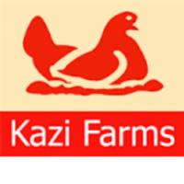

3.1 Background of Kazi Firms Group
From the young days, Kazi Farms Limited started its journey in 1916, it became the biggest producer of broiler and chicken in Bangladesh. They are now the largest producer of poultry feed in Bangladesh.
In Bangladesh, it is Cobb-Ventures franchisee of the United States of America, Cobb for 500 chicken coop, considered the best in the world. World's oldest poultry farm and American feed producer Kargil Hijain, other strategic partners of Kazi Farms Group.
Kazi Farm now operates three farms, 3 parents’ farm, 8 parent broiler producer farms, 7 nurseries, and 2 chicken feed mill. Their current production capacity is 1.8 million chicken a day. About 35% of the broiler sold in Bangladesh come from the Kazi farm. Kazi Farms has started exporting to the Middle East and Nepal and is operating a broiler farm in the Sultan of Oman.
In the last ten years, due to the fast growth of chickens in the day to day production, Kazi Firms allowed poultry farmers of the country to expand their business. Therefore, Kazi Firms have played an important role in achieving the so-called "Poultry Revolution" in Bangladesh. This has increased the availability of protein in the country and created opportunities for the generation of income for the rural household across the country.
Additionally, Kazi Farms Limited was founded in 1996 as an imported nursery for eggs; the following year, it created its own mother farms. In 2004, production began on our grandparent farm. It was responsible for the first exports of hatching eggs and day-old chicks from Bangladesh in 2004. That year, our general manager, Kazi Zahedul Hasan, was named the business star of the year by the Daily Star / DHL company awards.

3.1.1 Mission
The mission of Kazi Farms Limited is to produce the best quality day-old girl in the country, consistent with international standards.

3.1.2 Vision
The vision of Kazi Farms Limited is to be one of the best commercial organizations operated by Bangladesh in terms of the quality, technology, innovation, operational superiority, and growth. Moreover, it will continue to produce the day-old chicks of the highest international standard.

3.2 Product and services served by the Organization

3.2.1 Layer chicks and table eggs
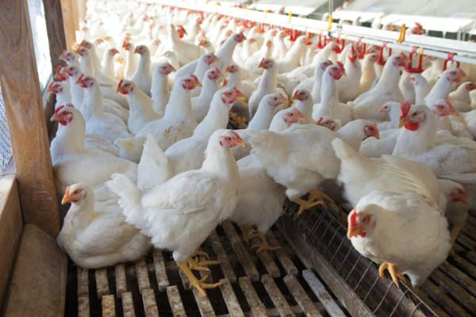

Kazi Farms Group is also the distributor of the brown and white layers of the Hy-line in Bangladesh. Hy-line International is the oldest poultry farm in the world and the main layer farmer. The commercial farms of Kazi Farms make it the largest producer of eggs for consumption in Bangladesh.

3.1.2 Feed
The Kazi Farms Group expanded its activities in the poultry feed production sector in 2006. In a very short time, it has become a market leader in terms of quality and volume. To ensure food quality, the Kazi Farms group has received technical assistance from Cargill USA and Buhler Switzerland for the installation of its feed factory.
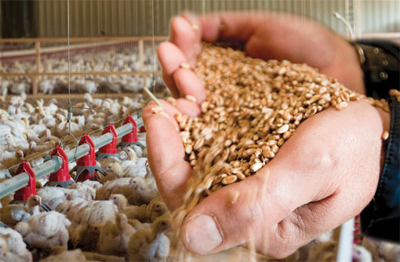
Gajaria's feed plant uses state-of-the-art sanitation pellet mills from Buhler, Switzerland, which produces the world's best feed equipment. By eliminating any potential bacterial contamination of the feed, Buhler dry mills ensure that poultry farmers experience fewer outbreaks and achieve better results.

3.1.3 Chickens and Broiler Chickens
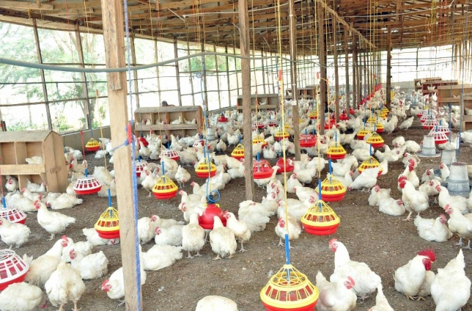
Kazi Farms Group is the Avigen Indian River Bangladesh Grandparent Franchisee and Cobb-Vantress, recognized as the best beef breed in the world. The broiler chickens of the Kazi Farms Group are considered the most successful chicks on the national market and are sold at a higher price than other beef breeds.
Chapter Four
Analysis and Findings
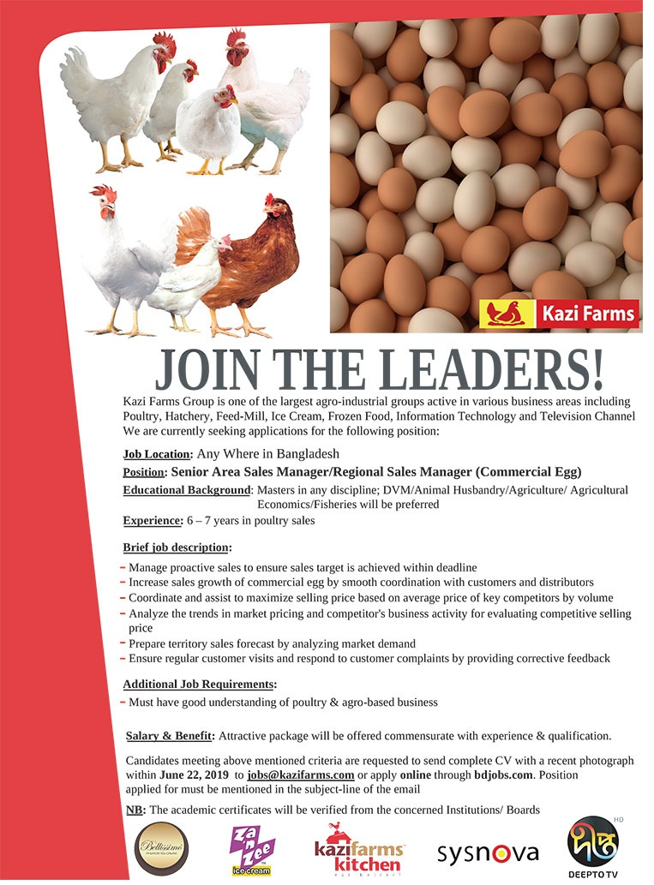

4.1 The impact on talent management through job analysis in Kazi Farms Group
The job analysis at Kazi Farms begins with the acquisition of candidates for any vacancy. Here at Kazi Farms, the recruitment is different for different level positions. For each new entry-level position, the corresponding SBU completes and sends a recruitment request form (RRF) to the central office. The RRF contains the reasons and justifications by which a particular position and/or multiple positions must be filled. If it is a replacement for a previous employee, no justification is required. However, in the case of a new position or new positions, the corresponding justifications must be provided in the RRF.
However, after RRF has arrived at its headquarters, human resources officers from the Human Resources Department (HR) examine the RRF to find out the need for a vacancy. They try to find out what kind of skills are required for certain positions and exactly when the vacancy should be closed. RFF then obtains the approval of the head of human resources and, therefore, the RRF is sent to the administrators for final approval. After the approval of the Directors, the RRF is filed and actions are then taken to publicize the vacancy. Typically, ads are prepared and posted on online job portals such as bdjobs. The ads are kept alive for at least 7 (seven) days, depending on the positions. If it is a position that requires important technical skills, the ads are also published in the newspapers. In addition to announcements from bdjobs and newspapers, candidates also have the opportunity to send a printed copy of the questions to the human resources department at the central office. An example of the RRF and the ad template is shown below:
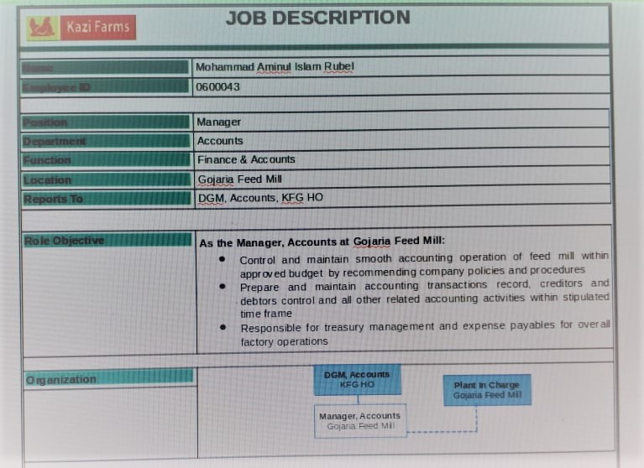
After the deadline, the questions are collected from the sources in which the work was announced. In addition, in some cases, questions are received internally, which means that employees can inform candidates if they know someone suitable. The Talent Acquisition team then lists the applications according to the work requirements.
If the position is for recent graduates, selected candidates are invited to take a written test and an IT test. The written tests are generally composed of English language tests, math tests, and critical thinking. Those who pass the written and computer tests; then proceed to the next phase that is the Group Discussion. The group discussion was recently introduced in the recruitment process of Kazi Farms. At least 10 (ten) candidates are required for group discussion. All are sitting together and are in charge of discussing any topic. A jury observes this discussion about the candidates. The members of the jury are selected from the functional department where the vacancy and the human resources department are present. From the group, members of the discussion panel evaluate candidates' leadership skills, their presentation, and communication, their knowledge of work, appearance, ability to work in groups and their ability to cope with pressure or stress, and so on. Among the ten candidates, the best 3-4 candidates are chosen and subsequently interviewed by the members of the jury. Then the final candidate is selected. However, for technical positions and for those positions that lack good candidates in the market, it is not necessary to organize group discussions. In these cases, the candidates are called in writing and proof. And those who pass are interviewed directly. This also applies to mid-level positions. In addition, the forms of evaluation of the interview are different. There are 3 interview evaluation forms for entry, medium and high-level positions.
In addition, from the positions of medium-high level, the candidates do not appear for an interview but are interviewed several times. First, they are interviewed by the functional manager along with the supervisor and the talent acquisition manager. Then, the preselected candidates are interviewed by the head of the business unit as CEO and human resources manager. The final decisions are made based on the interview.
The only exception here is for AGM and the positions listed above the selected candidates also meet with the directors of the company for a final interview. Sometimes, instead of a final interview, pre-selected candidates are invited to a presentation and presented to the Board of Directors. In addition, for higher-level positions, job advertisements are published by the head hunters.
Currently, the Kazi Farms group employs 7,500 people, including 1,500 managers and 6,000 non-managers. Furthermore, KFG is a temporary and occasional worker who works in season and only works for a short time. The total number of casual and temporary workers varies according to commercial production. In general, it is around 500.
Talented resources in KFG are created for all managerial positions and others. And follow all the classifications of the company. However, one of the genes of the process. The distribution of resources between management and non-director is different. Furthermore, the job of the employer is to withdraw from the business unit in which the employee is not affiliated, where the positions are vacant. Recruitment for all management positions is carried out by the central office.
- When potential candidates are hired through a job analysis, specific criteria are envisaged:
Each Kazi Farms Group administrative site has a specific job description and a golden sheet that includes Job description information authority, general responsibilities, requirements and skills for a specific job, Key Performance Indicators (KPIs) and Key Results Area (KRA) for a specific position on the Objectives tab. Potential candidates should be recruited based on their job descriptions and goals.
- The third parties are usually involved in the job analysis and talent management process:
The high level of the third party was involved in the recruitment. For all high-level vacancies, the requirements are sent to the headhunter. If a successful candidate is elected, the company must pay a certain fee.
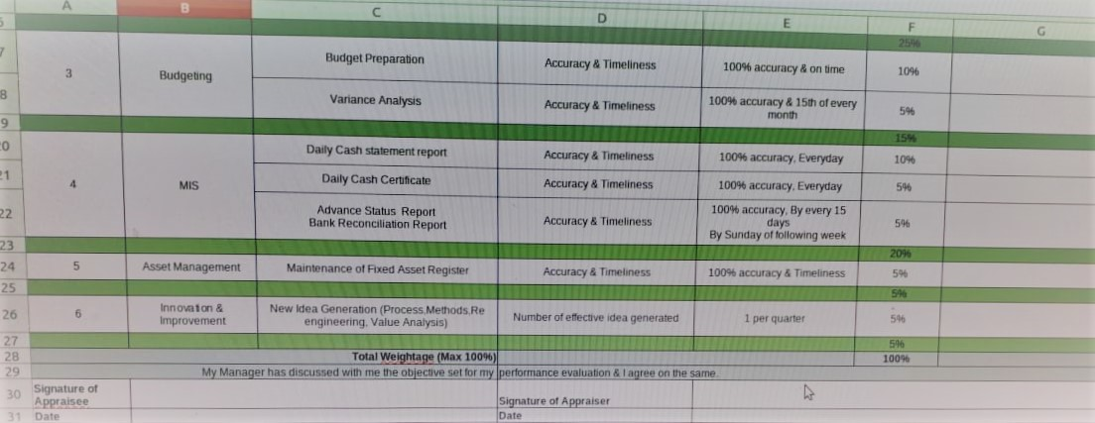

4.2 Flowchart Job Analysis Process that manages and resources talent at Kazi Farms Group

4.3 The Impact on Organizational Development through job Analysis Process.
As we know, job analysis is a preliminary stage that helps to hire relevant human resource for any organization. Human resource management ensures the talent management of the organization and if organization maintain and retain its skillful employees, the employees will bring the development in the long term. In the previous part, we have seen how the job analysis process of Kazi Farms Group manages the talent inside the organization. Here we can shortly discuss how this talent management can bring the organizational development.

To compete in a changing world, businesses are often rebuilt. The organizational development is a way of improving business through this changing process. Organizational developments keep an eye on the best use of the company's employees when effectively effective. Human Resources Division of Kazi Farms plays an important role in this development through the appointment of qualified people to fit in corporate culture of Bangladesh. The Department of Human Resources has increased the number of jobs through training and bridges to ensure a competitive advantage.
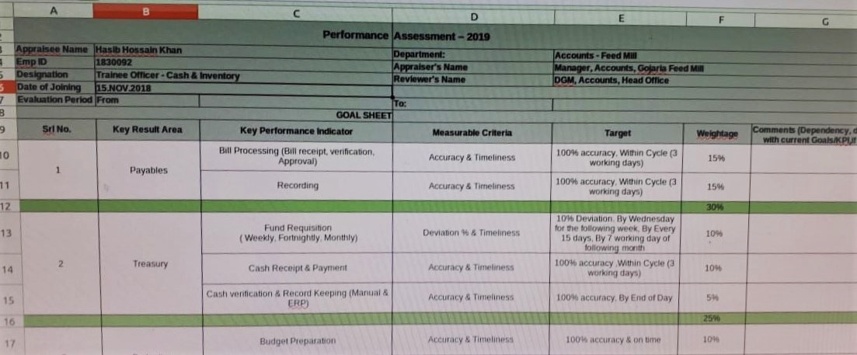

4.3.1 Organizational Development of Kazi Farms Group through Job Analysis
When the restructuring or when necessary changes are evaluated in Kazi Farms Group, any analyzes of Human Resources representatives carry out positions in the work. This position involves involvement in studying the functions involved and the alignment with the company's organizational development plan. For example, suppose the CEO wants to reduce the VC staff by coordinating the important administrative role. Human Resource Staff review the duties, interview employees can review and perform their performance in deciding. From there, the HR Manager can design administration details of administration professionals with higher responsibilities and potential high salaries. This is a simple example. In fact, often job analysis of Kazi Farms Group became very complicated and may need to use advanced theories by software, discussion groups, and academic research.

Recruitment capacity
The Kazi Farms Group's human resource professionals have been renowned for researching and recruiting talent. They play an active role in recruiting and interviewing candidates and assisting managers who decide to rent. Human resources professionals know the best place to drive the marketing of new jobs. They must remain unchanged due to changes in labor legislation. Employees of human resources, especially managers, are often questioned, dismissed and disciplined. During the electoral process, the human resources managers of the Recruitment Committee conduct interviews to determine which candidate is suitable for jobs and organizations.

Business sense
Cooperation with organizational development means that knowing the profitability of the company can increase the type of intelligent business. The CEO and other executives want numbers and expect human resources employees to provide these numbers. Human resources professionals should be able to determine how companies can improve their work by merging other companies and how they can save money and spend money on specific programs, as well as how to improve activities and results.

Maintain consistency
The HR planners and executives of Kazi Farms Group know that they cannot develop their full potential in the face of the organization's legal problems. Although the organization has legal services, they often guarantee that human resource departments comply with laws and regulations. Organize mandatory information sessions on issues related to the planning and prevention of sexual harassment of human resources workers. The company performs a thorough check of numerous candidates to protect it from neglected rent requests.

Strategic planning
Strategic planning of Kazi Farms Group takes place at the highest level of the organization. The CEO explains that he wants to be in the company's five year time. He usually looks for a group approach involving human resources managers. Human resources are responsible for the analysis of the head, in which there is group of talented employees in the company and their flow increases. From there, the human resources department has set up a system to provide more balance. For example, this may suggest a policy of friction in areas where workers need to reduce and encourage early retirement. In other cases, it may suggest layoffs, although generally as a last resort. To meet vacuum, according to the purpose of the human resource, it may suggest active or passive recruitment efforts. An empty notice of passive effort is included in the publication. An active effort involves the recruitment of suitable candidates from other companies.
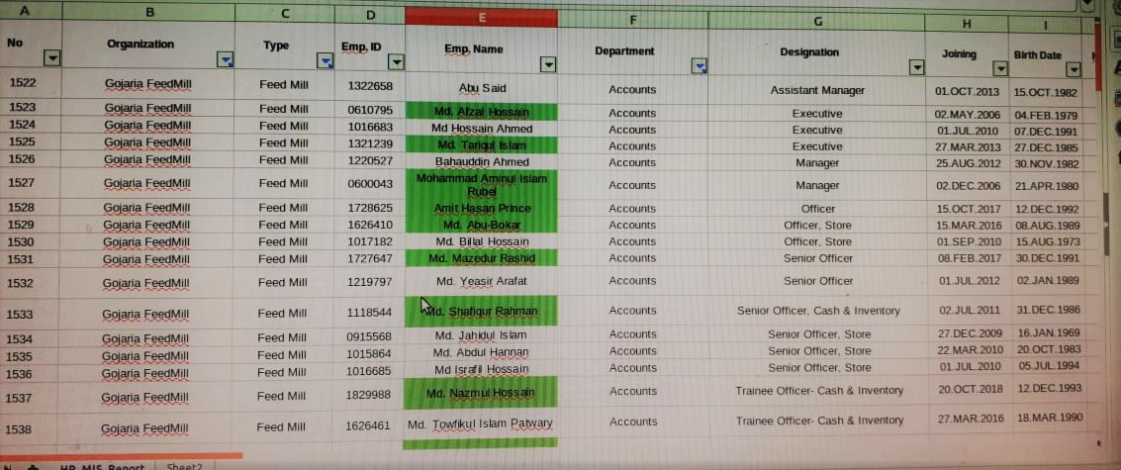

Chapter Five
Findings, Recommendation and Conclusion
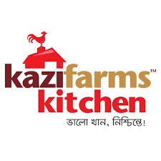

5.1 Findings
After analyzing the Kazi farms group’ job analysis process, it is clear that the company efficiently maintains its talent management and organizational development process by selecting appropriate candidates and retain them. On the other hand, we also get to know the employee turnover rate in Kazi Farm is also high. At the part, few findings that are found while gathering information of Kazi Farms are listed below:
- The recruitment method of the organization is not done in a uniform manner when the organization practices talent management. Therefore, the process of recruitment in the Kazi Farm Group is not standard. As noted above, the recruitment process is different for those who are not manageable and are not related to the employee. All non-management employees are employed by the Human Resource Department and the Regional Administration. In addition, all plant workers are hired by the Human Resources and Administration Department. Most of the executive staff is recruited from the human resources department at the central office. Even for employees at the manager level, the hiring process is different. In terms of the process of recruitment, all employees at the executive level are divided into three categories: (a) Internship Executive, (b) Deputy Director to Deputy Director and (C) Director and Higher.

- Currently there are no workshop plans at Kazi Farm Group. Without an employment plan, it is very difficult to prepare an annual budget for talent resources. It is fairly impossible to accurately predict the number of jobs and their numbers. At the same time, from the point of view, if the budget for the gifted company is not formulated and the company cannot fulfill the budget, then the general agreement process cannot be beneficial. Therefore, the prerequisite for a sufficient and effective budget for the provision of employment planning talent organization Due to lack of budget, the company loses the opportunity to compete in the market by hiring a good talent, which is one of the key advantages of the talent search.

- The time required for the appointment is different and it depends on the filling position and the vacancy is based on the reasons for the disclosure. In the case of cards and hunters, the recruitment period for recruitment is not more than two months, and in the case of Bdjobs, only one month of delivery.

- Succession plans have not yet been set up in KFG. Succession planning administration works well in training programs. However, the MTO program is only available for farms, hatchery, and food plants. There are no automated translation programs for sales and other support functions such as financial, accounting, supply chain, engineering and human resources. But recently the administration has decided to review the MT program and develop a new MT program for all support functions: - Human resources, finance, accounts, supply chain, engineering, and main functions: - Sales. This new professional training program is designed to be very attractive, competitive and exciting for talented graduates.

- For some reason, the recruitment process affects the process and consequently, the recruitment process in the Kazi Farm Group is delayed. For example, recruitment is requested, the actual copy of the Recruitment Request Form (RRF) does not always come in the office. The IRF may take a few months to reach its headquarters. And through the system through which RRF is created. For example, each RIF must be approved immediately by the vacant supervisor, the regional director, the human resource manager, the executive director, and finally the director. It is a boring process to accept the approval of these people and the process of recruitment can not begin without the authorized RRF.

5.2 Recommendation
After analysis and findings part of the report we can realize the obviousness of the job analysis process of Kazi Farms Group that helps to retain the talents and through managing talents job analysis process helps to develop the overall organization through utilizing recruitment capacity, skills management, sensing the market and maintaining consistencies inside the organization.
At this part of the report, I would like to share few suggestions for the betterment of the Kazi Farms Group so that the farm can overcome few shortcomings that I have found during my internship experience there.
- The work pressures at Kazi Farms Group is too high that employees cannot fulfill their targets and not even often complete their given responsibilities. Moreover, each employee has to perform jobs that need to be performed by two or more employees. These problems often create tension inside the office what I think should be reduced. To reduce this problem, the Kazi Farms should hire more employees so that the work pressures of employees can be reduced.
- Awards and compensation accreditation should be attached to performance measures so that employees feel motivated to work more.
- In order to successfully complete the performance measurement process, Kazi Farms Group should develop an effective internal and external communication process.
- The job analysis process of Kazi Farms should be clearly defined so that human resource manager can analyze the employee need properly and the hiring process is become easier.
- The salary and incentives should be increased and clearly communicated to the employees so that the company can retain existing employees.
- It is observed there are lack of coordination between employees and the management of different departments. Therefore, a greater coordination between different groups of employees of Kazi farm should be established.
- The performance measurement system should provide information to the decision-makers rather than providing information only so that the top level manager can take decision on several organizational development measurement.

5.3 Conclusion
Like all other companies, the Kazi Farms group has its strengths and weaknesses. Despite the development of activities in the sectors of poultry, hatchery, food, information technology, and media, Kazi Farm is one of the main poultry leaders of Bangladesh. Kazi Farm is a successful business in Bangladesh but must reflect on the needs of its staff. Because if employees are happy, an organization can reach its preferred position, Kazi companies do it and try to fight their weaknesses and threats. So, Job analysis process should be highly considered to be improved for better talent management and organizational development.
Reference
- Kazifarms.com. (2018).Kazi Farms Group. Available at: http://www.kazifarms.com.
- Eva, t. (2015). Job Analysis & Talent Management: A Key to Success in Any Organization -Perspective from Bangladesh, volume 3(12).
- Cooper, P., PC. (2013). How talent acquisition can establish a competitive advantage. Retrieved from https://www.allegisglobalsolutions.com/blog/2013/november/how-talent-acquisition-can-establish-a-competitive-advantage.
- Atwood, C. (2018). Avoiding the Succession Planning Pitfalls. [Online] Available at: https://www.td.org/newsletters/atd-links/avoiding-the-succession-planning-pitfalls.
- Bugg, k. (2015). Best Practices for Talent Acquisition in 21st -Century Academic Libraries. 29(4).
- Hamid, M., Rahman, M., Ahmed, S. and Hossain, K. (2016). Status of Poultry Industry in Bangladesh and the Role of Private Sector for its Development. Asian Journal of Poultry Science, 11(1), pp.1-13.
- Fitzgerald M (2014), Talent and Talent Management Insights, NHS Leadership Academy.
- Quora. (2018). What is the greatest challenge in Talent Acquisition?. Available at: https://www.quora.com/What-is-the-greatest-challenge-in-Talent-Acquisition.
- Henson, M and Eskenazi, J. (2005). Workforce planning: The key to true staff forecasting and strategic staffing.

Appendix
