New Market Creation Strategy in the Particle Board Industry: A Case of the Concern of Partex Star Group

Md. Zillur Rahman

This internship report is submitted to the School of Businesses & Economics, United International University as a partial requirement for the fulfillment of Bachelor of Business Administration Degree
New Market Creation Strategy in the Particle Board Industry: A Case of the Concern of Partex Star Group

Submitted by

Md. Zillur Rahman
Student ID: 111-192-029
Major: Marketing
School of Business & Economics
United International University

Supervised by

Dr. Kawsar Ahmmed
Professor
School of Business and Economics
United International University

Date of Submission: August 3, 2025

Letter of Transmittal

03 August, 2025

Dr. Kawser Ahmmed
Professor
School of Business & Economics
United International University

Subject: Submission of Internship Report “New Market Creation Strategy in the Particle Board Industry: A Case of the Concern of Partex Star Group”

Dear Sir,
Assalamualaykum, I hope you are doing well, by the Grace of Allah. I’m creating this Internship report on Partex Star Group. I have completed this report during my internship period to grow my conceptual understanding gained from my academic studies. I always try to make it in a formal way. I'm trying to achieve knowledge from Partex Star Group, which could help me in future achievements.
Therefore, I would be grateful to you if you would accept my internship report.

Yours sincerely,
Md. Zillur Rahman
111192029
Major: Marketing
Bachelor of Business Administration
School of Business and Economics
United International University

Declaration Of the Student

I'm Md. Zillur Rahman, and I am a student at the School of Business and Economics at United International University. I am signing up for this internship report to say that it is based on my time working in the Corporate Marketing team of PSG Marketing. I worked hard to finish the PSG internship report. I don't do anything incorrectly; I added information with honor and values. I also want to make it clear that my paper lacks any plagiarism. Information has come from sources that are both primary and secondary.
I have completed the report, and the content is intended for my academic use.

Yours sincerely,
Md. Zillur Rahman
ID: 111 192 029
Major: Marketing
Bachelor of Business Administration
School of Business and Economics
United International University

Executive Summary
A new market creation strategy involves identifying unmet customer needs or emerging trends and developing innovative solutions that redefine industry boundaries. It requires blending customer insight, technology, and strategic positioning to launch offerings that transform non-consumers into enthusiastic adopters. Successful execution often demands cultural sensitivity, localized adaptation, and bold value propositions that break away from conventional competition. The purpose of this study is to identify, describe, and suggest the market creation strategies in the context of the particular board industry. This report describes my internship with Partex Star Group's Brand Marketing team, a leading Bangladeshi company with an expanded product range in food, beverages, and packaging. During my internship, I engaged with the Brand Marketing team on strategic and operational actions that increased the company's reputation.

I discovered a lot regarding brand strategy, advertising initiatives, market analysis, and online advertising at Partex Star Group. I assisted in developing brand strategies to improve the company's competitiveness and link marketing with target client requirements. I saw firsthand how to create and manage effective brand communication, ensuring consistent and connected marketing messages. I provided market research on consumer habits, industry trends, and rivals' strategies, in addition to campaign deployment. This data helps the firm refine its marketing and product placement strategies. I collaborated with Sales and Product Development to ensure a cohesive, integrated brand marketing plan, emphasizing the value of collaboration and cross-functional interaction in achieving corporate goals.
I acquired practical skills as well as more knowledge about brand marketing in a large business during my internship at Partex Star Group. It improved my professional understanding as well as preparing me for marketing problems. Strategic planning, campaign management, and communication with consumers have changed my perspective and prepared me for a brand marketing job.

Keywords: Market Creation, Customer Segment, Particle Board Industry, Partex Star Group, Bangladesh

Table of Contents
Letter of Transmittal 3
Declaration Of the Student 4
Executive Summary 5
Chapter One 8
-Introduction 8
Primer 9
Objective of the Study: 9
Motivation Of the Study 10
Limitations of the Study In Partex Star Group 10
Organization of the remaining chapters 11
Chapter Two 12
Company Overview 12
SPBML Market Overview 13
Overview & History 15
History Of the Organization 16
Partex Group Concerns 17
Mission & Vision statement: 18
Location And Facilities 19
Facilities: 20
Departments 20
Boards of Directors 20
Customer Mix of Pratex Star Group 20
Customer Segmentation in Partex Star Group 21
Product Mix 21
Product Quality 24
SWOT Analysis on Star Particle Board Ltd. 24
Strengths: 24
Weakness: 25
Opportunity: 25
Threats: 25
Strategies to meet the challenge and Opportunity Based on SWOT analysis 26
Chapter Three 27
Industry Overviews 27
Specification of the Industry in Particle Board Ltd. in Bangladesh 28
Product Specifications: 29
Market Size, Growth, Product size 30
Technological Factors: 31
Political, Legal, And Regulatory Factors 32
Summary Of Challenges and Opportunities 33
The Key motive in the Particle Board Industry 34
Chapter Four 35
New Market Creation Strategy 35
Importance of New Market Strategy 36
Types of New Market Strategy for Partex Star Group: 37
Domestic Market Creation Strategy: 37
International Market Creation Strategy for SPBML 39
SWOT For SPBML (strengths, weaknesses, opportunities, threats) 39
Challenges faced in creating a New Market Strategy: 40
Consideration for New Market Strategy for PSG 41
Chapter Five 43
Internship Experience, Recommendation, And Conclusion 43
Internship Experience 44
Recommendation 45
Conclusion 45
Reference 46

Chapter One

Introduction

Primer
Partex Star Board is a Pioneering Ethical Wood Solutions. Partex Star Group's signature product, Partex Star Board, reflects Bangladesh's wood panel field's innovation and sustainability. Star Particle Board Mills Limited, a Partex Star Group firm, mixes jute stalks—an abundant agro-waste material—with synthetic resins to make long-lasting, eco-friendly boards.
There are 4 main boards
- Veneered Boards: Light layers of real wood laminate give these hardwoods a beautiful finish for furnishings and cabinets.
- Melamine Faced Chipboards (MFC): The chips have a sleek, sturdy melamine laminate the outside, suitable for contemporary furnishings and interior design.
- Partex plywood, renowned for its strength and versatility, is employed in many building and interior applications.
- Plain Particle Boards: These panels, available in Jutex and Wooded, are adaptable building and decor substrates.

For Sustainability Commitment, Partex Star Board safeguards nature by using renewable jute stalk as its core material. The approach decreases wood use and supports farming by reusing crop wastes. The boards have been built to withstand changes in the seasons and termite and antifungal attacks, making them strong and trustworthy in various uses.

Objective of the Study:
There are several objectives for this internship period: 1^{st.} Studying Organizational Structure: Knowing business structure, areas, and their roles to accomplish goals. 2nd Analyzing business operations, especially supply chain management, production, and distribution, for effectiveness and efficiency. Evaluating Market Tactics: Examining Partex Star Group's marketing and sales strategies to stay relevant and grow both locally and globally. Product Evaluation: Analyzing Partex Star Group's line of goods, development cycles, and consumer feedback methods.

Motivation Of the Study
This study is driven by the growing significance of corporate structures and their economic effects in Bangladesh. One of the nation's biggest corporations, Partex Star Group, made contributions to producing, trading, and real estate. The organization's operations, methods, and budgeting show how huge firms traverse market difficulty and adapt to changing economic circumstances.
The article examines Partex Star Group's administration, operations, and performance. This internship exposed me to the organization's business plans and functions, which let me understand the company's expansion, its culture, and its competitive landscape. The investigation analyzes Partex Star Group to see how its broad portfolio helps it survive in a competitive industry. This report will also show how a company balances innovation, staff oversight, and current market conditions to grow sustainably. The research project seeks to comprehend how an established commercial entity functions, its difficulties, and how it adapts to a Bangladeshi competitive landscape.

Limitations of the Study In Partex Star Group
The study intended to analyze Partex Star Group, yet limitations constrained its scope: The research project was limited in time, making it difficult to gather longterm data or analyze person-firm operations.
Access to Data: Company rules prevented seeing financial documents, strategy plans, and corporate metrics for performance, limiting the assessment.
Group Size: The study used a relatively small sample for employee interviews and surveys, which could not accurately reflect Partex Star Group's staff or customers.
Regional constraints: The study centered on the company's Dhaka operations and may not have caught the complex nature of activities in other regions or foreign markets.

Organization of the remaining chapters
In Chapter Two: Overview of the Star Particle Board Market, Organization History, Group Concern, Customer and Product Mix, And SWOT Analysis
In Chapter Three: Industry Overview of the Particle Board Market, Specification of the Industry, Product specification, Market Size, and Challenge and Opportunity.
In Chapter Four: New Market Creation Strategy for Partex Star Group, the Importance of New Market Creation, Types of new Market Creation strategies, Challenges of New Market Creation, and considerations of New Market Creation are discussed.

Chapter Two

Company Overview

SPBML Market Overview
Partex Star Group was founded by M.A. Hashem in 1962. Partex Star Group, a well-known company in Bangladesh with over 65+ businesses across a range of industries, including furniture, textiles, cables, food, and fast-moving consumer goods, was founded. Star Particle Board Mills Limited is the key player in Partex Star board company, which is the first company in the country's particle board industry by introducing jute-based boards in 1962 and switching to wood-based boards in 2006.

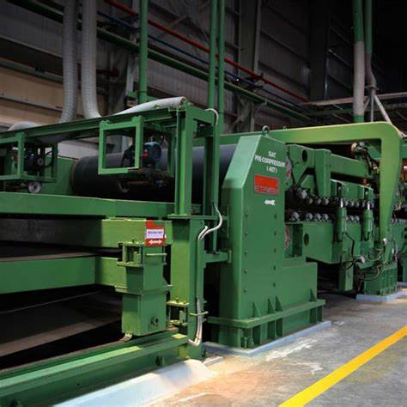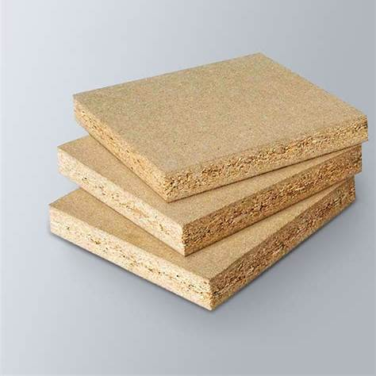

The category of product in SPBML:
There are 4 types of boards that are produced by Partex Star Group.
- Plain Particle Boards, which are made of Jute and Woodex.

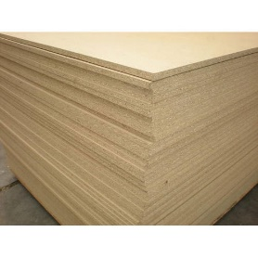
Plain Particle Boards

- Veneered Boards, which are composite wood panels, in our industry, we call them MDF.
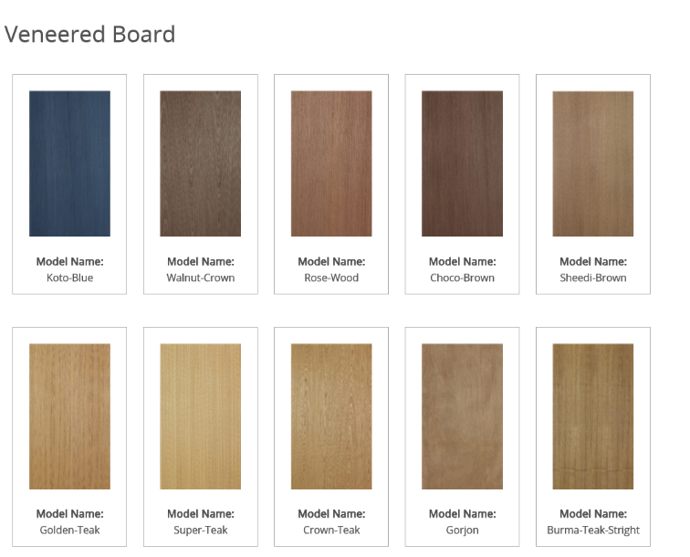

- Melamine-faced chipboard is MCF wood, which is another composite wood.

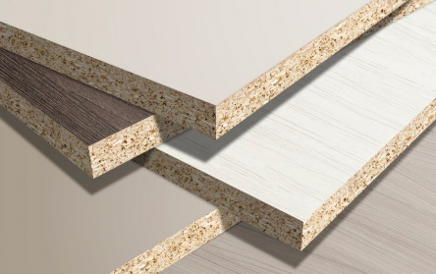

- Playwood is the top most selling product in Partex Star Group. The quality and the finishing are taking place in the customer's heart.
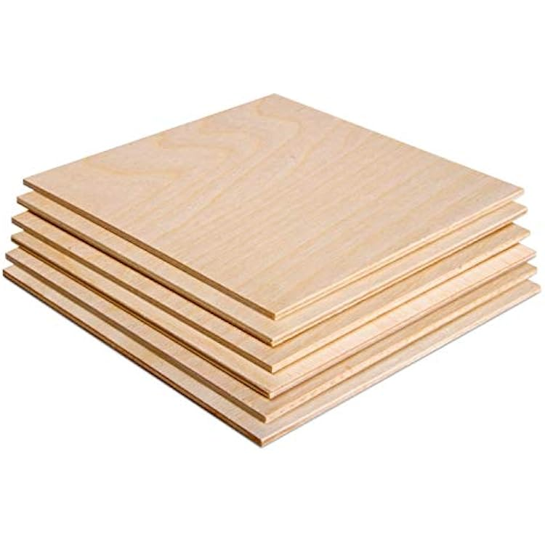
These products significantly increase the group's earnings and are used thoroughly in the building, interior design, and furniture manufacturing sectors. Partex Star Group is focusing on the continued growth through urbanization, affordability, and sustainability. They have been in the industry for a long period on the Board.

Overview & History

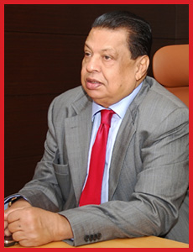
Partex Star Group is one of the largest private companies in Bangladesh, which is established in 1959 by founder M. A. Hashem. It starts from beside the Meghna River in Madanpur, Narayanganj. Now it's spread out all over Bangladesh. Nowadays, individuals aged 65 and above are playing a significant role in day-to-day activities. It has tobacco, consumer goods, cabinetwork, cloth, and the IT sectors. It has resolved into two groups, Partex Group and Partex Star Group. It has food and potables, sugar, paper, jute, shipping, cabinetwork, real estate, media, education, plastics, fabrics, cotton, services, IT, etc.
M. A. Hashem (1940 – 2020)
Partex Star Group is growing its empairs in Bangladesh. M.A. Hashem is also known as the founder of the birth and growth of private banks and insurance companies in Bangladesh. He innovated two of the largest private banks in Bangladesh – United Commercial Bank Limited (UCB) &The City Bank. M.A. Hashem is also a philanthropist because of his modest background. In 2010, as part of the elaboration. Partex Star Group surfaced from Partex Group and shortly erected its own identity. By highlighting quality in prosecution from the ground up, the organization is committed to giving clients greater satisfaction from hiring staff to choosing goods, collaborating with suppliers to build showrooms, placing purchase orders, and delivering the goods to visitors' homes. A driven pool, operation, and dedicated board members under the direction of the Partex Star Group Chairperson, supported by a well-known marketing approach, have been the foundation of the company's achievement. "Living heritage while presenting a new face forward" is the collective's motto.

History Of the Organization
Under the direction of its founder and Passed chairman, M.A. Hashem, the Partex firm started operations in 1959. The group experienced tremendous growth over 50 years and the merger of 60 businesses, primarily diverse manufacturing divisions, thanks to the unmatched dynamic skills of M.A. Hashem, a living legend. Due to our dedication to values, high-quality products, and ethical business practices, Partex has been a respected springboard both nationally and internationally for the past 50 years, and the significant growth and realization of expected success finally resulted in an organic departure from the patrimonial management system. Over the years, the family line of Mr. Aziz Al-Kaiser, Mr. Aziz Al-Mahmood, Mr. Amman Al Aziz, Mr. Showkat Aziz Russell, Mr. Rubel Aziz, and Amid Al Aziz has served as an example of Partex's entrepreneurial spirit. In particular, under the direction of Vice Chairman Mr. Aziz Al Kaiser and Chairperson Mrs. Sultana Hashem, Partex Star Group, the affiliate of Partex Group, has successfully managed its business operations. The Partex Star Group is made up of seventeen entities. With an expected 11% annual growth rate, its estimated earnings in 2010 were Tk 7,000 million. The current market value of the net worth is Tk 5,500 million. The shipping of goods and services involves more than 1550 distributors nationwide. Products are sold in over 50,000 establishments. The Partex movement is complex. It expands its network across a wide range of sectors, from steel to dairy. One well-known conglomerate, Partex Star Group, constantly works to ensure both customer satisfaction and product quality. It currently has about 12000+ employees. Every employee works hard to increase the company's profits and well-being. Partex Star Group uses a variety of incentives to give bonuses to its employees.
Partex Star Group's history is below:
- Partex Group Established in 1959.
- It exposed itself nationally in 1962 as Partex Group.
- The most popular operation of Danish Condensed Milk Started In 1990.
- Datacom (ISP) formed in 1997.
- In 1997, Royal Crown (RC) International Company was included in Bangladesh under Partex.
- PARTEX Plastics Ltd. Started in 2004.
- Corporate Overview Registration Name: Partex Star Group; Registered Corporate Office: Shanta Western Tower, Level 13, Tejgaon I/A, Dhaka-1208.

Partex Group Concerns
There are 2 complexes.
Under Complex 1:
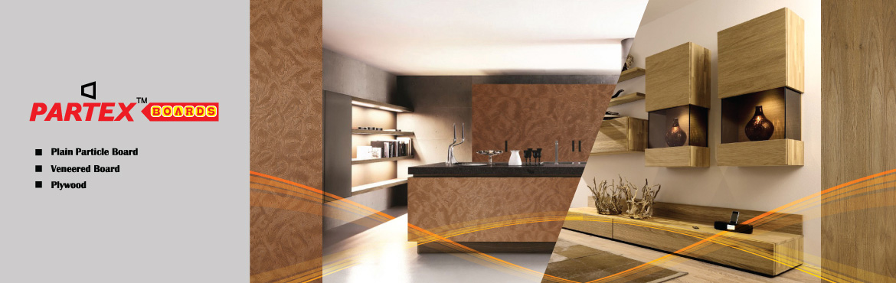
- Star Particle Board Mills Limited
- Partex Gypsum
- Corvee Maritime Company Limited
- Partex Furniture Industries Limited
- Partex Cables
- Partex Builders
- Ashly Furniture
- Partex Laminates Limited
- Partex Builders Limited
- Partex PVC Industries Limited
- Partex Agro
- Partex Adhesive
- Shubornobhumi Housing Limited

Under Complex 2:

- Danish Condensed Milk Bangladesh Limited
- Danish Milk Bangladesh Limited
- Rubel Steel Mills Limited
- Danish Distribution Network Limited
- Danish Dairy Farm Limited
- Societal Limited
- Danish Foods Limited

Mission & Vision statement:

Vision: Partex Star Group is always empowered to transcend boundaries as a globally diversified, sustainable enterprise, committed to excellence, stakeholder value creation, & Customer engagement. They are offering a Quality product with advanced manufacturing, which ensures product quality. They are always trying to innovate and make individual contributions.
Mission: They are always delivering high-quality products & services for customer satisfaction. They have operational efficiency and improvement.
Principles:
- Ensure the commitments
- Ensure trust and respect with the customer.
- Work as a team.
- Take initiative to maintain standards.
- Transparent and fair in all our dealings.
- Focusing on social responsibility.

Location And Facilities

Sales Office: Partex Star Group, 68 Tejgaon I/A, Dhaka-1208 F. Karim Building, Tejgaon I/A, Dhaka-1208
Operating Office: 267, Tejgaon I/A, Dhaka-1208
Corporate Office: Shanta Western Tower, Bir Uttam Mir Shawkat Road, 186 Tejgaon I/A, Dhaka-1208
Plant:
Complex-1: Madanpur, Bandar, Narayanganj
Complex-2: Shimrail, Siddirganj, Narayanganj
Facilities: Partex Star group has its shipping so they don’t wait for others, as the factory location is beside the Meghna River, so they can easily ship their raw materials.

Departments

- Finance & Accounts
- Supply Chain
- IT
- HR
- Admin
- Marketing
- Sales

Boards of Directors

Chairman: Aziz Al Kaisar
ED: Aziz Al Mahmud
ED: Amman Al Aziz
Director: Amid Al Aziz

Customer Mix of Pratex Star Group

As we know, Partex Star Group is one of the big role players in the Bangladeshi Market. So it’s a valid role in customer day-to-day activities. At this time, 15+ concerns are playing their activities to fulfill customers' daily needs.
The main Player in this company is Partex Particle Board LTD. SPBML has a loyal customer because SPBML is the first product that can be used for interior in the company and home interior.

Customer Segmentation in Partex Star Group
The main customer for FMCG & consumer goods for PSG is the Bangladeshi Consumer. Those who have purchased dairy products like beverages, cookies, spices, and other consumer goods. 3 leading brands satisfy their customer: Danish Condensed Milk, Danish Foods, and Danish Milk Bangladesh.
The target audience for Partex Furniture is Businesses, interior designers, and homeowners those looking for furniture. There is Ashly Furniture. Which is focusing on Premium Customer, on the other hand, Partex furniture is targeting middle-class customers who want budget budget-friendly product.
For Building Materials & Construction, the main customers are contractors, developers, and construction companies. They have Particle board, doors, Gypsum, and leminets, Partex Cables.
Partex Star Group has always tried to go into the market through its marketing team for research. Because they emphasize making sure their customer satisfaction.

Product Mix
My professional area covers the Partex Board, Gypsum, Cables, and Furniture sectors, and also Adhesive Ltd. which relate to product mix rather than service mix. Therefore, I am engaged in product mix management. The number of product quantity lines maintained by a corporation is referred for product mix. Upon researching the PSG product line, PSG provides 07 products nowadays for its customers.
- Gypsum Board and Selling is the latest innovative product that can take place as a first mover in the market. Therefore, it's taken advantage form the Bangladeshi market.
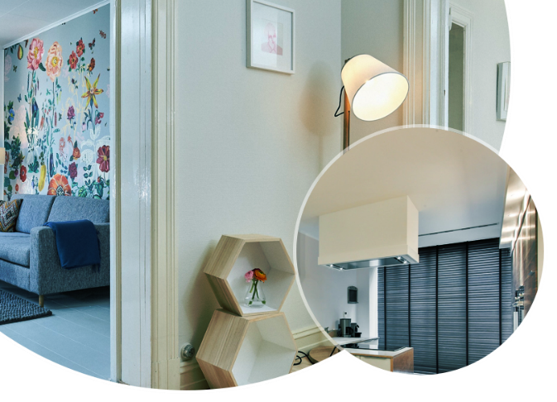

Partex Cables: Partex Cables provided a huge amount of profit, because its quality and loyal customers. Partex cables spread the market by creating SDP and loyal dealers.


Partex Furniture: It’s taken 2 parts, one is for premium customers, those like Ashly furniture, which operates only one location in the Gulshan area. Because some customers like a posh product which is international product.


Another one is Partex Furniture, which focuses focusing wood products for middle-class customers.


Star Adhesive is now starting to decline because of a shortage of raw materials. Therefore, for some of the products are not available in the market. The available products are glass cleaner and star glue.


Product Quality
Star Particle Board Ltd. It is a product of Partex Star Group. This is known as the Partex Board. Because of its quality, consumer give their place to heart. So many reasons for people to know it's a very good quality. Some of the reasons are discussed below.
There is a variety of product lines in Partex Star Group; they always maintain a modern production line and advanced manufacturing, and consistent quality. In 2014, Partex Star Group achieved the International BIZZ award for its flagship product quality.
Partex Star group always maintains eco-friendly products; therefore, they use Jute Stalks, which are renewable and reduce dependence on timber.

SWOT Analysis on Star Particle Board Ltd.

Since 1962, SPBML has taken the best place in the Bangladeshi market; therefore, nowadays Partex Star Group exports some quantity. In my work experience on SPBML, I am trying to discuss its SWOT analysis below:

Strengths:
As a first mover in the PBML industry, Partex group has achieved some loyal customers who always join the semi-annually meeting in Shanta place. For the first time, they provide jute-based particle board.
Partex board is still maintaining its sustainability in the market. They made boards by using agro-based raw materials like jute stalk and agro-based raw materials.
A variety of products could be their strength. They have Plain wood, ply, veneer board, MDF, and Melamine boards.

Weakness:
The raw materials in this industry are jute stalks. So the production could depend on jute agro if the jute production is good, then the raw materials for boards is available on the market.
Day by day production line is upgraded, so the maintenance cost would be higher day by day.
The local market always wants a lower competitive price, but sometimes it's difficult to maintain the price.

Opportunity:
Growing demand for home decor and corporate interiors, as they are sustainable, they are increasing their production. As partex star group stays in the market for a long period, they took advantage of this demand increases.
Creating a new production line could gain more loyal customers.

Threats:
Sometimes, raw material prices are up or down, depending on the agro. Currently, maintaining production is challenging. There is a change in alternatives on the boards come to the market.
Sometimes govt. Policy can hamper the production line.

Strategies to meet the challenge and Opportunity
One of the largest private companies in Bangladesh is Partex Star Group, which was established before the Liberation War. Day by day it is increasing its business and grow up customers. They are using SWOT analysis to develop strategies with plans.
Strengths:
Partex Star Group has 20 plus products for a wide production line for building materials, and Partex furniture. They are using a diverse product portfolio.
As I know, Partex Furniture has 17% market share in the organized market so Partex Furniture is the key player in the market.
Partex Star Group has a strong, loyal customer base, because its outstanding brand value and quality.
Weakness:
Managing many industries is sometimes difficult for Partex Star Group, because sometimes raw material problems, LC problems can cause difficulties. Many times collect resources from different industries must be difficult.
Opportunities:
They have a strong Marketing team, some of whom are the creative team, social media team, and also the brand manager team. As they are sustainable for a long time, they know about Bangladeshi people's culture and purchasing power. So it's easy to find out the problem through some research.

Threats:
Day by day, competitors are increasing, so it’s difficult to set a competitive price. And also copying a product should hamper productivity. The economically volatile situation in Bangladesh makes business productivity lower. Because many times the raw materials often take too much time in shipment.

Chapter Three

Industry Overviews

Specification of the Industry in Particle Board Ltd. in Bangladesh
As a middle-class urbanization in Bangladesh, there are a lot of infrastructure projects growing day by day. Therefore, the interior and also the replacement of wood are increasing. At this time, a huge number of particle board LTD. Are open market in Bangladesh. The top three are-
- Star Particleboard is a concern of Partex Star Group (Established in 1962)
- Akij Board is a concern of Akij Group (Established in 2001)
- Super Board is a concern of (Established In 1992)
These three are taking place (20+30+17=67%) market share.
Particle board, a component of Bangladesh's larger furniture and construction material industries, has increased as a result of urbanization, a demand for cheaper housing, and a growing middle class. Particle board is created from chipped wood, sawdust, and other wood-based materials and is frequently used in interior design, the manufacturing of furniture, and building as an alternative to real wood.

In recent years, a significant increase in demand has occurred in the Bangladeshi market. Day by day, customers are increasing. The eco-friendly board can make a good interior for a home, corporate office, or building.




Product Specifications:
There are some common products in this industry.
- Veneer Board

This is the thin layer of wood surface. The cost is lower for appearance.

- Plain Particle Board: For creating a plain particle board, it combines sawdust, wood chips, and wood shavings with glue and then heats and compresses them.

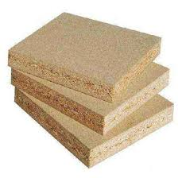

- Ply: Ply is another name for laminate particle board, which is made from composite wood with high compression. That has an additional layer on top.

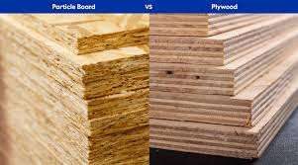

Market Size, Growth, Product size
The Size of this product: The standard measurement is 8 feet by 4 feet (2440mm by 1220mm).
The thickness can vary from 12mm to 25mm, so it may be utilized for an array of structural and decorative uses.
Density: about 650–700 kg/m³, which makes it strong and stable.
Market Size: In the Bangladesh context, there is a lot of demand for the Board industry. The 2024 report says around 93 square feet is needed nowadays. The market estimated market growth is 7000 core BDT. Day by day, urbanization and the growing housing sector are growing very first. So the market of PBML is increasing day by day.
The Key players in this market are Akij Group, TK Group, and Partex Star Group.
Growth Rate: The growth rate on PBML is 15%-18% annually. So there is an advantage as a first mover company in the market for SPBML. The rising demand for furniture made from subsidized wood and interior for housing. It will continue to grow steadily between 2025 and 2029, peaking at 4.58% in 2029 after beginning at 3.46% in 2025.
Market Share: The recent market research shows that Akij is the leading market taker with hold 30% share, on the other hand, Superboard holds 17% and Partex Star Group holds 20%.

Manufacturer Of this Industry:
- Partex Star Group (Star Particle Board)
- Akij Group (Akij Board)
- TK Group (Super board)

Technological Factors:
Modifications in manufacturing techniques, automation, and sustainable development practices have all had significant effects on the innovations used in Bangladesh's particle board industry. Here is a list of the key technological elements that are affecting the industry.

Innovative Technologies for Contemporary Manufacturing
Production: The paths with a Lot of Capacity. The most significant particle board manufacturing plant in the country is run by Akij Particle Board Mills Ltd. It makes about 1,029 cubic meters of particle board every day. Their manufacturing facility uses the latest German technology, such as the Genesis 8 ContiRoll press from Siempelkamp, to improve the quality of their products and the speed at which they produce them.
Automation in the Raw Material Processing Akij's plant has an automated chip storage as well as a feeding system, as well as a robotic flaker machine that sharpens itself and finds difficulties, thus ensuring that the chips constantly remain of the same quality and cutting down on the demand for manual labor.
The company has constructed its glue manufacturing to make Urea Formaldehyde adhesive. The goal is to keep the end products' formaldehyde emissions insignificant, which is in line with environmental guidelines.

Finding recyclable resources and utilizing them
Using Local the Raw show Materials, the industry mainly employs materials which have been produced or found close by, such as jute sticks and branches from trees like maple and raintree, to make wood chips. It benefits the planet and makes the enterprise less reliant on received wood.
Recycling Initiatives Hatil and Partex are two companies that are using recycled materials in their manufacturing processes. For example, Hatil becomes sawdust and scrap wood into particle boards and uses leftover fabric and foam to make rebounding mattresses, helping the economy remain strong.

Political, Legal, And Regulatory Factors

Sometimes it is influenced by political conditions, legal, and regulatory; therefore, there have been productivity problems.
Political Factors: There are 2 main problems
- Govt. Act: Government policies may impact the production of particle boards, particularly through tariffs on trade, subsidies, and regional regulations that are intended to assist local enterprises or protect the environment.
- Unstable Political situations: Political stability in a country assists the wood pulp industry in flourishing and attracting expenditure. On the other side, political instability can stop results, therefore rendering the market less secure.
Legal Factors:
- Law for Lebor: Labor laws that control conditions at work, safety standards, pay, and hours have a direct effect on the industry. If your company violates these rules, you can be fined or have to stop completing business.
- Consumer Protection Laws: Product quality and safety, including consumer rights, must be followed for consumers.
Regulatory Factors: health and safety issues for the Maintenance Environment Act, and eco eco-friendly working environment for production. Include regulations regarding air quality, the use of harmful chemicals, and worker exposure to dust and toxic substances. Regulatory authorities can check anytime for a survey if they are looking for any problem, they can fine or totally shut down the industry.

Summary Of Challenges and Opportunities
There are several challenges and opportunities like
Challenge:
- Availability of raw material: Insufficient wood and other elements are costly day after day.
- Environmental Issue: Deforestation is increasing day by day. For this reason, industry is facing sustainable productivity difficulties.
- Strict Law: for the government. instability, sometimes it's difficult to maintain some rules and regulations.
- Changes in Prices: The selling prices of beginning supplies like wood, resin, and chemicals may vary a lot, which influences the cost of manufacturing as well as profit margins.

Opportunity:
- Sustainability Initiatives: To meet consumer demand for eco-friendly products, innovative products with sustainable and reused components are available.
- Scientific Advancements: Improving the science of adhesives and utilizing alternative fibers like agricultural leftovers can increase the quality of goods and reduce expenses.
- Increasing Market Demand: Building and furniture growth, particularly in emerging economies, offers numerous market prospects.
- Customization and Niche Markets: Selling plywood products in several widths, densities, and finishes can help acquire niche markets with interior design.
- Regulation Benefits: stricter rules may prevent less-compliant competition from joining the market, allowing conformity organizations to acquire market share.

The Key motive in the Particle Board Industry
Market growth and demand:
- Focusing on Urbanization and the Construction Boom: As Bangladesh is one of the fastest-growing countries, affordable housing has grown dramatically. That's why furniture and interior design have increased. So, Particle board demand and growth increased day by day.
- Reasonable for the Middle Class: Bangladeshi Middle-Class people are changing their tastes to make their houses beautiful. So they need something affordable that makes their house beautiful. Particle Board is the option for their replacement of wood.
Production Capacity and Manufacturer:
- The particleboard market in Bangladesh is occupied by a variety of domestic and foreign producers. While some businesses import fiber or wood chips to suit the manufacturing needs, others gain their beginnings domestically.
- In terms of quality and efficiency, the industry remains far behind more developed markets, despite its shift toward advances in manufacturing processes.

Future Prospects:
- With a rising need for affordable and sustainable construction materials, the particleboard sector in Bangladesh holds great promise. The implementation of innovative technologies for production and enhanced raw material purchasing methods could help companies in satisfying the increasing demand.
- As countries are growing with more eco-friendly product consumption and balancing the natural climate, so is particle board going through a safe nature.
There are some challenges in this industry, one of the most common issues is a lack of skilled workers, raw materials Shortages, and the most common environmental concern. As we know, Bangladesh has a limited forest, so day by day, wood will be more costly. And also, the use of wood-based products could be a concern for eco eco-friendly environment.

Chapter Four

New Market Creation Strategy

When I joined the Partex Star group, I saw there is a team those are always visits the field & I also saw the Marketing team is different from the Sales team. The marketing team is always busy expanding business and creative thinking.
As a part of the Brand team, I had an opportunity to visit several places where we are creating new SDP for the Star Particle board. 1^{st,} I was going into the Kurigram district. We are collecting data from our dealers who have been staying with us for a long time.
They suggested some points for creating a new business in that area. I’m trying to discuss this domestic area below the point in my academic experiences.

Importance of New Market Strategy
As a corporate group, there is a lot of importance in expanding business; some of the reasons discussed below:

- Create More Sales and Market Expansion: Using an innovative plan to attract new clients can help you make more money. You may reach more individuals who purchase items with more money to spend through expanding worldwide, especially into developing nations. This ability for expansion can be very helpful for an established company like Partex Star Group that continually looks for methods to grow bigger.
- New Product Development: Companies typically must modify their products or services to meet requirements, wants, as well as rules of fresh markets. It also leads to **innovation**, which pushes Partex Star Group to make its items more beneficial and effective for more kinds of customers. It could mean coming up with new items, improving packaging better, or modifying marketing plans so that their appeal to residents.
- Getting Recent Resources: If you enter new markets, you might also be able to get new resources like inventory, cheaper labor, or technical expertise. Sometimes a new product could help to gain new customers. This may assist businesses in making more money by reducing expenses and coming up with new ways to make money.
- Building Strategic Planning Partnerships: Partex Star Group can make "strategic partnerships" with local enterprises by following new markets. Such relationships may provide you with crucial knowledge, tools, and links that would make it simpler to get into the sector, lower risks, and speed up your progress.

Types of New Market Strategy for Partex Star Group:
Since my joining at Partex Star Group, I have seen that they are always using Product Development Strategy and Market Development Strategy to into new markets.
In the product development Strategy, they are developing new products to meet customers' needs and expectations. Coming up with new and different kinds of things, such as meals that are better for you or packaging that is better for the environment. Using tools to create new containers or products that are better for the environment. Keeping an eye on what people desire, like food in its natural state, or inventing new plastics that are good for the environment.
In the market development strategy, Partex Star Group focused on the new market with its new product. For a specific geographic area or demographic area, they are targeting new customers. They are using it in this phase for their brand awareness.

Domestic Market Creation Strategy:
Star Particle Board Ltd. Of Partex Star Group expands its business by customer based. Then they build their brand recognition and go to the market.
Below, I am trying to discuss the Market creation Strategy:
- Market Research and Segmentation: Here, we start from the possible market, which can be worth it for our company. We are always close eye on it. Focusing on the building, construction, and also the Interior, which are highly needed for particleboard.

- Group of Goals: In the construction area, focus on low-cost, long-lasting Plywood replacement; people want to decorate furniture with particle board.

- Product Differentiation: Since 1962, Partex Starboard has never agreed with low-quality products. Therefore, it creates many more loyal customers for its business. Consumer pick the thickness, size, and meet their expectation with Partex Star Board Ltd.

- Sustainability in Market: Since 1959, Partex has maintained its product quality and brand value. For this reason, they have a good reputation in the consumer market. For their eco-friendly production, they had achieved Bazz award 2010.

- B2B Focus: Furniture manufacturers, carpenters, interior designers, and building contractors are likely the main consumers of particle boards. Split the market into categories based on shape (small, medium, and big companies) and location (urban, semi-urban, and rural).

- Competitive price set: As a company, Partex has good brand value. After entering the new market, they have set a lower competitive price.It could also be beneficial to use the Partex Star Group's reputation for quality.

- Geographic Area Targeting: Star Particle Boards Ltd. may begin by concentrating on townships with lots of growth, so Dhaka, Chattogram, and Sylhet. Once people are aware of your brand and you have effective methods to get it to them, you may expand to smaller towns and villages.

International Market Creation Strategy for SPBML

There are a few significant processes that go into establishing a global market strategy for SPBML (Star Particale Board Ltd.), which is a concern of Partex Star Group. These processes consist of market research, branding, positioning, and sales tactics. Here's an idea for how SPBML might expand its company in other countries:

Evaluate The Target Market:
Find Your Goal Markets:
Look at locations where there's a lot of market for SPBML's products but a minimum level of competitors available, like building resources, plastic items, packaging, and so on.
Target countries that have similar sector characteristics or growing economies that are seeing rises in facilities, retail, and creation.
Look at market share potential, rates of expansion, and client tastes in the regions you want to target.

SWOT For SPBML (strengths, weaknesses, opportunities, threats)
The Highly Competitive Landscape:
Look at local rivals and foreign companies to find gaps in the sector that SPBML can fill.
Branding & Positioning
Creating Brand Awareness: Use SPBMLs related to Partex Star Group, a reputable, trusted name in Bangladesh, to develop trust in new markets. Use the "Made in Bangladesh" angle to get countries that require excellent goods at affordable rates to buy from you.
Set the Strategy for Product Positioning:
Market SPBML's interests as high-quality, stylish, and thrifty choices for building, making, or shipping. If you can, talk about the methods they are eco-friendly and possible, since more and more people want creations that are good for the climate.

Challenges faced in creating a New Market Strategy:

Partex Star Group has diverse production, like as consumer goods, manufacturing furniture, buildings, construction elements, etc. So there for some challenges that can hamper the creation new Market.
- This is difficult when a company has a diverse production line, so it's difficult to set Targeting and Positioning.
Solution: They must include 4 Segmentation (geographical, demographical, behavioral, and psychographics). If the researcher does it properly, then an accurate result comes out.

- In the competitive market, Partex Star Group has different types of sectors, like product packaging, transportation, and home goods. So, competitors are already strong in this market.

Solutions: only Competitive market research could help from this perspective.

- The PSG has loyal consumers, but sometimes it's difficult to provide proper service or quality production based on raw materials and other production equipment.

Solution: Always survey on the production line to ensure product quality and also consumer satisfaction.

- Maintaining the supply chain system and distribution is more challenging sometimes, because of natural disasters and location.

Solution: A Local distributor could be helpful in this case, and also a partnership business.

Partex Star Group's new market strategy will be successful if it conducts thorough research of the marketplace, speaks logically, makes strong partnerships, and gives particular attention to cultural as well as legal issues. By addressing such issues, the company will be able to successfully enter new areas and keep introducing fresh goods to its range.

Consideration for New Market Strategy for PSG
Partex Star Group (PSG) ought to consider several factors while creating an innovative market plan for its continued development and achievement. Partex Star Group, a major Bangladeshi company, produces packaging, plastics, food, and consumer goods. A new market strategy in detail:
Market Research and Analysis
Target Industry: Evaluate PSG's market entry. This may represent a fresh market or particular product category in current markets. Research on markets must investigate their population size, tastes, buying power, and habits.
Economic Environment: Evaluate target market rivals. Find their benefits, problems, and share of the market. Innovative selling aspects have to differentiate PSG from its competitors.
Economic considerations: Study the new market's economy. Do developing trends, purchasing power, or economic slumps affect business?

The Demographics: classify consumers by age, income, lifestyle, and area.
Psychographics: Understand customer wants and difficulties. It can incorporate qualitative techniques like focus groups, polls, or interviews that analyze customer behavior.
Behavioral Segmentation: Analyze client purchases, frequency, commitment, etc. This data may guide the positioning of goods, pricing, and promotion.
Marketing and Brand Positioning
Increase Partex Star Group's reputation in the new market. This may be done using digital, typical, partnership, and sponsorship marketing. Local prominent people may boost visibility.
Value Argument: Describe PSG's unique value in this fresh market. Companies might emphasize quality, long-term viability, and creativity.
Social media sites and online marketing: PSG must utilize Instagram, LinkedIn, and Facebook to sell things and interact with the target age group as digital channels expand in popularity. The plan may encompass SEO, blogging, and influencer alliances.

Chapter Five

Internship Experience, Recommendation, And Conclusion

Internship Experience
I worked in the Marketing and Communication department at PSG in Tejgaon, Dhaka. All over my internship, I was satisfied with Mr. Fazle Rabbi, the Head of Marketing, who was always supportive of me when I had problems. My boss, Rajib Protim Shadhu, was nice and always gave me time, regardless of whether he was free. He gave me clear instructions. I got to work with nearly everyone in the department and learned about corporate sales and event planning. At first, everything developed unusually, but my academic background helped me get used to it fast. With the help of my supervisor and fellow workers, I was able to rapidly understand how they work, leaving me more inspired and confident. I felt like a valuable member of the team, not just an intern. This made my time there even better.
Key Responsibilities, Reporting, And Feedback: After joining PSG, my boss introduced me to the Creative team, and he told me to connect with them as his assistant. Sometimes I went with him for market research. I was handling the SPBML Social Account. And also Gypsum Board and selling Social Account. I created a post for it, then my boss checked it then he referred me to the head of marketing after his clarification, I was post it in Social media. Here creative team member for SPBML, Md. Saifullah helped me with his Creative image. After all things done again, I go to my boss to see the post, then post it on social media.
I was learn from my boss how to deal with suppliers, customers, and also the head of the organization. When I worked with the creative team to develop my idea, I saw how to use graphic design layer by layer. Visited into market survey, I saw how to deal with dealers and wholesalers.
In my workplace, I always take the opportunity to talk to my boss to learn more things from him. One day, he was doing an email for invitations for all of our dealers for the semiannually meeting. By using SSL for bulk SMS. I told him I wanted to do it, then he gave me his laptop and instructions on it.
I didn’t face many challenges at work as an Intern because they treated me as an employee.

Recommendation
Partex Star Group ought to continue to enhance its online advertising methods to keep up with the way customers are changing. Regular training sessions that focus on improving employees' skills and using modern technology in operations may make things even better. Installing healthier procedures for all groups can also help enhance the company's reputation and long-term growth.
Increase the effectiveness of digital marketing: The company can boost brand awareness or recruiting via the social networking site Ti, and
Creation of an internship program with meticulous orientation, project-based tasks, and regular feedback would boost both productivity and knowledge.
Cross-Department Teamwork: Marketing, Sales, and Product Development collaborating on projects can boost creativity and responsiveness to the market.
Improved Marketing and Analytics Tools: CRM systems or live dashboards help boost efficiency and decision-making.
Sustainable Focus: Promoting sustainability might improve customer loyalty and follow global trends.

Conclusion
In the end, (PSG) was one of the most enjoyable jobs I've ever had. I can work in real life. People in the home and construction materials market understand PSG for its excellent products. High-quality, affordable products are what make customers happy and earnings go up. What I've acquired from PSG will help me to succeed in the future. I'm certain I can use the information I've learned from my job and everyone at PSG. PSG also respects the rules set by the federal government.
The program for internships displayed my love for work and my skills in the business environment. The PSG team plays together like family members.
Lastly, I would like to thank my internship supervisors and the "Corporate Marketing" team at PSG.

Reference
- Partex Star Group Corporation, Retrived from https://partexstargroup.com/
- About Partex Star Group, Retrived from https://partex-star-group.netlify.app/
- The Daily Star
- Partex Group, Retrived from https://www.google.com/url?sa=t&source=web&rct=j&opi=89978449&url=https://en.wikipedia.org/wiki/Partex_Group&ved=2ahUKEwj4i4Xxo9yOAxWVwzgGHRMxNqUQFnoECCsQAQ&usg=AOvVaw3vSw0Q6ViCVRCx1e-WoUaQ

