Enhancing Undergraduate Business Student Performance through Education Data Mining: A Study on Classification, Regression, and Pattern Analysis

“Enhancing Undergraduate Business Student Performance through Education Data Mining: A Study on Classification, Regression, and Pattern Analysis”
Submitted to:
Ahmed Imran Kabir
Lecturer
School of Business and Economics

Submitted by:
Golam Kibria
ID: 111 183 086
Major: Management Information Systems
School of Business and Economics
United International University
Date of Submission: May 10, 2023

Letter of Transmittal
Date: May 10, 2023
Ahmed Imran Kabir
Lecturer
School of Business & Economics
United International University

Subject: Submission of report on "Enhancing Undergraduate Business Student Performance through Education Data Mining: A Study on Classification, Regression, and Pattern Analysis."

Dear Sir,
I am writing to formally submit my report on "Enhancing Undergraduate Business Student Performance through Education Data Mining: A Study on Classification, Regression, and Pattern Analysis," which was assigned as a part of my BBA program in United International University.

I believe the report accomplishes the goals stated in the project brief and offers insightful observations and recommendations. I hope you'll find it useful and informative.

Thank you for the opportunity to work on this project, and please let me know if you have any questions or feedback.

Sincerely,
Golam Kibria
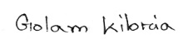
ID: 111 183 086
Signature:
School of Business and Economics
United International University

Certification of Similarity Index

Declaration of the student
I hereby certify that, as a student, I have written this project paper honestly and to the best of my ability. This paper's content is all my own study and analysis, and all references have been properly mentioned.

I followed the instructions given by my supervisor, Ahmed Imran Kabir Sir, and finished the paper in the allotted time. I acknowledge that any sort of academic dishonesty is strictly forbidden and take full responsibility for the content in this paper.

Golam Kibria
ID: 111 183 086

Acknowledgement
"I want to show my sincere gratitude to my supervisor, Ahmed Imran Kabir Sir, for his invaluable advice, assistance, and encouragement during my research. His expertise and constructive feedback have been instrumental in shaping this thesis.

I also want to express my gratitude to the BBA teachers for their helpful feedback and recommendations.

Finally, I am grateful to my family and friends for their unwavering love, support, and motivation."

Abstract
This is a research paper that focuses on education data mining and its impact on improving the education system in Asian countries. The paper highlights the importance of using data mining to improve the quality of education, enhance students' performance, and bring positive changes to the educational system. It emphasizes the need for efficient pattern and related data to identify the most significant courses for the final result. The paper presents a problem statement that focuses on the performance of undergraduate learners in Asian countries. The authors state that there is no linear relevance that exists in the educational structure of these countries, and it generates a tremendous problem for faculties and learners to track their institutional performance. The authors aim to predict the academic results of these students and identify their pattern to sort out the problem and help the faculties and teachers judge their students in danger. The scope of the research is to use a generalized framework to predict the CGPA of business undergraduate students using a DNN approach. The authors use student data gathered from a reputed university in Bangladesh to predict student performance and apply the proposed method to improve the students' academic performance and the quality of teaching procedures. The objectives of the paper are to predict student performance, find efficient patterns, and related data to search for the most significant courses for the final result. The authors aim to use classification methods such as Random Forest, Gradient Boosted Tree, Tree Ensemble, Decision Tree, SVM, and KNN to predict the level of student performance. They use the DNN model to predict students' CGPA of business undergraduate students with a minimum error rate based on transcript data of the initial four semesters. Overall, the paper highlights the importance of education data mining and its impact on improving the education system in Asian countries. It provides a useful framework for predicting student performance and improving the quality of teaching procedures in educational institutions.
[Keywords: education data mining, Asian countries, student performance, CGPA, DNN approach, pattern identification, classification methods, Random Forest, Gradient Boosted Tree, Tree Ensemble, Decision Tree, SVM, KNN, quality of teaching, educational institutions.]

Table of Contents

Letter of Transmittal iii
Certification of Similarity Index iv
Declaration of the student v
Acknowledgement vi
Abstract vii
Chapter I: Introduction 10
Introduction 10
Research Background 10
Problem Statement 10
Scope of the Research 11
Objectives 12
Significance of the Research 12
Research Outlines 13
Conclusion 13
Chapter II: Literature Review 14
Introduction 14
Core Background Research 14
Review Based on Methods 14
Review Based on Frameworks 15
Review Based on Experimental Evaluation 16
Observation and Discussion 16
Conclusion 17
Chapter III: Research Methodology 18
Introduction 18
Proposed Method / Framework / Methodology 18
Data Collection 18
Classification 23
Regression 28
Conclusion 32
Chapter IV: Experimental Results 33
Introduction 33
Experimental Results 33
Classification 33
Regression 35
Pattern Analysis 38
Descriptive Analysis 39
Conclusion 40
Chapter V: Conclusion 41
Introduction 41
Contribution of the Research 41
Future Work 41
Conclusion 42
References 43
Appendix A 46
Appendix B 47

Chapter I: Introduction

Introduction
In neoteric century, Education holds the key to bring a chance to the world. Researchers are constantly on the verge of exploring the factors which emphasize on educational growth. They are working on increasing the quality of education, bringing positive changes to the educational system and also ways to enhance students’ performance. The educational institutions are literally in a competition as to who provides better education. Researchers are constantly bringing up techniques such as data mining to deal with large scale data generated by the educational institutions with in a short time. Data Mining is a basically a technique that analyze and extracts information which then is identifies concealed patterns in the data [1]. It analyses large sets of data and discovers patterns and relationships which then is used to identify a possible problem. Nowadays higher quality data mining methods are used by institutions which provide higher education. This education performance research based on data mining skill and method which collect the high potential data and help the academic outcome prediction properly [2]. When predict an actual data to perform via education data mining process then can take necessary terms to develop the education performance of an institutions and popularity of its past punctually. So, education data mining has to play a necessary move to develop education of a nation.

Research Background
The progressive emphasize of seeker on education data mining system has formerly made a modern experimental site called EDM which is outbound concerned with thriving methods for analyzing educational data to better understand of learners [3]. It is attached in various techniques like tree ensemble, KNN, DNN, pattern analysis and regression.

Problem Statement
In majority of the countries in Asia we see that, various rhythm is noticeable of a student when their performance is slow or down into their undergrad stage. As a result, it generates a tremendous problem for faculties and learners to path their institutional performance and take fundamental moves to eliminate the pedagogical hopelessness. To make prediction of their academic results and identify their pattern which can sort out the problem to help the faculties and teachers to judge their students in danger and fork out to next level dependence for learners of their study.

Scope of the Research
We look around in Asian countries we can see that our educational structure like student institutional performance of undergraduate learners there is no linear relevance subsist. If we categorized the all kind of learners in three types of categories, then we realize the perform of undergraduate students. One of them are better performance to starting of their primary period but sequentially they switch the overview of their study performance can be down and one day their situation turns out in danger in the end of their graduation period when second type of students going throw their opposite way. Other categorical learners where few of students either better or worst perform in their undergraduate period. This variant of students’ categories to make the huge problems to their faculties to discover their students genuinely whose are in danger to their study situation. If we find out the actual students, we predict their outcome of total academic figure then faculty or teacher to identify the learners and lead them rightly. Some of students turns to problems at their inner point of their graduation period because they fail to judge their actual outcome and their expected outcome in that way students becomes frustrated. Whether they will be understanding their position and possibly they fall apart from their study gradually. If students will show them predict of total academic performance before fall apart from study, they will feel better and try to focus on their study with enthusiastically. If they Dedicated to change for their betterment and this will support them fail to study. We are required to pattern identification to resolve this matter. The major impact of this problem is the impactful courses which down the student CGPA and fail to overcome their obstacles. The prediction performance will help to realize to focus on these impactful courses attentively and faculties also help them to easily understand their courses study properly that why students will capable of helping their good grades on these critical courses and their CGPA will be higher before their undergrad result publish. So, we work this prediction performance basis then they can easily pass their courses and will get a good result in institutional performance that will be reputed in countries. But there has a non-linearity’s question which tough to predict the inner facts hence final CGPA. To solve these difficulties, we apply a generalized framework which though help us to predict the students CGPA using DNN approach only utilizing the students’ academic first four semester results.

Objectives
The aim of this paper to predict student performance for analyzing the educational data originated from student transcripts. So that the students can think about taking the right step at the proper time to fulfill their goal. We will be using student’s dataset that have been gathered students’ transcripts from business background students from a reputed university in Bangladesh. Only prediction performance cannot reach the success goal for improving students’ education performance or not the quality of teaching procedure. We have to research to find efficient pattern and related data to search which are the most significance courses for our final result. To apply the proposed method faculties capable to understand their learners and improve learners themselves in academic and restructure of course pattern organized way. At first, we apply classifications method to predict the level of student performance. Mostly we used this machine learning method to predict categorical labels for each instance in datum [4]. We used six classification method which are Random Forest, Gradient boosted tree, Tree Ensemble, Decision Tree, SVM and KNN basis on our data which generate higher accuracy. Random forest with others models highest accuracy (94.1%). We generate tree diagram though the decision tree algorithm to improve the important hidden model in this datum. DNN model is used to predict students CGPA of business undergraduate students with a minimum error rate which based on transcript data of initial four semesters. We consider that decision tree is also a baseline performance model. DNN model can predict CGPA with the MSE, MAE and MAPE. If we compared between DNN and baseline model we see that DNN model perform better to prediction performance to keep with the minimum error rate of MSE, MAE and MAPE by their results respectively.

Significance of the Research
The prediction of final academic outcome can help students to identify their situations and assist them rightly. Student and faculties can easily understand their problems through this early prediction education performance research. And student try to overcome their frustration and can get good result in their graduation or final result. Institution focuses on backward students and guided them properly based on this early prediction research. In this way faculty catch their student pattern and push them to improve their studies.

Research Outlines
Section 1 (Introduction): In this section to evolve the overall overview of whole research study in briefly explain introduction, Research background, Problem statement, scope of the research, objectives, significance of the research, conclusion.
Section 2 (Literature Review): In this term discuss about the frameworks and approach of the data mining method and observation of the algorithms and methods, review based method, experimental evaluation.
Section 3 (Research Methodology): to explain about method of data mining approach and evaluate the method. To evaluate the metrics and explain the classification and regression. To analysis the pattern of algorithm, metrics, prediction error.
Section 4 (Experimental Results): To explain about the analysis part of research analysis algorithms and pattern analysis of student predicted value and actual value. Find out the outcome results and how the efficiency of this research work.
Section 5 (Conclusion): In this part, to explain the research future work, contribution of work, importance of research work in future and to explain the efficiency of applied method.

Conclusion
Education plays an important role to develop a nation. When identify the education performance to a nation through an actual process and find out the lacking behind the dullness of education skill then we apply a good technique to measure the problems. If predict the education performance earlier before the student academic result publishes and apply the suitable steps to solve education quality. Most of the students are frustrate on their study and move to opposite path of study which help to this kind of student very exactly. We explained six algorithms to solve this research these are Tree ensemble, Support vector machine, Gradient boost tree, KNN. This algorithm helps to understand the faculties to their students’ education performance prediction and what to do them for their students to overcome their bad path to right path. They predict their students’ quality and what necessary steps to take their students by this education data mining process algorithm. Any of the institutions popularity depends on their students’ activities and their good results which help for an initiative process to justify their education performance to apply the early prediction process of student results and develop their future in this way.

Chapter II: Literature Review

Introduction
Process of receiving or giving systematic instruction is called Education and currently many researchers have made a point of on applying the data mining methods to solve the problems and making decisions in sphere of education. “Data Mining of Educational (EDA)” is a rising discipline, related with progress techniques for prospecting the general and additionally large- scale data. To draw out the hidden knowledge is its techniques and block out the pattern from the facts. Different types of machines are used by the Researchers are also in applying opposite learning algorithms for building predictive model. A Machine Learning is a term that concept which allows the machine to acquire from theoretical & Practical, so that without being absolutely programmed. Machine learning are dissecting into two parts that are (a) Supervised and (b) Unsupervised that are used in different types of fields. Conducting of educational data mining (EDM) spread use of tools have emerged for the purposes. Mining of Data is helpful for solving many challenges and problems in different fields

Core Background Research
Naturalism is a common term used in discussions around immigrants and related practical field operationalization within the social sciences still remain shifty. The concept has an elusive nature of limited the scientific exchange of information and meaningful discussion around research searching and theory development of the data. To clarify the aims of concept’s definition used in social sciences and for research and theory development are applicable in both. As an introduction to give a broad overview to the concept in a comprehensive handbook, it’s major emphasis. In the various aspects of the concept found a more detailed coverage.

Review Based on Methods
Discovery of the knowledge in databases is known as Data mining [5], defined as the activity of analyzing large information repositories and of discovering implicit, but latency effective information. Hidden relationships are related to uncover data mining and to reveal unknown shapes and movement by digging into huge data. As stated by the task performed the functions or models of data mining divided with 1. association 2. classification 3. clustering and 4. regression (Hui & Jha, 2000; Kao, Chang, & Lin, 2003; Nicholson, 2006b). Data mining analysis is form normally on three techniques: (1) definitive statistics (2) unreal intelligence and (3) learning of machine. Definitive statistics is chiefly used from monitoring data, data connection, Vast databases with numeric data for trading with this.
Examples of classical statistics include regression analysis, clump analysis, and distinguish analysis. Artificial intelligence (AI) applies processing to statistical problems. Such as genetic algorithms AI uses several techniques and neural [7] computing. Advanced methods of statistical & AI are the combination of advanced statistical methods and AI are used for analysis of data and knowledge discovery. Machine learning uses several classes of theory such as neural networks [8], symbolic learning, genetic algorithms, and optimization. Data mining benefits from these technologies, but differs from the objective pursued: extracting patterns, describing trends, and predicting behavior.

Review Based on Frameworks
The study of foundations of this data mining may be viewed as a scientific research into the environment of it is the scope of data mining theory. Enough attention not to paid about data mining for study of the environment or its philosophical roots. This is apparent that the abstract studies of mining of data as a scientific investigation field, Collection of isolated algorithms patterns alternatively, is helpful for further development of the whole field. There are three-layer conceptual framework that is (a) philosophy layer of consisting (b) the technique layer and (c) the application layer. Many types of prime questions focus on mining of data above these layers, and mentioned collectively form a full epithet of the area. The layered framework is incontestable by applying 3 sub-fields of mining of data, classification, measurements, and justify-oriented data mining [6]. Exemplify three popular views of mining of data, (a) function-oriented, (b) theory oriented and (c) procedure-oriented, respectively. Introduction with the development and aim of mining of data, many researchers became concerned in the fundamental issues, the base of mining of data [2, 8, 9, 23]. The relationship between mining of data and base of mining of data is equivalent to the connection between computer science and computers. For study of data mining scientific searching into the environment of data mining and area of data mining theory. This is looking divided into two important issues. The characteristic of data mining studied of mining of data covers the philosophical, theoretical and mathematical foundations of mining of data, and follows that this is a content of study; At the time of studied technological foundations about the data mining methods concerns its and follow up on the algorithms and machines, and looks it as content of practice.

Review Based on Experimental Evaluation
In the literature there are new time series with large number of classification algorithms proposed in the last 5 years. Algorithms of these have been evaluated upon subsets of the 47 data package in the reputed University, Archive has been recently boarded to 85 data packages, University of East Anglia fully and one half of that are created by researchers. Balancing between algorithms complex have been made from previous evaluations. Respective different types of programmable words are used, testing attached with a single test lot and used changed data whilst another changing did not. The abolish of archives retrofit a timely possibility to assess algorithms on a big number of data package. in a common Java framework, there are implemented 18 recently proposed algorithms and compared with them about two standard reference classifiers by acting 100 testing of resampling experiments upon the 85 data package.

Observation and Discussion
Two decades past, numerous education has been arranged in the concealed pattern in studies data. This segment, we are going to shortly recapitulate of education discipline. In present years, most research in this subject has emphatic the utilize of mining of data theory and some source applied several cases of machine research theory guess the ability of the fresher’s, choose the actual catalogue for the future idea, and discover the discuss few of the recent and pertinent studies. Decision Trees to predict [9] student’s last GPA using only the grades of the previous courses. They collected the dataset included students’ last GPA and CGPA in all programs from the students’ transcript but their focus was only on the mandatory courses. They separated the numerical value of the student's grade into groups and categories that showed a lot of grade inflation. Using the J48 decision tree technique, the classification theory was discovered. They have also discovered a connection between GPA and the title that negatively affects the final outcome [9]. Sushmita have proposed a model work for predicting [10] students’ outcome in which to inspect and classify students’ details based on academic records K-mean clustering algorithm is used. The most accurate attributes selected for the 24 attributes, by the ranking analysis were CGPA, Arrears, Attendance, 12 marks, Engineering Cut-off, Education Medium, and Board Types. In discussing their issues, they predicted the students’ ability [11]by comparative analysis of efficient classification algorithms namely Naive Bayes, Multilayer perceptron, SMO, J48, REP tree and obtained a high influence using J48 with accuracy 97%.

Conclusion
The assessment data are applied on look after the data mining algorithms are to anticipate success in a program (fail or pass) and activity of the theory of learning to be evaluated root on their predictive quality, ease of study and user-friendly characteristics. Classifier out performance in prediction about determination and chain link methods issue indicate. Model regarding Good Classifier also been indicated that in accordance with accurate and intelligible for professors. After finishing the data collect the data mining theory were applied after the data was composed. This methodology used to help students and proceedings, method of international seminar on intelligent teaching systems, Educational Data Mining Workshop (EDMW).

Chapter III: Research Methodology

Introduction
We followed a good methodology for conducting our experiment in this study. In fact, multiple work flows for classification, regression, and pattern analysis have been preserved. We suggested a generalized framework for forecasting each student's class level and for pattern analysis in the first phase. We developed a DNN architecture for forecasting the final CGPA of undergraduate business students in the second phase.

Proposed Method / Framework / Methodology

Data Collection
Here we used a dataset created from business students' transcript data acquired from the department of Marketing of a prestigious institution. We've gathered information from students who have already finished the courses. There were total 398 instances.

Description of the Attributes
Each of the pupils' attributes are included in our prepared dataset.
Name, ID, Gender, All the courses with grade, GPA, State of the students based on GPA, CGPA.
The course descriptions can be found at. We've eliminated useless attributes like Student name and Student ID for the sake of modeling.

Data Preprocessing
To tackle a realistic problem with machine learning, it’s critical to preprocess raw data accurately so that we can acquire a good result from the model that has been applied, as this has a direct impact on the model's ability to learn. In most cases, real data is not complete and most of the time they are noisy and distorted. Because the data is inconsistent and unbalanced, it’s critical preprocessing it without feeding it before. Data pre-processing steps have been applied to our dataset to pre-process the data. In the subsections below, all of the tasks are briefly addressed.
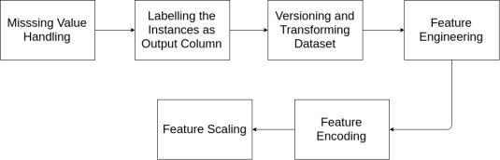

Fig. 3-1: Block diagram of preprocessing tasks.

Missing value Handling
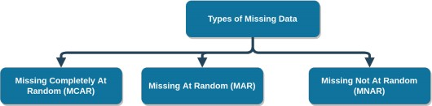
There are always some missing values in real data, which are normally deterged during the experiment's data preprocessing. Before we can deal with the missing data, we must first learn about the nature of the data that is missing. Data might be absent in a variety of ways:

Figure 3-2: Types of Missing Data.

Missing Completely at Random (MCAR):
If there are values which are missing and which are spread at random over entire examination in a data set, it is considered missing completely at random. A data point that is absent in MCAR is independent of both the observable and the unknown variables, as well as observable and unobservable characteristics of interest That is to say, the missing data has been found. There is no correlation between the hypothetical variable value and the values of other variables.

Missing at Random (MAR):
The main distinction between MCAR and MAR is that in MAR, data is missing randomly only within sub-samples of data rather than across all observations. The propensity for a data point to be used in MAR be missing has nothing to do with missing data, but it does have something to do with some of the observed data.

Missing Not at Random (MNAR):
In MNAR, the value of a missing variable is related to the reason for its absence. There are two probable reasons for missing value, both of which are dependent on the hypothetical value (e.g., Low-achieving students in a class doesn't wish to share their CGPA) or missing value depending on the value of another variable (e.g., Assume that the majority of female students do not want to know how old they are! The missing value in the age field is influenced by the following factors vary based on gender).
In the first two circumstances (MCAR and MAR), it is safe to delete data with missing values based on their frequency, however in the third instance (MNAR), eliminating observations with missing values can lead to model bias. No ignorable nonresponse is another name for MNAR. Because our data is MCAR, we were able to filter out the missing cases and there are a total of 372 cases left.

Labelling the Instances as Output Column
We constructed a goal column. The column is constructed for classifying the performance of students by labeling each of them based on their performance classes. There are total three performance classes. They are Honors, First Class and Second Class. These classes are chosen by the final CGPA. Only a few of the 372 cases in our dataset. There are 10 Honors students, 27 First Class students and 335 Second Class students. Table of contents 3.1 displays the designations along with the university's predetermined CGPA.
Table 3-A: Performance Classes with Minimum CGPA

Class | Minimum CGPA
Honors | 3.75
First Class | 3.00
Second Class | 2.20

Versioning and Transforming the Dataset
The dataset comes in two versions: one with grades and the other with grade points. We used the first version named "courses in grade" so that we can discover patterns, and the second version, dubbed "courses in grade point" so that we can forecast the students' class. We changed all of the grades with their associated grade points to build the second version because our collected data comprises grades. Table 3-A lists the grades and their associated grade points.
Table 3-B: Grades with the narrating Grade Point

Grade | Grade point | Grade | Grade Point
A+ | 4.00 | B- | 2.75
A | 3.75 | C+ | 2.50
A- | 3.50 | C | 2.25
B+ | 3.25 | D | 2.00
B | 3.00 | F | 0.00

Feature Engineering
Feature Engineering [17] is a method which is used to extract new characteristics by converting existing features into formats appropriate for machine learning models. Using feature engineering approaches, we were able to determine students’ gender by the names. Table 3-B shows a small sample of our data of extraction of the gender of students after applying feature engineering.

Table 3-C: Gender column based on Students’ name

Name | Gender
MD. ABUL KALAM AZAD | M
TAHMINA KHANOM | F
S.M. SHAHNEOAJ | F
MD. ILIAS ALI | M
MD. ISMAIL HOSSAIN | M
MD. MAMUN ALI | M
SIRAJUM MUNIRA | F
MD. ROBIUL HASAN | M

We’ve also created different feature columns that show how students are doing after each semester, based on their GPA. We used four unique terminologies to indicate the state of the kids, as shown in Table 3.4: ‘Excellent,’ ‘Very Good,’ ‘Good,’ and ‘At Risk.’
Table 3-D: Range of GPA for States

GPA | Terminology
3.5>= | Excellent
3.00<= or <=3.50 | Very Good
2.50<= or <=3.00 | Good
2.5< | At risk

Feature Encoding
Feature encoding is a technique for converting category data into numerical data. The learning of neural networks is fixed. It can learn from continuous data only. Therefore, categorical data must be encoded into numbers before being fed to the model. Gender and State of the students, as noted before, are categorical factors that are included in our dataset in this study. We used the One-hot encoding technique so that we can transform those categorical data into continuous data [18].

Feature Scaling
Data normalization requires feature scaling [19], which is a critical step in the data pData normalization requires feature scaling [19], which is a critical part in the data preprocessing. This contains some strategies. The data is scaled into a predefined extent in order to fetch each of the characteristics to the similar magnitude level. This is necessary to train a model which is based on neural-network. Min-max scaling is applied to every feature column for feature scaling, and the new value Xsc of a X is derived:
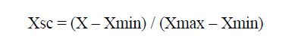

In a feature column Xmin is the smallest value. The maximum value is Xmax, accordingly. Now, the updated value is between 0 and 1 as a result of the scaling.

Classification

Classification Algorithm

Decision Tree
Very few algorithms of machine learning are as popular as Decision tree [20] among the family of controlled learning algorithms. This method works for both classification and regression. But it is widely used for solving classification tasks. It creates three nodes like root node, branch nodes and leaf nodes in a decision tree. Generally, it cracks the Sample more than two or two set founded by most eminent features. Gain ratio, Gini index, Chi- square and entropy are some used techniques and they are used to achieve this from decision tree. Here, Gain Ratio has been used as a split criterion in our study and no pruning method have also been used. We have used a formula for split Entropy and Gain Ratio which are stated below:
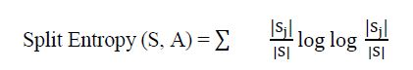

Where train data S divided into k sections. Sj is the subset. ‘j’ is the probable values of attribute A. And Gain Ratio is defined as:
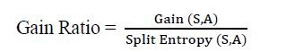

The measure of purity or impurity of a random variable is known as Entropy. In this study we have used entropy to find the Information Gain Ratio of data samples. However, “Information gain is grounded on the information theory”. Information gain has been used to regulate the finest structures/ characteristics that render concentrated information about a class or a node. It always maintains the idea of entropy through aiming at lessening the measure of entropy. Information gain subtracts the variance between previous entropy and after entropy which also agrees the impurity in the elements.
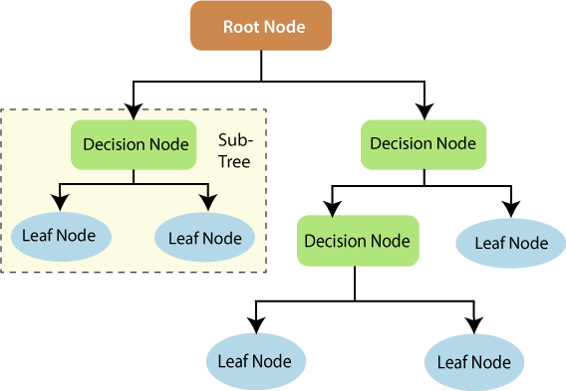

Fig. 3-3 Decision tree.

Random Forest
Supervised ensemble learning method has various method, among them Random Forest is very popular that is used for both regression task and classification [21]. Actually, Random Forest is generated by congregating Decision Trees. Then bagging method is used to train it. It utilizes different techniques to divide the feature nodes. Gini index information gain is one of those techniques. Below we can see how a random forest would look like with two trees:
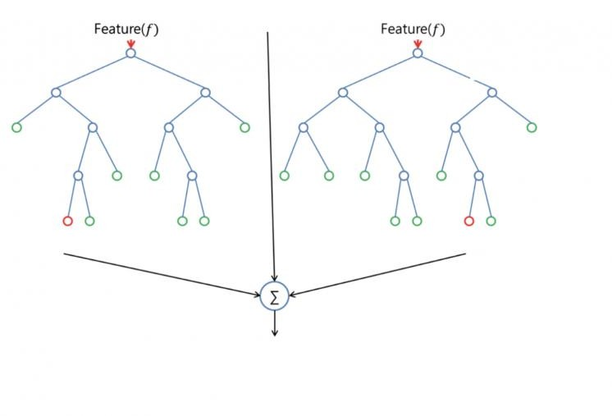
Fig3-4: Tree feature

Every tree predicts in the test stage. At last, it performs classification by choosing the class which is frequently selected by most classes. Due to the integration of several decision trees, the bias is unchanged from that of a single decision tree. Random forest usually prevents this by randomly selecting subsets of the parameters and utilizing those selections to create smaller trees. It then joins the sub trees together. It's crucial to note that this doesn't always work, and it also slows down the calculation conditional to how many trees the random forest generates. The random forest's adaptability is one of the greatest advantages. This may be used both for regression and classification purposes, and the relative priority that they attach to the input functions is also plain to see. Random forest is however a highly convenient technique since the predetermined hyper parameters used typically yield a decent forecast result. The hyper parameters are rather easy to understand, and several of them are also not accessible. A great number of trees can lead to an algorithm that is too slow and useless for real-time predictions is the principal restriction of the random forest. Generally speaking, these algorithms are quick to train, but sluggish to predict when taught. More predictions need more trees, leading to a slower model. The random forest technique is quick enough in most real-world applications, but there surely can be circumstances where run time speed is crucial and alternative techniques are desired.

Support Vector Machine
The support vector machine algorithm [22]is a predictive machine learning approach for solving binary classification issues. Every data in dataset which is placed as a point which has space of n-dimension. Here n expresses the number of features. Then kernel trick is used to convert it into higher dimensional space. The general form of kernel is written as,
K (Xi. Xj) = φ(Xi). φ(Xj)
In this thesis, polynomial kernel has been applied. It can be defined by,
K (Xi. Xj) = (Xi. Xj + 1) d
Here, polynomial degree is expresses as d. Depending on where the unknown samples are in relation to the hyperplane during testing, they are recognized. The symbol for a separating hyperplane is,
W.X + b = 0
Where W = {w1, w2, · · ·} weight vector denoted by w and scalar denoted by b.

Tree Ensemble
Tree ensemble is a skillful technique [23] to enhance the exact outcome in combining model. These combining models are boosted the great sound of this method in machine learning. Ensemble method aim is enhanced the prediction of in structural model via combining models to create an accurate model smoothly. Tree ensemble is used to solve a computational problem by combining separate decisions of set of classifiers which are being generated strategically. This method is norm for classification and regression to minimize the variance to enhance the precision of this model. Similar to random forest model it assumes patterns according to an aggregation of predict the individual trees.

Gradient Boosted Tree
For classification and regression tasks, Gradient Boosted Tree [24] is an effective machine learning approach. It combines a boosting algorithm known as gradient boosting with decision trees, particularly CART trees, to generate an ensemble of weak prediction models called a prediction model. Boosting algorithm is a strategy for converting weak learners into strong learners in which future forecasters learn from the mistakes of prior predictors. Furthermore, less iterations are required to get near to the real forecasts. The following equation can be used to compute the loss function:
L (yi, yip) = Σ (yi – yip)2

Here, yi = ith target value, yip = ith prediction, and L (yi, yp) is the loss function. Using the gradient descent approach, the loss function is minimized.

K-Nearest Neighbors (KNN)
KNN [25] is a prominent supervised strategy which may be used to solve classification and regression problems, though it is more commonly employed to solve task of classifications. It is an algorithm which saves every existing example of all training dataset. Then it classifies newly come cases based on the higher number of votes k neighbors. During test stage, one fresh example is allocated to the most common class among its K closest neighbors, as determined by a distance function. Euclidean, Manhattan, Minkowski, and Hamming distance are the distance functions utilized in KNN.
As a result, the Hamming distance has been employed in this work. It can be defined by,
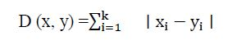

Where x is a dataset data point and y are a new data point that needs to be predicted.

Evaluation Metrics
We used six different evaluation indicators to assess the performance of our predictive models, as follows:

Accuracy
Accuracy means classification accuracy. The number of correct predictions divided by the total number of input samples is the ratio.
TP+TN
TP+TN +FP+FN

It only works better when the number of samples in every class is equal.

Precision
Precision tries to respond to the following query:
What percentage of the affirmative identifications were correct?
It is the ratio between correct positive outcomes and classifier’s predicted outcomes.
TP TP+FP

Sensitivity (recall)
Recall makes an attempt to respond to the following question:
What percentage of true positives were successfully identified?
It is calculated by dividing valid positive results by relevant samples.

𝑇𝑃
𝑇𝑃 + 𝐹𝑁
To completely assess a model's effectiveness, we must look at both precision and recall. Regrettably, precision and recollection are sometimes at odds. In other words, increasing precision usually decreases recall and vice versa.

Specificity
The fraction of real negatives that were anticipated as negatives is known as specificity (or true negative). This means that a part of true negatives will be forecasted as positives, which could be referred to as false positives. This percentage is also known as the false positive rate.
𝑇𝑁
𝑇𝑁 + 𝐹𝑃

F-measure
The Harmonic Mean of precision and recall is the F1 Score. F1 Score has a range of [0, 1. It helps you to understand the propriety of your classifier. If the precision is high and recall is low, then it will give us an incredibly accurate result. If the score of F1 is high, then our model will perform better. It can be stated mathematically as:
2 × (𝑟𝑒𝑐𝑎𝑙𝑙 × 𝑝𝑟𝑒𝑐i𝑠i𝑜𝑛)
(𝑟𝑒𝑐𝑎𝑙𝑙 + 𝑝𝑟𝑒𝑐i𝑠i𝑜𝑛)

Cohen’s kappa
The Kappa score is identical to the Accuracy score, but it also considers the accuracy that would have occurred by random predictions.
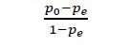

The confusion matrix generates TP, FP, TN, and FN. The p0 is the observed relative accuracy agreement, pe is the hypothetical probability of chance agreement. Only accuracy would not be an acceptable measure in our circumstance because our dataset is not symmetric. As a result, while examining the findings for each of the distinct classes, we have chosen F- measure, sensitivity, specificity and precision. We did, however, include Accuracy and Cohen's Kappa score when evaluating the models' overall performance.

Regression
We suggested a DNN architecture to forecast the ultimate CGPA of undergraduate business students. The complete procedure consists of three steps: building the DNN model's architecture, picking the evaluation criteria. The Python programming language was used for all of the implementations of these three steps.

The Architecture of the proposed DNN Model
There are three key layers that make up DNN models. These three layers are the output layer, the hidden layers, and the input layer. Neurons, hidden layers, activation function, optimization technique, learning rate, epochs, batch size, and other parameters can all be used to design this model. All of these characteristics must be considered throughout the building of a network, as they direct the learning process and the model's final performance. As a result, determining the value of these characteristics is undeniably difficult. The visual architecture of our suggested model is depicted in in Figure 4.3.

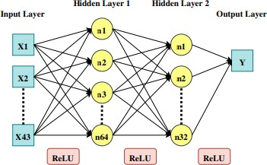

Figure 3-5: DNN Architecture

The Number of Neurons in the Input and Output Layers
At first hyper parameters are configured to create a neural-network architecture. The neurons in input layer and the neuron in output layer are called hyper parameter. Basically, the hyper parameter or the neuron numbers are determined by size of training data. The form of our training data is (261, 43), indicating that there are 261 instances and 43 attributes. Being 43 attributes, 43 neurons have been specified in the input layer by us. On the other hand, output layer has only one neuron because the problem is a regression problem with a single numeric value as the expected conclusion.

The Number of Hidden Layers and Neurons
Determination of hidden layers and neurons number in every hidden layer is an important work since it defines the architecture of neural network. According to a research by Jeff Heaton [26], Approximation of any function can be done by networks with a single hidden layer. With rational activation functions, networks which have two hidden layers may characterize a despotic boundary of decision to despotic accuracy. Furthermore, networks with more than three hidden layers are capable of learning complex designs and delivering automated feature engineering. If the number of hidden layers is more than two, it will create the model exceedingly complex. It will make the model computationally inefficient. As a result, we created a neural network architecture with only two hidden layers.
A rule of thumb has been used from [27] so that we can find out the number of neurons in the hidden layer once more. 64 neurons were used for the first hidden layer since our 43 is the dimension of our final input. We used 32 neurons in the second hidden layer because before output it is the last layer.

Activation Functions
Activation function is one of the most important things of neural network. Activation functions is used for functional mapping. This functional mapping is applied between input and response variables. It is a non-linear change applied to an input signal. Complex tasks can be learnt by it. In a hidden layer every hidden neuron produces one output after computation. ReLU has been used in this investigation as activation function, which is briefly detailed below.
Rectified Linear Unit (ReLU): When creating a DNN model, ReLU [28] is the most commonly employed activation function. The function converts the input to zero when the input is negative. Then the neuron will be deactivated. nevertheless, if the input is positive, the function returns that value. It's described as
f(x) = max (0, x)
Here the number of neuron’s input is x. It is an advantage using ReLU that it does not activate all the functions simultaneously.

Optimization Algorithm
In DNN, the most crucial factor in attaining a good output from the model is an optimization technique. It adjusts the weights and trains the neural network model with an optimal cost function to make it as precise as feasible. Adam algorithm has been used as optimization algorithm for our experiment.
Adaptive Moment Estimation (Adam): The Adam [29] optimization technique is a stochastic gradient descent extension which iteratively perform updating network weights depending on train data, and it performs well through a variety of deep learning architectures. Adam has several benefits over other optimization algorithms, including cheap memory requirements, invariance to gradient diagonal rescaling, simple hyper parameter interpretation, and frequently little tuning.

Evaluation Metrics
Three metrics have been used to evaluate the effectiveness of our suggested model in terms of error measurement: MSE, MAE, MAPE. All of the indicators were chosen based on their use and applicability. The specifics of these measurements are described further down.

Mean Squared Error (MSE)
MSE is a metric that indicates the distance between our fitted line and data points. This metric is used to compute the squared difference of the predicted and goal values for each data point. Then it calculates the averages those differences. The model will fit better if the computed value is very small. The mathematical formulation of MSE is given below:
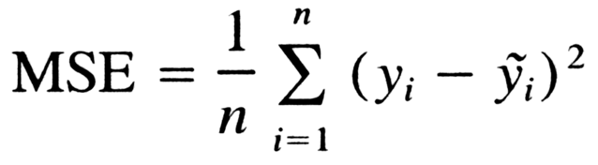

Mean Absolute Error (MAE)
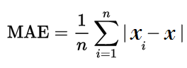
The use of MAE is to forecast the accuracy. At first absolute difference between predictions and target values is determined. Then error is calculated by making average of those differences. There is one important benefit of it that it does not penalize large errors as harshly as MSE does. As a result, it is less susceptible to outliers than MSE. Mean Absolute Error can be written as follows:

Mean Absolute Percentage Error (MAPE)
It's a non-scaled error metric that's measured in relative error preference. The target value divides the absolute error for each data point, providing a relative error. One of the important benefits of this metric is that this metric is straightforward and easy to comprehend because the mistake is expressed in percentages. As a result, it can calculate the prediction easily if it knows the prediction's average range already. The following equation can be used to compute it mathematically:
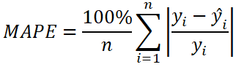

Defining Baseline Performance
It is critical to define the baseline performance for monitoring and assessing the neural network model's effectiveness during the training phase. For all of the test samples, we used the performance of a Decision Tree as a baseline. An experiment was run on our dataset. We used the Decision Tree model for our experiment. The performance achieved from it was Mean Squared Error (=0.02390), Mean Absolute Error (=0.1114), and Mean Absolute Percentage Error (=8.0047). Our model should have a performance error that is less than the baseline error in order to produce a positive result.

Conclusion
A tree diagram was created using the decision tree for pattern analysis because it provides a graphical representation that leads to our desired result. We'll go through pattern analysis and descriptive analysis in detail in the upcoming chapter.

Chapter IV: Experimental Results

Introduction
In this phase, we'll go over the outcomes of our classification and regression jobs in detail. We'll also go through the pattern analysis and descriptive analysis of our research.

Experimental Results

Classification
The dataset was evaluated and likened with six various classification methods, including GBT, RF, Tree Ensemble, Decision Tree, SVM and KNN apropos prolepsis the performance class where the dataset is utilized to test these classification methods apropos prolepsis the performance class of students. Precision, specificity and the f1-measure are used to determine the individual results of each class. The accuracy and Cohen's Kappa, on the other hand, provide the overall findings. In table 4-A displays the models' categorization performance using several evaluation indicators.

Table 4-A shows that all six models do the categorization with a high degree of accuracy.
Table 4-A: Classification Performance of the multiple Models:

 |  | Precision | Sensitivity | Specificity | F-measure | Accuracy | Cohen’s  Kappa
Gradient Boosted Tree | Honors | 0.556 | 0.500 | 0.989 | 0.526 | 0.927 | 0.515
Gradient Boosted Tree | First Class | 0.940 | 0.982 | 0.432 | 0.961 | 0.927 | 0.515
Gradient Boosted Tree | Second Class | 0.846 | 0.407 | 0.994 | 0.550 | 0.927 | 0.515
Random Forest | Honors | 0.833 | 0.500 | 0.997 | 0.625 | 0.941 | 0.598
Random Forest | First Class | 0.946 | 0.991 | 0.486 | 0.968 | 0.941 | 0.598
Random Forest | Second Class | 0.867 | 0.481 | 0.994 | 0.619 | 0.941 | 0.598
Tree Ensemble | Honors | 1.000 | 0.300 | 1.000 | 0.462 | 0.938 | 0.544
Tree Ensemble | First Class | 0.938 | 0.997 | 0.405 | 0.967 | 0.938 | 0.544
Tree Ensemble | Second Class | 0.923 | 0.444 | 0.997 | 0.600 | 0.938 | 0.544
Decision Tree | Honors | 0.300 | 0.300 | 0.981 | 0.300 | 0.884 | 0.361
Decision Tree | First Class | 0.935 | 0.937 | 0.405 | 0.936 | 0.884 | 0.361
Decision Tree | Second Class | 0.462 | 0.444 | 0.959 | 0.453 | 0.884 | 0.361
Support Vector Machine (SVM) | Honors | 1.000 | 0.500 | 1.000 | 0.667 | 0.914 | 0.491
Support Vector Machine (SVM) | First Class | 0.944 | 0.961 | 0.486 | 0.953 | 0.914 | 0.491
Support Vector Machine (SVM) | Second Class | 0.500 | 0.481 | 0.962 | 0.491 | 0.914 | 0.491
KNN | Honors | 0.778 | 0.700 | 0.994 | 0.737 | 0.919 | 0.435
KNN | First Class | 0.932 | 0.982 | 0.351 | 0.956 | 0.919 | 0.435
KNN | Second Class | 0.600 | 0.222 | 0.988 | 0.324 | 0.919 | 0.435

We visualized the results in Figure 4.1 to compare the models' categorization performance more specifically.
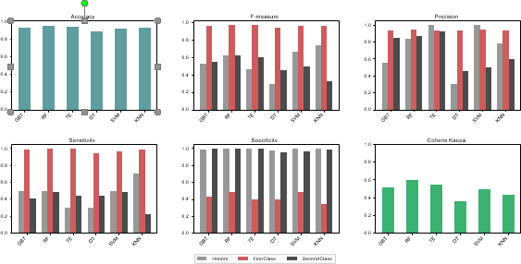

Figure 4-1: Performance Plot of different Classifiers with different Evaluation Metrics.

As seen in Figure 4-1, the Random Forest outperformed the other models with the highest accuracy (94.01%). Furthermore, the picked F-measure and sensitivity, the Random Forest surpasses the other models.

Regression
After completion the training session we performed to applying our proposed method DNN to take some prediction on our dataset. Table 4-B view our applying model's prolepsis outcomes.
We performed some prediction on our test data after the learning phase of our proposed DNN model. The outcomes of our model's prediction are shown in Table 4-B.
In this research, there are three assessments we used to estimate the performance of proposed neural network model: MSE, MAE, and MAPE. We used the MAE to indicate the loss function in this example and learned model for 50 epochs. In Figure 4-2 we show that the graph to represent the graph loss vs v epochs.

The model's learning rates through the epochs are depicted in the diagram above. The two axes have converged at the 10th epochs between loss vs epochs, as can be shown. The converging line indicate that the two-axis line has been quite compatible in converging between loss and epochs, indicating that the model is well-fitted.
Table 4-B: Prediction results of proposed model

 | Roll | Name | Gender | Actual CGPA | Predicted CGPA
0 | 13037425 | RAYHAN IBNE ALI | M | 3.52 | 3.49
1 | 13107436 | ABU BAKAR SIDDIK | M | 3.44 | 3.46
2 | 12097483 | MD. KHALID HASAN | M | 3.37 | 3.33
3 | 11047437 | MD. FAISAL MIA | M | 3.36 | 3.28
4 | 10107449 | HASANUZZAMAN | M | 3.44 | 3.36
5 | 12247529 | MUSA. SALMA KHATUN | F | 3.51 | 3.51
6 | 11027492 | MD. ZOSIM UDDIN | M | 3.52 | 3.46
7 | 10097496 | MD. TOMAL HOSSAIN | M | 3.42 | 3.32
8 | 11097468 | ASIK CHOWDRY | M | 3.38 | 3.43
9 | 1067495 | PROSENJIT RAY | M | 3.18 | 3.19
10 | 11047477 | HORI KISOR | M | 2.62 | 2.95
11 | 13237445 | MUSA. TOSLIMA KHATUN | F | 3.71 | 3.62
12 | 12247423 | MUSA. BELI | F | 3.75 | 3.77
13 | 10027508 | MD. ABDUL ALIM | M | 3.24 | 3.18
14 | 11237465 | MUSTAKIMA AKTER | F | 3.54 | 3.52
15 | 11027496 | LITON KUMAR | M | 2.88 | 2.85
16 | 11247427 | TAHMINA KHANOM | F | 3.72 | 3.68
17 | 13087455 | SABBIR HOSSAIN | M | 3.27 | 3.19
18 | 11037502 | IBRAHIM KHOLIL | M | 3.34 | 3.37
19 | 11097402 | NASMUS SAKIB | M | 3.42 | 3.41
20 | 10087488 | MD. DELOAR HOSSAIN | M | 3.41 | 3.35
21 | 12077533 | TUGUNG CHAKMA | M | 3.1 | 3.09
22 | 10047415 | MD. POLASH ALI | M | 3.32 | 3.37
23 | 13217514 | TANIS TASLIMA RINVI | F | 3.08 | 3.04
24 | 13057478 | SOHRAB HOSSAIN | M | 3.38 | 3.1
25 | 12107471 | MD. ZAHRUL ISLAM | M | 3.46 | 3.5
26 | 11107419 | KAZI MUHAMMD ZUBAYER | M | 3.38 | 3.49
27 | 10027437 | MD. HAFIZUR RAHMAN | M | 3.44 | 3.4
28 | 11087446 | MD. UMOR FARUK | M | 3.17 | 3.19
29 | 11037504 | SHARIFUL ALAM | M | 3.33 | 3.34
30 | 12117431 | SUNJIT SHIKDAR | M | 3.44 | 3.4
31 | 10117409 | ARUP KUMAR RAY | M | 3.26 | 3.19
32 | 12017430 | MD. MONIRUL ISLAM | M | 3.27 | 3.25
33 | 13207463 | MUSA. SABIHA KHATUN | F | 3.59 | 3.49
34 | 12217424 | SANJIDA SETU | F | 3.19 | 3.18
35 | 12047407 | MD. SAROAR ALAM | M | 3.56 | 3.55
36 | 10057414 | MD. SADEKUL ISLAM | M | 3.13 | 3.03
37 | 11017451 | RASHEDUL ISLAM | M | 3.26 | 3.14
38 | 13037426 | MD. MEZBAUL HAQUE | M | 3.5 | 3.37
39 | 11117461 | IMRAN HASAN | M | 2.77 | 2.86
40 | 11087498 | NIRAMAN NASIR | M | 3.49 | 3.47
41 | 12057472 | ZAMIR HOSSAIN | M | 3.62 | 3.63
42 | 10087408 | MD. JULFIKAR | M | 3.27 | 3.21
43 | 11027472 | AVHI AHMED | M | 3.15 | 3.18
44 | 13087437 | HORIDASH BISSASH | M | 3.56 | 3.43

Following the training and validation phases, to use the model which predict the final CGPA using trial data. There were 45 instances in the test data set. Table 4-C shows the training, validation, and test results for our model.
In table 4-C shown that training and validation outcome value are close to each which indicating that our applying model has learned enough from the datum except over fitting.
Surprisingly, the outcome is fairly consistent across all phases, with very little fluctuation.
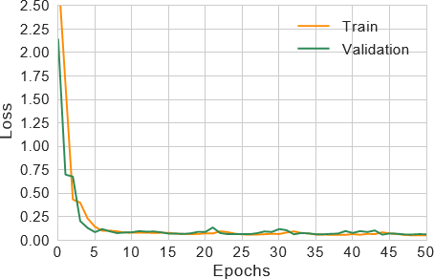

Fig. 4-2: Train vs Validation loss across epochs.

Table 4-C: Performance of the proposed model

 | MSE | MAE | MAPE
Training | 0.005 | 0.051 | 1.520
Validation | 0.009 | 0.067 | 2.085
Test | 0.008 | 0.066 | 2.050

We displayed all 45 test instances in line graph in Figure 4-3 to better understand the variances in actual and anticipated CGPA.
The line graph in Fig. 4-3 shows that, with the exception of a few places, we see that there has a dew difference between predicted and actual values. For the vast majority of the samples, the model fits perfectly and accurately predict the actual value. Based on the pattern test and error metrics, we may deduce that the applied model has extraordinarily well learned the underlying pattern from pedagogical data and can reasonably estimate the real CGPA of undergraduate learners.

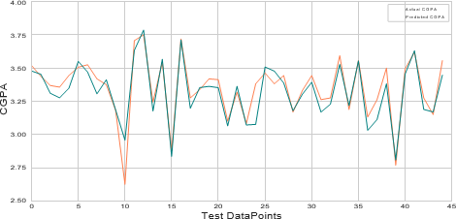

Figure 4-3: Actual CGPA vs Predicted CGPA.

Table 4-D: Difference between baseline and proposed model performance

 | Baseline Model  (Decision Tree) | Proposed model  (DNN)
MSE | 0.0226 | 0.008
MAE | 0.1101 | 0.066
MAPE | 8.1168 | 2.050

Pattern Analysis
To reveal the underlying patterns, we developed a tree model and generate rule set using baseline model to uncover the hidden patterns, and our findings are as follows:
Only 10 of the 372 occurrences in our dataset have received Honors as the ultimate result. We can see from the tree diagram and the rule set that 7 of the 10 students achieved a ‘A+' in course ‘201(c),' and 5 learners also achieved ‘A+' in course ‘302.'
Our dataset contains 335 students who received First Class as their final grade. Interestingly, 153 learners received a ‘A' in course ‘201(c),' whereas 63 learners received a ‘A-' in course ‘110.' Furthermore, there are 91 First-class students who received a ‘A-' in ‘201.'
As a result, we can deduce that course '201,' or 'Computer in Business,' has the huge impact and is most nearly linked to the final output.

Descriptive Analysis
We created an outlook set utilizing four terms: that are ‘Excellent,' ‘Very Good,' ‘Good,' and ‘At Risk,' as described previously, to denote the level of the learner’s performance which based on each semester GPA. We've looked at what number of learners in every status change from semester to semester. Figure 4-4 depicts an analysis for marketing department learners across states and semesters.

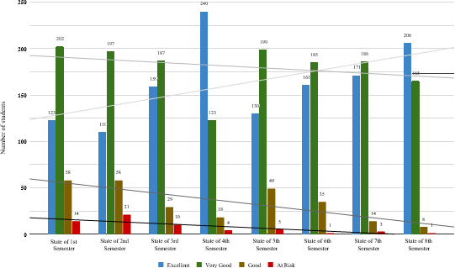

Figure 4-4: Analysis between states and semesters.

Figure 4-4 shows that the number of students who achieved ‘Excel- lent' status rapidly grew as the semester progressed. The number of pupils who achieved the other three states, on the other hand, has been steadily declining, with the trend line of ‘Good' declining faster than the other two.
We've also created a trend chart, which you can see in Figure 4-5, to compare this to the projected outcome.
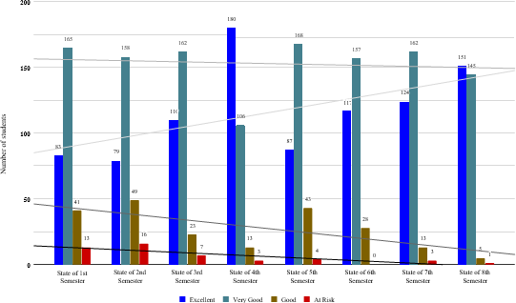

Figure 4-5: Analysis between states and semesters (with predicted data).
The analysis between states after each semester is shown in Figure 4-5, together with the obtained GPA for that semester and the expected outcome.
As a result of the aforementioned variables, we can decide that the majority of Bangladeshi business learners perform poorly in the beginning period. In contrast, the majority of students perform well during their graduation time.

Conclusion
In experimental phase, evaluated the classifications algorithms and regression to got a good result by predict the students’ performance to analysis the actual value and predicted value. In all these algorithms random forest outperforms from other models which is more than 94 percent accuracy. To maintain this pattern of algorithms and evaluate the method Bangladeshi business students can get a good result during their graduation period.

Chapter V: Conclusion

Introduction
The goal of this project was to use prediction and pattern recognition to help undergraduate business students enhance their performance. In the first phase of our research, we applying a generalized framework that can undeniably assist faculties or teachers to identifying and correctly guiding students at risk. In Bangladesh, we guided a research using business learners using our proposed framework, in which we used six classification algorithms to classify the students depending on the end outcome: GBT, RF, Tree Ensemble, Decision Tree, SVM, and KNN. Three evaluation criteria were used to assess the classification model's accomplishment: accuracy, precision, recall, specificity, f1-measure, and Cohen's kappa. With a 94.01 percent accuracy, the most effective output is produced by Random Forest, which rises above the other models.

Contribution of the Research
To improve the students’ performance through the prediction of students results or activities by data mining approach. We accomplished the introduction, problems statement, literature review explains of the algorithms, Evaluate the data sets, analyze the codes and algorithms of research this paper. We all partially done this work without code analysis and results part. We study the many of research papers before done this work and then we find out the problems and trying to solve the problems and we analyze how to increase our research work efficiency to getting the results easily. We selected the classification algorithms and metrics to sort out the problems through education data mining process. We measure the error of our research work done by MSE, MAE, MAPE. Finally, we got the efficient output of our research work.

Future Work
In a future study, we hope to present an improved framework that can be used to make predictions based on this type of data. Moreover, for an in-depth analysis students’ performance, we will include additional factors like environment, study behavior, study schedule, family assistance and disqualification.

Conclusion
Finally, in the second phase, we proposed using a DNN model with a lower error ratio than traditional models to predict the final CGPA of undergraduate business learners. We chose the hidden layers, neurons, optimization, and hyper-parameters in DNN architecture through human search and practical judgment. Three evaluation measures, MSE, MAE and MAPE were utilized to evaluate the effectiveness of the DNN model. To examine the training and validation losses, we used MAE as the loss metric. In the test phase, our suggested model generated highly positive results, such as 0.008 for MSE, 0.066 for MAE, and 2.050 for MAPE. Furthermore, when compared to the baseline decision tree model, our suggested approach reduced MSE, MAE, and MAPE errors by 0.0146, 0.0441, and 6.066, respectively. The bulk of projected points are very close to true values, and the suggested model's performance has shown compatible knowledge from results data as well as undertaking prognostic performance.
Furthermore, this study found that the course "Computer in Business" has the greatest impact on business students' final outcomes, and that professors should devote more time to this subject.

References

- Pea-Ayala, A. (2014). Educational data mining: A survey and a data mining-based analysis of recent works. Expert systems with applications, 41(4), 1432-1462.
- David, J. (2007). Hand. Principles of data mining. Drug safety, 30(7), 621-622.

- Sukhija, K., Jindal, M., & Aggarwal, N. (2016). Educational data mining towards knowledge engineering: a review state. International Journal of Management in Education, 10(1), 65-76.
- Phyu, T.N., 2009, March. Survey of classification techniques in data mining. In Proceedings of the International MultiConference of Engineers and Computer Scientists (Vol. 1, pp. 18-20).
- Al-Barrak, M.A. and Al-Razgan, M., 2016. Predicting students fifinal GPA using decision trees: A case study. International Journal of Information and Education Technology, 6(7), p.528.
- Daud, A., Aljohani, N.R., Abbasi, R.A., Lytras, M.D., Abbas, F. and Alowibdi, J.S., 2017, April. Predicting student performance using advanced learning analytics. In Proceedings of the 26th International Conference on World Wide Web Companion (pp. 415- 421) . International World Wide Web Conferences Steering Committee.
- Iyanda, A.R., Ninan, O.D., Ajayi, A.O. and Anyabolu, O.G., 2018. Predicting Student Academic Performance in Computer Science Courses: A Comparison of Neural Network Models.
- R. Rifat, A. A. Imran, and Badrudduza, 2019. EduNet: A Deep Neural Network Approach for Predicting CGPA of Undergraduate Students.
- Mueen, A., Zafar, B. and Manzoor, U., 2016. Modeling and Predicting Students’ Academic Performance Using Data Mining Techniques. International Journal of Modern Education and Computer Science, 8(11), p.36.

- Chaudhury, P. and Tripathy, H.K., 2017. An empirical study on attribute selection of student performance prediction model. International Journal of Learning Technology, 12(3), pp.241-252.
- Sumitha, R., Vinothkumar, E.S. and Scholar, P., 2016. Prediction of Students Outcome Using Data Mining Techniques. International Journal of Scientifific Engineering and Applied Science (IJSEAS), 2(6), p.8.
- Adejo, O. and Connolly, T., 2017. An Integrated System Framework for Predicting Students’ Academic Performance in Higher Educational Institution. International Journal of Computer Science and Information Technology (IJCSIT), 9(3), pp.149-157.
- Iyanda, A.R., Ninan, O.D., Ajayi, A.O. and Anyabolu, O.G., 2018. Predicting Student Academic Performance in Computer Science Courses: A Comparison of Neural Network Models.
- Oza, N.C. and Russell, S., 2001. Online ensemble learning. University of California, Berkeley.
- Kostopoulos, G., Kotsiantis, S., Pierrakeas, C., Koutsonikos, G. and Gravvanis, G.A., 2018. Forecasting students’ success in an open university. International Journal of Learning Technology, 13(1), pp.26-43.
- Department of Marketing, http://dept.ru.ac.bd/marketing/index.php /programs/bba (Accessed 05 February 2019).
- Zheng, A., & Casari, A. (2018). Feature Engineering for Machine Learning: Principles
and Techniques for Data Scientists. ” O’Reilly Media, Inc.”.

- Marko. Mooi Sarstedt (Erik.). (2018). Concise Guide To Market Research: The Process, Data, And Methods Using Ibm Spss Statistics. Springer-verlag Berlin An.
- Pedregosa, F., Varoquaux, G., Gramfort, A., Michel, V., Thirion, B., Grisel, O., & Vanderplas, J. (2011). Scikit-learn: Machine learning in Python. Journal of machine learning research, 12(Oct), 2825-2830.
- Quinlan, J.R., 1986. Induction of decision trees. Machine learning, 1(1), pp.81-106.

- Breiman, L., 2001. Random forests. Machine learning, 45(1), pp.5-32. formation and knowledge management (pp. 2061-2064). ACM. 44
- Cristianini, N. and Shawe-Taylor, J., 2000. An introduction to support vector machines and other kernelbased learning methods. Cambridge university press.

- Dietterich, T.G., 2000, June. Ensemble methods in machine learning. In International workshop on multiple classififier systems (pp. 1-15). Springer, Berlin, Heidelberg.
- Ye, J., Chow, J.H., Chen, J. and Zheng, Z., 2009, November. Stochastic gradient boosted distributed decision trees. In Proceedings of the 18th ACM conference on In
- Cover, T. and Hart, P., 1967. Nearest neighbor pattern classifification. IEEE transactions on information theory, 13(1), pp
- Heaton, J. (2008). Introduction to neural networks with Java. Heaton Research, Inc.

- Moolayil, J. (2019). Learn Keras for Deep Neural Networks. Apress. https://doi.org/10.1007/978-1-4842-4240-7
- Hahnloser, R. H. R., Sarpeshkar, R., Mahowald, M. A., Douglas, R. J., & Seung, H. S. (2000). Erratum: Digital selection and analogue amplifification coexist in a cortex-inspired silicon circuit. Nature, 405(6789), 947951. https://doi.org/10.1038/35016072

- Kingma, D. P., & Ba, J. (2014). Adam: A method for stochastic optimization. arXiv preprint arXiv:1412.6980.

Appendix A

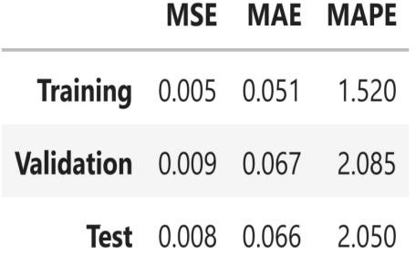

Figure-1: Performance of proposed model

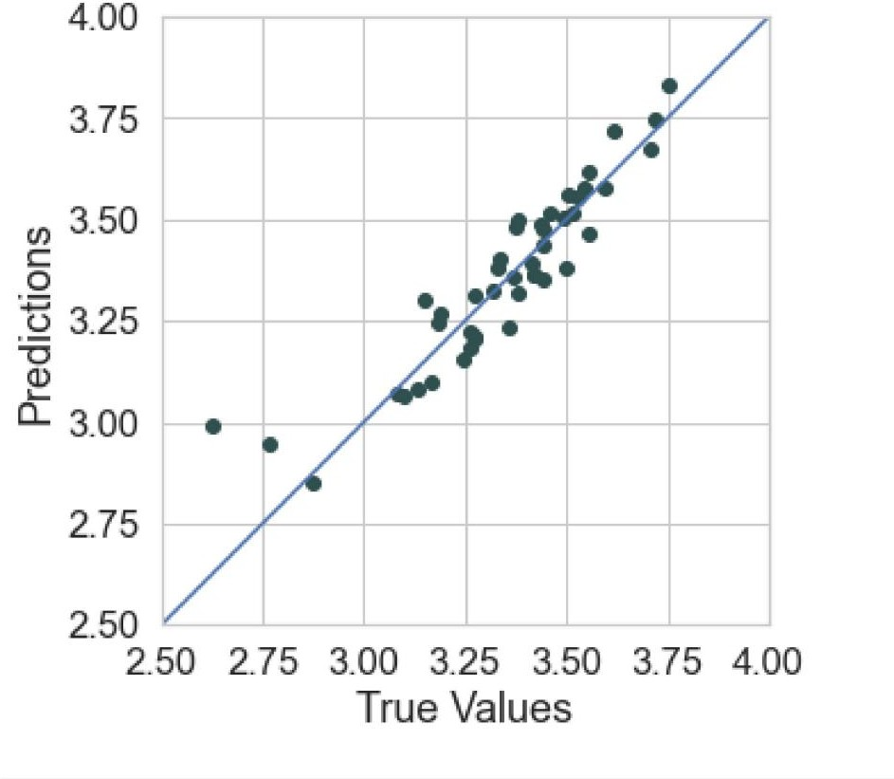
Figure-2: Actual Vs Predicted values

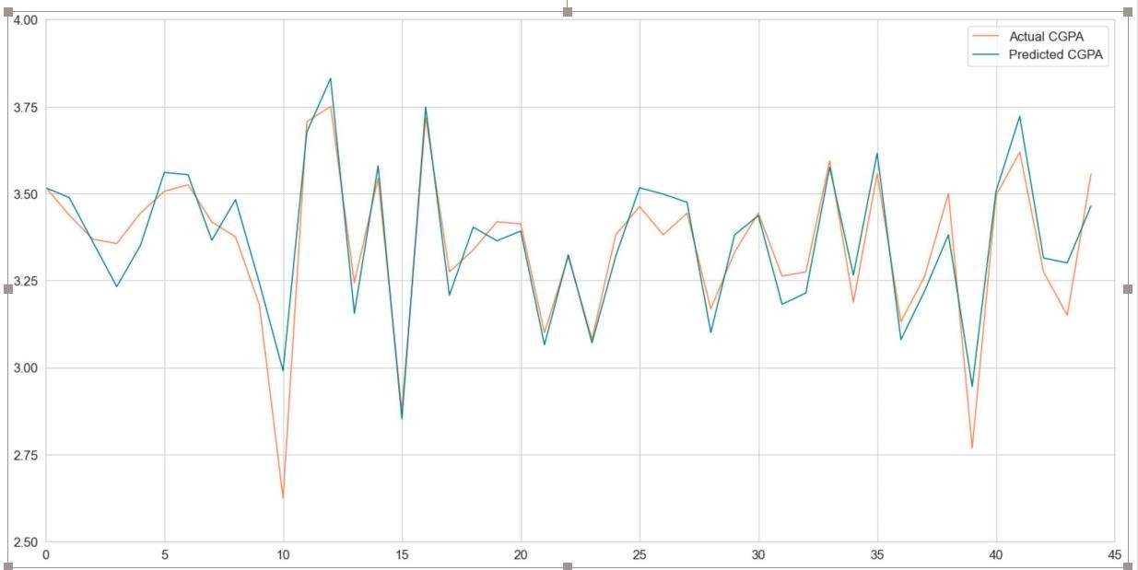

Figure-3: Graph of Actual Vs Predicted CGPA

Appendix B

