Project Report

On

General Banking Activities of South Bangla Agriculture & Commerce Bank (SBAC) Ltd.

Submitted to

Dr. Mohammad A. Ashraf

Associate Professor

School of Business and Economics

United International University

Submitted by

Tawhida Akhter

ID- 111 132 218

Major in Finance

School of Business

United International University

Date of Submission: May 1st 2018


Letter of Transmittal

1st May 2018

Dr. Mohammad A. Ashraf

Associate Professor

School of Business and Economics s

United International University

Subject: Submission of Project Report on “General Banking Activities of South Bangla Agriculture & Commerce Bank (SBAC) Ltd”.

Dear Sir,

I am very pleased to submit the report on “General Banking Activities of South Bangla Agriculture & Commerce Bank (SBAC) Ltd. I am prepared and submit this report on the fulfillment of the course of Project. I am doing at my best level to prepare this project.

I will be obligate if you kindly accept this report.

Sincerely Yours,

-------------------------

Tawhida Akhter

ii

Declaration

I hereby declare that the report entitled “Report on General Banking Activities of South Bangla Agriculture & Commerce Bank (SBAC) Ltd” is submitted as the partial fulfillment of the degree of Business Administration of United International University.

……………………

Tawhida Akhter

ID No.: 111- 132-218

Program: BBA

United International University (UIU)

Acknowledgement

As per decision of the course coordinator Dr. Mohammad A. Ashraf, I have prepared a Project

Paper on “General Banking Activities of South Bangla Agriculture & Commerce Bank (SBAC) Ltd”. It is a first attempt for making this paper for this course. A report that is contains a lot of information. When prepare a report the all data and information is collected by much kind one is to depend upon many people and other information.

First of all I would like to thanks almighty Allah to let me complete this report. I also would like to thanks those people whose help and support help me to complete this report. I have word really heard and doing my best for this report. I am very thankful to my honorable teacher Dr. Mohammad A. Ashraf who helps me in every step of starting and completing my report,

I also pay my indebtedness to those websites that helped me by providing a lot of information. Without these help & support I could not be able to complete this report successful

Table of Contents

1. | Introduction: ........................................................................................................................ |  | 2
 | 1.1 | Background of the study: ................................................................................................... | 3
 | 1.2 | Objective of the Study: ...................................................................................................... | 3
 | 1.3 | Methodology of the Study ................................................................................................. | 3
 | 1.4 | Scope of the Study: ........................................................................................................... | 4
 | 1.5 | Limitations of the Study: ................................................................................................... | 4
2. | About SBAC Bank Ltd. ....................................................................................................... |  | 6
 | 2.1 History OF SBAC BANK Ltd. .......................................................................................... |  | 6
 | 2.2 PRODUCT AND SERVICES ........................................................................................... |  | 7
 | 2.3 | Organizational Structure of SBAC Bank: ........................................................................ | 16
3. Theoretical aspects of General Banking Activities ............................................................. |  |  | 18
 | 3.1 | Banking:.......................................................................................................................... | 18
 | 3.2 | General Banking: ............................................................................................................ | 18
 | 3.3 | Bank Account: ................................................................................................................ | 18
 | 3.4 | Remittance: ..................................................................................................................... | 19
 | 3.5 | Clearing: ......................................................................................................................... | 19
 | 3.6. Mail transfer/ Telegraphic transfer:................................................................................. |  | 19
 | 3.7. Credit: ............................................................................................................................ |  | 19
 | 3.8. Loans and Advance: ....................................................................................................... |  | 20
 | 3.9. Consumer credit: ............................................................................................................ |  | 20
 | 3.10. Cheque: ........................................................................................................................ |  | 20
 | 3.11. Pay Order (PO):............................................................................................................ |  | 20
 | 3.12. Short Term Deposit: ..................................................................................................... |  | 21
4. | General Banking Department:............................................................................................ |  | 23

iv

4.1. |  | Functions of General Banking: ...................................................................................... | 23
4.2. |  | Sections of General Banking: ........................................................................................ | 23
5. | Analysis ............................................................................................................................. |  | 40
6. | Financial Analysis: ............................................................................................................ |  | 42
7. | Findings and suggestions ................................................................................................... |  | 57
8. | Recommendation ............................................................................................................... |  | 59
9. | Conclusion ......................................................................................................................... |  | 60
10. | References ....................................................................................................................... |  | 61

v

Executive Summary

The Project is the linking between the theoretical knowledge and real life experience. This aim is providing with an overview on the General Banking Activities of South Bangla Agriculture & Commerce Bank Limited. The objective of the report is to know about the general banking activities of South Bangla Agriculture & Commerce Bank Ltd (SBAC). For collecting, the information related with the topic used secondary data. That`s why this report is prepared by segmenting into different parts. First part shows the origin, background, scope, objective, methodology and limitations of study. Second part the overall overview of South Bangla Agriculture & Commerce Bank Ltd. (SBAC) with its vision, mission, objectives and financial performance in the company overview part. Third part is about the theoretical knowledge about general banking system in the perspective of Bangladesh. The next part is the about the overall procedure of general banking of SBAC Bank and comparison of financial performance between City bank and SBAC bank, with the segment of different department & product. After that, I state some major findings and recommendations base on the findings & analysis of the report. Next part is the conclusion of the report. At the end I included all the source of data and the list of journal, website by which this report completed successfully.

vi



CHAPTER-01


INTRODUCTION


1

- INTRODUCTION:

Bank they divert and employ the funds in such avenues, which are aimed to develop a country’s economy and add to South Bangla Agriculture & Commerce wealth. Banks offer necessary finance to set up, run the industries, and provide finance to agriculture and other sectors, which can create opportunities for the development of South Bangla Agriculture & Commerce resources and provide employment on a large scale

2

1.1 BACKGROUND OF THE STUDY:

Then government decides to reform the financial sector and commercial banks now a day have proved themselves as the life blood of modern economy in Bangladesh. No business, trade, exports, imports. Production, all other economic activities can run without the aid of banking. So understanding the above circumstances,

1.2 OBJECTIVE OF THE STUDY:

The main objective of this report is accommodating us with the actual market situation as the financial condition of multinational company. There are two objectives of this study:

General Objectives: Basically the general objective of the study is to fulfill the requirement of BBA program with the real life activities and gathering knowledge from these activities.

Specific Objectives:

- To review the different foreign exchange activities of SBAC Bank Ltd.

- Understanding financial performance of the SBAC Bank Ltd.

- Identifying some problem of the SBAC Ltd.

- To access the quality of financial statement.

- Knowledge of general banking activities of SBAC.

- To forecast the future financial statement.

- Gathering an idea about the banking sector in Bangladesh.

- To determine value of the firm.

1.2 METHODOLOGY OF THE STUDY

Study Design

For the purpose of this, study the data in nature. Data have been collected from source:

Secondary sources.

3

Data Collection.

Secondary sources of data:

- Annual report of South Bangla Agriculture & Commerce Bank Ltd (SBAC), 2016

- Different papers of South Bangla Agriculture & Commerce Bank Ltd (SBAC).

- Different manuals of South Bangla Agriculture & Commerce Bank Ltd (SBAC)

- Different circulars of South Bangla Agriculture & Commerce Bank Ltd (SBAC).

- Different textbooks.

1.4 SCOPE OF THE STUDY:

This report has been prepared through extensive discussion with bank employees and with the clients. While preparing this report, I had a great opportunity to have in depth knowledge of all the banking activities practiced by the South Bangla Agriculture & Commerce Bank limited.

1.5 LIMITATIONS OF THE STUDY:

It’s not possible for any report which has no limitation. Every study has some limitations. I am working the General banking Activities of SBAC Ltd. And I also found some limitations. Some limitations of this study are in the bellow:

- When I collect the data I face the difficulty in accessing data of its internal operations.

- There is not available of some preceding year’s statistical data.

- There is No manifestation of some basic information.

- Three months are not enough to cover such wide arena of foreign exchange activities of banking sector. This study is limited time and resource.

- I couldn’t found the information in a structured way.

- I have Lack of experience of writing project report.

- This bank can’t update Up-to-date information, so this information is not available.

- Sometimes they could not be able to supply my topic related data for preparing a more in depth research study.

- As the offices are busy with their daily work they could provide very little time.

- I have not any previous experience of writing this type of report based on Foreign exchange activities of sSBAC

- Sometime it was difficult to accommodate all the information from the big organization.

- The SBAC web page contains not enough information.

4

CHAPTER-02


ORGANIZATIONAL

PROFILE

5

- ABOUT SBAC BANK LTD.

2.1 HISTORY OF SBAC BANK LTD.

South Bangla Agriculture and Commerce (SBAC) Bank Ltd. is one of the newest bank in Bangladesh. It was started in 2013 and now it has a 6 branches in Bangladesh

A. VISION

Their vision is to build poverty free, pollution free, healthy Green Bangladesh through sustainable development by application of latest information technology. They want to be leading Private Commercial Bank in terms of efficiency, capital adequacy, asset quality, sound management and Profitability with strongly liquidity.

6

B. MISSION

The mission of SBAC Bank Ltd. Is-

  - To provide a customer friendly environment

  - To deliver service excellence for all of corporate, agro based SME and retail segments.

- OBJECTIVE

SBAC Bank believes in its uncompromising commitment to fulfill its customer needs and satisfaction and to become their first choice in banking. Taking cue from its pool esteemed Clientele, SBAC Bank also focuses on its tagline “LOCAL BANK GLOBAL VISION”.

2.2 PRODUCT AND SERVICES

A Deposit account

1 .CURRENT DEPOSIT:

Current Deposit Account is the net flow of current transaction with no restrictions, including services and interest payments. Types of Current Deposit Account:

- Individual, joint

- Proprietorship

- Partnership

- Club, Society, Trust, Autonomous Body Govt. Dep’t, Directors Etc.

7

Regular Deposit Product Rate:

Product Name | Interest Rate
Current Deposit | 0.00
Saving Deposit(General) | 5.00
Short Noticed Deposit(7 Days) | 5.00
Foreign Currency Accounts | 0.00

2. Savings deposit Accounts

A saving Bank account (SB account) is offered to promote the habit of saving among the people of their idol money. Types of Saving Deposit Account:

  - Individual

  - Joint

  - Club

  - Society

  - Others

- Monthly Savings Scheme

Monthly 500 tk. 1000 tk. 2000 tk. 2500 tk. 3000 tk. 4000 tk. 5000 tk.


Installment

 | 03 years | 21700 | 43400 | 86800 | 108500 | 130200 | 173600 | 217000
 | 05 years | 40950 | 81900 | 163800 | 204750 | 245700 | 327600 | 409500
 | 08 years | 79350 | 158700 | 317400 | 396750 | 476100 | 634800 | 793500
 | 10 years | 113050 | 226100 | 452200 | 565250 | 678300 | 904400 | 113050

Benefits to the Monthly Savings Scheme Accounts

- It can be operated from any branches of it.

- On maturity of accounts it will get so much interest and benfits

- Instruction will be provided free of cost

- Secure overdraft Loan facility is available against MSS account.

8

4. Monthly Benefit Scheme

Tenure | Monthly Benefit Per Lac Before Tax (in Tk.)
03 years | 667/- ( Deduction 10% with TIN & 15% without TIN )
05 years | 667/- ( Deduction 10% with TIN & 15% without TIN )

Benefits to the Monthly benefit scheme Accounts

  - Any branch provided the facility of scheme & profit withdrawn

  - Account Can be opened at any working day by depositing only Tk.100000/=or it’s multiple.

  - Against the deposit amount any one can get Higher profit

  - Secure overdraft Loan facility is available against MBS accounts.

- Short term Deposit Account

Short term Deposit account is the net flow of current transactions including services and interest payments .Types of short term Deposit account:

  - Public Limited Co.

  - Private Limited Co.

  - Govt./semi Govt./Autonomous/Corp

  - Societies/Clubs etc.

- FIXED DEPOSIT ACCOUNT:

9

Fixed Deposit Receipt Products (FDR): (TIN 10%, Without TIN 15%)

Product Name |  | Interest Rate
FDR – 1 Month | 5.00%
FDR – 3 Months | 7.00%
FDR – 6 Months |  | 7.00%
FDR – 12 Months | 7.00%

Benefits to the FDR Accounts

  - Money can grow with attractive interest rate and flexible tenure starting from 1 Month FDR.

  - FDR accounts can be opened with any amount.

  - Auto renewal or profit transfer on maturity instruction can be facilitated and no need to Come at branch frequently for such reason.

  - Secured Overdraft Loan facility is available against FDR accounts

- Special Benefit Scheme:

Product Name | Tenure | Initial Deposit
Double benefit scheme | 8 years 3 Months | Tk. 25000.00 or its multiple
Triple benefit scheme | 12 years 3 Months | Tk. 25000.00 or its multiple

Benefits to the DBS & TBS Accounts

- Attractive and higher profit for the DBS and TBS Scheme products.

- Account can be opened at any working day by depositing only Tk.10,000/or it’s multiple.

- Secured Overdraft Loan facility is available against DBS and TBS accounts.

10

8. TRUST SMART SAVERS SCHEME (TSS):

The name of the scheme is ‘Trust Smart Savers Scheme (TSS)’ and an Account holder subscribing to this scheme will be called TSS Account holder.

9. SBAC LAKHOPOTI SCHEME:

It is a benefit-rich Savings Scheme Account Product with Terminal Benefit of 1 Lac Taka for any resident citizen of Bangladesh. The period of maturity for these accounts will be 3 Years, 5 Years, 10 Years or 15 Years regarding the Monthly Deposited amount.

Tenure |  | Interest Rate | Monthly Installment
3 years | 9.00% |  | 2422
5 years | 9.00% |  | 1331
10 years | 9.00% |  | 528
15 years | 9.00% |  | 277

They also have some other special purpose deposit scheme like TRUST EDUCARE SCHEME,

Monthly Benefited Deposit Scheme beside these also has some other saving schemes under their banking service.

B. Retail banking product

Though SBAC Bank is a new comer in the banking sector so, till now it’s not providing all Retail services already other banks have launched, but there are trying to covering main services. All are listed below which are already offering and planning to offer very soon.
- House Hold Durable Loan scheme

- Doctor’s Loan

- Advance against Salary

- Education Loan

11

  - Travel Loan

  - Hospitalization Loan

  - Any Purpose Loan

  - CNG Conversion Loan

  - Marriage Loan

C. OTHER PRODUCTS

1. Credit Card service:

2. Debit Card service:

3. 24x7 service

12

5. Lease Finance:

D. AGRICULTURE BANKING

SBAC Bank has provided financial services to the agricultural sector of Bangladesh and is committed to the development of agriculture across the nation.

1 .Livestock Loans

2 .Agro Help Desk

13

3. Farmers Deposit

5 .Grower Loans:

14

15

2.3 ORGANIZATIONAL STRUCTURE OF SBAC BANK:

Chairperson (Owner)

↓

Vice Chairperson (Owner)

↓

Directors (Owners)

↓

Managing Director (MD)

↓

Deputy Managing Director (DMD)

↓

Executive Vice President (EVP)

↓

Senior Vice President (SVP)

↓

Vice President (VP)

↓

First Vice President (FVP)

↓

Assistant Vice President (AVP)

↓

First Assistant Vice President (FAVP)

↓

Senior Executive Officer (SEO)

↓

Executive Officer (EO)

↓

First Executive Officer (FEO)

↓

Senior Officer

↓

Officer

↓

Trainee Officer

Source: HRD, Head Office SBAC

16

CHAPTER-03


THEORETICAL

ASPECTS

17

3. THEORETICAL ASPECTS OF GENERAL BANKING ACTIVITIES

3.1 BANKING:

According to Random House kerneman Webster’s college dictionary ``Banking engaging in the

business of keeping money for savings and checking accounts or for exchange or for issuing

loans and credit etc.”.

3.2 GENERAL BANKING:

General banking is the storage point of all kinds of transaction of foreign exchange department, loans and advance department and itself.

3.3 BANK ACCOUNT:

An account held by an investor at a financial institution. For example, a bank account where a credit is maintained

3.4 REMITTANCE:

The process of sending money to remove an obligation .

3.5 CLEARING:

Outward Clearing

Inward Clearing

3.6. MAIL TRANSFER/ TELEGRAPHIC TRANSFER:

These transfers are used most commonly in reference to CHAPS, Clearing House Automated Payment System, transfers in the U.K. banking system.

3.7. CREDIT:

3.8. LOANS AND ADVANCE:

3.9. CONSUMER CREDIT:

3.10. CHEQUE:

3.11. PAY ORDER (PO):

20

3.12. SHORT TERM DEPOSIT:

21

CHAPTER-04


General Banking

Activities of SBAC Bank

22

- GENERAL BANKING DEPARTMENT:

General banking is the heart of all business banking activities. It is the storage point of all kinds of transaction of foreign exchange department, loans and advance department and itself.

4.1. FUNCTIONS OF GENERAL BANKING:

4.2. SECTIONS OF GENERAL BANKING:

General banking department generally deals with the following sections:

23

- Account opening section

- Clearing Section

- Cash Section

- Accounts Section

- Remittance Section

- Mail receives and dispatch section

Account Opening Section:

The relationship between customer and banker begins with opening of an account by the customer.

Opening an account binds banker and customer into contractual relationship.

A. Current Deposit (CD)

- Savings Deposit (SB)

- Fixed Deposit (FDR)

- Short Term Deposit (STD)

- Monthly Saving Scheme (MSS)

Account Opening Section of SBAC Dhanmondi Branch:

A. Current Account Opening:

24

For a person:

There is an individual application from for opening personal current account. The person, who wants to open this type of a/c, is said to fulfill the following requirements:
Name, father’s/husband’s name
Occupation

  - Introducer of A/C holder.

  - Two copies of passport size photographs

- Initial deposit of Tk. 1000.

For Joint stock companies, Association, Clubs etc:

25

- Certificate list containing names and signature of Directors/Officer bearers.

For Partnership/Proprietorship Company:

To open a current a/c on the name of any partnership or proprietorship company, the following documents are required:

- Filled up application from stating about the name and address of the firm.

- Partnership deed.

- Trade license.

- Two copies of photograph.

- Endorsement of an a/c holder on the same branch.

- Undertaking / declaration about the partnership is taken by the bank in a write paper (for proprietorship firm)

For public and private limited company:
.

B. Saving Account Opening:

A saving is meant for the person of the lower and middle classes who wishes to save a part of their income to meet their future needs and intend to earn an income from their saving. All the features are like CD a/c as no restriction imposed by the bank.

26

- Fixed Deposit Accounts:

Opening of FDR:

27

C. Short Term Deposit:

Special notice account that is commonly known as short-term deposit a/c will keep in the short-term ledger. The customer should dully sign a/c opening form and specimen signature card.

Entries Passed:

A deposit shall be prepared crediting the STD a/c with the amount of deposit.

Cash—————-Dr

STD a/c —————-Cr

If the amount is deposited by the check or transfer a/c, the following entries shall be passed.

Party C/D, S/D a/c————–Dr

STD a/c———————————–Cr

The account opening shall be pasted in the pasting file in numerical order.

The credit voucher shall be passed in the STD a/c of the party.

In case of letter of attorney to debit the STD a/c of the customer voucher will be prepared and the following entries shall be passed:

28

STD a/c (party) —————-Dr

C/D (party) —————————Cr

Minimum seven days’ notice in required for withdrawal of any sum from STD a/c Banker is not legally liable to the customer, if the check is dishonored under the following conditions, although the check is properly drawn:


Monthly | 500tk | 1000tk | 2000tk | 2500tk | 3000tk | 4000tk | 5000tk
Inst.
Term



- 20,615.00 41,230.00 82,460.00103,075.00 123,690.00 164,920.00 206,150.00

- 37,575.00 75,150.00 150,300.00187,875.00 225,450.00 300,600.00 375,750.00

Years

- 68,955.00 137,910.00 275,820.00344,775.00 413,730.00 551,640.00689,550.00

Years 

- 94,625.00 189,250.00 378,500.00473,125.00 567,750.00 757,000.00946,250.00

Years

29

Requirements for opening Savings Scheme Account:

  - Letter of introduction:

- Declaration of nominee:

.

- Specimen signature:

30

- Initial deposits:

- Operating Instruction/Mandate in writing:

If any party wants his a/c to be operated by somebody else, he will provide the banker in writing statement about the operator.

- Verification of documents:

.

31

- When the paying bank is one of their own branch

32

After a whole day’s transaction, the surplus money remaining in the cash counter is put back in the vault and known as the closing balance. Money is received and paid in this section.

A. Cash Receipt:

  - .

- Cash payment:

33

34

Remittance Section:

Inland remittance

When one bank sends these T.T, M.T, T.C or cheque to another bank then it will be called inland remittance.

Foreign remittance

When a bank got this T.T, M.T, T.C and cheque from outside bank, which is not situated in the home country than it, will be called foreign remittance.

There are three ways of transferring fund domestically. The modes of transferring funds are:

- Pay- Order (PO).

- Demand Draft (DD).

- Telegraphic Transfer (TT).

Mail Receive and Dispatch Section:

- A. Mail receiving:

- All mail comes to the bank recorded in this desk. For this reason a register book maintained called inward mail register. A number is given on receiving mail and records particulars of document in the register book.

35

- B. Mail Dispatching:

- .

Other Activities of General Banking in SBAC

A. Pay in slip, Checkbook and Passbook:

B. Closing of an account:

36

C. Pay Order (PO):

Entries for PO:

Clients A/c———————————–Dr

Pay order—————————————————–Cr

Income A/c commission on remittance————Cr

D. Refund of Pay Order:

The following procedure should be followed for refund of pay order by cancellation:

- The original entries are to be reversed with proper narration.

- Cancellation of the pay order should also be recorded in the pay order register.

37

E. Mail Receive and Dispatch

SBAC records all mails received and dispatched through the bank.

38

CHAPTER-04


39

- ANALYSIS

In this part I am going to analyze SBAC Bank Ltd.’s different parts comparing with a smart bank like CITY Bank Ltd. Here I want to show how its look like comparing with City Bank Ltd., what is the present position in the banking sector, how much they had faced entered into the competitive market.

SWOT Analysis

SWOT analysis is a tool that identifies the strengths, weakness, opportunities and threats of an organization. The method of SWOT analysis is to take information from the environmental analysis and separate it into internal (strengths &weakness) and external issues (opportunities & threats). Among them strengths & opportunities are the positive side for an organization and weakness & threats are the negative things.

- 

Strengths  
- Provide high level customer service.  

- Highest interest rate for FDR.  
- Offering unique products in agriculture sector.  
- Cut lowest service charge.  
- Using Flora Banking Solution software.  
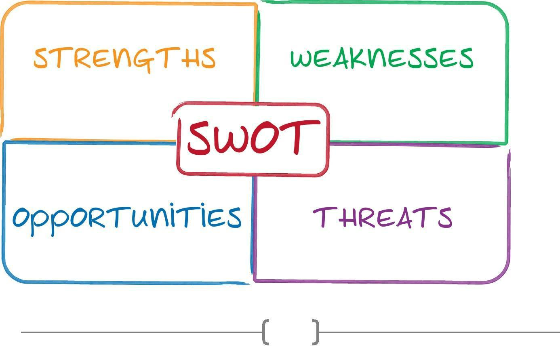

40

❖ Weakness  
 
✓ It is a new bank and it has new employees
 
 
✓ Work Process slow
 
✓ No training.  
 
✓ Low amount of branches.  
 
✓ Lower ATM booth.  
 
- Opportunities  
 
Using online service.  
 
  - Involve with the core economic activities like agriculture and related

 

diversification to ensure quality service.  

- Threats  
 
  - Banking sector is highly competitive at present.  
 

  - Growth of profitability is very slow because of less different between interest getting and giving.  

41

- FINANCIAL ANALYSIS:

Financial performance comparison between SBAC & City Bank Ltd. stated for the year of 2016 and 2017. Though South Bangla Agriculture & Commerce Bank Limited is the 3rd generation
bank it continually run with its slogan “Local Bank Global Vision”. As a compared bank like

City Bank Limited which is the 2nd generation bank, started their journey since long time

Financial Performance

Assets Growth:
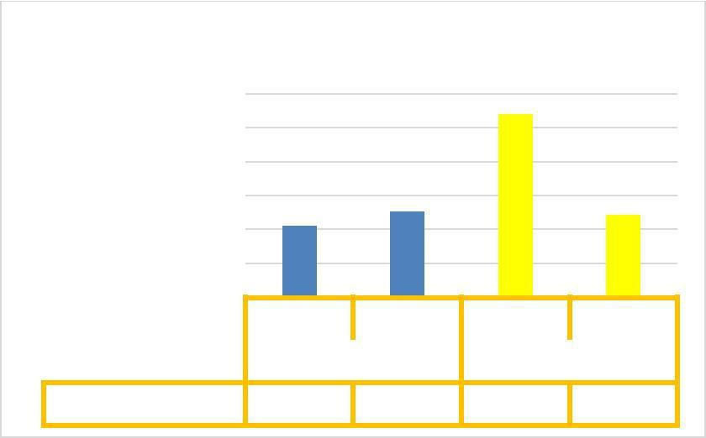

Assets Growth

60.00%

50.00%
40.00%
30.00%

20.00%
10.00%
0.00%
2016 2017 2016 2017

City Bank SBAC Bank

Assets Growth 21.04% 25.26% 53.92% 24.29%

Graph- 1: Assets Growth

Asset growth ratio represents the percentage changes in total assets between years. Here we can see that in 2016 city bank had 21.04% and in 2017 it was 25.56% which is good. But SBAC bank in 2016 was 53.92% and in 2017 it was jumped into 24.29% which indicates there was problem with asset growth.

42

Loans Growth:

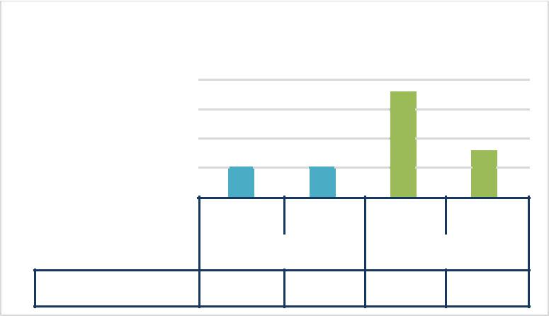
Loans Growth

80.00%

60.00%

40.00%

20.00%

0.00%
2016 | 2017 | 2016 | 2017
City Bank |  | SBAC Bank

Loans Growth 22.77% 22.95% 71.09% 30.46%

Graph- 2: Loans Growth

Loan Growth rates represents the organizations liquidity power and it represents in percentage. It calculated through loan and lease amount. We can see that city bank had good loan growth rate in 2016 and 2017 respectively. But SBAC had very bad growth rate

Equity Growth:
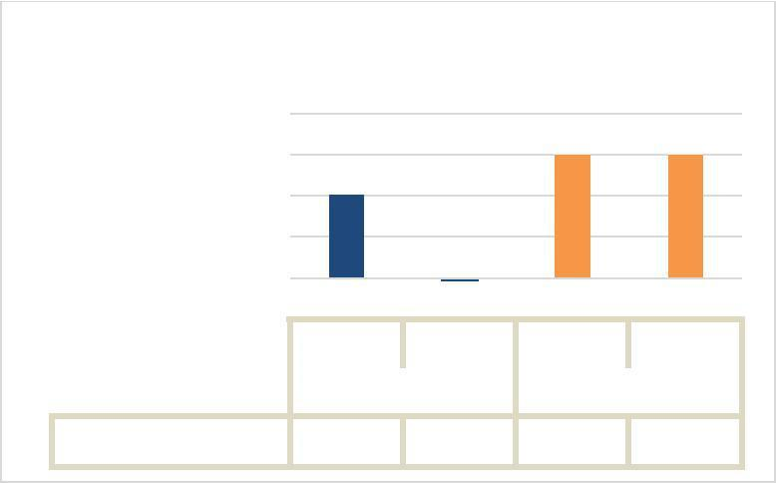

Equity Growth

20.00%

15.00%

10.00%

5.00%

0.00%
-5.00%
2016 2017 2016 2017

City Bank SBAC Bank

Equity Growth 10.19% -0.31% 15.03% 15.08%

Graph- 3: Equity Growth

Equity growth rate represents the growth of organization in percentage. And it also represents the owners ability. We can see that SBAC had a good rate on equity growth.

43

Earnings Growth:
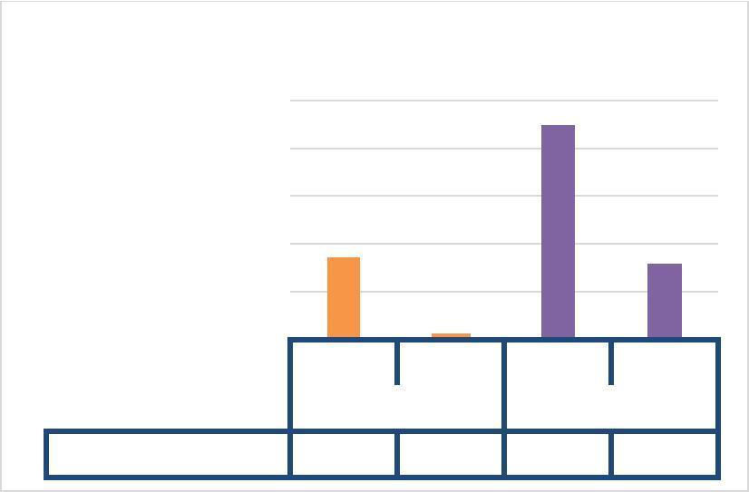

Earnings Growth

500.00%

400.00%

300.00%

200.00%

100.00%

0.00%
2016 2017 2016 2017

City Bank SBAC Bank

Earnings Growth 172.28% 13.07% 450.00%158.86%

Graph- 4: Earnings Growth

Earning growth rate represents percentage of net earnings not paid out dividend, but retained earnings reinvest its earnings. City bank’s has increased their earnings at 13.07% rate in 2017 from year 2016. SBAC bank has increased at 158.86% rate in 2017. But both banks has highly increased rate in 2016 which means both has highly profited that year.

44

Deposits Growth:
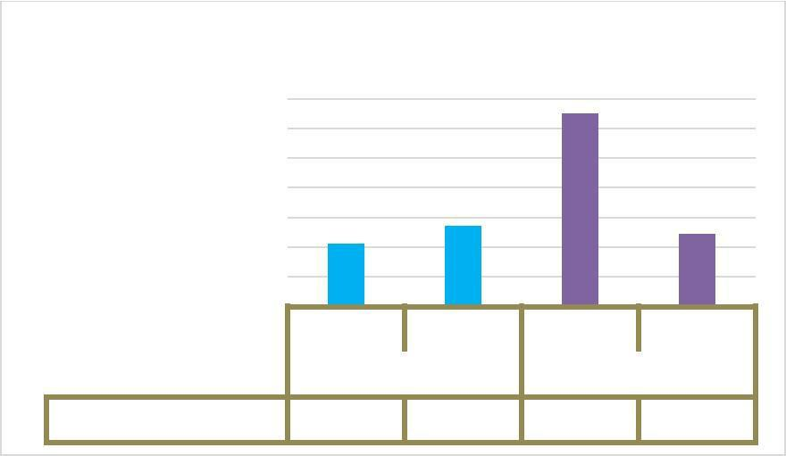

Deposits Growth

70.00%
60.00%
50.00%
40.00%
30.00%
20.00%
10.00%
0.00% | 2017 | 2016 | 2017
2016 | 2017 | 2016 | 2017
City Bank |  | SBAC Bank
Deposits Growth 21.11% | 27.46% | 65.09% 24.57%

Graph- 5: Deposits Growth
. And we can see that SBAC bank’s deposits growth performance is not look like efficient cause they performed 65.09% in 2016 which was dropped down at 24.57% in 2017 because the fixed deposit was the main component of deposits contributing 73.53 percent of the total deposits. Interest cost of deposits decreased to 6.34 percent as against 7.75 percent of the previous year as a result of decrease in rates of high cost term deposits fueled by the liquidity position in the market. For details view of both banks deposit position is given below:

45

City Bank's Deposit Position:

City Bank's Deposit Position | amount in million

120000

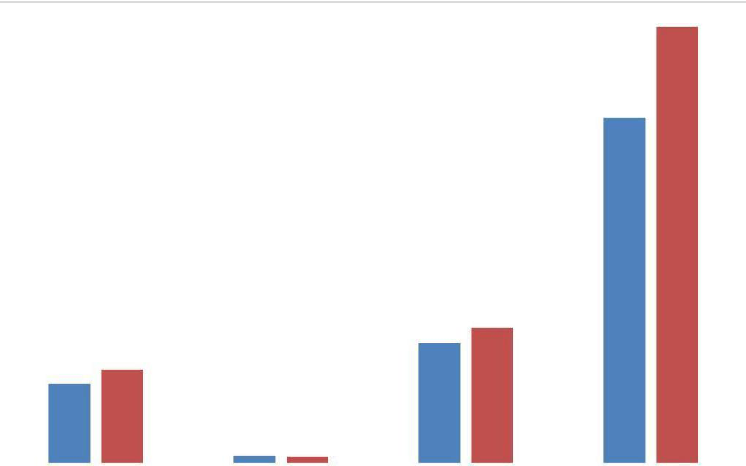

100000
80000
60000
40000
20000
0
 |  |  |  | Current Deposit | Bills Payable | Savings Bank | Fixed Deposit
 |  |  |  | Current Deposit | Bills Payable | Deposit | Fixed Deposit
 |  |  |  | 20572.16 | 1976.45 | 31213.31 | 89966.81
 |  |  | 2016
 |  |  |  | 24384.17 | 1587.15 | 34994.25 | 113451.96
 |  |  | 2017

Graph- 6: City Bank’s Deposit Position

46

SBAC Bank's Deposit Position:

 |  |  |  | SBAC Bank's Deposit Position |  |  |  |  |  | amount in million
30000.00
25000.00
20000.00
15000.00
10000.00
5000.00
0.00
 |  |  |  | Current | Special | Bills | Savings |  | Fixed |  |  |  | Scheme
 |  |  |  | Current | Notice | Bills | Bank |  |  |  |  |  | Scheme
 |  |  |  | Deposit | Notice | Payable | Bank |  | Deposit |  |  |  | Deposit
 |  |  |  | Deposit | Deposit | Payable | Deposit |  |  |  |  |  | Deposit
 |  |  | 2016 | 2162.90 | 2879.37 | 272.05 | 0 | 22626.11 |  |  |  |  | 1997.26
 |  |  | 2017 | 3034.00 | 1673.24 | 1255.47 | 1284.22 | 28190.00 |  |  |  |  | 2900.27
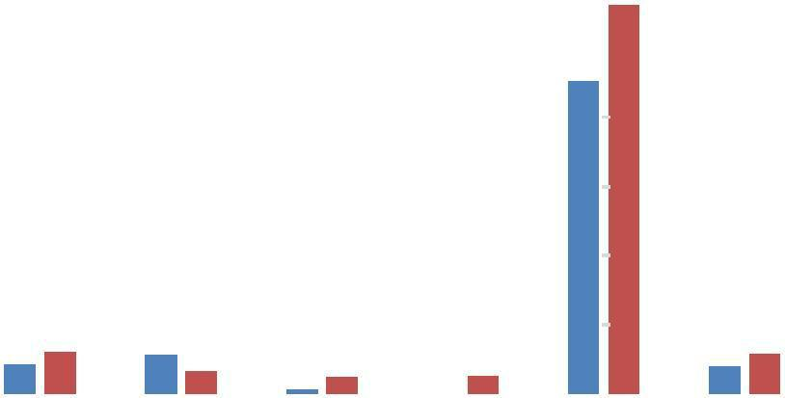

Graph- 7: SBAC Bank’s Deposit Position

SBAC bank has an advantage of having to extra kinds of deposits like “Special Notice Deposit & Scheme Deposit” than the City bank.

Net Interest Income Growth:
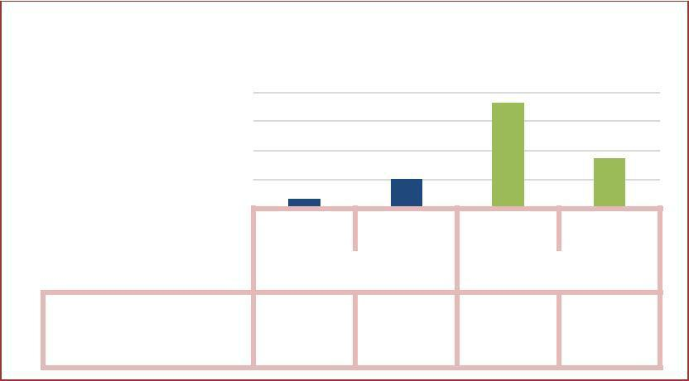

Net Interest Income Growth

80.00%
60.00%
40.00%
20.00%
0.00% | 2017 | 2016 | 2017
2016 | 2017 | 2016 | 2017
City Bank |  | SBAC Bank
Net Interest
Income Growth 6.86% | 20.46% | 72.59% 34.35%

Graph- 8: Net Interest Income Growth

47


Net interest income shows the difference between net income and interest. It was increased at 20.46% in 2017 means their income from interest was so good than previous year but SBAC bank’s interest income was 34.35% in 2017 means growth of net interest income was lower than the 2016 rate 72.59% because their interest earning assets became lower in 2017. SBAC bank’s net interest income increased due to increase in interest earning assets and decrease in interest expense on deposits.

Net Investment Income Growth:
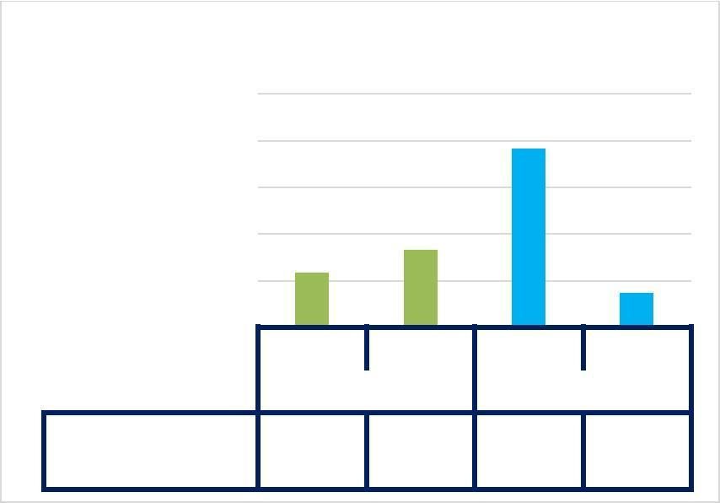

Net Investment Income Growth

250.00%

200.00%

150.00%

100.00%

50.00%

0.00%

2016 2017

City Bank
2016 2017

SBAC Bank

Investment

Income Growth 58.31% 83.22% 191.79% 37.26%

Graph- 9: Net Investment Income Growth

If we compare with City bank with SBAC bank we see, SBAC bank was in the worst position than the City bank. Investment income growth stood for city bank at 83.22% and SBAC bank has 37.26% in 2017. SBAC bank’s net investment income increased due to increase in investment in Government securities and capital gain on sale of shares of listed companies.

48

Operating Income Growth:
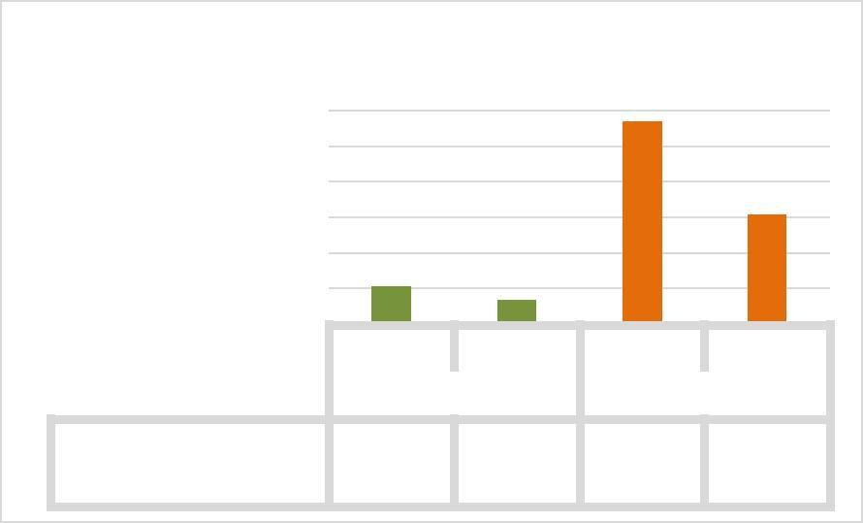

Operating Income Growth

120.00%
100.00%
80.00%
60.00%
40.00%
20.00%
0.00% | 2017 | 2016 | 2017
2016 | 2017 | 2016 | 2017
City Bank |  | SBAC Bank

Operating Income 21.64% 13.77% 114.11% 61.74%

Growth

Graph- 10: Operating Income Growth

Operating income measures the operating ability of organization. In comparison we see that the income from operation of city bank correspondingly in year 2016 and 2017 was 21.64% & 13.74% and the growth of SBAC bank was 114.11% & 61.74% in respective year’s means SBAC was in a good position. SBAC bank operating income increased due to increase in interest investment, operating and other non-interest income.

Net Operating Cash flow per share (NOCF):
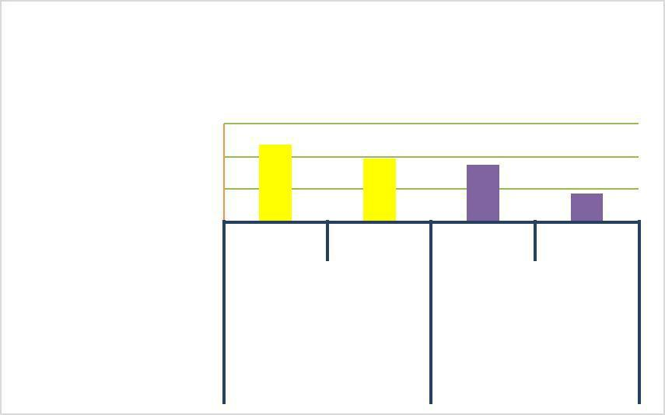

Net Operating Cash flow per share
(NOCF)
amount in TK.

15.00
10.00
5.00
0.00 | 2017 | 2016 | 2017
2016 | 2017 | 2016 | 2017
City Bank |  | SBAC Bank
Net Operating
Cash flow per 11.79 | 9.76 | 8.73 | 4.39
share (NOCF)

Graph- 11: Net Operating Cash Flow per Share

Cash flow per share is the after-tax earnings plus depreciation on a per-share basis that functions as a measure of a firm's financial strength. The NOCF of the City bank is better than the SBAC

49

bank. In 2016 City bank had 11.79 taka and in 2017 had 9.76 taka whereas SBAC bank had 8.73 and 4.39 taka in the respective years.

Operating Profit Margin:
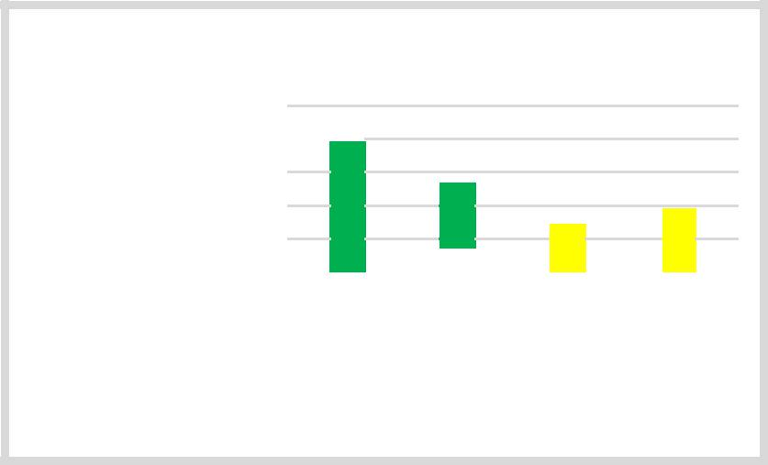

Operating Profit Margin

100.0%
80.0%
60.0%
40.0%
20.0%

0.0%
0.0% | 2016 |  |  | 2017 |  |  | 2016 |  |  | 2017
 |  | City Bank |  |  |  |  |  | SBAC Bank
Operating Profit | 85.9% |  |  | 52.25% |  |  | 28.17% |  |  | 39.54%
Margin

Graph- 12: Operating Profit Margin

SBAC bank’s operating profit margin was in increased from 2016 to 2017 at 28.17% to 39.54% where City bank’s rate was fall from 85.9% to 52.25%. The fall in operating profit margin refers they could not satisfy their creditors and could not create that much value for the shareholders by generating operating cash flow.

Net Profit Margin:


Net Profit Margin

30.00%
20.00%
10.00%
0.00%
0.00% | 2016 |  |  | 2017 |  |  | 2016 |  |  | 2017
 |  | City Bank |  |  |  |  |  | SBAC Bank
Net Profit | 23.60% |  |  | 27.29% |  |  | 12.51% |  |  | 24.70%
Margin

Graph- 13: Net Profit Margin
Here both banks net profit margin was good but City bank’s rate is steadily increased and SBAC bank’s rate is almost double from the previous year

50

rate was 12.51% to 24.70%. It means SBAC bank was pricing its products correctly and was exercising good cost control.

Cash Reserve Ratio:
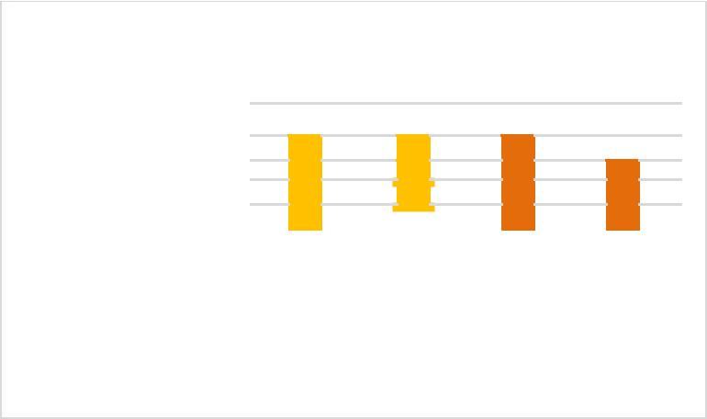

Cash Reserve Ratio

10%
8%
6%
4%
2%

0%
0% | 2016 |  |  | 2017 |  |  | 2016 |  |  | 2017
 |  | City Bank |  |  |  |  |  | SBAC Bank
Cash Reserve | 8% |  |  | 7.70% |  |  | 7.67% |  |  | 6.59%
Ratio

Graph- 14: Cash Reserve Ratio

. But City bank was in the good position than SBAC bank.

Capital Adequacy Ratio:


Capital Adequacy Ratio

25%
20%
15%
10%
5%

0%
0% | 2016 |  |  | 2017 |  |  | 2016 |  |  | 2017
 |  | City Bank |  |  |  |  |  | SBAC Bank
Capital Adequacy | 14% |  |  | 13.60% |  |  | 21.19% |  |  | 18.59%
Ratio

Graph- 15: Capital Adequacy Ratio

. If we compare two banks, we see SBAC bank

51

maintained higher capital adequacy ratio over the years than the City bank, that means SBAC bank gave high protection of their depositor’s money.

Cost of Fund:
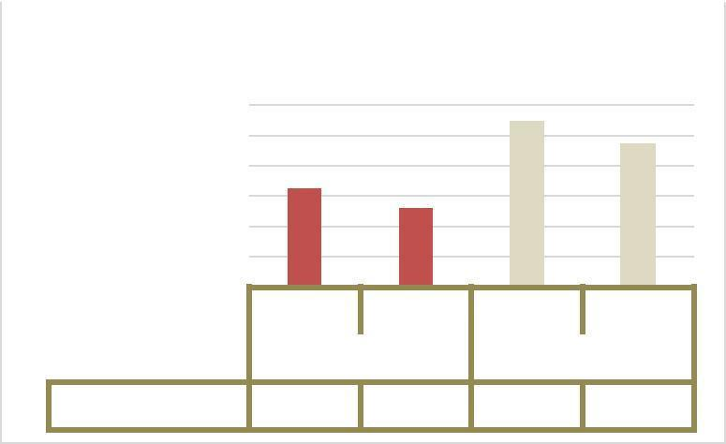

Cost of Fund

12.0%
10.0%
8.0%
6.0%
4.0%
2.0%
0.0% | 2017 | 2016 | 2017
2016 | 2017 | 2016 | 2017
City Bank |  | SBAC Bank
Cost of Fund 6.5% | 5.20% | 10.95% 9.47%

Graph- 16: Cost of Fund

. Here, City bank’s cost of fund in best position by keeping low in regards to receive better returns. On the other hand SBAC bank’s cost of fund rate was quite excess than the City bank, which means their returns was not good.

Non-Performing Loan (NPL):

Non Performing Loan (BDT)
TK. in million
12000
10000
8000
6000
4000
2000
0
 |  |  | 2015 | 2016 | 2015 | 2016
 |  |  | City Bank |  | SBAC Bank
 |  | Non Performing | 10845 | 10,582 | 22.33 | 0
 |  | Loan (BDT)



Graph- 17: Non-Performing Loan

52

City bank has drawn a greater amount of non-performing loan than the SBAC bank. That means city bank has high default rate where in 2016 SBAC bank drawn 22.33 taka (in million) and in 2017 it’s became zero.

Return on Asset (ROA):
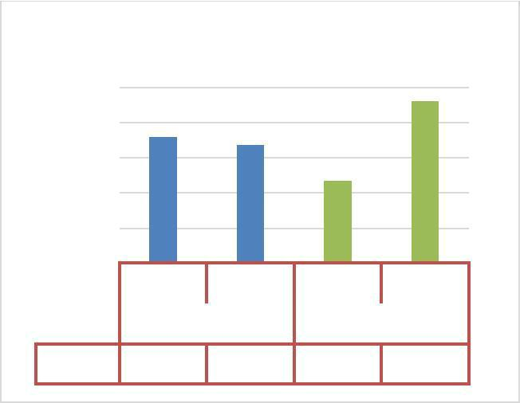

Return on Asset

2.5%
2.0%
1.5%
1.0%
0.5%
0.0% | 2016 | 2015 | 2016
2015 | 2016 | 2015 | 2016
City Bank |  | SBAC Bank
ROA 1.8% | 1.68% | 1.18% 2.31%

Graph- 18: Return on Asset

. In 2016 SBAC bank has 3.31% ROA, because the bank was earning more money on less investment.

Return on Equity (ROE):


Return on Equity

20.0%
15.0%
10.0%
5.0%
0.0%
0.0% | 2015 |  |  | 2016 |  |  | 2015 |  |  | 2016
 |  | City Bank |  |  |  |  |  | SBAC Bank
ROE | 14.7% |  |  | 17.35% |  |  | 7.85% |  |  | 18.09%

Graph- 19: Return on Equity

53

. The ROE of City bank was 14.7% and SBAC bank 7.35% which is lower than the City bank. But in 2016 SBAC bank has 18.09% ROE which is better than the City bank 17.35%.

Return on Investment:
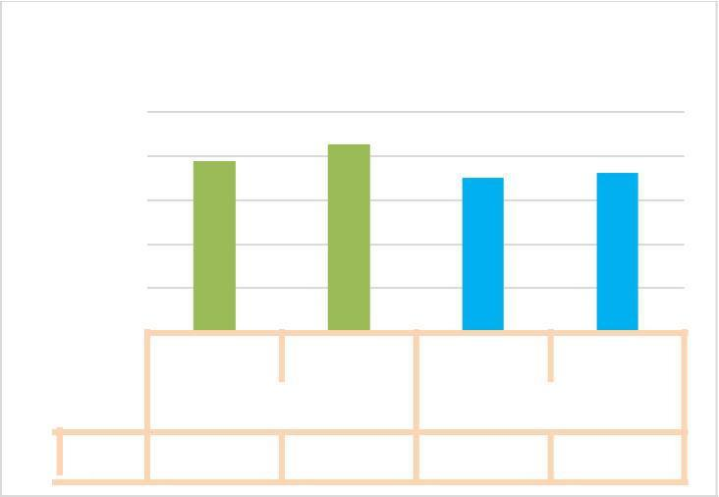

Return on Investment

25.00%

20.00%

15.00%

10.00%

5.00%
0.00%
2015 | 2016 |  | 2015 |  | 2016
City Bank |  |  |  | SBAC Bank
ROI 19.42% | 21.26% | 17.57% |  | 18.17%

Graph- 20: Return on Investment
ROI which investment are preferable and attracting their customers than the SBAC bank. City bank got 19.42% in 2015 and 21.26% in 2016 where SBAC bank got 17.57% and 18.17% relatively lower than City bank.

54

Leverage Ratio:
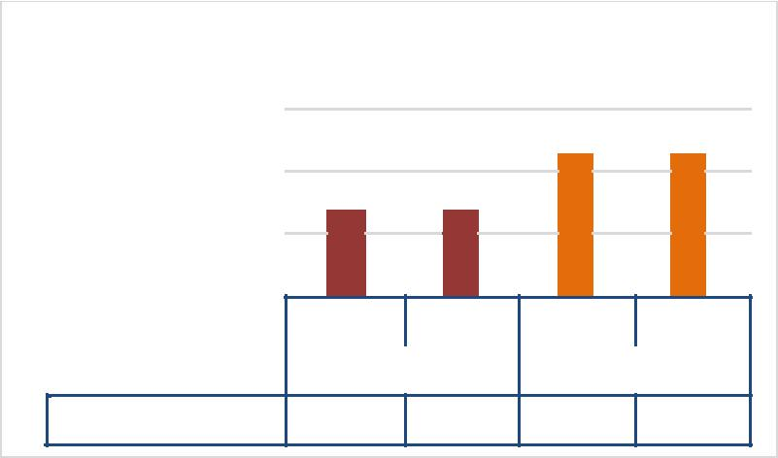

Leverage Ratio

15.00%

10.00%

5.00%

0.00%
2015 2016 2015 2016

City Bank SBAC Bank

Leverage ratio 7.06% 6.60% 11.76% 11.16%

Graph- 20: Leverage Ratio
SBAC Bank has the higher leverage ratio like 11.76% & 11.16% over the year 2015 and 2016. And City bank has 7.06% and 6.60% that means city bank is in the safe position than SBAC bank. High leverage ratio may turn into bankruptcy for any company if they occur loss continually.

Export Growth:
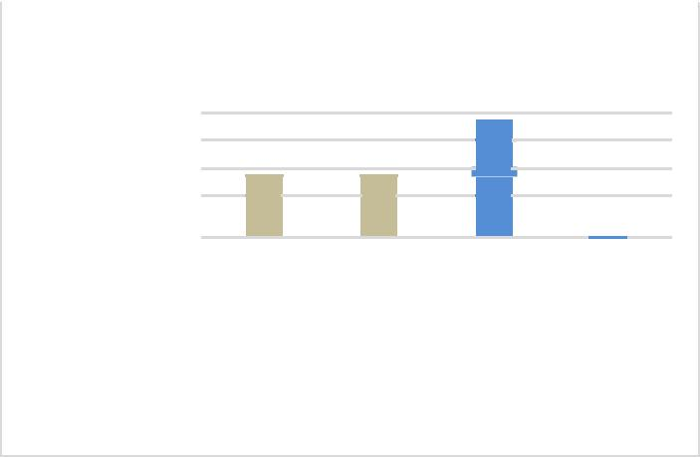

Export Growth

80%
60%
40%
20%
0%

-20%
-20% | 2015 | 2016 | 2015 |  | 2016
 | City Bank |  |  | SBAC Bank
Export | 33% | 36% | 75% |  | -12%
Growth

Graph- 21: Export Growth

Export growth of City bank’s overall was quite better than SBAC bank if compared. City bank’s export growth was 33% in 2015 where SBAC bank has almost double like 75%, and in year 2016 SBAC bank’s export growth was dropped at only 12% where City bank’s growth steadily increased.

55

Import Growth:


Import Growth

80%
60%
40%
20%
0%
 |  | 2015 |  |  | 2016 |  |  | 2015 |  |  | 2016
 |  |  | City Bank |  |  |  |  |  | SBAC Bank
 | Import Growth | 21% |  |  | 27% |  |  | 37% |  |  | 61%

Graph- 22: Import Growth

Here the totally opposite scenario in import growth for SBAC bank. They had high import growth like 37% and 61% on the respective years than the City bank. SBAC bank had drawn high transaction on import side which rate were in double from 2015 to 2016.

Dividend:

30%
25%
20%
15%
10%
5%

0%

Dividend
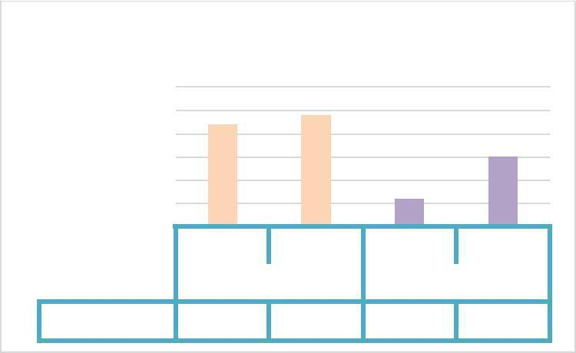

2015 2016 2015 2016

City Bank SBAC Bank

Dividends 22% 24% 6% 15%

Graph- 22: Dividend
. SBAC bank has provided 6% stock dividend to their shareholders in 2016 and in 2017 the board of directors are committed to provide 15% stock dividend to the Shareholders in 2017.

56

- FINDINGS AND SUGGESTIONS

It was found the following findings by analyzing the study:

- It was found that the bank maintains all the necessary steps while the customers open different types of accounts with bank.

- SBAC Bank doing decentralized management system in general banking means their general banking operations are done by branch wise.

- In many cases, bank imposes unnecessary condition in opening accounts (individual and joint) and as a result people disinterest in dealing with the bank.

- As a new bank SBAC Bank take high cost deposits from the customers where City Bank take low cost deposits like SBAC Bank give 7% interest in fixed deposit.

- Many of the individual thinks that the terms and conditions of the deposits schemes are reasonable.

- There is no sufficient ATM booth for SBAC.

- In General Banking section, main problems is lack of manpower for that reasons the employee does not complete the job in time.
57

- The software used for SBAC bank in General banking is very slow. So, the officer does not provide best service in time.
- Most of the respondents think that the security facilities of SBAC are not adequate enough to provide efficient services.

- Almost half of the clients think that the opening an account in SBAC is very useful to them as individuals as well as organizations due to the provisions of many value –worthy facilities.

- SBAC Bank employed new employee without experience those are not effective in general banking

- SBAC Bank has also call center customer service but it’s not available.

- In financial performance analysis we see that City Bank was in the better position than the SBAC Bank because City Bank is the oldest and smart bank in banking sector and their management procedure is much better than the SBAC Bank.

58

- RECOMMENDATION

The following suggestions are recommended for overcoming the problems-

- The branch is mostly dependent on deposit. The dependency of any bank in any specific sector is not wise for competition. So, emphasis should be given to develop and increase dependency in other department.

- The bank can enhance its asset quality through offering rebate on interest rate and hence provocation of timely repayment by the customers. This will be offered only to regular customers.

- The loan sanction process should be easier that the clients can feel convenient to take loan from the bank.

- The Bank has not enough ATM booths in our country. They should take necessary step to increase number of ATM booths.

- Online Banking should be provided for fast services.

- The software in General Banking as well as foreign exchange should be upgraded.

- Manpower should be increase in general banking section. So, that they provide services in time of their customers.

- In general banking service SBAC Bank may follow the City Bank’s token service to reduce

the customer lead time.

- SBAC Bank should hire or employed experienced employee for general banking section.

- In financial performance we see that SBAC bank’s leverage ratio is much higher than the

City Bank which is not good for the bank. They should be give more concentration on reduce the leverage ratio.

59

- CONCLUSION

Among them South Bangla Agriculture & Commerce Bank Limited is one of the leading commercial bank.

SBAC has introduced a new dimension in the field of innovative and benevolent banking in our country. It plays a great role in collecting scattered Deposit, Loan settlement and International Trade etc. For better growth and healthy economic position, it should introduce new and lucrative long-term credit schemes especially for new investors and schemes for poverty alleviation like micro credit.

I hope SBAC do more work for socio-economic development besides their banking business..

I hope this report can provide a good guideline for their future. I wish continuous success and healthy business portfolio of South Bangla Agriculture & Commerce Bank Limited (SBAC), Dhanmondi Branch, Dhaka.

60

- REFERENCES

- Annual Report – 2016 and 2017, South Bangla Agriculture & Commerce Bank Ltd.

- Annual Report – 2016 and 2017, City Bank Limited.

- Web site of SBAC www.sbacbank.com

- Web site of City Bank- www.thecitybank.com

- Web site of Lanka Bangla Finance ltd. - http://lankabd.com/

- Personally data collection by communicating with SBAC Bank , Dhanmondi Branch serior officer.

61

