
Internship Report
On
Recruitment & Selection Process Of
Acorn Infrastructure Services Limited- Bangla Trac



Letter of Transmittal

Farhana Rashid
Assistant Professor
United International University (UIU)
United City, Madani Avenue, Badda,
Dhaka, Bangladesh.

Dear Madam,
With due respect, I am submitting my internship report on Acorn Infrastructure Services Ltd. It was a great journey of 3 months internship program and I experienced many different things from it. My Internship topic is “Recruitment and Selection Process of Acorn Infrastructure Services Ltd”. I was mainly focused to understand the practice of Recruitment and Selection process of Acorn Infrastructure Services Ltd.
I have really tried hard to make this report successful and capable of your expectation from me. This Internship program helped me to experience a real life situation in the corporate world.
I welcome your all query and criticism of this report and give me more opportunity to learn. I hope you will consider any of mistakes that might be present though I have tried my best.
Sincerely,
-------------------------------------------
Kazi Musrat
ID: 111 131 353

Acknowledgement

At first I would like to thanks our creator for giving me the ability to think out of the box and make a successful repot.
Second I would like to thanks my Honorable faculty Farhana Rashid, Assistant Professor, United International University- for giving me proper advice and guidance during my internship program.
And then I will show my humble honor to my supervisor Mahmuda Sultana, Senior HR Executive to help me as much as possible while doing this report.
I am also very grateful to my friends to give me support during my hard times and encourage me to do my level best during this regards.
Finally, I sincerely express my gratitude to my family for supporting me and sharing their thoughts and giving me the moral support during the preparation of this report.

Table of Content

Executive Summery | 04
Chapter 1:  Introduction | 05
Objectives of the Report | 06-9
Background of the Organization | 10-27
Electricity Demand in Bangladesh | 28-31
Chapter 2:  HR Policies of AISL | 32
Different HR Policies of AISL | 33 - 35
Chapter 3: Activities Undertaken  Recruitment and Selection Process of AISL | 36 - 47
Chapter 4:  Lessons Learned From the Internship Program at AISL | 48
Description of the Job | 49-56
Chapter 5:  Findings from Internship Program at AISL | 57-59
Findings | 60
Chapter 6:  Suggestions for Improvement and Conclusion | 61
Suggestions for Improvement | 62
Conclusion | 63
Appendices | 64
Survey | 65-67
Reference | 68-70

Executive Summary

This report is mainly based on my three months program of internship in Acorn Infrastructure Services Ltd from 18th February, 2018 to 31st May, 2018 which was a part of my BBA program on United International University. I was under Human Recourse Department. Established in January 2009, Acorn Infrastructure Services Ltd is an Electricity Generation and Transmission company which generates 4,504 MW using light diesel oil, natural gas or heavy fuel oil (HFO).
The main topic of my report is how recruitment and selection process are practiced at an Electricity Generation and Transmission company in Bangladesh.
The whole report is based on only data that I have experienced day to day during my internship program.
Recruitment system is one of the most complicated and significant activity that every organizations have to undergo. Putting right people at the right place is not as easy as it sounds. And for big and prominent companies like AISL, the recruitment process is never easy when the company ensures the quality of the work as well as quality of the people. But AISL has been in that business for a long enough for coping up with the difficulties. They have their own structure and way of selecting people. The fact that took my attention to work on the matter is AISL’s smooth recruiting system.

Chapter 1:
Introduction
Introduction

Objectives of the Report

Primary Objective:
The main objective of this report is to provide necessary idea and information about the procedures of Recruitment and selection process followed by the ACORN INFRASTRUCTURE SERVICES LTD. (AISL) through the HR Department and recommendation.

Secondary Objective:
The major aim of this report is to recognize and identify how theories and concepts are discussed in the BBA program that can be applied in the real situation of Recruitment and Selection process in an organization of Bangladesh.
The objectives of the report is
1. To understand recruitment and selection system as a part of HR activity.
2. To gain knowledge about various recruitment and selection activities followed by Acorn Infrastructure Services Ltd.
3. To acquire knowledge on the topic so that it can be implemented in the future to increase company’s performance.
4. Provide my opinion and suggestions to management for their further practice on their area.

Scope of the study
As my report topic is “Recruitment and Selection process of Human Resource Division in Acorn Infrastructure Services Ltd.” the report will give a bird’s eye view of how the organization selects the right people to fill a post. So, it will help in the future to know about the all the functions of Human Resources Department practiced in Acorn Infrastructure Services Ltd.
For example:
    - The different department of HRD
    - The functional procedure of the recruitment and selection process
    - Benefits Acorn Infrastructure Services Ltd. offer to their employees to motivate their work

Hence, I think this report will give a clear picture of Human Resources Department of Acorn Infrastructure Services Ltd. and their functions.

Methodology of the study
Starting from selection of the topic to final report preparation, in a systematic procedure the study is conducted. The integral part, to find the vital points, were classified and was to identify and collect data; analyzed, interpreted and presented in a systematic manner.
In this paper, methodology includes direct observation, face to face discussion with the employees as well as searching on their websites and studying on their practical work.

Selection of the Topic
I communicated with my academic supervisor to help me on selecting the topic after taking suggestions from my official supervisor.

Sources of Data
In order to make the study more meaningful and presentable, both primary and secondary sources of data and information had been used. The two sources of data are:

Primary Sources
➢ By observing the organization
➢ By discussing with official members and concerned experts.

Secondary Sources
Different Books of HRM
➢ Different Annual reports
➢ Various Newspapers
➢ By following Internet
➢ By reading Textbook

Collection of Data
I collected Primary data from observation method. I have communicated face to face the officials. Then I collected Secondary data from AISL publications and other related websites and documents.

Limitations of the study
I have faced some limitations in preparing this report. I faced difficulties in collecting data from the different sources basically. Some people didn’t showed their interest while I was surveying to collect primary data.

There are also some problems I faced during the preparation of my report.
Those problems are,

➢ The time was too limited to collect all the data that were required.
➢ Everyone was keeping their information very confidential to share it with interns.
➢ Internal activities were not allowed by interns to access.
➢ It was very hard to arrange analytical data and theoretical data within a very short time limit.
➢ The three months time was not very much enough to gain a greater scenario of this company.
➢ As the organization remains confidential to interns, relevant data collecting was very difficult.
➢ Load of works was also a great barrier for me to prepare the report in earlier time.
➢ As an fresher I had lack of knowledge to prepare such a report.

Lastly I want to say that, the whole report gone through from very difficulties which was sometimes unbearable for me to maintain because I was not a permanent employee to the office members to share anything.

Background of the Organization
Acorn Infrastructure Services Ltd. (Associate Company of Bangla Cat) Specialized in Electricity Generation and Transmission (100MW HFO Based Power Plant) whose power plant is in Juldha, Chittagong. The parent company of the organization is known as Bangla Trac. Since January 2009, nearly 40 contracts have been signed to increase the capacity by 4,504 MW using light diesel oil, natural gas or heavy fuel oil (HFO). The investor, Dhaka-based Acorn Infrastructure Services Ltd. (AISL), signed a five-year rental agreement with BPDB and Caterpillar Power Generation Systems. Under the agreement, Caterpillar provided equipment and services for eight Cat® 16CM43 HFO-operated generator sets. Local Cat dealer, Bangla Cat, supported the project with onsite supervision and engineering services.

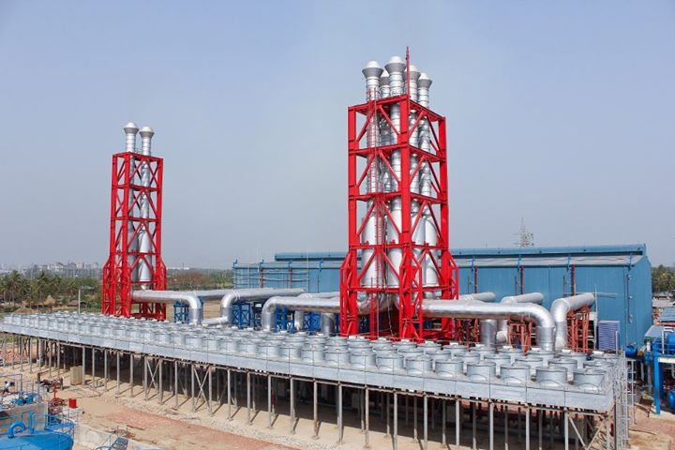
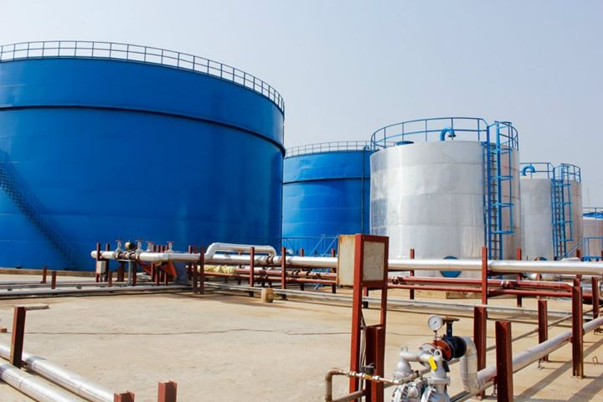

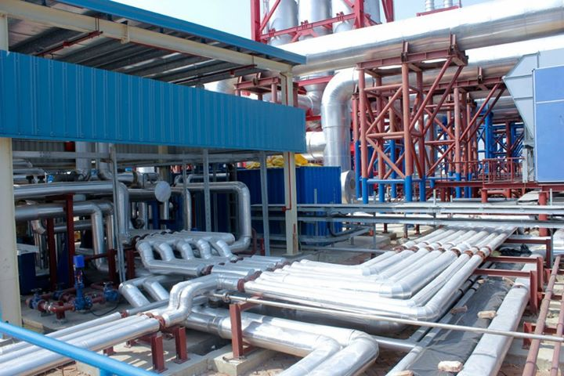
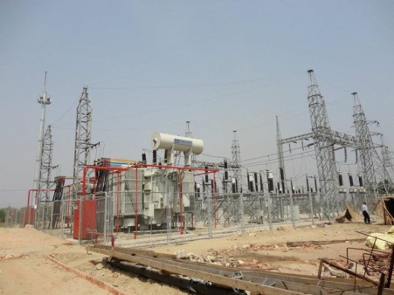

Acorn Infrastructure Services Ltd. is a Strategic Business Unit of Bangla Trac. Bangla Trac is a premium telecom service provider which is driven by commitment and innovation to quality. Since its inception, as one of the pioneer International Gateway (IGW) Service Providers, they have diversified their portfolio well beyond core business of premium quality voice termination to Bangladesh. Their wide range of innovative products and services are designed to enable their local and international partners to realize their full potential in target markets. Their Businesses are:

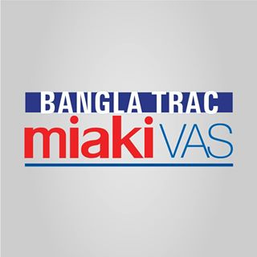





Mission and Vision of AISL

Mission
Your Industry, Our Energy.

Vision
We make progress possible through excellence in technology, integrity and unsurpassed customer services.

Values
The idea of innovative practices through persistent teamwork of responsible employees and providing high quality customer services with the reliability evolved by company’s principal. The Acorn Infrastructure Services Ltd. management strongly appreciates the diversity in the vast amount of knowledge and experience their people bring with them to the company. The principal values of AISL are:

    - Customer Service First.
    - Innovation
    - Quality
    - Integrity
    - Teamwork
    - Ownership Mentality
    - Leadership through Excellence.
Company Details

Website
http://www.aisl.com.bd
Headquarter
House No: 04, Road No: 19/A, Block: E, Banani, Dhaka.

Year founded
2010

Company type
Privately Held

Company size
501-1000 employees

Specialties
Energy & Power, Power Plant, and Infrastructure Services

Organizational Structure of AISL

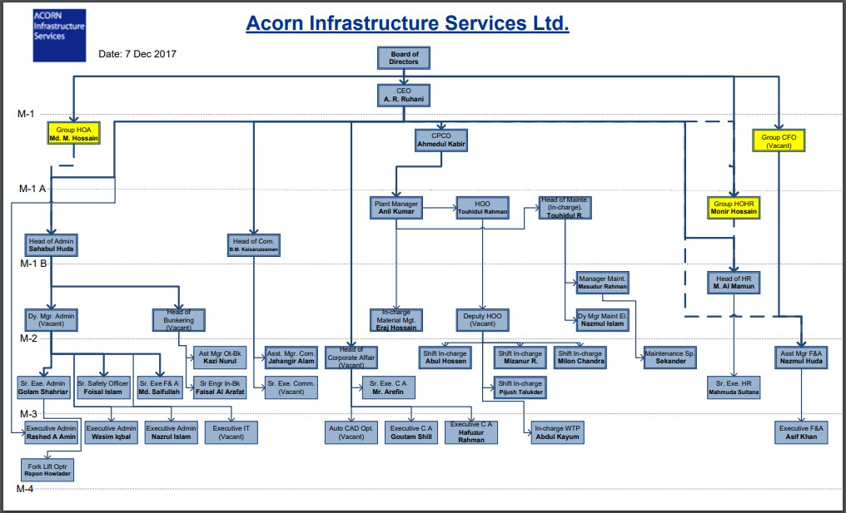

Performance Overview of Acorn Infrastructure Services Ltd.

Year 2011
The AISL power plant generated total 545,000,000kWh unit of power throughout the year 2011 and added full of their produced power to the national grid.

Utilization Chart 2011
Month | Export (kWh)
January | 29,000,000
February | 36,000,000
March | 42,000,000
April | 58,000,000
May | 48,000,000
June | 50,000,000
July | 52,000,000
August | 58,000,000
September | 52,000,000
October | 38,000,000
November | 42,000,000
December | 40,000,000
Total: | 545,000,000

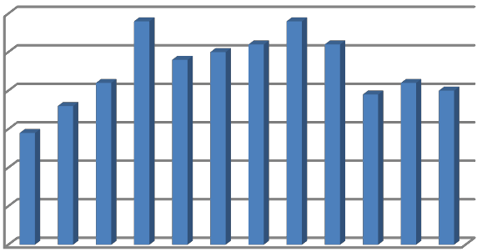
Utilization Chart - 2014
60000000
50000000
40000000
30000000
20000000
10000000
0
Export (kWh)

FIGURE: Utilization Chart of AISL in 2014
January
February March April May June July August
September
October November
December

Year 2012
The AISL power plant generated total 388,000,000 kWh unit of power throughout the year 2012 and added full of their produced power to the national grid.

Utilization Chart 2012
Month | Export (kWh)
April | 58,000,000
May | 46,000,000
June | 60,000,000
July | 62,000,000
August | 48,000,000
September | 58,000,000
October | 56,000,000
Total: | 38,800,0000

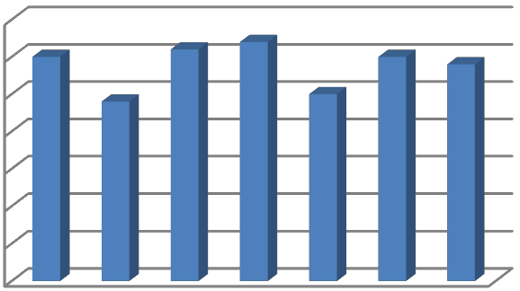
Utilization Chart - 2012
70000000
60000000
50000000
40000000
30000000
20000000
10000000
0
Export (kWh)
FIGURE: Utilization Chart of AISL in 2012

Year 2013
The AISL power plant generated total 629,000,000kWh unit of power throughout the year 2013 and added full of their produced power to the national grid.

Utilization Chart 2013
Month | Export (kWh)
January | 38,000,000
February | 48,000,000
March | 68,000,000
April | 59,000,000
May | 48,000,000
June | 60,000,000
July | 61,000,000
August | 48,000,000
September | 58,000,000
October | 56,000,000
November | 46,000,000
December | 39,000,000
Total: | 629,000,000

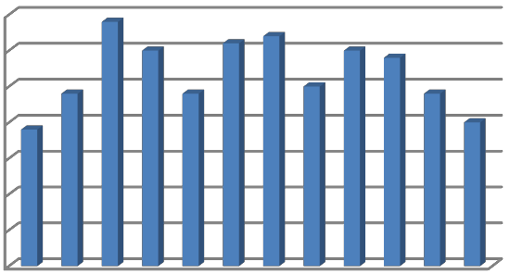FIGURE: Utilization Chart of AISL in 2013
Utilization Chart - 2013
70000000
60000000
50000000
40000000
30000000
20000000
10000000
0
Export (kWh)
January
February
March April May June July August
September
October
November
December
Year 2014
The AISL power plant generated total 545,000,000kWh unit of power throughout the year 2014 and added full of their produced power to the national grid.

Utilization Chart 2014
Month | Export (kWh)
January | 29,000,000
February | 36,000,000
March | 42,000,000
April | 58,000,000
May | 48,000,000
June | 50,000,000
July | 52,000,000
August | 58,000,000
September | 52,000,000
October | 38,000,000
November | 42,000,000
December | 40,000,000
Total: | 545,000,000

Utilization Chart - 2014
60000000
50000000
40000000
30000000
20000000
10000000
0
Export (kWh)

FIGURE: Utilization Chart of AISL in 2014
January
February March April May June July August
September
October November
December

Year 2015
The AISL power plant generated total 545,000,000kWh unit of power throughout the year 2015 and added full of their produced power to the national grid.

Utilization Chart 2015
Month | Export (kWh)
January | 29,000,000
February | 36,000,000
March | 42,000,000
April | 58,000,000
May | 48,000,000
June | 50,000,000
July | 52,000,000
August | 58,000,000
September | 52,000,000
October | 38,000,000
November | 42,000,000
December | 40,000,000
Total: | 545,000,000

Utilization Chart - 2015
60000000
50000000
40000000
30000000
20000000
10000000
0
Export (kWh)

FIGURE: Utilization Chart of AISL in 2014
January
February March April May June July August
September
October November
December

Year 2016
The AISL power plant generated total 545,000,000kWh unit of power throughout the year 2016 and added full of their produced power to the national grid.

Utilization Chart 2016
Month | Export (kWh)
January | 29,000,000
February | 36,000,000
March | 42,000,000
April | 58,000,000
May | 48,000,000
June | 50,000,000
July | 52,000,000
August | 58,000,000
September | 52,000,000
October | 38,000,000
November | 42,000,000
December | 40,000,000
Total: | 545,000,000

Utilization Chart - 2016
60000000
50000000
40000000
30000000
20000000
10000000
0
Export (kWh)

FIGURE: Utilization Chart of AISL in 2014
January
February March April May June July August
September
October November
December

Year 2017
The AISL power plant generated total 545,000,000kWh unit of power throughout the year 2017 and added full of their produced power to the national grid.

Utilization Chart 2017
Month | Export (kWh)
January | 29,000,000
February | 36,000,000
March | 42,000,000
April | 58,000,000
May | 48,000,000
June | 50,000,000
July | 52,000,000
August | 58,000,000
September | 52,000,000
October | 38,000,000
November | 42,000,000
December | 40,000,000
Total: | 545,000,000

Utilization Chart - 2017
60000000
50000000
40000000
30000000
20000000
10000000
0
Export (kWh)

FIGURE: Utilization Chart of AISL in 2014
January
February March April May June July August
September
October November
December

Acorn Infrastructure Services Ltd. (Associate Company of Bangla Cat) Specialized in Electricity Generation and Transmission (100MW HFO Based Power Plant) whose power plant is in Juldha, Chittagong. The parent company of the organization is known as Bangla Trac. Since January 2009, nearly 40 contracts have been signed to increase the capacity by 4,504 MW using light diesel oil, natural gas or heavy fuel oil (HFO). The investor, Dhaka-based Acorn Infrastructure Services Ltd. (AISL), signed a five-year rental agreement with BPDB and Caterpillar Power Generation Systems. Under the agreement, Caterpillar provided equipment and services for eight Cat® 16CM43 HFO-operated generator sets. Local Cat dealer, Bangla Cat, supported the project with onsite supervision and engineering services.

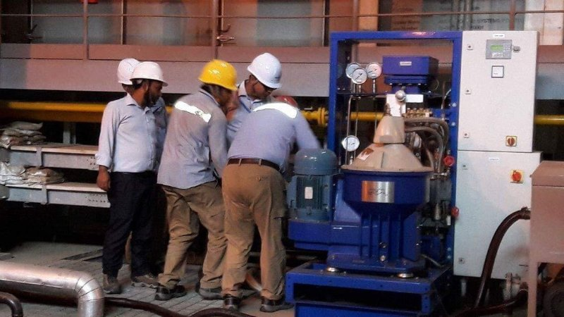

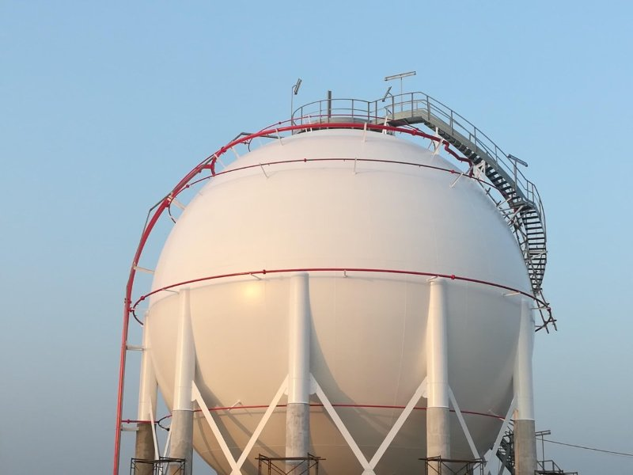

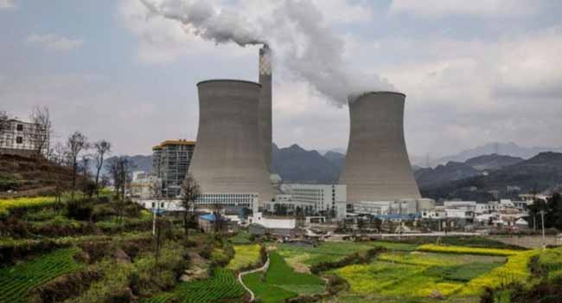

Electricity Demand in Bangladesh:
The Bangladesh Power Development Board (BPDB) was created by the Bangladesh Water and Power Development Authority nearly 40 years ago. The BPDB provides power generation, transmission and distribution services, and has increased the country’s generation capacity from 200 MW to 6,727 MW since its formation.
Today, just 49 percent of the people in Bangladesh have access to electricity. Per capita generation is only 236 kWh, the lowest in the region. The unstable grid causes frequent power outages while a shortage of natural gas and load shedding during peak hours only make the situation worse.
The present power demand is 6,000 MW, but the grid can only generate 4,500 to 4,750 MW due to the gas shortage and load shedding. Because electricity is crucial to economic growth and improved quality of living, the government has prepared several short- and long-term plans to ensure balanced development of power generation in the country.

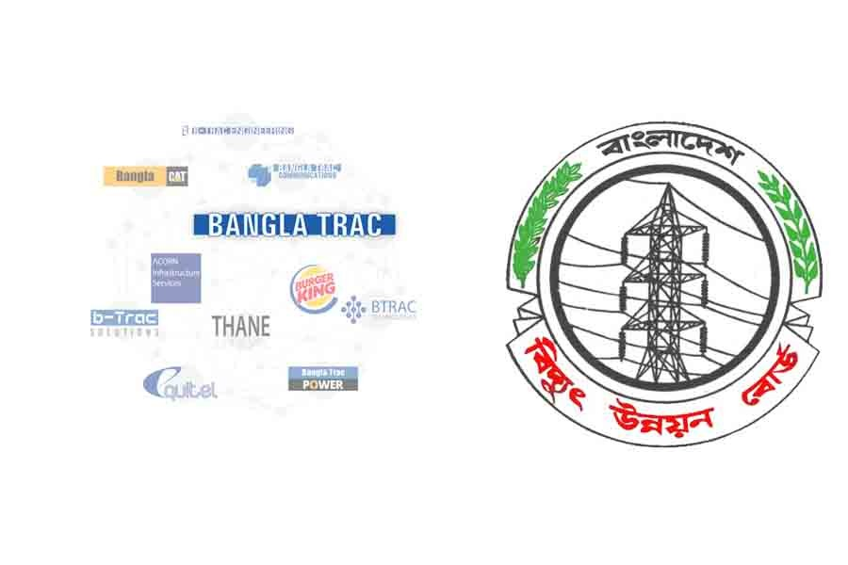
Acorn Infrastructure Services Ltd. is a Strategic Business Unit of Bangla Trac. Bangla Trac is a premium telecom service provider which is driven by commitment and innovation to quality. Since its inception, as one of the pioneer International Gateway (IGW) Service Providers, they have diversified their portfolio well beyond core business of premium quality voice termination to Bangladesh. Their wide range of innovative products and services are designed to enable their local and international partners to realize their full potential in target markets.

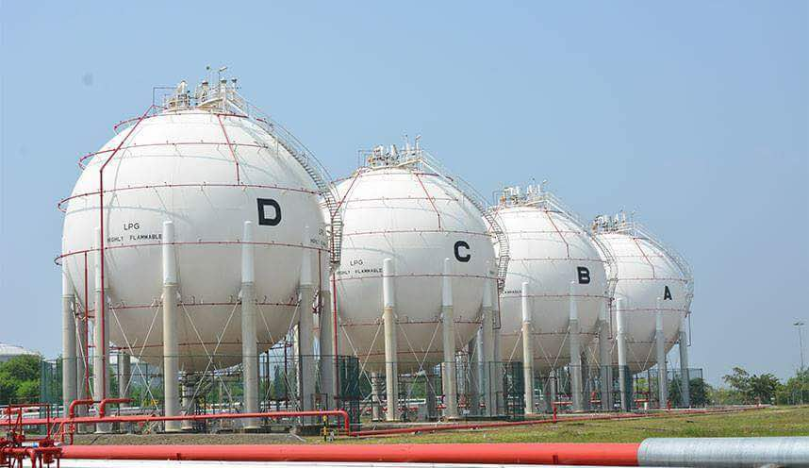

KEY STATISTICS

S.N. | Particulars | Year 2015-16 | Year 2016-17 | % Change over the previous year
1 | Installed Capacity of Power Plants as of June (MW):  a) Public Sector
 | i) BPDB | 4,320 | 4,508 | 4.35
 | ii) APSCL | 904 | 1,508 | 66.81
 | iii) EGCB | 622 | 622 | 0
 | iv) RPCL | 77 | 77 | 0
 | v) NWPGCL | 440 | 718 | 63.18
 | vi) BPDB-RPCL JV | 149 | 149 | 0
 | b) Private Sector:
 | i) IPP/SIPP | 2,974 | 3,232 | 8.68
 | ii) Rental | 2,028 | 1,890 | -6.8
 | c) REB (for PBS's only) | 251 | 251 | 0
 | d) Energy Import | 600 | 600 | 0
 | e) System Total Installed Capacity (MW) | 12,365 | 13,555 | 9.62
2 | Maximum Peak Generation (MW) | 9,036 | 9,479 | 4.9
3 | Maximum Peak Demand (MW) | 11,405 | 12,644 | 10.86
4 | Net Energy generation (GWh):
 | a) i) Public Sectors | 22,585 | 26,597 | 17.76
 | ii) Private Sectors (IPP, SIPP and Rental) | 23,786 | 24,094 | 1.3
 | iii) Energy Import | 3,822 | 4,656 | 21.81
 | iv) Total Generation (In account of Single Buyer) | 50,193 | 55,347 | 10.27
 | b) REB (for PBS's only) | 1,999 | 1,929 | -3.51
 | c) System Total Generation (GWh) | 52,193 | 57,276 | 9.74
5 | Per Unit Generation Cost in Public & Private (Tk/Kwh) | 5.1 | 5.24 | 2.75
6 | a) Fuel Cost for Thermal Plants in Public Sector (MTk) | 60,652 | 70,591 | 16.39
 | b) Per Unit fuel Cost for thermal Plants (Tk/KWh) | 3.1 | 2.76 | -10.97
7 | Annual Plant Factor of Public Sector's Power Plants (%) | 48.07 | 44.25 | -7.95
8 | System load factor (%) | 63.41 | 66.65 | 5.11
9 | BPDB's Commercial Activities as Single Buyer :
 | a) Bulk Sales Unit to Utilities (GWh) | 48,895 | 53,937 | 10.31
 | lb) Bulk Billing Amount (MTk) | 245,744 | 273,351 | 11.23
 | c) Bulk Collection Amount (MTk) | 222,382 | 274,355 | 23.37
 | d) Accounts Receivables to Utilities (MTk) | 105,609 | 101,433 | -3.95
10 | Transmission Loss (%) | 2.73 | 2.72 | -0.37
11 | Ave. Bulk Electricity Supply cost Taka/kWh | 5.55 | 5.7 | 2.7
12 | BPDB's Commercial Activities within Distribution Zones :
 | a) Energy Imports for Retail Sale (MKWh) | 12,159 | 11,024 | -9.33
 | b) Retail Sales Unit (MKWh) | 10,820 | 10,002 | -7.56
 | c) Retail Billing Amount (MTk) | 69,379 | 65,791 | -5.17
 | d) Retail Collection Amount (MTk) | 66,531 | 65,218 | -1.97
 | e) Accounts Receivables to Retail Consumers (MTk) | 18,696 | 13,999 | -25.13
 | f ) Collection/Bill Ratio (%) | 95.9 | 99.13 | 3.37
 | g) Collection/Import Ratio (%) | 85.34 | 89.94 | 5.39
 | h) Distribution System loss (%) | 11.01 | 9.27 | -15.8
13 | Transmission and Distribution (T & D) system Loss (%) | 13.1 | 12.74 | -6.56
14 | Total Number of consumers of BPDB (Nos.) | 3,457,263 | 2,526,682 | -26.92
15 | Total Population in the Country (Million) | 161 | 163 | 1.24
16 | Per capita generation (kWh) | 324 | 351 | 8.45
17 | Per capita Consumption (kWh) | 281 | 308 | 9.74
18 | Net profit/(loss) (MTk) | 38,738 | 44,349 | 14.48
*Note: Maximum Demand is shown as per power system master plan 2010
FIGURE: Key Statistics of Bangladesh Power Sector

Chapter 2:
HR Policies of AISL

Different HR Policies of Acorn Infrastructure Services Ltd

Dress code at AISL
Male | Female
• Long shirt or half shirt.  • Formal pant.  • Jacket/Blazer/Suit/Sweaters | • Saree or Salwar Kameez  • Formal sandals  • Jacket/Shawl/Sweaters

Conversation
By avoiding any kind of local colloquial diction, employee should be communicated with his/her peers; customers, supervisors or vendors formally.

System of using Telephone
Employees are prohibited to make personal call during work time. However they can attend personal calls in break time. Employees should always keep their voice low so that it does not distract other people from their work.

Using company’s property
The entire employee should use company’s property very carefully so that they don’t get damaged.

Using the computer:
Employees should be very careful while using company’s computer. If they foloow any problem, they should consult with IT.


Employee’s Personal property:
Employee personal things should be kept at their own responsibility. No one would be responsible if any of things of someone get lost due to their own mistake.
Non Smoking:
No one can smoke inside AISL’s because it has been decaled a non-smoking zone. If any employee wants to smoke, he is advised to leave the workplace during that time.



Clean Desk/Work Station:
Employees’ desks should be clean and neat so that it doesn’t hamper the work of other employees.

Access to colleague’s desks/PC:
No one can use the work station of another employee without taking the permission of him.


v Chapter 3:
Activities Undertaken: Recruitment and Selection Process of AISL

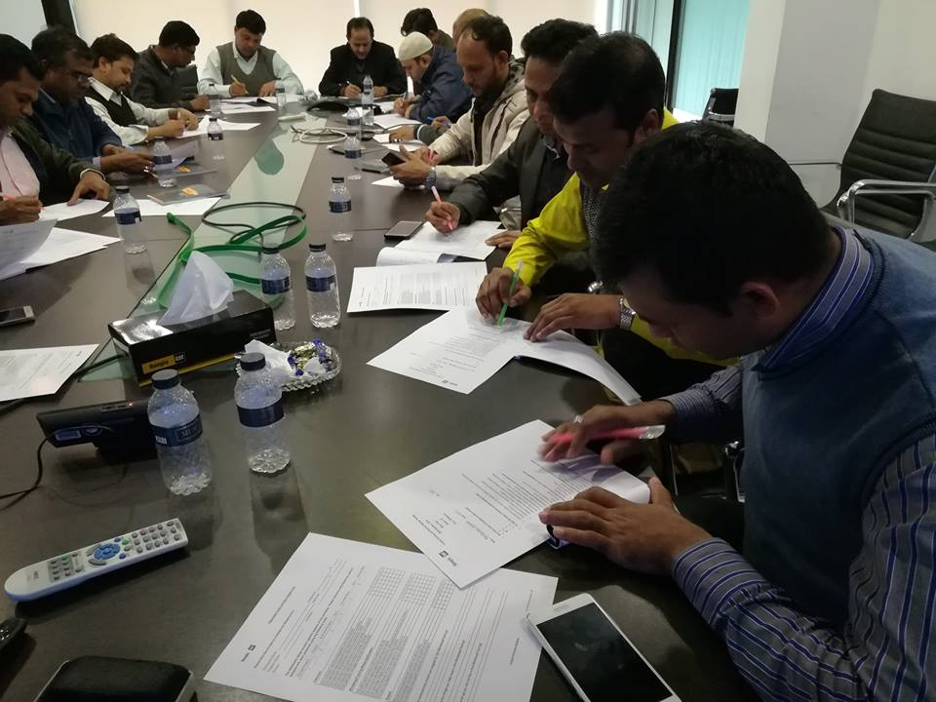
Human Resource Division of Acorn Infrastructure Services Ltd:

Acorn Infrastructure Services Ltd has a clear concept of recruiting and selecting candidates. They always focus on keeping their standard towards Bangladesh. It gives specific guidelines of operation of human resource division, with a vision to maintain the expected standards that are maintained. It provides proper guidelines of HR division to introduce organizational policy.
They have a very simple method of selecting candidates and carefully consider their qualification for their required post.
There are different functions of Acorn Infrastructure Services Ltd, those are,

HR functions:
- Recruiting and Selecting candidates
- Training and Developing candidates.
- By HR Transaction
✓ Managing Transport
✓ Employee Compensations and Benefits

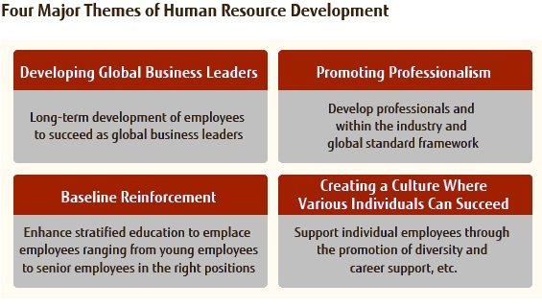
Recruitment and selection process of Acorn Infrastructure Services Ltd:
One of the important tasks of Acorn Infrastructure Services Ltd is Recruitment and Selection process. Through these tasks, Acorn Infrastructure Services Ltd attracts people who have the perfect qualification.

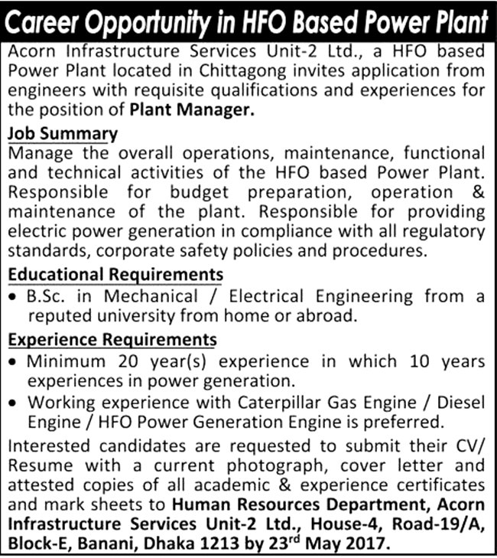

Purpose:
Acorn Infrastructure Services Ltd ensures that they can get right candidate on right time to meet the human resources demand across the organization.

Standard of procedures of recruitment and selection process:
Acorn Infrastructure Services Ltd has a guideline for recruitment and selection process which is called “Standard of Procedures”. For Acorn Infrastructure Services Ltd every HR tasks meets that Standard of Procedures. Standard of Procedures about recruitment and selection process of Acorn Infrastructure Services Ltd has some steps:
- When any vacancy arises, Head of HR asks HR department to take necessary steps to arrange an interview with proper selection of CV’s.

- Then HR department starts selecting capable CV’s came from drop box or reception or bd jobs sites.

- HR division selects the candidates and waits for the approval for onward processing.

- Then HR heads lookup those CV’s and grand permission to call those candidates for interview.

- Then HR division calls the shortlisted candidates for the interview.

- The interview gets fixed in a fixed date and all interviewees are requested to come on that exact date.

- Then candidates give their interview and HR department complete their recruitment and selection process with the approval of management.

- Then HR division will inform the selected candidates if they got selected and inform to HR Division for salary negotiation.

- It will conduct interview as required on the appointed date in combination with HRD and concerned divisional/departmental head representatives nominated by concerned division/department.
- The candidate’s performance will be checked and HR division will complete recruitment and selection process, with the approval of management under a set standard.


- HR division selects the candidates and waits for the approval for onward processing.

- Then HR heads lookup those CV’s and grand permission to call those candidates for interview.

- Then HR division calls the shortlisted candidates for the interview.



Manpower requisition form:
Manpower department must be filling up by concerned division/department. And there are some aspects. These are:
1) Positions: Here position name, department, division, type of vacancy, number of employee needed, date will be written by manger from concerned division/department. And by this personnel is requested to join. There are two types of vacancy. These are:
i) Replacing
ii) New position

2) Job description of manager: In job description, managers describe about the job tasks that might have to be done by candidate of the vacant job. If job descriptions get matches as their job description book, this will be written “as role play”.

3) Job specification of manager: Here manager will provide information about skills that needs to be performed by an employee. Here, he will write about educational background, experience, and special skills. Manager can add other things.

4) Approvals of Managers: Here just need a signature. HR head, Divisional Head, will sign and give approval. After sign, manager will give it to the HR department to sign. After the sign of HR department, it will go for deputy managing director for his sign.

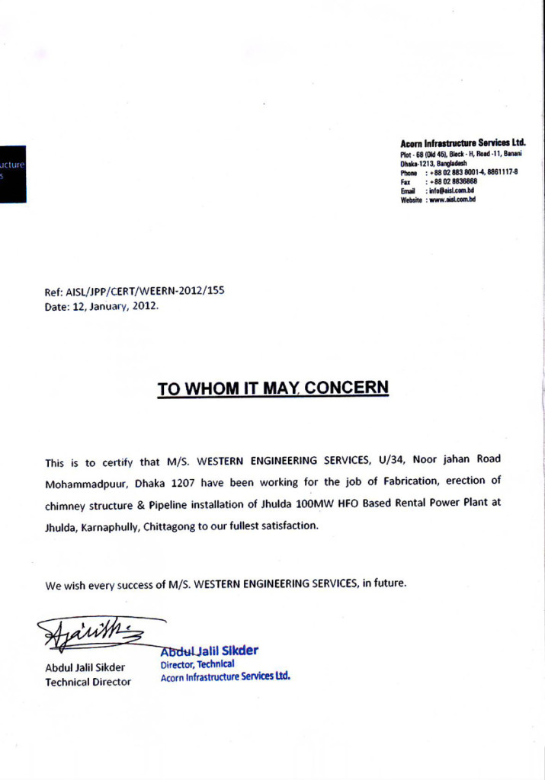
Attract applicants and collecting resumes:
After approval from deputy managing director, Human resource division will start their recruitment tasks. HR division will send the photocopy of manpower requisition form and it will keep the original copy. After that it will set how to draw applicants’ attention. There are two sources for collecting resumes. These are:

- Internal sources: Resumes are collected through internal sources. Internal sources are helpful for HR division. Because it reduces the cost. To utilize internal resources there are some sources and those are:

- Referrals: Acorn Infrastructure Services Ltd has many employees and among them, there are some employees of referrals that are great and strong source for Acorn Infrastructure Services Ltd. Here Acorn Infrastructure Services Ltd’s employee will sign on applicant’s resume. Employee will contact with officer if giving signature is not possible. Internees employees also get refer.

- On Notice board: Acorn Infrastructure Services Ltd provides their advisement of vacancy on notice board of their company which can attract candidates to apply for their position. External HR takes the responsibilities for lower level post like security guard, driver, and technician in Acorn Infrastructure Services Ltd.

- Transfer and promotion: if vacant position is immediately important, HR Division follows this source.

- External sources: Acorn Infrastructure Services Ltd gathers so many candidates through these sources. This Sources are:

- Newspaper advertisement: About its job recruitment, HR Division provides advertises. At first, they prepare an advertisement. And then management approves it. After Management approves it, advertisement is published in newspaper.

- Online advertisement: Bdjobs has a contract with HR Division of Acorn Infrastructure Services Ltd. HR manager posts a circular there. Here, mid-level and high level jobs are published.

- Interns: One of the best external sources is Interns. Acorn Infrastructure Services Ltd HR division chooses interns’ from different Universities. Students also personally sent their CV’s to the company.

- CV Bank: CV bank is always maintained by HR Division of Acorn Infrastructure Services Ltd. There two parts in CV banks. Unsolicited CVs are first. Some applicants send their CVs on their carrier service mail. Those CV’s are collected by HR Division if they are suitable for Acorn Infrastructure Services Ltd. Some CV’s are rejected from different selection. CV’s those are excellent are kept in a separate file.

Shortlisted applicants:
Acorn Infrastructure Services Ltd HR division starts their selection process after collecting CV’s. Resumes are divided in two sets. At first, applicant’s resumes are selected by HR division. Next, they orderly set resumes and sent these to the department. After that, final selection has been done and resumes are given back to the HR division.

Making call list to inform candidates:
Informing candidates is the next task. This is called TI, Telephone Interview. Here applicants faces some common questions about their present situation, whether they are currently employed, and their present salary on that organization. And then they are inform to join the interview on the seduced time. If applicants’ can’t join that interview, they are requested to inform that before the interview of scheduled time.

Preparing Sheet of Attendance:
Before viva, attendance sheets of expected candidates are prepared. Applicants’ name, last education, university names, mobile number and signature box these are listed in a sheet. After completing the making of it, it is sent to the reception.

Viva \board:
Finally candidates are present for the viva. Here, Divisional head, HR head and other managers are present. Both have their own rights of giving feedback about the employee during the time of viva. Applicants have to face different question of all the managers. They also asked about their current salary again and what is their expected salary for now. After Viva, both of the managers submits their opinion. According to everyone’s judgment, candidates are selected and salary is negotiated.

These are:
- Educational Record
- Basic Technical Knowledge
- In-depth Technical Knowledge
- Communication Skill
- Body Language (Appearance and Smartness)

Candidates are being judged by their smartness and asked questions that were asked on the viva board.HR select multiple candidates so that if any employee takes leave, they can at least get backup in future.



Call the finally selected candidates:
After final evaluation, HR division confirms the finally selected candidates and asked to call them to make them sure that they are selected for the job. In the phone call, finally selected candidates are informed about the salary that is offered by management. If they get agry on the amount, they are selected, if they don’t get agree, they negotiate it.

Employment for new joiner:
New joiner must carry some papers for his employment. Those are,
- Resumes: New joiner will have to carry his updated resume before joining.

- Employee Information form: Employees are also asked an information form about him. Academic description, prior work experiences, emergency contact etc information should be given there.

- Certificate and Transcript: He has to carry his all original and photocopy of all certificates.

- Release order: He also has to provide a release letter of his previous organization.

- 3 copy passport size photograph: He has to carry 3 copy of his passport size photo in a color for and give a signature behind that photo.

- National ID card photocopy: He has to carry his national id card’s photocopy and another of his nominees’ identity cards.

- Nationality certificate: He has to carry his nationality certificate signed by his commission or chairman.

- Joining letter: Then HR division will provide joining letter to the selected candidates and new joiner will have to sign on it by agreeing the terms and conditions.

- Nominee form: New joiner will not mention more than three persons of his nominee, who will get benefits later if the employee dies.

- Medical certificate: New joiner has to provide his medical certificate from any govt. medical officer.

- Blood group: New joiner has to provide his blood group report also.

- Bank account: All employees of AISL have bank account in Prime Bank Ltd.

Chapter 4:
My Internship Program at Acorn Infrastructure Services Ltd

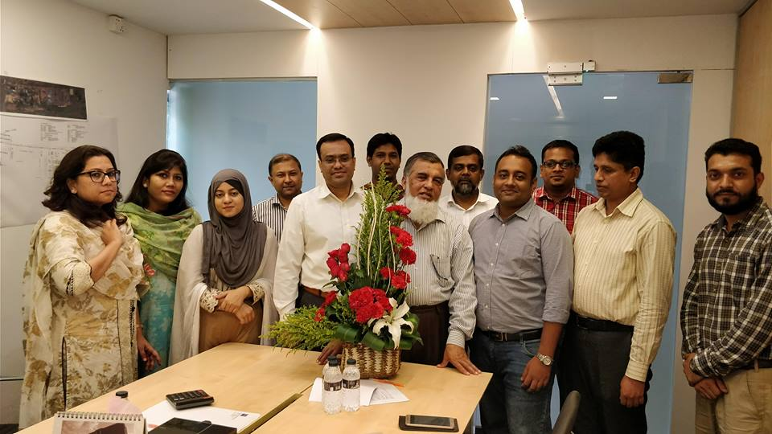

My Internship at Acorn Infrastructure Services Ltd
I had got the opportunity to work in Acorn Infrastructure Services Limited for three months, 18th February to 18st May. It was a great journey of my educational life. The whole experience was a great opportunity for me to learn and experience corporate world. My major is Human resource management so I was assigned as a HR under HR division there.

Description of my program:
As I was under HR division so I got the chance of doing different types of work there. At the 1st day, my supervisor introduced me to the other employees on that company. I have started my actual work from day one by managing Interviews as a part of the recruitment and selection process. My supervisor helped me in this regard, how I should manage my work and the correct procedure of it. Then day by day as the times gone, I was assigned for my other various types work. I have done the following jobs regularly. These are:
✓ Collection the resumes of candidates
✓ Screened those resumes for interview.
✓ Made call list for the upcoming Viva.
✓ For Viva, made various list of attendance.
✓ Candidates profile summery
✓ Various copy making of their attendance
✓ In CPS, inputting the final result.
✓ Rejected resumes were maintained.
✓ Important resumes were photocopied.
✓ Took all the signature of them.
Collecting resumes:
I collected various resumes for different types of post like executives, engineer, manager, technician etc. Applicants send their resumes in two ways. They either send their resumes on the job site of Acorn Infrastructure Services Limited or Send their resumes to the reception of the office. I was collected those resumes and printed the online resumes.

Screening resumes:
After the collection of the resumes, I gave them a screening because AISL receives a large number of resumes. I had to look after those resumes very carefully because each position they required are with special skills. For example, Educational background, age limit, special skills, experience etc. I have separated those resumes by public and private universities according to the suggestion of my supervisor. There are also some resumes that are from reference of the CEO Sir. I kept those separately as those are mandatory to call. Then I give those resumes to my supervisor. She give it to the HR head for final screening.

Call list making for viva:
I wrote down all candidates’ names, their university names, and mobile number in Microsoft Excel after selecting final applicants. I printed that excel sheet then. Next, I sent those papers to HR department.

Attendance making for viva:
Attendance sheets are same as call list sheet. I had just provided a spate space for signature box in the attendance sheet. After making it, I sent those to the reception on the day of viva.

Candidates profile summary for viva:
Before arranging viva, I made candidate profile summary and included different information like, candidates’ name, his father’s name, contact number, last education of him, his university, and experience. Then send those for viva board.

Mark sheet making for viva board:
Then I prepared blank mark sheets before viva where the evaluation will be done by the evaluators.

Inputting the final result in CPS:
Next, in CPS I inputted the exam. I separated the rejected resumes that were rejected by the evaluators.

Making the final result:
Then I made the final result after viva and send it to the supervisor after finishing it.

Maintaining rejected resumes:
I have also kept those rejected resumes for any emergency in file. Sometimes rejected employees also get call for any requirement.

Photocopy important papers:
Many papers like requisition form, call list, top sheet, exam questions, final results etc are photocopied by me for requirement.
Screening resumes:
After the collection of the resumes, I gave them a screening because AISL receives a large number of resumes. I had to look after those resumes very carefully because each position they required are with special skills. For example, Educational background, age limit, special skills, experience etc. I have separated those resumes by public and private universities according to the suggestion of my supervisor. There are also some resumes that are from reference of the CEO Sir. I kept those separately as those are mandatory to call. Then I give those resumes to my supervisor. She gives it to the HR head for final screening.

Call list making for viva:
I wrote down all candidates’ names, their university names, and mobile number in Microsoft Excel after selecting final applicants. I printed that excel sheet then. Next, I sent those papers to HR department.





Mark sheet making for viva board:
Then I prepared blank mark sheets before viva where the evaluation will be done by the evaluators.

Inputting the final result in CPS:
Next, in CPS I inputted the exam. I separated the rejected resumes that were rejected by the evaluators.

Making the final result:
Then I made the final result after viva and send it to the supervisor after finishing it.

Observation:
I have observed some issues in Acorn Infrastructure Services Limited. Those are:

- Workforce limitations: There is limited workforce in Recruitment and selection activities of HR division. Sometimes, I felt so stress during my work time as well as other existing employees.

- Happening of Recruitment and selection process: Recruitment and selection process has been done in a continuous process. Every week, HR division does their recruiting and selecting in a specific manner.

- Paper work: There is lots of paper work done at HR department of AISL. From requisition to make the final result, paper is used continuously.

- Internal sources uses of recruitment: AISL give very importance to internal sources. When there is any recruitment notice, HR department post advertisement on the internet. Every people are able to apply there. Some referral resumes are also come through different sources. But they do not post their resumes on any official websites.
.

- Environment for any internee: AISL has no training arrangements for interns. They just teach interns by providing daily tasks and keep them doing it continuously. As a result, interns make mistakes sometimes.

- Recruitment process learning: AISL’s recruitment process is standard process according to me. They follow exact rules and regulations according to the book. It is matched with what I have leaned in the book. More or less, they are same So, I did not find any mismatch between them.

- Workforce limitations: There is limited workforce in Recruitment and selection activities of HR division. Sometimes, I felt so stress during my work time as well as other existing employees.

- Happening of Recruitment and selection process: Recruitment and selection process has been done in a continuous process. Every week, HR division does their recruiting and selecting in a specific manner.

- Paper work: There is lots of paper work done at HR department of AISL. From requisition to make the final result, paper is used continuously.

- Workforce limitations: There is limited workforce in Recruitment and selection activities of HR division. Sometimes, I felt so stress during my work time as well as other existing employees.

- Happening of Recruitment and selection process: Recruitment and selection process has been done in a continuous process. Every week, HR division does their recruiting and selecting in a specific manner.

- Paper work: There is lots of paper work done at HR department of AISL. From requisition to make the final result, paper is used continuously.
- Internal sources uses of recruitment: AISL give very importance to internal sources. When there is any recruitment notice, HR department post advertisement on the internet. Every people are able to apply there. Some referral resumes are also come through different sources. But they do not post their resumes on any official websites.
.

- Environment for any internee: AISL has no training arrangements for interns. They just teach interns by providing daily tasks and keep them doing it continuously. As a result, interns make mistakes sometimes.

- Recruitment process learning: AISL’s recruitment process is standard process according to me. They follow exact rules and regulations according to the book. It is matched with what I have leaned in the book. More or less, they are same So, I did not find any mismatch between them.

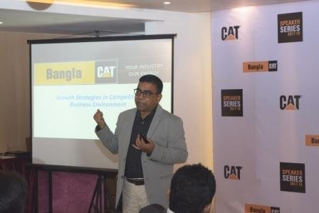

Chapter 5:
Findings From Internship at Acorn Infrastructure Services Ltd.


Major Findings through Internship at AISL

In my internship at AISL, Different issues were observed by me. These are:

- Managing Director has the complete rights and authority to approve the final decisions. Then after receiving approval from the Managing Director, HR Division starts all their duties as they are advised.

- AISL doesn’t have any online requisition process. For example, manager of sales in Gulshan, raises a requisition form. He must send this requisition form through their internal mail service. If there is any strike or hartal, that day is hard to conduct any recruitment activities. As a result, recruitment process goes to delay.

- HR division of AISL has poor way of maintaining resumes correctly. They often lose their resumes for their poor way maintain. Sometimes they just ignore the resumes for this.

- There is only one senior executive in their HR department. That one employee does the whole recruiting and selecting process alone. So sometimes that one employee has to face huge pressure for the lack of employee.

- AISL doesn’t publish their advertisement on their own website rather on the other source of job site.

- AISL doesn’t take any written exam for any employee. They just take interview for several times.

- The company has a good way of maintaining good working environment, health & safety procedure.

- Managing Director has the complete rights and authority to approve the final decisions. Then after receiving approval from the Managing Director, HR Division starts all their duties as they are advised.

- AISL doesn’t have any online requisition process. For example, manager of sales in Gulshan, raises a requisition form. He must send this requisition form through their internal mail service. If there is any strike or hartal, that day is hard to conduct any recruitment activities. As a result, recruitment process goes to delay.

- HR division of AISL has poor way of maintaining resumes correctly. They often lose their resumes for their poor way maintain. Sometimes they just ignore the resumes for this.

- There is only one senior executive in their HR department. That one employee does the whole recruiting and selecting process alone. So sometimes that one employee has to face huge pressure for the lack of employee.

- AISL doesn’t publish their advertisement on their own website rather on the other source of job site.

- AISL doesn’t take any written exam for any employee. They just take interview for several times.

- The company has a good way of maintaining good working environment, health & safety procedure.

Chapter 6:
Suggestions for Improvement and Conclusion



Suggestions for improvement

I have some suggestions for Acorn Infrastructure Services Limited, for their improvement after completing internship program. These are:

- Online requisition system should be followed by AISL HR Division so that they can get requisition form immediately and make it easy for them.

- Internal network properly for recruitment advertisement should be exercised by HR Division. Now they can post recruitment advertisement on their website. So that when applicants visit their website can get information easily.

- There need enough space for HR Division to maintain CV bank. This will make you find easily those employees CV’s.

- There should always be fair in viva so that AISL doesn’t lose their appropriate candidates.

- Rejected candidates should be informed for their awareness. They can also be informed through email at least.

- HR division should also use less paper using during its recruitment and selection process.

- There should take some arrangements for of training for interns so that they can get proper knowledge about their area.

- There should also need some training for its managers for their better interviewing.

Conclusion

Recruitment is an important issue for any organization. Recruitment and selection allows an organization to choose the best personnel who will lead the organization in future, assess the vacancy also. So the organization should give more emphasize on selecting a person. A person who can carry forwarded the organization in terms of development, values and ethics. Mainly the precious resource is the knowledge based efficient workers for any organization. The organizations should more cautious on this issue to ensure the quality and ethics.

Human Resource is not the head count of people working in an Organization. It is sum total of their knowledge, skill, creative abilities, talents and aptitudes as well as their values attitude and beliefs and positive frame of mind.

A person who can carry forwarded the organization in terms of development, values and ethics. Mainly the precious resource is the knowledge based efficient workers for any organization. The organizations should more cautious on this issue to ensure the quality and ethics.

Mainly the precious resource is the knowledge based efficient workers for any organization. The organizations should more cautious on this issue to ensure the quality and ethics.
Human Resource is not the head count of people working in an Organization. It is sum total of their knowledge, skill, creative abilities, talents and aptitudes as well as their values attitude and beliefs and positive frame of mind.

So the organization should give more emphasize on selecting a person. A person who can carry forwarded the organization in terms of development, values and ethics. Mainly the precious resource is the knowledge based efficient workers for any organization.

The AISL, Flagship Company of Bangla Trac, is a power generation and transmission company.
So they have so many project of those on AISL.

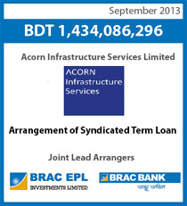

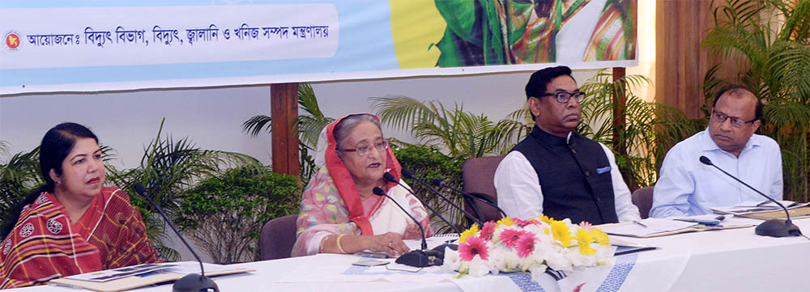

Chapter 7
Appendices

Employee Satisfaction Survey

Please rate the following items on a scale from 1 to 5, with 1 being “strongly disagree” and 5 being “strongly agree.”

I am satisfied with the level of work that is each day expected of me.
 | 1 | 2 | 3 | 4 | 5
The training which Is received by me, adequately prepared me for this position.
 | 1 | 2 | 3 | 4 | 5
My work environment is allowing me to do my job without difficulty and it is very comfortable.
 | 1 | 2 | 3 | 4 | 5
The equipment I use makes my job stress-free because of the well functions.
 | 1 | 2 | 3 | 4 | 5
During my workday, my supervisor is always available to answer any questions that I may have.
 | 1 | 2 | 3 | 4 | 5
I always feel as though I am a part of the team.
 | 1 | 2 | 3 | 4 | 5
There is always reward for hard work and attention to detail.
 | 1 | 2 | 3 | 4 | 5
The pay and benefits of this company are reasonable.
 | 1 | 2 | 3 | 4 | 5
I am motivated to come to work every day.
 | 1 | 2 | 3 | 4 | 5
There are ample opportunities for promotions within this company I believe.
 | 1 | 2 | 3 | 4 | 5
I would definitely recommend my family and friends to apply for a job here.
 | 1 | 2 | 3 | 4 | 5

After several different queries here is the survey result of Customer Satisfaction at Acorn Infrastructure Services Limited. The overall satisfaction score of Acorn Infrastructure Services Limited is 4.09 out 5 scales.

References

http://www.btraccl.com/
https://www.linkedin.com/company/acorn-infrastructure-services-ltd.
http://www.aisl.com.bd/
https://en.wikipedia.org/wiki/Electricity_sector_in_Bangladesh
https://www.sciencedirect.com/science/article/pii/S1876610217302230
https://www.facebook.com/banglacat.trac/



