RECRUITEMENT & SELECTION PROCESS:
A STUDY ON BANGLADESH DIGITAL EDUCATION RESEARCH LIMITED


This report is submitted as a partial fulfillment of the degree of Master in International Human Resource Management

Jannatul Fardush Boby
ID No. 115191001
MIHRM Program



School of Business & Economics
United International University

25th July 2020

Table of Contents
Sl. No. | Particulars | Page No.
 | Letter of Acceptance | I
 | Declaration | II
 | Acknowledgement | III
 | Executive Summary | IV-V
Chapter 1: Introduction
1.0 | Background of the study | 1-2
1.1 | Origin of the study | 3
1.2 | Literature Review | 4
1.2 | Objectives of the study | 9
1.3 | Scope of the study | 9
1.4 | Methodology of the study | 9-10
1.5 | Limitations of the study | 11
Chapter-2: Profile of Bangladesh Digital Education Research Ltd.
2.1 | Background of the company | 12-13
2.2 | Introduction to Schools and college | 14-15
2.3 | Objectives of the Bdeducation | 16
2.4 | Organogram of Bdeducation | 17
2.5 | Functions of the Bdeducation | 17-20
2.6 | SWOT Analysis of Bdeducation | 21
Chapter- 3: Recruitment and Selection process of Bdeducation
3.1 | Definition of Recruitment | 22
3.2 | Recruitment Philosophy of Bdducation | 22
3.3 | Mode of employment of Bdeducation | 23
3.4 | Source of Recruitment of Bdeducation | 23
3.5 | Mode of Recruitment of Bdeducation | 24
3.6 | Recruitment Process of Bdeducation | 25
3.7 | Definition of Selection | 25-26
3.8 | Selection process of Bdeducation | 27-28
3.9 | Job Analysis of Bdeducation | 29-30
3.10 | Evaluation of Recruitment and Selection process of Bdeducation | 30-36
Chapter-4: Summary and Conclusion
4.1 | Summary of the Findings | 37
4.2 | Recommendations | 38
4.3 | Conclusion | 39
 | Bibliography
 | Appendix
 | Questionnaire’s

Letter of Acceptance

This is to certify that Boby Jannatul Fardush, ID No. 115191001, MIHRM Program, School of Business & Economics, United International University (UIU) has successfully completed her project work under my supervision.

The title of his report is “Recruitment & Selection Process: A study on Bangladesh Digital Education Research Ltd. (Bdeducation)”

I wish her a total success in life.

------------------------------------
Dr. Farid A. Sobhani
Professor
School of Business & Economics
United International University (UIU)
Email: drsobhani@uiu.ac.bd

I

DECLARATION

I, the undersigned, hereby declare that I have completed my project under the supervision of Dr. Farid A. Sobhani, Professor, School of Business & Economics, United International University (UIU), Dhaka, Bangladesh.

I have prepared a report on “Recruitment & Selection Process on Bangladesh Digital Education Research Ltd. (Bdeducation)” that is my own work.

Neither part of this report is copied from elsewhere nor submitted before for any academic qualification, certification, diploma or degree to any other university.

Name: Jannatul Fardush Boby.
ID No. 115191001
Program: Masters in International Human Resource Management (MIHRM)
School of Business & Economics
United International University

II
Acknowledgement
The successful accomplishment of this project work is the outcome of the contribution of the number of people, especially those who have given the time and effort to share their thoughts and suggestions to improve the report. In the beginning, I would like to pay my humble gratitude to the Almighty for giving me the ability to work hard under pressure. This is a great pleasure for me to be assigned under the guidance of Dr. Farid A. Sobhani, Professor, School of Business & Economics, United International University (UIU), Dhaka, Bangladesh. I am very grateful to him for all his kind cooperation and guidance in preparing this project paper. His valuable suggestions & guidelines helped me a lot to prepare this report in a well-organized manner. Then, I would like to give special thanks to my Supervisor, Jashodhan Saha, Managing Director in Bdeducation, for his close supervision. And also I convey my gratitude to Sharmin Yusuf, Director in Bdeducation, for helping me by providing guidelines for working throughout my project work period. Without their guidance and assistance, this report would not have seen the light of day. I would also like to thank the authority of United Trust for giving me the opportunity to do my project work in this well.

Finally, I would like to thank all those people who have shared their views about my work, provided me with the necessary information, criticized me, and congratulated me. This acknowledgment is not enough to tell them how profound the impact of their opinion is on this report, how indebted I am to them. I express my heartiest gratitude to all of them.

III
Executive Summary
Bdeducation Limited is not an exception to the dynamic world of digital education where they stand with a mission of “Excellence in education”. Bangladesh Digital Education Research Limited (Bdeducation) is a pioneer and a leading organization especially catered to provide various services for educational institutions from classes PG to XII to aid in developing students to be more responsible, caring, and career-oriented. We help to design and developing practical, aesthetic, and secure environments for students so that they feel the enthusiasm and interest that they need to come to school. They also provide interesting, pragmatic, and digitalized academic content appropriate for each class which is developed based on an ICT oriented pedagogical framework. Their school automation software and mobile applications include the necessary functional features to help smoothly run all day-to-day school activities; all brought together by a modern and easy-to-use layout. One of their more unique services includes the “Age-Based Skill Development Program” which focuses on different developmental areas of a student, namely Mathematics, English, and ICT. In addition to that they have an elaborate “Teacher Training Program” and a “Teacher Performance Evaluation Software” organized and developed through research and scientific analysis.
Today they have about 50 dedicated and experienced staff whose sincere and tireless effort to develop the best educational products and services and to promote seamless interaction with our clients (at present they are providing their services for 7 schools and colleges) makes them unique in the educational arena.
HR activities are one of the major activities of an organization. Bdeducation HR department is an ideal place for learning HR related activities thoroughly. An excellent team of management of the HR division conducts all the HR-related issues. Their dedicated work makes them possible to get suitable people for suitable positions. They maintain an actual flow of each and every step of the Recruitment and selection process. They conduct recruitment activities for teachers and staff of every school and college outside Dhaka. Their only goal is to improve the quality of education by providing services to institutions outside Dhaka through highly educated people. Therefore, they have to consider many aspects of the recruitment and selection process. As a pioneer and a leading organization work pressure are very high in Bdeducation, so they need highly professional people who are very dedicated to their work, otherwise, the whole operation will mess up. This is a great challenge for any organization to find out such talented people. Bdeducation practices both the recruitment and selection process,
IV
but as it is a huge organization, the process differs for different job positions. Quality of service depends on the competence and the quality of the employees of the organization. Therefore, the authority of bdeducation has to be careful in recruiting the right person for each job. Though the overall recruitment and selection process of the bdeducation is a well-organized process but still there is scope for improvement. The policy and process should be revised. So although the process they have been adopting so far has been somewhat effective, to adapt to the changing times, the process should be revised and streamlined. By developing strategies to overcome the limitations, Bdeducation can make the recruitment and selection process more effective.

V

CHAPTER-1
INTRODUCTION

1
INTRODUCTION
1.0 Background of the study

HR’s main role in an organization is to recruit the right staff and encourage employees to work by providing appropriate salaries and rewards depending on their performance. The HR panel performs effectively all the activities of an organization.
The requirements of the employees of all the departments of an organization are fulfilled by HR. Human resources are at the center of an organization's development. Institutional development is not possible without proper evaluation of these human resources. Human resources can be properly evaluated through the staff selection process. So it can be said that the success of the organization depends on the skilled human resources. Human resource management, or HRM, is defined as the process of managing employees in an organization and may involve hiring, firing, training, and motivating employees.
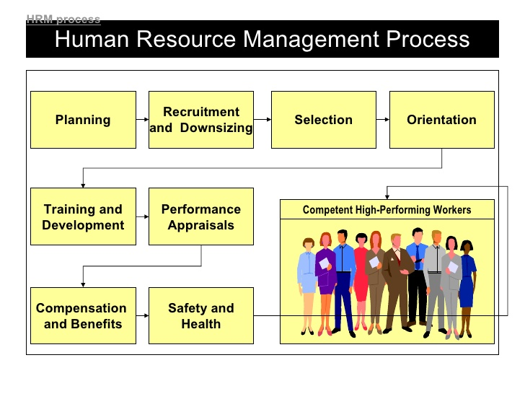
It is never possible to run an organization properly without suitable staff. A skilled worker can help the organization achieve its goals by creating skilled teams. For that, strategic planning must be needed in recruiting and selecting skilled and qualified employees for any organization.

Exhibit 1.0 Recruitment & Selection Process

The recruitment process is to indicate the appointment of a person or group for a particular position. Applications are collected from the job seekers through the recruitment process and the best candidates are selected through the selection process. If the selection process is not
2
correct then the purpose of the organization may be undermined. Recruiting and retaining staff is a very important step for any organization. In a word, this process can also be referred to as finding new employees in an organization.
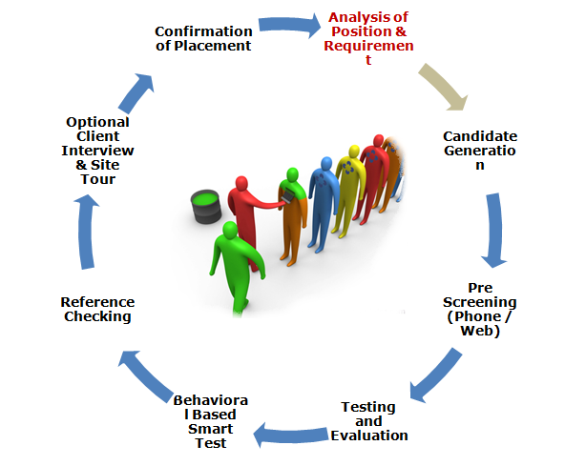

Exhibit 1.0 Recruitment & Selection Process

Without a reliable and uplifting electoral system in the current world market economy, no institution can ever develop, especially one that is highly competitive. Typically after the successful completion of the recruitment, selection process the new employee needs to be developed to fit the job and the organization better.
Bangladesh Digital Education Research Limited has a skilled human resource division. HRD selects and trains manpower to achieve its ultimate goal through a precise and systematic recruitment and selection process.
Since Bdeducation manages the digital education system in rural areas, they are very careful in the selection and recruitment process of staff.

3
1.1 Origin of the Study

This report is prepared based on "Recruitment and Selection Procedure of Bdeeducation ". Here I Included two years of practical work experience related to MIHRM in an organization. The report has been supervised by Dr. Farid A. Sobhani, Professor, School of Business & Economics, United International University (UIU), Dhaka, Bangladesh. The report contains details of the work experience with the employees of the organization and the activities of this organization.
LITERATURE REVIEW

2.0 Introduction

In the 1st chapter, I am trying to introduce the research goal and objectives and try to present some overview of the company of this report. Now, this chapter I will try to review employee recruitment and selection process in organizations and from the perspective of human resource management. The development of a conceptual framework is also included.
2.1 The concept of Recruitment and Selection

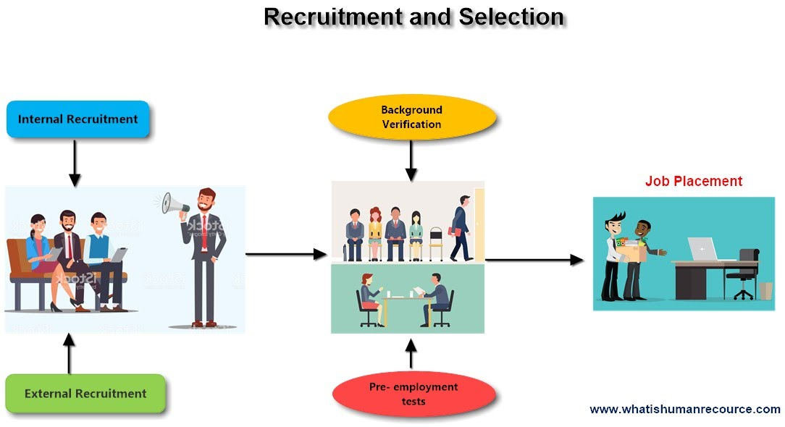
Recruitment and selection
If Recruitment is like a torch, employee selection is a shadow of that torch. Recruitment and selection is the process of identifying the need for a job, defining the requirements of the
4
position and the job holder, advertising the position, and choosing the most appropriate person for the job. When HR planning indicates the need for additional labor, organizations have a number of choices to make. This may be the first step in a full-scale recruitment and selection process. Recruiting employees with the correct skills can add value to a business and recruiting
workers at a wage or salary that the business can afford, will reduce costs. Employees should, therefore, be carefully selected, managed and retained, just like any other resource.

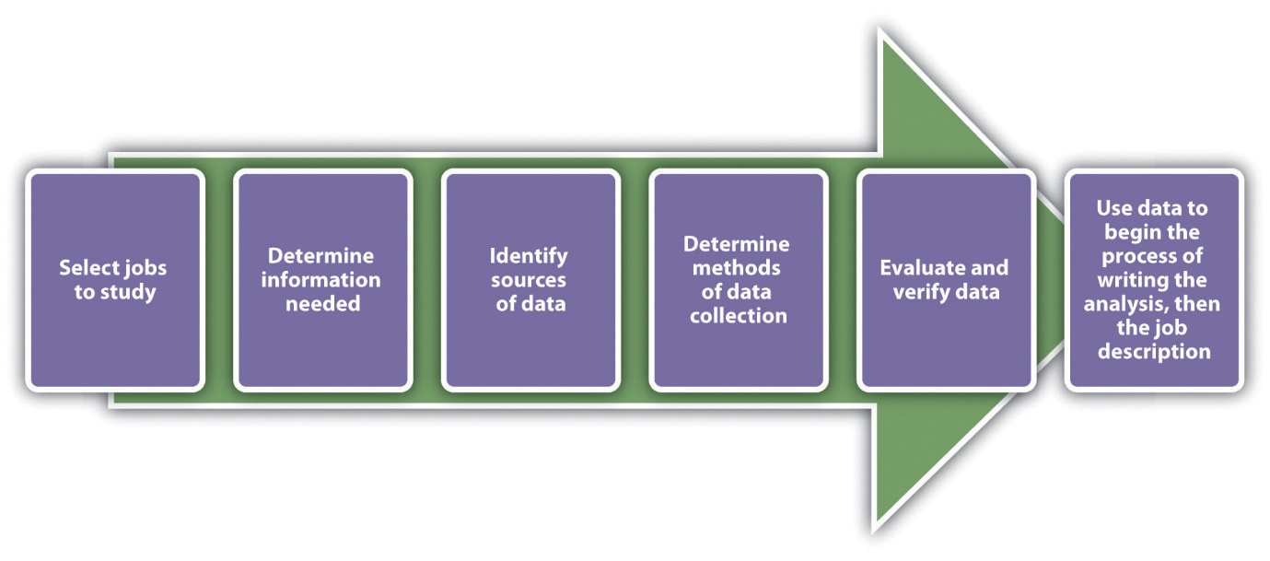
Image: Recruitment Process

2.1.1 What is the Meaning of Recruitment Process
The recruitment process means selecting the right person at the right time for the right place. In HRM recruitment is the process means- finding and choosing the best and experienced candidate for the right position. The process of Recruitment can be of three types-
Planned, Expected and unexpected
Planned recruitment means,
According to the need of the organization, advertisements are given for the recruitment of staff through various sources and suitable candidates are recruited for a specific post through written and oral examinations.
Expected recruitment means,
When a suitable and skilled employee can be recruited for the right position as per the demand of the company, it is called expected recruitment.
Unexpected recruitment process
When staff is recruited only through oral interviews to meet the immediate needs of the organization. This type of recruitment is more likely to be unexpected because the focus is not
5
on the performance, qualifications, or experience of the employee. Until then, employees were hired on an emergency basis only to perform the duties of the organization.
Recruitment is a very important process. There are a number of reasons why recruitment is important, Such as-
- Set various action plans to ensure the success of the organization and manage accordingly.
- To ensure that the recruitment of staff is efficient and precise
- In order to run the organization properly, special attention should be paid to ensure that the rules and regulations are followed properly.
- To form an efficient team to achieve the goals of the organization
Employers can achieve their goals through 5 important guidelines - planning, strategic expansion, exploration, selection and evaluation and organization. There are many sources of recruiting potential employees but all of them can be grouped into two categories, namely.
2.1.1.1 Internal Sources of Recruitment:
The internal source refers to those employees who are already working in the company. An employee who is working in the company is selected to another branch of the company through promotion or transfer. Most of the organization depends on this source. They believe that a person who has knowledge of all aspects of the organization and is qualified enough to work will play a significant role in the development of the organization. If the internal staff can be developed with new training, they will be able to prove themselves as an active and qualified person. Recruitment from internal sources is done to fill up vacancies through promotion, re-hiring, and transferring employees within the organization.
Internal Sources of Recruitment
1. Organizational Database
2. Job Posting
3. Promotions and Transfer
4. Employees Focused
5. Employees Referrals
6. Re-recruiting former Employees & Applicants

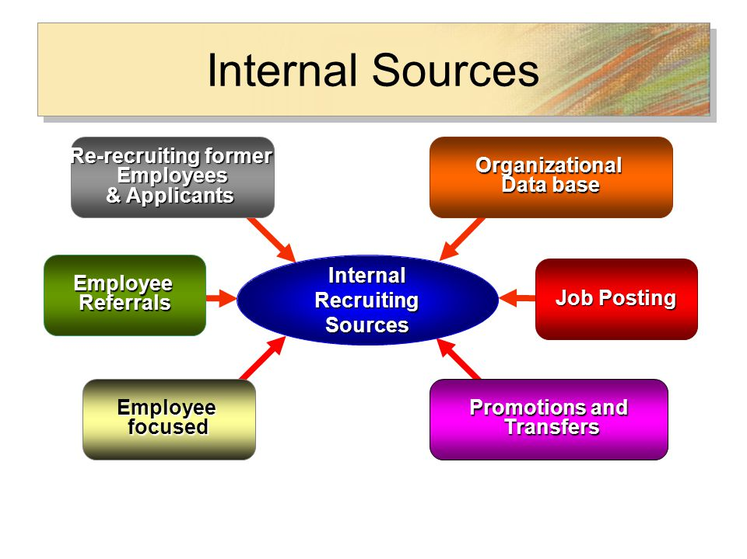
6

Characteristics of Internal Sources of Recruitment
- Internal recruitment is a Quick process.
- Cheaper than the external recruitment process.
- Works as a tool of motivation for the staff.
- The company’s choice is limited to existing employees of the company.
- It will be a lost project of Hiring fresh employees
Advantages of internal sources of recruitment
- Internal selection in the organization is a simple process. In this process, the employee is assigned to another department of the company considering the skills and qualifications.
- Internal recruitment plays a very important role in boosting the morale of the staff. As a result, this process creates more focus on the work of existing employees in the organization and creates opportunities for promotion to higher positions.
- Since the existing employees of the company are aware of all the internal work, it is not a problem for them to adapt to the new job and it takes less time.
7
- They do not need to be given any new training in case of the transfer of internal employees.
- Since the management has an idea about the work skills and experience of every employee working in the organization, it is very easy to determine which employee is suitable for which position.
However, there are some shortcomings in the recruitment of internal staff. For example, it is only because of being involved in the work of the organization for a long time to hire employees who are often not qualified. It does the company cannot be associated with new employees or new ideas.
2.1.1.2: External Sources of Recruitment
External sources of recruitment mean finding out candidates through advertisements from various sources and recruiting them to consideration of qualifications and experience through written test or interview.
Sources of external recruitment
- Schools Colleges & Universities
- Professional Organizations
- Employee Leasing
- Unsolicited Applications
- Media sources and Job Fairs
- Placement Agencies
- List of applications
- Temporary workers etc.
Whereas, external recruitment provides a wider collection of potential employees with the necessary skillset. It has proven to be a successful recruitment process when hiring for managerial and technical positions.

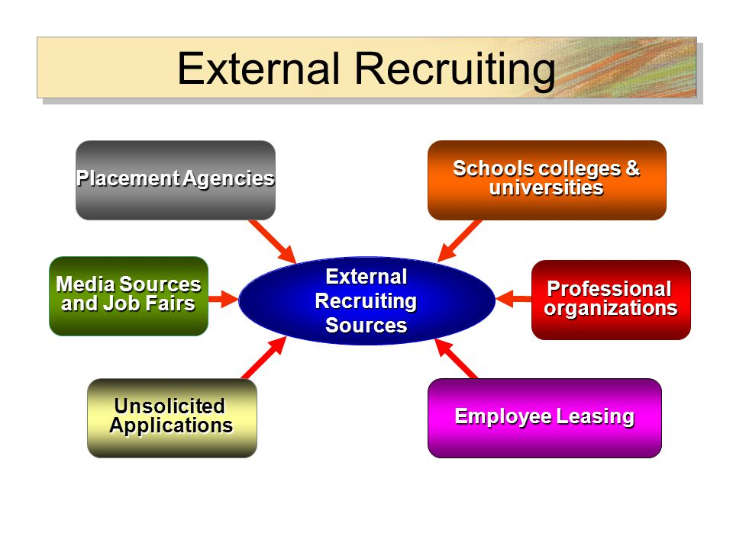
8

Benefits of External Sources
- The innovation of work is found in the organization through the recruitment of staff from External resources.
- We can get ideas about different new experiences.
- In the case of hiring employees from external resources, the best employee can be selected from among many types of candidates.
- Recruitment in a temporary manner gives an idea about the efficiency and competence of the employee. In this case, if it is good, the employee can be hired permanently. And if the qualification is not completed, a new appointment can be made. This opportunity is not available in the internal source.
There are also some problems with recruitment staff from external sources. Failure to hire the right staff can lead to various forms of harassment in the organization. Recruiting staff from external sources is a time consuming and costly process, so it can waste both valuable time and money of the organization.
Characteristics of External Sources
- It is a very time-consuming process.
- It is a costly process.
- When external people are given opportunities over them, then existing workers lose morale
- Hiring new employees can lead to the introduction of new experience and thus the introduction of a new set of skills and ideas.
9
1.2 Objective of the Study
Objective of this study are grouped in two, Broad objectives and Specific studies.
1.2.1 Broad Objectives:
- To know about the digital education system
- To make familiar with the terms that I have studied during MIHRM program.
- To gather practical knowledge on the digital education system of Bangladesh.
- To fulfil the partial recruitment of MIHRM degree.
1.2.2 Specific Objectives:
- To know the recruitment philosophy of Bdeducation..
- To know the mode of employment of Bdeducation
- To know the source of recruitment & selection of Bdeducation.
- To know the recruitment & selection process of Bdeducation.
- To appraise the recruitment & selection process of Bdeducation
- To suggest necessary measures for improving the recruitment & selection process of Bdeducation.

1.3 Scope of the study

When I worked at Beducation Limited, I had many opportunities to learn more about this subject. The report does not cover all the work related to human resources in conducting bdeduction but only discusses the recruitment and selection process. So I needed to take an interview with Samira Mishkat, the coordinator of United Trust, to find out more information about the recruitment and selection process. The information she provided helped me a lot in creating this project.

1.4 Methodology of the study
Research methodology is a method to solve the research problem systematically. It involves gathering data, use of statistical techniques, interpretations and drawing conclusions about research data. Keeping in view the objectives of the study, data is collected from different sources.
The primary purpose for applied research is discovering interpreting and development of methods and systems for the advancement of human knowledge on a wide variety of scientific matters of our country and the world.
10
GOAL
To analyze the recruitment and selection process of IT personnel and the Academic Personnel in Bangladesh Digital Education Research Ltd. (Bdeducation). And to observe what kind of processes should be followed
- Research Design:
Descriptive research
- Sources of Information
The primary sources and the secondary sources was used to collection of data about the organization of Bdeducation.
- Primary Data:
Based on Questioner and Interview
- Secondary Data:
Based on Books, Prospectus and Online

- Primary Sources | - Secondary Source
- Talking with the employees in face to face  - Talking with the management of Bdeducation  - Collect data over the phone call  - Work in practical  - Visit Schools and colleges. | Internal Sources  - Companies Prospectus  - Different files and documents  External Resources  - Online Resource’s  - Company Website  - Institutions Facebook page.

- Primary Sources:
The primary information collected through face to face interview, observation, visiting different schools and colleges which is situated at the outside of Dhaka. Talking with the Managing Director and Director of the Bdeducation Limited when I fell need.
Bdeducation management and institution head help me a lot to prepare this report by providing more information.

11
- Secondary Sources:
The secondary information collected from the website, Facebook page, prospectus, brochure, internal database, and some other relevant resources. Both primary and secondary data sources helped me to prepare this report.

1.5 Limitations of the study

The main limitation of the study was to collect data from various educational institutions involved in providing digital education systems. Gathering this information was the biggest challenge for me. Because of the current Corona situation, visiting institutions outside Dhaka was a challenge for me. Moreover, since all office activities inside Dhaka are closed, most of the time I had to talk on very time-consuming phone calls.

CHAPTER-2
Profile of Bangladesh Digital Education Research Ltd.

12

2.1 Background of the company

Bdeducation is an organization that introduces the digital education system. It is a sister concern of United Trust. The main objective of this organization is to educate the boys and girls of remote rural areas in modern education through digital education. So That all those rural children can get modern education like the boys and girls of the city and make themselves future successors.
To keep pace with the boys and girls of the city, they too can prove themselves in various professional competitions and establish themselves in various prestigious institutions in-country and abroad.

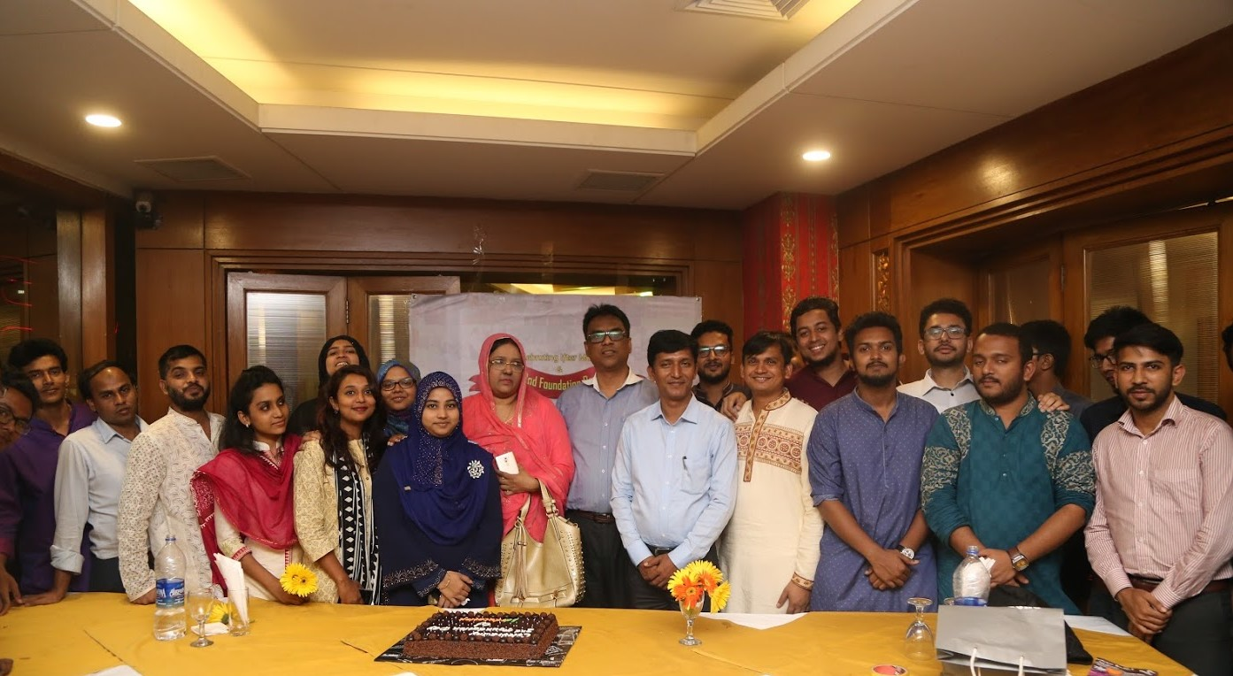
TEAM of BDEDUCATION

Bdeducation has been working on this pledge since 2016. BdEducation is being run by three Board of Directors. They are-

13
BOARD OF DIRECTORS


Engr. Suman Ahmmed

Chairman, bdeducation

MSc. and BSc. Engg. CSE BUET

Founder Trustee, United International University (UIU)

Member, Managing Committee, ABIS, MARMA, MKMA, RMA, YKMC

Director, CDIP, UIU and Senior Faculty, CSE, UIU


Jashodhan Saha
Managing Director, bdeducation
M.Sc., B.Sc. (Hons.) in Mathematics, University of Dhaka
MBA (Finance)
Faculty of Mathematics, United International University (on leave)
Former Coordinator, CDP Program, Scholastica
Former Faculty, O & A level Program, Scholastica



Engr. Sharmin Yusuf

Director, bdeducation

BSc. Engg. EEE, BUET

Former Senior System Analyst, ROSC, LGED (World Bank Funded Project)

Former GIS Specialist, LGED

14
At present they have about 23 employees. Since the educational activities are being provided digitally, the number of IT workers in this organization is high. Such as Software Engineer, Content Developer, Front End Developer, Graphics Designer, Multimedia Analyst and Animator, Distance Learning Monitoring Team.
2.2 Introduction to schools and colleges run by Bdeducation

BdEducation is currently providing digital education in different districts outside Dhaka. Below are some descriptions of their digital educational institutions.
- Asiya Bari Ideal School (ABIS)
Ashiabari Ideal School is located in Pakundia Upazila of Kishoreganj district. Since 2016, Bdeucation has been responsible for providing overall education in this school. These include integrated management software, a state-of-the-art computer lab, digital content, CCTV facilities, solar power systems, RFID facilities for students and teachers, attendance machines, improving administrative management, and most importantly to appoint teachers/staffs.


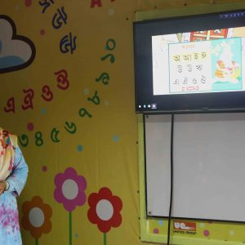
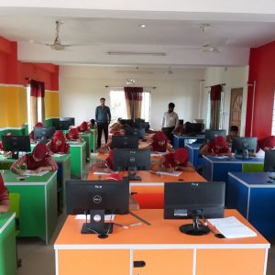

School Campus Digital Classroom Computer Class

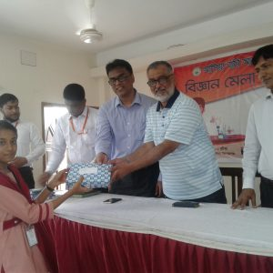
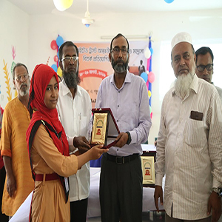


Inter-school
Competition
Teachers Training
Public speaking
Award Distribution

15
2. M A Rashid Memorial Academy (MARMA)
M.A Rashid Memorial Academy is located in Jamalpur. This educational institution is being run by United Trust's sponsorship and management of bdeducation. After taking the responsibility for the overall education of this school, bdeducation is working to develop and implement effective management, administrative and physical infrastructural reforms to build the school as an information technology based, modern, contemporary and responsible educational institution.
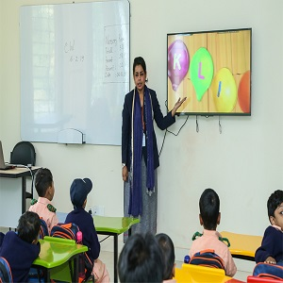
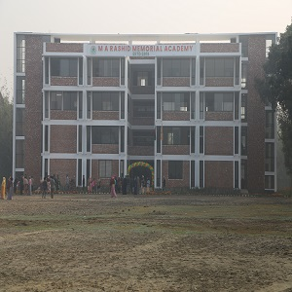
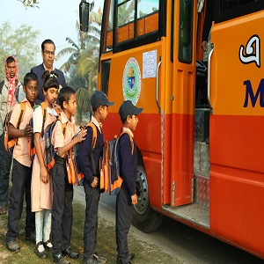

Transport
Classroom
School Campus

- Nizkunjara KG Ideal School (NKAB)

Nizkunjara KG Model School is located in Chhagalnaiya upazila of Feni district Immediately after taking responsibility for the overall education by bdeducation, the educational institution has taken necessary reforming activities for modernization.

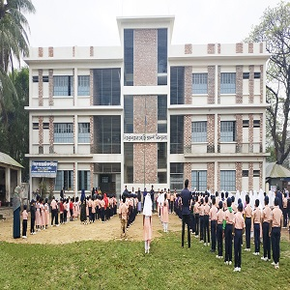
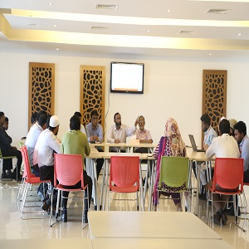

School Campus Classroom Teachers Meeting

- Mahmuda Khanam Memorial Academy (MKMA)

Mahmuda Khanam Memorial Academy, established in 2018 in Louhajang upazila of Munshiganj district. Since taking responsibility of this school, Bdeducation has started activities for the development of all the physical infrastructure, digital education system and overall management of the school.
16

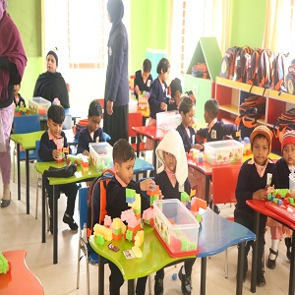


School Campus Classroom Co-curricular Activities

- Yunus Khan Memorial Academy (YKMC)

Yunus Khan Memorial College was established in 2019 in Louhjong Upazila of Munshiganj district. The main goal of Yunus Khan Memorial College is to inculcate in the student's human values, awareness, sense of responsibility, good citizenship, and above all skills to survive in a modern technology-dependent and competitive world. Apart from skilled and experienced teachers, Bangladesh Digital Educational Research Limited is working tirelessly to manage the overall activities of the school.


2.3 Objectives of the Bdeducation
- Providing digital education in remote areas
- To educate rural children in advanced education.
- Bring change in the education system
- To shape a better future by providing all-round educational services in order to meet international compliances while preserving our culture and tradition.
- To establish and promote interesting and modern educational systems by integrating ICT oriented pedagogical infrastructure that allows all children to experience learning success.
17
2.4 Organoram of the Bdeducation

Bdeducation Financial Organogram

Bdeducation HR Planning

2.5 Functions of the Bdeducation

- Academic framework with digital content.
- They have developed a ground breaking school management software that simplifies faced in everyday school operations, including academic, administrative
and financial management.
There are some more activities which are done by bdeducation through school management software-
18
- Students and Teachers Profile
- Class routine management
- Student attendance management
- Examination Management and Result Generation
- Scholarship and Fees Management
- Regular student Monitoring and Assessment
- Teachers preparation and class monitoring
- IT Survey
- Staff leave management
- Budget management
- Staff Payroll Management
- Asset Management
- Library Management
- Hostel Management
- Mobile Apps for school: - This is a mobile app developed by bdeducation for monitoring student’s activities and performance records, such as-
- Attendance
- Exam results
- Class routine
- Notice
- Tuition fee details
- Mathematical Deficiency Identification & Skill Development Program (MDI & SDP): Mathematical Deficiency Identification & Skill Development Program (MDI & SDP) is designed to help students those who are struggling with Mathematics learning and suffering from math’s anxiety. Bdeducation has developed age based different types of tests to identify the level of deficiency and anxiety in Mathematics that students
may encounter in their academic life and provided many remedial programs to overcome these problems.
- Age based skill development program:- We are providing research and age based skill development lessons and labs in IT and innovation, communications, mathematics, ethics and health for students.

19
- Development Programs
- IT and Innovation Development program (IIDP)
- English Communication Development Program (ECDP)
- Mathematical Skill Development Program (MSDP)
- Bangla Communication Development Program (BCDP)
- Upcoming Programs
- Health Management and Monitoring Program (HMMP)
- Ethical and Social Development program (ESDP)
- Soft Skill Development Program (SSDP)
- Admission and Career Development Program (ACDP)
- Features of Skill Development Programs
- Research and age based curriculum
- Internationally compliant
- 30 lab classes per program
- 100 minutes per lab
- Teachers Training: There are some activities about Teachers Training which are done by bdeducation-
- Training on IT Adaptation
- Training on Digital Content
- Training on Adaptation of Total Quality Assurance and Monitoring Systems
- Training on Aged Based Skill Development
- Training on Classroom Management
- Training on Academic Subjects (Need Based)
- Training on Ethical Education
- Teachers Performance Evaluation System: There are some activities about Teachers Performance Evaluation System which are done by bdeducation-
- Evaluation by Students
- Evaluation by Principal/Headmaster/Managing committee
- Performance report generation
- Total Quality Assurance and Monitoring System: - There are some activities about Total Quality Assurance and Monitoring System which are done by bdeducation-
20
- Academic
- Exam Info Creation
- Examination Marks Entry
- Result/Report Card Generation
- Assigning Subject Teacher & routine creation, syllabus bookmarks distribution
- Class Routine Profile Creation
- Teacher’s Evaluation
- Classroom Activity Reporting
- Lesson Plan Progress Assessment
- Teacher’s Preparation
- Regular Student Monitoring & Assessment
- Weekly/Fortnightly/Monthly Teachers Meeting Minutes
- IT Services Monitoring
- Administrative
- Budget Management
- Payroll Management
- Asset Management
- Fees Management
- Scholarship Management
- Library Management
- Leave Management
- Administrative
- Special Module
- Extra curricular Module
- Hostel Management
- Evening Study Program
- Software Development and Customization
- Academic & IT Infrastructure Design: BDEducation works to make their institutions as modern which are located outside Dhaka. They are trying to taking great care of every part in the school and maintaining the quality of the equipment which are providing by the vendor. Such as-

- Furnished classroom, School auditorium
- Extensive library of textbooks
- Computer lab, Kids Zone, Cafeteria
- Uninterrupted power supply
2.6 SWOT Analysis of the Bdeducation

Now I am sharing Strength, Weakness, Opportunities and some Threat (SWOT) of the Bdeducation
Strength:
- Skilled IT & Faculty team
- Good Management
- Good Relationship with Management and Employees
- Cooperation with others
- Friendly environment
- Availability of resources
- They have a studio room for voice record which is used in digital content
Weakness:
- They have no office building of its own
- They have no provident fund and no gratuity policy
- They have no insurance policy for their employees
- They have to depend on the United trust in financial matters
- There is no transport of its own for visiting different schools outside Dhaka.
- They have no performance appraisal system for employees.
Opportunities:
- Opportunities have been created to work at the government level.
- There is also an opportunity to build a modern school in Dhaka
- A new modern campus is being built in Jamalpur.

Threats:
- As they have to pass a new budget every year, they often have to face different types of financial problems
- Being an online-based activity almost leads to network problems and disruption of work

CHAPTER-3
Recruitment & Selection Process of Bangladesh Digital Education Research Ltd.

22
3.1 Definition of Recruitment

- Edwin B. Flippo defined the recruitment process – ‘Recruitment is the process of searching the candidates for employment and stimulating them to apply for jobs in the organization.’
- According to Yoder Recruitment is a process to discover the sources of manpower to meet the requirement of the staffing schedule and to employee effective measures to attracting that manpower in adequate number to facilitate effective selection of an effective workforce.
- According to the Business Dictionary Employee selection as the “process of interviewing and evaluating candidates for a specific job and selecting an individual for employment based on certain criteria.”
So we can say that- Recruitment is a process through which a candidate pool is created by combining different types of applications. And from where the suitable staff is selected and recruited based on the needs of the organization.
3.2 Recruitment philosophy of Bdeducation
- In addition to recruiting staff within BDEducation's own organization, they also work on the recruitment of teachers and other staff in all institutions located outside Dhaka.
- Bdeducation always emphasizes on long term recruitment. BdEducation seeks to attract and select candidates who will work for the betterment of the organization in the future through organizational classification.
- Bdeducation is very careful in hiring employees. BdEducation Management plays an important role in the recruitment of teachers and other employees in schools are located outside Dhaka.

23
  - Mode of employment of Bdeducation

Bdeducation has seven types of employees-
- Casual
- Temporary
- Probationer
- Permanent
- Part Time
- Contractual
- Intern
3.4. Source of Recruitment of Bdeducation

Bdeducation uses a variety of sources for recruitment. Because they want to hire skilled and qualified staff for their organization. Since schools have to be run in a rural environment outside Dhaka, Bdeducation Management has to take up a variety of approaches in selecting staff. This is why they try to focus on different sources.
- Online source 'bdjobs' -
When the organization feels the need for some employees to manage their work, they advertise on Bdjobs. Bdjobs is a reputable job advertising site. By collecting advertisements in bdjobs, they collect applications from different parts of the country. HR then selects some applications to suit their needs. Then a shortlist is made by all these applications and in this way, they select the staff from Bdjobs.
- Online source "Facebook" -
Bdeducation also advertises for the required posts through their own Facebook page. And publishes job advertisements on the Facebook page as needed of each school they run.
- Internal Referral-
Internal Referrals - Bdeducation often recruits staff from within their own organization. They hire the best staff from their own sources for each level of work, thus avoiding the hassles of the recruitment process and promoting the employees of the organization according to their qualifications.

24
3.5 Mode of Recruitment

- Each candidate has to take part in a written test. Since BDEducation works to introduce the digital education system, they have to consider different issues in the written test. The Bdeducation Office has a large staff in the IT sector, so candidates who have passed in Computer Science and Engineering are preferred here. Preference is also given to candidates with experience in Animation, Multimedia Analyst, Android, Laravel, JavaScript etc.
- They also have an important contribution to make in the recruitment of teachers in every school run by BDAEducation. In the case of teacher recruitment, everything from written test to oral test, the presentation is conducted by BDEducation.
- In Bdeducation, the interview session is done in 3 steps-
- In the 1st step, the candidates are asked to participate in a written test through phone calls. And written examinations are held according to the subject.
- In the second stage, the oral examination of the candidates is taken. Candidates who have passed the 1st and 2nd stage are called for final presentation.
- In the 3rd step, the selected candidates are given a PowerPoint presentation. In this case, the presentation of the selected candidates is observed strictly. Since classes have to be conducted through PowerPoint presentations in every school, the presentation and speech style is very important at this stage.
- Appointment letters are given to the successful candidates on the same day.
- Each selected candidate is kept in the first three months' probation period. If the employee can show good performance, then he is made permanent. If the performance is not good, then the probation period stays for another three months.
- In the above manner, Bseducation conducts the recruitment process at institutions outside Dhaka in addition to their own office.
- Many times staff are recruited on an emergency basis only by taking viva. In this case, it is often not possible for the Bdeducation representative to go to their outside institutions. At that time, employees are recruited through Skype meetings from Dhaka which is conducted by the management of bdeducation.

25
3.6 Recruitment process of Bdeducation
The recruitment process of bdeducation happens in 10 steps of process. These steps are-
Identifying Job Recruitment

Recruitment planning

Preparing Job Description and Job Specification

Advertising the vacant position
Attracting Candidates to apply for Job
Application searching

Manage Applications
Shortlisting Candidates
Considering Employees Referral

Considering Directors Referral

Exhibit 4.6: The Recruitment Process of Bdeducation

3.7 Definition of Selection

Employee selection is an important, strategic, and complex process for any organization. Depending on the needs of the organization one has to select the right person at the right time for the right position. The main purpose of employee selection is, to recruit a person who has a proper assessment of the needs of the organization and his own.

26
Through strategic planning, only a suitable employee can form a suitable team and achieve the goal using the resources of the organization. For this, the right person has to be appointed for the organization. Through which the organization will be able to work properly in achieving its goals.
Different authors define selection differently. Here is a list of some definitions -
- Employee selection is about placing the right employee at the right time for the right position
- Selection of an employee to fill the vacancies of the organization by selecting the right and suitable employees from among the eligible applicants.
- Employee selection is a process that matches the needs of the organization and the performance of the individual.
- A selection process will be successful only if the employees can meet the needs of the organization properly.
Now we know the differences between Recruitment and Selection process.

Recruitment | Selection
It is an activity of establishing contact between employers and applicants. | It is a process of picking up more competent and suitable employees.
It encourages large number of Candidates for a job. | It attempts at rejecting unsuitable candidates.
It is a simple process. | It is a complicated process.
Recruitment is called as a positive process with its approach of attracting as many candidates as possible for the vacant jobs | Selection is called as a negative process with its elimination or rejection of as many candidates as possible for identifying the right candidate for the position.
Less time is required. | More time is required..
It is an economical method. | It is an expensive method.
It proceeds selection. | It follows recruitment.
The candidates have not to cross over many hurdles. | Many hurdles have to be crossed.

27
3.8 Selection process of Bdeducation
The current selection process of bdeducation is described below:

Inviting Application

Receiving of Application

Create Applicant pool

Scrutiny of Application

Written Test of Candidate
Employment Interview

Power Point Presentation
Checking References & Background Analysis

Job offer

Pre-Joining Documentation

Salary Negotiation

Provision Period

Exhibit 4.7: The Selection Process of Bdeducation

- 3.14.1 Inviting Applications:
Job seekers are invited to apply for specific positions through bdjobs and official Facebook page
28
- 3.14.2 Receiving of Application:
Applications for specific posts are received from Bdjobs. CVs are also collected from official emails and many people come directly to the office and submit their CV.
- 3.14.3 Create Applicant pool:
An application pool is created after collecting applications from all sources.
- 3.14.4 Scrutiny of Application:
After collecting the application forms from all the sources, a short list of candidates is made as per the demand of the organization. They sort the applications that have the actual qualifications (Degree, age, experience) for the post through the online system. Then these candidates are called for the written test via phone call
- 3.14.5 Written test of candidates:
After the initial selection, the next step is a written employment test. The written test is mostly taken to test the candidate's knowledge of the subject and his written communication skills. After checking and sorting the answer sheets and preparing the result sheets, the list of successful candidates is prepared and the interview is arranged.
- 3.14.6 Employment Interview:
Candidates who have appeared in the written test are taken viva on the same day. In Viva, candidates are monitored for communication skills, eye contact, body language, and subjective knowledge.
- 3.14.7 Power Point Presentation:
After passing the written test and the viva test, the finalists have to give a PowerPoint presentation on their respective subjects. PowerPoint education is conducted in the schools run by Bdeducation. So having experience with PowerPoint is a must.
- 3.14.8 Salary Negotiation:
The salary is discussed after the final selection.
- 3.14.9 Checking References & Background Analysis:
For experienced candidates in most cases, background check is another important check taken in the hands of the employer. This includes taking the former employer of the assistant referee, to make sure that the information given by the candidate is true. This check is done to know more about the candidate's interpersonal skills, performance, the position he/she was in, and such number.

29
- 3.14.10: Job Offer
The Head of HRD offers the job to the selected candidate after the final approval is obtained. HRD sends the job offer letter through the mail. The Chairman of the Board of Directors is the sole authority to sign an appointment letter.
- 3.14.11 Pre-Joining Documentation:

The following documents are collected from the candidates before they join:
- Verification of all certificates.
- Copy of Last Education and Professional certificates.
- Filled up setup papers (Service Recodes, Declaration of Fidelity, Employee Profile)
- Three Copies of passport size Photograph
- 3.14.12 Provision Period:
Those employees who do not have previous content making or IT experience have to serve a probation period for at least six months before getting confirmation as a full-time employee. Those who have experience and not necessarily need to be trained; he/she does go through the three months’ probation period.

So we can say that Recruitment is a process of attracting candidates towards a job in an organization. When a vacancy for a job exists recruitment is limited.
And Selection is process of hiring a right person to the right job at a right time at aright cost.
Selection follows recruitment.

3.9 Job Analysis of Bdeducation

Job analysis is the initial step in gathering information for any job. In addition to the type of job, job description and job specification can be found through job analysis, which will help to select and recruit employees are easy. Without knowing the type of job description and job specification it will never be possible for HR to hire the right staff for the organization. If you know the type and description of the job, you can easily manage the work of the organization by hiring the right person at the right time. The job description and job specification must be clearly stated in any job. Otherwise, job seekers will never know what kind of requirements they will need for a job. So it is considered an important task.

30
Job Analysis
Job Description
- Job Title
- Job Location
- Job Summary
- Reporting to
- Working Condition
- Job Duties

Job Specification
- Qualifications
- Experience
- Training
- Skills
- Responsibilities
- Presentation Skills

Exhibit: 4.9 Job Evaluation

3.9.1 Purpose of Job Description of Bdeducation

- The main purpose of the job description is to collect job-related data to advertising a specific job. It helps in attracting, targeting, recruiting, and recruiting the right candidate for the right job.
- This is done to determine what kind of responsibilities should be involved in a particular job.
- It gives the recruiting staff a clear idea of ​​what kind of candidate is required by a particular department or department to perform a particular job or task.
- Specifies what kind of conditions will apply to the job.
- In the case of employment, it is clearly stated in which area he has to stay
- He also clarified who will report to whom.
3.9.2 Purpose of Job Specification of Bdeducation
- The job specification helps the candidates to analyze whether they are eligible to apply for a particular job vacancy.
- It helps the recruiting team of a company to understand that any candidate must have a set of qualifications, qualities, and attributes present to qualify him.
- Job specification gives a detailed information on any job including job responsibilities, desired technical, presentation and physical skills, ability to communicate, and much more.
- This helps in selecting the most suitable candidate for a particular job.
31
3.10 Evaluation of Recruitment and Selection Process

The education sector in the country is getting better and better. As a proof of this, we can say that even in the current epidemic situation due to Covid-19, from the government to private educational institutions continue to provide education to the students using advanced technology and online methods. The education sector needs skilled human resources to run these activities smoothly. In addition to the current situation, skilled and qualified human resources are also needed to run an improved education system. Evaluating the recruitment and selection practices of an organization is not an easy task, as the final guidelines can be traced to any recruitment and selection practices. The organization cannot fulfill its responsibilities only through the recruitment and selection process. Appropriate evaluation is to be considered in the selection and recruitment of employees.

3.10.1 Evaluation of Recruitment Procedure

- Bdeducation uses internal functions for recruitment which ensures a recruitment process consistent with their needs.
- Since Bdeducation manages the recruitment process in their own way, they can customize this method as required.
- It is controlled and managed by the HR department.
- Beducation has its own internet server; They keep records of all workers in the internet system.
- HRDs transfer and input files to their system.
- This method can be a long process.

3.10.2 Evaluation of Selection Procedure

- The system of bdeducation is using for the recruitment and selection process is very efficient. It helps to HRD to find out candidate details easily.
- The selection process is a bit longer because they arrange a written test for huge candidates on time.
- Candidates appearing in the written test are informed for the next step.
- Those who are not selected do not receive any subsequent feedback.
32
Analysis

1. Sources used in recruitment and selection:
Which of the sources of recruitment and selection are used in Bdeducation?
- Internal
- External
- Both

Options | Internal | External | Both | Total
Responses | 15 | 8 | 0 | 23
Percentage | 70 | 30 | 0 | 100%

Chart:1 Sources used in recruitment and selection

Interpretation:
It was found that about 40% of the recruitment and selection is done by internal and 40% of the recruitment and selection is done by external sources, while internal and external source are more than both sources. Employee are hired mostly from United International University and mostly come from the reference by the internal employees which are the students of the UIU. Most of the employees are come from the UIU because the Chairman and the Managing Director are the direct related with UIU.

33
2. External sources used in recruitment:

The following external sources are used for the recruitment in Bdeduction-
- Advertisement
- Campus recruitment
- Internal employee’s referral.
- Internet
- All of the above
Table: 4.2.2
Options | Advertisement | Campus recruitment | Employees Referral | Internet | All of the above | Total
Responses | 4 | 9 | 5 | 3 | 2 | 23
Percentage | 20 | 40 | 25 | 10 | 5 | 100%

Chart 2. External sources used in recruitment

3 Employees perception about online recruitment process
Are you satisfied with the recruitment process?
  - Yes
  - No
Table: 4.2.3
Options | Yes | No | Total
Responses | 18 | 5 | 23
Percentage | 80 | 20 | 100%
34

Chart 3 Employees perception about online recruitment process

4 Methods used during selection process
The following methods does bdeducation uses during selection process
- Written exam
- Group discussion
- Personal Interview
- Group Discussion and personal Interview
- Presentation
- All of the above
Table 4

Options | Written | Group Discussion | Personal Interview | GD & PI | Presentation | All above | Total
Responses | 4 | 3 | 2 | 3 | 5 | 6 | 23
Percentage | 15% | 10% | 5% | 10% | 25% | 35% | 100%

Chart-4 Methods used during selection process
35
5 Perception of employees towards the selection process

Are the employees satisfied with the selection process?
- Yes
- No

Table: 5
Options | Yes | No | Total
Responses | 19 | 4 | 23
Percentage | 85 | 15 | 100%

Chart 5 Perception of employees towards the selection process

6 Labor Law practices in Bdeducation

How do you rate HR practices of the organization?

Sl. No. | Options | Respondents | In percentage
1 | Excellent | 12 | 50%
2 | Good | 6 | 30%
3 | Average | 4 | 15%
4 | Bad | 1 | 5%
 | Total | 23 | 100%

36

4.2.7 HR policy of the Bdeducation

Chart-6 Labor Law practices in Bdeducation

7 They hire staff on the basis of qualifications and skills.
What is the recruitment rate based on their qualifications and skills?
- Qualification
- Skills
- Boath
Table 7
Sl. No. | Options | Respondents | In Percentage
1. | Qualification | 7 | 30%
2. | Skills | 6 | 20%
3. | Both | 10 | 50%
 | Total | 23

Chart 7 HR policy practices in Bdeducation

CHAPTER-4
Summary and Conclusion

37
4.1 Summary of the Findings

- Bdeducation pays special attention to the quality of the selection staff.
- The employment opportunities in Bdeducation and the schools run by them are increasing day by day.
- There is no bias in the recruitment process of Bdeducation.
- They hire staff on the basis of qualifications and skills.
- The Management and HR Department of Bdeducation work honestly and impartially in the selection and recruitment of staff.
- Bdeducation plays an important role in the selection and recruitment of staff, it also takes great care in the retrenchment of staff.
- Bdeducation revised its HR planning according to the change in this fast-moving organization then it can be more effective and efficient.
- No study is conducted to justify the effectiveness of recruitment tests.
- HR of Bdeducation does not send the regret letters to the candidates who are not selected.
- Bdeducation always checks references properly, they think if they do not check reference properly then in future their employee selection will be wrong and the organization may face big trouble.
- Bdeducation give priority to recruits fresh graduates for entry-level. In case the efficient candidate is not available then they try to recruit experienced people from the same organization.
- Management does not provide any facilities to retain internal staff. There is no provident fund, no gratuity system for the job security of employees
- Bdeducation follows steps for recruitment & selection: initial screening, written test, viva voice, presentation, reference checks, and placement.
- The method of providing their digital education is quite standard.
- Bdeducation is a suitable institution for gaining a clear idea about staff recruitment and selection process.
- The number of female employees in Bdeducation is much less than that of male employees. In Bdeducation 60% of male staff and 40% of female staff.
- Bdeducation has less opportunity to recruit high ranking staff from among the internal staff.
38
4.2 Recommendations

In Bangladesh Digital Education Research Limited I gather the practical knowledge of human resource management. Though it’s my first experience, I gather some problems by discussing the Management of this organization. So I would like to recommend those problems as follows.
- Recruit efficient and eligible manpower in HRD to reduce the work pressure in the organization.
- Make a competitive and efficient salary structure.
- Provide some motivational or recreation and competitive activities with the employees.
- The online recruitment system is not upgraded. It has to be upgraded.
- More focuses to retain existing employees than to recruit new employees.
- Recruitment and selection process should be designed to attract more efficient, experience and eligible workers for the organization
- Every employee should have a provident fund, gratuity, or insurance to secure their future.
- Offices and staff must be managed in accordance with Bangladesh Labor Law 2006 and Bangladesh Labor Rules 2015.
- A proper HR policy should be followed.
- Every employee should be rewarded for good work
- It is better if the organization can arrange the training by identifying the weak side of the employees.
- Girls are no different from boys in terms of education and workability. Therefore, it is necessary to give enough importance to the recruitment of girls for employment.
- The studies are should be conducted to justify the effectiveness of recruitment tests.

39
CONCLUSION
4.3 Conclusion:

To survive in this competitive world, Bdeducation is formulating new strategies with new levels of skills in all educational fields. Bdeducation is working tirelessly to survive in a competitive market depending on the socio-economic context of Bangladesh and the current situation. The Bdeducation Team is working on the education sector for the children from growing up in the rural environment of the country with providing high quality and modern education. Even in the current Corona situation, quality education is being imparted to the village children through the use of various types of mobile apps, such as Facebook, WhatsApp, Imo, etc., including online live classes. To conduct all these activities, the organization has to be careful and tactful in selecting and hiring staff.
Recruitment of Bdeducation are satisfied with the current/existing recruitment and selection process.
There are some issues with staff selection in Bdeducation but they are encouraging that they are trying to overcome these barriers. Bdeducation should be more responsive in selecting employees to keep pace with current needs. The quality of service depends on the qualifications and quality of the employees of the company. Therefore, the authorities of Bdeducation have to be careful in hiring the right person for each job. I think the HR policy of Bdeducation is good, but if there is a problem, they should reduce it appropriately. In order to improve, they should develop their human resources properly.

4.4 Suggestion:
From the findings I can suggest to bdeducation following things for the more effectiveness of recruitment and selection process and HR policies: -
- Recruitment must be done by analyzing the job firstly which will make it easier and will be beneficial from the company’s point of view.
- The recruitment and selection procedure should not be too lengthy and time consuming.
- Provide training to employees so that they get better knowledge, skills and attitude.
- Organization should amend some parts of their HR policies for better effectiveness.
- Bdeducation should provide better rewards for retaining and attracting employees.
- Bdeducation must be followed by HR practices to run office management smoothly and efficiently.
- Keep stay in positive i\employees.
40
4.7 Bibliography:

References:
http://www.whatishumanresource.com/recruitment-vs-selection
https://www.tutor2u.net/business/reference/recruitment-selection-overview
IOSR Journal of Business and Management (IOSR-JBM) e-ISSN: 2278-487X, p-ISSN:
2319-7668. Volume 15, Issue 5 (Jan. 2014), PP 60-67
www.iosrjournals.org
https://open.lib.umn.edu/humanresourcemanagement/chapter/4-1-the-recruitment-process/
HUMAN RESOURCE MANAGEMENT
https://www.bdeducation.org.bd/bdeduwebsitefiles/marma.php
http://nizkunjarakgschool.org/
https://www.bdeducation.org.bd/bdeduwebsitefiles/mkma.php
https://www.managementstudyguide.com/difference-between-recruitment-selection.htm
Recruitment and Selection Tutorial
https://www.tutorialspoint.com/recruitment_and_selection/what_is_selection.htm
https://www.researchgate.net/publication/268210664_A_Study_On_Recruitment_Selection_Process_With_Reference

APPENDIX

4.8 Questionnaire:

Questionnaire:

Recruitment ad selection process of IT personnel in Bdeducation
This questionnaire survey is purely for academic purpose. Any information collected through this survey is confidential and would not be shared with anyone other than the people.
Q.1 Which of the sources of recruitment and selection are used in Bdeducation?
- Internal
- External
- Both
Q.2 Which of the following external sources are used in Bdeducation?
- Advertisement
- Internet
- Campus recruitment
- All of the above
- Internal employee’s referral.
Q.3 Which of the following methods are used in Bdeducation?
- Written exam
- Group discussion
- Personal Interview
- Group Discussion and personal Interview
- Presentation
- All of the above
Q.4 Which of the following methods are used in Bdeducation?
- Written exam
- Group discussion
- Personal Interview
- Group Discussion and personal Interview
- Presentation
- All of the above
Q.5 Are you satisfied with the selection & Recruitment process?
- Yes b. No
Q.6 How do you rate Labor Law practices in Bdeducation?
- Excellent
- Good
- Average
- Bad
Q.7 Are you comfortable with the HR policies in Bdeducation?
- Yes
- No

Job Circular: For the post of Lecturer/Asst. Professor at YKMC



****END****

