

United International University

Functions and Importance of Event Management:
The case of Rings N Roses

Submitted To

Muhammad Rehan Masoom
Assistant professor
School of Business and Economics
United International University

Submitted By

MD. Rakibul Islam Suvo
111 141 061
Major in Marketing
School of Business and Economics
United international University

Date of Submission: December 5, 2018

Declaration

I am MD. Rakibul Islam Suvo, declare that my present internship report title is “Functions and the importance of event management: the case of Rings N Roses”. I prepare this report after completing three months of working as a Marketing Officer in the Rings N Roses.
I also verified that I prepare this report for my educational prerequisite. This report has not previously used in any place.

MD. Rakibul Islam Suvo
111 141 061
School of Business and Economics
United International University
Date. December 5, 2018
Letter of Transmittal

To
Masoom, Muhammad Rehan
Assistant professor
School of Business and Economics
United International University

Subject: Submission of intern report on Functions and Importance of event management: the case of Rings N Roses

Sir,
With due respect, I inform you that it was a matter of pleasure and learning to prepare an intern report on “functions and the importance of event management and the cases of Rings N Roses.” I have enjoyed more, and I have tried hard to prepare this intern report. So I would highly oblige if my intern report content is acceptable to you.
Though I have put my best effort to prepare this report, this report may have some mistake which is unintentional. Therefore, I hope that this report will be worthy of your consideration.

MD. Rakibul Islam Suvo
Date. December 5, 2018
111 141 061
School of Business and Economics
United International University

Acknowledgments

To prepare any type of perfect report, it requires help from various peoples. I have received assistance from various individuals to do this Paper. At the specific beginning, with all the motivation, I envy to reveal the entirety of my dedication and worship to the Almighty Allah, the most forgiving advantageous maker who has empowered us to finish the Report on " Functions and the importance of event management and the cases of Rings N Roses " for the satisfaction of the necessity for the paper.
At first, I would like to give sincere gratitude to my honorable supervisor Masoom, Muhammad Rehan, Assistant professor, School of Business and Economics, United International University for his important counsel and direction. Without his help, it can’t be possible to complete this report.
I want to give thanks to my office colleagues, from start to end they help me a lot. They create a friendly environment in Rings N Roses. They gave me all the information what I need for this report — especially our chief executive officer (CEO), Abu Tareq, MD. Morshed helps me in every step of my work. For his co-operation, I can complete my report on time.

Contents
Executive summary 7
Chapter: 1 8
Introduction 8
1.0. Introduction of an event Management 9
1.1.Classes of event management 10
1.2. Introduction of the Learning 10
1.3. History of the paper 11
1.4. The importance of the paper 11
1.5. The field of the research 11
1.6. The objective of the paper 12
1.7. Methodology 12
1.7.1. Analysis type 12
1.7.2. Source of the data 12
1.7.3. Primary sources 13
1.7.4. Secondary origin of data 13
1.8. Data interpretation and recording 13
1.9. Restrictions 14
Chapter: 2 15
Overview of Rings N Roses 15
2.0. Rings N Roses glimpse 16
2.1. Background 17
2.2. Mission, Goals & Objectives of Rings N Roses 17
2. 3. Core Values of Rings N Roses 17
2.4. Purposes of the organization 18
2.5. Organization Offerings / Activities of Rings N Roses 18
2.6. Correspondence power Between CEO, Representative or the Work Teams 22
2.7. Work Obligations 22
2.8. Team of Rings N Roses 23
2.9. Main Rivals 26
2.10. Project Work 27
Planning 27
Site Choice And Design 28
Staging 29
Organizing: 30
2.11. Upcoming Project of Rings N Roses 36
Chapter: 3 37
Learning as an Intern 37
3.0. Learning as an intern student 38
Chapter:4 40
Findings, Recommendation, Conclusion, Appendix & Reference 40
4.0 Findings 41
4.1. Recommendation 42
4.2.Appendix 44
4.3. Reference 46

Executive summary

"Event management" this term is very new to Bangladesh. Event management is a very challenging topic nowadays. It gains buzz in Bangladesh from after the ’90s. In every event, you have to take mental and psychical pressure. So event owner can’t enjoy the event. To reduce this type of pressure Event Management arises. Now a day event management is a booming business. Event management ensures the event owner a successful event. Without taking any stress, an event owner can get a perfect event. We can see that many problems occur in the event like food problem, design problem, lighting problem, photography problem, etc because of lack of expertise. When we select event management for an event, they will take all the responsibilities of the event from start to end. They promise to give a very successful event to the event owner without taking any stress. Event management charge differently for different type of events. They have many packages also for the help of their clients. Their services are event planning, stage designing, catering, photography, cinematography, etc. Now a day we can see many successful event management in Bangladesh.

Chapter: 1

Introduction



1.0. Introduction of an event Management

At the very beginning, before exploring the attributes and detailed specificities about event management, let us fixate the starting point to get a glimpse of the definition of event in The Accepted Practices Exchange Industry Glossary of terms “An arranged moment such as a reception, conference, fair, exceptional event, gala dinner, etc”. An event is often made of several distinct besides related purposes. A principle applying to all events is they are temporary and that: ‘Each event is unique, arising from the mixture of control, performance, setting, and people.’ This temporary public assembly for something, the, i.e., event has to be organized, planned, executed, controlled and managed to achieve specific goals and to meet specific success criteria at a specific time, and that is what Event Management refers to.
As the size and needs of the event industry have grown, event management has started emerging with newer opportunities but entailed with the newer exigency of skill sets and profound understanding of the flourishing discreet discipline. Understanding event management is about the actual process of understanding what events are, devoting to comprehend and ameliorate the idea of in-depth-impact assessment of planned events with time, experience and perseverance, and mastering the critical skills to formulate a plan strategically and to reify that plan to reality. That is how this newly thriving discipline is enigmatic and simple both at the very same time.
With all that said, engaging into event management and initiating the path of understanding this fascinating discipline seems simply fun to pursue, but without strategically approach and professional sobriety, with little time the fun can lead to a career disaster. That is not to dissuade anyone but to motivate towards diligence and risk-taking for exhibiting your forte in managing an event to the level of coup de maître.

1.1.Classes of event management

Three classes of event management are given below:

1.2. Introduction of the Learning

As a Bachelor of business administration (BBA) scholar, not just academic education is enough for working in a real-life job or business situation, it is a great chance for the business undergraduate to understand how the actual business works after finishing the internship program. An internship program is the complete mix of the academic and the working life experience. While during completion of the internship I developed this paper on “Functions and importance of event management: he case of Rings N Roses” which covers the subject of native event management importance, functions and the cases of Rings N Roses.

1.3. History of the paper

Bachelor of business administration (BBA) is a professional undergraduate program. The program is intended with a great mix of working and academic aspects. After fulfillment of all requirements of BBA, specific credit is retained for an internship. Being a scholar of four years BBA, an internship is an educational requisite. For each student, it is compulsory to select an organization to gather practical and theoretical knowledge through an internship. After completing the internship period, the student has to prepare a paper on the experience of an internship. Of that point of view, this paper is developed on “Functions and importance of event management and the cases of Rings N Roses”.

1.4. The importance of the paper

Here entry-level position paper is a critical incomplete prerequisite of four years BBA program. This is because information and learning turned out to be flawless while it is linked with theory and practice of work. This is, understudy can prepare and set them up to the activity showcase. A smaller nation like Bangladesh becomes a mind-boggling amount of jobless taught. Because they have no functional knowledge possessed the capacity to develop ordinary expert learning to set up systems administration, which is vital in landing a position. In this manner, this is clear that the importance of an internship holds the crucial prerequisite of four years BBA program.

1.5. The field of the research

The paper overlays the points of interest of Rings N Roses about all exercises. This report comprises the author's perception and at work involvement among the entry-level position period in Rings N Roses. The paper indicates the chronological actions involves and managed by Rings N Roses to every contact. It converges on the functions and the importance of event management and the cases of Rings N Roses.

1.6. The objective of the paper

The objective of the paper is to investigate the Functions and importance of case management and the cases regarding Rings N Roses.

1.7. Methodology

Rules developed to complete a duty or managing activities to accomplish a job is described methodology. Handling this type of research the methodology was adopted in gathering data and information to the development of papers etc. The methodology of the paper is provided below:

1.7.1. Analysis type

Here analysis is narrative research, which casually exposes overall event management functions, importance and the cases of Rings N Roses.

1.7.2. Source of the data

To develop this paper all the knowledge and data accumulated from two different origins

Primary sources

Secondary sources

1.7.3. Primary sources

- For the primary sources, I choose face to confront discussion and also meet with the organization's Chief Executive Officer (CEO) Abu Tareq Morshed and other associates the individuals who are helping the association from doing a high time, different office records including information.

1.7.4. Secondary origin of data

For the secondary sources of data, I collected information from Organizations outline, firms website and different written document regarding the Rings N Roses webpage and fan page.

1.8. Data interpretation and recording

The paper has developed after finishing ninety days of an intern in Rings N Roses. So it was an incredible opportunity to inspect event management tasks of Rings N Roses. Necessary primary sources information data was gathered from different office documents and information. It isn't conceivable that the essential information for the association security. Different types of PC programming use to examine the gathered information like MS Office, MS Excel, MS Powerpoint.

1.9. Restrictions

This paper may be restricted to some constraints. In this report features of various perspectives of the assistance of Rings N Roses have been bounded due to several constraints with a limited period. Furthermore, the major drawbacks to write this paper was the confidentiality of the information of Rings N Roses. In addition, for the establishment of this paper, I discovered that there is some barrier exist though I have tried to give my best attempt. Some limitations are given below-

- The representatives are extremely occupied with their very own work which drives me to short time to counsel with them.

- I saw in Rings N Roses many information and data are not up to dated.and not published yet.

- Nonavailability of related books is another huge restriction.

- Due to the time confinement, numerous parts of Rings N Roses couldn't be talked about in this report. Adapting every element of an organization inside only 90 days is extremely intense

Notwithstanding, overlooking the constraints this report will comprehend the functions and the importance of event management and the cases of Rings N Roses.

Chapter: 2

Overview of Rings N Roses



2.0. Rings N Roses glimpse

Name | Rings n Roses
Integration | August 2006
Business Starts | September 2006
The motto of the company | “Revitalize Your Dreams With Rings N Roses”
Type of company | Privet company
Main Business | Event Management
No. of Employees | Ten employee
Ownership | Privet limited company
Years in Business | 12 years

2.1. Background

Rings N Roses is a premier event-management company that has extended legions over all sectors including photography, cinematography, event-planning and décor, and catering. With over 12 years of experience in the industry, this company was founded with an alliance to provide impeccable customer service enveloped around astounding execution and creativity.
Although primarily focused on wedding ceremonies, Rings N Roses as a company has grown to gain expertise in all fields associated to photography, event décor, and catering, and with its thoroughly developed team, it has also successfully conquered the world of corporate events. Rings N Roses now offers very professional services, the best quality cuisine, and the memorable event experiences. The team of Rings N Roses is the main power of the company and their resourceful collaboration and intense teamwork for the custom design event spaces, guarantees events of the highest caliber.

2.2. Mission, Goals & Objectives of Rings N Roses

Our Mission: Our main goal is to give our customers the most astonishing occasion arranging, cooking and improvement administrations, Rings n Roses guarantee to make any occasion the essential occasion ever.
Business Goals and Objective: all the way, we endeavor to plan and execute the ideal occasion encounter that obviously conveys our customer's vision and surpass their objectives.

2. 3. Core Values of Rings N Roses

We do diligent work in building our notoriety inside the business and grow great association with our customers to comprehend their necessities and requirements.
- Our client:
To end up the most minding occasion the board association by giving the best and incredible administration in each zone of our business.
- Our representative:
By giving the prosperity of the individuals from the stuff.

2.4. Purposes of the organization

The slogan of the Rings n Roses implies “Revitalize Your Dreams With Us.”
- Our main objective is to contribute the finest quality service to our clients and attract the inherent market.
- Help to resolve the unemployment problem
- To reach the top position in the market and be the qualified event management firm in the nation.
- To earn profit
- To help to boost economic development

2.5. Organization Offerings / Activities of Rings N Roses

Rings N Roses gives the creative plan to:
- Event design

- Unique idea
- Graphics drawing
- Stage design
- Snap shooting
- pavilion design

Blessing thing and marking
- Gift thoughts improvement for corporate and core individuals

TXT Marketing
- Corporate advertisement

- Individual advertisement

Rings N Roses Services

- Wedding

- Catering

- Cultural show

- Stall/ Pavilion

- Fashion Show

- Brand promoting

- Prize giving ceremony

- Annual general meeting

- Fair/Exhibition management

- Training, seminar, and workshop

- Participation registration and tourism package management

Rings N Roses Event Management facilities

- Wedding Photography

- Wedding Stage Design

- Haldi Night

- Bridal Ornaments Design

- The bride and Groom accessories

- Engagement/Akth

- Theme Party

- Holi Festival

- Building Lighting

- Car Decoration

- Dala Decoration

- Basor Ghar

- DJ Show, Band & Dance Show

- Sangeet

Ring n Roses event management packages:
Rings N Roses is an epitome of flawless quality and unique creativity, which makes us one of the best in the industry today. Customer service is our number one priority, and we pride ourselves when it comes to making the most out of your special day.

- Stage
- Accessories
- Center – pieces
- Overall floral decoration
- DJ and sound system
- Photography and cinematography
- Catering
- Bride/Groom entry and exit bonanza

Ring n Roses event management catering:
Supreme service and world-class cuisine. Rings N Roses represents flawless quality, modernism and achievement rejoicing over ten years of professional excellence.

Birthday packages:
Our experienced event planners take care of every small detail for you, while our world-class cuisine and photography bound to blow you away. Our team is associated with the best values, suppliers, and caterers and we strive to provide the very best to you, based on international standards, our team can whip up various themes and pull together a stunning occasion to suit your taste.

- Artistic balloon decorations
- Cakes
- Wall hangings
- Chair bow
- Entrance gate and whole event decorations
- Photography and cinematography
- Catering

2.6. Correspondence power Between CEO, Representative or the Work Teams

If you want to achieve any organizational goal interaction strength between (CEO) Chief Executive Officer, representative about the team works continues the must. You need to frequent communication with each other, and they are bound to do frequent communication with each other. Rings N Roses team is like a family. We have strong communication intensity and bonding between CEO and other teammates.

2.7. Work Obligations

- Make a rundown of target customers/organizations

- Maintain and upload customer database
- Communicating with the target audience and maintain customer relationship
- Monitor competitors activities
- Liaising with design and printers
- Monitor website, fan page
- Digital marketing
- Attend various customers event
- Enlisted venue visit
- Organizing and attending events such as conferences, seminars, receptions and exhibitions
- Contributing and developing marketing plans and strategies
- Supporting the marketing manager and other and collogues
- Delivering presentation to the clients
- Writing and presenting reports to customers and senior administration
- Writing formal and informal e-mail and proposal latter to different customers.

2.8. Team of Rings N Roses

2.9. Main Rivals

The field of occasion the executives is an extremely focused division to get by in the aggressive market. All the occasion the executive's organizations take distinctive sorts of the system, arranging, strategies to get the market and contend with one another. These days in the field of Bangladesh, there are heaps of occasion the board organizations exist where each and everybody is contending with each other keep their situation in the market. Amid my temporary job period, one of my real obligations was to screen the exercises of the contenders of the Rings N Roses. The rundown of real contenders of Rings N Roses in Bangladesh are given beneath

Shahjahan Wedding Planner
Service Range: Shahjahan Wedding planner and event management limited are a renowned target oriented venture run by a group of a dedicated group of personnel who has the experience of a numerous illustrious weddings and events. Wedding and event management Services, decoration, Floral decoration, Catering, Logistic support, etc.
Asiatic Event Marketing Limited
Administration Range: Events initiation and retail battle
BD Event Management & Wedding Planers
Administration Range: Event the executives, Employee gatherings, Wedding arranging, Birthday party, Marriage commemoration and so forth.
SYGMAZ
“It is important for me to create moments of joy for my clients. As an artist, I like crafting personalized weddings that are a reflection of the couples’ style, personality and relationship, “ she says. Sigma always believes in a relaxed approach when guiding couples through the planning process, creating an enjoyable and stress-free experience for the families involved.
Whether it is a wedding, birthday, anniversary or a corporate get-together, the SYGMAZ touch to any event adds a layer of sophistication and brings to life any celebration from a date on your calendar to a memory lasting a lifetime.
Wedding Diary
Wedding Dairy creates intimate works of art timeless and striking images illustrating the special moments and detail of an event. As event unfold, they capture the day using the variety of styles.
spark events
Service Range: Wedding, Gaye hold, Birthday party, corporate parties, Bridal shower, Educational reasonable, work reasonable, workshop, challenge, discussion, class etc.
Creator Bangladesh
Corporate event & activation ||brand/product communication ||market activation || television and radio event || road show || wedding || sports || entertainment || local & international artist’s concert || high profile event and party
Dream maker event Management
Administration Range: Corporate occasions (gatherings and meeting), Wedding, Roadshow and exceptional corporate cordiality, an occasion like shows, grant functions, film premiers, dispatches discharge party, press and so forth.

2.10. Project Work

Functions and importance of event management and the cases of Rings N Roses

Planning
Planning starts with recognizing the customer outline, The detailed summary for the event, the target presence and the number of people assumed in the event, the main component of each event That follows in the arrangement an occasion income proclamation. Arranging includes setting up the statement of purpose and the target dependent on which techniques are taken to accomplish the arrangement of objectives. To design an occasion we should concentrate on the accompanying zones of an occasion viz, practicality, advancement, site decision/plan, arranging, shutdown, sitemap and occasion proposition.
An important element an occasion venture the board is the arranging. It is the method of implementing all the tiny pieces all collectively. It covers anticipating any problem also the solution. Nevertheless, to see all the problem is a difficulty. We can say that event planning is reducing the number of problems. Occasion arranging is to design every one of the undertakings can be arranged so changes and unanticipated issues can be managed focused. Planning starts with the idea or concert. When the idea or concept is ready than the first question will be knocked in your head is “Is it feasible”. If you got the answer is yes that means you are ready to work. Now you can start your event planning. Planning will find the opportunities and cut the risk of an event.
Rings N Roses always make a clear plan with the help of their creative department before each event occurs. They list down all the tasks and give that task to specific departments so specialized sector people can complete their work. If they found any problem in their plan, they always have the contingency plan to accomplish the event. Before any event they select the venue or place even they draft the suggested place. They focus on the event date and all the logistics. They note all the event content. They are very smart at cost and revenue. Rings N Roses believes to perfect plan always make a perfect event.

Site Choice And Design
When we select the venue or site for an event, we have to consider some aspects those are :
Size of the event: Event can be large, medium and shorter scale. So obviously we should make a different plan for the different scale to carry out the event.
Location: Location is a very important part for selecting a venue or site. We have to consider distance. If the venue is far away for the guest so that guest will not attain in the event. If we select the reputed bad venue, we have to suffer. For this reason, we have to research the history of previous events so that we can collect previous data.
Structure of the site: Site or Venue configuration is the vital piece of an occasion the board. The idea of an occasion is temporary, so event manager has to think about the design of the venue very carefully.
The layout of the venue: We have conceded the shape and size of the room from where guests will view the event.
The flow of people and equipment: Flow of people and equipments can be different in a different event. So event planner and the occasion administrator must know about the stream of people and equipment

Staging
A stage is very important part of an event. We have to think about many things where the stage will be set. Stage is the action where the group of people looks. In the event management stage is called life of an event management.
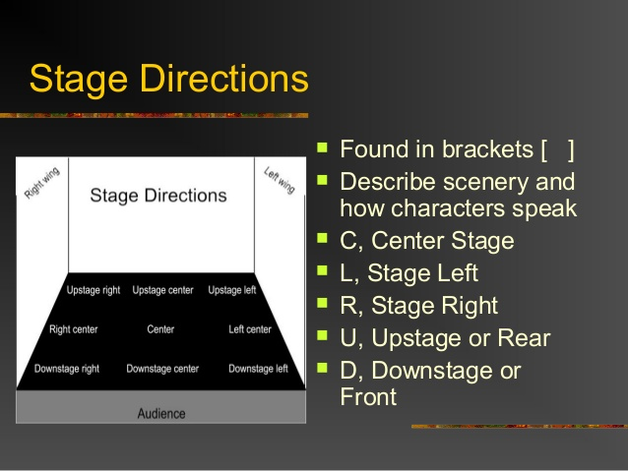
When the stage is decorating an event manager, have to think about all the scenario of the place. Where to set the stage is a big deal, from which side audience will see the event very clearly and enjoy the event very much. We need to map down the stage direction where will be the stage center. We have to use all the sides of the stage very cleverly with client demand. There is different variation in the different type of event, so the event manager has to think about client demand.

Organizing:

Event management is not a work of one person army. It’s totally a team-based work. We have to divide the work into the team members. All the responsibilities are assigned to all the members and staff of event management. Coordination of the plans required is to isolated among the colleagues. We additionally repeat That understanding sorting out with regards to occasion administration basically includes the portrayal of the exercises required for an occasion, distinguishing individual and group undertakings and dispersion of duties to facilitators.

We have different departments to organizing an event.

In this Event management chart, C.E.O is the boss of the organization. After the c.e.o we can see the advisor who works with all the paperwork and see the legal issue. Then comes the most important person who is event manager. His responsibility is to check up to the bottom of an event. Event manager permits event planner to plan the event. An event planner will see the venue or site, and he has to map the site where he should design. Event planner is especially responsible for organizing part for an event. From the starting to an end of the event he must have to plan properly after planning creative functions continue to the game plan. Event planner makes the plan and give it to the client. Sometimes clients have specific demand, so the event manager has to focus on it also. Marketing department promotes the company and collect the clients. Marketing department has a very important role in event management. Marketing department responsibility is to communicate with the client and make an advertisement for the organization. Photography and cinematography is a very crucial part of event management now a day. They collect and share all the memories of an event by photography and cinematography. Catering department arrange hospitality management such as food, beverage, etc

Staffing

Functional responsibilities define event stuffing requirements. The importance of team structure, experiences, background and expertise of team members plays a vital role in the event management. It’s a matter of size and the resource availability in the event firm that to an extent defines the exact pole of the staff members.

In the big organization there can be more way to use specific personnel to limited functional responsibilities, but in the small organization, there can be functions of responsibilities to specific personnel. So for the event management, we need friendly people and hard-working people who van manage the situation very easily. When we recruit for event management, we need to see the candidate should have experience in the hospitality industry, sells, advertising. If a candidate has experience in that sector he/she can control the tough situation. Events are very psychical. In the event, a host, skilled, unskilled volunteers and labor stuff need to guide efficiently. Sometimes event can be a do or die project. At that time only a smart employee can trouble shoot the event problem.

The overall coordinator is the person who is the in-charge of an event. He has the full power of dissension making in the event. Creative department has a Creative manager who leads the creative team. The project manager role is to see the event successful.

Sales and marketing people duty is to promote and make an advertisement for the organization. They negotiate with the client and collect the project. They show their portfolio and convince the client how their firm works and how to fit their work with client demand.

Event planner carries al the responsibilities of an event. They need to well versed with public relations activities and people skilled in handling. They also need to adopt the technical side. They have to guide the technical staff like lights, sounds, stage, etc as well as a host of the skilled an unskilled labor.

Leading

The event manager will be the leader of all departments. The event manager continuously motivates the labor and the other junior to work hard in the psychical nature of the job. The event manager should guide the marketing and the project managers. Even they have to guide the newcomers or fresher to do their job. Sometimes event manager has to check the financial condition of the firm. Event manager also takes care of the photography department and catering department.

Thus the great communication skill, relationship with all the employee and patients without too many errors as well as know the carrot and the stick approach in the perfect way are the characteristics of a good event manager. A good event manager must have to have leadership skills to lead the organization. C.E.O of event management will lead and guide event manager to perform his/her job.

Controlling:

In event planning, controlling can be simply referred to as the compliance with predefined methodology without deviations to accomplish the cherished objectives. By the varied genres of events, the sole purposes and goals of them may also differ. But the stereotypical goals of every event, e.g., interaction and reach, has to be satiated without any errs.

By evaluating and rectifying the deviation from the predefined path is the par excellence method to ensure control over any event. In the case of evaluation, tangible objectives are set, sensibility in evaluation is incorporated and then the former, mid and post performances are compared to scrutinize any error deviation. After that, rectifying the error ruling out the determined deviation from the methodology perpetrate us to the quintessence of controlling.

Thus, by proper perspective in controlling an event, we can accomplish a more perfected out attitude to bring about the beau ideal in every event plans.

Importance of Event Management

Event Management means any service offered to the clients that contain planning, advertising, wedding, birthday party, company or presentation of different events. The scope of an event includes various activities connected to arts, sports, enjoyment, business or family functions like the wedding, bridal shower, Mehendi night, haldi, birthday party or joyful events. Dealing with an event can turn out to be a difficult task for you if you plan to handle all factors of the same by on your own. It needs a lot of time, strength, and money. So choosing a professional Event Management Company that who are managing such responsibilities is a sensible move.

- Save valuable time
- Access insider knowledge, skills & expertise
- Avoid hidden costs
- Ensure you’re covered
- Remain Stress-Free

Now a daytime is a money. A professional event management company can save your valuable time. If you give your event to event management, they will manage your program from beginning to an end. So it can save your valuable time. The event management company has the different type of packages, so you don’t need to be worry of budget or cost. They didn’t charge any extra cost. They have no hidden charge. They ensure you a successful event which is your need. If you didn’t go for Event management, you have to manage all the responsibilities of your event that is tough for common people. Professional event management remains you stress-free. Cause they have taken all the responsibilities from you. They give you promise to make the event perfect and successful.

Cases of Rings N Roses

Rings N Roses worked is Bangladesh cancer progress 2016. We create that successful event. That event was in Army Golf Club, Kurmitola, Dhaka.

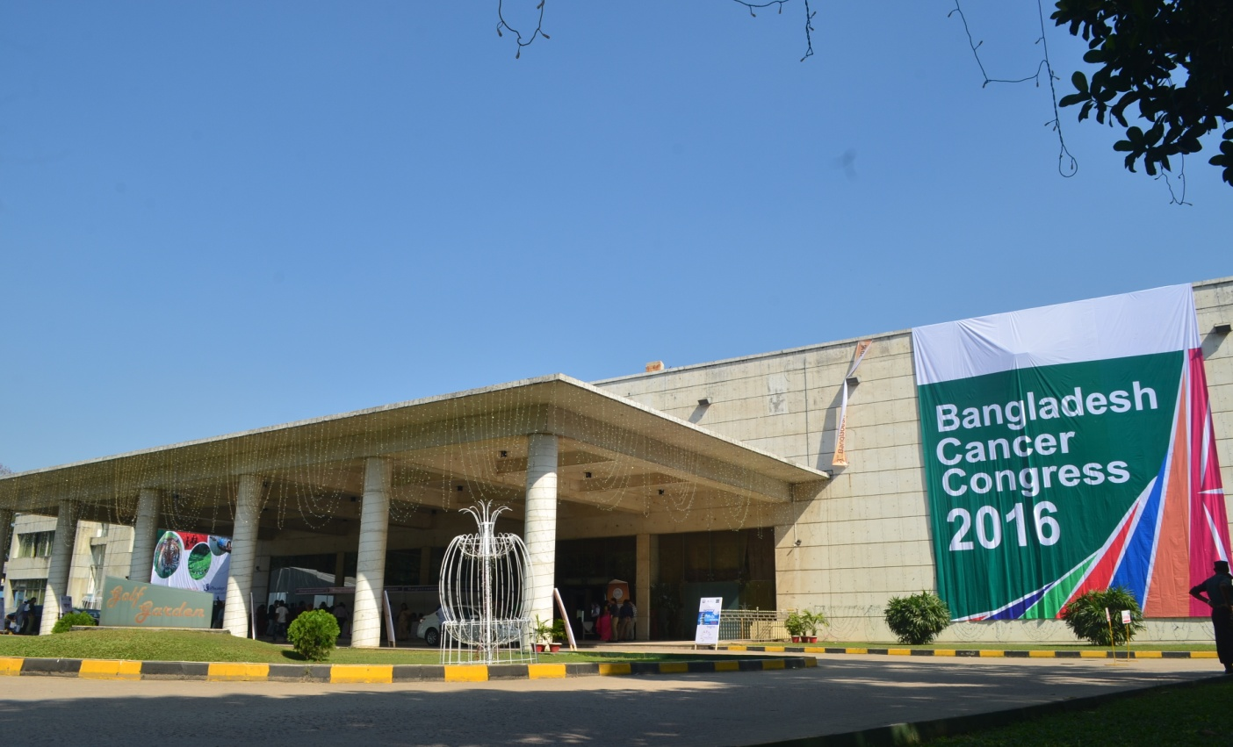

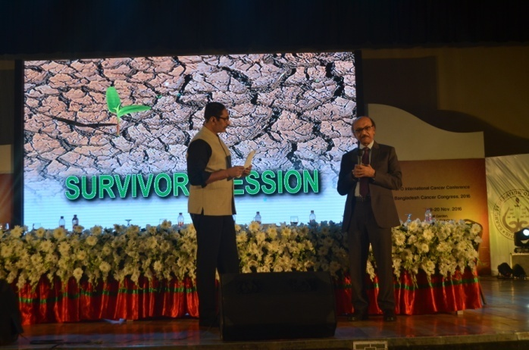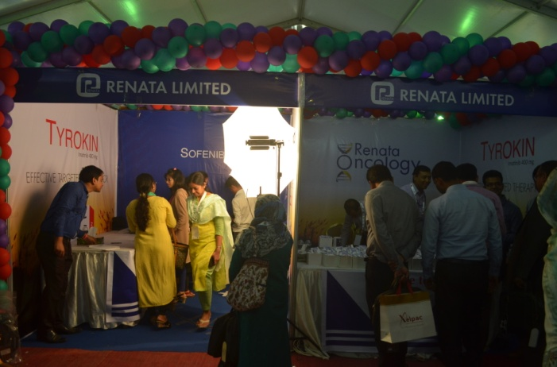

Successful wedding and birthday parties by Rings N Roses

.

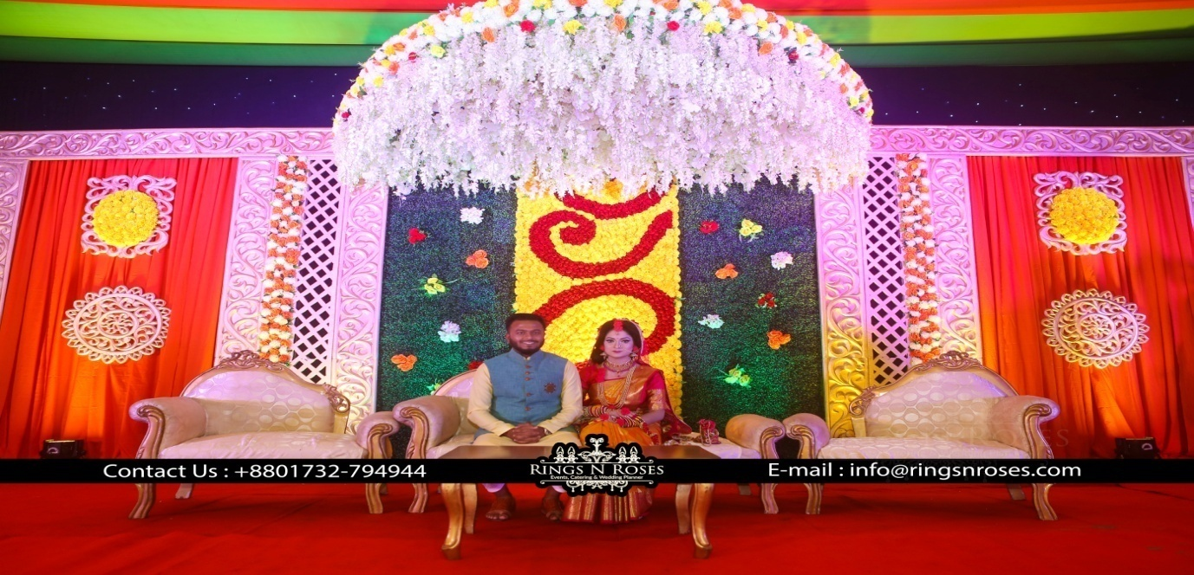

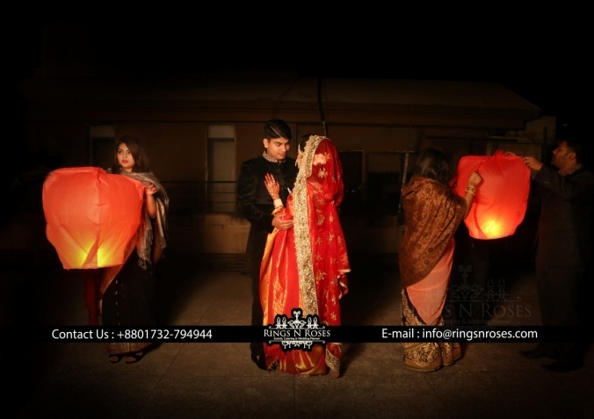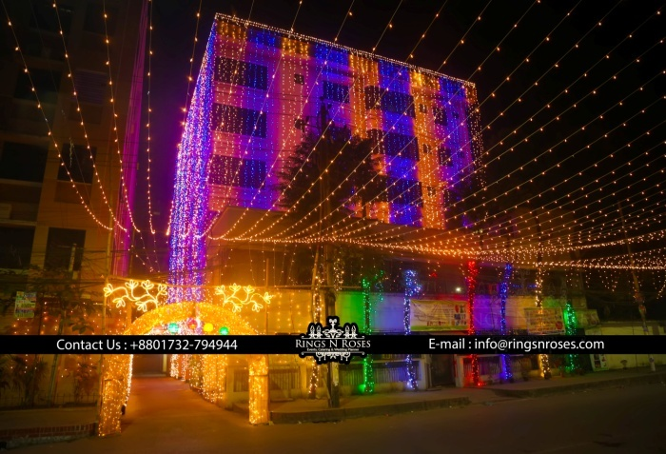

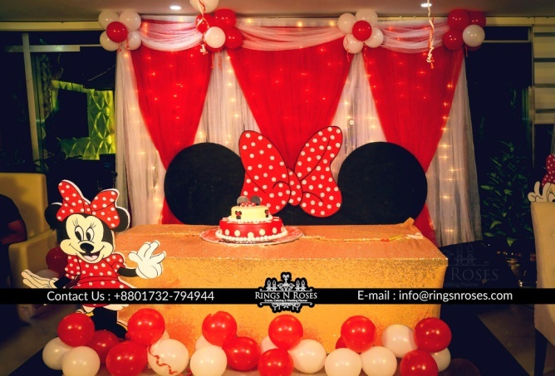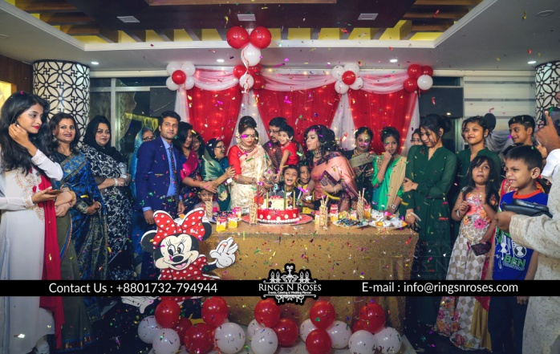

2.11. Upcoming Project of Rings N Roses

Prince spa center decoration and opening ceremony at Banani

Sham E Gazal by Ustad Gulam Ali At Dhaka club

Xirconium opening ceremony at Banani

Chapter: 3

Learning as an Intern

3.0. Learning as an intern student

For the internship, I have chosen an event management company. the name of that company ic Rings N Roses. I have completed my internship program from Rings N Roses. My period of the internship was only three months, but three months isn't enough for a student to learn and fulfill all the activities of an organization. In the Rings N Roses some sort of exercises which are exceptionally limited or secret for an understudy student. As an intern student, I have tried my level best to reach all the topic and the vast majority of the fundamental exercises. I would say that I have learned marketing which is not only for Rings N Roses but also required for all the organization. Whatever I have gained from my entry-level position these are given below:

- I have conducted the task – Via looking through the web, I should discover and list down the recent and the current startup event management company in Bangladesh. I have to find their details and offerings.

- My job was to interact with the existing and new customer over the phone with the help of our database. To know very well about my company which was Rings N Roses, I need to study about our company profile very well. After that, I have to find our customer and visit them with our offers and bring the work from them. I have to maintain a good relationship with our old customers..

- Maintain the fan page and website.

- Maintain and refresh clients database.

- Attending occasions, for example, classes, meeting, social gatherings, gatherings and shows to get new thoughts and new clients.

- Sending greetings and email about our new packages to our target customers.

- I need to screen our rival organizations always what sort of methodology they were using to grab the customers, who are the customer, what kind of packages they are offering to the market.

- Supporting our marketing manager and other marketing colleagues with my skills and knowledge.

- Attending various customer events.

- Deliver the creative presentation to our target clients.

- Writing the company proposal, different proposal letter, powerpoint introductions, refreshing the organization's profile.

- I have to make notes and collect the order from our top management and CEO about how effectively create a successful event.

- Last of all I have to always keep in mind that I must have to follow the rules and regulation of the company.

Chapter:4

Findings, Recommendation, Conclusion, Appendix & Reference

4.0 Findings

- Rings N Roses have a great office location which is located in Banani. They can get easily elegant clients in that area. They have a very strong relationship with suppliers as well as the contractor who delivered the event materials.

- Healthy and strong relationship with existing and new customer is the key to success for the Rings N Roses, and they hold a solid political reinforcement.

- Rings N Roses have a good connection with all the customers and employee. This is very important for a company.

- They have a creative department, architect, interior designer, and painters.

- Some old organizations are experienced they are our rivals. It is extremely hard to compete with them in the event management market.

- The training system is unavailable in our company. For a reason it takes a very long time to get success for the employee and the organization.

- Employee switch in another sector if they get new opportunities.

- It is true that R&D is an extremely abridged part of an organization. Sad to say that Rings N Roses have no Research & Development system. So we have to suffer in the long run.

- A total number of employees is insufficient for the organization.

- Lack of working environment and motivation.

4.1. Recommendation

- I want to recommend Rings N Roses has to put concentration on another sector too.

- Provide corporate training for the employee expertise. If employee is expert in their work, they can produce a very good outcome in a short time.

- Rings N Roses have a very good relationship with media and corporate contract. So they have to concentrate on how to improve service quality.

- They have to recruit qualified Designer, architect and the market also.

- Research and development is a very crucial part for the business organization. Building an R&D center can boost up Rings N Roses in the event management market.

- Sometimes arranging a picnic or get together for all the workers can work as a motivational tool.

- Minimize the employee turnover rate and develop the relation between new companies and new agencies.

- Give sufficient working environment for the employee.

- Regular meeting with CEO and share new ideas with all the employees can make Rings N Roses best event management in Bangladesh.

4.2.Conclusion

Event management is professional work which needs hard working and dynamic people who can manage all the event creatively. Event Management means planning, organizing, leading, stuffing and controlling or executing, etc. This industry in now in the growing stage in Bangladesh. In this industry, we can see lots of opportunities for the young generation. This industry needs active young creative people. Event management industry is growing rapidly all over the world — naturally event organized by the event manager like as wedding ceremony, bridal shower, baby shower, birthday parties, haldi nights, product launching, concert, festival, etc. Event management industry has the potentiality to grow economic condition of Bangladesh.

4.3.Appendix

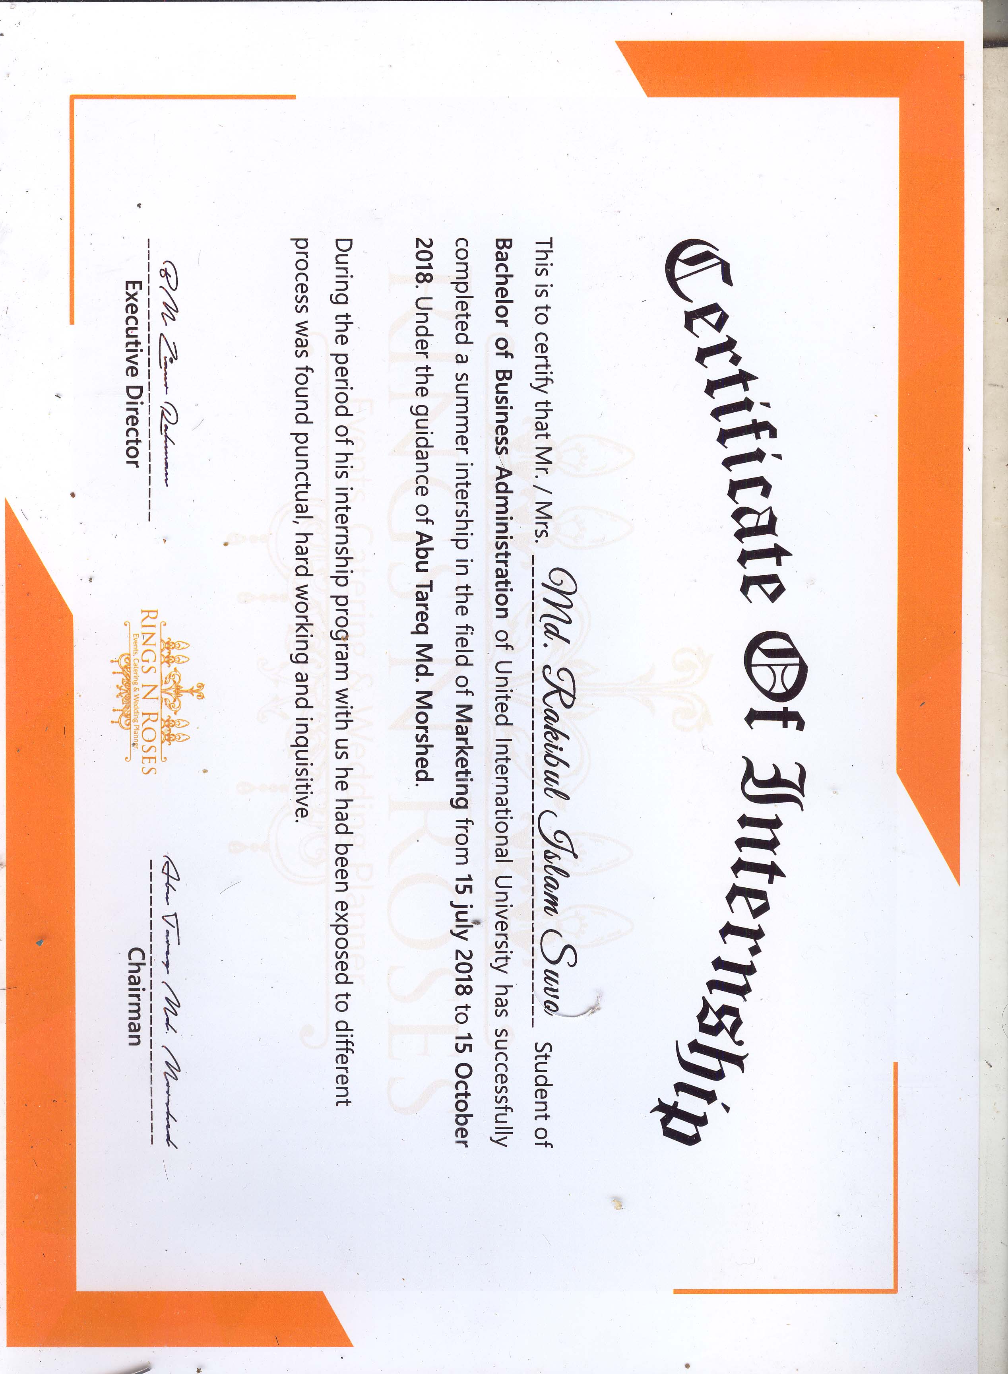

4.4. References

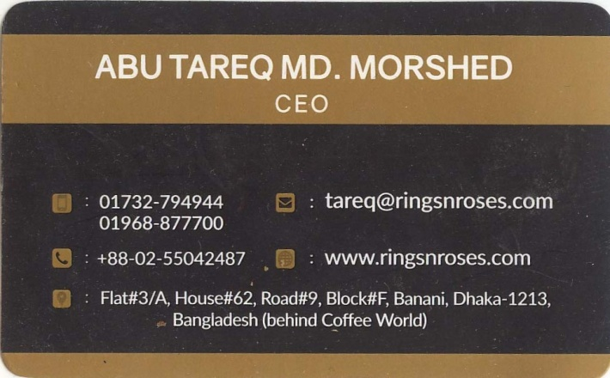

https://www.facebook.com/ringsnroses.event/?eid=ARCBEf3m-eP9UmHVZtvVgtGVbQPCiNChXH3Zpz7SIwkvGPqIidzXude4qVibYGvDyC-ijlTReWn9uI-Z&timeline_context_item_type=intro_card_work&timeline_context_item_source=1602026567&fref=tag

www.ringsnroses.com

www.Google.com

