Internship Report on
Impact of Human Resource Planning on Organizational Performance during the COVID 19 Pandemic: A Study on City Bank Limited

Name of the student
Shanjida Rahman Monisha

This report is submitted to the school of Business and Economics, United International University as a partial requirement for the degree fulfillment of Bachelor of Business Administration.

Internship Report
On
Impact of Human Resource Planning on Organizational Performance during the COVID 19 Pandemic: A Study on City Bank Limited
Course code: INT 4399

Submitted To
Yeasmin Islam
Assistant Professor
School of Business and Economics
United International University
Submitted By
Shanjida Rahman Monisha
ID: 111 171 064
Enrollment: Fall 2021
School of Business and Economics
BBA Program, Major in Human Resource Management
United International University
Date of Submission
February 27, 2021

Letter of Transmittal
February 27, 2021
Yeasmin Islam
Assistant Professor,
School of Business and Economics
United International University
Subject: Submission of Internship Report.
Dear Miss,
With due respect, I am submitting my internship report on “Impact of Human Resource Planning on Organizational Performance during the COVID 19 Pandemic: A study on City Bank Limited” which is part of the Bachelor of Business Administration degree and the INT course 4399.
Under your supervision, I was able to complete the report, and I am grateful for the opportunity. I have put forth my best efforts to make this report informative and consistent with your directions and guidelines, and I very grateful for it.
I hope you find this report to be satisfactory. I would be really appreciative if you would approve my internship report.
Sincerely

Shanjida Rahman Monisha
ID – 111 171 064
BBA Program, Major in Human Resource Management
School of Business and Economics
United International University

Declaration of the Student
I am Shanjida Rahman Monisha, student of Bachelor of Business Administration, major in Human Resource Management, United International University.
I do hereby declare that
- The internship report on “Impact of Human Resource Planning on Organizational Performance during the COVID 19 Pandemic: A study on City Bank Limited” is a presentation of my original work.
- This study incorporates contributions from a variety of persons who assisted with collecting appropriate references for the literature review, conducting surveys for the purpose of assessing the subjects and discussions, and writing the report.
- Additionally, this study was compiled under the supervision of Yeasmin Islam, Assistant Professor, Business and Economics, United International University.
- Furthermore, I hereby certify that I did not engage in any unethical practices while creating the report, and that the paper was written only for academic objectives.

Shanjida Rahman Monisha
ID – 111 171 064
Enrollment: Summer 2021
BBA Program, Major in Human Resource Management
Enrollment: Summer 2021
School of Business and Economics
United International University

Acknowledgement
First and foremost, I would like to show my thankfulness to Allah for giving me with the strength to carry out my internship tasks and functions and to complete the study and report on-time.
Following that, I would like to express my deepest gratitude to my internship supervisor, Yeasmin Islam, Assistant Professor, School of Business and Economics, United International University for her constructive guidance and valuable support. If I hadn't had her help, guidance, support, and cooperation, I would not have been able to complete the report on time and with accuracy. I am pleased at the prospect of completing my internship report under her supervision.
Additionally, I would like to express my thanks to Mizanur Rahman, Branch Operational Manager of City Bank Limited (Dhanmondi Branch), for providing me with the chance to gain significant practical experience while working as an intern at the bank. In moreover, I would like to show my thankfulness to City Bank Limited (Dhanmondi Branch) personnel for taking the time to participate in this survey.

Executive Summary
Every aspect of global commerce, industry, economy, multi relationship, economy, or way of life is being transformed by COVID 19. A rising number of workers are turning to virtual workplaces to escape the dangers of corona infection while yet carrying on with their jobs. On the other hand, Managers and human resource management (HRM) practitioners confront a complicated and tough environment in the wake of the COVID-19, which has jolted every organization and created an unprecedented crisis for managers and HRM practitioners. This report focuses on how human resource planning impacted on organizational performance at City Bank Limited during the COVID 19 pandemic.
The first chapter provides an overview of the study, including its objectives, scope, limitations, and methods.
The literature review is included in the second chapter. In this chapter, important literature on the subject matter of this research will be presented.
The contemporary banking market in Bangladesh and the corporate profile of City Bank Limited, such as product and service offerings, culture of the firm as well as a philosophy for human resource management, are discussed in the third chapter.
In fourth and five chapters have been highlighted on the survey and data analysis on impact of human resource management on organizational performance and data was gathered from 31 respondents from the employees of City Bank Limited, and the results of this experiment were presented. Data analysis is found that there is a negative impact on the HRP on organizational performance at City Bank Limited during the pandemic situation. Although employees are responsible for the development of the organization, they anticipate that they will be provided with the required atmosphere in order to increase their work satisfaction.
For City Bank Limited, several challenges have been emphasized in chapter five and significant points such as recommendations and key understandings have been included in chapter six based on the analysis of the study. Finally, the report's conclusion is included in this section.
Table of Content

Executive Summary iv
Chapter 01: Introduction
1.1 Introduction of the Report 2
1.2 Rationale of the Report 2
1.3 Objectives of the Report 2
1.3.1 Primary Objective 2
1.3.2 Specific Objectives 2
1.4 Scope of the Report 3
1.5 Methodology of the Report 3
1.5.1 Primary Sources 4
1.5.2 Secondary Sources 4
1.6 Limitations of the Report 4
Chapter 02: Literature Review
2.1 Concept of Human Resource Planning (HRP) 6
2.2 Aligning HRP to Organizational Strategic Goals 6
2.3 Role of HRP in Ensuring Optimal Staffing 7
2.4 Role of HRP on Employee Motivation 7
2.5 Role of HRP on Succession Planning 8
2.6 Human Resource Planning and Organizational Performance 8
Chapter 03: Industry and Company Analysis
PART A: INDUSTRY ANALYSIS 11
3.1 Private Banking Industry Scenario in Bangladesh (2020-2021) 11
3.1.1 Financial Sector and Growth 11
3.1.2 Changes to the Digital System 11
3.1.3 Online Banking Services 12
3.1.4 Virtual Activities and Work from Home 12
3.1.5 Layoffs in Banking Industry 13
3.1.6 Cuts of Employees’ Salary and Wages 13
PART B: ORGANIZATION PROFILE 14
3.2 Overview of City Bank Limited (CBL) 14
3.3 Vision 15
3.4 Mission 15
3.5 Core Values 15
3.6 Strategic Partnership 16
3.7 Products and Services 16
3.8 Hierarchy System of City Bank Limited 17
3.9 Philosophy of Human Resource Management at City Bank Limited 17
3.9.1 Career Prospect at City Bank Limited 18
3.9.2 Selection Process at City Bank Limited 18
3.10 Key Highlights of 2020-2021 19
3.10.1 Supporting Innovative Solution 19
3.10.2 Caring in the Time of COVID 19 20
3.10.3 Extending Comprehensive Support to Customers 20
3.11 Responding to COVID-19 20
3.11.1 Customers 20
3.11.2 Employees 21
3.11.3 Shareholders 21
3.11.4 Regulators 21
Chapter 04: Research Method
Data Collection and Analysis Procedure 23
4.1 Variables and Research Design 23
4.2 Data Collection and Analysis Plan 24
Chapter 05: Analysis and Findings
5.1 Analysis of Demographic Characteristics 26
5.1.1 Gender Respondent 26
5.1.2 Job Category Analysis (Designation) 27
5.1.3 Working Experience 27
5.2 Descriptive Analysis 29
5.2.1 Survey Data Analysis 32
5.3 Findings 41

Chapter 06: Recommendations and Conclusion
6.1 Recommendations 43
6.2 Conclusion 44
References 45
Survey Questionnaire (2021-2022) - HRM 47

List of Tables
Table 1.1: Loan Facilities of City Bank Limited 16
List of Figures
Figure 1.1: Core Values of City Bank Limited 15
Figure 1.2: Organogram of City Bank Limited 17
Figure 1.3: Selection Process of City Bank Limited 19
Figure 1.4: Variables/ Factors of impact of HRP on Organizational Perfroemnace 23
Figure 1.5: Gender Respondents 26
Figure 1.6: Job Category Analysis (Designation) 27
Figure 1.7: Working Experience 27

CHAPTER ONE:
INTRODCUTION

Introduction of the Report
A recent study demonstrated that good management of human resources (HR) may help a firm to acquire and retain a competitive advantage across the world. Human resource planning (HRP) is therefore an essential part of human resources management. The goal of HRP is to ensure that the organization has access to a workforce that is capable of facilitating and enhancing its performance. HRP enables firms to maintain a desired human resource position while also anticipating future requirements, ensuring that they have the right number and kind of personnel on hand when they're required. Consequently, HRP is a strategy for the organization to get, use, develop and retain its workforce by anticipating future workforce needs, evaluating present staffing requirements and creating measures to meet any projected manpower shortages. The main purpose of this report is to study how human resource planning impacted on organizational performance at City Bank limited during the COVID 19 pandemic.

Rationale of the Report
In order to complete the prerequisites for the Bachelor of Business Administration degree, it is necessary to prepare a report on the internship experience. The internship report is done under the supervisor of Yeasmin Islam, Assistant Professor, Business and Economics, United International University and the topic which is “Impact of Human Resource Planning on Organizational Performance during the COVID 19 Pandemic: A study on City Bank Limited”.

Objectives of the Report
The objectives of my report are divided into 2 sections. In that sequence:

Primary Objective
The primary objective is to analyze the factors of human resource planning of City Bank Limited that impact on their organizational performance during the COVID 19 Pandemic.

Specific Objectives
According to the following of specific objectives:
- To understand of the concept of human resource planning on organizational performance.
- To know about the impact of COVID 19 pandemic in the private banking industry of Bangladesh.
- To analyze the factors of HRP that creates an impact on organizational performance during the COVID 19 pandemic at City Bank Limited.
- To provide some recommendation that help to develop effective human resource planning for increasing organizational performance during the pandemic situation.

Scope of the Report
The report and the study are beneficial in that it may be used to inform policy making as well as academic comparison. The findings of the study may be used by human resource practitioners as well as HR managers at City Bank Limited to develop effective human resource policies and regulations. This demonstrates the importance of using human resource best practices when it comes to aligning workforce supply & utilization with expected demand based on the organization's strategy. The City Bank Limited may benefit from the study's recommendations for dealing with succession management issues. Organization is able to manage ideal workforce levels, ensuring demanding positions are maintained at all times, and retain necessary competencies and abilities to carry out the mission of City Bank Limited properly.
Similar academics in the subject of human resources management (HRM) may benefit from this study. It adds to the corpus of academic knowledge that already exists. These findings were aimed at helping management to better connect their HR planning strategies with their employee performance assessment systems in order to get the best possible performance from their workforce. There are no additional studies in the City Bank Limited on HRP that are known to exist. The findings of this study may serve as the foundation for future research in the field of human resource planning.

Methodology of the Report
Data for this research and study came from two separate sources. the following are the details in:

Primary Sources

The data for this report was acquired from a variety of primary sources, as well as from participants in a survey designed to gather primary information on the issue. Another primary sources are listed below:
- Face to face interaction and discussions with employees of City Bank Limited (Dhanmondi Branch).
- An in-depth look into how an organization's human resources department is currently operating.

Secondary Sources
The secondary data was gathered from the following sources:
- Newspapers, Articles, Journals, books which are related to the concept of human resource planning and organizational performance and the impact of COVID 19.
- Official Website of City Bank Limited.
- Internal reports of City Bank Limited (2020, 2019 and 2018).

Limitations of the Report
The process of gathering data and putting up this report for my internship report was difficult for me. Listed below are a few of them:
- The survey was being conducted by a few staff who was a little confused. As a result of their fear of judgment by their coworkers and superiors, employees are unwilling to take part in the survey.
- The majority of employees were unwilling to read out full of the questionnaire of the survey and they claim that they do not have enough time to complete the survey.

CHAPTER TWO:
LITERATURE REVIEW

LITERATURE REVIEW PART
This chapter provides an overview of previous research on the topic area of this study. The following sections have been subdivided into sub-sections in line with the research objectives: the concept of human resource planning (HRP); aligning HRP to organizational strategic goals; role of HRP in ensuring optimal staffing; succession management strategies; and the impact of human resource planning on the organization's performance.

Concept of Human Resource Planning (HRP)
The availability of workers is impacted by a variety of new concerns, including globalization, technology, innovation, new market, consumer trends and competition. Professional human resource management methods are needed to ensure that an organization or company has a healthy work environment. This data is necessary for future forecasts of demand and supply for human resources to ensure that firms maintain appropriate levels of personnel.
According to the expertise (Dr. Janes O. Samwel, 2018), An HRP process ensures that a corporation has an adequate number of employees with relevant abilities who are deployed or positioned. According to (Griffins, 2006), Human resource planning (HRP) may be described as an effort to predict future business requirements and environmental demands for a company.
There will also be a need for skilled employees to carry out these commercial requirements and satisfy the environmental requirements. In the HRM function, HRP is considered to be the process of determining an organization's workforce requirements. Furthermore, it is developing interventions, ideas, and activities that will allow the organization to accomplish its objectives and requirements. In this procedure, job analysis is carried out (by producing job descriptions and work requirements) and career progression guidelines are developed with the purpose of allowing employees to advance in their careers (John M. Dirkx, 2000). Consequently, HRP is an essential part of HR management and plays a crucial role in achieving the goals and objectives of the firm.

Aligning HRP to Organizational Strategic Goals
For any firm to achieve its goals and objectives, it is necessary to develop a strategic strategy. Strategic planning incorporates the company's long-term goals and objectives, as well as the methods used to attain them (Woodhall, 2001). Organizations need resources in order for them to be able to fulfill their strategic objectives. These resources are often divided into three categories: technology, finance, and workforce. For this, hr planning (HRP) is necessary to identify the amount and types of workforce that the organization needs to successfully accomplish its aim.
According to (Gupta, 2008), Human resource planning (HRP) may be in order for the company to attain its objectives, it is described as a process of assessing existing and future requirements of personnel.
There must be a connection between an organization's HRP and its goals and objectives; otherwise, missteps like hiring the wrong people or neglecting to foresee changes in appointment requirements might be expensive. When HRP is aligned with an organization's strategic goals, the workforce is provided with the skills and competencies necessary to fulfill its objectives (Ghazala, 2012). Because of this, HRP helps a company's strategic goals and human resource management goals into one cohesive unit. According to (Reilly, 2003), HRP procedures, an organization is able to accurately forecast the number, type, and source of the workforce it will require in order to achieve its goals and objectives.

Role of HRP in Ensuring Optimal Staffing
According to (Woodhall, 2001), human resource demand forecasting is the process of estimating future staffing requirements based on the appropriate amount and desired quality of candidates. Estimates of human resource requirements should be made in light of the organization's strategic strategy for a defined period of time, such as yearly. Demand forecasting is essential for any business to examine its human resource demands in terms of numbers, composition, skills with regard to services provided, and productivity levels in achieving organizational objectives (Ghazala, 2012). Following the identification of staffing shortages, the organization sets strategies in action to address the shortages (Griffins, 2006).
Human resource supply forecasting is the practice of anticipating the workforce's availability needed to meet demand for human resources over a certain time period (Reilly, 2003). It identifies the locations where the required number of people with the necessary education, training, and experience can be found and provided (Kwon, 2009).

Role of HRP on Employee Motivation
As defined by (Armstrong, 2003), employee motivation may be defined as a person's desire or need to perform to the best of their ability in order to achieve a desired objective. When it comes to attracting and retaining personnel, motivation is greatly regarded. According to Mackay (2006) and Nel (2015), identifying the elements that drive individuals in the workplace is essential since it has a direct impact on their overall productivity. Workers who are well-compensated, have the opportunity to advance in their careers, and are given the right working equipment and training are more likely to be motivated. An increase in efficiency in the workplace should lead to an increase in both employee and customer satisfaction, according to Stone (2013). Competitive advantages will be gained as a result of this strategy, as well. Motivated personnel, according to Sharma (2006), are essential to the success of any company. Barling (2003) agrees that HR practices and HRP in particular have a significant impact on employee well-being and organizational effectiveness.

Role of HRP on Succession Planning
Succeeding in a position requires a company to make a conscious effort to recruit and retain the best and brightest people in order to secure the long-term viability of the business. Human resource concerns such as the shrinking workforce, the increasing number of employees quitting, the loss of key talent and skills, and other gaps in the organization's capacity may all be addressed via succession planning as an element of a larger human resource planning framework (Mohamad, 2009). Having a succession plan in place allows for a smooth transition of responsibilities, ensures that vital positions are filled with qualified successors, and allows for the easy transfer of information.

Human Resource Planning and Organizational Performance
An organization's success may be assessed by comparing its anticipated productivity to its actual results, which is a measure of the organization's potential results (Shirey, 2008). HRP-enabled organizations outperform their non-enabled counterparts in terms of production, thanks to the many HRP measures put in place to help the business meet its objectives (Cohen, 2004). It is possible to assess an organization's performance in terms of its goals and objectives, as well as the actions taken by the whole firm and how those decisions were executed, by using HRP as a framework. The pursuit of a company's aims and objectives might be aided by acquiring a track or course that personnel can follow (Boxall, 2001). As a result, HRP serves as a road map to help a business uncover its most important objectives and choose the best course of action for achieving them. In addition, HRP procedures use a systematic, logical, and pragmatic method to develop an organization's recruiting and selection strategy. HRP enables a framework for informed decision-making by disclosing and elaborating on organizational opportunities and risks. HRP makes it easier to create a high-quality performance that is both consistent and effective (William, 1988).

CHAPTER THREE:
INDUSTRY AND ORGANIZATION ANALYSIS

PART A: INDUSTRY ANALYSIS

Private Banking Industry Scenario in Bangladesh (2020-2021)
Organizations have been forced to stop operations and go into recession as a consequence of the COVID-19 outbreak. Due to this, Bangladesh's banking system has seen an increase in embezzlement and irregularities, including a large number of:
- Nonperforming loans,
- An increase in loan write-off,
- There is a deficiency in corporate governance,
- An increase in capital shortage,
- And among other reasons, a lack of loan recovery.
The covid-19 pandemic is adding salt to the wound for this sector, which is already reeling. There will be additional problems for the nation and the banking industry in the next months and years as a result of the lingering effects of Covid-19 (Tapash Chandra Paul, 2020-2021).

Financial Sector and Growth
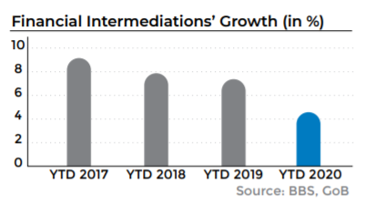
Bangladesh's Bureau of Statistics reports that growth in financial intermediation has been dropping throughout the years, but a considerable decrease was seen in 2020 compared with the previous year.

Changes to the Digital System
Due to COVID 19's global pandemic status, the country's economy, particularly its financial sector, has suffered. It wasn't possible to do business with Corona directly because of the social divide at the time of its creation. There is a lot of growth in digital transactions, and banks need to provide digital banking services to allow customers to do business from a safe distance. Individuals are more inclined to do digital transactions as a result of the broader epidemic and its impact on COVID 19. In order to better serve their customers, banks now provide a broad variety of online banking solutions. In the United States, several banks have made it easier for customers to set up safe deposit products, transfer money quickly online, open bank accounts, and conduct transactions online using technology (Masoom, 2020).

Online Banking Services
For a range of local and foreign organizations, banks have created new apps to collect money from consumers at home and send it on to distributors. A loan request may be made using the app and the money will be transferred as soon as a loan is accepted (Masoom, 2020).
According to Standard Chartered Bank Limited (SBL), in an effort to speed up import and export, the country's first block chain transactions were carried out. Lately, the Contour Block Chain Network, which was built just recently, was successfully used to issue letters of credit (LCs). Since the block chain automates the process, the transaction may be completed much faster.
Cashless Pay, a digital payment method offered by Eastern Bank Limited's Paper Fly home delivery network, allows customers to pay for online purchases using their bank accounts rather of cash.
After launching the following steps, Dhaka Bank's clients may conduct transactions from their own houses without having to leave. There are two new services in Bangladesh's banking sector. The bank opened a branch in its hometown in June of last year. Customer's ATM cards and cheque books will be sent to their home free of charge when they open an online account.

Virtual Activities and Work from Home
When it comes to training, seminars, and meetings, COVID 19 showed the banks how technology can assist. Even when virtual meetings were held, their reach was restricted. Board and management meetings are conducted online during COVID 19. Prior to Corona, the government had limited online training. And throughout the outbreak, workshops and personnel training are held on online. Virtual meetings held on everyday at various banks. Virtual meetings do not need leasing, service consumption, hospitality, or travel. As a consequence, financial institutions try to cut corners on employee training in order to save time and money. It is also possible to include more students at the same time in the instruction. Online trainings, Virtual meetings, and virtual seminars have been more popular since the emergence of COVID 19. Many staff set up virtual offices from their homes to reduce the danger of corona infection while still keeping the bank running smoothly. Senior authorities, on the other hand, have used technology to disseminate information and interact with their subordinates (Masoom, 2020).

Layoffs in Banking Industry
For the first time in the history of private banks, the period of the Coronation saw the greatest number of layoffs. Hundreds of thousands of employees have been laid off by some of the world's most prestigious financial institutions. AB Bank, City Bank, South East Bank, and a number of other private Bangladeshi institutions have all terminated around 500 employees as a result of the incident. It has never happened before, although there have been whispers of mass layoffs in the banks of the United States from time to time. According to COVID 19, bank employees must be well-versed in banking and other areas in order to handle circumstances like the one described above (Masoom, 2020).

Cuts of Employees’ Salary and Wages
No private bank in Bangladesh's banking industry has ever heard of reducing its salary budget, and this is still true today. A fierce competition among the banks resulted in increases in employee pay allowances at different periods. No one predicted that wages would ever be lowered, on the other hand. A number of private banks have lowered wages as a result of the epidemic in an effort to decrease costs. When COVID 19 situation started, it developed an attitude of acceptance among bankers, such as a reduction in the compensation allocation for staff members. The development of cutting-edge technology, intelligent systems, and computer vision technologies is presently being prioritized by financial institutions in order to reduce the risk of corona infection.

PART B: ORGANIZATION PROFILE

Overview of City Bank Limited (CBL)
As a case study of growth from 1983 to the present, City Bank has evolved from a conventional corporation to an internationally recognized multi-faceted institution that embraces worldwide best practices while choosing to remain at the forefront of technology advancements. Unlike many other financial institutions, the Bank's performance is measured not only by the bottom-line figures, but also by the milestones achieved on the path to become the most comprehensive financial institution in the nation.
The CBL network now consists of 132 branches with online around the country in Bangladesh, and ten SME service centers. ATM sharing is now in place with another bank that operates over 550 of its own machines. At least 413 ATMs will be owned and operated by CBL. It has embraced e-banking and digital banking methods. It offers a dedicated customer support contact centre staffed 24 hours a day, seven days a week, to assist customers with any issues they may have when using any of their services. CBL customer support may be reached at 16234 via phone. They've also launched a Smartphone app called "City Touch" in order to better service their customers.
City Bank Limited (CBL)
Private Commercial Bank, Headquartered in Dhaka
Form of Business | Banking Service
Key Business Segments | Retail, SME, Wholesale
Number of Branch | 132
Corporate Head Office | Gulshan Avenue, Gulshan 1, Dhaka 1212, Bangladesh
Website | https://www.thecitybank.com/home
Employees | 4, 356
Customers | Over 17, 00, 000
Cards Issued | Over 13, 90, 000
Source: (Website of City Bank Limited- Who We Are)

Vision
- The Financial Supermarket with a Winning Culture that Provides a Pleasurable Shopping Experience.

Mission
- Provide a diverse range of goods and services that distinguish and excite customers across all demographics.
- Make the business "Employer of Choice" by providing an atmosphere in which individuals can succeed and leaders are developed.
- Challenge methods and platforms on a frequent basis so that they may be more effective and efficient.
- With the goal of ensuring and increasing customer service quality, encourage innovation and automation.
- In whatever they do, they must ensure community respect, good governance, and compliance.

Core Values

Figure 1.1: Core Values of City Bank Limited
Source: (Website of City Bank Limited- Career)

Strategic Partnership
As a challenge, they want to push you to new heights, meet outside investors, and get more than low-cost finance help. They work closely with international investors to ensure that environmental standards, corporate governance, and creative solutions are all of the utmost importance to you. They do it better than anybody else. Numerous international organizations, including
- IFC,
- ADB,
- FMO, and
- GCPF, have recognized the value of our work.

Products and Services
Loan Facilities | Loan Amount (BDT) | Loan Tenure | Interest Rate
Auto Loan  Up to 50% | 3- 40 Lac | 12- 72 months | Competitive
Personal Loan | 1-20 Lac | 12- 60 months | Competitive
Home Loan | 5Lac – 2 Crore | 1 – 25 years | Competitive
City Bank Loan | Up to 10 Lac | Easy Installment (36months) | 1.5%
Secured Facilities, Secured Overdrafts and Secured loan bullet payment

Table 1.1: Loan Facilities of City Bank Limited
A commercial bank in Bangladesh was permitted by Bangladesh Bank to accept CBL's notice of connection in compliance with the Banking Companies Act of 1991, which was also approved by Bangladesh Bank.
- Wholesale Banking
- Retail Banking
- Cards
- SME
- Treasury Operation
- Agent Banking
- Digital Banking, and so on.

Organogram of City Bank Limited
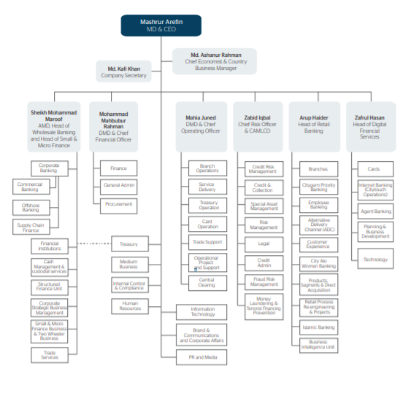
Figure 2.2: Organogram of City Bank Limited
Source: (Integrated Annual Report, City Bank Limited , 2020)

Philosophy of Human Resource Management at City Bank Limited
As one of Bangladesh's largest private commercial banks, the City Bank Limited (CBL) has come a long way since its foundation in 1983. As a result of the visionary entrepreneurship of 13 local merchants, one of their country's most important banks now employs more than 2700 people.
In order for them to embark on this remarkable journey, CBL has to believe in a rewarding culture. CBL encourages everyone to reach their best potential by following in the footsteps of their goal. A member of CBL has the freedom to pursue a career in an area in which he or she has expertise or a passion. Their products and services are amazing, but they also have a great corporate culture and attitude toward their staff and customers. They are a quickly developing and wonderful bank.
CBL seeks to construct a Winning Culture for both our internal and external stakeholders and to ensure that our talents may grow and thrive on both the functional and leadership fronts, no matter what function one chose. They feel that this bank is the best place to start a career in banking because of the following reasons:
- Recognized Brand.
- Philosophy of Human Resource Management.
- Process that is both robust and transparent.
- Organization that is dynamic and growing.
- Winning Culture.
- Organization with a Socially Responsible Mission.

Career Prospect at City Bank Limited
City Bank Limited (CBL) is one of the very few local banks that does not operate or benefit from a typical branch-based business strategy that is dispersed and geographically controlled. A vertical management approach is used by the bank to manage business and operations from its headquarters, primarily via five segments that include:
- Business
- Branch Banking
- Risk
- Operations
- Support

Selection Process at City Bank Limited
The City Bank Limited's selection process is intended to identify candidates who are the perfect fit for a particular role. When it comes to CBL, we use the following selection procedure:
- Job Posting
- CV shorting and listing
- Written Test
- Interview
- Job Offer
- Medical Test
- Appointment Letter

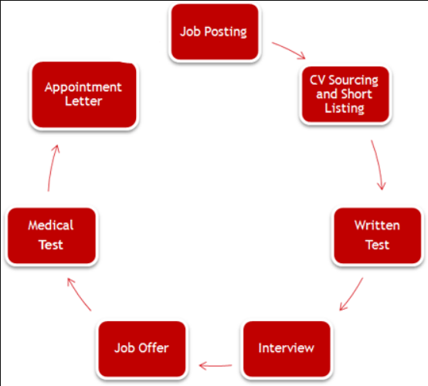
Figure 3.3: Selection Process of City Bank Limited
Source: (Website of City Bank Limited- Career)

Key Highlights of 2020-2021

More than a functional aspect of City Bank's business, shared value extends beyond delivering services that meet the needs of customers, career aspirations for employees and growth aspirations for business partners, and returns for investors to include delivering value to City Bank's customers, employees and shareholders alike.

Supporting Innovative Solution
Through their Ekhoni Account app, their customers may sign up for an account with us in just a few short steps. Their clients were able to access their accounts at any time, from any location, thanks to this. They have launched a Shariah-compliant credit product for SME-Small clients in Bangladesh, which is the first of its type in the country.

Caring in the Time of COVID 19
They provided their consumers with a variety of financial assistance and support programs, as well as donating over BDT 50 million to the Prime Minister's Relief Fund, to help limit the epidemic. Some BDT 16,000 million of government stimulus funds were also distributed.

Extending Comprehensive Support to Customers
While following regulatory rules, they went above to assist their long-standing clients in getting through these difficult times by extending credit lines, providing working capital assistance, and other measures to help them to cope with this difficult situation.

Responding to COVID-19
By March 2020, when early signs showed that COVID-19 might become a significant pandemic, our business continuity plans were activated. They were fast to activate their business continuity procedures despite the fact that City Bank had created bank-wide agility. Throughout their operations, they have implemented progressive steps to protect the safety of their employees and customers, while also working to preserve the quality of their services with the least amount of disturbance possible. They also looked extensively at how the pandemic will cause structural adjustments and how they might transform these into long-term economic possibilities that would be sustainable.

Consumers and Customers
- Customers and customers who had their payments suspended or rescheduled received aid and support in the form of these two methods.
- With the help of proactive communication with our customers and clients and the promotion of digital banking in accordance with movement control restrictions, they were able to provide information on available financial aid possibilities.
- Enhanced and expanded digital financial services so that clients may conduct their day-to-day banking remotely with the least amount of inconvenience.
- When necessary, they've implemented branch closures or shifted hours of operation.
- Regularly disinfected and sanitized all of our facilities, as well as encouraged the use of protective equipment such as masks and barriers at the counters.

Employees
- City Bank Limited on all of the branches, they have activated their Business Continuity Plan in order to ensure that their employees are exposed to the least amount of risk possible from infectious disease.
- Maintaining excellent levels of cleanliness and safety in the workplace was a top priority.
- Implemented a division of operations teams between office and work-from-home places.
- Strict physical distance, the use of personal protective equipment, health monitoring, and the postponement of any activities involving physical attendance are all recommended steps to be taken.
- Accelerated deployment of mobile working policies and practices, together with the rollout of the requisite technical infrastructure, for flexible work environments.
- Constant virtual learning and workforce engagement activities to improve mental health.

Shareholders
- Dividend payments for 2020 (announced) will continue to reward shareholders while preserving strong capital and liquidity.
- The first-ever entirely virtual AGM for 2019 was aired live in 2020, giving shareholders a forum to ask board members questions while still adhering to physical distance and other safety precautions.
- By use of webinars, quarterly results briefings were held.
- The scope of susceptible portfolios and strategies for asset quality protection was made public.

Regulators
- Adherence to all moratorium/lending standards and other criteria was sufficient in meeting all relief/stimulus directions.
- As the operational environment rapidly changed, they conducted stress tests and simulation analyses to verify overall resilience and the maintenance of portfolio quality.

CHAPTER FOUR:
RESEARCH METHOD

Data Collection and Analysis Procedure

This chapter has outlined the technique and processes that were used in order to complete this research study. It included topics such as variables and research and questionnaire design, factors and variables with relevant of the topic sample size, data collecting, and data analysis with among other things.

Variables and Research Design
It was necessary to include several independent variables in order to complete the study, as indicated in the figure Human Resource Planning and Organizational Performance at City Bank Limited during the COVID 19 situation. The main point of this figure was to illustrate the design of the study and questionnaire of the survey. The figures of dependent variable and independent variables are shown below:
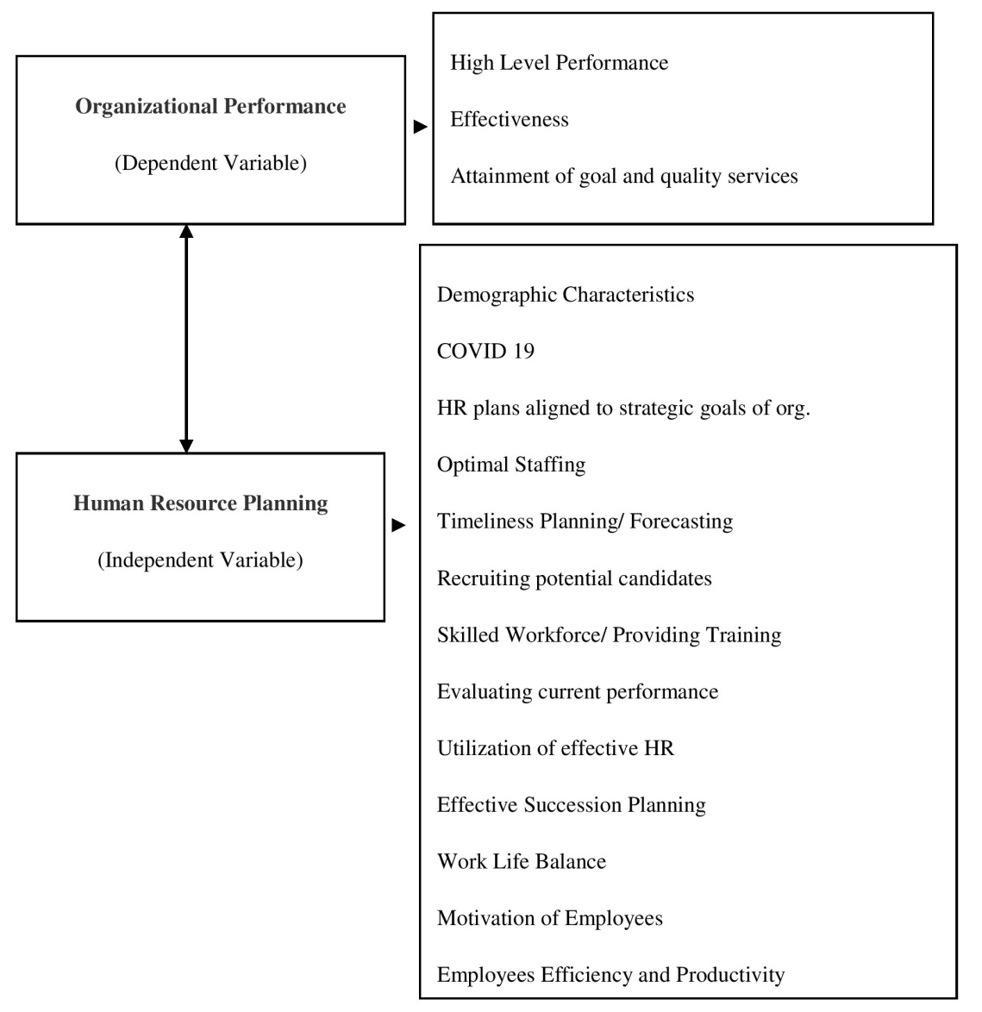
Figure 4.4: Variables/ Factors of impact of HRP on Organizational Perfroemnace

Data Collection and Analysis Plan
This study and the report have been analyzed based on the current pandemic situation in the context of Bangladesh. Both qualitative and quantitative data have been collected in order to prepare this report. Data was gathered using the following two methods:
- Conducting a survey through Google form.
- And a variety of scholarly sources, such as books and journal articles from throughout the world.
For the purpose of analyzing the topic, a standard level questionnaire has been designed. Sampling data have been collected from the employees of City Bank Limited and 31 employees participated on conducting this survey.
For the purpose of data collecting, five likert scales have been used to design the questionnaire and there are 15 statements on the questionnaire.
Google form’s link has been provided to the employees of City Bank Limited. The total response rate was 100 percent.
The data analysis was carried out in a descriptive way with table, ratio of respondents, and perception of the impact of HRP on organizational performance during the pandemic situation being the variables considered.

CHAPTER FIVE:
ANALYSIS AND FINDINGS

Analysis of Demographic Characteristics
Sample Size (n): 31 respondents participated on conducting the survey who works at City Bank Limited in various departments.

Gender Respondent
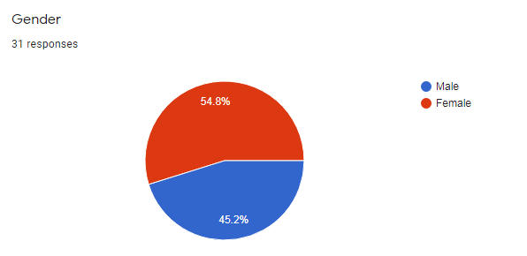
Figure 5.5: Gender Respondents
Among the respondents, 14 males (45.2%) and 17 females (54.8%) were participated on conducting the survey.
From figure 1.5, it can be said that the percentage of female is greater than the percentage of male respondents. So, on this survey, more participants are female.
Gender-Percentage of Participants: Female > Male

Job Category Analysis (Designation)
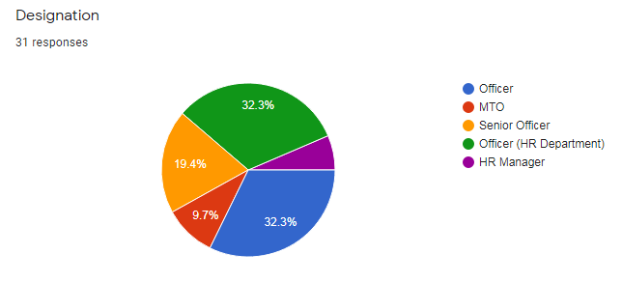
Figure 6.6: Job Category Analysis (Designation)
From Figure 1.6, Among 31 of respondents, 10 respondents (32.3%) were in Officer ranking and Officer in HR department, 3 respondents (9.7%) were in MTO ranking, 6 respondents (19.4%) were in Senior Officer ranking, and 2 respondents (6.5%) were in HR manager ranking at City Bank Limited.
Job Categories (Designation) - Percentage of Participants
Officer and HR Officer > Senior Officer > MTO > HR manager

Working Experience
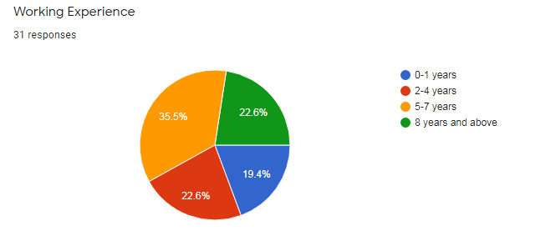
Figure 7.7: Working Experience
Among 31 of respondents, 6 respondents (19.4%) have 0-1year experience, 7 respondents (22.6%) have 2-4years experience, 11 respondents (36.5%) have 5-7years experience and remaining 7 respondents (22.6%) have 8 years & above experience at City Bank Limited.
From figure 1.7, it can be said that the percentage of 0-1years experience then 5-7years experience of respondents is greater than other.
Working Experience - Percentage of Participants
5-7 years > 2- 4 years and 8 years & above > 0-1 year

Descriptive Analysis
The study attempts to identify the “The impact of Human Resource Planning on Organization Performance- A study on City Bank Limited”. This study and the report have been analyzed based on the current pandemic situation in the context of Bangladesh. Both primary and secondary have been utilized to conduct the topic of the study.
For the purpose of analyzing the topic, a standard level questionnaire has been designed. Sampling data have been collected from the employees of City Bank Limited and 31 employees participated on conducting this survey in where female respondents are greater than male respondents.
For the purpose of data collecting, five likert scales have been used to design the questionnaire and there are 16 statements on the questionnaire.
However, since the table is not particularly instructive, additional pie charts have been showed to help the observer reach a conclusion more quickly.
Statement |  | Strongly  Disagree  (1) | Disagree  (2) | Neutral  (3) | Agree  (4) | Strongly  Agree  (5)
1. | Organization does proper HR planning for achieving the business targets during the COVID 19 pandemic. | 19  (61.3%) | 10  (32.3%) | 01  (3.2%) | 01  (3.2%) | 0  (0%)
2. | An effective recruiting and selection procedure for new workers during the COVID 19 pandemic is accomplished by HR planning. | 08  (25.8%) | 07  (22.6%) | 09  (29%) | 07  (22.6%) | 0  (0%)
3. | During the COVID 19 pandemic, organizations create their human resources (HR) strategies based on the skills, knowledge, and experience of current workers. | 20  (64.5%) | 10  (32.3%) | 0  (0%) | 01  (3.2%) | 0  (0%)
4. | Organization gives enough training to current and new workers to help them adapt to the new business climate created by the COVID 19 pandemic. | 10  (32.3%) | 04  (12.9%) | 05  (16.1%) | 10  (32.3%) | 02  (6.5%)
5. | Changes to human resource planning improve the organization's performance during the COVID 19 pandemic. | 18  (58.1%) | 09  (29%) | 02  (6.5%) | 02  (6.5%) | 0  (0%)
6. | During the COVID 19 pandemic, the organization has a successful yearly feedback session to assess workers' performance. | 25  (80.6%) | 06  (19.4%) | 0  (0%) | 0  (0%) | 0  (0%)
7. | The estimated KPI is adequate for all levels of the organization's personnel during the COVID 19 pandemic. | 12  (40%) | 05  (16.7%) | 06  (20%) | 07  (23.3%) | 0  (0%)
8. | Changes in human resource planning and policy during the COVID 19 pandemic aided in assessing the organization's capacity to employ human resources efficiently. | 14  (45.2%) | 11  (35.5%) | 05  (16.1%) | 01  (3.2%) | 0  (0%)
9. | Maintaining a good work-life balance for employees is a priority for the organization's human resource planning process during the COVID 19 pandemic. | 28  (90.3%) | 03  (9.7%) | 0  (0%) | 0  (0%) | 0  (0%)
10. | During the COVID 19 pandemic, the organization provides remote working options to all of its workers in order to maintain staff efficiency and production. | 01  (3.2%) | 0  (19.4%) | 09  (29%) | 18  (58.1%) | 03  (9.7%)
11. | During the COVID 19 pandemic, the current modifications in HR planning process take into account the grades and performance of workers' remuneration. | 22  (71%) | 07  (22.6%) | 02  (6.5%) | 0  (0%) | 0  (0%)
12. | During the COVID 19 pandemic, working conditions and job satisfaction are considered in the current changes of HR planning process. | 14  (45.2%) | 02  (6.5%) | 02  (6.5%) | 12  (38.7%) | 01  (3.2%)
13. | To prepare and conduct the HR planning process during the COVID 19 pandemic, the HR manager encourages all workers to contribute their opinions. | 08  (25.8%) | 05  (16.1%) | 05  (16.1%) | 11  (35.5%) | 02  (6.5%)
14. | Throughout the COVID 19 pandemic, the organization's whole workforce is participating in establishing strategic strategies. | 09  (29%) | 04  (12.9%) | 05  (16.1%) | 11  (35.5%) | 02  (6.5%)
15. | During the COVID 19 pandemic, the organization performs customer satisfaction surveys to assess how well it performed. | 22  (71%) | 09  (29%) | 0  (0%) | 0  (0%) | 0  (0%)

Survey Data Analysis
There are 15statements on the questionnaire. Below the 15 statements have been analyzed and discussed:

Statement 01: Organization does proper HR planning for achieving the business targets during the COVID 19 pandemic.
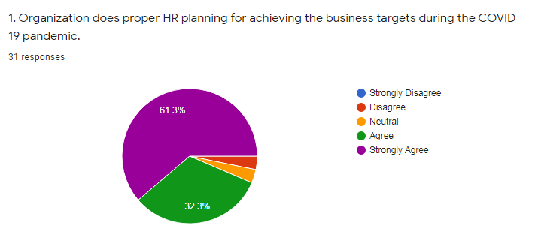
Figure 1.8
From the above data 61.3% of respondents were strongly agreed, 32.3% of respondents were agreed on this statement. And remaining 3.2% were neutral, only 3.2% were disagreed on this statement.

Statement 02: An effective recruiting and selection procedure for new workers during the COVID 19 pandemic is accomplished by HR planning.
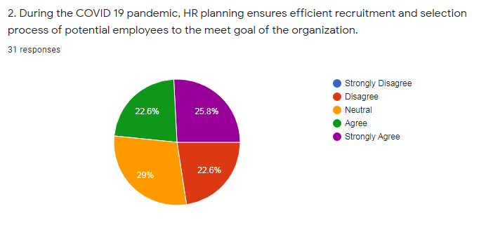
Figure 1.9
From the above data 25.8% of respondents were strongly agreed, 22.6% of respondents were agreed on this statement. Remaining 29% were neutral, and only 22.6% were disagreed on this statement because of according to them, due to pandemic situation job posting and recruitment process had been postponed.

Statement 03: During the COVID 19 pandemic, organizations create their human resources (HR) strategies based on the skills, knowledge, and experience of current workers.
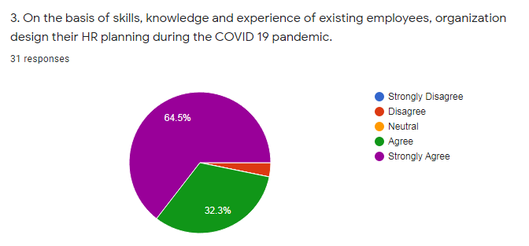
Figure 1.10
From the above data 64.5% of respondents were strongly agreed, 32.3% respondents were agreed on this statement. And remaining 3.2% were disagreed on this statement.

Statement 04: Organization gives enough training to current and new workers to help them adapt to the new business climate created by the COVID 19 pandemic.
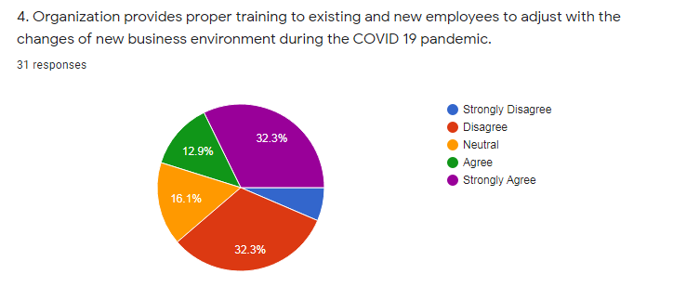
Figure 1.11
From the above data 32.3% of respondents were strongly agreed, 12.9% of respondents were agreed on this statement.
Beside 16.1% were neutral, 32.3 % disagreed and 6.5% of respondents were strongly disagreed on this statement because of most of the female and some of male employees think that the organization should provide them with a different sort of training program such as emotional intelligence, online communication tools and way of communication on online and they need to require sufficient these training in order to overcome this situation and gain a new skill to cope up with the new business environment. But organization does not provide this sort of training programs to them.

Statement 05: Changes to human resource planning improve the organization's performance during the COVID 19 pandemic.
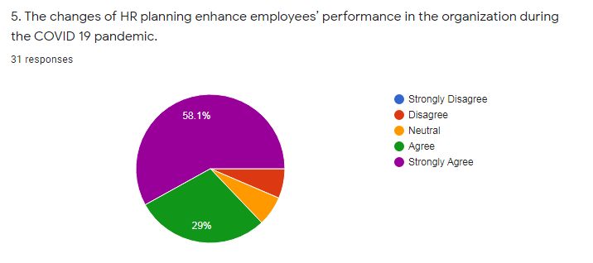
Figure 1.12
From the above data 58.1% of respondents were strongly agreed, 29% respondents were agreed on this statement. 6.5% of respondents were neural and remaining 6.5% were disagreed on this statement.

Statement 06: During the COVID 19 pandemic, the organization has a successful yearly feedback session to assess workers' performance.
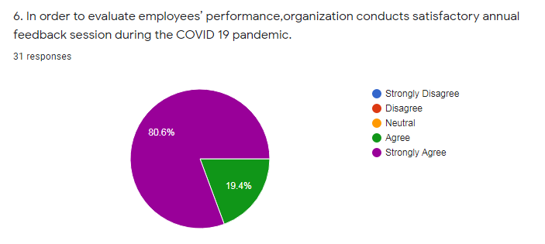
Figure 1.13
From the above data 80.6% of respondents were strongly agreed, 19.4% respondents were agreed on this statement that means 100% of respondents agreed on here.

Statement 07: The estimated KPI is adequate for all levels of the organization's personnel during the COVID 19 pandemic.
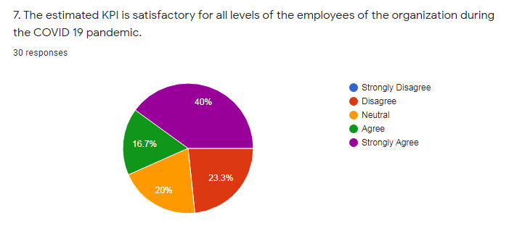
Figure 1.14
From the above data 40% of respondents were strongly agreed, 16.7% respondents were agreed on this statement. 20% of respondents were neutral and remaining 23.3% were disagreed on this statement because of they said, despite the epidemic, their workplace productivity remained unchanged. They think, better mental and physical health statuses, more contact with colleagues, and having a dedicated work area were all factors that impact on the employee efficiency, productivity and satisfactory KPI during the pandemic situation.

Statement 08: Changes in human resource planning and policy during the COVID 19 pandemic aided in assessing the organization's capacity to employ human resources efficiently.
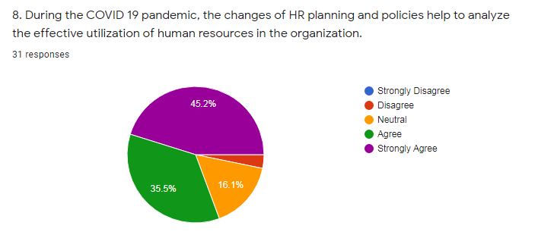
Figure 1.15
From the above data 45.2% of respondents were strongly agreed, 35.5% respondents were agreed on this statement. 16.1% of respondents were neutral and remaining 3.2% were disagreed on this statement.
Statement 09: Maintaining a good work-life balance for employees is a priority for the organization's human resource planning process during the COVID 19 pandemic.
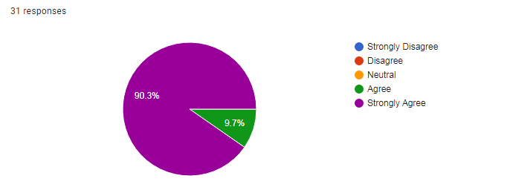
Figure 1.16
From the above data 90.3% of respondents were strongly agreed, 9.7% respondents were agreed on this statement that means all of respondents agreed on it.

Statement 10: During the COVID 19 pandemic, the organization provides remote working options to all of its workers in order to maintain staff efficiency and production.
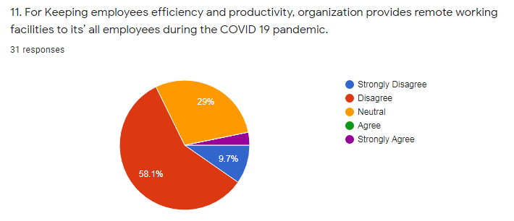
Figure 1.17
From the above data only 3.2% of respondents were strongly agreed. 29 % of respondents were neutral. On the other hand 58.1% respondents were disagreed and 9.7% were strongly disagreed on this statement because the majority female employees said that work from home affects their job efficiency and as well as their productivity. Because they had to manage both their job and personal lives at the same time and they were more stressed.

Statement 11: During the COVID 19 pandemic, the current modifications in HR planning process take into account the grades and performance of workers' remuneration.
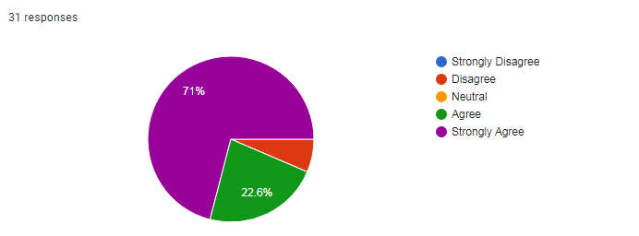
Figure 1.18
From the above data 71% of respondents were strongly agreed. 22.6 % of respondents were agreed and remaining 6.5% were disagreed on this statement.

Statement 12: During the COVID 19 pandemic, working conditions and job satisfaction are considered in the current changes of HR planning process.
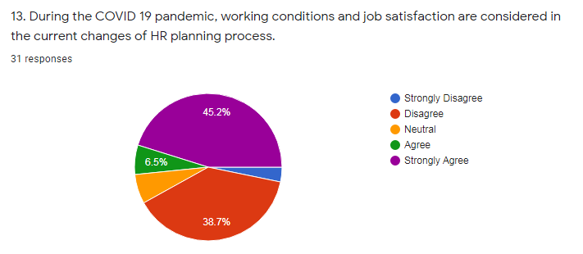
Figure 1.19
From the above data 45.2% of respondents were strongly agreed and 6.4 % of respondents were agreed and 6.5% were neutral on this statement.
On the other hand, 38.7% of respondents were disagreed and 3.2% were strongly disagreed on this statement because they said, during the pandemic situation, since the whole world activities and business activities were based on online platforms, so the employees of City Bank Limited worked more and gave more efforts to help their clients by providing digital banking services. Most of the employees worked six days a week on average. In such situation, they were unable to get flexible working hours while dealing with the pandemic situation. It adds an additional layer of stress to their already stressful lives.

Statement 13: To prepare and conduct the HR planning process during the COVID 19 pandemic, the HR manager encourages all workers to contribute their opinions.
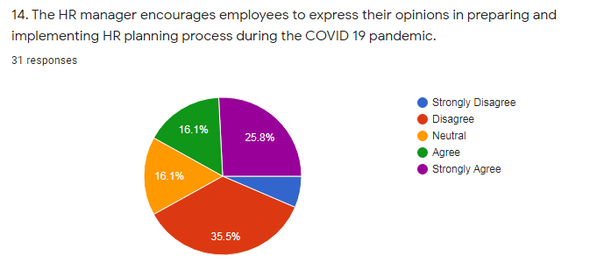
Figure 1.20
From the above data 25.8% of respondents were strongly agreed and 16.1 % of respondents were agreed and 16.1% were neutral on this statement. On the other hand, 35.5% of respondents were disagreed and 6.5% were strongly disagreed on this statement because they said, all the HR policy and steps are done in the head office of the bank. From the branch office, there is no scope to share their options to the head of HR department of the organization.

Statement 14: Throughout the COVID 19 pandemic, the organization's whole workforce is participating in establishing strategic strategies.
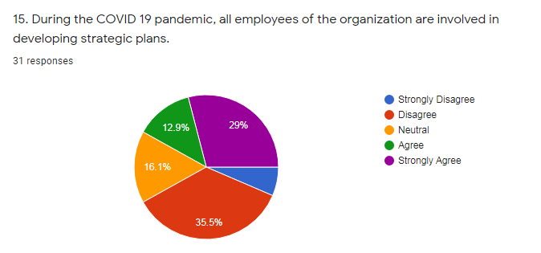
Figure 1.21
From the above data 29% of respondents were strongly agreed and 12.9 % of respondents were agreed and 16.1% were neutral on this statement. On the other hand, 35.5% of respondents were disagreed and 6.5% were strongly disagreed on this statement.

Statement 15: During the COVID 19 pandemic, the organization performs customer satisfaction surveys to assess how well it performed.
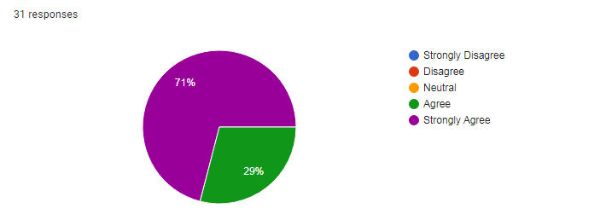
Figure 1.22
From the above data 71% of respondents were strongly agreed and 29% of respondents were agreed on this statement.

Findings
According to the analysis, some of the findings are listed below which are based on the impact of Human Resource Planning on organizational performance at City Bank Limited during the pandemic situation:
- The majority of respondents agreed that, during the COVID 19 pandemic due to postpone of job posting and recruitment process in City Bank Limited, there was a great shortage of manpower in the organization on various department.
- Majority of female employees think that the organization should provide them with a different sort of training program such as emotional intelligence, online communication tools and way of communication on online and they need to require sufficient these training in order to overcome this situation and gain a new skill to cope up with the new business environment. But organization does not provide this sort of training programs to them.
- The estimated KPI was not so much satisfactory for some of the employees in the organization and they said, despite the epidemic, their workplace productivity remained unchanged. They think, better mental and physical health statuses, more contact with colleagues, and having a dedicated work area were all factors that impact on the employee efficiency, productivity and satisfactory of KPI during the pandemic situation.
- In the case of keeping employees’ efficiency and productivity, majority of females did not get remote working facilities and they said, work from home affects their job efficiency and as well as their productivity. Because they had to manage both their job and personal lives at the same time and they were more stressed.
- Majority of female and male employees agreed that working conditions and job satisfaction were not considered in HRP of the organization. Most of the employees worked six days a week on average which was impacted on their performance and productivity of the tasks.
- And since the HR planning, policy are done in the head office of the bank, from the branch and sub branch, there is no scope for all employees to share their options to the head of HR department of the organization before planning of the human resource management.

CHAPTER SIX:
RECOMMENDATIONS AND CONCLUSION

Recommendations
The following step that can be help to HRD of City Bank Limited to develop human resource planning for the increasing performance of the organization during the pandemic situation:
- For reducing shortage of manpower organization should start recruitment process through online in where they should follow the series of procedural steps, completion of application form on online, employment test, comprehensive interview (written test, viva, presentation), and final employee selection through online.
- It is necessary for the bank to implement a variety of human resource development programs on a regular basis. These programs should include seminary, workshop and conference sessions as well as various short courses and training programs on current pandemic issues, financial matters, and software up gradation that would help to develop knowledgeable manpower as well as raise awareness and change mental attitudes among bank employees in order to further develop their careers.
- For getting satisfactory KPI from all level of employees, bank should develop and implement customized work life balance policy on the basis of needs and problems during the pandemic situation. Because it helps to keeps lowering absenteeism, boosting productivity, improving mental health of employees as well as increasing job satisfaction of the employees.
- In the case of keeping efficiency of female employees, organization should support to them by providing flexibility, priorities career development, providing family benefits (such as: health care benefits, supporting on child career plan, providing online tutors and subscriptions to age-relevant online activities for children).
- Consideration of working conditions and job satisfaction, bank should give the opportunities of sharing job with other employees so that employees can take break from doing more works. This break will help to all employees to become productivity on their tasks as well as the good performance of the organization.
- Bank has their own departments dedicated to human resources. However, it is necessary to empower the department or division in charge of human resource management in banks to deal with a variety of challenges. The divisions should be provided with well-organized HRIS (human resource information systems) for all branches and sub branches that employees can share their opinions, difficulties and problems to the HRD of the head office. It may be help to develop the proper HRP as well as the increase the performance of the organization.

Conclusion
A thorough review of several studies and significant revelations of current pandemic situation, employees have a high risk of being mentally unstable, which may result in lower productivity at work. Individuals should be encouraged to give their daily updates as well as a variety of tips and many suggestions in order to increase their time's productivity and cooperation with other people throughout this time, which is very important. In this uncertainty scenario, the individual should be held accountable for the organization's goals and objectives. Employees must be constantly informed of the company's development and new strategic direction. Everyone in the workplace should take precautionary health measures to prevent the spread of the epidemic situation.
There has been a great deal of study and research that has shown a significant association between human resource planning and organizational performance. The alignment of an organization's human resource planning (HRP) with its organizational goals and objectives is necessary; otherwise, mistakes such as employing the wrong personnel or failing to anticipate swings in appointment needs may be costly in the long term. Human resource planning methods enable an organization to forecast demand for labor and examine the amount, type, and sources of supply that would be required to achieve the firm's goals and objectives in order to achieve success. HR practices and HRP in particular have a significant impact on employee well-being and organizational effectiveness.
As a result of this report, it can be concluded that human resource planning is important for both employees and organizations. According to the findings of this study, for minimizing the shortage of manpower, online recruitment process, providing proper training facilities, support females employees on their work life balance, sharing job opportunities and flexibility on work, well organized HRIS system allows keeping good performance of the organization in more easily during the pandemic situation at City Bank Limited.
So it can be said that effective human resource planning is more vital for them personally and also more beneficial for the business in terms of fulfilling the organizational goals. If the HRD of City Bank Limited can develop their sorts of some problems on effective human resource planning during the COVID 19 pandemic then it may be created a healthy work life culture on the organization as well the performance of the organization.

References

Armstrong, M. (2003). A Hand Book of Human Resource Management Practice 9th Edition. Kogan Page Ltd.
Boxall, M. S. (2001). Human resource strategy and competitive advantage: A longitudinal study of engineering consultancies. Journal of Management Studies, 36, 443-463.
Cohen, D. (2004). Taking Stock II Report on the Reports. Action Aid International.
Dr. Janes O. Samwel, P. (2018). Human Resource Planning as an Important Practice to Anticipate Future Human Resource Requirements of the Organization. International Journal of Research in Business Studies and Management, 24-30.
Ghazala, I. &. (2012). Journal of Business and Management. 3(6): 06-13.
Griffins, L. W. (2006). Human Resource Planning: concept and cases. Human Resource Management Journal, 16(2), 71-83.
Gupta, C. (2008). Modern Human Resource Management. Sultan Chand & Sons.
(2020). Integrated Annual Report, City Bank Limited . Bangladesh.
John M. Dirkx, J. W. (2000). Organizational learning, performance, and change: An introduction to strategic HRD. . Cambridge: MA: Perseus.
Kwon, D. (2009). Human capital and its measurement. Forum on Statistics, Knowledge and Policy. . Charting Progress, Building Visions, Improving Life, Busan, Korea,, 27- 30.
Masoom, M. (2020, September 05). What did Corona teach the banks? Retrieved from Bankibarta Newspapaer: https://bonikbarta.net/home/news_description/240460/%E0%A6%95%E0%A6%B0%E0%A7%8B%E0%A6%A8%E0%A6%BE-%E0%A6%AC%E0%A7%8D%E0%A6%AF%E0%A6%BE%E0%A6%82%E0%A6%95%E0%A6%97%E0%A7%81%E0%A6%B2%E0%A7%8B%E0%A6%95%E0%A7%87-%E0%A6%95%E0%A7%80-%E0%A6%B6%E0%A6%BF%E0%A6%95%E
Mohamad, M. C. (2009). Human Resource Practices and Organizational Performance. Journal of Academic Research in Economics.
Reilly, P. (2003). Guide to workforce planning in local authorities, employers’ organization for local government. London.
Shirey, M. (2008). Building the leadership development pipeline. A 5-step succession planning model. Clinical Nurse Specialist, 22(5), 214-217.
Tapash Chandra Paul, P. (2020-2021). COVID-19 Impact in Banking Industry. Bangladesh: MBL Monthly Online Bulletin.
Website of City Bank Limited- Career. (n.d.). Retrieved from City Bank Limited: https://www.thecitybank.com/career
Website of City Bank Limited- Who We Are. (n.d.). Retrieved from City Bank Limited: https://www.thecitybank.com/who-we-are
William, R. &. (1988). Human Resource Planning and Management. New Jersey: Prentice Hall.
Woodhall, M. (2001). Human capital: Educational aspects. International Encyclopedia of the Social &Behavioural Sciences.

Survey Questionnaire (2021-2022) - HRM
Impact of Human Resource Planning on Organizational Performance during the COVID 19 Pandemic: A Study on City Bank Limited.
Google Forms’ Link: https://forms.gle/cPZEAZZaivhyJ77C6

