Internship Report
on
Recruitment and selection process of Bengal Group of Industries.



This Report is Submitted to United International University's School of Business and Economics as Part of the Bachelor of Business Administration Degree Requirements.

Internship report on Recruitment and Selection Process of Bengal Group of Industries.


Submitted To:
Shayla Khanam
Assistant Professor,
School of Business and Economics
United International University

Submitted By:
SHANJIDA BINTE ALAM
ID: 111 191 066
Submission Date: November 6, 2024

Letter of transmittal
November 6, 2024
Ms. Shayla Khanam,
Asst. Professor
School of Business and Economics,
United International University.

Subject: Submission of the Internship report titled “Recruitment & Selection Process of Bengal Group of Industries.”
Honorable Madam,
With the utmost respect, I would like to state that, by the grace of Almighty Allah, I have completed writing my internship report on the "Recruitment & Selection Process of Bengal Group of Industries," as required by United International University's (UIU) BBA program. I had a terrific experience working as an intern. During my internship, I was able to focus solely on the recruitment field. Overall, the data compiled in the internship report illustrates the learning outcomes that I gained from my experiences working as an HR intern at Bengal Group of Industries. It also includes the theory that I learned from various online resources, the company website, the book, and the results of the interviews that I conducted. I will greatly benefit from the knowledge and experience I have received while producing this report in my future endeavors. Your heartfelt blessing on this endeavor would be greatly appreciated.
Sincerely,
Shanjida Binte Alam
ID –111 191 066
BBA Program, Major in Human Resource Management
School of Business and Economics
United International University

Acknowledgment

I would like to begin by sincerely thanking the Almighty Allah, the Most Gracious and Merciful, for his kindness and for allowing me to complete the internship and turn in the internship report on time. Firstly, I would like to express my sincere gratitude to Ms. Shayla Khanam, Assistant Professor, at United International University's School of Business and Economics, for her genuine and important advice and help in writing my internship report. Furthermore, I could not possibly complete such a large document by the deadline without the guidance and the structure of the report. Next, I would like to sincerely thank Ahsanul Islam, my respected supervisor, Assistant Manager, People, and OD at Bengal Group of Industries, for his immense passion, and intellectual support throughout the last three months. He helped me with all of the everyday responsibilities related to HRM activities. It would be very difficult for me to fully understand the human resources process and the actual workplace culture without him. He also gave me all the information I required to complete the report. I would want to thank all of my peers and coworkers for helping me to complete my internship report.

Table of Content
Letter of transmittal III
Acknowledgment IV
Executive Summary VII
Chapter-1: INTRODUCTION 1
1.1 Introduction 2
Chapter-2: OBJECTIVES OF THE STUDY 3
2.1 Primary Objectives: 4
2.2 Secondary Objectives 4
Chapter-3: METHODOLOGY OF THE STUDY 5
3.1 Type of Data: 6
3.2 Sample size: 7
3.3 Sample Size Technique: 7
3.4 Data Collection: 7
3.5 Data Analysis Technique: 7
3.6 Limitations: 7
Chapter - 4:ORGANIZATIONAL BACKGROUND AND INDUSTRY PERSPECTIVE 9
4.1 Historical Background of the Organization 10
4.1.1 Values & Behavior 12
4.1.2Mission: 12
4.1.3Goals: 13
4.1.4Company Profile: 13
4.2 BGI Business Concerns: 14
4.3 Organogram of BGI 19
4.4 Industry Scenario: 21
Chapter-5 : FINDINGS OF THE STUDY 22
5.1 HR Functions of Bengal Group of Industries: 23
5.2 Recruitment process 24
5.3 Selection Process of BGI: 29
5.4 My Internship Experience 33
5.4.1Training Session: 33
5.4.2 My Job Responsibilities 33
Chapter-6: RECOMMENDATION & CONCLUSION 35
6.1Recommendation 36
6.2 Conclusion 37
CHAPTER-7 : APPENDIX 38
7.1 Questionnaire 39
7.2 Reference: 40

Executive Summary

I have completed the internship report to fulfill the requirements for my Bachelor of Business Administration (BBA). It is based on my hands-on experience gained while interning at Bengal Group of Industries' Human Resources Department. The Bengal Group of Industries' "overall recruitment and selection process" is the subject of my investigation. This report, which is divided into six chapters, explains the history of Bengal Group of Industries, the hiring and selection procedure, and my own internship experience.
Chapter one is focused on introducing Human Resource Management (HRM), along with the Bengal Group of Industries' hiring, screening, and placement procedures. The importance of HR policies in the organization's operations is established.
Chapter two covers the objectives of the study the primary objectives and secondary objectives. Completing the academic internship report required for the Bachelor of Business Administration (BBA) degree is the major objective. The application of academic knowledge in a practical HR environment is the main focus of this part. Secondary objectives include analyzing Bengal Group of Industries' recruitment processes, understanding the key phases of their hiring and selection procedure, identifying problems with these procedures, and offering suggestions for improvement.
Chapter three covers methodology, including the kinds of data, sample strategies, data gathering procedures, and constraints that were faced during the research process.
In chapter four, I have explained Bengal Group of Industries (BGI) organizational background and industry viewpoint, including information on its history, key values, business divisions, and organizational structure.
In Chapter Five I have explained the findings of the analysis of the recruitment and selection process of the Bengal Group of Industries, highlighting particular HR duties, recruiting procedures, and the organization’s selection process.
Finally concluded with suggestions in chapter six, this internship gave valuable and vast learning opportunities in HRM. The hiring procedures will especially help with future professional diversion. This study provides useful recommendations and insightful examination that will improve the human resources strategies of the Bengal Group of Industries.

Chapter-1

INTRODUCTION

1.1 Introduction

HRM has always placed a high value on people and voiced concerns about their management status. Human resource management's primary duty inside an organization is to develop and carry out human resource policies. Management can make decisions concerning human resources with the help of human resource policies. HR rules cover hiring and selecting employees, managing leaves, transforming employees, managing assessments of performance, paying salaries and benefits, encouraging employee training and development, inspiring employee motivation, and more.
I started an internship with the Bengal Group of Industries as part of my BBA degree. They produce a wide range of products, but they are particularly well-known for their plastic products. I developed this report based on my observations while working in their recruitment and selection team during my internship.
The recruitment and selection process is considered the very first stage of human resource management. A standard, step-by-step procedure must be followed to find job openings, choose the best role, review applicants, filter, shortlist, and hire the best applicant.
Bengal Group of Industries' hiring and selection processes are seen to be quite well-organized. The HR Division's hiring procedure is one of its primary duties. Creating procedures to invite potential candidates, screening them, choosing and interviewing the shortlisted candidates, hiring them, and bringing them into the organization's culture are all part of the recruitment process. Companies post job openings on their websites and social media platforms for candidates to apply. In response to the opening, candidates send in their resumes.

Chapter-2

OBJECTIVES OF THE STUDY

2.1 Primary Objectives:

The main objective is to complete the academic internship report, which is necessary to receive a BBA. Understanding the learnings' implications for academics is the purpose of the three credits provided for this internship. I used what I learned from the BBA program overall, and especially from the Human Resources classes, to try and discover the many applications of HRM concepts and expertise in the workplace.

2.2 Secondary Objectives

- To discuss Bengal Group of Industries recruitment efforts.
- To identify the main phases involved in the hiring and selection procedure at Bengal Group of Industries.
- To find out more about the problems with the hiring and selection processes used by Bengal Group of Industries.
- To offer some suggestions aimed at enhancing Bengal Group of Industries' hiring and selection procedure.

Chapter-3

METHODOLOGY OF THE STUDY

The knowledge I gathered during my internship at Bengal Group of Industries is summarized in the internship report in every aspect. This report was created after closely reviewing the information and facts from the study and the on-the-job experience. The following describes the procedures for collecting, sampling, and analyzing data:

3.1 Type of Data:

Most of the primary information came from the collective knowledge of academics and workers in the field. Secondary data was used to understand the industrial environment and the organization's historical background.
- Primary Data:
Observe Bengal Group of Industries' human resources department's internal processes. Using an already-prepared questionnaire, conduct in-person interviews and discussions with Bengal Group executives and senior executives.

- Secondary Data:
I gathered information for the secondary data from sources such as
- company's official website
- web portal,
- Google,
- several magazines,
- online newspapers.
- HR related website.

3.2 Sample size:

My sample size is limited to two since Bengal Group HR department employs a relatively smaller number of people than other departments. Through setting up a face-to-face interview, I have gathered knowledge of my data from the executive and senior executive of Bengal Group of Industries' human resource department.

3.3 Sample Size Technique:

A process of selective sampling was applied in this investigation. selective sampling was employed to gather data to identify Bengal Group recruitment and selection procedures. As a result, the executive and senior executive Bengal Group human resources department willingly participated part in this research.

3.4 Data Collection:

I have created a questionnaire to gather data. I asked them my question using this form, and I collected my data in the personal interaction. Additionally, I have gathered facts from observation and experience.

3.5 Data Analysis Technique:

Qualitative data analysis is the technique I utilized in my research because the data was provided as words and descriptions.

3.6 Limitations:

Since I was an intern for the company, I was unable to search for details more thoroughly. I couldn't understand every activity. I also struggled a little bit with creating the report. As an example,
- The period limitation was my first constraint. My study's sample size was slightly small because of time restrictions. Analyzing a significant number of samples was not possible due to time constraints. I worked for a total of just twelve weeks. This limited time will not allow us to fully express and complete this study.
- The Bengal Group employees were all highly involved in their jobs; therefore, they weren't always available to share their time or information. On the other hand, gathering all organizational and strategic data is not possible.

Chapter-4

ORGANIZATIONAL BACKGROUND AND INDUSTRY PERSPECTIVE

4.1 Historical Background of the Organization

Bengal Group of Industries (BGI) is a famous and rapidly expanding diversified industrial group based in Bangladesh, with a global influence. We operate in eight business categories: food processing, plastics, rubber & melamine, textile & apparel, power & energy, hospitality, building materials, infrastructure, electronics, and media & entertainment. We have the necessary resources to be firmly established in these industries. With over 32,000 highly skilled workers spread throughout 28 facilities and the head office, the privately held corporation has expanded organically over the past 50 years.
Our five decades of manufacturing experience have earned us a reputation for quality around the world. The US, Europe, and Asia have more than 60 export markets, which contribute to the nation's foreign exchange earnings.
The following illustrates the Bengal Group of Industries' historical trajectory.
1969 | Mr. Morshed Alam established BGI with a single hand-operated plastic injection molding machine in a leased space in old Dhaka
1971 | Jute and textile spare parts, which were previously imported from India and Europe, were produced on a large scale in Bengal when the country gained independence. He  started making household goods such as plates, chairs, plastic bottles, and other equipment. Entered the wooden furniture and leather industries by founding Bengal Adhesive & Chemical. Bengal Plastic Industries Ltd. was founded in Dhaka as a joint stock company and private limited company.
1991 | For clothing companies that are solely focused on exporting to the US and the EU, plastic apparel hangers were presented in Bangladesh.
1993 | Bengal has been permitted by Coca-Cola Export Corporation, Atlanta, Georgia, USA, to produce molded bottle crates for Coca-Cola in Bangladesh.
1995 | Bengal Overseas Corporation Ltd. started bringing a variety of products into and out of Bangladesh.
1998 | Obtain a license from Scheoller Wavin System, Germany, the top manufacturer and designer of Coca-Cola, Pepsi-Cola, and other popular soft drink bottle caps in the world, with production partners and licensees in more than 50 countries.
2001 | Power Utility Bangladesh Ltd. is an energy firm that will develop power plants in strategic locations around Bangladesh to help fulfill the nation's rapidly increasing electricity demand. The nation's leading processor of clothing and fabric products, the Bengal garment and fabric sector was established in 2001. The company has come a long way and expanded into both the domestic and international markets throughout this time.
2008 | Bengal Polymer Wares Ltd. has ISO 9001:2008 and ISO 14001:2004 certifications for its quality management system and environmental system, respectively.
2009 | Bengal Plastic Industries Ltd. received the National Export Trophy (Gold) for the 2007–2008 fiscal year.
2010 | Romania Food & Beverage has been accredited as an ISO 22000 food safety management system.
2012 | Xenergeia International Limited, which was later renamed, was the source of Bengal Renewable Energy Limited.
2015 | Bengal Melamine Ltd., Hamilton Mould & Engineering Ltd., Bengal Retails Ltd., and Linnex Electronics Bangladesh Ltd. have commenced their operations, respectively.
2018 | Since Bengal Cement Ltd. first started, its mission has been to supply top-notch raw materials to aid in the development of the country.

4.1.1 Values & Behavior

Bengal Group of Industries has established business values and behavior to help staff members meet both the organization and their objectives. These values & behaviors, which are connected to the mission and values statement of the business, are the core of the organization's identity and serve as guidelines for how it should operate. We have set values and behaviors to inspire everyone in the organization since they are essential to making an impact that is successful, long-lasting, and inspirational.

- Innovation: We'll be informed about emerging concepts and technological advancements so that our services, procedures, goods, and business plans stay.
- Collaboration: Employees at BGI will collaborate effectively by exchanging ideas and expertise, which increases our chances of becoming stronger monetarily, culturally compatible, and engaging.
- Integrity: As a team, we will maintain strong moral and ethical ideals and values with consistency and unwavering honesty, bringing integrity to our daily work.
- Quality: Our DNA is built to be quality. It extends beyond labor, culture, performance, and products.
- Performance: The foundation of both business and people is performance.

4.1.2Mission:
The objective of Bengal Group is to consistently work towards meeting customers' expectations to reach unending perfection by providing them with greater value than their competitors.

4.1.3Goals:
Bengal Group aspires to be the best at everything it does. Since its founding, Bengal has broadened the scope of its business to raise industry standards and maintain a higher threshold! Its objective is to lead the industry by providing its clients with the most superior goods.

4.1.4Company Profile:
Company Name:  Year of Establishment:  Company Type:  Number of Employees:  Number of Factories:  Number of SBUs:  Corporate Head Office:  Telephone:  Email:  Group Website: | Bengal Group of Industries  1969  Private Limited Company  32000+  28  26  Bengal House,75, Gulshan Avenue, Gulshan-1, Dhaka-1212  +88-2-222288248  info@bengal.com.bd  www.bengalgroup.com

4.2 BGI Business Concerns:

Bengal Group of Industries operates in a large range of business sectors with around 26+ SBUs. The following lists concerns with brief descriptions:
Bengal Plastics Limited: The largest plastics manufacturer in Bangladesh, Bengal Plastics processes about 3,000 metric tonnes of raw materials every month. Bengal Plastics manufactures a wide range of plastic goods, such as office supplies, housewares, cuisine, kids' items, furniture, home and garden organizers, and many more plastic products.

Bengal Windsor Thermoplastics Limited: Bengal Windsor Thermoplastics Limited was established in 2004 to export hangers and accessories for clothing. To increase output, the facility has multi-cavity molds and sizable injection molding machinery.

Hamilton Metal Corporation Limited: Hamilton Metal Corporation Ltd. makes metal hooks and other clothing accessories out of metal. Numerous metal processing tools, such as an electroplating and fully automated heat treatment unit, are installed in the plant.

Bengal Retail Store: Happy Mart is the Bengal Group of Industries' retail shop. Here, all plastic goods, household items, and accessories that have been placed on display are available for purchase. Happy Mart's dedication to quality and innovation, supported by a highly qualified team of specialists, is one of its main advantages.

Bengal Plastic Pipes Limited: The company known as Bengal Plastic Pipes Limited introduced a new product line in 2009. A wide range of premium plastic pipes, such as HDPE, PPR, uPVC, coil pipe, and fittings for cable ducting, chemical distribution lines, sewage, and water, are produced by Bengal.

Bengal Cement Limited: As a recent addition to the Bengal Group, Bengal Cement Limited (2018) aims to increase accessibility to premium building materials. To meet the growing demand for cement and to contribute to global infrastructure development by providing high-quality building materials, the firm aims to produce new commodities and construction solutions with a strong commitment to social and environmental sustainability.
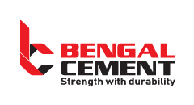
Romania Food & Beverage Limited: Romania Biscuit & Bread Factory Ltd. was acquired by the company in 2004 to launch it. With three completely automated hybrid oven lines in its manufacturing fleet, Romania is currently the most prestigious and high-quality biscuit brand. We provide 25 different types of biscuits, including bakery, confections, crackers, and snacks. Romania's major benefits are creativity and quality. To guarantee that their consumers' high requirements for quality are satisfied, they are constantly adding new products to their varied collections.

Bengal Feed & Fisheries Limited: The Bengal Group company that makes fish and poultry feeds is this one. Eighty percent of Bangladesh's feed demand for fish and poultry feed is supplied by Bengal Feed & Fisheries. Their primary goal is to provide our farmers with the highest-quality feed at the most affordable price.

Euphoria Apparels Limited: Premium lingerie producer Euphoria Apparels Ltd. creates an extensive range of intimate apparel to meet the demands of global brands. They supply several renowned customers in the US and the EU. Euphoria is an entirely compliance factory, with certifications from OEKO-TEX, Sedex, WRAP, and BSCI.

Media & Entertainment: RTV is a satellite and cable television station in Bangladesh that is owned by Bengal Media Corporation. Located in Kawran Bazar, Dhaka, the BSEC Building houses the organization's headquarters. 2012 saw RTV start broadcasting its shows live online to a global audience.

Bengal Concepts & Holdings Limited: The founder of the Bengal Group, Mr. Morshed Alam, had this business unit as his dream project. This division is dedicated to the real estate industry and works hard to satisfy its clients. The Morshed Alam complex, a Noakhali shopping mall that is still under development, has been the subject of recent work.

Linnex Technologies Limited: Through a license from Linnex Global LLC, Linnex is registered in the United States. Tejgaon, Bangladesh is home to Linnex's manufacturing facility. In this cutthroat technological market, Linnex provides the best products at the most affordable costs.

Available products include air conditioning units, microwave ovens, freezers, rice cookers, rice cookers, air conditioners, LED lights, blenders, electric ovens, and other appliances.
Power Utility Bangladesh Limited: Power Utility Bangladesh Limited started its journey in early 1998 by producing more than 3 MW of electricity to satisfy the energy needs of the Bengal Group of Industries. Using the brand name "Bengal Solar," Power Utility Bangladesh Limited has concentrated mainly on encouraging the use of solar energy and increasing public awareness of how power generation contributes to environmental harm.

AJ Overseas Company Limited: One of the multiple organizations within the Bengal Group of Industries, AJ Overseas Company Ltd. (AJOCL) engages in various business ventures. It is one of the biggest and most well-known trading houses, involved in importing and exporting different goods, machinery, and equipment to and from Bangladesh. It has been involved in public and private sector commercial activity for over ten years. AJ Overseas Company Ltd. has expanded its reach globally over the years. It has thus far been effective in assisting forward-thinking and well-known foreign producers in marketing and promoting their goods in this region.
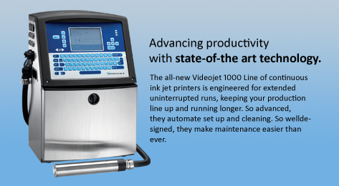
Bengal Hotel & Resort Limited: The hospitality sector has been added to by Bengal Group. The first Swissotel Dhaka—an Accor hotel brand—is being built in Bangladesh by Bengal Hotels & Resorts. The new Business District of Gulshan is home to the Swissotel Dhaka.


4.3 Organogram of BGI
Bengal maintains a simple organogram in all of its divisions and at the group offices.
A chairman is leading the "Board of Directors" for the Bengal Group. The "Managing Director," as Bengal refers to its chief executive, is frequently selected by Bengal. The managing director is responsible for the overall performance of Bengal Group in Bangladesh. He reports to "The Board of Directors" of Bengal Group, based in Bangladesh. The Bengal Group's HR Department and Commercial Department organograms are shown below. Every department in the group head office follows the same organogram.

4.4 Industry Scenario:

A part of my internship report is an industry scenario, Bengal Group of Industries has many business sectors, so I will focus on one business sector and analyze the current situation. Bengal Plastics Limited is one of Bangladesh's top producers of plastic goods. The company is well-known for its superior products and contributions to the nation's export industry. It won many national awards. They prioritize sustainability and are Bangladesh's first plastics manufacturing firm to receive LEED Gold certification. Bengal Plastics Limited has grown rapidly in recent years due to several causes:
Growing Market Demand: The company's expansion has been made possible by the rising demand for plastic items in both home and foreign markets.
Product diversification: Bengal Plastics has been offering a broader range of products, such as consumer goods, industrial components, and packaging materials, to serve a larger customer base.
Technological Advancements: The organization has invested in new technology and machinery to boost productivity, cut costs, and improve product quality.
Sustainability Initiatives: Bengal Plastics has attracted partners and customers who care about the environment due to its dedication to sustainability.

However, it’s important to remember that the plastics business encounters difficulties such as changes in the cost of raw materials, adherence to environmental laws, and competition from other producers. To keep up its current growth trajectory, Bengal Plastics Limited will need to keep adjusting to these obstacles.

Chapter-5

FINDINGS OF THE STUDY

5.1 HR Functions of Bengal Group of Industries:

The whole workforce's effort is taken into account by the Bengal Group of Industries. The HRM Department of the Bengal Group of Industries has comprehensive policies and procedures that outline best practices while taking ethical and legal factors into account. Being comfortable with organizational policy and building relationships with Bengal Group of Industries personnel is the human resource division's primary goal. It offers precise operational instructions to uphold the expected standards upheld by HR divisions. It also offers precise guidance about the assessment, compensation, and long-term benefits of the organization's workforce. It provides a clear illustration of the expected standard. The employees gain knowledge about the organization's value-adding process, growth, and current state.
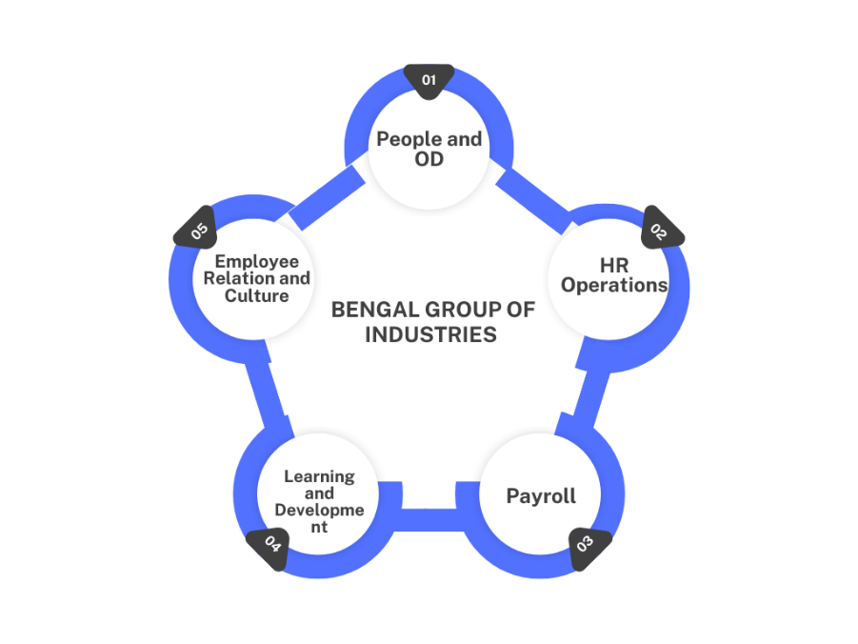
People and OD: The hiring procedure inside the company is under the supervision of this team. The talent management of the entire organization is related to this team. As a vacant position arises or the company requires workers for business expansion, they are responsible for talent sourcing, recruiting, onboarding, retention, and other related tasks.

Operations: During hiring, all operational tasks, such as queries of any type and talent management-related operational decisions, fall within the area of operation and continue until the employee leaves. The operational team is responsible for employee job confirmation, transfers, promotions, discontinuations, increments, fingerprint-related concerns, etc.

Payroll: The team manages final settlement, staff wages, and other forms of compensation. This team conducts annual performance reviews with each employee. Organizing employee salaries, maintaining internal payroll records, and guaranteeing on-time payments are all part of their job duties.

Learning and Development: After joining there are many skill gaps. This team helps to develop the employee's skills. Their task is to identify the development scope, plan training, and awareness sessions accordingly, and provide these training sessions through internal or external trainers.

Employee Relation and Culture: The Bengal Group of Industries' organizational culture and values are largely shaped by the work of the culture team. They establish a strong working relationship between the organization and its employees as well as between the employees and management by establishing and maintaining policies that are followed by the workforce.

5.2 Recruitment process

The process of finding, assessing, and hiring new personnel for a company is known as recruitment. There are four stages in this process. These include job analysis, sourcing, screening and selection, and onboarding. Any organization's most common and important component is the recruitment process. The most crucial step in any hiring procedure is selecting the best applicant for the position. An organization's ability to succeed determines how well its management can handle its profession and provide standard service to its clients. The primary goal of keeping the organization's hiring procedure well-organized is to keep that end goal in mind. Recruitment is one of the key duties of the human resources division. This is the hiring process that the Bengal Group of Industries follows. HR oversees the hiring and selection process between the grade and level of management and non-management staff. There are three categories or levels at the managerial level. These are listed below:
1. Entry-level
2. Mid-level
3. Top management

Here those steps are followed by Bengal Group of Industries:
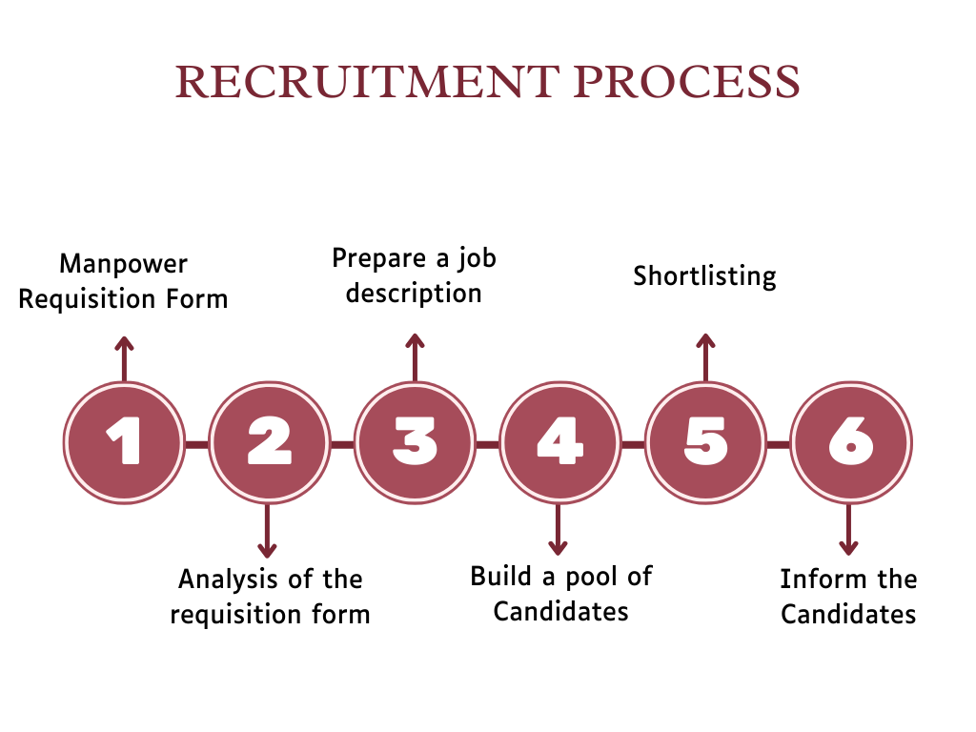
Manpower Requisition Form: Manpower requisition form in Bengal group of industries A supervisor of the concerned department first sends a manpower requisition form to HR. This form mainly contains the Department, designation, placement, and types of recruitment. , supervisors of other departments send a form to HRD to specify manpower requirements. After receiving the HRD, it will analyze the requisition form.
Analysis of the requisition form: Members of the HRD team evaluate whether or not they genuinely need people after receiving the demand. To put it briefly, they evaluate the need. The Director approves the manpower demand form after it has been examined by HR staff and processed for approval. The Director will approve the request if, after taking everything into account, they decide that hiring is required and supported by HRD.

Prepare a job description: The HR department of Bengal Group creates the job description for the particular position after evaluating the manpower request. The post title, category, location, division, reporting structure, primary duties, necessary education, area of specialization, required work experience, and other details are all mentioned in the job description. They then produce advertisements for other media platforms to draw in possible applicants. Here are some key responsibilities of the Sr. Executive given below from the job description:
- Create a formal onboarding process for new hires that includes introductions to key personnel and the team, employee orientation, and the provision of a welcome pack.
- Work together with the team lead to identify open positions and take the appropriate action to fill them.
- During the direction of the team lead, prepare talent acquisition by creating daily, weekly, monthly, quarterly, and annual reports on requisition activity.
- Human resources need for recruiting by quarter and year are forecasted.
- Find candidates through job fairs, recruitment agencies, institutions, internet job ads, and social media platforms.
- CV screening and shortlisting the CV, call for an interview, and employee background.
- Build a strong applicant pool in case important roles become available in the future. Keep a database of sources, specifically for the support personnel. check.
- Weekly vacancy list submission with analysis is required. For every open position, a graph should be created based on these outcomes.

Build a pool of Candidates: After HRD approves new recruitment requests, they create advertisements for each managerial position available. HRD of Bengal Group will create an advertisement. Bengal group advertises through Bdjobs, LinkedIn, the Company website, and the Facebook page (Bengal Career).HR will post job advertisements in a quantity of media outlets selected based on the nature of the post. Job advertisement is posted online as well as published periodically in newspapers for a short period. Candidates will mail their resumes to the job posting and HR department after the scheduled time. HR stops accepting applications after a certain time.
Sources of Candidates: In the Bengal group of industries there are two types of recruitment:
- Internal
- External
Internal Source:
- Company's website.
- Additionally, they fill a vacancy by giving a certain person a promotion.
- Bengal Group of Industries presents Employees who recommend applicants for vacant positions.
- From Internship student
- Bengal Group transfers a particular employee from one unit to another unit, because there are 26 SBUs in the Bengal Group. Bengal Group employees are internally transferred from the Dhaka office to the Chittagong office.
- Employee’s relatives.

External Source:
- Bdjobs.com
- Facebook Page (Bengal Career)
- LinkedIn
- CV Bank

Shortlisting: This next step's key objective is to reduce the number of candidates after all applications have been received. Shortlists are created based on the required expertise, skills, etc.

Inform the Candidates: After shortlisting, HRD contacts candidates via phone or SMS to schedule an initial interview. For entry-level, and mid-level positions, candidates shortlisted for interviews are called and texted and a confirmation call is made before the interview. In case of a senior post, an email invitation is to be sent and a candidate form is sent. Here is an image of the candidate form used in the Bengal Group of Industries.
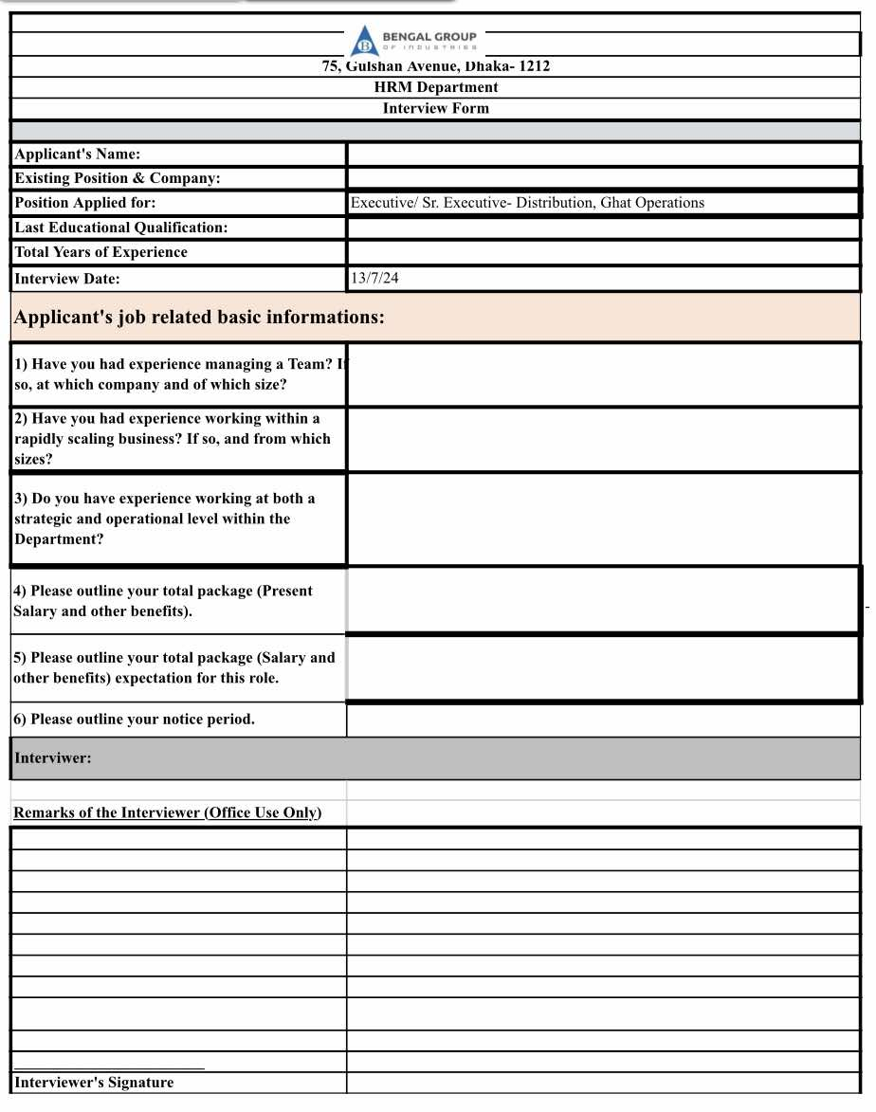

5.3 Selection Process of BGI:

Organizing specific changes is a part of the selection process that determines who gets recruited. After enrolment is closed, the selection process begins, based on the number of participants who are enthusiastic and willing to engage in the activity. Finding out more about a possible participant and estimating their level of contribution to the activity are the main objectives of the selecting session. After the entire recruitment process is completed, HRD handles the candidate selection process. The following is a list of the actions that the Bengal Group of Industries uses:
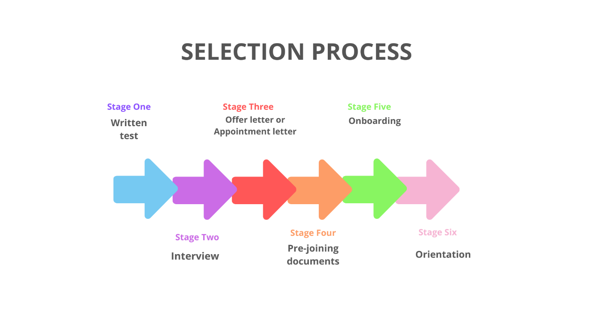

Written test: Every public-private sector hiring procedure includes a written exam as a standard component. This is usually handled for the greatest number of vacant positions. Before the interview, the top management of Bengal Group of Industries is certain that the written exam has shown to be a useful and effective tool for choosing the most suitable candidate. Assessing a candidate's level of knowledge in the necessary field is the primary goal of a written exam.

Interview:
After the written exam, candidates must appear before the interview board. The interview board typically consists of two interviewers. Attending the interview board is the HR Assistant Manager, a manager, or the head of a particular department. Here, HR-established fundamental criteria are used to interview and evaluate candidates. Selected candidates will be individuals who complete the requirements and receive a perfect score during this initial interview. This is an image of the assessment sheet the Bengal group used during the interview.
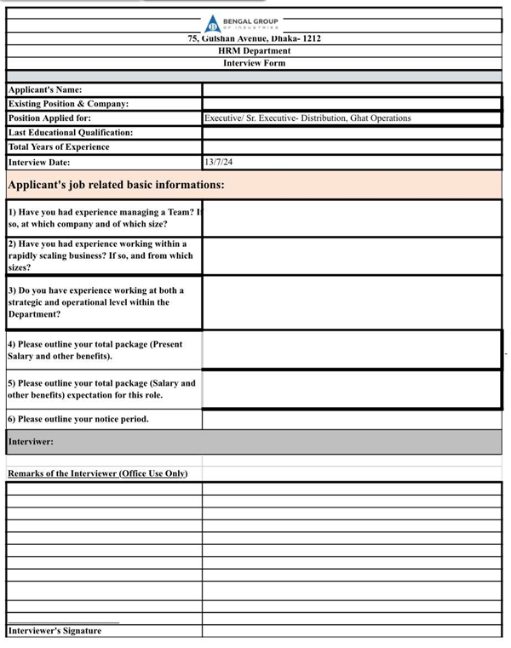

Offer letter or Appointment letter:
Bengal Group of Industries management issues a confirmation letter and emails to the selected candidate. They also confirmed their joining over the phone. Selected candidates are given appointment letters for regular jobs as well as contractual employees. The letter of appointment must contain:
- Job title.
- Grade and salary.
- Nature of appointment.
- Name of section or department.
- Effective date of appointment.
- Probationary period, conditions of confirmation, and notice period.
- Ending date of employment.

Pre-joining documents: The candidate must provide the following documents before joining. Human resource division officers handle the following documents:
- 4 Copies of Passport-size Photographs
- Photocopies of all educational certificates.
- Photocopies of Utility bill
- TIN certificate,
- Photocopy of NID
- 1 Copy Passport size picture and photocopy of NID of nominee.
- photocopies of release letter/clearance letter/experience letter.

Onboarding: During the onboarding of Bengal group, the new joiner has to fill up some forms, including the joining report, employee information form, health declaration form, employee logistic requisition form, and employee authentic signature form. Then collect all other documents from the employee.
- All educational certificate
- Passport-size photographs
- NID card photocopies
- Nominee NID card photocopies and photographs
- TIN certificate
- Release letter /clearance letter/experience letter.
- Utility Bill

Also, HRD provides bank forms for management employees. Some documents to be provided along with it are:
- Passport-size photographs
- NID card photocopies
- Nominee NID card photocopies and photographs
- Office ID Card
- TIN certificate
- Utility Bill

Orientation: This orientation program mainly welcomes new employees to the Bengal Group of Industries. Through the orientation program, you will get to know the details about the company their working style, and the terms and conditions of the company.

5.4 My Internship Experience

5.4.1Training Session:
I obtained some training from The Bengal Group of Industries to help me advance my career when I joined. The following are the lessons I have learned from the training:
Employee Induction Training: The training has provided me with detailed information about the organization, including its policies and procedures. The organization's policies and values were also covered in this training session.
Office Etiquette & Personal Grooming: I learned about corporate behavior and culture in this training session. Now I know what is appropriate and inappropriate behavior for me to conduct as an office worker. I also gained knowledge on how to treat juniors and how to act around seniors.
MS Office (From Basic to Intermediate): In this two-day training session, I learned many new things about MS Word, PowerPoint, Excel, and Outlook, which will help me a lot in my job sector.
Time Management: During this training program, I learned how to maintain a to-do list, complete tasks on time, and allocate my time based on their important task.
CV writing skills and face-to-face interviews: I gained knowledge from this training session on how to properly format my CV for a corporate job. Also, I gained knowledge on how to prepare for an interview board job interview, and audiovisual presentation I learned how to properly prepare for the interview board.

5.4.2 My Job Responsibilities

As an HR intern at Bengal Group, I reported to my supervisor Ahsanul Islam, Assistant Manager, HRD People and OD, He assigns and manages all of my assignments. I helped her primarily with a range of tasks. Normally, I would perform:
- Significant work in the process of recruiting and selecting employees
- Collecting the resumes that my supervisor has provided and printing them as needed.
- Make a short list of potential applicants based on the requirements for the role.
- Phone calls and messages to the interview's shortlisted candidates, as well as confirming the call before the interview.
- Email invitation for all candidates.
- Set a time for the applicant's interview and written test.
- Making the assessment sheet ready for the interview and printing the candidate information form, CV, attendance sheet, and assessment sheet before the interview.
- Conducting written tests and interviews.
- Managing the employees' joining.
- Processing files, checking and updating personal file information, keeping record of personal file information, and updating and maintaining the human resources database
- Distribution of appointment letters.
- Providing bank opening forms and distributing checkbooks and cards are some of the tasks related to opening a bank account.
- Providing the official ID card and visiting card requisition list to the administrative team.

Chapter-6

RECOMMENDATION & CONCLUSION

6.1Recommendation

Install Digital Screening Tools: I recommend Bengal Group's HR Department use an Applicant Tracking System (or ATS for short) to quickly review resumes and cover letters. This way, our HR team can spend more time talking to the best candidates instead of getting bogged down in paperwork, making the recruitment process smoother and faster for everyone involved.
Enhance onboarding procedure: Newly hired employees might use an online onboarding tool to complete paperwork and become acquainted with corporate policies before their first work day. As a result, early employee retention may improve as they feel more at ease and prepared to join the company.
Improve interview pool: In Bengal group written exam and viva are conducted on the same day, so there is no time to check the candidates properly. I think they should check the marks of the written exam and then take the final interview so that they can hire the best candidates.
Implement Regular Training Programs: There is no training for the new employees and existing employees in Bengal Group. But if they deliver any training program for employees then it will be easier for them to adjust new atmosphere. Bengal Group should start training new and existing employees, it will increase work productivity.
Develop a Positive Candidate Experience: To improve Bengal Group's reputation and attract top talent, we should focus on providing a positive candidate experience. This can be achieved by communicating promptly and openly, offering feedback after interviews, and streamlining the onboarding process.

6.2 Conclusion

My internship at Bengal Group of Industries provided a valuable opportunity to apply theoretical HR concepts in a practical setting. This experience allowed me to gain deeper insights into the recruitment and selection process, covering all key phases from job analysis to onboarding. This report outlines these processes in detail, demonstrating how they are implemented in a real-world business environment.
However, there are areas where the recruitment and selection processes can be improved, as a company's growth depends heavily on attracting and retaining talented individuals. Efficient recruitment and selection methods are essential for identifying and hiring productive employees. During my time at Bengal Group, I observed several challenges within the process that could hinder its effectiveness. This report highlights those issues and offers a comprehensive overview of how the company sources candidates and manages workforce placements.
It was a privilege to work at Bengal Group of Industries, a well-established organization with a highly skilled and dedicated team. The company fosters a positive work culture, balancing professionalism with a supportive and disciplined environment, which enables employees to perform their tasks effectively. The leadership is approachable, cooperative, and communicative, creating an engaging and organized atmosphere for all employees.

CHAPTER-7

APPENDIX

Questionnaire

- What are the key stages involved in the recruitment and selection process at Bengal Group of Industries?
- How does Bengal Group ensure that job descriptions accurately reflect the requirements of the role?
- What are the sources you use for the recruitment and selection process? (external/internal/both)
- How are recruitment processes tailored for managerial versus non-managerial positions?
- Does HRD complete both the Managerial and Non-managerial recruitment and selection process?
- What onboarding procedures are in place to ensure new hires adapt quickly to the company?
- What training programs are available to both new and existing employees at Bengal Group?

Reference:

- Bengal Group of Industries. (n.d.). Home. https://www.bengalgroup.com/
- Wikipedia contributors. (n.d.). Bengal Group of Industries. Wikipedia. Retrieved October 9, 2024, from https://en.wikipedia.org/wiki/Bengal_Group_of_Industries
- Jobsoid.com (n.d.). What is the recruitment process? https://www.jobsoid.com/recruitment-process/
- LinkedIn. (n.d.). Bengal Group of Industries - HR Division. LinkedIn. Retrieved October 3, 2024, from https://www.linkedin.com/company/bgihrd/

