Internship Report

On

Analysis of the Client’s and its Competitors’
Marketing Communication

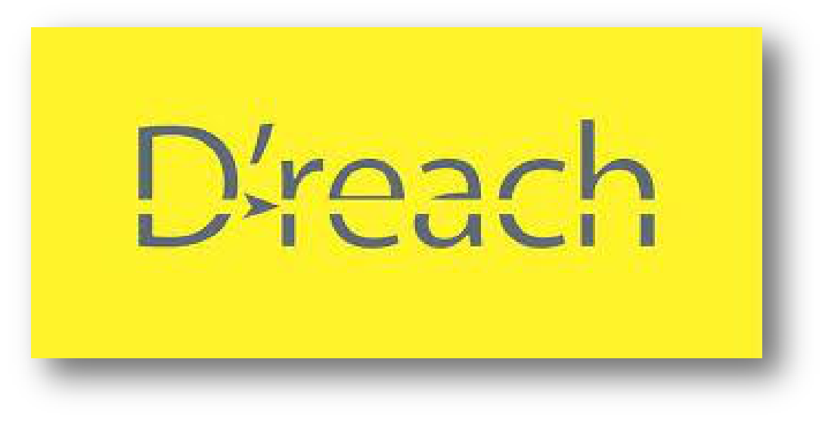

i



Report On

Analysis of The Client’s and Its Competitors’
Marketing Communication

Prepared For

Dr. Khandoker Mahmudur Rahman

Associate Professor

School of Business & Economics

United International University (UIU)

Prepared By

Maisha Mahmud

ID: 111 141 036

School of Business & Economics

United International University

January 04, 2020

ii

Letter of Transmittal

4 January, 2020

Dr. Khandoker Mahmudur Rahman
Associate Professor
School of Business and Economics
United International University

Subject: Submission of the Internship Report

Dear Sir,

I would like to submit my internship report titled “Analysis of the Client’s and its competitors’ marketing communication.” In fact, this is a study on Lovello Ice Cream’s increasing awareness of digital marketing, which has been prepared as a requirement for the completion of the BBA Program of United International University.

D’reach was formed in March 2018 and its mother company is MACOMM which establish on 2005. While working on the report, I have tried to follow every guideline that you had advised. . By collecting information for this report I also learned something very superfluous in practical. I look forward to make the optimal use of the knowledge. It was a great pleasure for me to have the opportunity to work on the above mentioned subject. I have tried my best to come out with a good one. It was a great experience to work with D’reach and I have really enjoyed my internship period at D’reach competitive analysis. MACOMM has also extended their cooperation whenever required.

Sincerely,

Maisha Mahmud
ID No: 111 141 036

iii

ACKNOWLEDGEMENT

I would like to thank my Internship supervisor, Dr. Khandoker Mahmudur Rahman who has helped me to complete my internship report. And the name of my internship report is “Analysis of the Client’s and its competitors’ marketing communication.” I am really grateful to Mr. Sajid Nurul Kabir (Chief Operating Officer, D’reach) for giving me the opportunity to complete my internship at D’reach. I am sure that his dynamic managerial activities will give inspiration to anybody to build one’s career properly.

I also want to thank Mr. S. M. Faheem Alam (Assistant Manager- Strategy, Planning & Performance Management) and and Mr. Md. Ashikur Rahman (Executive- Social Media and Online Community Management ) also all individual of D’reach, for their support that I have been provided for preparing my report. I practically work with them, try to share their perception, on the basis of my experience, which I achived through working with them. And it help to preparing thereport from my perception. I am grateful to all people of D’reach who had gave effort and contribution to complete the report and who shall get benefit from this report at present and in future.

iv

DECLARATION

I am Maisha Mahmud, the student of School of Business and Economic (Marketing) of United International University, Bangladesh, and declare that my internship Report is an original work and has not been previously submitted for any institution, degree, diploma, recognition and title.

________________

Maisha Mahmud

ID No: 111 141 036

School of Business and Economics

United International University.

v

EXECUTIVE SUMMARY

I have completed my Internship at D’reach Bangladesh, one of the fastest growing Digital Marketing Agency in Bangladesh. My internship is in the Digital Marketing Department. Throughout my internship, I had to work for the different brands of Bangladesh, and this report is the reflection of my first experience in the world of digital marketing. In this report, a clear explanation of digital marketing is given, explaining its importance, priorities and the role it plays in the growth of a company. This report will also mention the process of creating awareness of a product, how to manage the relation between the clients in an agency. After reading this report, a reader will have a clear understanding about digital marketing and its growth.

Objectives of the internship are to analyze the clients and its competitor’s communications.

Methodologies used for increasing awareness with the help of digital marketing. For understanding their communication system and increasing awareness, I have analyzed on clients competitive & comparative analysis and study all the communication method and audience engagements for the agency – D’reach. By communicating with the clients, I got the opportunity to work with the ice cream brand “Lovello Ice Cream”.

The key research findings of this internship are given here. Audience in Lovello Ice Cream Facebook fan Page are information seeker and asks query regarding product or contest that are happening monthly bases. They collect all information of the post, product, and campaign. Though in Bangladesh people are more becoming in to social media, so social media and digital platform become more important for marketing and marketing strategies. Brands are getting more attention to reach out their targeted customers in this digital age. Elaborate details are also mentioned in this report. The completion of this internship clearly states that the current future of marketing relies completely on digital marketing. I would like to conclude the report by saying that “Increasing awareness with the digital marketing”.

vi

 | Table of Contents
Sl No | Topic | Page No
 | Acknowledgement | iv
 | Declaration | v
 | Executive Summary | vi
Part-1 | Organization Part | 1
1.1 | Background of the Company | 1
1.2 | Mission | 2
1.3 | Vision | 3
1.4 | Objectives | 3
1.5 | Services Offered | 3
1.6 | Digital Service Capabilities | 4
1.7 | Clients of D’reach | 6
1.7.1 | Lovello Ice Cream | 7
Part-2 |  | 8
2. | Origin of the report | 8
2.2 | Scope of the study | 8
2.3 | Methodology | 8
2.4 | Limitation | 9
3. | Description about Job | 10
3.1 | Job Title | 10
3.2 | Job Responsibilities for Lovello Ice Cream and other Clients | 10
3.3 | Servicing for the clients (Lovello Ice Ceram) | 10
3.4 | Core Responsibility | 11
3.5 | Specific Responsibility of Jobs | 11
3.6 | Critical observation and Recommendation | 12

vii

4. Project Topic (Lovello Ice Cream Increasing Awareness with |  | 17
 | the help of digital marketing)
4.1 | Description | 17
4.2 | Description Lovello as our client | 17
4.3 | Objectives of Digital marketing for Lovello Ice Cream | 17
4.4 | Ideal Digital Plan for “Kishor Alo” Project | 18
4.5 | Reason for Implementing on “Kishor Alo” Campaign | 19

5. | Strategic Plan of Project | 21
5.1 | The Right People | 22
5.2 | Targeting the right People in Facebook | 23
5.3 | Right Communication | 24
5.4 | The right Action | 24
5.5 | Budgeting | 25
5.6 | What D’reach did for Lovello Ice Cream | 26

6. | Analysis | 27
6.1 | Audiences Reached | 27
6.2 | Post Engagements | 28
7. | Results and Discussion | 29
8. | Conclusion | 30
9. | Appendix & References | 31
 | Appendix | 31
 | References | 42

viii

Part 1

1. ORGANIZATION PART

Overview of the Organization about Analysis of The Clients and its
Competitor’s Communications of D’reach:

MACOMM is the mother company of D’reach. And D’ reach means Digital Reach. D’reach is a company where they work digitally to create & increase awareness for other Brand’s in Bangladesh and foreign counties.

A complete inventory of day to day services ranging from consumer insights, competitive insights, planning, buying, campaign optimizations, reporting to the future ready service capabilities of AI, VR, AR, InApp Video Advertising and Premium Online Cricket Properties. Their digital services delivery efficiency is backed by global practices and expertise of Dentsu Aegis Network’s digital arms – Isobar, i-Prospect, SVG and others.

MACOMM, MediaAxis and D’reach are the 3 flag bearers of Dentsu Aegis Network in Bangladesh.

MACOMM is the Official Affiliate of Dentsu / DAN, MediaAxis is the Official Affiliate of Carat / DAN Media / DAN and D’reach is the digital arm of our group with strong collaborative support from Isobar, i-Prospect and SVG.

In addition, we have Creinse Limited, an independent subsidiary operation of the group which specializes in branded content and productions, live music events of global music performers, international program syndication and music content and artist management and distribution.

Another subsidiary organization in the making is Nagamorich which is being set up as technology driven event management specialist.

D’reachis a company dedicated to the development of consumer awareness. The main objectives of the company are advertising and promotion. D’reachaims to establish a brand as being one of the best digital promoters of a given product or service, and to even have the brand name become the meaning for the product or service that is offered.

1

1.1 Background of the company:

Launched in April 2018, as an independent digital agency growing from a digital division of MediaAxis/Carat, D’reach is the digital specialist of the group which delivers digital transformation, powered by creativity. D’reach thrives on delivering diverse digital marketing services ranging from planning, data mining, execution, innovation and immersive.

D’reach’ s digital expertise is strongly supported by Isobar, i-Prospect and SVG, which are the world’s leading digital agencies and the digital flag bearers of Dentsu Aegis Network.

D’reach is the Company and they are interested to create awareness of the other brand service and product with the help of digital marketing. Currently digital media is growing very fast everywhere and Bangladesh is also following this trend. The result of its growth is very large. At present, millions of people are connected to the internet with the help of digital smart devices. So, D’reachseized the market opportunity by capturing the digital market in Bangladesh. They also have many competitors. D’reachplans to carry out all the digital campaigns of their respective clients.

MACOMM, the flagship agency of the group, began its journey in 2005as an independent full service advertising agency and initiated its journey with three global brands – Panasonic, Toshiba and Tourism Malaysia. The core specialization of the agency at the time of inception was creative, media buying and event management solutions and today it focuses on creative services, brand management and event management. MACOMM became the Official Affiliate of Dentsu / Dentsu Aegis Network in 2015.

MACOMM has worked over 50 leading global brands and over 100 brands in total over the last 14 years spreading across multiple and diverse products and service segments.

MACOMM is the only agency to have an in-house consumer research and brand/services. Industry data tracking division, Black Box, making it the only advertising agency to be a data and insight driven creative agency.

With a client retention rate of over 80% it is currently one of the top 5 creative agencies in the industry.

D’reachis a consultancy provider for its clients and also provides necessary media investments.
The company makes sure that the media investment gives the desired output for its clients.

1.2 Mission:

D’reach Mission is creating awareness with the help of digital presence for its clients.

2 | P a g e

1.3 Vision:

The vision of the company is to become a the agency everyone considers as a primary choicein Bangladesh, by being the client-focused and socially committed service provider”

1.4 Objectives:

There are few objectives of D’reach. It includes:
- Create a compelling digital presence on web and social platforms
- Manage business information across online channel
- Facilitate the discovery of content across customers’ digital assets
- Drive traffic, leads and revenues from online channels

1.5 Services Offered

Facebook Marketing Services

Facebook is undoubtedly the most effective and renowned form of social media. As Facebook have introduced the new Ad platform, organizations are now able to trigger conversation with their target audience and attain massive boosts in their branding and lead generation campaigns. D’reach therefore, offers a full variety of Facebook Marketing Services as businesses can now benefit from the power of social media by allowing the experts handle the marketing part.

Social Media Marketing

Social Media Marketing is currently dominating the digital scenario. Social Media Marketing currently seems like a reasonable option for a spam free, people friendly platform. The social media experts from D’reach help create such relationship with the audience that allows an organization to own a set of followers of Instagram, YouTube and word of mouth.

3 | P a g e

1.6 Digital Service Capabilities:

D’reach is capable to provide services to their clients. And the service they Provide:
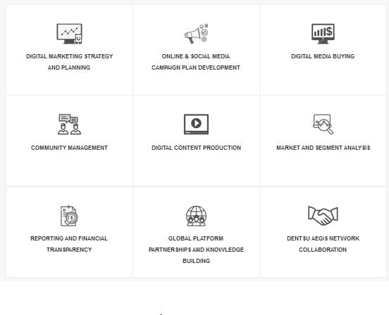

Figure: Digital Services Provided by D’reach.

Above figure shows the services that D'reach provides to its clients. Services include digital marketing strategy and planning, online social media campaign plan development and management, community management, digital content production etc.

4 | P a g e

D’reach’ s strong work integration structure with Dentsu Aegis Network enables its capability to produce the latest digital innovations in real time, tested and assured executions.
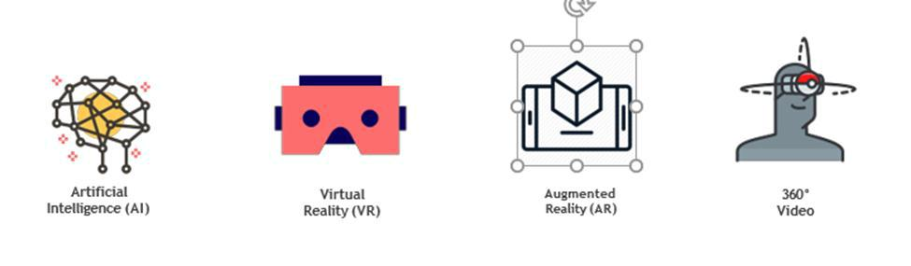

D’reach has direct service support from Facebook, Google and Yahoo which ensures quick turnaround time for campaign execution, trouble shooting and campaign optimization. D’reach also provide Facebook Official Page Verification enabling services for its clients.


Digital Activities:
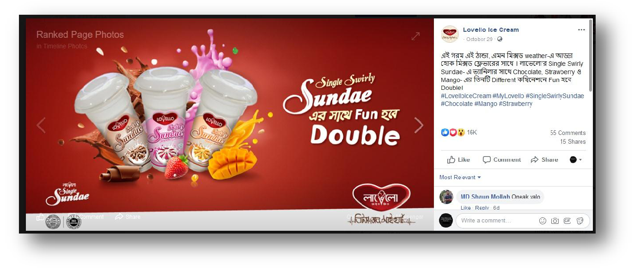

Figure: Facebook post of Lovello ice cream promotion

5 | P a g e

1.7 Clients of D’reach:

D’reach works for many brands to build their clients brand awareness. & it’s value is to get successes for their clients and think for betterment of the company. And their clients are Lovelle, Laugfs Gas, Standard Chartered, Yellow, Honda, Kumarika Soap, IOM, Toshiba, USA AID, Jaquar etc.
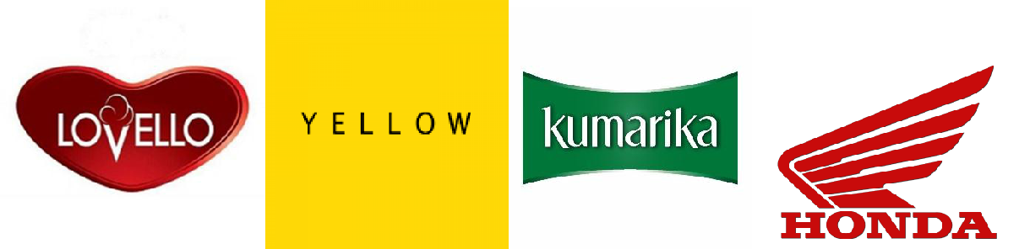
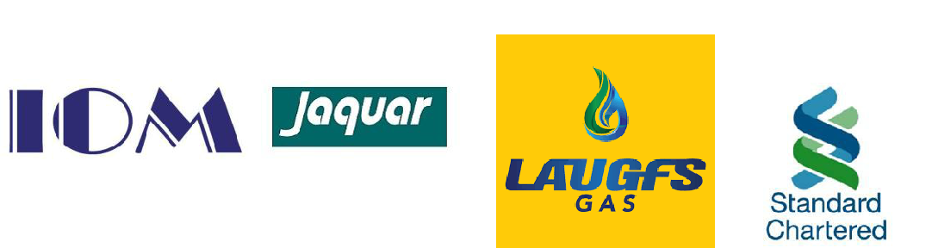



Figure: Brands D'reach worked with so far

6 | P a g e

They have lots of clients and from the first day of my internship I am working for the comparative analysis of Lovello. So, I will write details on Lovello Ice Cream company. And in the second part I will write abouthow D’reach Create awareness for their client Lovello Ice Cream with the help of digital marketing or online marketing.

1.7.1 Lovello Ice Cream:

Lovello is one of the most popular ice cream brand in Bangladesh &D’reach handle the digital sector of Lovello. Mainly the Handle the Facebook page and Google Page too. Which give our client instant sale of their products?

The Taufika Foods and Agro Industries Ltd launched a new ice cream brand, Lovello, at the Hotel Pan Pacific Sonargaon in the city on Valentine's Day yesterday.

Managing Director of the company EkramulHaque, Chied Operating Officer Momtazul Islam, Head of Operations PW Gunapala, Head of Planning and Marketing Pervez Hasan were, among others, present.

Lovello Ice cream is new Ice cream brand in Bangladesh, But It’s popularity is increasing day by day, and now a day’s people of Bangladesh are engaging with digital sector’s and for their client’s betterment D’reach help Lovello to create their communication sectors on digitally. And on Online Promotion Lovello is increasing their communication with the help of D’reach.
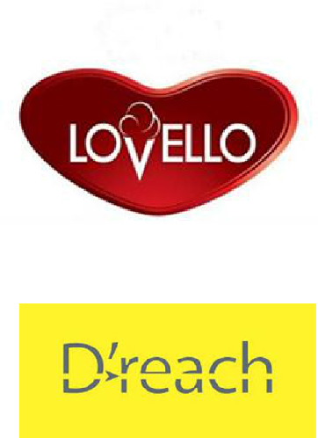

7 | P a g e

Part 2

2. Origin of the report

This report was assigned to me by the UIU Business School, as the final step of the completion of all the credits. And, the report has been prepared from the perspective of my internship in D’reach, where I was appointed as an intern of D’reach DMS (Digital Marketing System) department. After successfully completing the three month of internship at D’reach, I have prepared a report on, “Analysis the clients and its competitor’s communications (Study on Lovello Ice Cream increasing Awareness with the help of digital marketing)” and this elaborate report has been prepared under the kind supervision of Dr. Khandoker Mahmudur Rahman from United International University and Organizational Supervisor was Mr. S. M. Faheem Alam (Assistant Manager- Strategy, Planning & Performance Management) and and Mr. Md. Ashikur Rahman (Executive- Social Media and Online Community Management ) from D’reach.

2.2 Scope of the Study

This report may provide a detailed idea of Study on Lovello Ice Cream increasing Awareness with the help of digital marketing. This report also mentions some of the issues I faced during my internship period in D’reach, and hopefully it will allow the company to take necessary steps to fix those issues. Also, if anyone is interested to complete their internship in D’reach, this report will guide them properly by helping them to know the methods for its competitor’s communications.

2.3 Methodology

Primary source

Clients Brief and recommendation Is very important to make digital promotion. Like, what Lovello wants to promote first they considerate their recommendations after that how D’reach want to create awareness for them and they can reach all audience of Bangladesh will be considerable. And if D’reach can increase Lovello ice creams’ sales volume through online sectors. Than our client like to give us more new assignments and like to work with D’reach.

Secondary data

The secondary data are collected from the company and its monthly and annual reports of their clients. And also with the help of their client’s competitors monthly and annual reports which they can find on online and Facebook pages of their competitors.

8 | P a g e

2.4 Limitation

Despite of all the limitations I faced during my internship, I have given my full effort to the company and also on preparing this report.

For me, the primary limitation was time. As three months of internship is not enough to understand a company and get experience in different sections of DMS (Digital Marketing System) department.

Most of the companies have a strict rule of not sharing their information outside. It’s quite obvious that they want their information to be confidential and D’reachis no different. Most of the time, I faced the issues with data availability. And it’s a little bit difficult for me to prepare a report on informatics without necessary data, but as I was working as an intern at the agency, I managed to get some relevant information that was helpful enough to complete my report.

For confidentiality of the company, I would like to add that some of the numeric data are not completely accurate but the scenarios are appropriate.

9 | P a g e

3. Description about Job:

3.1 Job Title: Internship

3.2 Job Responsibilities for Lovello Ice Cream and other clients:

- Client servicing for Lovello Facebook Page

- Making Reports on Competitive Analysis for Lovello after end of the month

- Making Reports Comparative Analysis for Lovello Ice Cream

- Contributing Social Media and online strategy Reports for other clients

- Contributing to all the business strategies in accordance with the clients’ brief Looking after all the social media contents.

3.3- Servicing for the clients (Lovello Ice cream)

I did internship under Digital Marketing System department. The main responsibilities of this department is to analyze the industry and the digital media for clients, preparing strategies, making comparative analysis and executing them according to the objectives of the client. This entire process consists of 15 steps,

- Brief: Details provided by the client that is based on their marketing objective.

- Pitch Presentation: Prepared by us for the client based on their brief, by analyzing industry and the digital media.

- Proposal: The proposal given by Lovello ice cream including post on Facebook page, campaign objective, targeted market, approaches, strategies, estimated cost and desired outputs. And all of them work on digital platform like Facebook, You Tube & instagram.

- Review: Reviewing the proposal of D’reach to Lovello Ice Cream.

- Revised negotiation: If Lovello has any problems with proposal, the proposal needs to be re-written to make negotiation.

- Final proposal: The proposal which is finally forwarded to Lovello Ice Cream by

D’reach.

- Approved: The final proposal needs to get the approval from Lovello, or else we will lose client.

- Estimate Signed: It’s a contract between Lovello and D’reach.

- Release Order: The order which is submitted to the Facebook Page Post (Static Post& Video Post)and placing online ads (O.V.C). Mostly are product post, other ways awareness post, wish post, religious wish post etc.

- Creative: The executing of the idea or the plans of campaigning like banner for online post, creating event page to gather audience, websites, handling the customers through online or Facebook Pages Etc.

10 | P a g e

- Run Campaign: Initiating the campaign by placing ads banners, facebook contests, videos, and all of them are created by managing Facebook page etc.

- Reports: The reports are collected from the end of the event through that Facebook promotional activity.

- Compile: Collecting all the reports, and compiling the main order to submit to Lovello.

- Optimization: Optimizing the campaign to improve the effectiveness in order to achieve objectives.

- End: Ending the Campaign after achieving the objective, and making a presentation to show them how D’reach did their job well.

3.4 Core Responsibility

Basically, an intern’s main responsibility is to handle the customers of different brands through digital media, like facebook. Interns usually do not engage on all the tasks in digital service department. So I am mainly handling four different brands of comparative analysis like, “LovelloIce Cream”, “Lougfs Gas”, “Yellow” and “Kumarika soap”. I am also assigned to find the official page of Lovello Ice Cream. My task is making reports on comparative analysis of D’reachclients.

3.5 Specific Responsibility of Jobs

Specific Responsibilities of the job:

- At first, we reply to the comments. Mainly it’s the query that our customers ask to get the proper information regarding that respected brand. And it is mostly done in the comment section of any Facebookpost or they post on the wall or they inbox us.
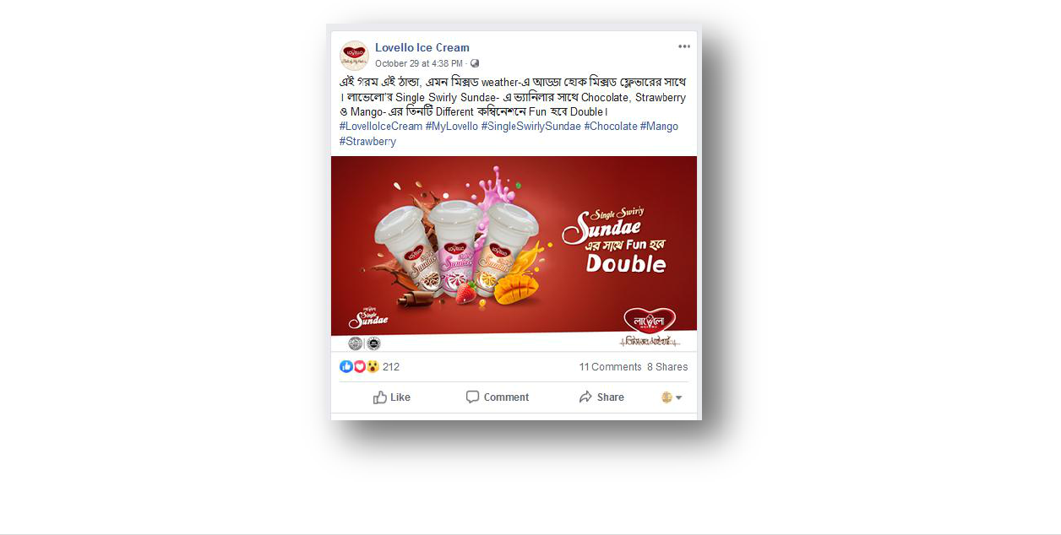

11 | P a g e

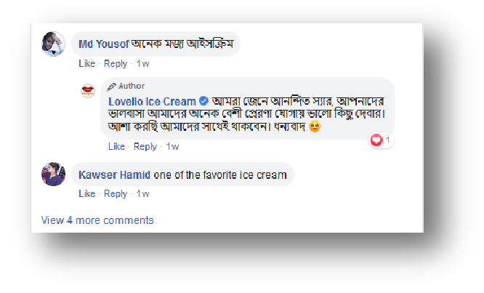

Figure: Engagements with clients through comment section of Facebook post

- In order to reach our brand to the customers, we must first reach the customers, a simple meaning that brands are expecting something their customers will accept. And to do that, we need to make creative contents and posts that reflects the brands message and to catch the attention of customers. We must be more creative and unique. Our job is to play the role as both the brand and the customer.

- Like in recently Lovello Ice Cream & Prothom Alo Presents Kishor Alo Campaign and for digital promotion D’reach help Lovello ice cream.

- And after the end of the program we have to submit how many people where engage through the promotional activities.

- And Lovello and D’reach worked as a team to increase the engagement of audience.

Repeatedly post through digitally and answer all of the customer or audience comments.

3.6 Critical Observation and Recommendation

Easy to identify the target audience:

It’s very essential to find out the target audience of Lovello Ice Cream. Because Lovello is a new brand and igloo, Bellissimo, Polar id their strong competitors. So here D’reach made a graph of target audience through Demography, gender, lifestyle, location, income, and Lovello distribution location. Here, is some behavioral pattern of Lovello target audience.

12 | P a g e

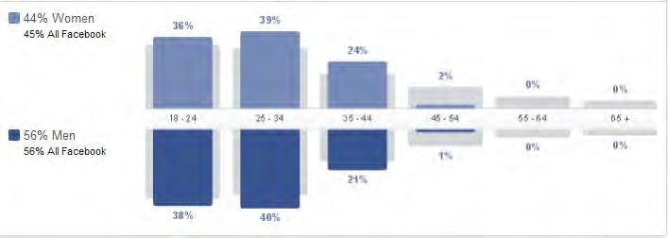

Figure 1: Percentages of Facebook users 18 to 40 +

D'reach mainly targets the customers between the age 18 to 40+ years. Amongst them 44 percent are female and 56 percent are male.
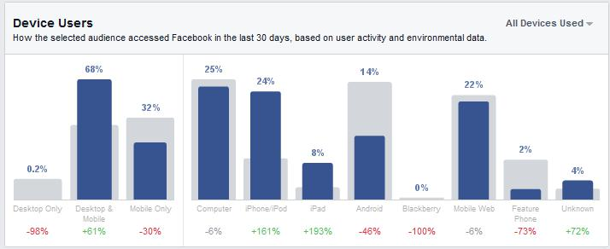

Figure 2: Facebook usage percentage of different device.

According to the pictures above, D’reach target Lovello audiences very easily. The chart mentioned above shows how D'reach fulfills their target through different devices.

Getting continuous effective sight:

Through digital promotion D’reach have to show the Lovello the page engagement and promotional activities through comparative and competitive analysis. And for this I had to make the presentation reports too.

13 | P a g e

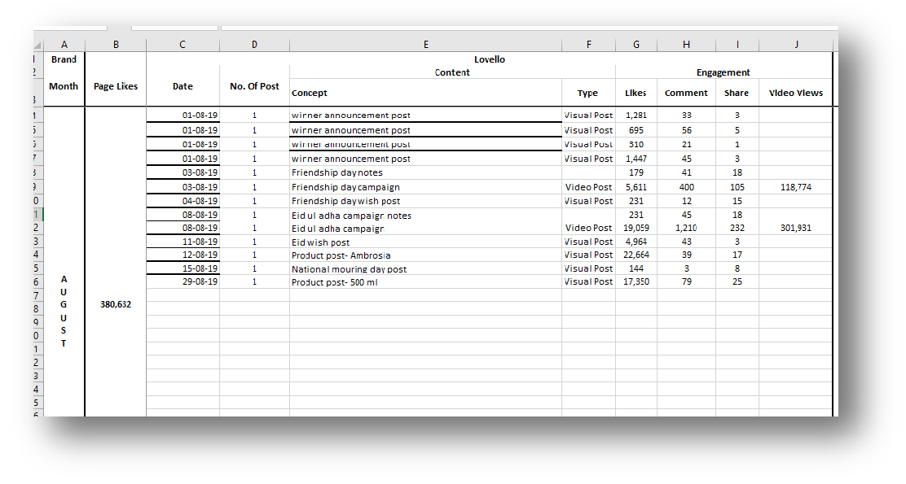

Figure 3: Comparative Analysis through Excel Sheet.

The above mention spreadsheet shows the detailed comparative analysis of Lovello ice cream.

The above figure is the original working format of how Lovello ice cream monthly analysis.
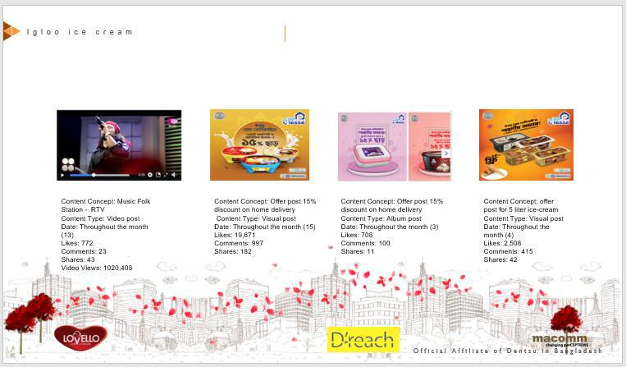

Figure 4: Competitor analysis through PPT File.

Above figure shows the competitor analysis for Lovello ice cream. it's the analysis of how Igloo promotes their brand through social media.

And all of these thing helps them to reach every monthly engagements and increasing rate of the audiences.

14 | P a g e

Engagements with campaign of (“KishorAlo”):

To make the engagements for the program they need to create too more individual pages. And for that I had to comments all of the answers of the audience very politely. And so I could increase more audience. And the event was very successful for the engagements.

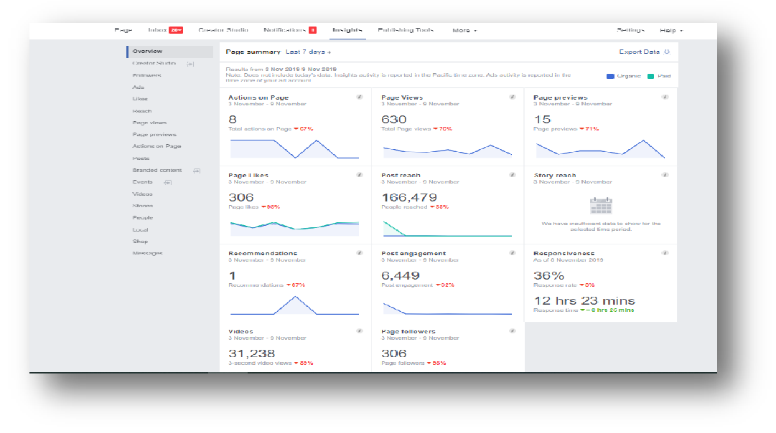

Figure 5: The Engagement of the Audience.

The Engagement of the Audience:

The above figure shows the complete graph of Lovello ice cream social media promotional activities which are done through company software. The entire line chart is done using software which the company uses to analyze their customers digital engagements. And this chart shows the Lovello ice cream customers digital engagements.

Knowing the Brand Personally:

Another interesting thing is that I know about the brand personally. First one week they ask me to study on each brands. And after that I had to work for yellow, Lovello, Kumarika, standard chartered Bank &laugfs gas. But specially I work for Lovello Ice Cream most.

Getting a opportunity to work for Lovello directly:

Most of the post share, communicating with audience, making comparative and competitive analysis for Lovello ice cream. And become a small member of D’reach. For D’reach I had learn a lot. First they teach me properly after that I work form them. I don’t know about how a digital agency work for their clients. But I could do this because they gave me the opportunity.

15 | P a g e

Getting up to date information of competitors’ activities:

We can easily monitor our competitors using this page to know how they are performing. A table is given below to describe the entire scenario –

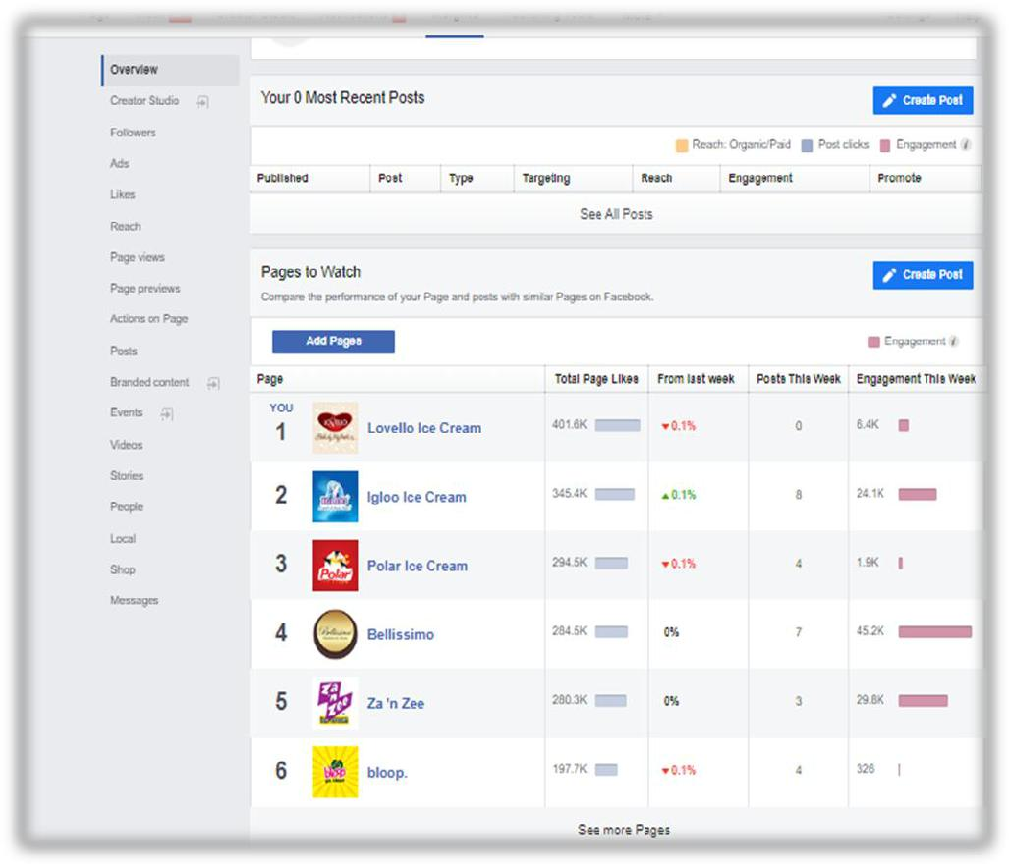

Figure 6: Competitor Analysis of Lovello Ice Cream.

Competitor Analysis of Lovello Ice Cream:
As we can see, Lovello is the top one for digital marketing. Igloo is posting more than any other companies. But Lovello can engage more customers because of campaign, awareness, and competition digitally to capture digital market. And all of these activities are done by D’reach. This chart describes how D’reach activities and efforts are affecting their clients and to keep track of their activities. So, that they can serve their clients the best through the digital media. In the chart Lovello ice cream is grabbing customer engagements through Facebook. And in the Facebook Lovello is doing better than other brands like Igloo, Polar etc. They are in the top list of ice cream industry on Facebook.

- P a g e

4. Project Topic (Lovello Ice Cream increasing Awareness with the help of digital marketing):

4.1 Description:

I had work here at Digital marketing service system department. That is the most important part of client service digitally. And learn how to collect client brief, and pitch them, make creative post, run a campaign digitally, and how to engage maximum people as customers. And after that, the methodology, objective and limitations will be discussed. After that the process of how an agency works when they get the details in brief from the client will be discussed. Lovello ice cream is our client in this time. In this part, we will be discussing the total strategic plan that we did for our client and also the result we obtained after completing this campaign which lasted a whole month. And finally, this report will end with conclusion which is a summary of the most important events of this whole project.

4.2 Description of Lovello as our Client

Here, I will discuss about D’reach Client Lovello ice cream. Mainly How D’reach worked after getting the details from Lovello. And to explain that, I have chosen Lovello ice cream recent promotional activities on (KishorAlo) campaign.

Understanding the brief:


Brand Name

360 degree
communication Category
system

 | Client Brief
Target market | Positioning
Target market | statement
 | Competitors

Figure 7: Client Brief

17 | P a g e
Client Brief

Brand Name: Lovello Ice Cream

Company Name: Taufika Group

Competitors: Igloo, Polar, Bellissimo, Bloop, Za N’ Zee.

TG Engagement on Social Media: Facebook, YouTube and Instagram.

Campaign Name: “KishorAlo”.

And all of this comes from the client means Lovello Ice Cream. And D’reachhave to promote digitally through follow all Lovello instruction.

4.3 OBJECTIVES of digital marketing for Lovello ice cream

- To know the entire process of making plans for clients.

- To know how much effective digital marketing in this competitive age.

- To know digital marketing is important for brands.

4.4 IDEAL DIGITAL PLAN FOR “KishorAlo” PROJECT



Direct Traffic

Product Relevant
Consumers
1. search
Annousment Post
2. display

3. Social Media
Lovello Ice Cream
Online Promotion

Email | Referrals
Email | (Quaries)

Mobile Base

  - mobile

- number base audiance

Figure 8: Lovello Digital Project.

18 | P a g e

4.5 Reason for implementing on “KishorAlo” Campaign:

Product relevant customer:

In “KishorAlo” campaign most of the students where school going student. Lovello ice cream and ProthomAlo both are campaign the kishoralo every year. And D’reachhelp online Promotional activities. So, for that their target audience are class 5 to class 10 school going students. But on digital their target audience are their parents. And the children parents will collect the invitation from online or Facebook pages. From the link where the online form has to fill up.
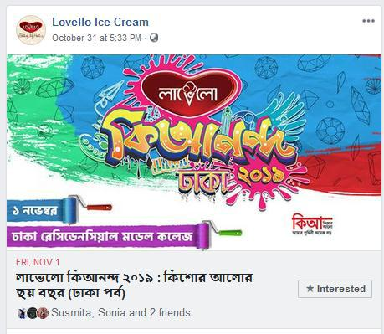

Figure 19: Lovello Ki Anondo Campaign

And it was the campaign where D’reach helping them to engage more audience for the campaign. Lovello Kishore Alo campaign which was organized by Lovello and Prothom Alo, their Facebook promotional activity was done by D'reach.

19 | P a g e

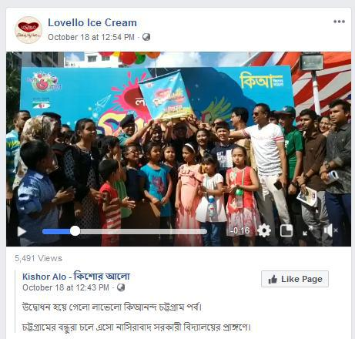

Figure 11: Video screenshot of The Campaign
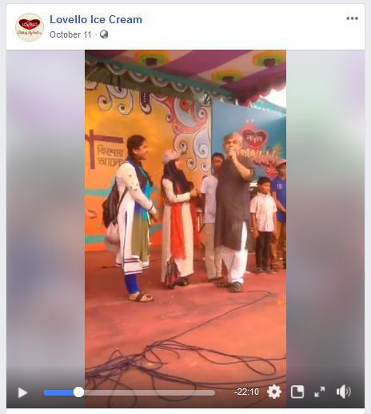

Figure 12: Another screenshot of the footage of the Campaign

These are the promotional activities for Kishore Alo campaign done by D'reach. Throughout the month D'reach did all of these promotional activities.

20 | P a g e

- Facebook Engagements: All of engagement was digitally.

- Search: It is mainly performing search using keywords. For example, when we search something in Google. And then Google automatically shows us the campaign of Lovello. But in this situation, we could not do it, because Lovello Ice Cream website does not provide well information that can help the audiences enquire.

- Mobile: Lovello ice cream website is not very user friendly in mobile devices, otherwise we will be able to post an ad, so when people who uses the internet using smartphones can see them.

- We are unable to make a direct communication with customers with the help of online. D’reach normally handles customers through replying to their comments. Which causes the customers not getting their reply on time which causes customer dissatisfaction.

21 | P a g e

- Strategic Plan of Project

The art of achieving more goals under conditions and uncertainty is called strategy. According to the "art of the general", it includes Proper uses of skills including siege craft, tactics, logistics etc. The strategy came into use in the 6th year of the program which was arranged or organized by Lovello ice cream & Prothom Alo. Now, we will be describing the three stages of the strategic plan of Lovello Ki Anondo Campaign.

Strategy:
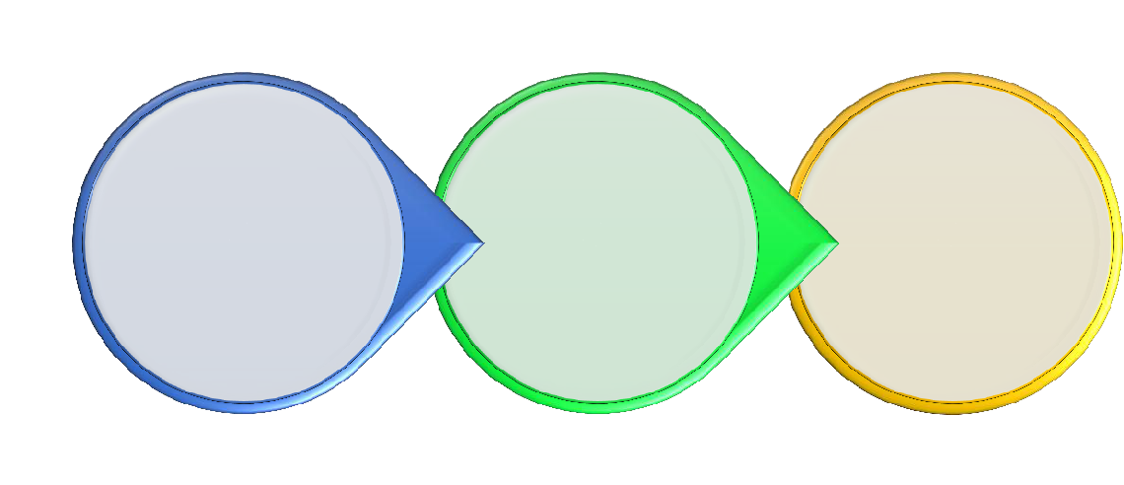

TARGETING THE | RIGHT | RIGHT
RIGHT | RIGHT | RIGHT
RIGHT | COMMUNICATION | ACTION
PEOPLE | COMMUNICATION | ACTION

Figure 13: Strategy of Lovello Ki Anondo Campaign.

5.1The Right People:

In the first stage of this strategy is to target the right people who are mainly our audience. In this campaign, we focused on class 5 to class 10 school going students as our targeted audience. And for that we can’t reach everyone. So, in every school Lovello had to visit and inform them about the program. And also told them that they have to visit the Facebook Page for collecting the tickets which was handled by D’reach and further information. And some information will be given in the Prothom Alo Newspaper. And all of the audience D’reach had to communicate for the audience engagements. The strategy was to get their interest in two different ways. First one is by Facebook and the other one is posting O.V.C targeting.

22 | P a g e

 |  | GOOGLE DISPLAY
FB TARGETING |  | GOOGLE DISPLAY
FB TARGETING |  | NETWORKING TARGETING
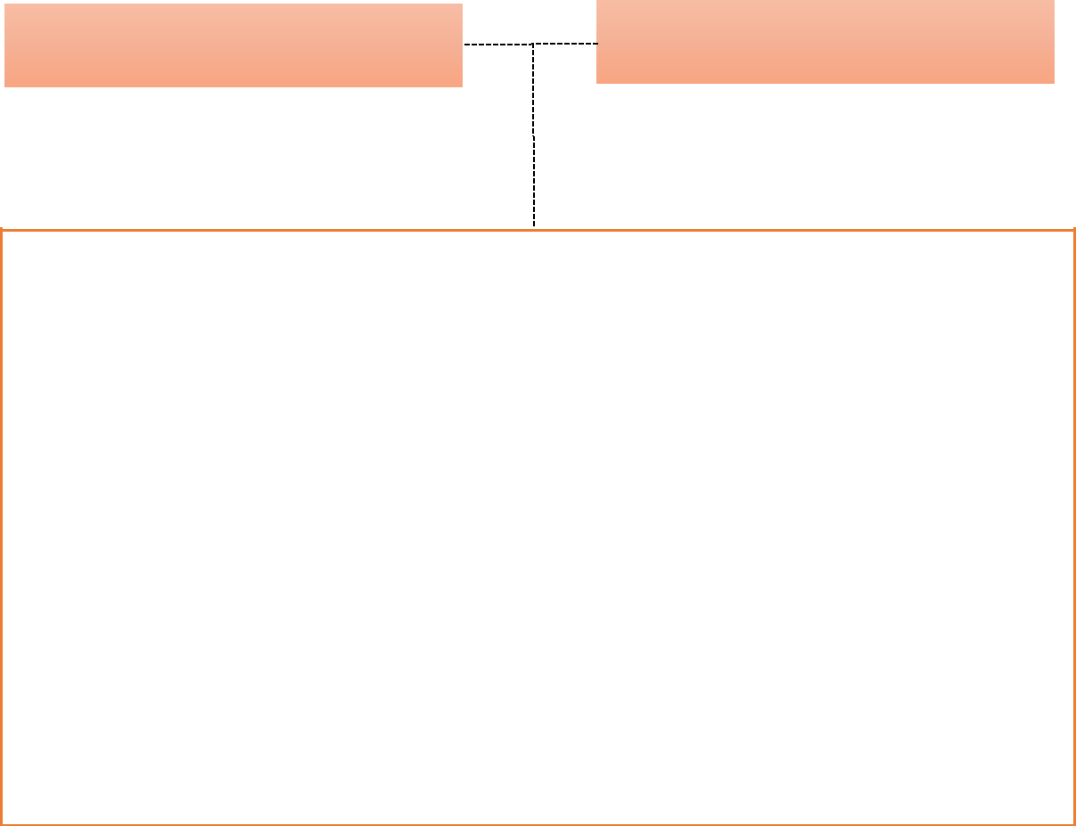

Primary Audience Age: 13 to 18

Secondary Audience Age: 30 to 50

Gender: Male & Female

Region: Dhaka, Chittagong, Rangpur.

Social Economic Class (SEC): B and C

Interest: Playing indoor outdoor games, quiz competition, singing, drawing, dancing etc.

Activities: Reading Books, studying, playing, making aims etc.

Primary Audience Profession: School Students.

Secondary Audience Profession: Working People, Business, Homemaker etc.
Primary Audience Age: 13 to 18

Figure 14: Target Audience of Lovello Ki Anondo Campaign.

5.2 Targeting The Right People in Facebook:

Based on category mentioned above, D’reach will be able to target the audiences by posting on Facebook or posting multiple ads digitally.

- Facebook post: Two kinds of things should be kept in mind while posting on Facebook. One is being creative and another one is post copy. For superstore post, we can write about the campaign location, region and reply all comments of the audience. And, creative posting may contain the picture of campaign and if anyone can’t collect the ticket then they have to buy a 100 tk ice cream for the ticket and also unlimited ice cream offer.

- Facebook Multiple add: The idea of this is to compile at least 3 to 5 different posts together in one post with the link so that the link can redirect the audience into the website link. The main benefit from this is that we will be able to add different links for our audience from Dhaka, Chittagong & Rangpur.

23 | P a g e

5.3 Right Communication:


Facebook Post Promotion


Campaign Post


Locataion & Detailing Post


Invitation & Link for Ticket Collction

Figure15: Right Communication for Lovello Ice Cream

The explanation of face book promotion and multi ads. After posting this, we gained a lot of queries about the product or the services. So, we were required to answer all of those queries on behalf of our clients. Sometimes, we didn’t have the proper knowledge on some queries. So, then we ask our clients of behalf of our customers and again get back to our customers. And this is how we build up the communication.

5.4 The Right Action:

- Total Reach: It shows the amount of unique people our posts are exposed to. It says that after boosting a post, how many audiences actually reached in our post.

- Impressions: The number of times the posts have been shown to the audience. It shows how many times we were able to reacha person through our post.

- Engagement: It means the clicks, likes and shares by our audience. The result can be seen at the bottom of our post.

24 | P a g e

5.5 BUDGETING:

If the client likes our plan, we give them a budget. Then, there is a negotiation between the client and us. The plan is executed when both sides are satisfied with the budget. Finance or operating management handles the budgeting part. Client service department takes this to the operation and finance department soon after completing the planning, And after that, finance department prepares the budget. In the table below, the budget for “Lovello Ki Anondo” campaign is given.

 |  |  |  |  |  |  | MOST
SL NO |  | PARTICULARS |  |  |  |  | MONTHLY
 |  |  |  |  |  |  | COST (BDT)
1. |  | Facebook Management Cost |  |  |  |  | 75,000 | – 85,000
2. |  | Creative Cost |  |  |  |  |  | -
 |  |  |  | Master Creative |  |  | 3,500 – 5,500
 |  | I. Static
 |  | I. Static |  | Adaptation |  |  | 2,000- 4,000
 |  | II. |  | Video |  | 12,000 |  | – 13,000
 |  | III. GIF |  |  |  |  | 5,000 | – 7,000
3. |  | Media Buying |  |  |  | 250,000 |  | – 500,000
4. |  | Total Cost |  |  |  |  | 347,500 | – 614,500
5. |  | Agency Commission (10%) |  |  |  | 34,750 |  | – 61,450
6. |  | Total Cost with Agency Commission |  |  |  |  | 382,250 | – 675,950
7. |  | 15% VAT |  |  |  |  | 57,338 – 101,393
8. |  | 20% Remittance Tax |  |  |  |  | 50,000 – 100,000
 |  | Grand Total |  |  |  | 489,588 |  | – 877,343

Figure 16: Budget for Lovello Ice Cream.

25 | P a g e

5.6 What D’reach did for Lovello Ice Cream:


Content Creation
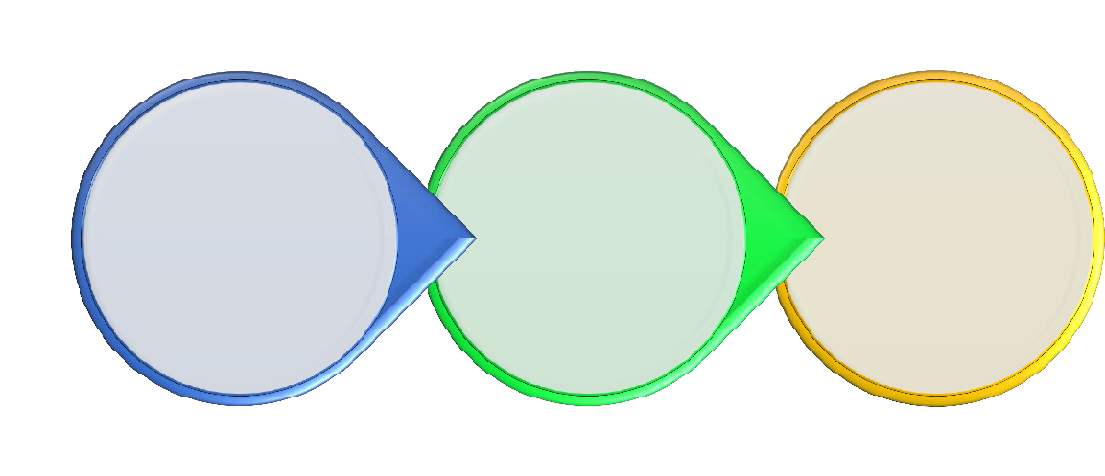

CHOSE IMAGES | DESIGN | ADD THE PROPER
THAT ARE | ATTRACTIVE | COMMUNICATION
RELEVANT FROM | ATTRACTIVE | COMMUNICATION
RELEVANT FROM | CREATIVES | MESSAGE FOR THE
THE PARTNER | CREATIVES | MESSAGE FOR THE
THE PARTNER | TO GENERATE POST | MESSAGE FOR THE
WEBSITE OR | TO GENERATE POST | RESPECTIVE
FACEBOOK PAGE | ENGAGEMENTS | CATEGORY

Figure 17: Execution of Plan

In the first stage of our plan, we select the relevant images from the partners official website and Facebook, such as Kumarika, Lovello, Yellow, etc.
- Then, we design attractive creatives to engage our audiences.

- The creative contains a message that highlights Lovello Facebook page posts & videos.

- Then we run the Facebook and multi product ad posts.

26 | P a g e

- Analysis:

We have calculated an assumption here. Let’s assume, Lovello has 5,00,000 customers and they share Lovello Ki Anondo campaign post 700 times and comment on the link About 45,00 people or mention someone 6 to 8. That means per month they share the post with 10,000 to 15000 people Comment in the link that cost and mention their friends on the link about 4,500* 6= 27,000. Now, if they attend in the program D’reach would engage 40,000 to 50,000 thousand people.

6.1 Audiences Reached:

From the content that we uploaded in September, has made 4,00,000 engagements. And 402,378 audiences saw our campaign ads and posts. Among them, 4,01,547 people were reached by Facebook post promotions and 72,981 people were reached by multi-product promotions.

From Facebook, each people got to know about our posts 2.38 times and from multi ad, the number was 1.2.
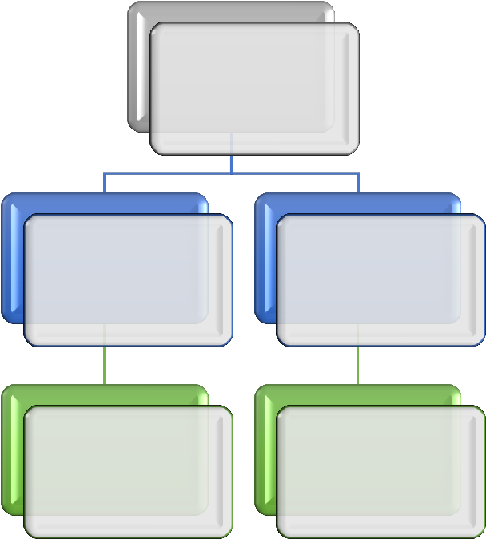

Total Reach

402,378

Post Multi-
Promotion ampaign Post

Reach Reach

401,547 72,981

Figure 18: Audience Reached in one month

27 | P a g e

6.2 Post Engagements:

The term post engagement means how many comments, likes, shares, photo views and website clicks were done. From the results, we can see that the engagement was higher from post promotions. It’s 1,08,539 and the likes are 79,344. But the website clicks are much higher in post engagement section which is 27,938.
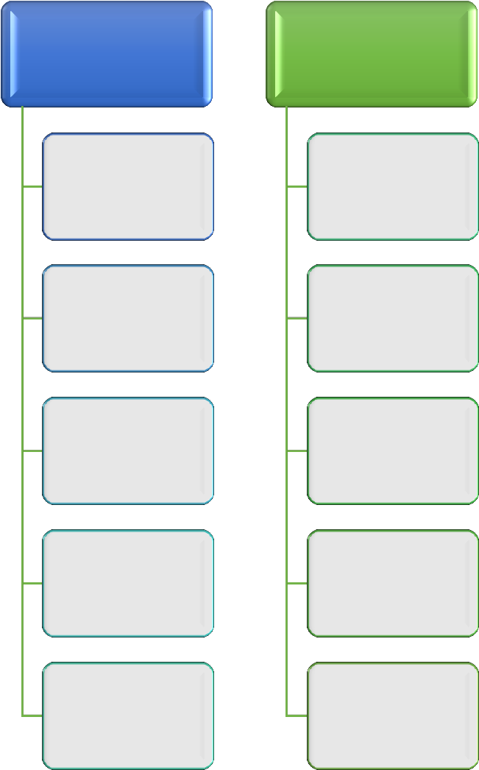

Post
Promotion

Multi-
Campaign ad

Post
Engagements

Post
Engagements

108,539 27,938

Likes Likes

14,677 4,536

Comments Comments

570 85

Shares share

350+ 150

Photo views Photo Views

57,763 -

Figure 19: Post Engagement for Lovello Ice Cream Campaign.

28 | P a g e

- Result and Discussion:

The results achieved by D’reach from this campaign were positive. Post engagements, page likes and, page impressions can be increased. The results are given below-

- About 4,02,378 people can be reached by using 1 month to aware them about this campaign.

- About 1,08,539 people liked, shared and commented in our contents.

- Our achievement after this campaign is that, Lovello ice cream will be always our loyal client.

- The official Lovello Ice Cream Facebook page became a strong method of communication for its audience.

- Visited rate of audience for their Facebook page & website could be increased.
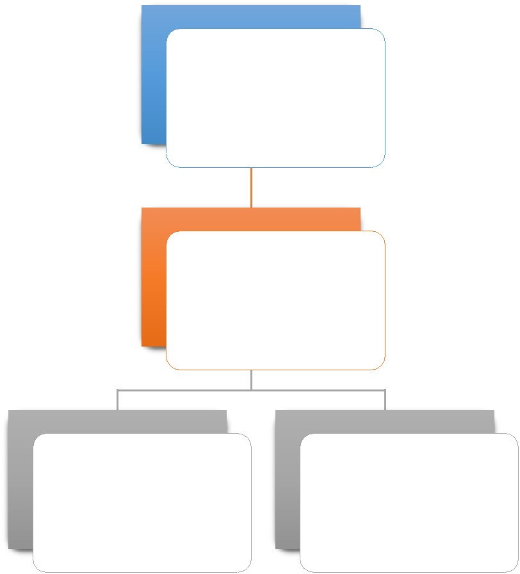

Total Reach

500,000

Impression

401,547

Post | Total like
Engagement | Total like
Engagement | 14,677
402,378 | 14,677

Figure 20: Total Result of Lovello Ice Cream

29 | P a g e

- Conclusion:

The completion of this internship clearly indicates that the future of marketing is digital marketing. It’s not only just posting ads on portals, but also integrated services and integrated channels. Now these days, marketers want to use these components in an effective way to gain more targeted audience, so that they can build a brand. In this age of digital advancement, marketer sare not the only custodian for a brand, people who are connected across the digital platforms all over the world are also the custodians.

Brands prefer building their presence in the digital platforms because people all over the world are either connected or slowly getting connected to this platform. Moreover, the customers are also very eager to seek information and digital media is the perfect platform for two-way communication between customers and brands.

To convert a product into a brand, digital media is the best method for that. The reason for this is that it’s much more cost effective and it also provides lot of brief points to marketer. Brands are able to engage their targeted groups in a very effective way through this platform. It is not only for customer engagement but brands can also increase their customers or they can also communicate with their existing customers through digital media. This platform helps a company to increase the impact of brand in target groups.

This research mainly focuses on the how digital marketing operates. Consumers can be very eager about information and they will research before going to a retail shop to buy their required product. And for that, brands want to give the consumers a platform where they can get to know the brand.

And I had learned a lot to know about the digital marketing. How it works, and work for the clients. How to make Awareness to engage audience?

I have a strong belief that this project report will be of good help for marketers to understand the world of digital market and to prepare strategies.

I would like to conclude my research on Analysis the clients and its competitor’s communications. And I had (Study on Lovello Ice Cream increasing Awareness with the help of digital marketing).

30 | P a g e

- Appendix & Reference:

Appendix:

- How D’reach work for their clients with the help of social media marketing?

- Who are the current clients of D’reach?

- How Lovello ice cream got involved with D’reach?

- What is the Primary and secondary data collecting source of D’reach to knowing and work with their clients?

- What are the responsibilities D’reach done for Lovello Ice Cream?

- What are the service provided for Lovello ice cream?

- How to do critical observation and recommendations for Lovello ice cream?

- Recently project description to Creating awareness for Lovello company?

- How D’reach create awareness foe Lovello “kishoralo” campaign?

- What is the Strategic plan of “kishoralo” campaign?

- What was D’reach budget making method for “kishoralo” project?

- What’s D’reach overall did for Lovello ice cream?

Skills of D’reach:

Which they help me to complete my Research well.
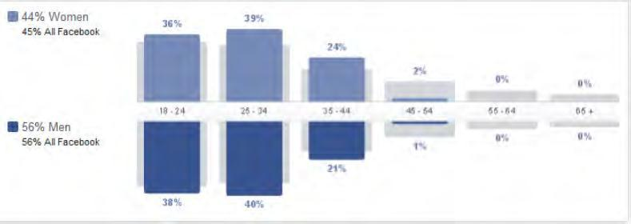

Figure 1: Percentages of Facebook users 18 to 40 +

31 | P a g e

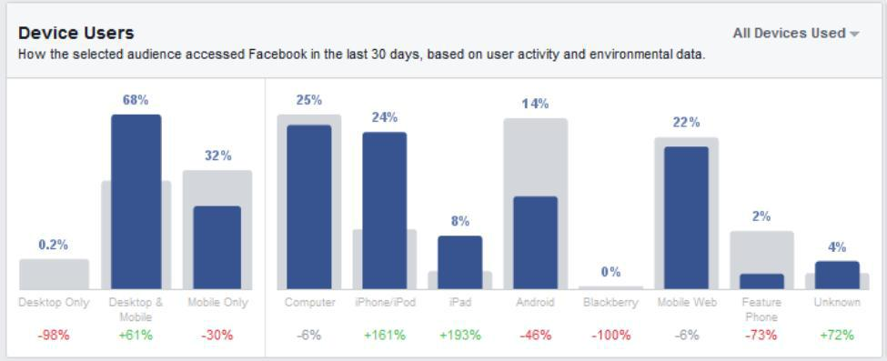

Figure 2: Percentage of Facebook using from different device.
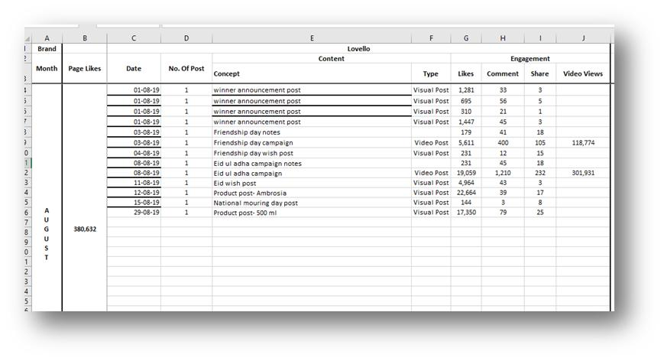

Figure 3: Comparative Analysis through Excel Sheet.

32 | P a g e

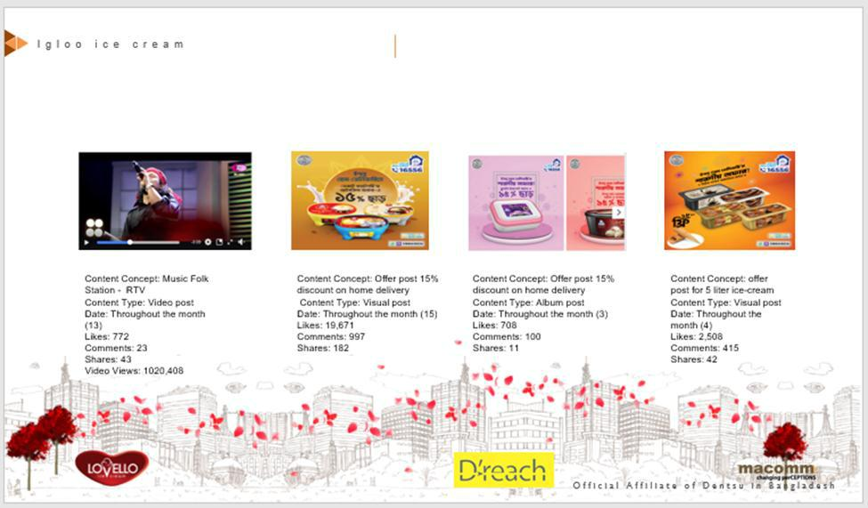

Figure 4: Competitor analysis through PPT File.
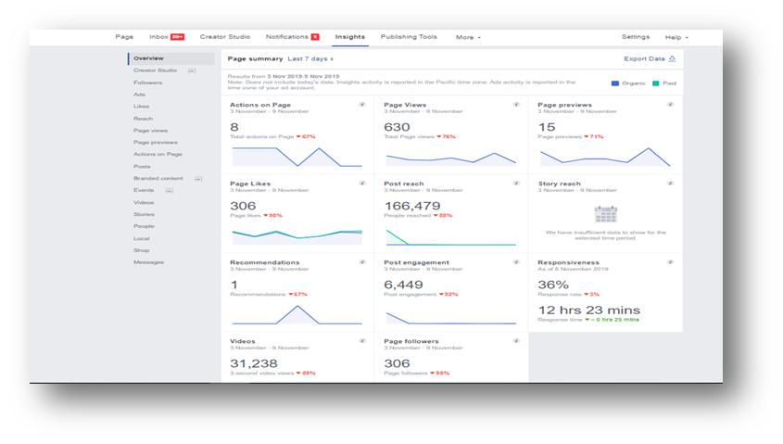

33 | P a g e

Figure 5: The Engagement of the Audience.
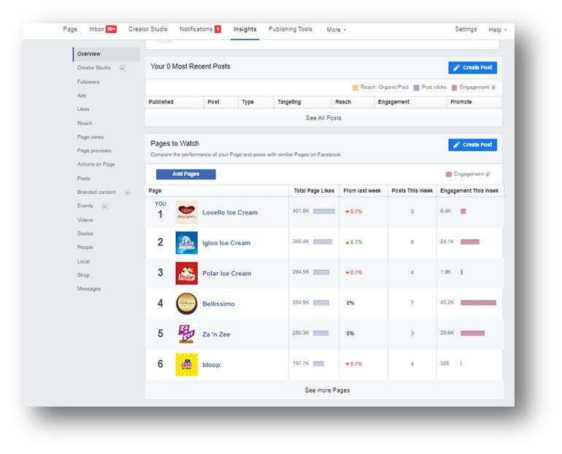

Figure 6: Competitor Analysis.

34 | P a g e

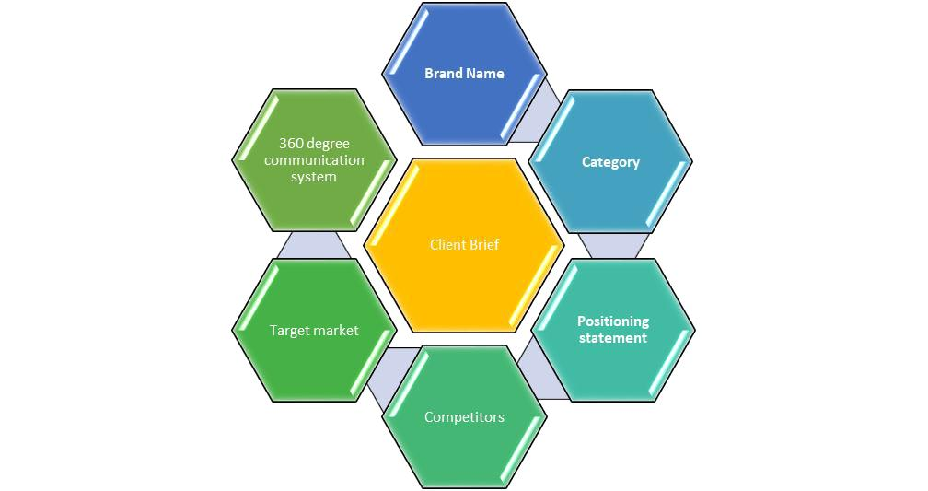

Figure 7: Client Brief
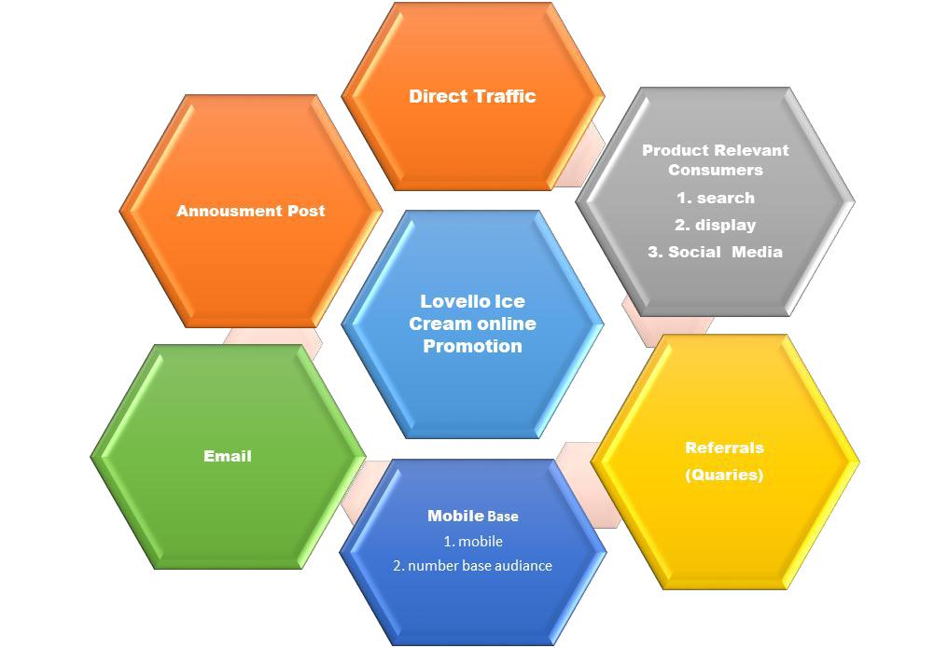

Figure 8: Lovello Digital Project.

35 | P a g e

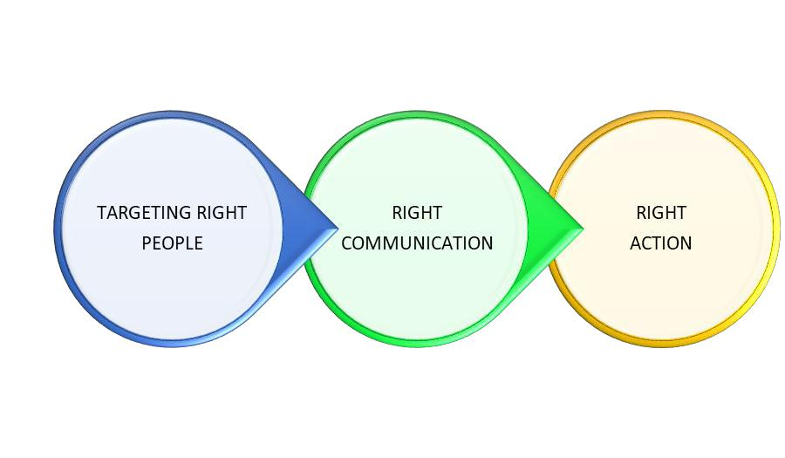

Figure 13: Strategy of Lovello Ki Anondo Campaign.

 |  | GOOGLE DISPLAY
FB TARGETING |  | GOOGLE DISPLAY
FB TARGETING |  | NETWORKING TARGETING
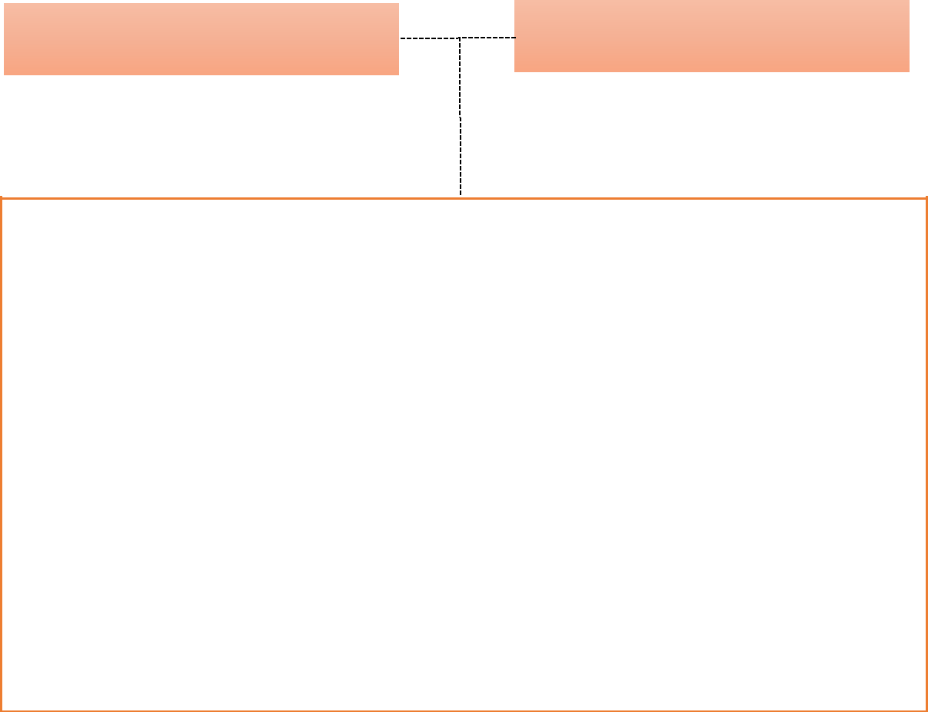

Primary Audience Age: 13 to 18

Secondary Audience Age: 30 to 50

Gender: Male & Female

Region: Dhaka, Chittagong, Rangpur.

Social Economic Class (SEC): B and C

Interest: Playing indoor outdoor games, quiz competition, singing, drawing, dancing etc.

Activities: Reading Books, studying, playing, making aims etc.

Primary Audience Profession: School Students.

Secondary Audience Profession: Working People, Business, Homemaker etc.

36 | P a g e

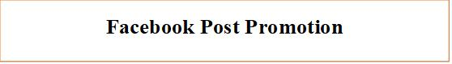
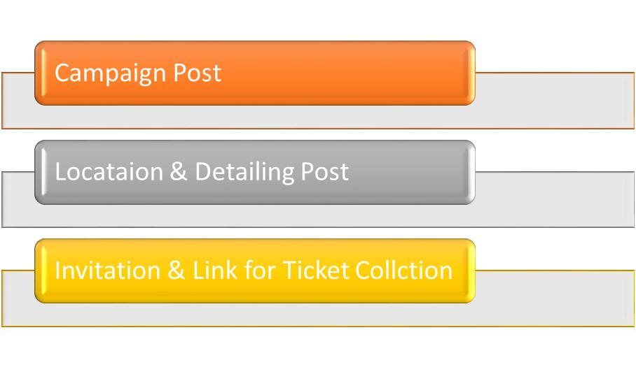

Figure15: Right Communication for Lovello Ice Cream

37 | P a g e

 |  |  |  |  |  |  | MOST
SL NO |  | PARTICULARS |  |  |  |  | MONTHLY
 |  |  |  |  |  |  | COST (BDT)
1. |  | Facebook Management Cost |  |  |  |  | 75,000 | – 85,000
2. |  | Creative Cost |  |  |  |  |  | -
 |  |  |  | Master Creative |  |  | 3,500 – 5,500
 |  | I. Static
 |  | I. Static |  | Adaptation |  |  | 2,000- 4,000
 |  | II. |  | Video |  | 12,000 |  | – 13,000
 |  | III. GIF |  |  |  |  | 5,000 | – 7,000
3. |  | Media Buying |  |  |  | 250,000 |  | – 500,000
4. |  | Total Cost |  |  |  |  | 347,500 | – 614,500
5. |  | Agency Commission (10%) |  |  |  | 34,750 |  | – 61,450
6. |  | Total Cost with Agency Commission |  |  |  |  | 382,250 | – 675,950
7. |  | 15% VAT |  |  |  |  | 57,338 – 101,393
8. |  | 20% Remittance Tax |  |  |  |  | 50,000 – 100,000
 |  | Grand Total |  |  |  | 489,588 |  | – 877,343

Figure 16: Budget for Lovello Ice Cream.

38 | P a g e

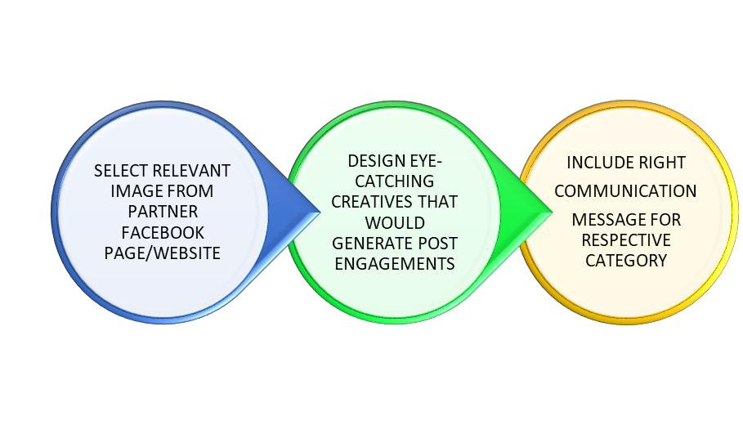

Figure 17: Execution of Plan Figure
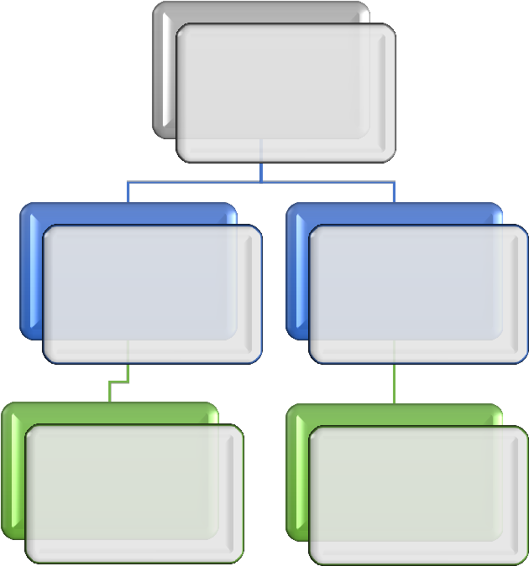

Total Reach

402,378

Post Multi-
Promotion ampaign Post

Reach Reach

401,547 72,981

Figure 18: Audience Reach in one month

39 | P a g e

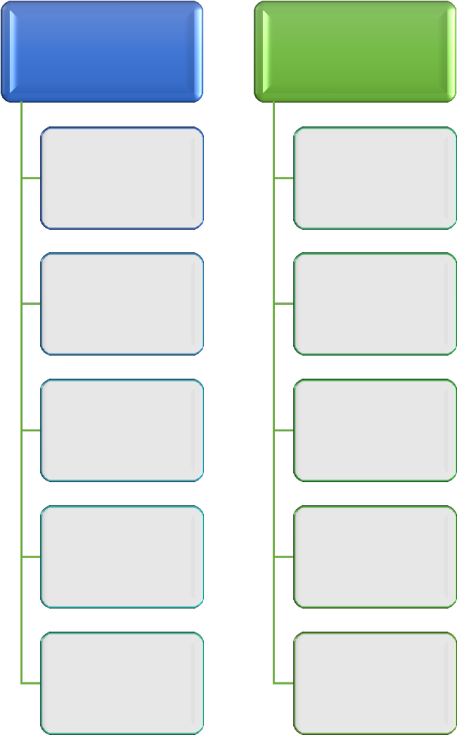
Post | Multi-
Promotion | Campaign ad
Post | Post
Engagements | Engagements
108,539 | 27,938
Likes | Likes
14,677 | 4,536
Comments | Comments
570 | 85
Shares | share
350+ | 150
Photo views | Photo Views
57,763 | -

Figure 19: Post Engagement for Lovello Ice Cream Campaign.

40 | P a g e

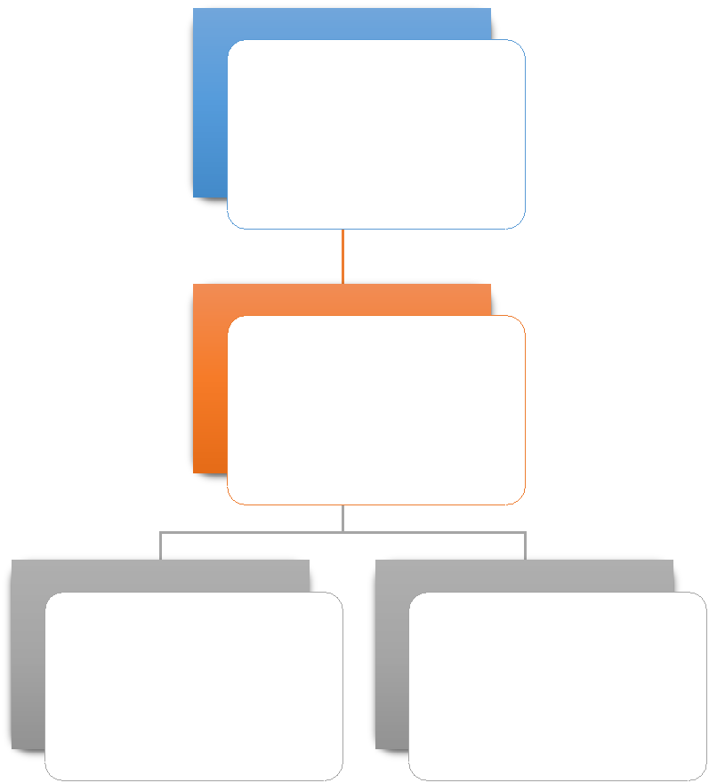

Total Reach

500,000

Impression

401,547

Post | Total like
Engagement | Total like
Engagement | 14,677
402,378 | 14,677

Figure 20: Total Result of Lovello Ice Cream

41 | P a g e

Reference:

- http://www.dreachbd.com/

- https://www.facebook.com/Dreachbd/?epa=SEARCH_BOX

- https://www.facebook.com/LovelloIceCream/

- http://dspace.bracu.ac.bd/xmlui/bitstream/handle/10361/8565/13104020_BBA.pdf?seque nce=1&isAllowed=y

42 | P a g e

