Measuring Employee Job Satisfaction based on the working environment in Shahjalal Islami Bank Limited


Submitted to
Nasrin Akter
Assistant Professor
School of business and economics
United International University

Submitted by:
Ziaun Naher
ID: 111 141 221
BBA Program
United International University

Date of Submission:
2nd May 2019

Letter of Transmittal
To
Nasrin Akter
Assistant Professor,
School of business and economics
United International University

Subject: Submission of internship report on ‘Measuring employee job satisfaction based on the working environment in Shahjalal Islami Bank Limited’
Dear Madam,
You will be glad to know that I have recently completed my internship program and have prepared my internship report on ‘Measuring employee job satisfaction based on the working environment in Shahjalal Islami Bank Limited’
Today, a lot of organizations face the challenge of correctly measuring job satisfaction, because the definition of satisfaction may be different from that of the people in the organization. Despite this widespread concern, several research have shown that high-level workers do not feel satisfied with their work due to high salary expectations or high-level qualifications. This lack of connection is a major apprehension for organizations, as the study also found that the implementation of positive human resources practices has financial benefits for businesses. Therefore, measuring employee job satisfaction is very important for any HR department and I feel lucky myself that I get the opportunity to measure the employee job satisfaction based on the working environment in Shahjalal Islami Bank Limited.
While preparing the internship report, your guidelines and report format was proved very essential for me to understand the report fulfilment criterion. I highly support your help and support during the time and I want to assure you that I have followed all the advice I have received from you to make the study a valuable one.
I, therefore, pray and hope that your honour would be kind enough to grant my internship report and oblige thereby.

Your obedient student,
Ziaun Naher
ID: 111 141 221
School of business and economics
United International University

Acknowledgement
It is high time when I need to start the study by thanking my Almighty Allah for his blessings and making me able to complete this four years of Bachelor of Business Administration (BBA) program successfully. Moreover, I also like to show my gratitude to my parents for bearing all the cost and help me to reach today’s position.
First of all, I want to thank my respected internship supervisor as well as my course teacher “Nasrin Akter, Assistant Professor, School of business and economics, United International University. All her efforts were highly motivated me to attempt for such a long study and during the preparation period of the report her guidelines and advices helped me a lot to understand a lot of critical aspects.
Secondly. I like to thank my instructor at SJIBL, Md, Shahjahan Alamgir, Branch manager, Shahjalal Islami Bank Limited. He always manages time from his busy schedule to help me if I faced any difficulties ever in performing my roles and responsibilities as an intern. He also guided me with a lot of inside information of the branch so that I can prepare the report with important information of the bank and then they can also use the report for further studies of their employee.
Last but not the least, I am thankful to all my friends and colleagues for sharing their valuable time with me during the period and helped me to collect information for the study.
Executive Summary
I was lucky that I got the opportunity to work as an intern in Shahjalal Islami Bank Limited by the help of the UIU Career Counsel (UIUCC). I have performed various distinctive responsibilities while working in the bank during my internship program. In the meantime, I contacted my honourable internship supervisor for her guidance to prepare my internship report. The topic, I have chosen, is ‘Measuring employee job satisfaction based on the working environment in Shahjalal Islami Bank Limited’ as a lot of organizations face the challenge of correctly measuring job satisfaction nowadays. Therefore, employees of the organizations are becoming dissatisfied day by day. On the other hand, the implementation of positive human resources practices has various financial benefits for financial institutions. Moreover, I felt that measuring employee job satisfaction based on the working environment has a vital role for Shahjalal Islami Bank Limited.
This internship report is prepared to analyse Shahjalal Islami Bank Limited and to measure the employee job satisfaction based on the working environment in Shahjalal Islami Bank Limited. The report consists of total five broad chapters. The first chapter of the report is to discuss the general ideas for what the report has been created. The chapter includes background, objectives, scopes, methodology and limitations of the report. The Second Chapter is to clear the technical business terms so that any reader of this report may understand the report well. The third chapter is to analyse Shahjalal Islami Bank Limited that is consists of background and history, mission, vision, products and services, SWOT analysis of SJIBL. The fourth and main chapter measures and share finding on the employee job satisfaction at Shahjalal Islami Bank Limited.
The fifth and final chapter is to share some recommendation based on my academic learnings so that Shahjalal Islami Bank Limited can manage their employees more efficiently and motivates them so that the dissatisfied employees may get satisfied. Hopefully, all the recommendation will help the HR Department of Shahjalal Islami Bank Limited to improve its inside working conditions as well as the employee satisfaction.

Table of Contents
Chapter one: Introduction of the report
1.1 Background behind the study 7
1.2 Scopes of the study 7
1.3 Objectives of the study 7
1.4 Methodology of the study 8
a. Sample size: 8
b. Data collection process: 8
c. Analysis tools: 8
1.5 Limitations of the study 9
Chapter two: Literature review
2.1 Employee satisfaction defined 11
2.2 The importance of measuring employee satisfaction 11
2.3 Working environment defined 12
2.4 The impact of well working environment on employees 13
Chapter three: Overview of SJIBL
3.1 Background and history of Shahjalal islami Bank Limited (SJIBL) 16
3.1.1 SJIBL's vision 16
3.1.2 SJIBL's mission 16
3.1.3 SJIBL Strategies 16
3.1.4 SJIBL's motto 17
3.5 Highlights of products and services of SJIBL 17
3.6 Highlights of corporate information of SJIBL 17
3.7 Management Hierarchy of SJIBL 19
3.8 SWOT Analysis of SJIBL 19
Chapter four: Analysis and findings
4.1 Analysis and findings 22
4.1.1 Measuring Employee Job Satisfaction based on the working environment in Shahjalal Islami Bank Limited (SJIBL) 22
4.1.2 Specific Questions on Measuring Job Satisfaction of Shahjalal Islami Bank Limited 27
Chapter five: Recommendation and conclusion
5.1 Recommendation 31
5.2 Conclusion 32

Chapter One
Introduction of the Study

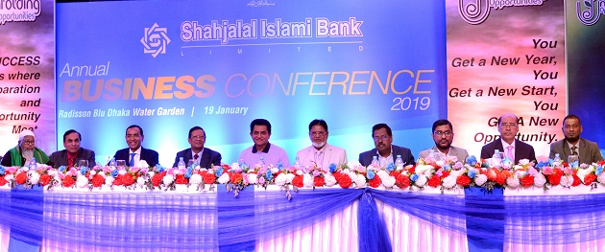

1.1 Background behind the study
The internship program is a pre-requirement of Bachelor of Business Administration (BBA). The students who have completed their 120 courses, have to take internship/ project program for 3 credits before achieving the BBA degree.
I had taken internship program and luckily got an opportunity to work as an intern in Shahjalal Islami Bank Limited by the help of the UIU Career Counsel (UIUCC). I have performed various distinctive responsibilities while working in the bank during my internship program. In the meantime, I contacted my honourable internship supervisor for her guidance to prepare my internship report. The topic, I have chosen, is ‘Measuring employee job satisfaction based on the working environment in Shahjalal Islami Bank Limited’ as a lot of organizations face the challenge of correctly measuring job satisfaction nowadays. Therefore, employees of the organizations are becoming dissatisfied day by day. On the other hand, the implementation of positive human resources practices has various financial benefits for financial institutions. Moreover, I felt that measuring employee job satisfaction based on the working environment has a vital role for Shahjalal Islami Bank Limited.

1.2 Scopes of the study
The scope of the study is to help the bank personnel to share their opinion anonymously and try to provide suggestions to assist Shahjalal Islami Bank Limited to understand the average of the personnel opinion. It may help the human resource department to identify the difficulties or shortcomings the employee are facing. Any reader of the study can get to know the bank’s profile, the services it’s offering, the way I have surveyed employee and the overall process of measuring job satisfaction of employees. Moreover, other banks can also use the methodology of measuring job satisfaction. The university students and teachers can get useful information of the bank and can compare their theoretical learnings with my practical experiences.

1.3 Objectives of the study
The objectives refer to the goals of something for what that something is being conducted. The report objectives are separated into two parts and both of them can deliver the essence of goals in short for what the report is being conducted. The objectives are:
- Primary objective: The primary objective is to attain the BBA degree by submitting a proper and complete internship report as it is a pre-requirement of United International University.
- Specific objectives: The specific objectives of this study are given below:
- To analyse the Shahjalal Islami Bank Limited.
- To measure the employee job satisfaction based on working environment of the bank.
- To identify difficulties the employees are currently facing.
- To propose few suggestions on the problems found.

1.4 Methodology of the study

a. Sample size: The study consists a survey of 10 out of 16 employee who are randomly chosen from the Mirpur branch of Shahjalal Islami Bank Limited. All these employees are currently working in the bank and are highly aware of the working environment of the bank.
b. Data Collection: The data of the bank and other necessary job satisfaction related information are collected from two distinctive sources:
- Primary Sources:
- Formal and informal communication with the bank personnel
- From the practical internship experiences.
- Through a survey questionnaire.
- Annual Report of the bank

- Secondary Sources:
- Brochure and leaf lets of the bank.
- Several published books and materials.
- A lots of online articles and blogs related to the employees job satisfaction subject.
Data Analysis: Both qualitative and quantitative data are used in the analysis part to get the appropriate scenario of the employee job satisfaction in terms of working environment inside the branch.
- Analysis tools: Two popular and widely accepted concepts are applied in the report. They are:
- Swot Analysis: Used to analyse the bank’s (SJIBL) strengths, weakness, opportunities, and threats based on the bank’s internal or external environmental factors.
- Survey Questionnaire: A survey questionnaire is a widely accepted data collection tool that helps to collect necessary information through using a questionnaire. Collecting information from bank employee was very convenient through survey questionnaire because the bank personnel find it very easy to answer and submit the questionnaire in their free time. On the other hand, personal interview can increase the cost and take more time.

1.5 Limitations of the study
The limitations are the difficulties one may face while doing something. I have also encounter and faced few limitations while preparing my internship report. The limitations are:

- Confidentiality of data: Shahjalal Islami Bank Limited hold strict restrictions to use any information that may downgrade the bank’s reputation in the market. I was highly requested by the manager not to use any negative information of the bank.

- Unbearable work pressure: There were huge work pressure inside the bank during the office hour and always surrounded by the visitors and customers also. It was very hard for me to tackle and perform both internship responsibilities in the bank all the day long and at the same time to prepare my report.

- Short period of time: The duration of the internship program is three months only and I found it hard to prepare my report in this limited schedule.

Chapter Two
Literature Review


2. Literature Review
The literature review chapter is going to provide a broad idea of the technical terms used in this report so that the readers of my report can easily understand the concepts. This chapter also help to understand the coming chapters. The title of the report is ‘Measuring employee job satisfaction based on the working environment in Shahjalal Islami Bank Limited. Here, two terms are very necessary to understand. They are:
- What is Employee Job Satisfaction?
- What is Working Environment?
These questions are discussing below.

2.1 Employee satisfaction defined
The employee job satisfaction means how happy or satisfied the employees are who are working in an organization. Employee satisfaction or job satisfaction are the key words of each KRA. A satisfied employee is not only a loyal employee, but also an ambassador of the brand, both internally and externally. This can help dissipate the fears of others and can defend society in various forums. Happy employees are more loyal to the company and its goals, do everything possible to achieve them and are proud of their work, their equipment and their results.
Most organizations consider that job satisfaction depends on two things: pay and "promotion activities". Although employees create an impression based on these parameters, they cannot be considered as the basis for employee engagement. A recent Harvard study found that solo participation programs skyrocket and that satisfaction levels are reduced soon after. What matters is how human resources meet the needs of their employees.

2.2 The importance of measuring employee satisfaction
There are many advantages to getting employee feedback. However, once done, feedback is needed to guide a small business towards its goals.
Researchers have shown that satisfied and encouraged employees will create greater customer satisfaction and, in turn, positively influence the performance of the organization.

Regular checks on employee satisfaction and commitment are essential. If it gives employees the impression that their opinions are important, it will help increase their productivity. When employees share their assessments safely, they feel appreciated. Contributing to the workplace gives an employee a sense of belonging and responsibility.
Equally, employee surveys help employers measure and understand the attitudes, comments, motivation and satisfaction of their employees (Michael Armstrong, 2008). And you will find out if the company's goals are clearly represented by the managers. It is said that managers who contribute or cause the active disconnection of employees in the United States about 450-550 billion dollars a year. Employee opinions and ideas are an invaluable resource to help you understand the current dynamics of the workplace and also to identify training needs or learning activities. Measuring employee engagement with regular surveys allows you to timely detect potential problems and take action.

(Source: Michael Armstrong, 2008, Book name: A Handbook of Human Resource Management Practice, Available at: https://books.google.com.bd/books?id=D78K7Q IdR3UC&lpg)

Here are four strategies for completing an employee survey:
- Don't ask questions if you're not ready to respond to the answers.
- Comments to respondents within a reasonable time
- Keep the responses confidential!
- Give feedback to employees.
Using the information gathered to make positive changes, it is possible to encourage and promote employee enthusiasm for any future participation in an investigation.

2.3 Working environment defined
The term working environment is the surrounding conditions in which an employee works. The work environment can be physical conditions, such as offices or equipment, such as personal computers. It can also be related to factors such as work processes or procedures.
The term working environment can also be associated with the physical state of the building. Healthy workplaces will not present a problem with unhealthy construction syndrome, which is often caused by poor ventilation or the release of chemicals used during construction. The accumulation of mold and fungus can also lead to unhealthy building syndrome.
The work environment can involve social interactions in the workplace, including interactions with colleagues, subordinates, and managers. In general, and to some extent, employees are entitled to a harassment-free work environment. There is a hostile work environment when unwanted sexual behaviour interferes with an employee's work performance or creates a hostile, intimidating or offensive work environment.

2.4 The impact of well working environment on employees
According to Nielseny (2008), the work environment of an employee is a determining factor in the quality of work and the level of productivity. The way in which the workplace involves an employee influences the desire to acquire the skills and their level of motivation to play. The skills and level of motivation therefore influence the characteristics of an employee:
- Absenteeism
- Error rate
- Service duration
- Collaboration with others
- Output speed, and
- Level of innovation
The following diagram illustrates the most important factors in the work environment that lead to commitment or disconnection.

Chart: Working environment factors affecting employee performance
A human resource manager can use a company survey of employee surveys, which can be estimated to measure the degree of motivation and satisfaction of his employees in their daily responsibilities. Careful consideration of each of these factors is also very useful in ensuring that employees apply the skills learned during the training programs once they return to their place of work. By taking into account the structural and interpersonal aspects of each of these factors, employees can apply the required skills in a constant and routine manner.
(Source: Buhai et al., 2008, Buhai, S., Cottini, E., & Nielseny, N. (2008). The impact of Workplace Conditions on Firm Performance (Working Paper Number 08-13). Retrieved from http://www.hha.dk/nat/wper/08-13_sebu.pdf.)

Chapter Three
Overview of Shahjalal Islami Bank Limited (SJIBL)



3.1 Background and history of Shahjalal islami Bank Limited (SJIBL)
Shahjalal Islami Bank Limited (SJIBL) commenced operations in accordance with the principle of Islamic Sharia on May 10, 2001 under the Banking Companies Act of 1991. During these years, SJIBL diversified its service coverage by opening new branches in various strategic locations throughout the country offers various investment and storage services products. Islamic banking, in essence, is not just an interest-free banking business, it also offers business-oriented products, thereby generating real income and thus increasing the GDP of the economy. The board of directors has great references in the country's commercial arena, the management team is strong and supportive and has excellent professional knowledge under the direction of a former banker, the banker Muhammed Shahidul Islam.

3.1.1 SJIBL's vision
Being the only modern Islami bank in Bangladesh and making a significant contribution to the national economy and improving customer confidence and wealth, quality investments, employee value and rapid growth of equity.

3.1.2 SJIBL's mission
- Establish high standards of integrity.
- Provide quality services to clients.
- Ensure sustainable growth in the business world.
- Make a quality investment.
- Extend our innovative services to customers by acquiring advanced technology associated with Islamic principles.
- Ensure the maximization of shareholder wealth.
- Ensure the development of human resources to face the challenges of time.

3.1.3 SJIBL Strategies
- Manage and manage the bank in the most efficient way.
- Identify customer needs and monitor their perception to meet these requirements.
- Look for the best customer satisfaction and earn their trust.
- Train and develop all employees and provide them with adequate resources so that the needs of customers are reasonably solved.
- Review and update policies, procedures and practices to improve the ability to extend better services to clients.
- Diversify the portfolio in both the retail and wholesale markets.
- Cultivate a pleasant work environment.
- Promote organizational effectiveness by communicating business plans, policies and procedures to employees in an open and timely manner.

3.1.4 SJIBL's motto
- Committed to a friendly service to all of its clients

3.5 Highlights of products and services of SJIBL

3.6 Highlights of corporate information of SJIBL
Name of the Company | Shahjalal Islami Bank Limited
Legal Form | A public limited company incorporated in Bangladesh on 1st April 2001 under the companies Act 1994 and listed in Dhaka Stock Exchange Limited and Chittagong Stock Exchange Limited.
Commencement of Business | 10th May 2001
Head Office | Shahjalal Islami Bank Tower
Head Office | Plot No: 4, CWN(C)
Head Office | Gulshan Avenue, Dhaka-1212.
Telephone No. | 88-02-9845457
Fax No. | 88-02-9847607
Website | www.sjiblbd.com
SWIFT | SJBL BD DH
E-mail | sjiblho@sjiblbd.com
Chairman | Mr. Akkas Uddin Mollah
Managing Director | Mr. Muhammed Shahidul Islam
Auditors | M/s. Hoda Vasi Chowdhury & Co, Chartered Accountants
Auditors | BTMC Bhaban (7th & 8th floor)
Auditors | 7-9 Kawran Bazar Commercial Area, Dhaka-1215
Auditors | Phone: +88-02-9120090
Tax Advisor | M/S K.M Hasan & Co.
Tax Advisor | Chartered Accountants
Tax Advisor | 87, New Eskaton Road
Tax Advisor | Dhaka.
Tax Advisor | Phone: 88-02-9351457, 9351564
Legal Advisor | Hasan & Associates
Legal Advisor | Chamber of Commerce Building
Legal Advisor | (6th floor), 65-66 Motijheel C/A, Dhaka
No. of Branches | 123
No. of ATM Booth | 87
No. of SME Centers | At present Bank has no SME centre
Off-Shore banking Unit | 1
No. of Employees | 2,156
Stock Summary:
Authorized Capital | Tk. 10,000 million
Paid up Capital | Tk. 7,714 million
Face Value per Share | Tk. 10

3.7 Management Hierarchy of SJIBL

3.8 SWOT Analysis of SJIBL
Find out the SWOT – Strength, Weakness, Opportunities, and Threats of Shahjalal Islami Bank Limited helps to understand external internal situation of the bank in the marketplace. The four part of the SWOT analysis is discussed below:
3.8.1 Strengths of SJIBL
- The workforce is very strong because the majority of the workforce is youth/employees.
- very attractive brand
- Strong support from the Government of Bangladesh.
- The position of the branch is very ideal
- The continuous and phenomenal growth in profitability with age.
- Beautiful banking buildings
- Financing costs lower than those of competition
- Highly qualified, qualified and professional human resources
- The employee training program is better than other banks.
3.8.2 Weakness of SJIBL

3.8.3 Opportunities of SJIBL

3.8.4 Treats of SJIBL
- Privatization
- Adverse economic conditions
- Similar products are offered by other banks.
- Upcoming Banks/Branches
- Industrial Downturn.

Chapter Four
Analysis and findings of employee’ job satisfaction based on working environment of Shahjalal islami Bank Limited (SJIBL)


This Chapter has shown the analysis and findings of employee satisfaction based on working environment of Shahjalal Islami Bank Limited based on a questionnaire made by google forms and later the link of the questionnaire, had shared through several social media platforms, for instance, Facebook or google plus to collect the responds from 15 selected and current employees of SJIBL. After attaining the responses, the findings are shared below by using pie charts and bar charts following each of their interpretations and the questionnaire is added in the appendix part of the report.

4.1 Analysis and findings

4.1.1 Measuring Employee Job Satisfaction based on the working environment in Shahjalal Islami Bank Limited (SJIBL)

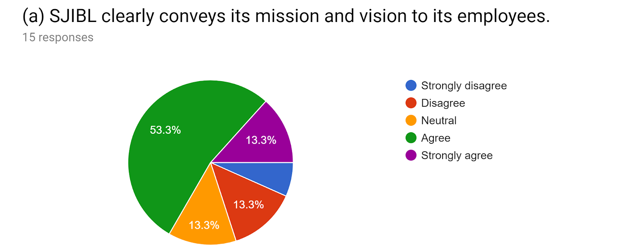
Interpretation
Among the 15 employees of Shajalal Islami Bank Limited 53.3% or 8 employee agrees that the bank clearly conveys its mission and vision to its employees so that the employees can easily understand the importance to perform their responsibilities in order to achieve the banks financial objectives and goals. Moreover, 2 employees also strongly agreed on the statement and total 4 employees are there who disagreed and strongly disagreed on the statement.
Findings: The satisfaction level is:
Satisfied = Agreed + strongly agreed = 8+2= 10
And, dissatisfied = neutral + disagreed + strongly disagreed = 1+2+2 = 5
So mostly employees are satisfied on the statement.

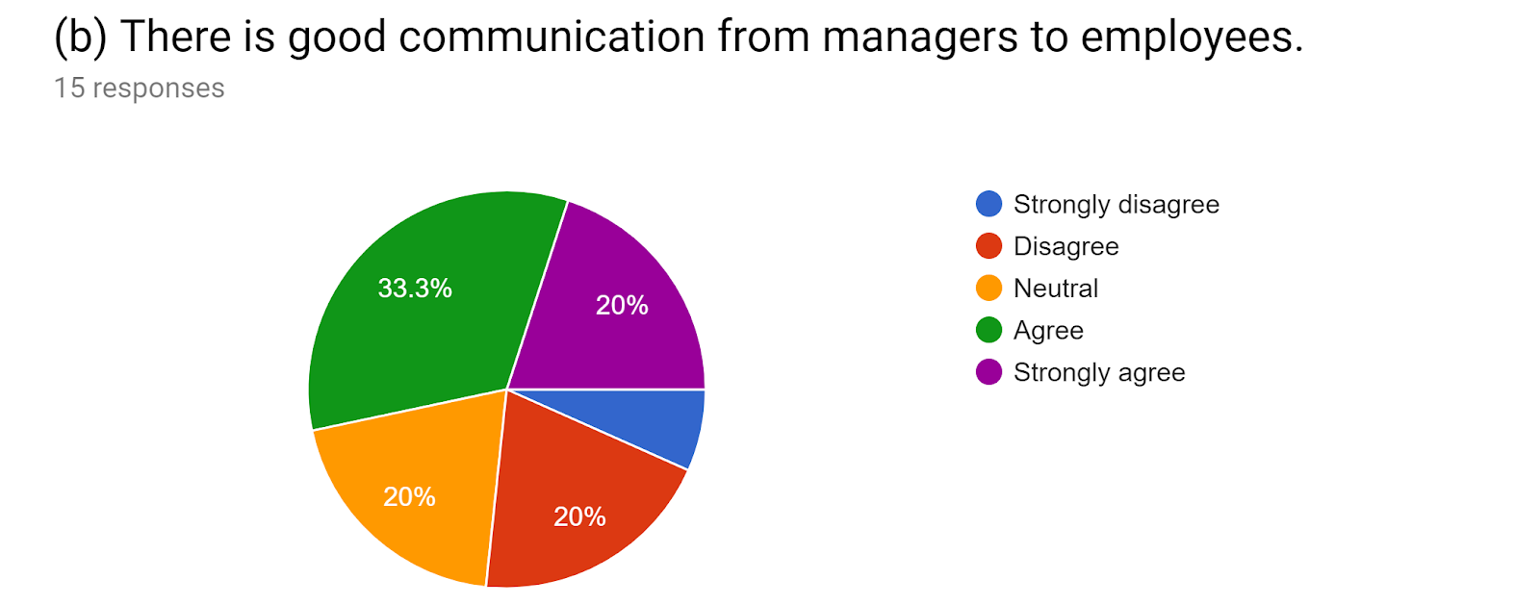
Interpretation
Among the 15 employees, 5 employees are agreed and 3 employees are strongly agreed with the statement that there is a good communication from managers to employees in Shahjalal Islami Bank. On the other hand, 3 employees were neutral and total 3 employees disagreed the statement.
Findings: The satisfaction level is:
Satisfied = Agreed + strongly agreed = 5+3= 8
And, dissatisfied = neutral + disagreed + strongly disagreed = 3+2+1 = 6
So mostly employees are satisfied on the statement.

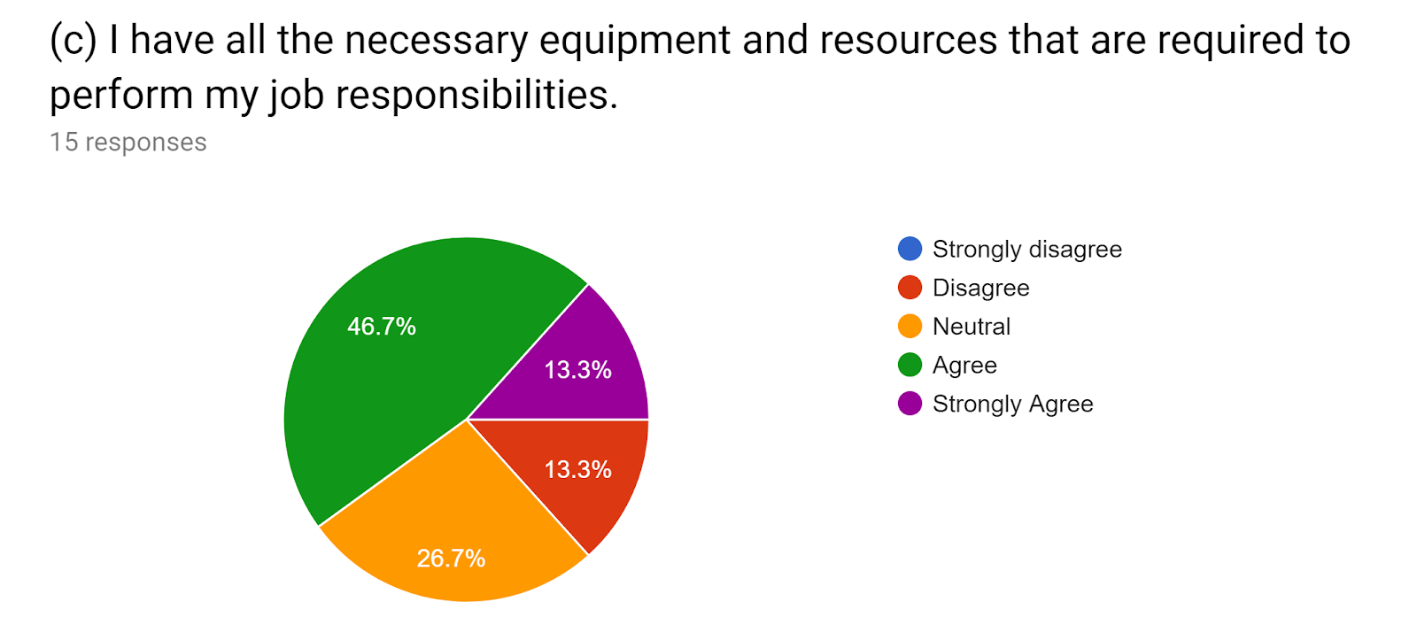
Interpretation
Among 15 employees, 7 respondents agreed and 2 respondents were strongly agreed on the statement that the banks provides them necessary equipment and resources that are required to perform their job responsibilities. On the other hand, 4 employees were neutral and 2 employees disagreed on the statement.
Findings: The satisfaction level is:
Satisfied = Agreed + strongly agreed = 7+2=9
And, dissatisfied = dissatisfied = neutral + disagreed + strongly disagreed = 4+2= 6
So mostly employees are satisfied on the statement.

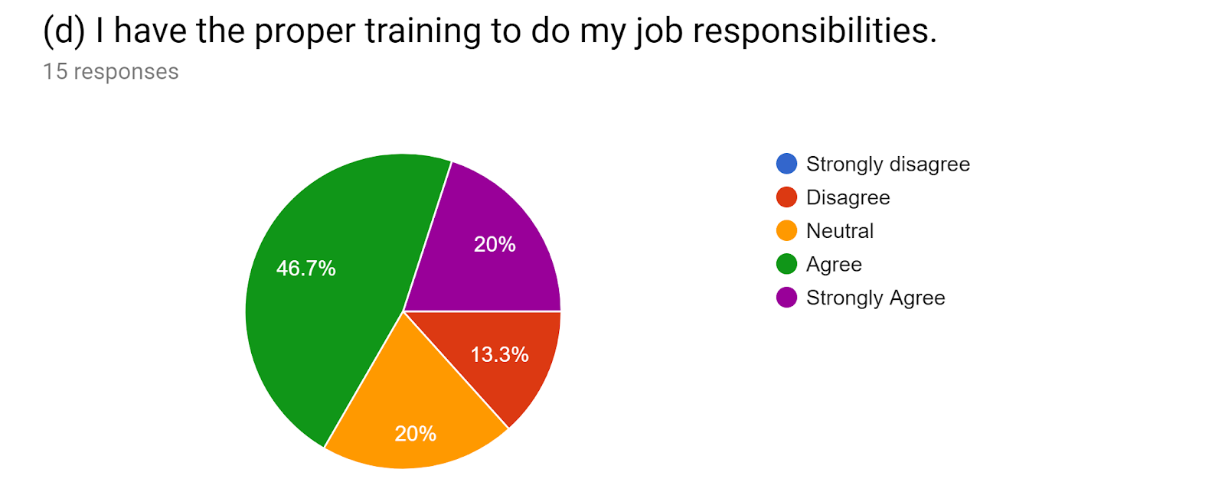
Interpretation
Among 15 employees, 7 employees agreed and 3 employees strongly agreed with the statement that they have proper training to perform their responsibilities. On the other hand, 3 employees were neutral and 2 employees replied that they are disagreed with the statement.
Findings: The satisfaction level is:
Satisfied = Agreed + strongly agreed = 7+3= 10
And, dissatisfied = neutral + disagreed + strongly disagreed = 3+2+0 = 5
So mostly employees are mostly satisfied on the statement.
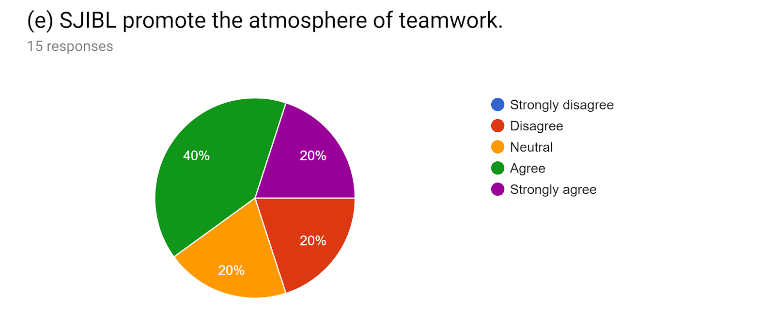Interpretation
Among the 15 employees, 6 employees agreed and 3 employees strongly agreed that Shahjalal Islami Bank promotes team work that help employees to get the decision making skills while working in a group or team. Though 3 employees were neutral and 3 were disagreed with the statement.
Findings: The satisfaction level is:
Satisfied = Agreed + strongly agreed = 6+3 = 9
And, dissatisfied = neutral + disagreed + strongly disagreed = 3+3+0 = 6
So mostly employees are mostly satisfied on the statement.

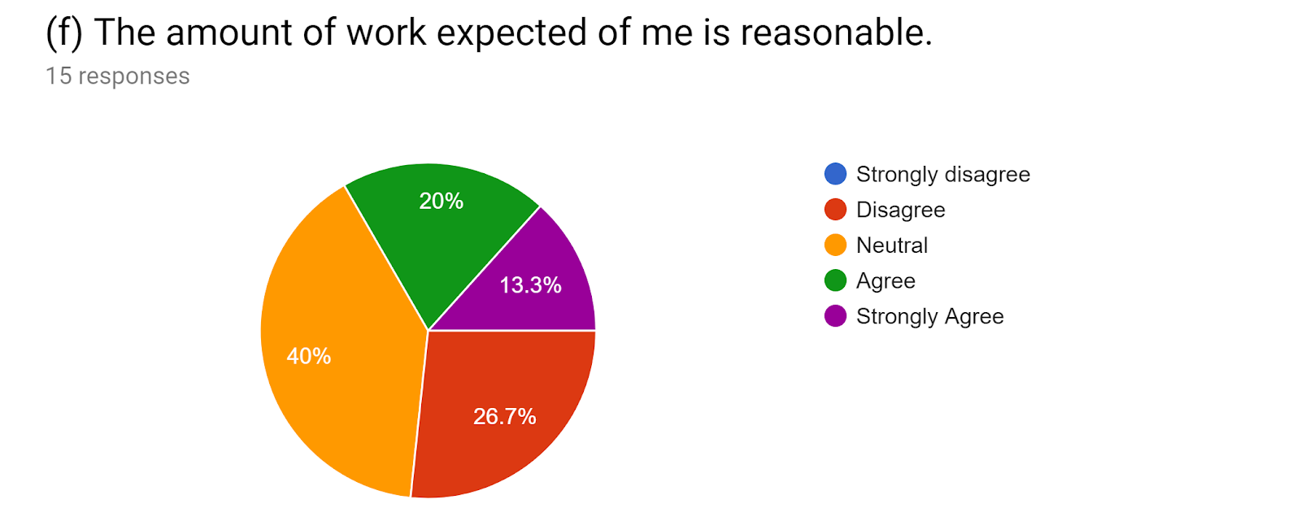
Interpretation
Among 15 employees, 3 employees were agreed and 2 were strongly agreed on the statement that the amount of work they have to perform daily is reasonable. Though 40% or 6 employees were neutral and 4 employees were disagreed on the statement.
Findings: The satisfaction level is:
Satisfied = Agreed + strongly agreed = 3+2 = 5
And, dissatisfied = neutral + disagreed + strongly disagreed = 6+4+0 = 10
So mostly employees are mostly dissatisfied on the statement.

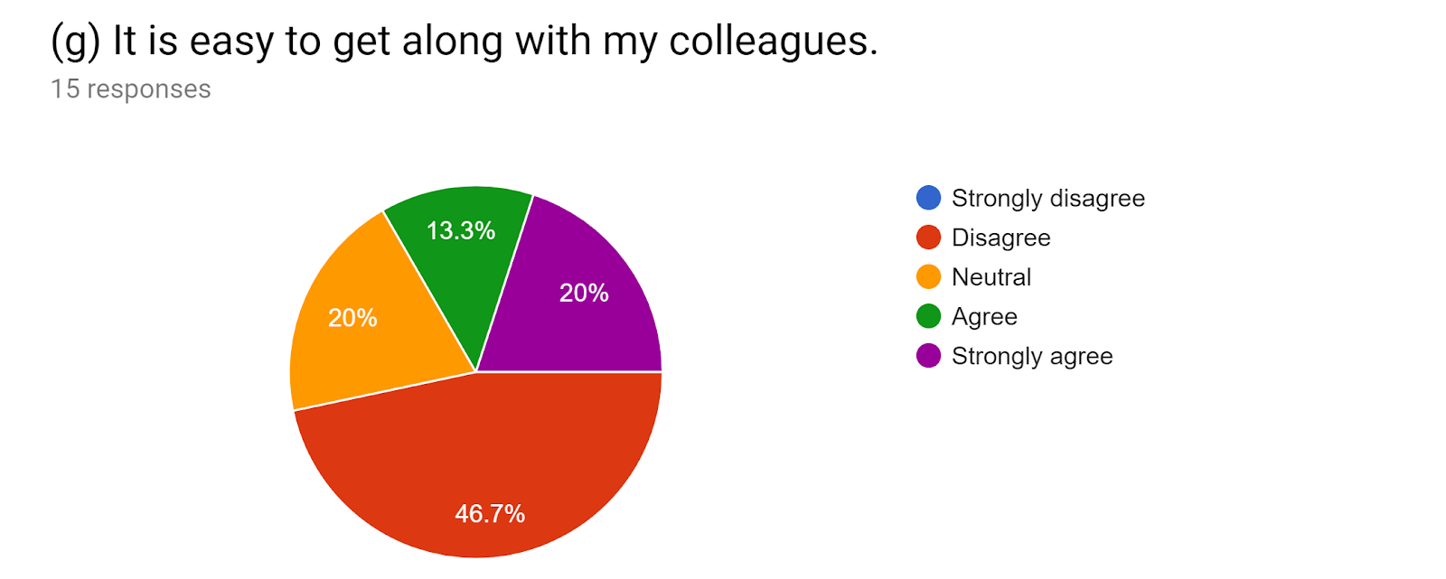

Interpretation
Among 15 employees, 13.3% or 2 employees replied that they agreed and 20% or 3 employees replied that they are strongly agreed on the statement that it is easy to work with their colleagues. On the other hand, a large proportion of 46.71% or 7 employees disagreed and 3 employees were neutral here.
Findings: The satisfaction level is:
Satisfied = Agreed + strongly agreed = 2+3 = 5
And, dissatisfied = neutral + disagreed + strongly disagreed = 3+7+0 = 10
So mostly employees are mostly dissatisfied on the statement.
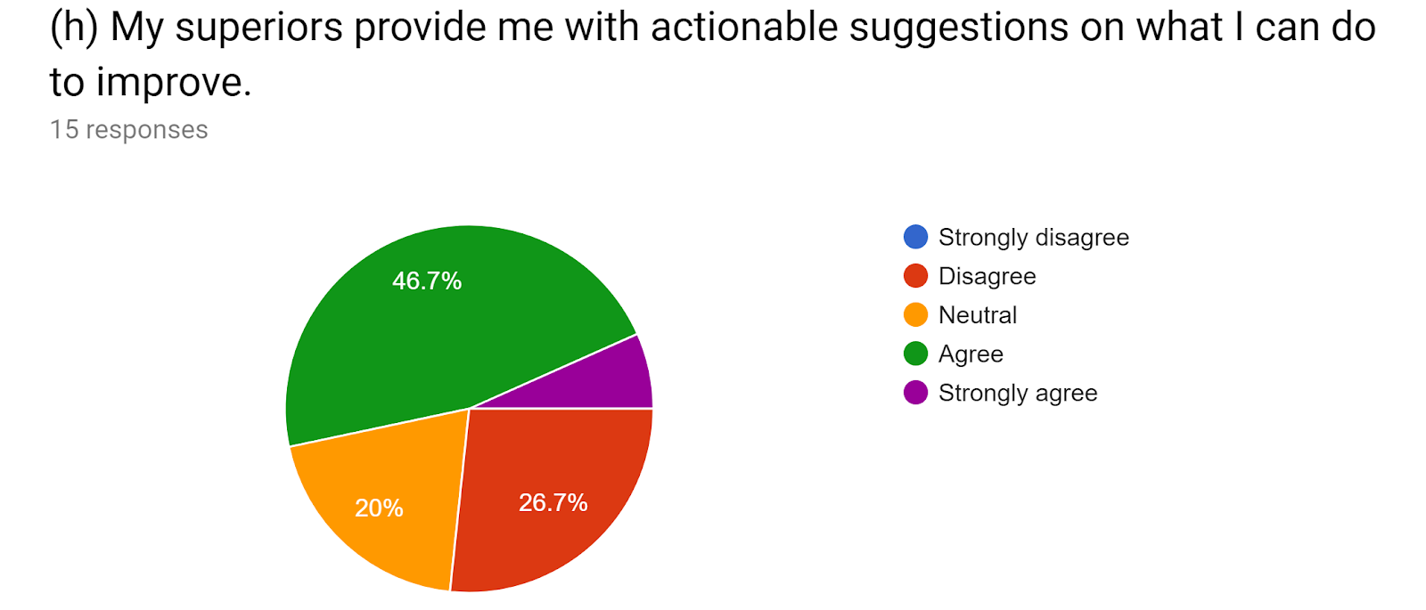
Interpretation
Among 15 employees, 46.7% or 7 employees replied that they agreed and 6.7% or 1 employee replied that the supervisor of Shahjalal Islami bank provide them actionable suggestions on what they need to do while they face any difficulties. On the other hand, a large proportion of 26.7% or 4 employees disagreed and 3 employees were neutral here.
Findings: The satisfaction level is:
Satisfied = Agreed + strongly agreed = 7+1 = 8
And, dissatisfied = neutral + disagreed + strongly disagreed = 3+4+0 = 7
So, though the satisfaction and dissatisfaction level are very close, but we can conclude that mostly employees are satisfied on the statement.

4.1.2 Specific Questions on Measuring Job Satisfaction of Shahjalal Islami Bank Limited

At this section, the questionnaire was designed to directly get the satisfaction level of employees by asking 3 few specific questions that may help to know the overall employee working environment satisfaction of SJIBL. The results and findings are shared below:
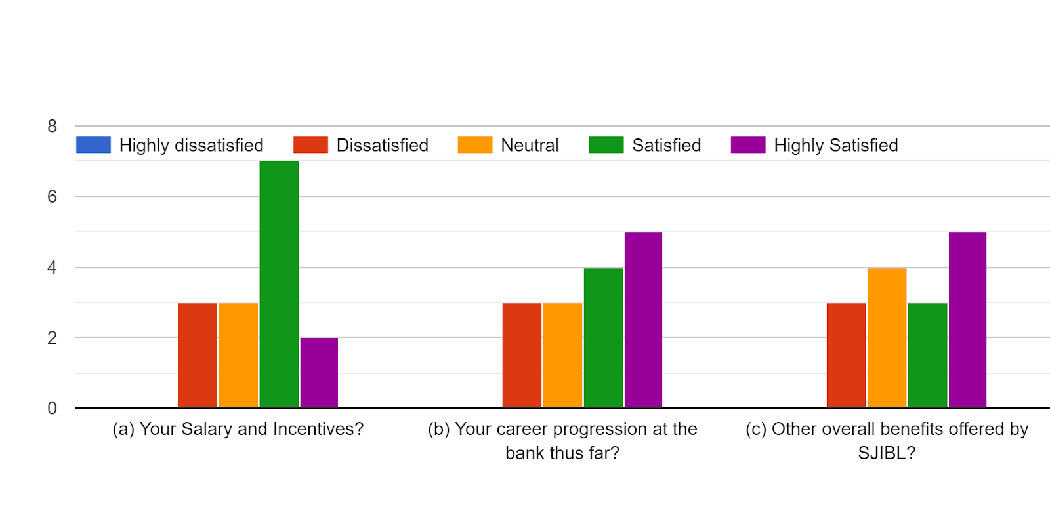

Interpretation
- The first specific question was about the amount of satisfaction provided by the salary and incentives of the employees of Shahjalal Islami Bank Limited. Among 15 employees, 7 were satisfied and 2 were strongly satisfied with their salary and incentives. On the other hand, 3 employees were dissatisfied and 3 were neutral here.
Findings: The satisfaction level is:
Satisfied = Agreed + strongly agreed = 7+2 = 9
And, dissatisfied = neutral + disagreed + strongly disagreed = 3+3+0 = 6
So mostly employees are mostly satisfied with their salary and incentives.

- The second question of the bar chart above was about the career progression of employees at the bank. Among 15 employees, 4 were satisfied and 5 were strongly satisfied with their career progression working in the bank. On the other hand, 3 employees were dissatisfied and 3 were neutral here.
Findings: The satisfaction level is:
Satisfied = Agreed + strongly agreed = 4+5 = 9
And, dissatisfied = neutral + disagreed + strongly disagreed = 3+3+0 = 6
So mostly employees are mostly satisfied with their career progression working in the bank.

- The last and final question was find out the satisfaction level of other overall benefits that are provided by the bank. Among 15 employees, 3 were satisfied and 5 were strongly satisfied with the overall benefits offered by the bank. On the other hand, 3 employees were dissatisfied and 4 were neutral here.
Findings: The satisfaction level is:
Satisfied = Agreed + strongly agreed = 3+5 = 8
And, dissatisfied = neutral + disagreed + strongly disagreed = 4+3+0 = 7
So mostly employees are mostly satisfied with their salary and incentives.

Chapter Five
Recommendations and conclusion

5.1 Recommendation
After findings the employee job satisfaction regarding the working environment in Shahjalal Islami Bank Limited, it can be said that has maintained a well friendly environment for employees as most of the questions had shown that most of all employees among 15 employees are satisfied on the statements. At this part, I want to share some suggestion based on my academic learnings for the betterment of the employee management of Shahjalal Islami Bank Limited.
- There are lack of advertisement promoted by SJIBL what makes the bank less renowned. Increasing promotional activities can make more known name to the customers. It also motivates the employee to work if the bank becomes a reputed one.
- Very few products and services are offered by the bank. Yet, though the products are few but the work pressures of the employee are too high what should be reduced.
- I have often observed a lot of conflicts among employees during the working hour. The branch manager and HR manager should create policies to mitigate the internal conflict among the employees.
- There are some benefit package having SJIBL but it has no practice in real view. That benefit package can be increase the satisfaction of the employee. So it should be practice earlier.
- Officials whom are involved in Customer Services should be trained properly.
- The bank can arrange picnics and tours so that the relationship among the employees may improve.

5.2 Conclusion
This internship report has analysed the overall satisfaction of the employees based on the working environment of Shahjalal Islami Bank Limited. However, the job satisfaction of bank agents depends largely on salary, work efficiency, social benefits, quality of supervision and relationships between colleagues. The remaining three factors, management style, bank loyalty and availability of employment, do not have sufficient statistics to improve bank agent satisfaction. The type of bank is the most relevant in terms of bank agent satisfaction in terms of work experience, age differences, and gender. The happier people are in their work, the more they are said to be satisfied. Job satisfaction is not the same thing as motivation, even if it is clearly linked. Work planning aims to improve job satisfaction and performance; the methods include business rotation, expansion and business enrichment. Management style and culture, employee involvement, empowerment, and autonomous workgroups are other influences on satisfaction. Job satisfaction is a very important attribute often measured by organizations.

Reference (APA Format)
(1) Bank information, Collected from the bank website, Available at:
https://www. sjiblbd.com/
(2) David A. Decenzo, Stephen P Robbins, 2012, Book name: Fundamental of Human Resource Management.
(3) Michael Armstrong, 2008, Book name: A Handbook of Human Resource Management Practice, Available at: https://books.google.com.bd/books?id=D78K7Q IdR3UC&lpg
(4) M. Tariq, M. Ramzan, A. Riaz, 2013, The Impact of Employee Turnover on The Efficiency of The Organization, Inter-disciplinary Journal of Contemporary Research in Business, 4 (9) (2013), pp. 700-711
(5) Buhai, S., Cottini, E., & Nielseny, N. (2008). The impact of Workplace Conditions on Firm Performance (Working Paper Number 08-13). Retrieved from http://www.hha.dk/nat/wper/08-13_sebu.pdf.

Appendices
Survey questionnaire
